Inflammation, SARS-CoV-2 infection and mental health disorders impact on systemic serotonin and dopamine metabolism

Supplementary Material

PSY Team

2023-05-23

# Supplementary Methods

## Software

Study data were analyzed with R version 4.2.3. Import and general data transformation tasks were accomplished with *foreign* (1), *readxl* (2), the *tidyverse* package bundle (3), *rlang* (4) and the development package [*trafo*](https://github.com/PiotrTymoszuk/trafo). Text data was handled with *stringi* (5).

Descriptive statistics, statistical hypothesis testing and correlation analysis was done with the packages *rstatix* (6) and [*ExDA*](https://github.com/PiotrTymoszuk/ExDA). For linear modeling and robust linear modeling, base R functions, the packages *stats*, *MASS* (7), *caret* (8), [*lmqc*](https://github.com/PiotrTymoszuk/lmqc) and [*caretExtra*](https://github.com/PiotrTymoszuk/caretExtra) were employed. Correlation matrices were converted to force-directed graphs with *igraph* (9). For factor analysis and assessment of psychometric tool consistency, *stats*, *psych* (10) and [*clustTools*](https://github.com/PiotrTymoszuk/clustTools) were used.

Results were visualized with tools provided by the packages *ggplot2* (11) (ribbon and bubble plots), [*ExDA*](https://github.com/PiotrTymoszuk/ExDA) (scatter and box plots), [*lmqc*](https://github.com/PiotrTymoszuk/lmqc) (Forest plots) and *ggnetwork* (12) (force-directed graphs). Figures and tables were created with *cowplot* (13) and *flextable* (14), respectively. The manuscript and Supplementary Material were written in the *rmarkdown* environment (15) and rendered with the *knitr* (16) and *bookdown* (17) packages, with the author-info-blocks.lua and scholarly-metadata.lua Pandoc filters developed by Albert Krewinkel, Robert Winkler and Jörn Krenzer. Management of figures and tables in the rmarkdown documents was accomplished with [*figur*](https://github.com/PiotrTymoszuk/figur).

## SIMMUN cohort dataset

Individuals tested for SARS-CoV-2 via PCR at the University Hospital of Innsbruck (Innsbruck, Austria), as well as inpatients and outpatients of the University Clinic for Psychiatry I and II (Innsbruck, Austria) undergoing routine SARS-CoV-2 PCR screening were invited to participate in the SIMMUN study. The study enrollment was initiated on 10. June 2020. The inclusion criteria for the SIMMUN study were age of 18 - 70 years, proficiency in German language, residence in the study region (Tyrol, Austria), and a SARS-CoV-2 PCR test conducted at the University Hospital of Innsbruck. The exclusion criteria were active SARS-CoV-2 infection (< 14 days following a positive test), pregnancy, active malignancies, organ transplantation, prior surgery in the past 3 months, acute or chronic inflammatory illness and treatment with oral corticosteroids. The analysis inclusion criterion was the complete study variable dataset consisting of basic demographic and medical history variables, SARS-CoV-2 infection status and titer of anti-receptor-binding domain S12/S2 protein immunoglobulin gamma (anti-RBD IgG), psychometric scoring of depression, anxiety and mental stress as well as blood levels of inflammatory markers and metabolites of KYN pathway affecting also TRP and catecholamine pathway. A total of 165 SIMMUN study participants were analyzed here. The SIMMUN study variables with their transformation and stratification schemes are listed in **Supplementary Table S1**. The SIMMUN study data were gathered during a single on-site study visit at the study center at median 139 days after the SARS-CoV-2 test (interquartile range: 119 - 157). The study visits were conducted between 17.June 2020 and 27.May 2021. The SIMMUN analysis flowchart is presented in **Figure 1**. Significant differences between participants included in the analysis and excluded due to data missingness are shown in **Supplementary Table S2**. Characteristic of the analyzed SIMMUN collective split by the SARS-CoV-2 infection status is presented in **Table 1**.

Demographic and clinical history variables age, sex, body mass index (BMI), professionally diagnosed psychiatric disorders, self-reported chronic physical disorders, smoking and alcohol consumption were surveyed during the study visit or extracted from electronic patient records. Body mass classes were defined as follows: normal for BMI < 25 kg/m2, overweight for BMI 25 - 30 kg/m2 and obesity for BMI > 30 kg/m2. Result and date of the SARS-CoV-2 PCR test were retrieved from electronic patient records.

The inflammatory markers included in the analysis, plasma concentration of neopterin (NEO) and neutrophil - lymphocyte ratio (NLR) were determined by the certified clinical routine laboratory at the University Hospital of Innsbruck. C-reactive protein (CRP) and interleukin-6 (IL6) were determined in the SIMMUN cohort as well but excluded from the analysis, since their levels were within the reference range in the great majority of participants. Elevated CRP > 0.5 mg/dL was detected in 10% and elevated IL6 > 7 pg/mL was observed in 4.8% of the analyzed SIMMUN cohort. Plasma concentrations of tryptophan (TRP), kynurenine (KYN), phenylalanine (PHE) and tyrosine (TYR) were determined by high-performance liquid chromatography, as described elsewhere (18,19). Kynurenine - tryptophan and phenylalanine - tyrosine ratios (KYN/TRP and PHE/TYR) were used as readouts of systemic indoleamine 2,3-dioxygenase (IDO) and phenylalanine hydroxylase (PAH) activity (20). Plasma titer of anti-RBD IgG were quantified by ELISA as described before (21). Strongly non-normally distributed anti-RBD IgG levels were expressed as arbitrary units (AU) and stratified with the 1, 1 - 16.3 and > 16.3 AU cutpoints defined by the maximal titer in the uninfected participants (1 AU) and median titer in the SARS-CoV-2 subset (16.3 AU). Laboratory measurements at and below the lower detection limit were substituted with the lower detection limit. Laboratory measurements at and above the upper detection limit were substituted with the upper detection limit.

Mental stress was assessed with the 4-item perceived stress scale (PSS-4) (22). Clinically relevant symptoms of anxiety and depression were scored with the hospital anxiety and depression scale (HADS) including 7 items for anxiety and 7 items for depression (23). The total possible score range for each subscale is 0 to 21, with higher scores indicating more severe symptoms of anxiety/depression. Clinically relevant signs of anxiety or depression were identified with the cutoff of 8 points at the respective subscale as proposed (23,24). PSS-4, HADS anxiety and depression scales displayed good-to-excellent internal consistency as measured by the McDonald statistic (25) (**Supplementary Figure S1**).

In order to improve normality of some numeric SIMMUN study variables prior to linear modeling and statistical hypothesis testing with parametric tools, logarithm (KYN, PHE, TYR, KYN/TRP, NEO, NLR) or square root transformations (PHE/TYR) were applied. Strongly non-normally distributed HADS scores and anti-RBD IgG were stratified with the cutoffs described above. Transformation and stratification schemes of study variable are provided in **Supplementary Table S1**.

The SIMMUN cohort data were stored as a SPSS file and imported in R with the read.spss() function (package *foreign*). Transformation, stratification of numeric study variables and coding of categorical features was done with an in-hose developed script.

## INCOV cohort dataset

Plasma proteome measurements in the INCOV cohort were obtained by proximity extension assay (PEA, Olink, Sweden). Plasma metabolome was quantified by ultra-high-performance liquid chromatography/tandem accurate mass spectrometry (Metabolon, USA) (26,27). m Normalized, age- and sex-adjusted, log2-transformed plasma levels as well as clinical information (sex, SARS-CoV-2 infection status, COVID-19 severity, timepoint) for the INCOV cohort were extracted from [supplementary tables](https://data.mendeley.com/datasets/96v329bg7g/1) accompanying the report by Su and colleagues (26) (function read_xlsx, package *readxl*) (2). In the current analysis, 354 INCOV study samples obtained for 167 individuals with the complete dataset of metabolites of interest (serotonin, tryptophan [TRP], kynurenine [KYN], quinolinate [QUIN], phenylalanine [PHE], tyrosine [TYR] and dopamine 3-O-sulfate [DA sulfate]), inflammatory cytokine markers of interest (interleukin-6 [IL6], interleukin-10 [IL10], tumor necrosis factor-alpha [TNF] and interferon-gamma [IFNG]) and complete information of age at enrollment were included. The INCOV study variables are listed in **Supplementary Table S3**. The analysis inclusion scheme for the INCOV cohort is presented in **Figure 1**. Characteristic of the INCOV cohort are shown in **Table 2**. Concerning the INCOV study design, plasma metabolites and proteome analyes were performed in uninfected controls and SARS-CoV-2 individuals at three timepoints after diagnosis: acute (median 10 days), sub-acute (median 14 days) and recovery (median 64 days after diagnosis of SARS-CoV-2 infection via PCR). The measurements were only partially matched by participant (i.e. multiple longitudinal measurements for an individual) hence precluding a classical repeated measurement analysis approach. Numbers of available INCOV cohort samples and the sampling timepoints are shown in **Supplementary Table S4**.

## Descriptive statistic, variable distribution and psychometric tool consistency

Numeric variables were presented in the tables as medians with interquartile ranges and ranges. Categorical variables are presented as percentages and counts within the complete observation set. Descriptive statistics were computed with the function explore() from the [*ExDA*](https://github.com/PiotrTymoszuk/ExDA) package.

Distribution normality and variance homogeneity was assessed by Shapiro-Wilk and Levene test, respectively (functions explore() and compare_variables(), package [*ExDA*](https://github.com/PiotrTymoszuk/ExDA)). The distribution testing revealed substantial deviations from normality for some SIMMUN study parameters. For this reason, logarithm and square root transformations were applied prior to modeling and statistical hypothesis testing with parametric tools as specified in **Supplementary Table S1**. Most of the INCOV study variables were non-normally distributed. For this reason, non-parametric Spearman rank test was chosen for correlation analysis and robust linear regression was used as a modeling approach.

The tau-equivalence assumption was clearly violated for both the HADS depression and HADS anxiety scale in the SIMMUN collective as investigated by factor analysis (function reduce_data(), package [*clustTools*](https://github.com/PiotrTymoszuk/clustTools), employing internally factanal() from the *stats* package). For this reason, global McDonald’s statistic was used as a consistency measure for all psychometric tools in the SIMMUN cohort (function omega(), package *psych*) (10,25,28) (**Supplementary Figure S1**).

## Statistical significance, effect size

Except for results of multi-parameter linear modeling and multi-parameter robust linear regression, p values were corrected for multiple testing with the false discovery rate method (FDR) (29) separately for each analysis task. Effects with p < 0.05 were considered significant. The following effect size measures were used (30): Cramer’s V for comparison of distribution of categorical variables (weak: < 0.3, moderate: 0.3 - 0.5, large effect: 0.5), Cohen’s d for two group comparisons of normally distributed variables (weak: < 0.5, moderate: 0.5 - 0.8, large effect: 0.8), r for two group comparisons of non-normally distributed variables (weak: < 0.3, moderate: 0.3 - 0.5, large effect: 0.5), for correlation of non-normally distributed variables (weak: < 0.3, moderate: 0.3 - 0.5, strong correlation: 0.5), r for correlation of normally distributed variables (weak: < 0.3, moderate: 0.3 - 0.5, strong correlation: 0.5), as a measure of explained variance in modeling (weak: < 0.13, moderate: 0.13 - 0.26, substantial: 0.26).

## Statistical hypothesis testing

Differences in characteristic of SIMMUN participants included in the analysis and excluded due to data missingness were assessed by test with Cramer’s V effect size statistic and Mann-Whitney test with r effect size metric for numeric and categorical features, respectively (**Supplementary Table S2**). Differences in characteristic of SIMMUN participants or INCOV study participants dvided by the SARS-CoV-2 infection status were investigated by test with Cramer’s V effect size statistic and Mann-Whitney test with r effect size metric for numeric and categorical features, respectively (**Tables 1** and **2**). Correlation of metabolite concentrations with age, scoring of mental stress (PSS-4) and markers of inflammation (NEO and NLR) in the SIMMUN cohort was done by Pearson’s test (**Supplementary Table S7**). Differences in metabolite concentrations and metabolite ratios in the SIMMUN cohort divided by the SARS-CoV-2 infection status or presence of depression symptoms (HADS) were assessed by two-tailed T test with Cohen’s d effect size metric (**Supplementary Table S8**).

Statistical hypothesis testing was accomplished with the functions compare_variables() and correlate_variables() from the development package [*ExDA*](https://github.com/PiotrTymoszuk/ExDA) for comparison and correlation, respectively.

## Multi-parameter linear regression with backwards elimination in the SIMMUN cohort

Effects of age, sex, body mass class, physical and mental disorders, body mass class, smoking and alcohol consumption, the inflammation markers NEO and NLR, SARS-CoV-2 infection status, anti-RBD IgG titer, clinically relevant signs of depression and anxiety (HADS), mental stress scoring (PSS-4) on systemic levels of amino acid neurotransmitter precursor and products of competitor pathways (TRP, KYN, KYN/TRP ratio, PHE, TYR and PHE/TYR ratio) was assessed by multi-parameter linear regression with backward elimination. Responses and numeric explanatory variables were transformed with log or squared root functions to improve normality as specified in **Supplementary Table S1** and normalized prior to modeling.

Full models including the complete set of explanatory variables listed above were constructed (function make_lm(), package [*lmqc*](https://github.com/PiotrTymoszuk/lmqc)) and optimized by Bayesian information criterion (BIC) driven backwards elimination of non-significant terms (method step(), [*lmqc*](https://github.com/PiotrTymoszuk/lmqc), employing internally stepAIC() from the *MASS* package) (7). Normality and homogeneity of distribution of the model residuals were checked by Shapiro-Wilk and Levene tests, respectively (method summary(type = 'assumptions'), package [*lmqc*](https://github.com/PiotrTymoszuk/lmqc)) and visually inspected in standard diagnostic plots of model residuals (residuals vs fitted, quantile-quantile plots, method plot() called for the model objects). Fit stats ( and root mean squared error [RMSE]) were retrieved from the model objects by calling summary(type = 'fit') (package [*lmqc*](https://github.com/PiotrTymoszuk/lmqc)). Validity of the optimized models was determined by likelihood-ratio test (LRT) versus the respective null models (method anova()). Reproducibility and proper parameterization of the optimized multi-parameter models was investigated by repeated cross-validation (10 folds, function train(method = 'lm'), package *caret*)(8) and by comparison of the RMSE and statistics obtained with in the training dataset and in cross-validation (method summary(), package *caretExtra*). As presented in **Supplementary Figure S2A**, similar values of error fit in the training and cross-validation data suggest good reproducibility of the optimized models and lack of over-parameterization.

Inference statistics for the model estimates (, expected values and 95% confidence intervals) were extracted with the summary() method. Significance of the estimates () was determined by two-tailed T test. Results of the linear modeling in the INCOV cohort are presented in **Figure 2** and **Supplementary Table S6**.

## Multi-parameter robust linear modeling in the INCOV cohort

Effects of the key explanatory factors identified by multi-parameter linear modeling in the SIMMUN cohort on systemic neurotransmitter availability yand associated metabolites were subsequently tested in the publicly available INCOV collective (26). We modeled normalized plasma levels of serotonin as the end product of serotonin biosynthesis associated with mental disorders (31–36), and the major product of systemic dopamine catabolism, dopamine 3-O-sulfate (DA-sulfate) (37,38). The explanatory variables were age, plasma levels of cytokines induced by inflammatory signaling (IL6, IL10, TNF, IFNG), plasma concentrations of neurotransmitter precursors and KYN pathway products (for serotonin: TRP, KYN and quinolinate [QUIN], for DA sulfate: PHE and TYR) and timepoint of SARS-CoV-2 infection (acute, sub-acute, recovery versus uninfected control). Since most numeric features were non-normally distributed, MM algorithm robust linear regression with Huber’s psi function was chosen (7,39) as a modeling approach.

The robust linear models were built with the make_lm() wrapper ([*lmqc*](https://github.com/PiotrTymoszuk/lmqc) package) around the MASS package rlm() function (7). The parameterization and reproducibility of the models were tested by 10-fold cross-validation with the *caret* package (8) as described for multi-parameter linear regression. As presented in **Figure 5A**, similar values of error fit in the training and cross-validation data suggest good reproducibility of the robust linear models and proper model parameterization. Inference statistics were extracted from the models with summary() method. Significance of the model estimates () was determined by two-tailed T test, 95% confidence intervals were computed based on theoretical t distribution. The robust linear modeling results are presented in **Figure 3** and **Supplementary Table S9**.

## Time course of cytokines and metabolites in the INCOV cohort

Differences in normalized blood concentrations of cytokines and metabolites between uninfected controls, acute and sub-acute SARS-CoV-2 infection and recovery were investigated with robust linear modeling with uninfected subset or acute infection serving as baselines. Models were constructed with the make_lm() function (package [*lmqc*](https://github.com/PiotrTymoszuk/lmqc)) employing internally the MM rlm() algorithm with Huber’s psi function (package *MASS*) (7,39). Inference statistics were computed as described for multi-parameter robust linear modeling. The time course modeling results are presented in **Figure 4**, **Supplementary Table S10** - **S11**.

## Correlation and network analysis in the INCOV cohort

Pairwise Spearman’s correlation coefficients were calculated for plasma concentrations of cytokines (IL6, IL10, TNF and IFNG), and metabolite involved in serotonin (serotonin, TRP, KYN and QUIN) and dopamine turnover (PHE, TYR and DA sulfate) with the cor() function from the *stats* package at each of the timepoints of SARS-CoV-2 infection (uninfected, acute, sub-acute and recovery). The correlation matrices were subsequently scaled into the [0, 1] range with the function and converted to undirected force directed graphs with the graph_from_adjacency_matrix() function from the *igraph* package (9). The graphs were visualized with tools provided by the *ggnetwork* package (12) as two-dimensional network plots with the node proximity determined by the value and distance-dependent repulsion, and edge color and width coding for the value and sign (**Figure 5**). Additionally, correlation analysis results were presented as correlograms in **Supplementary Figure 5**.

## Data and code availability

Anonymized patient data will be made available upon request to the corresponding author. The INCOV cohort data are publicly available at <https://data.mendeley.com/datasets/96v329bg7g/1>. The analysis pipeline code is available at <https://github.com/PiotrTymoszuk/simmun>.

# Supplementary Tables

Table 1: Study variables in the SIMMUN cohort.

| **Variable type** | **Variable labela** | **Format** | **Unit** | **Transformation** | **Categories** |
| --- | --- | --- | --- | --- | --- |
| response | TRP | numeric | µmol/L | identity |  |
| KYN | numeric | µmol/L | logarithm |  |
| PHE | numeric | µmol/L | logarithm |  |
| TYR | numeric | µmol/L | logarithm |  |
| KYN/TRP | numeric |  | logarithm |  |
| PHE/TYR | numeric |  | square root |  |
| explanatory | age | numeric | years | identity |  |
| sex | categorical |  |  | female, male |
| mental disorder | categorical |  |  | no, yes |
| physical disorder | categorical |  |  | no, yes |
| SARS-CoV2 | categorical |  |  | no, yes |
| body mass indexb | categorical |  |  | normal, overweight, obesity |
| smoking | categorical |  |  | no, yes |
| Alcohol consumption | categorical |  |  | no, yes |
| HADS, anxiety score | categorical |  |  | < 8, ≥ 8 |
| HADS, depression score | categorical |  |  | < 8, ≥ 8 |
| PSS-4, perceived stress score | numeric |  | identity |  |
| NEO | numeric | nmol/L | logarithm |  |
| NLR | numeric |  | logarithm |  |
| anti-RBD IgG | categorical |  |  | negative, 1 - 16.3 AU, > 16.3 AU |
| aTRP: tryptophan; KYN: kynurenine; PHE: phenylalanine; TYR: tyrosine; KYN/TRP: kynurenine - tryptophan ratio; PHE/TYR: phenylalanine/tyrosine ratio; HADS: hospital anxiety and depression score; PSS-4: perceived stress scale, 4 item; NEO: neopterin; NLR: neutrophil - lymphocyte ratio; anti-RBD IgG: anti-receptor-binding domain S1/S2 immunoglobulin. | | | | | |
| bnormal: body mass index (BMI) < 25 kg/m², overweight: BMI 25 - 30 kg/m², obesity: BMI > 30 kg/m². | | | | | |

Table 2: Significant differences between participants of the SIMMUN study included in the analysis and SIMMUN participants excluded due to data missingness. Numeric variables are presented as medians with interquartile ranges (IQR) and ranges. Categorical variables are presented as percentages and counts within the complete observation set.

| **Variablea** | **Analyzed** | **Excluded** | **Test** | **Significanceb** | **Effect size** |
| --- | --- | --- | --- | --- | --- |
| Psychiatric comorbidity | 41% (68) complete: n = 165 | 84% (42) complete: n = 50 | χ² | p < 0.001 | V = 0.36 |
| HADS anxiety score | < 8: 66% (109) ≥ 8: 34% (56) complete: n = 165 | < 8: 42% (21) ≥ 8: 58% (29) complete: n = 50 | χ² | p = 0.016 | V = 0.21 |
| HADS depression score | < 8: 75% (124) ≥ 8: 25% (41) complete: n = 165 | < 8: 40% (20) ≥ 8: 60% (30) complete: n = 50 | χ² | p < 0.001 | V = 0.32 |
| Depression or anxiety signs, HADS ≥ 8 | HADS-: 65% (107) HADS+: 35% (58) complete: n = 165 | HADS-: 38% (19) HADS+: 62% (31) complete: n = 50 | χ² | p = 0.0066 | V = 0.23 |
| PSS-4 stress score | 6 [IQR: 3 - 8] range: 0 - 14 complete: n = 165 | 9 [IQR: 6 - 12] range: 0 - 16 complete: n = 49 | Mann-Whitney | p < 0.001 | r = 0.26 |
| Infection | healthy: 61% (101) SARS-CoV-2: 39% (64) complete: n = 165 | healthy: 84% (42) SARS-CoV-2: 16% (8) complete: n = 50 | χ² | p = 0.016 | V = 0.2 |
| COVID-19 severity | healthy: 61% (101) ambulatory: 28% (47) hospitalized: 10% (17) complete: n = 165 | healthy: 84% (42) ambulatory: 12% (6) hospitalized: 4% (2) complete: n = 50 | χ² | p = 0.033 | V = 0.2 |
| aHADS: hospital anxiety and depression scale; PSS-4: perceived stress scale, 4 item. | | | | | |
| bCorrected for multiple testing with the false discovery rate method. | | | | | |

Table 3: Study variables in the INCOV cohort.

| **Variable type** | **Variable labela** | **Unit** |
| --- | --- | --- |
| explanatory | TNF | Z-score of log₂ concentration |
| IFNG | Z-score of log₂ concentration |
| IL6 | Z-score of log₂ concentration |
| IL10 | Z-score of log₂ concentration |
| QUIN | Z-score of log₂ concentration |
| PHE | Z-score of log₂ concentration |
| response | 5-HT | Z-score of log₂ concentration |
| explanatory | TRP | Z-score of log₂ concentration |
| TYR | Z-score of log₂ concentration |
| KYN | Z-score of log₂ concentration |
| response | DA sulfate | Z-score of log₂ concentration |
| explanatory | age | years |
| aTNF: tumor necrosis factor-alpha; IFNG: interferon gamma; IL6: interleukin-6; IL10: interleukin-10; QUIN: quinolinate; PHE: phenylalanine; 5-HT: serotonin; TRP: tryptophan; TYR: tyrosine; KYN: kynurenine; DA sulfate: dopamine 3-O-sulfate. | | |

Table 4: Number of available samples and sampling timepoints in the INCOV cohort.

| **Time point** | **Days post infection** | **Sample number** |
| --- | --- | --- |
| uninfected |  | 27 |
| acute | 10 [6 - 13] | 140 |
| sub-acute | 14 [10 - 20] | 126 |
| recovery | 64 [51 - 90] | 61 |

Table 5: Comparison of the SIMMUN and INCOV cohorts. Numeric variables are presented as medians with interquartile ranges (IQR) and ranges. Categorical variables are presented as percentages and counts within the complete observation set.

| **Variable** | **SIMMUN** | **INCOV** | **Test** | **Significance** | **Effect size** |
| --- | --- | --- | --- | --- | --- |
| Patritipants, n | 165 | 167 |  |  |  |
| Sex | female: 62% (102) male: 38% (63) | female: 44% (73) male: 56% (94) | χ² | p = 0.0014 | V = 0.18 |
| Age, years | 50 [IQR: 35 - 56] range: 18 - 69 | 60 [IQR: 48 - 71] range: 26 - 89 | Mann-Whitney | p < 0.001 | r = 0.39 |
| Body massa | normal: 53% (88) overweight: 30% (49) obesity: 17% (28) | normal: 29% (48) overweight: 34% (57) obesity: 37% (62) | χ² | p < 0.001 | V = 0.28 |
| SARS-CoV-2 | uninfeccted: 61% (101) SARS-CoV-2: 39% (64) | uninfected: 16% (27) SARS-CoV-2: 84% (140) | χ² | p < 0.001 | V = 0.46 |
| SARS-CoV-2 hospitalization | uninfected: 61% (101) ambulatory: 28% (47) hospitalized: 10% (17) | uninfected: 16% (27) ambulatory: 2.4% (4) hospitalized: 81% (136) | χ² | p < 0.001 | V = 0.72 |
| aoverweight: body mass index (BMI) 25 - 30 kg/mm², obesity: BMI > 30 kg/mm² | | | | | |

Table 6: Results of multi-parameter linear modeling of plasma concentrations of tryptophan, kynurenine, tyrosine, and kynurenine - tryptophan, and phenylalanine - tyrosine ratios in the SIMMUN cohort.

| **Responsea** | **Explanatory variableb** | **Stratum** | **Observations/stratum** | **Estimate, 95% CI** | **Significance** |
| --- | --- | --- | --- | --- | --- |
| TRP | Intercept | baseline |  | 0.12 [-0.052 - 0.29] | ns (0.17) |
| log NEO |  | 165 | -0.19 [-0.34 - -0.04] | p = 0.013 |
| HADS, depression score | ≥ 8 | 41 | -0.48 [-0.83 - -0.14] | p = 0.0064 |
| log KYN | Intercept | baseline |  | -0.19 [-0.36 - -0.012] | p = 0.036 |
| SARS-CoV2 |  | 64 | 0.48 [0.2 - 0.76] | p = 0.001 |
| log NEO |  | 165 | 0.35 [0.2 - 0.49] | p = 4.9e-06 |
| log NLR |  | 165 | -0.19 [-0.32 - -0.051] | p = 0.0074 |
| age |  | 165 | 0.21 [0.067 - 0.35] | p = 0.0041 |
| log KYN/TRP | Intercept | baseline |  | -0.16 [-0.32 - -0.004] | p = 0.045 |
| SARS-CoV2 |  | 64 | 0.42 [0.16 - 0.68] | p = 0.0017 |
| log NEO |  | 165 | 0.47 [0.34 - 0.61] | p = 5.4e-11 |
| age |  | 165 | 0.26 [0.12 - 0.39] | p = 0.00022 |
| PSS-4, stress score |  | 165 | 0.18 [0.055 - 0.31] | p = 0.0052 |
| log TYR | Intercept | baseline |  | -4.5e-16 [-0.14 - 0.14] | ns (1) |
| log NEO |  | 165 | -0.2 [-0.35 - -0.048] | p = 0.01 |
| age |  | 165 | 0.37 [0.21 - 0.52] | p = 4.5e-06 |
| sqrt PHE/TYR | Intercept | baseline |  | 0.15 [-0.04 - 0.34] | ns (0.12) |
| SARS-CoV2 |  | 64 | -0.38 [-0.68 - -0.08] | p = 0.013 |
| age |  | 165 | -0.27 [-0.41 - -0.12] | p = 0.00047 |
| aTRP: tryptophan; KYN: kynurenine; KYN/TRP: kynurenine - tryptophan ratio; TYR: tyrosine; PHE/TYR: phenylalanine - tyrosine ratio. | | | | | |
| bNEO: neopterin; HADS: hospital anxiety and depression scale; NLR: neutrophil - lymphocyte ratio; PSS-4: perceived stress scale, 4 item. | | | | | |

Table 7: Correlation of age, stress scoring, blood neopterin levels and neutrophil - leukocyte ratio with plasma metabolite levels in the SIMMUN cohort investigated by Pearson's test.

| **Metabolitea** | **Explanatory variableb** | **n** | **Correlation coefficient, 95% CI** | **Significancec** |
| --- | --- | --- | --- | --- |
| TRP | age | 165 | -0.025 [-0.18 - 0.13] | ns (p = 0.84) |
| log KYN | age | 165 | 0.3 [0.16 - 0.43] | p < 0.001 |
| log KYN/TRP | age | 165 | 0.36 [0.21 - 0.48] | p < 0.001 |
| TRP | PSS-4, stress score | 165 | -0.17 [-0.31 - -0.016] | ns (p = 0.062) |
| log KYN | PSS-4, stress score | 165 | -0.016 [-0.17 - 0.14] | ns (p = 0.85) |
| log KYN/TRP | PSS-4, stress score | 165 | 0.12 [-0.029 - 0.27] | ns (p = 0.16) |
| TRP | log NEO | 165 | -0.17 [-0.32 - -0.02] | ns (p = 0.061) |
| log KYN | log NEO | 165 | 0.35 [0.2 - 0.47] | p < 0.001 |
| log KYN/TRP | log NEO | 165 | 0.52 [0.4 - 0.62] | p < 0.001 |
| TRP | log NLR | 165 | -0.16 [-0.31 - -0.01] | ns (p = 0.066) |
| log KYN | log NLR | 165 | -0.18 [-0.32 - -0.023] | ns (p = 0.061) |
| log KYN/TRP | log NLR | 165 | -0.055 [-0.21 - 0.098] | ns (p = 0.58) |
| log PHE | age | 165 | 0.14 [-0.013 - 0.29] | ns (p = 0.16) |
| log TYR | age | 165 | 0.3 [0.16 - 0.44] | p < 0.001 |
| sqrt PHE/TYR | age | 165 | -0.25 [-0.39 - -0.11] | p = 0.0044 |
| log PHE | log NEO | 165 | -0.044 [-0.2 - 0.11] | ns (p = 0.58) |
| log TYR | log NEO | 165 | -0.085 [-0.23 - 0.069] | ns (p = 0.37) |
| sqrt PHE/TYR | log NEO | 165 | 0.083 [-0.071 - 0.23] | ns (p = 0.37) |
| aTRP: tryptophan; KYN: kynurenine; KYN/TRP: kynurenine - tryptophan ratio; PHE: phenylalanine; TYR: tyrosine; PHE/TYR: phenylalanine - tyrosine ratio. | | | | |
| bPSS-4: perceived stress scale, 4 item; NEO: neopterin; NLR: neutrophil - lymphocyte ratio. | | | | |
| cCorrected for multiple testing with the false discovery rate method. | | | | |

Table 8: Comparison of plasma metabolite levels in SIMMUN study participants stratified by depression signs and SARS-CoV-2 infection status with two-tailed T test and Cohen's d effect size statistic.

| **Metabolitea** | **Explanatory variableb** | **Stratumc** | **Observations/stratum** | **Statisticd** | **Significance** | **Effect size** |
| --- | --- | --- | --- | --- | --- | --- |
| TRP | HADS, depression score | < 8 | 124 | 62 [IQR: 55 - 68] range: 33 - 93 | ns (p = 0.059) | d = 0.45 |
| TRP | HADS, depression score | ≥ 8 | 41 | 53 [IQR: 48 - 65] range: 43 - 85 | ns (p = 0.059) | d = 0.45 |
| TRP | SARS-CoV2 | uninfected | 101 | 59 [IQR: 50 - 66] range: 33 - 88 | ns (p = 0.12) | d = 0.28 |
| TRP | SARS-CoV2 | recovery | 64 | 62 [IQR: 56 - 69] range: 42 - 93 | ns (p = 0.12) | d = 0.28 |
| log KYN | HADS, depression score | < 8 | 124 | 0.71 [IQR: 0.57 - 0.86] range: -0.13 - 1.4 | ns (p = 0.12) | d = 0.35 |
| log KYN | HADS, depression score | ≥ 8 | 41 | 0.59 [IQR: 0.41 - 0.72] range: -0.084 - 1.4 | ns (p = 0.12) | d = 0.35 |
| log KYN | SARS-CoV2 | uninfected | 101 | 0.67 [IQR: 0.48 - 0.79] range: -0.13 - 1.4 | ns (p = 0.061) | d = 0.36 |
| log KYN | SARS-CoV2 | recovery | 64 | 0.71 [IQR: 0.57 - 0.88] range: 0.18 - 1.4 | ns (p = 0.061) | d = 0.36 |
| log KYN/TRP | HADS, depression score | < 8 | 124 | -3.4 [IQR: -3.6 - -3.3] range: -4 - -2.8 | ns (p = 0.85) | d = 0.036 |
| log KYN/TRP | HADS, depression score | ≥ 8 | 41 | -3.4 [IQR: -3.6 - -3.3] range: -4 - -2.7 | ns (p = 0.85) | d = 0.036 |
| log KYN/TRP | SARS-CoV2 | uninfected | 101 | -3.4 [IQR: -3.6 - -3.3] range: -4 - -2.7 | ns (p = 0.45) | d = 0.15 |
| log KYN/TRP | SARS-CoV2 | recovery | 64 | -3.4 [IQR: -3.5 - -3.3] range: -3.8 - -2.8 | ns (p = 0.45) | d = 0.15 |
| log PHE | SARS-CoV2 | uninfected | 101 | 4.2 [IQR: 4.1 - 4.4] range: 3.6 - 4.9 | ns (p = 0.58) | d = 0.11 |
| log PHE | SARS-CoV2 | recovery | 64 | 4.2 [IQR: 4.1 - 4.3] range: 3.7 - 5.3 | ns (p = 0.58) | d = 0.11 |
| log TYR | SARS-CoV2 | uninfected | 101 | 4.2 [IQR: 4 - 4.4] range: 3.6 - 5 | ns (p = 0.37) | d = 0.2 |
| log TYR | SARS-CoV2 | recovery | 64 | 4.2 [IQR: 4 - 4.4] range: 3.7 - 5.1 | ns (p = 0.37) | d = 0.2 |
| sqrt PHE/TYR | SARS-CoV2 | uninfected | 101 | 1 [IQR: 0.96 - 1.1] range: 0.78 - 1.4 | ns (p = 0.092) | d = 0.35 |
| sqrt PHE/TYR | SARS-CoV2 | recovery | 64 | 0.98 [IQR: 0.9 - 1] range: 0.79 - 1.6 | ns (p = 0.092) | d = 0.35 |
| aTRP: tryptophan; KYN: kynurenine; KYN/TRP: kynurenine - tryptophan ratio; PHE: phenylalanine; TYR: tyrosine; PHE/TYR: phenylalanine - tyrosine ratio. | | | | | | |
| bHADS: hospital anxiety and depression scale. | | | | | | |
| cMedian with interquartile range (IQR) and range. | | | | | | |
| dCorrected for multiple testing with the false discovery rate method. | | | | | | |

Table 9: Results of multi-parameter robust linear modeling of plasma concentrations of serotonin, and dopamine 3-O-sulfate in the INCOV cohort.

| **Responsea** | **Explanatory variableb** | **Group** | **Observations/stratum** | **Estimate, 95% CI** | **Significance** |
| --- | --- | --- | --- | --- | --- |
| 5-HT | Intercept | baseline |  | -0.27 [-0.64 - 0.11] | ns (0.16) |
| TRP |  | 354 | 0.17 [0.048 - 0.29] | p = 0.0061 |
| KYN |  | 354 | 0.1 [-0.086 - 0.3] | ns (0.28) |
| QUIN |  | 354 | -0.011 [-0.2 - 0.18] | ns (0.91) |
| SARS-CoV-2 | acute | 140 | 0.25 [-0.18 - 0.68] | ns (0.26) |
| SARS-CoV-2 | sub-acute | 126 | 0.3 [-0.12 - 0.72] | ns (0.16) |
| SARS-CoV-2 | recovery | 61 | 0.72 [0.3 - 1.1] | p = 0.00071 |
| Age |  | 354 | -0.15 [-0.25 - -0.041] | p = 0.0065 |
| IL6 |  | 354 | -0.24 [-0.4 - -0.089] | p = 0.002 |
| IL10 |  | 354 | -0.061 [-0.21 - 0.088] | ns (0.42) |
| TNF |  | 354 | 0.0055 [-0.12 - 0.13] | ns (0.93) |
| IFNG |  | 354 | 0.063 [-0.074 - 0.2] | ns (0.37) |
| DA sulfate | Intercept | baseline |  | -0.2 [-0.52 - 0.12] | ns (0.22) |
| PHE |  | 354 | 0.0028 [-0.1 - 0.11] | ns (0.96) |
| TYR |  | 354 | 0.036 [-0.059 - 0.13] | ns (0.46) |
| SARS-CoV-2 | acute | 140 | -0.1 [-0.48 - 0.27] | ns (0.58) |
| SARS-CoV-2 | sub-acute | 126 | 0.17 [-0.19 - 0.53] | ns (0.35) |
| SARS-CoV-2 | recovery | 61 | 0.64 [0.28 - 1] | p = 0.00047 |
| Age |  | 354 | -0.02 [-0.11 - 0.068] | ns (0.66) |
| IL6 |  | 354 | -0.1 [-0.23 - 0.025] | ns (0.12) |
| IL10 |  | 354 | 0.026 [-0.1 - 0.15] | ns (0.69) |
| TNF |  | 354 | 0.14 [0.032 - 0.24] | p = 0.0096 |
| IFNG |  | 354 | -0.13 [-0.24 - -0.014] | p = 0.027 |
| a5-HT: 5-hydroxy tryptamine/serotonin; DA sulfate: dopamine 3-O-sulfate. | | | | | |
| bTRP: tryptophan; KYN: kynurenine; QUIN: quinolinate; IL6: interleukin-6, IL10: interleukin-10; TNF: tumor necrosis factor-alpha; IFNG: interferon gamma; PHE: phenylalanine; TYR: tyrosine. | | | | | |

Table 10: Results of robust linear modeling of serum levels of inflammatory cytokine markers, tryptophan, tyrosine and their metabolites as a function of SARS-CoV-2 infection status in the INCOV cohort. The uninfected subset served as a baseline.

| **Baseline** | **Responsea** | **Timepoint** | **Estimate, 95% CIb** | **Significance** |
| --- | --- | --- | --- | --- |
| uninfected | TNF | baseline | -0.24 [-0.54 - 0.063] | ns (p = 0.24) |
| TNF | acute | 2 [1.6 - 2.3] | p < 0.001 |
| TNF | sub-acute | 1.8 [1.5 - 2.2] | p < 0.001 |
| TNF | recovery | 1.1 [0.74 - 1.5] | p < 0.001 |
| IFNG | baseline | 0.00042 [-3.2 - 3.2] | ns (p = 1) |
| IFNG | acute | 7.7 [4.3 - 11] | p < 0.001 |
| IFNG | sub-acute | 2.8 [-0.76 - 6.3] | ns (p = 0.24) |
| IFNG | recovery | 0.61 [-3.2 - 4.4] | ns (p = 0.83) |
| IL6 | baseline | -0.011 [-1.1 - 1.1] | ns (p = 1) |
| IL6 | acute | 4.8 [3.6 - 6] | p < 0.001 |
| IL6 | sub-acute | 3.3 [2.1 - 4.5] | p < 0.001 |
| IL6 | recovery | 0.71 [-0.6 - 2] | ns (p = 0.45) |
| IL10 | baseline | 0.0065 [-0.79 - 0.81] | ns (p = 1) |
| IL10 | acute | 4.4 [3.5 - 5.3] | p < 0.001 |
| IL10 | sub-acute | 2.8 [1.9 - 3.7] | p < 0.001 |
| IL10 | recovery | 1.1 [0.11 - 2] | ns (p = 0.065) |
| QUIN | baseline | 0.14 [-0.36 - 0.63] | ns (p = 0.7) |
| QUIN | acute | 1.8 [1.3 - 2.4] | p < 0.001 |
| QUIN | sub-acute | 1.6 [1 - 2.1] | p < 0.001 |
| QUIN | recovery | 0.48 [-0.12 - 1.1] | ns (p = 0.24) |
| PHE | baseline | 0.37 [-0.056 - 0.79] | ns (p = 0.19) |
| PHE | acute | 1.4 [0.97 - 1.9] | p < 0.001 |
| PHE | sub-acute | 0.89 [0.42 - 1.4] | p < 0.001 |
| PHE | recovery | 0.27 [-0.24 - 0.78] | ns (p = 0.46) |
| 5-HT | baseline | 0.25 [-0.25 - 0.76] | ns (p = 0.48) |
| 5-HT | acute | -0.31 [-0.86 - 0.24] | ns (p = 0.44) |
| 5-HT | sub-acute | -0.089 [-0.65 - 0.47] | ns (p = 0.83) |
| 5-HT | recovery | 0.91 [0.3 - 1.5] | p = 0.0089 |
| TRP | baseline | 0.3 [-0.48 - 1.1] | ns (p = 0.56) |
| TRP | acute | -1.9 [-2.7 - -1] | p < 0.001 |
| TRP | sub-acute | -1.1 [-2 - -0.25] | p = 0.028 |
| TRP | recovery | 0.0047 [-0.93 - 0.94] | ns (p = 1) |
| TYR | baseline | 0.21 [-0.33 - 0.74] | ns (p = 0.56) |
| TYR | acute | 0.1 [-0.48 - 0.69] | ns (p = 0.83) |
| TYR | sub-acute | 0.34 [-0.25 - 0.93] | ns (p = 0.44) |
| TYR | recovery | 0.24 [-0.41 - 0.88] | ns (p = 0.57) |
| KYN | baseline | 0.21 [-0.25 - 0.66] | ns (p = 0.5) |
| KYN | acute | 1.5 [0.99 - 2] | p < 0.001 |
| KYN | sub-acute | 1.2 [0.67 - 1.7] | p < 0.001 |
| KYN | recovery | 0.22 [-0.32 - 0.77] | ns (p = 0.56) |
| DA sulfate | baseline | 0.33 [-0.22 - 0.88] | ns (p = 0.41) |
| DA sulfate | acute | -0.28 [-0.88 - 0.31] | ns (p = 0.49) |
| DA sulfate | sub-acute | 0.4 [-0.2 - 1] | ns (p = 0.35) |
| DA sulfate | recovery | 1.3 [0.6 - 1.9] | p < 0.001 |
| aTNF: tumor necrosis factor-alpha; IFNG: interferon gamma; IL6: interleukin-6; IL10: interleukin-10; QUIN: quinolinate; PHE: phenylalanine; 5-HT: serotonin; TRP: tryptophan; TYR: tyrosine; KYN: kynurenine; DA sulfate: dopamine 3-O-sulfate. | | | | |
| bCorrected for multiple testing with the false discovery rate method. | | | | |

Table 11: Results of robust linear modeling of serum levels of inflammatory cytokine markers, tryptophan, tyrosine and their metabolites as a function of SARS-CoV-2 infection status in the INCOV cohort. The acute SARS-CoV-2 infection subset served as a baseline.

| **Baseline** | **Responsea** | **Timepoint** | **Estimate, 95% CIb** | **Significance** |
| --- | --- | --- | --- | --- |
| acute | TNF | baseline | 1.7 [1.6 - 1.9] | p < 0.001 |
| TNF | uninfected | -2 [-2.3 - -1.6] | p < 0.001 |
| TNF | sub-acute | -0.14 [-0.33 - 0.054] | ns (p = 0.19) |
| TNF | recovery | -0.87 [-1.1 - -0.63] | p < 0.001 |
| IFNG | baseline | 7.7 [6.3 - 9.1] | p < 0.001 |
| IFNG | uninfected | -7.7 [-11 - -4.3] | p < 0.001 |
| IFNG | sub-acute | -5 [-7 - -3] | p < 0.001 |
| IFNG | recovery | -7.1 [-9.7 - -4.6] | p < 0.001 |
| IL6 | baseline | 4.8 [4.3 - 5.3] | p < 0.001 |
| IL6 | uninfected | -4.8 [-6 - -3.6] | p < 0.001 |
| IL6 | sub-acute | -1.5 [-2.2 - -0.79] | p < 0.001 |
| IL6 | recovery | -4.1 [-5 - -3.2] | p < 0.001 |
| IL10 | baseline | 4.4 [4.1 - 4.8] | p < 0.001 |
| IL10 | uninfected | -4.4 [-5.3 - -3.5] | p < 0.001 |
| IL10 | sub-acute | -1.6 [-2.1 - -1.1] | p < 0.001 |
| IL10 | recovery | -3.3 [-4 - -2.7] | p < 0.001 |
| QUIN | baseline | 2 [1.8 - 2.2] | p < 0.001 |
| QUIN | uninfected | -1.8 [-2.4 - -1.3] | p < 0.001 |
| QUIN | sub-acute | -0.29 [-0.61 - 0.022] | ns (p = 0.085) |
| QUIN | recovery | -1.4 [-1.8 - -0.97] | p < 0.001 |
| PHE | baseline | 1.8 [1.6 - 2] | p < 0.001 |
| PHE | uninfected | -1.4 [-1.9 - -0.97] | p < 0.001 |
| PHE | sub-acute | -0.54 [-0.81 - -0.27] | p < 0.001 |
| PHE | recovery | -1.2 [-1.5 - -0.83] | p < 0.001 |
| 5-HT | baseline | -0.057 [-0.28 - 0.17] | ns (p = 0.64) |
| 5-HT | uninfected | 0.31 [-0.24 - 0.86] | ns (p = 0.31) |
| 5-HT | sub-acute | 0.22 [-0.1 - 0.54] | ns (p = 0.21) |
| 5-HT | recovery | 1.2 [0.81 - 1.6] | p < 0.001 |
| TRP | baseline | -1.6 [-1.9 - -1.2] | p < 0.001 |
| TRP | uninfected | 1.9 [1 - 2.7] | p < 0.001 |
| TRP | sub-acute | 0.75 [0.25 - 1.3] | p = 0.0041 |
| TRP | recovery | 1.9 [1.2 - 2.5] | p < 0.001 |
| TYR | baseline | 0.31 [0.076 - 0.55] | p = 0.012 |
| TYR | uninfected | -0.1 [-0.69 - 0.48] | ns (p = 0.73) |
| TYR | sub-acute | 0.23 [-0.11 - 0.57] | ns (p = 0.21) |
| TYR | recovery | 0.13 [-0.29 - 0.56] | ns (p = 0.58) |
| KYN | baseline | 1.7 [1.5 - 1.9] | p < 0.001 |
| KYN | uninfected | -1.5 [-2 - -0.99] | p < 0.001 |
| KYN | sub-acute | -0.31 [-0.6 - -0.022] | p = 0.044 |
| KYN | recovery | -1.3 [-1.6 - -0.9] | p < 0.001 |
| DA sulfate | baseline | 0.046 [-0.19 - 0.29] | ns (p = 0.72) |
| DA sulfate | uninfected | 0.28 [-0.31 - 0.88] | ns (p = 0.38) |
| DA sulfate | sub-acute | 0.68 [0.34 - 1] | p < 0.001 |
| DA sulfate | recovery | 1.5 [1.1 - 2] | p < 0.001 |
| aTNF: tumor necrosis factor-alpha; IFNG: interferon gamma; IL6: interleukin-6; IL10: interleukin-10; QUIN: quinolinate; PHE: phenylalanine; 5-HT: serotonin; TRP: tryptophan; TYR: tyrosine; KYN: kynurenine; DA sulfate: dopamine 3-O-sulfate. | | | | |
| bCorrected for multiple testing with the false discovery rate method. | | | | |

# Supplementary Figures

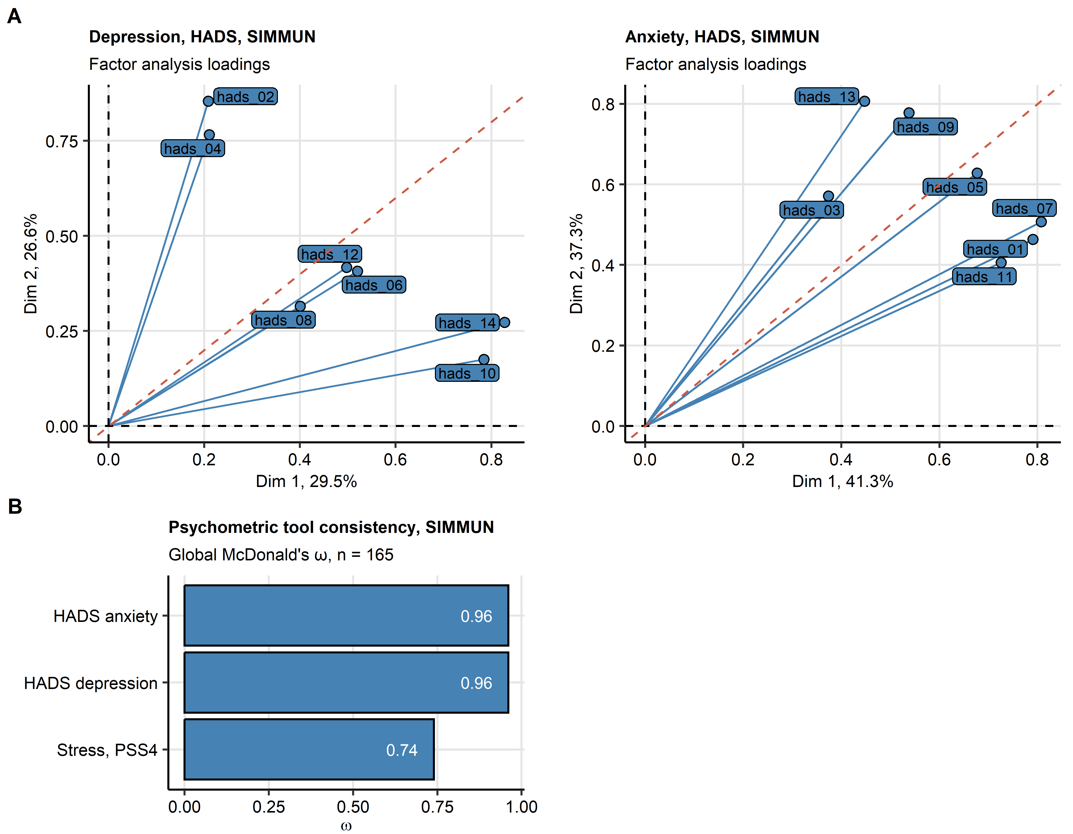P

Figure 1: Consistency of the PSS-4 score for mental stress HADS depression and HADS anxiety psychometric tools in the SIMMUN cohort.

**Supplementary Figure S1. Consistency of the PSS-4 stress HADS depression and HADS anxiety psychometric tools in the SIMMUN cohort.**

*(A) Assessment of tau-equivalence of the HADS (hospital anxiety and depression scale) depression and anxiety tool by three-dimensional factor analysis. Loadings for the first two major factors are presented. Each point represents a single HADS item. Percentages of total dataset variance associated with the factors are indicated in the plot axes. Note: tau equivalence implicates equal loadings of each HADS items for all factors. In case of tau equivalence, proximity of the items to the diagonal of the plot (orange dashed line) is expected.*

*(B) Consistency of the HADS depression, HADS anxiety and PSS-4 (perceived stress scale, 4 item) psychometric tools determined by McDonald’s metric.*

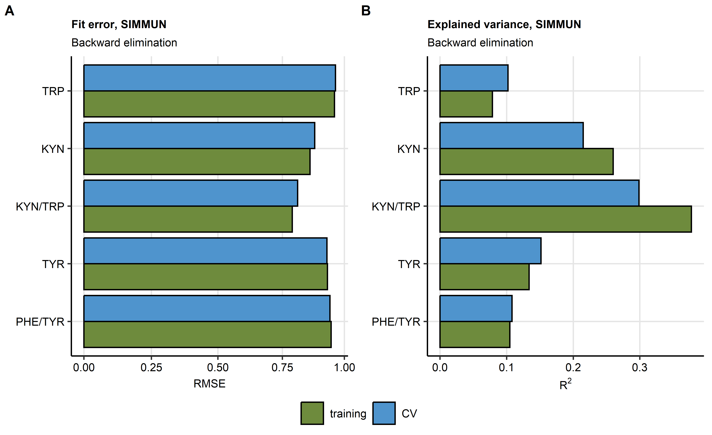

Figure 2: Root mean square error and R-squared statistics for multi-parameter linear models of tryptophan, tyrosine and their metabolites in the SIMMUN cohort.

**Supplementary Figure S2. Root mean square error and R-squared statistics for multi-parameter linear models of tryptophan, tyrosine and their metabolites in the SIMMUN cohort.**

*Multi-parameter linear regression models of plasma levels of tryptophan (TRP), kynurenine (KYN), kynurenine/tryptophan ratio (KYN/TRP), phenylalanine (PHE), tyrosine (TYR) and phenylalanine/tyrosine ratio (PHE/TRP) in the SIMMUN models were optimized by backwards elimination and their reproducibility was tested by cross-validation (CV, 10 folds). Values of root mean square error (RMSE, A) and (B) in the training data set and CV are plotted.*

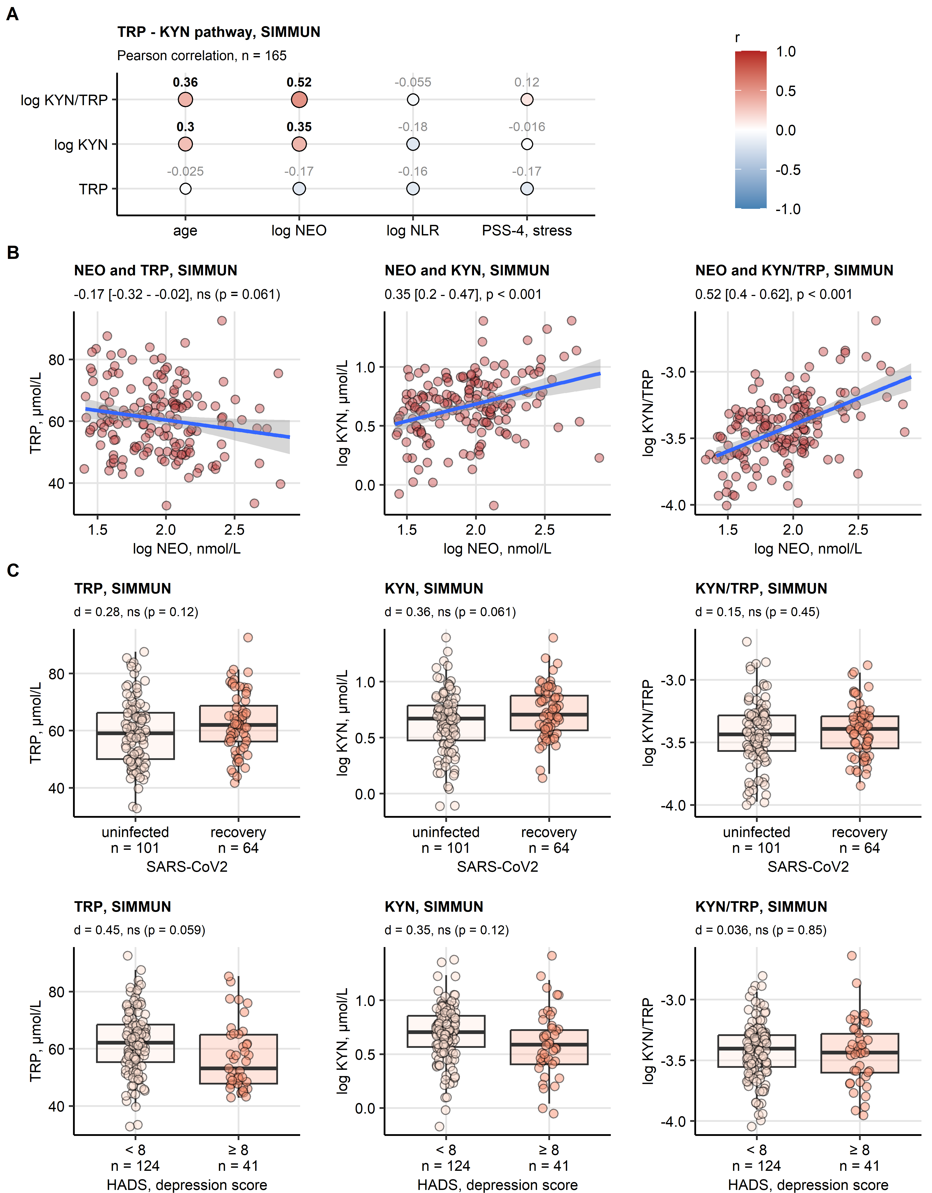

Figure 3: Effects of age, serum inflammatory markers neopterin and neutrophil-lymphocyte ratio, stress, depression and SARS-CoV-2 infection on tryptophan, kynurenine and kynurenine/tryptophan ratio in the SIMMUN cohort.

**Supplementary Figure S3. Effects of age, serum inflammatory markers neopterin and neutrophil-lymphocyte ratio, mental stress, depression and SARS-CoV-2 infection on tryptophan, kynurenine and kynurenine/tryptophan ratio in the SIMMUN cohort.**

*Age, systemic inflammatory markers: neopterin (NEO), neutrophil - lymphocyte ratio (NLR), SARS-CoV-2 infection status, clinically relevant symptoms of depression (hospital anxiety and depression scale [HADS] > 8 points) and mental stress scoring (perceived stress scale, 4 item [PSS-4]) were identified as significant determinants of systemic levels of tryptophan (TRP), kynurenine (KYN) and kynurenine - tryptophan ratio (KYN/TRP). Their association with plasma concentrations of these metabolites was investigated by univariable correlation analysis and statistical hypothesis testing.*

*(A, B) Correlation of the metabolite levels and the numeric explanatory factors of interest was assessed by Pearson’s test corrected for multiple testing by the false discovery rate method. (A) Correlation coefficients are presented in a bubble plot with point size and color corresponding to values of correlation coefficients (r); points are labeled with their r values, significant effects are highlighted in bold. (B) Scatter plots of plasma concentrations of NEO, TRP, KYN and KYN/TRP. Points represent single observations, fitted linear trends with 95% confidence intervals are visualized as blue lines with gray ribbons. Correlation coefficients with 95% confidence intervals and p values are displayed in the plot captions.*

*(C) Levels of the metabolite levels were compared between infected and uninfected participants, and between participants with and without clinically relevant symptoms of depression by two-tailed T test with Cohen’s d effect size statistic. P values were corrected for multiple testing with the false discovery rate method. Medians with interquartile ranges (IQR) are represented by boxes, whiskers span over 150% IQR, single observations are depicted as points. Effect sizes and p values are displayed in the plot captions. Numbers of observations are indicated in the X axes.*

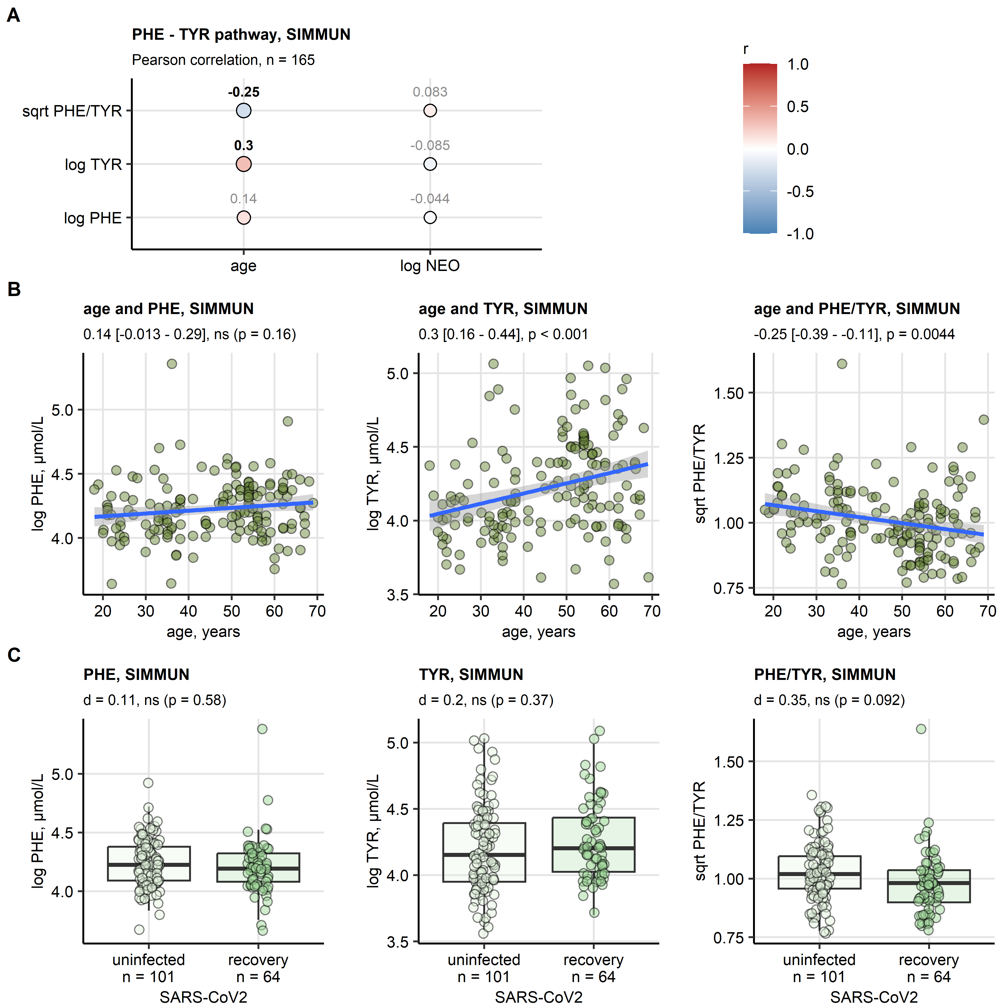

Figure 4: Effects of age, serum inflammatory marker neopterin and SARS-CoV-2 infection on phenylalanine, tyrosine and phenylalanine/tyrosine ratio in the SIMMUN cohort.

**Supplementary Figure S4. Effects of age, serum inflammatory marker neopterin and SARS-CoV-2 infection on phenylalanine, tyrosine and phenylalanine/tyrosine ratio in the SIMMUN cohort.**

*Age, the systemic inflammatory marker neopterin (NEO), and SARS-CoV-2 infection status were identified as significant determinants of systemic levels of phenylalanine (PHE), tyrosine (TYR) and phenylalanine - tyrosine ratio (PHE/TYR). Their association with plasma concentrations of these metabolites was investigated by univariable correlation analysis and statistical hypothesis testing.*

*(A, B) Correlation of the metabolite levels and the numeric explanatory factors of interest was assessed by Pearson’s test corrected for multiple testing by the false discovery rate method. (A) Correlation coefficients are presented in a bubble plot with point size and color corresponding to values of correlation coefficients (r); points are labeled with their r values, significant effects are highlighted in bold. (B) Scatter plots of patient’s age, PHE, TYR and PHE/TYR. Points represent single observations, fitted linear trends with 95% confidence intervals are visualized as blue lines with gray ribbons. Correlation coefficients with 95% confidence intervals and p values are displayed in the plot captions.*

*(C) Levels of the metabolite levels were compared between infected and uninfected participants by two-tailed T test with Cohen’s d effect size statistic. P values were corrected for multiple testing with the false discovery rate method. Medians with interquartile ranges (IQR) are represented by boxes, whiskers span over 150% IQR, single observations are depicted as points. Effect sizes and p values are displayed in the plot captions. Numbers of observations are indicated in the X axes.*

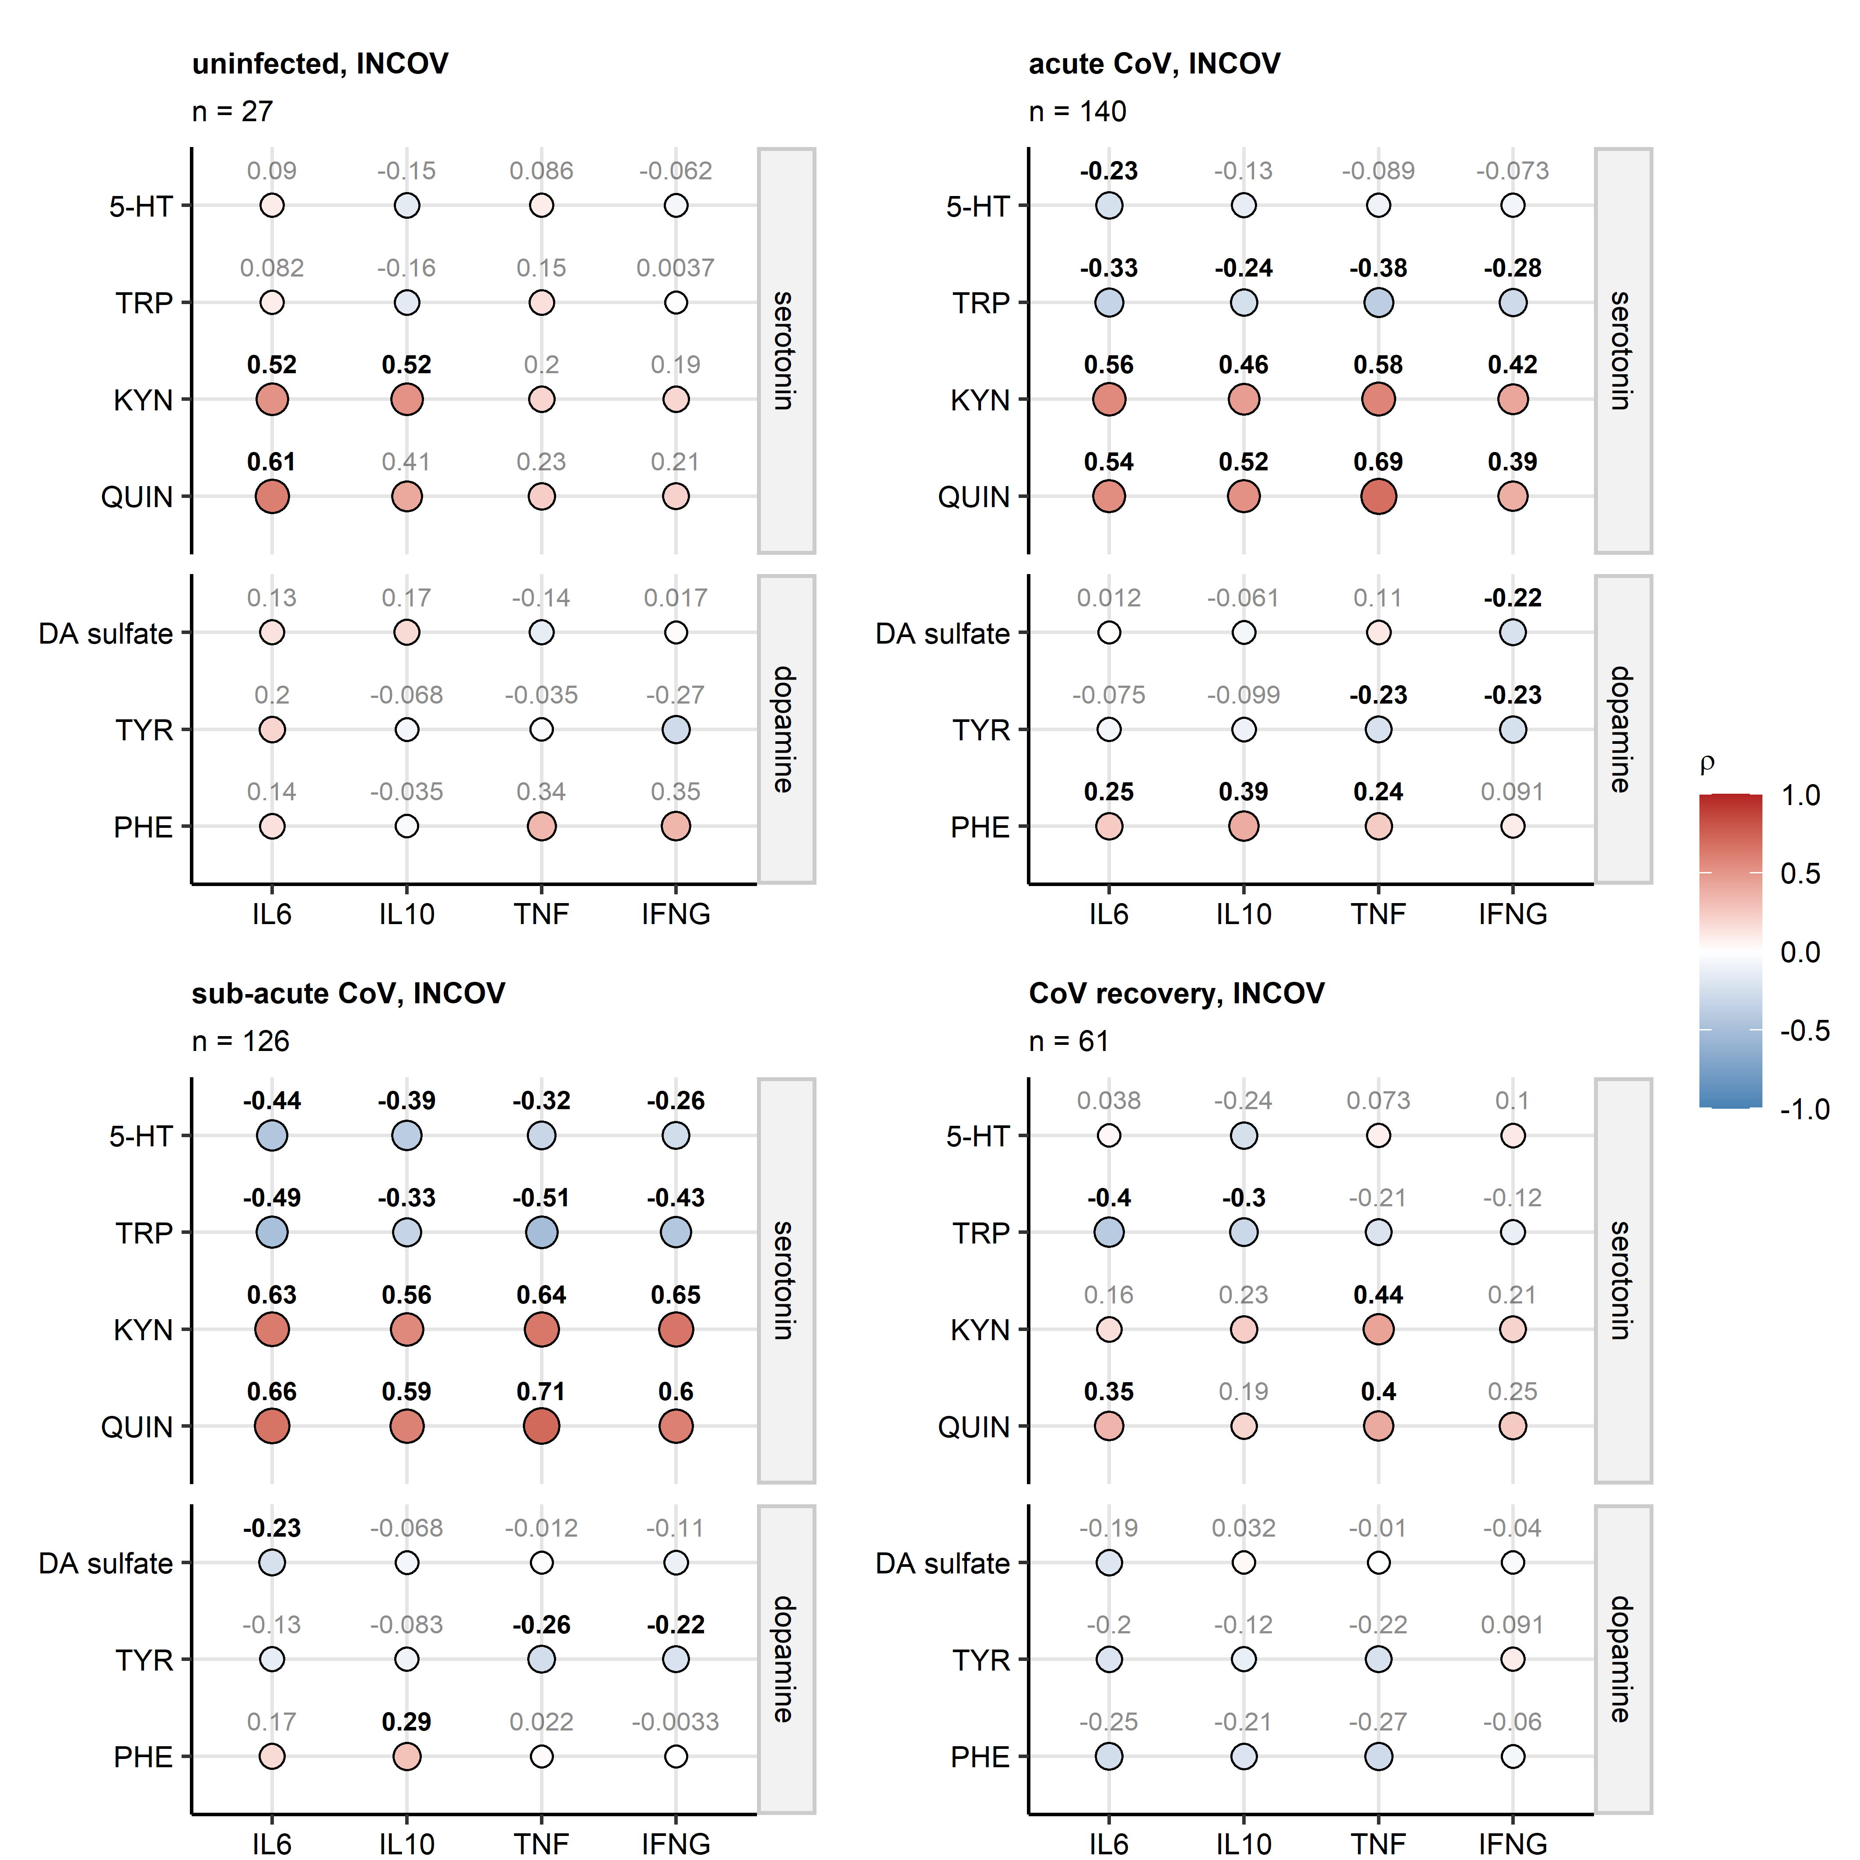

Figure 5: Correlation of metabolites with cytokine markers of inflammation in the INCOV cohort.

**Supplementary Figure S5. Correlation of metabolites with cytokine markers of inflammation in the INCOV cohort.**

*Plasma levels of metabolites implicated in serotonin biosynthesis and the serotonin biosynthesis competitor kynurenine pathway (5-hydroxy tryptamine/serotonin [5-HT], tryptophan [TRP], kynurenine [KYN], quinolinate [QUIN]) and metabolites related to dopamine metabolism (phenylalanine [PHE], tyrosine [TYR], dopamine 3-O-sulfate [DA sulfate]) were correlated with plasma levels of inflammatory cytokine markers (interleukin-6 [IL6], interleukin-10 [IL10], tumor necrosis factor-alpha [TNF] and interferon-gamma [IFNG]) in uninfected individuals, and during acute (median 10 days), sub-acute (median 14 days) SARS-CoV-2 infection and recovery (median 64 days after SARS-CoV-2 infection diagnosis via PCR). Statistical significance was determined by Spearman’s rank test corrected for multiple testing with the false discovery rate method. Correlation coefficients are presented in bubble plots with point size and color corresponding to values of correlation coefficients; points are labeled with their values, significant effects are highlighted in bold.*

# References

1. R Core Team, Bivand R, Carey VJ, DebRoy S, Eglen S, Guha R, Herbrandt S, Lewin-Koh N, Myatt M, Nelson M, et al. foreign: Read Data Stored by ’Minitab’, ’S’, ’SAS’, ’SPSS’, ’Stata’, ’Systat’, ’Weka’, ’dBase’, ... (2022) <https://cran.r-project.org/web/packages/foreign/index.html>

2. Wickham H, Bryan J, Posit P, Kalicinski M, Komarov V, Leitienne C, Colbert B, Hoerl D, Miller E. readxl: Read Excel Files. (2022) <https://cran.r-project.org/web/packages/readxl/index.html>

3. Wickham H, Averick M, Bryan J, Chang W, McGowan L, François R, Grolemund G, Hayes A, Henry L, Hester J, et al. Welcome to the Tidyverse. *Journal of Open Source Software* (2019) 4:1686. doi: [10.21105/joss.01686](https://doi.org/10.21105/joss.01686)

4. Henry L, Wickham Hadley. rlang: Functions for Base Types and Core R and ’Tidyverse’ Features. (2022) <https://cran.r-project.org/web/packages/rlang/index.html>

5. Gagolewski M, Tartanus B. Package ’stringi’. (2021) <https://cran.r-project.org/web/packages/stringi/index.html http://cran.ism.ac.jp/web/packages/stringi/stringi.pdf>

6. Kassambara A. rstatix: Pipe-Friendly Framework for Basic Statistical Tests. (2021) <https://cran.r-project.org/package=rstatix>

7. Ripley B. MASS: Support Functions and Datasets for Venables and Ripley’s MASS. (2022) <https://cran.r-project.org/package=MASS>

8. Kuhn M. Building predictive models in R using the caret package. *Journal of Statistical Software* (2008) 28:1–26. doi: [10.18637/jss.v028.i05](https://doi.org/10.18637/jss.v028.i05)

9. Csardi G, Nepusz T. The igraph software package for complex network research. *InterJournal* (2006) Complex Sy:1695. [https://igraph.org](https://igraph.org/)

10. Revelle W. Package ’psych’ - Procedures for Psychological, Psychometric and Personality Research. *R Package* (2015)1–358. <https://cran.r-project.org/web/packages/psych/index.html http://personality-project.org/r/psych-manual.pdf>

11. Wickham Hadley. *ggplot2: Elegant Graphics for Data Analysis*. 1st ed. New York: Springer-Verlag (2016). [https://ggplot2.tidyverse.org](https://ggplot2.tidyverse.org/)

12. Briatte F, Bojanowski M, Canouil M, Charlop-Powers Z, Fisher JC, Johnson K, Rinker T. ggnetwork: Geometries to Plot Networks with ’ggplot2’. (2021) <https://cran.r-project.org/package=ggnetwork>

13. Wilke CO. *Fundamentals of Data Visualization: A Primer on Making Informative and Compelling Figures*. 1st ed. Sebastopol: O’Reilly Media (2019).

14. Gohel D. flextable: Functions for Tabular Reporting. (2022) <https://cran.r-project.org/web/packages/flextable/index.html>

15. Allaire J, Xie Y, McPherson J, Luraschi J, Ushey K, Atkins A, Wickham H, Cheng J. rmarkdown: Dynamic Documents for R. (2022) <https://cran.r-project.org/web/packages/rmarkdown/index.html>

16. Xie Y. knitr: A General-Purpose Package for Dynamic Report Generation in R. (2022) <https://cran.r-project.org/web/packages/knitr/index.html>

17. Xie Y. *Bookdown: Authoring books and technical documents with R Markdown*. (2016). doi: [10.1201/9781315204963](https://doi.org/10.1201/9781315204963)

18. Widner B, Werner ER, Schennach H, Wachter H, Fuchs D. Simultaneous measurement of serum tryptophan and kynurenine by HPLC. *Clinical Chemistry* (1997) 43:2424–2426. doi: [10.1093/CLINCHEM/43.12.2424](https://doi.org/10.1093/CLINCHEM/43.12.2424)

19. Neurauter G, Schrocksnadel K, Scholl-Burgi S, Sperner-Unterweger B, Schubert C, Ledochowski M, Fuchs D. Chronic immune stimulation correlates with reduced phenylalanine turnover. *Current drug metabolism* (2008) 9:622–627. doi: [10.2174/138920008785821738](https://doi.org/10.2174/138920008785821738)

20. Capuron L, Schroecksnadel S, Féart C, Aubert A, Higueret D, Barberger-Gateau P, Layé S, Fuchs D. Chronic low-grade inflammation in elderly persons is associated with altered tryptophan and tyrosine metabolism: role in neuropsychiatric symptoms. *Biological psychiatry* (2011) 70:175–182. doi: [10.1016/J.BIOPSYCH.2010.12.006](https://doi.org/10.1016/J.BIOPSYCH.2010.12.006)

21. Deisenhammer F, Bauer A, Kavelar C, Rudzki D, Rössler A, Kimpel J, Borena W, Reindl M. 12-month SARS-CoV-2 antibody persistency in a Tyrolean COVID-19 cohort. *Wiener klinische Wochenschrift* (2021) 133:1265–1271. doi: [10.1007/S00508-021-01985-X](https://doi.org/10.1007/S00508-021-01985-X)

22. Cohen S, Kamarck T, Mermelstein R. A global measure of perceived stress. *Journal of health and social behavior* (1983) 24:385–396. doi: [10.2307/2136404](https://doi.org/10.2307/2136404)

23. Zigmond AS, Snaith RP. The hospital anxiety and depression scale. *Acta psychiatrica Scandinavica* (1983) 67:361–370. doi: [10.1111/J.1600-0447.1983.TB09716.X](https://doi.org/10.1111/J.1600-0447.1983.TB09716.X)

24. Bjelland I, Dahl AA, Haug TT, Neckelmann D. The validity of the Hospital Anxiety and Depression Scale: An updated literature review. *Journal of Psychosomatic Research* (2002) 52:69–77. doi: [10.1016/S0022-3999(01)00296-3](https://doi.org/10.1016/S0022-3999(01)00296-3)

25. McDonald RP. *Test theory: A unified treatment*. 1st Editio. New Yor: Psychology Press (1999). doi: [10.4324/9781410601087](https://doi.org/10.4324/9781410601087)

26. Su Y, Yuan D, Chen DG, Ng RH, Wang K, Choi J, Li S, Hong S, Zhang R, Xie J, et al. Multiple early factors anticipate post-acute COVID-19 sequelae. *Cell* (2022) 185:881–895.e20. doi: [10.1016/J.CELL.2022.01.014](https://doi.org/10.1016/J.CELL.2022.01.014)

27. Su Y, Chen D, Yuan D, Lausted C, Choi J, Dai CL, Voillet V, Duvvuri VR, Scherler K, Troisch P, et al. Multi-Omics Resolves a Sharp Disease-State Shift between Mild and Moderate COVID-19. *Cell* (2020) 183:1479. doi: [10.1016/J.CELL.2020.10.037](https://doi.org/10.1016/J.CELL.2020.10.037)

28. BARTLETT MS. THE STATISTICAL CONCEPTION OF MENTAL FACTORS. *British Journal of Psychology General Section* (1937) 28:97–104. doi: [10.1111/j.2044-8295.1937.tb00863.x](https://doi.org/10.1111/j.2044-8295.1937.tb00863.x)

29. Benjamini Y, Hochberg Y. Controlling the False Discovery Rate: A Practical and Powerful Approach to Multiple Testing. *Journal of the Royal Statistical Society: Series B (Methodological)* (1995) 57:289–300. doi: [10.1111/j.2517-6161.1995.tb02031.x](https://doi.org/10.1111/j.2517-6161.1995.tb02031.x)

30. Cohen J. Statistical Power Analysis for the Behavioral Sciences. *Statistical Power Analysis for the Behavioral Sciences* (2013) doi: [10.4324/9780203771587](https://doi.org/10.4324/9780203771587)

31. Holck A, Wolkowitz OM, Mellon SH, Reus VI, Nelson JC, Westrin Å, Lindqvist D. Plasma serotonin levels are associated with antidepressant response to SSRIs. *Journal of affective disorders* (2019) 250:65–70. doi: [10.1016/J.JAD.2019.02.063](https://doi.org/10.1016/J.JAD.2019.02.063)

32. Tateishi H, Setoyama D, Kang D, Matsushima J, Kojima R, Fujii Y, Mawatari S, Kikuchi J, Sakemura Y, Fukuchi J, et al. The changes in kynurenine metabolites induced by rTMS in treatment-resistant depression: A pilot study. *Journal of psychiatric research* (2021) 138:194–199. doi: [10.1016/J.JPSYCHIRES.2021.04.009](https://doi.org/10.1016/J.JPSYCHIRES.2021.04.009)

33. Sun Y, Drevets W, Turecki G, Li QS. The relationship between plasma serotonin and kynurenine pathway metabolite levels and the treatment response to escitalopram and desvenlafaxine. *Brain, Behavior, and Immunity* (2020) 87:404–412. doi: [10.1016/J.BBI.2020.01.011](https://doi.org/10.1016/J.BBI.2020.01.011)

34. Kheirouri S, Kalejahi P, Noorazar SG. Plasma levels of serotonin, gastrointestinal symptoms,and sleep problems in children with autism. *Turkish journal of medical sciences* (2016) 46:1765–1772. doi: [10.3906/SAG-1507-68](https://doi.org/10.3906/SAG-1507-68)

35. Paul-Savoie É, Potvin S, Daigle K, Normand E, Corbin JF, Gagnon R, Marchand S. A deficit in peripheral serotonin levels in major depressive disorder but not in chronic widespread pain. *The Clinical journal of pain* (2011) 27:529–534. doi: [10.1097/AJP.0B013E31820DFEDE](https://doi.org/10.1097/AJP.0B013E31820DFEDE)

36. Ertugrul A, Ucar G, Basar K, Demir B, Yabanoglu S, Ulug B. Influence of clozapine on platelet serotonin, monoamine oxidase and plasma serotonin levels. *Psychiatry research* (2007) 149:49–57. doi: [10.1016/J.PSYCHRES.2005.12.009](https://doi.org/10.1016/J.PSYCHRES.2005.12.009)

37. Goldstein DS, Swoboda KJ, Miles JM, Coppack SW, Aneman A, Holmes C, Lamensdorf I, Eisenhofer G. Sources and physiological significance of plasma dopamine sulfate. *The Journal of clinical endocrinology and metabolism* (1999) 84:2523–2531. doi: [10.1210/JCEM.84.7.5864](https://doi.org/10.1210/JCEM.84.7.5864)

38. Meiser J, Weindl D, Hiller K. Complexity of dopamine metabolism. *Cell Communication and Signaling* (2013) 11:1–18. doi: [10.1186/1478-811X-11-34/FIGURES/5](https://doi.org/10.1186/1478-811X-11-34/FIGURES/5)

39. Huber PJ. Robust Statistics. *International Encyclopedia of Statistical Science* (2011)1248–1251. doi: [10.1007/978-3-642-04898-2_594](https://doi.org/10.1007/978-3-642-04898-2_594)