Inflammation, SARS-CoV-2 infection and mental health disorders impact on systemic levels of aminoacid neurotransmitter precursors

Manuscript

2023-05-18

# Keywords

SARS-CoV-2, inflammation, serotonin, dopamine, tryptophan, kynurenine, mental health

# Abstract

**Background:** Serotonin and dopamine metabolism poses a junction of mental and somatic health. We aimed to identify demographic, clinical, mental health- and SARS-CoV-2 infection-related factors affecting systemic serotonin and dopamine turnover.

**Methods:** The cross-sectional SIMMUN (n = 165, Austria) and longitudinal INCOV cohort (n = 167, Su et al. 2022) were investigated. Explanatory variables encompassed age, sex, clinical and inflammatory parameters, SARS-CoV-2 infection, and anxiety, depression (HADS) and mental stress scoring (PSS-4). Their effects on plasma concentrations of serotonin (serotonin, tryptophan, kynurenine) and dopamine availability markers (dopamine sulfate, phenylalanine, tyrosine) were assessed by linear modeling, correlation analysis and two-tailed T tests.

**Results:** In the SIMMUN collective, the inflammatory marker neopterin, SARS-CoV-2 infection, age, depression symptoms and mental stress independently stimulated catabolism of the serotonin precursor tryptophan to kynurenine. Inflammation and age were also suppressed the first step of dopamine biosynthesis, phenylalanine - tyrosine conversion. In the INCOV cohort, inflammation was associated with lowered serotonin (IL6: = -0.24 [95% CI: -0.4 to -0.089]) and the dopamine metabolite, dopamine sulfate (interferon-gamma: = -0.13 [95% CI: -0.24 to -0.014]). Serotonin correlated with tryptophan levels, especially in acute and sub-acute infection. Serotonin ( = 0.72 [95% CI: 0.3 to 1.1]) and dopamine sulfate ( = 0.64 [95% CI: 0.28 to 1]) were significantly increased during SARS-CoV-2 infection recovery.

**Conclusion:** Inflammation limits systemic serotonin and dopamine by activating the competitor kynurenine pathway and inhibiting the phenylalanine - tyrosine conversion, respectively, and may link SARS-CoV-2 infection with mental health problems. Advanced age and mental disorders can additionally suppress neurotransmitter synthesis.

# Introduction

*Katharina, Sophia: your part*

The impact of persistent and SARS-CoV-2-related inflammation and immunity, SARS-CoV-2 recovery on indolamine and katecholamine neurotransmitter metabolism as well as its mutual interaction with mental disorder symptoms are still incompletely resolved. To address that, we explored effects of demographic and clinical factors, inflammation, SARS-CoV-2 infection, anti-SARS-CoV-2 humoral response and mental disorders on the tryptophan - kynurenine and phenylalanine axes as readouts of systemic availability of serotonin and dopamine in the SIMMUN cohort, a cross-sectional medical service user collective. Furthermore, association of circulating serotonin (1–4) and of the major dopamine decay product, dopamine 3-O-sulfate (5–7) with systemic levels of inflammatory cytokines, SARS-CoV-2 course, age and availability of biosynthesis precursors and competition pathway metabolites were investigated in the published longitudinal INCOV collective (8).

# Materials and Methods

## Ethics statement

The SIMMUN study was conducted in accordance with the Declaration of Helsinki and European Data Policy. All participants gave written informed consent prior to enrollment. Participants’ data were stored and analyzed in anonymized form. This study was approved by the ethics committee of the Medical University Innsbruck, Austria (approval number: 1132/2020). No approval by the ethics committee was required for analysis of the published INCOV data set (8).

## Study cohorts

Details on study cohorts, procedures and analses are provided in **Supplementary Methods**.

### SIMMUN study

Individuals tested for SARS-CoV-2 via PCR at the University Hospital of Innsbruck and patients of the University Clinic for Psychiatry I and II (Innsbruck, Austria) undergoing routine SARS-CoV-2 PCR were invited to participate in the SIMMUN study. The study was conducted between 10. June 2020 and 27.May 2021. The inclusion criteria were age of 18 - 70 years, proficiency in German, residence in the study region (Tyrol, Austria), and a SARS-CoV-2 PCR test conducted at the study site. The exclusion criteria were active SARS-CoV-2 infection (< 14 days after diagnosis), pregnancy, active malignancy, organ transplantation, surgery in the past 3 months, inflammatory illness and oral corticosteroid treatment. The analysis inclusion criterion was the complete study variable dataset (**Figure 1**, **Supplementary Table S1**). Significant differences between the analyzed and excluded participants are listed in **Supplementary Table S2**.

### INCOV study

Proteome and metabolome data and clinical information for the INCOV cohort were extracted from supplementary tables accompanying the report by Su and colleagues (8). In the current analysis, samples obtained for individuals with the complete age information and complete study variable dataset (**Figure 1**, **Table 2**, **Supplementary Table S3**).

## Procedures

### SIMMUN study

The SIMMUN study data were gathered during in-person visits including a physician assessment, supervised completion of self-rating questionnaire and a blood sample collection (**Supplementary Table S1**).

Demographic and clinical variables: age, sex, body mass index, professionally diagnosed mental illness, self-reported chronic somatic conditions, smoking and alcohol consumption, result and date of the SARS-CoV-2 PCR test were surveyed during the study visit or extracted from electronic patient records.

Inflammatory markers: plasma neopterin concentrations (NEO) and neutrophil - lymphocyte ratio (NLR) were determined by the certified clinical routine laboratory at the University Hospital of Innsbruck. Plasma concentrations of tryptophan (TRP), kynurenine (KYN), phenylalanine (PHE) and tyrosine (TYR) were determined by high-performance liquid chromatography, and the KYN/TRP and PHE/TYR ratios calculated (9–11). Plasma titer of immunoglobulin gamma against receptor binding domain S1/S2 protein (anti-RBD IgG) were quantified by ELISA (12). Laboratory measurements at and beyond the detection limits were substituted with the lower or upper detection limit value, respectively.

Mental stress was scored with the 4-item perceived stress scale (PSS-4) (13). Anxiety and depression signs were scored with the hospital anxiety and depression scale (HADS) including 7 items for anxiety and 7 items for depression (14). The total possible score range for each subscale is 0 to 21, with higher scores indicating more intense symptoms of anxiety/depression. Clinically relevant signs of anxiety or depression were identified with the cutoff of 8 points (14,15).

In order to improve normality of some numeric study variables prior to linear modeling and statistical hypothesis testing with parametric tools, logarithm or square root transformations were applied (**Supplementary Table S1**)

### INCOV cohort

Plasma proteomes and metabolomes in the INCOV cohort were measured by proximity extension assay (Olink, Sweden) and ultra-high-performance liquid chromatography/tandem accurate mass spectrometry (Metabolon, USA) (8,16). Normalized, age- and sex-adjusted, log2-transformed plasma concentrations of metabolites and cytokines, and clinical information were extracted from [supplementary tables](https://data.mendeley.com/datasets/96v329bg7g/1) of the report by Su et al. (8). Plasma levels of metabolites implicated in systemic turnover of serotonin (serotonin, TRP, KYN, quinolinate [QUIN]) and dopamine (PHE, TYR and dopamine 3-O-sulfate [DA sulfate]), major inflammatory cytokines (interleukin-6 [IL6], interleukin-10 [IL10], tumor necrosis factor-alpha [TNF] and interferon-gamma [IFNG]) and age were analyzed (**Supplementary Table S3**).

Plasma features were sampled in uninfected controls and SARS-CoV-2 individuals at three timepoints after diagnosis: acute (median: 10 days), sub-acute (median: 14) and recovery (median: 64 after diagnosis) (**Supplementary Table S3**).

## Study endpoints

Our analysis pursued two endpoints. The first endpoint was to determine demographic, clinical, psychometric, inflammation- and SARS-CoV-2-related factors influencing plasma levels of serotonin and dopamine precursors and products of competitor metabolic pathways (TRP, KYN, KYN/TRP, PHE, TYR, PHE/TYR). This endpoint was addressed by multi-parameter modeling in the SIMMUN cohort. The second endpoint was to investigate how the readouts of systemic serotonin and dopamine availability, plasma serotonin (1–4) and DA sulfate (5–7), are influenced by age, inflammatory cytokines, timepoint of the SARS-CoV-2 infection, their precursors (TRP, PHE, TYR) and competitor pathway products (KYN, QUIN). This endpoint was addressed by multi-parameter robust linear modeling, time course modeling and correlation analysis in the INCOV cohort (**Figure 1**).

## Statistical analysis

R version 4.2.3 was used for statistical analysis.

Numeric variables were presented as medians with interquartile ranges and ranges. Categorical variables are presented as percentages and counts within the complete observation set. Distribution normality and variance homogeneity was assessed by Shapiro-Wilk and Levene test, respectively. In the SIMMUN cohort, non-normally distributed numeric variables were transformed with the logarithm or square root prior to modeling and analyses with parametric tests (**Supplementary Table S1**). Since most of the INCOV study variables were non-normally distributed, robust linear modeling and non-parametric testing were employed. Since the tau-equivalence assumption investigated by factor analysis for the HADS scales was violated, consistency of psychometric tools was investigated by global McDonald’s (17–19). Except for multi-parameter modeling, p values were corrected for multiple testing with the false discovery rate method (20) separately for each analysis task. Effects with p < 0.05 were considered significant.

Correlation was assessed by Spearman’s rank or Pearson test. Significance of comparisons of numeric variables between two groups was determined by Mann-Whitney test with r effect size statistic or by two-tailed T test with Cohen’s d effect size metric. Comparisons of categorical variable distributions were evaluated by test with Cramer V effect size statistic. Correlation was assessed by Pearson’s or Spearman’s rank test (21,22).

In the SIMMUN cohort, effects of age, sex, body mass class, somatic and metal conditions, body mass class, smoking and alcohol consumption history, the inflammation markers NEO and NLR, SARS-CoV-2 infection status, anti-RBD IgG titer, signs of depression and anxiety (HADS), mental stress scoring (PSS-4) on systemic levels of aminoacid neurotransmitter precursor and competitor pathway products (TRP, KYN, KYN/TRP ratio, PHE, TYR and PHE/TYR ratio) was assessed by multi-parameter linear regression with backward elimination. Modeling responses and explanatory variables were subjected to normality-stabilizing transformations (**Supplementary Table S1**) and normalized prior to modeling in the SIMMUN cohort. Normality and homogeneity of linear model residuals were evaluated by Shapiro-Wilk and Levene test, respectively, and visual inspection (residuals versus fitted and quantile-quantile plots). In the INCOV cohort, effects of age, plasma levels of inflammatory cytokines (IL6, IL10, TNF, IFNG), timepoint of SARS-CoV-2 infection (acute, sub-acute, recovery versus uninfected control) and plasma levels of neurotransmitter precursors and competitor pathway products (TRP, KYN, QUIN, PHE, TYR) on plasma serotonin and DA sulfate were modeled by multi-parameter robust linear regression with the MM algorithm and Huber psi function (23,24). Reproducibility and proper parameterization of the multi-parameter linear and robust models was investigated by RMSE and statistics in 10-fold cross-validation (25). Significance of the model estimates was assessed by two-tailed T test.

Differences in cytokines and metabolites between uninfected controls, acute and sub-acute SARS-CoV-2 infection and recovery in the INCOV collective were investigated by robust linear modeling (MM algorithm, Huber’s psi function) with uninfected subset or acute infection serving as baselines.

Pairwise Spearman’s correlation coefficients were calculated for cytokines and metabolites in the INCOV cohort. The correlation matrices were subsequently scaled into the [0, 1] range and converted to undirected force directed graphs (26). The graphs were visualized as two-dimensional network plots with the node proximity determined by the value and distance-dependent repulsion, and edge color and width coding for the value and sign (27).

# Results

## Characteristic of the study cohorts

Herein, two collectives of uninfected controls and COVID-19 convalescents were analyzed. The SIMMUN cohort, included adult healthy individuals, patients of the University Hospital of Innsbruck and patients of the local psychiatry clinic (Innsbruck, Austria), who underwent routine SARS-CoV-2 PCR screening at the study site between June 2020 and May 2021. Out of 215 individuals enrolled, 165 SIMMUN participants with a study variable dataset were analyzed (**Figure 1**, **Supplementary Table S1**). The excluded individuals were characterized by more frequent psychiatric conditions, depression and anxiety signs, elevated mental stress scoring and less frequent SARS-CoV-2 infections as compared with the analyzed participants (**Supplementary Table S2**). SARS-CoV-2-positive individuals accounted for 39% of the SIMMUN cohort. None of the participants had received anti-SARS-CoV-2 vaccination prior to enrollment. Males represented 38% of the cohort and the median age was 50 years. The gender and age structure of the SARS-CoV-2-negative and -positive subsets was comparable. Roughly half of participants were overweight or obese and suffered from somatic comorbidities; these figures were similar for SARS-CoV-2-negative and -positive individuals. The psychiatric conditions affected 41% of the SIMMUN collective and were more significantly more common in SARS-CoV-2-negative participants. Signs of depression and anxiety, and intensity of mental stress were gauged with the HADS depression, HADS anxiety and PSS-4 tools, respectively (13,14). The psychometric tools displayed good-to-excellent internal consistency ( = 0.74 - 0.96) (17) (**Supplementary Figure S1**). Percentages of clinically relevant anxiety signs (HADS 8) (14,15) were significantly higher in the uninfected subset. Depression signs tended to be more common in SASR-CoV-2-negative participants; scores of mental stress were comparable in both SARS-CoV-2 strata. As expected, titer of antibodies against the S1/S2 SARS-CoV-2 pathogen (anti-RBD IgG) was significantly higher in the convalescent subset. In 73% of SARS-CoV-2-infected SIMMUN study participants, the infection was mild and ambulatory (**Table 1**). In the SIMMUN study, inflammatory markers and metabolites were recorded at a single timepoint. The median SARS-CoV-2 test - sampling interval was 138.5 days (IQR: 119 - 157.25).

The analyzed subset of the genuine INCOV cohort (8,16) encompassed participants with complete age information, serotonin- and dopamine-related metabolites and major inflammatory cytokines (**Figure 1**, **Supplementary Table S3**). The metabolites and cytokines were sampled in uninfected individuals and at three timepoints of SARS-CoV-2 infection: acute (median 10 days), sub-acute (median 14 days) and recovery (median 64 days after diagnosis) (**Supplementary Table S4**). Out of 645 initially enrolled participants, 167 individuals with 354 samples were included in the analyzed INCOV subset (**Figure 1**). SARS-CoV-2-positive individuals comprised 84% of the analyzed INCOV collective. Males constituted 56% of participants, the median age was 60 years. SARS-CoV-2-positive participants were significantly older than the uninfected subset. Shares of overweight or obese individuals tended to be higher in the SARS-COV-2 group. Nearly all (97%) of SARS-CoV-2-positive INCOV individuals were hospitalized due to a moderate-to-critical infection (**Table 2**).

As compared with the SIMMUN collective, INCOV study participants were characterized by a significantly higher percentages of males, more advanced age, elevated rates of overweight or obesity, higher share of SARS-CoV-2 cases and more severe infection course (**Supplementary Table S5**).

## Inflammation, SARS-CoV-2 infection, age, mental stress and depression influence systemic levels of neutrotransmitter precursors

In an initial search for predictors of neurotransmitter turnover, we modeled plasma TRP, KYN and KYN/TRP as readouts of systemic serotonin (2,9), and PHE, TYR and PHE/TYR as markers of dopamine availability (5,11) in the INCOV collective. The candidate explanatory variables were age, sex, body mass, somatic and mental conditions, alcohol and tobacco consumption, SARS-CoV-2 infection recovery, anti-SARS-CoV-2 antibody titer, NEO and NLR as inflammatory markers, as well as mental stress, depression and anxiety signs (**Supplementary Table S1**).

Full multi-parameter linear models were optimized by backwards elimination of non-significant terms (24) (**Supplementary Table S6**). Meaningful models could be established for TRP, KYN, KYN/TRP, TYR and PHE/TYR. The PHE model had a negligible explanatory performance, proved non-significant as compared with the intercept-only null model and was hence not further analyzed. The remaining models were characterized by good reproducibility and proper parameterization as indicated by comparable fit errors in the genuine dataset and cross-validation. The KYN and KYN/TRP ratio models had the best explanatory performance measured by cross-validated of 0.21 and 0.3, respectively. The TRP, TYR and PHE/TYR models could explain between 10% and 15% of the cross-validated response variances (, **Supplementary Figure S2**).

The inflammatory marker NEO and depression signs were independently associated with reduced plasma TRP. Increased KYN and KYN/TRP were significantly associated with SARS-CoV-2 infection, elevated NEO and age. Additionally, high mental stress was linked to increased KYN/TRP.  
Low NLR, in turn, was related to increased KYN (**Figure 2A**). Plasma TYR concentrations were negatively regulated by inflammation gauged by NEO and rose significantly with age. SARS-CoV infection and age were independently linked to lower PHE/TYR (**Figure 2B**).

In, univariable analysis of the INCOV dataset (**Supplementary Tables S7 - S8**), we could corroborate significant, positive, moderate-to-strong correlations of age and NEO with increased KYN and higher KYN/TRP (**Supplementary Figure S3**). Participant’s age was paralleled by elevated circulating TYR and lowered PHE/TYR in univariable correlation analysis (**Supplementary Figure S4**).

Collectively, in the SIMMUN cohort, systemic inflammation reflected by NEO, SARS-CoV-2 infection and age were the key factors, which possibly brake serotonin synthesis by depletion of its precursor TRP via the KYN pathway. This mechanism may be further perpetuated by signs of depression and mental stress. Age and SARS-CoV-2 infection are proposed as regulators of the dopamine precursors, PHE and TYR.

## Inflammatory cytokines, SARS-CoV-2 infection course, age and availability of biosynthesis precursors regulate systemic serotonine and dopamine turnover

Next, we validated the effects of inflammation, SARS-CoV-2 infection and age on serotonin and dopamine metabolism in the INCOV cohort (8). The outcome parameters in such analyses were plasma levels of serotonin (1–4), and DA sulfate, a the main circulating dopamine catabolite (5–7). The explanatory variables were age, infection timepoint, major inflammatory cytokines (IL6, IL10, TNG, IFNG), precursors and competitor metabolites of serotonin (TRP, KYN, QUIN), and precursors of dopamine (PHE, TYR) (**Supplementary Table S3**).

Multi-parameter robust regression models could explain 13% and 11% of cross-validated variance of serotonin and DA sulfate. Comparable model errors in the training dataset and cross-validation indicated good reproducibility and proper parameterization of the models (**Figure 3A**). In the INCOV collective, 4 predictors of plasma serotonin were identified. Age and IL6 was associated with significantly lower serotonin levels, whereas TRP and the SARS-CoV-2 recovery timepoint, i.e. 64 were predictors of increased serotonin. The SARS-CoV-2 recovery timepoint and TNF predicted higher DA sulfate levels, and IFNG was associated with a significantly decreased DA sulfate (**Figure 3**, **Supplementary Table S9**).

These findings were confirmed by time course modeling. The peak inflammatory cytokine levels during acute infection were paralleled by a significant decrease in the serotonin precursor TRP and upregulated TRP decay products KYN and QUIN (9). The inflammatory milieu of acute infection correlated with a significant rise in PHE, suggestive of an inhibited PHE - TYR conversion (11). In turn, resolution of systemic inflammation during sub-acute SARS-CoV-2 infection and recovery, was associated with significantly decreased KYN and QUIN, paralleled by elevated TRP and serotonin. This suggests re-routing of the TRP from IDO-mediated decay to the serotonin biosynthesis (9). Similarly, infection recovery was associated with significantly decreased PHE and elevated DA sulfate suggestive of an efficient PH - TYR conversion, dopamine synthesis and subsequent dopamine sulfonylation (5–7,11).

In correlation analysis, plasma serotonin TRP were negatively associated with inflammatory cytokines with at least moderate strength ( > 0.2) during acute and sub-acute infection. By contrast, the TRP decay products KYN and QUIN correlated positively with circulating IL6, IL10, TNF and IFNG. Serotonin levels correlated also TRP during acute and sub-acute infection with moderate effect size (acute: = 0.2, sub-acute: = 0.3). This may indicate that systemic availability of tryptophan may be particularly crucial for serotonin synthesis at the peak of the infection-related inflammation (**Figure 5A**). Concerning the dopamine turnover metabolites, moderate-to-strong positive correlations of PHE with inflammatory cytokines and negative association of TYR with inflammatory markers could be observed in acute and sub-acute infection. For these timepoints, moderate, negative correlation of IFNG and IL6 with plasma levels of DA sulfate were identified. This regulatory pattern of dopamine-related metabolite regulation during infection fits well into the proposed inhibition of PHE-TYR conversion and dopamine biosynthesis by inflammation (11).

In sum, the analyses of the longitudinal INCOV collective suggest the SARS-CoV-2-elicited inflammation bolsters the TRP catabolism via the KYN pathway and downregulates the PHE - TYR conversion, which may limit serotonin and dopamine formation during acute infection and early recovery.

# Discussion

With two cohorts consisting of uninfected and SARS-CoV-2-positive individuals, we explored the effects of demographic, clinical, psychometric, infection-, inflammation- and SARS-CoV-2-related factors on systemic turnover of serotonin and dopamine. Our results underline the pivotal role of SARS-CoV-2-dependent and -independent, e.g. chronic low grade inflammation on systemic availability of serotonin and dopamine. Furthermore, they put forward plasma TRP levels as a one of limiting factors for systemic serotonin biosynthesis during SARS-CoV-2 infection. Mechanistically, we corroborate the stimulatory effect of inflammation on IDO, which catalyzes the decay of TRP to KYN and hence suppresses serotonin synthesis by depletion of its precursor. Advanced age, mental stress and depression were proposed as infection-independent factors contributing to reduced TRP and, consequently, reduced serotonin formation. Our data suggest similar inhibitory effects of inflammation and age on PHE - TYR conversion, which is the initial step of dopamine formation.

*Points to discuss*

* Role of inflammation and SARS-CoV-2 in activity of the TRP -> KYN pathway and its implication for systemic serotonin synthesis
* Role of inflammation and SARS-CoV-2 in the PHE - TYR conversion and subsequent dopamine synthesis
* Effects of mental health-related factors on serotonin and dopamine availability, mutual relationship?
* Systemic turnover of serotonin and dopamine - is it relevant for the central nervous system? Pro and contra!

# Limitations

Our study has limitations. First, circulating serotonin, dopamine or any abundant dopamine metabolites (e.g. DA sulfate) (5–7), i.e. more direct readouts of neurotransmitter turnover, were not measured in the SIMMUN cohort. Additionally, the metabolite were measured in the SIMMUN cohort at a single time point with a highly variable infection - sampling time interval. This precluded time course analyses like those conducted in the INCOV cohort. For the INCOV collective, KYN/TRP and PHE/TYR could not be computed with normalized metabolome data, and measurements of stress, depression and anxiety were not available. This incompatibility of the datasets precluded development of comprehensive multi-parameter models in one of the cohorts and subsequent direct validation in the other. Second, relevance of circulating serotonin- and dopamine-related metabolites for the neurotransmitter metabolism in the central nervous system and mental health disorders is controversial, as discussed above. Third, the SIMMUN cohort suffered from a selection bias due to enrichment in psychiatric and hospital patients with a high rate of mental and somatic conditions. Hence, the SIMMUN collective is not representative for the entire pandemic population. Fourth, both the SIMMUN and INCOV cohorts were recruited during initial phases of the pandemic and do not include any (SIMMUN) or systematically vaccinated patients (INCOV). Similarly, the analyzed cohorts were exposed to wild-type-like SARS-CoV-2 variants and do not allow to assess effects of repeated, seasonal infections with highly transmissible but far less virulent omicron pathogens. For these reasons, studies with recent, real world post-pandemic collectives are urgently needed to validate our findings. Finally, the cross-sectional SIMMUN and INCOV cohorts encompassed uninfected controls and SARS-CoV-2 infections ranging from asymptomatic to critical disease. In particular, the shares of pathogen-positive individuals and the infection severity differed significantly between the analyzed collectives. The more severe infection in INCOV study participants can explain stronger effects of inflammation and infection recovery on the metabolites of interest that those observed in the SIMMUN collective.

# Conclusions

SARS-CoV-2-dependent and -independent inflammation can lower systemic availability of serotonin and dopamine by depletion of the tryptophan via the competitive kynurenine pathway and inhibition of the phenylalanine - tyrosine suppression, respectively. Those effects can be further amplified by advanced age, mental stress and depression.  
It remains to be investigated, if and how this mechanism may contribute to neurotransmitter metabolism in the central nervous system and, consequently, to mental disorders following SARS-CoV-2 infection.

# Acknowledgements

We thank all participants and patients for the participation in the study.

# Funding

The study was supported by the Science Fund of the Land Tirol (grant number GZ71134 to Katharina Hüfner).

# Data and code availability

Anonymized patient data will be made available upon request to the corresponding author. The INCOV cohort data are publicly available at <https://data.mendeley.com/datasets/96v329bg7g/1>. The analysis pipeline code is available at <https://github.com/PiotrTymoszuk/simmun>.

# Tables

Table 1: Characteristic of the local SIMMUN cohort. Numeric variables are presented as medians with interquartile ranges. Categorical variables are presented as percentages and counts within complete observation sets.

| **Variablea** | **Uninfected** | **SARS-CoV-2** | **Test** | **Significanceb** | **Effect size** |
| --- | --- | --- | --- | --- | --- |
| Participants, n | 101 | 64 |  |  |  |
| Sex | female: 64% (65) male: 36% (36) | female: 58% (37) male: 42% (27) | χ² | ns (p = 0.54) | V = 0.066 |
| Age, years | 50 [IQR: 35 - 58] range: 18 - 69 | 50 [IQR: 32 - 56] range: 20 - 68 | Mann-Whitney | ns (p = 0.45) | r = 0.069 |
| Body mass classc | normal: 53% (54) overweight: 32% (32) obesity: 15% (15) | normal: 53% (34) overweight: 27% (17) obesity: 20% (13) | χ² | ns (p = 0.6) | V = 0.079 |
| Somatic comorbidity | 54% (55) | 45% (29) | χ² | ns (p = 0.43) | V = 0.089 |
| Psychiatric comorbidity | 50% (50) | 28% (18) | χ² | p = 0.021 | V = 0.21 |
| HADS anxiety score | < 8: 57% (58) ≥ 8: 43% (43) | < 8: 80% (51) ≥ 8: 20% (13) | χ² | p = 0.013 | V = 0.23 |
| HADS depression score | < 8: 69% (70) ≥ 8: 31% (31) | < 8: 84% (54) ≥ 8: 16% (10) | χ² | ns (p = 0.078) | V = 0.17 |
| Depression or anxiety signs, HADS ≥ 8 | 45% (45) | 20% (13) | χ² | p = 0.0078 | V = 0.25 |
| PSS-4 stress score | 6 [IQR: 3 - 9] range: 0 - 14 | 5 [IQR: 3 - 8] range: 1 - 13 | Mann-Whitney | ns (p = 0.33) | r = 0.095 |
| anti-RBD SARS-CoV-2, IgG, AU | 0.31 [IQR: 0.28 - 0.34] range: 0.21 - 0.99 | 16 [IQR: 14 - 17] range: 0.42 - 20 | Mann-Whitney | p < 0.001 | r = 0.84 |
| COVID-19 severity |  | ambulatory: 73% (47) hospitalized: 27% (17) |  |  |  |
| aHADS: hospital anxiety and depression scale; PSS-4: perceived stress scale, 4 item; RBD: receptor binding domain; IgG: immunoglobulin gamma; AU: arbitrary urnits. | | | | | |
| bcorrected for multiple testing with the false discovery rate method. | | | | | |
| coverweight: body mass index (BMI) 25 - 30 kg/m²; obesity: BMI > 30 kg/m² | | | | | |

Table 2: Characteristic of the external INCOV cohort. Numeric variables are presented as medians with interquartile ranges. Categorical variables are presented as percentages and counts within complete observation sets.

| **Variable** | **Uninfected** | **SARS-CoV-2** | **Test** | **Significance** | **Effect size** |
| --- | --- | --- | --- | --- | --- |
| Participants, n | 27 | 140 |  |  |  |
| Sex | female: 56% (15) male: 44% (12) | female: 41% (58) male: 59% (82) | χ² | ns (p = 0.25) | V = 0.1 |
| Age, yearsa | 56 [IQR: 49 - 60] range: 32 - 70 | 62 [IQR: 48 - 73] range: 26 - 89 | Mann-Whitney | p = 0.044 | r = 0.17 |
| Body mass class | normal: 44% (12) overweight: 22% (6) obesity: 33% (9) | normal: 26% (36) overweight: 36% (51) obesity: 38% (53) | χ² | ns (p = 0.17) | V = 0.16 |
| Ethnicsb | Asian: 0% (0) Black or African-American: 12% (3) White: 88% (21) Other: 0% (0) | Asian: 16% (22) Black or African-American: 9.3% (13) White: 46% (65) Other: 29% (40) | χ² | p = 0.0013 | V = 0.33 |
| COVID-19 severity |  | mild: 2.9% (4) moderate: 59% (83) severe: 25% (35) critical: 13% (18) |  |  |  |
| aoverweight: body mass index (BMI) 25 - 30 kg/mm², obesity: BMI > 30 kg/mm² | | | | | |
| bWHO ordinal scale for clinical improvement; mild: 1 - 2, moderate: 3 - 4, severe: 5 - 6, critical: 7 | | | | | |

# Figures

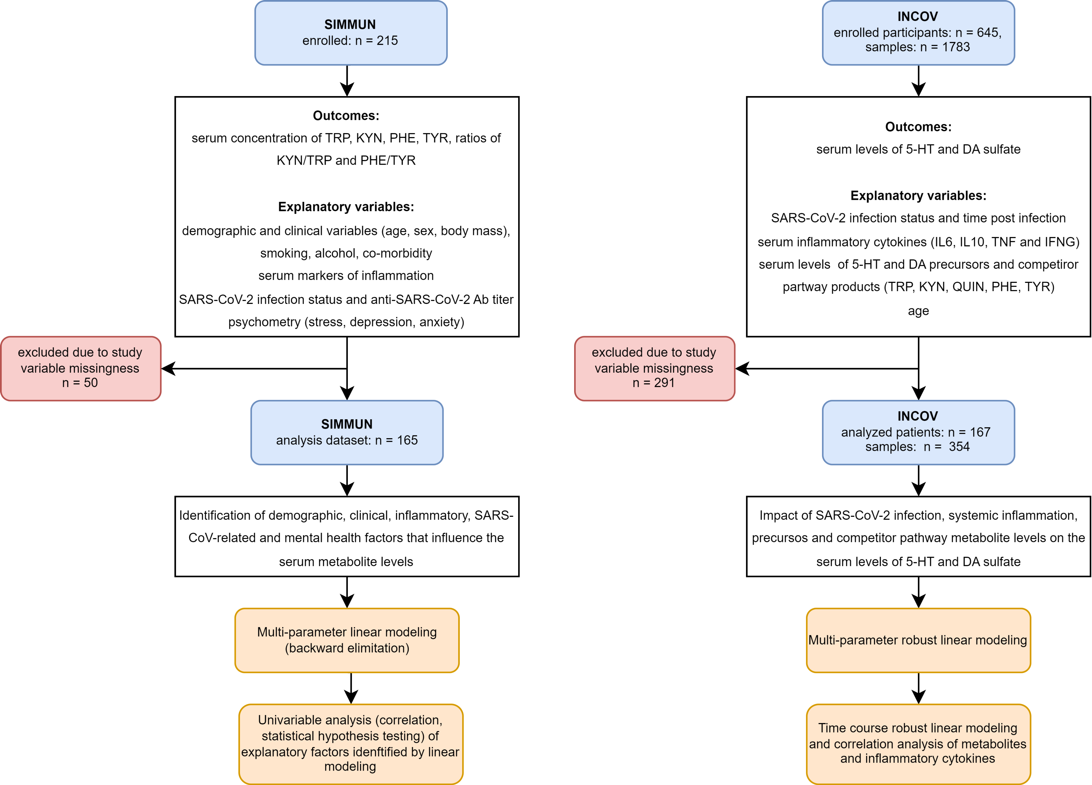

Figure 1: Inclusion scheme for the SIMMUN and INCOV cohorts, and analysis strategy.

**Figure 1. Inclusion scheme for the SIMMUN and INCOV cohorts, and analysis strategy.**

*TRP: tryptophan; KYN: kynurenine; PHE: phenylalanine; TYR: tyrosine; KYN/TRP: kynurenine - tryptophan ratio; PHE/TYR: phenylalanine - tyrosine ratio; QUIN: quinolinate; 5-HT: serotonin; DA: dopamine; Ab: antibody; IL6: interleukin-6; IL10: interleukin-10; TNF: tumor-necrosis factor alpha; IFNG: interferon gamma.*

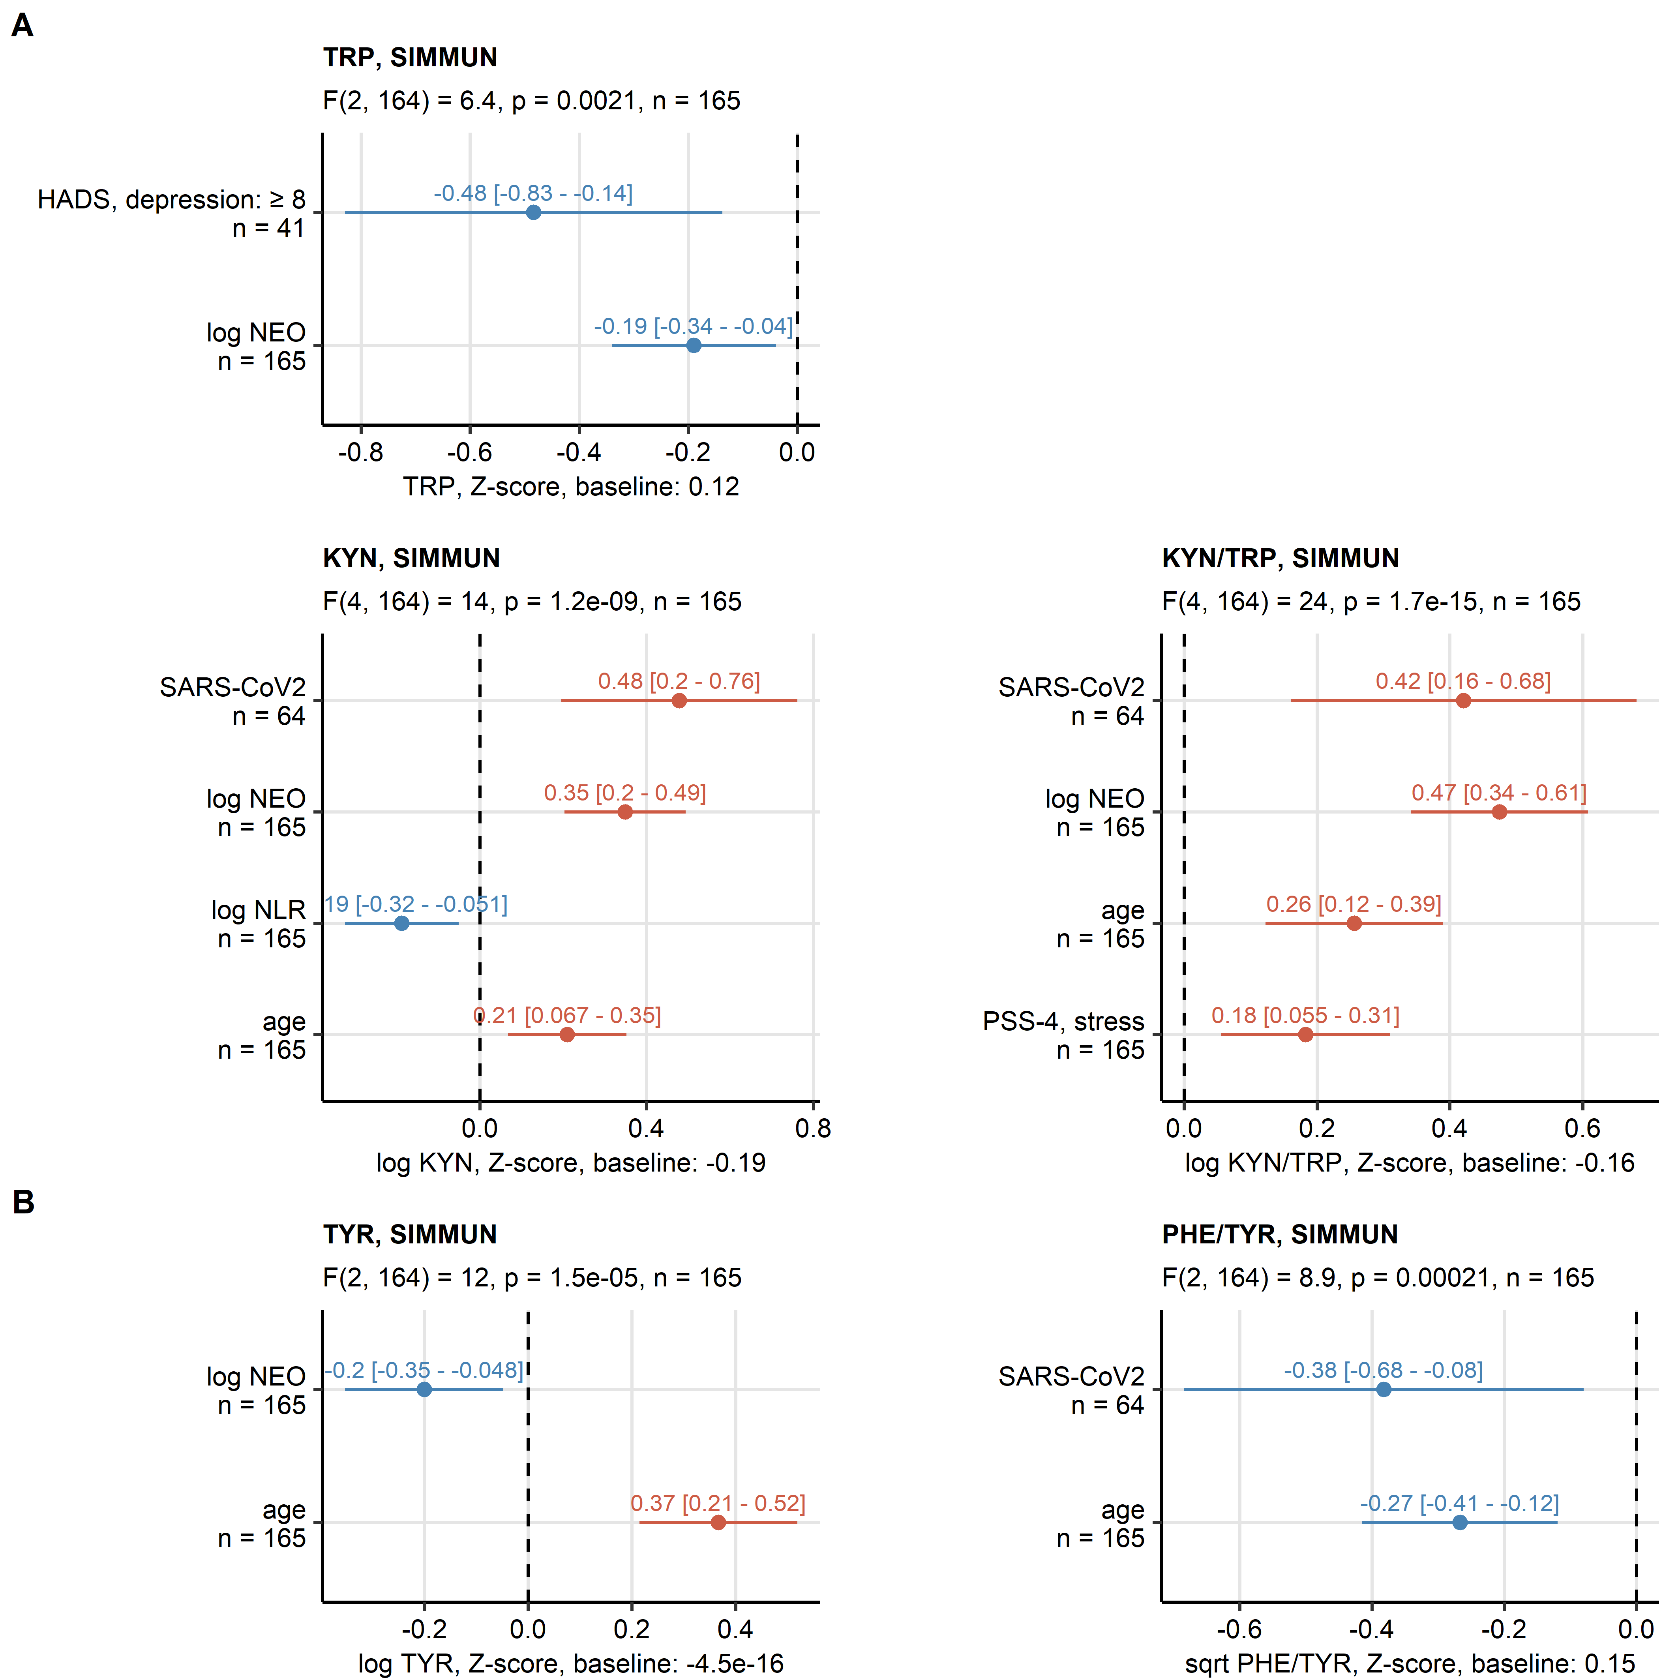

Figure 2: Results of multi-parameter linear modeling of tryptophan, kynurenine, kynurenine/tryptophan ratio, tyrosine and phenylalanine/tyrosine ratio in the SIMMUN cohort.

**Figure 2. Results of multi-parameter linear modeling of tryptophan, kynurenine, kynurenine/tryptophan ratio, tyrosine and phenylalanine/tyrosine ratio in the SIMMUN cohort.**

*Effects of systemic inflammation markers (neopterin [NEO], neutrophil-lymphocyte ratio [NLR]), SARS-CoV-2 infection status, titre of immunoglobulin gamma against the receptor binding domain of the S1 SARS-CoV-2 protein (anti-RBD IgG), scores of anxiety, depression (hospital depression and anxiety scale [HADS]) and mental stress (perceived stress scale, 4 item [PSS4]), age and sex was investigated by multi-parameter linear regression with backward elimination of non-significant terms. Overall model validity was assessed by likelihood-ratio test (LRT). Significant model coefficient estimates with 95% confidence intervals are presented in Forest plots. LRT results (F values, degrees of freedom and p values) and total numbers of complete observations are indicated in the plot captions. Model intercepts (baseline) are indicated in the X axis titles.*

*TRP: tryptophan; KYN: kynurenin; KYN/TRP: kynurenine - tryptophan ratio; PHE: phenylalanine; TYR: tyrosine; PHE/TYR: phenylalanine - tyrosine ratio.*

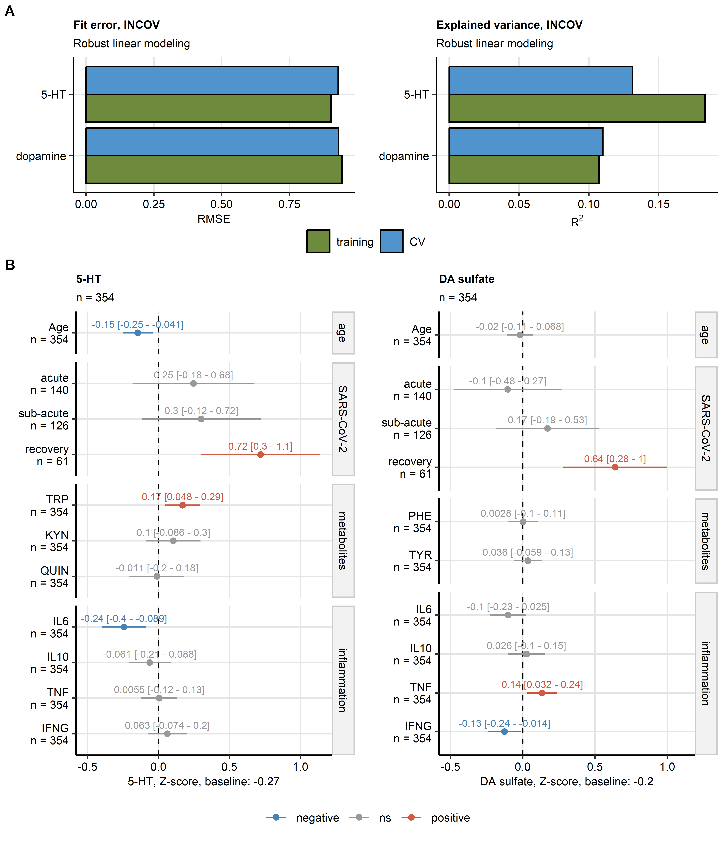

Figure 3: Results of multi-parameter robust linear modeling of plasma levels of serotonin and dopamine sulfate in the INCOV cohort.

**Figure 3. Results of multi-parameter robust linear modeling of plasma levels of serotonin and dopamine sulfate in the INCOV cohort.**

*Effects of patient’s age, timepoint after SARS-CoV-2 infection (acute: median 10 days, sub-acute: median 14 days, recovery: median 64 days after infection as compared with healthy controls), plasma levels of metabolites related to neurotransmitter biosynthesis and competitor pathways (tryptophan [TRP], kynurenine [KYN], quinolinate [QUIN], phenylalanine [PHE] and tyrosine [TYR]), and plasma concentrations of inflammatory cytokines (interleukin-6 [IL6], interleukin-10 [IL10], tumor necrosis factor-alpha [TNF] and interferon-gamma [IFNG]) on plasma concentrations of serotonin (5-hydroxy tryptamine [5-HT]) and dopamine sulfate (DA sulfate) were modeled by multi-parameter robust linear regression.*

*(A) Model fit error (root mean square error [RMSE]) and fraction of explained variances (R-squared) of the robust linear models assessed in the genuine training dataset and 10-fold cross-validation (CV).*

*(B) Estimated of model coefficients with 95% confidence intervals presented in Forest plots. Numbers of complete observations are indicated in the plot captions. Model intercepts (baseline) are indicated in the X axis titles.*

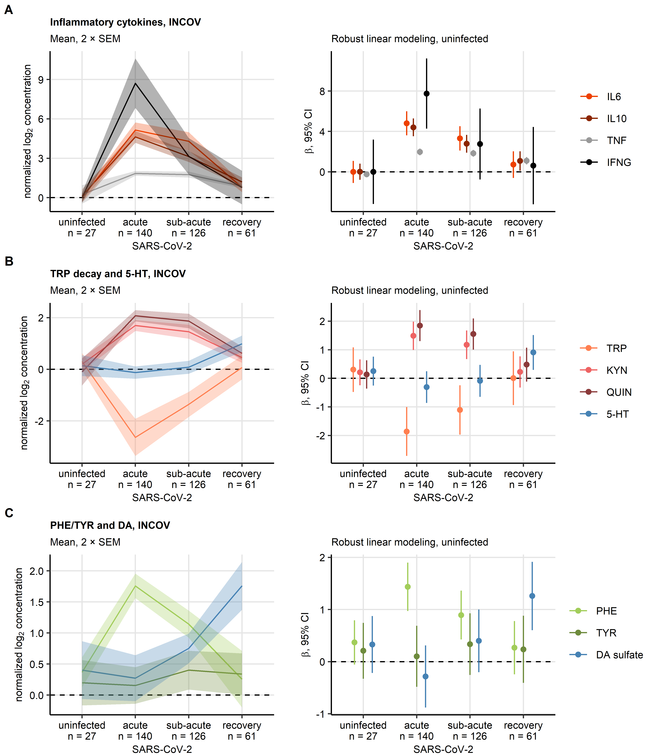

Figure 4: Time course of inflammatory cytokines, serotonin, dopamine sulfate and the neurotransmitter biosynthesis precursors and competitor pathway products during SARS-CoV infection and recovery in the INCOV cohort.

**Figure 4. Time course of inflammatory cytokines, serotonin, dopamine sulfate and the neurotransmitter biosynthesis precursors and competitor pathway products during SARS-CoV infection and recovery in the INCOV cohort.**

*Time courses of normalized log2-transformed plasma concentrations of inflammatory cytokines (A, interleukin-6 [IL6], interleukin-10 [IL-10], tumor necrosis factor-alpha [TNF] and interferon gamma [INFG]), metabolites implicated in serotonin synthesis (B, tryptophan [TRP], kynurenine [KYN], quinolinate [QUIN] and serotonin/5-hydroxy tryptamine [5-HT]) and metabolites implicated in dopamine turnover (C, phenylalanine [PHE], tyrosine [TYR] and dopamine sulfate [DA sulfate]). Differences between uninfected controls and acute, sub-acute SARS-CoV-2 infection and recovery (median 10, 14 and 64 days after infection, respectively) were modeled by robust linear regression with the uninfected controls as baseline. Mean normalized concentrations with 2 standard errors of the mean (2 SEM) are depicted as solid lines with tinted ribbons (plots on the left). Robust linear model coefficient estimates with 95% confidence intervals are visualized in Forest plots (right). Numbers of complete observations per timepoint are indicated in the X axes.*

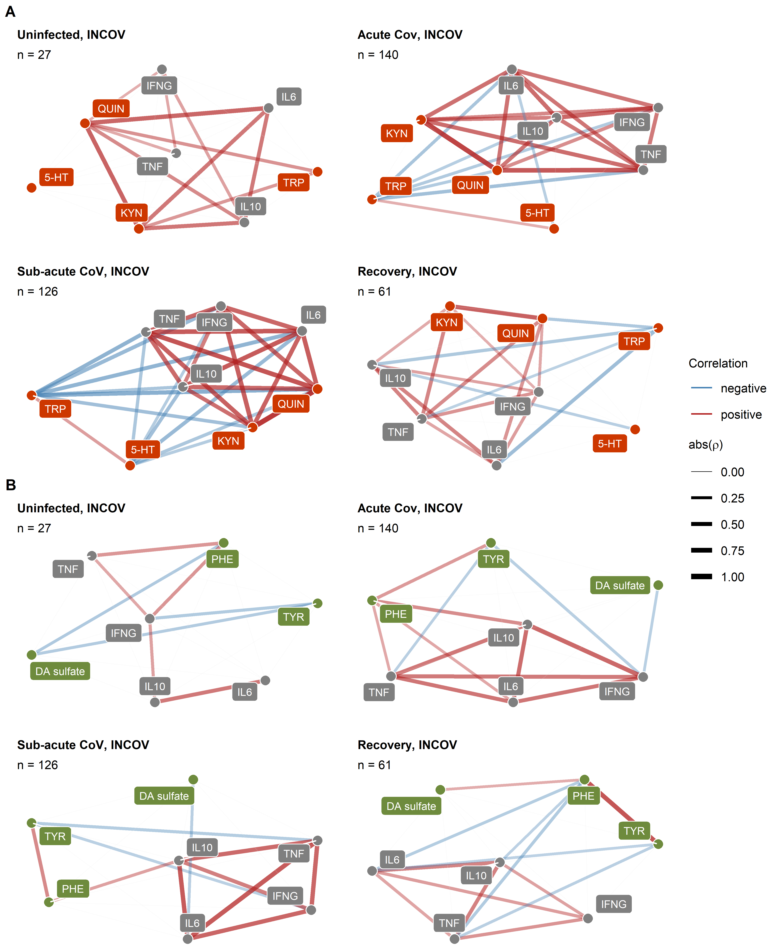

Figure 5: Correlation of plasma levels of inflammatory cytokines, serotonin and dopamine sulfate, their precursors and competitor pathway products in healthy controls and SARS-CoV-2 patients of the INCOV cohort.

**Figure 5. Correlation of plasma levels of inflammatory cytokines, serotonin and dopamine sulfate, their precursors and competitor pathway products in healthy controls and SARS-CoV-2 patients of the INCOV cohort.**

*plasma levels of metabolites implicated in serotonin synthesis (A, tryptophan [TRP], kynurenine [KYN], quinolinic acid [QUIN], serotonin [5-hydroxy tryptamine, 5-HT]), dopamine turnover (B, phenylalanine [PHE], tyrosine [TYR], dopamine sulfate [DA sulfate]) and inflammatory cytokines (interleukin-6 [IL6], interleukin-10 [IL10], tumor necrosis factor-alpha [TNF], interferon-gamma [INFG]) were subjected to pairwise correlation analysis in uninfected and SARS-CoV-2-infected individuals (acute: median 10 days, sub-acute: median 14 days, recovery: median 64 days after infection). Correlation coefficient matrices for at least moderate effects ( > 0.2) were visualized as force-directed network plots. Node color codes for the parameter type (gray: inflammatory cytokines, orange: serotonin, green: dopamine turnover), edge width and color codes for the value and sign of the correlation coefficient.*

# Acknowledgements

The scheme of report findings was created with bioicons by Simon Duerr. The SARS-CoV-2 virus image was created by Hanna Vega and licensed under the terms of a Creative Commons CC-BY SA 4.0.

# References

1. Paul-Savoie É, Potvin S, Daigle K, Normand E, Corbin JF, Gagnon R, Marchand S. A deficit in peripheral serotonin levels in major depressive disorder but not in chronic widespread pain. *The Clinical journal of pain* (2011) 27:529–534. doi: [10.1097/AJP.0B013E31820DFEDE](https://doi.org/10.1097/AJP.0B013E31820DFEDE)

2. Sun Y, Drevets W, Turecki G, Li QS. The relationship between plasma serotonin and kynurenine pathway metabolite levels and the treatment response to escitalopram and desvenlafaxine. *Brain, Behavior, and Immunity* (2020) 87:404–412. doi: [10.1016/J.BBI.2020.01.011](https://doi.org/10.1016/J.BBI.2020.01.011)

3. Tateishi H, Setoyama D, Kang D, Matsushima J, Kojima R, Fujii Y, Mawatari S, Kikuchi J, Sakemura Y, Fukuchi J, et al. The changes in kynurenine metabolites induced by rTMS in treatment-resistant depression: A pilot study. *Journal of psychiatric research* (2021) 138:194–199. doi: [10.1016/J.JPSYCHIRES.2021.04.009](https://doi.org/10.1016/J.JPSYCHIRES.2021.04.009)

4. Holck A, Wolkowitz OM, Mellon SH, Reus VI, Nelson JC, Westrin Å, Lindqvist D. Plasma serotonin levels are associated with antidepressant response to SSRIs. *Journal of affective disorders* (2019) 250:65–70. doi: [10.1016/J.JAD.2019.02.063](https://doi.org/10.1016/J.JAD.2019.02.063)

5. Meiser J, Weindl D, Hiller K. Complexity of dopamine metabolism. *Cell Communication and Signaling* (2013) 11:1–18. doi: [10.1186/1478-811X-11-34/FIGURES/5](https://doi.org/10.1186/1478-811X-11-34/FIGURES/5)

6. Goldstein DS, Swoboda KJ, Miles JM, Coppack SW, Aneman A, Holmes C, Lamensdorf I, Eisenhofer G. Sources and physiological significance of plasma dopamine sulfate. *The Journal of clinical endocrinology and metabolism* (1999) 84:2523–2531. doi: [10.1210/JCEM.84.7.5864](https://doi.org/10.1210/JCEM.84.7.5864)

7. Hashizume K, Yamatodani A, Yamamoto T, Ogihara T, Kumahara Y, Wada H. Effects of oral and intravenous administrations of dopamine and L-dopa on plasma levels of two isomers of dopamine sulfate in man. *Life sciences* (1987) 41:2697–2704. doi: [10.1016/0024-3205(87)90462-0](https://doi.org/10.1016/0024-3205(87)90462-0)

8. Su Y, Yuan D, Chen DG, Ng RH, Wang K, Choi J, Li S, Hong S, Zhang R, Xie J, et al. Multiple early factors anticipate post-acute COVID-19 sequelae. *Cell* (2022) 185:881–895.e20. doi: [10.1016/J.CELL.2022.01.014](https://doi.org/10.1016/J.CELL.2022.01.014)

9. Capuron L, Schroecksnadel S, Féart C, Aubert A, Higueret D, Barberger-Gateau P, Layé S, Fuchs D. Chronic low-grade inflammation in elderly persons is associated with altered tryptophan and tyrosine metabolism: role in neuropsychiatric symptoms. *Biological psychiatry* (2011) 70:175–182. doi: [10.1016/J.BIOPSYCH.2010.12.006](https://doi.org/10.1016/J.BIOPSYCH.2010.12.006)

10. Widner B, Werner ER, Schennach H, Wachter H, Fuchs D. Simultaneous measurement of serum tryptophan and kynurenine by HPLC. *Clinical Chemistry* (1997) 43:2424–2426. doi: [10.1093/CLINCHEM/43.12.2424](https://doi.org/10.1093/CLINCHEM/43.12.2424)

11. Neurauter G, Schrocksnadel K, Scholl-Burgi S, Sperner-Unterweger B, Schubert C, Ledochowski M, Fuchs D. Chronic immune stimulation correlates with reduced phenylalanine turnover. *Current drug metabolism* (2008) 9:622–627. doi: [10.2174/138920008785821738](https://doi.org/10.2174/138920008785821738)

12. Deisenhammer F, Bauer A, Kavelar C, Rudzki D, Rössler A, Kimpel J, Borena W, Reindl M. 12-month SARS-CoV-2 antibody persistency in a Tyrolean COVID-19 cohort. *Wiener klinische Wochenschrift* (2021) 133:1265–1271. doi: [10.1007/S00508-021-01985-X](https://doi.org/10.1007/S00508-021-01985-X)

13. Cohen S, Kamarck T, Mermelstein R. A global measure of perceived stress. *Journal of health and social behavior* (1983) 24:385–396. doi: [10.2307/2136404](https://doi.org/10.2307/2136404)

14. Zigmond AS, Snaith RP. The hospital anxiety and depression scale. *Acta psychiatrica Scandinavica* (1983) 67:361–370. doi: [10.1111/J.1600-0447.1983.TB09716.X](https://doi.org/10.1111/J.1600-0447.1983.TB09716.X)

15. Bjelland I, Dahl AA, Haug TT, Neckelmann D. The validity of the Hospital Anxiety and Depression Scale: An updated literature review. *Journal of Psychosomatic Research* (2002) 52:69–77. doi: [10.1016/S0022-3999(01)00296-3](https://doi.org/10.1016/S0022-3999(01)00296-3)

16. Su Y, Chen D, Yuan D, Lausted C, Choi J, Dai CL, Voillet V, Duvvuri VR, Scherler K, Troisch P, et al. Multi-Omics Resolves a Sharp Disease-State Shift between Mild and Moderate COVID-19. *Cell* (2020) 183:1479. doi: [10.1016/J.CELL.2020.10.037](https://doi.org/10.1016/J.CELL.2020.10.037)

17. McDonald RP. *Test theory: A unified treatment*. 1st Editio. New Yor: Psychology Press (1999). doi: [10.4324/9781410601087](https://doi.org/10.4324/9781410601087)

18. BARTLETT MS. THE STATISTICAL CONCEPTION OF MENTAL FACTORS. *British Journal of Psychology General Section* (1937) 28:97–104. doi: [10.1111/j.2044-8295.1937.tb00863.x](https://doi.org/10.1111/j.2044-8295.1937.tb00863.x)

19. Revelle W. Package ’psych’ - Procedures for Psychological, Psychometric and Personality Research. *R Package* (2015)1–358. <https://cran.r-project.org/web/packages/psych/index.html http://personality-project.org/r/psych-manual.pdf>

20. Benjamini Y, Hochberg Y. Controlling the False Discovery Rate: A Practical and Powerful Approach to Multiple Testing. *Journal of the Royal Statistical Society: Series B (Methodological)* (1995) 57:289–300. doi: [10.1111/j.2517-6161.1995.tb02031.x](https://doi.org/10.1111/j.2517-6161.1995.tb02031.x)

21. Cohen J. Statistical Power Analysis for the Behavioral Sciences. *Statistical Power Analysis for the Behavioral Sciences* (2013) doi: [10.4324/9780203771587](https://doi.org/10.4324/9780203771587)

22. Kassambara A. rstatix: Pipe-Friendly Framework for Basic Statistical Tests. (2021) <https://cran.r-project.org/package=rstatix>

23. Huber PJ. Robust Statistics. *International Encyclopedia of Statistical Science* (2011)1248–1251. doi: [10.1007/978-3-642-04898-2_594](https://doi.org/10.1007/978-3-642-04898-2_594)

24. Ripley B. MASS: Support Functions and Datasets for Venables and Ripley’s MASS. (2022) <https://cran.r-project.org/package=MASS>

25. Kuhn M. Building predictive models in R using the caret package. *Journal of Statistical Software* (2008) 28:1–26. doi: [10.18637/jss.v028.i05](https://doi.org/10.18637/jss.v028.i05)

26. Csardi G, Nepusz T. The igraph software package for complex network research. *InterJournal* (2006) Complex Sy:1695. <https://igraph.org>

27. Briatte F, Bojanowski M, Canouil M, Charlop-Powers Z, Fisher JC, Johnson K, Rinker T. ggnetwork: Geometries to Plot Networks with ’ggplot2’. (2021) <https://cran.r-project.org/package=ggnetwork>