The effect of inflammation, status post SARS-CoV-2 infection, age and mental health on kynurenin and catecholamine pathway metabolites – a psychoneuroimmunological study

Manuscript

Katharina Hüfner1, Sophia Vedova1, Piotr Tymoszuk2, Philipp Nelles1, Tobias Bruckner1, Eberhard A. Deisenhammer1,3, Jonas Egeter1, Matyas Galffy1, Johannes Giesinger1, Jens Lehmann1, Maria Oberhammer2, Joachim Rockenschaub1, Magdalena Sacher4, Bernhard Holzner1, Johanna M. Gostner5, Barbara Sperner-Unterweger1

1University Hospital of Psychiatry II, Department of Psychiatry, Psychotherapy, Psychosomatics and Medical Psychology, Medical University Innsbruck, Innsbruck, Austria.

2University Hospital of Psychiatry I, Department of Psychiatry, Psychotherapy, Psychosomatics and Medical Psychology, Medical University Innsbruck, Innsbruck, Austria.

3Data Analytics as a Service Tirol, Innsbruck, Austria

4Department of Visceral, Transplant and Thoracic Surgery (VTT), Medical University Innsbruck, Innsbruck, Austria

5Insitute of Medical Biochemistry, Medical University Innsbruck, Innsbruck, Austria

Corresponding author:

Katharina Hüfner

University Hospital of Psychiatry II, Department of Psychiatry, Psychotherapy, Psychosomatics and Medical Psychology

Anichstrasse 35

6020 Innsbruck

Austria

[katharina.huefner@tirol-kliniken.at](mailto:katharina.huefner@tirol-kliniken.at)

Running title: Neurotransmitter precursor amino acid levels and COVID-19

Keywords: neurotransmitter precursor amino acids, COVID-19, kynurenine, tryptophan, mental stress, inflammation

# Keywords

SARS-CoV-2, inflammation, serotonin, dopamine, tryptophan, kynurenine, mental disorders

# Abstract

**Background:** In the light of the high prevalence of health impairment following COVID-19, it is essential to elucidate underlying biological mechanisms linking SARS-CoV-2 infections and mental health. The availability of neurotransmitter precursor amino acids and changes in the associated metabolic pathways could be a link between mental and physical health, with inflammation playing a major role in this bi-directional relationship. We aimed to identify demographic, clinical, psychometric and SARS-CoV-2 infection-related factors affecting the kynurenine and catecholamine pathways and associate metabolites.

**Methods:** The cross-sectional SIMMUN (n = 165, Austria, own data) and longitudinal INCOV cohort (n = 167, Su et al. 2022) were investigated. The SIMMUN cohort was used to investigate the effect of explanatory variables such as age, sex, clinical characteristics, inflammation, SARS-CoV-2 infection status, symptoms of anxiety and depression (HADS), and perceived mental stress (PSS-4) on the kynurenine pathway affecting also serotonin availability (tryptophan (TRP), kynurenine (KYN), TRP/KYN) and the catecholamine pathway (phenylalanine (PHE), tyrosine (TYR), PHE/TYR). In the INCOV cohort a detailed investigation of the effect of SARS-CoV-2 infection, inflammation, neurotransmitter precursors and competitive pathway metabolites (TRP, KYN, quinolinate, PHE, TYR) on serotonin and dopamine sulfate levels was performed. Multi parameter linear modeling, correlation analysis and two-tailed T tests were used for analyses.

**Results:** In the SIMMUN cohort, the inflammatory marker neopterin, status post SARS-CoV-2 infection, age, and mental stress were positively and independently associated with the KYN/TRP ratio (R2 = 0.3). TRP was negatively influenced by neotperin and clinically relevant symptoms of depression. The PHE/TYR ratio was negatively and independently influenced by status post SARS-CoV-2 infection and age (R2 = 0.1)... In the INCOV cohort, inflammation was associated with lower serotonin (IL6: = -0.24 [95% CI: -0.4 to -0.089]) and, dopamine sulfate (interferon-gamma: = -0.13 [95% CI: -0.24 to -0.014]). Serotonin ( = 0.72 [95% CI: 0.3 to 1.1]) and dopamine sulfate levels ( = 0.64 [95% CI: 0.28 to 1]) were higher in individuals with status post SARS-CoV-2 infection compared to acute and subacute disease.

**Conclusion:** SARS-CoV-2 infection, inflammation, and mental health can independently and additively influence the kynurenine and catecholamine pathways and associate metabolites. These pathways could thus be a biological link between COVID-19 infection and mental health with an important role of inflammation.

# Introduction

The immune system and the brain interact at multiple levels and in a bidirectional manner with influences on one system having consequences on the other. Physical conditions such as chronic infections, interferon treatment, cardiovascular disease, frailty, autoimmune disorders or malignancies often co-occur with depression and anxiety (1–8). Inflammation is thought to be an important link between mental and physical health and can act via an influence on the kynurenine pathway (affecting also tryptophan and serotonin availability) and the catecholamine pathway (2,9,10).

.Serotonin is synthesized from the essential aminoacid tryptophan (TRP) via reactions catalyzed by tryptophan hydroxylase (TPH) and aromatic L-amino acid decarboxylase. Alternatively TRP can be metabolized along the kynurenine pathway to kynurenine (KYN) by indoleamine 2,3-dioxygenase (IDO-1) or in the liver by tryptophan 2, 3-dioxygenase (TDO); this reaction is the rate limiting step in this pathway **(figure 1)**. IDO1 can be stimulated by cytokines and other inflammatory stimuli which leads to TRP depletion and subsequently lower levels of serotonin (11,13–15).,9,10,16). TDO can be stimulated by glycocorticoids, of note the HPA axis plays an important role in depression and mental stress . 11). Consequently, changes in blood levels of KYN pathway metabolites, and associated changes in TRP and serotonin were reported for numerous physical conditions and in some study an association with symptoms of mental disorders was found (3,8, ,17–22). Kynurenine is capable of passing the blood-brain barrier via neutral [amino acid transporters](https://www.sciencedirect.com/topics/neuroscience/amino-acid-transporter" \o "Learn more about amino acid transporters from ScienceDirect's AI-generated Topic Pages). In downstream catabolites along the kynurenine pathway such as quinolinic acid (QUIN) might have neurotoxic properties .

Reactive oxygen species (ROS) pose another link between inflammation and neurotransmitter precursors. Interferon gamma (IFN-γ) was shown to trigger ROS production among others by microglia (Rahimian et al., 2022). ROS in turn mediated depletion of 5,6,7,8-tetrahydrobiopterin (BH4), a critical co-factor for synthesis of serotonin and catecholamine neurotransmitters (Neurauter et al., 2008). Furthermore, IFN-γ-stimulated macrophages and dendritic cells form neopterin, a cellular marker of inflammation, instead of BH4 (Werner et al., 1989). Hence, reduced BH4 availability can be assessed via an increased ratio of phenylalanine to tyrosine (PHE/TYR ratio) as depletion of BH4 leads to an inhibition of PHE – TYR conversion by phenylalanine-hydroxylase (Capuron et al., 2011). Changes in PHE and TYR levels have been reported in different physical disorders such as cancer, infections and inflammatory conditions and associated with depression and anxiety (6,8,16,24,25).

SARS-CoV-2 virus is the causal pathogen of coronavirus disease 2019 (COVID-19). Acute SARS-CoV-2 infection has been shown to trigger a strong systemic inflammatory response (Song et al., 2020) causing an increased permeability of the blood brain barrier (Najjar et al., 2020), so that consequences on cognition and mental health are conceivable (Bower et al., 2022). values have and are associated with inflammation and disease severity (31–37).

Changes in KYN and PHE levels in acute COVID-19 as well as at follow up have also been found in other studies and an association with sleep distrubances was described. On the other hand, psychological wellbeing and mental health can influence the immune system accounting for the higher susceptibility and risk for a more severe disease course in individuals with mental disorders (Wang et al., 2021). Mental stress is important mediating the effects of mental disorders on the immune system, and can act via the HPA axis (ZITAT). Individual health in COVID-19 survivors is negatively high values . This effect is more pronounced than antibody titers, impaired lung function, lung lesions or cardiac deficits, . Apart from sustained physical disability, mental disorders in millions of individuals who have been infected with SARS-CoV-2 amount to the persistent burden of the COVID-19 pandemic (26–30). Theoretical considerations (ref 38 insert here) and preliminary experimental data indicate that the KYN pathway affecting also TRP and serotonin availability as well as the catecholamine pathway could play a role in mediating mental impairment during COVID-19 recovery (38–40)

While this theoretical link between SARS-CoV-2 infection – KYN and catecholamine pathway and mental health seems appealing, the experimental evidence is still scarce. Specifically the exact link between SARS-CoV-2 infection and mental health is still unresolved and the impact of inflammation on the kynurenine pathway (affecting also the associated tryptophan and serotonin availability) and the catecholamine pathway in acute SARS-CoV-2 infection and recovery is still unclear. To address this question, explored the effect demographic, clinical, psychometric (anxiety, depression, mental stress), inflammation- and SARS-CoV-2-related factors on the kynurenine pathway and associated tryptophan availability (tryptophan (TRP), kynurenine (KYN), TRP/KYN) and the catecholamine pathway (phenylalanine (PHE), tyrosine (TYR), PHE/TYR) in the cross-sectional cohort SIMMUN. Data from the previously published, longitudinal INCOV cohort (ref 41) were analyzed for a detailed investigation of the effect of SARS-CoV-2 infection and timepoint, inflammation, neurotransmitter precursor amino acids and competitive pathway metabolites (TRP, KYN, quinolinate, PHE, TYR) on serotonin and dopamine sulfate levels.

# Materials and Methods

## Ethics statement

The SIMMUN study was conducted in accordance with the Declaration of Helsinki and European Data Policy. All participants gave written informed consent prior to enrollment. Participants’ data were stored and analyzed in anonymized form. This study was approved by the ethics committee of the Medical University Innsbruck (Austria, approval number: 1132/2020). No approval by the ethics committee was required for analysis of the published INCOV dataset (41).

## Study cohorts

Details on study cohorts, procedures and analyses are provided in **Supplementary Methods**.

### SIMMUN study

Individuals tested for SARS-CoV-2 via PCR at the University Hospital of Innsbruck and patients of the University Clinic for Psychiatry I and II (Innsbruck, Austria) undergoing routine SARS-CoV-2 PCR were invited to participate. The study was conducted between June 2020 and May 2021. The inclusion criteria were age of 18 - 70 years, proficiency in German, residence in the study region (Tyrol, Austria), and a SARS-CoV-2 PCR test conducted at the study site. The exclusion criteria were active SARS-CoV-2 infection (< 14 days after diagnosis), pregnancy, active malignancy, organ transplantation, surgery in the past 3 months, inflammatory illness and oral corticosteroid treatment. Only individuals with complete data sets were included in the analysis (**Figure 1**, **Supplementary Table S1**). Significant differences between the analyzed and excluded participants are listed in **Supplementary Table S2**.

### INCOV study

Proteome and metabolome data and clinical information for the INCOV cohort were extracted from supplementary tables accompanying the report by Su and colleagues (41). Only complete data sets were included in the current analysis, (**Figure 1**, **Table 2**, **Supplementary Table S3**).

## Procedures

### SIMMUN study

The SIMMUN study data were collected during a single on-site study visit including a general medical assessment, supervised completion of self-rating questionnaires and a blood sample collection (**Supplementary Table S1**). The median time interval between the study visit and SARS-CoV-2 PCR was 139 days (interquartile range: 119 - 157).

Demographic and clinical variables age, sex, body mass index, mental disorders diagnosed by mental health professional, self-reported physical disorders, smoking and alcohol consumption, result and date of the SARS-CoV-2 PCR test were surveyed during the study visit or extracted from electronic patient records. Inflammatory markers plasma neopterin concentrations (NEO) was measured by ELISA and neutrophil - lymphocyte ratio (NLR) were determined by the certified clinical routine laboratory at the University Hospital of Innsbruck. Plasma concentrations of tryptophan (TRP), kynurenine (KYN), phenylalanine (PHE) and tyrosine (TYR) were determined by high-performance liquid chromatography, and the KYN/TRP and PHE/TYR ratios calculated (22,25,42). Plasma titer of immunoglobulin gamma against receptor binding domain S1/S2 protein (anti-RBD IgG) were quantified by ELISA (43). Laboratory measurements at and beyond the detection limits were substituted with the lower or upper detection limit value, respectively. Mental stress was scored with the 4-item perceived stress scale (PSS-4) (44). Symptoms of anxiety and depression were scored with the hospital anxiety and depression scale (HADS) including 7 items for anxiety and 7 items for depression (45). Clinically relevant symptoms of anxiety or depression were defined as 8 points (45,46).

In order to improve normality of some numeric study variables prior to linear modeling and statistical hypothesis testing with parametric tools, logarithm or square root transformations were applied (**Supplementary Table S1**).

### INCOV cohort

Plasma proteomes and metabolomes in the INCOV cohort were measured by proximity extension assay (Olink, Sweden) and ultra-high-performance liquid chromatography/tandem accurate mass spectrometry (Metabolon, USA) (41,47). Normalized, age- and sex-adjusted, log2-transformed plasma concentrations of metabolites and cytokines, and clinical information were extracted from [supplementary tables](https://data.mendeley.com/datasets/96v329bg7g/1) of the report by Su et al. (41). Metabolites implicated in systemic serotonin availability (serotonin, TRP), KYN pathway activity (KYN, quinolinate [QUIN]) and dopamine availability (PHE, TYR and dopamine 3-O-sulfate [DA sulfate]), cytokine markers of inflammation (interleukin-6 [IL6], interleukin-10 [IL10], tumor necrosis factor-alpha [TNF] and interferon-gamma [IFNG]) and age were analyzed (**Supplementary Table S3**).

Plasma features were sampled in uninfected controls and SARS-CoV-2 infected individuals during acute (median: 10) and sub-acute (median: 14) infection, and recovery (median: 64 days after diagnosis of SARS-CoV-2 infection via PCR) (**Supplementary Table S3**).

## Analysis endpoints

Our analysis pursued two endpoints. The first endpoint was to determine demographic, clinical, psychometric, inflammation- and SARS-CoV-2-related factors influencing the kynurenine pathway and associated TRP availability and catecholamine pathways (TRP, KYN, KYN/TRP, PHE, TYR, PHE/TYR). This endpoint was addressed by multi-parameter modeling in the SIMMUN cohort. The second endpoint was to investigate how more direct readouts of systemic serotonin (21,48–50) and dopamine (DA sulfate (23,51,52)) availability, are influenced by age, inflammation, timepoint of the SARS-CoV-2 infection, neurotransmitter precursor amino acids (TRP, PHE, TYR) and KYN pathway products (KYN, QUIN). This endpoint was addressed by multi-parameter robust linear modeling, time course modeling and correlation analysis in the INCOV cohort (**Figure 1**).

## Statistical analysis

R version 4.2.3 was used for statistical analysis.

Numeric variables were presented as medians with interquartile ranges and ranges. Categorical variables are presented as percentages and counts within the complete observation set. Distribution normality and variance homogeneity was assessed by Shapiro-Wilk and Levene test, respectively. In the SIMMUN cohort, non-normally distributed numeric variables were logarithm- or square root-transformed prior to modeling and parametric tests (**Supplementary Table S1**). Since most of the INCOV study variables were non-normally distributed, robust linear modeling and non-parametric testing were employed. Since the tau-equivalence assumption investigated by factor analysis for the HADS scales was violated, consistency of psychometric tools was investigated by global McDonald’s (53–55). Except for multi-parameter modeling, p values were corrected for multiple testing with the false discovery rate method (56) separately for each analysis task. Effects with p < 0.05 were considered significant.

Correlation was assessed by Spearman’s rank or Pearson test. Significance of comparisons of numeric variables between two groups was determined by Mann-Whitney test with r effect size statistic or by two-tailed T test with Cohen’s d effect size metric. Comparisons of categorical variable distributions were evaluated by test with Cramer V effect size statistic. Correlation was assessed by Pearson’s or Spearman’s rank test (57,58).

In the SIMMUN cohort, effects of age, sex, body mass class, physical and psychiatric disorders, body mass class, smoking and alcohol consumption, inflammation markers (NEO, NLR), SARS-CoV-2 infection, anti-RBD IgG titer, depression and anxiety signs (HADS), mental stress (PSS-4) on TRP, KYN, KYN/TRP, PHE, TYR and PHE/TYR were assessed by multi-parameter linear regression with backward elimination. Modeling responses and explanatory variables were subjected to normality-stabilizing transformations (**Supplementary Table S1**) and normalized. Normality and homogeneity of model residuals were evaluated by Shapiro-Wilk and Levene test, respectively, and visual inspection (residuals versus fitted and quantile-quantile plots). In the INCOV cohort, effects of age, cytokine markers of inflammation (IL6, IL10, TNF, IFNG), SARS-CoV-2 infection timepoint (acute, sub-acute, recovery versus uninfected control), neurotransmitter precursors (TRP, PHE, TYR) and KYN pathway products (QUIN, KYN) on plasma serotonin and DA sulfate were modeled by multi-parameter robust linear regression with the MM algorithm and Huber psi function (59,60). Reproducibility and proper parameterization of the multi-parameter linear and robust models was investigated by RMSE and statistics in 10-fold cross-validation (61). Significance of the model estimates was assessed by two-tailed T test.

Differences in cytokines and metabolites between SARS-CoV-2 infection timepoints in the INCOV collective were investigated by robust linear modeling (MM algorithm, Huber’s psi function) with uninfected subset or acute infection serving as baselines.

Pairwise Spearman’s correlation coefficients were calculated for cytokines and metabolites in the INCOV cohort. The correlation matrices were subsequently scaled into the [0, 1] range and converted to undirected force directed graphs (62). The graphs were visualized as two-dimensional network plots with the node proximity determined by the value and distance-dependent repulsion, and edge color and width coding for the value and sign (63).

# Results

## Characteristic of the study cohorts – SIMMUN and INCOV

Two separate cohorts of uninfected and SARS-CoV-2-infected individuals were analyzed (SIMMUN and INCOV). Out of 215 individuals enrolled in the SIMMUN study, 165 participants with a complete study variable dataset were analyzed (**Figure 1**, **Supplementary Table S1**). The excluded individuals were characterized by more frequent mental disorders, higher percentages of clinically significant signs of depression and anxiety (HADS scoring), higher values for mental stress (PSS-4)g and less frequent SARS-CoV-2 infections as compared with the analyzed participants (**Supplementary Table S2**). Individuals with status post SARS-CoV-2 infection accounted for 61% of the analyzed SIMMUN cohort. None of the participants had received anti-SARS-CoV-2 vaccination prior to enrollment. Males represented 38% of the cohort and the median age was 50 years. The gender and age structure of the SARS-CoV-2-negative and status post SARS-CoV-2 infection subsets was comparable. In the entire SIMMUN cohort, 47% of participants were overweight or obese and 51% self-reported a physical disorder; these figures were comparable between SARS-CoV-2-negative individuals and such with status post SARS-CoV-2 infection. Mental disorders diagnosed by a mental health professional affected 41% of participants and were significantly more common in SARS-CoV-2-negative (50%) than in individuals with status post SARS-CoV-2 infection (28%, p = 0.021, effect size: p = 0.021; table 1). The employed psychometric tools (HADS for assessment of anxiety and depression and PSS-4 to assess mental stress) displayed good-to-excellent internal consistency ( = 0.74 - 0.96) (53) (**Supplementary Figure S1**). Clinically relevant anxiety symptoms (HADS 8) (45,46) was more frequent in the uninfected (43%) than in the individuals with status post SARS-CoV-2 infection (20%, p = 0.013, effect size: V = 0.23). Clinically relevant depressive symptoms were more common in SARS-CoV-2-negative (31%) than in the participants with status post SARS-CoV-2 infection (16%), yet this effect was not statistically significant. Scores of mental stress were comparable in both SARS-CoV-2 subsets (negative: median 6, status post SARS-CoV-2 infection: median 5 points). As expected, titer of antibodies against the S1/S2 SARS-CoV-2 protein (anti-RBD IgG) was significantly higher in the convalescent subset (median: 16 AU) as compared with uninfected individuals (median: 0.31 AU, p < 0.001, effect size: r = 0.84). In 73% of SARS-CoV-2-infected SIMMUN study participants, the infection was mild and treated on an outpatient basis (**Table 1**).

Out of 645 individuals initially enrolled in the INCOV study (41,47), 167 participants (providing 354 individual samples) with a complete study variable dataset were analyzed (**Figure 1**, **Supplementary Table S3 - S4**). SARS-CoV-2-positive individuals comprised 84% of the analyzed INCOV collective. 56% of the analyzed participants were male, the median age was 60 years. SARS-CoV-2-positive individuals (median age: 62 years) were significantly older than uninfected participants (median age: 56 years, p = 0.044, effect size: r = 0.17) and percentages of overweight or obese individuals were higher among SARS-COV-2-positive (74%) than uninfected participants (55%), this effect was not statistically significant. Nearly all (97%) of SARS-CoV-2-positive individuals in the INCOV cohort were hospitalized due to a moderate, severe or critical infection severity (**Table 2**).

As compared with the SIMMUN cohort, the INCOV cohort was characterized by a significantly higher percentage of males (p = 0.0014, effect size: V = 0.18), higher age (p < 0.001, effect size: p < 0.001), higher rates of overweight or obese participants (p < 0.001, effect size: V = 0.28), more SARS-CoV-2 infected cases (p < 0.001, effect size: V = 0.46) and higher hospitalization rates (p < 0.001, effect size: V = 0.72) (**Supplementary Table S5**).

## Inflammation, status post SARS-CoV-2 infection, age, mental stress and symptoms of depression influence metabolites of the kynurenine pathway

In the SIMMUN dataset we performed an initial search for predictors of systemic neurotransmitter precursor amino acid availability. As markers of serotonin turnover, we modeled plasma levels the kynurenine pathway (KYN, KYN/TRP) affecting also TRP (11,12,22). Plasma concentrations of PHE, TYR and PHE/TYR were investigated as markers of the catecholamine pathway and associated dopamine availability (6,23,25). The candidate explanatory variables were age, sex, body mass index, the presence of physical and mental disorders, smoking, alcohol consumption, status post SARS-CoV-2 infection, anti-SARS-CoV-2 antibody titer, NEO and NLR as inflammatory markers, perceived mental stress, symptoms of depression and anxiety (**Supplementary Table S1**). All variables were recorded at a single timepoint, median 139 days after the SARS-CoV-2 PCR test (interquartile range: 119 - 157).

Full multi-parameter linear models were optimized by backwards elimination of non-significant terms (60) (**Supplementary Table S6**). Meaningful models could be established for TRP, KYN, KYN/TRP, TYR and PHE/TYR. The PHE model had a negligible explanatory performance, proved non-significant as compared with the intercept-only null model and was hence not further analyzed. The remaining models were characterized by good reproducibility and proper parameterization as indicated by comparable fit errors in the genuine dataset and cross-validation. The KYN and KYN/TRP models had the best explanatory performance measured by cross-validated of 0.21 and 0.3, respectively. The TRP, TYR and PHE/TYR models could explain between 10% and 15% of the cross-validated response variances (, **Supplementary Figure S2**).

Regarding the kynurenine pathway, the inflammatory marker NEO ( = -0.19 [95% CI: -0.34 - -0.04]) and clinically relevant symptoms of depression (HADS depression 8, = -0.48 [95% CI: -0.83 - -0.14]) were independently associated with reduced plasma TRP. Higher values of KYN and KYN/TRP were significantly associated with status post SARS-CoV-2 infection (KYN: = 0.48 [95% CI: 0.2 - 0.76], KYN/TRP: = 0.42 [95% CI: 0.16 - 0.68]), higher NEO (KYN: = 0.35 [95% CI: 0.2 - 0.49], KYN/TRP: = 0.47 [95% CI: 0.34 - 0.61]) and age (KYN: = 0.21 [95% CI: 0.067 - 0.35], KYN/TRP: = 0.26 [95% CI: 0.12 - 0.39]). Additionally, high perceived mental stress measured by PSS-4 was linked to higher KYN/TRP values ( = 0.18 [95% CI: 0.055 - 0.31]). Higher KYN was related to lower NLR (= -0.19 [95% CI: -0.32 - -0.051]) (**Figure 2A**).

Regarding the catecholamine pathway, plasma TYR concentrations were negatively associated with the inflammatory marker NEO ( = -0.2 [95% CI: -0.35 - -0.048]) and positively with age ( = 0.37 [95% CI: 0.21 - 0.52]). Status post SARS-CoV infection ( = -0.38 [95% CI: -0.68 - -0.08]) and age ( = -0.27 [95% CI: -0.41 - -0.12]) were linked to lower PHE/TYR (**Figure 2B**).

By univariable analysis, we could corroborate significant, positive, moderate-to-strong correlations of age and NEO with KYN and KYN/TRP concentrations in the SIMMUN dataset. There was also a significant positive correlation of age with TYR and a significant negative correlation of age with PHE/TYR in univariable correlation analysis (**Supplementary Figure S3 - S4**, **Supplementary Tables S7 - S8**).

## Inflammatory cytokines, SARS-CoV-2 infection course, age and availability of biosynthesis precursors regulate systemic serotonin and dopamine turnover

The second endpoint was to investigate how direct readouts associated with the kynurenine pathway i.e. systemic serotonin and associated with the catecholamine pathway i.e. dopamine sulfate, are influenced by age, inflammation (IL6, IL10, TNF, IFNG), timepoint of the SARS-CoV-2 infection, neurotransmitter precursor amino acid availability (TRP, PHE, TYR) and KYN pathway products (KYN, QUIN). This analysis was performed in thelongitudinal INCOV cohort (41(**Supplementary Table S3**). Metabolites and cytokines were sampled in SARS-CoV-2 INCOV patients at three timepoints of infection: acute (median 10), sub-acute (median 14) and recovery (median 64 days after infection diagnosis via PCR) (**Supplementary Table S4**).

Multi-parameter robust regression models (59,60) could explain 13% and 11% of cross-validated variance () of serotonin and DA sulfate levels, respectively. Comparable fit errors in the training dataset and cross-validation indicated good reproducibility and proper parameterization of the models (**Figure 3A**). In the INCOV collective, four predictors of plasma serotonin were identified: Age ( = -0.15 [95% CI: -0.25 - -0.041]) and the inflammatory cytokine IL6 ( = -0.24 [95% CI: -0.4 - -0.089]) were associated with significantly lower serotonin levels, whereas TRP ( = 0.17 [95% CI: 0.048 - 0.29]) and SARS-CoV-2 infection recovery status ( = 0.72 [95% CI: 0.3 - 1.1]) were predictors of higher plasma serotonin. For dopamine SARS-CoV-2 infection recovery status ( = 0.64 [95% CI: 0.28 - 1]) and TNF ( = 0.14 [95% CI: 0.032 - 0.24]) predicted higher DA sulfate levels, and IFNG was associated with significantly lower DA sulfate concentrations ( = -0.13 [95% CI: -0.24 - -0.014]) (**Figure 3**, **Supplementary Table S9**).

This association of serotonin and DA sulfate levels with inflammation was confirmed by time course modeling. The maximum plasma concentrations of inflammation markers IL6, IL10, TNF and IFNG were observed during acute infection. They were paralleled by changes in the kynurenine pathway with a significant decrease of TRP ( = -1.9 [95% CI: -2.7 - -1]) and increased KYN ( = 1.5 [95% CI: 0.99 - 2]) and QUIN ( = 1.8 [95% CI: 1.3 - 2.4]) during acute SARS-CoV-2 infection as compared with uninfected individuals. The inflammatory milieu of acute infection was also associated with changes in the catecholamine pathway withsignificantly increased PHE ( = 1.4 [95% CI: 0.97 - 1.9] versus uninfected),. Resolution of systemic inflammation during sub-acute SARS-CoV-2 infection and recovery was reflected by decreasing plasma levels of IL6, IL10, TNF and INFG as compared with acute disease. The inflammation resolution was paralleled by decreasing KYN levels (sub-acute: = -0.31 [95% CI: -0.6 - -0.022], recovery: = -1.3 [95% CI: -1.6 - -0.9]) and QUIN (sub-acute: = -0.29 [95% CI: -0.61 - 0.022], recovery: = -1.4 [95% CI: -1.8 - -0.97]), and higher TRP (sub-acute: = 0.75 [95% CI: 0.25 - 1.3], recovery: = 1.9 [95% CI: 1.2 - 2.5]) and serotonin (sub-acute: 0.22 [95% CI: -0.1 - 0.54], recovery: = 1.2 [95% CI: 0.81 - 1.6]) levels as compared with acute SARS-CoV-2 infection. Similarly, infection recovery was associated with significantly decreasing PHE (recovery: = -1.2 [95% CI: -1.5 - -0.83]) and increasing DA sulfate (recovery: = 1.5 [95% CI: 1.1 - 2]) levels as compared with acute infection.

In correlation analysis of the kynurenine pathway and associated metabolites TRP was negatively associated with all investigated cytokines during acute (: -0.38 - -0.24) and sub-acute infection (: -0.51 - -0.33). Plasma serotonin levels correlated negatively with IL6 concentrations during acute infection ( = -0.23) and negatively with IL6, IL10, TNF and IFNG in sub-acute infection (: -0.44 - -0.26). By contrastKYN (acute, : 0.42 - 0.58; sub-acute. : 0.56 - 0.65) and QUIN (acute, : 0.39 - 0.69; sub-acute, : 0.59 - 0.71) correlated positively with circulating IL6, IL10, TNF and IFNG. Serotonin levels correlated with TRP during acute ( = 0.2) and sub-acute infection ( = 0.3) with weak and moderate effect size, respectively. (**Figure 5A**, **Supplementary Figure S5**). Concerning the analysis of the catecholamine pathway positive correlations of PHE with IL6, IL10 and TNF were observed in acute infection (: 0.24 - 0.39). PHE was positively associated with IL10 in sub-acute SARS-CoV-2 infection ( = 0.29). TYR plasma concentrations correlated in turn negatively with TNF and IFNG during acute ( = -0.23) and sub-acute infection (: -0.26 - -0.22). DA sulfate correlatednegatively with IFNG and IL6 in acute (IFNG, = -0.22) and sub-acute infection (IL6, = -0.23), respectively (**Figure 5B**, **Supplementary Figure S5**).

# Discussion

We investigated the bidirectional relationship between the mental and physical health in individuals infected with SARS-CoV-2 and uninfected controls in two separate cohorts. Our analysis underlines the pivotal role of SARS-CoV-2-dependent – and independent inflammation in systemic neurotransmitter metabolism. In the SIMMUN cohort we found an independent influence of the factors inflammation (neopterin), status post SARS-CoV-2 infection, age, and mental stress on the KYN/TRP ratio. The neurotranstmitter precursor amino acid TRP was negatively associated with inflammation (neopterin) and clinically relevant symptoms of depression. The PHE/TYR ratio was negatively and independently influenced by status post SARS-CoV-2 infection and age; while TYR was associated negatively with inflammation (neopterin) and positively with age. In the INCOV cohort, inflammation was associated with lower serotonin and dopamine sulfate. Serotonin and dopamine sulfate levels were higher in convalescents with status post SARS-CoV-2 infection as compared to acute and subacute disease. Additionally, serotonin levels were positively associated with TRP and negatively with age.

## Inflammation influences the KYN pathway in and following SARS-CoV-2 infection

The results of multi-parameter modeling in the SIMMUN cohort suggest influences of SARS-CoV-2-dependent and -independent inflammation on the kynurenine pathway and associated TRP and serotonin. A correlation of KYN/TRP with the inflammatory marker NEO was also observed in the univariate analyses. The activity and expression of IDO has been shown to be induced by inflammation (Werner-Felmayer et al., 1989) and inflammatory cytokines, such as IL-6, TNF-α, and IFN-γ o activate the kynurenine pathway (Leonard and Maes, 2012) thereby limiting serotonin availability. (11,12). Elevated KYN and KYN pathway products were reported for multiple inflammatory conditions (11); and also in COVID-19 the activity of the KYN pathway correlates positively with inflammatory markers (33,36,37). Alterations in the kynurenine pathway were described in acute COVID-19 using a metabolomics approach, with this pathway being the most prominently affected of all of the investigated compounds. In the same study tryptophan and serotonin were altered in an IL-6 dependant way during acute COVID-19 (Thomas et al., 2020). Analysis of data from the INCOV cohort demonstrate a positive association of serotonin and TRP levels in acute and subacuteCOVID-19, suggesting the KYN pathway activity may especially efficiently compete for TRP with systemic serotonin synthesis in the highly inflammatory milieu of acute and sub-acute COVID-19. Elevated KYN levels were also found in the urine of COVID-19 patients and associated with disease severity (Dewulf et al., 2022; Robertson et al., 2020). These findings were summarized in a recent metaanalysis confirming the alterations of KYN/TRP ratio in COVID-19 and especially in severe manifestations (Almulla et al., 2022). During recovery from COVID-19 our analysis detected increasing TRP and serotonin levels in INCOV study participants, which might indicated re-routing of TRP from IDO-mediated catabolism to the serotonin biosynthesis (11,12,22).

Two discrepancies of our results need a more thorough discussion. First, in the SIMMUN cohort, the inflammatory marker NEO was associated with higher plasma levels of KYN (22). Unexpectedly, another inflammatory variable, NLR could be linked to lower KYN. This may be explained e.g. by sustained suppression of neutrophil counts reported for up to 1 year after infection (65). Second, effects of inflammatory markers on neurotransmitter-associated metabolites were stronger in the INCOV than in the SIMMUN cohort. This phenomenon can be traced back to the more severe infection in INCOV study participants

association between these two sets of factors and what you call mental health measured by HADS and PSS, first in the immune -> HDAS symptomatology or kynurenine -> HDAS symptomatology and then in the

stress -> immune direction

## The effect of inflammation on mental health could be mediated via the kynurenine pathway and associated TRP and serotonin availability in and following SARS-CoV-2 infection

Immune system->depression, kynurenine -depressoin

Sickness behaviour in humans comprises, among others, symptoms of depressed and anxious mood, social disconnection, fatigue, cognitive disturbance, and psychomotor slowing (Bower et al., 2022). This is a clear indication that inflammatory changes are associated also with alterations of mental status (Dantzer et al., 2008). Elevated levels of pre-existing (i.e. prior to the beginning of the pandemic) inflammation markers were associated with a 40% greater risk of developing depressive symptoms in the early months of the pandemic, and mental stress was proposed as the mediating factor (Hamilton et al., 2021). Protracted systemic inflammation beyond acute phase of COVID-19 is linked to reduced antioxidative glutathion in the brain as well as depressive symptoms (Poletti et al., 2022).

For the KYN pathway and associated TRP and serotonin availability evidence in a larger and recent metanalysis has shown increases in KYN and KYN/TRP as well as decreases in TRP in individuals with TNF alpha treatment and depression(Hunt et al., 2020). This effect is less clear when individuals with unipolar depression were investigate: in this population there was a reduced KYN compared to healthy controls and no changes in KYN/TRP and TRP. This demonstrates that activity in the KYN pathway is probably differentially altered in individual subgroups with depression. Higher increasingcan be. The potential role of KYN/TRP and IDO-1 activation in persisting COVID_19 symptoms has been summarized in a recent hypothesis paper (Eroğlu et al., 2021). KYN has been proposed as a potential marker of post COVID-19 condition (Bizjak et al., 2022). There are additional studies implicating the KYN pathway and associated TRP availability in symptom persistence following COVID-19 (31,35,40,67) The neutrophil-to-lymphocyte ratio at a median of 6 month following COVID-19 has been shown to predicit depressive symtpoms at 3 months. KYN and TRP have been proposed as predictors of increased mental stress, anxiety and depression following COVID-19 infection (Kucukkarapinar et al., 2022).

## The effect of inflammation on the catecholamine pathway and its role in SARS-COV-2 infection

BH4 poses, apart from IDO1, another junction between neurotransmitter metabolism and inflammation (6,23,24,68,69). Activity of GTP cyclohydrolase I, the enzyme catalyzing the rate limiting step of the BH4 synthesis is strongly stimulated by IFNG and other inflammatory stimuli (24,68,69). However, during inflammation, BH4 is oxidized to the inactive derivative dihydrobiopterin and consumed during nitric oxide formation by the BH4-dependent nitric oxide synthase, which restricts BH4 from neurotransmitter synthesis (3,6,16,24,25,70) In line with a previous report (34), we could demonstrate an increase in circulating PHE in acute SARS-CoV-2 infection in the INCOV cohort and a negative correlations of plasma levels of the dopamine derivative DA sulfate and TYR with IFNG. This supports the model of inflammatory BH4 deficiency during acute COVID-19 culminating at inefficient PHE - TYR conversion, and impaired catecholamine biosynthesis. By contrast, the increases in DA sulfate during recovery in the INCOV cohort may indicate a restored BH4 homeostasis (6,23,25,51,52). ). Similarly in the SIMMUN cohort PHE/TYR was reduced in individuals and status post SARS-CoV-2 infection. Such a negative correlation of PHE/TYR was found in individuals with mild depressive symtpoms indicating a direct biochemical mechanism related to BH4 availability rather than inflammation related changes (Hüfner et al., 2021). Reduced BH4 availability can be the result of impaired synthesis, low recycling from BH2 or oxidation by ROS (Thony et al., 2000; Werner-Felmayer et al., 2002).

## Mental stress- immune system interactions in COVID-19 and beyond

. Mental stress is known to alter inflammation in the brain thereby affecting mental health COVID-19 patients with more severe diseases have shown reduced ACTH and cortisol rates which could also affect the coping with mental stress, as hypocortisolism has been descriped in indviduals with long term chronic stress as a way of dysregulation of the HPA axis was Mental stress has been shown to influence KYN/TRP values, probably via inflammatory mechanisms. C In the SIMMUN cohort we found a positive effect of mental stress on KYN/TRP values alongside with increased signs of inflammation. The additive effects of inflammation, status post SARS-CoV-2 infection, mental stress and age may hence disrupt neurotranstmitter pathways and lower systemic availability of the serotonin precursor TRP and predispose to depressive or anxious disorders (Dantzer et al., 2008). This finding i.e. the interaction of mental and physical health with an additive effect on neurotransmitter precursor amino acid levels has been observed by our group independently of COVID-19 (Hüfner et al., 2015) We have also shown previously that not only acute but also chronic somatic diseases can interact with mental health presumably via their bi-directional influence on neurotransmitter precursor amino acid levels (Hüfner et al., 2019).

~~BH4 is also important for nitric oxide synthesis and thus involved in oxidative stress;~~ an.

.

# Limitations

Our study has limitations. The major limitation of the SIMMUN study is the limited sample size and a highly variable infection - sampling interval, however, the recruitment during a defined and early stage of the pandemic is also an advantage since influences due to vaccinations or multiple COVID-19 viral variants were eliminated. The cohorts consisted of hospital patients along with patients of psychiatric facilities, which resulted in a selection bias toward subjects with high rate of somatic and psychiatric comorbidities. The major limitation of the INCOV data is that KYN/TRP and PHE/TYR could not be computed with normalized metabolome data, and measurements of stress, depression and anxiety were not available. This incompatibility of the datasets precluded development of comprehensive multi-parameter models in one of the cohorts and subsequent direct validation in the other. Additionally, the infection severity differed significantly between the analyzed cohorts, which may have contributes to stronger effects of inflammation on neurotransmitter metabolism observed in the INCOV cohort.

Finally, in both cohorts, alterations of neurotransmitter precursors and associated metabolites were analyzed cross-sectionally and at the systemic level, which does not have to reflect metabolic changes of the central nervous system. Many of the neurotransmitter precursor amino acids readily cross the blood-brain barrier, especially in a pro-inflammatory state so it is possible that fluctuations in the blood levels of these metabolites directly affect their concentration and metabolism in the brain (Schwarcz et al., 2012) (9,10,16). There is still an ongling general discussion in the community on the role of serotonin as well as KYN and catecholamine pathways in psychiatric disorders(64).

# Conclusions

SARS-CoV-2-dependent and -independent inflammation can alter the KYN pathway affecting also TRP and serotonin availability as well as the catecholamine pathway. Those effects can be further amplified by advanced age, mental stress and depression. Further research is needed to explore in more detail the biological mechanisms linking SARS-CoV-2 infection, inflammation and mental health parameters in a bi-directional way. .It remains to be investigated, if and how this mechanism may contribute to neurotransmitter availability in the central nervous system and, consequently, to psychiatric disorders following SARS-CoV-2 infection.

# Acknowledgements

We thank all participants and patients for the participation in the study.

# Funding

The study was supported by the Science Fund of the Land Tirol (grant number GZ71134 to Katharina Hüfner).

# Conflict of interest

Katharina Hüfner has received research grants from Austria Wirtchaftsservice (AWS) and the State of Tyrol as well as lecturer’s honoraria from Forum Medizinische Fortbildung (FOMF), the Anton Proksch Institute and the Hospital of Schwaz. Piotr Tymoszuk owns a data science company, Data Analytics as a Service Tirol, and receives payments from statistical data analysis, bioinformatic and scientific writing services. Other authors declare that no conflict of interest exists.

# Data and code availability

Anonymized patient data will be made available upon request to the corresponding author. The INCOV cohort data are publicly available at <https://data.mendeley.com/datasets/96v329bg7g/1>. The analysis pipeline code is available at <https://github.com/PiotrTymoszuk/simmun>.

# Tables

Table 1: Characteristic of the local SIMMUN cohort. Numeric variables are presented as medians with interquartile ranges. Categorical variables are presented as percentages and counts within complete observation sets.

| **Variablea** | **Uninfected** | **Status post SARS-CoV-2 infection** | **Test** | **Significanceb** | **Effect size** |
| --- | --- | --- | --- | --- | --- |
| Participants, n | 101 | 64 |  |  |  |
| Sex | female: 64% (65) male: 36% (36) | female: 58% (37) male: 42% (27) | χ² | ns (p = 0.54) | V = 0.066 |
| Age, years | 50 [IQR: 35 - 58] range: 18 - 69 | 50 [IQR: 32 - 56] range: 20 - 68 | Mann-Whitney | ns (p = 0.45) | r = 0.069 |
| Body mass classc | normal: 53% (54) overweight: 32% (32) obesity: 15% (15) | normal: 53% (34) overweight: 27% (17) obesity: 20% (13) | χ² | ns (p = 0.6) | V = 0.079 |
| Physical disorder | 54% (55) | 45% (29) | χ² | ns (p = 0.43) | V = 0.089 |
| Mental disorder | 50% (50) | 28% (18) | χ² | p = 0.021 | V = 0.21 |
| HADS anxiety score | < 8: 57% (58) ≥ 8: 43% (43) | < 8: 80% (51) ≥ 8: 20% (13) | χ² | p = 0.013 | V = 0.23 |
| HADS depression score | < 8: 69% (70) ≥ 8: 31% (31) | < 8: 84% (54) ≥ 8: 16% (10) | χ² | ns (p = 0.078) | V = 0.17 |
| Clincally relevant symtpoms of depression or anxiety signs, HADS ≥ 8 | 45% (45) | 20% (13) | χ² | p = 0.0078 | V = 0.25 |
| PSS-4 mental stress score | 6 [IQR: 3 - 9] range: 0 - 14 | 5 [IQR: 3 - 8] range: 1 - 13 | Mann-Whitney | ns (p = 0.33) | r = 0.095 |
| anti-RBD SARS-CoV-2, IgG, AU | 0.31 [IQR: 0.28 - 0.34] range: 0.21 - 0.99 | 16 [IQR: 14 - 17] range: 0.42 - 20 | Mann-Whitney | p < 0.001 | r = 0.84 |
| COVID-19 severity |  | ambulatory: 73% (47) hospitalized: 27% (17) |  |  |  |
| aHADS: hospital anxiety and depression scale; PSS-4: perceived stress scale, 4 item; RBD: receptor binding domain; IgG: immunoglobulin gamma; AU: arbitrary urnits. | | | | | |
| bcorrected for multiple testing with the false discovery rate method. | | | | | |
| coverweight: body mass index (BMI) 25 - 30 kg/m²; obesity: BMI > 30 kg/m² | | | | | |

Table 2: Characteristic of the INCOV cohort. Numeric variables are presented as medians with interquartile ranges. Categorical variables are presented as percentages and counts within complete observation sets.

| **Variable** | **Uninfected** | **SARS-CoV-2 infected** | **Test** | **Significance** | **Effect size** |
| --- | --- | --- | --- | --- | --- |
| Participants, n | 27 | 140 |  |  |  |
| Sex | female: 56% (15) male: 44% (12) | female: 41% (58) male: 59% (82) | χ² | ns (p = 0.25) | V = 0.1 |
| Age, yearsa | 56 [IQR: 49 - 60] range: 32 - 70 | 62 [IQR: 48 - 73] range: 26 - 89 | Mann-Whitney | p = 0.044 | r = 0.17 |
| Body mass class | normal: 44% (12) overweight: 22% (6) obesity: 33% (9) | normal: 26% (36) overweight: 36% (51) obesity: 38% (53) | χ² | ns (p = 0.17) | V = 0.16 |
| Ethnicsb | Asian: 0% (0) Black or African-American: 12% (3) White: 88% (21) Other: 0% (0) | Asian: 16% (22) Black or African-American: 9.3% (13) White: 46% (65) Other: 29% (40) | χ² | p = 0.0013 | V = 0.33 |
| COVID-19 severity |  | mild: 2.9% (4) moderate: 59% (83) severe: 25% (35) critical: 13% (18) |  |  |  |
| aoverweight: body mass index (BMI) 25 - 30 kg/mm², obesity: BMI > 30 kg/mm² | | | | | |
| bWHO ordinal scale for clinical improvement; mild: 1 - 2, moderate: 3 - 4, severe: 5 - 6, critical: 7 | | | | | |

# Figures

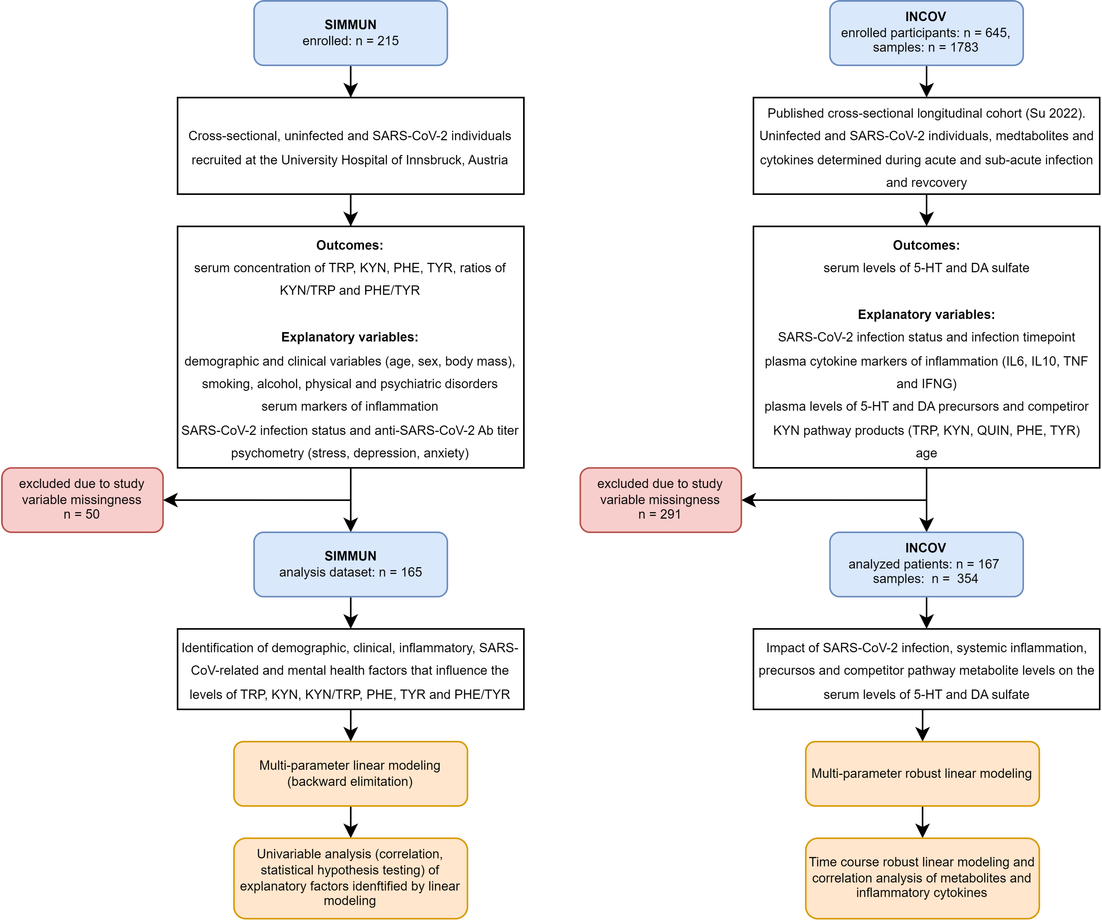

Figure 1: Flowchart of participants and paramters for the SIMMUN and INCOV cohorts and analysis strategy.

**Figure 1.** Flowchart of participants and paramters **for the SIMMUN and INCOV cohorts, and analysis strategy.**

*Sampling timepoints in the INCOV cohort: acute: median 10 days, sub-acute: median 14 days, recovery: median 64 days after diagnosis of SARS-CoV-2 infection via PCR.*

*TRP: tryptophan; KYN: kynurenine; PHE: phenylalanine; TYR: tyrosine; KYN/TRP: kynurenine - tryptophan ratio; PHE/TYR: phenylalanine - tyrosine ratio; QUIN: quinolinate; 5-HT: serotonin; DA: dopamine; Ab: antibody; IL6: interleukin-6; IL10: interleukin-10; TNF: tumor-necrosis factor alpha; IFNG: interferon gamma.*

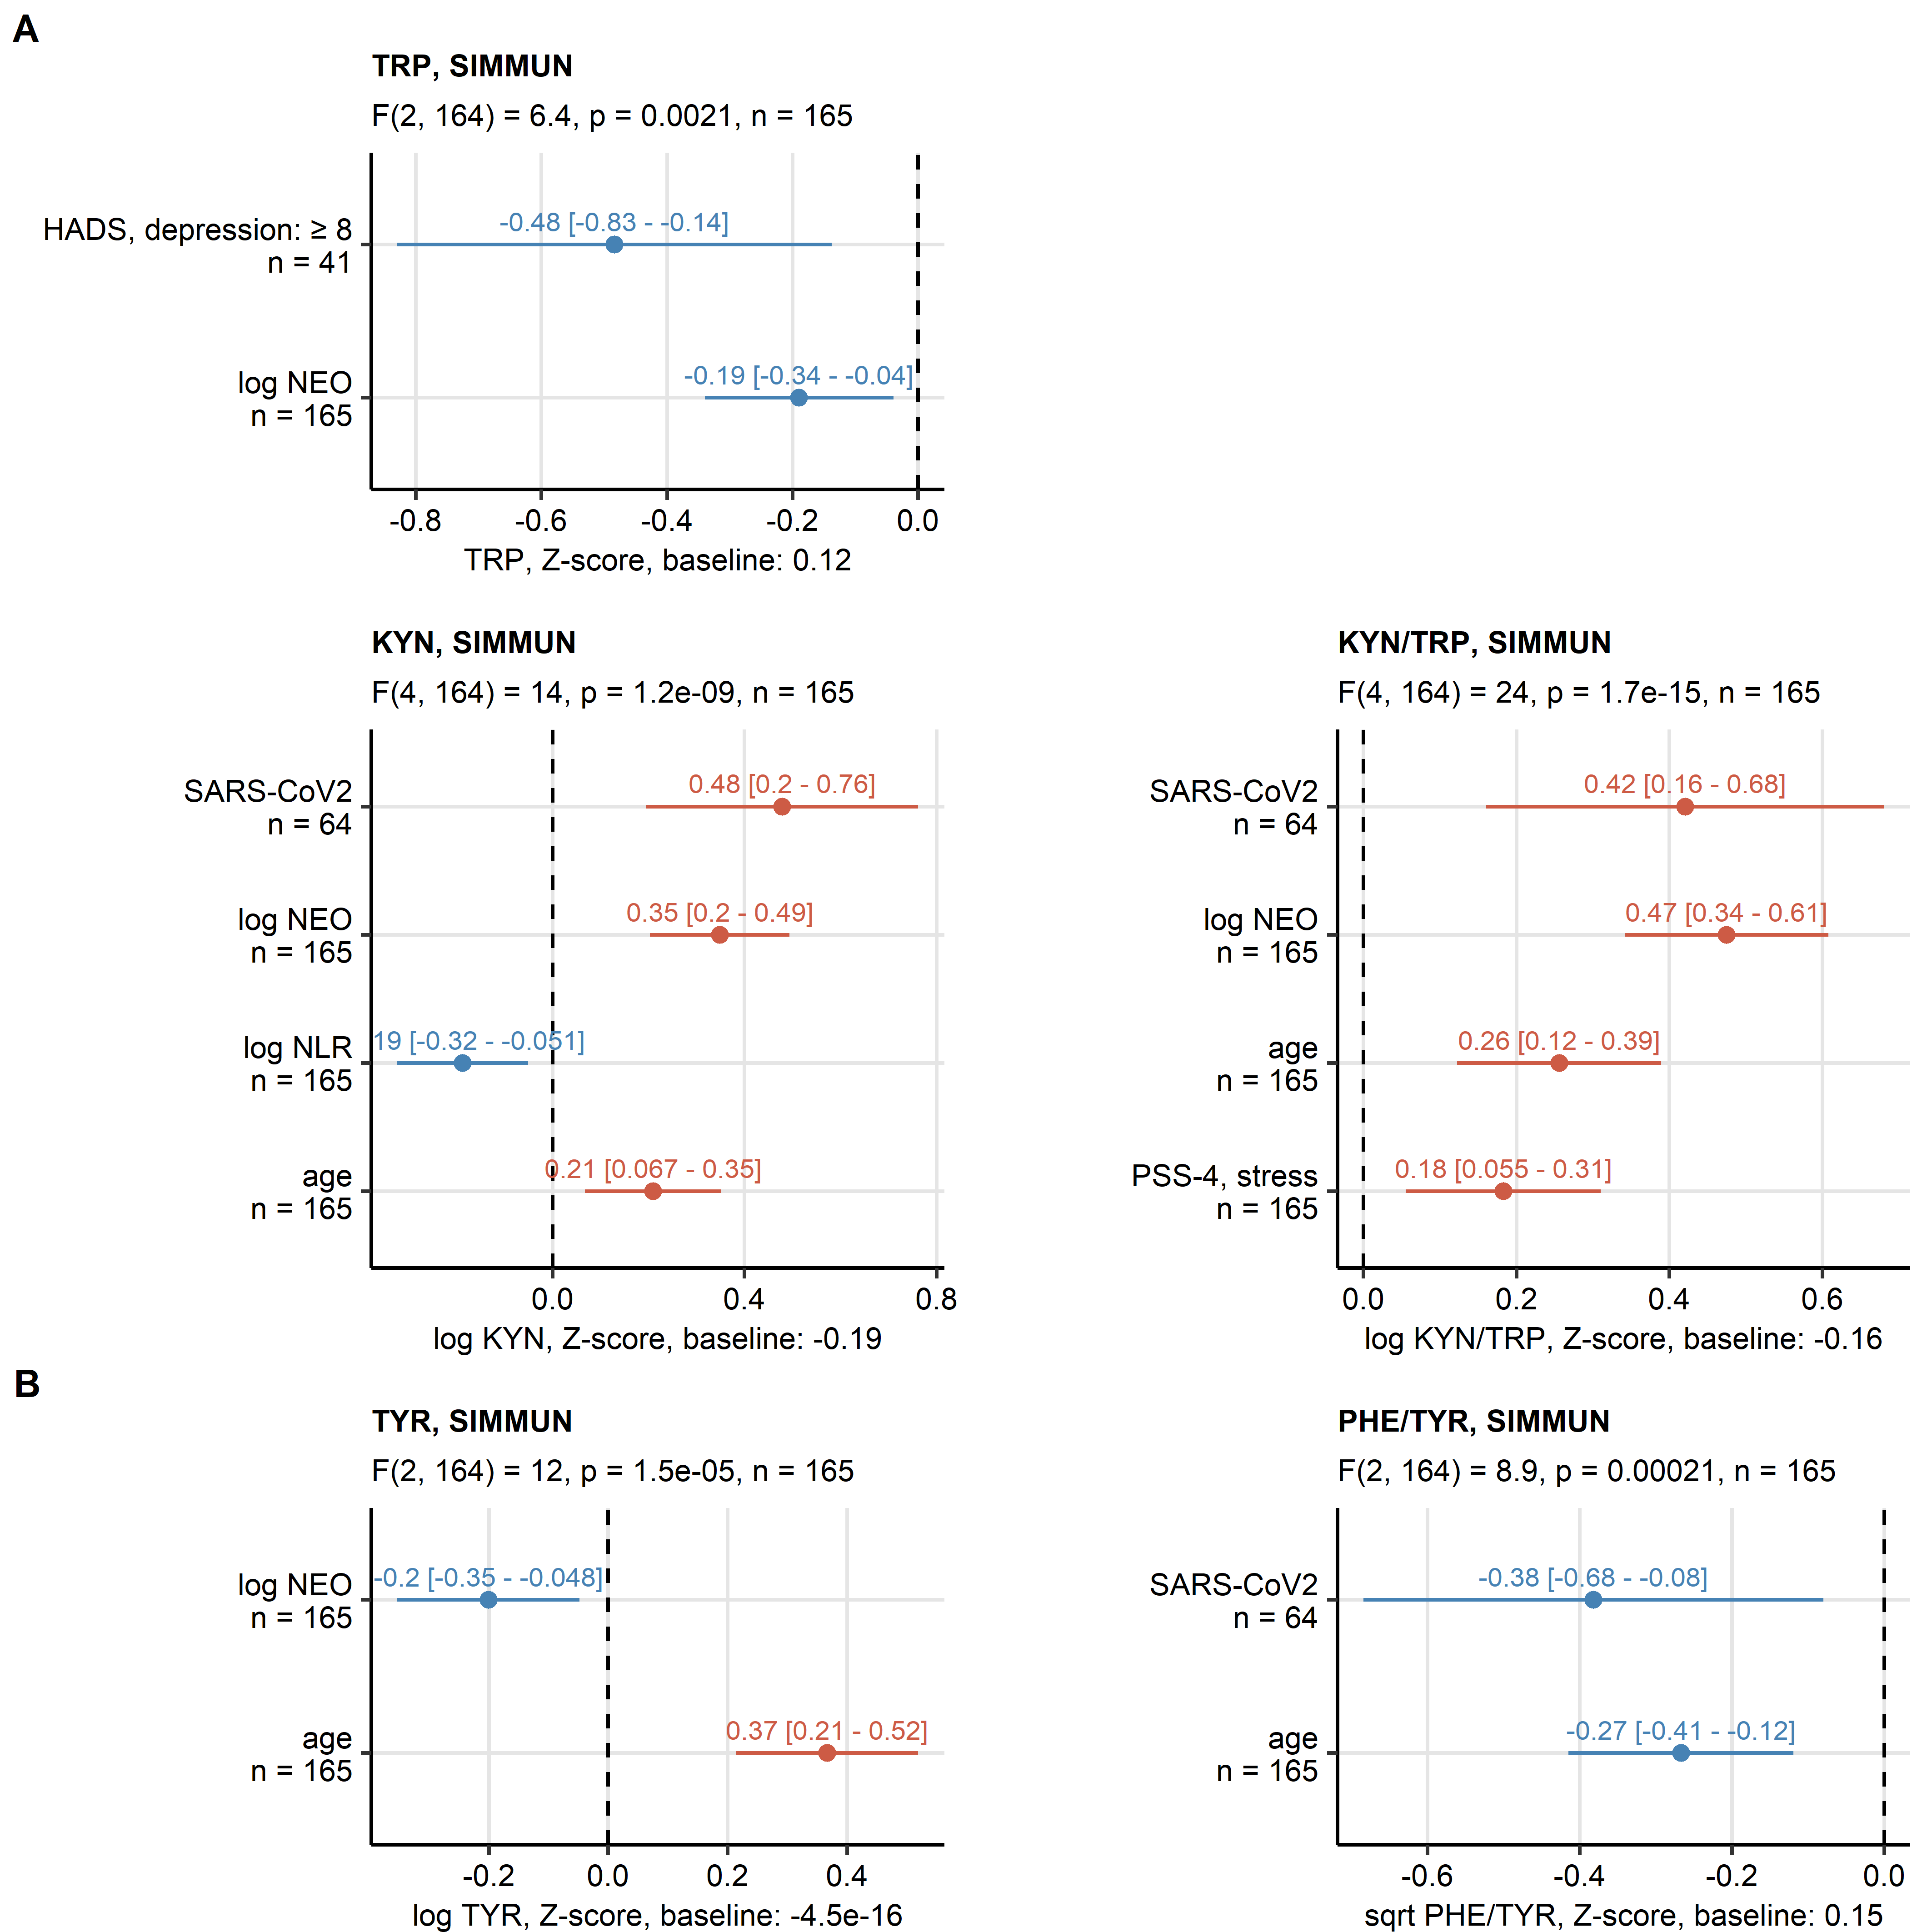

Figure 2: Results of multi-parameter linear modeling of tryptophan, kynurenine, kynurenine/tryptophan ratio, tyrosine and phenylalanine/tyrosine ratio in the SIMMUN cohort.

**Figure 2. Results of multi-parameter linear modeling of tryptophan, kynurenine, kynurenine/tryptophan ratio, tyrosine and phenylalanine/tyrosine ratio in the SIMMUN cohort.**

*Effects of markers of systemic inflammation (neopterin [NEO], neutrophil-lymphocyte ratio [NLR]), status post SARS-CoV-2 infection, titre of immunoglobulin gamma against the receptor binding domain of the S1/S2 SARS-CoV-2 protein (anti-RBD IgG), clinically relevant symptoms of anxiety and depression (hospital depression and anxiety scale [HADS] 8 points), level of mental stress (perceived stress scale, 4 item [PSS4]), age and sex on kynurenine and catecholamine pathways were investigated by multi-parameter linear regression with backward elimination of non-significant terms. Numeric variables were normalized prior to modeling. Overall model validity was assessed by likelihood-ratio test (LRT) as compared with the respective null models. Significant coefficient estimates () with 95% confidence intervals are presented in Forest plots. LRT results (F values, degrees of freedom and p values) and total numbers of complete observations are indicated in the plot captions. Model intercepts (baseline) are indicated in the X axis titles.*

*TRP: tryptophan; KYN: kynurenine; KYN/TRP: kynurenine - tryptophan ratio; PHE: phenylalanine; TYR: tyrosine; PHE/TYR: phenylalanine - tyrosine ratio.*

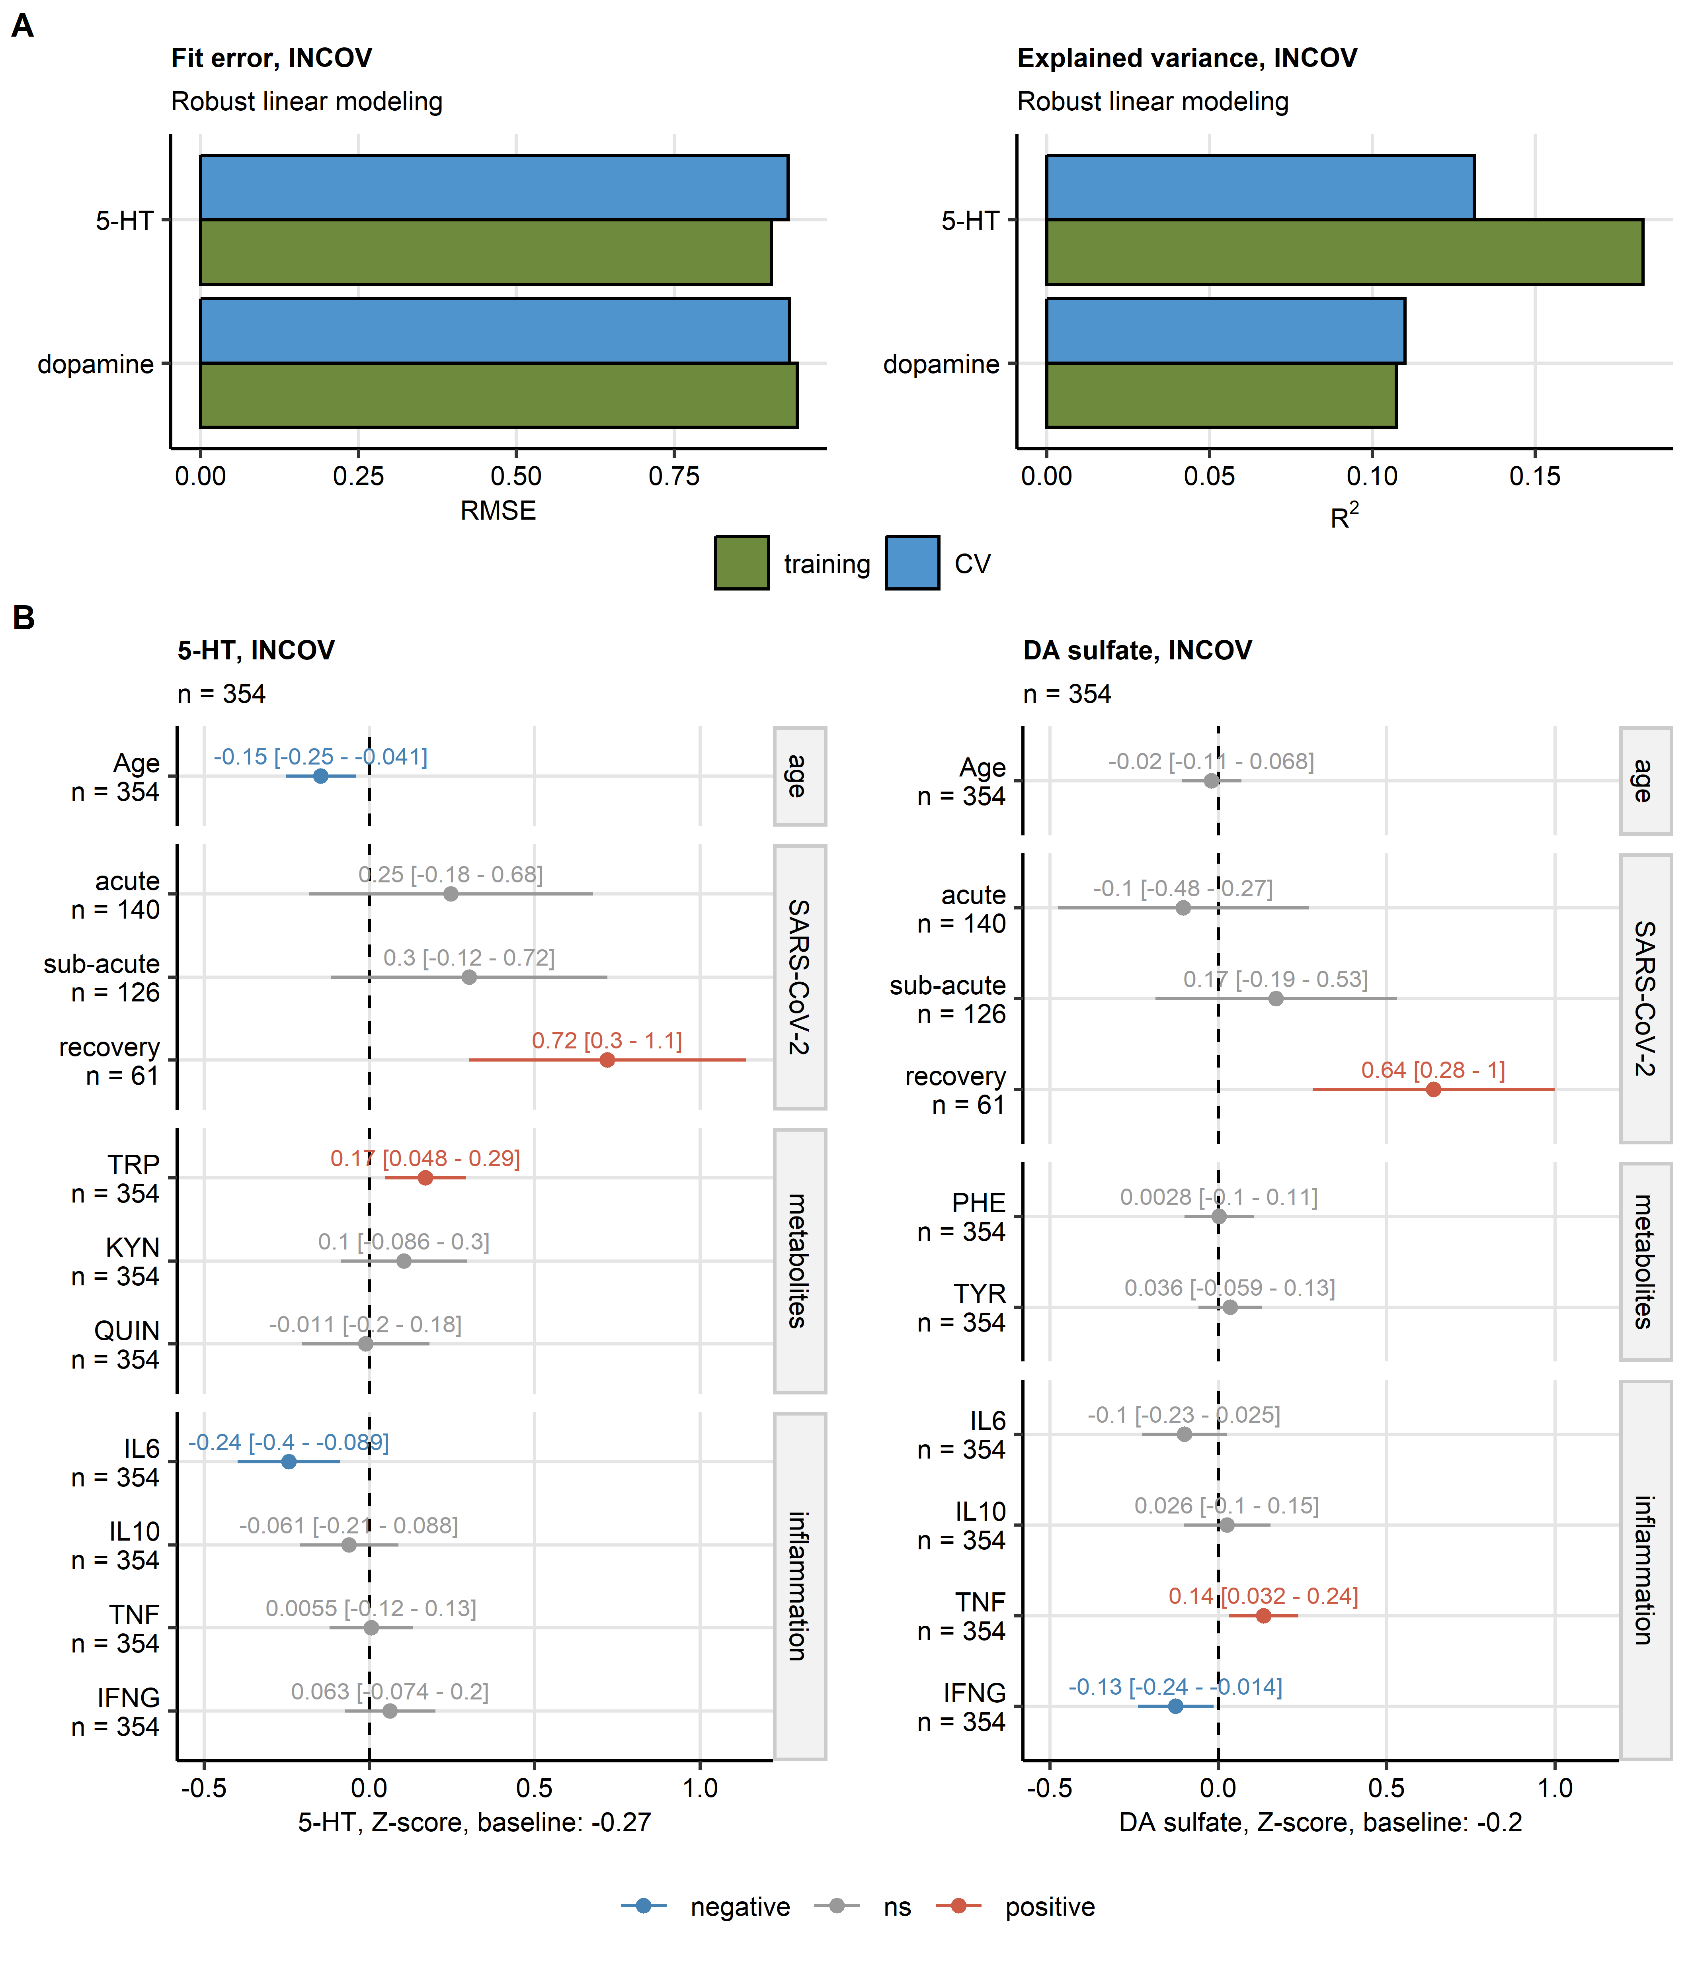

Figure 3: Results of multi-parameter robust linear modeling of plasma levels of serotonin and dopamine 3-O-sulfate in the INCOV cohort.

**Figure 3. Results of multi-parameter robust linear modeling of plasma levels of serotonin and dopamine 3-O-sulfate in the INCOV cohort.**

*Effects of age, timepoint following SARS-CoV-2 infection (acute: median 10 days, sub-acute: median 14 days, recovery: median 64 days after SARS-CoV-2 infection diagnosis via PCR as compared with uninfected controls), plasma levels of metabolites related to the kynurenine pathway affecting also tryptophan and the catecholamine pthway (tryptophan [TRP], kynurenine [KYN], quinolinate [QUIN], phenylalanine [PHE] and tyrosine [TYR]), and plasma concentrations of markers of inflammation (interleukin-6 [IL6], interleukin-10 [IL10], tumor necrosis factor-alpha [TNF] and interferon-gamma [IFNG]) on plasma concentrations of serotonin (5-hydroxy tryptamine [5-HT]) and dopamine 3-O-sulfate (DA sulfate) were modeled by multi-parameter robust linear regression.*

*(A) Model fit error (root mean square error [RMSE]) and fraction of explained variances (R-squared) of the robust linear models assessed in the genuine training dataset and 10-fold cross-validation (CV).*

*(B) Estimates of model coefficients () with 95% confidence intervals presented in Forest plots. Numbers of complete observations are indicated in the plot captions. Model intercepts (baseline) are indicated in the X axis titles.*

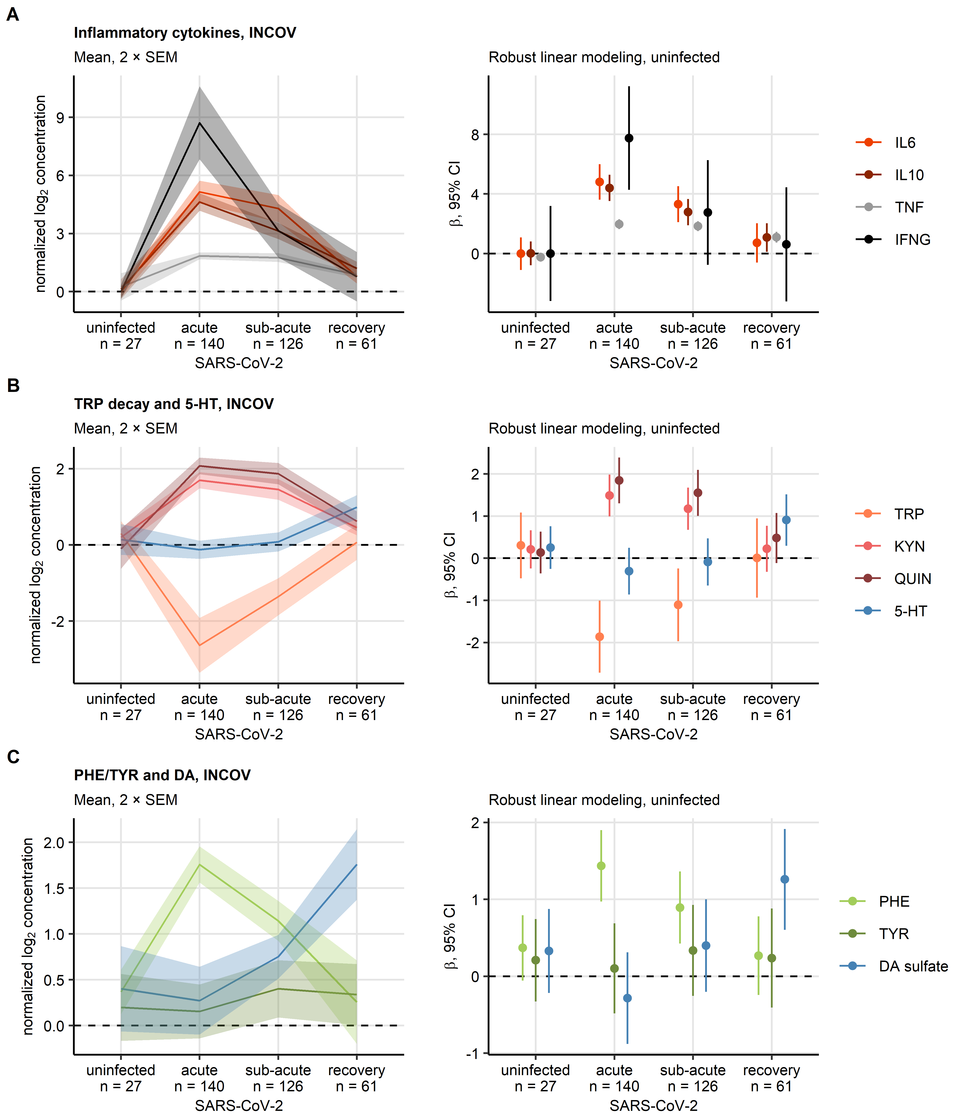

Figure 4: Time course of cytokine markers of inflammation, serotonin, dopamine 3-0-sulfate and the neurotransmitter biosynthesis precursors and kynurenine pathway products during SARS-CoV infection and recovery in the INCOV cohort.

**Figure 4. Time course of cytokine markers of inflammation, serotonin, dopamine 3-0-sulfate and the neurotransmitter precursor amino acids and kynurenine pathway metabolites during SARS-CoV infection and recovery in the INCOV cohort.**

*Time courses of normalized log2-transformed plasma concentrations of makers of inflammation (A, interleukin-6 [IL6], interleukin-10 [IL-10], tumor necrosis factor-alpha [TNF] and interferon gamma [INFG]), metabolites of the kynurenine pathway affecting also tryptophan (B, tryptophan [TRP], kynurenine [KYN], quinolinate [QUIN] and serotonin/5-hydroxy tryptamine [5-HT]) and metabolites of the catecholamine pathway (C, phenylalanine [PHE], tyrosine [TYR] and dopamine 3-O-sulfate [DA sulfate]). Differences between uninfected controls and acute, sub-acute SARS-CoV-2 infection and recovery (median 10, 14 and 64 days after SARS-CoV-2 infection diagnosis via PCR, respectively) were modeled by robust linear regression with the uninfected controls as baseline. Mean normalized concentrations with 2 standard errors of the mean (2 SEM) are depicted as solid lines with tinted ribbons (plots on the left). Robust linear model coefficient estimates () with 95% confidence intervals are visualized in Forest plots (right). Numbers of complete observations per timepoint are indicated in the X axes.*

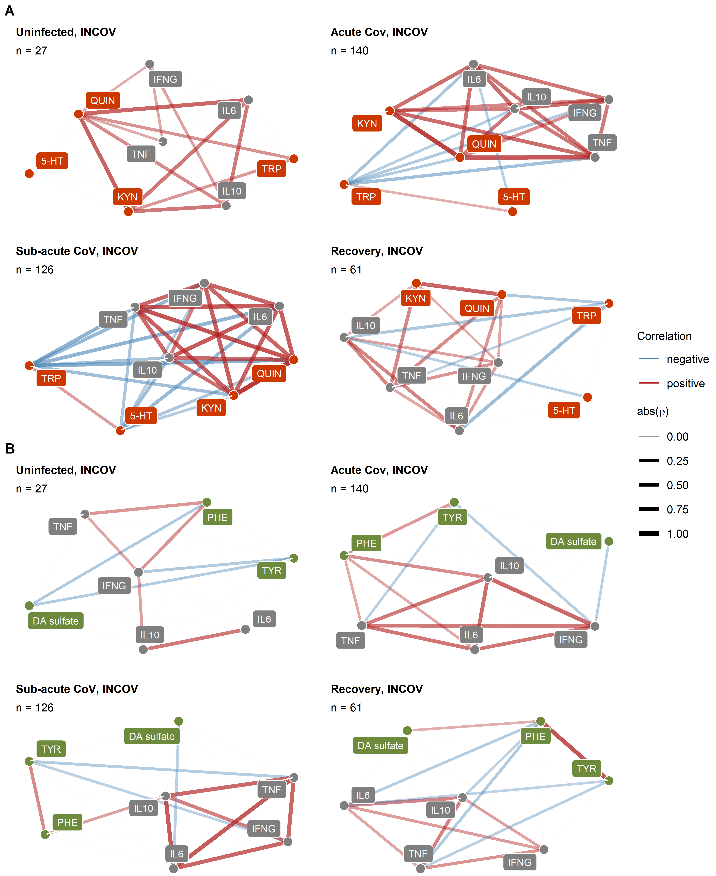

Figure 5: Correlation of plasma levels of cytokine markers of inflammation, serotonin and dopamine 3-O-sulfate, neurotransmitter precursors and kynurenine pathway products in healthy controls and SARS-CoV-2 patients of the INCOV cohort.

**Figure 5. Correlation of plasma levels of cytokine markers of inflammation, serotonin and dopamine 3-O-sulfate, neurotransmitter precursor amino acids and kynurenine pathway metabolites in uninfected controls and SARS-CoV-2 infected patients of the INCOV cohort.**

*Plasma levels of metabolites of the kynurenine pathway (kynurenine [KYN], quinolinic acid [QUIN]) affecting also serotonin synthesis (tryptophan [TRP], serotonin [5-hydroxy tryptamine, 5-HT]), and the catecholamine pahtway (phenylalanine [PHE], tyrosine [TYR], dopamine sulfate [DA sulfate]) and cytokine markers of inflammation (interleukin-6 [IL6], interleukin-10 [IL10], tumor necrosis factor-alpha [TNF], interferon-gamma [INFG]) were subjected to pairwise correlation analysis in uninfected and SARS-CoV-2-infected individuals (acute: median 10 days, sub-acute: median 14 days, recovery: median 64 days after SARS-CoV-2 infection diagnosis via PCR). Correlation coefficient matrices for correlation coefficients > 0.2 were visualized as force-directed network plots. Node color codes for the variable type (gray: inflammatory markers, orange: serotonin metabolism and KYN pathway, green: dopamine metabolism), edge width and color codes for the value and sign of the correlation coefficient.*

# References

1. Sorgdrager FJH, Naudé PJW, Kema IP, Nollen EA, De Deyn PP. Tryptophan metabolism in inflammaging: From biomarker to therapeutic target. *Frontiers in Immunology* (2019) 10:2565. doi: [10.3389/FIMMU.2019.02565/BIBTEX](https://doi.org/10.3389/FIMMU.2019.02565/BIBTEX)

2. Dantzer R, O’Connor JC, Freund GG, Johnson RW, Kelley KW. From inflammation to sickness and depression: when the immune system subjugates the brain. *Nature reviews Neuroscience* (2008) 9:46–56. doi: [10.1038/NRN2297](https://doi.org/10.1038/NRN2297)

3. Hüfner K, Fuchs D, Blauth M, Sperner-Unterweger B. How acute and chronic physical disease may influence mental health – An Analysis of neurotransmitter precursor amino acid levels. *Psychoneuroendocrinology* (2019) 106:95–101. doi: [10.1016/j.psyneuen.2019.03.028](https://doi.org/10.1016/j.psyneuen.2019.03.028)

4. Hüfner K, Galffy M, Egeter J, Giesinger JM, Arnhard K, Oberacher H, Gostner JM, Fuchs D, Sperner-Unterweger B. Acute and Chronic Mental Stress both Influence Levels of Neurotransmitter Precursor Amino Acids and Derived Biogenic Amines. *Brain Sciences* (2020) 10: doi: [10.3390/BRAINSCI10060322](https://doi.org/10.3390/BRAINSCI10060322)

5. Maes M, Berk M, Goehler L, Song C, Anderson G, Gałecki P, Leonard B. Depression and sickness behavior are Janus-faced responses to shared inflammatory pathways. *BMC Medicine* (2012) 10:1–19. doi: [10.1186/1741-7015-10-66/TABLES/1](https://doi.org/10.1186/1741-7015-10-66/TABLES/1)

6. Geisler S, Gostner JM, Becker K, Ueberall F, Fuchs D. Immune activation and inflammation increase the plasma phenylalanine-to- tyrosine ratio. *Pteridines* (2013) 24:27–31. doi: [10.1515/PTERID-2013-0001/MACHINEREADABLECITATION/RIS](https://doi.org/10.1515/PTERID-2013-0001/MACHINEREADABLECITATION/RIS)

7. Haroon E, Raison CL, Miller AH. Psychoneuroimmunology meets neuropsychopharmacology: Translational implications of the impact of inflammation on behavior. (2012) 37: doi: [10.1038/npp.2011.205](https://doi.org/10.1038/npp.2011.205)

8. Hüfner K, Oberguggenberger A, Kohl C, Geisler S, Gamper E, Meraner V, Egeter J, Hubalek M, Beer B, Fuchs D, et al. Levels in neurotransmitter precursor amino acids correlate with mental health in patients with breast cancer. *Psychoneuroendocrinology* (2015) 60:28–38. doi: [10.1016/J.PSYNEUEN.2015.06.001](https://doi.org/10.1016/J.PSYNEUEN.2015.06.001)

9. Brown SJ, Huang XF, Newell KA. The kynurenine pathway in major depression: What we know and where to next. *Neuroscience & Biobehavioral Reviews* (2021) 127:917–927. doi: [10.1016/J.NEUBIOREV.2021.05.018](https://doi.org/10.1016/J.NEUBIOREV.2021.05.018)

10. Schwarcz R, Bruno JP, Muchowski PJ, Wu HQ. Kynurenines in the mammalian brain: When physiology meets pathology. (2012) 13: doi: [10.1038/nrn3257](https://doi.org/10.1038/nrn3257)

11. Badawy AAB. Kynurenine pathway of tryptophan metabolism: Regulatory and functional aspects. *International Journal of Tryptophan Research* (2017) 10: doi: [10.1177/1178646917691938/ASSET/IMAGES/LARGE/10.1177_1178646917691938-FIG2.JPEG](https://doi.org/10.1177/1178646917691938/ASSET/IMAGES/LARGE/10.1177_1178646917691938-FIG2.JPEG)

12. Lukić I, Ivković S, Mitić M, Adžić M. Tryptophan metabolites in depression: Modulation by gut microbiota. *Frontiers in Behavioral Neuroscience* (2022) 16:367. doi: [10.3389/FNBEH.2022.987697/BIBTEX](https://doi.org/10.3389/FNBEH.2022.987697/BIBTEX)

13. Robinson CM, Shirey KA, Carlin JM. Synergistic Transcriptional Activation of Indoleamine Dioxygenase by IFN- and Tumor Necrosis Factor-. *Journal of interferon & cytokine research : the official journal of the International Society for Interferon and Cytokine Research* (2003) 23:413. doi: [10.1089/107999003322277829](https://doi.org/10.1089/107999003322277829)

14. Dai W, Gupta SL. Regulation of indoleamine 2,3-dioxygenase gene expression in human fibroblasts by interferon-gamma. Upstream control region discriminates between interferon-gamma and interferon-alpha. *Journal of Biological Chemistry* (1990) 265:19871–19877. doi: [10.1016/S0021-9258(17)45453-6](https://doi.org/10.1016/S0021-9258(17)45453-6)

15. Litzenburger UM, Opitz CA, Sahm F, Rauschenbach KJ, Trump S, Winter M, Ott M, Ochs K, Lutz C, Liu X, et al. Constitutive IDO expression in human cancer is sustained by an autocrine signaling loop involving IL-6, STAT3 and the AHR. *Oncotarget* (2014) 5:1038–1051. doi: [10.18632/ONCOTARGET.1637](https://doi.org/10.18632/ONCOTARGET.1637)

16. Vancassel S, Capuron L, Castanon N. Brain Kynurenine and BH4 Pathways: Relevance to the Pathophysiology and Treatment of Inflammation-Driven Depressive Symptoms. (2018) 12:499. doi: [10.3389/fnins.2018.00499](https://doi.org/10.3389/fnins.2018.00499)

17. Marx W, McGuinness AJ, Rocks T, Ruusunen A, Cleminson J, Walker AJ, Gomes-da-Costa S, Lane M, Sanches M, Diaz AP, et al. The kynurenine pathway in major depressive disorder, bipolar disorder, and schizophrenia: a meta-analysis of 101 studies. *Molecular Psychiatry 2020 26:8* (2020) 26:4158–4178. doi: [10.1038/s41380-020-00951-9](https://doi.org/10.1038/s41380-020-00951-9)

18. Hunt C, Macedo e Cordeiro T, Suchting R, Dios C de, Cuellar Leal VA, Soares JC, Dantzer R, Teixeira AL, Selvaraj S. Effect of immune activation on the kynurenine pathway and depression symptoms – A systematic review and meta-analysis. (2020) 118: doi: [10.1016/j.neubiorev.2020.08.010](https://doi.org/10.1016/j.neubiorev.2020.08.010)

19. Fellendorf FT, Bonkat N, Dalkner N, Schönthaler EMD, Manchia M, Fuchs D, Reininghaus EZ. Indoleamine 2,3-dioxygenase (IDO)-activity in Severe Psychiatric Disorders: A Systemic Review. *Current Topics in Medicinal Chemistry* (2022) 22: doi: [10.2174/1568026622666220718155616](https://doi.org/10.2174/1568026622666220718155616)

20. Hüfner K, Giesinger JM, Gostner JM, Egeter J, Koudouovoh-Tripp P, Vill T, Fuchs D, Sperner-Unterweger B. Neurotransmitter Precursor Amino Acid Ratios Show Differential, Inverse Correlations with Depression Severity in the Low and High Depression Score Range. *International Journal of Tryptophan Research : IJTR* (2021) 14: doi: [10.1177/11786469211039220](https://doi.org/10.1177/11786469211039220)

21. Paul-Savoie É, Potvin S, Daigle K, Normand E, Corbin JF, Gagnon R, Marchand S. A deficit in peripheral serotonin levels in major depressive disorder but not in chronic widespread pain. *The Clinical journal of pain* (2011) 27:529–534. doi: [10.1097/AJP.0B013E31820DFEDE](https://doi.org/10.1097/AJP.0B013E31820DFEDE)

22. Capuron L, Schroecksnadel S, Féart C, Aubert A, Higueret D, Barberger-Gateau P, Layé S, Fuchs D. Chronic low-grade inflammation in elderly persons is associated with altered tryptophan and tyrosine metabolism: role in neuropsychiatric symptoms. *Biological psychiatry* (2011) 70:175–182. doi: [10.1016/J.BIOPSYCH.2010.12.006](https://doi.org/10.1016/J.BIOPSYCH.2010.12.006)

23. Meiser J, Weindl D, Hiller K. Complexity of dopamine metabolism. *Cell Communication and Signaling* (2013) 11:1–18. doi: [10.1186/1478-811X-11-34/FIGURES/5](https://doi.org/10.1186/1478-811X-11-34/FIGURES/5)

24. Fanet H, Capuron L, Castanon N, Calon F, Vancassel S. Tetrahydrobioterin (BH4) Pathway: From Metabolism to Neuropsychiatry. *Current neuropharmacology* (2021) 19:591–609. doi: [10.2174/1570159X18666200729103529](https://doi.org/10.2174/1570159X18666200729103529)

25. Neurauter G, Schrocksnadel K, Scholl-Burgi S, Sperner-Unterweger B, Schubert C, Ledochowski M, Fuchs D. Chronic immune stimulation correlates with reduced phenylalanine turnover. *Current drug metabolism* (2008) 9:622–627. doi: [10.2174/138920008785821738](https://doi.org/10.2174/138920008785821738)

26. Huang C, Huang L, Wang Y, Li X, Ren L, Gu X, Kang L, Guo L, Liu M, Zhou X, et al. 6-month consequences of COVID-19 in patients discharged from hospital: a cohort study. *The Lancet* (2021) 397:220–232. doi: [10.1016/S0140-6736(20)32656-8](https://doi.org/10.1016/S0140-6736(20)32656-8)

27. Al-Aly Z, Xie Y, Bowe B. High-dimensional characterization of post-acute sequelae of COVID-19. *Nature* (2021) 594:259–264. doi: [10.1038/s41586-021-03553-9](https://doi.org/10.1038/s41586-021-03553-9)

28. Hüfner K, Tymoszuk P, Ausserhofer D, Sahanic S, Pizzini A, Rass V, Galffy M, Böhm A, Kurz K, Sonnweber T, et al. Who Is at Risk of Poor Mental Health Following Coronavirus Disease-19 Outpatient Management? *Frontiers in Medicine* (2022) 9: doi: [10.3389/fmed.2022.792881](https://doi.org/10.3389/fmed.2022.792881)

29. Sahanic S, Tymoszuk P, Luger AK, Hüfner K, Boehm A, Pizzini A, Schwabl C, Koppelstätter S, Kurz K, Asshoff M, et al. COVID-19 and its continuing burden after 12 months: a longitudinal observational prospective multicentre trial. *ERJ open research* (2023) 9:00317–2022. doi: [10.1183/23120541.00317-2022](https://doi.org/10.1183/23120541.00317-2022)

30. Staudt A, Jörres RA, Hinterberger T, Lehnen N, Loew T, Budweiser S. Associations of Post-Acute COVID syndrome with physiological and clinical measures 10 months after hospitalization in patients of the first wave. *European Journal of Internal Medicine* (2022) 95: doi: [10.1016/j.ejim.2021.10.031](https://doi.org/10.1016/j.ejim.2021.10.031)

31. Gietl M, Burkert F, Seiwald S, Böhm A, Hofer S, Gostner JM, Piater T, Geisler S, Weiss G, Loeffler-Ragg J, et al. Interferon-gamma Mediated Metabolic Pathways in Hospitalized Patients During Acute and Reconvalescent COVID-19. *International Journal of Tryptophan Research : IJTR* (2023) 16: doi: [10.1177/11786469231154244](https://doi.org/10.1177/11786469231154244)

32. Lionetto L, Ulivieri M, Capi M, De Bernardini D, Fazio F, Petrucca A, Pomes LM, De Luca O, Gentile G, Casolla B, et al. Increased kynurenine-to-tryptophan ratio in the serum of patients infected with SARS-CoV2: An observational cohort study. *Biochimica et biophysica acta Molecular basis of disease* (2021) 1867: doi: [10.1016/J.BBADIS.2020.166042](https://doi.org/10.1016/J.BBADIS.2020.166042)

33. Santiago-Mujika E, Heinrich K, George S, Forton C, Madaj Z, Burmeister AR, Sims M, Pospisilik A, Brundin P, Graham SF, et al. Increased levels of circulating neurotoxic metabolites in patients with mild Covid19. *bioRxiv* (2022)2022.06.22.497189. doi: [10.1101/2022.06.22.497189](https://doi.org/10.1101/2022.06.22.497189)

34. Luporini RL, Pott-Junior H, Di Medeiros Leal MCB, Castro A, Ferreira AG, Cominetti MR, de Freitas Anibal F. Phenylalanine and COVID-19: Tracking disease severity markers. *International Immunopharmacology* (2021) 101:108313. doi: [10.1016/J.INTIMP.2021.108313](https://doi.org/10.1016/J.INTIMP.2021.108313)

35. Bizjak DA, Stangl M, Börner N, Bösch F, Durner J, Drunin G, Buhl JL, Abendroth D. Kynurenine serves as useful biomarker in acute, Long- and Post-COVID-19 diagnostics. *Frontiers in immunology* (2022) 13: doi: [10.3389/FIMMU.2022.1004545](https://doi.org/10.3389/FIMMU.2022.1004545)

36. Dewulf JP, Martin M, Marie S, Oguz F, Belkhir L, De Greef J, Yombi JC, Wittebole X, Laterre PF, Jadoul M, et al. Urine metabolomics links dysregulation of the tryptophan-kynurenine pathway to inflammation and severity of COVID-19. *Scientific reports* (2022) 12: doi: [10.1038/S41598-022-14292-W](https://doi.org/10.1038/S41598-022-14292-W)

37. Saito K, Ishikawa R, Kitamura I, Ogawa K, Arakawa N, Sun Y, Imai K, Maeda T, Saito Y, Hasegawa C. Characterization of serotonin as a candidate biomarker of severity and prognosis of COVID-19 using LC/MS analysis. *Journal of Pharmacological Sciences* (2022) 150:49–55. doi: [10.1016/J.JPHS.2022.06.005](https://doi.org/10.1016/J.JPHS.2022.06.005)

38. Bower JE, Radin A, Kuhlman KR. Psychoneuroimmunology in the time of COVID-19: Why neuro-immune interactions matter for mental and physical health. *Behaviour Research and Therapy* (2022) 154:104104. doi: [10.1016/J.BRAT.2022.104104](https://doi.org/10.1016/J.BRAT.2022.104104)

39. Kucukkarapinar M, Yay-Pence A, Yildiz Y, Buyukkoruk M, Yaz-Aydin G, Deveci-Bulut TS, Gulbahar O, Senol E, Candansayar S. Psychological outcomes of COVID-19 survivors at sixth months after diagnose: the role of kynurenine pathway metabolites in depression, anxiety, and stress. *Journal of Neural Transmission* (2022) 129: doi: [10.1007/s00702-022-02525-1](https://doi.org/10.1007/s00702-022-02525-1)

40. Matits L, Munk M, Bizjak DA, Kolassa IT, Karrasch S, Vollrath S, Jerg A, Steinacker JM. Inflammation and severity of depressive symptoms in physically active individuals after COVID-19 - An exploratory immunopsychological study investigating the effect of inflammation on depressive symptom severity. *Brain, behavior, & immunity - health* (2023) 30: doi: [10.1016/J.BBIH.2023.100614](https://doi.org/10.1016/J.BBIH.2023.100614)

41. Su Y, Yuan D, Chen DG, Ng RH, Wang K, Choi J, Li S, Hong S, Zhang R, Xie J, et al. Multiple early factors anticipate post-acute COVID-19 sequelae. *Cell* (2022) 185:881–895.e20. doi: [10.1016/J.CELL.2022.01.014](https://doi.org/10.1016/J.CELL.2022.01.014)

42. Widner B, Werner ER, Schennach H, Wachter H, Fuchs D. Simultaneous measurement of serum tryptophan and kynurenine by HPLC. *Clinical Chemistry* (1997) 43:2424–2426. doi: [10.1093/CLINCHEM/43.12.2424](https://doi.org/10.1093/CLINCHEM/43.12.2424)

43. Deisenhammer F, Bauer A, Kavelar C, Rudzki D, Rössler A, Kimpel J, Borena W, Reindl M. 12-month SARS-CoV-2 antibody persistency in a Tyrolean COVID-19 cohort. *Wiener klinische Wochenschrift* (2021) 133:1265–1271. doi: [10.1007/S00508-021-01985-X](https://doi.org/10.1007/S00508-021-01985-X)

44. Cohen S, Kamarck T, Mermelstein R. A global measure of perceived stress. *Journal of health and social behavior* (1983) 24:385–396. doi: [10.2307/2136404](https://doi.org/10.2307/2136404)

45. Zigmond AS, Snaith RP. The hospital anxiety and depression scale. *Acta psychiatrica Scandinavica* (1983) 67:361–370. doi: [10.1111/J.1600-0447.1983.TB09716.X](https://doi.org/10.1111/J.1600-0447.1983.TB09716.X)

46. Bjelland I, Dahl AA, Haug TT, Neckelmann D. The validity of the Hospital Anxiety and Depression Scale: An updated literature review. *Journal of Psychosomatic Research* (2002) 52:69–77. doi: [10.1016/S0022-3999(01)00296-3](https://doi.org/10.1016/S0022-3999(01)00296-3)

47. Su Y, Chen D, Yuan D, Lausted C, Choi J, Dai CL, Voillet V, Duvvuri VR, Scherler K, Troisch P, et al. Multi-Omics Resolves a Sharp Disease-State Shift between Mild and Moderate COVID-19. *Cell* (2020) 183:1479. doi: [10.1016/J.CELL.2020.10.037](https://doi.org/10.1016/J.CELL.2020.10.037)

48. Sun Y, Drevets W, Turecki G, Li QS. The relationship between plasma serotonin and kynurenine pathway metabolite levels and the treatment response to escitalopram and desvenlafaxine. *Brain, Behavior, and Immunity* (2020) 87:404–412. doi: [10.1016/J.BBI.2020.01.011](https://doi.org/10.1016/J.BBI.2020.01.011)

49. Tateishi H, Setoyama D, Kang D, Matsushima J, Kojima R, Fujii Y, Mawatari S, Kikuchi J, Sakemura Y, Fukuchi J, et al. The changes in kynurenine metabolites induced by rTMS in treatment-resistant depression: A pilot study. *Journal of psychiatric research* (2021) 138:194–199. doi: [10.1016/J.JPSYCHIRES.2021.04.009](https://doi.org/10.1016/J.JPSYCHIRES.2021.04.009)

50. Holck A, Wolkowitz OM, Mellon SH, Reus VI, Nelson JC, Westrin Å, Lindqvist D. Plasma serotonin levels are associated with antidepressant response to SSRIs. *Journal of affective disorders* (2019) 250:65–70. doi: [10.1016/J.JAD.2019.02.063](https://doi.org/10.1016/J.JAD.2019.02.063)

51. Hashizume K, Yamatodani A, Yamamoto T, Ogihara T, Kumahara Y, Wada H. Effects of oral and intravenous administrations of dopamine and L-dopa on plasma levels of two isomers of dopamine sulfate in man. *Life sciences* (1987) 41:2697–2704. doi: [10.1016/0024-3205(87)90462-0](https://doi.org/10.1016/0024-3205(87)90462-0)

52. Goldstein DS, Swoboda KJ, Miles JM, Coppack SW, Aneman A, Holmes C, Lamensdorf I, Eisenhofer G. Sources and physiological significance of plasma dopamine sulfate. *The Journal of clinical endocrinology and metabolism* (1999) 84:2523–2531. doi: [10.1210/JCEM.84.7.5864](https://doi.org/10.1210/JCEM.84.7.5864)

53. McDonald RP. *Test theory: A unified treatment*. 1st Editio. New Yor: Psychology Press (1999). doi: [10.4324/9781410601087](https://doi.org/10.4324/9781410601087)

54. BARTLETT MS. THE STATISTICAL CONCEPTION OF MENTAL FACTORS. *British Journal of Psychology General Section* (1937) 28:97–104. doi: [10.1111/j.2044-8295.1937.tb00863.x](https://doi.org/10.1111/j.2044-8295.1937.tb00863.x)

55. Revelle W. Package ’psych’ - Procedures for Psychological, Psychometric and Personality Research. *R Package* (2015)1–358. [https://cran.r-project.org/web/packages/psych/index.html http://personality-project.org/r/psych-manual.pdf](https://cran.r-project.org/web/packages/psych/index.html%20http://personality-project.org/r/psych-manual.pdf)

56. Benjamini Y, Hochberg Y. Controlling the False Discovery Rate: A Practical and Powerful Approach to Multiple Testing. *Journal of the Royal Statistical Society: Series B (Methodological)* (1995) 57:289–300. doi: [10.1111/j.2517-6161.1995.tb02031.x](https://doi.org/10.1111/j.2517-6161.1995.tb02031.x)

57. Cohen J. Statistical Power Analysis for the Behavioral Sciences. *Statistical Power Analysis for the Behavioral Sciences* (2013) doi: [10.4324/9780203771587](https://doi.org/10.4324/9780203771587)

58. Kassambara A. rstatix: Pipe-Friendly Framework for Basic Statistical Tests. (2021) <https://cran.r-project.org/package=rstatix>

59. Huber PJ. Robust Statistics. *International Encyclopedia of Statistical Science* (2011)1248–1251. doi: [10.1007/978-3-642-04898-2_594](https://doi.org/10.1007/978-3-642-04898-2_594)

60. Ripley B. MASS: Support Functions and Datasets for Venables and Ripley’s MASS. (2022) <https://cran.r-project.org/package=MASS>

61. Kuhn M. Building predictive models in R using the caret package. *Journal of Statistical Software* (2008) 28:1–26. doi: [10.18637/jss.v028.i05](https://doi.org/10.18637/jss.v028.i05)

62. Csardi G, Nepusz T. The igraph software package for complex network research. *InterJournal* (2006) Complex Sy:1695. <https://igraph.org>

63. Briatte F, Bojanowski M, Canouil M, Charlop-Powers Z, Fisher JC, Johnson K, Rinker T. ggnetwork: Geometries to Plot Networks with ’ggplot2’. (2021) <https://cran.r-project.org/package=ggnetwork>

64. Moncrieff J, Cooper RE, Stockmann T, Amendola S, Hengartner MP, Horowitz MA. The serotonin theory of depression: a systematic umbrella review of the evidence. *Molecular Psychiatry 2022* (2022)1–14. doi: [10.1038/s41380-022-01661-0](https://doi.org/10.1038/s41380-022-01661-0)

65. Lin H, Liu X, Sun H, Zhang J, Dong S, Liu M, Li L, Tian J, Guo Y, Gan J, et al. Sustained abnormality with recovery of COVID-19 convalescents: a 2-year follow-up study. *Science Bulletin* (2022) 67:1556. doi: [10.1016/J.SCIB.2022.06.025](https://doi.org/10.1016/J.SCIB.2022.06.025)

66. Sathyasaikumar KV, Notarangelo FM, Kelly DL, Rowland LM, Hare SM, Chen S, Mo C, Buchanan RW, Schwarcz R. Tryptophan Challenge in Healthy Controls and People with Schizophrenia: Acute Effects on Plasma Levels of Kynurenine, Kynurenic Acid and 5-Hydroxyindoleacetic Acid. *Pharmaceuticals 2022, Vol 15, Page 1003* (2022) 15:1003. doi: [10.3390/PH15081003](https://doi.org/10.3390/PH15081003)

67. Cysique LA, Jakabek D, Bracken SG, Allen-Davidian Y, Heng B, Chow S, Dehhaghi M, Pires AS, Darley DR, Byrne A, et al. Post-acute COVID-19 cognitive impairment and decline uniquely associate with kynurenine pathway activation: a longitudinal observational study. *medRxiv* (2022)2022.06.07.22276020. doi: [10.1101/2022.06.07.22276020](https://doi.org/10.1101/2022.06.07.22276020)

68. Werner ER, Werner-Felmayer G, Fuchs D, Hausen A, Reibnegger G, Yim JJ, Pfleiderer W, Wachter H. Tetrahydrobiopterin biosynthetic activities in human macrophages, fibroblasts, THP-1, and T 24 cells. GTP-cyclohydrolase I is stimulated by interferon-gamma, and 6-pyruvoyl tetrahydropterin synthase and sepiapterin reductase are constitutively present. *Journal of Biological Chemistry* (1990) 265:3189–3192. doi: [10.1016/S0021-9258(19)39752-2](https://doi.org/10.1016/S0021-9258(19)39752-2)

69. Werner-Felmayer G, Prast H, Werner ER, Philippu A, Wachter H. Induction of GTP cyclohydrolase I by bacterial lipopolysaccharide in the rat. *FEBS letters* (1993) 322:223–226. doi: [10.1016/0014-5793(93)81574-J](https://doi.org/10.1016/0014-5793(93)81574-J)

70. Huber C, Richard Batchelor J, Fuchs D, Hausen A, Lang A, Niederwieser D, Reibnegger G, Swetly P, Troppmair J, Wachter H. Immune response-associated production of neopterin. Release from macrophages primarily under control of interferon-gamma. *The Journal of experimental medicine* (1984) 160:310–316. doi: [10.1084/JEM.160.1.310](https://doi.org/10.1084/JEM.160.1.310)

71. Valdiglesias V, Marcos-Pérez D, Lorenzi M, Onder G, Gostner JM, Strasser B, Fuchs D, Bonassi S. Immunological alterations in frail older adults: A cross sectional study. *Experimental gerontology* (2018) 112:119–126. doi: [10.1016/J.EXGER.2018.09.010](https://doi.org/10.1016/J.EXGER.2018.09.010)

72. Marttila S, Jylhävä J, Eklund C, Hervonen A, Jylhä M, Hurme M. Aging-associated increase in indoleamine 2,3-dioxygenase (IDO) activity appears to be unrelated to the transcription of the IDO1 or IDO2 genes in peripheral blood mononuclear cells. *Immunity & Ageing : I & A* (2011) 8:9. doi: [10.1186/1742-4933-8-9](https://doi.org/10.1186/1742-4933-8-9)

73. Peters R. Ageing and the brain. *Postgraduate medical journal* (2006) 82:84–88. doi: [10.1136/PGMJ.2005.036665](https://doi.org/10.1136/PGMJ.2005.036665)

74. Ertugrul A, Ucar G, Basar K, Demir B, Yabanoglu S, Ulug B. Influence of clozapine on platelet serotonin, monoamine oxidase and plasma serotonin levels. *Psychiatry research* (2007) 149:49–57. doi: [10.1016/J.PSYCHRES.2005.12.009](https://doi.org/10.1016/J.PSYCHRES.2005.12.009)

75. Tyano S, Zalsman G, Ofek H, Blum I, Apter A, Wolovik L, Sher L, Sommerfeld E, Harell D, Weizman A. Plasma serotonin levels and suicidal behavior in adolescents. *European neuropsychopharmacology : the journal of the European College of Neuropsychopharmacology* (2006) 16:49–57. doi: [10.1016/J.EURONEURO.2005.05.005](https://doi.org/10.1016/J.EURONEURO.2005.05.005)

76. Miller AH, Raison CL. The role of inflammation in depression: from evolutionary imperative to modern treatment target. *Nature reviews Immunology* (2016) 16:22–34. doi: [10.1038/NRI.2015.5](https://doi.org/10.1038/NRI.2015.5)

77. Miller CL, Llenos IC, Cwik M, Walkup J, Weis S. Alterations in kynurenine precursor and product levels in schizophrenia and bipolar disorder. *Neurochemistry International* (2008) 52:1297–1303. doi: [10.1016/J.NEUINT.2008.01.013](https://doi.org/10.1016/J.NEUINT.2008.01.013)

78. Clark SM, Pocivavsek A, Nicholson JD, Notarangelo FM, Langenberg P, McMahon RP, Kleinman JE, Hyde TM, Stiller J, Postolache TT, et al. Reduced kynurenine pathway metabolism and cytokine expression in the prefrontal cortex of depressed individuals. *Journal of Psychiatry and Neuroscience* (2016) 41:386–394. doi: [10.1503/JPN.150226](https://doi.org/10.1503/JPN.150226)