The effect of inflammation, SARS-CoV-2 infection, age and mental health on serotonin, and kynurenine and catecholamine pathway metabolites

Supplementary Material

PSY Team

2023-07-18

# Supplementary Methods

## Software

Study data were analyzed with R version 4.2.3. Import and general data transformation tasks were accomplished with *foreign* (R Core Team et al., 2022), *readxl* (Wickham et al., 2022), the *tidyverse* package bundle (Wickham et al., 2019), *rlang* (Henry and Wickham, 2022) and the development package [*trafo*](https://github.com/PiotrTymoszuk/trafo). Text data was handled with *stringi* (Gagolewski and Tartanus, 2021).

Descriptive statistics, statistical hypothesis testing and correlation analysis were done with the packages *rstatix* (Kassambara, 2021) and [*ExDA*](https://github.com/PiotrTymoszuk/ExDA). For linear modeling and robust linear modeling, base R functions, the packages *stats*, *MASS* (Ripley, 2022), *caret* (Kuhn, 2008), [*lmqc*](https://github.com/PiotrTymoszuk/lmqc) and [*caretExtra*](https://github.com/PiotrTymoszuk/caretExtra) were employed. Correlation matrices were converted to force-directed graphs with *igraph* (Csardi and Nepusz, 2006). For factor analysis and assessment of psychometric tool consistency, *stats*, *psych* (Revelle, 2015) and [*clustTools*](https://github.com/PiotrTymoszuk/clustTools) were used.

Results were visualized with tools provided by the packages *ggplot2* (Wickham, 2016) (ribbon and bubble plots), [*ExDA*](https://github.com/PiotrTymoszuk/ExDA) (scatter and box plots), [*lmqc*](https://github.com/PiotrTymoszuk/lmqc) (Forest plots) and *ggnetwork* (Briatte et al., 2021) (force-directed graphs). Figures and tables were created with *cowplot* (Wilke, 2019) and *flextable* (Gohel, 2022), respectively. The manuscript and Supplementary Material were written in the *rmarkdown* environment (Allaire et al., 2022) and rendered with the *knitr* (Xie, 2022) and *bookdown* (Xie, 2016) packages, with the author-info-blocks.lua and scholarly-metadata.lua Pandoc filters developed by Albert Krewinkel, Robert Winkler and Jörn Krenzer. Management of figures and tables in the rmarkdown documents was accomplished with [*figur*](https://github.com/PiotrTymoszuk/figur).

## SIMMUN cohort dataset

Individuals tested for SARS-CoV-2 via PCR at the University Hospital of Innsbruck (Innsbruck, Austria) and patients of the University Clinic for Psychiatry I and II (Innsbruck, Austria) undergoing routine SARS-CoV-2 PCR screening were invited to participate in the SIMMUN study. The study enrollment was initiated on 10. June 2020. The inclusion criteria for the SIMMUN study were age of 18 - 70 years, proficiency in German, residence in the study region (Tyrol, Austria), and a SARS-CoV-2 PCR test conducted at the University Hospital of Innsbruck. The exclusion criteria were active SARS-CoV-2 infection (< 14 days following a positive test), pregnancy, active malignancies, organ transplantation, prior surgery in the past 3 months, acute or chronic inflammatory illness and treatment with oral corticosteroids. The analysis inclusion criterion was the complete study variable dataset consisting of basic demographic and medical history variables, SARS-CoV-2 PCR result, titer of anti-receptor-binding domain S12/S2 protein immunoglobulin gamma (anti-RBD IgG), psychometric scoring of depression, anxiety and mental stress as well as blood levels of inflammatory markers and metabolites of the kynurenine and catecholamine pathway. A total of 165 SIMMUN study participants were analyzed. The SIMMUN study variables with their transformation and stratification schemes are listed in **Supplementary Table S1**. The SIMMUN study data were gathered during a single on-site study visit at the study center at median 139 days after the SARS-CoV-2 PCR test (interquartile range: 119 - 157). The study visits were conducted between 17. June 2020 and 27. May 2021. The SIMMUN inclusion scheme is presented in **Supplementary Figure S1**. Significant differences between participants included in the analysis and excluded due to data missingness are shown in **Supplementary Table S2**. Characteristic of the analyzed SIMMUN cohort split by the SARS-CoV-2 infection status is presented in **Table 1**.

Demographic and clinical history variables, age, sex, body mass index (BMI), professionally diagnosed psychiatric disorders, self-reported chronic physical disorders, smoking and alcohol consumption, and result and date of the SARS-CoV-2 PCR were surveyed during the study visit or extracted from electronic patient records. Body mass classes were defined as follows: normal for BMI < 25 kg/m2, overweight for BMI 25 - 30 kg/m2 and obesity for BMI > 30 kg/m2.

Neutrophil/lymphocyte ratio (NLR) and serum neopterin concentration were used as markers of inflammation. NLR was determined by a certified clinical routine laboratory at the University Hospital of Innsbruck. NEO levels were measured by enzyme-linked immunosorbent assay (BRAHMS Diagnostics, Berlin, Germany). In addition to NLR and NEO, C-reactive protein (CRP) and interleukin-6 (IL6) were determined in the SIMMUN cohort as well but excluded from the analysis, since their levels were within the reference range in the great majority of participants. Elevated CRP > 0.5 mg/dL was detected in 10% and elevated IL6 > 7 pg/mL was observed in 4.8% of the analyzed SIMMUN participants. Serum concentrations of tryptophan (TRP), kynurenine (KYN), phenylalanine (PHE) and tyrosine (TYR) were determined by high-performance liquid chromatography, as described elsewhere (Neurauter et al., 2008; Widner et al., 1997). Kynurenine - tryptophan and phenylalanine - tyrosine ratios (KYN/TRP and PHE/TYR) were used as readouts of systemic indoleamine 2,3-dioxygenase (IDO, kynurenine pathway) and phenylalanine hydroxylase (PAH, catecholamine pathway) activity, respectively (Capuron et al., 2011). Serum titer of anti-RBD IgG were quantified by ELISA as described before (Deisenhammer et al., 2021). Strongly non-normally distributed anti-RBD IgG levels were expressed as arbitrary units (AU) and stratified with the 1, 1 - 16.3 and > 16.3 AU cutpoints defined by the maximal titer in the uninfected participants (1 AU) and median titer in the SARS-CoV-2 subset (16.3 AU). Laboratory measurements at and beyond detection limits were substituted with the respective detection limit value.

Mental stress was assessed with the 4-item perceived stress scale (PSS-4) (Cohen et al., 1983). Clinically relevant symptoms of anxiety and depression were scored with the hospital anxiety and depression scale (HADS) including 7 items for anxiety and 7 items for depression (Zigmond and Snaith, 1983). The total possible score range for each subscale is 0 to 21, with higher scores indicating more severe symptoms of anxiety/depression. Clinically relevant symptoms of anxiety or depression were identified with the cutoff of 8 points at the respective subscale as proposed (Bjelland et al., 2002; Zigmond and Snaith, 1983). PSS-4, HADS anxiety and depression scales displayed good-to-excellent internal consistency as measured by the McDonald statistic (McDonald, 1999) (**Supplementary Figure S2**).

In order to improve normality of some numeric SIMMUN study variables prior to linear modeling and statistical hypothesis testing with parametric tools, logarithm (KYN, PHE, TYR, KYN/TRP, NEO, NLR) or square root transformations (PHE/TYR) were applied. The strongly non-normally distributed HADS scores and anti-RBD IgG titers were stratified with the cutoffs described above. Transformation and stratification schemes of study variable are provided in **Supplementary Table S1**.

The SIMMUN cohort data were stored as a SPSS file and imported in R with the read.spss() function (package *foreign*). Transformation, stratification of numeric study variables and coding of categorical features was done with an in-house developed script.

## INCOV cohort dataset

Plasma proteome measurements in the INCOV cohort were obtained by proximity extension assay (PEA, Olink, Sweden). Plasma metabolome was quantified by high-performance liquid chromatography/tandem mass spectrometry (Metabolon, USA) (Su et al., 2022, 2020). Normalized, age- and sex-adjusted, log2-transformed plasma levels of metabolites and cytokines as well as clinical information (sex, SARS-CoV-2 infection status, COVID-19 severity, timepoint) for the INCOV cohort were extracted from [supplementary tables](https://data.mendeley.com/datasets/96v329bg7g/1) accompanying the report by Su and colleagues (Su et al., 2022) (function read_xlsx, package *readxl*) (Wickham et al., 2022). In the current analysis, 354 INCOV study samples obtained for 167 individuals with the complete dataset of metabolites of interest (serotonin, TRP, KYN, quinolinic acid [QUIN], PHE, TYR and dopamine 3-O-sulfate [DA sulfate]), inflammatory cytokine markers of interest (interleukin-6 [IL6], interleukin-10 [IL10], tumor necrosis factor-alpha [TNF] and interferon-gamma [IFNG]) and complete information of age, sex and BMI at enrollment were included. BMI classes were defined as in the SIMMUN cohort. The INCOV study variables are listed in **Supplementary Table S3**. The analysis inclusion scheme for the INCOV cohort is presented in **Supplementary Figure S1**. Characteristics of the INCOV cohort are shown in **Table 2**.

Concerning the INCOV study design, plasma metabolome and proteome analyses were performed in uninfected participants and SARS-CoV-2-infected individuals at three timepoints after diagnosis: acute (median 10 days), sub-acute (median 14 days) and recovery (median 64 days after diagnosis of SARS-CoV-2 infection via PCR). The measurements were only partially matched by participant (i.e. multiple longitudinal measurements for an individual) hence precluding a classical repeated measurement analysis approach. Numbers of available INCOV cohort samples and the sampling timepoints are shown in **Supplementary Table S4**.

## Descriptive statistic, variable distribution and psychometric tool consistency

Numeric variables were presented in the tables as medians with interquartile ranges and ranges. Categorical variables are presented as percentages and counts within the complete observation set. Descriptive statistics were computed with the function explore() from the [*ExDA*](https://github.com/PiotrTymoszuk/ExDA) package.

Distribution normality and variance homogeneity was assessed by Shapiro-Wilk and Levene test, respectively (functions explore() and compare_variables(), package [*ExDA*](https://github.com/PiotrTymoszuk/ExDA)). The distribution testing revealed substantial deviations from normality for some SIMMUN study parameters. Therefore, logarithm and square root transformations were applied to non-normally distributed variables prior to modeling and statistical hypothesis testing with parametric tools. Transformations of the SIMMUN study variables are specified in **Supplementary Table S1**. Most of the INCOV study variables were non-normally distributed. For this reason, non-parametric Spearman rank test was chosen for correlation analysis and robust linear regression was used as a modeling approach.

The tau-equivalence assumption was clearly violated for both the HADS depression and HADS anxiety scale in the SIMMUN cohort as investigated by factor analysis (function reduce_data(), package [*clustTools*](https://github.com/PiotrTymoszuk/clustTools), employing internally factanal() from the *stats* package). For this reason, global McDonald’s statistic was used as a consistency measure for all psychometric tools in the SIMMUN cohort (function omega(), package *psych*) (BARTLETT, 1937; McDonald, 1999; Revelle, 2015) (**Supplementary Figure S2**).

## Statistical significance, effect size

Except for results of multi-parameter linear modeling and multi-parameter robust linear regression, p values were corrected for multiple testing with the false discovery rate method (FDR) (Benjamini and Hochberg, 1995) separately for each analysis task. Effects with p < 0.05 were considered significant.

The following effect size measures were used (Cohen, 2013):

* Cramer’s V for comparison of distribution of categorical variables (weak: < 0.3, moderate: 0.3 - 0.5, large effect: 0.5)
* Cohen’s d for two group comparisons of normally distributed variables (weak: < 0.5, moderate: 0.5 - 0.8, large effect: 0.8)
* r for two group comparisons of non-normally distributed variables (weak: < 0.3, moderate: 0.3 - 0.5, large effect: 0.5)
* for correlation of non-normally distributed variables (weak: < 0.3, moderate: 0.3 - 0.5, strong correlation: 0.5)
* r for correlation of normally distributed variables (weak: < 0.3, moderate: 0.3 - 0.5, strong correlation: 0.5)
* as a measure of explained variance in modeling (weak: < 0.13, moderate: 0.13 - 0.26, substantial: 0.26).

## Statistical hypothesis testing

Differences in characteristic of SIMMUN participants included in the analysis and excluded due to data missingness were assessed by test with Cramer’s V effect size statistic and Mann-Whitney test with r effect size metric for numeric and categorical features, respectively (**Supplementary Table S2**). Differences in characteristic of SIMMUN study participants or INCOV study participants divided by the SARS-CoV-2 infection status were investigated by test with Cramer’s V effect size statistic and Mann-Whitney test with r effect size statistic for numeric and categorical features, respectively (**Tables 1** and **2**). Correlation of metabolite concentrations with age, scoring of mental stress (PSS-4) and markers of inflammation (NEO and NLR) in the SIMMUN cohort was done by Pearson’s test (**Supplementary Table S7**). Pairwise correlations of cytokine and metabolite levels in the INCOV cohort were assessed by Spearman’s rank test. Differences in metabolite concentrations and metabolite ratios in the SIMMUN cohort split by the SARS-CoV-2 infection status or presence of clinically relevant depression symptoms (HADS) were assessed by two-tailed T test with Cohen’s d effect size metric (**Supplementary Table S8**).

Statistical hypothesis testing was accomplished with the functions compare_variables() and correlate_variables() from the development package [*ExDA*](https://github.com/PiotrTymoszuk/ExDA) for comparison and correlation, respectively.

## Multi-parameter linear regression with backwards elimination in the SIMMUN cohort

Effects of age, sex, physical and mental disorders, BMI class, smoking and alcohol consumption, the inflammation markers NEO and NLR, SARS-CoV-2 infection status, anti-RBD IgG titer, clinically relevant symptoms of depression and anxiety (HADS), mental stress scoring (PSS-4) on readouts of the kynurenine (TRP, KYN, KYN/TRP) and catecholamine pathway activity (PHE, TYR, PHE/TYR) were assessed by multi-parameter linear regression with backward elimination. Responses and numeric explanatory variables were transformed with log or squared root functions to improve normality as specified in **Supplementary Table S1** and normalized prior to modeling.

Full models including the complete set of explanatory variables listed above were constructed (function make_lm(), package [*lmqc*](https://github.com/PiotrTymoszuk/lmqc)) and optimized by Bayesian information criterion (BIC) driven backwards elimination of non-significant terms (method step(), [*lmqc*](https://github.com/PiotrTymoszuk/lmqc), employing internally stepAIC() from the *MASS* package) (Ripley, 2022). Normality and homogeneity of distribution of the model residuals were checked by Shapiro-Wilk and Levene tests, respectively (method summary(type = 'assumptions'), package [*lmqc*](https://github.com/PiotrTymoszuk/lmqc)) and visually inspected in standard diagnostic plots of model residuals (residuals vs fitted, quantile-quantile plots, method plot() called for the model objects). Fit stats ( and root mean squared error [RMSE]) were retrieved from the model objects by calling summary(type = 'fit') (package [*lmqc*](https://github.com/PiotrTymoszuk/lmqc)). Validity of the optimized models was determined by likelihood-ratio test (LRT) versus the respective null models (method anova()). Explanatory performance, reproducibility and proper parameterization of the optimized multi-parameter models was investigated by cross-validation (10 folds, function train(method = 'lm'), package *caret*)(Kuhn, 2008) and by comparison of the RMSE (root mean square error) and statistics obtained in the training dataset and in cross-validation (method summary(), package *caretExtra*). As presented in **Supplementary Figure S3A**, similar values of model error (RMSE) in the training and cross-validation data suggest good reproducibility of the optimized models and lack of over-parameterization.

Inference statistics for the model estimates (, expected values and 95% confidence intervals) were extracted from the model objects with the summary() method. Significance of the estimates () was determined by two-tailed T test. Results of the linear modeling in the SIMMUN cohort are presented in **Figure 2** and **Supplementary Table S6**.

## Multi-parameter robust linear modeling in the INCOV cohort

Effects of the key explanatory factors identified by multi-parameter linear modeling in the SIMMUN cohort on kynurenine and catecholamine pathway activity were subsequently tested in the publicly available INCOV cohort (Su et al., 2022). We modeled normalized plasma levels of serotonin, and the major product of systemic dopamine catabolism, dopamine 3-O-sulfate (DA sulfate) (Goldstein et al., 1999; Meiser et al., 2013). The explanatory variables were age, sex and BMI class, plasma levels of cytokines markers of inflammation (IL6, IL10, TNF, IFNG), plasma concentrations of metabolites of the kynurenine (TRP, KYN, QUIN) and catecholamine pathway (PHE, TYR) and timepoint of SARS-CoV-2 infection (acute, sub-acute, recovery versus uninfected individuals). Since most numeric features were non-normally distributed, MM algorithm robust linear regression with Huber’s psi function was chosen (Huber, 2011; Ripley, 2022) as a modeling approach.

The robust linear models were built with the make_lm() wrapper ([*lmqc*](https://github.com/PiotrTymoszuk/lmqc) package) around the MASS package rlm() function (Ripley, 2022). The parameterization and reproducibility of the models were tested by infection timepoint-stratified 10-fold cross-validation with the *caret* package (Kuhn, 2008) as described for multi-parameter linear regression. As presented in **Figure 5A**, similar values of error fit (RMSE) in the training and cross-validation data suggest good reproducibility of the robust linear models and proper model parameterization. Inference statistics were extracted from the models with summary() method. Significance of the model estimates () was determined by two-tailed T test, 95% confidence intervals were computed based on theoretical t distribution. The robust linear modeling results are presented in **Figure 3** and **Supplementary Table S9**.

## Time course of cytokines and metabolites in the INCOV cohort

Differences in normalized blood concentrations of cytokines and metabolites between uninfected individuals, acute and sub-acute SARS-CoV-2 infection and recovery were investigated with robust linear modeling with uninfected subset or acute infection serving as baselines. Models were constructed with the make_lm() function (package [*lmqc*](https://github.com/PiotrTymoszuk/lmqc)) employing internally the MM rlm() algorithm with Huber’s psi function (package *MASS*) (Huber, 2011; Ripley, 2022). Inference statistics were computed as described for multi-parameter robust linear modeling. The time course modeling results are presented in **Figure 4**, **Supplementary Table S10** - **S11**.

## Correlation and network analysis in the INCOV cohort

Pairwise Spearman’s correlation coefficients were calculated for plasma concentrations of cytokines (IL6, IL10, TNF and IFNG), serotonin and metabolites of the kynurenine (TRP, KYN and QUIN), and catecholamine pathway (PHE, TYR and DA sulfate) with the cor() function from the *stats* package at each of the timepoints of SARS-CoV-2 infection (uninfected, acute, sub-acute and recovery). The correlation matrices were subsequently scaled into the [0, 1] range with the function and converted to undirected force directed graphs with the graph_from_adjacency_matrix() function from the *igraph* package (Csardi and Nepusz, 2006). The graphs were visualized with tools provided by the *ggnetwork* package (Briatte et al., 2021) as two-dimensional network plots with the node proximity determined by the value and distance-dependent repulsion, and edge color and width coding for the value and sign (**Figure 5**). Additionally, correlation analysis results were presented as correlograms in **Supplementary Figure 6**.

## Data and code availability

Anonymized patient data will be made available upon request to the corresponding author. The INCOV cohort data are publicly available at <https://data.mendeley.com/datasets/96v329bg7g/1>. The analysis pipeline code is available at <https://github.com/PiotrTymoszuk/simmun>.

# Supplementary Tables

Table 1: Study variables in the SIMMUN cohort.

| **Variable type** | **Variable labela** | **Format** | **Unit** | **Transformation** | **Categories** |
| --- | --- | --- | --- | --- | --- |
| response | TRP | numeric | µmol/L | identity |  |
| KYN | numeric | µmol/L | logarithm |  |
| PHE | numeric | µmol/L | logarithm |  |
| TYR | numeric | µmol/L | logarithm |  |
| KYN/TRP | numeric |  | logarithm |  |
| PHE/TYR | numeric |  | square root |  |
| explanatory | age | numeric | years | identity |  |
| sex | categorical |  |  | female, male |
| mental disorder | categorical |  |  | no, yes |
| physical disorder | categorical |  |  | no, yes |
| SARS-CoV-2 | categorical |  |  | no, yes |
| body mass indexb | categorical |  |  | normal, overweight, obesity |
| smoking | categorical |  |  | no, yes |
| alcohol | categorical |  |  | no, yes |
| HADS, anxiety score | categorical |  |  | < 8, ≥ 8 |
| HADS, depression score | categorical |  |  | < 8, ≥ 8 |
| PSS-4, mental stress score | numeric |  | identity |  |
| NEO | numeric | nmol/L | logarithm |  |
| NLR | numeric |  | logarithm |  |
| anti-RBD IgG | categorical |  |  | negative, 1 - 16.3 AU, > 16.3 AU |
| aTRP: tryptophan; KYN: kynurenine; PHE: phenylalanine; TYR: tyrosine; KYN/TRP: kynurenine/tryptophan ratio; PHE/TYR: phenylalanine/tyrosine ratio; HADS: hospital anxiety and depression score; PSS-4: perceived stress scale, 4 item; NEO: neopterin; NLR: neutrophil - lymphocyte ratio; anti-RBD IgG: anti-receptor-binding domain S1/S2 immunoglobulin. | | | | | |
| bnormal: body mass index (BMI) < 25 kg/m², overweight: BMI 25 - 30 kg/m², obesity: BMI > 30 kg/m². | | | | | |

Table 2: Significant differences between participants of the SIMMUN study included in the analysis and SIMMUN participants excluded due to data missingness. Numeric variables are presented as medians with interquartile ranges (IQR) and ranges. Categorical variables are presented as percentages and counts within the complete observation set.

| **Variablea** | **Analyzed** | **Excluded** | **Test** | **Significanceb** | **Effect size** |
| --- | --- | --- | --- | --- | --- |
| Mental illness | 41% (68) complete: n = 165 | 84% (42) complete: n = 50 | χ² | p < 0.001 | V = 0.36 |
| HADS anxiety score | < 8: 66% (109) ≥ 8: 34% (56) complete: n = 165 | < 8: 42% (21) ≥ 8: 58% (29) complete: n = 50 | χ² | p = 0.016 | V = 0.21 |
| HADS depression score | < 8: 75% (124) ≥ 8: 25% (41) complete: n = 165 | < 8: 40% (20) ≥ 8: 60% (30) complete: n = 50 | χ² | p < 0.001 | V = 0.32 |
| PSS-4 stress score | 6 [IQR: 3 - 8] range: 0 - 14 complete: n = 165 | 9 [IQR: 6 - 12] range: 0 - 16 complete: n = 49 | Mann-Whitney | p < 0.001 | r = 0.26 |
| SARS-CoV-2 infection | uninfected: 61% (101) SARS-CoV-2: 39% (64) complete: n = 165 | uninfected: 84% (42) SARS-CoV-2: 16% (8) complete: n = 50 | χ² | p = 0.016 | V = 0.2 |
| COVID-19 severity | uninfected: 61% (101) ambulatory: 28% (47) hospitalized: 10% (17) complete: n = 165 | uninfected: 84% (42) ambulatory: 12% (6) hospitalized: 4% (2) complete: n = 50 | χ² | p = 0.033 | V = 0.2 |
| aHADS: hospital anxiety and depression scale; PSS-4: perceived stress scale, 4 item. | | | | | |
| bCorrected for multiple testing with the false discovery rate method. | | | | | |

Table 3: Study variables in the INCOV cohort.

| **Variable type** | **Variable labela** | **Format** | **Unit** |
| --- | --- | --- | --- |
| response | serotonin | numeric | Z-score of log₂ concentration |
| DA sulfate | numeric | Z-score of log₂ concentration |
| explanatory | TNF | numeric | Z-score of log₂ concentration |
| IFNG | numeric | Z-score of log₂ concentration |
| IL6 | numeric | Z-score of log₂ concentration |
| IL10 | numeric | Z-score of log₂ concentration |
| QUIN | numeric | Z-score of log₂ concentration |
| PHE | numeric | Z-score of log₂ concentration |
| TRP | numeric | Z-score of log₂ concentration |
| TYR | numeric | Z-score of log₂ concentration |
| KYN | numeric | Z-score of log₂ concentration |
| age | numeric | years |
| sex | categorical |  |
| body mass indexb | categorical |  |
| aTNF: tumor necrosis factor-alpha; IFNG: interferon gamma; IL6: interleukin-6; IL10: interleukin-10; QUIN: quinolinic acid; PHE: phenylalanine; TRP: tryptophan; TYR: tyrosine; KYN: kynurenine; DA sulfate: dopamine 3-O-sulfate. | | | |
| bnormal: body mass index (BMI) < 25 kg/m², overweight: BMI 25 - 30 kg/m², obesity: BMI > 30 kg/m². | | | |

Table 4: Number of available samples and sampling timepoints in the INCOV cohort.

| **Time point** | **Days since positive PCR test** | **Sample number** |
| --- | --- | --- |
| uninfected |  | 27 |
| acute | 10 [6 - 13] | 140 |
| sub-acute | 14 [10 - 20] | 126 |
| recovery | 64 [51 - 90] | 61 |

Table 5: Comparison of the SIMMUN and INCOV cohorts. Significant differences are shown. Numeric variables are presented as medians with interquartile ranges (IQR) and ranges. Categorical variables are presented as percentages and counts within the complete observation set.

| **Variable** | **SIMMUN** | **INCOV** | **Testb** | **Significanceb** | **Effect size** |
| --- | --- | --- | --- | --- | --- |
| Patritipants, n | 165 | 167 |  |  |  |
| Sex | female: 62% (102) male: 38% (63) | female: 44% (73) male: 56% (94) | χ² | p = 0.0014 | V = 0.18 |
| Age, years | 50 [IQR: 35 - 56] range: 18 - 69 | 60 [IQR: 48 - 71] range: 26 - 89 | Mann-Whitney | p < 0.001 | r = 0.39 |
| Body massa | normal: 53% (88) overweight: 30% (49) obesity: 17% (28) | normal: 29% (48) overweight: 34% (57) obesity: 37% (62) | χ² | p < 0.001 | V = 0.28 |
| SARS-CoV-2 infection | uninfected: 61% (101) SARS-CoV-2: 39% (64) | uninfected: 16% (27) SARS-CoV-2: 84% (140) | χ² | p < 0.001 | V = 0.46 |
| SARS-CoV-2 hospitalization | uninfected: 61% (101) ambulatory: 28% (47) hospitalized: 10% (17) | uninfected: 16% (27) ambulatory: 2.4% (4) hospitalized: 81% (136) | χ² | p < 0.001 | V = 0.72 |
| bCorrected for multiple testing with the false discovery rate method. | | | | | |
| aoverweight: body mass index (BMI) 25 - 30 kg/mm², obesity: BMI > 30 kg/mm² | | | | | |

Table 6: Results of multi-parameter linear modeling of serum concentrations of tryptophan, kynurenine, tyrosine, and kynurenine/tryptophan and phenylalanine/tyrosine ratios in the SIMMUN cohort.

| **Responsea** | **Explanatory variableb** | **Category** | **n** | **Estimate, 95% CI** | **Significance** |
| --- | --- | --- | --- | --- | --- |
| TRP | Intercept | baseline |  | 0.12 [-0.052 - 0.29] | ns (0.17) |
| log NEO |  | 165 | -0.19 [-0.34 - -0.04] | p = 0.013 |
| HADS, depression score | ≥ 8 | 41 | -0.48 [-0.83 - -0.14] | p = 0.0064 |
| log KYN | Intercept | baseline |  | -0.19 [-0.36 - -0.012] | p = 0.036 |
| SARS-CoV-2 |  | 64 | 0.48 [0.2 - 0.76] | p = 0.001 |
| log NEO |  | 165 | 0.35 [0.2 - 0.49] | p = 4.9e-06 |
| log NLR |  | 165 | -0.19 [-0.32 - -0.051] | p = 0.0074 |
| age |  | 165 | 0.21 [0.067 - 0.35] | p = 0.0041 |
| log KYN/TRP | Intercept | baseline |  | -0.16 [-0.32 - -0.004] | p = 0.045 |
| SARS-CoV-2 |  | 64 | 0.42 [0.16 - 0.68] | p = 0.0017 |
| log NEO |  | 165 | 0.47 [0.34 - 0.61] | p = 5.4e-11 |
| age |  | 165 | 0.26 [0.12 - 0.39] | p = 0.00022 |
| PSS-4, mental stress score |  | 165 | 0.18 [0.055 - 0.31] | p = 0.0052 |
| log TYR | Intercept | baseline |  | -4.5e-16 [-0.14 - 0.14] | ns (1) |
| log NEO |  | 165 | -0.2 [-0.35 - -0.048] | p = 0.01 |
| age |  | 165 | 0.37 [0.21 - 0.52] | p = 4.5e-06 |
| sqrt PHE/TYR | Intercept | baseline |  | 0.15 [-0.04 - 0.34] | ns (0.12) |
| SARS-CoV-2 |  | 64 | -0.38 [-0.68 - -0.08] | p = 0.013 |
| age |  | 165 | -0.27 [-0.41 - -0.12] | p = 0.00047 |
| aTRP: tryptophan; KYN: kynurenine; KYN/TRP: kynurenine/tryptophan ratio; TYR: tyrosine; PHE/TYR: phenylalanine/tyrosine ratio. | | | | | |
| bNEO: neopterin; HADS: hospital anxiety and depression scale; NLR: neutrophil - lymphocyte ratio; PSS-4: perceived stress scale, 4 item. | | | | | |

Table 7: Correlation of age, perceived mental stress scoring, serum neopterin levels and neutrophil/leukocyte ratio with serum levels of metabolites of the kynurenine and catecholamine pathways in the SIMMUN cohort investigated by Pearson's test.

| **Metabolitea** | **Explanatory variableb** | **n** | **Correlation coefficient, 95% CI** | **Significancec** |
| --- | --- | --- | --- | --- |
| TRP | age | 165 | -0.025 [-0.18 - 0.13] | ns (p = 0.75) |
| log KYN | age | 165 | 0.3 [0.16 - 0.43] | p < 0.001 |
| log KYN/TRP | age | 165 | 0.36 [0.21 - 0.48] | p < 0.001 |
| TRP | PSS-4, mental stress score | 165 | -0.17 [-0.31 - -0.016] | p = 0.031 |
| log KYN | PSS-4, mental stress score | 165 | -0.016 [-0.17 - 0.14] | ns (p = 0.84) |
| log KYN/TRP | PSS-4, mental stress score | 165 | 0.12 [-0.029 - 0.27] | ns (p = 0.11) |
| TRP | log NEO | 165 | -0.17 [-0.32 - -0.02] | p = 0.027 |
| log KYN | log NEO | 165 | 0.35 [0.2 - 0.47] | p < 0.001 |
| log KYN/TRP | log NEO | 165 | 0.52 [0.4 - 0.62] | p < 0.001 |
| TRP | log NLR | 165 | -0.16 [-0.31 - -0.01] | p = 0.037 |
| log KYN | log NLR | 165 | -0.18 [-0.32 - -0.023] | p = 0.024 |
| log KYN/TRP | log NLR | 165 | -0.055 [-0.21 - 0.098] | ns (p = 0.48) |
| log PHE | age | 165 | 0.14 [-0.013 - 0.29] | ns (p = 0.073) |
| log TYR | age | 165 | 0.3 [0.16 - 0.44] | p < 0.001 |
| sqrt PHE/TYR | age | 165 | -0.25 [-0.39 - -0.11] | p < 0.001 |
| log PHE | log NEO | 165 | -0.044 [-0.2 - 0.11] | ns (p = 0.58) |
| log TYR | log NEO | 165 | -0.085 [-0.23 - 0.069] | ns (p = 0.28) |
| sqrt PHE/TYR | log NEO | 165 | 0.083 [-0.071 - 0.23] | ns (p = 0.29) |
| aTRP: tryptophan; KYN: kynurenine; KYN/TRP: kynurenine/tryptophan ratio; PHE: phenylalanine; TYR: tyrosine; PHE/TYR: phenylalanine/tyrosine ratio. | | | | |
| bPSS-4: perceived stress scale, 4 item; NEO: neopterin; NLR: neutrophil - lymphocyte ratio. | | | | |
| cCorrected for multiple testing with the false discovery rate method. | | | | |

Table 8: Comparison of serum metabolite concentrations in SIMMUN study participants split by presence of clinically relevant symptoms of depression and SARS-CoV-2 infection status with two-tailed T test and Cohen's d effect size statistic.

| **Metabolitea** | **Explanatory variableb** | **Categoryc** | **N** | **Median, IQR, range** | **Significanced** | **Effect size** |
| --- | --- | --- | --- | --- | --- | --- |
| TRP | HADS, depression score | < 8 | 124 | 62 [IQR: 55 - 68] range: 33 - 93 | p = 0.016 | d = 0.45 |
| HADS, depression score | ≥ 8 | 41 | 53 [IQR: 48 - 65] range: 43 - 85 | p = 0.016 | d = 0.45 |
| SARS-CoV-2 | uninfected | 101 | 59 [IQR: 50 - 66] range: 33 - 88 | ns (p = 0.078) | d = 0.28 |
| SARS-CoV-2 | SARS-CoV-2 | 64 | 62 [IQR: 56 - 69] range: 42 - 93 | ns (p = 0.078) | d = 0.28 |
| log KYN | HADS, depression score | < 8 | 124 | 0.71 [IQR: 0.57 - 0.86] range: -0.13 - 1.4 | ns (p = 0.073) | d = 0.35 |
| HADS, depression score | ≥ 8 | 41 | 0.59 [IQR: 0.41 - 0.72] range: -0.084 - 1.4 | ns (p = 0.073) | d = 0.35 |
| SARS-CoV-2 | uninfected | 101 | 0.67 [IQR: 0.48 - 0.79] range: -0.13 - 1.4 | p = 0.024 | d = 0.36 |
| SARS-CoV-2 | SARS-CoV-2 | 64 | 0.71 [IQR: 0.57 - 0.88] range: 0.18 - 1.4 | p = 0.024 | d = 0.36 |
| log KYN/TRP | HADS, depression score | < 8 | 124 | -3.4 [IQR: -3.6 - -3.3] range: -4 - -2.8 | ns (p = 0.85) | d = 0.036 |
| HADS, depression score | ≥ 8 | 41 | -3.4 [IQR: -3.6 - -3.3] range: -4 - -2.7 | ns (p = 0.85) | d = 0.036 |
| SARS-CoV-2 | uninfected | 101 | -3.4 [IQR: -3.6 - -3.3] range: -4 - -2.7 | ns (p = 0.35) | d = 0.15 |
| SARS-CoV-2 | SARS-CoV-2 | 64 | -3.4 [IQR: -3.5 - -3.3] range: -3.8 - -2.8 | ns (p = 0.35) | d = 0.15 |
| log PHE | SARS-CoV-2 | uninfected | 101 | 4.2 [IQR: 4.1 - 4.4] range: 3.6 - 4.9 | ns (p = 0.51) | d = 0.11 |
| SARS-CoV-2 | SARS-CoV-2 | 64 | 4.2 [IQR: 4.1 - 4.3] range: 3.7 - 5.3 | ns (p = 0.51) | d = 0.11 |
| log TYR | SARS-CoV-2 | uninfected | 101 | 4.2 [IQR: 4 - 4.4] range: 3.6 - 5 | ns (p = 0.21) | d = 0.2 |
| SARS-CoV-2 | SARS-CoV-2 | 64 | 4.2 [IQR: 4 - 4.4] range: 3.7 - 5.1 | ns (p = 0.21) | d = 0.2 |
| sqrt PHE/TYR | SARS-CoV-2 | uninfected | 101 | 1 [IQR: 0.96 - 1.1] range: 0.78 - 1.4 | p = 0.031 | d = 0.35 |
| SARS-CoV-2 | SARS-CoV-2 | 64 | 0.98 [IQR: 0.9 - 1] range: 0.79 - 1.6 | p = 0.031 | d = 0.35 |
| aTRP: tryptophan; KYN: kynurenine; KYN/TRP: kynurenine - tryptophan ratio; PHE: phenylalanine; TYR: tyrosine; PHE/TYR: phenylalanine - tyrosine ratio. | | | | | | |
| bHADS: hospital anxiety and depression scale. | | | | | | |
| cMedian with interquartile range (IQR) and range. | | | | | | |
| dCorrected for multiple testing with the false discovery rate method. | | | | | | |

Table 9: Results of multi-parameter robust linear modeling of plasma concentrations of serotonin, and dopamine 3-O-sulfate in the INCOV cohort.

| **Responsea** | **Explanatory variableb** | **Category** | **n** | **Estimate, 95% CI** | **Significance** |
| --- | --- | --- | --- | --- | --- |
| serotonin | Intercept | baseline |  | -0.12 [-0.53 - 0.28] | ns (0.55) |
| TRP |  | 354 | 0.17 [0.047 - 0.29] | p = 0.0067 |
| KYN |  | 354 | 0.12 [-0.072 - 0.31] | ns (0.22) |
| QUIN |  | 354 | -0.03 [-0.23 - 0.17] | ns (0.77) |
| SARS-CoV-2 | acute | 140 | 0.3 [-0.13 - 0.73] | ns (0.17) |
| sub-acute | 126 | 0.33 [-0.088 - 0.75] | ns (0.12) |
| recovery | 61 | 0.76 [0.34 - 1.2] | p = 0.00039 |
| Age |  | 354 | -0.16 [-0.27 - -0.055] | p = 0.0031 |
| Sex | male | 202 | -0.24 [-0.44 - -0.039] | p = 0.019 |
| BMI | overweight | 121 | 0.014 [-0.24 - 0.27] | ns (0.91) |
| obesity | 138 | -0.11 [-0.37 - 0.15] | ns (0.4) |
| IL6 |  | 354 | -0.22 [-0.38 - -0.053] | p = 0.009 |
| IL10 |  | 354 | -0.078 [-0.23 - 0.071] | ns (0.3) |
| TNF |  | 354 | 0.023 [-0.11 - 0.15] | ns (0.73) |
| IFNG |  | 354 | 0.02 [-0.12 - 0.16] | ns (0.77) |
|  | Intercept | baseline |  | -0.084 [-0.43 - 0.26] | ns (0.64) |
| PHE |  | 354 | 0.0045 [-0.098 - 0.11] | ns (0.93) |
| TYR |  | 354 | 0.023 [-0.072 - 0.12] | ns (0.63) |
| SARS-CoV-2 | acute | 140 | -0.071 [-0.44 - 0.3] | ns (0.71) |
| sub-acute | 126 | 0.2 [-0.16 - 0.55] | ns (0.27) |
| recovery | 61 | 0.63 [0.28 - 0.99] | p = 0.00048 |
| Age |  | 354 | -0.045 [-0.14 - 0.045] | ns (0.32) |
| Sex | male | 202 | 0.013 [-0.16 - 0.19] | ns (0.89) |
| BMI | overweight | 121 | -0.11 [-0.32 - 0.11] | ns (0.32) |
| obesity | 138 | -0.3 [-0.52 - -0.085] | p = 0.0061 |
| IL6 |  | 354 | -0.12 [-0.25 - 0.011] | ns (0.072) |
| IL10 |  | 354 | 0.017 [-0.11 - 0.14] | ns (0.8) |
| TNF |  | 354 | 0.18 [0.074 - 0.28] | p = 0.00075 |
| IFNG |  | 354 | -0.15 [-0.26 - -0.036] | p = 0.0096 |
| aDA sulfate: dopamine 3-O-sulfate. | | | | | |
| bTRP: tryptophan; KYN: kynurenine; QUIN: quinolinic acid; IL6: interleukin-6, IL10: interleukin-10; TNF: tumor necrosis factor-alpha; IFNG: interferon gamma; PHE: phenylalanine; TYR: tyrosine; BMI: body mass index, normal: BMI < 25 kg/m², overweight: BMI 25 - 30 kg/m², obesity: BMI > 30 kg/m². | | | | | |

Table 10: Results of robust linear modeling of plasma levels of cytokine markers of inflammation, serotonin, and metabolites of the kynurenine and catecholamine pathways as a function of SARS-CoV-2 infection timepoint in the INCOV cohort. The uninfected subset served as a baseline.

| **Baseline** | **Responsea** | **Timepoint** | **Estimate, 95% CI** | **Significanceb** |
| --- | --- | --- | --- | --- |
| uninfected | TNF | baseline | -0.24 [-0.54 - 0.063] | ns (p = 0.12) |
| acute | 2 [1.6 - 2.3] | p < 0.001 |
| sub-acute | 1.8 [1.5 - 2.2] | p < 0.001 |
| recovery | 1.1 [0.74 - 1.5] | p < 0.001 |
| IFNG | baseline | 0.00042 [-3.2 - 3.2] | ns (p = 1) |
| acute | 7.7 [4.3 - 11] | p < 0.001 |
| sub-acute | 2.8 [-0.76 - 6.3] | ns (p = 0.12) |
| recovery | 0.61 [-3.2 - 4.4] | ns (p = 0.75) |
| IL6 | baseline | -0.011 [-1.1 - 1.1] | ns (p = 0.98) |
| acute | 4.8 [3.6 - 6] | p < 0.001 |
| sub-acute | 3.3 [2.1 - 4.5] | p < 0.001 |
| recovery | 0.71 [-0.6 - 2] | ns (p = 0.29) |
| IL10 | baseline | 0.0065 [-0.79 - 0.81] | ns (p = 0.99) |
| acute | 4.4 [3.5 - 5.3] | p < 0.001 |
| sub-acute | 2.8 [1.9 - 3.7] | p < 0.001 |
| recovery | 1.1 [0.11 - 2] | p = 0.028 |
| QUIN | baseline | 0.14 [-0.36 - 0.63] | ns (p = 0.59) |
| acute | 1.8 [1.3 - 2.4] | p < 0.001 |
| sub-acute | 1.6 [1 - 2.1] | p < 0.001 |
| recovery | 0.48 [-0.12 - 1.1] | ns (p = 0.11) |
| PHE | baseline | 0.37 [-0.056 - 0.79] | ns (p = 0.087) |
| acute | 1.4 [0.97 - 1.9] | p < 0.001 |
| sub-acute | 0.89 [0.42 - 1.4] | p < 0.001 |
| recovery | 0.27 [-0.24 - 0.78] | ns (p = 0.3) |
| serotonin | baseline | 0.25 [-0.25 - 0.76] | ns (p = 0.33) |
| acute | -0.31 [-0.86 - 0.24] | ns (p = 0.27) |
| sub-acute | -0.089 [-0.65 - 0.47] | ns (p = 0.75) |
| recovery | 0.91 [0.3 - 1.5] | p = 0.0034 |
| TRP | baseline | 0.3 [-0.48 - 1.1] | ns (p = 0.45) |
| acute | -1.9 [-2.7 - -1] | p < 0.001 |
| sub-acute | -1.1 [-2 - -0.25] | p = 0.011 |
| recovery | 0.0047 [-0.93 - 0.94] | ns (p = 0.99) |
| TYR | baseline | 0.21 [-0.33 - 0.74] | ns (p = 0.44) |
| acute | 0.1 [-0.48 - 0.69] | ns (p = 0.73) |
| sub-acute | 0.34 [-0.25 - 0.93] | ns (p = 0.26) |
| recovery | 0.24 [-0.41 - 0.88] | ns (p = 0.47) |
| KYN | baseline | 0.21 [-0.25 - 0.66] | ns (p = 0.36) |
| acute | 1.5 [0.99 - 2] | p < 0.001 |
| sub-acute | 1.2 [0.67 - 1.7] | p < 0.001 |
| recovery | 0.22 [-0.32 - 0.77] | ns (p = 0.42) |
| DA sulfate | baseline | 0.33 [-0.22 - 0.88] | ns (p = 0.23) |
| acute | -0.28 [-0.88 - 0.31] | ns (p = 0.35) |
| sub-acute | 0.4 [-0.2 - 1] | ns (p = 0.19) |
| recovery | 1.3 [0.6 - 1.9] | p < 0.001 |
| aTNF: tumor necrosis factor-alpha; IFNG: interferon gamma; IL6: interleukin-6; IL10: interleukin-10; QUIN: quinolinic acid; PHE: phenylalanine; TRP: tryptophan; TYR: tyrosine; KYN: kynurenine; DA sulfate: dopamine 3-O-sulfate. | | | | |
| bCorrected for multiple testing with the false discovery rate method. | | | | |

Table 11: Results of robust linear modeling of plasma levels of cytokine markers of inflammation, serotonin, and metabolites of the kynurenine and catecholamine pathways as a function of SARS-CoV-2 infection timepoint in the INCOV cohort. The acute SARS-CoV-2 infection subset served as a baseline.

| **Baseline** | **Responsea** | **Timepoint** | **Estimate, 95% CI** | **Significanceb** |
| --- | --- | --- | --- | --- |
| acute | TNF | baseline | 1.7 [1.6 - 1.9] | p < 0.001 |
| uninfected | -2 [-2.3 - -1.6] | p < 0.001 |
| sub-acute | -0.14 [-0.33 - 0.054] | ns (p = 0.16) |
| recovery | -0.87 [-1.1 - -0.63] | p < 0.001 |
| IFNG | baseline | 7.7 [6.3 - 9.1] | p < 0.001 |
| uninfected | -7.7 [-11 - -4.3] | p < 0.001 |
| sub-acute | -5 [-7 - -3] | p < 0.001 |
| recovery | -7.1 [-9.7 - -4.6] | p < 0.001 |
| IL6 | baseline | 4.8 [4.3 - 5.3] | p < 0.001 |
| uninfected | -4.8 [-6 - -3.6] | p < 0.001 |
| sub-acute | -1.5 [-2.2 - -0.79] | p < 0.001 |
| recovery | -4.1 [-5 - -3.2] | p < 0.001 |
| IL10 | baseline | 4.4 [4.1 - 4.8] | p < 0.001 |
| uninfected | -4.4 [-5.3 - -3.5] | p < 0.001 |
| sub-acute | -1.6 [-2.1 - -1.1] | p < 0.001 |
| recovery | -3.3 [-4 - -2.7] | p < 0.001 |
| QUIN | baseline | 2 [1.8 - 2.2] | p < 0.001 |
| uninfected | -1.8 [-2.4 - -1.3] | p < 0.001 |
| sub-acute | -0.29 [-0.61 - 0.022] | ns (p = 0.067) |
| recovery | -1.4 [-1.8 - -0.97] | p < 0.001 |
| PHE | baseline | 1.8 [1.6 - 2] | p < 0.001 |
| uninfected | -1.4 [-1.9 - -0.97] | p < 0.001 |
| sub-acute | -0.54 [-0.81 - -0.27] | p < 0.001 |
| recovery | -1.2 [-1.5 - -0.83] | p < 0.001 |
| serotonin | baseline | -0.057 [-0.28 - 0.17] | ns (p = 0.61) |
| uninfected | 0.31 [-0.24 - 0.86] | ns (p = 0.27) |
| sub-acute | 0.22 [-0.1 - 0.54] | ns (p = 0.18) |
| recovery | 1.2 [0.81 - 1.6] | p < 0.001 |
| TRP | baseline | -1.6 [-1.9 - -1.2] | p < 0.001 |
| uninfected | 1.9 [1 - 2.7] | p < 0.001 |
| sub-acute | 0.75 [0.25 - 1.3] | p = 0.003 |
| recovery | 1.9 [1.2 - 2.5] | p < 0.001 |
| TYR | baseline | 0.31 [0.076 - 0.55] | p = 0.0093 |
| uninfected | -0.1 [-0.69 - 0.48] | ns (p = 0.73) |
| sub-acute | 0.23 [-0.11 - 0.57] | ns (p = 0.18) |
| recovery | 0.13 [-0.29 - 0.56] | ns (p = 0.54) |
| KYN | baseline | 1.7 [1.5 - 1.9] | p < 0.001 |
| uninfected | -1.5 [-2 - -0.99] | p < 0.001 |
| sub-acute | -0.31 [-0.6 - -0.022] | p = 0.034 |
| recovery | -1.3 [-1.6 - -0.9] | p < 0.001 |
| DA sulfate | baseline | 0.046 [-0.19 - 0.29] | ns (p = 0.71) |
| uninfected | 0.28 [-0.31 - 0.88] | ns (p = 0.35) |
| sub-acute | 0.68 [0.34 - 1] | p < 0.001 |
| recovery | 1.5 [1.1 - 2] | p < 0.001 |
| aTNF: tumor necrosis factor-alpha; IFNG: interferon gamma; IL6: interleukin-6; IL10: interleukin-10; QUIN: quinolinic acid; PHE: phenylalanine; TRP: tryptophan; TYR: tyrosine; KYN: kynurenine; DA sulfate: dopamine 3-O-sulfate. | | | | |
| bCorrected for multiple testing with the false discovery rate method. | | | | |

# Supplementary Figures

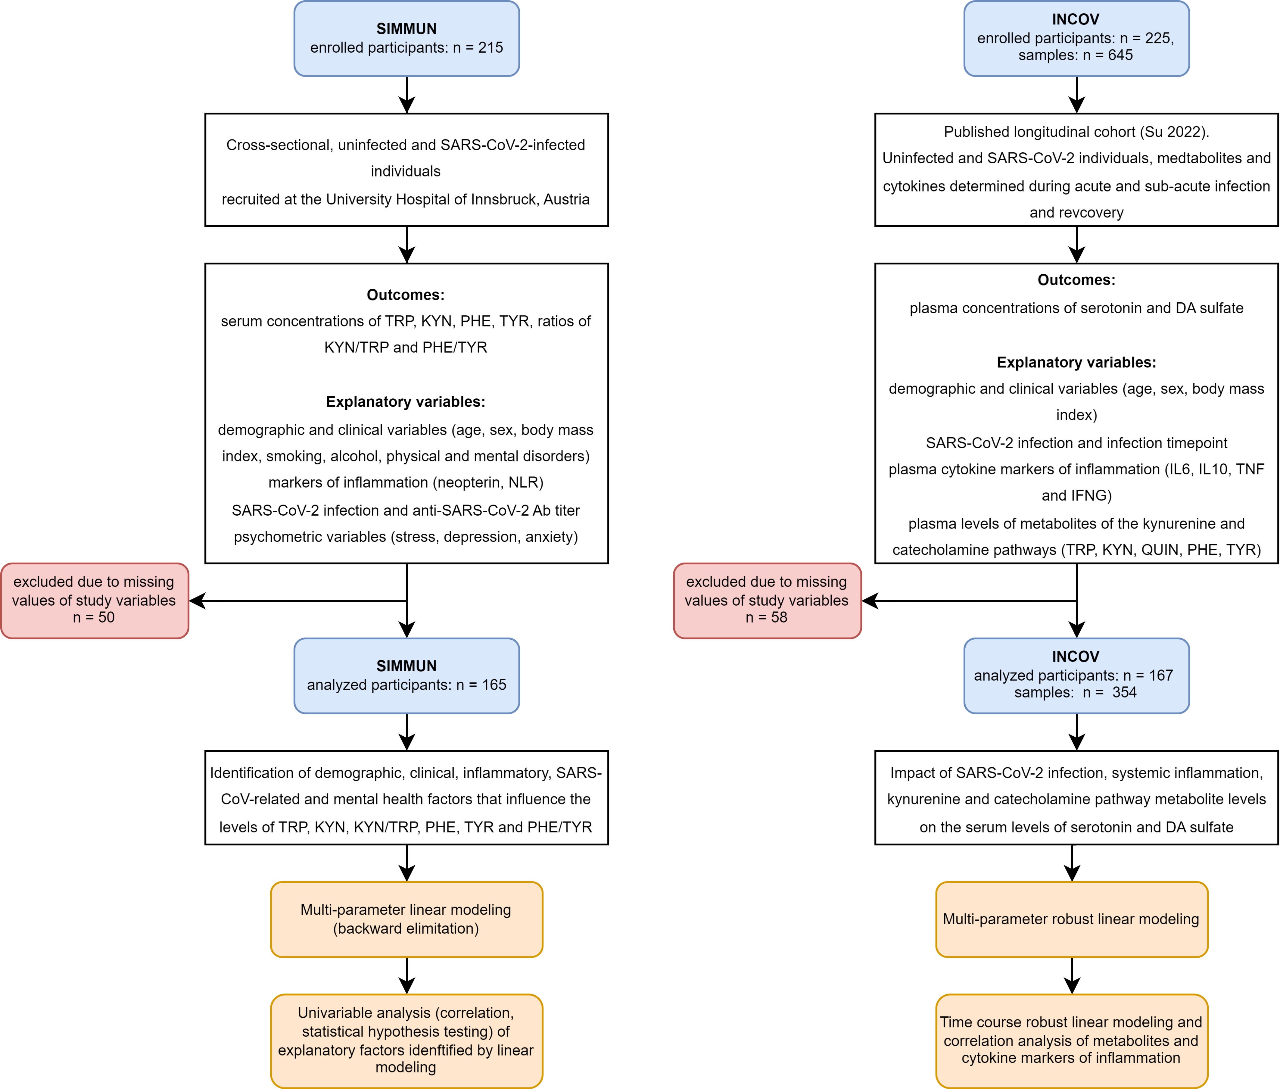

Figure 1: Inclusion scheme for the SIMMUN and INCOV cohorts, and analysis strategy.

**Supplementary Figure S1. Inclusion scheme for the SIMMUN and INCOV cohorts, and analysis strategy.**

*Sampling timepoints in the INCOV cohort: acute: median 10 days, sub-acute: median 14 days, recovery: median 64 days after diagnosis of SARS-CoV-2 infection via PCR.*

*TRP: tryptophan; KYN: kynurenine; PHE: phenylalanine; TYR: tyrosine; KYN/TRP: kynurenine/tryptophan ratio; PHE/TYR: phenylalanine/tyrosine ratio; NLR: neutrophil - leukocyte ratio; QUIN: quinolinic acid; DA: dopamine; Ab: antibody; IL6: interleukin-6; IL10: interleukin-10; TNF: tumor-necrosis factor alpha; IFNG: interferon gamma.*

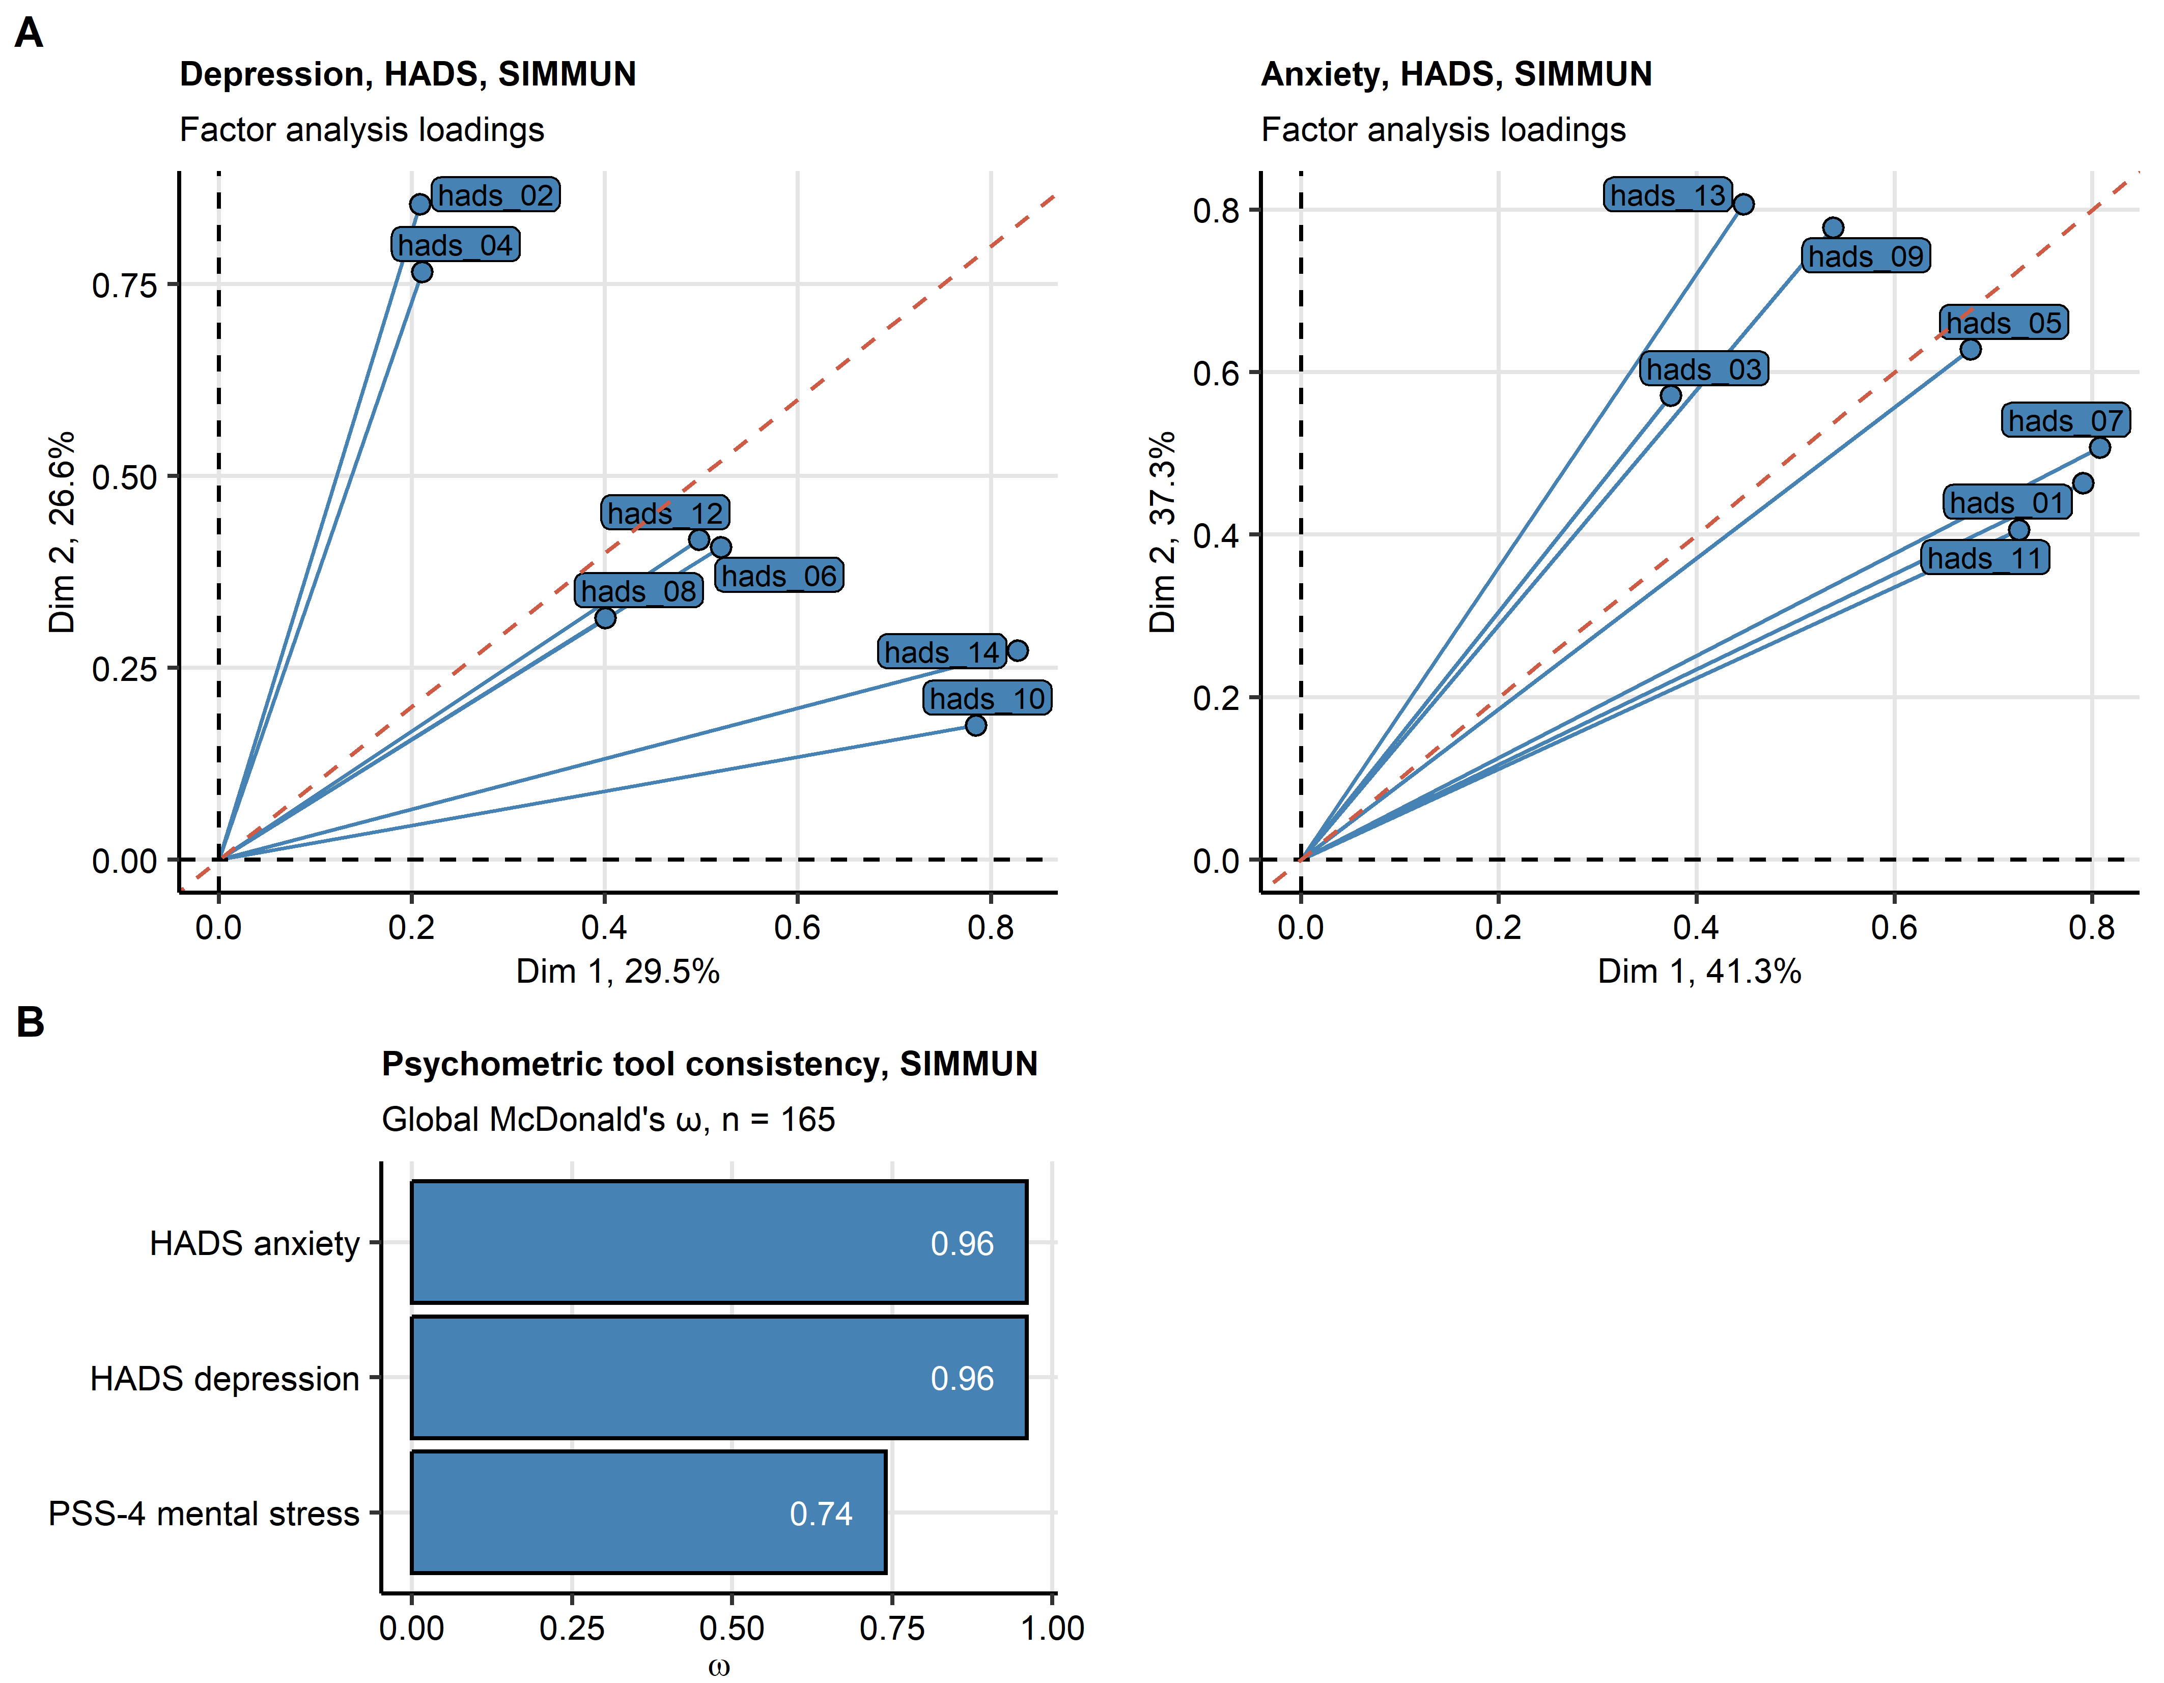

Figure 2: Consistency of the PSS-4 mental stress, HADS depression and HADS anxiety psychometric tools in the SIMMUN cohort.

**Supplementary Figure S2. Consistency of the PSS-4 mental stress, HADS depression and HADS anxiety psychometric tools in the SIMMUN cohort.**

*(A) Assessment of tau-equivalence of the HADS (hospital anxiety and depression scale) depression and anxiety tool by three-dimensional factor analysis. Loadings for the first two major factors are presented. Each point represents a single HADS item. Percentages of total dataset variance associated with the factors are indicated in the plot axes. Note: tau equivalence implicates equal loadings of each HADS items for all factors. In case of tau equivalence, proximity of the items to the diagonal of the plot (orange dashed line) is expected.*

*(B) Consistency of the HADS depression, HADS anxiety and PSS-4 (perceived stress scale, 4 item) psychometric tools determined by McDonald’s metric.*

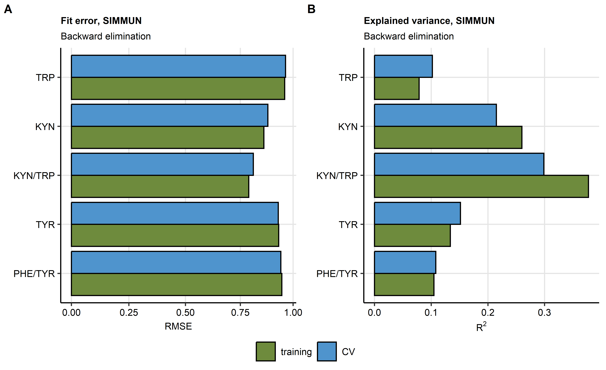

Figure 3: Root mean square error and R2 statistics for multi-parameter linear models of readouts of the kynurenine and catecholamine pathway activity in the SIMMUN cohort.

**Supplementary Figure S3. Root mean square error and R2 statistics for multi-parameter linear models of readouts of the kynurenine and catecholamine pathway activity in the SIMMUN cohort.**

*Multi-parameter linear regression models of serum levels of tryptophan (TRP), kynurenine (KYN), kynurenine/tryptophan ratio (KYN/TRP), phenylalanine (PHE), tyrosine (TYR) and phenylalanine/tyrosine ratio (PHE/TRP) in the SIMMUN models were optimized by backwards elimination and their reproducibility was tested by cross-validation (CV, 10 folds). Values of root mean square error (RMSE, A) and R2 (B) in the training data set and CV are plotted.*

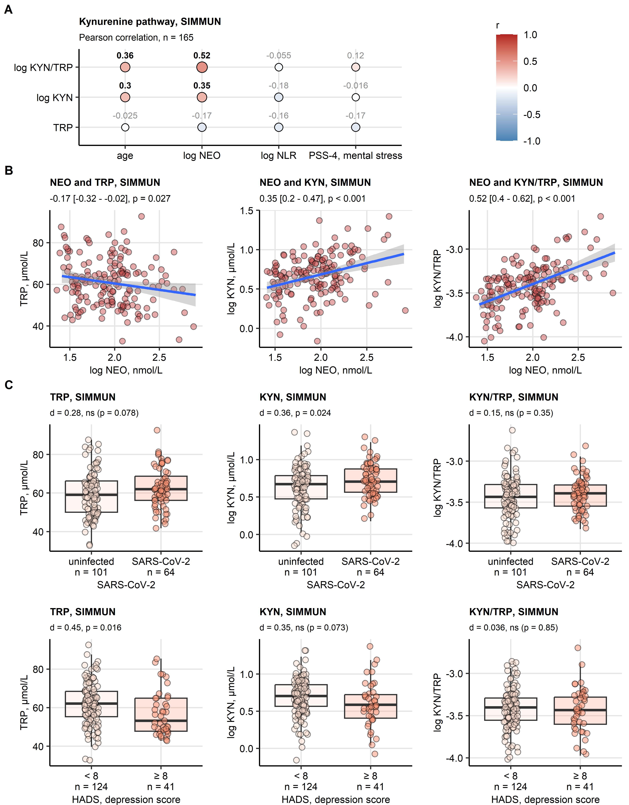

Figure 4: Effects of age, serum inflammatory markers neopterin and neutrophil-lymphocyte ratio, mental stress, depression and SARS-CoV-2 infection on tryptophan, kynurenine and kynurenine/tryptophan ratio in the SIMMUN cohort.

**Supplementary Figure S4. Effects of age, serum inflammatory markers neopterin and neutrophil-lymphocyte ratio, mental stress, depression and SARS-CoV-2 infection on tryptophan, kynurenine and kynurenine/tryptophan ratio in the SIMMUN cohort.**

*Age, systemic inflammatory markers: neopterin (NEO), neutrophil/lymphocyte ratio (NLR), SARS-CoV-2 infection status, clinically relevant symptoms of depression (hospital anxiety and depression scale [HADS] > 8 points) and mental stress scoring (perceived stress scale, 4 item [PSS-4]) were identified as significant determinants of serum levels of tryptophan (TRP), kynurenine (KYN) and kynurenine/tryptophan ratio (KYN/TRP). Their association with serum concentrations of these metabolites was investigated by correlation analysis and statistical hypothesis testing.*

*(A, B) Correlation of the metabolite levels and the numeric explanatory factors of interest was assessed by Pearson’s test corrected for multiple testing by the false discovery rate method. (A) Correlation coefficients are presented in a bubble plot with point size and color corresponding to values of correlation coefficients (r); points are labeled with their r values, significant effects are highlighted in bold. (B) Scatter plots of serum concentrations of NEO, TRP, KYN and KYN/TRP. Points represent single observations, fitted linear trends with 95% confidence intervals are visualized as blue lines with gray ribbons. Correlation coefficients with 95% confidence intervals and p values are displayed in the plot captions.*

*(C) Levels of the metabolite levels were compared between infected and uninfected participants, and between participants with and without clinically relevant symptoms of depression by two-tailed T test with Cohen’s d effect size statistic. P values were corrected for multiple testing with the false discovery rate method. Medians with interquartile ranges (IQR) are represented by boxes, whiskers span over 150% IQR, single observations are depicted as points. Effect sizes and p values are displayed in the plot captions. Numbers of observations are indicated in the X axes.*

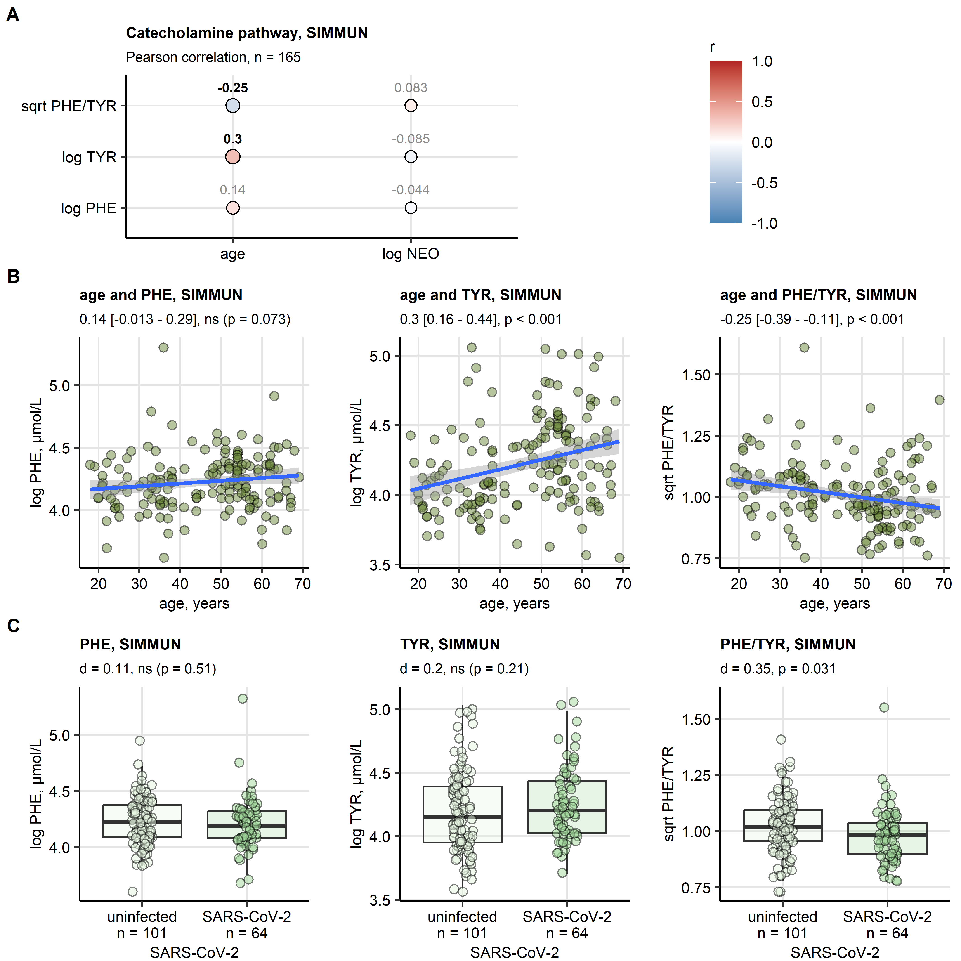

Figure 5: Effects of age, serum inflammatory marker neopterin and SARS-CoV-2 infection on phenylalanine, tyrosine and phenylalanine/tyrosine ratio in the SIMMUN cohort.

**Supplementary Figure S5. Effects of age, serum inflammatory marker neopterin and SARS-CoV-2 infection on phenylalanine, tyrosine and phenylalanine/tyrosine ratio in the SIMMUN cohort.**

*Age, the systemic inflammatory marker neopterin (NEO), and SARS-CoV-2 infection status were identified as significant determinants of serum levels of phenylalanine (PHE), tyrosine (TYR) and phenylalanine/tyrosine ratio (PHE/TYR). Their association with serum concentrations of these metabolites was investigated by correlation analysis and statistical hypothesis testing.*

*(A, B) Correlation of the metabolite levels and the numeric explanatory factors of interest was assessed by Pearson’s test corrected for multiple testing by the false discovery rate method. (A) Correlation coefficients are presented in a bubble plot with point size and color corresponding to values of correlation coefficients (r); points are labeled with their r values, significant effects are highlighted in bold. (B) Scatter plots of patient’s age, PHE, TYR and PHE/TYR. Points represent single observations, fitted linear trends with 95% confidence intervals are visualized as blue lines with gray ribbons. Correlation coefficients with 95% confidence intervals and p values are displayed in the plot captions.*

*(C) Levels of the metabolites were compared between infected and uninfected participants by two-tailed T test with Cohen’s d effect size statistic. P values were corrected for multiple testing with the false discovery rate method. Medians with interquartile ranges (IQR) are represented by boxes, whiskers span over 150% IQR, single observations are depicted as points. Effect sizes and p values are displayed in the plot captions. Numbers of observations are indicated in the X axes.*

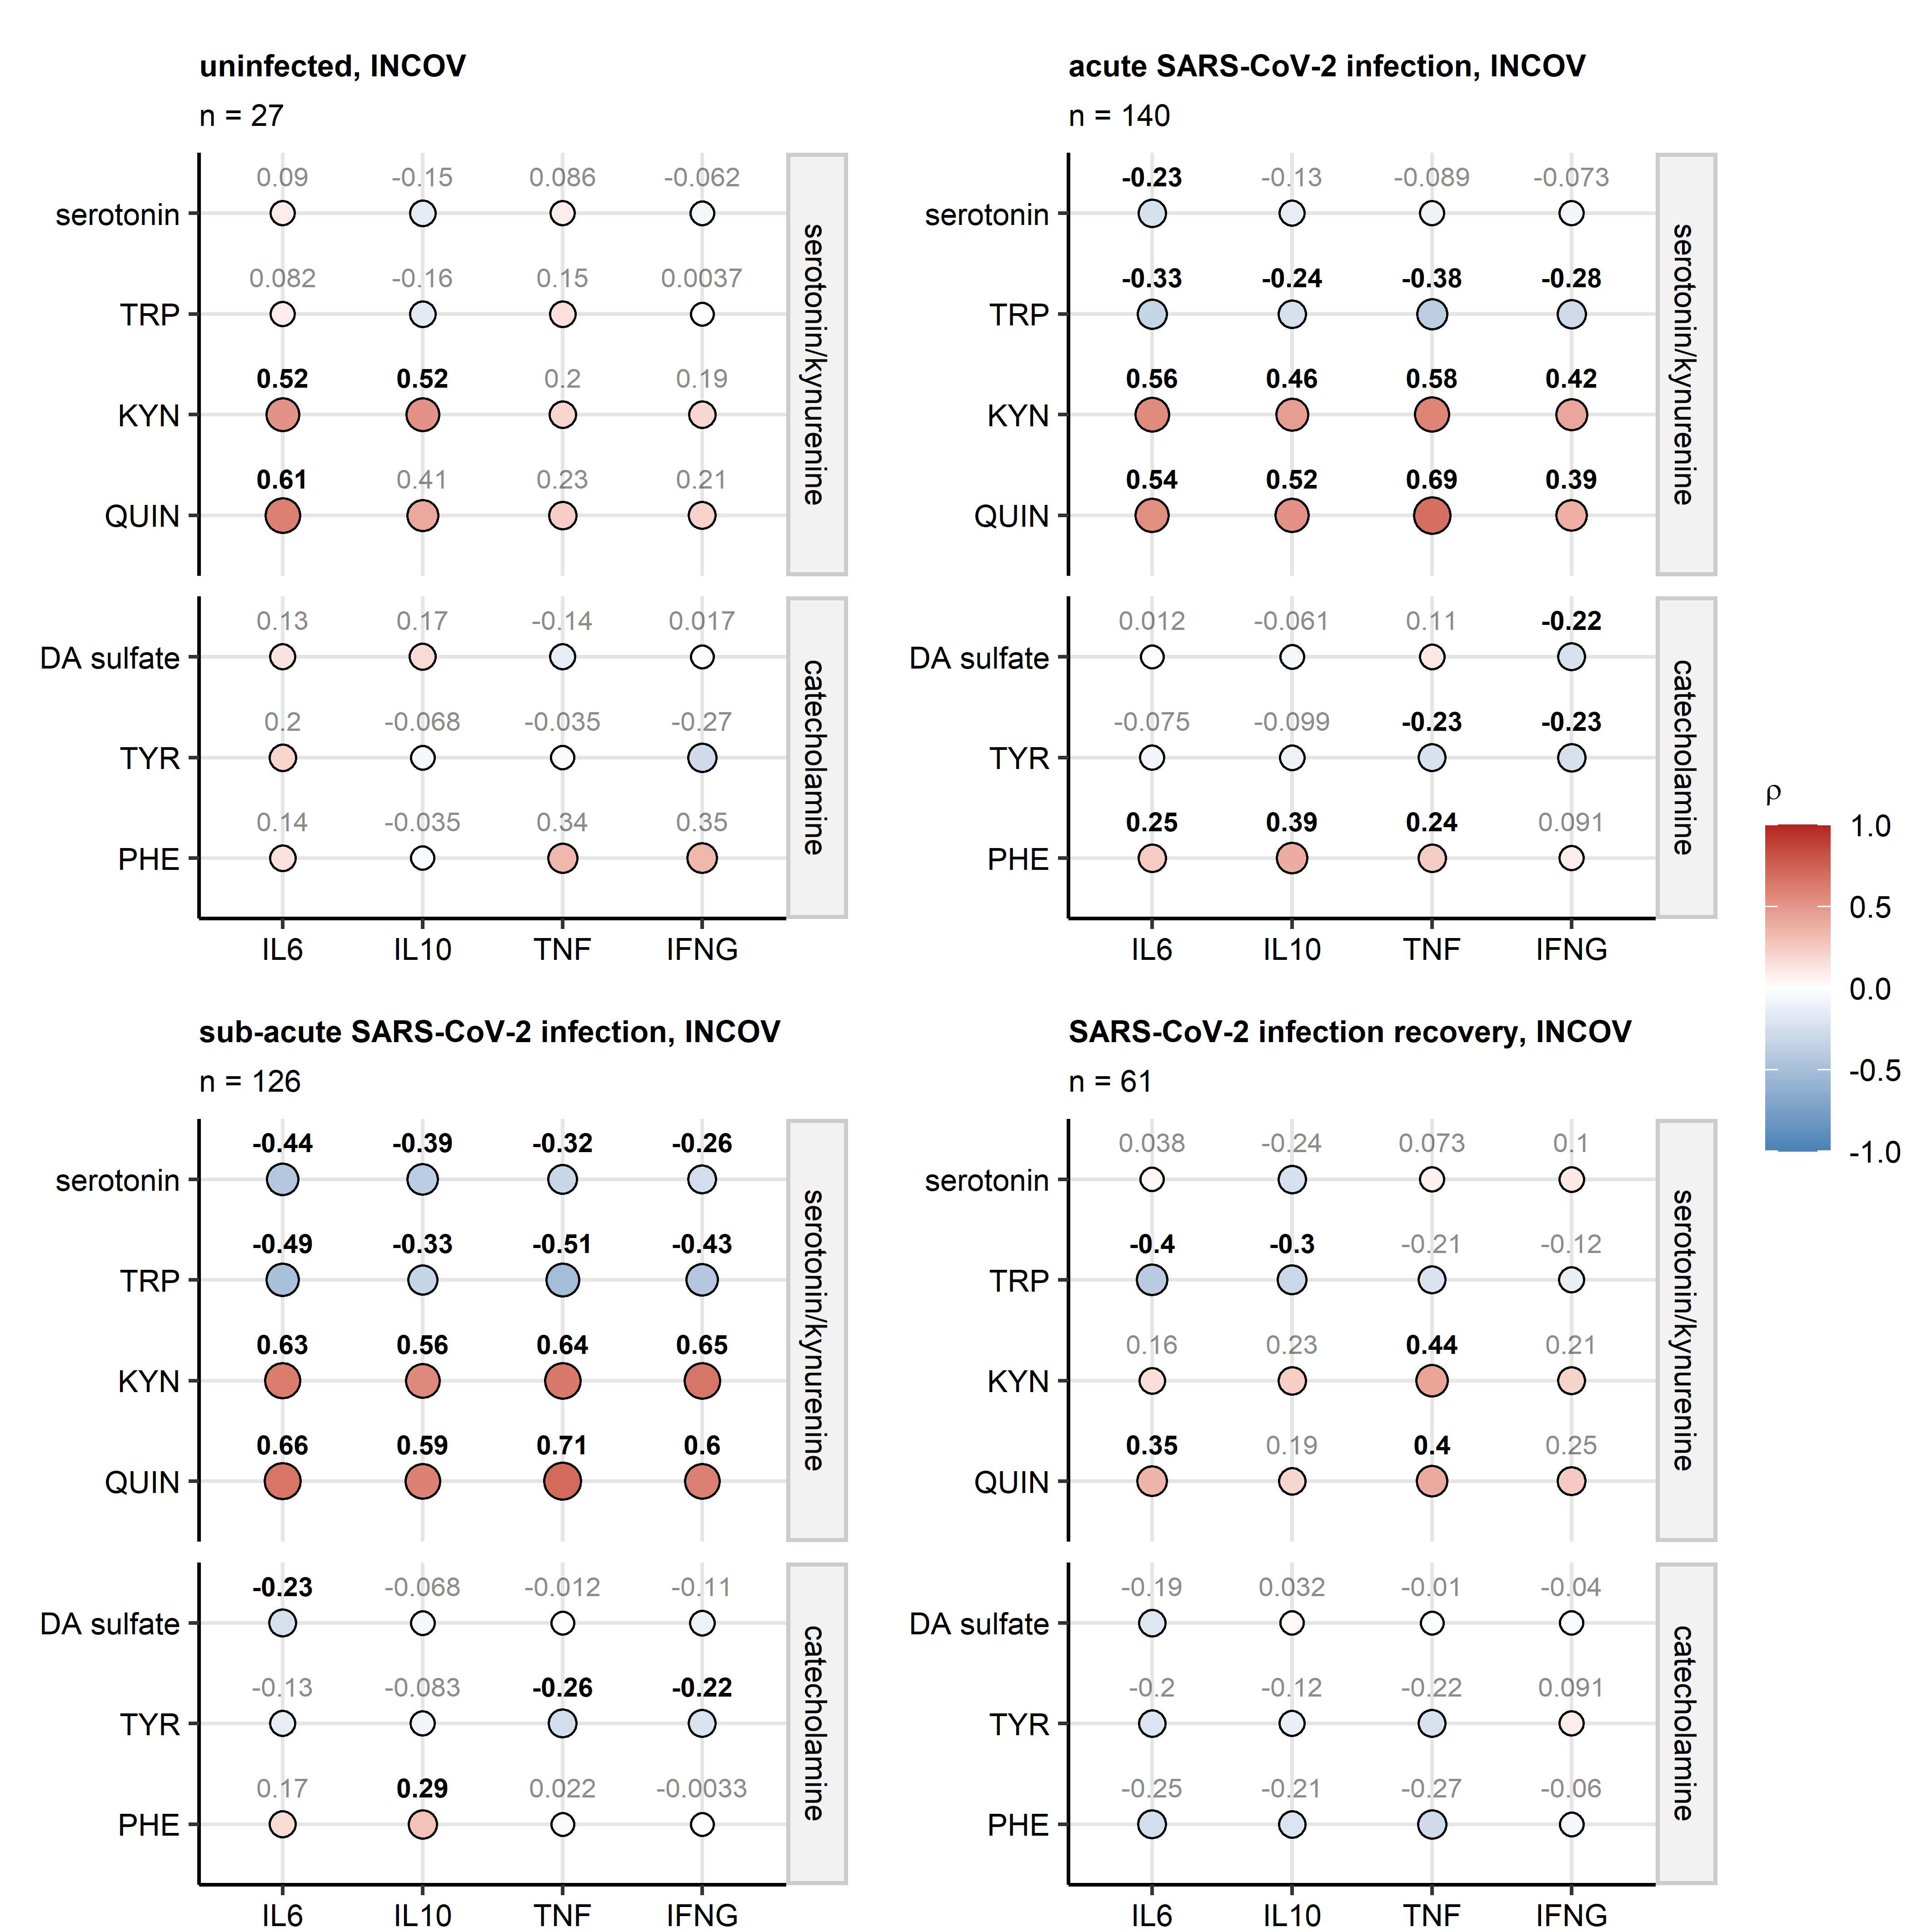

Figure 6: Correlation of metabolites with cytokine markers of inflammation in the INCOV cohort.

**Supplementary Figure S6. Correlation of metabolites with cytokine markers of inflammation in the INCOV cohort.**

*Plasma levels of serotonin and metabolites of the kynurenine (tryptophan [TRP], kynurenine [KYN], quinolinic acid [QUIN]) and catecholamine pathways (phenylalanine [PHE], tyrosine [TYR], dopamine 3-O-sulfate [DA sulfate]) were correlated with plasma levels of cytokine markers of inflammation (interleukin-6 [IL6], interleukin-10 [IL10], tumor necrosis factor-alpha [TNF] and interferon-gamma [IFNG]) in uninfected individuals, and during acute (median 10 days), sub-acute (median 14 days) SARS-CoV-2 infection and recovery (median 64 days after SARS-CoV-2 infection diagnosis via PCR). Statistical significance was determined by Spearman’s rank test corrected for multiple testing with the false discovery rate method. Correlation coefficients are presented in bubble plots with point size and color corresponding to values of correlation coefficients; points are labeled with their values, significant effects are highlighted in bold.*

# References

Allaire, J., Xie, Y., McPherson, J., Luraschi, J., Ushey, K., Atkins, A., Wickham, H., Cheng, J., 2022. [rmarkdown: Dynamic Documents for R](https://cran.r-project.org/web/packages/rmarkdown/index.html).

BARTLETT, M.S., 1937. THE STATISTICAL CONCEPTION OF MENTAL FACTORS. British Journal of Psychology. General Section 28, 97–104. <https://doi.org/10.1111/j.2044-8295.1937.tb00863.x>

Benjamini, Y., Hochberg, Y., 1995. Controlling the False Discovery Rate: A Practical and Powerful Approach to Multiple Testing. Journal of the Royal Statistical Society: Series B (Methodological) 57, 289–300. <https://doi.org/10.1111/j.2517-6161.1995.tb02031.x>

Bjelland, I., Dahl, A.A., Haug, T.T., Neckelmann, D., 2002. The validity of the Hospital Anxiety and Depression Scale: An updated literature review. Journal of Psychosomatic Research 52, 69–77. <https://doi.org/10.1016/S0022-3999(01)00296-3>

Briatte, F., Bojanowski, M., Canouil, M., Charlop-Powers, Z., Fisher, J.C., Johnson, K., Rinker, T., 2021. [ggnetwork: Geometries to Plot Networks with ’ggplot2’](https://cran.r-project.org/package=ggnetwork).

Capuron, L., Schroecksnadel, S., Féart, C., Aubert, A., Higueret, D., Barberger-Gateau, P., Layé, S., Fuchs, D., 2011. Chronic low-grade inflammation in elderly persons is associated with altered tryptophan and tyrosine metabolism: role in neuropsychiatric symptoms. Biological psychiatry 70, 175–182. <https://doi.org/10.1016/J.BIOPSYCH.2010.12.006>

Cohen, J., 2013. Statistical Power Analysis for the Behavioral Sciences. Statistical Power Analysis for the Behavioral Sciences. <https://doi.org/10.4324/9780203771587>

Cohen, S., Kamarck, T., Mermelstein, R., 1983. A global measure of perceived stress. Journal of health and social behavior 24, 385–396. <https://doi.org/10.2307/2136404>

Csardi, G., Nepusz, T., 2006. [The igraph software package for complex network research](https://igraph.org). InterJournal Complex Sy, 1695.

Deisenhammer, F., Bauer, A., Kavelar, C., Rudzki, D., Rössler, A., Kimpel, J., Borena, W., Reindl, M., 2021. 12-month SARS-CoV-2 antibody persistency in a Tyrolean COVID-19 cohort. Wiener klinische Wochenschrift 133, 1265–1271. <https://doi.org/10.1007/S00508-021-01985-X>

Gagolewski, M., Tartanus, B., 2021. [Package ’stringi’](https://cran.r-project.org/web/packages/stringi/index.html http://cran.ism.ac.jp/web/packages/stringi/stringi.pdf).

Gohel, D., 2022. [flextable: Functions for Tabular Reporting](https://cran.r-project.org/web/packages/flextable/index.html).

Goldstein, D.S., Swoboda, K.J., Miles, J.M., Coppack, S.W., Aneman, A., Holmes, C., Lamensdorf, I., Eisenhofer, G., 1999. Sources and physiological significance of plasma dopamine sulfate. The Journal of clinical endocrinology and metabolism 84, 2523–2531. <https://doi.org/10.1210/JCEM.84.7.5864>

Henry, L., Wickham, Hadley., 2022. [rlang: Functions for Base Types and Core R and ’Tidyverse’ Features](https://cran.r-project.org/web/packages/rlang/index.html).

Huber, P.J., 2011. Robust Statistics. International Encyclopedia of Statistical Science 1248–1251. <https://doi.org/10.1007/978-3-642-04898-2_594>

Kassambara, A., 2021. [rstatix: Pipe-Friendly Framework for Basic Statistical Tests](https://cran.r-project.org/package=rstatix).

Kuhn, M., 2008. Building predictive models in R using the caret package. Journal of Statistical Software 28, 1–26. <https://doi.org/10.18637/jss.v028.i05>

McDonald, R.P., 1999. Test theory: A unified treatment, 1st Editio. ed. Psychology Press, New Yor. <https://doi.org/10.4324/9781410601087>

Meiser, J., Weindl, D., Hiller, K., 2013. Complexity of dopamine metabolism. Cell Communication and Signaling 11, 1–18. <https://doi.org/10.1186/1478-811X-11-34/FIGURES/5>

Neurauter, G., Schrocksnadel, K., Scholl-Burgi, S., Sperner-Unterweger, B., Schubert, C., Ledochowski, M., Fuchs, D., 2008. Chronic immune stimulation correlates with reduced phenylalanine turnover. Current drug metabolism 9, 622–627. <https://doi.org/10.2174/138920008785821738>

R Core Team, Bivand, R., Carey, V.J., DebRoy, S., Eglen, S., Guha, R., Herbrandt, S., Lewin-Koh, N., Myatt, M., Nelson, M., Pfaff, B., Quistorff, B., Warmerdam, F., Weigand, S., Free Software Foundation, Inc., 2022. [foreign: Read Data Stored by ’Minitab’, ’S’, ’SAS’, ’SPSS’, ’Stata’, ’Systat’, ’Weka’, ’dBase’, ...](https://cran.r-project.org/web/packages/foreign/index.html)

Revelle, W., 2015. [Package ’psych’ - Procedures for Psychological, Psychometric and Personality Research](https://cran.r-project.org/web/packages/psych/index.html http://personality-project.org/r/psych-manual.pdf). R Package 1–358.

Ripley, B., 2022. [MASS: Support Functions and Datasets for Venables and Ripley’s MASS](https://cran.r-project.org/package=MASS).

Su, Y., Chen, D., Yuan, D., Lausted, C., Choi, J., Dai, C.L., Voillet, V., Duvvuri, V.R., Scherler, K., Troisch, P., Baloni, P., Qin, G., Smith, B., Kornilov, S.A., Rostomily, C., Xu, A., Li, J., Dong, S., Rothchild, A., Zhou, J., Murray, K., Edmark, R., Hong, S., Heath, J.E., Earls, J., Zhang, R., Xie, J., Li, S., Roper, R., Jones, L., Zhou, Y., Rowen, L., Liu, R., Mackay, S., O’Mahony, D.S., Dale, C.R., Wallick, J.A., Algren, H.A., Zager, M.A., Wei, W., Price, N.D., Huang, S., Subramanian, N., Wang, K., Magis, A.T., Hadlock, J.J., Hood, L., Aderem, A., Bluestone, J.A., Lanier, L.L., Greenberg, P.D., Gottardo, R., Davis, M.M., Goldman, J.D., Heath, J.R., 2020. Multi-Omics Resolves a Sharp Disease-State Shift between Mild and Moderate COVID-19. Cell 183, 1479. <https://doi.org/10.1016/J.CELL.2020.10.037>

Su, Y., Yuan, D., Chen, D.G., Ng, R.H., Wang, K., Choi, J., Li, S., Hong, S., Zhang, R., Xie, J., Kornilov, S.A., Scherler, K., Pavlovitch-Bedzyk, A.J., Dong, S., Lausted, C., Lee, I., Fallen, S., Dai, C.L., Baloni, P., Smith, B., Duvvuri, V.R., Anderson, K.G., Li, J., Yang, F., Duncombe, C.J., McCulloch, D.J., Rostomily, C., Troisch, P., Zhou, J., Mackay, S., DeGottardi, Q., May, D.H., Taniguchi, R., Gittelman, R.M., Klinger, M., Snyder, T.M., Roper, R., Wojciechowska, G., Murray, K., Edmark, R., Evans, S., Jones, L., Zhou, Y., Rowen, L., Liu, R., Chour, W., Algren, H.A., Berrington, W.R., Wallick, J.A., Cochran, R.A., Micikas, M.E., Wrin, T., Petropoulos, C.J., Cole, H.R., Fischer, T.D., Wei, W., Hoon, D.S.B., Price, N.D., Subramanian, N., Hill, J.A., Hadlock, J., Magis, A.T., Ribas, A., Lanier, L.L., Boyd, S.D., Bluestone, J.A., Chu, H., Hood, L., Gottardo, R., Greenberg, P.D., Davis, M.M., Goldman, J.D., Heath, J.R., 2022. Multiple early factors anticipate post-acute COVID-19 sequelae. Cell 185, 881–895.e20. <https://doi.org/10.1016/J.CELL.2022.01.014>

Wickham, Hadley., 2016. [ggplot2: Elegant Graphics for Data Analysis](https://ggplot2.tidyverse.org), 1st ed. Springer-Verlag, New York.

Wickham, H., Averick, M., Bryan, J., Chang, W., McGowan, L., François, R., Grolemund, G., Hayes, A., Henry, L., Hester, J., Kuhn, M., Pedersen, T., Miller, E., Bache, S., Müller, K., Ooms, J., Robinson, D., Seidel, D., Spinu, V., Takahashi, K., Vaughan, D., Wilke, C., Woo, K., Yutani, H., 2019. Welcome to the Tidyverse. Journal of Open Source Software 4, 1686. <https://doi.org/10.21105/joss.01686>

Wickham, H., Bryan, J., Posit, P., Kalicinski, M., Komarov, V., Leitienne, C., Colbert, B., Hoerl, D., Miller, E., 2022. [readxl: Read Excel Files](https://cran.r-project.org/web/packages/readxl/index.html).

Widner, B., Werner, E.R., Schennach, H., Wachter, H., Fuchs, D., 1997. Simultaneous measurement of serum tryptophan and kynurenine by HPLC. Clinical Chemistry 43, 2424–2426. <https://doi.org/10.1093/CLINCHEM/43.12.2424>

Wilke, C.O., 2019. Fundamentals of Data Visualization: A Primer on Making Informative and Compelling Figures, 1st ed. O’Reilly Media, Sebastopol.

Xie, Y., 2022. [knitr: A General-Purpose Package for Dynamic Report Generation in R](https://cran.r-project.org/web/packages/knitr/index.html).

Xie, Y., 2016. Bookdown: Authoring books and technical documents with R Markdown. <https://doi.org/10.1201/9781315204963>

Zigmond, A.S., Snaith, R.P., 1983. The hospital anxiety and depression scale. Acta psychiatrica Scandinavica 67, 361–370. <https://doi.org/10.1111/J.1600-0447.1983.TB09716.X>