Status post SARS-CoV-2 infection, persistent low-grade inflammation, and mental stress impact on systemic levels of aminoacid neurotransmitter precursors

– a psychoneuroimmunological cohort study

Katharina Hüfner1, Sophia Vedova1, Piotr Tymoszuk3, Philipp Nelles1, Markus Anliker, Tobias Bruckner1, Eberhard Deisenhammer1,2, Jonas Egeter1, Alexander Egger, Matyas Galffy1, Johannes Giesinger1, Jens Lehmann2, Maria Oberhammer2, Joachim Rockenschaub1, Magdalena Sacher, Bernhard Holzner, Johanna Gostner, Barbara Sperner-Unterweger1

1University Hospital of Psychiatry II, Department of Psychiatry, Psychotherapy and Psychosomatics, Innsbruck Medical University, Innsbruck, Austria.

2University Hospital of Psychiatry I, Department of Psychiatry, Psychotherapy and Psychosomatics and Medical Psychology, Innsbruck Medical University, Innsbruck, Austria.

3 Data Analytics as a Service Tirol, Innsbruck, Austria

Corresponding author:

Katharina Hüfner

University Hospital of Psychiatry II, Department of Psychiatry, Psychotherapy, Psychosomatics and Medical Psychology

Anichstrasse 35

6020 Innsbruck

Austria

[Katharina.huefner@tirol-kliniken.at](mailto:Katharina.huefner@tirol-kliniken.at)

Running title: Neurotransmitter precursor amino acid levels and COVID-19

Keywords: neurotransmitter precursor amino acids, COVID-19, kynurenine, tryptophan

Words in Abstract

Words in Text

Tables:

Figures:

# Abstract

**Background:** Systemic serotonin availability and the catecholamine neurotransmitter synthesis pathway have been proposed as the biological link between mental health, inflammation and physical symptoms and disorders. Here we assessed serotonin and noradrenaline precursors following SARS-CoV-2 infection in individuals with and without mental health impairment.

**Methods:** The cross-sectional SIMMUN cohort study included 67 SARS-CoV-2 infection convalescents and 110 uninfected controls recruited in Tyrol, Austria. Explanatory variables encompassed clinical parameters, inflammatory markers , anti-SARS-CoV-2 antibodies, and standardized scorings of anxiety, depression and mental stress. Their effects on markers of serotonin availability (tryptophan [TRP], kynurenine [KYN], KYN/TRP ratio) and catecholamine neurotransmitter synthesis (phenylalanine [PHE], tyrosine [TYR], PHE/TYR ratio) were assessed by correlation analysis, two-tailed T tests and multi-parameter linear modeling. Association of neurotransmitter availability markers with inflammation was additionally investigated in a published longitudinal cohort (SARS-CoV-2: n = 205, uninfected: n = 440, Su et al. 2022).

**Results:** Both in the SIMMUN and INCOV collectives, levels the serotonin precursor TRP and its decay product KYN were regulated strongly by systemic inflammation. TRP concentrations were substantially lower in participants with impaired mental health. In multi-parameter modelling, systemic availability of serotonin measured by TRP, KYN and KYN/TRP, was regulated independently by inflammation, mental stress and status post SARS-CoV-2 infection. The influence of the assessed parameters on the catecholamine neurotransmitter precursor availability were heterogeneous.

**Conclusion:** Inflammation, SARS-CoV-2 infection and mental stress can both independently and additively influence serum levels of neurotransmitter precursor amino acids. These pathways could thus be a biological link between COVID-19 infection and mental health via psychoneuroimmunological mechanisms.

# Introduction

The immune system and the brain interact at multiple levels and in a bidirectional manner with influences on one system having consequences on the other (Bower et al., 2022). Acute SARS-CoV-2 infection has been shown to trigger a strong systemic inflammatory response (Song et al., 2020) causing an increased permeability of the blood brain barrier (Najjar et al., 2020), so that consequences on cognition and mental health are conceivable (Bower et al., 2022). On the other hand, psychological wellbeing and mental health can influence the immune system via psychoneuroimmunological mechanisms, explaining for example the higher susceptibility and risk for a more severe disease course in individuals with mental disorders (Wang et al., 2021).

Protracted inflammation can lead to mental health impairment, namely depressive symptoms via psychoneuroimmunolgoical mechanisms (Dantzer et al., 2008). Individual health in COVID-19 survivors shows only weak association with routine inflammatory markers, antibody titers, impaired lung function, lung lesions or cardiac deficits, but is rather influenced by measurements of health concern and mental stress (Hüfner et al., 2022b; Matta et al., 2022; Staudt et al., 2022) (Sahanic et al. submitted). Anxiety and depressive symptoms are prevalent in the general population and are increased in survivors of COVID-19 (Al-Aly et al., 2021; Huang et al., 2021; Nasserie et al., 2021; Taquet et al., 2021) and related to mental stress in individuals following COVID-19 (Hüfner et al., 2022a).

Inflammation caused by factors such as stress or infection impact the synthesis of neurotransmitters which are in turn also modulated by mental health (Bower et al., 2022). One such mechanism involves the degradation of tryptophan (TRP) to catabolic tryptophan products (TRYCATS) mediated by indoleamine 2,3-dioxygenase (IDO-1) **(figure 1)**. TRYCATS synthesis depletes TRP, which serves as a serotonin precursor. In addition, TRYCATS like kynurenin (KYN) or quinolinic acid (QUIN) on their own have anxiogenic and depressiogenic effects. The ratio of KYN to TRP (KYN/TRP ratio) is an IDO activation marker associated with anxiety and depression (Fellendorf et al., 2022; Hüfner et al., 2015). QUIN acts as a N-methyl-D-aspartate (NMDA) receptor agonist and therefore amplifies the excitatory and neurotoxic effect of glutamate. Inflammation therefore augments depression and anxiety by shifting the metabolic pathway away from a balanced neurotransmitter homeostasis seen in healthy subjects towards the anxiety- and depression-amplifying TRYCATs. Increased KYN suggestive of lowered systemic serotonin availability has recently been identified in acute COVID-19 patients in comparison with uninfected controls, as well as in individuals previously tested positive for SARS-CoV-2 (Bizjak et al., 2022).

Reactive oxygen species (ROS) pose another link between inflammation and neurotransmitter precursors. Interferon gamma (IFN-γ) was shown to trigger ROS production among others by microglia (Rahimian et al., 2022). ROS in turn mediated depletion of 5,6,7,8-tetrahydrobiopterin (BH4), a critical co-factor for synthesis of serotonin and catecholamine neurotransmitters (Neurauter et al., 2008). Furthermore, in IFN-γ-stimulated macrophages and dendritic cells form neopterin, a cellular marker of inflammation, instead of BH4 (Sucher et al., 2010). Hence, reduced BH4 availability can be reliably assessed via an increased ratio of phenylalanine to tyrosine (PHE/TYR ratio) as depletion of BH4 leads to an inhibition of PHE – TYR conversion by phenylalanine-hydroxylase (Fanet et al., 2021).

The association of persisting low grade inflammation in individuals with status post SARS-CoV-2 infection and its possible association with mental health variables is still incompletely resolved to date. Herein, we explored effects of inflammation, SARS-CoV-2 infection, anti-SARS-CoV-2 humoral response strength and mental disorder scoring on neurotransmitter precursor amino acid levels in individuals recovering from SARS-CoV-2 infection and uninfected controls (SIMMUN cohort). Furthermore, association of inflammation with systemic availability of serotonin and catecholamine neurotransmitter precursors was explored in a published longitudinal collective (INCOV, Su et al. 2022).

# Materials and Methods

## Ethics statement

The SIMMUN study was conducted in accordance with the Declaration of Helsinki. All participants gave written informed consent prior to enrollment. This study was approved by the ethics committee of the Medical University Innsbruck, Austria (approval number: 1132/2020). No approval by the ethics committee was required for analysis of the published anonymized INCOV data set (Su et al., 2022).

## Study design SIMMUN

Results of observational single cohort SIMMUN study are presented here along the STROBE guidelines. The study consisted of an online survey (not reported here) and an in person study visit, whose results are reported here. Study enrollment started on 10. June 2020 , the study visits were conducted between 17.June 2020 and 27.May 2021.

Individuals tested for SARS-CoV-2 via PCR at the University Hospital of Innsbruck Medical University (Innsbruck, Austria) were invited to participate. Additionally, inpatients and outpatients of the University Clinic for Psychiatry I and II (Innsbruck, Austria) undergoing routine SARS-CoV-2 PCR screening were invited to participate. Inclusion criteria were a SARS-CoV-2 test performed at the study site, residence in Tyrol, age 18-70 years and proficiency in German language. Exclusion criteria were active SARS-CoV-2 infection (< 14 days following a positive test), pregnancy, active malignancies, organ transplantation, prior surgery in the past 3 months, or acute or chronic inflammatory illness and treatment with oral corticosteroids. The analysis inclusion criterion was the complete study variable data set consisting of neurotransmitter precursor availability and inflammatory markers, anti-SARS-CoV-2 antibody levels and psychometric survey (**Figure 2**).

## Procedures SIMMUN

The study visit included a physician assessment, supervised completion of self-rating questionnaire and a blood sample collection.

### Psychometric assessment of anxiety, depression and mental stress

To assess anxious and depressive symptoms, the Hospital Anxiety and Depression Scale (HADS) was used. The HADS comprises 14 items: a 7-item subscale on anxiety and a 7-item subscale on depression. The total possible score range for each subscale is 0 to 21, with higher scores indicating higher levels of anxiety/depression. In accordance with existing literature, a cutoff of >8 for each subscale was used to identify individuals with clinically relevant symptom load (Bjelland et al., 2002) . Stress was rated with the 4-item Perceived Stress Scale and expressed as the sum of all items as described (Cohen et al., 1983)

### Laboratory blood analysis

C-reactive protein (CRP), interleukin-6 (IL6), and full blood count were determined in the University Hospital of Innsbruck´s certified clinical routine laboratory. CRP was measured using a Cobas8000 C702 and IL6 using Cobas8000 E602 (Roche, Vienna, Austria). The full blood count was done using Sysmex XN (Sysmex, Vienna, Austria). NLR (neutrophil lymphocyte ratio) was calculated. Neopterin concentrations were measured by enzyme-linked immunosorbent assay (BRAHMS Diagnostics, Berlin, Germany). TRP, KYN, PHE and TYR, were determined by high-performance liquid chromatography, as described elsewhere (Neurauter et al., 2008; Widner et al., 1997). The ratios of KYN/TRP and PHE/TYR were calculated as indices of IDO and PHA activity, respectively (Capuron et al., 2011) . SARS-CoV-2 antibodies were determined by ELISA as described previously (Deisenhammer et al., 2021).

## Study endpoints

The primary endpoint was identification of inflammatory, SARS-CoV2- and mental health-related factors impacting on activity of serotonin and catecholamine metabolic pathways as assessed by levels of precursor aminoacids and their decay products (KYN, TRP, KYN/TRP and PHE, TYR, PHE/TYR).

## Bioinformatic and statistical analysis of SIMMUN and INCOV cohorts

R version 4.2.0 was employed for the data analysis.

Normalized, age- and sex-adjusted, log2-transformed serum protein and metabolite levels and clinical data for the INCOV cohort were extracted from the report by Su at al. (Su et al., 2022).

In the SIMMUN cohort Normality and homogeneity of variances was investigated by Shapiro-Wilk and Levene test, respectively. Non-parametric tests or normality/homogeneity-improving variable transformations (logarithm and square root) were used in cases of non-normal distribution. Comparison of serum metabolite and cytokine levels between uninfected controls and COVID-19 individuals at consecutive timepoints after infection was done by Kruskal-Wallis test with Benjamini-Hochberg-corrected Mann-Whitney post-hoc test (Benjamini and Hochberg, 1995). Correlations of metabolite and cytokine serum levels and of mental disorder scoring with metabolite and cytokine levels was investigated by Spearman test. Correlation of SIMMUN dataset metabolite levels with age was accomplished by Pearson test. Significance of differences in SIMMUN cohort metabolite and inflammatory marker serum concentrations between participants stratified by gender or SARS-CoV-2 was assessed by two-tailed T test.

In multi-parameter linear modeling of aminoacid neurotransmitter precursors and their decay products, neopterin (representative inflammation marker), SARS-CoV-2 infection status, scores of anxiety (HADS), depression (HADS) and stress (PSS-4), age and gender served as candidate explanatory variables. Modeling responses and numeric explanatory variables were normalized. The models with the complete explanatory variable set were optimized by Bayesian information criterion (BIC) driven backwards elimination of non-significant terms. The normality and homogeneity model residual assumptions were evaluated by Shapiro-Wilk and Levene test, respectively, and additionally visually inspected in standard diagnostic plots (residuals versus fitted, quantile-quantile plots). Reproducibility of the optimized multi-parameter models was investigated by repeated cross-validation (50 repeats, 10 folds) and by comparison of the RMSE and statistics obtained with the training dataset and in cross-validation.

Details of bioinformatic and statistical analysis are provided in **Supplementary Methods**.

# Results

## Characteristic of the study cohorts

Herein, two independent collectives of uninfected controls and COVID-19 convalescents were analyzed. The SIMMUN cohort included uninfected participants (n = 110) and individuals recovering from a PCR-confirmed SARS-CoV-2 infection (n = 67) recruited at the Medical University of Innsbruck, Austria. None of the participants had received anti-SARS-CoV-2 vaccination prior to enrollment. Males represented 40% of the cohort and the median age at enrollment was 49 years. The gender and age structure of the uninfected and SARS-CoV-2 subsets was comparable. Roughly half of the SIMMUN cohort individuals was overweight or obese and suffered from at least one somatic comorbidity; these figures were similar for SARS-CoV-2-negative and -positive individuals. The rate of diagnosed psychiatric conditions in the entire SIMMUN collective was 43% and tended to be higher in the SARS-CoV-2-negative participants. HADS scores and percentage of individuals with symptoms of depression or anxiety (HADS 8) were significantly higher in the SARS-CoV-2-negative strata, there was also a tendency towards higher rating of mental stress (PSS-4) in the uninfected subset. As expected, levels of antibodies against receptor binding domain (RBD) of the S1 SARS-CoV-2 protein was dramatically higher in the SARS-CoV-2 recovering subset. Approximately three-quarters of the SIMMUN SARS-CoV-2-positive study participants experienced mild, ambulatory COVID-19 (**Table 1A**).

Besides clinical, demographic and psychometric variables, the SIMMUN dataset included serum concentrations of precursors of indolamine (tryptophan [TRP]) and catecholamine neurotransmitters (phenylalanine [PHE], tyrosine [TYR]), their decay and inter-conversion markers (kynurenine [KYN], KYN/TRP ratio and PHE/TYR ratio) along with blood markers of inflammation (interleukin 6 [IL6], C-reactive protein [CRP], neopterin [NEO] and neutrophil/lymphocyte ratio [NLR]). In the participants who tested SARS-CoV-2 positive, these blood parameters were measured at one fixed timepoint in course of COVID-19 convalescence at median 138.5 days (IQR: 119 - 157.25) after the positive SARS-CoV-2 test

The INCOV cohort described by Su and colleagues (Su et al., 2022) included uninfected controls (n = 440) and SARS-CoV-2 individuals (n = 205). Slightly more than half of the INCOV cohort were female and the percentage of females was significantly higher in the SARS-CoV-2 negative strata. The median age at enrollment in the entire INCOV cohort was 51 years. The age of the SARS-CoV-2-positive participants was significantly higher than SARS-CoV-2-negative controls’ age. Approximately two-third of the INCOV cohort participants were overweight or obese and this fraction was significantly higher in the SARS-CoV-positive subset. The largest fraction of the SARS-CoV-2 INVOV subset had moderate COVID-19 (WHO ordinal scale for clinical improvement: 3 - 4). In 29% of the SARS-CoV-2-positive INVOV participants the course of COVID-19 was mild (WHO: 1 - 2, ambulatory treatment) (**Table 1B**).

For the INCOV collective, a wide range of serum proteins and metabolites was recorded by high throughput multiplex assays. Age- and sex-normalized serum concentrations of the indolamine neurotransmitter precursor TRP, its catabolism products KYN and quinolinic acid (QUIN), catecholamine neurotransmitter precursors PHE and TYR along with the inflammatory cytokines IL6, interleukin 10 (IL10), tumor necrosis factor-alpha (TNF) and interferon-gamma (IFNG) were investigated. These parameters were measured at one fixed timepoint for uninfected controls and at three consecutive timepoints after COVID-19 symptoms onset: acute (median 11 days), sub-acute (17 days) disease and during recovery (64 days) (**Supplementary Table S1**).

## Effects of systemic inflammation on aminoacid neurotransmitter precursors

In the INCOV cohort, the maximum concentration of serum IL6, IL10, TNF and IFNG were detected during acute COVID-19 and returned gradually to near-uninfected levels during convalescence (**Supplementary Figure S1**). The nadir TRP concentrations were observed during acute COVID-19 and went back to levels comparable with uninfected controls during convalescence in the INCOV collective. Concomitantly, courses of TRP decay products, KYN and QUIN, and of catecholamine neurotransmitter precursors PHE and TYR paralleled the time courses of inflammatory cytokines with peaking concentrations in acute COVID-19 (**Figure 3**).

Both in the SARS-CoV-2-negative and -positive SIMMUN study participants significant moderate-to-strong positive correlations between KYN and KYN/TRP ratio and inflammatory markers CRP and NEO were observed. CRP correlated significantly with PHE in both SARS-CoV-2 strata (**Figure 4A**). These findings were corroborated by a correlation analysis in the INCOV collective. KYN and QUIN concentrations were significantly positively associated with all investigated inflammatory cytokines in the SARS-CoV-2-positive INCOV strata at each timepoint after COVID-19 onset. TRP correlated significantly and negatively with each of IL6, IL10, TNF and IFNG in acute and sub-acute COVID-19. PHE levels were correlated positively with all analyzed cytokines in acute COVID, and with IL6 and IL10 in sub-acute disease. Of note, significant positive association of KYN and QUIN with IL6 and IL10 could be detected also in SARS-CoV-2-negative INCOV study participants, comparable to the SIMMUN cohort (**Figure 4B**).

## Effects of SARS-CoV-2 infection and mental health on aminoacid neurotransmitter precursors

In the SIMMUN collective we could not observe any significant differences in markers of systemic inflammation (IL6, CRP, NEO and NLR) between the SARS-CoV-2-negative individuals and individuals with status post SARS-CoV-2 infection when investigated during late recovery at median 138.5 days (IQR:119 - 157.25) after the positive SARS-CoV-2 test (**Supplementary Figure S2**). This finding is in line with the INCOV cohort data indicating near-uninfected concentrations of inflammatory cytokines at median 64 days after COVID-19 onset (**Supplementary Figure S1**). However, despite the comparable levels of systemic inflammation measured by standard laboratory values between the SARS-CoV-2 cohort strata, significantly increased KYN and tendency towards increased KYN/TRP and decreased PHE/TYR ratios were detected in COVID-19 convalescents of the SIMMUN cohort (**Figure 5A**). In line with these findings, in the INCOV cohort levels of KYN, PHE and TYR were still significantly elevated in recovering COVID-19 participants (median 64 days after infection) as compared with uninfected controls **(Figure 3)**. There were no significant correlation of the investigated metabolites and the strength of anti-SARS-CoV-2 immune response (**Figure 5B**). As a readout of mental health symptoms of anxiety were found significantly associated with reduced serum TRP concentrations (**Figure 6**).

## Effects of age and sex on aminoacid neurotransmitter precursors

In the entire SIMMUN cohort, age significantly affected serum levels of neurotransmitter-related aminoacid metabolites. KYN and KYN/TRP ratio correlated positively with age with moderate strength. TYR was also found to be positively associated with age, whereas PHE/TYR ratio decreased with participant’s age. Serum TRP concentrations were virtually age-independent (**Supplementary Figure S3**). Blood concentrations of TRP and TYR tended to be higher in males than females. PHE/TYR was found to be significantly lower in the male participants (**Supplementary Figure S4**).

## Multi-parameter modeling of aminoacid neurotransmitter

To get a more thorough insight at the interplay of demographic background, inflammation, status post SARS-CoV-2 infection, anti-SARS-CoV-2 antibody response, and symptoms of anxiety, depression and mental stress on levels of neurotransmitter-related aminoacids, we resorted to multi-parameter linear regression in the SIMMUN collective. The initial models included age, sex, NEO as a representative inflammation marker, status post SAR-CoV-2 infection, anti-RBD antibody titres, and scores of anxiety, depression and mental stress as explanatory variables. The full linear models were constructed and subsequently optimized by backwards elimination of non-significant terms. For six dependent variables analyzed (TRP, KYN, KYN/TRP ratio, PHE, TYR and PHE/TYR ratio), five valid multi-parameter models could be established. The PHE model had a negligible explanatory performance, proved non-significant as compared with the intercept-only null model and was hence not further analyzed. The remaining multi-parameter models were characterized by good reproducibility and proper parameterization as indicated by comparable fit errors and R2 statistic values in the genuine modeling dataset and cross-validation. The KYN and KYN/TRP ratio models had the best explanatory performance measured by R2 of 0.22 and 0.45. The TRP, TYR and PHE/TYR ratio models could explain between 9% and 16% of their response variable variances (**Supplementary Figure S5**).

Concentrations of the inflammatory marker NEO were identified as the sole independent factor associated with reduced TRP serum concentrations. Increased KYN concentration and KYN/TRP ratio were associated with NEO and status post SARS-CoV-2 infection. In addition, mental stress levels and age were found to be positively associated with higher KYN/TRP ratios in multi-parameter modeling (**Figure 7A**). Serum levels of TYR were found negatively regulated by inflammation gauged by blood NEO and the anti-RBD antibody titer. Post SARS-CoV-2 infection status and age were in turn positive covariates of TYR. PHE/TYR was reduced by status post SARS-CoV-2 infection and age and on the other hand increased by inflammation and anti-SARS-CoV-2 antibody levels (**Figure 7B**).

# Discussion

Here we investigated the bidirectional relationship between the mental and somatic disease i.e. the brain and the immune system in individuals infected with SARS-CoV-2 and uninfected controls in two separate cohorts. In both cohorts there was an association of neurotransmitter precursor amino acids, especially those related to the serotonin pathway, with markers of inflammation in uninfected individuals as well as such with acute SARS-CoV-2 infection and status post SARS-CoV-2 infection. As shown by multi -parameter modelling, parameters of TRP decay are influenced by mental stress, age, inflammation, and, independently of inflammation, by status post SARS-CoV-2, all of them leading to lower availability of serotonin. On the other hand parameters of the catecholamine neurotransmitter synthesis pathway are affected by age, anti-SARS-CoV-2 antibody levels, inflammation, and, independently of inflammation, by the status-post SARS-CoV-2.

## Inflammatory markers correlate with neurotransmitter precursor aminoacids

Collectively, the temporal relationships and correlations between cytokines and neurotransmitter-related aminoacid metabolites suggest reduced systemic availability of serotonin and elevated availability substrates for dopamine/adrenaline/noradrenaline synthesis mediated by systemic inflammatory reaction during COVID-19. Additionally, activity of TRP/KYN/QUIN degradation pathway was positively associated with COVID-19-independent systemic inflammation as indicated by the correlation analysis results in SARS-CoV-2-negative individuals.

## Interaction of mental and somatic symptoms on neurotranstmitter precursor aminoacids of the serotonin pathway

The results of multi-parameter modeling suggest SARS-CoV-2-dependent and -independent inflammation as well as SARS-CoV-2 related factors dependent and independent of inflammation on outcome parameters. The additive effects of inflammation, status post SARS-CoV-2 infection, mental stress and age may hence lower systemic availability of the serotonin precursor TRP and predispose to depressive or anxious disorders (Dantzer et al., 2008) (**Figure 7**). This finding i.e. the interaction of mental and physical health with an additive effect on neurotransmitter precursor amino acid levels has been observed by our group independently of COVID-19 (Hüfner et al., 2015). We have also shown previously that not only acute but also chronic somatic diseases can interact with mental health presumably via their bi-directional influence on neurotransmitter precursor amino acid levels (Hüfner et al., 2019). We have also demonstrated previously the influence of acute mental stress on KYN/TRP values (Hüfner et al., 2020).

Sickness behaviour in humans comprises among others symptoms of depressed and anxious mood, social disconnection, fatigue, cognitive disturbance, and psychomotor slowing (Bower et al., 2022). This is a clear indication that inflammatory changes are associated also with alterations of mental status (Dantzer et al., 2008) and especially for the KYN and TRP pathway data are now also available in a larger metaanalyses (Hunt et al., 2020). Alterations of KYN levels and the serotonin pathway activity were described in acute COVID-19 using a metabolomics approach, with this pathway being the most prominently affected of all of the investigated compounds (Thomas et al., 2020). Elevated KYN levels were also found in the urine of COVID-19 patients and associated with disease severity (Dewulf et al., 2022). These findings were summarized in a recent metaanalysis confirming the alterations of KYN/TRP ratio in COVID-19 and especially in its severe manifestations (Almulla et al., 2022). Furthermore, profound alterations of aminoacid turnover and KYN metabolism were identified as a unique pheynotype of COVID-19 (Lawler et al., 2021).

Low grade inflammation is a transdiagnostic feature of many psychiatric disorders and psychopathological symptoms (Miller and Raison, 2016). Recently, elevated levels of pre-pandemic inflammation makers could be associated with a 40% greater risk of developing depressive symptoms in the early months of the pandemic, and mental stress was proposed as the mediating factor (Hamilton et al., 2021). Protracted systemic inflammation beyond acute phase of COVID-19 was linked to reduced antioxidative glutathion in the brain as well as with depressive symptoms (Poletti et al., 2022). Elevated inflammatory markers during acute COVID-19 were shown to predict psychopathology at three months follow up, underlining the role of inflammation (Mazza et al., 2021). This finding was supported by observation of protective effects of cytokine-blocking agents in acute COVID-19 against development of depressive symptoms during recovery (Benedetti et al., 2021). In our local cohort the increases in KYN/TRP are reflective of higher IDO1 activity and related to inflammation as well as SARS-CoV-2 status. Serum metabolomics and proteomics data from the INCOV cohort (Su et al., 2022) indicate strongly, that systemic availability of the serotonin precursor TRP and circulating amounts of KYN and quinolinic acid, the products of IDO1-mediated TRP decay stays under control of systemic inflammation during acute COVID-19 and recovery. Interestingly, in both analyzed cohorts, serum levels of standard inflammatory cytokines were comparable in fully recovered COVID-19 patients and uninfected controls. The potential role of KYN/TRP and IDO activation has been summarized in a recent hypothesis paper (Eroğlu et al., 2021) and KYN has been suggested as a potential marker of in individuals with status post COVID-19 (Bizjak et al., 2022). Markers of serotonin availability, especially KYN and TRP have been proposed as predictors of increased mental stress, anxiety and depression following COVID-19 infection (Kucukkarapinar et al., 2022).

## BH4 and neurotransmitter precursor aminoacids of the noradrenaline pathway

Mental stress has been proposed to play an important role in recovery from COVID-19: both factors could act as a “double hit” with synergistic effects of psychological stress and infection on inflammation (Bower et al., 2022; Hüfner et al., 2022a). Changes in the availability of BH4 can lead to alterations in PHE/TYR also independently of inflammation as a direct biochemical mechanism (Hüfner et al., 2020). PHE/TYR was reduced with age and in individuals and status post SARS-CoV-2 infection. A similar pattern was found in individuals with no or mild depression were a negative correlation with PHE/TYR was found indicating a direct biochemical mechanism related to BH4 availability (Hüfner et al., 2021). Reduced BH4 availability can be the result of impaired synthesis, low recycling from BH2 or oxidation by ROS (Thony et al., 2000; Werner-Felmayer et al., 2002). Changes in BH4 availability can also influence the production of serotonin (Haroon et al., 2012). BH4 is also important for nitric oxide synthesis and thus involved in oxidative stress; an interaction between nitric oxide and the HPA- axis is increasingly recognized (Yılmaz et al., 2007). It could be a sign of a salutogenetic feedback mechanism that inflammation as assessed by neopterin and anti SARS-CoV-2 antibodies regulate PHE/TYR levels in an opposite direction as the status post SARS-CoV-2 infection.

# Limitations

The major limitation of the SIMMUN study is the limited sample size, however, the recruitment during a defined and early stage of the pandemic is also an advantage since influences due to vaccinations or multiple COVID-19 viral variants were eliminated. The cohorts consisted of hospital patients along with patients of psychiatric facilities, which resulted in a selection bias toward subjects with high rate of somatic and psychiatric comorbidities. In the INCOV cohort ratios of KYN/TRP and PHE/TYR could not be analyzed due to the fact that only transformed data were available. For the INCOV cohort, psychometric measures were unavailable and data of somatic symptoms were recorded only for the SARS-CoV-2-infected participants making validation of multi-parameter modeling results in the SIMMUN collective impossible. Furthermore, the time interval between SARS-CoV-2 infection and the study visit varied substantially. Finally, in both cohorts, alterations of neurotransmitter precursors were analyzed cross-sectionally and at the systemic level, which does not have to reflect metabolic changes of the central nervous system. Many of the neurotransmitter precursor amino acids readily cross the blood-brain barrier so it is possible that fluctuations in the blood levels of these metabolites directly affect their concentration and metabolism in the brain (Schwarcz et al., 2012). More preclinical studies are urgently needed to elucidate these findings.

# Conclusions

Here we show that status post COVID-19 infection as well as mental health and inflammation impact on KYN/TRP and PHE/TYR levels as a surrogate marker of the serotonin and noradrenaline transmitter pathway jointly but yet independently. This underlines that there are effects of SARS-CoV-2 infection which go beyond those of inflammation, while there are also inflammatory effects not related to SARS-CoV-2. These findings could help to further explore the biological mechanisms linking SARS-CoV-2 infection, inflammation and mental health parameters in a bi-directional way.

# Acknowledgments

We thank all participants and patients for the participation in the study. The study was supported by GZ 71134 from Land Tirol. The scheme of report findings was created with bioicons by Simon Duerr.

The SARS-CoV-2 virus image was created by Hanna Vega and licensed under the terms of a Creative Commons CC-BY SA 4.0.

# Data and code availability

Anonymized patient data will be made available upon request to the corresponding author. The INCOV cohort data are publicly available. The study pipeline code is available at <https://github.com/PiotrTymoszuk/stigma_validation>.

# Supplementary Materials

# Tables

***Table 1:***

***A Characteristic of the local SIMMUN cohort. Numeric variables are presented as medians with interquartile ranges. Categorical variables are presented as percentages and counts within complete observations.***

***B Characteristic of the external INCOV cohort. Numeric variables are presented as medians with interquartile ranges. Categorical variables are presented as percentages and counts within complete observations.***

***A)***

| **Variable** | **Uninfected** | **SARS-CoV-2** | **Test** | **Significance** |
| --- | --- | --- | --- | --- |
| Participants, n | 110 | 67 |  |  |
| Sex | female: 64% (70) male: 36% (40) complete: n = 110 | female: 54% (36) male: 46% (31) complete: n = 67 | χ² | ns (p = 0.25) |
| Age, years | 48 [IQR: 35 - 57] range: 18 - 69 complete: n = 110 | 50 [IQR: 32 - 56] range: 20 - 68 complete: n = 67 | Mann-Whitney | ns (p = 0.69) |
| Body mass classa | normal: 53% (54) overweight: 34% (34) obesity: 13% (13) complete: n = 101 | normal: 52% (34) overweight: 28% (18) obesity: 20% (13) complete: n = 65 | χ² | ns (p = 0.42) |
| Somatic comorbidity | 56% (59) complete: n = 106 | 45% (29) complete: n = 64 | χ² | ns (p = 0.25) |
| Psychiatric comorbidity | 54% (59) complete: n = 110 | 34% (23) complete: n = 67 | χ² | p = 0.019 |
| HADS anxiety scoreb | 7 [IQR: 3 - 12] range: 0 - 20 complete: n = 110 | 3 [IQR: 2 - 7] range: 0 - 19 complete: n = 67 | Mann-Whitney | p = 0.0027 |
| HADS depression scoreb | 5 [IQR: 1 - 10] range: 0 - 20 complete: n = 110 | 3 [IQR: 1 - 6] range: 0 - 17 complete: n = 67 | Mann-Whitney | p = 0.028 |
| Depression or anxiety signs, HADS ≥ 8b | 48% (53) complete: n = 110 | 24% (16) complete: n = 67 | χ² | p = 0.0022 |
| PSS-4 stress scorec | 6.5 [IQR: 3 - 10] range: 0 - 16 complete: n = 110 | 5 [IQR: 3 - 8] range: 1 - 13 complete: n = 67 | Mann-Whitney | ns (p = 0.082) |
| anti-RBD SARS-CoV-2, IgG, AUd | 0.31 [IQR: 0.28 - 0.34] range: 0.22 - 0.99 complete: n = 110 | 16 [IQR: 14 - 17] range: 0.34 - 25 complete: n = 67 | Mann-Whitney | p < 0.001 |
| COVID-19 severitye |  | mild: 75% (50) moderate: 19% (13) severe-critical: 6% (4) complete: n = 67 |  |  |
| anormal: body mass index [BMI] < 25 kg/mm², overweight: BMI 25 - 30 kg/mm², obesity: BMI > 30 kg/mm² | | | | |
| bHADS: hospital anxiety and depression scale | | | | |
| cPSS-4: 4 item perceived stress scale | | | | |
| dimmunoglobulin gamma anti receptor binding domain of the SARS-CoV-2 S1 protein, arbitrary units (AU) | | | | |
| emild: ambulatory care, moderate: hospitalized, normal ward, severe: intensive care unit | | | | |

***B***

| **Variable** | **Healthy** | **SARS-CoV-2** | **Test** | **Significance** |
| --- | --- | --- | --- | --- |
| Sex | female: 59% (261) male: 41% (179) complete: n = 440 | female: 50% (102) male: 50% (103) complete: n = 205 | χ² | p = 0.028 |
| Age, years | 50 [IQR: 41 - 58] range: 19 - 80 complete: n = 440 | 57 [IQR: 42 - 69] range: 18 - 89 complete: n = 205 | Mann-Whitney | p < 0.001 |
| Body mass classa | normal: 38% (167) overweight: 30% (134) obesity: 32% (139) complete: n = 440 | normal: 24% (36) overweight: 36% (53) obesity: 39% (58) complete: n = 147 | χ² | p = 0.012 |
| Ethnics | Asian: 11% (44) Black or African-American: 6.2% (26) White: 81% (337) Other: 2.6% (11) complete: n = 418 | Asian: 14% (28) Black or African-American: 9.3% (19) White: 51% (104) Other: 26% (54) complete: n = 205 | χ² | p < 0.001 |
| COVID-19 severityb |  | mild: 29% (60) moderate: 43% (88) severe: 18% (37) critical: 9.8% (20) complete: n = 205 |  |  |
| anormal: body mass index [BMI] < 25 kg/mm², overweight: BMI 25 - 30 kg/mm², obesity: BMI > 30 kg/mm² | | | | |
| bWHO ordinal scale for clinical improvement; mild: 1 - 2, moderate: 3 - 4, severe: 5 - 6, critical: 7 | | | | |

**Figures**

Figure 1

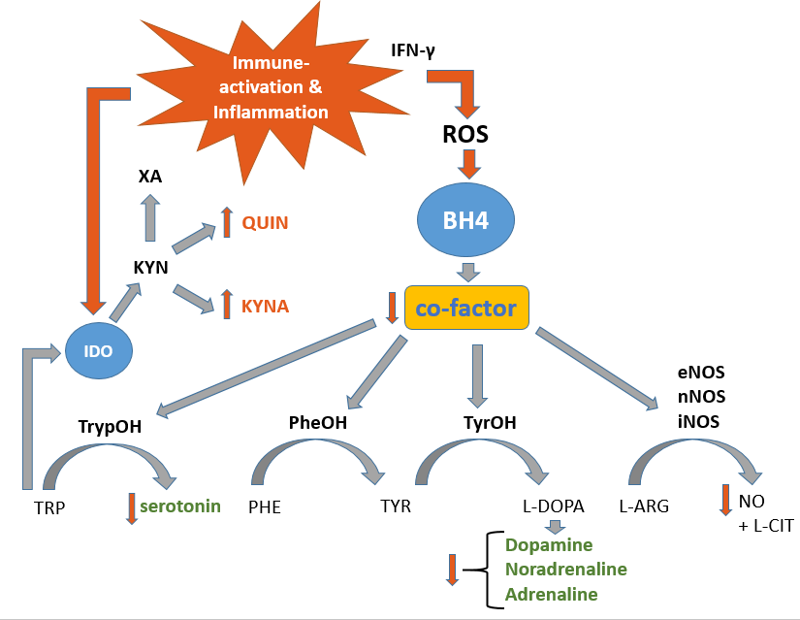

Fig. 1: Immune-activation and associated inflammation cause IFN-γ release which in turn triggers ROS-emission by the innate immune system. ROS causes a decline in BH4-levels due to their oxygen-sensitivity. Since BH4 acts as a co-factor for several aromatic amino acid mono-oxygenases, neurotransmitter synthesis of serotonin, dopamine, noradrenaline and adrenaline levels are diminished. BH4 is recycled via BH2 in a DHFR-dependent manner.

Abbreviations: IFN-γ: Interferon-γ; ROS: reactive oxygen species; BH4: 5,6,7,8-tetrahydrobiopterin; IDO: Indolamin-2,3-Dioxygenase; XA: Xanthurenic acid; QUIN: Quinolonic acid; KYNA: Kynurenic acid; KYN: Kynurenin; TyrOH: Tyrosine hydroxylase; TrypOH: Tryptophan hydroxylase; PheOH: Phenylalanin hydroxylase; eNOS: endothelial nictric oxide synthase; nNOS: neuronal nictric oxide synthase; iNOS: inducible nictric oxide synthase; L-ARG: L-Arginine; NO: nictric oxide; L-CIT: L-citrulline; PHE: Phenylalanine; TYR: Tyrosine; L-DOPA: L-Dopamine; TRP: Tryptophan

Figure 2 Participant recruitment SIMMUN cohort

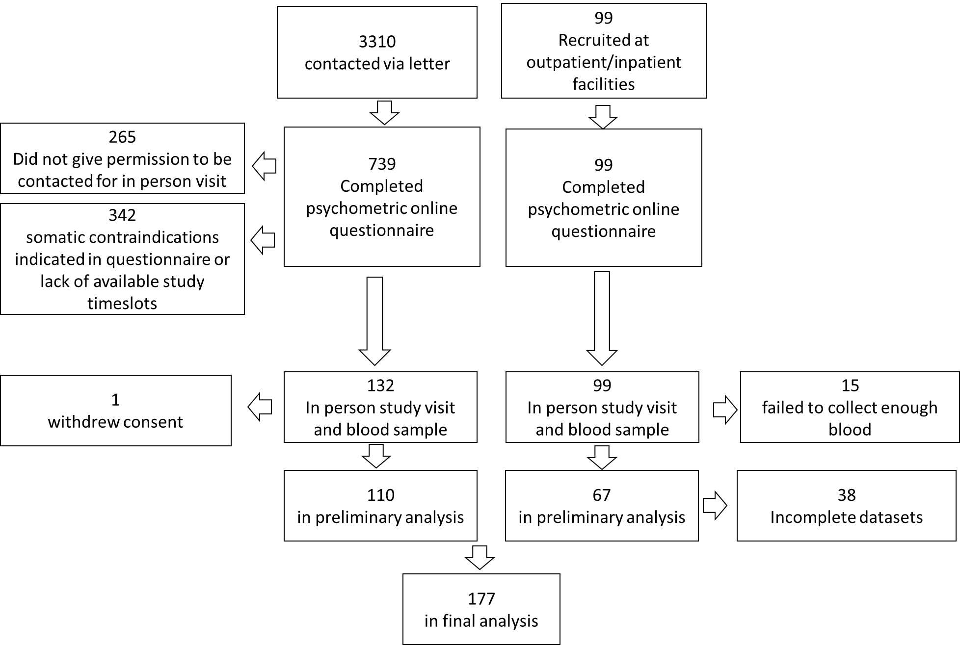

# Figures

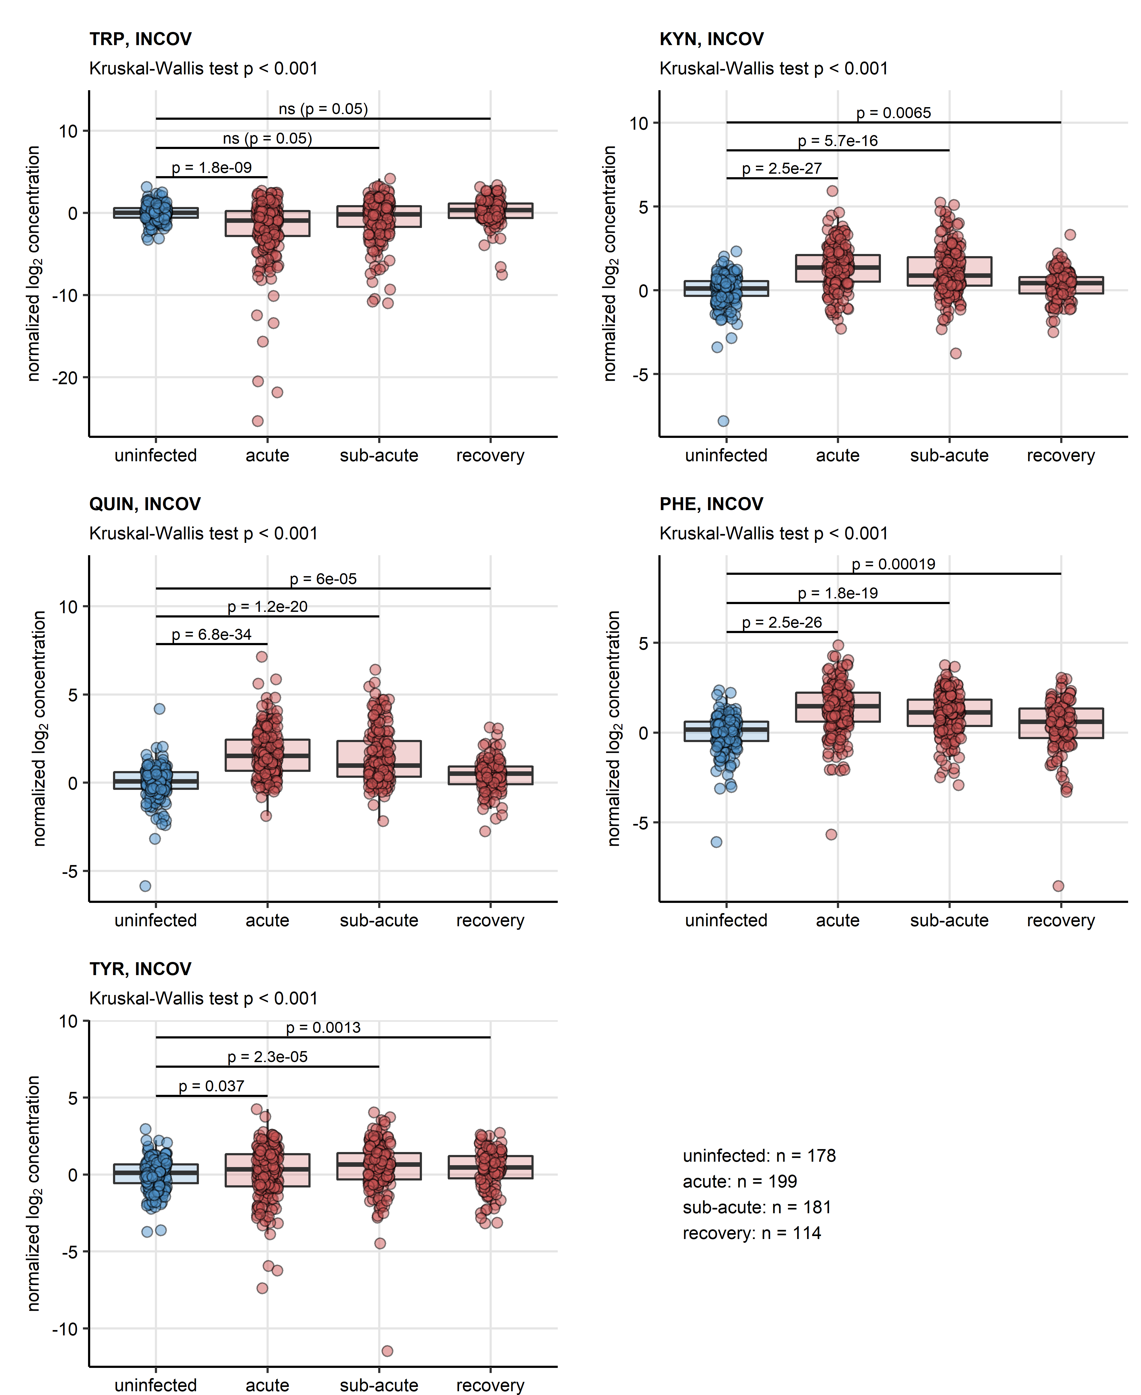

**Figure 3. Serum levels of neurotransmitter precursor and their decay products in course of COVID-19 and recovery, INCOV cohort.**

*Serum levels of tryptophan (TRP), kynurenine (KYN), quinolinic acid (QUIN), phenylalanine (PHE) and tyrosine (TYR) in serum of uninfected controls and COVID-19 individuals during acute, sub-acute and recovery phase of the disease in the INCOV cohort. Statistical significance was determined by Kruskal-Wallis test with Benjamini-Hochberg-corrected Mann-Whitney U test. Normalized serum level concentrations are presented in box plots. Points represent single samples. The Kruskal-Wallis test results are indicated in the plot captions. Results of the post-hoc tests are indicated in the plots. Numbers of complete observations are displayed under the plots.*

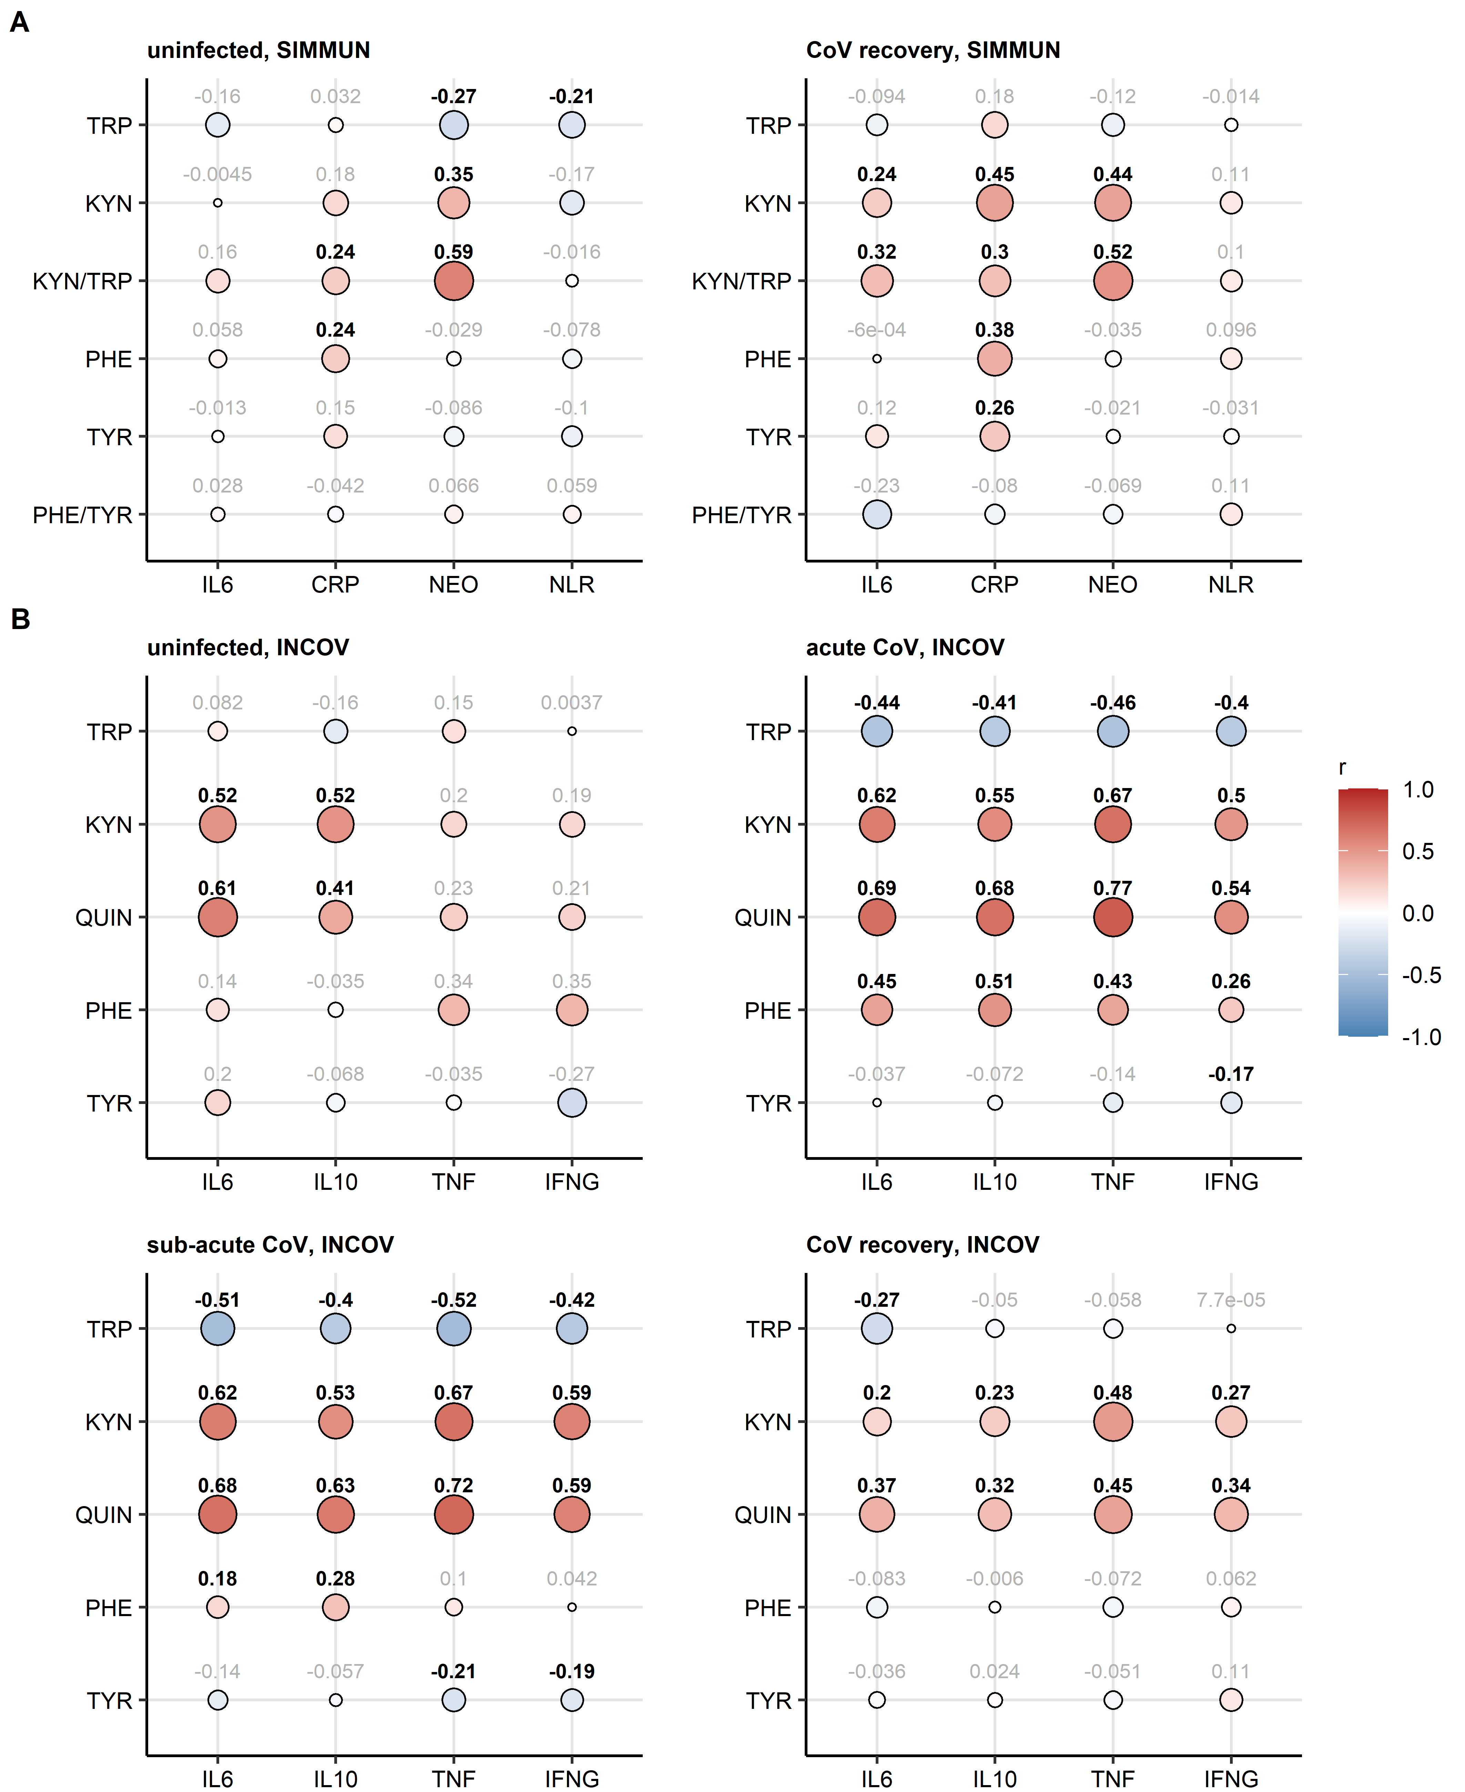

**Figure 4. Correlation of serum levels of aminoacid precursors of neurotransmitters and their decay products with markers of inflammation.**

*Serum levels of tryptophan (TRP), kynurenine (KYN), quinolinic acid (QUIN), kynurenine/tryptophan ratio (KYN/TRP), phenylalanine (PHE), tyrosine (TYR) and phenylalanine/tyrosine ratio (PHE/TYR) were correlated with serum levels of inflammatory markers interleukin 6 (IL6), interleukin 10 (IL10), tumor necrosis factor-alpha (TNF), interferon-gamma (INFG), C-reactive protein (CRP), neopterin (NEO) and neutrophil/lymphocyte ratio (NLR) in uninfected and SARS-CoV-2-infected individuals from the SIMMUN (A) and INCOV cohort (B). Statistical significance was assessed by Spearman test. Correlation coefficients are presented in bubble plots. Point sizes correspond to absolute values of correlation coefficient. Point color corresponds to the correlation coefficient value. Correlation coefficients for significant effects are highlighted in bold.*

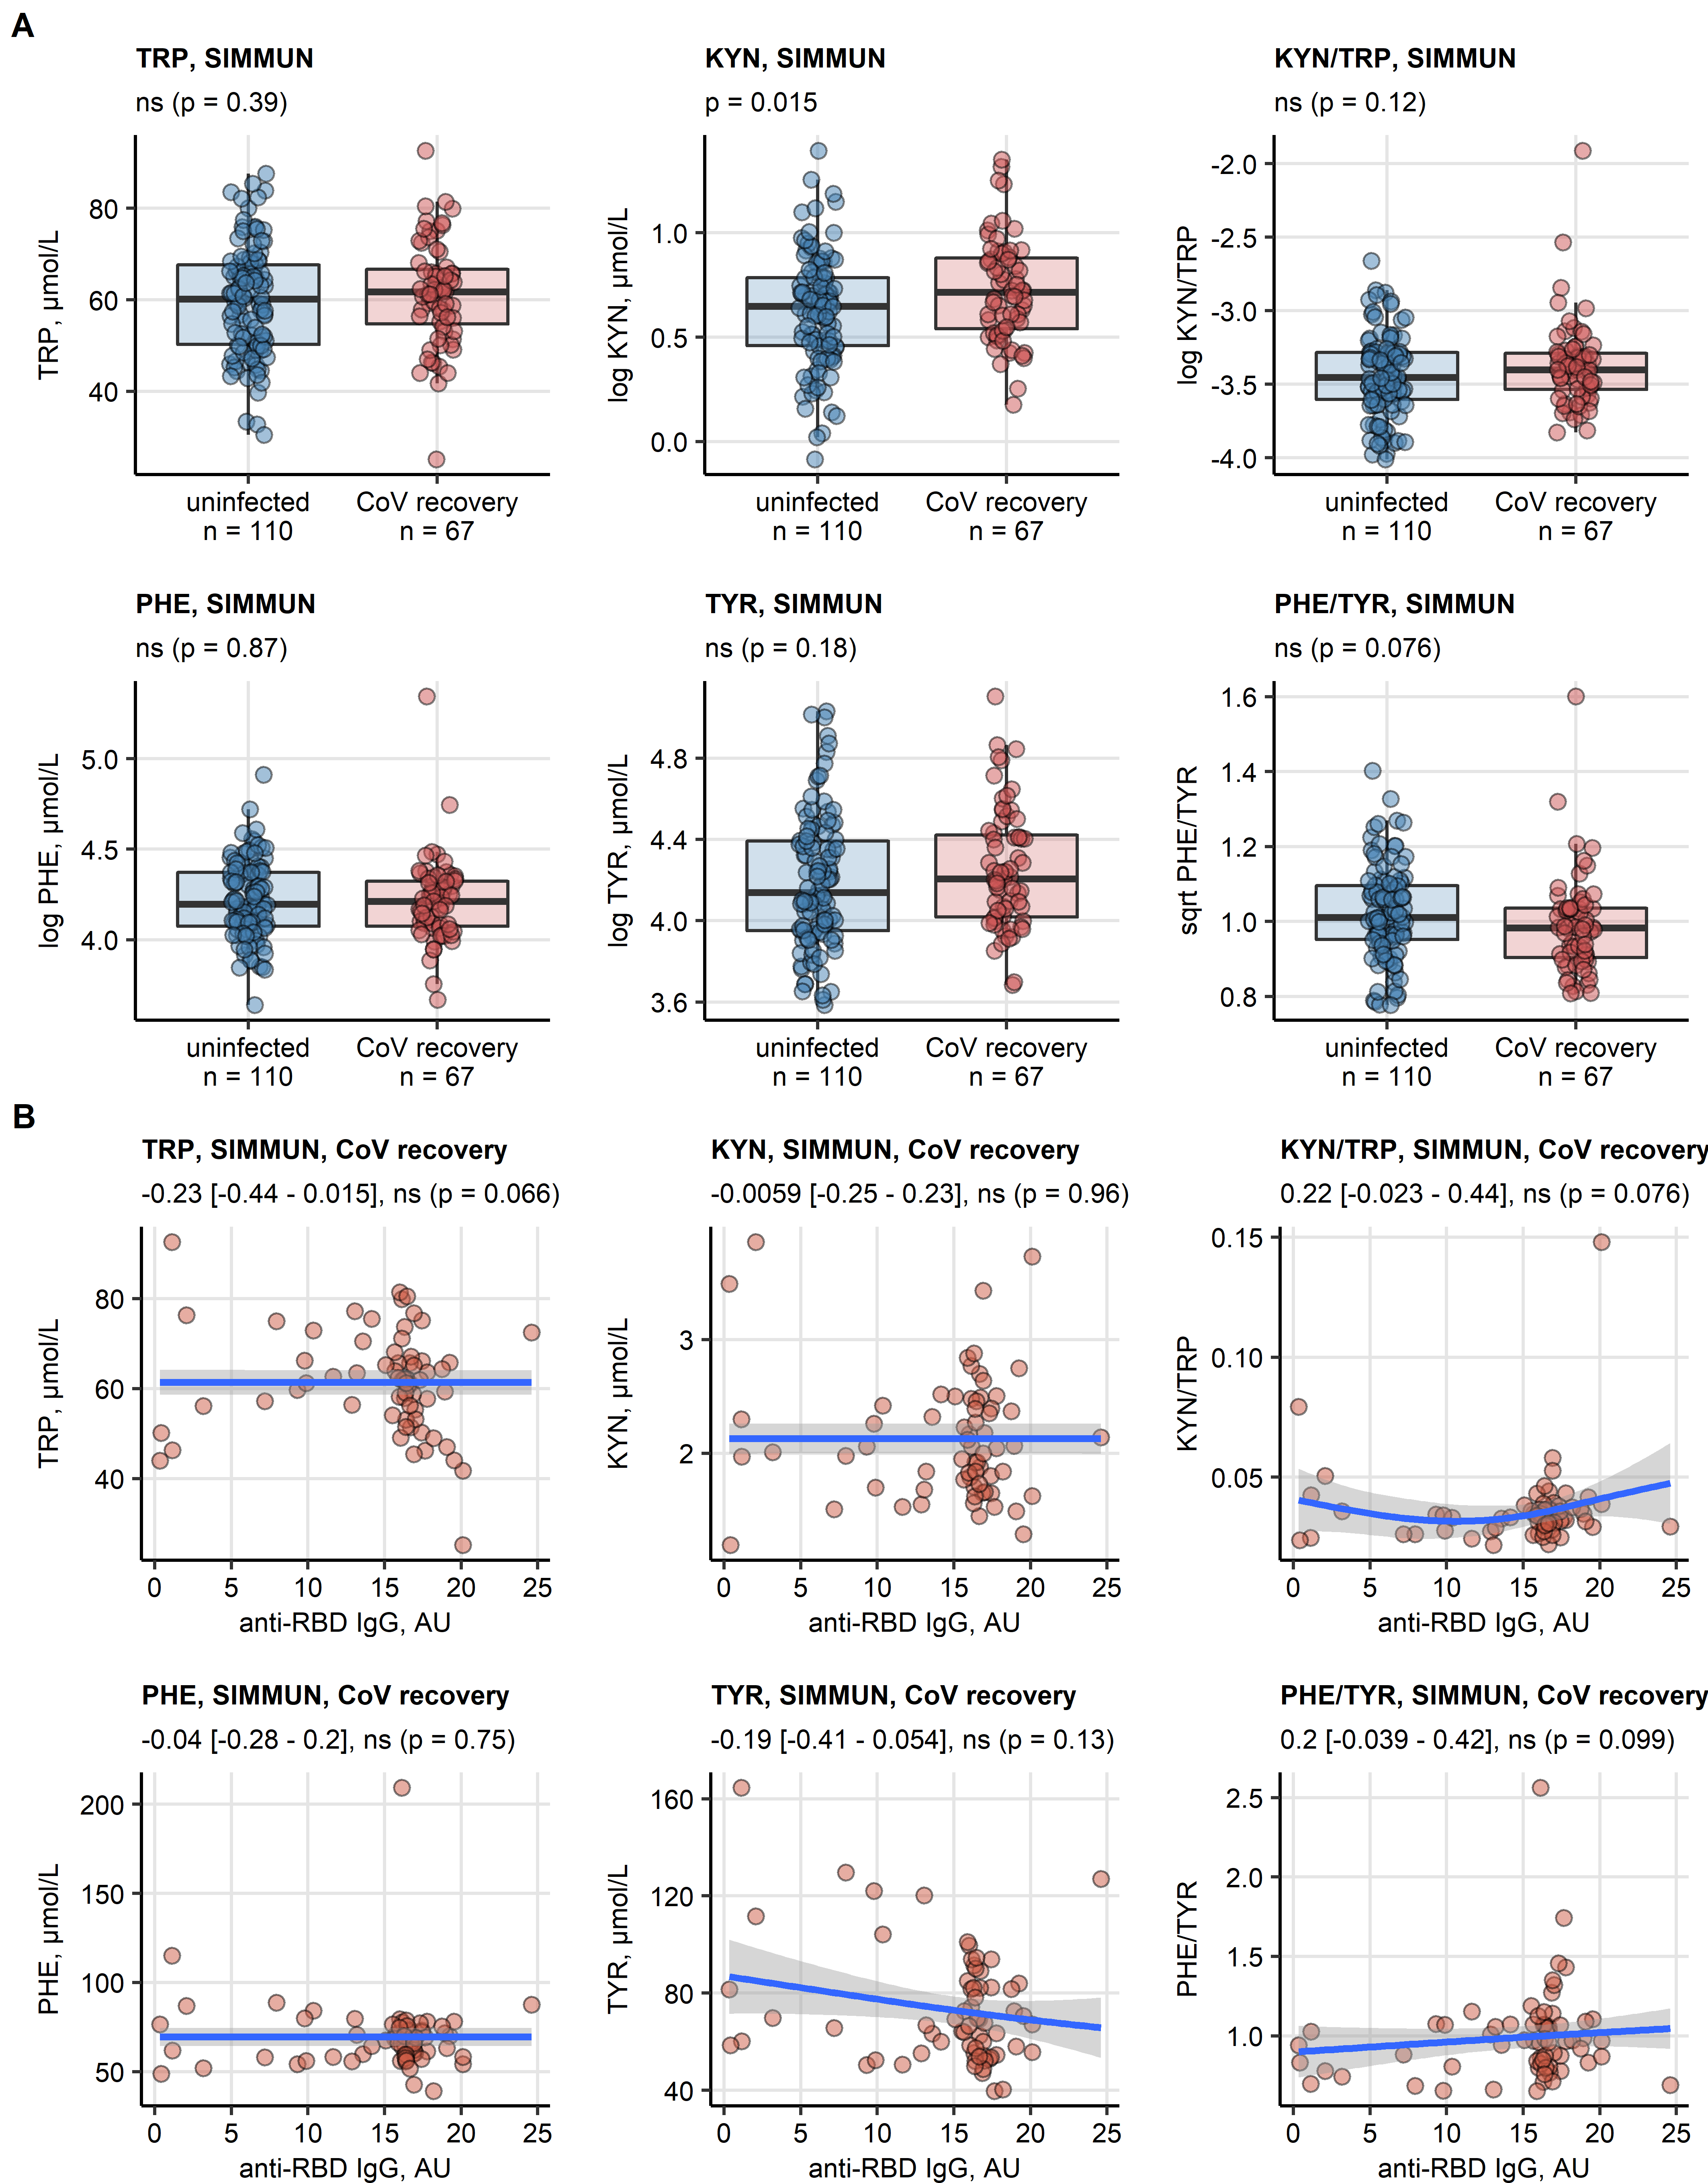

**Figure 5. Association of neurotransmitter precursor aminoacids and their decay products with SARS-CoV-2 infection and anti-SARS-CoV-2 antibody response in the SIMMUN cohort.**

*(A) Serum levels of tryptophan (TRP), kynurenine (KYN), kynurenine/tryptophan ratio (KYN/TRP), phenylalanine (PHE), tyrosine (TYR) and phenylalanine/tyrosine ratio (PHE/TYR) in the SIMMUN study participants stratified by SARS-CoV-2 infections status. Statistical significance was determined by two-tailed T test. Serum levels are shown in box plots. Points represent single observations. Significance p values are displayed in the plot captions, numbers of complete observations are indicated in the plot axes.*

*(B) Correlation of TRP, KYN, KYN/TRP, PHE, TYR and PHE/TRP with the titre of immunoglobulin gamma to receptor binding domain of the SARS-CoV-2 S1 protein (anti-RBD IgG, arbitrary units [AU]) in the SIMMUN cohort (n = 177) was investigated by Spearman test. Points represent single observations, blue lines with gray ribbons depict fitted generalized additive model (GAM) trends with 95% confidence intervals. Values of correlation coefficients with 95% confidence intervals and significance are indicated in the plot captions.*

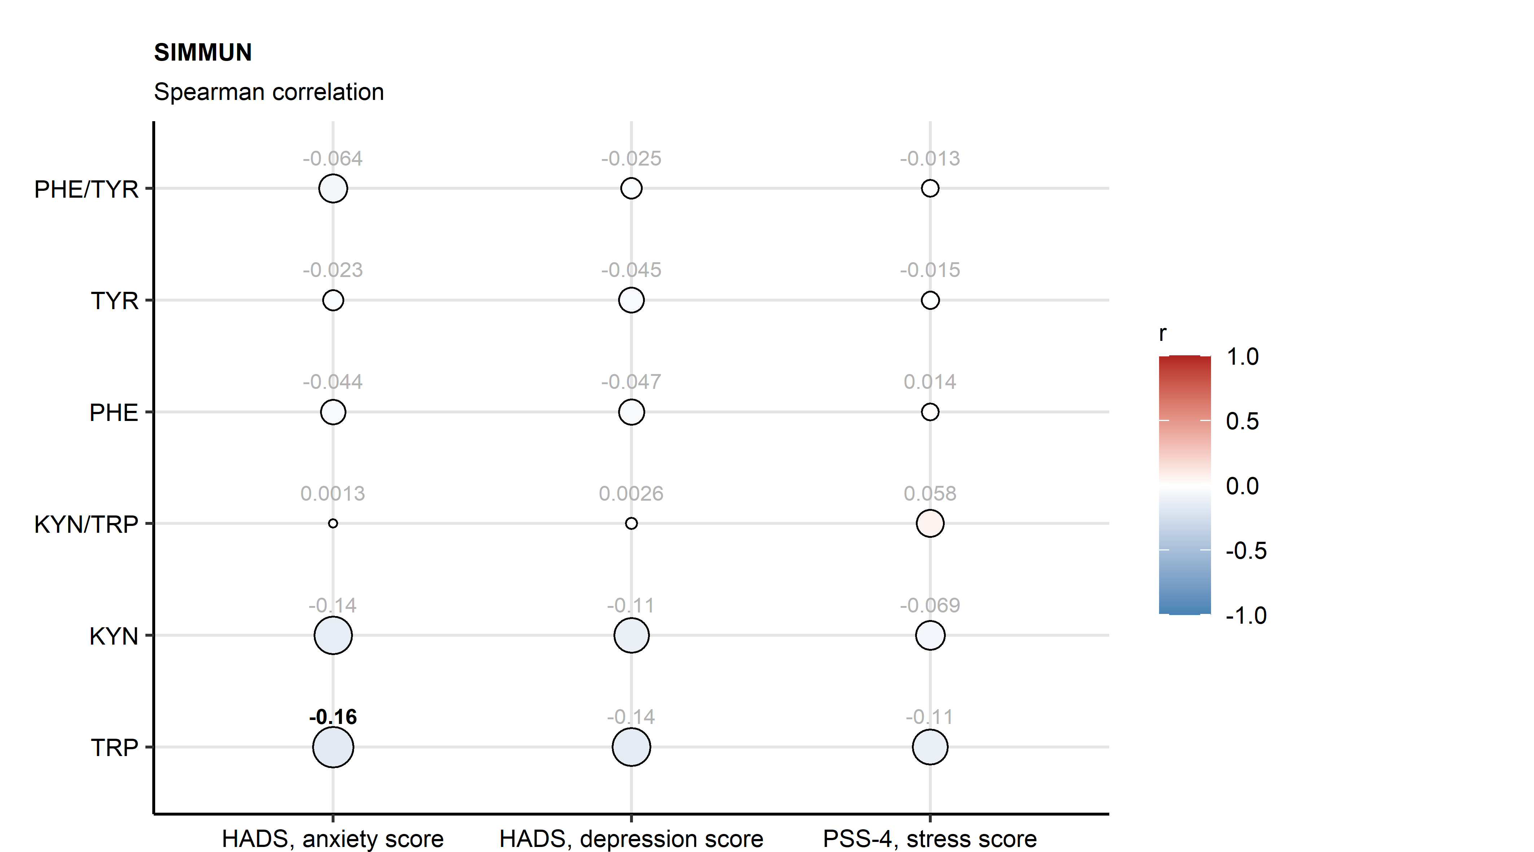

**Figure 6. Association of neurotransmitter precursor aminoacids and their decay products with anxiety, depression and mental stress scoring in the SIMMUN cohort.**

*Serum levels of TRP, KYN, KYN/TRP, PHE, TYR and PHE/TYR were correlated with anxiety, depression and mental stress scores in the SIMMUN study participants (n = 177). Statistical significance was assessed by Spearman test. Correlation coefficients are presented in bubble plots. Point sizes correspond to absolute values of correlation coefficient. Point color corresponds to the correlation coefficient value. Correlation coefficients for significant effects are highlighted in bold.*

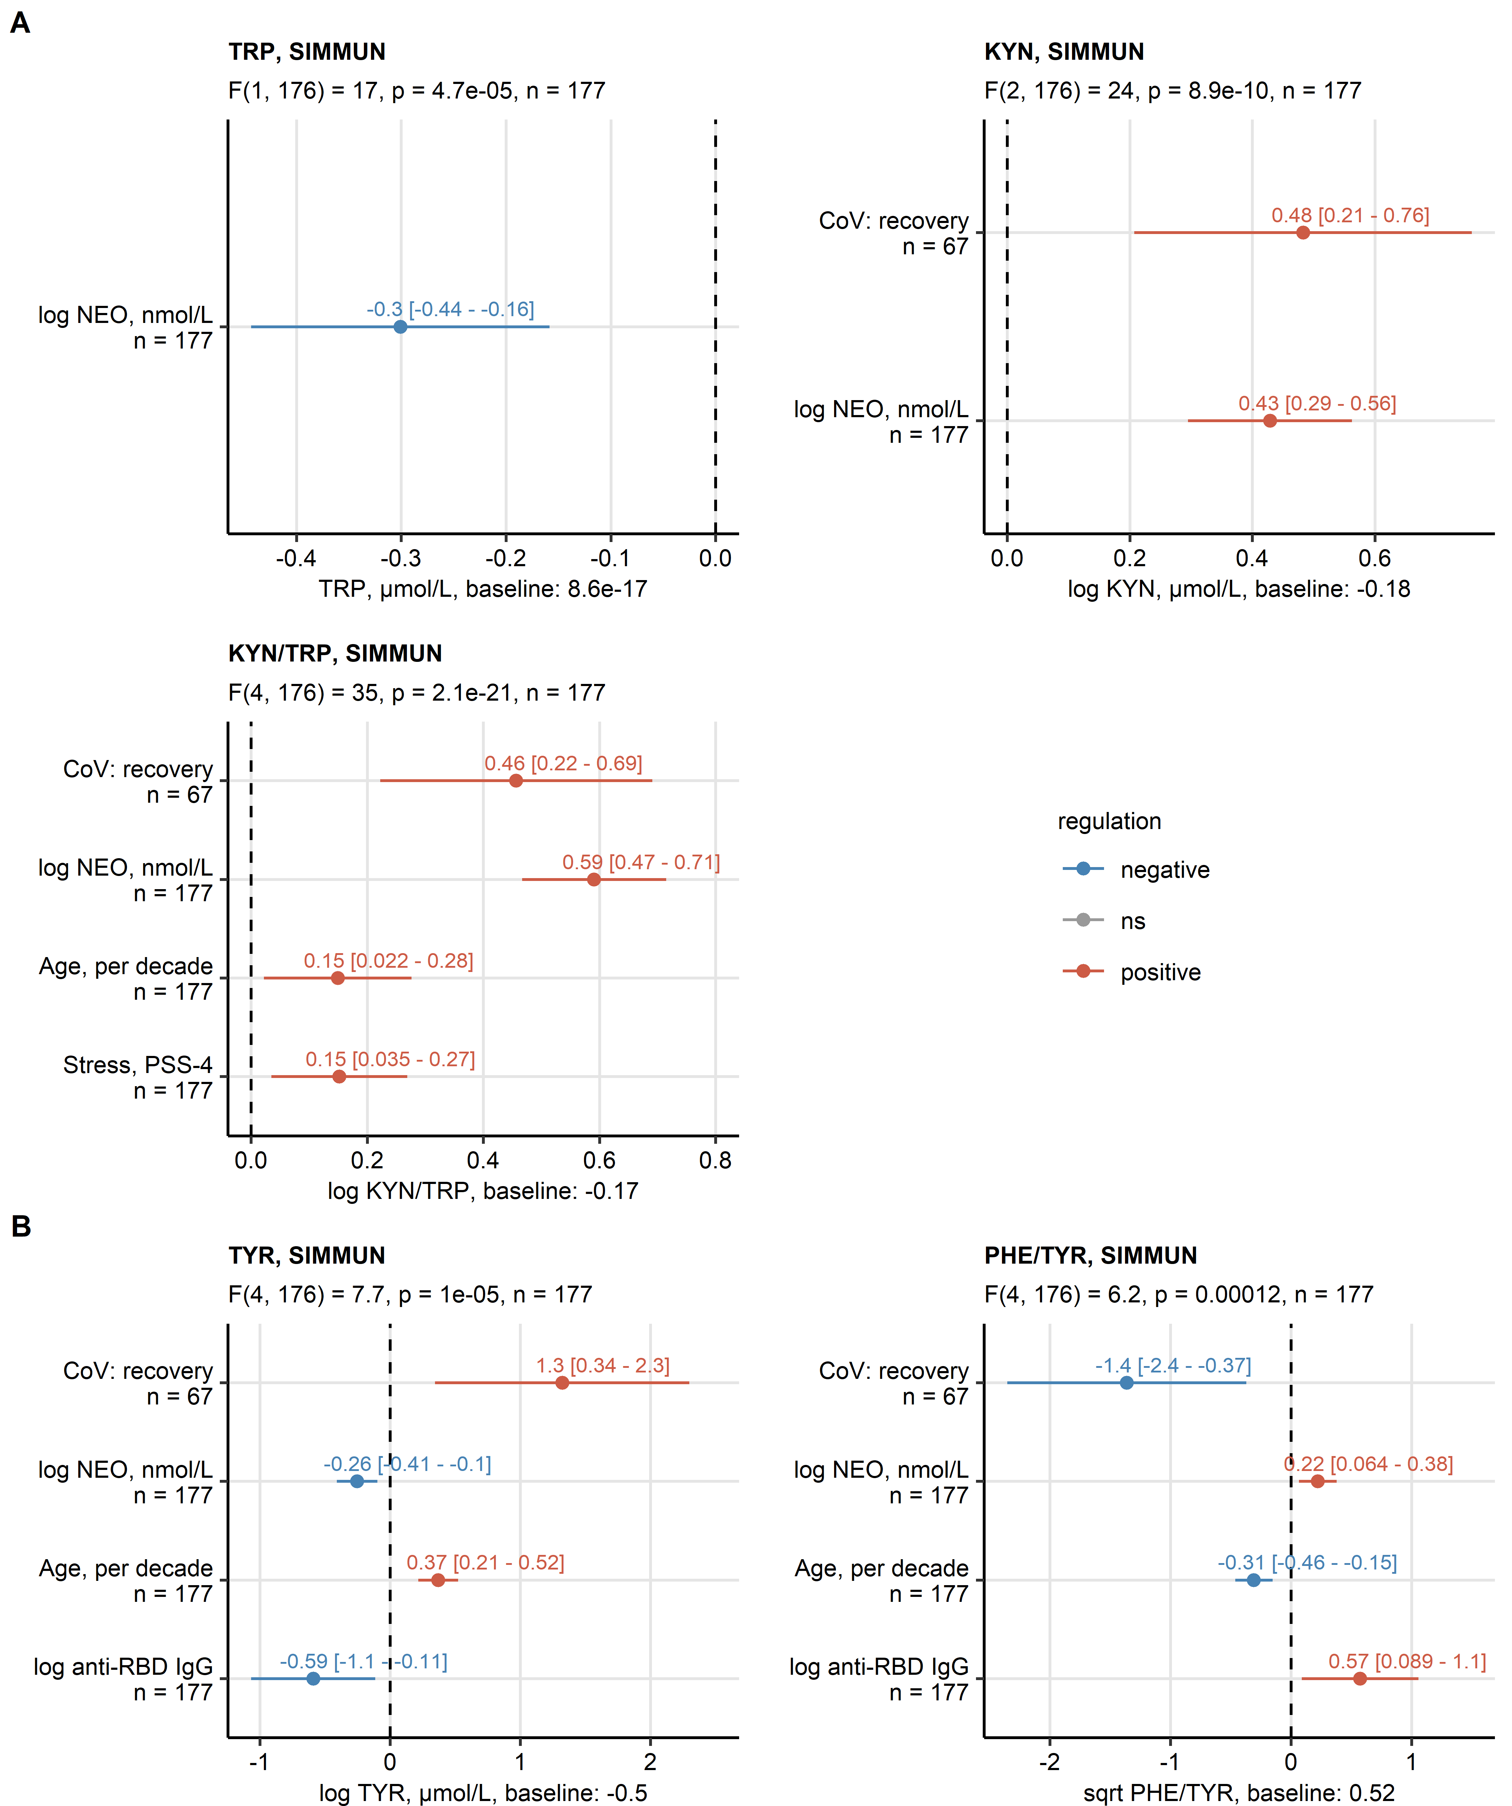

**Figure 7. Results of multi-parameter modeling of aminoacid neurotransmitter precursor and their decay products.**

*Effects of systemic inflammation (neopterin, NEO), SARS-CoV-2 infection status, titer of immunoglobulin gamma against the receptor binding domain of the S1 SARS-CoV-2 protein (anti-RBD IgG), scores of anxiety, depression and mental stress, age and sex was investigated by multi-parameter linear regression with backward elimination of non-significant terms. Overall model validity was assessed by likelihood-ratio test (LRT). Significant model coefficient estimates with 95% confidence intervals are presented in Forest plots. LRT results (F values, degrees of freedom and p values) and total numbers of complete observations are indicated in the plot captions. Model intercepts (baseline) are indicated in the X axis titles.*

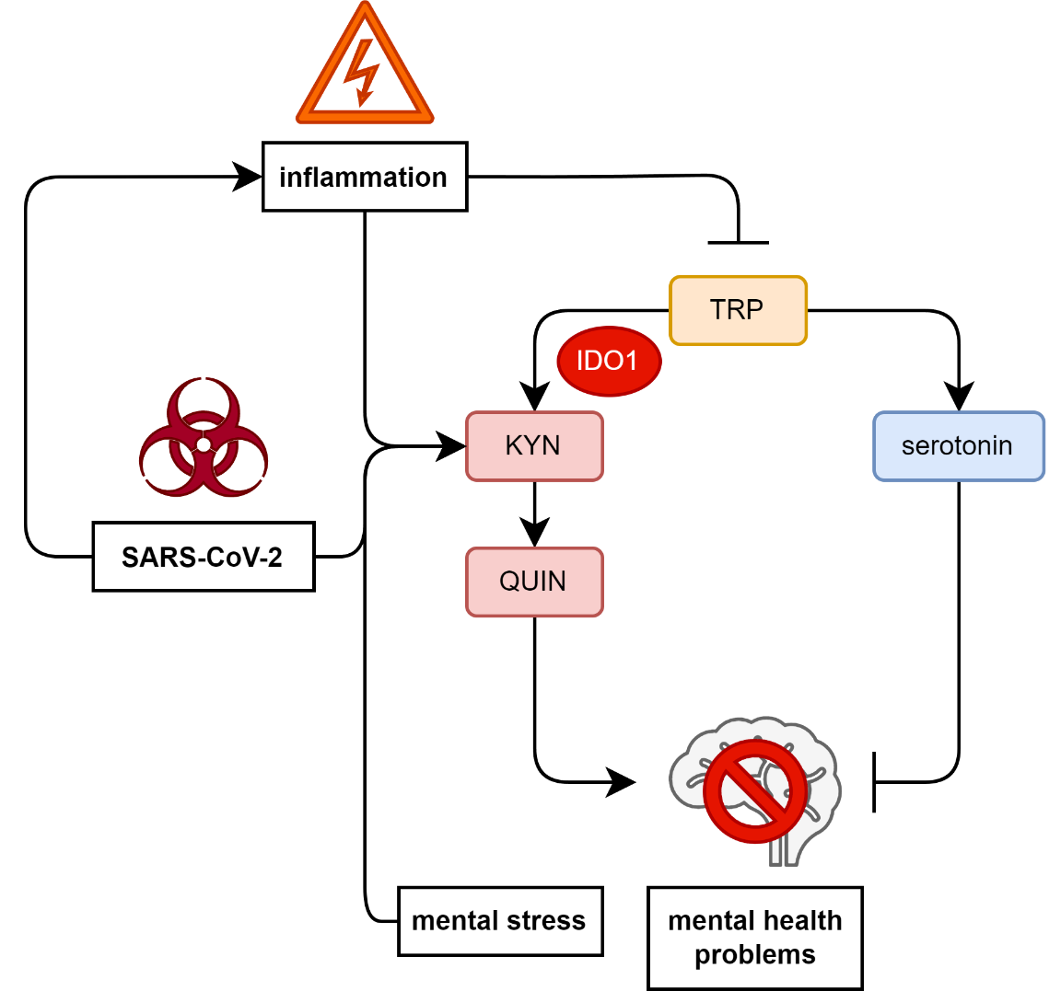

**Figure 8. Schematic representation of effects of inflammation, SARS-CoV-2 and mental stress on indolamine neurotransmitter precursor metabolism.**

*Effects on metabolism of tryptophan (TRP), the serotonin precursor. SARS-CoV-2-dependent and -independent inflammation reduces systemic TRP levels, stimulates IDO1-mediated conversion of TRP to kynurenin (KYN) and quinolinic acid (QUIN). Independently of inflammation, during recovery from SARS-CoV-2 infection, TRP/KYN/QUIN conversion is stimulated as well. As a result, less substrate for production of the anti-depressive and anxiolytic neurotransmitter serotonin is available, which may predispose to depression or anxiety. Depression and anxiety symptoms on their own are paralleled by decrease in circulating TRP.*

3. Kassambara A. rstatix: Pipe-Friendly Framework for Basic Statistical Tests. (2021) <https://cran.r-project.org/package=rstatix>

4. Kassambara A, Mundt F. factoextra: Extract and Visualize the Results of Multivariate Data Analyses. (2020) <https://cran.r-project.org/web/packages/factoextra/index.html>

# References

Almulla, A.F., Supasitthumrong, T., Tunvirachaisakul, C., Algon, A.A.A., Al-Hakeim, H.K., Maes, M., 2022. The tryptophan catabolite or kynurenine pathway in COVID-19 and critical COVID-19: a systematic review and meta-analysis. BMC Infectious Diseases 22, 615.

Benjamini, Y., Hochberg, Y., 1995. Controlling the False Discovery Rate: A Practical and Powerful Approach to Multiple Testing. Journal of the Royal Statistical Society: Series B (Methodological) 57, 289-300.

Bizjak, D.A., Stangl, M., Börner, N., Bösch, F., Durner, J., Drunin, G., Buhl, J.L., Abendroth, D., 2022. Kynurenine serves as useful biomarker in acute, Long- and Post-COVID-19 diagnostics. Front Immunol 13, 1004545.

Bjelland, I., Dahl, A.A., Haug, T.T., Neckelmann, D., 2002. The validity of the Hospital Anxiety and Depression Scale. An updated literature review. J Psychosom Res 52, 69-77.

Bower, J.E., Radin, A., Kuhlman, K.R., 2022. Psychoneuroimmunology in the time of COVID-19: Why neuro-immune interactions matter for mental and physical health. Behav Res Ther 154, 104104.

Capuron, L., Schroecksnadel, S., Feart, C., Aubert, A., Higueret, D., Barberger-Gateau, P., Laye, S., Fuchs, D., 2011. Chronic low-grade inflammation in elderly persons is associated with altered tryptophan and tyrosine metabolism: role in neuropsychiatric symptoms. Biol Psychiatry 70, 175-182.

Dantzer, R., 2005. Somatization: A psychoneuroimmune perspective. Psychoneuroendocrinology 30, 947-952.

Dantzer, R., O'Connor, J.C., Freund, G.G., Johnson, R.W., Kelley, K.W., 2008. From inflammation to sickness and depression: when the immune system subjugates the brain. Nature Reviews Neuroscience 9, 46-56.

Deisenhammer, F., Bauer, A., Kavelar, C., Rudzki, D., Rössler, A., Kimpel, J., Borena, W., Reindl, M., 2021. 12-month SARS-CoV-2 antibody persistency in a Tyrolean COVID-19 cohort. Wien Klin Wochenschr 133, 1265-1271.

Dewulf, J.P., Martin, M., Marie, S., Oguz, F., Belkhir, L., De Greef, J., Yombi, J.C., Wittebole, X., Laterre, P.-F., Jadoul, M., Gatto, L., Bommer, G.T., Morelle, J., 2022. Urine metabolomics links dysregulation of the tryptophan-kynurenine pathway to inflammation and severity of COVID-19. Scientific Reports 12, 9959.

Eroğlu, İ., Eroğlu, B., Güven, G.S., 2021. Altered tryptophan absorption and metabolism could underlie long-term symptoms in survivors of coronavirus disease 2019 (COVID-19). Nutrition 90, 111308.

Fanet, H., Capuron, L., Castanon, N., Calon, F., Vancassel, S., 2021. Tetrahydrobioterin (BH4) Pathway: From Metabolism to Neuropsychiatry. Curr Neuropharmacol 19, 591-609.

Hamilton, O.S., Cadar, D., Steptoe, A., 2021. Systemic inflammation and emotional responses during the COVID-19 pandemic. Transl Psychiatry 11, 626.

Hüfner, K., Fuchs, D., Blauth, M., Sperner-Unterweger, B., 2019. How acute and chronic physical disease may influence mental health - An Analysis of neurotransmitter precursor amino acid levels. Psychoneuroendocrinology 106, 95-101.

Hüfner, K., Galffy, M., Egeter, J., Giesinger, J.M., Arnhard, K., Oberacher, H., Gostner, J.M., Fuchs, D., Sperner-Unterweger, B., 2020. Acute and Chronic Mental Stress Both Influence Levels of Neurotransmitter Precursor Amino Acids and Derived Biogenic Amines. Brain Sci 10.

Hüfner, K., Giesinger, J.M., Gostner, J.M., Egeter, J., Koudouovoh-Tripp, P., Vill, T., Fuchs, D., Sperner-Unterweger, B., 2021. Neurotransmitter Precursor Amino Acid Ratios Show Differential, Inverse Correlations with Depression Severity in the Low and High Depression Score Range. Int J Tryptophan Res 14, 11786469211039220.

Hüfner, K., Oberguggenberger, A., Kohl, C., Geisler, S., Gamper, E., Meraner, V., Egeter, J., Hubalek, M., Beer, B., Fuchs, D., Sperner-Unterweger, B., 2015. Levels in neurotransmitter precursor amino acids correlate with mental health in patients with breast cancer. Psychoneuroendocrinology 60, 28-38.

Hüfner, K., Tymoszuk, P., Sahanic, S., Luger, A., Boehm, A., Pizzini, A., Schwabl, C., Koppelstätter, S., Kurz, K., Asshoff, M., Mosheimer-Feistritzer, B., Pfeifer, B., Rass, V., Schroll, A., Iglseder, S., Egger, A., Wöll, E., Weiss, G., Helbok, R., Widmann, G., Sonnweber, T., Tancevski, I., Sperner-Unterweger, B., Löffler-Ragg, J., 2022. Persistent somatic symptoms are key to individual illness perception at one year after COVID-19. medRxiv, 2022.2009.2005.22279602.

Matta, J., Wiernik, E., Robineau, O., Carrat, F., Touvier, M., Severi, G., de Lamballerie, X., Blanché, H., Deleuze, J.-F., Gouraud, C., Hoertel, N., Ranque, B., Goldberg, M., Zins, M., Lemogne, C., Santé, P., Relations et Inégalités Sociales en Population Générale Pendant la Crise COVID-19–Sérologie Study Group, 2022. Association of Self-reported COVID-19 Infection and SARS-CoV-2 Serology Test Results With Persistent Physical Symptoms Among French Adults During the COVID-19 Pandemic. JAMA Internal Medicine 182, 19-25.

Miller, A.H., Raison, C.L., 2016. The role of inflammation in depression: from evolutionary imperative to modern treatment target. Nature Reviews Immunology 16, 22-34.

Najjar, S., Najjar, A., Chong, D.J., Pramanik, B.K., Kirsch, C., Kuzniecky, R.I., Pacia, S.V., Azhar, S., 2020. Central nervous system complications associated with SARS-CoV-2 infection: integrative concepts of pathophysiology and case reports. J Neuroinflammation 17, 231.

Neurauter, G., Schrocksnadel, K., Scholl-Burgi, S., Sperner-Unterweger, B., Schubert, C., Ledochowski, M., Fuchs, D., 2008. Chronic immune stimulation correlates with reduced phenylalanine turnover. Curr Drug Metab 9, 622-627.

Rahimian, R., Belliveau, C., Chen, R., Mechawar, N., 2022. Microglial Inflammatory-Metabolic Pathways and Their Potential Therapeutic Implication in Major Depressive Disorder. Front Psychiatry 13, 871997.

Schwarcz, R., Bruno, J.P., Muchowski, P.J., Wu, H.Q., 2012. Kynurenines in the mammalian brain: when physiology meets pathology. Nat Rev Neurosci 13, 465-477.

Song, P., Li, W., Xie, J., Hou, Y., You, C., 2020. Cytokine storm induced by SARS-CoV-2. Clin Chim Acta 509, 280-287.

Staudt, A., Jörres, R.A., Hinterberger, T., Lehnen, N., Loew, T., Budweiser, S., 2022. Associations of Post-Acute COVID syndrome with physiological and clinical measures 10 months after hospitalization in patients of the first wave. European Journal of Internal Medicine 95, 50-60.

Su, Y., Yuan, D., Chen, D.G., Ng, R.H., Wang, K., Choi, J., Li, S., Hong, S., Zhang, R., Xie, J., Kornilov, S.A., Scherler, K., Pavlovitch-Bedzyk, A.J., Dong, S., Lausted, C., Lee, I., Fallen, S., Dai, C.L., Baloni, P., Smith, B., Duvvuri, V.R., Anderson, K.G., Li, J., Yang, F., Duncombe, C.J., McCulloch, D.J., Rostomily, C., Troisch, P., Zhou, J., Mackay, S., DeGottardi, Q., May, D.H., Taniguchi, R., Gittelman, R.M., Klinger, M., Snyder, T.M., Roper, R., Wojciechowska, G., Murray, K., Edmark, R., Evans, S., Jones, L., Zhou, Y., Rowen, L., Liu, R., Chour, W., Algren, H.A., Berrington, W.R., Wallick, J.A., Cochran, R.A., Micikas, M.E., Unit, I.S.-S.C.-B., Wrin, T., Petropoulos, C.J., Cole, H.R., Fischer, T.D., Wei, W., Hoon, D.S.B., Price, N.D., Subramanian, N., Hill, J.A., Hadlock, J., Magis, A.T., Ribas, A., Lanier, L.L., Boyd, S.D., Bluestone, J.A., Chu, H., Hood, L., Gottardo, R., Greenberg, P.D., Davis, M.M., Goldman, J.D., Heath, J.R., 2022. Multiple early factors anticipate post-acute COVID-19 sequelae. Cell 185, 881-895 e820.

Sucher, R., Schroecksnadel, K., Weiss, G., Margreiter, R., Fuchs, D., Brandacher, G., 2010. Neopterin, a prognostic marker in human malignancies. Cancer Lett 287, 13-22.

Thony, B., Auerbach, G., Blau, N., 2000. Tetrahydrobiopterin biosynthesis, regeneration and functions. Biochem J 347 Pt 1, 1-16.

Wang, Q., Xu, R., Volkow, N.D., 2021. Increased risk of COVID-19 infection and mortality in people with mental disorders: analysis from electronic health records in the United States. World Psychiatry 20, 124-130.

Werner-Felmayer, G., Golderer, G., Werner, E.R., 2002. Tetrahydrobiopterin biosynthesis, utilization and pharmacological effects. Curr Drug Metab 3, 159-173.

Widner, B., Werner, E.R., Schennach, H., Wachter, H., Fuchs, D., 1997. Simultaneous measurement of serum tryptophan and kynurenine by HPLC. Clin Chem 43, 2424-2426.

Yılmaz, N., Herken, H., Cicek, H.K., Celik, A., Yürekli, M., Akyol, Ö., 2007. Increased Levels of Nitric Oxide, Cortisol and Adrenomedullin in Patients with Chronic Schizophrenia. Medical Principles and Practice 16, 137-141.

Al-Aly, Z., Xie, Y., Bowe, B., 2021. High-dimensional characterization of post-acute sequelae of COVID-19. Nature 594, 259-264.

Benjamini, Y., Hochberg, Y., 1995. Controlling the False Discovery Rate: A Practical and Powerful Approach to Multiple Testing. Journal of the Royal Statistical Society: Series B (Methodological) 57, 289-300.

Bizjak, D.A., Stangl, M., Börner, N., Bösch, F., Durner, J., Drunin, G., Buhl, J.L., Abendroth, D., 2022. Kynurenine serves as useful biomarker in acute, Long- and Post-COVID-19 diagnostics. Front Immunol 13, 1004545.

Bjelland, I., Dahl, A.A., Haug, T.T., Neckelmann, D., 2002. The validity of the Hospital Anxiety and Depression Scale. An updated literature review. J Psychosom Res 52, 69-77.

Bower, J.E., Radin, A., Kuhlman, K.R., 2022. Psychoneuroimmunology in the time of COVID-19: Why neuro-immune interactions matter for mental and physical health. Behav Res Ther 154, 104104.

Capuron, L., Schroecksnadel, S., Feart, C., Aubert, A., Higueret, D., Barberger-Gateau, P., Laye, S., Fuchs, D., 2011. Chronic low-grade inflammation in elderly persons is associated with altered tryptophan and tyrosine metabolism: role in neuropsychiatric symptoms. Biol Psychiatry 70, 175-182.

Cohen, S., Kamarck, T., Mermelstein, R., 1983. A Global Measure of Perceived Stress. Journal of Health and Social Behavior 24, 385-396.

Dantzer, R., O'Connor, J.C., Freund, G.G., Johnson, R.W., Kelley, K.W., 2008. From inflammation to sickness and depression: when the immune system subjugates the brain. Nature Reviews Neuroscience 9, 46-56.

Deisenhammer, F., Bauer, A., Kavelar, C., Rudzki, D., Rössler, A., Kimpel, J., Borena, W., Reindl, M., 2021. 12-month SARS-CoV-2 antibody persistency in a Tyrolean COVID-19 cohort. Wien Klin Wochenschr 133, 1265-1271.

Fanet, H., Capuron, L., Castanon, N., Calon, F., Vancassel, S., 2021. Tetrahydrobioterin (BH4) Pathway: From Metabolism to Neuropsychiatry. Curr Neuropharmacol 19, 591-609.

Fellendorf, F.T., Bonkat, N., Dalkner, N., Schönthaler, E.M.D., Manchia, M., Fuchs, D., Reininghaus, E.Z., 2022. Indoleamine 2,3-dioxygenase (IDO)-activity in severe psychiatric disorders: A systemic review. Curr Top Med Chem.

Haroon, E., Raison, C.L., Miller, A.H., 2012. Psychoneuroimmunology Meets Neuropsychopharmacology: Translational Implications of the Impact of Inflammation on Behavior. Neuropsychopharmacology 37, 137-162.

Huang, C., Huang, L., Wang, Y., Li, X., Ren, L., Gu, X., Kang, L., Guo, L., Liu, M., Zhou, X., Luo, J., Huang, Z., Tu, S., Zhao, Y., Chen, L., Xu, D., Li, Y., Li, C., Peng, L., Li, Y., Xie, W., Cui, D., Shang, L., Fan, G., Xu, J., Wang, G., Wang, Y., Zhong, J., Wang, C., Wang, J., Zhang, D., Cao, B., 2021. 6-month consequences of COVID-19 in patients discharged from hospital: a cohort study. Lancet 397, 220-232.

Hüfner, K., Galffy, M., Egeter, J., Giesinger, J.M., Arnhard, K., Oberacher, H., Gostner, J.M., Fuchs, D., Sperner-Unterweger, B., 2020. Acute and Chronic Mental Stress Both Influence Levels of Neurotransmitter Precursor Amino Acids and Derived Biogenic Amines. Brain Sci 10.

Hüfner, K., Oberguggenberger, A., Kohl, C., Geisler, S., Gamper, E., Meraner, V., Egeter, J., Hubalek, M., Beer, B., Fuchs, D., Sperner-Unterweger, B., 2015. Levels in neurotransmitter precursor amino acids correlate with mental health in patients with breast cancer. Psychoneuroendocrinology 60, 28-38.

Hüfner, K., Tymoszuk, P., Ausserhofer, D., Sahanic, S., Pizzini, A., Rass, V., Galffy, M., Böhm, A., Kurz, K., Sonnweber, T., Tancevski, I., Kiechl, S., Huber, A., Plagg, B., Wiedermann, C.J., Bellmann-Weiler, R., Bachler, H., Weiss, G., Piccoliori, G., Helbok, R., Loeffler-Ragg, J., Sperner-Unterweger, B., 2022a. Who Is at Risk of Poor Mental Health Following Coronavirus Disease-19 Outpatient Management? Front Med (Lausanne) 9, 792881.

Hüfner, K., Tymoszuk, P., Sahanic, S., Luger, A., Boehm, A., Pizzini, A., Schwabl, C., Koppelstätter, S., Kurz, K., Asshoff, M., Mosheimer-Feistritzer, B., Pfeifer, B., Rass, V., Schroll, A., Iglseder, S., Egger, A., Wöll, E., Weiss, G., Helbok, R., Widmann, G., Sonnweber, T., Tancevski, I., Sperner-Unterweger, B., Löffler-Ragg, J., 2022b. Persistent somatic symptoms are key to individual illness perception at one year after COVID-19. medRxiv, 2022.2009.2005.22279602.

Hunt, C., Macedo, E.C.T., Suchting, R., de Dios, C., Cuellar Leal, V.A., Soares, J.C., Dantzer, R., Teixeira, A.L., Selvaraj, S., 2020. Effect of immune activation on the kynurenine pathway and depression symptoms - A systematic review and meta-analysis. Neurosci Biobehav Rev 118, 514-523.

Kucukkarapinar, M., Yay-Pence, A., Yildiz, Y., Buyukkoruk, M., Yaz-Aydin, G., Deveci-Bulut, T.S., Gulbahar, O., Senol, E., Candansayar, S., 2022. Psychological outcomes of COVID-19 survivors at sixth months after diagnose: the role of kynurenine pathway metabolites in depression, anxiety, and stress. J Neural Transm (Vienna) 129, 1077-1089.

Matta, J., Wiernik, E., Robineau, O., Carrat, F., Touvier, M., Severi, G., de Lamballerie, X., Blanché, H., Deleuze, J.-F., Gouraud, C., Hoertel, N., Ranque, B., Goldberg, M., Zins, M., Lemogne, C., Santé, P., Relations et Inégalités Sociales en Population Générale Pendant la Crise COVID-19–Sérologie Study Group, 2022. Association of Self-reported COVID-19 Infection and SARS-CoV-2 Serology Test Results With Persistent Physical Symptoms Among French Adults During the COVID-19 Pandemic. JAMA Internal Medicine 182, 19-25.

Najjar, S., Najjar, A., Chong, D.J., Pramanik, B.K., Kirsch, C., Kuzniecky, R.I., Pacia, S.V., Azhar, S., 2020. Central nervous system complications associated with SARS-CoV-2 infection: integrative concepts of pathophysiology and case reports. J Neuroinflammation 17, 231.

Nasserie, T., Hittle, M., Goodman, S.N., 2021. Assessment of the Frequency and Variety of Persistent Symptoms Among Patients With COVID-19: A Systematic Review. JAMA Network Open 4, e2111417-e2111417.

Neurauter, G., Schrocksnadel, K., Scholl-Burgi, S., Sperner-Unterweger, B., Schubert, C., Ledochowski, M., Fuchs, D., 2008. Chronic immune stimulation correlates with reduced phenylalanine turnover. Curr Drug Metab 9, 622-627.

Rahimian, R., Belliveau, C., Chen, R., Mechawar, N., 2022. Microglial Inflammatory-Metabolic Pathways and Their Potential Therapeutic Implication in Major Depressive Disorder. Front Psychiatry 13, 871997.

Song, P., Li, W., Xie, J., Hou, Y., You, C., 2020. Cytokine storm induced by SARS-CoV-2. Clin Chim Acta 509, 280-287.

Staudt, A., Jörres, R.A., Hinterberger, T., Lehnen, N., Loew, T., Budweiser, S., 2022. Associations of Post-Acute COVID syndrome with physiological and clinical measures 10 months after hospitalization in patients of the first wave. European Journal of Internal Medicine 95, 50-60.

Su, Y., Yuan, D., Chen, D.G., Ng, R.H., Wang, K., Choi, J., Li, S., Hong, S., Zhang, R., Xie, J., Kornilov, S.A., Scherler, K., Pavlovitch-Bedzyk, A.J., Dong, S., Lausted, C., Lee, I., Fallen, S., Dai, C.L., Baloni, P., Smith, B., Duvvuri, V.R., Anderson, K.G., Li, J., Yang, F., Duncombe, C.J., McCulloch, D.J., Rostomily, C., Troisch, P., Zhou, J., Mackay, S., DeGottardi, Q., May, D.H., Taniguchi, R., Gittelman, R.M., Klinger, M., Snyder, T.M., Roper, R., Wojciechowska, G., Murray, K., Edmark, R., Evans, S., Jones, L., Zhou, Y., Rowen, L., Liu, R., Chour, W., Algren, H.A., Berrington, W.R., Wallick, J.A., Cochran, R.A., Micikas, M.E., Wrin, T., Petropoulos, C.J., Cole, H.R., Fischer, T.D., Wei, W., Hoon, D.S.B., Price, N.D., Subramanian, N., Hill, J.A., Hadlock, J., Magis, A.T., Ribas, A., Lanier, L.L., Boyd, S.D., Bluestone, J.A., Chu, H., Hood, L., Gottardo, R., Greenberg, P.D., Davis, M.M., Goldman, J.D., Heath, J.R., 2022. Multiple early factors anticipate post-acute COVID-19 sequelae. Cell 185, 881-895.e820.

Sucher, R., Schroecksnadel, K., Weiss, G., Margreiter, R., Fuchs, D., Brandacher, G., 2010. Neopterin, a prognostic marker in human malignancies. Cancer Lett 287, 13-22.

Taquet, M., Luciano, S., Geddes, J.R., Harrison, P.J., 2021. Bidirectional associations between COVID-19 and psychiatric disorder: retrospective cohort studies of 62 354 COVID-19 cases in the USA. Lancet Psychiatry 8, 130-140.

Wang, Q., Xu, R., Volkow, N.D., 2021. Increased risk of COVID-19 infection and mortality in people with mental disorders: analysis from electronic health records in the United States. World Psychiatry 20, 124-130.

Widner, B., Werner, E.R., Schennach, H., Wachter, H., Fuchs, D., 1997. Simultaneous measurement of serum tryptophan and kynurenine by HPLC. Clin Chem 43, 2424-2426.