Persisting somatic symptoms following COVID-19 as well as mental health status are associated with changes in neurotransmitter precursor amino acid levels – a psychoneuroimmunological study

Sophia Vedova1, Philipp Nelles1, Matyas Galffy1, Jonas Egeter1, Tobias Bruckner1, Eberhard Deisenhammer1,2, Johannes Giesinger, Jens Lehmann 2, Anna Kirchmayr, Maria Oberhammer2, Joachim Rockenschaub1, Magdalena Sacher, Piotr Tymoszuk, Bernhard Holzner, Johanna Gostner, Barbara Sperner-Unterweger1, Katharina Hüfner1

1University Hospital of Psychiatry II, Department of Psychiatry, Psychotherapy and Psychosomatics, Innsbruck Medical University, Innsbruck, Austria.

2University Hospital of Psychiatry II, Department of Psychiatry, Psychotherapy and Psychosomatics and Medical Psychology, Innsbruck Medical University, Innsbruck, Austria.

Corresponding author:

Katharina Hüfner

University Hospital of Psychiatry II, Department of Psychiatry, Psychotherapy, Psychosomatics and Medical Psychology

Anichstrasse 35

6020 Innsbruck

Austria

[Katharina.huefner@tirol-kliniken.at](mailto:Katharina.huefner@tirol-kliniken.at)

Running title: Neurotransmitter precursor amino acids in post COVID condition

Keywords: neurotransmitter precursor amino acids, post COVID condition, kynurenine, tryptophan

Words in Abstract

Words in Text

Tables:

Figures:

# Abstract

**Background:** Post-COVID-19 condition, i.e. persisting symptoms following an acute SARS-CoV-2 infection emerges as a global health challenge but mechanisms underlying the persistence of somatic symptoms and mental health impairment in post COVID condition are still largely unknown.

**Methods:** 215 individuals without SARS-CoV-2 vaccination and without active infection or immunological disorder were enrolled in this cross-sectional assessment in Tyrol, Austria. Of these, 89 were screened positive for symptoms of anxiety and/or depression (Hospital Anxiety Depression Scale), 72 had a PCR-confirmed SARS-CoV-2 infection and 29 suffered from persisting somatic symptoms following COVID-19. Laboratory analyses included complete blood counts, SARS-CoV-2 antibodies, neopterin, nitrite and neurotransmitter precursor amino acids. ANCOVA with age and sex confounders was used for analysis. Proteomic and metabolomic data from a published INCOV dataset were used in validation of our fndings.

**Results:** Kynurenine/tryptophan ratio as a marker of the serotonin synthesis pathway was increased in individuals with persisting somatic symptom (p=0.002) and those with symptoms of anxiety and/or depression (p=0.005), with a positive interaction effect (p=0.017) indicating the highest values in individuals with a combination of persisting somatic symptoms and impaired mental health. Using an external validation cohort we confirm that mental health manifestations and neurological persistent symptoms of post-COVID-19 are associated with lowered systemic availability of TRP and higher activity of the TRYCATS metabolic pathway.

**Conclusion:** We demonstrate that persistent somatic symptoms of COVID-19 may lead to alterations in the serotonin pathway and hence contribute to mental health deterioration and possibly persistent somatic symtpoms described for post-COVID-19 condition via psychoneuroimmunological mechanisms.

# Introduction

During acute COVID-19, the SARS-CoV-2 virus has been shown to trigger systemic immune response accompanied by a specific „cytokine storm“, i.e. an excessive release of pro-inflammatory mediators (Song et al., 2020). One consequence of this cytokine storm is increased permeability of the blood brain barrier (Najjar et al., 2020). Persisting somatic symptoms following COVID-19 subsumed under post COVID-19 condition were reported to affect 10-70% individuals(Ballering et al., 2022; Nasserie et al., 2021) which poses a serious challenge for post-acute management of the pandemicer of persistent symptoms following COVID-19 was shown to correlate with the belief of having been infected but not with the measured antibody titres (Matta et al., 2022) . In addition, long.term symptom persistence shows only weak association with inflammatory markers, impaired lung function, lung lesions or cardiac deficits (Sonnweber et al., 2022) (Sahanic accepted 2022). Instead, as demonstrated by us recently, the presence of persistent symptoms was linked to elevated levels of health concern and mental stress (Hüfner et al., 2022; Staudt et al., 2022). Anxiety and depressive symptoms were found to be significantly more frequent in COVID-19 survivors than in the non-infected population (Al-Aly et al., 2021; Huang et al., 2021; Nasserie et al., 2021; Taquet et al., 2021) and related to mental stress in COVID-19 convalescents (Hüfner et al., 2022a).

Persisting somatic symptoms (conceptualized as “somatization” in earlier days and as somatic symptom disorder in ICD-11) were found to be mediated by an interplay of inflammatory cytokines and neurotransmitter metabolism (Dantzer, 2005). A similar link between protracted low-grade inflammation, neurotransmitter levels and symptoms of depression and anxiety was identified (Dantzer et al., 2008), and suggested to contribute to post COVID-19 condition as well (Bower et al., 2022). Inflammation caused e.g. by stress or infection impact the synthesis of neurotransmitters via different pathways. The so called “TRYCATS pathway” involves degradation of tryptophan (TRP) to catabolic tryptophan products (TRYCATS) like kynurenine (KYN) or quinolinic acid (QUIN) and iscatalized, among others, by the key enzyme indoleamine 2,3-dioxygenase (IDO-1). As such, TRYCATS pathway depletes TRP, the sole precursor of serotonin and hence lowers the levels of this anxiolytic and antidepressive neurotransmitter. The KYN/TRP ratio serves as an IDO-1 activity marker associated with anxiety and depression (Fellendorf et al., 2022; Hüfner et al., 2015). TRYCATS on their own have anxiogenic and depressiogenic effects. QUIN as a N-methyl-D-aspartate (NMDA) receptor agonist and therefore amplifies the excitatory and neurotoxic effect of glutamate. Glutamate is a neurotransmitter known to play a crucial role in depression and to amplify symptoms of anxiety (Steiner et al., 2011). Inflammation therefore augments depression and anxiety by shifting the metabolic pathway away from a balanced neurotransmitter homeostasis seen in healthy subjects towards the anxiety- and depression-amplifying TRYCAT pathway. Increased KYN suggestive of lowered systemic serotonin availability have recently been identified in acute COVID-19 patients in comparison with uninfected controls, as well as in a group of 11 individuals with post COVID condition in comparison to individuals without post COVID condition (Bizjak et al. 2022).

Reactive oxygen species (ROS) pose another link between inflammation and neurotransmitter precursors. Interferon gamma (IFN-γ) was shown to trigger ROS production among others by microglia. ROS in turn mediated depletion of 5,6,7,8-tetrahydrobiopterin (BH4), a critical co-factor for synthesis of serotonin and catecholamine neurotransmitters. BH4 availability can be reliably assessed via the ratio of phenylalanine to tyrosine (PHE/TYR ratio) as depletion of BH4 leads to an inhibition of PHE – TYR conversion (Sperner-Unterweger et al., 2014).

Herein, we investigated whether persisting somatic symptoms following COVID-19 as well as symptoms of anxiety/depression are associated with alterations of serotonin and catecholamine neurotransmitter metabolism gauged by serum levels of precursor aminoacids: KYN/TRP and PHE/TYR ratios. Furthermore, we used data from a previously published INCOV study (Su et al., 2022) to validate our findings.

# Materials and Methods

## Ethics statement

The study was conducted in accordance with the Declaration of Helsinki and European Data Policy. All participants gave written informed consent prior to enrollment. This study was approved by the ethics committee of the Medical University Innsbruck, Austria (approval number: 1132/2020).

## Study design

The observational single cohort ‘STIGMA_STRESS_IMMUN’ study conducted between 10. June 2020 (first-patient enrolled) and 27. May 2021 consisted of an online survey and an in person study visit. The in person study visit data are reported here. The study visit included a physician assessment, self-completion questionnaire under supervision of a study assistant and blood draw.

## Participants

The inclusion criteria were availability of a PCR SARS-CoV-2 test result (positive or negative), residence in Tyrol (Austria), age 18-70 years and proficiency in German language. Exclusion criteria were active SARS-CoV-2 infection (< 14 days post diagnosis), pregnancy, active malignancy, organ transplantation, surgery in the past 3 months, acute or chronic inflammatory illness and treatment with oral corticosteroids.

Individuals undergoing PCR SARS-CoV-2 screening at the University Hospital of Innsbruck (Austria), independently of the result, were invited to participate. Such persons included patients of the University Clinic for Psychiatry I and II and other departments of the hospital. Overall 215 participants were enrolled(n= at psychiatric clinics), of these 72 were tested positive and 143 were tested negative for SARS-CoV-2. The participants were stratified (1) by the presence of self-reported COVID-19-related persistent somatic symptoms (PSS) and (2) by the presence of anxiety or depression signs defined by ≥8 points at the respective sub-scales of HADS (Hospital Anxiety and Depression Scale).

## Procedures

### **Measures of depression, anxiety and somatic symptom survey**

Sociodemographic variables, history of somatic and mental health conditions, date and result of SARS-CoV-2 PCR and depression/anxiety rating were recorded during the in person study visit.

Signs of anxiety and depression were assessed with HADS comprising depression and anxiety sub-scales (7-items each, possible scoring 0 – 21). A cutoff of >8 for each subscale was used to identify individuals with clinically relevant symptom load (Bjelland et al., 2002).

Presence and duration of self-reported COVID-19-related symptoms was recorded with a checklist (somatic: fever, chills, running nose, cough, sore throat, shortness of breath, abdominal pain, diarrhea, vomiting, headache, physical weakness/fatigue, muscle/joint aches, hyposmia/hypalgia, other; mental symptoms: mental weakness/fatigue, anxiety/panic). PSS were defined as self-reported complaints present at the study visit and lasting for at least … days after symptom onset in participants with a positive PCR result.

### Laboratory blood analysis

Venous blood was drawn into serum, EDTA and heparin vials. An aliquot of serum samples were stored at -80°C until use. C-reactive protein (CRP), interleukin-6 (IL-6), and full blood count were determined in the University Hospital of Innsbruck´s certified clinical routine laboratory. CRP and IL-6 were measured using a Roche Cobas 8000 analyzer. The full blood count was done using XXXXX. Neopterin (NEO) was measured by enzyme-linked immunosorbent assay (ELISA, BRAHMS Diagnostics, Berlin, Germany). TRP, KYN, PHE and TYR, were determined by high-performance liquid chromatography, as described elsewhere and the KYN/TRP ratios calculated (Neurauter et al., 2008; Widner et al., 1997)(Capuron et al., 2011). Serum nitrite (NO) was measured via the Griess reaction assay (Giustarini et al., 2004). Anti-S1/S2 SARS-CoV-2 antibodies were determined by ELISA as described previously (Deisenhammer et al., 2021). SII was calculated using the formula: SII=P*N/L, where P, N, and L refer to the peripheral platelet, neutrophils, and lymphocyte counts, respectively.

## Study endpoints

The primary endpoint was assessment of systemic availability of serotonin and catecholamines measured by levels of precursor aminoacids, KYN/TRP and PHE/TYR ratios in participants stratified by PSS and anxiety/depression signs defined by HADS ≥8 points. The secondary endpoint was systemic inflammation assessment in participants stratified by PSS and anxiety/depression signs.

## Statistical analysis of the local cohort data

Normality of numeric parameters was checked for with quantile-quantile plots …. Variance homogeneity in respect to anxiety/depression signs, PSS and sex was investigated with Levene test. Variables (welche Sophia) were log transformed to improve normality and homoscedasticity.

Sociodemographic and clinical characteristics (**Table 1**) were compared between participants stratified by PSS and depression/anxiety signs by one-way ANOVA (numeric variables, normal distribution), Kruskal-Wallis test (numeric variables, non-normal distribution) or χ2 test (categorical variables).

Two way analyses of covariance (ANCOVA) were used to compare neopterin, NO, inflammatory parameters, TRP, KYN, PHE and TYR, KYN/TRP and PHE/TYR ratios in participants with/without PSS (PSS+/PSS-) and of anxiety/depression signs (HADS+/HADS). Age and sex as factors known to affect inflammation and neurotransmitter metabolism readouts (**Supplementary Figure…,** **Supplementary Table …**) were included in ANCOVA as confounders (Casimir and Duchateau, 2011; Klein and Flanagan, 2016). Validity of ANCOVA model was investigated by likelihood ratio test versus null model. P<0.05 was considered significant in all analyses. All analyses were performed in SPSS Version 27 and R version 4.2.0.

## Analysis of cytokine and TRP metabolite data in the INCOV cohort

Details of bioinformatic analysis are provided in **Supplementary Methods**. Normalized, age- and sex-adjusted, log2-transformed serum protein and metabolite levels and clinical data for the INCOV cohort were extracted from the report by Su at al. (Su et al., 2022). The characteristics of healthy controls and COVID-19 participants of the INCOV cohort are presented in **Table 3**.

Comparison of serum metabolite and cytokine levels between healthy controls and COVID-19 individuals at consecutive timepoints after infection was done with Kruskal-Wallis test with Mann-Whitney post-hoc test with Benjamini-Hochberg correction for multiple testing (Benjamini and Hochberg, 1995). Correlation of metabolite and cytokine serum levels was investigated by Spearman test. Serum levels of metabolites and cytokines in healthy controls, COVID-19 subjects without persistent symptoms, COVID-19 subjects with putative psychiatric persistent symptoms (depression, anxiety or sleep disorders) and COVID-19 subjects with other non-psychiatric persistent symptoms were compared with Kruskal-Wallis test (packages *rstatix* (3), *ggpubr* (4) and *ExDA*, <https://github.com/PiotrTymoszuk/exda>).

# Results

## Cohort characteristics

We divided the participants in respect to symptoms of anxiety/depression measured by HADS (HADS+ and HADS-) and presence of COVID-19-specific persistent somatic symptoms (PSS+ and PSS-) into four groups (**Table 1**). Age was significantly lower in the HADS+/PSS- group compared to the other three groups (Chi-Square test, p= 0.035, post hoc?. No sex differences between the groups were found. The HADS+/PSS+ group showed significantly higher number of currently active somatic disordes (Chi squre test p = 0.002, post hoc test?). COVID-19 course ……Currently active somatic disorders included disorders such as…… Psychiatric morbidity included the following diagnoses ……

## Effect of mental and physical health on inflammation markers

We used ANCOVA to analyze effects of the factors “anxiety/depression” (HADS status) and “persisting somatic symptoms” (PSS status) on systemic inflammation markers. As shown in **Table 2**, neither HADS status nor PSS status had a significant effect on analyzed inflammatory markers (neopterin, nitrite, CRP, IL-6 and systemic immune-inflammation index [SII]). Yet, neopterin was found to significantly increase/decrease with age.

## Effect of mental and physical health on serotonin pathway

The KYN/TRP ratio as marker of the serotonin pathway was significantly affected both by symptoms of anxiety/depression (HADS status, ANCOVA, p = 0.005) and persistent somatic symptoms (PSS, ANCOVA, p=0.002) as well as the interaction of these two factors (ANCOVA, p = 0.017, Table 2, Figure 3). In more detail, KYN/TRP ratio was found significantly higher in participants suffering from persistent somatic symptoms both in the subset HADS+ and HADS- subsets (p=………). In line with the significant interaction effect of the mental health status and persistent somatic symptoms, KYN/TRP ratio peaked in the HADS+ PSS+ subjects. In addition, KYN/TRP ratio was significantly affected by participant’s age. In particular, KYN/TRP ratio was substantially higher/lower in elderly participants. The effects of sex were not significant. When KYN and TRP results were analyzed independently XXXXXXX

## Effect of mental and physical health on catecholamine pathway

PHE/TYR as a marker for the catecholamine pathway was influenced by the factor “anxiety/depression” with lower values in individuals with impaired mental health (HADS status, ANCOVA, p = 0.047). No influence of the factor “persisting somatic symptoms” (PSS status, ANCOVA, p = 0.454) was found and the interaction (ANCOVA, p = 0.126; Table 2) was not significant. A significant effect of age was found (ANCOVA, p = 0.005) with ……

## Serum TRP and TRP degradation products are associated with cytokine levels and persistent COVID-19 symptoms in the publicly available INCOV cohort

To validate our observations on regulation of TRP metabolism during COVID-19 convalescence, we re-analyzed published proteome and metabolome data of the INCOV collective (Table 3, Supplementary Table S1) (Su et al., 2022). In the INCOV study participants, serum levels of key inflammatory cytokines, IL6, IL10, TNF-alpha and IFN-gamma, as well as main immunosuppressive metabolites of the TRYCATS pathway, kynurenine (KYN) and quinolinic acid (QUIN), peaked during acute (median: 11 days after symptom onset) and sub-acute COVID-19 (median 17 days after symptom onset) and decreased to levels comparable with healthy control during late convalescence (median: 64 days after symptom onset). At the same time, serum tryptophan (TRP) concentrations reached their minimum during acute disease and returned to near-healthy levels during late convalescence. Circulating serotonin concentrations rose significantly throughout COVID-19 recovery (Figures 4 - 5). Furthermore, at each analyzed timepoint of acute COVID-19 and COVID-19 convalescence, serum KYN and QUIN correlated significantly with each of blood IL6, IL10, TNF-alpha and IFN-gamma concentrations. Serum concentrations of TRP and 5-HT were significantly negatively associated with blood levels of all investigated cytokines during acute and sub-acute COVID-19 (Figure 6). These results of the time course and correlation analyses indicate that circulating amounts of KYN, QUIN and TRP are closely linked with systemic inflammation during COVID-19 and COVID-19 recovery.

Next, we compared cytokine and TRP metabolism product levels in the INCOV cohort during COVID-19 convalescence, i.e. at median 64 days after symptom onset, between healthy controls, fully recovered COVID-19 participants, COVID-19 participants with putative self-reported psychiatric symptoms (depression, anxiety or sleep problems) and COVID-19 participants suffering from other non-psychiatric persistent symptoms. In such analysis, we could detect significantly higher concentration of serum IL6, IL10 and TNF-alpha in COVID-19 convalescents, irrespective of their persistent symptom status, as compared with healthy controls (**Figure 7**). Interestingly, serum TRP tended to be lower and QUIN tended to be substantially higher in the INCOV study participants with persistent depression, anxiety or sleep disorders as compared with the subjects suffering from other persistent symptoms. In this analysis, circulating 5-HT levels were generally higher in COVID-19 convalescents than in healthy controls and tended to rise even further in convalescents with non-mental persistent complaints (**Figure 8**). Similar tendencies in regulation of cytokines and a lowered systemic availability of TRP could be observed for COVID-19 participants of the INCOV study suffering from self-reported, putative neurological symptoms as compared with non-neurological forms of pos-COVID-19 condition (**Supplementary Figures S1 - S2**).

In sum, the validation INCOV analyses suggest that mental health manifestations and neurological persistent symptoms of post-COVID-19 condition may go hand in hand with lowered systemic availability of the serotonin precursor TRP and higher activity of the TRYCATS metabolic pathway.

# Discussion

In the present study we show that persistent somatic symptoms following COVID-19 as well as impaired mental health are associated with significant, supper-additive increases in KYN/TRP ratio. suggestive of lowered systemic availability of serotonin. No effect of persisting somatic symptoms post COVID-19 was found on PHY/TYR ratio, while impaired mental health was associated with reduced PHE/TYR ratios. Analysis of a previously published cohort shows that mental health manifestations and neurological persistent symptoms of post-COVID-19 are associated with lowered systemic availability of TRP and higher activity of the TRYCATS metabolic pathway.

Sickness behaviour in humans comprises among others symptoms of depressed and anxious mood, social disconnection, fatigue, cognitive disturbance, and psychomotor slowing (Bower et al., 2022). This is a clear indication that inflammatory changes are associated also with alterations of mental status (Maes and Rief, 2012). Alterations kynurenine levels and the serotonin pathway activity were described in acute COVID-19 using a metabolomics approach, this pathway being the most prominently affected of all of the investigated compounds (Thomas et al., 2020). Elevated kynurenine levels were also found in the urine of COVID-19 patients and associated with disease severity (Dewulf et al., 2022). These findings were summarized in a recent metaanalysis confirming the alterations of KYN/TRP ratio in COVID-19 and especially in its severe manifestations (Almulla et al., 2022). Furthermore, profound alterations of aminoacid turnover and KYN metabolism were identified as a unique pheynotype of COVID-19 (Lawler et al., 2021).

Low grade inflammation is a transdiagnostic feature of many psychiatric disorders and psychopathological symptoms (Miller and Raison, 2016). Recently, elevated levels of pre-pandemic inflammation makers could be associated with a 40% greater risk of developing depressive symptoms in the early months of the pandemic, and mental stress was proposed as the mediating factor (Hamilton et al., 2021). Protracted systemic inflammation beyond acute phase of COVID-19 was linked to reduced antioxidative glutathion in the brain as well as with depressive symptoms (Poletti et al., 2022). Elevated inflammatory markers during acute COVID-19 were shown to predict psychopathology at three months follow up, underlining the role of inflammation (Mazza et al., 2021). This finding was supported by observation of protective effects of cytokine-blocking agents in acute COVID-19 against the later onset of depressive symptoms (Benedetti et al., 2021). In our local cohort the increases in KYN/TRP are reflective of higher IDO1 activity in individuals with persisting somatic symptoms or impaired mental health, but we could not observe a correlation crude markers of systemic inflammation. Serum metabolomics and proteomics data from the INCOV validation cohort (Su et al., 2022) indicate strongly, that systemic availability of the serotonin precursor TRP and circulating amounts of KYN and quinolinic acid, the products of IDO1-mediated TRP decay, stays under control of systemic inflammation during acute COVID-19 and recovery. Interestingly, in the INCOV cohort, serum levels of inflammatory cytokines were comparable in fully recovered COVID-19 patients, subjects with mental health or neurological manifestations of post-COVID-19 condition and participants affected by non-mental persistent symptoms when analyzed by groups. Yet, COVID-19-associated depression, anxiety, sleep problems and self-reported neurological abnormalities were paralleled by substantially lower circulating TRP levels and higher serum amounts of TRYCATs. So it is possible that inflammatory changes in HADS+ and PSS+ individuals are sub-threshold when doing routine blood analyes or inflammation was more compartmentalized (e.g. within the nervous system). In line with these findings the potential role of KYN/TRP and IDO activation has been summarized in a recent hypothesis paper (Eroğlu et al., 2021) and KYN has been suggested as a potential marker of post COVID condition (Bizjak et al., 2022).

The interaction of mental and physical health with an additive effect on neurotransmitter precursor amino acid levels has been observed by our group outside of COVID-19 (Hüfner et al., 2015) and we have also shown previously that not only acute but also chronic somatic diseases can interact with mental health presumably via their bi-directional influence on neurotransmitter precursor amino acid levels (Hüfner et al., 2019). Persisting somatic symptoms following COVID-19 have been proposed to show similarities to somatic symptoms disorders (ICD11) or the older concept of somatization, which has been shown to be associated with increased KYN/TRP ratios (Maes and Rief, 2012) (Figure 9). Mental stress plays an important role here: persistent symptoms post COVID-19 might be conceptualized as the result of a “double hit” with synergistic effects of psychological stress and infection on inflammation (Bower et al., 2022; Hüfner et al., 2022a). These effects may be due to stress-related alterations in the blood-brain interface or increased activation of [microglia](https://www.sciencedirect.com/topics/medicine-and-dentistry/microglia), both of which can increase sensitivity to peripheral inflammation (Bower et al., 2022). Chronic mental stress has been shown to be associated with reduced PHE/TYR ratios, a finding which could help to explain the observed PHY/TYR in the current analysis (Hüfner et al., 2020). Changes in the availability of BH4 have been proposed to contribute to this finding (Hüfner et al., 2020).

# Limitations

The major limitation of our study is the limited sample size, however, this is also an advantage because we recruited individuals during the very early phase of the pandemic so that influences due to vaccinations or multiple COVID-19 viral variants were eliminated. The cohorts consisted from hospital patients along with patients of psychiatric facilities, which resulted in a selection bias toward subjects with high rate of somatic and psychiatric comorbidities. Alterations of neurotransmitter precursors were analyzed cross-sectionally and at the systemic level, which does not have to reflect metabolic changes of the central nervous system. Brain TRP and KYN both readily cross the blood-brain barrier so it is possible that fluctuations in the blood levels of these metabolites directly affect their concentration and metabolism in the brain (Schwarcz et al., 2012). More preclinical studies are urgently needed to elucidate these findings.

# Conclusions

Here we show that persisting somatic symptoms following COVID-19 as well as mental health impact on KYN/TRP levels as a surrogate marker of systemic serotonin availability. These findings are largely replicated in an external validation cohort extracted from (Su et al. 2022). In the external cohort, due to the multitude of assessed parameters, it was also possible to demonstrate an association of the changes in the neurotransmitter precursor amino acids with markers of inflammation. To the best of our knowledge this is the first study evaluating neurotransmitter precursor amino acids in individuals with COVID-19 -related persisting somatic symptoms in association with mental health parameters and therefore can give important insights into possible pathogenetic mechanisms and open new avenues for treatments.

# Acknowledgments

We thank all participants and patients for the participation in the study. The study was supported by GZ 71134 from Land Tirol.

## Data and code availability

Anonymized patient data will be made available upon request to the corresponding author. The INCOV cohort data are publicly available. The study pipeline code is available at <https://github.com/PiotrTymoszuk/stigma_validation>.

# Supplementary Materials

# Tables

Table 1: Characteristic of the study cohort

|  |  |  |  |  |  |  |
| --- | --- | --- | --- | --- | --- | --- |
|  | **HADS + PSS +**  **(n= 11)** | **HADS + PSS –**  **(n= 78)** | **HADS – PSS +**  **(n= 18)** | **HADS – PSS –**  **(n=108)** | **Test Statistics** | **Sig.** |
| **Age in years (m, SD)** | 48.5 (± 10.8) | 41.9 (± 14.3) | 48.2 (± 13.7) | 47.6 (± 13.9) |  | 0.035 |
| **Female in %** | 54.5 | 66.7 | 44.4 | 56.5 |  | n.s. |
| **Employment** |  |  |  |  |  |  |
| **Education** |  |  |  |  |  |  |
| **Currently active somatic disorders in %** | 80.0 | 61.4 | 47.1 | 42.3 |  | 0.022 |
| **Psychiatric condition history, lifetime** | 7  (63%) | 69 (88.5%) | 4  (22.2%) | 30 (27.7%) | X2 73.8  df 3 | <0.001 |
| **Smoking in %** | 0 | 48.0 | 0 | 19.0 |  | < 0.001 |
| **BMI (m, SD) kg/m2** | 22.5 (± 4.01) | 25.48 (± 6.05) | 26.61 (± 3.87) | 25.41 (± 5.65) |  | n.s. |
| **Days since positive SARS-CoV-2 PCR test (m, SD)** | 135.0 (± 95.7) | 76.8 (± 76.0) | 141.1 (± 38.2) | 137.5 (± 43.1) |  | n.s. |
| **SARS-CoV-2 Antibody positive**  **Absolute number (%)** | 11 (100%) | 8 (10.3%) | 18 (100%) | 35 (32.4%) | X2 76.5  df 3 | 0.001 |
| **COVID-19 inpatient treatment** | 5 | 1 | 3 | 6 |  |  |
| **Oxygen Therapy for COVID-19** | 3 | 0 | 4 | 3 |  |  |

Chi-Square Test was used to analyze binary and categorical data and XX for continuous data. BMI: body mass index

n.s. not significant

Table 2

|  |  |  |  |  |  |  |  |  |
| --- | --- | --- | --- | --- | --- | --- | --- | --- |
| Parameter | HADS + PSS- | HADS + PSS + | HADS - PSS -  - | HADS -PSS + | P value overall model | Test statistics and P value HADS | Test statistics and P value PSS | Test statistics and P value interaction |
| KYN/TRP  (μmol/mmol) | 35.13 | 48.44 | 33.40 | 34.51 | <0.001* | 0.005 | 0.002 | 0.017 |
| KYN (μmol) | 2.16 | 2.24 | 2.04 | 1.95 | <0.001* | 0.968 | 0.073 | 0.455 |
| TRP (mmol) | 63.06 | 55.49 | 61.91 | 57.76 | 0.070 | 0.019 | 0.821 | 0.492 |
| PHE/TYR (μmol/μmol) | 1.09 | 0.89 | 1.05 | 1.02 | 0.015* | 0.047 | 0.454 | 0.126 |
| TYR (μmol) | 73.03 | 70.96 | 69.49 | 73.92 | 0.013* | 0.820 | 0.955 | 0.530 |
| PHE (μmol) | 77.42 | 61.34 | 69.82 | 68.64 | 0.157 | 0.021 | 0.967 | 0.046 |
| Neopterin (nmol/l) | 7.62 | 8.27 | 7.14 | 8.01 | <0.001* | 0.239 | 0.563 | 0.864 |
| IL-6 | 1.65 | 1.93 | 3.39 | 2.41 | 0.487 | 0.794 | 0.412 | 0.637 |
| SII | 620.47 | 511.95 | 507.14 | 560.11 | 0.737 | 0.678 | 0.626 | 0.226 |
| CRP (mg/dl) | 0.08 | 0.15 | 0.34 | 0.32 | 0.271 | 0.915 | 0.283 | 0.816 |
| Nitrite (µmol/l) | 17.20 | 13.09 | 16.62 | 18.20 | 0.050° | 0.707 | 0.502 | 0.398 |

* Significant effect of age ° significant effect of sex

Table 3: Characteristic of the external INCOV cohort. Numeric variables are displayed as medians with interquartile ranges. Categorical variables are presented as percent and numbers within the complete observation set.

| **Variable** | **Healthy** | **SARS-CoV-2** | **Test** | **Significance** |
| --- | --- | --- | --- | --- |
| Sex | female: 59% (261) male: 41% (179) complete: n = 440 | female: 50% (102) male: 50% (103) complete: n = 205 | χ² | p = 0.028 |
| Age, years | 50 [IQR: 41 - 58] range: 19 - 80 complete: n = 440 | 57 [IQR: 42 - 69] range: 18 - 89 complete: n = 205 | Mann-Whitney | p < 0.001 |
| BMI, kg/m²a | 27 [IQR: 24 - 31] range: 17 - 53 complete: n = 440 | 29 [IQR: 25 - 34] range: 14 - 56 complete: n = 147 | Mann-Whitney | p = 0.0017 |
| Body mass classb | normal: 38% (167) overweight: 30% (134) obesity: 32% (139) complete: n = 440 | normal: 24% (36) overweight: 36% (53) obesity: 39% (58) complete: n = 147 | χ² | p = 0.012 |
| Ethnics | Asian: 11% (44) Black or African-American: 6.2% (26) White: 81% (337) Other: 2.6% (11) complete: n = 418 | Asian: 14% (28) Black or African-American: 9.3% (19) White: 51% (104) Other: 26% (54) complete: n = 205 | χ² | p < 0.001 |
| COVID-19 severityc |  | mild: 29% (60) moderate: 43% (88) severe: 18% (37) critical: 9.8% (20) complete: n = 205 |  |  |
| post-COVID-19 syndromed |  | 60% (75) complete: n = 125 |  |  |
| Persistent depression, anxiety or sleep disorders |  | 7.2% (9) complete: n = 125 |  |  |
| Persistent memory or concentration problems |  | 17% (21) complete: n = 125 |  |  |
| Persistent neurological symptoms or smell/taste disorders |  | 38% (47) complete: n = 125 |  |  |
| Persistent fatigue or psysical performance loss |  | 47% (59) complete: n = 125 |  |  |
| Persistent cough, shortness of breath or other respiratory symptoms |  | 38% (47) complete: n = 125 |  |  |
| Persistent gastrointestinal symptoms |  | 10% (13) complete: n = 125 |  |  |
| aBody mass index | | | | |
| bNormal: BMI < 25, overweight: BMI 25 - 30, obesity: BMI > 30 kg/m² | | | | |
| cMild: WHO ordinal scale for clinical improvement 1 - 2, moderate: 3 - 4, severe: 5 - 6, critical: 7 | | | | |
| dDefined as participants with at least one persistent symptom during convalescence (median: 64 days after symptom onset). | | | | |

**Figures**

Figure 1

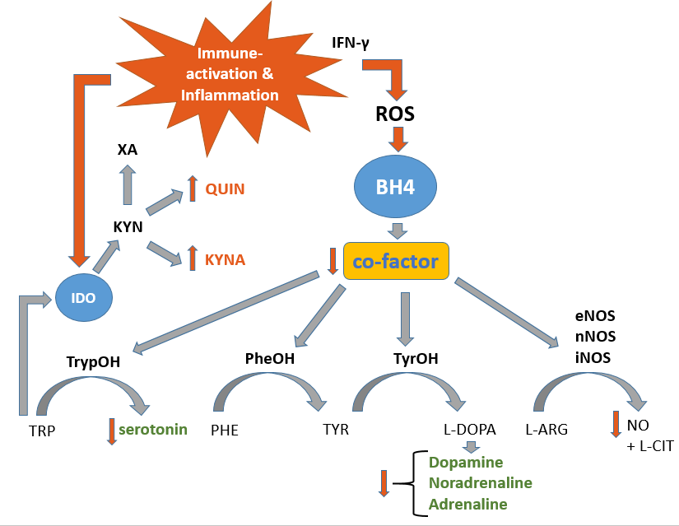

Fig. 1: Immune-activation and associated inflammation cause IFN-γ release which in turn triggers ROS-emission by the innate immune system. ROS causes a decline in BH4-levels due to their oxygen-sensitivity. Since BH4 acts as a co-factor for several aromatic amino acid mono-oxygenases, neurotransmitter synthesis of serotonin, dopamine, noradrenaline and adrenaline levels are diminished. BH4 is recycled via BH2 in a DHFR-dependent manner.

Abbreviations: IFN-γ: Interferon-γ; ROS: reactive oxygen species; BH4: 5,6,7,8-tetrahydrobiopterin; IDO: Indolamin-2,3-Dioxygenase; XA: Xanthurenic acid; QUIN: Quinolonic acid; KYNA: Kynurenic acid; KYN: Kynurenin; TyrOH: Tyrosine hydroxylase; TrypOH: Tryptophan hydroxylase; PheOH: Phenylalanin hydroxylase; eNOS: endothelial nictric oxide synthase; nNOS: neuronal nictric oxide synthase; iNOS: inducible nictric oxide synthase; L-ARG: L-Arginine; NO: nictric oxide; L-CIT: L-citrulline; PHE: Phenylalanine; TYR: Tyrosine; L-DOPA: L-Dopamine; TRP: Tryptophan

Figure 2 Participant recruitment

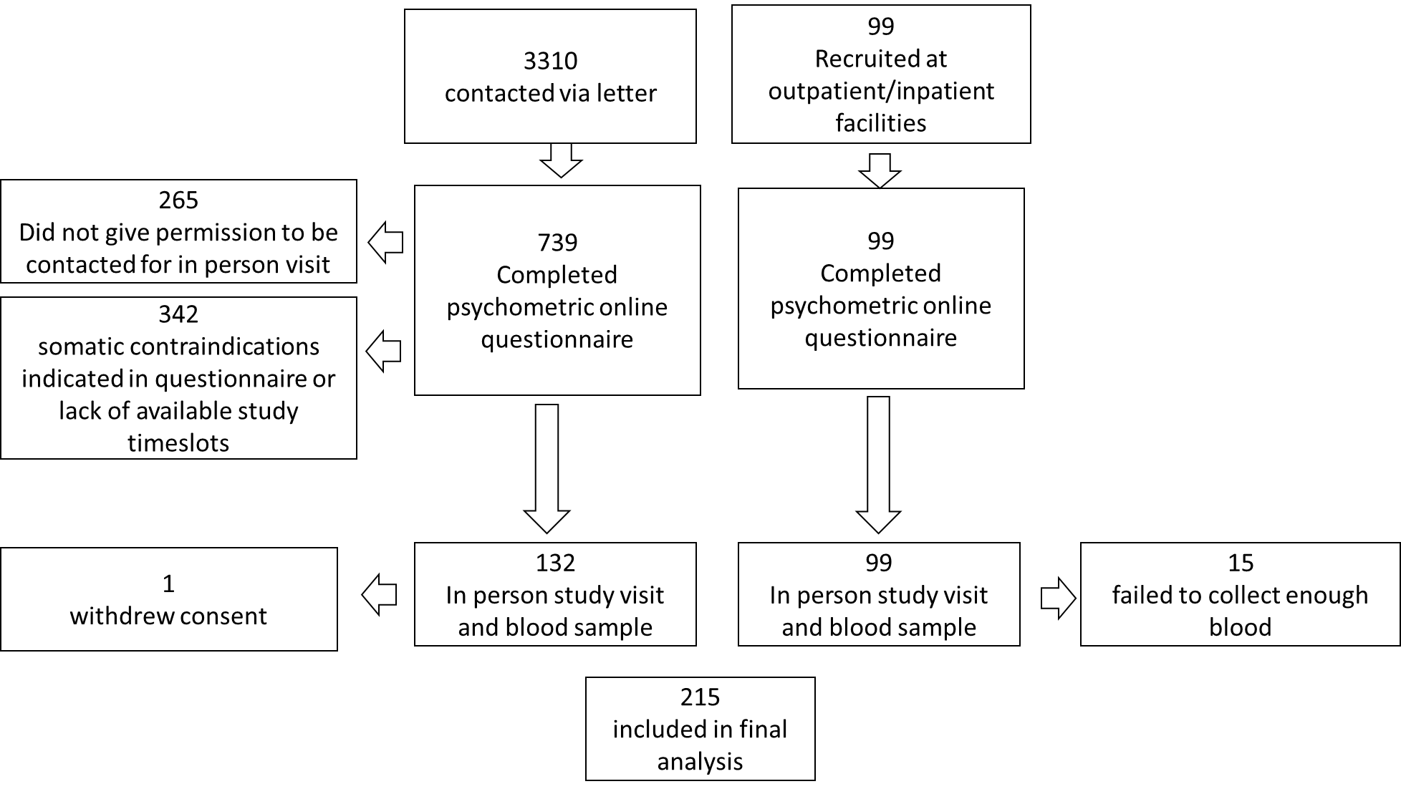

Figure 3

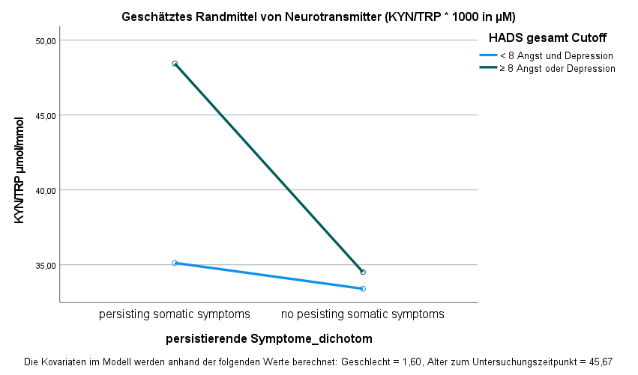



**Figure 1. ANCOVA results (placeholder).**

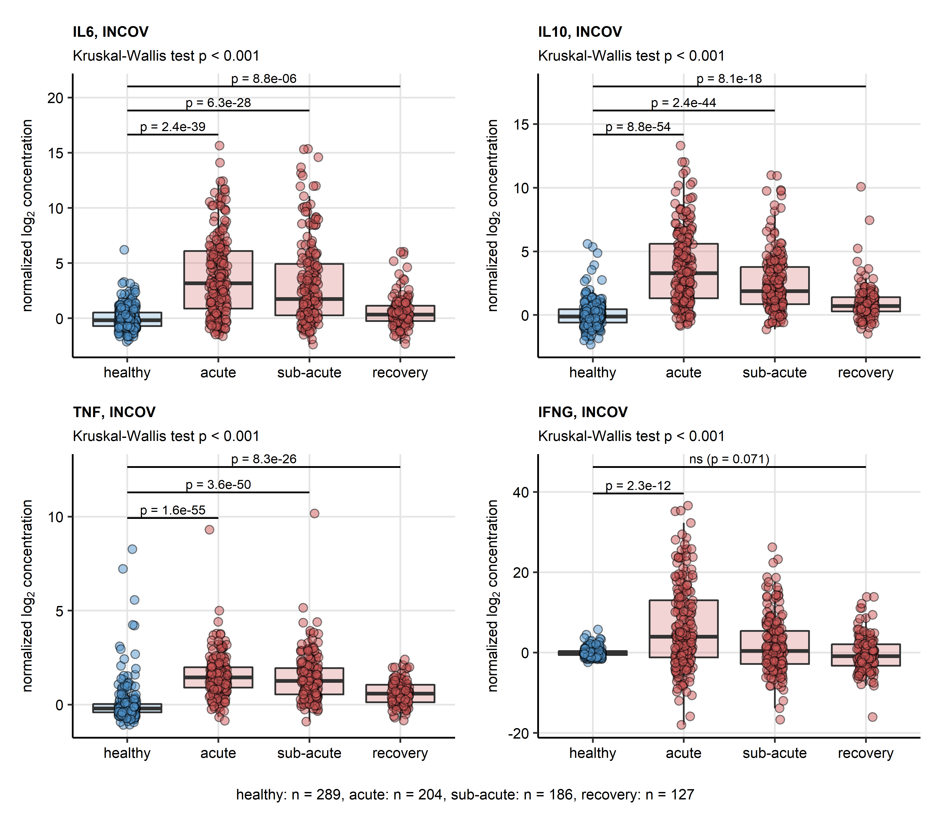

**Figure 4. Serum levels of cytokines in healthy controls and COVID-19 individuals in the INCOV cohort** *Normalized serum levels of IL6, IL10, TNF-alpha (TNF), IFN-gamma (IFNG) were extracted from the INCOV study data for healthy controls and COVID-19 participants at consecutive timepoints after symptom onset (acute: median 11 days, sub-acute: 17 days, convalescence: 64 days). Statistical significance was assessed by Kruskal-Wallis test with Benjamini-Hochberg-corrected Mann-Whitney post-hoc test. Each point in the plots represent a single sample, boxes depict medians with interquartile ranges (IQR), whiskers span over 150% IQR. Kruskal-Wallis P values are displayed in the plot captions. Significant and near significant (p < 0.1) results of post-hoc tests are presented in the plots. Numbers of complete observations are shown below the plots.*

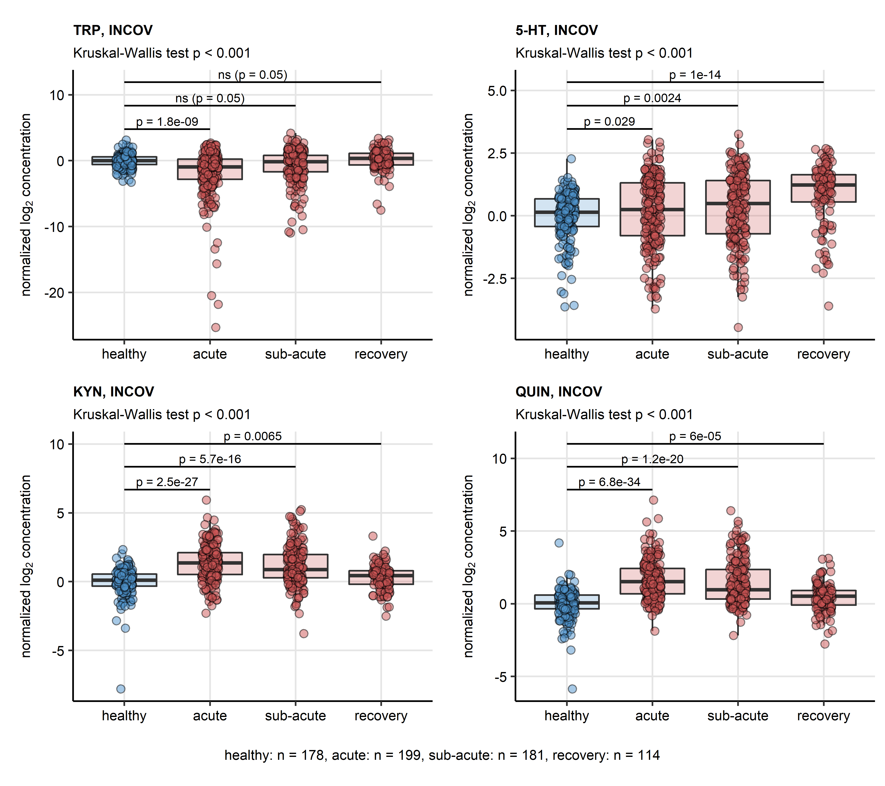

**Figure 5. Serum levels of TRP degradation products in healthy controls and COVID-19 individuals in the INCOV cohort** *Normalized serum levels of tryptophan (TRP), serotonin (5-HT), kynurenine (KYN) and quinolinic acid (QUIN) were extracted from the INCOV study data for healthy controls and COVID-19 participants at consecutive timepoints after symptom onset (acute: median 11 days, sub-acute: 17 days, convalescence: 64 days). Statistical significance was assessed by Kruskal-Wallis test with Benjamini-Hochberg-corrected Mann-Whitney post-hoc test. Each point in the plots represent a single sample, boxes depict medians with interquartile ranges (IQR), whiskers span over 150% IQR. Kruskal-Wallis P values are displayed in the plot captions. Significant and near significant (p < 0.1) results of post-hoc tests are presented in the plots. Numbers of complete observations are shown below the plots.*

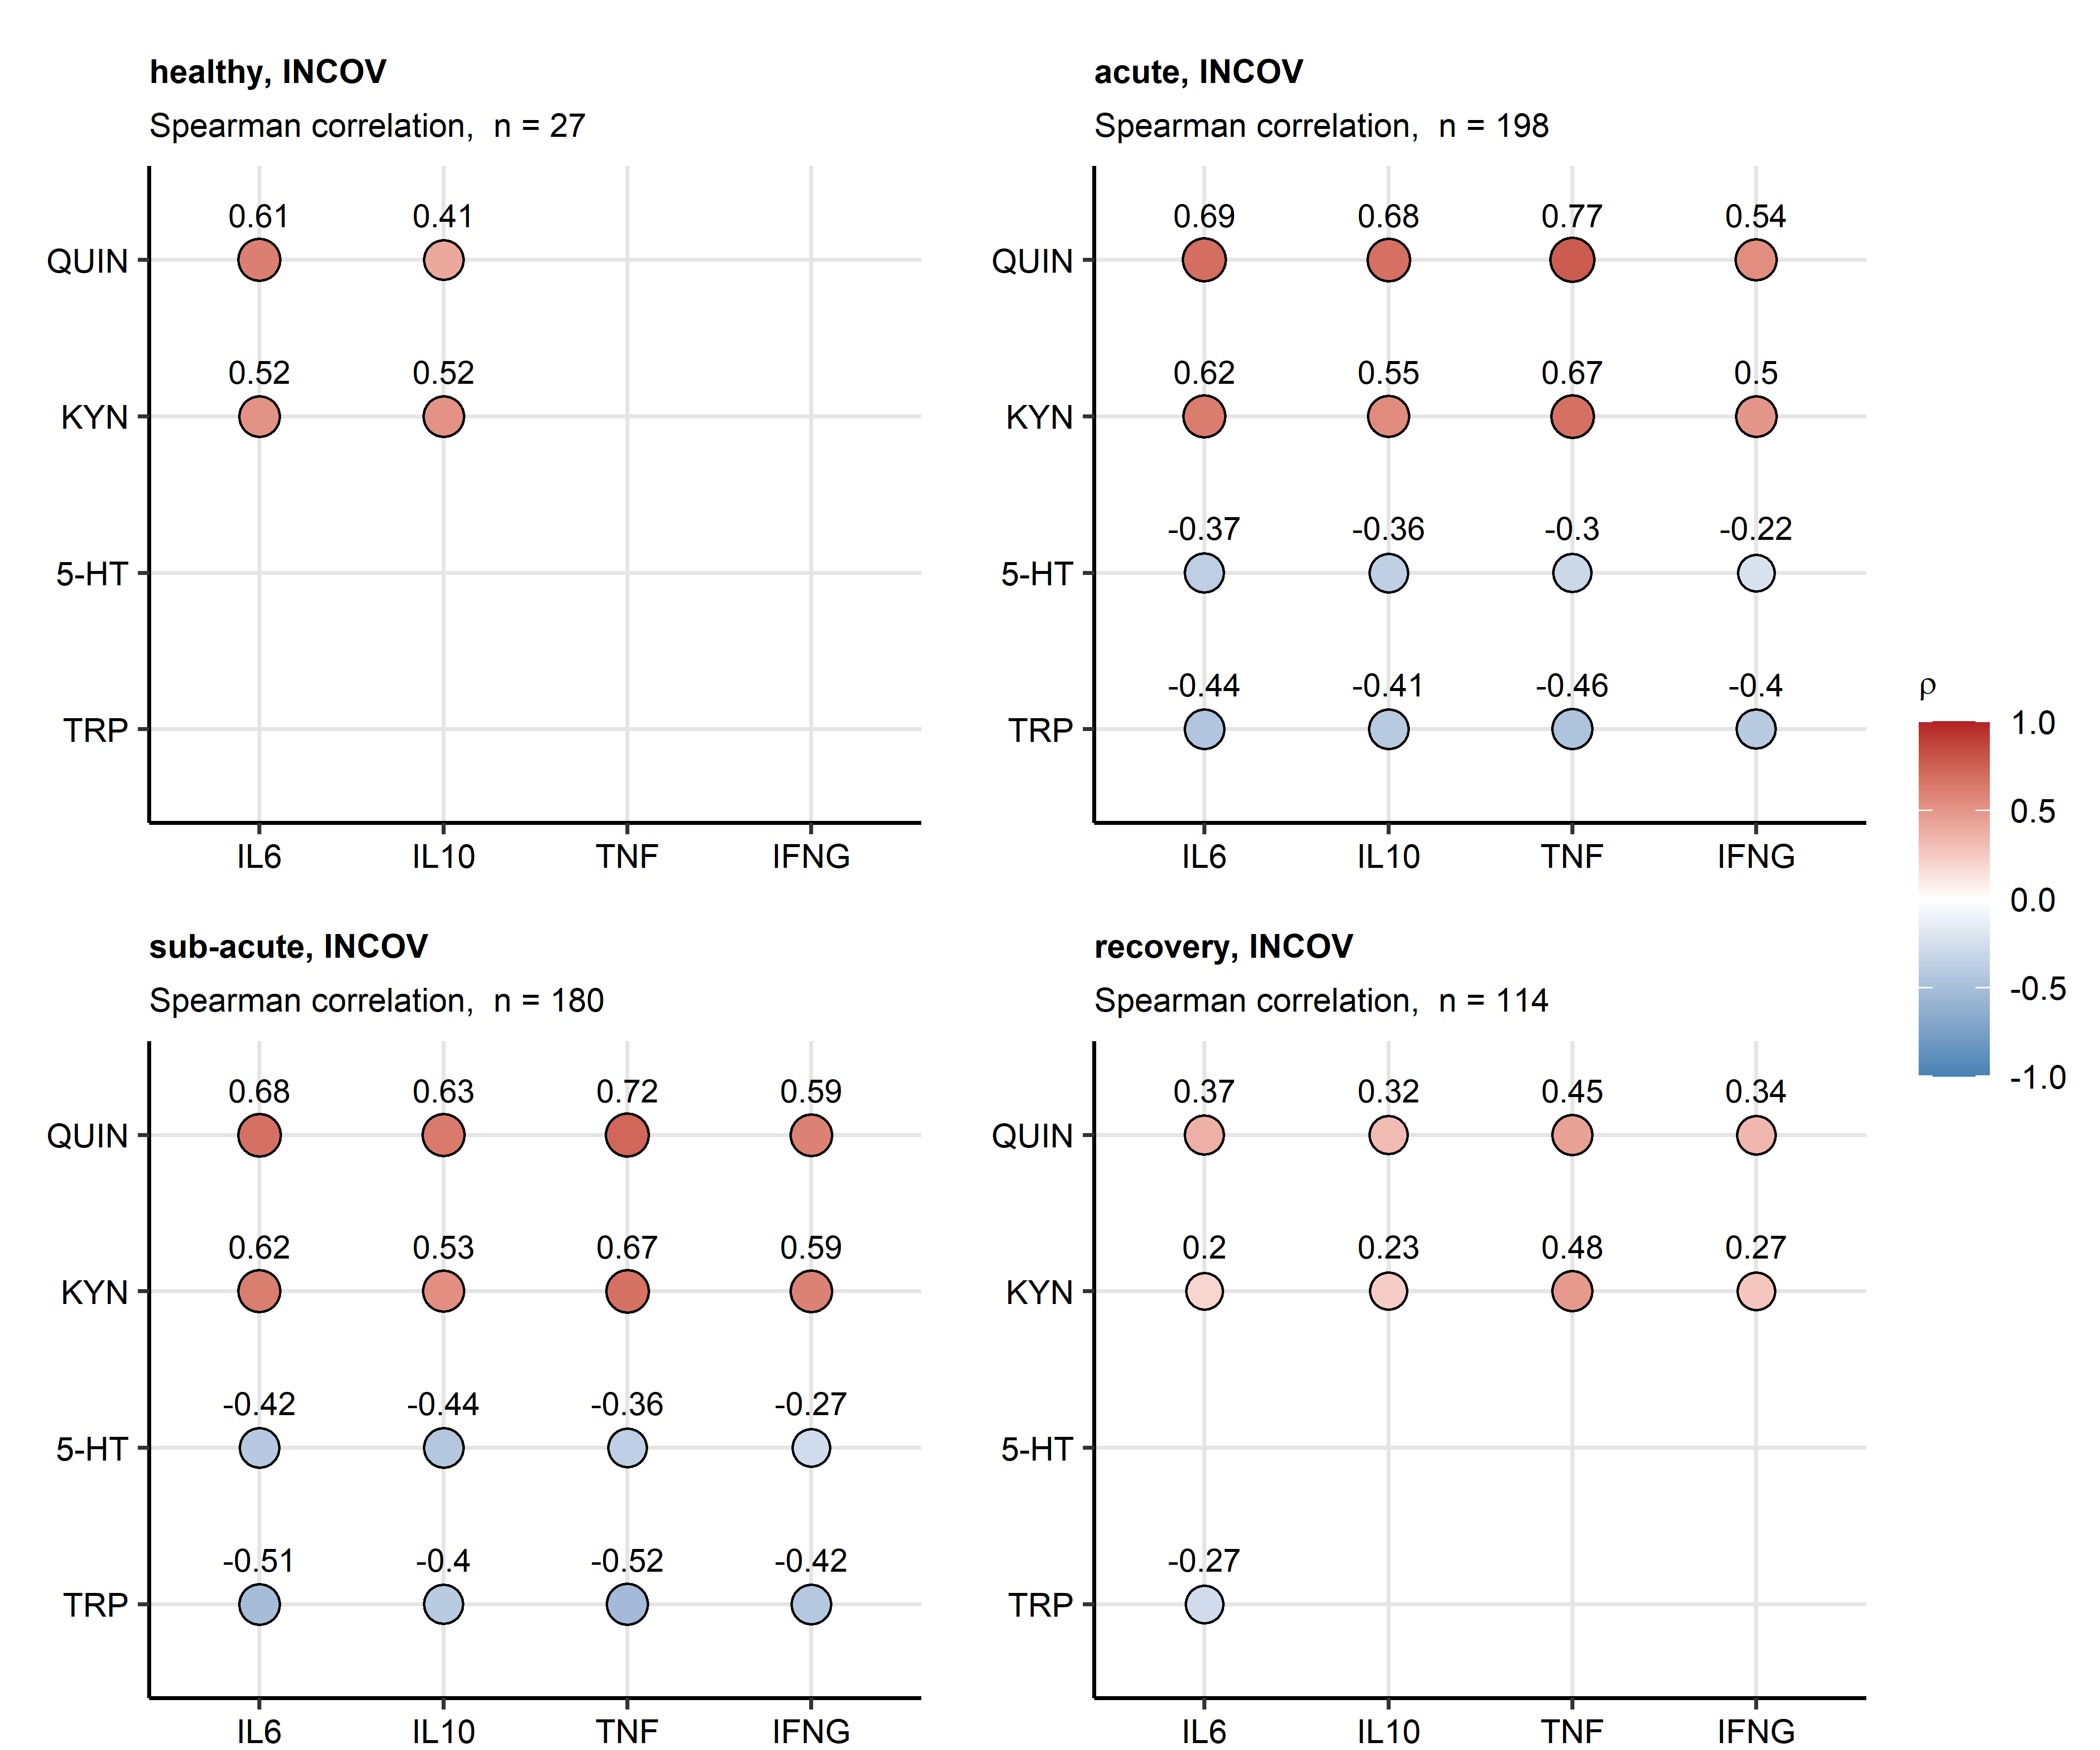

**Figure 6. Correlation of serum levels of cytokines, TRP and TRP degradation products in acute COVID-19 and convalescence in the INCOV cohort.** *Normalized levels of tryptophan (TRP), serotonin (5-HT), kynurenine (KYN) and quinolinic acid (QUIN) were correlated with normalized serum levels of IL6, IL10, TNF-alpha (TNF) and IFN-gamma (IFNG) in healthy controls and COVID-19 participants of the INCOV study at consecutive time points after symptom onset (acute: median 11 days, sub-acute: 17 days, convalescence: 64 days) with Spearman test. Correlation coefficients () for the significant correlations are presented in bubble plots. Point size corresponds to the absolute value of correlation coefficient, point color codes for the correlation coefficient value. Points are labeled with their correlation coefficient values. Numbers of samples are indicated in the plot captions.*

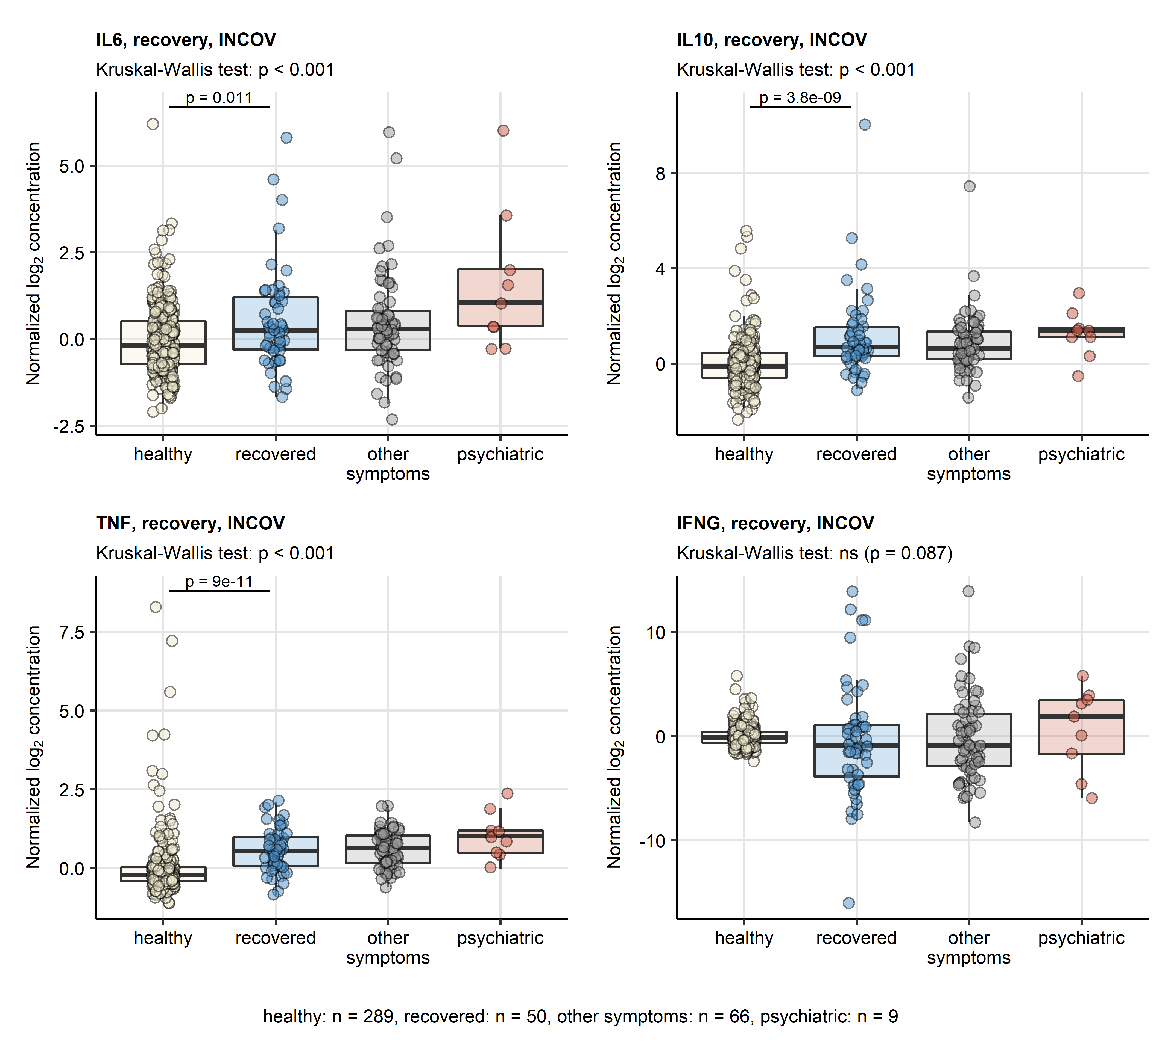

**Figure 7. Serum levels of cytokines in healthy controls, complete COVID-19 recovery, non-psychiatric and psychiatric persistent symptoms in the INCOV cohort.** *Normalized serum levels of IL6, IL10, TNF-alpha (TNF), IFN-gamma (IFNG) were extracted from the INCOV study data for healthy controls and COVID-19 participants during convalescence (median: 64 days after symptom onset). The serum levels were compared between healthy controls, COVID-19 subjects without persistent symptoms, COVID-19 subjects with putative psychiatric persistent symptoms (self-reported depression, anxiety or sleep problems) and COVID-19 subjects with other non-psychiatric persistent symptoms with Kruskal-Wallis test. Pairwise comparisons between the groups were done with Benjamini-Hochberg-corrected Mann-Whitney post-hoc test. Each point in the plots represent a single sample, boxes depict medians with interquartile ranges (IQR), whiskers span over 150% IQR. Kruskal-Wallis test p values are displayed in the plot captions. Significant and near-significant (p < 0.1) post-hoc test results are indicated in the plots. Numbers of complete observations are shown below the plots.*

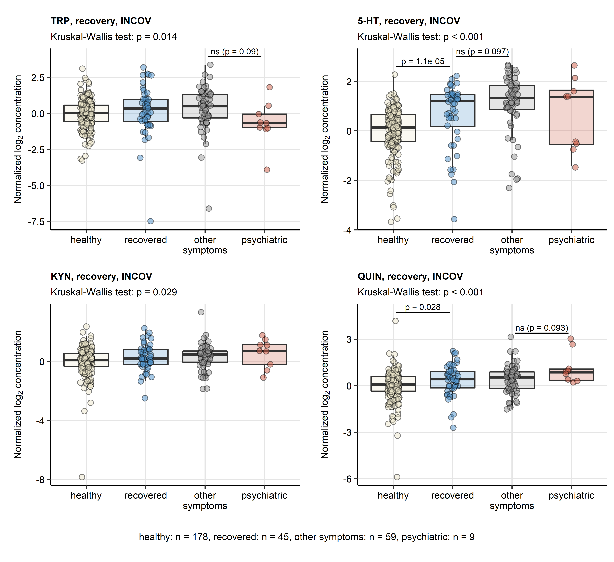

**Figure 8. Serum levels of TRP degradation products in healthy controls, complete COVID-19 recovery, non-psychiatric and psychiatric persistent symptoms in the INCOV cohort.** *Normalized serum levels of tryptophan (TRP), serotonin (5-HT), kynurenine (KYN) and quinolinic acid (QUIN) were extracted from the INCOV study data for healthy controls and COVID-19 participants during convalescence (median: 64 days after symptom onset). The serum levels were compared between healthy controls, COVID-19 subjects without persistent symptoms, COVID-19 subjects with putative psychiatric persistent symptoms (self-reported depression, anxiety or sleep problems) and COVID-19 subjects with other non-psychiatric persistent symptoms with Kruskal-Wallis test. Pairwise comparisons between the groups were done with Benjamini-Hochberg-corrected Mann-Whitney post-hoc test. Each point in the plots represent a single sample, boxes depict medians with interquartile ranges (IQR), whiskers span over 150% IQR. Kruskal-Wallis test p values are displayed in the plot captions. Significant and near-significant (p < 0.1) post-hoc test results are indicated in the plots. Numbers of complete observations are shown below the plots.*

Figure 9

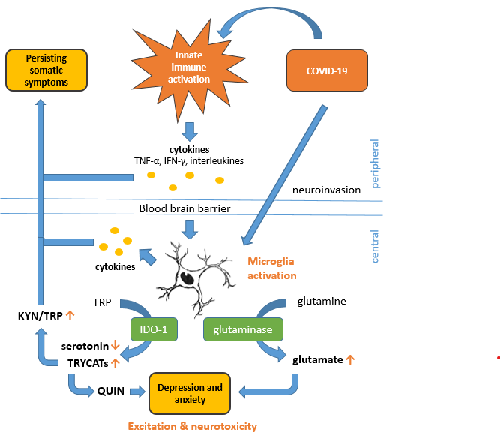

Fig.9: Presumed interaction of physical and mental health on neurotransmitter precursor amino acid levels following immune-activation of the peripheral innate immune system by exposure to COVID-19, microglia within the central nervous system are activated, causing an increase in KYN/TRP-ratio and QUIN due to IDO-1 activity alongside a rise in glutamate-levels due to glutaminase activity. The synergistic effect of the NMDA-R agonists QUIN and glutamate cause neuroexcitatation and neurotoxicity in pathologically raised levels that lead to symptoms of depression and anxiety. TNF-α = Tumor Necrosis Factor – alpha; TRP = Tryptophan; IDO-1 = indoleamine 2,3-dioxygenase-1; TRYCATs = Tryptophan catabolites; KYN/TRP-ratio: Kynurenine/Tryptophan-ratio; QUIN = Quinolonic acid

3. Kassambara A. rstatix: Pipe-Friendly Framework for Basic Statistical Tests. (2021) <https://cran.r-project.org/package=rstatix>

4. Kassambara A, Mundt F. factoextra: Extract and Visualize the Results of Multivariate Data Analyses. (2020) <https://cran.r-project.org/web/packages/factoextra/index.html>

# References

Almulla, A.F., Supasitthumrong, T., Tunvirachaisakul, C., Algon, A.A.A., Al-Hakeim, H.K., Maes, M., 2022. The tryptophan catabolite or kynurenine pathway in COVID-19 and critical COVID-19: a systematic review and meta-analysis. BMC Infectious Diseases 22, 615.

Benjamini, Y., Hochberg, Y., 1995. Controlling the False Discovery Rate: A Practical and Powerful Approach to Multiple Testing. Journal of the Royal Statistical Society: Series B (Methodological) 57, 289-300.

Bizjak, D.A., Stangl, M., Börner, N., Bösch, F., Durner, J., Drunin, G., Buhl, J.L., Abendroth, D., 2022. Kynurenine serves as useful biomarker in acute, Long- and Post-COVID-19 diagnostics. Front Immunol 13, 1004545.

Bjelland, I., Dahl, A.A., Haug, T.T., Neckelmann, D., 2002. The validity of the Hospital Anxiety and Depression Scale. An updated literature review. J Psychosom Res 52, 69-77.

Bower, J.E., Radin, A., Kuhlman, K.R., 2022. Psychoneuroimmunology in the time of COVID-19: Why neuro-immune interactions matter for mental and physical health. Behav Res Ther 154, 104104.

Capuron, L., Schroecksnadel, S., Feart, C., Aubert, A., Higueret, D., Barberger-Gateau, P., Laye, S., Fuchs, D., 2011. Chronic low-grade inflammation in elderly persons is associated with altered tryptophan and tyrosine metabolism: role in neuropsychiatric symptoms. Biol Psychiatry 70, 175-182.

Casimir, G.J., Duchateau, J., 2011. Gender differences in inflammatory processes could explain poorer prognosis for males. J Clin Microbiol 49, 478; author reply 478-479.

Dantzer, R., 2005. Somatization: A psychoneuroimmune perspective. Psychoneuroendocrinology 30, 947-952.

Dantzer, R., O'Connor, J.C., Freund, G.G., Johnson, R.W., Kelley, K.W., 2008. From inflammation to sickness and depression: when the immune system subjugates the brain. Nature Reviews Neuroscience 9, 46-56.

Deisenhammer, F., Bauer, A., Kavelar, C., Rudzki, D., Rössler, A., Kimpel, J., Borena, W., Reindl, M., 2021. 12-month SARS-CoV-2 antibody persistency in a Tyrolean COVID-19 cohort. Wien Klin Wochenschr 133, 1265-1271.

Dewulf, J.P., Martin, M., Marie, S., Oguz, F., Belkhir, L., De Greef, J., Yombi, J.C., Wittebole, X., Laterre, P.-F., Jadoul, M., Gatto, L., Bommer, G.T., Morelle, J., 2022. Urine metabolomics links dysregulation of the tryptophan-kynurenine pathway to inflammation and severity of COVID-19. Scientific Reports 12, 9959.

Eroğlu, İ., Eroğlu, B., Güven, G.S., 2021. Altered tryptophan absorption and metabolism could underlie long-term symptoms in survivors of coronavirus disease 2019 (COVID-19). Nutrition 90, 111308.

Giustarini, D., Dalle-Donne, I., Colombo, R., Milzani, A., Rossi, R., 2004. Adaptation of the Griess reaction for detection of nitrite in human plasma. Free Radic Res 38, 1235-1240.

Hamilton, O.S., Cadar, D., Steptoe, A., 2021. Systemic inflammation and emotional responses during the COVID-19 pandemic. Transl Psychiatry 11, 626.

Hüfner, K., Fuchs, D., Blauth, M., Sperner-Unterweger, B., 2019. How acute and chronic physical disease may influence mental health - An Analysis of neurotransmitter precursor amino acid levels. Psychoneuroendocrinology 106, 95-101.

Hüfner, K., Oberguggenberger, A., Kohl, C., Geisler, S., Gamper, E., Meraner, V., Egeter, J., Hubalek, M., Beer, B., Fuchs, D., Sperner-Unterweger, B., 2015. Levels in neurotransmitter precursor amino acids correlate with mental health in patients with breast cancer. Psychoneuroendocrinology 60, 28-38.

Hüfner, K., Tymoszuk, P., Sahanic, S., Luger, A., Boehm, A., Pizzini, A., Schwabl, C., Koppelstätter, S., Kurz, K., Asshoff, M., Mosheimer-Feistritzer, B., Pfeifer, B., Rass, V., Schroll, A., Iglseder, S., Egger, A., Wöll, E., Weiss, G., Helbok, R., Widmann, G., Sonnweber, T., Tancevski, I., Sperner-Unterweger, B., Löffler-Ragg, J., 2022. Persistent somatic symptoms are key to individual illness perception at one year after COVID-19. medRxiv, 2022.2009.2005.22279602.

Klein, S.L., Flanagan, K.L., 2016. Sex differences in immune responses. Nature Reviews Immunology 16, 626-638.

Maes, M., Rief, W., 2012. Diagnostic classifications in depression and somatization should include biomarkers, such as disorders in the tryptophan catabolite (TRYCAT) pathway. Psychiatry Res 196, 243-249.

Matta, J., Wiernik, E., Robineau, O., Carrat, F., Touvier, M., Severi, G., de Lamballerie, X., Blanché, H., Deleuze, J.-F., Gouraud, C., Hoertel, N., Ranque, B., Goldberg, M., Zins, M., Lemogne, C., Santé, P., Relations et Inégalités Sociales en Population Générale Pendant la Crise COVID-19–Sérologie Study Group, 2022. Association of Self-reported COVID-19 Infection and SARS-CoV-2 Serology Test Results With Persistent Physical Symptoms Among French Adults During the COVID-19 Pandemic. JAMA Internal Medicine 182, 19-25.

Miller, A.H., Raison, C.L., 2016. The role of inflammation in depression: from evolutionary imperative to modern treatment target. Nature Reviews Immunology 16, 22-34.

Najjar, S., Najjar, A., Chong, D.J., Pramanik, B.K., Kirsch, C., Kuzniecky, R.I., Pacia, S.V., Azhar, S., 2020. Central nervous system complications associated with SARS-CoV-2 infection: integrative concepts of pathophysiology and case reports. J Neuroinflammation 17, 231.

Neurauter, G., Schrocksnadel, K., Scholl-Burgi, S., Sperner-Unterweger, B., Schubert, C., Ledochowski, M., Fuchs, D., 2008. Chronic immune stimulation correlates with reduced phenylalanine turnover. Curr Drug Metab 9, 622-627.

Schwarcz, R., Bruno, J.P., Muchowski, P.J., Wu, H.Q., 2012. Kynurenines in the mammalian brain: when physiology meets pathology. Nat Rev Neurosci 13, 465-477.

Song, P., Li, W., Xie, J., Hou, Y., You, C., 2020. Cytokine storm induced by SARS-CoV-2. Clin Chim Acta 509, 280-287.

Sonnweber, T., Tymoszuk, P., Sahanic, S., Boehm, A., Pizzini, A., Luger, A., Schwabl, C., Nairz, M., Grubwieser, P., Kurz, K., Koppelstätter, S., Aichner, M., Puchner, B., Egger, A., Hoermann, G., Wöll, E., Weiss, G., Widmann, G., Tancevski, I., Löffler-Ragg, J., 2022. Investigating phenotypes of pulmonary COVID-19 recovery: A longitudinal observational prospective multicenter trial. Elife 11.

Sperner-Unterweger, B., Kohl, C., Fuchs, D., 2014. Immune changes and neurotransmitters: Possible interactions in depression? Progress in Neuro-Psychopharmacology and Biological Psychiatry 48, 268-276.

Staudt, A., Jörres, R.A., Hinterberger, T., Lehnen, N., Loew, T., Budweiser, S., 2022. Associations of Post-Acute COVID syndrome with physiological and clinical measures 10 months after hospitalization in patients of the first wave. European Journal of Internal Medicine 95, 50-60.

Steiner, J., Walter, M., Gos, T., Guillemin, G.J., Bernstein, H.G., Sarnyai, Z., Mawrin, C., Brisch, R., Bielau, H., Meyer zu Schwabedissen, L., Bogerts, B., Myint, A.M., 2011. Severe depression is associated with increased microglial quinolinic acid in subregions of the anterior cingulate gyrus: evidence for an immune-modulated glutamatergic neurotransmission? J Neuroinflammation 8, 94.

Su, Y., Yuan, D., Chen, D.G., Ng, R.H., Wang, K., Choi, J., Li, S., Hong, S., Zhang, R., Xie, J., Kornilov, S.A., Scherler, K., Pavlovitch-Bedzyk, A.J., Dong, S., Lausted, C., Lee, I., Fallen, S., Dai, C.L., Baloni, P., Smith, B., Duvvuri, V.R., Anderson, K.G., Li, J., Yang, F., Duncombe, C.J., McCulloch, D.J., Rostomily, C., Troisch, P., Zhou, J., Mackay, S., DeGottardi, Q., May, D.H., Taniguchi, R., Gittelman, R.M., Klinger, M., Snyder, T.M., Roper, R., Wojciechowska, G., Murray, K., Edmark, R., Evans, S., Jones, L., Zhou, Y., Rowen, L., Liu, R., Chour, W., Algren, H.A., Berrington, W.R., Wallick, J.A., Cochran, R.A., Micikas, M.E., Wrin, T., Petropoulos, C.J., Cole, H.R., Fischer, T.D., Wei, W., Hoon, D.S.B., Price, N.D., Subramanian, N., Hill, J.A., Hadlock, J., Magis, A.T., Ribas, A., Lanier, L.L., Boyd, S.D., Bluestone, J.A., Chu, H., Hood, L., Gottardo, R., Greenberg, P.D., Davis, M.M., Goldman, J.D., Heath, J.R., 2022. Multiple early factors anticipate post-acute COVID-19 sequelae. Cell 185, 881-895.e820.

Widner, B., Werner, E.R., Schennach, H., Wachter, H., Fuchs, D., 1997. Simultaneous measurement of serum tryptophan and kynurenine by HPLC. Clin Chem 43, 2424-2426.