Persistent low-grade inflammation, SARS-CoV-2 infection and mental health deterioration signs impact on systemic levels of aminoacid neurotransmitter precursors

Manuscript parts

2023-02-15

# Methods

## Bioinformatic and statistical analysis

R version 4.2.0 was employed for the data analysis.

Normalized, age- and sex-adjusted, log2-transformed serum protein and metabolite levels and clinical data for the INCOV cohort were extracted from the report by Su at al. (1).

Normality and homogeneity of variances was investigated by Shapiro-Wilk and Levene test, respectively. Non-parametric tests or normality/homogeneity-improving variable transformations (logarithm and square root) were used in cases of non-normal distribution. Comparison of serum metabolite and cytokine levels between uninfected controls and COVID-19 individuals at consecutive timepoints after infection was done by Kruskal-Wallis test with Benjamini-Hochberg-corrected Mann-Whitney post-hoc test (2). Correlations of metabolite and cytokine serum levels and of mental disorder scoring with metabolite and cytokine levels was investigated by Spearman test. Correlation of SIMMUN dataset metabolite levels with age was accomplished by Pearson test. Significance of differences in SIMMUN cohort metabolite and inflammatory marker serum concentrations between participants stratified by gender or SARS-CoV-2 was assessed by two-tailed T test.

In multi-parameter linear modeling of aminoacid neurotransmitter precursors and their decay products, neopterin (representative inflammation marker), SARS-CoV-2 infection status, scores of anxiety (HADS), depression (HADS) and stress (PSS-4), age and gender served as candidate explanatory variables. Modeling responses and numeric explanatory variables were normalized. The models models with the complete explanatory variable set were optimized by Bayesian information criterion (BIC) driven backwards elimination of non-significant terms. The normality and homogeneity model residual assumptions were by Shapiro-Wilk and Levene test, respectively, and additionally visually inspected in standard diagnostic plots (residuals versus fitted, quantile-quantile plots). Reproducibility of the optimized multi-parameter models was investigated by repeated cross-validation (50 repeats, 10 folds) and by comparison of the RMSE and statistics obtained with the training dataset and in cross-validation.

Details of bioinformatic and statistical analysis are provided in **Supplementary Methods**.

# Results

# Discussion

## Data and code availability

Anonymized patient data will be made available upon request to the corresponding author. The INCOV cohort data are publicly available. The study pipeline code is available at <https://github.com/PiotrTymoszuk/stigma_validation>.

# Tables

Table 1: Characteristic of the local SIMMUN cohort stratified by SARS-CoV-2 infection status. Numeric variables are presented as medians with interquartile ranges. Categorical variables are presented as percentages and counts within complete observations.

| **Variable** | **Uninfected** | **SARS-CoV-2** | **Test** | **Significance** |
| --- | --- | --- | --- | --- |
| Participants, n | 110 | 67 |  |  |
| Sex | female: 64% (70) male: 36% (40) complete: n = 110 | female: 54% (36) male: 46% (31) complete: n = 67 | χ² | ns (p = 0.25) |
| Age, years | 48 [IQR: 35 - 57] range: 18 - 69 complete: n = 110 | 50 [IQR: 32 - 56] range: 20 - 68 complete: n = 67 | Mann-Whitney | ns (p = 0.69) |
| Body mass classa | normal: 53% (54) overweight: 34% (34) obesity: 13% (13) complete: n = 101 | normal: 52% (34) overweight: 28% (18) obesity: 20% (13) complete: n = 65 | χ² | ns (p = 0.42) |
| Somatic comorbidity | 56% (59) complete: n = 106 | 45% (29) complete: n = 64 | χ² | ns (p = 0.25) |
| Psychiatric comorbidity | 54% (59) complete: n = 110 | 34% (23) complete: n = 67 | χ² | p = 0.019 |
| HADS anxiety scoreb | 7 [IQR: 3 - 12] range: 0 - 20 complete: n = 110 | 3 [IQR: 2 - 7] range: 0 - 19 complete: n = 67 | Mann-Whitney | p = 0.0027 |
| HADS depression scoreb | 5 [IQR: 1 - 10] range: 0 - 20 complete: n = 110 | 3 [IQR: 1 - 6] range: 0 - 17 complete: n = 67 | Mann-Whitney | p = 0.028 |
| Depression or anxiety signs, HADS ≥ 8b | 48% (53) complete: n = 110 | 24% (16) complete: n = 67 | χ² | p = 0.0022 |
| PSS-4 stress scorec | 6.5 [IQR: 3 - 10] range: 0 - 16 complete: n = 110 | 5 [IQR: 3 - 8] range: 1 - 13 complete: n = 67 | Mann-Whitney | ns (p = 0.082) |
| anti-RBD SARS-CoV-2, IgG, AUd | 0.31 [IQR: 0.28 - 0.34] range: 0.22 - 0.99 complete: n = 110 | 16 [IQR: 14 - 17] range: 0.34 - 25 complete: n = 67 | Mann-Whitney | p < 0.001 |
| COVID-19 severitye |  | mild: 75% (50) moderate: 19% (13) severe-critical: 6% (4) complete: n = 67 |  |  |
| anormal: body mass index [BMI] < 25 kg/mm², overweight: BMI 25 - 30 kg/mm², obesity: BMI > 30 kg/mm² | | | | |
| bHADS: hospital anxiety and depression scale | | | | |
| cPSS-4: 4 item perceived stress scale | | | | |
| dimmunoglobulin gamma anti receptor binding domain of the SARS-CoV-2 S1 protein, arbitrary units (AU) | | | | |
| emild: ambulatory care, moderate: hospitalized, normal ward, severe: intensive care unit | | | | |

Table 2: Characteristic of the external INCOV cohort. Numeric variables are presented as medians with interquartile ranges. Categorical variables are presented as percentages and counts within complete observations.

| **Variable** | **Healthy** | **SARS-CoV-2** | **Test** | **Significance** |
| --- | --- | --- | --- | --- |
| Sex | female: 59% (261) male: 41% (179) complete: n = 440 | female: 50% (102) male: 50% (103) complete: n = 205 | χ² | p = 0.028 |
| Age, years | 50 [IQR: 41 - 58] range: 19 - 80 complete: n = 440 | 57 [IQR: 42 - 69] range: 18 - 89 complete: n = 205 | Mann-Whitney | p < 0.001 |
| Body mass classa | normal: 38% (167) overweight: 30% (134) obesity: 32% (139) complete: n = 440 | normal: 24% (36) overweight: 36% (53) obesity: 39% (58) complete: n = 147 | χ² | p = 0.012 |
| Ethnics | Asian: 11% (44) Black or African-American: 6.2% (26) White: 81% (337) Other: 2.6% (11) complete: n = 418 | Asian: 14% (28) Black or African-American: 9.3% (19) White: 51% (104) Other: 26% (54) complete: n = 205 | χ² | p < 0.001 |
| COVID-19 severityb |  | mild: 29% (60) moderate: 43% (88) severe: 18% (37) critical: 9.8% (20) complete: n = 205 |  |  |
| anormal: body mass index [BMI] < 25 kg/mm², overweight: BMI 25 - 30 kg/mm², obesity: BMI > 30 kg/mm² | | | | |
| bWHO ordinal scale for clinical improvement; mild: 1 - 2, moderate: 3 - 4, severe: 5 - 6, critical: 7 | | | | |

# Figures

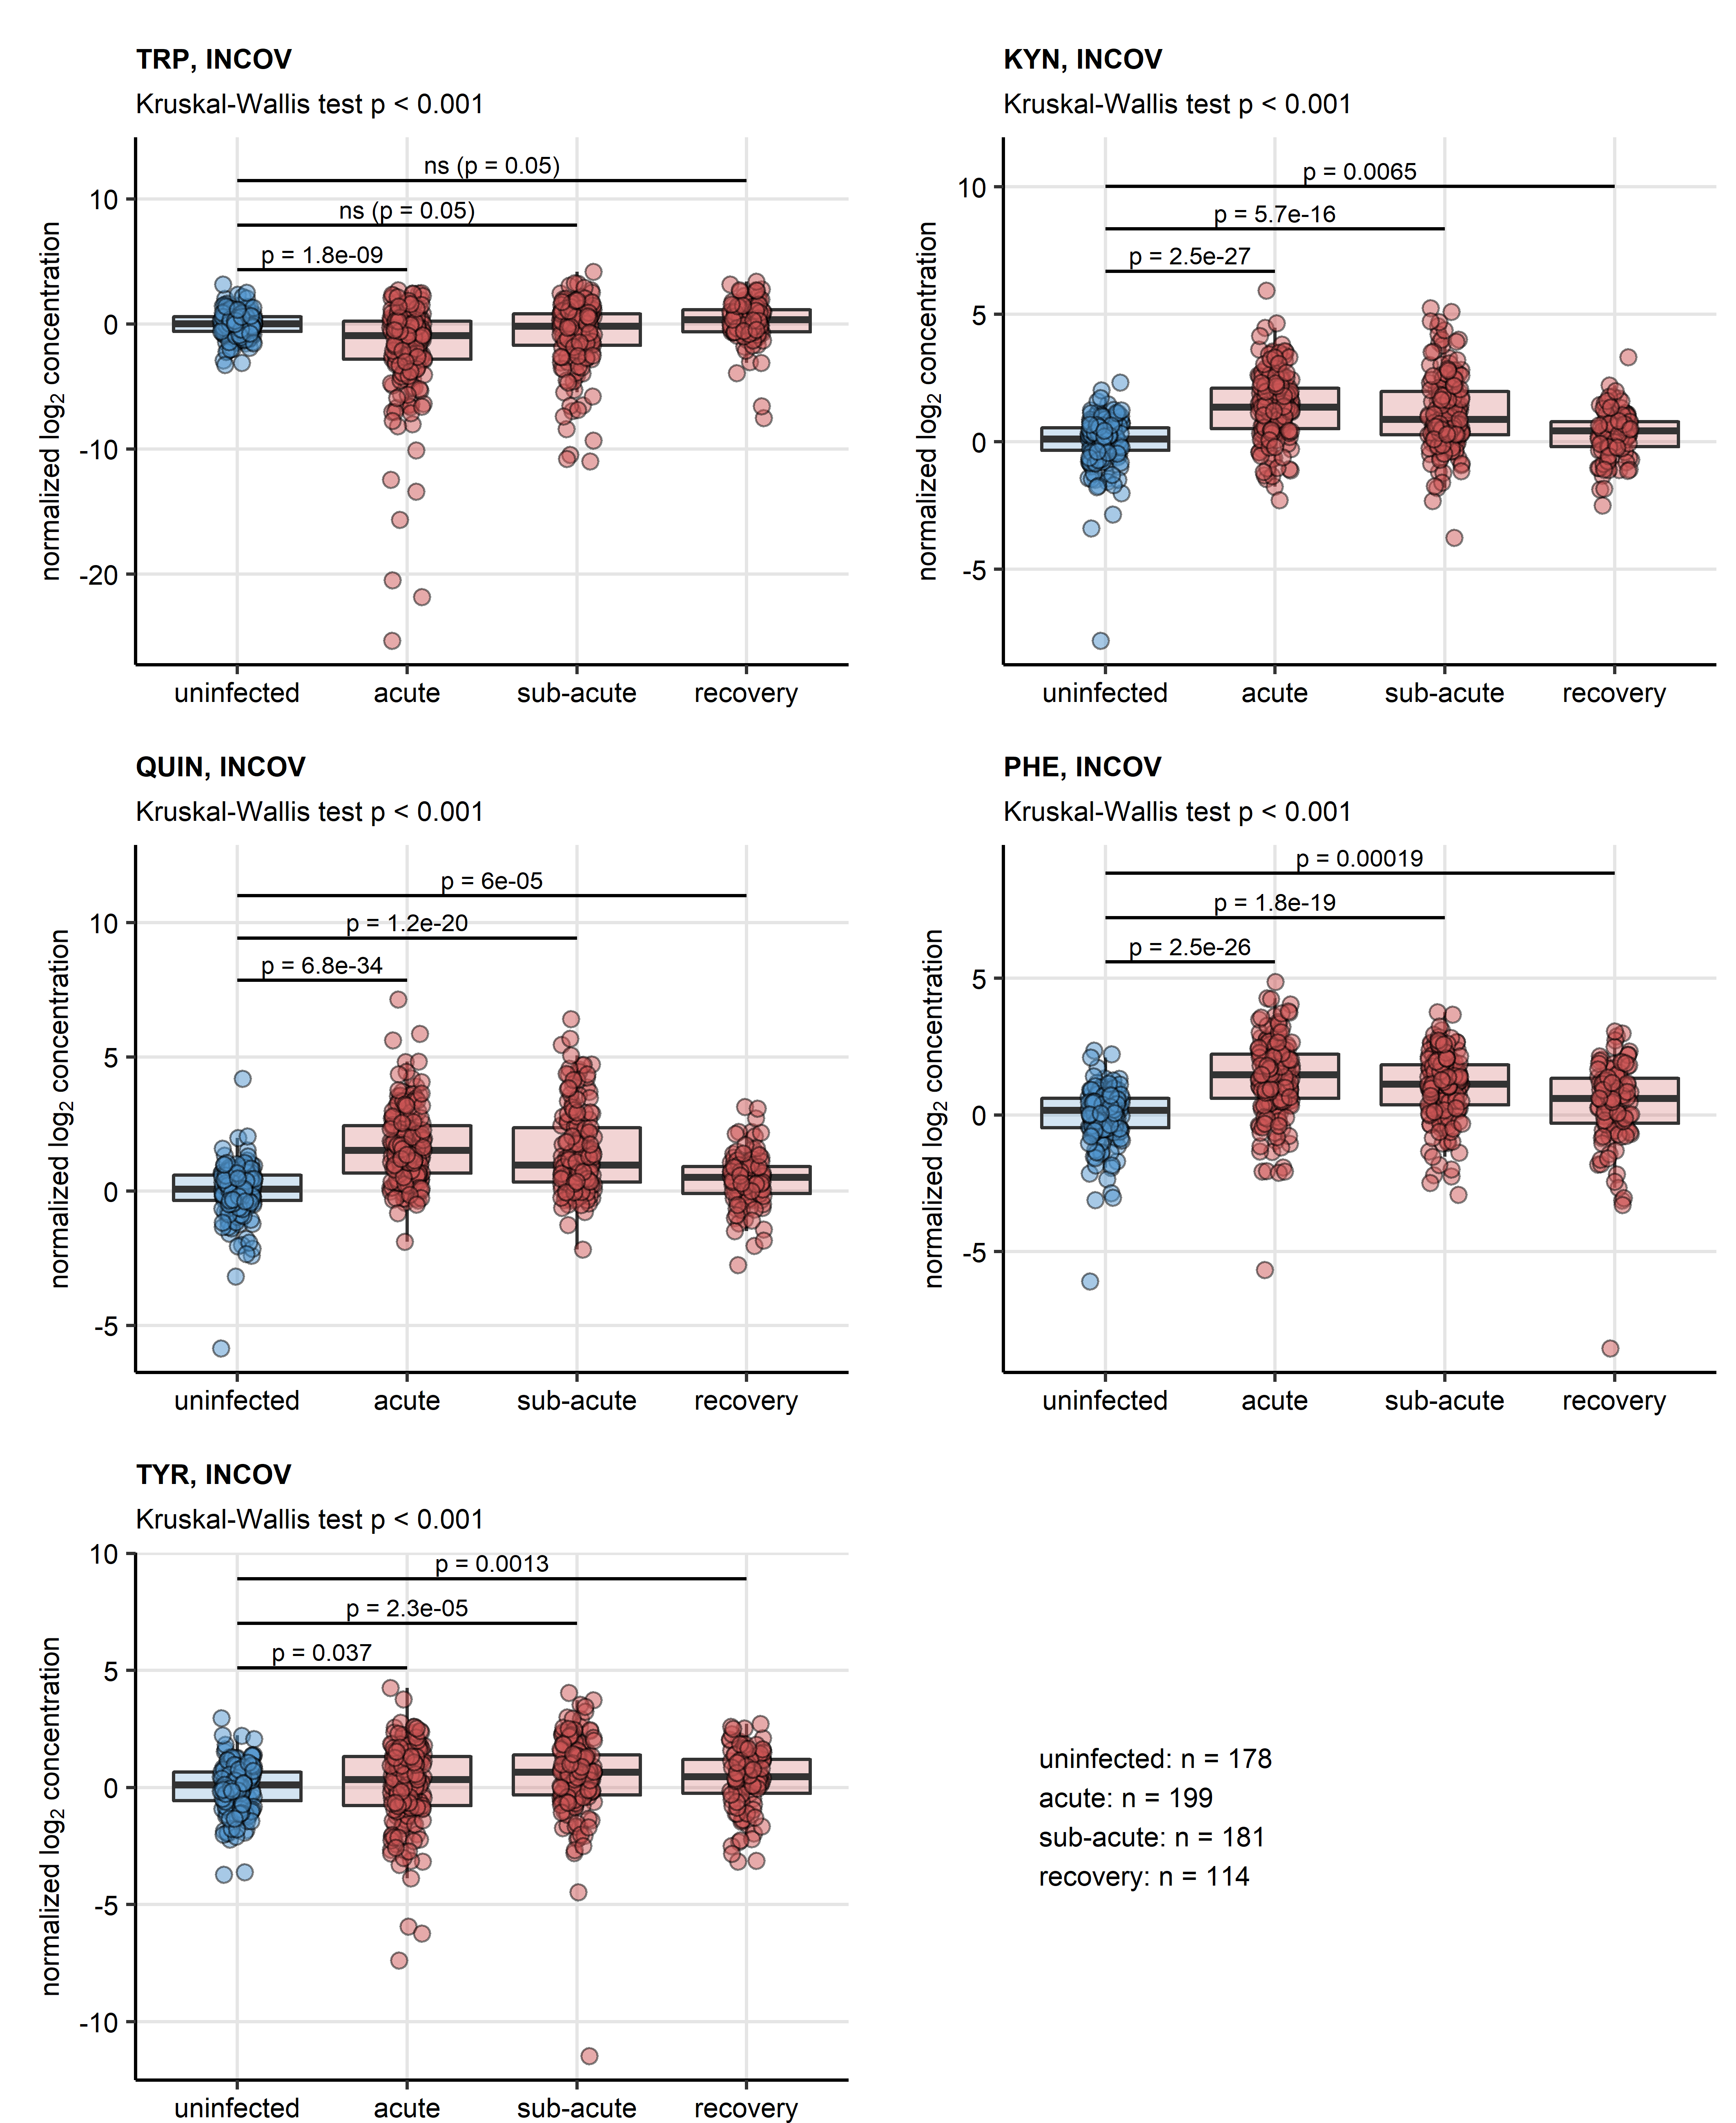

Figure 1: Serum levels of neurotransmitter precursor and their decay products in course of COVID-19 and recovery, INCOV cohort.

**Figure 1. Serum levels of neurotransmitter precursor and their decay products in course of COVID-19 and recovery, INCOV cohort.**

*Serum levels of tryptophan (TRP), kynurenine (KYN), quinolinic acid (QUIN), phenylalanine (PHE) and tyrosine (TYR) in serum of uninfected controls and COVID-19 individuals during acute, sub-acute and recovery phase of the disease in the INCOV cohort. Statistical significance was determined by Kruskal-Wallis test with Benjamini-Hochberg-corrected Mann-Whitney U test. Normalized serum level concentrations are presented in box plots. Points represent single samples. The Kruskal-Wallis test results are indicated in the plot captions. Results of the post-hoc tests are indicated in the plots. Numbers of complete observations are displayed under the plots.*

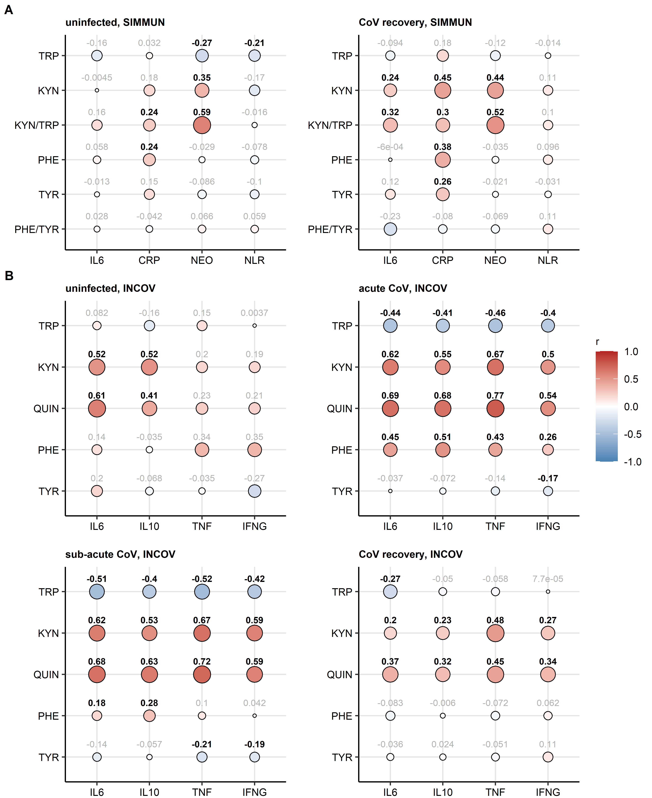

Figure 2: Correlation of serum levels of aminoacid precursors of neurotransmitters and their decay products with markers of inflammation.

**Figure 2. Correlation of serum levels of aminoacid precursors of neurotransmitters and their decay products with markers of inflammation.**

*Serum levels of tryptophan (TRP), kynurenine (KYN), quinolinic acid (QUIN), kynurenine/tryptophan ratio (KYN/TRP), phenylalanine (PHE), tyrosine (TYR) and phenylalanine/tyrosine ratio (PHE/TYR) were correlated with serum levels of inflammatory markers interleukin 6 (IL6), interleukin 10 (IL10), tumor necrosis factor-alpha (TNF), interferon-gamma (INFG), C-reactive protein (CRP), neopterin (NEO) and neutrophil/lymphocyte ratio (NLR) in uninfected and SARS-CoV-2-infected individuals from the SIMMUN (A) and INCOV cohort (B). Statistical significance was assessed by Spearman test. Correlation coefficients are presented in bubble plots. Point sizes correspond to absolute values of correlation coefficient. Point color corresponds to the correlation coefficient value. Correlation coefficients for significant effects are highlighted in bold.*

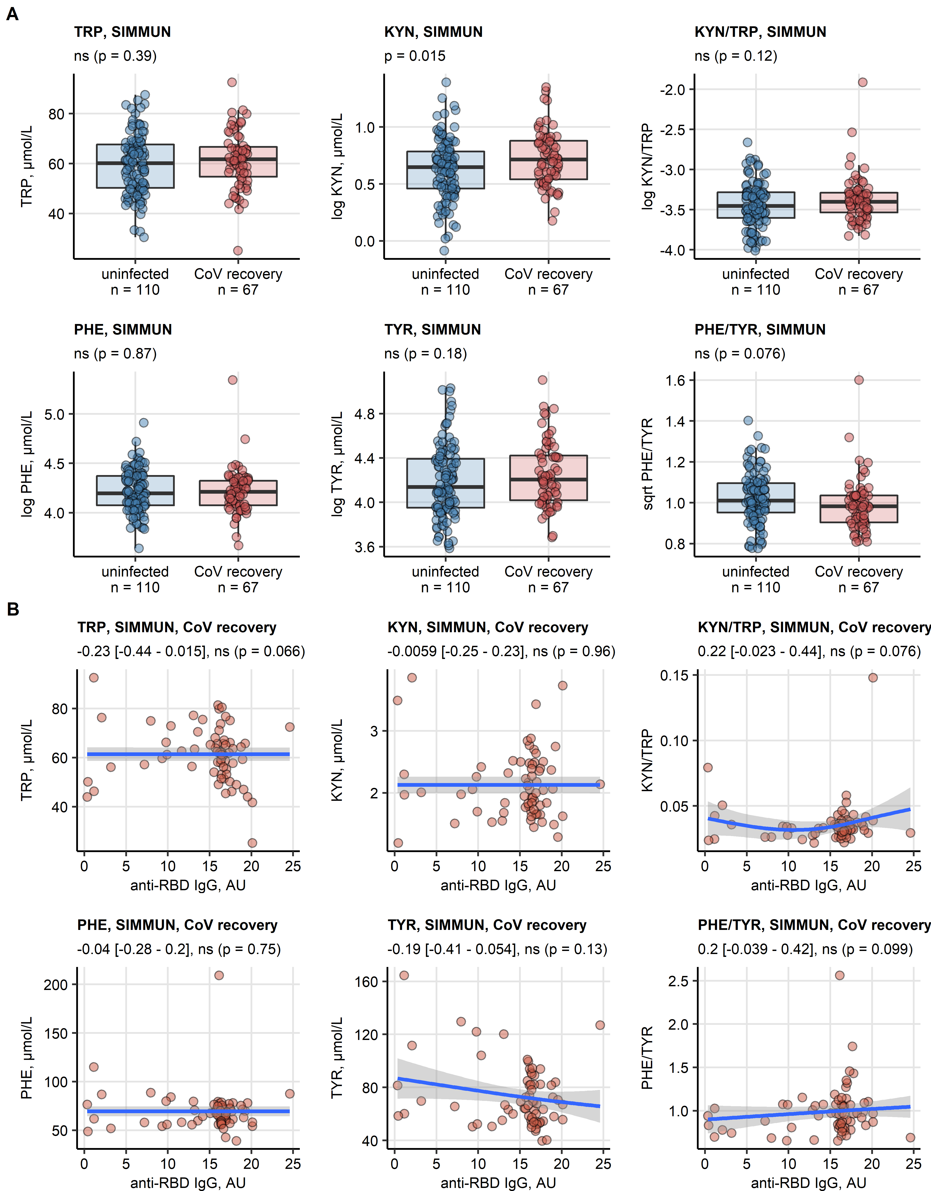

Figure 3: Association of neurotransmitter precursor aminoacids and their decay products with SARS-CoV-2 infection and anti-SARS-CoV-2 antibody response in the SIMMUN cohort.

**Figure 3. Association of neurotransmitter precursor aminoacids and their decay products with SARS-CoV-2 infection and anti-SARS-CoV-2 antibody response in the SIMMUN cohort.**

*(A) Serum levels of tryptophan (TRP), kynurenine (KYN), kynurenine/tryptophan ratio (KYN/TRP), phenylalanine (PHE), tyrosine (TYR) and phenylalanine/tyrosine ratio (PHE/TYR) in the SIMMUN study participants stratified by SARS-CoV-2 infections status. Statistical significance was determined by two-tailed T test. Serum levels are shown in box plots. Points represent single observations. Significance p values are displayed in the plot captions, numbers of complete observations are indicated in the plot axes.*

*(B) Correlation of TRP, KYN, KYN/TRP, PHE, TYR and PHE/TRP with the titre of immunoglobulin gamma to receptor binding domain of the SARS-CoV-2 S1 protein (anti-RBD IgG, arbitrary units [AU]) in the SIMMUN cohort (n = 177) was investigated by Spearman test. Points represent single observations, blue lines with gray ribbons depict fitted generalized additive model (GAM) trends with 95% confidence intervals. Values of correlation coefficients with 95% confidence intervals and significance are indicated in the plot captions.*

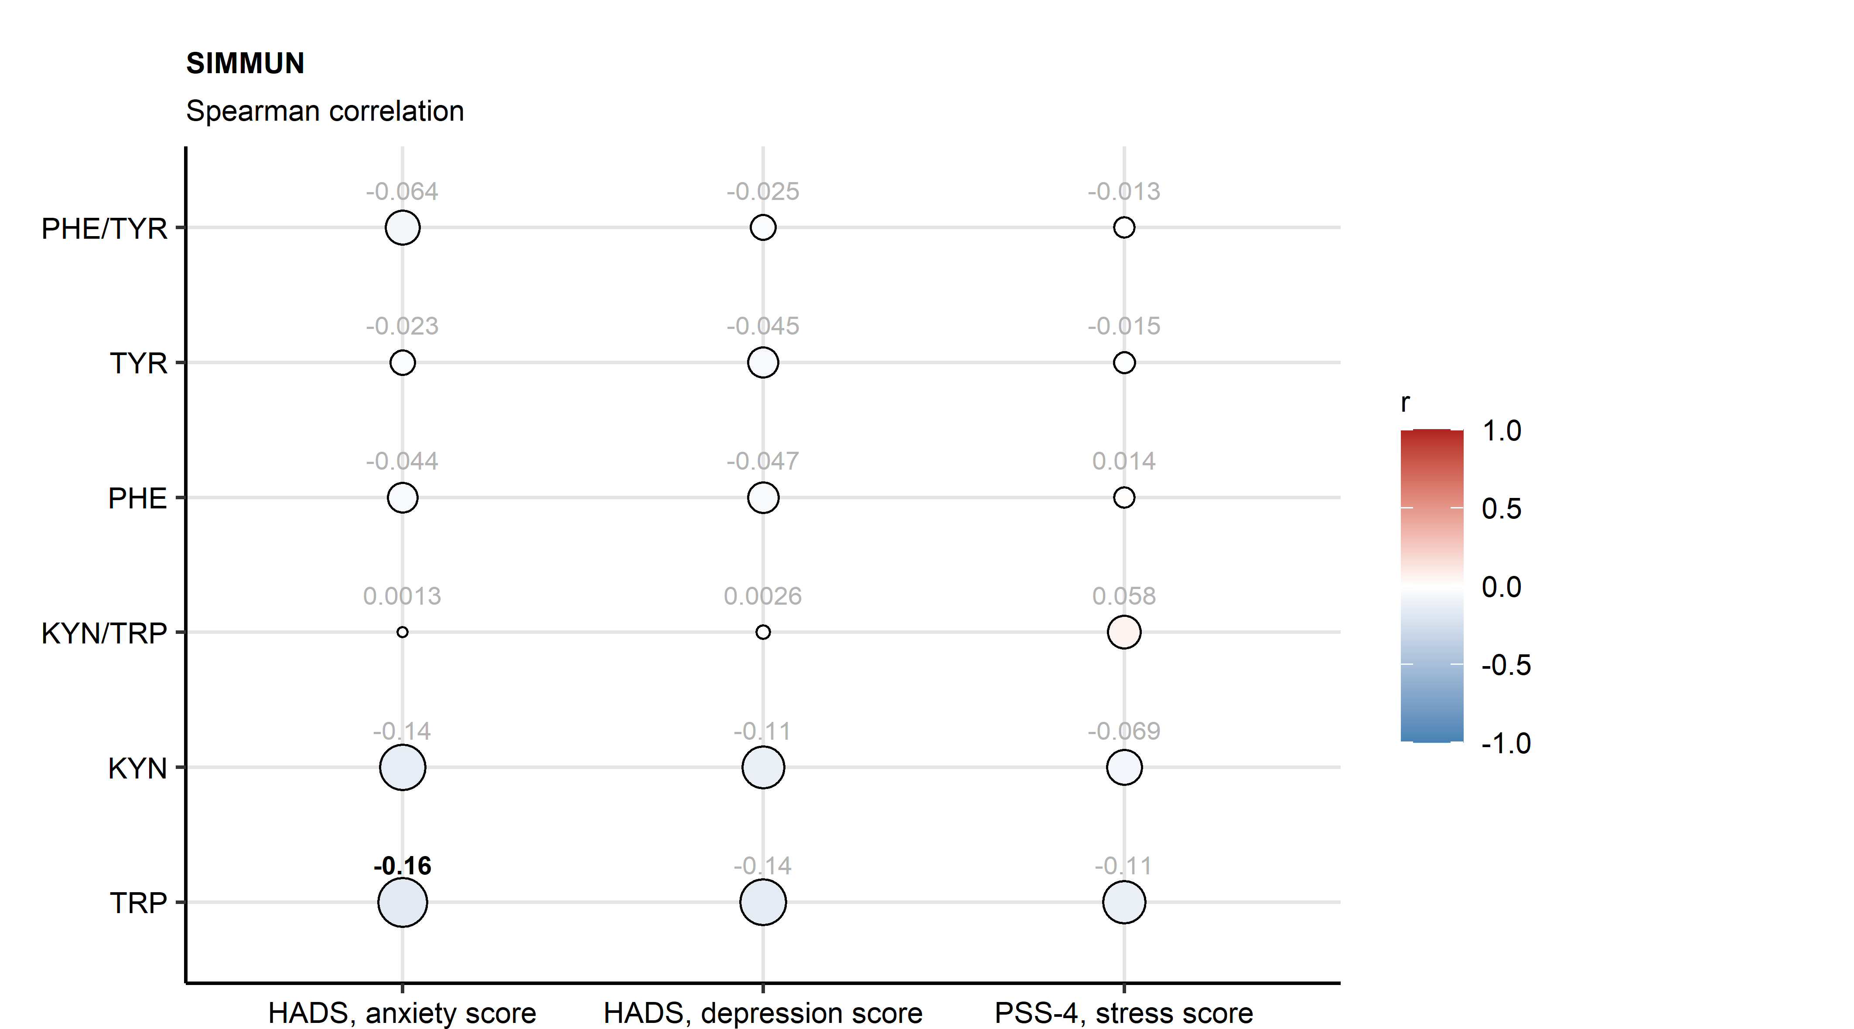

Figure 4: Association of neurotransmitter precursor aminoacids and their decay products with anxiety, depression and stress scoring in the SIMMUN cohort.

**Figure 4. Association of neurotransmitter precursor aminoacids and their decay products with anxiety, depression and stress scoring in the SIMMUN cohort.**

*Serum levels of TRP, KYN, KYN/TRP, PHE, TYR and PHE/TYR were correlated with anxiety, depression and stress scores in the SIMMUN study participants (n = 177). Statistical significance was assessed by Spearman test. Correlation coefficients are presented in bubble plots. Point sizes correspond to absolute values of correlation coefficient. Point color corresponds to the correlation coefficient value. Correlation coefficients for significant effects are highlighted in bold.*

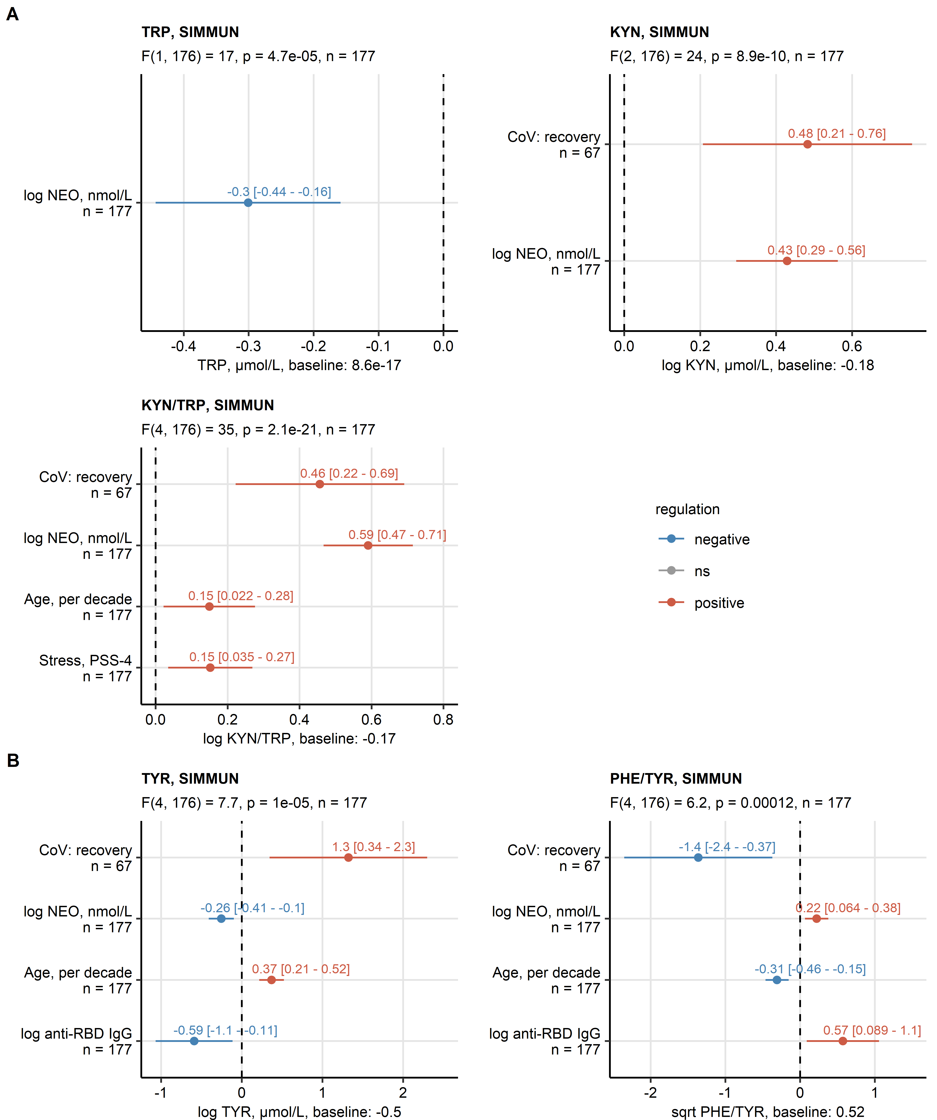

Figure 5: Results of multi-parameter modeling of aminoacid neurotransmitter precursor and their decay products.

**Figure 5. Results of multi-parameter modeling of aminoacid neurotransmitter precursor and their decay products.**

*Effects of systemic inflammation (neopterin, NEO), SARS-CoV-2 infection status, titre of immunoglobulin gamma against the receptor binding domain of the S1 SARS-CoV-2 protein (anti-RBD IgG), scores of anxiety, depression and stress, age and sex was investigated by multi-parameter linear regression with backward elimination of non-significant terms. Overall model validity was assessed by likelihood-ratio test (LRT). Significant model coefficient estimates with 95% confidence intervals are presented in Forest plots. LRT results (F values, degrees of freedom and p values) and total numbers of complete observations are indicated in the plot captions. Model intercepts (baseline) are indicated in the X axis titles.*

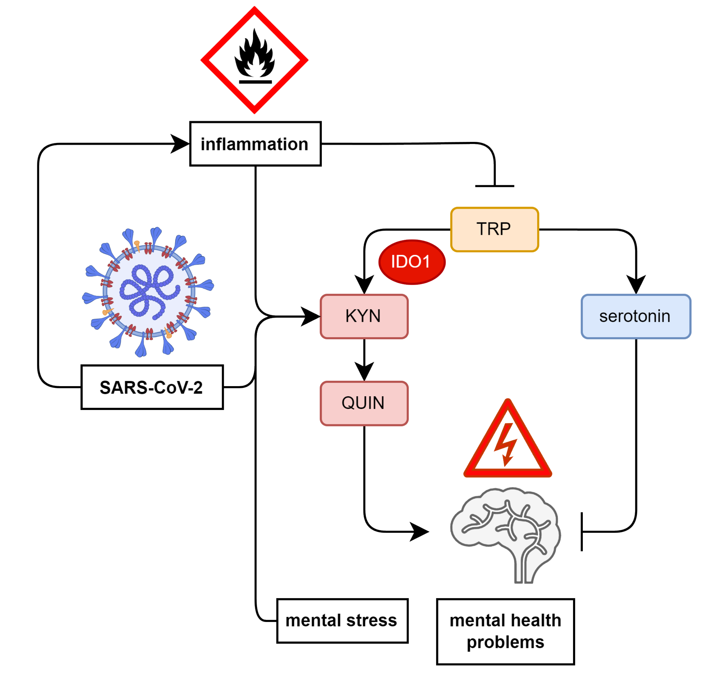

Figure 6: Schematic representation of effects of inflammation, SARS-CoV-2 and depression/anxiety symptoms on indolamine and catecholamine neurotransmitter precursor metabolism.

**Figure 6. Schematic representation of effects of inflammation, SARS-CoV-2 and depression/anxiety symptoms on indolamine neurotransmitter precursor metabolism.**

*Effects on metabolism of tryptophan (TRP), the serotonin precursor. SARS-CoV-2-dependent and -independent inflammation reduces systemic TRP levels, stimulates IDO1-mediated conversion of TRP to kynurenin (KYN) and quinolinic acid (QUIN). Independently of inflammation, during recovery from SARS-CoV-2 infection, TRP/KYN/QUIN conversion is stimulated as well. As a result, less substrate for production of the anti-depressive and anxiolytic neurotransmitter serotonin is available, which may predispose to depression or anxiety. Depression and anxiety symptoms on their own are paralleled by decrease in circulating TRP.*

# Acknowledgements

The scheme of report findings was created with bioicons by Simon Duerr. The SARS-CoV-2 virus image was created by Hanna Vega and licensed under the terms of a Creative Commons CC-BY SA 4.0

# References

1. Su Y, Yuan D, Chen DG, Ng RH, Wang K, Choi J, Li S, Hong S, Zhang R, Xie J, et al. Multiple early factors anticipate post-acute COVID-19 sequelae. *Cell* (2022) 185:881–895.e20. doi: [10.1016/J.CELL.2022.01.014](https://doi.org/10.1016/J.CELL.2022.01.014)

2. Benjamini Y, Hochberg Y. Controlling the False Discovery Rate: A Practical and Powerful Approach to Multiple Testing. *Journal of the Royal Statistical Society: Series B (Methodological)* (1995) 57:289–300. doi: [10.1111/j.2517-6161.1995.tb02031.x](https://doi.org/10.1111/j.2517-6161.1995.tb02031.x)