Persisting somatic symptoms following COVID-19 as well as mental health status are associated with changes in neurotransmitter precursor amino acid levels – a psychoneuroimmunological study

Supplementary Material

PSY Team

2022-11-23

# Supplementary Methods

## External data import and transformation

Proteome and metabolome data in form of normalized, age- and sex-adjusted, log2-transformed serum levels as well as clinical information (sex, SARS-CoV-2 infection status, COVID-19 severity, timepoint, post-COVID-19 syndrome status and particular symptoms) for the INCOV cohort were extracted from supplementary tables accompanying the report by Su and colleagues (1).

Characteristic of the INCOV cohorts is presented in **Table 2**. Numbers of available INCOV cohort samples and the sampling timepoints are shown in **Supplementary Table S1**.

## Software

Proteome and metabolome data were analyzed with R version 4.2.0. General data transformation tasks were accomplished with the *tidyverse* package bundle (2), *rlang* (3) and the development package *trafo* (<https://github.com/PiotrTymoszuk/trafo>). Statistical data analysis was done with the packages *rstatix* (4), *ggpubr* (5) along with the development package *ExDA* (<https://github.com/PiotrTymoszuk/ExDA>). Results were visualized with tools provided by the packages *ggplot2* (6), *cowplot* (7) and *ExDA*. Manuscript and supplementary tables were created with *flextable* (8). Supplementary Material file was written in the *rmarkdown* environment (9) and rendered with the *knitr* (10) and *booksdown* (11) packages.

## Statistical analysis of the cytokine and metabolite INCOV cohort data

Distribution normality and homogeneity of normalized cytokine and metabolite serum levels was assessed by Shapiro-Wilk and Levene tests, respectively. Comparison of normalized serum cytokine and metabolite levels between healthy controls and COVID-19 individuals at consecutive timepoints after symptom onset was done with Kruskal-Wallis test. Differences between healthy controls and consecutive timepoints of COVID-19 were investigated with Mann-Whitney U test corrected for multiple testing with Benjamini-Hochberg method (12). Correlation of serum cytokine and metabolite levels in healthy controls and COVID-19 individuals at consecutive timepoints was analyzed with Spearman test. For comparison of normalized serum levels of cytokines and metabolites during COVID-19 convalescence between healthy controls, COVID-19 individuals without persistent symptoms, COVID-19 individuals with persistent putative psychiatric symptoms (depression, anxiety or sleep disorders) and COVID-19 individuals with other persistent symptoms Kruskal-Wallis test with Mann-Whitney post-hoc test was employed.

## Data and code availability

Anonymized local cohort data will be made available upon request to the corresponding author. The INCOV cohort data are publicly available. The study pipeline code is available at <https://github.com/PiotrTymoszuk/stigma_validation>.

# Supplementary Tables

Table 1: Number of available samples and sampling timepoints in the INCOV cohort.

| **Time point** | **Days post infectiona** | **Sample number** |
| --- | --- | --- |
| healthy |  | 440 |
| acute | 11 [7.9 - 16] | 205 |
| sub-acute | 17 [12 - 23] | 187 |
| recovery | 64 [53 - 90] | 127 |
| aMedian with interquartile range, days after symptom onset. | | |

# Supplementary Figures

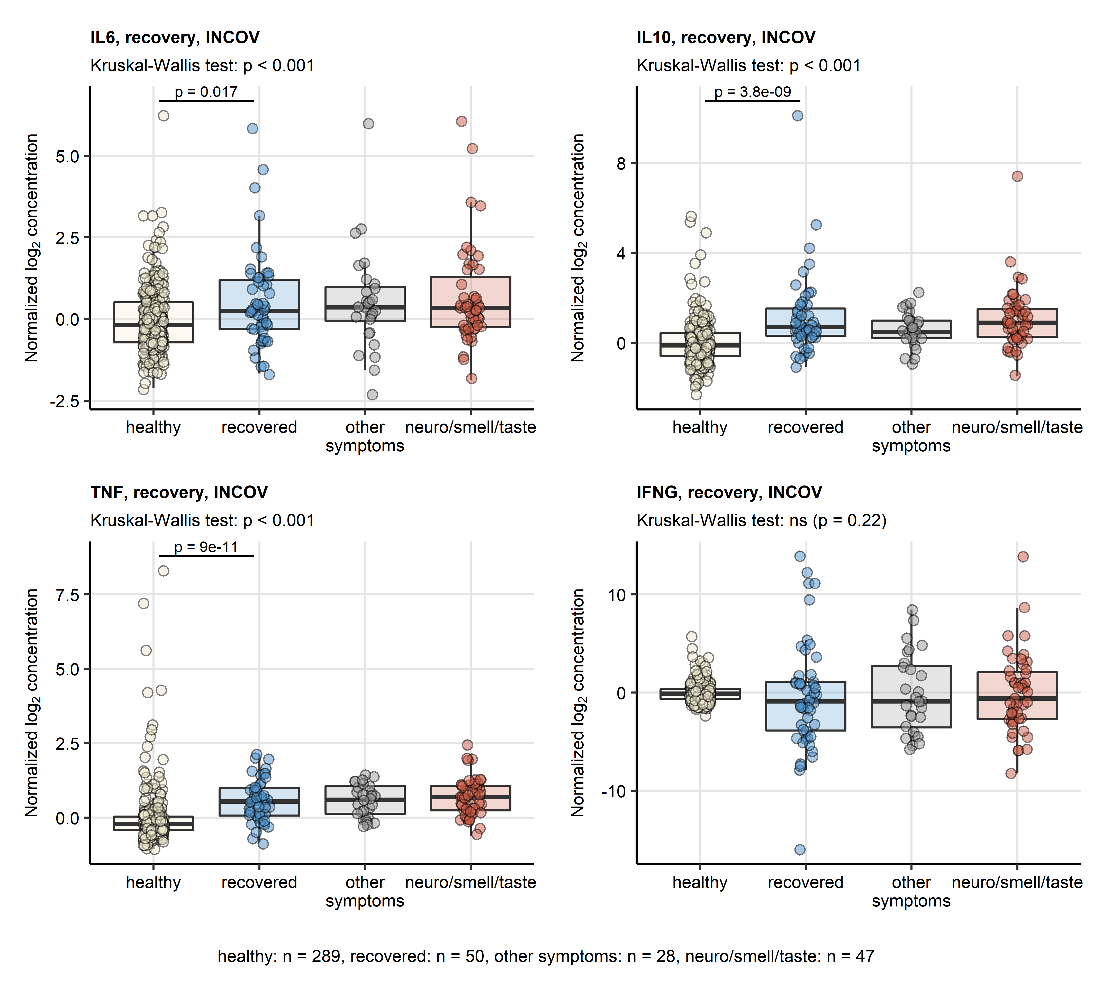

Figure 1: Serum levels of cytokines in healthy controls, complete COVID-19 recovery, non-neurological and neurological persistent symptoms in the INCOV cohort.

**Figure 1. Serum levels of cytokines in healthy controls, complete COVID-19 recovery, non-neurological and neurological persistent symptoms in the INCOV cohort.** *Normalized serum levels of IL6, IL10, TNF-alpha (TNF), IFN-gamma (IFNG) were extracted from the INCOV study data for healthy controls and COVID-19 participants during convalescence (median: 64 days after symptom onset). The serum levels were compared between healthy controls, COVID-19 subjects without persistent symptoms, COVID-19 subjects with putative neurological persistent symptoms (self-reported neurological symptoms, blurry vision, dizziness, feet or hand pain, smell or taste disorders) and COVID-19 subjects with other non-neurological persistent symptoms with Kruskal-Wallis test. Pairwise comparisons between the groups were done with Benjamini-Hochberg-corrected Mann-Whitney post-hoc test. Each point in the plots represent a single sample, boxes depict medians with interquartile ranges (IQR), whiskers span over 150% IQR. Kruskal-Wallis test p values are displayed in the plot captions. Significant and near-significant (p < 0.1) post-hoc test results are indicated in the plots. Numbers of complete observations are shown below the plots.*

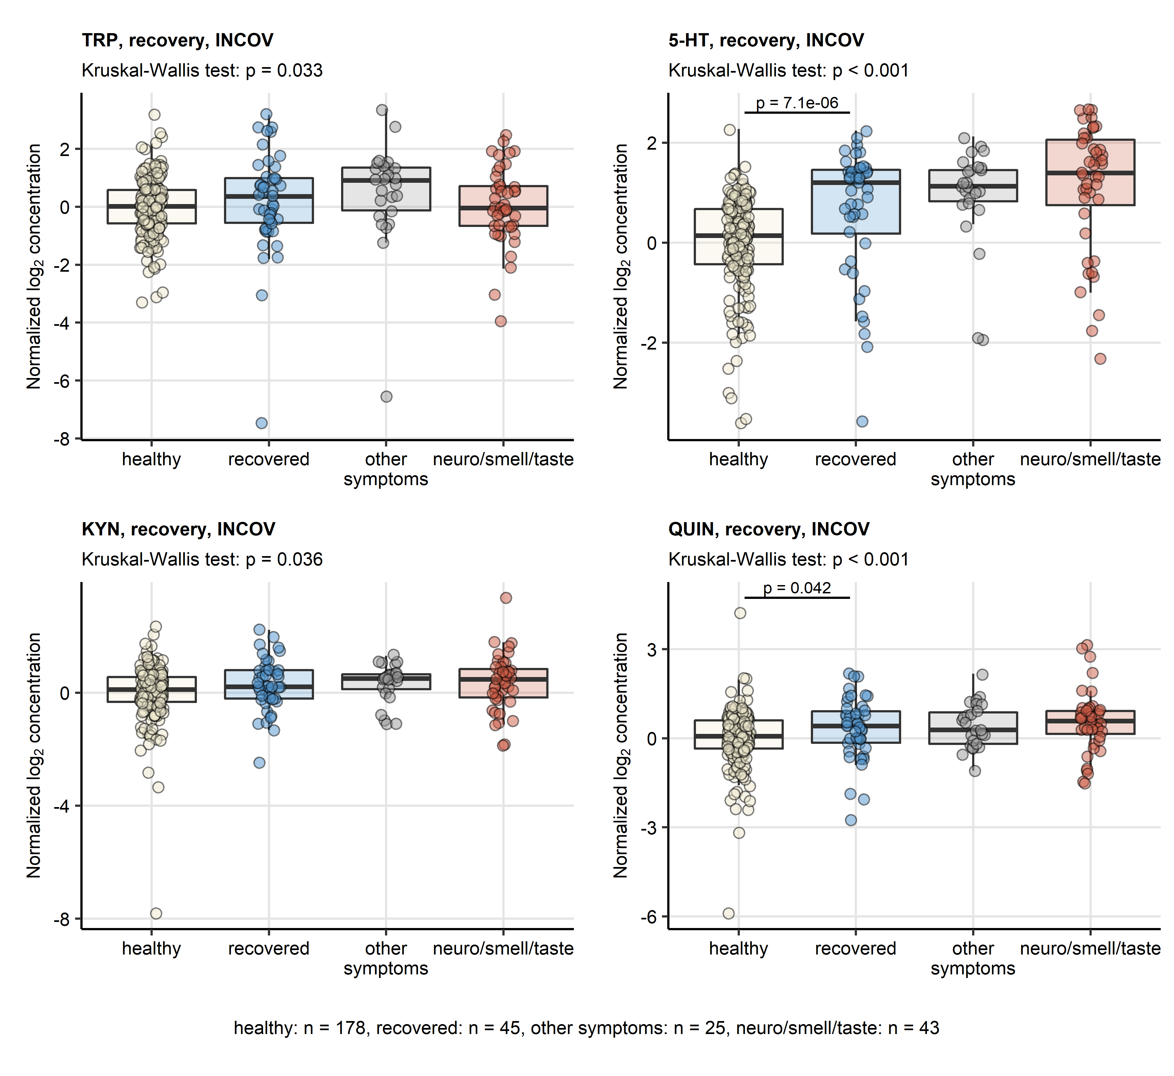

Figure 2: Serum levels of TRP degradation products in healthy controls, complete COVID-19 recovery, non-neurological and neurological persistent symptoms in the INCOV cohort.

**Figure 2. Serum levels of TRP degradation products in healthy controls, complete COVID-19 recovery, non-neurological and neurological persistent symptoms in the INCOV cohort.** *Normalized serum levels of tryptophan (TRP), serotonin (5-HT), kynurenine (KYN) and quinolinic acid (QUIN) were extracted from the INCOV study data for healthy controls and COVID-19 participants during convalescence (median: 64 days after symptom onset). The serum levels were compared between healthy controls, COVID-19 subjects without persistent symptoms, COVID-19 subjects with putative neurological persistent symptoms (self-reported neurological symptoms, blurry vision, dizziness, feet or hand pain, smell or taste disorders) and COVID-19 subjects with other non-neurological persistent symptoms with Kruskal-Wallis test. Pairwise comparisons between the groups were done with Benjamini-Hochberg-corrected Mann-Whitney post-hoc test. Each point in the plots represent a single sample, boxes depict medians with interquartile ranges (IQR), whiskers span over 150% IQR. Kruskal-Wallis test p values are displayed in the plot captions. Significant and near-significant (p < 0.1) post-hoc test results are indicated in the plots. Numbers of complete observations are shown below the plots.*

# References

1. Su Y, Yuan D, Chen DG, Ng RH, Wang K, Choi J, Li S, Hong S, Zhang R, Xie J, et al. Multiple early factors anticipate post-acute COVID-19 sequelae. *Cell* (2022) 185:881–895.e20. doi: [10.1016/J.CELL.2022.01.014](https://doi.org/10.1016/J.CELL.2022.01.014)

2. Wickham H, Averick M, Bryan J, Chang W, McGowan L, François R, Grolemund G, Hayes A, Henry L, Hester J, et al. Welcome to the Tidyverse. *Journal of Open Source Software* (2019) 4:1686. doi: [10.21105/joss.01686](https://doi.org/10.21105/joss.01686)

3. Henry L, Wickham Hadley. rlang: Functions for Base Types and Core R and ’Tidyverse’ Features. (2022) <https://cran.r-project.org/web/packages/rlang/index.html>

4. Kassambara A. rstatix: Pipe-Friendly Framework for Basic Statistical Tests. (2021) <https://cran.r-project.org/package=rstatix>

5. Kassambara A, Mundt F. factoextra: Extract and Visualize the Results of Multivariate Data Analyses. (2020) <https://cran.r-project.org/web/packages/factoextra/index.html>

6. Wickham Hadley. *ggplot2: Elegant Graphics for Data Analysis*. 1st ed. New York: Springer-Verlag (2016). <https://ggplot2.tidyverse.org>

7. Wilke CO. *Fundamentals of Data Visualization: A Primer on Making Informative and Compelling Figures*. 1st ed. Sebastopol: O’Reilly Media (2019).

8. Gohel D. flextable: Functions for Tabular Reporting. (2022) <https://cran.r-project.org/web/packages/flextable/index.html>

9. Allaire J, Xie Y, McPherson J, Luraschi J, Ushey K, Atkins A, Wickham H, Cheng J. rmarkdown: Dynamic Documents for R. (2022) <https://cran.r-project.org/web/packages/rmarkdown/index.html>

10. Xie Y. knitr: A General-Purpose Package for Dynamic Report Generation in R. (2022) <https://cran.r-project.org/web/packages/knitr/index.html>

11. Xie Y. *Bookdown : authoring books and technical documents with R Markdown*. (2016).

12. Benjamini Y, Hochberg Y. Controlling the False Discovery Rate: A Practical and Powerful Approach to Multiple Testing. *Journal of the Royal Statistical Society: Series B (Methodological)* (1995) 57:289–300. doi: [10.1111/j.2517-6161.1995.tb02031.x](https://doi.org/10.1111/j.2517-6161.1995.tb02031.x)