

**4TH YEAR THESIS IDEA**

*Enhancing Exercise Enjoyment and Physiological Benefits in Virtual Reality Fitness Games with the KATVR Treadmill*

*Initial Idea:*

Make a gym environment in VR with boxing ring, Tennis court and an outside area for running (Forest/ Beach). These exercises will be used to then measure the exercise enjoyment, calories burnt and BPM of the user along with other factors yet to be decided. Using the KATVR for natural feel movement instead of locomotion.

*Potential Questions:*

* How does using the KATVR Treadmill affect users’ perception of immersion and enjoyment in VR Fitness Games compared to stationary VR Setups.
* Do users experience different physiological responses, such as BPM and perceived exertion, when using the KATVR treadmill VS traditional VR locomotion methods.
* How can the KATVR Treadmill alongside VR Fitness Games motivate the users’ willingness to exercise frequently to improve their physical well-being.

*Types of Sports to use within the Answering of the Questions:*

* *Running*: An immersive environment will be created for the user to experience while running on the KATVR. The user can traverse the scenery and their data, such as BPM, will be measured.
* *Tennis*: Players' movement and hand-eye coordination will be tested with this feature. Players' enjoyment can also be given as a form of feedback to further understand the advantages of VR technology in promoting healthier and more engaging fitness experiences.
* *Boxing*: A fun and physically challenging exercise that could influence the user to continue improving their boxing skills which in return would improve their physical and cardiovascular health.

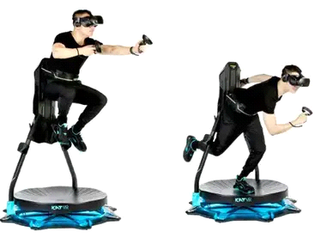

[**KAT Walk C 2 Core**](https://www.kat-vr.com/products/kat-walk-odts)