**Database Systems Design**

Piotr Wesoły 5TCS2 223953

Laboratory Report

In this Report I will present my database for public library. I will show the idea behind it, the diagram, code with which I created this database, input code, as well as the tables with examples. Later I will show the usefulness of this database using some query, which may be helpful in library.

**Idea behind my database**

I wanted to create a useful database, which may be helpful at the local libraries. Those institution have a lot of data to be stored. Library employees have to know where the certain book is located, how many copies of it there is, is there any copies rented by customers, what is the condition of the rented and returned book, when customer should return and so on. There is no way employees are able to remember all that stuff, that is why databases are so helpful.

**Database model**

Now let me present the model of my database. It consists of 16 tables, each serves different purpose and in my opinion is crucial for flawless work of library. On the figure below you may find Lucid Chart which contains my model.

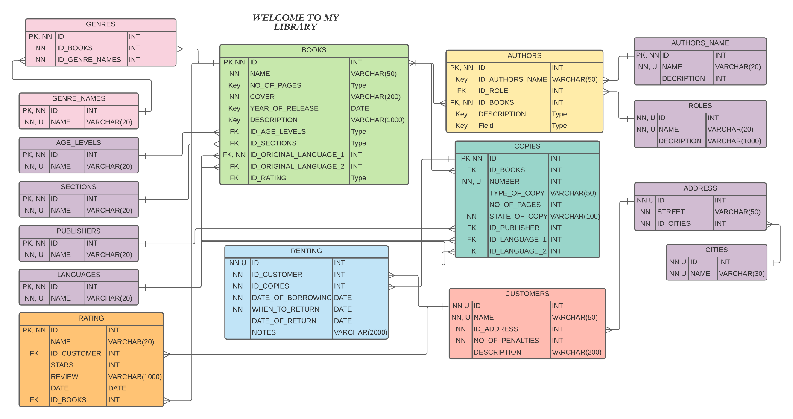

Figure 1: Lucid Chart Model of my database

My model consists of 16 tables, amongst which are:

* Books – this table stores the name, number of pages, year of release, and other attributes required to describe given book. This table provides customer with most important descriptions about the book.
* Authors – in this table you can find people who worked on the certain book, there might be more than one person, for example there may be main author, co-author, illustrator, translator, and so on. That is why in this table you may find attributes such as foreign key to author name as well as foreign key to their role.
* Authors name – in this table are stored the names of artists who worked on books.
* Roles – as mentioned before, roles are the professions of people working on book.
* Copies – here you may find the details about the copies of the book, so the distinct number of copy, by which customer may identify given copy of a book, number of pages of this copy, as we all know some copies may have different number of pages. Other attributes are the state of copy, or the type of the cover.
* Customer – in this table library can store the information about its customers, such as name, address or even number of penalties, caused by returning book after due date.
* Address – here are stores the addresses of the customers.
* Cities – in this table one may find the cities in which customers are living.
* Renting – in this table library can store the details about each rented book. For example, which copy who rented, on what day and when should it be returned. If the book was returned the column “date of return” will be filled, which can be checked against the “when to return” column to see if the book was returned on time.
* Age level – in this table we may find different age level, which will be assigned to books.
* Sections – in this table we may find sections of library in which the book is stored.
* Publishers – in this table we may find who published which book.
* Languages – in this table we may find languages in which the book were wither written or translated to.
* Rating – this table stores the reviews of either a customer or public figures. Each book can be rated in terms of 5 stars, as well as using typical review text.

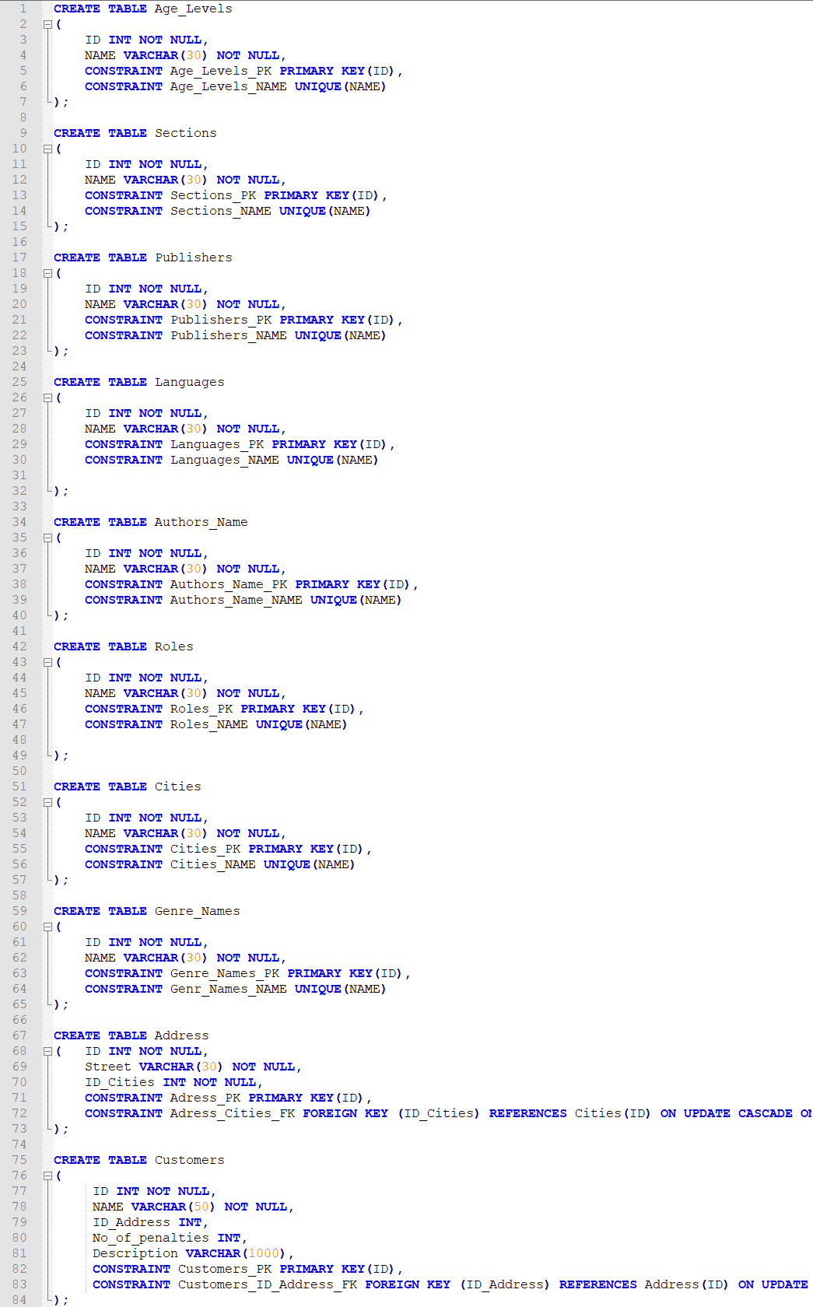**SQL code**

Figure 2: First half of the SQL code, with which I created this database

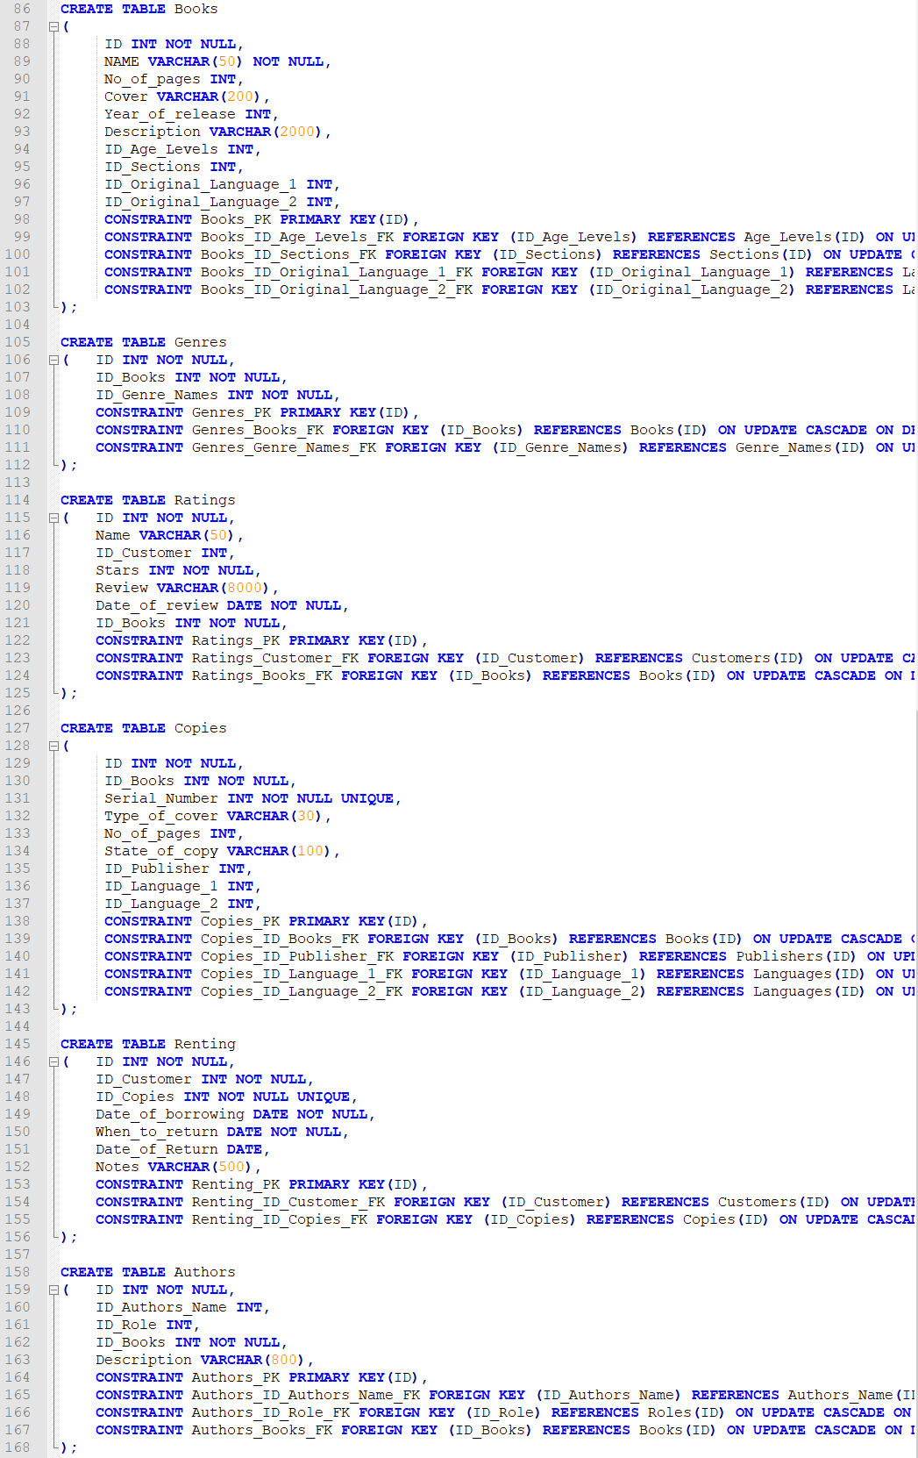

Figure 3: Second half of the SQL code, with which I created this database

Figures 2 and 3 present the SQL code, which I wrote to create the database for library. You may find there all of the tables I mentioned before. The order of table creation is not random, in order to create some tables I first had to create a table which contain primary keys used in other tables. That is why I started from purple and pink table (look Fig.1). The general order of table creation is as follows:

* First: Age levels, Sections, Publishers, Languages, Authors Name, Roles, Cities, Genre Names.
* Second: Address(required cities), Books (required Age levels, Sections, Publishers, Languages).
* Third: Customers (required Address), Genres (required Genre Names, Books).
* Fourth: Ratings (required Customers, Books), Copies* (required Books, Publishers, Languages).
* Fifth: Renting(requires Customer, Copies), Authors* (requires Authors Name, Books).

**\*Could be implemented in earlier stage. The order is the same as in code.**

**Input Code**

Following pages will contain the code I wrote to input data into my database. The input contains of exemplary code:

* Age Levels: Kids, Teenagers, Adults, Elders
* Sections: Thrillers, Horrors, Crime, Adventure, Fantasy, …
* Languages: English, Italian, Polish, German, Spanish, …
* Genre Names: Poetry, Comedy, Thriller, Action,…
* Roles: Main author, Co-author, Translator,…
* Cities: Lodz, Warsaw, New York, Sydney,…
* Authors Name: Fyodor Dostoyevsky, J.K. Rowling, …
* Publishers: Salamandra Infantil y Juvenil, W.A.B, …
* Books: Harry Potter, Crime and Punishment,…
* Address: Piotrkowska 45/3, Pomorska 54/4,…
* Customers: Piotr Wesoły, John Smith,…
* Copies: Copy of Harry Potter no.2000,…
* Renting: Piotr Wesoły rented Harry Potter, no. of copy 2000 on 13/01/2021,…

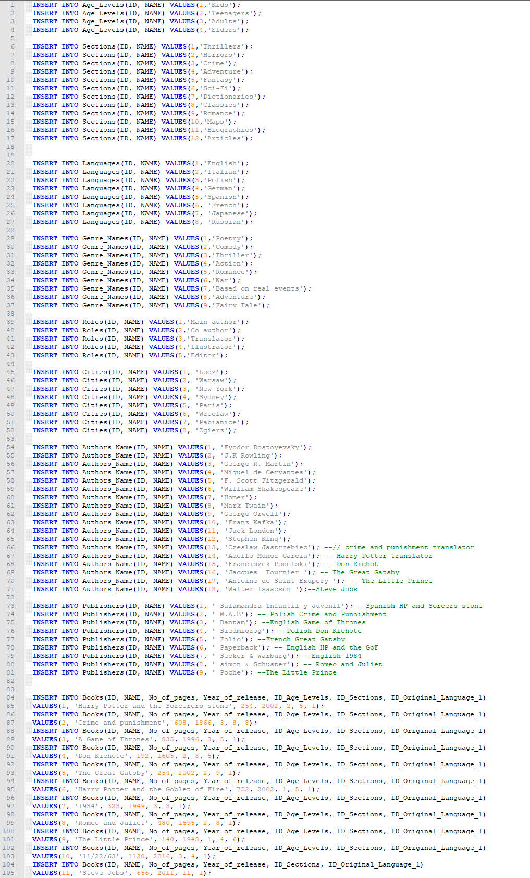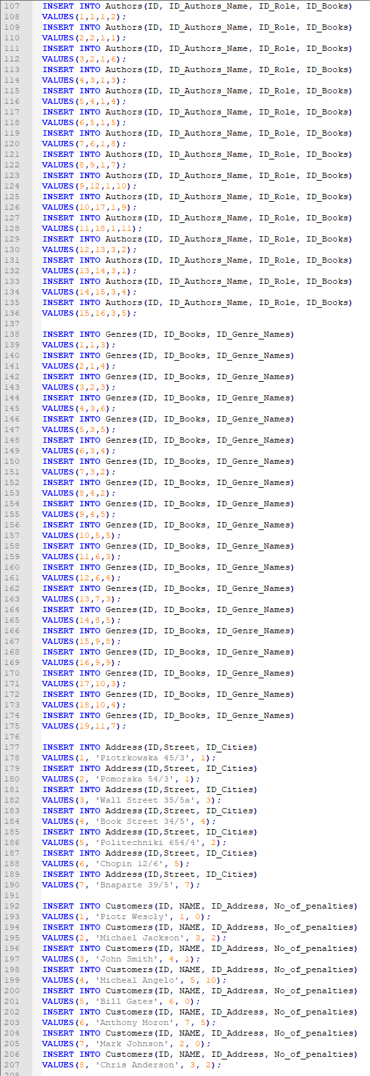

Figure 4: First 207 lines of input query code

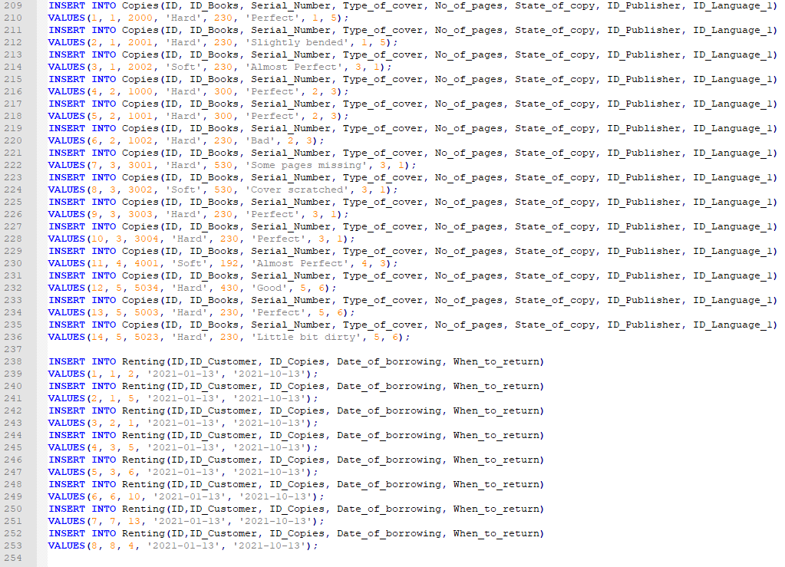

Figure 5: Remaining lines of input query code

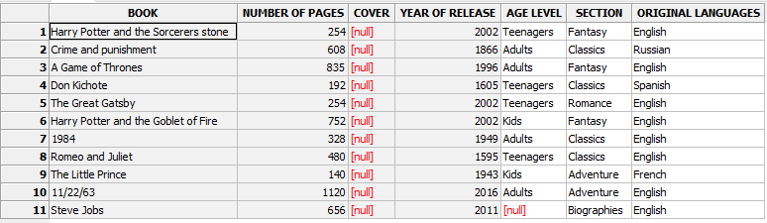**Tables with examples**

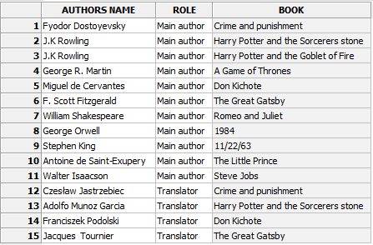

Figure 6: All attributes from table Books

Figure 7: All attributes from table authors

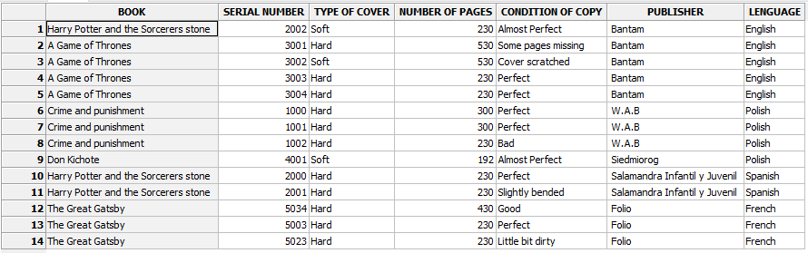

Figure 8: All attributes from table copies

Figure 9: All atributes from table ratings

As you can see on the figures 6, 7, 8 and 9 are presented the attributes of four tables: Books, Authors, Copies and Revies. They are filled with examples. All data inside this tables is real, which is the result of hours of research. The name of author, translator, publisher or even number of pages is the real information one can find online. Customers and reviews are the products of the mine imagination. Any resemblance to actual persons, living or dead, or actual events is purely coincidental.

**Useful query examples**

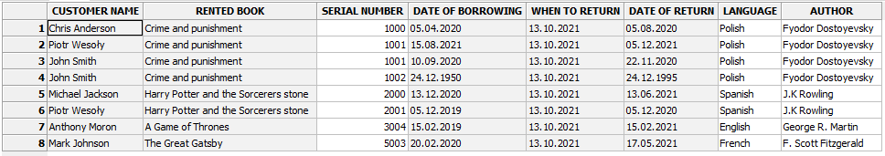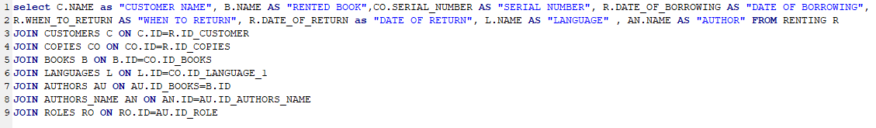 Now I will present a few query examples, which may be useful while using this database. Amongst them will be table with customers, who rented which book and when, as well as when should they return it.

Figure 10: Query which shows renting database

This would be the main table, which shows all of the books that customers have rented. We can clearly see who rented what, when they rented it, when returned the book, and what was the due date. There are also some additional informations such as language of rented book and author.

If a customer wants to borrow a book, the employee may check some information about him, as well as about the book. Let’s say that *Michael Angelo* wants to borrow *Crime and Punishment.*

To see how many books are available we can create a view:

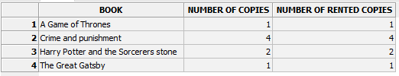

Figure 11: View which shows number of all copies as well as number of rented copies

Unfortunately, all copies of *Crime and Punishment* are rented, but even if they were available Michael Angelo wouldn’t be able to borrow them, because his number of penalties is greater than 3, which means that he is on BANNED list:

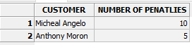

Figure 12: List of banned customers due to high number of penalties

We can also add the view which shows all customers who retuned book too late:



Figure 13: List of customers who returned book to late

**Random query**

Now I will present some random query. First, I will try to find who rented book in Polish between 2019-05-02 and 2021-02-03:

Figure : List of people who borrowed book in Polish between specific date

Next let’s count how many reviews over 2 stars does “Game of thrones” have?

Figure : List of number of positive Game of Thrones reviews

On the figure above we can see that out of 3 reviews only 1 has more than 2 stars.

**Conclusions**

I created database for public libraries for the Database System Design project. Database consists of 16 tables each consists of different lists crucial for the flawless work of most public libraries. The database consists of list of customers and their information so that employees may have more insight into the person they rent the book to. The list of books lets people get more familiar with what kind of book they can rent, who is the author, where they can find it, or even see how many pages it has. Review table helps customers choose the book they were not sure if they want. Renting list consists of information about the borrowed books, employee may check who borrowed which book and when. Created by me views may help employees check if certain book is available or if person who wants to borrow it is banned from this library due to the number of penalties. After inserting information into the database, we were able to see some examples of usefulness of this database.