Data Analytics Dashboard for Pathology Requesting from General Practice
The Laboratory Medicine Informatics Team has recently built a web based analytics platform to analyse the levels and distribution of pathology requests being sent by clinicians/surgeries. We hope that that it will allow us to better target efficiency measures and improve pathology requesting by highlighting the areas in GP practices which differ from the local averages.
This project was initially constructed for the Accident and Emergency department in Heartlands Hospital, however we feel that it could also provide some significant benefit for GP practices.
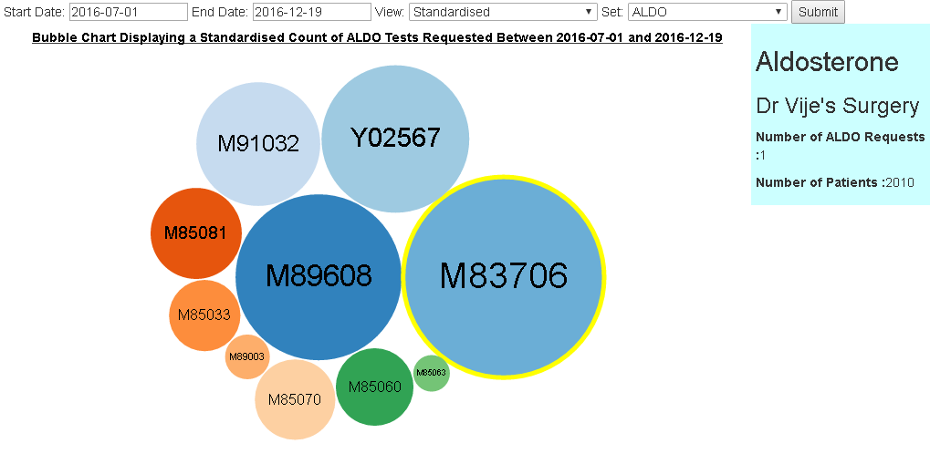
We have completed the initial construction phase and are now in the process of delivering the product to end users so that we can tailor the dashboard to user needs and display the information found to be the most useful.

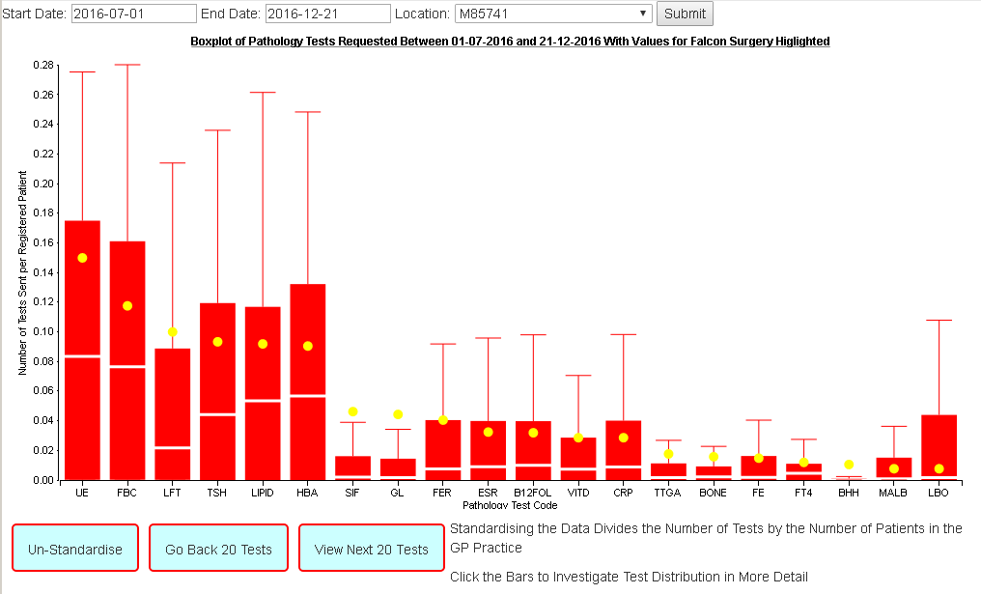

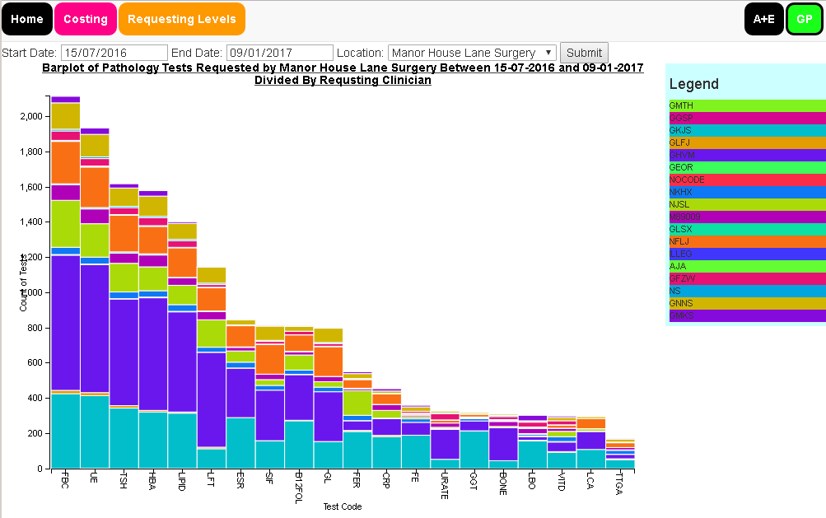

Getting Into the Dashboard
Currently the site is only available through the trusts local IT infrastructure; this means that it cannot be accessed from outside the Heartlands local area network without a VPN connection to that network. In future developments we may investigate getting a DNS address assigned so that it can be accessed from outside the trust.
If you do have a connection to the Heartlands network you can access the dashboard by entering http://ebh24751:8000/ into any web browser.
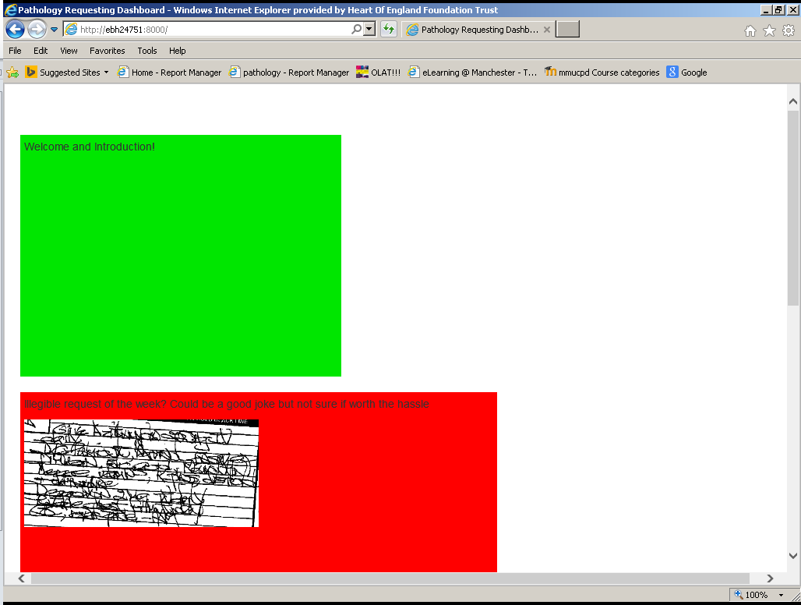
The dashboard is known to have compatibility issues with Internet explorer, so access through Google chrome, Firefox, Opera or Safari would be preferable.
If you must use internet explorer and you load a page like the picture to the left then you will need to change your compatibility settings to view the site.
To do this go to Tools>Compatibility View Settings and uncheck “Display Intranet Sites in Compatibility view”.
If you use ice requesting on this computer you should also add bhhiceaplive to the list of sites added to compatibility view see pic below.
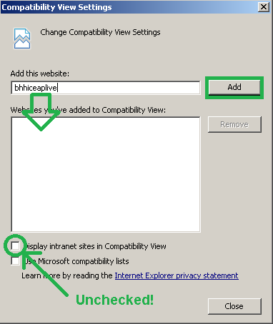
For any Problems please contact Pip Croxford at pip.croxford@heartofengland.nhs.uk .

