THE

ONLINE

**GLOSSARY**

*FOR*

**INVENTORS**

*AND*

**PATENT ATTORNEYS**

*from* **Piperpat.com**

**Category organisation**

Structure

Shape

Voids

Spring

Mounting method

Fastener

Bearing

Materials

Material properties

Fluid flow

Optical

Other

Electrical

Sequence

Numbers

Position

Placement

Movement

Rotation to Translation

Translation to Translation

Rotation to rotation

Structural

Flange

Beam

Bearing

Joint

Sheet

Shaft

Lift

Timber joints

Mouldings

Doors, hinges & locks

Roof trusses

Timber connectors

Brickwork

Mechanism

Jaws

Gear

Spring

Shape

Closure

Tube

Orifice

Cover

Slab

Interior

Member X

Projection

Limit

Wedge

Receptacle

Geometric adjectives/adverbs

Material

Fibre

Material structure

Relationship & movement

Relinquish

Relationship

Movement

Contact

Words can belong to more than one category. Having a category and subcategory field for each word is probably not the best approach. My original category lists of words would probably work much better. Subcategories are just subsets of category lists. If supercategories ever need to be added, that would be fairly easy to do.

Words should follow this basic structure:

const word = {

    word: "word",

    definition: "a thing to describe a thing",

    tags: ["language", "grammar"],

    has_img: false,

    img_src: ""

}

Some words might have more than one definition and more than one category. Making the definition field a list of strings, rather than just a string might be a better approach. At this stage it’s hard to tell how common this will be – it might not be worth changing the data structure for a handful of words.

Some words might have more than one image – the img_src field should be a list rather than a string.

**Extending the Glossary**

When adding words to the dictionary, add them to dict.js then run rm-repeats/script.py. This prevents js errors caused by declaring constant variables twice.

Technical fields from <https://www.debay.fr/home/technical-fields-patents/>

Agri-business

Aeronautics

Microwave applications

Automotive

Biotechnologies

Chemistry

Medical devices

Prosthetics and orthotics

Electrical and electronics devices

Smart cards

Computer sciences and software

Telecommunications

Television & Multimedia

Water treatment

Soil treatment

Optics and Opto-electronics

These are slightly higher-level abstractions than the glossary currently needs to handle. At the moment, the words will be limited to general/mechanical (and electrical?). Chemical and medical inventions can be added later.

Perhaps each word could have a “technicalField” property for now, but they’ll all be mechanical.

**UI**

Hach.com – chemistry glossary lists all words alphabetically in one page:

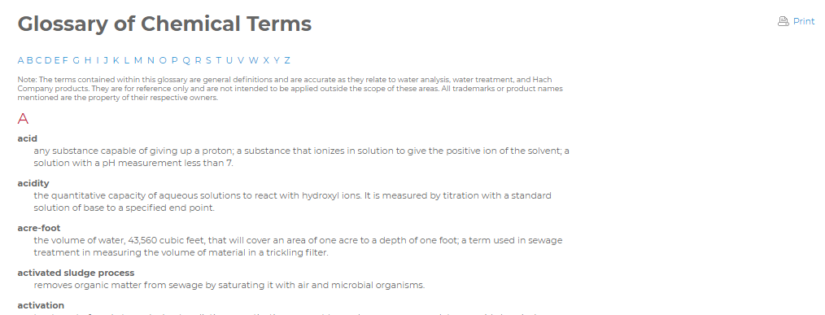

Maori dictionary looks like this:

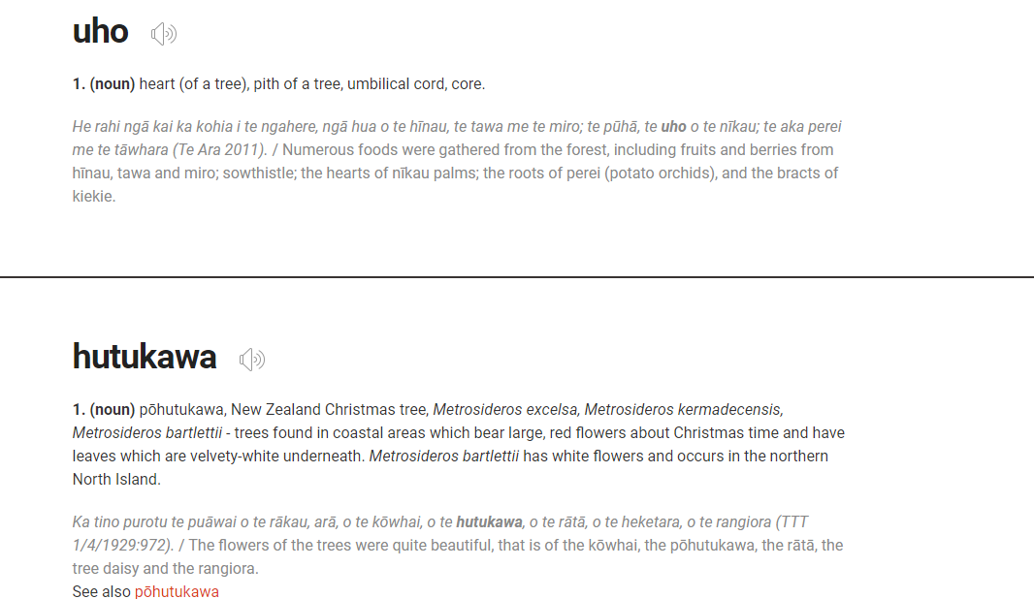

Each entry takes up a lot more space on the page and the font size is relatively large.

Dictionary.com has a page for each entry.

Justice.govt.nz is similar to hach:

