Intro to Programming (Python)

Assignment 08

# Overview

In this activity, you learn about classes, the components inside of them, and how you use them. You also download, install, and use GitHub Desktop.

This assignment includes the following tasks:

1. Watch the module videos.
2. Read Web articles
3. Read a chapter in your book.
4. Apply your knowledge.
5. Document your knowledge.
6. Watch Some Videos on GitHub
7. Post files to GitHub using GitHub Desktop.
8. Create a GitHub webpage (Optional).
9. Submit your work.

We are trying to answer the following questions:

* What is the difference between a class and the objects made from a class?
* What are the components that make up the standard pattern of a class?
* What is the purpose of a class constructor?
* When do you use the keyword "self?"
* When do you use the keyword "@staticmethod?"
* How are fields and attributes and property functions related?
* What is the difference between a property and a method?
* Why do you include a docstring in a class?
* What is the difference between Git and GitHub?
* What is GitHub Desktop?

# Assignment Steps

The following assignment steps ask you to read about, perform, and write about programming.

***Note:*** *Course assignments help you learn through* ***reading****,* ***watching*** *demonstrations,* ***performing*** *programming in Python, and reflecting on what you learned through* ***writing****. You are strongly encouraged to continue your learning by experimentation.*

## Step 1 - Watch the Module Videos

Please **watch the course videos**, found **on Canvas under modules -> module08**.

* Git and GitHub [**https://youtu.be/IHaTbJPdB-s**](https://youtu.be/IHaTbJPdB-s) (external site)

## Step 2 - Read Web Articles

Please review the following web pages. These are shorter than the book and provide online resources you can use later.

* <https://en.wikibooks.org/wiki/A_Beginner%27s_Python_Tutorial/Classes> (external site)

## Step 3 - Read a book chapter

Please **read chapter eight** in your textbook. You **do not have to perform the exercises or type in the code**, but it is best if you open the script files as you read about them. You can find the downloadable **book files** **on Canvas** for your convenience.

***Note:*** *Chapter eight and beyond start becoming difficult for beginners to follow. So, make sure you watch my course video before you start the chapter to make it a bit easier.*

## Step 4 - Apply your knowledge

Now that understand what classes are, you create a script with three classes.

### a. Create a Folder

Create a new **sub-folder called Assignment08** inside the _PythonClass folder.

### b. Create a new Project in PyCharm

Create a **new project** in PyCharm that uses the _PythonClass\Assignment08 folder as its location

### c. Create a Python Script

**Create a python script** file within your project.

### d. Add Code to the Script

I have **provided starter** code in the file called, **"Assigment08-Starter.py" on Canvas**. Currently, the code does nothing, but it does include pseudo-code (Listing 1). Your task is to **read and understand the pseudo-code, then add code to make the application work**. Make sure to **include error handling!**

### e. Run Your Script

With the script created in its proper location, run the script in **BOTH** PyCharm and an OS command/shell window and capture images of it working on your computer.

## Step 6 - Document your knowledge

After you have created and tested your Python script, **create** a document describing the steps you took in performing this assignment. **Use** screenshots and code samples to explain the process, just as was done in your book, my programming notes, and the web pages you reviewed. **Make sure** the document is in a Microsoft Word document (.doc or .docx) or .pdf file.

**Note**: Make sure you put it in a proper, professional level, formatting! It does not have to be perfect, but if you turn in a simple blob of text, you won't get credit for it! Here is a link that may help you understand what I am looking for: https://youtu.be/9ojhSW9ljjo (External Site)

## Step 7 - Post Files to GitHub using GitHub Desktop

In this module, you need to **post** your files on a public **GitHub repository** so that others may review it. Please post **both your Word document and your Python file**.

a. Watch the following video.

* GitHub Desktop (for **Everyone**) [**https://youtu.be/77W2JSL7-r8**](https://youtu.be/77W2JSL7-r8) (external site)

***Important: The process is almost the same on Windows and Mac, but the UI is different! If you are using a Mac, please watch this next video as well.***

* GitHub Desktop (for **Mac students only**) <https://youtu.be/oT1QweCzHB4> (external site)

b. **Install** GitHub Desktop and log into your GitHub account.

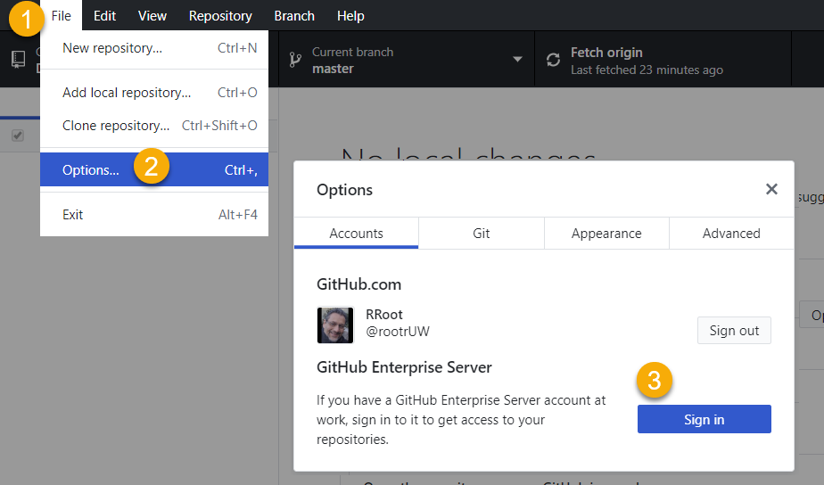

Figure 1. Logging into GitHub from GitHub Desktop

c. **Create** a new repository called **"*IntroToProg-Python-Mod08" on your local computer. Creating a repository this way creates a new GitHub folder on your computer (Figure 2).***

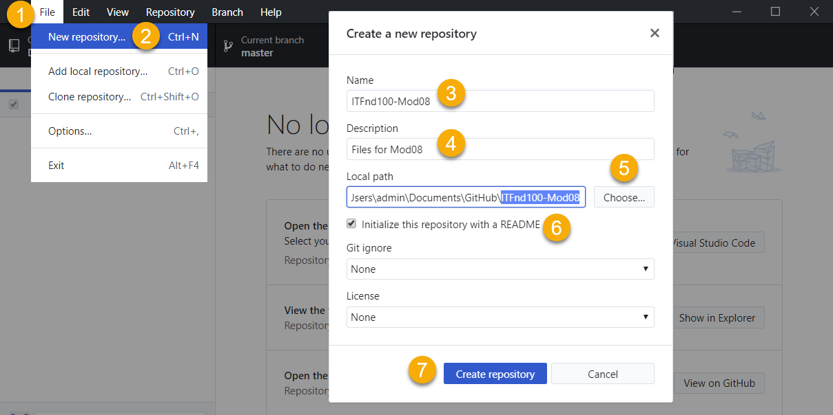

Figure 2. Creating a new local repository

d. **Copy** your Python script and knowledge document **into the local GitHub repository folder (Figure 3)**.

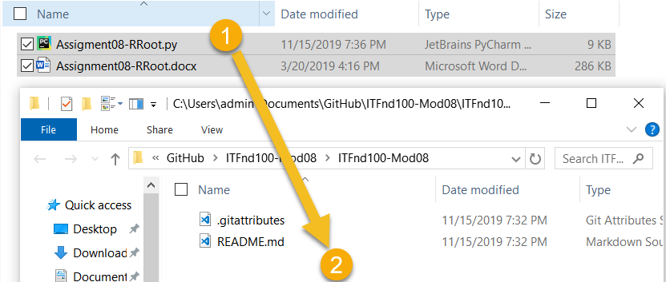

Figure 3. Copying files into your local repository folder

***Important: You are creating a new GitHub repository for assignment 8. Using a different repository gives you practice managing multiple repositories and is part of the assignment.***

e. **Review** the changes in GitHub Desktop, **add a title and description** of the change, then **click** the "**Commit to master**" button to finalize the change (Figure 4).

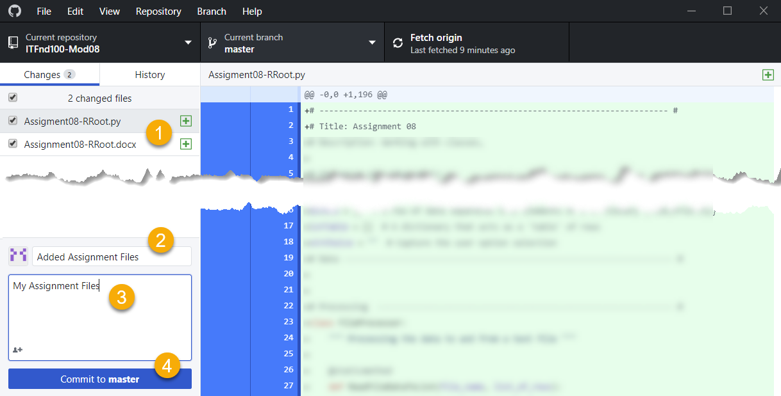

Figure 4. The changes shown in GitHub Desktop

f. **Upload** both of your files to the repository using GitHub Desktop's "Push origin" button (Figure 5).

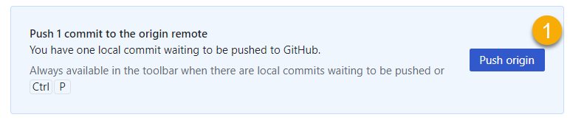

Figure 5. Uploading files with the "Push origin" button

g. **Navigate to the GitHub website, login, and verify** that the new repository and your files are there (Figure 6).

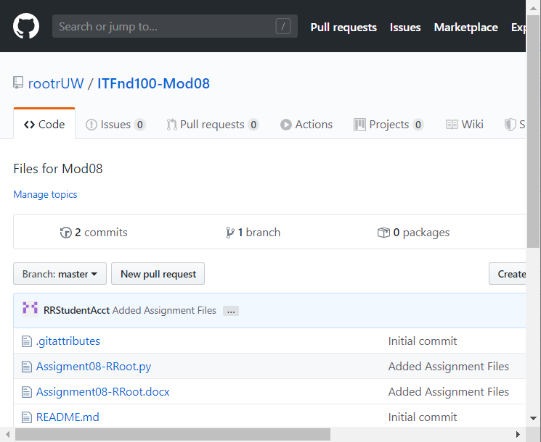

Figure 6. verifying the new repository and files

## Step 8 - Create a GitHub Webpage (OPTIONAL)

If you would like to show your work on the Internet, feel free to add a GitHub webpage to your repository, as you did in module 7.

## Step 9 - Post a Link to GitHub

You do not need to share your work using the Canvas discussion board this time. However, ***please copy and paste the URL for your GitHub repository into your MS Word knowledge document*** *(Figure 7). Having this link in the Word document make grading a lot easier and is a big help!*

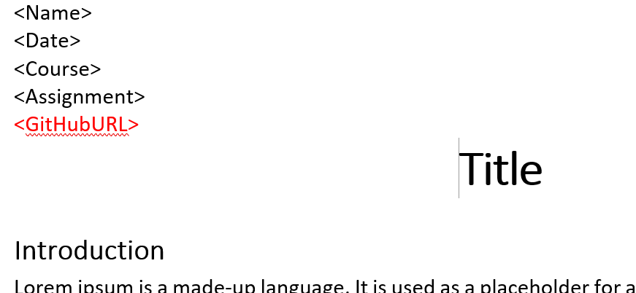

Figure 7. Adding your GitHub URL to your *knowledge* document

## Step 10 - Submit your work

**Submit your Python script and Word document as a Canvas assignment** for grading. So, place your document and python script in the Assignment08 folder. Zip this folder into a “.zip” file, then upload the .zip file to the class assignment page.

***Important:***

*1.* ***Upload*** *your work* ***to the Canvas*** *assignment’s as a* ***Zip file****.*

*2.* ***Post*** *a link to your GitHub site* ***on the******assignment textbox****.*

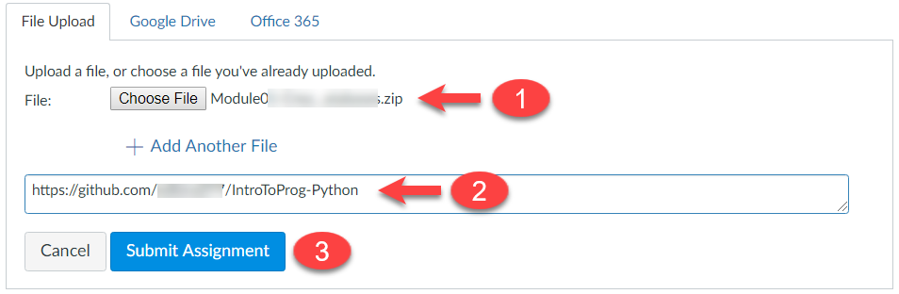

Figure 8. Posting your zip file to Canvas

Congratulations! You are done!