User Manual & UI Visual Evidence
This user manual comprehensively covers all SoluoPrint functionalities developed and evidenced during this examination.

Admin Authentication
Admins log in using their email and password. Authentication is secured by Supabase Auth.
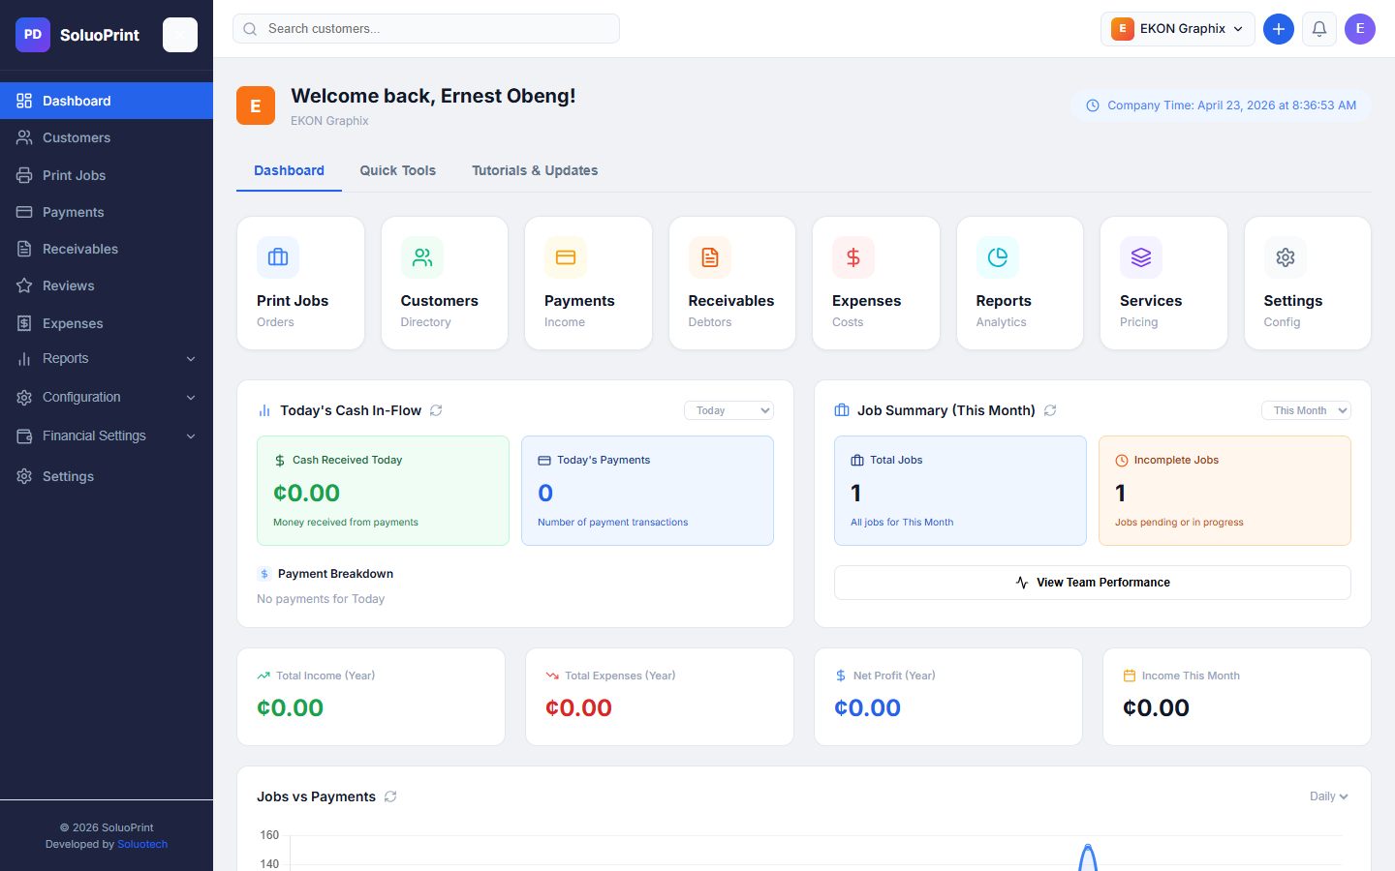

Admin Dashboard
The central analytics hub showing Total Revenue, Total Debt, Job Status distributions, and Recent Transactions.
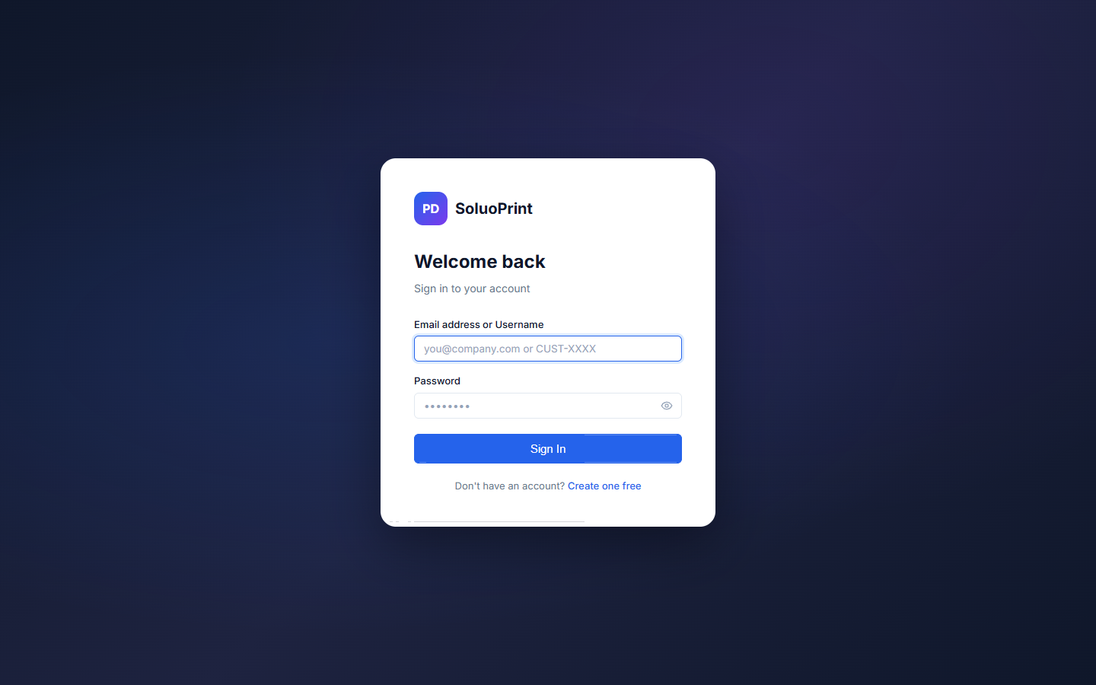

Customer Directory
Manage clients, view balances, edit customer details, and track SMS preference settings.


Print Jobs Management
Track job production states (Pending, In Progress, Completed, Delivered). Admins can update statuses and generate invoices.


Payment Records
Track all transactions, filter by cash, MoMo, Visa, or Bank Transfer, and monitor outstanding receivables.


Settings & Configurations
Configure company details, services, and categories.


Payment Integrations
Configure Hubtel, Paystack, and Flutterwave API keys to accept digital payments from customers.


Customer Portal
Customers can log in with a custom username (e.g., CUST-9999) to view their job history, pay outstanding balances via gateways, and upload new print jobs directly.
