Software Requirements Specification (SRS)
SoluoPrint

1. Introduction
The SoluoPrint system is a comprehensive print shop management application designed to handle customers, print jobs, financial transactions, and automated notifications (SMS). This document formalizes the requirements and architecture of the existing system as part of the CSCD 602 Advanced Software Engineering Project.

2. Functional Requirements
- FR1: The system shall allow users to register and create a company profile.
- FR2: The system shall enforce email verification for new accounts prior to granting access.
- FR3: The system shall allow authorized users to create, update, and manage print jobs with statuses (Pending, In Progress, Completed, Delivered).
- FR4: The system shall allow users to manage customer records and track customer balances.
- FR5: The system shall allow users to record payments against specific jobs or general customer balances.
- FR6: The system shall automatically send an SMS notification using SMSGH SMSAPI when a payment is received, formatted exactly as: 'Hello [Name], your payment of: [Currency] [Amount] has been received. Your remaining balance is [Currency] [Balance]. Regards: [Company Name] - [Phone] Powered by: Soluotech'.
- FR7: The system shall provide Role-Based Access Control (RBAC) supporting 'owner' and 'admin' roles.
- FR8: The system shall display analytics on a Dashboard (Total Revenue, Jobs, Outstanding Balances).

3. Non-Functional Requirements
- NFR1 (Security): Passwords and authentication must be handled securely via Supabase Auth. Passwords shall not be stored in plain text.
- NFR2 (Performance): The dashboard shall load within 2 seconds under normal conditions.
- NFR3 (Usability): The interface must be fully responsive, scaling appropriately for desktop and mobile browsers.
- NFR4 (Reliability): The system must rely on Row-Level Security (RLS) to strictly isolate company data in a multi-tenant environment.

4. System Architecture & Diagrams

4.1 System Context Diagram
The context diagram illustrates how the SoluoPrint system interacts with external entities (Users, Supabase Backend, and SMSGH SMSAPI).
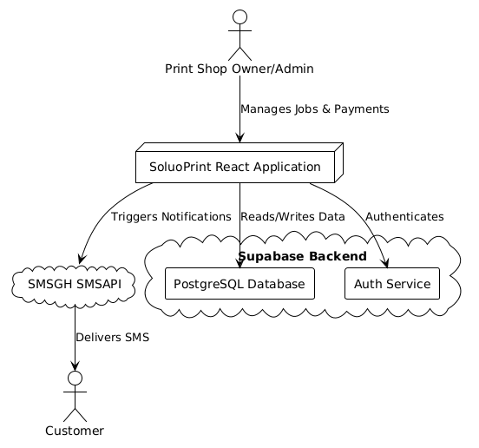

4.2 Use Case Diagram
The following diagram highlights the primary use cases available to an authenticated user.
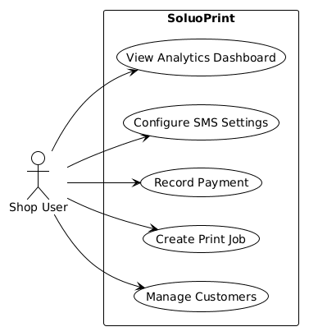

4.3 Entity Relationship Diagram
The core data model for the application, mapping relationships between companies, profiles, customers, jobs, and payments.
