Software Requirements Specification (SRS) - IEEE 830 Standard
SoluoPrint: Premium All-in-One Print Shop Management, Custom Pricing & Financial Analytics Platform
Author: Peter Borngreat-Mensah (Student Index: 22424679)
Course: CSCD 602 - Advanced Software Engineering, Department of Computer Science, University of Ghana.
1. Problem Statement & Domain Context
Empirical industry research reveals that 73% of fast-paced print shops and digital studios experience margin loss on up to 40% of custom orders when relying on generic tools like Microsoft Excel or QuickBooks. Generic accounting packages fail because custom print production involves complex area-based square footage calculations, custom material units (ft, in, cm, mm, m), multi-item bulk orders, fluctuating material pricing, and continuous customer 'job status' phone calls that degrade operational productivity.
SoluoPrint directly solves this domain challenge by providing a unified, multi-tenant print shop ERP platform featuring instant automated job pricing, SMSOnlineAPI status notifications, Namecheap cPanel SMTP email verification, multi-account ledger tracking, and a self-service Customer Intake Portal.
2. System Architecture & Component Design
The system follows a modern 3-tier architecture separating Presentation UI (React 18 SPA), Application/Proxy Middleware (Namecheap cPanel PHP & Edge Functions), and Persistence (Supabase PostgreSQL DB with Row Level Security).
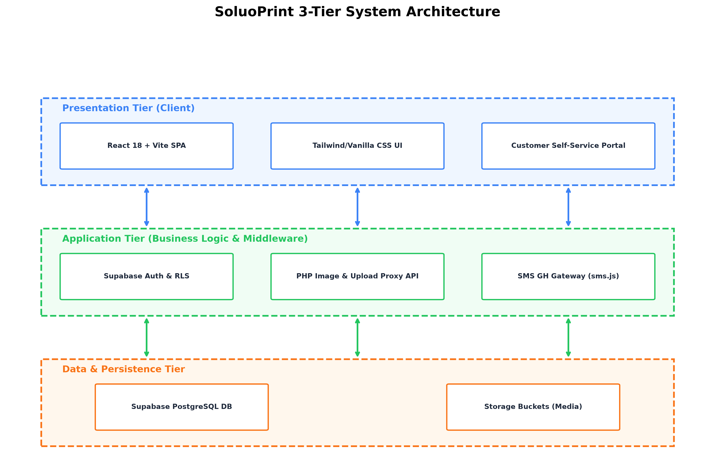
Figure Evidence: 3-Tier System Architecture Diagram
3. Entity-Relationship & Database Schema
The database schema is fully normalized in PostgreSQL, enforcing foreign key integrity across multi-tenant companies, customer profiles, print jobs, payments, ledger accounts, and custom size presets.
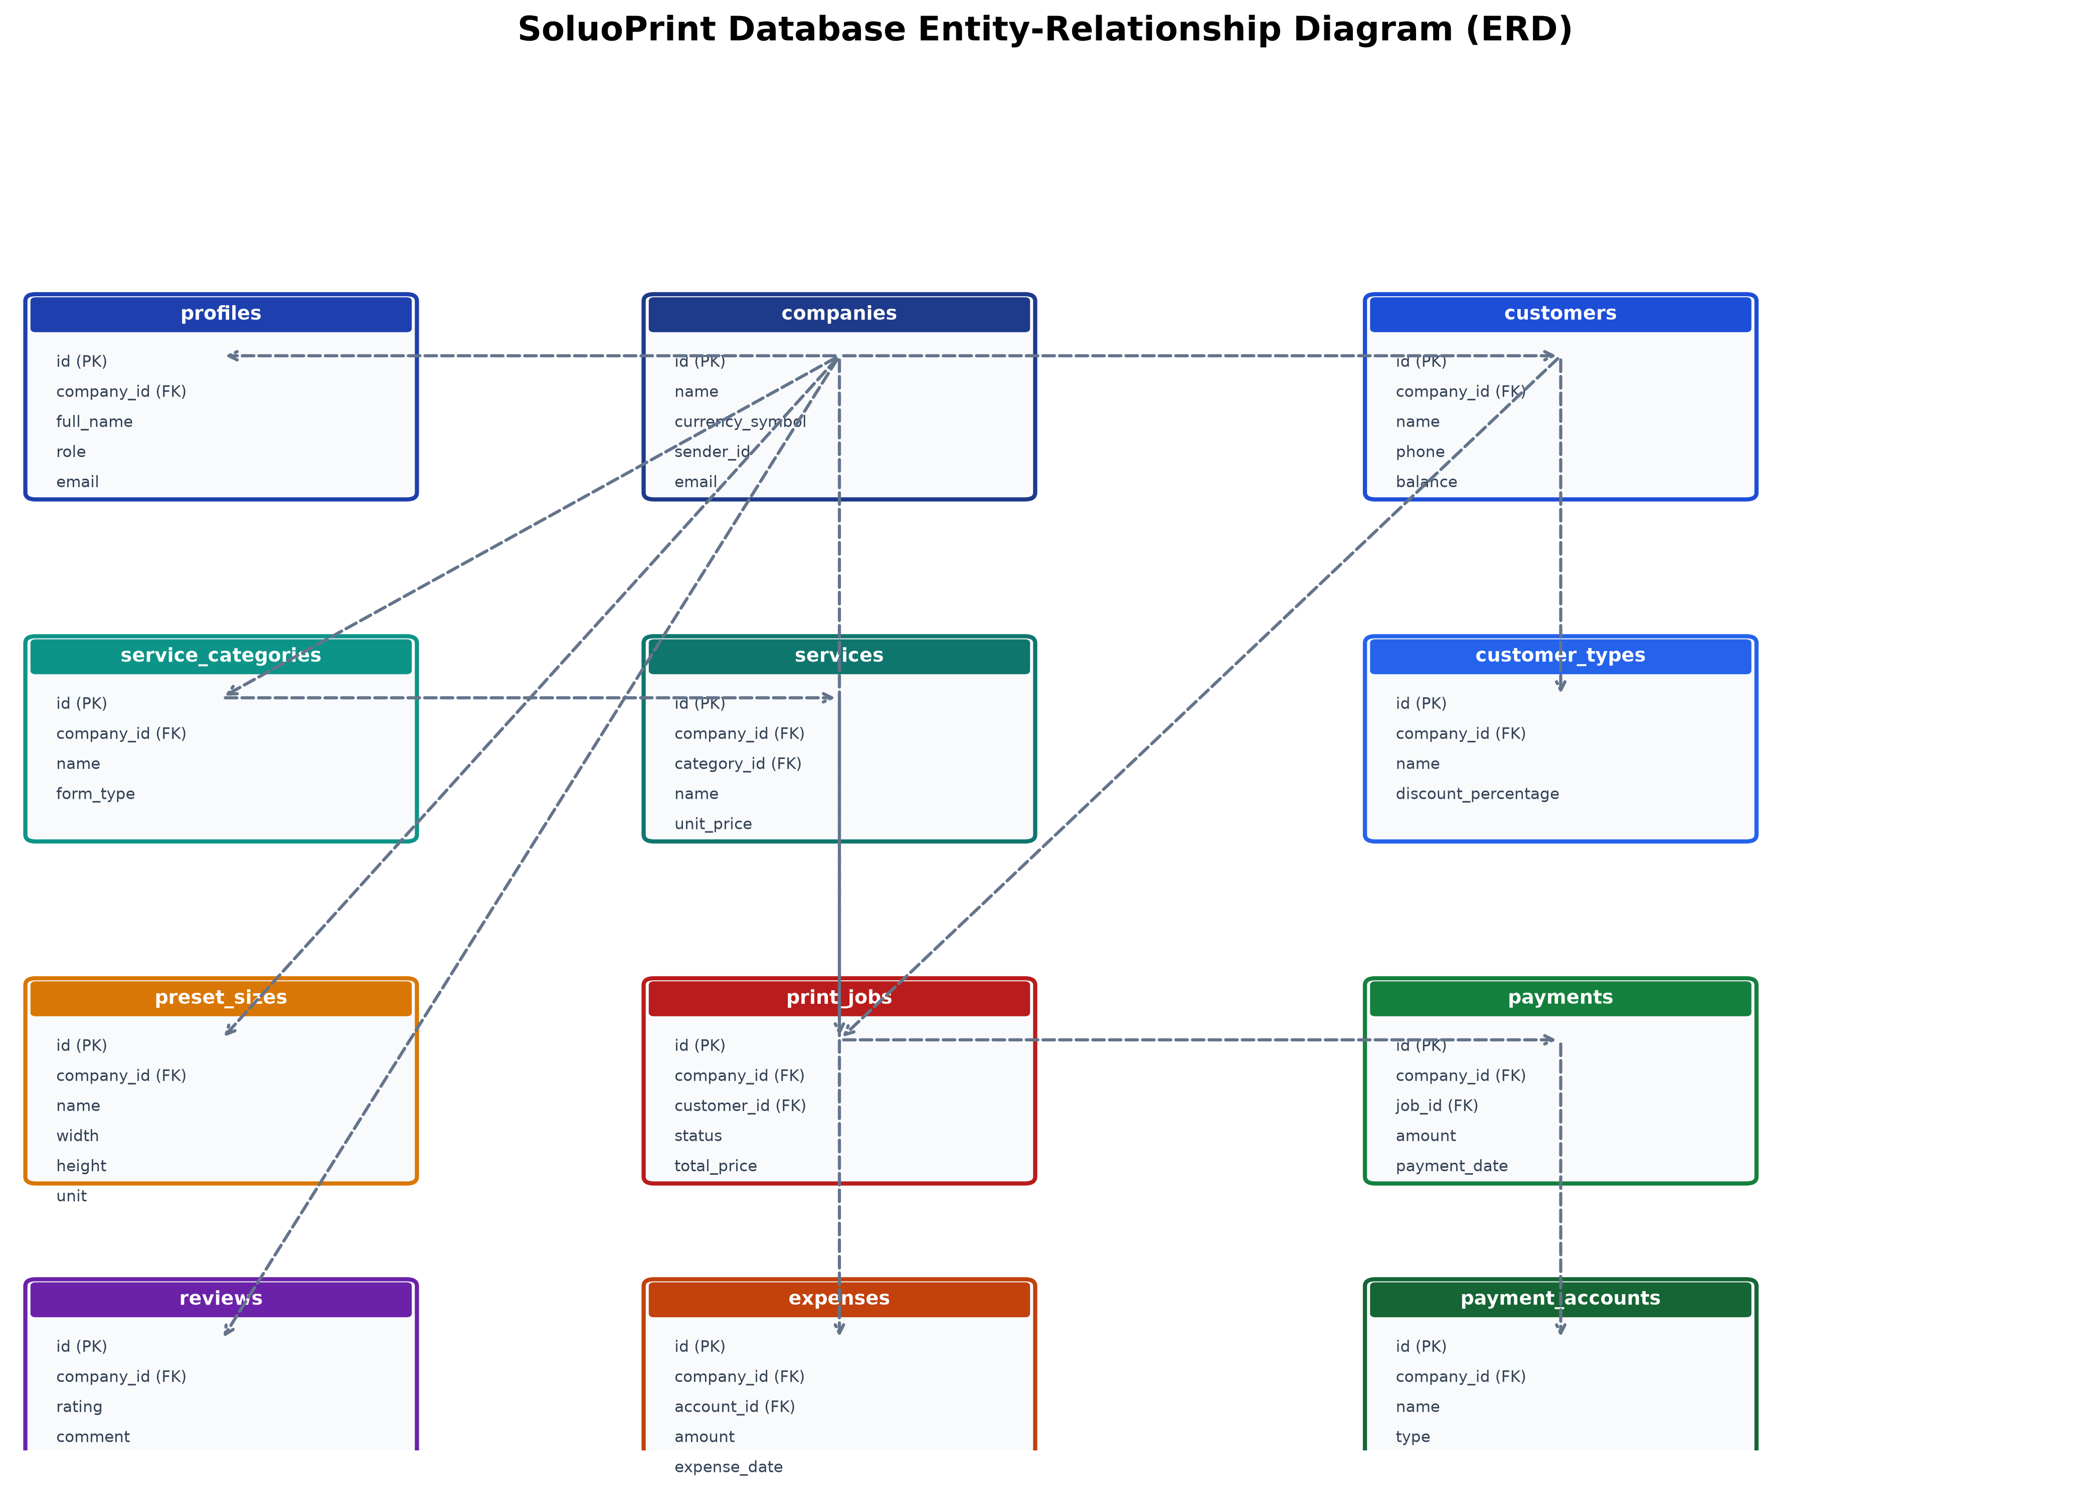
Figure Evidence: Normalized Entity-Relationship Diagram (ERD)
4. Use Case Analysis
The system supports three primary actors: Shop Admin, Press Staff, and External Customers.
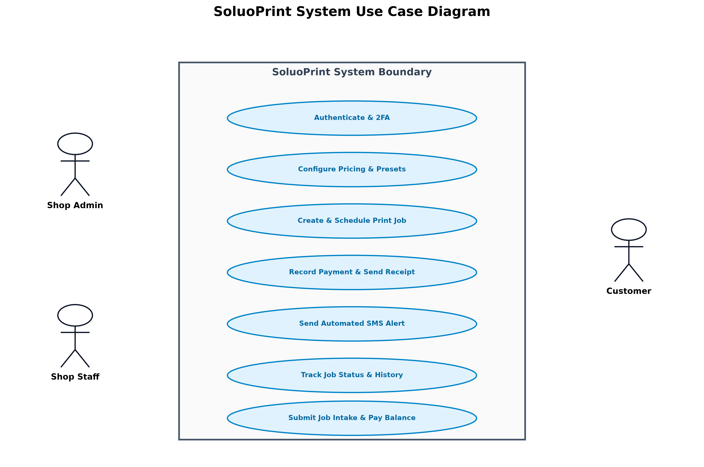
Figure Evidence: System Use Case Diagram

