The Communication between MGC3031 and Host is realized by I2C-Bus.

However, the MGC3031 provides two lines that are not implemented in the i2C Bus standard and are needed to use the sensor without restrictions.

The TRANSFER STATUS LINE TS is used by both, the I2C master and slave and is used to check if data is available or ready to be sent. With the TS the usage of the I2C-Bus can be reduced and is advantageous when several slaves are connected to the I2C-Bus. Used as bidirectional line the TS requires an open-drain connection!

In our Solution the TS is not used because we request every 10ms new data from the MGC3130 regardless of new data is available or not.

The second line that is provided by the MGC3031 is the MASTER CLEAR LINE MCLR. It is used by the I2C Master only and is especially needed to update the Firmware of the MGC3031. In our solution the MCLR is not used as we don’t require to update the firmware or to reset the MGC3031.

The MGC3031 has a lot of possibilities to track down movements, a lot of configuration options, provides error detection and it is possible to calibrate the Sensor.

To benefit from all these possibilities the message format and message order are predefined by the MGC3031.

Received and send messages have a similar format that consist of Header and Payload.

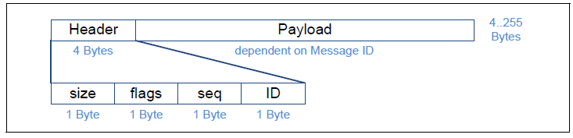

Figure 1

Header which contains the ID which shows what kind of message is to be received / transmitted and the Payload contains the information to be exchanged.

Our goal was to configuration the MGC3031 in a way, that it tracks the position of a finger and send only the xyz-coordinate of the tracked position.

To accomplish that the RUNTIME_PARAMETER of the MGC3031 has to be set accordingly.

Each time we send a SET_RUNTIME_PARAMETER message the MGC3031 response with a SYSTEM_STATUS message which includes an ErrorCode that indicates if the setting was successful. Each SYSTEM_STATUS messages is verified by the program. If one SYSTEM_STATUS Messages shows an Error the whole initialization is repeated.

After the MGC3031 is initialized the program calls the MGC3031 every 10ms. If there is an object within the range of the sensor the MGC3031 responses with a SENSOR_DATA_OUTPUT message which contains the xyz-coordinate. If there is no object within the range of the sensor the MGC3031 responses with a message which only contains zeros.

For more information about message format and initialization see appendix.