Switchgrav

# Game Design Document

## Pip Fox

Concept

# Genre

This game will be a simple single-screen puzzle platformer with many levels.

# Key features

This game is a completely normal platformer, except every few seconds, the gravity switches off. A few seconds later, it switches back on again. This means the player may need to time their jumps very carefully to reach far away or high up platforms, to make sure they can float there. To add slight difficulty and keep the player moving, there will be very basic enemies that walk back and forth on some platforms for the player to avoid.

# Platform / target hardware

The game will be made for PCs running Microsoft Windows.

# Setting

The game will be set in a space station setting, so that the gravity mechanic has some purpose for existing. The background will be a large window with a scrolling space background behind it. The platforms will be metallic space-age platforms.

# Art style

This game will have a pixel art style and 8 bit / chiptune sounds and music, to keep it simple.

Specification

# Mechanics

The player uses WASD to walk and space to jump. The gravity is on a timer that can be different for each level, but can never be influenced by the player. The player can only move when they are standing on a platform. When gravity is switched off, the player’s velocity is fixed until it switches back on again. The player’s only goal is to reach the end of each level. Enemies walk in a straight line until they reach the end of the platform, then they turn around and walk the other way. If the player finishes a level, their score goes up by one and they gain a life back. If the player falls below the edge of the screen, they will die. The level will reset and they will lose a life. If they run out of lives, the game is over.

# User Interface

There will be a bar in the top of the screen which slowly runs out. When the bar runs out, the gravity turns off. The bar will then fill up again, and when it is full gravity will switch back on. The word “GRAVITY” will be written below the bar in white. In the top right, there will be a score counter which increments every time the player finishes a level. In the top left will be a graphical counter for the player’s lives.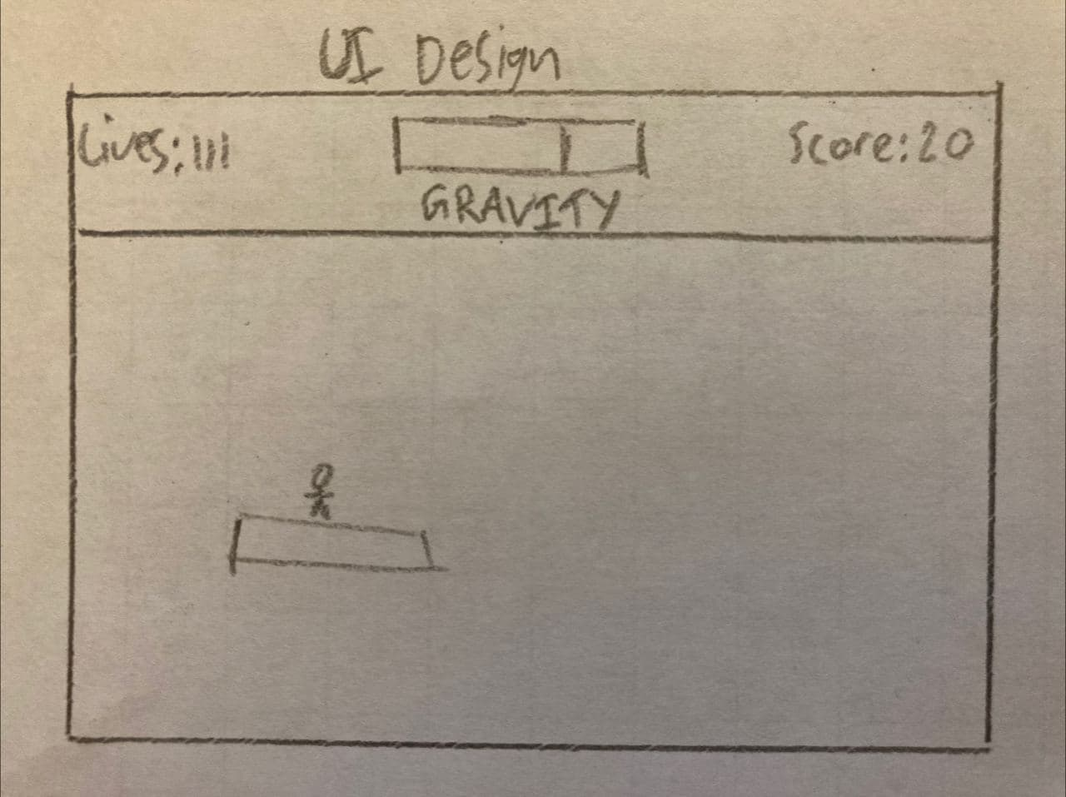

# Assets

Artwork will be pixel art drawn in GIMP by me, including animations, and they will be stored on sprite sheets. Sound effects and music will either be ones I already own, or downloaded from the internet (freesound for sound effects). 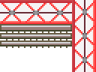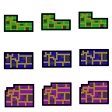

# Characters

The main character will be a tiny astronaut character, and the enemies will be tiny aliens who are even shorter than the character.