Extra Material with Special Component.

## scope.

Many special components can be used as extra material references associated with other components.

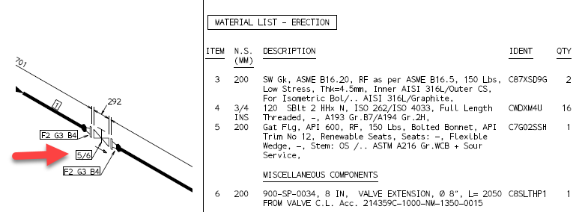

This works thanks to **MTOREF** (Extra material list spec references). MTOREF has to be filled with a **SPREF** (Specification Reference).

## how to find out a special component specification reference

We usually create component that are designed to be references as PCOMs. STYPE will show the SP TAG.

SP-PCOMS don't have geometric parts. But we can find them in the Model Explorer. Take the SPREF after deleting the PCOM.

Fill MTOREF with SPREF obtained in previous step.

