|  |  |  |
| --- | --- | --- |
|  |  |  |

|  |
| --- |
| **PIPING COMPONENTS REQUEST FOR AVEVA E3D** |

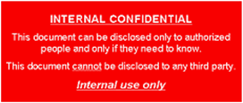

Pages modified in this revision:

|  |  |  |  |  |  |
| --- | --- | --- | --- | --- | --- |
|  |  |  |  |  |  |
|  |  |  |  |  |  |
|  |  |  |  |  |  |
|  |  |  |  |  |  |
|  |  |  |  |  |  |
|  |  |  |  |  |  |
| Rev | Date DD/MM/YYYY | OBJECT | WRITTEN BY | CHECKED BY | APPROVED BY |
| DOCUMENT REVISIONS | | | | | |
| Sections changed in this revision are identified with a vertical line in the margin | | | | | |

**REVISION MEMO**

|  |  |
| --- | --- |
| **Revision** | **SHORT DESCRIPTION** |
| 1 | 8. NOT WORKING COMPONENTS (NWC) |
|  |  |
|  |  |
|  |  |
|  |  |

**INDEX**

1. HOW TO IDENTIFY TYPES OF PIPING COMPONENTS. 5

2. SING IN PITREQUEST-V2 5

3. CREATE A NEW TICKET PITREQUEST-V2 6

3.1 SUBJET AND DESCRIPTION 6

3.2 INFORMATION ABOUT THE PROJECT 7

3.3 ATTACHMENTS 7

4. PIPING MATERIAL COMPONENTS (PMC) 7

5. SPECIAL PIECES (SP) 9

6. INSTUMENTS (INST) 9

6.1 GENERIC INSTRUMENTS 9

6.2 PSV 9

6.3 SPECIAL INSTRUMENTS 10

7. ATTACHMENT POINT ELEMENTS (ATTA) 10

8. not working components (NWC) 11

8.1 NOT WORKING COMPONENT GENERAL 11

8.2 NOT WORKING COMPONENT BOLT 12

APPENDIX 1: ALLOWED DATA TABLES 15

APPENDIX 2: GUIDELINES FOR TEXTS IN SMART PLATFORMS 16

**Table of Holds**

|  |  |  |
| --- | --- | --- |
| Hold Nº | Description | Page |
|  |  |  |
|  |  |  |
|  |  |  |
|  |  |  |
|  |  |  |
|  |  |  |

1. HOW TO IDENTIFY TYPES OF PIPING COMPONENTS.

|  |  |
| --- | --- |
| PMC: Piping Material Components | INST: Instruments |
| SP: Special Pieces | ATTA: Attachment Point Elements |

1. SING IN PITREQUEST-V2

Please, clip this link <http://es001vs0103/pitrequestv2> (or copy and paste in your favourite browser). In order to register you must follow this steps.

1. CREATE A NEW TICKET PITREQUEST-V2

When you are registered you will have access to the Request Dashboard. Create new ticket is easy, you only need to use the **+** button.

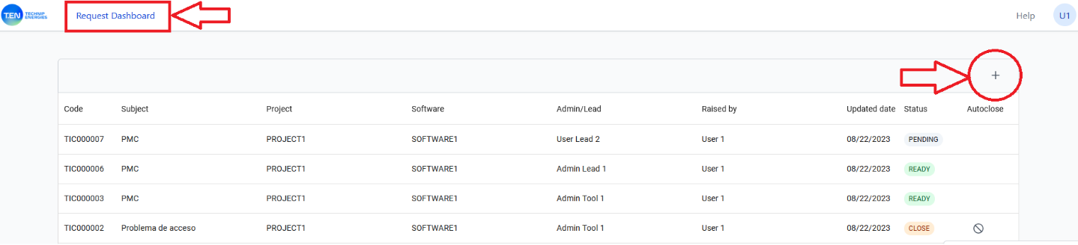

We can consider the New Ticket Form in three parts separately.

* 1. SUBJET AND DESCRIPTION

In general Ticket, You can write tha you consider better in Subject and Description.

But in order to create a useful Piping Component Request we need to:

1. Indicate the type of component that we need in the **SUBJECT**. Options are: PMC, SP, INST or ATTA
2. **DESCRIPTION**: We must indicate the corresponding information according this instruction.

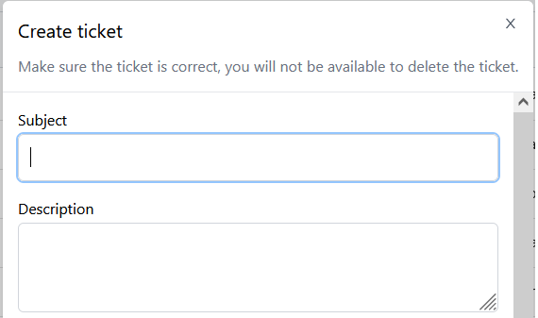

* 1. INFORMATION ABOUT THE PROJECT

We must indicate: project, software and the administrator that corresponds.

* 1. ATTACHMENTS

We can attach 3 files maximum, and size 2 mb.

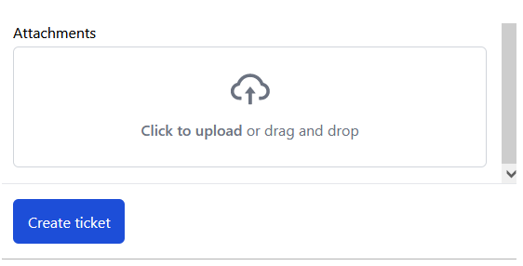

1. PIPING MATERIAL COMPONENTS (PMC)

First of all, we have to indicate in the Subject that we need a PMC

**Subject** : PMC

And It is also necessary to describe the PMC the following data:

**Description:** (Copy & Paste in the Ticket, complete the data)

A) Pipe Fitting . Flange , Gasket , Bolts :

Type of Component:

Piping Class:

Size1/Size2:

B) Valves and miscellaneous:

Type of Component:

Piping Class:

Size1/Size2:

PIDs:

Process Line:

Some examples:

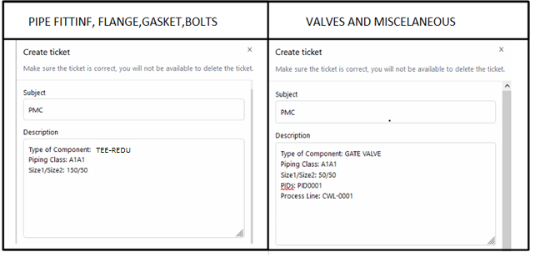

In any case, in a PMC ticket we must switch on the following button.

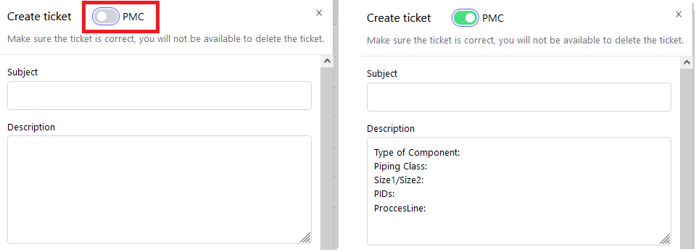

1. SPECIAL PIECES (SP)

Special Pieces are stored and managed within **CSPTracke**r application inside **3DTracker**

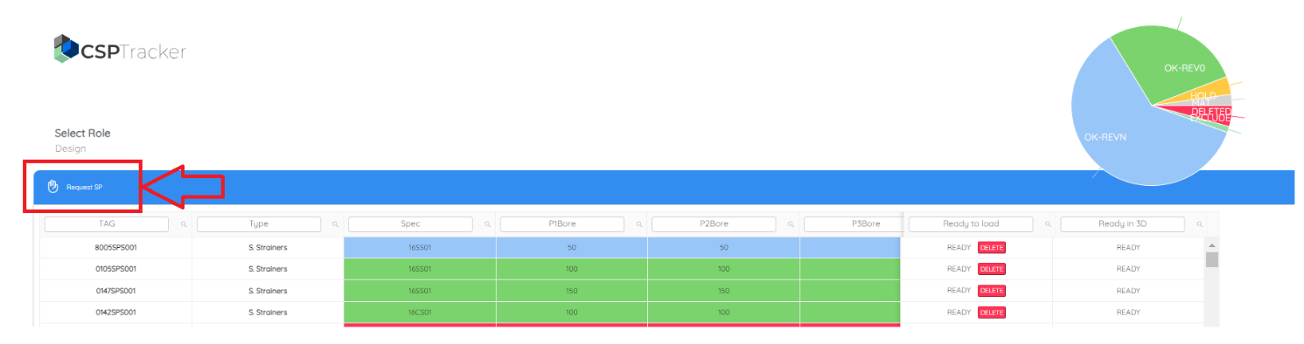

1. INSTUMENTS (INST)
   1. GENERIC INSTRUMENTS

**Subject** : INST

**Description:**

Type of Component: See Table 3 (copy & paste)

Piping Class:

From Size:

To Size:

End Preparation: See Table 1 (copy & paste)

Rating: See Table 2 (copy & paste)

BOLT TYPE: (Will be detailed by Material department)

* 1. PSV

**Subject** : INST

**Description:**

Type of Component: PSV

Tag:

Inlet: PipingClass-Diameter-Rating (e.g.: A1A1-DN25-PN16)

Outlet: PipingClass-Diameter-Rating (e.g.: A1A1-DN50-PN16)

Dimensions: H1: A: B:

BOLT TYPE: (Will be detailed by Material department)

**Attachment:**

A PSV Drawing is mandatory in order to calculate the length of bolts.

* 1. SPECIAL INSTRUMENTS

**Subject** : INST

**Description:**

Type of Component: Special Instrument

Tag:

Piping Class:

Size1/Size2:

**Attachment:**

A PSV Drawing is mandatory in order to define geometric dimensions.

1. ATTACHMENT POINT ELEMENTS (ATTA)

**Subject** : ATTA

**Description:**

Type of Component: See Table 4 (copy & paste)

Piping Class:

From Size:

To Size:

1. not working components (NWC)

This paragraph explains how to report components that you consider that it does not work properly.

**Subject** : NWC

**Description:**

For appropriate description of the NWC use the following buttons including in the Tab TPFMC-Piping, Group ‘Pitrequest’. Copy and paste the information from the command windows.

**Attachment:**

An Isometric Drawing (.pdf) would be useful.

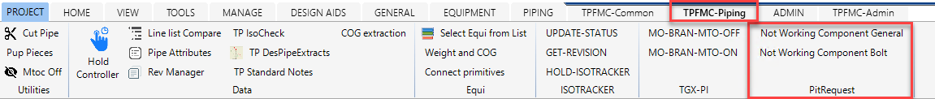

* 1. NOT WORKING COMPONENT GENERAL

Select the component that you consider that it does not work properly. Click the ‘Not Working Component General' button.

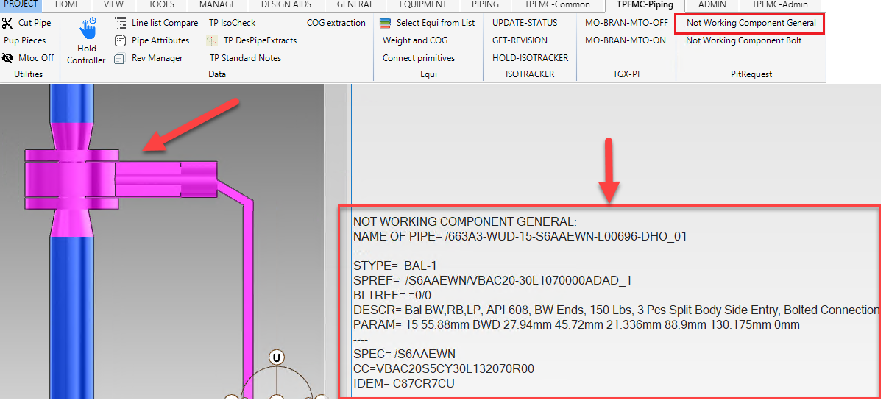

**Copy and paste** the information indicated in the command windows. PitRequest Ticket must have the following appearance:

Please include a short **description** of the problem.

Note that the PMC button must be **switch off**.

* 1. NOT WORKING COMPONENT BOLT

Select the first element of the **flanged connection**. From Head to Tail, first element will appear upper in the branch.

Copy and paste the information indicated in the command windows.

PitRequest Ticket must have the following appearance:

* 1. NOT WORKING COMPONENT DESCRIPTION.

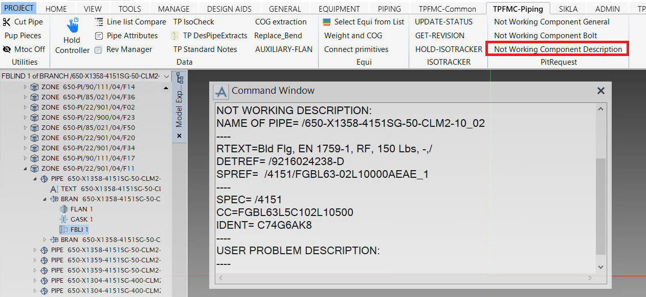

APPENDIX 1: ALLOWED DATA TABLES

|  |  |  |  |  |  |  |  |  |  |  |  |  |  |  |  |  |  |  |  |  |  |  |  |  |  |
| --- | --- | --- | --- | --- | --- | --- | --- | --- | --- | --- | --- | --- | --- | --- | --- | --- | --- | --- | --- | --- | --- | --- | --- | --- | --- |
| |  | | --- | | **TABLE 1: END PREPARATION** | | Buttweld End | | Flange FF | | Flange RF | | Lapped Joint | | Screwed Female | | Screwed Male | | Socket Weld Female | | Socket Weld Male (PE) | | Wafer Flange FF | | Wafer Flange RF | | NA | | |  | | --- | | **TABLE 2: RATING** | | ANSI 125lb | | ANSI 150lb | | ANSI 300lb | | DIN PN6 | | DIN PN10 | | DIN PN16 | | DIN PN25 | | DIN PN40 | | DIN PN63 | | DIN PN100 | | DIN PN160 | |
| | **TABLE 3: GENERIC INSTRUMENTS** | | --- | | Generic 3 Way Valve | | Generic Control Valve Diaphragm | | Generic Control Valve Pneumatic | | Generic Indicator | | Generic Indicator No Bolts | | Generic Instrument | | Generic Instrument Valve Diaphragm (CV) | | Generic Instrument Valve Pneumatic (On-Off) | | Generic On-Off Valve Pneumatic | | Generic Orifice Plate | | Generic Trasmiter | | |  | | --- | | **TABLE 4: TYPES OF ATTAS** | | ATTA | | General Purpose | | Support | | TienIn | |

APPENDIX 2: GUIDELINES FOR TEXTS IN SMART PLATFORMS

1. The following special character is not allowed in the data: **& # Ø Φ “ ! ^ ‘ + @ ? ~ | = $**
2. Do not insert a special character by using escape sequences such as Tabs: \t, Line Feed (New Line): \n, Carriage Return: \r.
3. If Ø or Φ are used to denote diameter use ‘dia’ after the value.
4. If # is used to denote pounds (pressure or weight) use lb, if # used to denote number use No or just enter the number (i.e., instead of Boiler #5 enter Boiler No. 5 or Boiler 5).
5. Do not enter superscripts or subscripts (i.e. 5ºC should be entered as 5C, m3 should be entered as cum).
6. Fractions are not permitted, use decimal values instead, see examples below:
   * 1/8 should be 0.125
   * ¼ should be 0.25
   * ½ should be 0.5
   * ¾ should be 0.75
   * 1-1/2 should be 1.5