## Indian Institute of Information Technology Surat



# Lab Report on

# Artificial Intelligence (CS 701) Practical

**Submitted by**

### [RAHUL KUMAR SINGH] (UI21CS44)

**Course Faculty**

### Dr. Ritesh Kumar

### Mrs. Archana Balmik

## Department of Computer Science and Engineering

## Indian Institute of Information Technology Surat

## Gujarat-394190, India

**Aug-2024**

## Lab No: 3

## Aim:

To diagnose childhood diseases based on given symptoms and to simulate a vacuum cleaner cleaning dirty tiles and measure performance in Prolog.

## Description:

(i) Write a PROLOG program for diagnosing childhood diseases. Diagnosis (disease, symptom)

(ii) Write a PROLOG program forVacuum-cleaner which takes a char array of 1's and 0's, 1 stating dirty and the 0 stating clean. Then the vacuum cleaner moves from left to right and cleans the dirty tiles. At the end of the sequence the program outputs the performance measure of the Vacuum-cleaner.

## Code:

**Q1**

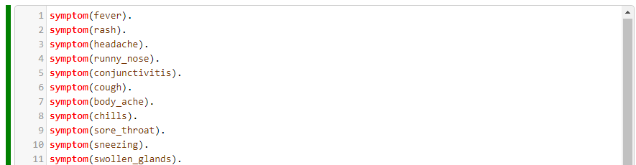

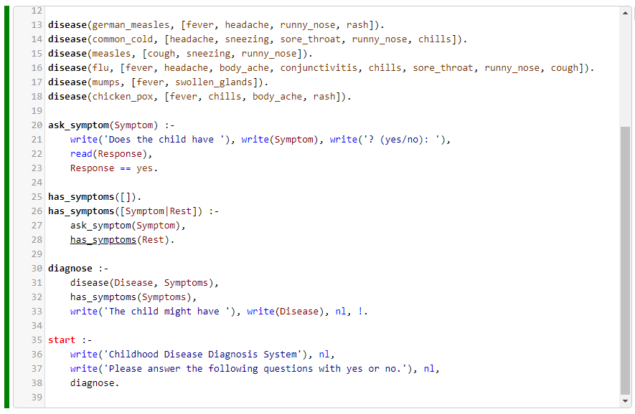

**Q2**

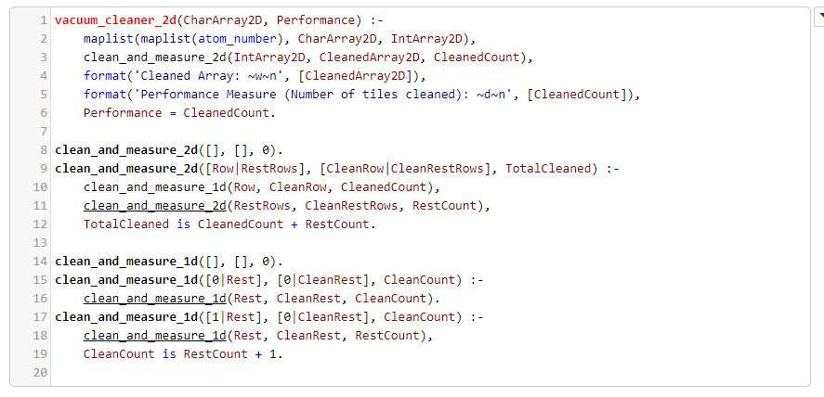

## Output:

**Q1**

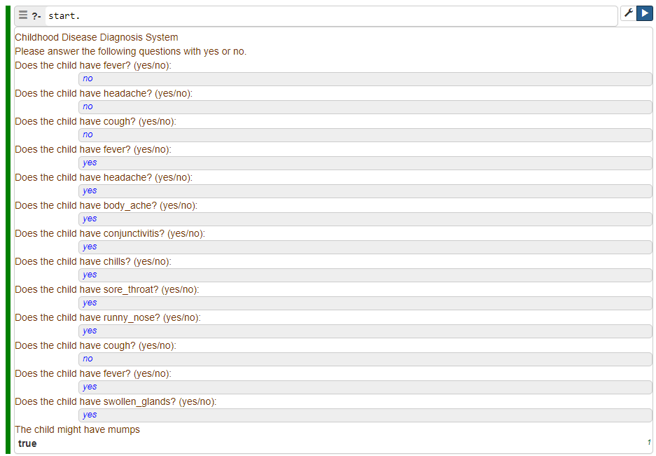

**Q2**

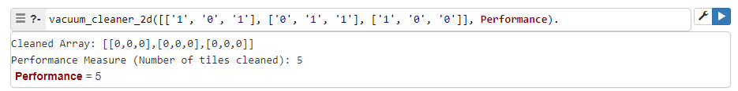

## Conclusion:

* **Accurate diagnosis**: Identifies diseases based on symptoms and provides disease information from symptom input.
* **Expandable**: Easily updatable with new data and simulates vacuum cleaner operations.