## Indian Institute of Information Technology Surat



# Lab Report on

# Artificial Intelligence (CS 701) Practical

**Submitted by**

### [RAHUL KUMAR SINGH] (UI21CS44)

**Course Faculty**

### Dr. Ritesh Kumar

### Mrs. Archana Balmik

## Department of Computer Science and Engineering

## Indian Institute of Information Technology Surat

## Gujarat-394190, India

**Aug-2024**

## Lab No: 1

## Aim:

To implement and test Prolog predicates for family relationships and develop basic mathematical functions in Prolog.

## Description:

Que 1. Implement the following.

Define a predicate brother(X,Y) which holds iff X and Y are brothers.

Define a predicate cousin(X,Y) which holds iff X and Y are cousins.

Define a predicate grandson(X,Y) which holds iff X is a grandson of Y.

Define a predicate descendent(X,Y) which holds iff X is a descendent of Y.

Consider the following genealogical tree:

father(a,b).

father(a,c).

father(b,d).

father(b,e).

father(c,f).

Say which answers, and in which order, are generated by your definitions for

the following queries

in Prolog:

?- brother(X,Y).

?- cousin(X,Y).

?- grandson(X,Y).

?- descendent(X,Y).

Que 2. Implement the following programs.

1) Implement Factorial and Fibonacci of given numbers.

2) Find maximum of 3 numbers

3) Find minimum of 3 numbers.

4) Check given number is even/odd.

5) Check given number is positive/negative

6) Calculate Pailindrom of given number.

## Code:

**Q1**

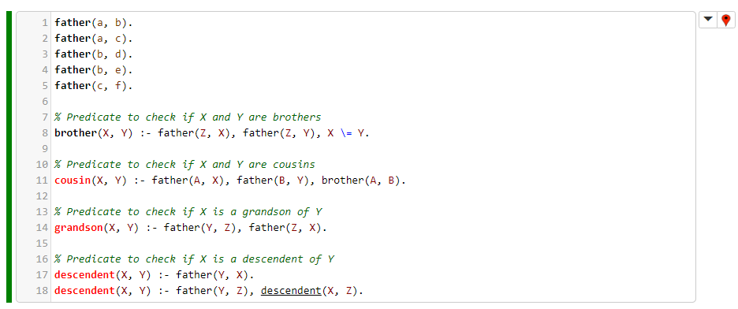

**Q2**

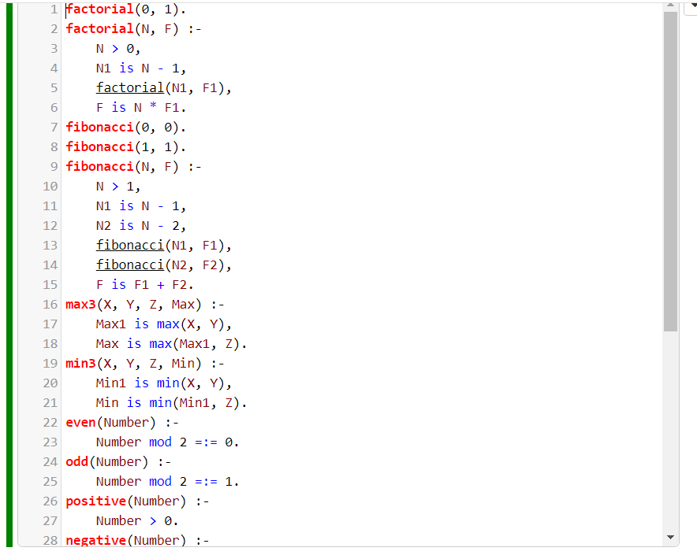

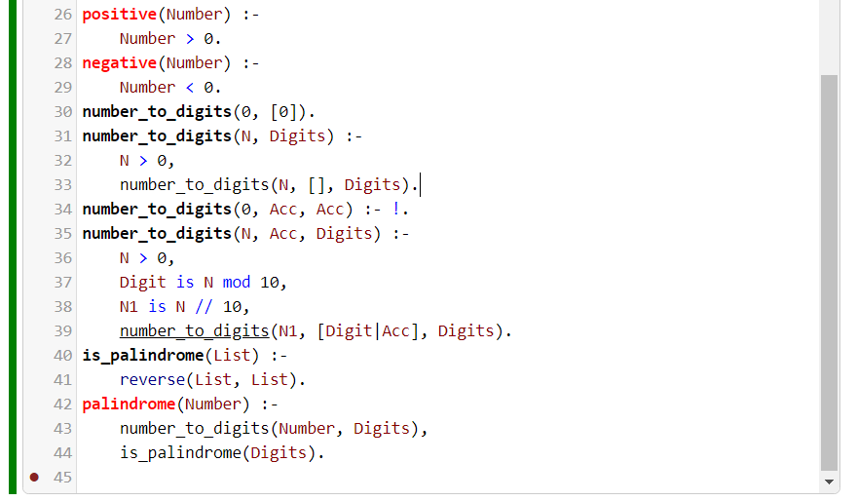

## Output:

**Q1**

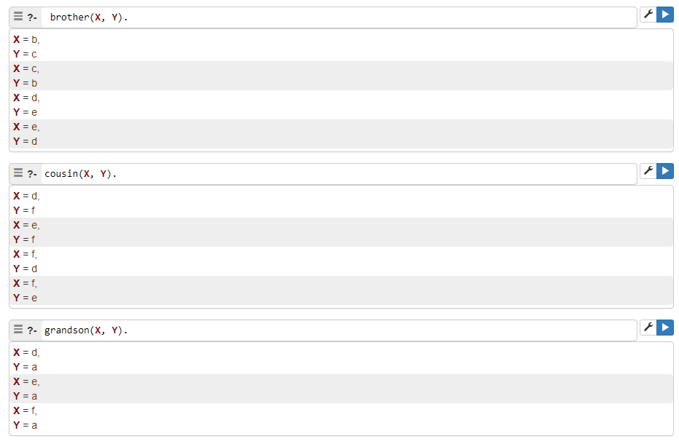

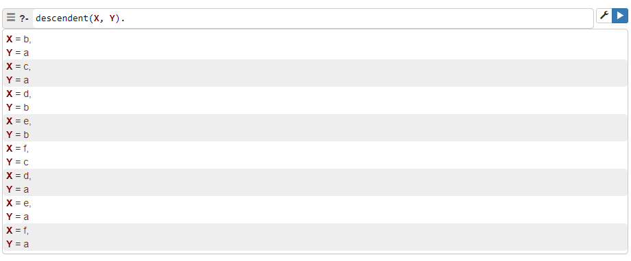

**Q2**

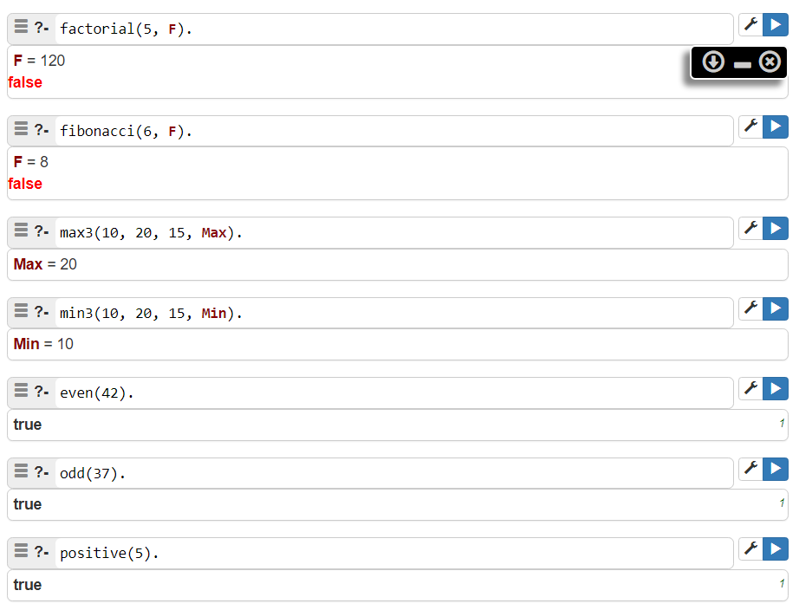

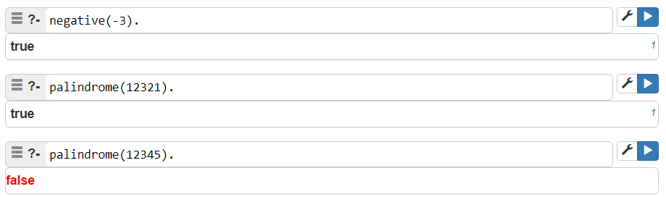

## Conclusion:

* Demonstrated queries for family relationships by defining relationships: brother, cousin, grandson, and descendant.
* Implemented factorial and Fibonacci functions, max/min of three numbers, checked even/odd and positive/negative, palindromes of numbers.