## Indian Institute of Information Technology Surat



# Lab Report on

# Natural Language Processing (CS 601) Practical

**Submitted by**

### [RAHUL KUMAR SINGH] (UI21CS44)

**Course Faculty**

### Mrs. Nidhi Desai

## Department of Computer Science and Engineering

## Indian Institute of Information Technology Surat

## Gujarat-394190, India

**Jan-2024**

## Lab No: 4

**Aim:**

To demonstrate the use of the Treebank and WordNet library in NLTK by performing sentence tagging and tokenization, and exploring the functions available in WordNet.

**Description:**

**Treebank:** A corpus of text annotated with syntactic structure, used for training and evaluating parsing models.

**WordNet:** A lexical database that groups words into synsets, providing semantic relations and definitions for computational linguistics.

**POS Tagging**: The sentence is tokenized and tagged using NLTK's *word_tokenize* and *pos_tag* functions.

**Functions Available in WordNet:**

* **synsets(word)**: Retrieves all synsets (senses) for a given word.
* **definition()**: Provides the definition of a specific synset.
* **lemmas()**: Returns the list of lemmas (base forms of a word) for a synset.
* **hypernyms()**: Shows general concepts related to the word.
* **hyponyms()**: Displays more specific categories related to the word.
* **part_meronyms()**: Retrieves parts of a concept.
* **member_holonyms()**: Finds collections to which a concept belongs.

### POS Tags:

* **Sentence**: The sentence as a tokenized string.
* **Noun**: Lists all nouns in the sentence (e.g., "cat", "mat").
* **Verb**: Lists all verbs in the sentence (e.g., "sat").
* **Adjective**: Lists all adjectives (e.g., "beautiful").
* **Adverb**: Lists all adverbs (e.g., "quickly").
* **Determiner**: Lists all determiners (e.g., "the").
* **Preposition**: Lists all prepositions (e.g., "on").
* **Pronoun**: Lists all pronouns (e.g., "he").
* **Conjunction**: Lists all conjunctions (e.g., "and"").
* **Modal**: Lists modal auxiliary verbs (e.g., "will").

### Output:

* **Treebank POS Tagging**: Lists the tokens along with their tags using the Treebank tagger.
* **WordNet-based Tagging**: Lists the tokens along with their WordNet-based POS tags.
* **Time Taken**: Displays the time taken by each approach.
* **Precision**: Compares the POS tagging accuracy between the two methods.

## Source Code:

**import nltk**

**from nltk.corpus import wordnet as wn**

**from nltk.tokenize import word_tokenize**

**from nltk import pos_tag**

**from time import time**

**nltk.download('treebank')**

**nltk.download('wordnet')**

**nltk.download('punkt')**

**nltk.download('averaged_perceptron_tagger')**

**nltk.download('omw-1.4')**

**pos_full_form = {**

**'CC': 'Coordinating conjunction', 'CD': 'Cardinal digit', 'DT': 'Determiner',**

**'EX': 'Existential there', 'FW': 'Foreign word', 'IN': 'Preposition/subordinating conjunction',**

**'JJ': 'Adjective', 'JJR': 'Adjective, comparative', 'JJS': 'Adjective, superlative',**

**'LS': 'List item marker', 'MD': 'Modal', 'NN': 'Noun, singular or mass', 'NNS': 'Noun, plural',**

**'NNP': 'Proper noun, singular', 'NNPS': 'Proper noun, plural', 'PDT': 'Predeterminer',**

**'POS': 'Possessive ending', 'PRP': 'Personal pronoun', 'PRP$': 'Possessive pronoun',**

**'RB': 'Adverb', 'RBR': 'Adverb, comparative', 'RBS': 'Adverb, superlative', 'RP': 'Particle',**

**'TO': 'To', 'UH': 'Interjection', 'VB': 'Verb, base form', 'VBD': 'Verb, past tense',**

**'VBG': 'Verb, gerund or present participle', 'VBN': 'Verb, past participle',**

**'VBP': 'Verb, non-3rd person singular present', 'VBZ': 'Verb, 3rd person singular present',**

**'WDT': 'Wh-determiner', 'WP': 'Wh-pronoun', 'WP$': 'Possessive wh-pronoun', 'WRB': 'Wh-adverb'**

**}**

**def wordnet_pos_code(tag):**

**if tag.startswith('J'):**

**return wn.ADJ**

**elif tag.startswith('V'):**

**return wn.VERB**

**elif tag.startswith('N'):**

**return wn.NOUN**

**elif tag.startswith('R'):**

**return wn.ADV**

**else:**

**return None**

**tokenization = tokenized_texts**

**total_treebank_time = 0**

**total_wordnet_time = 0**

**total_precision = 0**

**total_sentences = len(tokenization)**

**def get_pos_full_form(tag):**

**return pos_full_form.get(tag, "Unknown")**

**for tokens in tokenization:**

**print(f"\nProcessing sentence: {' '.join(tokens)}")**

**word = tokens[0]**

**synsets = wn.synsets(word)**

**print(f"\nSynsets of '{word}':")**

**for synset in synsets:**

**print(f"- {synset.name()}: {synset.definition()}")**

**print(f"\nLemmas of '{word}':")**

**for synset in synsets:**

**lemmas = synset.lemmas()**

**for lemma in lemmas:**

**print(f"- {lemma.name()}")**

**print(f"\nHypernyms of '{word}':")**

**for synset in synsets:**

**hypernyms = synset.hypernyms()**

**for hypernym in hypernyms:**

**print(f"- {synset.name()} -> {hypernym.name()}")**

**print(f"\nHyponyms of '{word}':")**

**for synset in synsets:**

**hyponyms = synset.hyponyms()**

**for hyponym in hyponyms:**

**print(f"- {synset.name()} -> {hyponym.name()}")**

**print(f"\nExample sentences for '{word}':")**

**for synset in synsets:**

**examples = synset.examples()**

**for example in examples:**

**print(f"- {synset.name()}: {example}")**

**# Treebank**

**start_treebank = time()**

**treebank_tags = pos_tag(tokens)**

**end_treebank = time()**

**print("Treebank POS tagging results:")**

**for token, tag in treebank_tags:**

**print(f'{token} -> {tag} ({get_pos_full_form(tag)})')**

**# WordNet**

**start_wordnet = time()**

**wordnet_tags = []**

**for token, tag in treebank_tags:**

**wn_tag = wordnet_pos_code(tag)**

**if wn_tag:**

**synsets = wn.synsets(token, wn_tag)**

**if synsets:**

**wn_tagged = synsets[0].pos()**

**else:**

**wn_tagged = "unknown"**

**else:**

**wn_tagged = "unknown"**

**wordnet_tags.append((token, wn_tagged))**

**end_wordnet = time()**

**print("\nWordNet-based tagging results:")**

**for token, tag in wordnet_tags:**

**print(f'{token} -> {tag}')**

**treebank_time = end_treebank - start_treebank**

**wordnet_time = end_wordnet - start_wordnet**

**total_treebank_time += treebank_time**

**total_wordnet_time += wordnet_time**

**correct_matches = sum(1 for t1, t2 in zip(treebank_tags, wordnet_tags) if t1[1].startswith(t2[1].upper()))**

**precision = correct_matches / len(treebank_tags)**

**total_precision += precision**

**avg_precision = total_precision / total_sentences**

**avg_treebank_time = total_treebank_time / total_sentences**

**avg_wordnet_time = total_wordnet_time / total_sentences**

**print(f"\nOverall average time for Treebank POS tagging: {avg_treebank_time:.6f} seconds")**

**print(f"Overall average time for WordNet-based tagging: {avg_wordnet_time:.6f} seconds")**

**print(f"Overall precision (accuracy): {avg_precision:.2f}")**

## Output:

**Wordnet library functions**

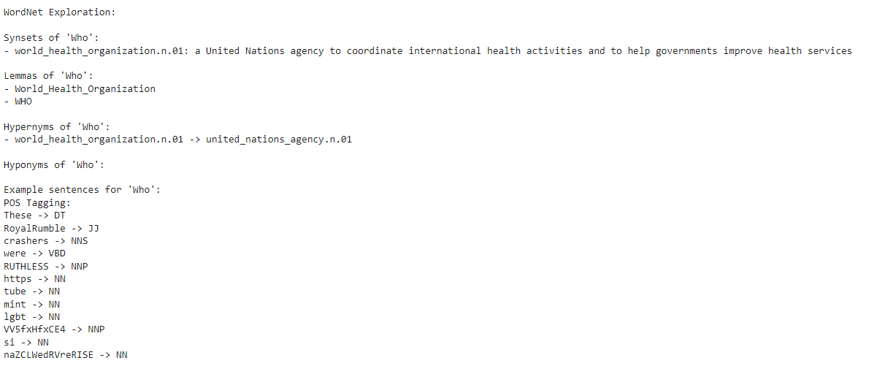

**POS Tagging**

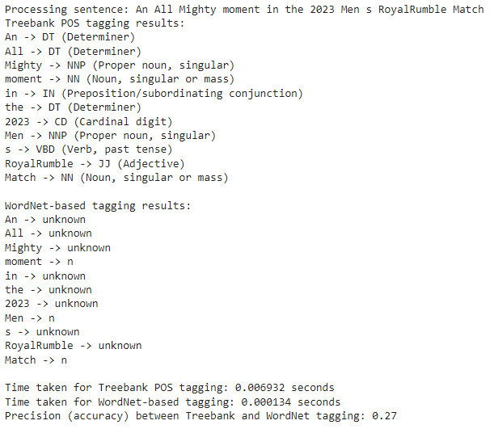

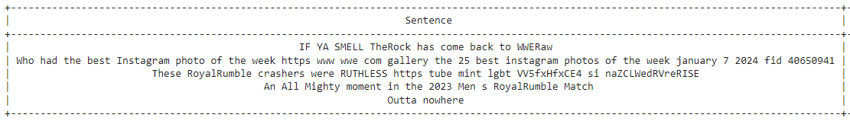

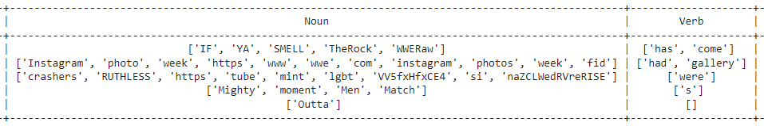

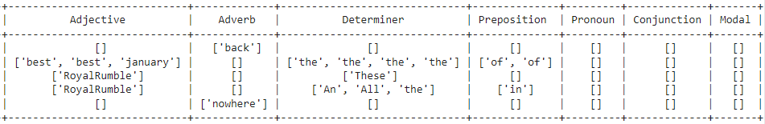

## Conclusion:

* Utilizes NLTK for tagging parts of speech in tokenized sentences.
* Maps POS tags to categories like Noun, Verb, and Adjective, Determiner, Preposition, Pronoun, Conjunction, and Modal.
* Measures and compares the time taken for Treebank and WordNet tagging.
* Provides a structured way to analyze and visualize POS tagging results.