## Indian Institute of Information Technology Surat



# Lab Report on

# Natural Language Processing (CS 601) Practical

**Submitted by**

### [RAHUL KUMAR SINGH] (UI21CS44)

**Course Faculty**

### Mrs. Nidhi Desai

## Department of Computer Science and Engineering

## Indian Institute of Information Technology Surat

## Gujarat-394190, India

**Jan-2024**

## Lab No: 5

**Aim:**

Perform n-gram operations on the dataset.For eg unigram, bi-gram and tri-gram. Analyze the outcomes of different n-gram and perform comparative Analysis.

**Description:**

* Objective: Perform n-gram operations (uni-gram, bi-gram, tri-gram) on text datasets and compare their outcomes.
* N-gram Extraction: Convert text into n-gram formats using TF-IDF vectorization.
* Datasets: Utilize NLTK datasets like Movie Reviews, Reuters Corpus, Twitter Samples, Product Reviews, Names Dataset, and Web Text Corpus.
* Comparative Analysis: Analyze and compare the accuracy, precision, recall, and F1-score of each n-gram model.
* Classification Task: Apply Logistic Regression for text classification.
* Outcome: Determine the optimal n-gram configuration based on dataset and classification task.

## Source Code:

import nltk

from nltk.corpus import reuters, twitter_samples, product_reviews_1, names, webtext

from sklearn.feature_extraction.text import TfidfVectorizer

from sklearn.model_selection import train_test_split

from sklearn.linear_model import LogisticRegression

from sklearn.metrics import accuracy_score, precision_score, recall_score, f1_score

import pandas as pd

nltk.download('movie_reviews')

nltk.download('twitter_samples')

nltk.download('names')

def prepare_movie_reviews():

documents = [(list(movie_reviews.words(fileid)), category)

for category in movie_reviews.categories()

for fileid in movie_reviews.fileids(category)]

reviews = [' '.join(doc) for doc, _ in documents]

labels = [1 if label == 'pos' else 0 for _, label in documents]

return reviews, labels

def prepare_twitter_samples():

positive_tweets = twitter_samples.strings('positive_tweets.json')

negative_tweets = twitter_samples.strings('negative_tweets.json')

reviews = positive_tweets + negative_tweets

labels = [1] * len(positive_tweets) + [0] * len(negative_tweets)

return reviews, labels

datasets = [

('Movie Reviews', prepare_movie_reviews),

('Twitter Samples', prepare_twitter_samples),

]

def evaluate_model(ngram_range, ngram_type, X_train, X_test, y_train, y_test):

vectorizer = TfidfVectorizer(ngram_range=ngram_range)

X_train_vec = vectorizer.fit_transform(X_train)

X_test_vec = vectorizer.transform(X_test)

clf = LogisticRegression(max_iter=1000)

clf.fit(X_train_vec, y_train)

y_pred = clf.predict(X_test_vec)

accuracy = accuracy_score(y_test, y_pred)

precision = precision_score(y_test, y_pred, average='weighted')

recall = recall_score(y_test, y_pred, average='weighted')

f1 = f1_score(y_test, y_pred, average='weighted')

return {

'ngram_type': ngram_type,

'accuracy': accuracy,

'precision': precision,

'recall': recall,

'f1_score': f1

}

for dataset_name, dataset_fn in datasets:

print(f"Evaluating on {dataset_name} dataset...")

reviews, labels = dataset_fn()

dataset_df = pd.DataFrame({'text': reviews, 'label': labels})

print(dataset_df.head())

X_train, X_test, y_train, y_test = train_test_split(reviews, labels, test_size=0.3, random_state=42)

results = []

results.append(evaluate_model((1, 1), 'Uni-grams', X_train, X_test, y_train, y_test))

results.append(evaluate_model((1, 2), 'Uni + Bi-grams', X_train, X_test, y_train, y_test))

results.append(evaluate_model((1, 3), 'Uni + Bi + Tri-grams', X_train, X_test, y_train, y_test))

print("Evaluation Metrics: ")

results_df = pd.DataFrame(results)

print(results_df)

## Output:

**n-gram:  
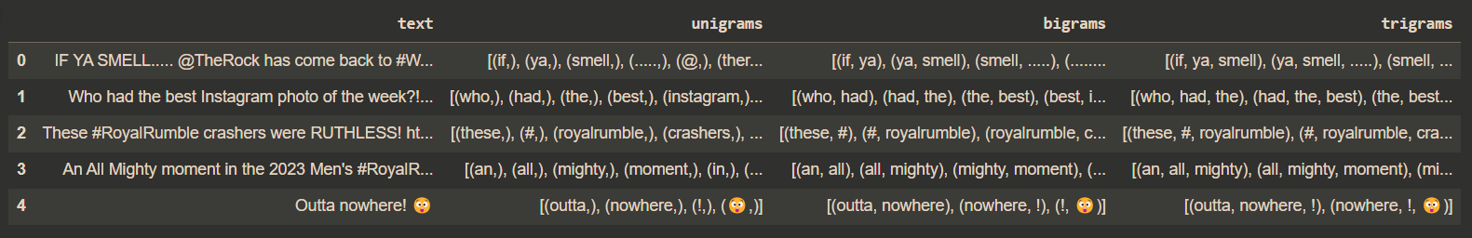**

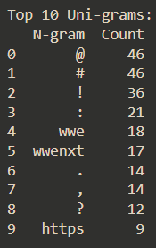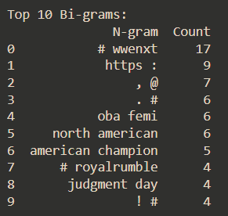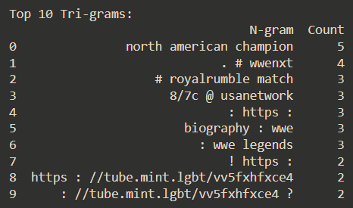

**Comparative Analysis on WWE Twitter Dataset:  
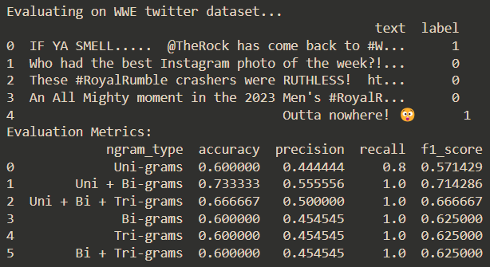**

**Comparative Analysis on Movie Reviews Dataset:**

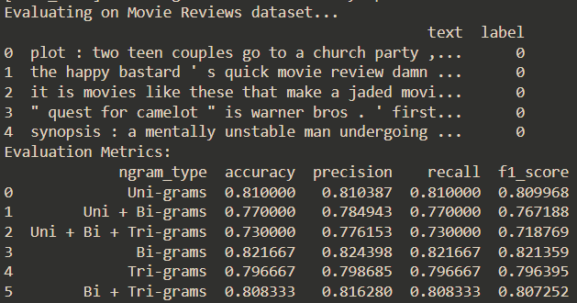

**Comparative Analysis on Twitter Samples Dataset:**

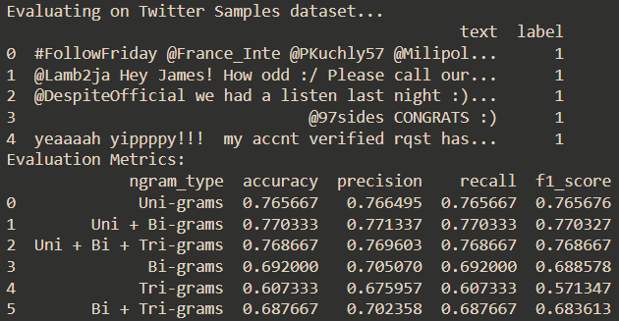

## Conclusion:

* WWE Twitter Dataset: (Uni + Bi) n-grams yield optimal performance.
* Movie Reviews Dataset: Bi-grams provide the best results.
* Twitter Samples Dataset: (Uni + Bi) n-grams achieve top accuracy.
* Performance varies across datasets making it essential to optimize n-grams.