## Indian Institute of Information Technology Surat



# Lab Report on

# Advanced Database Management (CS 604) Practical

**Submitted by**

### [RAHUL KUMAR SINGH] (UI21CS44)

**Course Faculty**

### Mr. Rishi Sharma

## Department of Computer Science and Engineering

## Indian Institute of Information Technology Surat

## Gujarat-394190, India

**Jan-2024**

## Lab No: 3

**Aim: Write a PL/SQL (MySQL Procedure) code block to perform specific tasks on tables Teacher, Class and Pay_scale.**

**Description:** Consider the following table to write PL/SQL code as specified under

* Teacher (t_no, f_name, l_name, salary, supervisor, joining_date, birth_date, title)
* Class (class_no, t_no, room_no)
* Pay_scale (Min_limit, Max_limit, grade)

1. Accept a range of salary and print the details of teachers from the teacher table.

2. By using cursor - Calculate the bonus amount to be given to a teacher depending on the following conditions:

a) if salary < 10000 then bonus is 10% of the salary.

b) if the salary is between 10000 and 20000 then bonus is 20% of the salary.

c) if the salary is between 20000 and 25000 then bonus is 25% of the salary.

d) if the salary exceeds 25000 then the bonus is 30% of the salary.

3. Using a simple LOOP structure, list the first 10 records of the ‘teachers’ table.

4. Accept the room number and display the teacher details like t_no, f_name, l_name, birth_date, title from table Teacher.

## Source Code:

**Teacher Table:**

CREATE TABLE Teacher (

t_no INT PRIMARY KEY,

f_name VARCHAR(50) NOT NULL,

l_name VARCHAR(50) NOT NULL,

salary DECIMAL(10, 2) NOT NULL,

supervisor INT,

joining_date DATE NOT NULL,

birth_date DATE NOT NULL,

title VARCHAR(50) NOT NULL

);

**Class Table:**

CREATE TABLE Class (

class_no INT PRIMARY KEY,

t_no INT,

room_no INT,

FOREIGN KEY (t_no) REFERENCES Teacher(t_no),

UNIQUE KEY unique_teacher_class (t_no, room_no)

);

**Pay_scale Table:**

CREATE TABLE Pay_scale (

Min_limit DECIMAL(10, 2) NOT NULL,

Max_limit DECIMAL(10, 2) NOT NULL,

grade VARCHAR(10) PRIMARY KEY

);

**Task 1:**

DELIMITER //

CREATE PROCEDURE GetTeachersBySalaryRange(

IN minSalary DECIMAL(10, 2),

IN maxSalary DECIMAL(10, 2)

)

BEGIN

SELECT *

FROM Teacher

WHERE salary BETWEEN minSalary AND maxSalary;

END //

DELIMITER ;

**Task 2:**

DELIMITER //

CREATE PROCEDURE CalculateTeacherBonus()

BEGIN

DECLARE done INT DEFAULT FALSE;

DECLARE t_no_var INT;

DECLARE salary_var DECIMAL(10, 2);

DECLARE bonus_var DECIMAL(10, 2);

DECLARE teacher_cursor CURSOR FOR

SELECT t_no, salary

FROM Teacher;

DECLARE CONTINUE HANDLER FOR NOT FOUND SET done = TRUE;

OPEN teacher_cursor;

teacher_loop: LOOP

FETCH teacher_cursor INTO t_no_var, salary_var;

IF done THEN

LEAVE teacher_loop;

END IF;

IF salary_var < 10000 THEN

SET bonus_var = salary_var * 0.10;

ELSEIF salary_var BETWEEN 10000 AND 20000 THEN

SET bonus_var = salary_var * 0.20;

ELSEIF salary_var BETWEEN 20000 AND 25000 THEN

SET bonus_var = salary_var * 0.25;

ELSE

SET bonus_var = salary_var * 0.30;

END IF;

SELECT t_no_var AS Teacher_ID, salary_var AS Salary, bonus_var AS Bonus;

END LOOP;

CLOSE teacher_cursor;

END //

DELIMITER ;

**Task 3:**

DELIMITER //

CREATE PROCEDURE ListFirst10Teachers()

BEGIN

DECLARE counter INT DEFAULT 0;

DECLARE t_no_var INT;

DECLARE f_name_var VARCHAR(50);

DECLARE l_name_var VARCHAR(50);

DECLARE salary_var DECIMAL(10, 2);

DECLARE supervisor_var INT;

DECLARE joining_date_var DATE;

DECLARE birth_date_var DATE;

DECLARE title_var VARCHAR(50);

DECLARE teacher_cursor CURSOR FOR

SELECT t_no, f_name, l_name, salary, supervisor, joining_date, birth_date, title

FROM Teacher;

OPEN teacher_cursor;

teacher_loop: LOOP

FETCH teacher_cursor INTO t_no_var, f_name_var, l_name_var, salary_var, supervisor_var, joining_date_var, birth_date_var, title_var;

IF counter >= 10 OR t_no_var IS NULL THEN

LEAVE teacher_loop;

END IF;

SET counter = counter + 1;

SELECT t_no_var AS Teacher_ID, f_name_var AS First_Name, l_name_var AS Last_Name, salary_var AS Salary,

supervisor_var AS Supervisor, joining_date_var AS Joining_Date, birth_date_var AS Birth_Date, title_var AS Title;

END LOOP;

CLOSE teacher_cursor;

END //

DELIMITER ;

**Task 4:**

DELIMITER //

CREATE PROCEDURE GetTeachersByRoomNumber(IN roomNumber INT)

BEGIN

SELECT t.t_no, t.f_name, t.l_name, t.birth_date, t.title

FROM Teacher t

JOIN Class c ON t.t_no = c.t_no

WHERE c.room_no = roomNumber;

END //

DELIMITER ;

## Output:

**Task 1:**

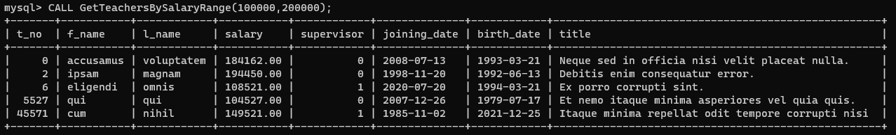

**Task 2:**

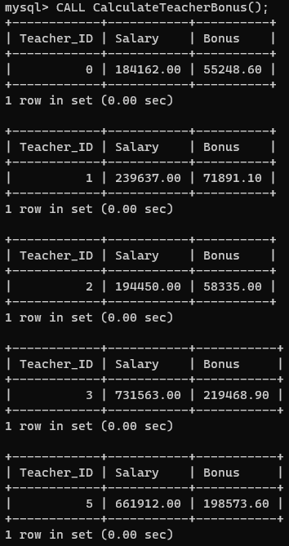

**Task 3:**

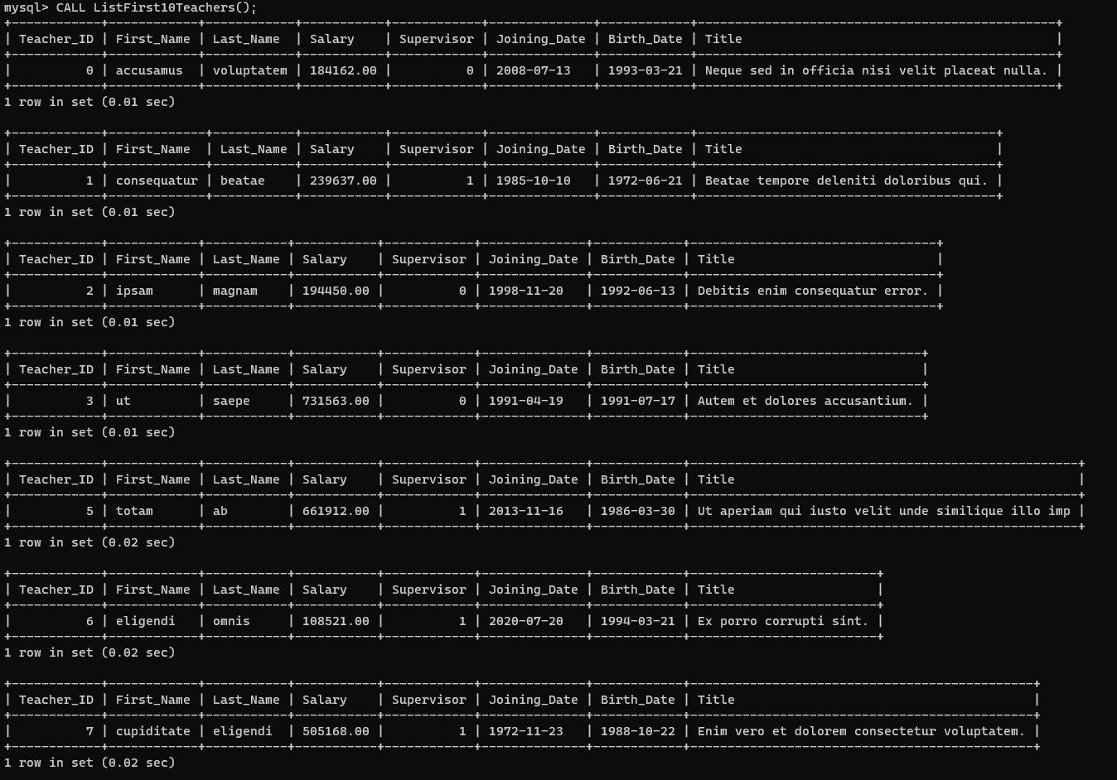

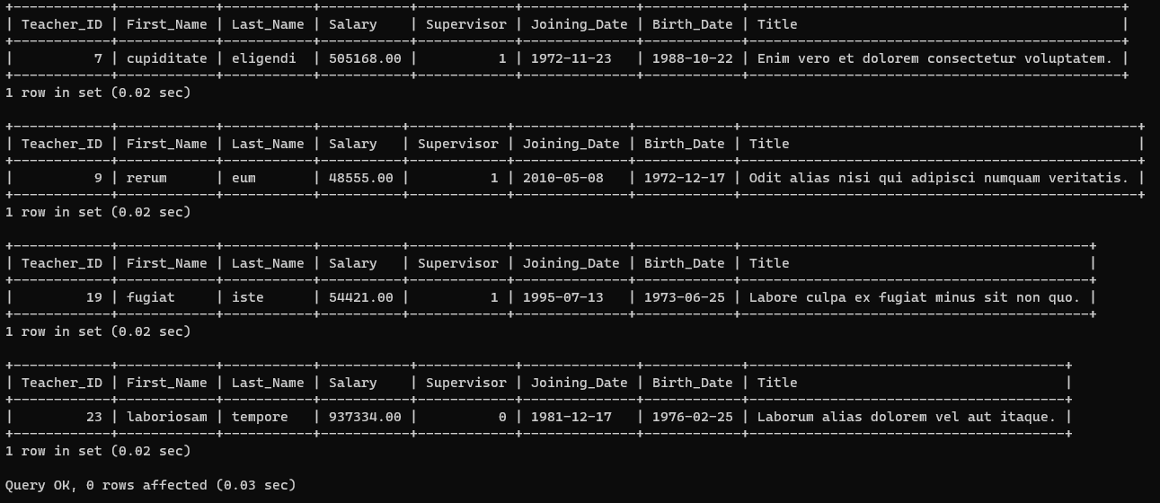

**Task 4:**

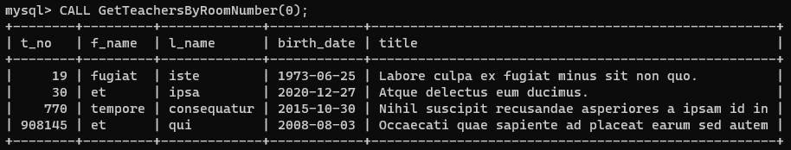

## Conclusion:

* GetTeachersBySalaryRange: Accepts a salary range and retrieves details of teachers from the Teacher table within that range.
* CalculateTeacherBonus: Uses a cursor to calculate the bonus amount for teachers based on salary conditions, considering different bonus percentages for specific salary ranges.
* ListFirst10Teachers: Utilizes a simple LOOP structure to list the first 10 records from the Teacher table.
* GetTeachersByRoomNumber: Accepts a room number and displays specific details (t_no, f_name, l_name, birth_date, title) of teachers associated with that room from the Teacher table.
* The code is structured in a modular manner using a MySQL Procedure block for better understanding.
* The code is designed for execution in interactive environments.
* Utilized DECLARE and BEGIN sections to define variables and execute procedural logic.
* Applied the DBMS_OUTPUT.PUT_LINE function for displaying output for all the procedures.

.