## Indian Institute of Information Technology Surat



# Lab Report on

# Advanced Database Management (CS 604) Practical

**Submitted by**

### [RAHUL KUMAR SINGH] (UI21CS44)

**Course Faculty**

### Mr. Rishi Sharma

## Department of Computer Science and Engineering

## Indian Institute of Information Technology Surat

## Gujarat-394190, India

**Jan-2024**

## Lab No: 7

**Aim: To Implement basic relational methods and statements using PostgreSQL.**

**Description:**

1. Write a PSQL statement to create a simple table countries including columns country_id,country_name and region_id.

2. Write a PSQL statement to create a simple table countries including columns country_id,country_name and region_id which already exist.

3. Write a PSQL statement to create the structure of a table dup_countries similar to countries.

4. Write a PSQL statement to create a duplicate copy of countries table including structure and data by name dup_countries.

5. Write a PSQL statement to create a table countries set a constraint NULL.

6. Write a PSQL statement to create a table named jobs including columns job_id, job_title, min_salary, max_salary and check whether the max_salary amount exceeding the upper limit 25000.

7. Write a PSQL statement to create a table named countries including columns country_id, country_name and region_id and make sure that no countries except Italy, India and China will be entered in the table.

8. Write a PSQL statement to create a table named countries including columns country_id,country_name and region_id and make sure that no duplicate data against column country_id will be allowed at the time of insertion.

9. Write a PSQL statement to create a table named jobs including columns job_id, job_title, min_salary and max_salary, and make sure that, the default value for job_title is blank and min_salary is 8000 and max_salary is NULL will be entered automatically at the time of insertion if no value assigned for the specified columns.

10. Write a PSQL statement to create a table named countries including columns country_id, country_name and region_id and make sure that the country_id column will be a key field which will not contain any duplicate data at the time of insertion.

11. Write a PSQL statement to create a table countries including columns country_id, country_name and region_id and make sure that the column country_id will be unique and store an auto-incremented value.

Click me to see the solution

12. Write a PSQL statement to create a table countries including columns country_id, country_name and region_id and make sure that the combination of columns country_id and region_id will be unique.

## Source Code & Output:

**Task 1:**

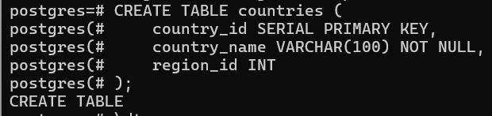

**Task 2:**

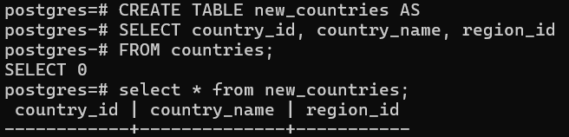

**Task 3:**

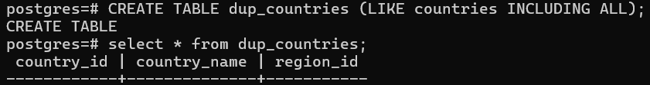

**Task 4:**

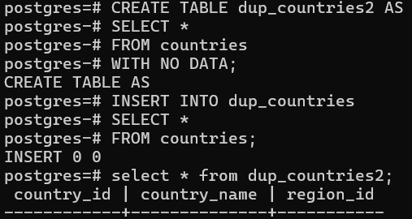

**Task 5:**

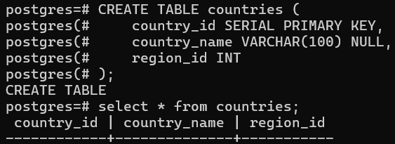

**Task 6:**

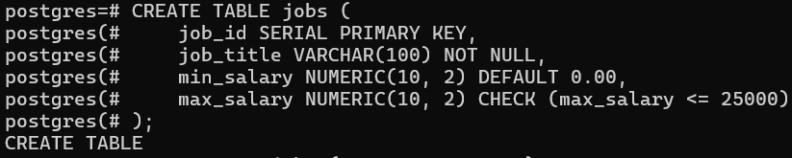



**Task 7:**

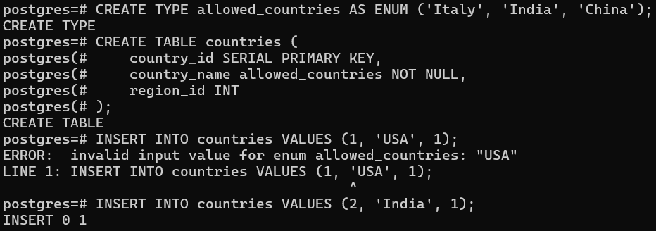

**Task 8:**

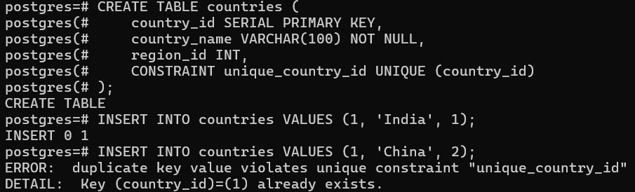

**Task 9:**

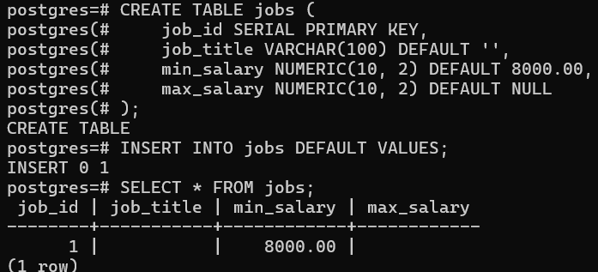

**Task 10:**



**Task 11:**

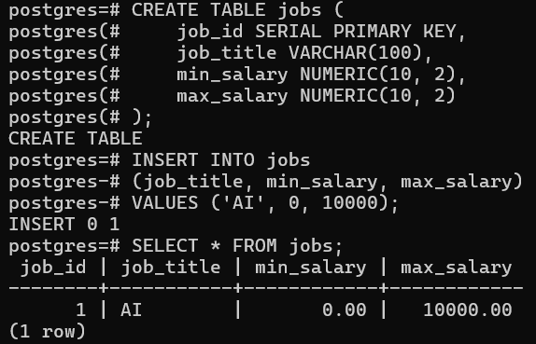

**Task 12:**

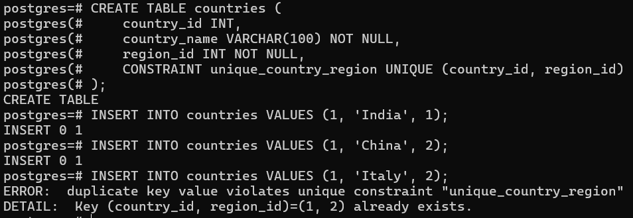

## Conclusion:

* PSQL is PostgreSQL command-line interface for database management.
* Similarity to MySQL language in terms of both statements and structures.
* SERIAL in place of AUTO_INCREMENT
* Doesn't have an explicit statement for displaying a list of table (but could be done by using command

**\dt**)