## Indian Institute of Information Technology Surat



# Lab Report on

# Advanced Database Management (CS 604) Practical

**Submitted by**

### [RAHUL KUMAR SINGH] (UI21CS44)

**Course Faculty**

### Mr. Rishi Sharma

## Department of Computer Science and Engineering

## Indian Institute of Information Technology Surat

## Gujarat-394190, India

**Jan-2024**

## Lab No: 6

**Aim: To Implement Object Oriented Approach for writing PL/SQL codes (MySQL)**

**Description:**

1. Write a PL/SQL code to create a class for a "Person" with attributes such as name, age, and address.
2. Write a PL/SQL code to Implement methods in the "Person" class to display the details and update the age.
3. Write a PL/SQL code to implement a method to calculate the annual bonus based on the salary in the "Employee" class.
4. Write a PL/SQL code to create a "Manager" subclass inheriting from the "Employee" class, and add an attribute to store the number of employees managed.

## Source Code:

**A) Implementing a "Person" class:**

Drop TABLE Person;

CREATE TABLE Person (

objectId VARCHAR(100) PRIMARY KEY,

name VARCHAR(100),

age INT,

address VARCHAR(200)

);

-- Dropping Procedures

DROP PROCEDURE DisplayDetails;

DROP PROCEDURE UpdateAge;

DROP PROCEDURE AppendPerson;

**B) Implementing methods to create object, display details and update age:**

DELIMITER //

CREATE PROCEDURE DisplayDetails(IN object_id VARCHAR(100))

BEGIN

SELECT name, age, address FROM Person WHERE objectId = object_id;

END //

CREATE PROCEDURE UpdateAge(IN object_id VARCHAR(100), IN new_age INT)

BEGIN

UPDATE Person SET age = new_age WHERE objectId = object_id;

END //

CREATE PROCEDURE AppendPerson(IN object_id VARCHAR(100), IN person_name VARCHAR(100), IN new_age INT, IN person_address VARCHAR(100))

BEGIN

INSERT INTO Person values (object_id, person_name, new_age, person_address);

END //

DELIMITER ;

-- Calling Procedures:

CALL AppendPerson("person1", "Rahul Kumar Singh", 20, "Raigarh");

CALL DisplayDetails("person1");

CALL UpdateAge("person1", 21);

CALL DisplayDetails("person1");

**C) Implementing methods to create object, display details and calculate the annual bonus based on salary:**

-- Dropping Procedures

DROP PROCEDURE DisplayEmpDetails;

DROP PROCEDURE AppendEmployee;

DROP PROCEDURE CalculateAnnualBonus;

DELIMITER //

CREATE PROCEDURE DisplayEmpDetails(IN object_id VARCHAR(100))

BEGIN

SELECT * FROM Employee WHERE objectId = object_id;

END //

CREATE PROCEDURE AppendEmployee(IN object_id VARCHAR(100), IN person_name VARCHAR(100), IN new_age INT, IN person_address VARCHAR(100), IN salary DECIMAL(10,2))

BEGIN

INSERT INTO Employee values (object_id, person_name, new_age, person_address, salary);

END //

CREATE PROCEDURE CalculateAnnualBonus(IN object_id VARCHAR(100))

BEGIN

SELECT salary * 0.1 FROM Employee WHERE objectId = object_id; -- 10% bonus rate.

END //

DELIMITER ;

-- Calling Procedures

CALL CalculateAnnualBonus(4000);

**D) Implementing an "Employee" and "Manager" subclass:**

Drop TABLE Employee;

Drop TABLE Manager;

CREATE TABLE Employee (

objectId VARCHAR(100) PRIMARY KEY,

name VARCHAR(100),

age INT,

address VARCHAR(200),

salary DECIMAL(10,2)

);

CREATE TABLE Manager AS

SELECT * FROM Employee;

ALTER TABLE Manager

ADD num_employees_managed INT;

-- Dropping Procedures

DROP PROCEDURE DisplayManDetails;

DROP PROCEDURE CalculateManagerBonus;

DROP PROCEDURE AppendManager;

DELIMITER //

CREATE PROCEDURE DisplayManDetails(IN object_id VARCHAR(100))

BEGIN

SELECT * FROM Manager WHERE objectId = object_id;

END //

CREATE PROCEDURE AppendManager(IN object_id VARCHAR(100), IN person_name VARCHAR(100), IN new_age INT, IN person_address VARCHAR(100), IN salary DECIMAL(10,2), IN num_emp INT)

BEGIN

INSERT INTO Manager values (object_id, person_name, new_age, person_address, salary, num_emp);

END //

CREATE PROCEDURE CalculateManagerBonus(IN object_id VARCHAR(100))

BEGIN

SELECT salary * 0.15 + num_employees_managed * 1000 FROM Manager WHERE objectId = object_id; -- Bonus

END //

DELIMITER ;

-- Calling Procedures

CALL AppendManager("manager1", "Rahul Kumar Singh", 20, "Raigarh", 10000.00, 10);

CALL DisplayManDetails("manager1");

CALL CalculateManagerBonus("manager1");

## Output:

**A) Implementing a "Person" class:**

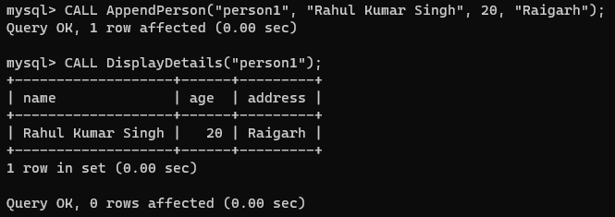

**B) Implementing methods to create object, display details and update age:**

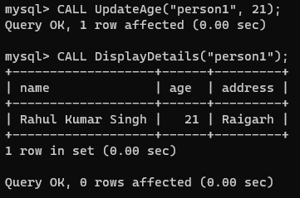

**C) Implementing methods to create object, display details and calculate the annual bonus based on salary:**

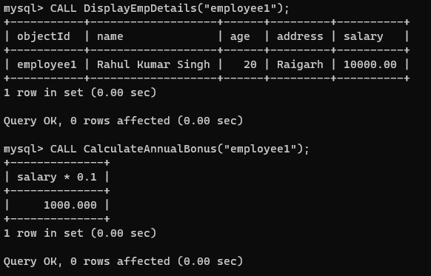

**D) Implementing an "Employee" and "Manager" subclass:**

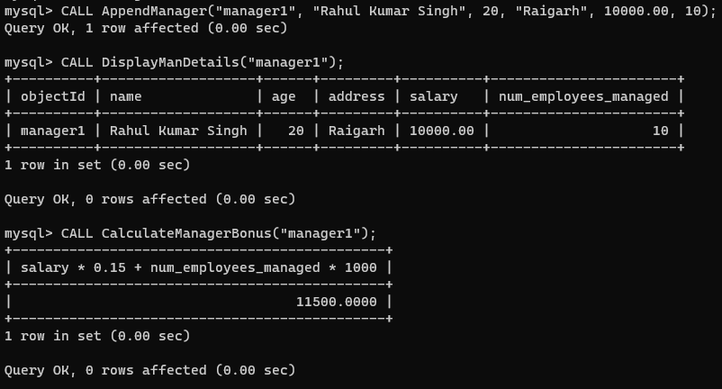

## Conclusion:

* Help us to understand the importance of object-oriented approach.
* Provide various features of object-oriented approach like Polymorphism, Inheritance and Encapsulation.
* To be able to implement the MySQL code into an Object-oriented programming model.