## Indian Institute of Information Technology Surat



# Lab Report on

# High Performance Computing (CS 602) Practical

**Submitted by**

### [RAHUL KUMAR SINGH] (UI21CS44)

**Course Faculty**

### Dr. Sachin D. Patil

## Department of Computer Science and Engineering

## Indian Institute of Information Technology Surat

## Gujarat-394190, India

**Jan-2024**

## Lab No: 1

**Aim: Write a parallel program in c, c++, java, or python to compute the dot product and cross product for N elements vector arrays a[N] and b[N].**

**Description:** Steps to follow:

* Divide the vectors into smaller chunks, assigning each chunk to a separate thread.
* Each thread independently computes the cross product for its assigned chunk.
* Leverage parallel processing to enhance overall computation speed.
* The cross product involves multiplying corresponding elements (when n < 4 apply the directional cross product).
* Sum all the products to obtain the dot product.

## Source Code:

import threading

import multiprocessing

import random

def generate_random_vector(n):

return [random.randint(1, 10) for _ in range(n)]

def compute_partial_dot_product(start, end, result, a, b):

partial_sum = 0

for i in range(start, end):

partial_sum += a[i] * b[i]

result.append(partial_sum)

def parallel_dot_product(a, b, num_threads):

n = len(a)

step = n // num_threads

result = []

threads = []

for i in range(num_threads):

start = i * step

end = (i + 1) * step if i < num_threads - 1 else n

thread = threading.Thread(target=compute_partial_dot_product, args=(start, end, result, a, b))

threads.append(thread)

thread.start()

for thread in threads:

thread.join()

dot_product = sum(result)

return dot_product

def compute_cross_product(start, end, a, b, result):

for i in range(start, end):

result[i] = a[i] * b[i]

def parallel_cross_product(a, b):

n = len(a)

result = multiprocessing.Array('d', n)

num_processes = multiprocessing.cpu_count()

chunk_size = n // num_processes

processes = []

for i in range(num_processes):

start = i * chunk_size

end = (i + 1) * chunk_size if i != num_processes - 1 else n

process = multiprocessing.Process(target=compute_cross_product, args=(start, end, a, b, result))

processes.append(process)

for process in processes:

process.start()

for process in processes:

process.join()

return list(result)

if __name__ == "__main__":

N = 10

a = generate_random_vector(N)

b = generate_random_vector(N)

print(f"Vector a: {a}")

print(f"Vector b: {b}")

num_threads = 2

result = parallel_cross_product(a, b)

print(f"Cross product: {result}")

result = parallel_dot_product(a, b, num_threads)

print(f"Dot Product: {result}")

## Output:

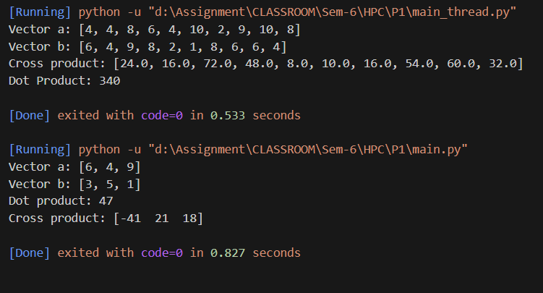

## Conclusion:

* Leveraging threads for both cross product and dot product computation enables parallel processing, optimizing performance for large N.
* Incorporating random inputs adds realism to the computational model, simulating scenarios with varied data distributions.