## Indian Institute of Information Technology Surat



# Lab Report on

# High Performance Computing (CS 602) Practical

**Submitted by**

### [RAHUL KUMAR SINGH] (UI21CS44)

**Course Faculty**

### Dr. Sachin D. Patil

## Department of Computer Science and Engineering

## Indian Institute of Information Technology Surat

## Gujarat-394190, India

**Jan-2024**

## Lab No: 2

**Aim: To run the sample program given for OpenMP and design the solution for assignment 1 for the sum of the dot product.**

**Description:** Important Directives of OpenMP:

* #pragma omp parallel: Begins a parallel region, where a block of code will be executed by multiple threads.
* #pragma omp for: Distributes the iterations of a loop among the available threads in a parallel region.
* #pragma omp critical: Defines a critical section, ensuring that only one thread at a time can execute the enclosed code.
* #pragma omp atomic: Specifies that a specific operation should be executed atomically, preventing race conditions.
* #pragma omp barrier: Synchronizes all threads at the barrier, ensuring that no thread proceeds beyond the barrier until all threads have reached it.
* #pragma omp threadprivate: Declares a variable to be private to each thread in a parallel region.
* #pragma omp reduction: Performs a reduction operation on a specified variable (result) across all threads.
* #pragma omp parallel num_threads(): Sets the number of threads to be used in a parallel region.

## Sample Program:

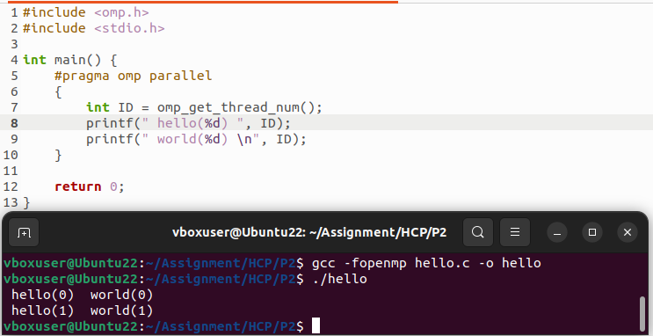

## Source Code:

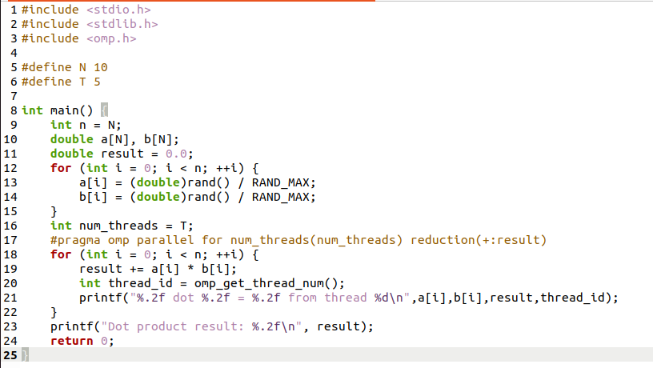

## Output:

**When T (Number of threads) < N (Array Length):**

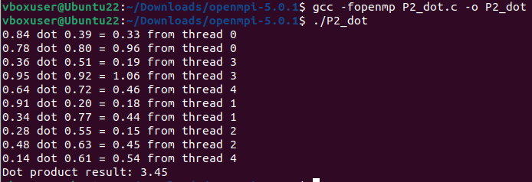

**When T (Number of threads) = N (Array Length):**

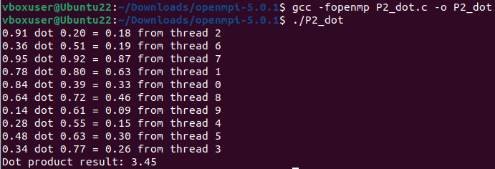

**When T (Number of threads) > N (Array Length):**

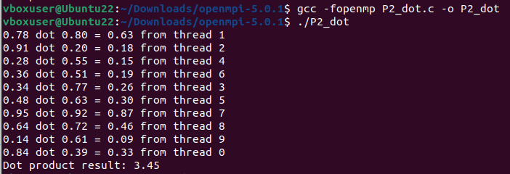

## Conclusion:

* Understanding of OpenMP directives for the creation and implementation of threads to enable parallelism.
* Leveraging threads for both cross product and dot product computation enables parallel processing, optimizing performance for large N.
* Incorporating random inputs adds realism to the computational model, simulating scenarios with varied data distributions.