## Indian Institute of Information Technology Surat



# Lab Report on

# High Performance Computing (CS 602) Practical

**Submitted by**

### [RAHUL KUMAR SINGH] (UI21CS44)

**Course Faculty**

### Dr. Sachin D. Patil

## Department of Computer Science and Engineering

## Indian Institute of Information Technology Surat

## Gujarat-394190, India

**Jan-2024**

## Lab No: 4

**Aim: Write an OpenMP program to test the Schedule clause, Section clause, and synchronization clause.**

**Description:**

* Schedule Clause: Demonstrates static scheduling with a chunk size of 10 where each thread processes a chunk of the array.
* Section Clause: Defines parallel sections with designated code blocks where threads execute distinct sections concurrently.
* Synchronization Clause: Utilizes the `critical` directive to create a critical section and includes a `barrier` to synchronize threads, ensuring all reach a designated point before continuing.

## Source Code:

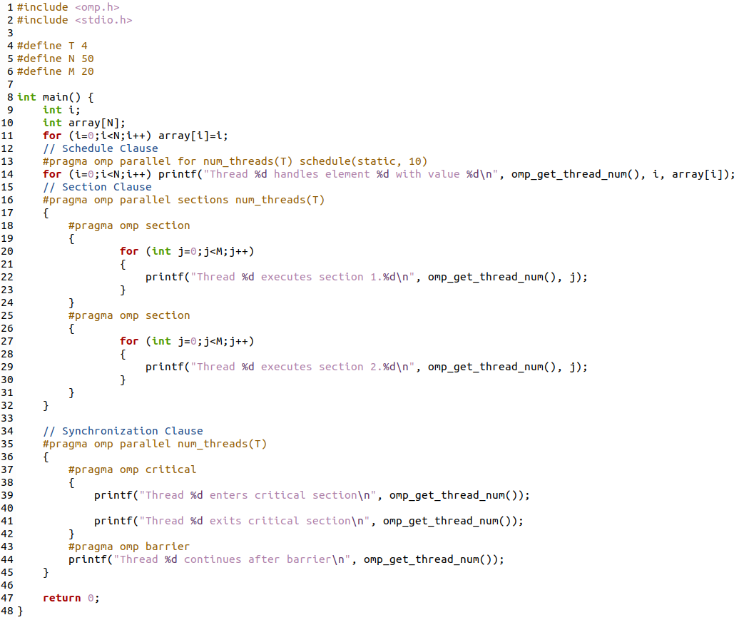

## Output:

**Schedule Clause:**

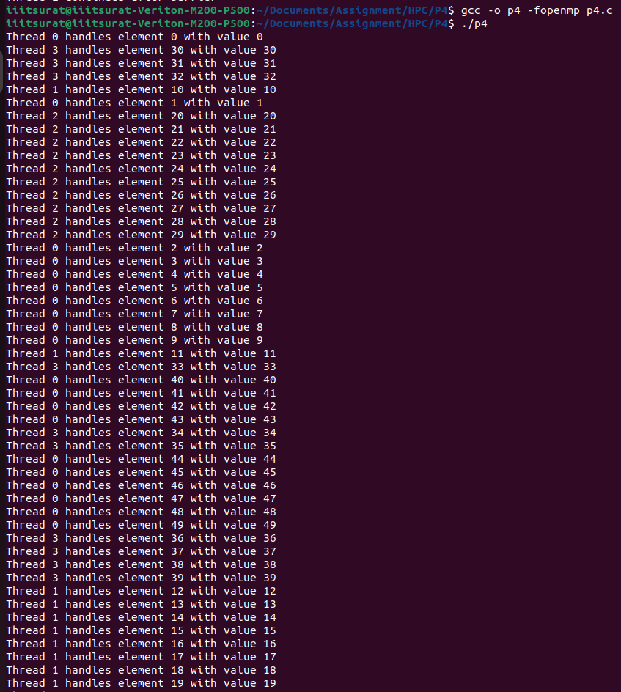

**Section Clause:**

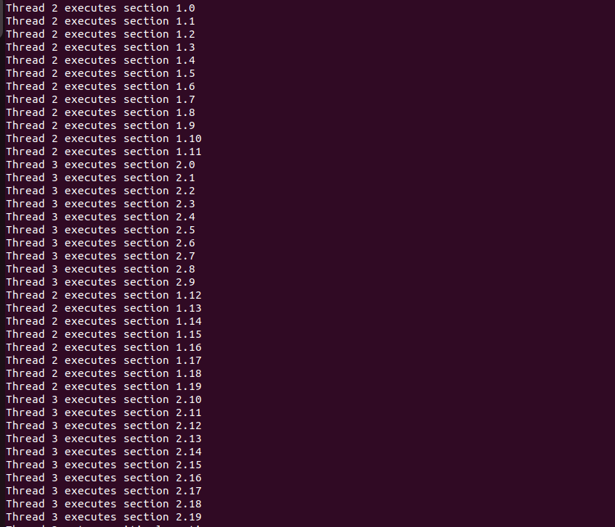

**Synchronization Clause:**

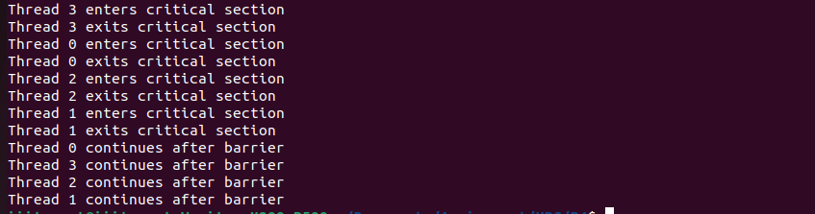

## Conclusion:

* Schedule Clause: Allows for efficient workload distribution among threads by controlling how iterations of a loop are assigned to threads.
* Section Clause: Facilitates parallel execution of distinct code sections.
* Synchronization Clause: Ensures orderly execution and prevents race conditions in critical sections.
* Efficiently utilizing clauses like `schedule`, `section`, and synchronization techniques improves code parallelism and resource management.