## Indian Institute of Information Technology Surat



# Lab Report on

# Machine Learning (CS 601) Practical

**Submitted by**

### [RAHUL KUMAR SINGH] (UI21CS44)

**Course Faculty**

### Dr. Pradeep Kumar Roy

### Dr. Rajesh K. Ahir

## Department of Computer Science and Engineering

## Indian Institute of Information Technology Surat

## Gujarat-394190, India

**Jan-2024**

## Lab No: 3

**Aim:**

To perform linear regression and utilize Python libraries to plot attribute relations, design optimal line fitting, and analyze global minima for given data.

**Description:**

Perform the following task with using inbuilt Python Libraries.:

* Plot the input-output relation for given attributes.
* Design a mathematical function to find the best-fitted line for the given data (attached here).
* Plot Error vs. Slope graph and show the global minima for the sample data X={2, 4, 6, 8} and Y={3, 7, 5, 10} considering different learning rate values (alpha).

## Source Code:

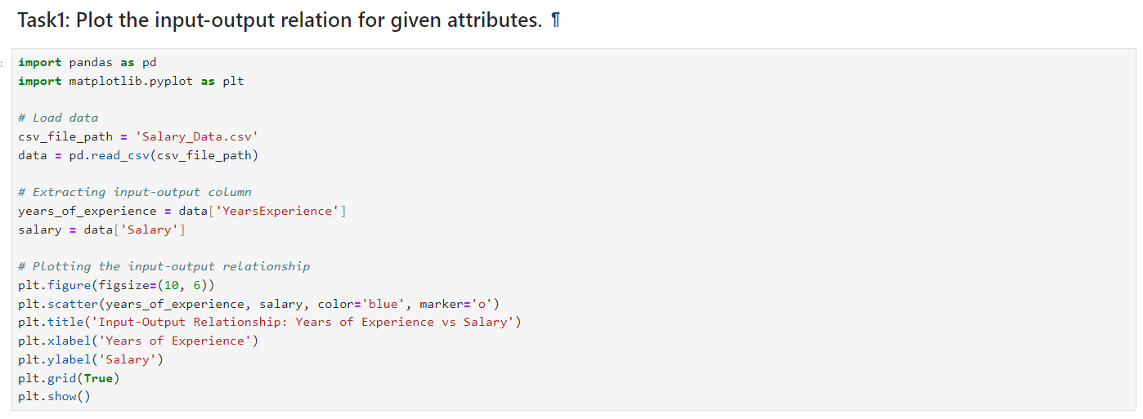

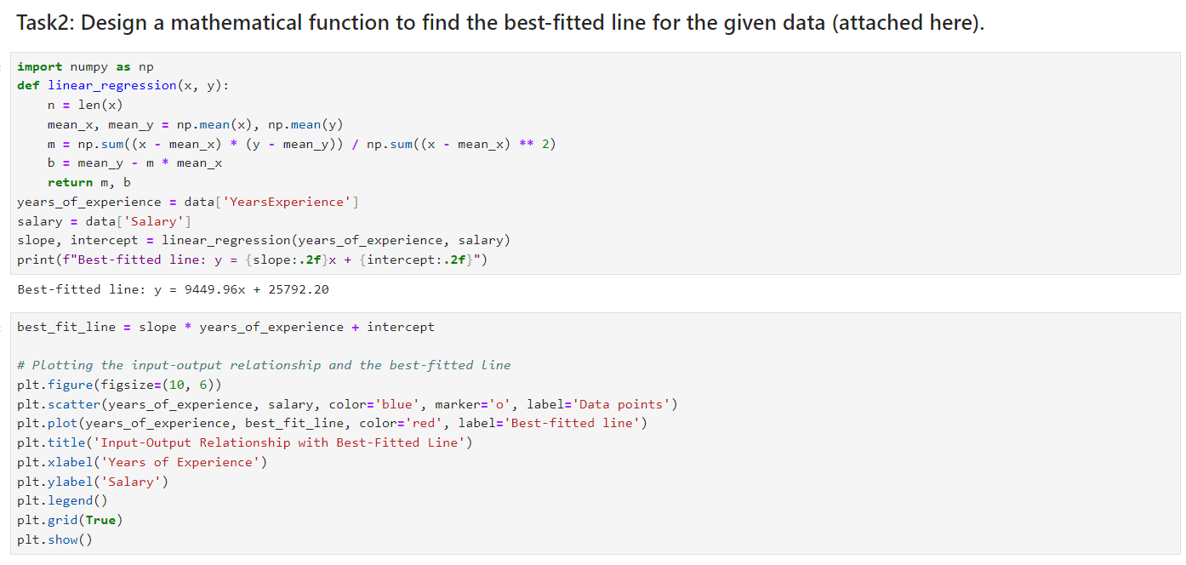

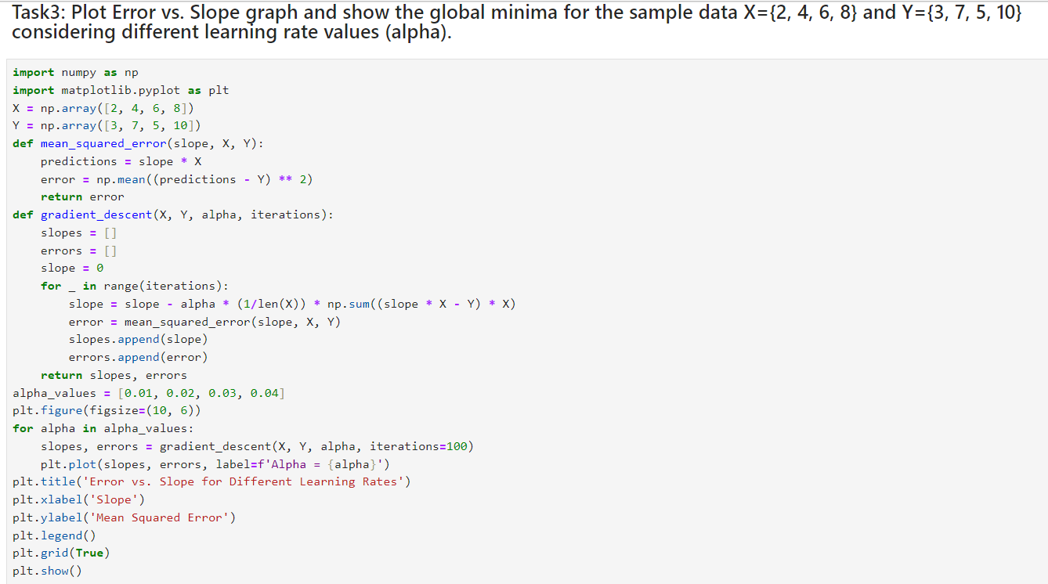

## Output:

**1. Plot the input-output relation for given attributes.**

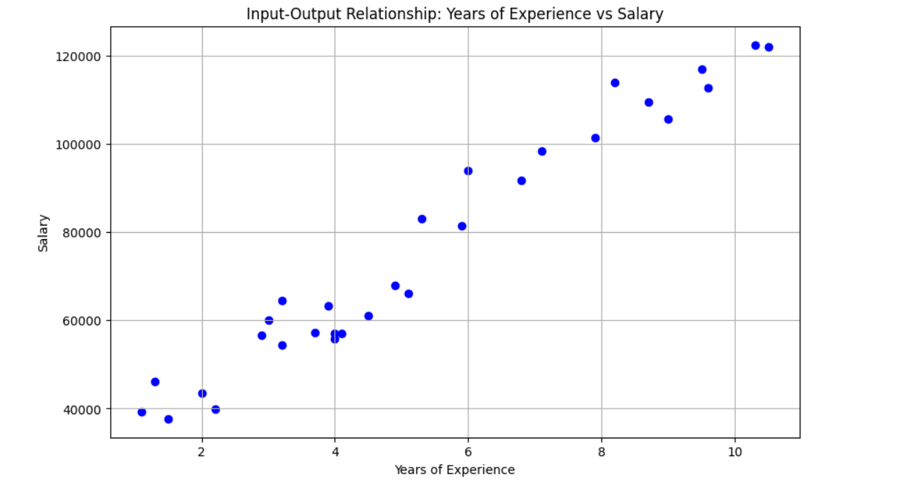



**2. Design a mathematical function to find the best-fitted line for the given data**



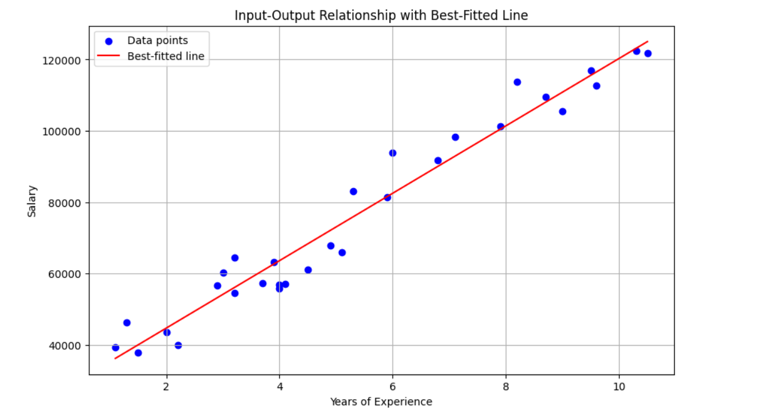



**3. Plot Error vs. Slope graph and show the global minima for the sample data X={2, 4, 6, 8} and Y={3, 7, 5, 10} considering different learning rate values (alpha).**

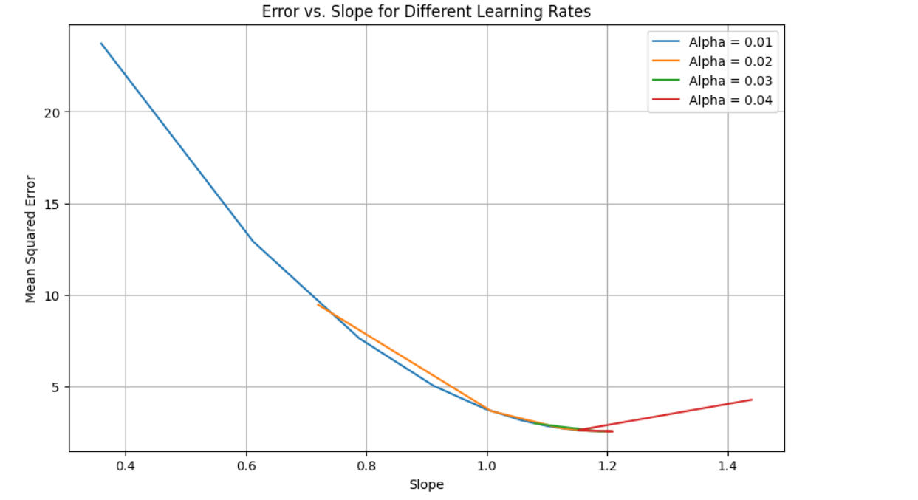



## Conclusion:

* A custom linear regression function was developed to find the best-fitted line for the given data.
* Utilized the gradient descent algorithm to minimize the cost function, aiming to find the optimal slope for the given linear regression problem.
* Plotted the Error vs. Slope graph for each learning rate, illustrating the convergence behavior over epochs.
* The impact of the learning rate on the convergence speed and the final error was observed through the plotted graphs.