## Indian Institute of Information Technology Surat



# Lab Report on

# Machine Learning (CS 601) Practical

**Submitted by**

### [RAHUL KUMAR SINGH] (UI21CS44)

**Course Faculty**

### Dr. Pradeep Kumar Roy

### Dr. Rajesh K. Ahir

## Department of Computer Science and Engineering

## Indian Institute of Information Technology Surat

## Gujarat-394190, India

**Jan-2024**

## Lab No: 6

**Aim:**

Classification of Handwritten Digits using Artificial Neural Networks

**Description:**

Perform the following task with using inbuilt Python Libraries:

1. Search relevant datasets to perform classification (MNIST dataset)
2. Classify handwritten digits using a simple neural network that has only input and output layers.
3. Add a hidden layer and see how the performance of the model improves.
4. Apply various activation functions to hidden and output layers to assess the model performance.
5. Apply various cost functions to measure the error of the model.

Activation Functions:

1. Softmax: Output layer for multi-class classification probabilities.
2. Sigmoid: Binary classification activation for output layer probabilities.
3. Tanh: Symmetric activation for hidden layers, mapping values to [-1, 1].
4. ReLU: Rectified Linear Unit, popular for hidden layer activations.

Cost/Loss Functions:

1. Mean Squared Error: Measures squared difference between predicted and actual values.
2. Categorical Crossentropy: Ideal for multi-class classification tasks, penalizing class probability deviations.
3. Binary Crossentropy: Suited for binary classification problems, optimizing log-likelihood of true labels.
4. Poisson: Used for count data; models distribution of rare events.

## Source Code:

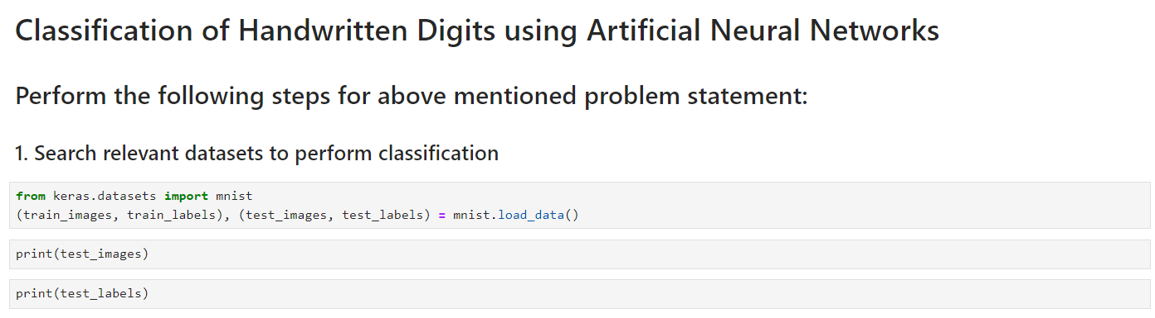

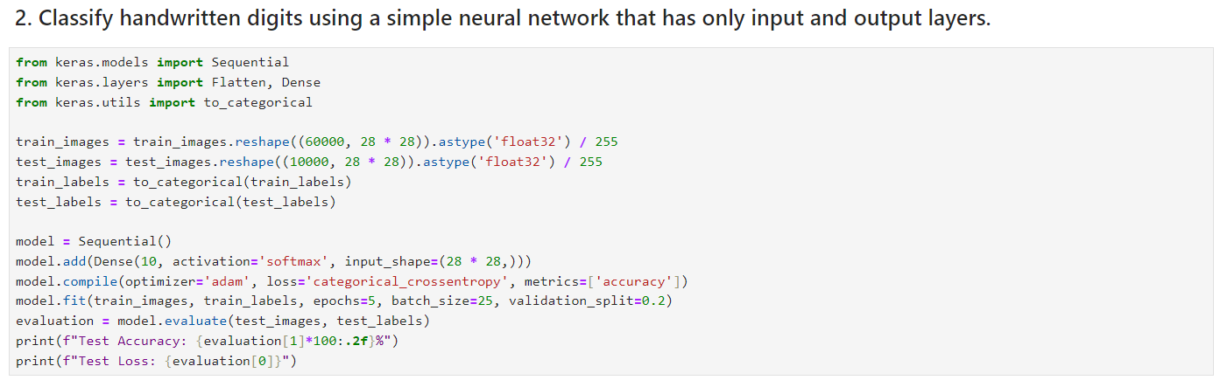

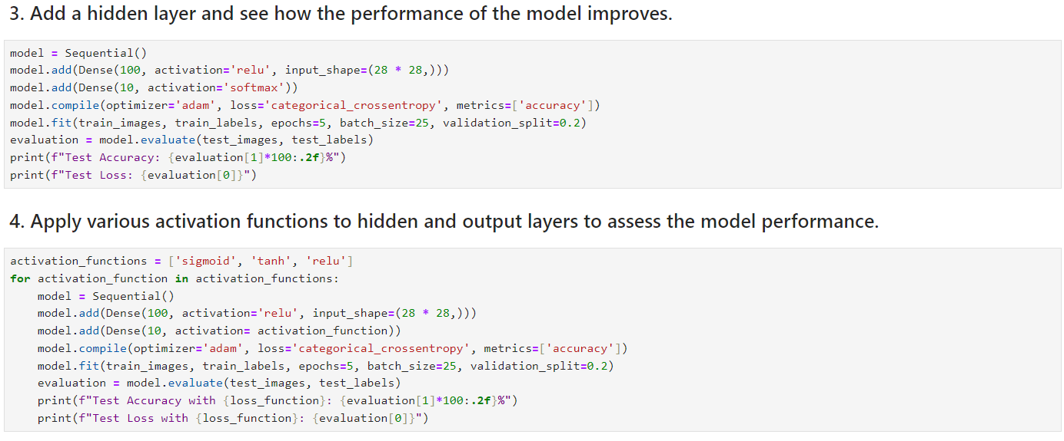

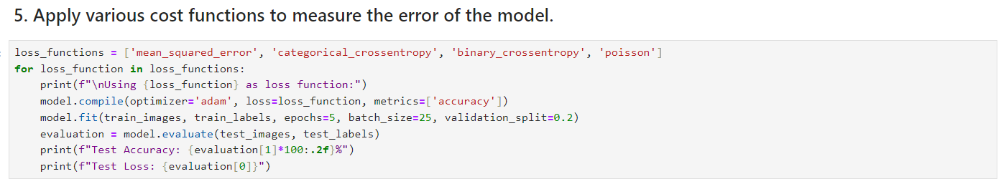

## Output:

**Task 1:**

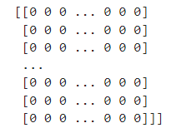



**Task 2:**





**Task 3:**





**Task 4:**









**Task 5:**











## Conclusion:

* The initial model achieves a baseline performance (92.47%) for handwritten digit classification.
* The inclusion of a hidden layer improves the model's ability having accuracy of 97.57%.
* The model's performance with “Sigmoid” activation function is the highest (97.66%).
* “Categorical cross entropy” is commonly used for classification tasks, but the experimentation with other loss functions provides a better loss function (“Binary cross entropy”) with accuracy of 98.04%.