## Indian Institute of Information Technology Surat



# Lab Report on

# Web Engineering (CS 603) Practical

**Submitted by**

### [RAHUL KUMAR SINGH] (UI21CS44)

**Course Faculty**

### Dr. Reema Patel

## Department of Computer Science and Engineering

## Indian Institute of Information Technology Surat

## Gujarat-394190, India

**Jan-2024**

## Lab No: 3

**Aim: PHP**

**Description:** Perform all the 7 Tasks:

1. Write the PHP script to display all the details of web server using phpinfo()

2. Write a program to check student grade based on the marks using if-else statements.

Conditions:

* If marks are 60% or more, the grade will be First Division.
* If marks between 45% to 59%, grade will be Second Division.
* If marks between 33% to 44%, grade will be Third Division.
* If marks are less than 33%, students will be Fail.

3. Write a program to calculate factorial of a number using a for loop in PHP.

4. Write a PHP program to find the factorial of a number using a recursive function.

5. Write a program to calculate Electricity bill in PHP

Conditions:

* For first 50 units – Rs. 3.50/unit
* For next 100 units – Rs. 4.00/unit
* For next 100 units – Rs. 5.20/unit
* For units above 250 – Rs. 6.50/unit

6. Write a program in PHP to remove specific element by value from an array using PHP

program.

Instructions:

* Take an array with a list of month names.
* Take a variable with the name of value to be deleted.
* Implement it using PHP array_search(), array_diff() functions and foreach loop.

7. Write a PHP script to generate a list of the first 20 prime numbers.

## Source Code:

**Task 1:**

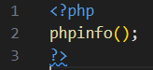

**Task 2:**

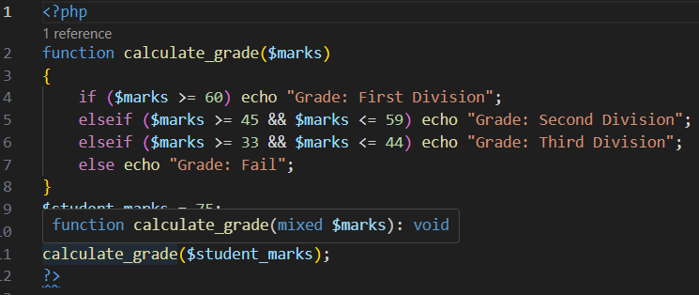

**Task 3:**

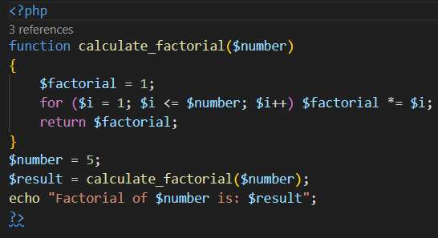

**Task 4:**

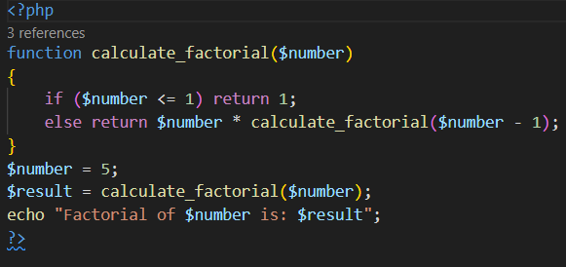

**Task 5:**

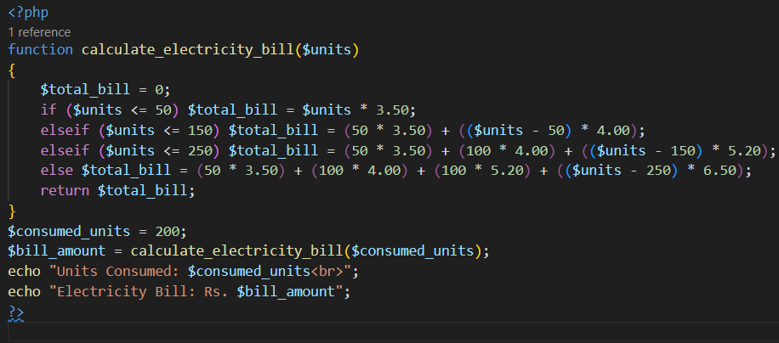

**Task 6:**

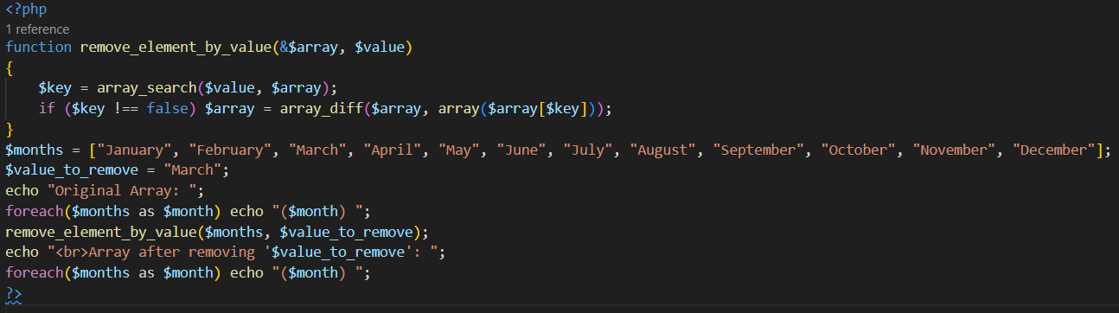

**Task 7:**

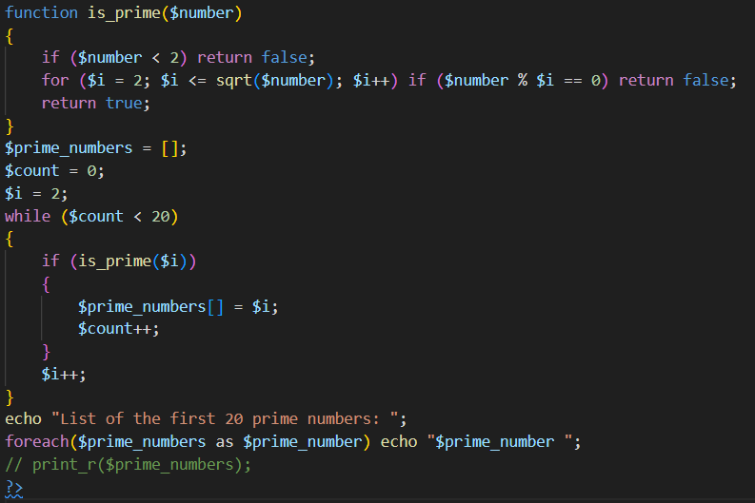

## Output:

**Task 1:**

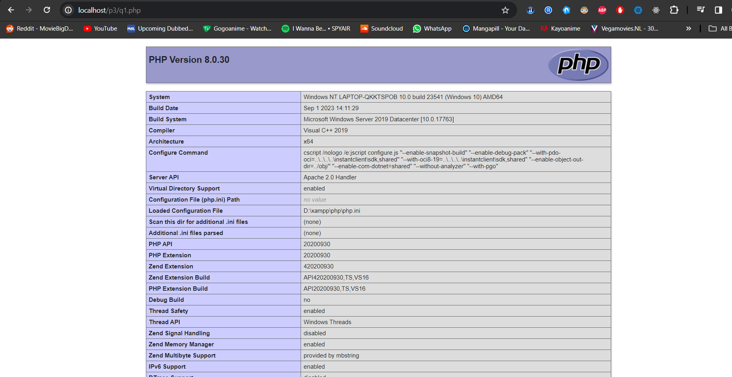

**Task 2:**



**Task 3:**



**Task 4:**



**Task 5:**



**Task 6:**



**Task 7:**



## Conclusion:

* PHP enables dynamic web development with embedded code in HTML.
* PHP efficiently calculates factorial recursively, reducing redundancy.
* PHP program computes electricity bills with tiered rates, applying conditional logic for accurate billing.