## Indian Institute of Information Technology Surat



# Lab Report on

# Web Engineering (CS 603) Practical

**Submitted by**

### [RAHUL KUMAR SINGH] (UI21CS44)

**Course Faculty**

### Dr. Reema Patel

## Department of Computer Science and Engineering

## Indian Institute of Information Technology Surat

## Gujarat-394190, India

**Jan-2024**

## Lab No: 4

**Aim: PHP - Working with String, Array, and Loops**

**Description:** Perform all the 8 Tasks:

1. Write a script to check if the input string consists of lowercase characters only.
2. Write a PHP script to remove whitespaces from a string.
3. Write a PHP script that checks if a string contains another string.
4. Write a simple PHP program to check that emails are valid. Hint: String should contain @ and . compulsorily. Also, should be after @ only and so on.
5. $color = array(‘white’, ‘green’, ‘red’). Write a PHP script which will display the colors in the following way :  
   Output : white, green, red  
   • white  
   • green  
   • red
6. Write a PHP script to replace the first ‘the’ of the following string with ‘That’.  
   Sample : ‘the IIIT Surat is located in Kholvad, Kamrej’.
7. Write a PHP program to create a new string where 'if' is added to the front of a given string. If the string already begins with 'if', return the string unchanged.  
   Sample Input:  
   "if else"  
   "else"  
   "if"  
   Sample Output:  
   if else  
   if else  
   if
8. Demonstrate the working of GET and Post methods of form element in HTML. Also, read the information of the input tag using $_GET and $_POST method using PHP.

## Source Code:

**HTML:**

**<!DOCTYPE html>**

**<html lang="en">**

**<head>**

**<meta charset="UTF-8">**

**<meta name="viewport" content="width=device-width, initial-scale=1.0">**

**<title>Working with String, Array, and Loops</title>**

**</head>**

**<body>**

**<form method="post" action="q1.php">**

**<label for="inputString">(Task 1) => Enter a string:</label>**

**<input type="text" name="inputString" id="inputString" required>**

**<input type="submit" value="Check Lowercase">**

**</form>**

**<form method="post" action="q2.php">**

**<label for="inputString">(Task 2) => Enter a string:</label>**

**<input type="text" name="inputString" id="inputString" required>**

**<input type="submit" value="Remove Whitespaces">**

**</form>**

**<form method="post" action="q3.php">**

**<label for="mainString">(Task 3) => Enter the main string:</label>**

**<input type="text" name="mainString" id="mainString" required>**

**<label for="subString">Enter the substring to check:</label>**

**<input type="text" name="subString" id="subString" required>**

**<input type="submit" value="Check Substring">**

**</form>**

**<form method="post" action="q4.php">**

**<label for="email">(Task 4) => Enter an email:</label>**

**<input type="text" name="email" id="email" required>**

**<input type="submit" value="Check Email">**

**</form>**

**<form method="post" action="q5.php">**

**<label for="submitButton">(Task 5) => Press the button:</label>**

**<input type="submit" value="Display Colors">**

**</form>**

**<form method="post" action="q6.php">**

**<label for="inputString">(Task 6) => Enter a string:</label>**

**<input type="text" name="inputString" id="inputString" required>**

**<input type="submit" value="Replace 'the'">**

**</form>**

**<form method="post" action="q7.php">**

**<label for="inputString">(Task 7) => Enter a string:</label>**

**<input type="text" name="inputString" id="inputString" required>**

**<input type="submit" value="Add 'if' to Front">**

**</form>**

**<form method="get" action="q8.php">**

**<label for="name">(Task 8 GET) => Name:</label>**

**<input type="text" name="name" id="name">**

**<input type="submit" value="Submit">**

**</form>**

**<form method="post" action="q8.php">**

**<label for="surname">(Task 8 POST) => Surname:</label>**

**<input type="text" name="surname" id="surname">**

**<input type="submit" value="Submit">**

**</form>**

**</body>**

**</html>**

**Task 1:**

**<?php**

**if ($_SERVER["REQUEST_METHOD"] == "POST") {**

**$inputString = $_POST["inputString"];**

**if (ctype_lower($inputString)) echo "The input string consists of lowercase characters only.";**

**else echo "The input string contains non-lowercase characters.";**

**}**

**?>**

**Task 2:**

**<?php**

**if ($_SERVER["REQUEST_METHOD"] == "POST") {**

**$inputString = $_POST["inputString"];**

**$resultString = str_replace(' ', '', $inputString);**

**echo "String after removing whitespaces: $resultString";**

**}**

**?>**

**Task 3:**

**<?php**

**if ($_SERVER["REQUEST_METHOD"] == "POST") {**

**$mainString = $_POST["mainString"];**

**$subString = $_POST["subString"];**

**if (strpos($mainString, $subString) !== false) echo "The main string contains the specified substring.";**

**else echo "The main string does not contain the specified substring.";**

**}**

**?>**

**Task 4:**

**<?php**

**if ($_SERVER["REQUEST_METHOD"] == "POST") {**

**$email = $_POST["email"];**

**if (filter_var($email, FILTER_VALIDATE_EMAIL)) echo "The email is valid.";**

**else echo "The email is not valid.";**

**}**

**?>**

**Task 5:**

**<?php**

**$colors = array('white', 'green', 'red');**

**echo "Output: " . implode(', ', $colors) . "<br>";**

**foreach ($colors as $color) echo "<li>$color</li>";**

**?>**

**Task 6:**

**<?php**

**if ($_SERVER["REQUEST_METHOD"] == "POST") {**

**$inputString = $_POST["inputString"];**

**$resultString = preg_replace('/\bthe\b/', 'That', $inputString, 1);**

**echo "String after replacement: $resultString";**

**}**

**?>**

**Task 7:**

**<?php**

**if ($_SERVER["REQUEST_METHOD"] == "POST") {**

**$inputString = $_POST["inputString"];**

**if (substr($inputString, 0, 2) !== 'if') $resultString = 'if ' . $inputString;**

**else $resultString = $inputString;**

**echo "Result string: $resultString";**

**}**

**?>**

**Task 8:**

**<?php**

**if ($_SERVER["REQUEST_METHOD"] == "GET") {**

**if (isset($_GET["name"])) {**

**$name = $_GET["name"];**

**echo "Name submitted using GET method: $name";**

**}**

**} elseif ($_SERVER["REQUEST_METHOD"] == "POST") {**

**if (isset($_POST["surname"])) {**

**$surname = $_POST["surname"];**

**echo "Surname submitted using POST method: $surname";**

**}**

**} else echo "Invalid request method.";**

**?>**

## Output:

**HTML:**

**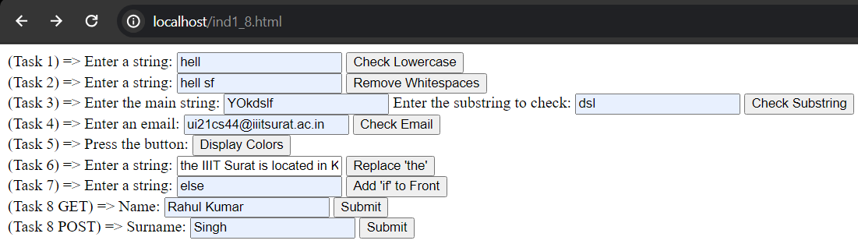  
Task 1:**

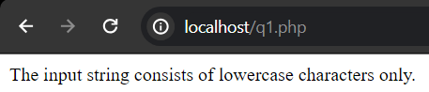

**Task 2:**

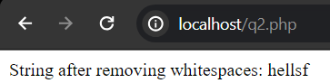

**Task 3:**

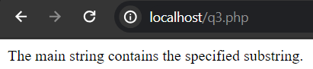

**Task 4:**

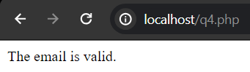

**Task 5:**

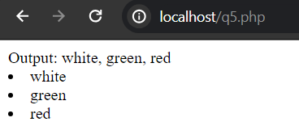

**Task 6:**

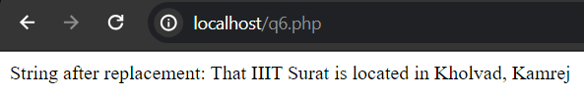

**Task 7:**

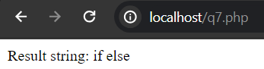

**Task 8:**

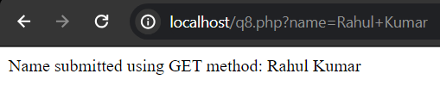

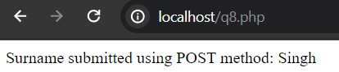

## Conclusion:

* HTML forms use methods like GET and POST to send data to the server.
* PHP processes form data based on the request method (GET/POST).
* Proper syntax and validation are crucial for robust form handling.