## Indian Institute of Information Technology Surat



# Lab Report on

# Web Engineering (CS 603) Practical

**Submitted by**

### [RAHUL KUMAR SINGH] (UI21CS44)

**Course Faculty**

### Dr. Reema Patel

## Department of Computer Science and Engineering

## Indian Institute of Information Technology Surat

## Gujarat-394190, India

**Jan-2024**

## Lab No: 6

**Aim: Javascripts**

**Description:** Write a HTML/CSS/JS Script for the following:

1. Write a JavaScript program to ask the user to input two values through a prompt. Perform the arithmetic operations addition, subtraction, multiplication, and division on input numbers and display the results on the webpage (on predefined paragraphs or div, etc...).
2. Implement “Guessing Game” which will have the following functionality:
3. Program generates a random number at the start of each game
4. User's goal is to guess the correct number
5. User gets a set # of tries (default = 5)
6. Program tracks user's guesses and prevents duplicate guessing
7. Game ends when user guesses correctly or runs out of tries
8. Implement Binary Search using JavaScript. Output image is given below.
9. Implement Substitution Cipher as per the given output. Each letter is encoded using the corresponding letter in the key. Each time key should be generated randomly.
10. Write a JavaScript to Collapse and Expand the content by clicking on the Button as per the following output image.
11. Write a JavaScript to Create the Mouse-Over effect. Build the webpage with one image. When the user puts the mouse over the image, the original image should change to a new image. When the mouse leaves the image, again the original image should appear.

## Source Code:

**Task 1:**

**<!DOCTYPE html>**

**<html>**

**<body>**

**<button onclick="performAriOp()">Perform</button>**

**<p id="addition"></p>**

**<p id="subtraction"></p>**

**<p id="multiplication"></p>**

**<p id="division"></p>**

**<script>**

**function performAriOp() {**

**var num1 = prompt("Please enter the first number", "0");**

**var num2 = prompt("Please enter the second number", "0");**

**num1 = Number(num1);**

**num2 = Number(num2);**

**document.getElementById("addition").innerHTML = "Addition: " + (num1 + num2);**

**document.getElementById("subtraction").innerHTML = "Subtraction: " + (num1 - num2);**

**document.getElementById("multiplication").innerHTML = "Multiplication: " + (num1 * num2);**

**if(num2 != 0) {**

**document.getElementById("division").innerHTML = "Division: " + (num1 / num2);**

**} else {**

**document.getElementById("division").innerHTML = "Division: Cannot divide by zero";**

**}**

**}**

**</script>**

**</body>**

**</html>**

**Task 2:**

**<!DOCTYPE html>**

**<html>**

**<body>**

**<button onclick="startGame()">Start Game</button>**

**<p id="gameStatus"></p>**

**<script>**

**var randomNumber;**

**var guesses;**

**var tries;**

**function startGame() {**

**randomNumber = Math.floor(Math.random() * 100) + 1;**

**guesses = [];**

**tries = 5;**

**guessNumber();**

**}**

**function guessNumber() {**

**if(tries === 0) {**

**alert("Game over. You didn't guess the number. The number was " + randomNumber + ".");**

**return;**

**}**

**var userGuess = prompt("Please enter your guess", "0");**

**userGuess = Number(userGuess);**

**if(guesses.includes(userGuess)) {**

**alert("You have already guessed this number. Try a different number.");**

**guessNumber();**

**} else {**

**guesses.push(userGuess);**

**tries--;**

**if(userGuess === randomNumber) {**

**alert("Congratulations! You guessed the number correctly.");**

**} else {**

**alert("Wrong guess. You have " + tries + " tries left.");**

**guessNumber();**

**}**

**}**

**}**

**</script>**

**</body>**

**</html>**

**Task 3:**

**<!DOCTYPE html>**

**<html>**

**<body>**

**<p>Input:</p>**

**<textarea id="arrayInput"></textarea>**

**<p>Search Element:</p>**

**<input type="number" id="searchElement">**

**<button onclick="binarySearch()">Search</button>**

**<p>Output:</p>**

**<textarea id="output" readonly></textarea>**

**<script>**

**var array = [1, 2, 3, 4, 5, 6, 7, 8, 9, 10];**

**function binarySearch() {**

**var arrayInput = document.getElementById("arrayInput").value;**

**var array = arrayInput.split(' ').map(Number);**

**var searchElement = document.getElementById("searchElement").value;**

**searchElement = Number(searchElement);**

**var start = 0;**

**var end = array.length - 1;**

**var output = "";**

**while (start <= end) {**

**var mid = Math.floor((start + end) / 2);**

**output += "Start: " + start + ", End: " + end + ", Mid: " + mid + ", Array[mid]: " + array[mid] + "\n";**

**if (array[mid] === searchElement) {**

**output += "Element found at index " + mid;**

**document.getElementById("output").value = output;**

**return;**

**} else if (array[mid] < searchElement) {**

**start = mid + 1;**

**} else {**

**end = mid - 1;**

**}**

**}**

**output += "Element not found";**

**document.getElementById("output").value = output;**

**}**

**</script>**

**</body>**

**</html>**

**Task 4:**

**<!DOCTYPE html>**

**<html>**

**<body>**

**<div style="display:flex; justify-content: center;">**

**<div><p>Input:</p>**

**<textarea class="text" id="inputText" rows=4> ABCDEFGHIJKLMNOPQRSTUVWXYZ </textarea></div>**

**<div style="display: flex; align-items: center;"><button style="margin: 10px 10px 10px 10px;" onclick="applyCipher()">Encode ==></button></div>**

**<div>**

**<p>Output:</p>**

**<textarea class="text" id="outputText" rows=4 readonly></textarea>**

**</div>**

**</div>**

**<script>**

**function generateKey() {**

**var alphabet = "ABCDEFGHIJKLMNOPQRSTUVWXYZ";**

**var key = alphabet.split('').sort(function() { return 0.5 - Math.random() }).join('');**

**return key;**

**}**

**function substitutionCipher(text, key) {**

**var alphabet = "ABCDEFGHIJKLMNOPQRSTUVWXYZ";**

**var cipherText = "";**

**for (var i = 0; i < text.length; i++) {**

**var char = text[i];**

**if (alphabet.includes(char.toUpperCase())) {**

**var index = alphabet.indexOf(char.toUpperCase());**

**var cipherChar = key[index];**

**cipherText += (char === char.toUpperCase()) ? cipherChar : cipherChar.toLowerCase();**

**} else {**

**cipherText += char;**

**}**

**}**

**return cipherText;**

**}**

**function applyCipher() {**

**var key = generateKey();**

**var inputText = document.getElementById("inputText").value;**

**var cipherText = substitutionCipher(inputText, key);**

**document.getElementById("outputText").value = cipherText;**

**}**

**</script>**

**</body>**

**</html>**

**Task 5:**

**<!DOCTYPE html>**

**<html>**

**<body>**

**<button id="expandButton" type="button" onclick="collapseExpand()">Click to expand</button>**

**<div id="content" style="display: none;">**

**<ol>**

**<li>Information Security</li>**

**<li>Web Technology</li>**

**<li>Operating System</li>**

**<li>Theory of Computation</li>**

**<li>Software Engineering</li>**

**</ol>**

**</div>**

**<div id="aside">**

**<p> Paragraph following the list (does not collapse). </p>**

**</div>**

**<script>**

**function collapseExpand() {**

**var content = document.getElementById("content");**

**if (content.style.display === "none") {**

**document.getElementById("expandButton").innerHTML = `Click to collapse`;**

**content.style.display = "block";**

**} else {**

**document.getElementById("expandButton").innerHTML = `Click to expand`;**

**content.style.display = "none";**

**}**

**}**

**</script>**

**</body>**

**</html>**

**Task 6:**

## <!DOCTYPE html>

## <html>

## <body>

## <img id="image" onmouseover="changeImage()" onmouseout="originalImage()" src="original.jpg" alt="Original Image">

## <script>

## function changeImage() {

## document.getElementById("image").src = "new.jpg";

## }

## function originalImage() {

## document.getElementById("image").src = "original.jpg";

## }

## </script>

## </body>

## </html>

## Output:

**Task 1 (Input: 10 & 15):**

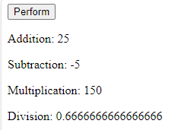

**Task 2:**

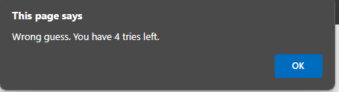

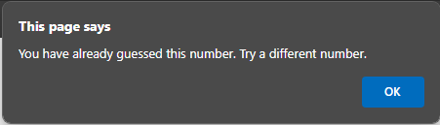

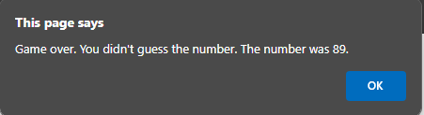

**Task 3:**

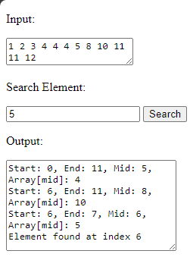

**Task 4:**

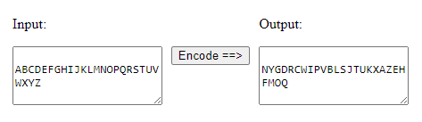

**Task 5:**

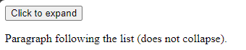

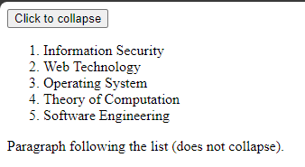

**Task 6:**



## Conclusion:

* Workings and Understanding of HTML, CSS, JS