Supplement S4. Encoder similarity geometry: a bimodality artifact in bge-small-en-v1.5
A complementary view of how each encoder organizes the cohort is the distribution of cosine similarities between patient embeddings. Figure S4 contrasts, for each encoder, the similarities of random patient pairs (red) against those of nearest-neighbor pairs (green). The red random-pair histogram is the encoder’s overall similarity distribution. Three of the four encoders produce smooth, unimodal random-pair distributions: bge-en-icl, Qwen3-Embedding-4B, and Qwen3-Embedding-8B. The smallest encoder, bge-small-en-v1.5, is the exception. Its random-pair distribution is distinctly multimodal, with a sharp primary peak near 0.99 and a separated secondary mode near 0.98. The cohort splits into two internally similar groups rather than spreading along a single continuum.
(A) bge-small-en-v1.5
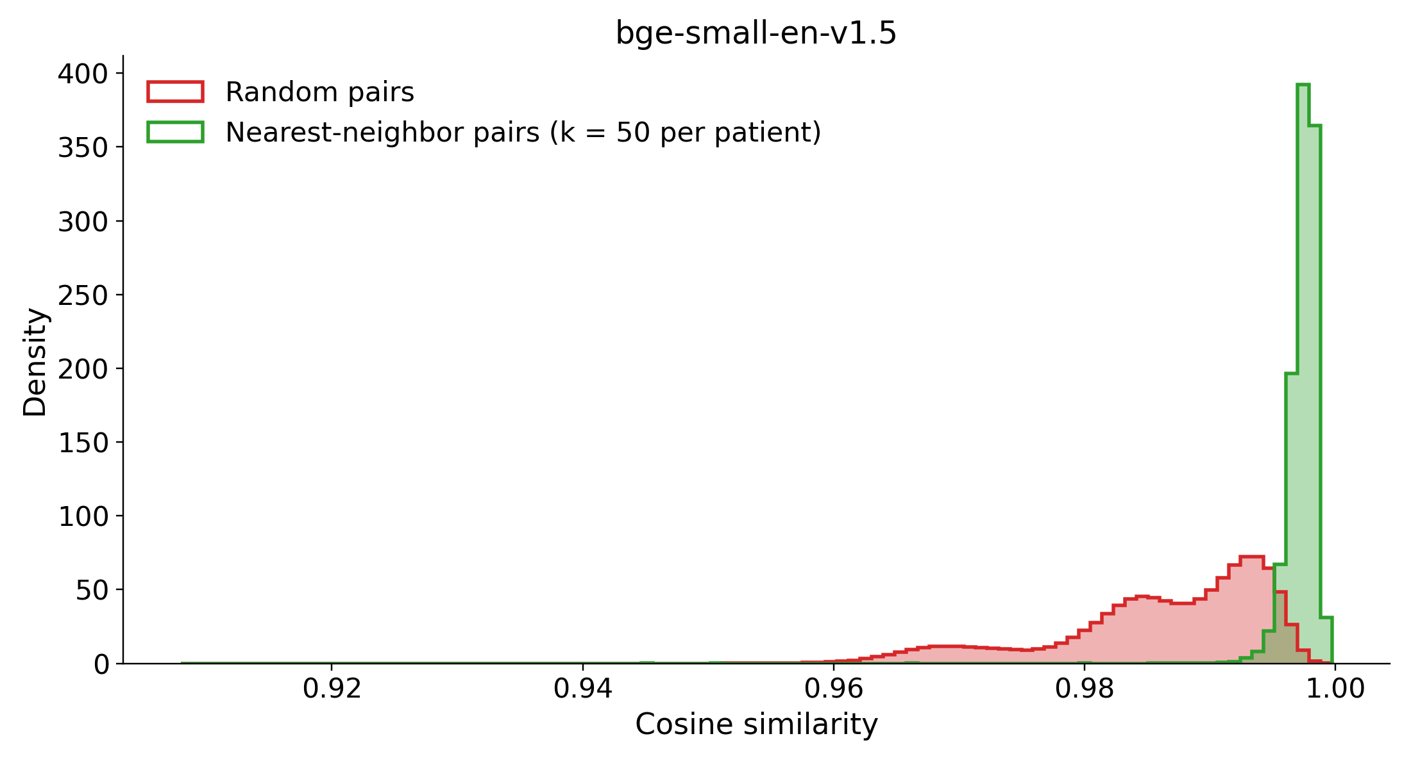
(B) bge-en-icl
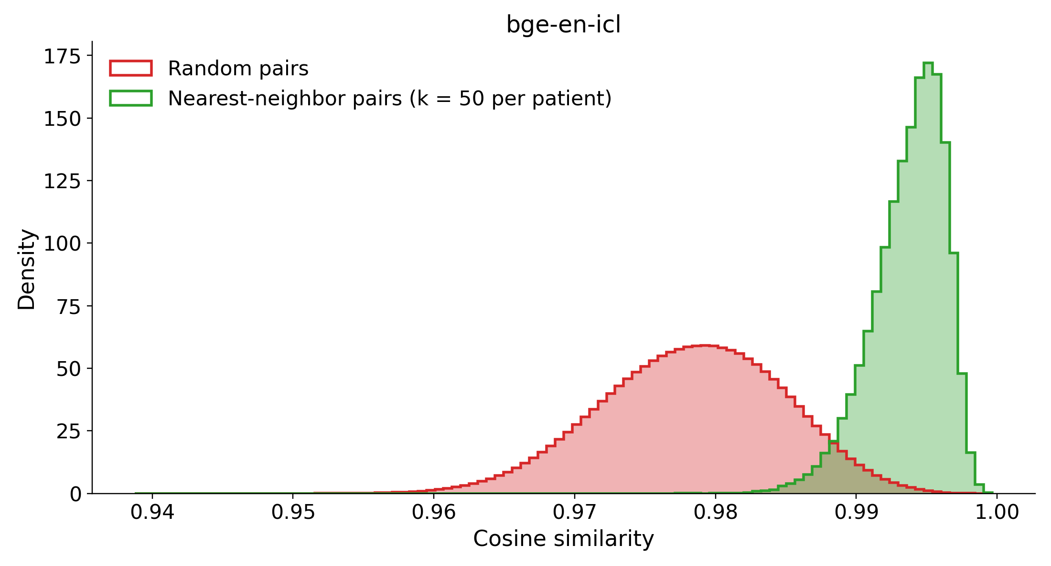
(C) Qwen3-Embedding-4B
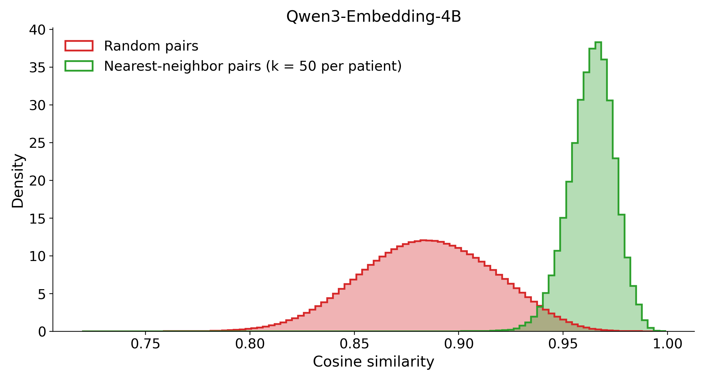
(D) Qwen3-Embedding-8B
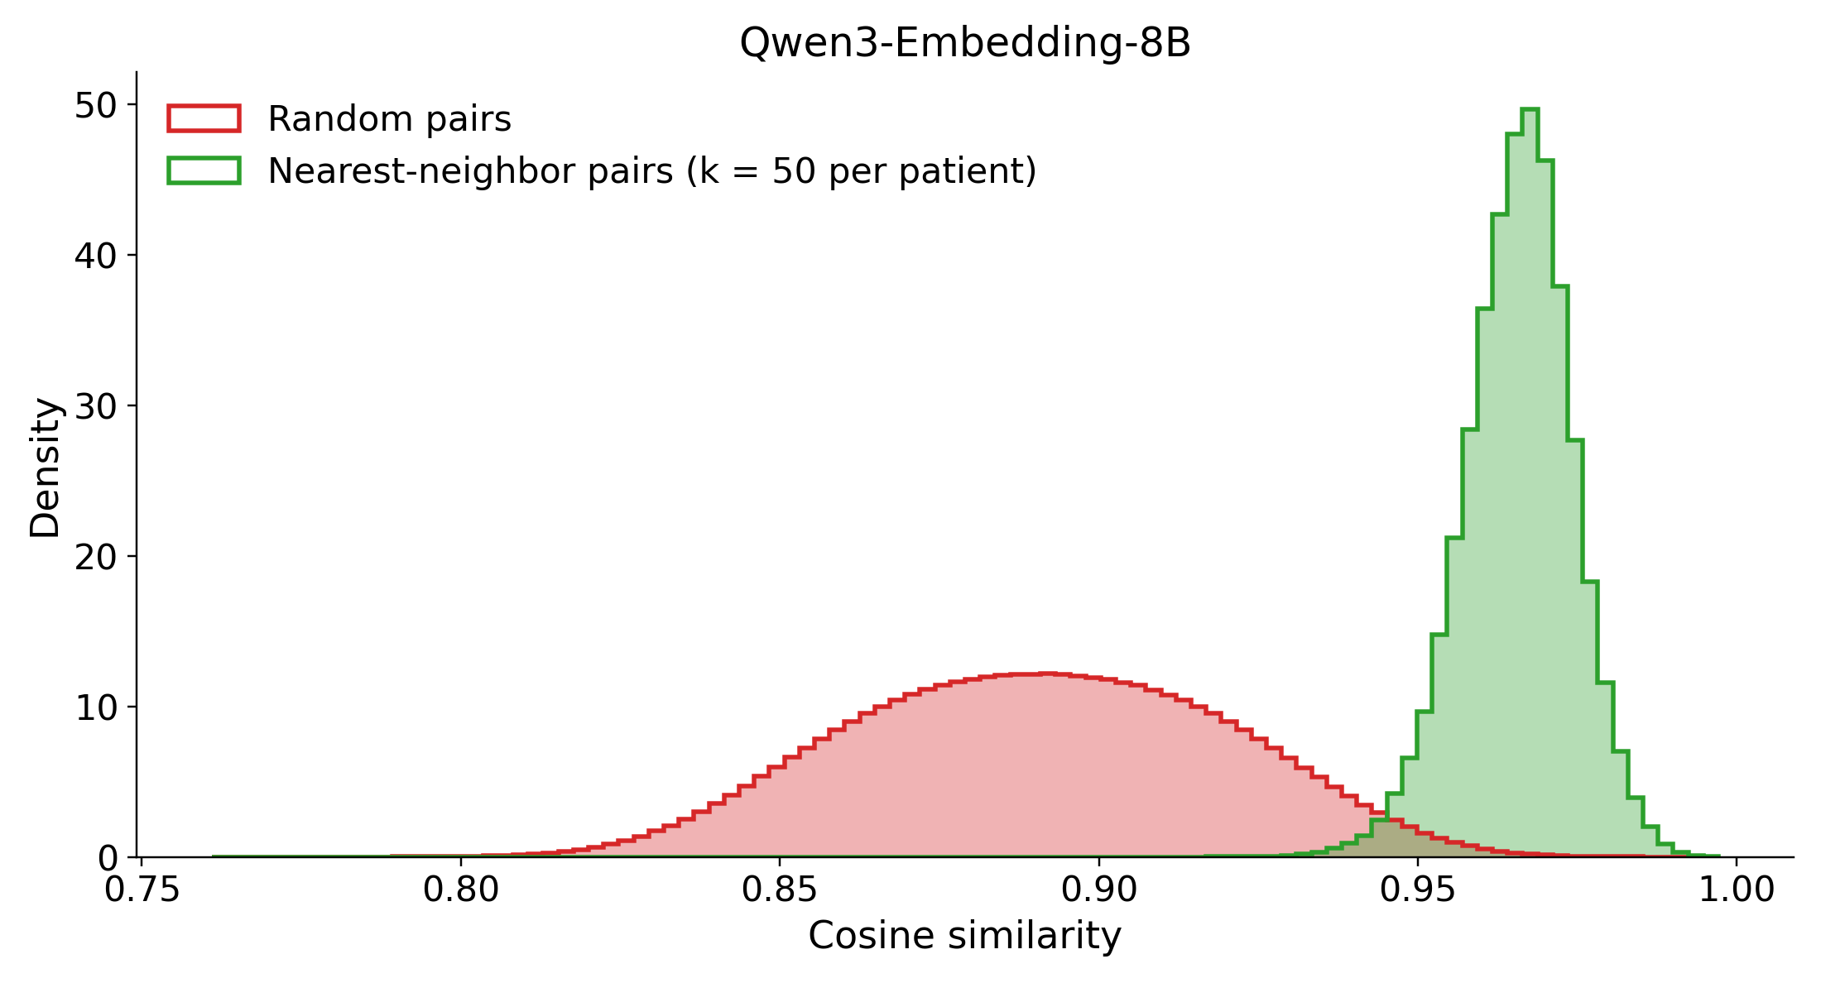
Figure S4. Random-pair (red) versus nearest-neighbor-pair (green) cosine similarities for each encoder (full cohort). (A) bge-small-en-v1.5, (B) bge-en-icl, (C) Qwen3-Embedding-4B, (D) Qwen3-Embedding-8B. The red random-pair histogram is the encoder’s overall similarity distribution: it is multimodal only for bge-small-en-v1.5 (A) and smoothly unimodal for the other three. In every panel the neighbor-pair similarities (green) sit above the bulk of the random-pair mass, confirming that nearest-neighbor retrieval selects genuinely more similar patients. Axis ranges differ per panel because the encoders occupy different absolute similarity bands.
To identify the split we clustered the L2-normalized bge-small embeddings into two groups with k-means (k = 2), which partitioned the 42,579 patients into 14,438 and 28,141. The partition coincides almost perfectly with a single surface lexical feature. The literal token “episode” appears in essentially every narrative of the larger cluster and almost none of the smaller. The related MDD recurrence and severity wording follows the same split (Table S4).
It is worth being precise about what each cluster is, because the two clusters are not simply “recurrent” versus “non-recurrent”. The narrative renders each patient’s MDD coding verbatim, e.g. MDD (Single Episode, Unspecified) or MDD (Recurrent, Moderate). Only the single-episode wording contains the word “episode”. So:
- Cluster B (28,141) = narratives that contain “episode”, which are the single-episode patients (28,206 in the cohort).
- Cluster A (14,438) = narratives that do not, a mixture of the 11,213 patients coded Recurrent and the ~3,200 coded Unspecified or Dysthymia, neither of which uses the word “episode”.
Cluster A is therefore best described as “no episode token”, not as “all recurrent”. Roughly one patient in five inside it is not coded recurrent at all. That distinction is what the second-order analysis below turns on.
Table S4. Surface tokens that most strongly separate the two k-means clusters of bge-small-en-v1.5 embeddings. Values are the fraction of narratives in each cluster containing the token (binary presence). Cluster A = 14,438 patients (narratives with no “episode” token: recurrent-coded plus unspecified/dysthymia), cluster B = 28,141 (single-episode narratives). The token “single” is elevated in both clusters because it also occurs as a marital status.
Token | P(present | cluster A) | P(present | cluster B) | |Δ|
episode | 0.00 | 1.00 | 1.00
recurrent | 0.78 | 0.00 | 0.78
single | 0.30 | 1.00 | 0.70
unspecified | 0.39 | 0.83 | 0.45
moderate | 0.32 | 0.09 | 0.23
Figure S5 makes that mechanism visible. Both panels are histograms of pairs of patients, not of patients. For every pair in the set shown we compute the cosine similarity between the two embeddings and ask one yes/no question about the two narratives. Do they agree on a particular word? Pairs that agree are drawn in blue, pairs that disagree in red, and the grey histogram behind them is every pair in the set (the sum of the two). If a single word were driving the geometry, blue and red would sit at visibly different similarities. If it were not, they would lie on top of each other.
Panel A asks this of all 42,579 patients, with the word “episode”: do both narratives contain it, or does neither? Blue is agreement (both single-episode, or both non-single-episode) and red is disagreement (one of each). The blue pairs pile up at ≈0.99 and the red pairs at ≈0.97, so the two modes of Figure S4A are exactly these two groups. The encoder places two patients ≈0.02 further apart when their MDD coding is phrased differently, whatever else is in their records.
Panel B asks it again inside cluster A alone, with the word “recurrent”. A second question is needed because every narrative in cluster A lacks “episode”, which makes panel A’s question uninformative there. And “recurrent” is a genuine question because cluster A is not uniformly recurrent: 11,425 of its members are coded Recurrent and 3,013 are coded Unspecified. Blue pairs (both Recurrent, or both Unspecified) again separate from red pairs, so cluster A carries a real second split, once more on wording rather than on clinical content.
Cluster B (n = 28,141) was tested the same way and is not plotted. Its only candidate second-order token is the narrative’s Missing sentinel, and there the blue and red histograms lie almost exactly on top of each other. There is no second split to show. Those numbers are in Table S5.
(A) All 42,579 patients, split by the “episode” token
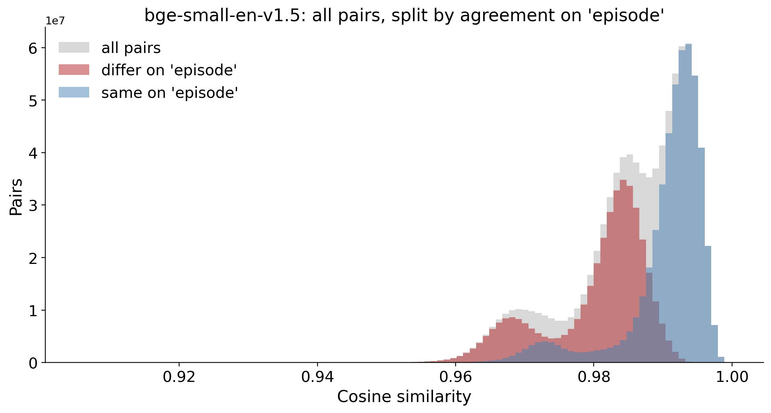
(B) Cluster A only (n = 14,438), split by the “recurrent” token
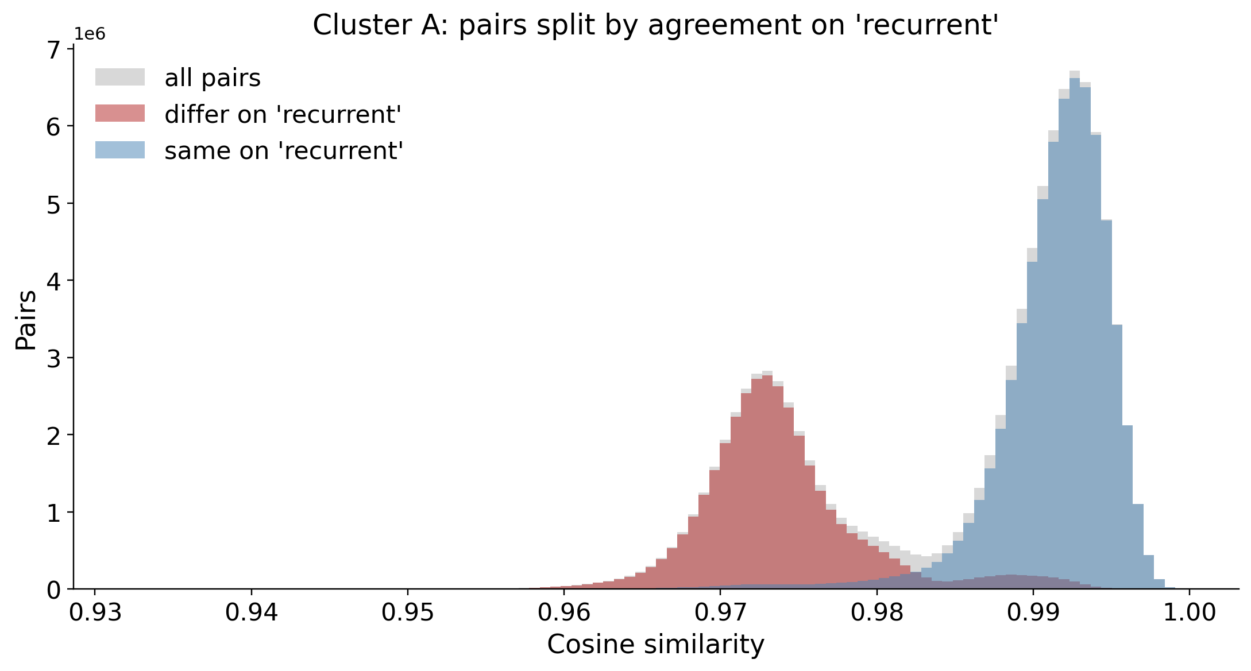
Figure S5. Pairwise cosine-similarity distributions for bge-small-en-v1.5, decomposed by whether the two patients in a pair use the same wording for one token (blue = same, red = different, grey = all pairs in the set shown). (A) All 42,579 patients, split on the “episode” token: same-wording pairs form the upper mode near 0.99 and differing-wording pairs the lower mode near 0.97, so the bimodality in Figure S4A is driven by recurrence phrasing rather than by holistic clinical similarity. (B) Cluster A only (the 14,438 patients whose narratives lack “episode”), split on the “recurrent” token: the two colours again separate, so this cluster is itself genuinely divided, once more along a surface-lexical axis. Cluster B admits no comparable second split and is not plotted (Table S5).
The lowest-capacity encoder therefore organizes its geometry around the presence or absence of one recurrence-phrasing token rather than around holistic clinical content, and that lexical split produces the second mode of Figure S4A (Figure S5A). The higher-capacity encoders show no such artifact.
On visual inspection each of the two parent clusters looks as though it might contain two further sub-modes. Table S5 tests whether those apparent sub-modes are real. The test is the same one twice: take a parent cluster on its own, re-run k-means (k = 2) inside it, ask how clean the resulting two-way split is, and then ask which word the split tracks.
Cleanliness is measured by the cosine silhouette (5,000-point subsample, seed fixed), a score from −1 to 1 that asks, for each patient, whether it sits closer to its own sub-cluster than to the other one. Higher means a better-separated split. The number is only interpretable by comparison, so the reference point is the top-level split of Table S4, which scores 0.48 under the same metric. A within-cluster split scoring well above 0.48 is more clearly separated than the split it came from. One scoring well below is not really a split at all.
The two parents give opposite answers. Cluster A, the one with no “episode” token, subdivides more cleanly than the parent split itself, at a silhouette of 0.69. It splits into an explicitly recurrent subgroup (n = 11,425, the token “recurrent” present in 98% and carrying the severity words “moderate”, “mild” and “severe”) and a smaller unspecified-recurrence subgroup (n = 3,013, “unspecified” in 100% and no severity wording). That smaller subgroup is the same ≈3,000 patients (7% of the cohort) that a flat three-cluster solution peels off. Cluster B (single-episode) does not meaningfully subdivide: silhouette 0.21, well below the parent 0.48. What little structure it has is keyed on the narrative’s Missing sentinel, present in 88% of one putative subgroup and 2% of the other. That is a data-completeness gradient, meaning how much of the record was filled in, rather than a clinical contrast. Consistent with that reading, the better-populated side additionally carries named SSRIs (citalopram 0.24, escitalopram 0.16, sertraline 0.17) simply because those patients have more recorded medication.
Table S5. Do the two clusters of Table S4 split again? Each parent cluster was re-clustered on its own with k-means (k = 2). “Driving token” is the word whose presence best separates the two resulting sub-clusters, and the two proportions are the fraction of narratives containing that word in each sub-cluster, so 0.98 / 0.00 means the word is essentially present in one sub-cluster and absent from the other. “Split silhouette” scores how cleanly the two sub-clusters separate. Compare it against 0.48, the score of the top-level split under the same metric. Cluster A splits cleanly, on recurrence phrasing. Cluster B does not split: its 0.21 is a weak data-completeness gradient on the missing-data sentinel, which is why it is not plotted in Figure S5.
Parent cluster (n) | Splits into (n / n) | Driving token | Token present, sub 1 / sub 2 | Split silhouette (top level = 0.48) | Real split?
A: no “episode” token (14,438) | recurrent + severity (11,425) / unspecified (3,013) | recurrent | 0.98 / 0.00 | 0.69 | Yes
B: single-episode (28,141) | sparse record (6,594) / populated record (21,547) | missing | 0.88 / 0.02 | 0.21 | No
This layered reading reinforces rather than complicates the single-token interpretation. At the top level the encoder keys on the recurrence token, and the only genuine finer structure is a further split of cluster A on recurrence phrasing, which is again a surface-lexical axis. Where a candidate second split does not track clinical content (cluster B), the silhouette correctly declines to support it, and the apparent mode there reduces to how completely the record was filled in. This is consistent with bge-small-en-v1.5 being the weakest discriminator in the cross-embedder comparison (main-text Table 5) and serves as a cautionary note that small sentence-transformer encoders can organize their geometry around individual surface tokens rather than clinical content. The analysis is descriptive, being k-means splits and binary token-presence rates, and it is specific to this encoder. All primary analyses use Qwen3-Embedding-8B.

