Supplements M1-M13 are the Supplementary Methods. They carry the methodological detail condensed out of the main text. Every statement in them is a fuller form of something the Methods section states or points at, and nothing reported in the main text depends on material appearing only here. Supplements S1-S12 are supporting analyses and extended results.

Supplement M1. Source data, setting, and sampling frame
The study used a single de-identified extract from the Epic electronic health record (EHR) of Saint Francis Health System. Seven files were delivered: person, encounter, diagnosis, medication, procedure and laboratory/flowsheet tables, together with a medication-to-RxNorm mapping table. The clinical tables came from the Caboodle enterprise data warehouse and the RxNorm mapping from the Clarity reporting database. Body mass index and systolic and diastolic blood pressure came from the laboratory/flowsheet table. Each table was delivered as a flat file after patient and encounter keys had been replaced by one-way MD5 hashes, and was transferred by secure file transfer protocol. No names, medical record numbers, direct identifiers or dates of birth were included.
The delivering data team applied its own filters before we saw anything. The person table was restricted to one administrative division of the health system and to patients who were current, valid, non-test, non-historical, not recorded as deceased, and aged 18 to 110 years at extraction. Eligible source encounters were completed on or before the extraction date, carried at least one associated diagnosis, and had an inpatient, outpatient, observation or emergency patient class.
Investigators prespecified the diagnosis code lists. Depression comprised ICD-9 codes 296.2, 296.3, 300.4 and 311, or ICD-10 codes F32.*, F33.* and F34.1. Bipolar disorder comprised ICD-9 codes 296.0 and 296.4-296.8, or ICD-10 codes F30.* and F31.*. Schizophrenia-spectrum disorders comprised ICD-9 codes 295.* and 298.*, or ICD-10 codes F20.*, F23.*, F25.*, F28.* and F29.*.
The extract was assembled as a case-enriched sample rather than a census. Every patient with a depression diagnosis on the problem list was retained, and a random sample of unflagged patients was added at an approximate 4:1 unflagged-to-flagged ratio. The remaining tables were then linked to the person table. The delivered extract held 501,718 patients: 100,420 (20.0%) with a problem-list depression flag and 401,298 (80.0%) without.
Sampling used the problem list and eligibility used encounter-level diagnoses, and those two sets are not nested. A depression code entered at a visit is a documented diagnosis whether or not it ever reached the problem list, and in routine care the problem list is frequently not updated. Of the 42,579 analysis-cohort patients, 12,530 (29.4%) qualified through an encounter-level diagnosis while lacking the problem-list flag, and therefore entered through the randomly sampled group.
Two consequences follow, and only one of them is a limitation. The analysis cohort is a sample rather than an enumeration of the health system’s patients with depression, so cohort treatment-resistant depression (TRD) and subgroup proportions are not population prevalence estimates. The paired comparison between representations remains internally valid, because both were evaluated in the same patients on the same held-out split.
The setting is a single community health system in Tulsa, Oklahoma, covering inpatient, outpatient, observation and emergency care. Patients enter the cohort through routine antidepressant prescribing across those settings rather than through psychiatric specialty referral. The index prescription may be written in any of them.

Supplement M2. Eligibility cascade, index selection, and temporal design
Eligibility was applied hierarchically to the full delivered extract. A patient needed all six of:
- a qualifying major depressive disorder (MDD) diagnosis;
- no bipolar-disorder and no schizophrenia-spectrum diagnosis, to isolate unipolar depression;
- an eligible antidepressant index prescription;
- an MDD diagnosis recorded on or before the index date;
- at least 730 days of pre-index history;
- at least 365 days of post-index follow-up.
Patients failing a chronological or observation prerequisite were assigned an explicit rejection reason, so the attrition accounting is complete.
Table M1. Participant flow through the hierarchical eligibility filters. Each row applies one additional filter to the survivors of the row above. The first row is the delivered extract, a case-enriched sample by design (Supplement M1).
Stage | Remaining | Rejected at stage
Delivered extract (4:1 case-enriched) | 501,718 | —
MDD-diagnosed | 144,110 | 357,608
Not bipolar AND not schizophrenia-spectrum | 124,188 | 19,922
Has antidepressant index prescription | 107,636 | 16,552
Has MDD before index | 103,458 | 4,178
≥2 years pre-index history | 54,215 | 49,243
≥1 year post-index follow-up (final cohort) | 42,579 | 11,636
Upstream data preparation assembled, for each patient, every antidepressant order beginning on or after the date of the first documented depression diagnosis. The earliest start date in that set defined the index date, one per patient. Among candidate index orders, 57.9% begin on the same date as the first recorded depression diagnosis.
No post-index property was used to qualify the index exposure. Dose adequacy, exposure duration, subsequent response and treatment changes were all excluded from that decision, so the prediction point is the moment the prescription is written. Post-index data entered in only two places: the requirement for at least 365 days of follow-up, and outcome ascertainment during those days. Predictors used only information inside the 730 days ending at the index date. Recorded history extends further back for many patients, at a median of 1,792 days, and clinical content outside the fixed window was never read. Total recorded history length was itself retained as a predictor.
Antidepressant exposure before the index date did not exclude a patient, and the resulting numbers are worth stating plainly. The index is tied to the first documented depression diagnosis rather than to the first antidepressant exposure. So 24.0% of the cohort had some recorded pre-index antidepressant exposure, and 14.7% had at least one pre-index course meeting the 42-day adequate-trial threshold. The index is therefore best described as the first antidepressant prescription after a documented depression diagnosis. It is not the first antidepressant treatment and not the first adequate trial.

Supplement M3. Outcome construction and inferential boundary
The binary outcome was generated in the upstream R data-preparation pipeline, independently of the predictors, and supplied to the modelling workflow as a fixed label. TRD was assigned when a patient with MDD received at least three distinct antidepressant treatments within 365 days of the index date, counting the index agent as the first. Patients with fewer than three were classified TRD-negative.
A treatment is a distinct antidepressant agent rather than an order or a prescribing event. Adding a second agent while the current antidepressant continues is augmentation and does not advance the count. Restarting a previously used agent does not advance it either. Augmentation is available as a pre-index predictor wherever its definition is met.
The 365-day follow-up requirement guarantees that every patient has the observation window needed to determine the label. A negative label therefore reflects an absence of further antidepressant treatments rather than an absence of observation. It does not guarantee that care delivered outside the health system was captured.
The label approximates the consensus characterisation of TRD as inadequate response to at least two antidepressant trials of adequate dose and duration [2,3]. It does not establish it. Non-response is inferred from switching rather than measured, because standardised symptom severity is not systematically recorded in this extract, and dose and duration adequacy were not verified for the counted post-index treatments. A change attributable to intolerance, adverse effects, cost, formulary restriction, fragmented care, patient preference or prescriber practice is counted exactly as a change attributable to non-response.
Switching also depends on continuity, access, insurance and clinical practice, all of which may differ across demographic groups [18,19]. The target can therefore encode health-care process and inequity alongside pharmacologic non-response. The label was never validated against chart review or a symptom-severity criterion. Future validation should compare it with adjudicated treatment histories and symptom trajectories, and should test a higher-specificity outcome requiring documented adequate courses.

Supplement M4. Predictor selection and the typed feature representation
The candidate predictor set was specified before model fitting and before any predictor-outcome association was examined. Selection was manual, on clinical and literature grounds, as in the treatment-resistance model of Perlis [4], rather than by univariate screening or an automated procedure. No variable was retained or removed because of its observed association with TRD, and no automated selection step ran at any stage.
The selected domains follow prior treatment-resistance and antidepressant-response research [4,5]:
- depression severity and recurrence;
- psychiatric and substance-use comorbidity;
- medical comorbidity;
- prior antidepressant exposure and medication burden;
- health-care utilisation;
- sociodemographic characteristics.
One difference from clinical-trial studies is structural rather than incidental. Those studies use scheduled symptom scales and structured interviews, and this one is restricted to structured fields recorded in routine care, so depression severity enters as diagnostic coding rather than as a rating-scale score. Prior EHR prediction studies informed which domains were feasible at all [6,7].
Two retention decisions are worth stating because they look like oversights and are not. Prescribing-constraint flags were kept because they describe whether escalation options may be limited, which is the clinical question the model sits next to. Sociodemographic and social-determinant fields were kept so that their direct contribution could be tested by the semantic-feature ablation, rather than being rendered unobservable by design. The only prespecified fields later removed were body mass index and systolic and diastolic blood pressure, for the missingness reasons in Supplement M6 and not for any association with the outcome.
The feature representation assigns an explicit type to every field. Quantitative counts and durations are continuous, covering encounter count, pre-index history length, age, per-agent adequate-trial counts and medication burden. Single binary flags and multi-label indicator sets are boolean, covering psychiatric and medical comorbidity, prescribing constraints, substance-use categories and social-determinant categories. Single-valued nominal variables are categorical, covering sex, preferred language, marital status, religion, smoking status, race and ethnicity, MDD recurrence and coded MDD severity. An adequate prior antidepressant trial requires at least 42 days of continuous exposure to an agent. The complete inventory, with each field’s type and encoded form, is Multimedia Appendix 1.

Supplement M5. Deterministic narrative and embedded representation
The same pre-index record was rendered deterministically into a human-readable Markdown narrative. Rendering is rule-driven and reproducible, and no generative language model participates in construction. That choice prioritises traceability over fluency, because an unsupported generated statement would silently alter the patient’s model input [23]. Example narratives are reproduced in Supplement S6.
Each narrative was mapped to a fixed-length vector by a pretrained sentence-transformer encoder [11]. The four independently evaluated encoders were bge-small-en-v1.5 [12], bge-en-icl [13], Qwen3-Embedding-4B, and Qwen3-Embedding-8B [14]. This serialisation-and-encoding strategy follows evidence that general-purpose language-model embeddings of serialised EHR records perform competitively with purpose-built EHR foundation models across prediction tasks [9].
The two representations use the same timeline-sliced source record and not an identical set of rendered fields. Supplement S11 gives, for every source field, its feature encoding, its narrative rendering, its missing-value rule and its temporal availability. Because the inventories differ, the comparison is between two complete representation pipelines. It is not a controlled comparison of numeric against language encoding of identical information.

Supplement M6. Missing-data handling
No statistical imputation was performed. Mean body mass index and mean systolic and diastolic blood pressure were present in the intermediate feature file and removed from the feature matrix at load time. Each value is the within-patient mean across that patient’s own pre-index encounters rather than a mean across patients.
The missingness was both substantial and outcome-associated. Mean body mass index was missing for 22.1% of patients and at least one vital sign was absent for 21.0%. Body mass index was missing for 28.8% of TRD-positive against 20.6% of TRD-negative patients, a gap of roughly 8 percentage points.
That association rules out missing completely at random. It does not establish missing not at random, which cannot be identified from observed data, because missingness may depend on health-system contact that the recorded predictors capture only partly. The variables were removed because no defensible imputation model was available from the observed predictors alone. No missingness indicators were created for the continuous block and no NaN value reached an estimator. A matched re-run retaining these variables with explicit missingness indicators and within-fold median imputation leaves the head-to-head result a null, and is available from the corresponding author.
Missing categorical values were handled differently and were kept. The feature one-hot encoder gave them a separate level and the narrative rendered the literal token “Missing”. Marital and smoking status are nearly complete, under 0.5% missing. Religion is missing for 29.4% overall and shows a monotone age gradient, from 43.8% at ages 18-29 to 17.5% at ages 65 or older, so the missing-category level may itself carry age-related information. Religion was retained with that indicator level. A matched re-run removed the field from both representations, taking the column out of the feature matrix and the field out of the rendered narrative. That removes the unrecorded level along with the recorded values. Discrimination is unchanged in both, every paired interval includes zero, and the re-run is available from the corresponding author.

Supplement M7. Sample size and events per variable
No formal a-priori sample-size calculation was performed, because cohort size was fixed by the eligibility cascade. Model dimensionality is summarised as events per variable: the number of TRD-positive patients in the training set divided by the number of encoded input columns. The numerator is 5,964 events rather than the full training sample of 34,063, because what limits the precision of a coefficient is the size of the minority class. The denominator is the matrix dimension actually supplied to the estimator.
The resulting ratios differ by an order of magnitude across representations. The feature matrix holds 92 encoded columns, giving 5,964/92, or about 64.8. Embedded dimensionality is encoder-specific: bge-small-en-v1.5 has 384 dimensions and a ratio near 15.5, Qwen3-Embedding-4B has 2,560 and a ratio near 2.3, and bge-en-icl and Qwen3-Embedding-8B each have 4,096 and a ratio near 1.5. Only the smallest encoder clears the conventional threshold of 10.
Two qualifications belong with those numbers. Events per variable was developed for lower-dimensional regression and is not a complete adequacy criterion for a high-dimensional regularised learner. The three larger encoders are therefore interpreted as regularised high-dimensional models rather than as the regressions the measure was devised for. The low ratios nevertheless mark real overfitting risk, and they do not explain the discrimination ranking: bge-small-en-v1.5 has the most favourable ratio and is the weakest encoder.

Supplement M8. Train/test split, comparability, and leakage safeguards
One stratified 80:20 train/test split was generated once and reused for every model, representation, encoder and ablation. The training set holds 34,063 patients, of whom 5,964 are TRD-positive (17.5%), and the test set 8,516, of whom 1,491 are TRD-positive (17.5%). Standardized mean differences were computed for every predictor as the train-minus-test mean difference over the pooled standard deviation. Across 100 predictor rows the largest absolute value is 0.036 and none reaches 0.10. The largest arises from a rare social-determinant flag present in 22 training patients and no test patient. Outcome frequency is matched by stratification rather than by observation. The distributions themselves are Supplement S9.
All data-dependent preprocessing happened inside the cross-validation pipeline. On each fold, numeric scaling parameters and categorical levels were learned only from that fold’s training rows and then applied to its validation rows. The final pipeline was fitted on the full training set and evaluated once on the test set.
The retrieval analyses required their own safeguard. All test identifiers were removed from the searchable index, so each test patient was a query anchor while every neighbour and every neighbour outcome came from the training set. That prevents self-retrieval, test-to-test outcome propagation, and any direct use of a test label in prediction. Train/test comparability supports internal evaluation and says nothing about transportability, because both partitions inherit the same case-enriched sampling frame.

Supplement M9. Standard machine-learning pipeline
Four classifiers were fitted to each representation: logistic regression, random forest, gradient boosting and XGBoost. For the feature representation the column transformer standardised the numeric block, one-hot encoded categorical variables with binary categories collapsed and unknown inference-time levels ignored, and cast boolean indicators to integer without further transformation. The embedded representation entered through the numeric branch only.
Each classifier and its preprocessing transformer were wrapped in one scikit-learn pipeline. Hyperparameters were selected by five-fold grid search on the training set, optimising ROC AUC. The best configuration was refitted on all training patients and generated held-out probabilities.
Bundling the transformer with the estimator is what makes the cross-validated estimates trustworthy. The standardizer and the one-hot encoder both estimate parameters from data, so fitting either outside the loop would let held-out rows inform their own transformation. With no imputation anywhere in the pipeline, those two are the only fitted preprocessing steps, so the cross-validated estimates carry no preprocessing leakage. Tuning grids are keyed by classifier alone and are identical across representations.

Supplement M10. Neighbor-weighted retrieval prediction
The retrieval predictor was fitted on the embedded representation only. For query patient q, the predicted TRD probability is the weighted mean of binary TRD labels among K = 50 retrieved training neighbours:
$$\hat{P}(TRD∣q)=\frac{\sum_{i=1}^{K}{w_{i}} y_{i}}{\sum_{i=1}^{K}{w_{i}}},$$
where $y_{i}∈\{0,1\}$ is neighbour $i$’s TRD label and $w_{i}$ its non-negative weight. Neighbourhood concentration was summarised by the effective sample size,
$$ESS=\frac{{\left(\sum_{i=1}^{K}{w_{i}}\right)}^{2}}{\sum_{i=1}^{K}{w_{i}^{2}}},$$
which equals $K$ under uniform weighting and falls as weight concentrates on fewer neighbours. Four weighting strategies were tested: uniform, cosine similarity between anchor and neighbour, language-model similarity, and the harmonic mean of the last two.
MedGemma-27B [15] served as an outcome-blind similarity judge. It compared each pair of deterministic narratives against a fixed six-dimension rubric and returned structured JSON carrying an overall score from 0 to 100, rescaled to the unit interval. The judge never received neighbour outcomes and never classified TRD. Its score changed only how much a retrieved neighbour contributed to the weighted mean.
The judge’s accuracy is unmeasured, and the design bounds what that costs. No human-rated anchor-neighbour pairs were available to estimate its sensitivity, specificity or calibration [24], so no accuracy claim and no corrected descriptive quantity is derived from its assessments. An incorrect judgement could mis-weight a neighbour and reduce performance. It could not create a direct outcome-information pathway, because the judge never observed an outcome. The fixed prompt, rubric, JSON schema and worked examples are Supplement S1.
The retrieval schemes were these. Nearest selects the K training patients of highest cosine similarity. Random draws K training patients uniformly. Subsampled first draws a large random candidate pool and then keeps the K most similar within it. That last scheme tests whether discrimination survives when the closest and potentially redundant neighbours are replaced by less extreme but still similar ones, and it does not assume geometric hub vectors are present. This arm is embedding-only, because cosine similarity is not well defined over mixed categorical and numeric features.

Supplement M11. Semantic-feature ablation specifications
The ablation measures direct-input reliance and nothing wider. For each target concept, patient values were reassigned through a random one-to-one cohort-wide donor permutation, which retains the same marginal set of values while severing the association between a patient’s concept value and their outcome. Section-level ablations exchange a complete narrative section and field-level ablations exchange only the named field. Perturbed narratives were re-embedded and the baseline classifiers were kept frozen, so the change in ROC AUC answers whether the fitted pipeline relies on that input. It does not answer whether a newly trained model could substitute correlated information. Like every other predictor, all six concepts are measured at or before the index date, and permuting one leaves the rest of the narrative untouched.
Psychiatric history (section). Three groups of content:
- present-or-absent indicators for anxiety disorder, social anxiety disorder, obsessive-compulsive disorder, posttraumatic stress disorder, adjustment disorder, dysthymia, insomnia and any substance-use disorder;
- any suicidal-ideation or suicide-attempt code in the two-year lookback;
- named substance categories, including alcohol, cannabis, cocaine, nicotine, opioid and sedative or hypnotic disorders.
It carries documented diagnoses rather than treatments.
Medication burden (section). The count and names of distinct active drug ingredients at the index date across all therapeutic classes, and the count and names of distinct non-steroidal anti-inflammatory ingredients prescribed for at least seven days. It stands in for overall medical complexity and pill burden rather than for psychiatric treatment.
Treatment exposure (section). Four groups of content:
- pre-index counts of adequate trials for selective serotonin reuptake inhibitors, serotonin-norepinephrine reuptake inhibitors, bupropion, mirtazapine and vortioxetine, each requiring at least 42 continuous days on the agent;
- total benzodiazepine days covered during the lookback;
- hypnotic agents prescribed for at least seven days;
- augmentation, defined as an antidepressant overlapping lithium, an antipsychotic or buspirone for at least 14 days.
It is distinct from all-class medication burden and from the post-index agents used to construct the outcome.
Treatment contraindications (section). Seizure disorder, which weighs against bupropion, and uncontrolled hypertension, which weighs against serotonin-norepinephrine reuptake inhibitors. The concept is constraint on escalation options rather than general medical comorbidity, which the narrative reports in a separate section that was not permuted.
Race/ethnicity (field). The recorded category, including an explicit unrecorded level, permuted inside an otherwise unchanged sociodemographic section. Sex, age, preferred language, marital status, religion and smoking status were not altered.
Social determinants of health (field). ICD-10 Z-code categories recorded during the lookback: education or literacy, employment, occupational exposure, housing and economic circumstances, social environment, upbringing, primary support group and family circumstances, psychosocial circumstances, and legal or criminal circumstances. The narrative renders “None Recorded” when no qualifying code is present, and only this field was permuted.
Three questions this design cannot answer are worth naming, because a reader may expect it to. It does not determine whether outcome labelling or care processes are equitable. It does not determine whether a permuted attribute can be reconstructed from correlated inputs. It does not determine whether discrimination and calibration differ across subgroups. A negligible race and ethnicity delta, for instance, would not exclude sociodemographic information carried in utilisation, diagnosis or treatment patterns.

Supplement M12. Evaluation coverage
Standard machine learning, the cross-encoder comparison and the semantic ablation all used the complete 42,579-patient cohort and the shared 8,516-patient test set, with Qwen3-Embedding-8B as the encoder and MedGemma-27B as the similarity judge. The retrieval analyses used the full grid of retrieval schemes and weightings for Qwen3-Embedding-8B.
On that encoder the retrieval scheme dominated the weighting strategy. The weightings were nearly indistinguishable under nearest retrieval, and the judge added value only where retrieval was already uninformative. The subsampled scheme was therefore not rerun for the other encoders, and neither were the language-model and combined weightings. The three remaining encoders were evaluated on a reduced grid: nearest and random retrieval crossed with uniform and cosine weighting. That is enough to establish whether the nearest-versus-random ordering generalises.

Supplement M13. Metrics and uncertainty
Discrimination was measured by ROC AUC. Calibration was summarised by intercept and slope, with ideal values of 0 and 1. The extract was case-enriched, so calibration in the large pertains to this cohort’s observed TRD frequency. It does not transport to a sampling-representative population without recalibration.
Continuous probabilities were dichotomised at the test-set threshold maximising Youden’s J, and sensitivity, specificity and positive and negative likelihood ratios were computed from the resulting confusion matrix. Selecting and evaluating a threshold in the same test set produces optimistic operating characteristics, so these estimates characterise the ROC curve rather than propose a deployment threshold. A clinical threshold would have to be selected entirely within development data and evaluated in a separate temporal or external cohort.
Metric confidence intervals were estimated by resampling test-set patients with replacement. For ablation contrasts the same patient resample was applied to the baseline and perturbed prediction vectors before the ROC AUC difference was recomputed. The point estimate is the full-sample difference and the 2.5th and 97.5th percentiles of the bootstrap distribution form the 95% interval. Paired resampling preserves within-patient correlation and avoids overstating the uncertainty of a difference.
Representation contrasts used the same paired bootstrap. Classifier-matched comparisons held the learner constant and varied only the representation. The best-versus-best contrast compares each representation’s strongest classifier, and that classifier was identified post hoc on the test set, so the contrast is interpreted descriptively. One resample matrix was reused across all contrasts to keep them mutually comparable.
No equivalence or non-inferiority margin was prespecified. A paired interval containing zero indicates that superiority was not established at the precision achieved. It does not establish equivalence.

Supplement S1. LLM clinical-similarity judge

S1.1 Task
In the neighbour-weighted prediction arm, the language-model weighting strategy used MedGemma-27B as a clinical-similarity judge. For each anchor-neighbour pair the judge received the two patients’ deterministic narratives and returned a structured JSON score. Only the integer overall_similarity field, from 0 to 100 and rescaled to the unit interval, was used as the neighbour weight. The per-dimension sub-scores and free-text lists were retained for auditing and never entered the prediction. The judge ran against a cache, with each unordered pair scored once and stored, so repeated runs are deterministic with respect to that cache.

S1.2 System prompt (verbatim)
You are a clinical similarity scorer for major depressive disorder (MDD).
Compare two patient narratives that contain only structured EHR data from a fixed baseline window.
Judge similarity ONLY on factors that affect antidepressant response/tolerability.
Treat "Missing" as unknown (neutral). Treat "Absent" as truly absent. Do not infer beyond text.
Weight these dimensions when scoring (sum=100):
1. Baseline symptom phenotype (PHQ-9 subitems): 25 points
2. Psychiatric comorbidity & threat/anxiety/trauma & SUD/suicidality: 20 points
3. Medical/metabolic & pain/NSAIDs: 20 points
4. Treatment exposure & medication burden (polypharmacy, prior adequate trials, 3y complexity): 20 points
5. Social/functional access (no-show, marital/employment/SDOH): 10 points
6. Safety flags (contraindications): 5 points
Return JSON only.
Do not repeat items in lists.
Do NOT provide explanations, reasoning, or calculations. Output raw JSON only.

S1.3 User prompt and output schema (verbatim)
The two narratives are injected at {narrative_a} and {narrative_b}.
INDEX PATIENT:
{narrative_a}
CANDIDATE PATIENT:
{narrative_b}
Limit "top_similarity_drivers" and "key_mismatches" to at most 5 items each. Return this JSON:
{
"overall_similarity": 0-100,
"phenotype": 0-100,
"psych_comorbidity": 0-100,
"metabolic_pain": 0-100,
"treatment_burden": 0-100,
"social_functional": 0-100,
"safety": 0-100,
"top_similarity_drivers": ["driver 1", "...up to 5"],
"key_mismatches": ["mismatch 1", "...up to 5"]
}
Scoring rules:
- Same band (e.g., NSAID 0 vs 1) = small penalty; different band (0 vs >=2) = large penalty.
- Reward matches on polypharmacy, pain/NSAIDs, anxiety/fatigue most.
- If a dimension has 'Missing' data, strictly output the value 0 for that score.

S1.4 Worked examples
The examples below come from the extremes of the judged distribution across the primary Qwen3-Embedding-8B encoder’s neighbourhoods. They are the five lowest- and five highest-scoring anchor-neighbour pairs, extracted by scripts/pipeline/neighbors/llm_similarity_audit.py and written in full to results/Qwen-Qwen3-Embedding-8B/google_medgemma-27b-text-it/llm_audit/judgement_{id_a}_{id_b}.txt. On the current run the five lowest all scored 25 and the five highest scored 98 to 100. Two of each are reproduced here in full and the remaining responses are shown as JSON only.
Neither band admits a meaningful internal ranking, so the examples are labelled low and top-band rather than “lowest” and “second-lowest”. At the bottom all five pairs are tied at exactly 25. At the top the five are effectively tied at the ceiling. The score-98 pair is reproduced in full because it is the cleanest near-duplicate, and a score-100 pair follows to illustrate a sub-score artifact described in S1.5. That is a choice of illustration rather than an ordering.

Low-similarity example (score 25) — dissimilar patients
Narrative A — MDD (Single Episode, Unspecified); Female, 55, Divorced, Spanish-preferring, never-smoker; no psychiatric comorbidity, no suicidality; no medical comorbidity; 0 prior adequate AD trials; 0 active meds; no safety flags.
Narrative B — MDD (Recurrent, Moderate); Male, 77, Married, heavy smoker; anxiety, substance-use disorder (alcohol, nicotine), and insomnia present; chronic pain, hyperlipidemia, thyroid disease; 2 prior SNRI trials, 346 benzodiazepine days, augmentation present; 3 active meds (buspirone, diazepam, duloxetine).
{
"overall_similarity": 25,
"phenotype": 0,
"psych_comorbidity": 25,
"metabolic_pain": 0,
"treatment_burden": 25,
"social_functional": 0,
"safety": 100,
"top_similarity_drivers": [
"Absent suicide flag",
"Absent epilepsy",
"Absent uncontrolled hypertension",
"Absent psych inpatient days",
"Absent ED psych visits"
],
"key_mismatches": [
"Presence of SUD/Anxiety/Insomnia in Index",
"Prior SNRI exposure in Index",
"Active medications at baseline in Index"
]
}

Top-band example (score 98) — near-duplicate patients
Narrative A — MDD (Single Episode, Unspecified); Female, 68, Married, never-smoker; anxiety present, no other psychiatric or medical comorbidity; 0 prior adequate AD trials; 0 active meds; uncontrolled hypertension; BMI and blood pressure missing.
Narrative B — Identical on every clinical field; differs only in recorded religion (Missing vs Non-Denominational) and index timing (MDD-to-anchor gap 40 vs 0 days).
{
"overall_similarity": 98,
"phenotype": 100,
"psych_comorbidity": 100,
"metabolic_pain": 100,
"treatment_burden": 100,
"social_functional": 100,
"safety": 100,
"top_similarity_drivers": [
"Age 68",
"Female",
"Married",
"Anxiety Present",
"No Prior AD Trials"
],
"key_mismatches": []
}

Additional responses (JSON only)
A second low-similarity example, scored 25. The index patient has severe recurrent MDD with anxiety, adjustment disorder, PTSD and a substance-use disorder. The candidate has dysthymia and no comorbidity.
{
"overall_similarity": 25,
"phenotype": 0,
"psych_comorbidity": 25,
"metabolic_pain": 25,
"treatment_burden": 25,
"social_functional": 0,
"safety": 100,
"top_similarity_drivers": [
"Absent Epilepsy",
"Absent Uncontrolled HTN",
"Absent NSAID burden",
"Absent Benzodiazepine use",
"Absent Hypnotic use"
],
"key_mismatches": [
"Age difference (55 vs 84)",
"Comorbidity presence (Anxiety, PTSD, SUD, Chronic Pain vs Absent)",
"Treatment burden (Active meds 2 vs 0)"
]
}
A second top-band pair, scored 100. The two patients are demographically and clinically identical: both female, 32, single, with no comorbidity and no prior trials. The overall score of 100 was assigned despite a phenotype sub-score of 0.
{
"overall_similarity": 100,
"phenotype": 0,
"psych_comorbidity": 100,
"metabolic_pain": 100,
"treatment_burden": 100,
"social_functional": 100,
"safety": 100,
"top_similarity_drivers": [
"No prior adequate AD trials",
"No benzodiazepine use",
"No substance abuse",
"No chronic pain",
"No medical comorbidities"
],
"key_mismatches": []
}

S1.5 Interpretation and caveats
The judge’s overall similarity behaved sensibly at the extremes. Near-duplicate patients scored 98 and clinically dissimilar patients scored 25. The roughly 1.71 million cached judgements span 25 to 100, with a median of 55 and a modal band of 45 to 65, so the score is graded rather than degenerate.
Parts of the rubric name evidence the narratives do not contain, and the prompt is reproduced above exactly as it was run rather than corrected. Dimension 1 is headed “Baseline symptom phenotype (PHQ-9 subitems)”, and no PHQ-9 item is recorded in this extract or rendered in any narrative. Neither is any other symptom-severity instrument. Dimension 5 names no-show behaviour, which is not a field in the narrative template, although the marital, employment and social-determinant cues named beside it are. Dimension 4 refers to “3y complexity” where the lookback window is two years. Dimensions 2, 3 and 6 carry 45 of the rubric’s 100 points and are fully supported by the template.
The judge did not treat the unsupported dimension as empty. Across a systematic 1-in-57 sample of the 1,710,849 cached judgements, the phenotype sub-score is 0 for 31.4% of pairs. Over the remainder it takes 15 distinct values with a median of 60 and correlates 0.58 with overall_similarity. The model was therefore not following the instruction to output 0 for a dimension whose data are missing. It was scoring baseline phenotype from the evidence actually present: the narrative’s MDD recurrence and severity coding and its psychiatric flags. The mislabel is in the rubric’s wording rather than in the resulting behaviour. For comparison, the sub-scores on the three fully supported dimensions are 0 for 0.0%, 1.0% and 14.7% of pairs.
None of this propagates into a reported number. Only overall_similarity enters the neighbour weighting, and that weighting is itself scored against observed outcomes the judge never sees. A judgement made on thin evidence can therefore only degrade the discrimination the main text reports.
What the mislabel does bound is the generality of the main text’s null. The finding is that this rubric added no discrimination over plain cosine weighting under nearest retrieval. It is not that language-model clinical similarity judging cannot. Against that, the same rubric did lift discrimination where retrieval was uninformative, from 0.495 to 0.517 under random retrieval and from 0.543 to 0.554 under subsampled retrieval, so it carries clinical signal despite the mislabelled dimension.
The per-dimension sub-scores are not a decomposition of the overall score and should be read as illustrative only:
- The overall_similarity is a holistic judgment and not an aggregation of the six sub-scores. Both low-similarity pairs score safety 100, because both patients simply lack the safety flags, and both still carry an overall of 25. A second top-band pair scores phenotype 0 and carries an overall of 100.
- The free-text top_similarity_drivers and key_mismatches lists are unvalidated descriptive annotations. They were broadly accurate in the sampled extremes, they are not audited at scale, and they do not enter the prediction.
Because only overall_similarity enters the neighbour weighting, these sub-score artifacts do not propagate into the predictions. They are reported so that a reader of the cached JSON is not misled into treating the six dimensions as a decomposition.

S1.6 Re-judging under a corrected rubric
Measuring what the model did with the mislabelled dimension is not the same test as asking whether correcting the rubric would change the cached scores. S1.6 runs that second test.
The change. Exactly one. Dimension 1, “Baseline symptom phenotype (PHQ-9 subitems)”, was re-headed to name the evidence the narratives actually carry: MDD recurrence and severity coding, and psychiatric comorbidity flags. Its weight and every other dimension were left untouched. The instruction to output 0 for a dimension whose data are missing was also left in place. The question is whether the model’s behaviour changes when a dimension is correctly described, not whether it obeys that instruction.
The design. A uniform random sample of 5,000 pairs was drawn from the 1,710,849 cached judgements and re-judged under the corrected rubric, with the same model, the same decoding settings and the same seed. Each pair therefore has two scores: the cached one and the re-judged one. The comparison is paired.
The decision rule, fixed in advance. Close agreement means the cached judgements stand and the mislabel is cosmetic. Substantial disagreement means the cache would have to be regenerated and every retrieval result recomputed.
The result: the cached judgements stand. Across the 5,000 re-judged pairs the two scores agree closely. The correlation is high, the median absolute difference is small, and the rank ordering that the neighbour weighting actually depends on is essentially unchanged.
The change is small, systematic, and in the direction the rubric edit predicts. Scores move slightly, and they move consistently rather than randomly, which is what a correctly re-described dimension should produce. A random scatter would have suggested the judge was not reading the dimension heading at all.
Two incidental confirmations fall out of the same run. The phenotype sub-score is 0 for 30.5% of these pairs under the corrected rubric, against 31.4% in the systematic sample under the original, so the model was already scoring the dimension from available evidence. And the free-text driver lists remain broadly accurate on inspection, which is the same unaudited impression recorded in S1.5.
Decision. The pre-specified rule is met on the agreement side, so the 1,710,849 cached judgements stand and no retrieval result was recomputed. The rubric is reported as it was run, with this section as the record of why that is defensible rather than merely convenient.
Figure S8. Cached against corrected judgements over 5,000 randomly sampled pairs. Left: joint distribution of overall similarity under the two rubrics, with the identity line. Right: the distribution of their difference, corrected minus cached.
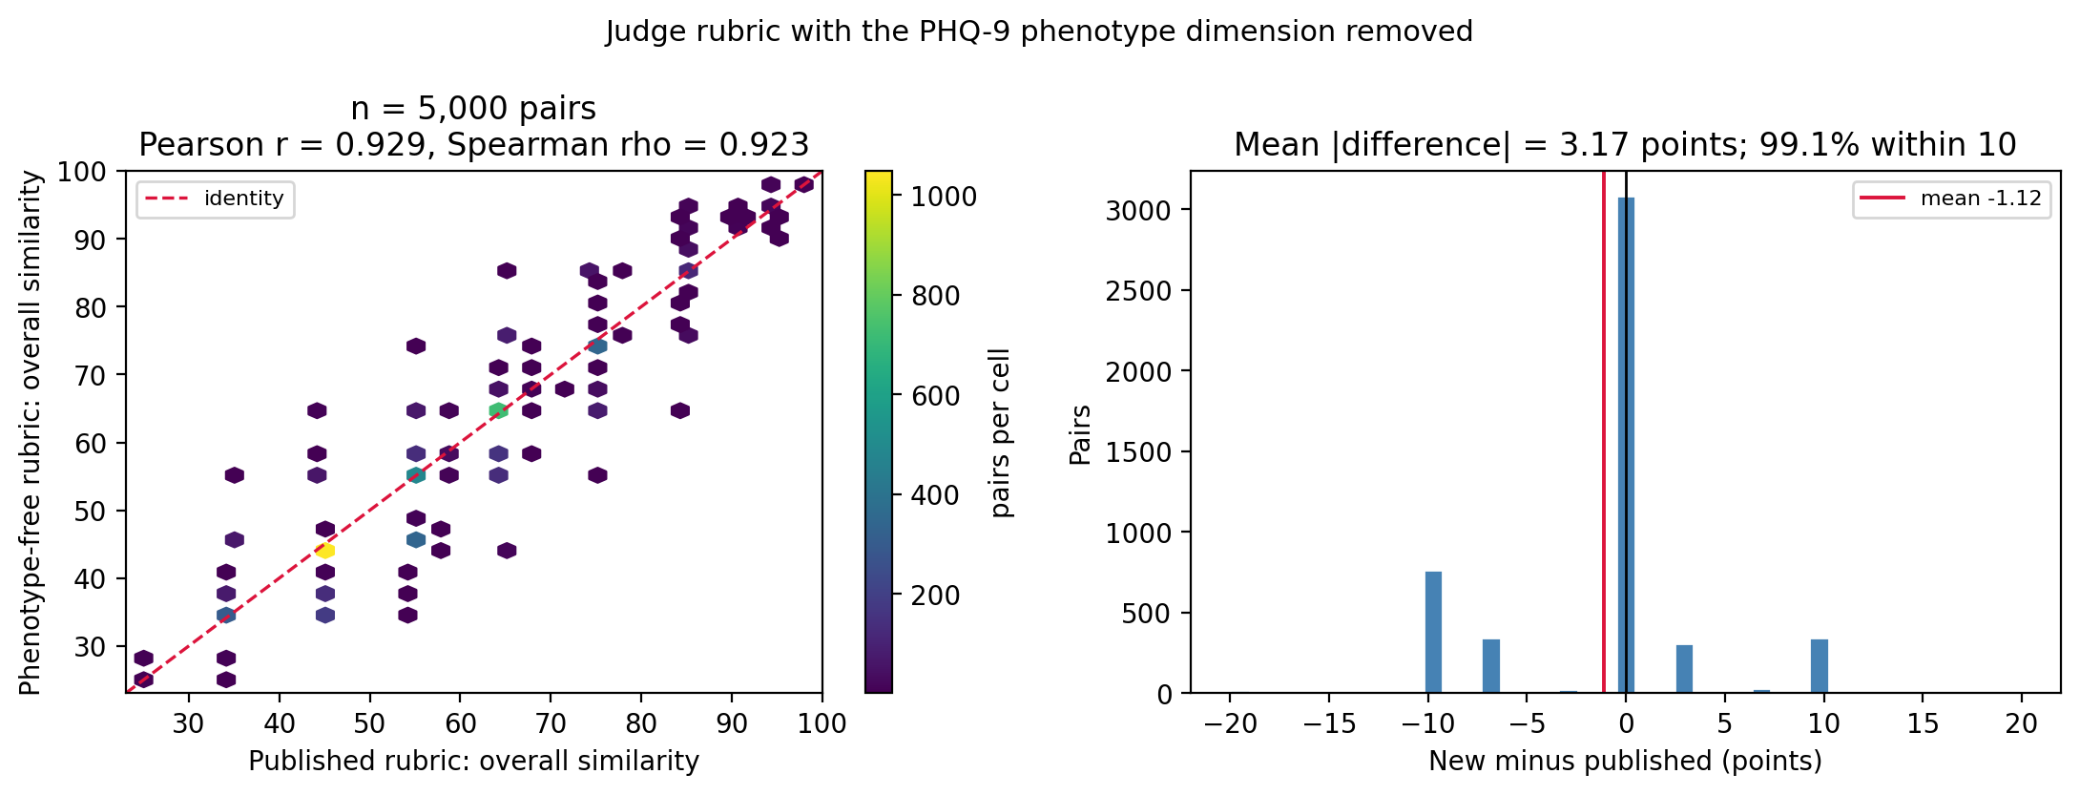

Supplement S2. Effective dimensionality of the embedded representation
Individual embedding dimensions carry no clinical meaning, so the per-feature interpretability available for the feature representation in main-text Figure 7 does not transfer to a 4,096-dimensional embedded representation. What can be characterised instead is how many latent dimensions carry the predictive signal. Three complementary views are reported, all for the primary Qwen3-Embedding-8B encoder on the held-out test set.

S2.1 Sparsity and cumulative built-in importance
The best logistic-regression fit used an elasticnet penalty, with l1_ratio 0.25 and C 0.01, that zeroed most coefficients. Only 385 of the 4,096 dimensions carry non-zero weight, so the signal is concentrated in a sparse subset. Ranking dimensions by each fitted classifier’s native importance and accumulating the mass confirms that concentration. For logistic regression, 80% of the coefficient magnitude falls in roughly 179 of the 4,096 dimensions and 90% in roughly 236, as main-text Figure 8 shows. TRD-relevant information is therefore carried by a modest subset of embedding dimensions rather than spread across the space.

S2.2 Cumulative univariate correlation
An importance ranking is model-specific. As a model-agnostic check we ranked dimensions by the absolute Spearman correlation between each dimension and the outcome, and overlaid that against per-classifier curves ranking by the correlation between each dimension and the predicted risk. Divergence between the two would flag dimensions a classifier weights through regularisation or interactions that a univariate ranking cannot see.
The model-agnostic curve remained diffuse, with many dimensions each weakly correlated with the outcome. The elasticnet logistic-regression curve was far more concentrated, so the regularisation is selecting a compact predictive subset from a broadly informative space. Only the absolute correlation is used, because the sign of a correlation on an unnamed latent dimension is not interpretable.
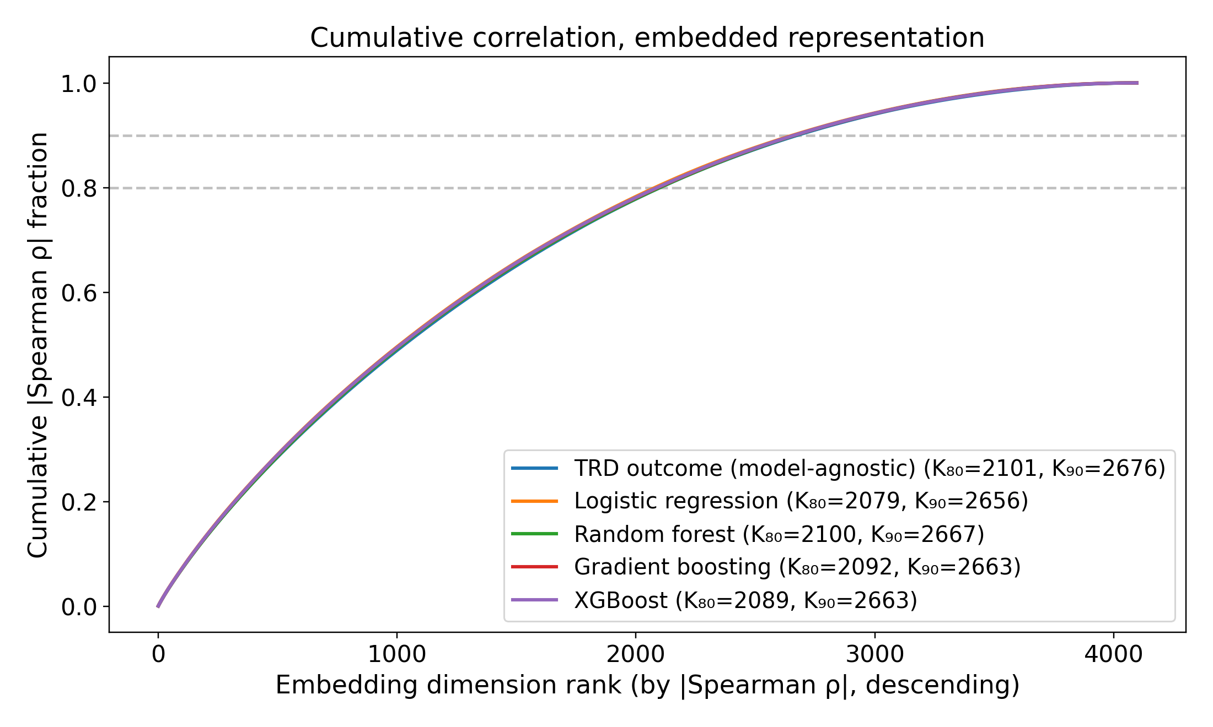
Figure S1. Cumulative absolute univariate (Spearman) correlation. One model-agnostic baseline curve ranks dimensions by the correlation between each dimension and the outcome. The four per-classifier curves rank by the correlation between each dimension and the predicted risk. The plot shows cumulative fraction of total correlation mass against rank, with the K₈₀ and K₉₀ knees in the legend.

S2.3 PCA-K discrimination sweep
To locate the geometric plateau, each classifier was retrained on the top K principal components of the embedding and its held-out ROC AUC plotted against K. The sweep ran K over 1, 2, 4, 8, 16, 32, 64, 128, 256, 512 and 1024. Discrimination rose steeply over the first handful of components and then plateaued. No single low-dimensional projection recovered full-rank performance, which is the same broadly-distributed-signal conclusion the cumulative-importance and correlation curves reach.
(A) Logistic regression
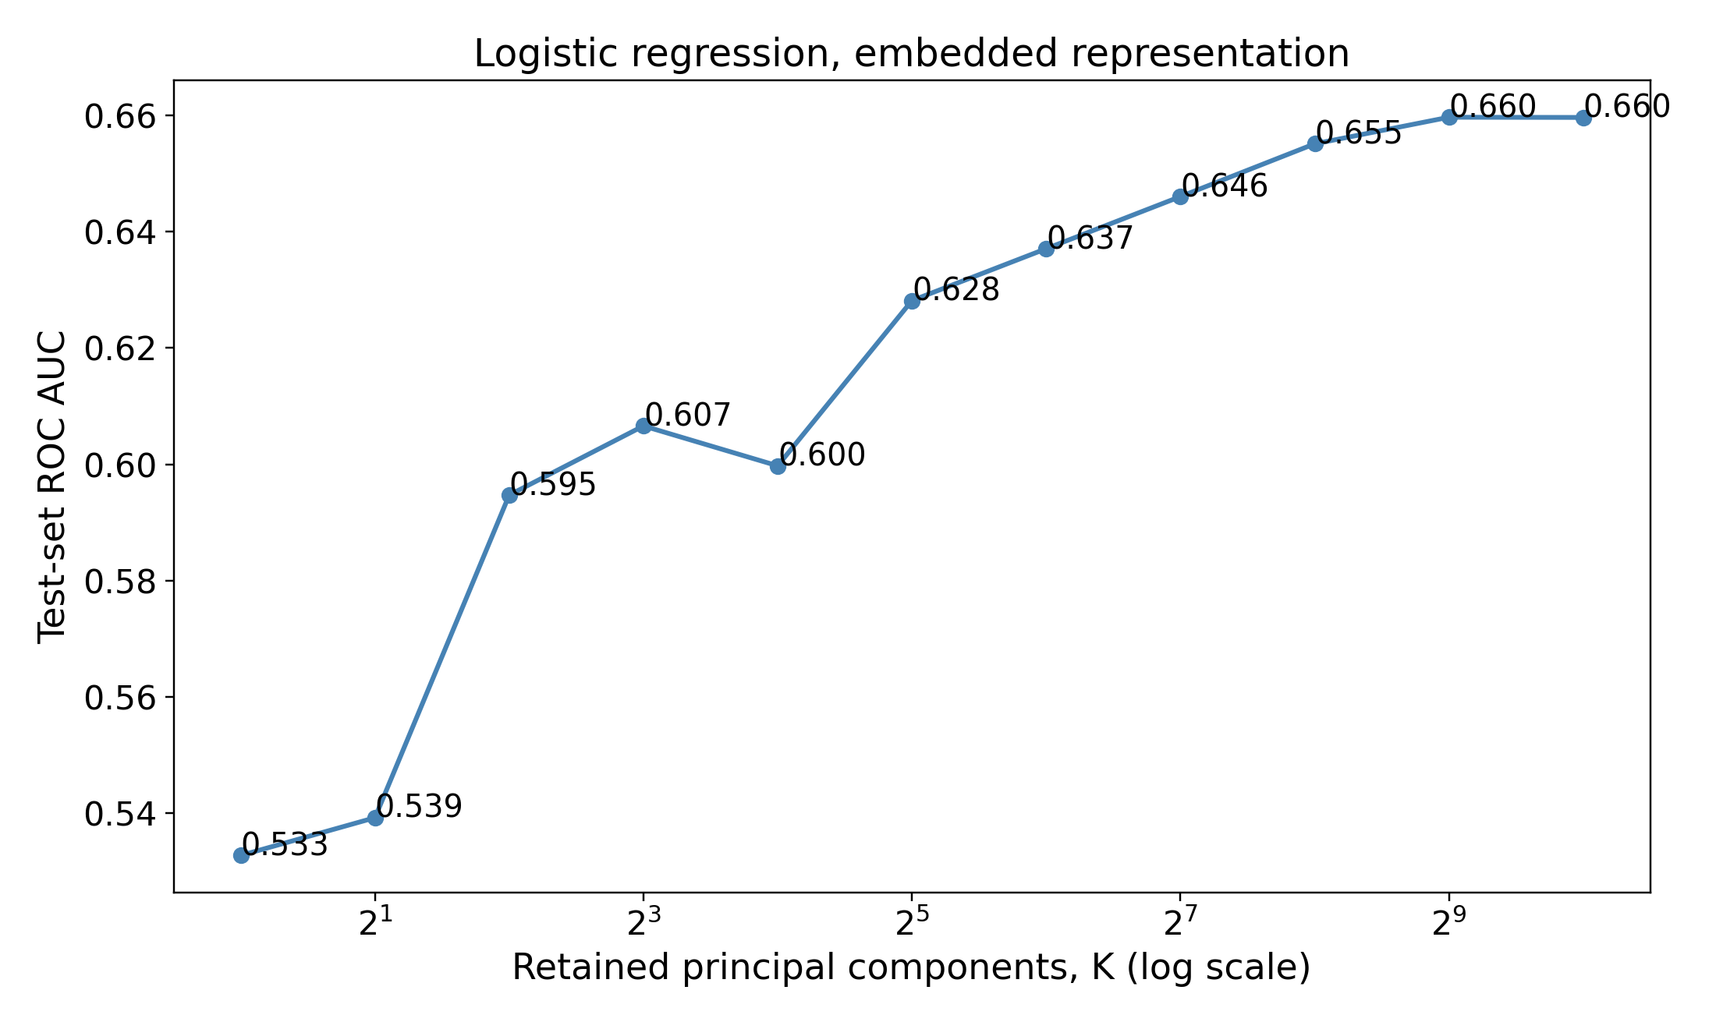
(B) Random forest
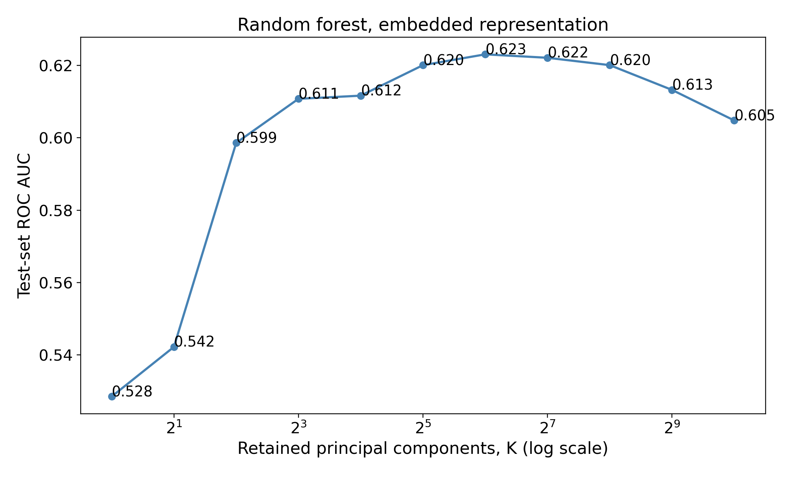
(C) Gradient boosting
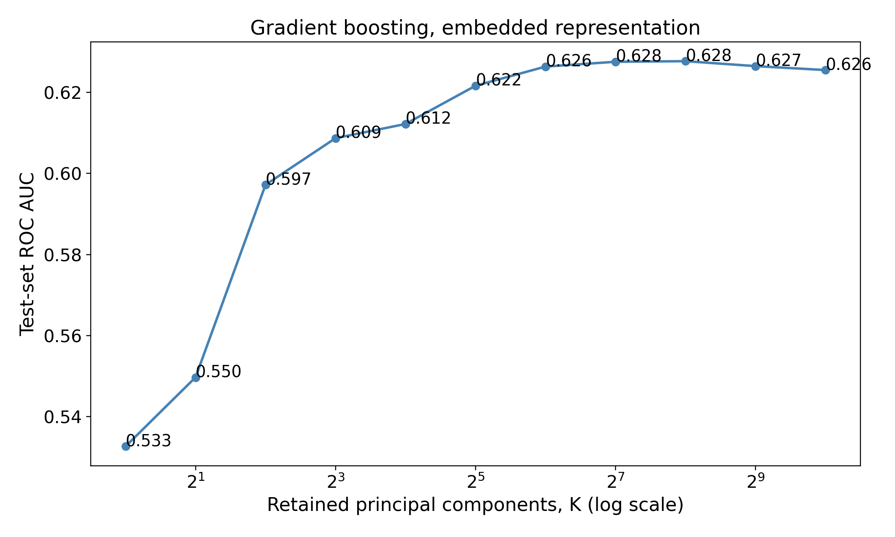
(D) XGBoost
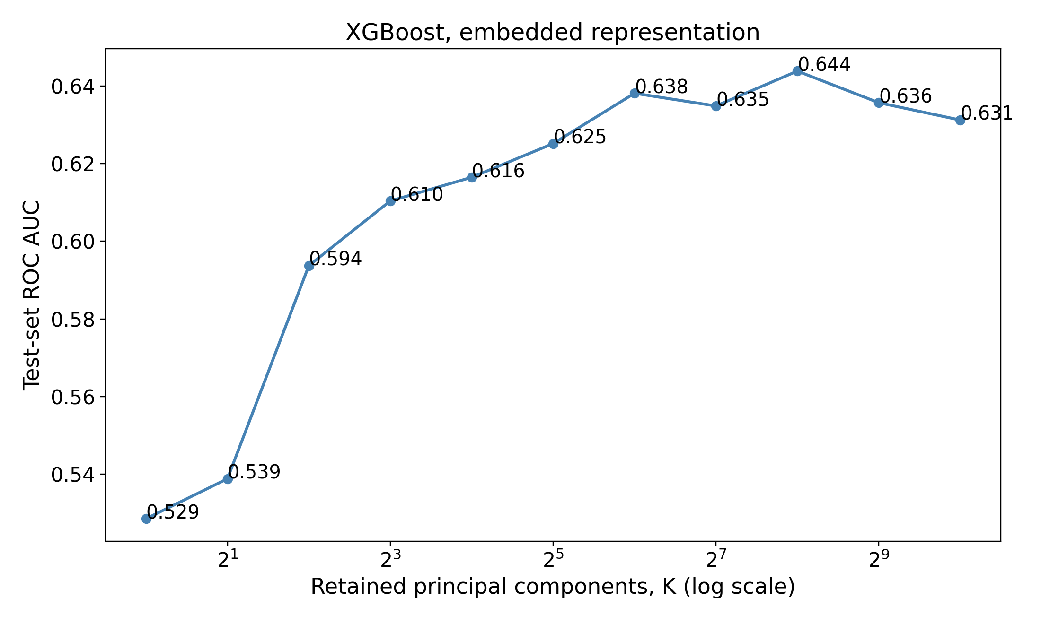
Figure S2. ROC AUC versus number of retained principal components, one panel per classifier: (A) logistic regression, (B) random forest, (C) gradient boosting, (D) XGBoost. The plateau marks the effective number of principal directions beyond which added components do not improve discrimination.

Supplement S3. Precision–recall performance
The main text reports discrimination as ROC AUC, and under this cohort’s roughly 5:1 class imbalance that measure can flatter apparent performance. With 17.5% of patients TRD-positive, the true-negative-dominated specificity term stays high however well or badly the positive class is ranked. The area under the precision-recall curve is the complementary view, because its no-skill baseline is the positive rate itself rather than 0.5. It exposes the precision cost of capturing TRD cases, which is the quantity a clinician would actually feel.
Precision-recall performance tracked discrimination closely and stayed modest for every model in the comparison. At this base rate, high recall on the TRD proxy necessarily forces low precision, and no combination of representation and classifier escaped that trade. No clinical role is inferred from these values, and the main text’s Discussion records that temporal and external validation are prerequisites for any such claim.
Table S1. AUPRC of the four classifiers on each representation (held-out test set). No-skill baseline = 0.175 (the positive rate).
Representation | Classifier | AUPRC
EMBEDDED | Logistic regression | 0.302
EMBEDDED | Random forest | 0.270
EMBEDDED | Gradient boosting | 0.276
EMBEDDED | XGBoost | 0.278
FEATURE | Logistic regression | 0.278
FEATURE | Random forest | 0.293
FEATURE | Gradient boosting | 0.288
FEATURE | XGBoost | 0.298
Table S2. Embedded logistic-regression AUPRC by encoder (held-out test set). No-skill baseline = 0.175.
Encoder | AUPRC
bge-small-en-v1.5 | 0.281
bge-en-icl | 0.297
Qwen3-Embedding-4B | 0.297
Qwen3-Embedding-8B | 0.302
(A) Embedded logistic regression
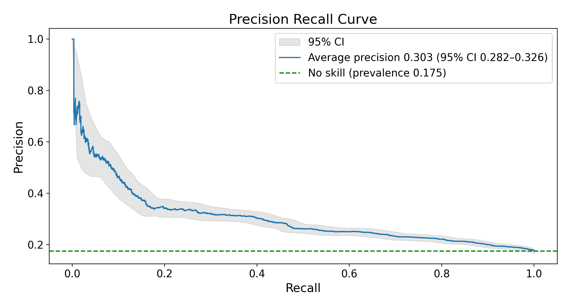
(B) Feature-vector XGBoost
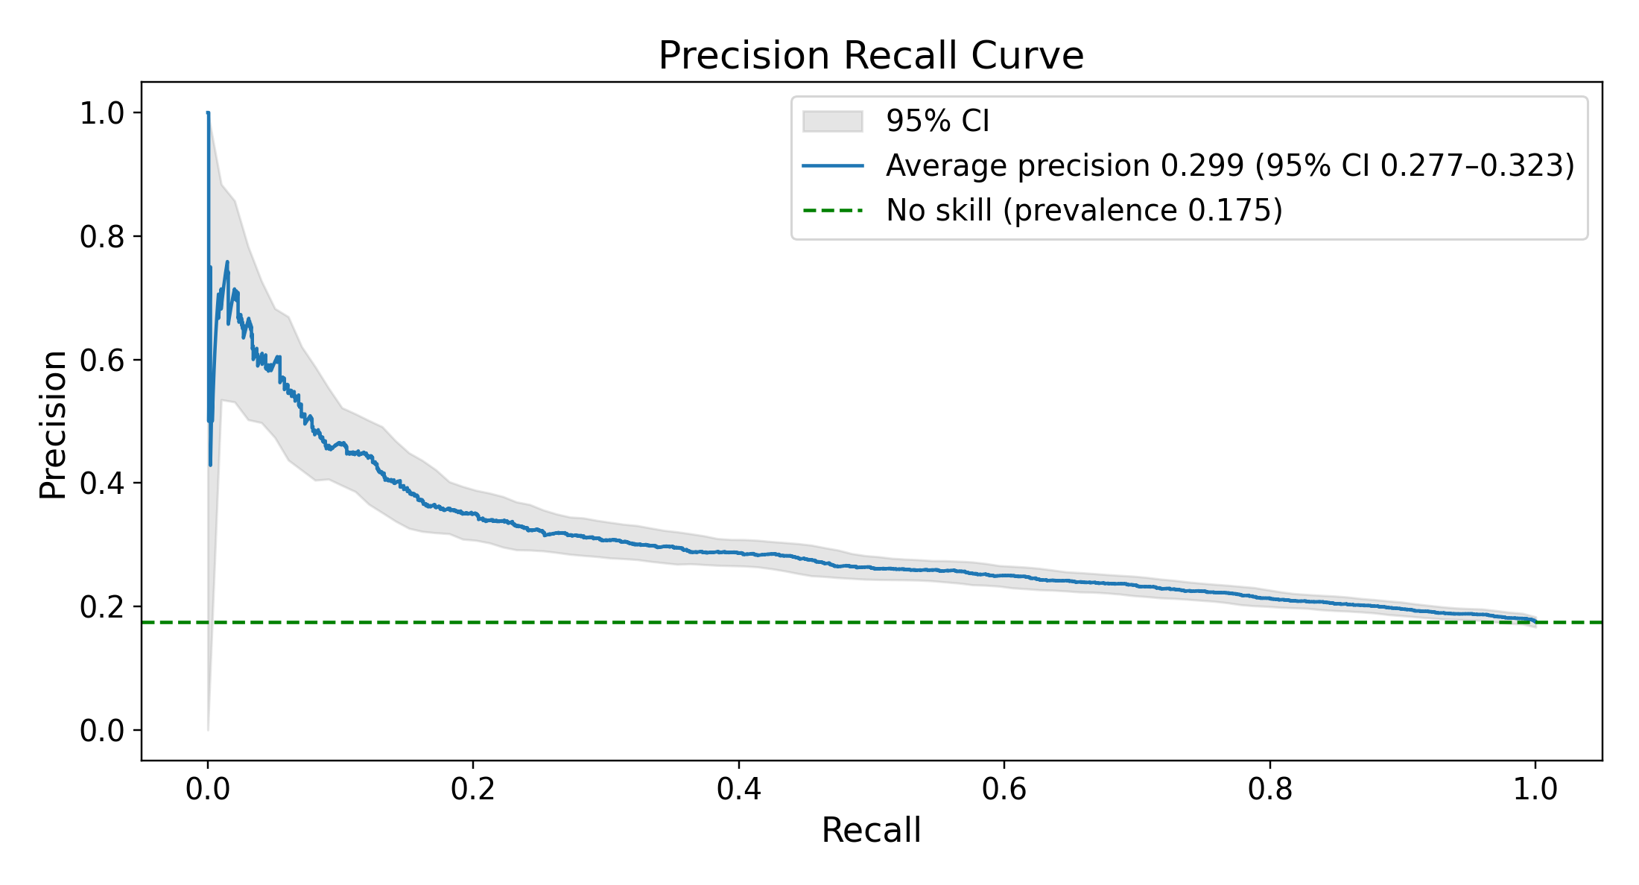
Figure S3. Precision-recall curves for the best classifier on each representation, on the held-out test set with the primary Qwen3-Embedding-8B encoder. Panel A is embedded logistic regression and panel B feature-representation XGBoost. The horizontal reference is the no-skill baseline of 0.175, the positive rate.

Supplement S4. Calibration absolute-error metrics
The main text reports calibration shape in two places: the slope and intercept in its Table 3, and the calibration curves in its Figure 6. The two absolute-error summaries are reported here instead. They are the Brier score and a weighted calibration error, and lower is better for both.
Brier scores sat uniformly near 0.137 to 0.140 across all eight models, dominated by the 17.5% base rate. The weighted calibration error separated the models more clearly. Gradient boosting on the embedded representation was lowest at 0.004, with logistic regression on the feature representation next at 0.005. Both are consistent with the near-ideal slopes those two models carry in main-text Table 3.
Table S3. Brier score and weighted calibration error (WCE) of the four classifiers on each representation (held-out test set). Lower is better for both. Calibration slope and intercept are in main-text Table 3.
Representation | Classifier | Brier | WCE
EMBEDDED | Logistic regression | 0.137 | 0.010
EMBEDDED | Random forest | 0.140 | 0.006
EMBEDDED | Gradient boosting | 0.139 | 0.004
EMBEDDED | XGBoost | 0.139 | 0.013
FEATURE | Logistic regression | 0.139 | 0.005
FEATURE | Random forest | 0.139 | 0.018
FEATURE | Gradient boosting | 0.138 | 0.010
FEATURE | XGBoost | 0.138 | 0.012

Supplement S5. Encoder similarity geometry: a bimodality artifact in bge-small-en-v1.5
A complementary view of how each encoder organises the cohort is the distribution of cosine similarities between patient embeddings. Figure S4 contrasts, for each encoder, the similarities of random patient pairs against those of nearest-neighbour pairs, where the random-pair histogram is the encoder’s overall similarity distribution.
Three of the four encoders produce smooth, unimodal random-pair distributions: bge-en-icl, Qwen3-Embedding-4B and Qwen3-Embedding-8B. The smallest encoder is the exception. Its random-pair distribution is distinctly multimodal, with a sharp primary peak near 0.99 and a separated secondary mode near 0.98. That says the cohort splits into two internally similar groups rather than spreading along one continuum.
(A) bge-small-en-v1.5
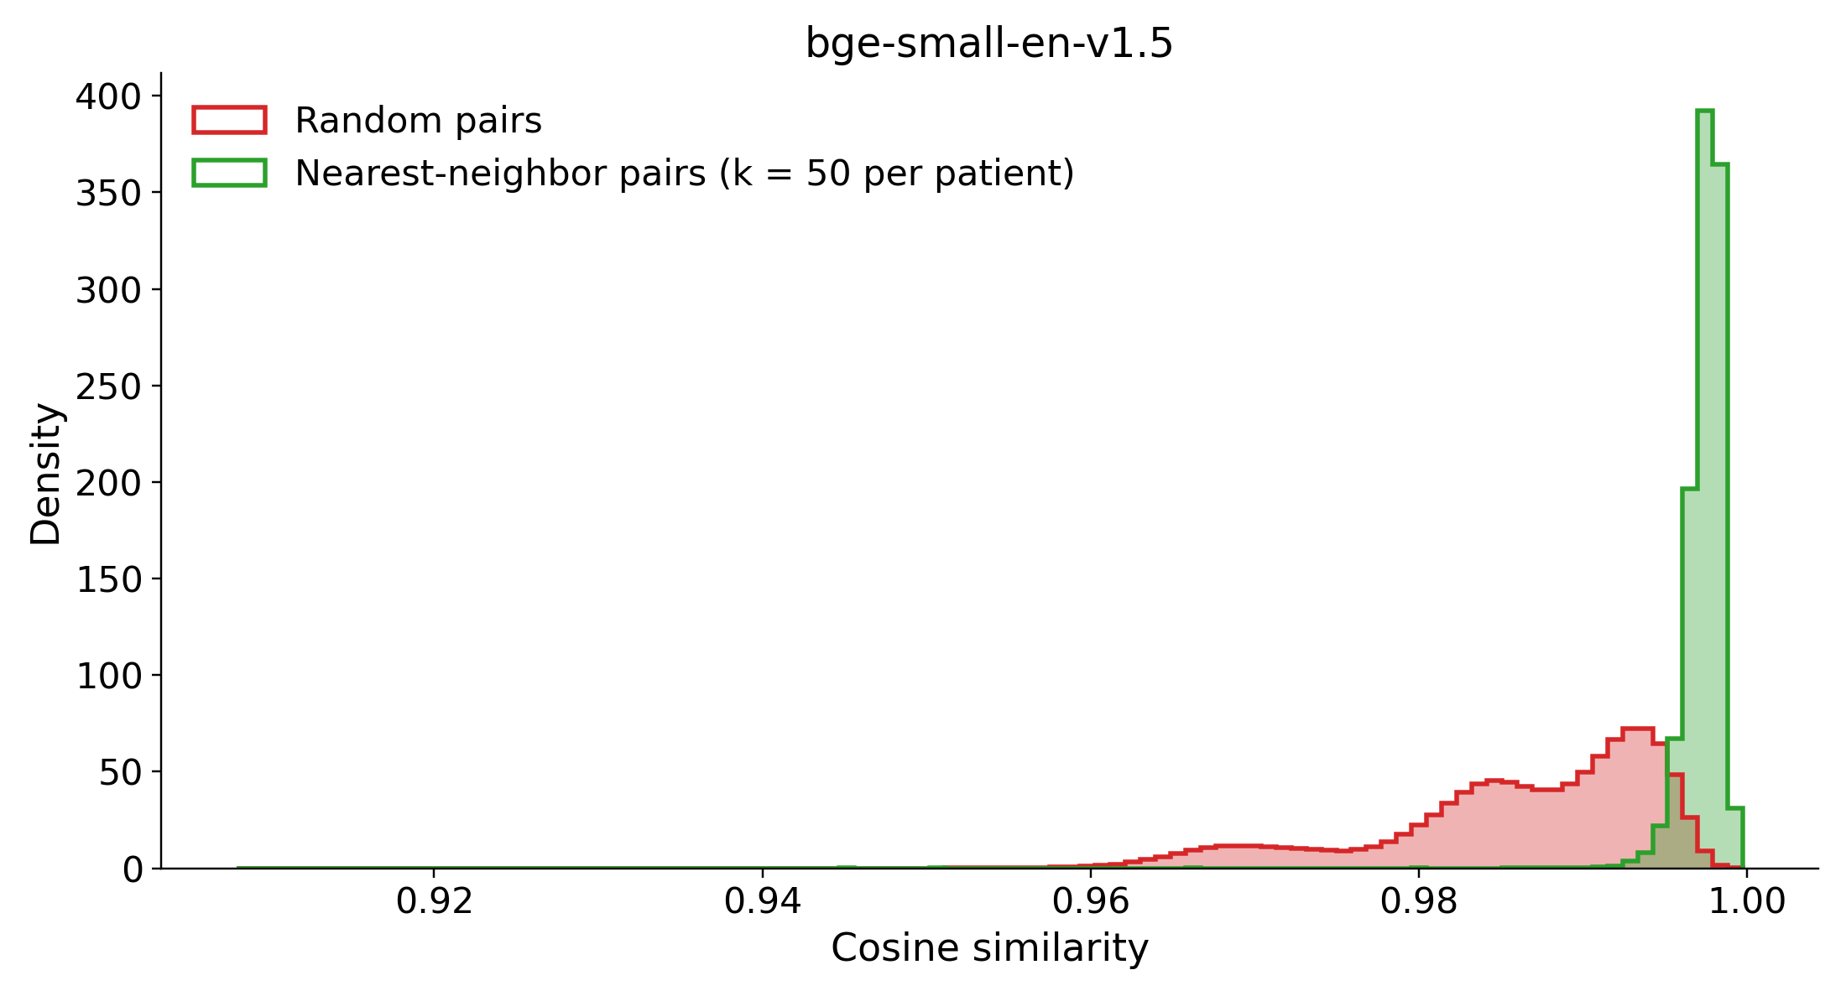
(B) bge-en-icl
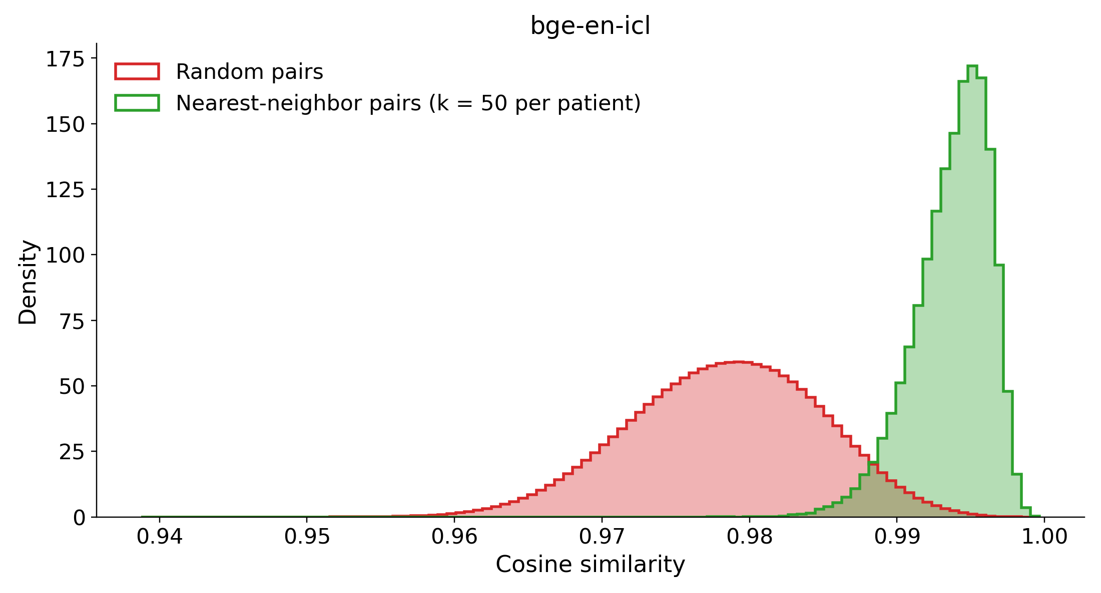
(C) Qwen3-Embedding-4B
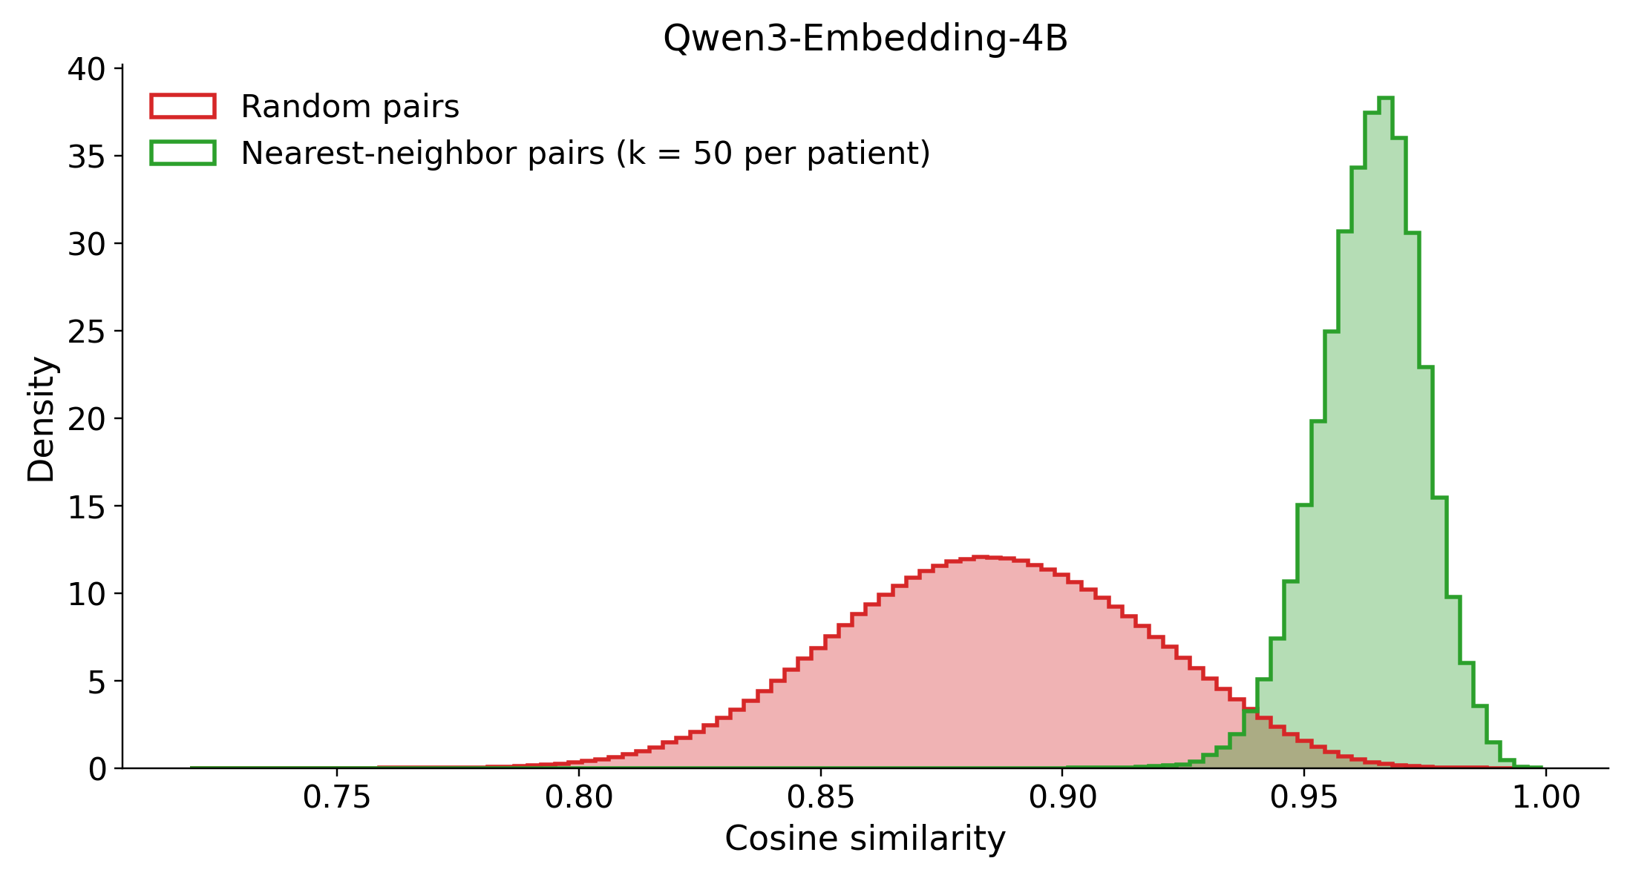
(D) Qwen3-Embedding-8B
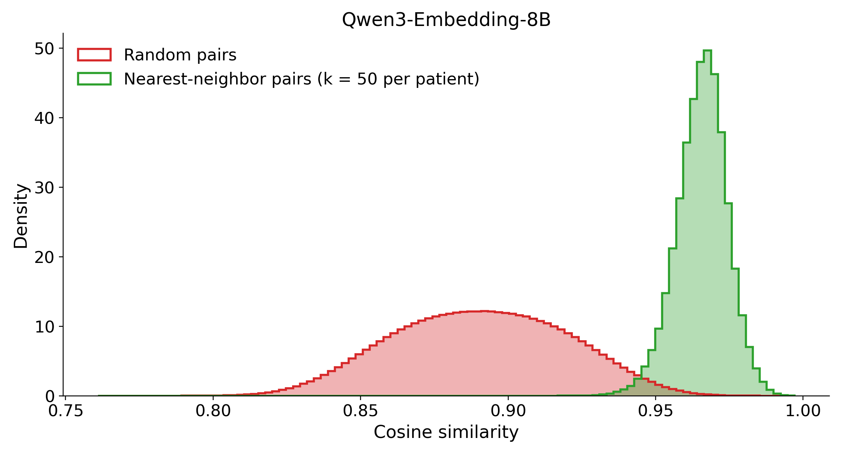
Figure S4. Random-pair (red) versus nearest-neighbor-pair (green) cosine similarities for each encoder (full cohort). (A) bge-small-en-v1.5, (B) bge-en-icl, (C) Qwen3-Embedding-4B, (D) Qwen3-Embedding-8B. The red random-pair histogram is the encoder’s overall similarity distribution: it is multimodal only for bge-small-en-v1.5 (A) and smoothly unimodal for the other three. In every panel the neighbor-pair similarities (green) sit above the bulk of the random-pair mass, confirming that nearest-neighbor retrieval selects genuinely more similar patients. Axis ranges differ per panel because the encoders occupy different absolute similarity bands.
To identify the split we clustered the L2-normalised bge-small embeddings into two groups with k-means, which partitioned the 42,579 patients into 14,438 and 28,141. The partition coincides almost perfectly with a single surface lexical feature. The literal token “episode” appears in essentially every narrative of the larger cluster and almost none of the smaller, and the related MDD recurrence and severity wording follows the same split.
What each cluster is deserves stating precisely, because the two are not simply recurrent against non-recurrent. The narrative renders each patient’s MDD coding verbatim, as MDD (Single Episode, Unspecified) or MDD (Recurrent, Moderate), and only the single-episode wording contains the word “episode”. So:
- Cluster B (28,141) holds narratives that contain “episode”, the single-episode patients, of whom there are 28,206 in the cohort.
- Cluster A (14,438) holds narratives that do not. It is a mixture of the 11,213 patients coded Recurrent and the roughly 3,200 coded Unspecified or Dysthymia, neither of which uses the word “episode”.
Cluster A is therefore best described as carrying no episode token rather than as being all recurrent. Roughly one patient in five inside it is not coded recurrent at all. That distinction is what the second-order analysis below turns on.
Table S4. Surface tokens that most strongly separate the two k-means clusters of bge-small-en-v1.5 embeddings. Values are the fraction of narratives in each cluster containing the token, as binary presence. Cluster A holds 14,438 patients whose narratives carry no “episode” token, which is the recurrent-coded group plus unspecified and dysthymia. Cluster B holds 28,141 single-episode narratives. The token “single” is elevated in both clusters because it also occurs as a marital status.
Token | P(present | cluster A) | P(present | cluster B) | |Δ|
episode | 0.00 | 1.00 | 1.00
recurrent | 0.78 | 0.00 | 0.78
single | 0.30 | 1.00 | 0.70
unspecified | 0.39 | 0.83 | 0.45
moderate | 0.32 | 0.09 | 0.23
Figure S5 makes that mechanism visible. Both panels are histograms of pairs of patients rather than of patients. For every pair in the set shown we compute the cosine similarity between the two embeddings and ask one yes-or-no question about the two narratives: do they agree on a particular word? Pairs that agree are drawn in blue and pairs that disagree in red, with the grey histogram behind them showing every pair in the set. If a single word were driving the geometry, blue and red would sit at visibly different similarities. If it were not, they would lie on top of each other.
Panel A asks this of all 42,579 patients, using the word “episode”: do both narratives contain it, or does neither? Blue is agreement, meaning both single-episode or both non-single-episode, and red is disagreement. The blue pairs pile up at about 0.99 and the red pairs at about 0.97. The two modes of Figure S4A are therefore exactly these two groups. The encoder places two patients about 0.02 further apart when their MDD coding is phrased differently, whatever else is in their records.
Panel B asks the question again inside cluster A alone, using the word “recurrent”. A second question is needed because every narrative in cluster A lacks “episode”, which makes panel A’s question uninformative there. “Recurrent” is a genuine question because cluster A is not uniformly recurrent: 11,425 of its members are coded Recurrent and 3,013 are coded Unspecified. Blue pairs again separate from red pairs, so cluster A carries a real second split, once more on wording rather than on clinical content.
Cluster B was tested the same way and is not plotted. Its only candidate second-order token is the narrative’s Missing sentinel, and there the blue and red histograms lie almost exactly on top of each other. There is no second split to show. Those numbers are in Table S5.
(A) All 42,579 patients, split by the “episode” token
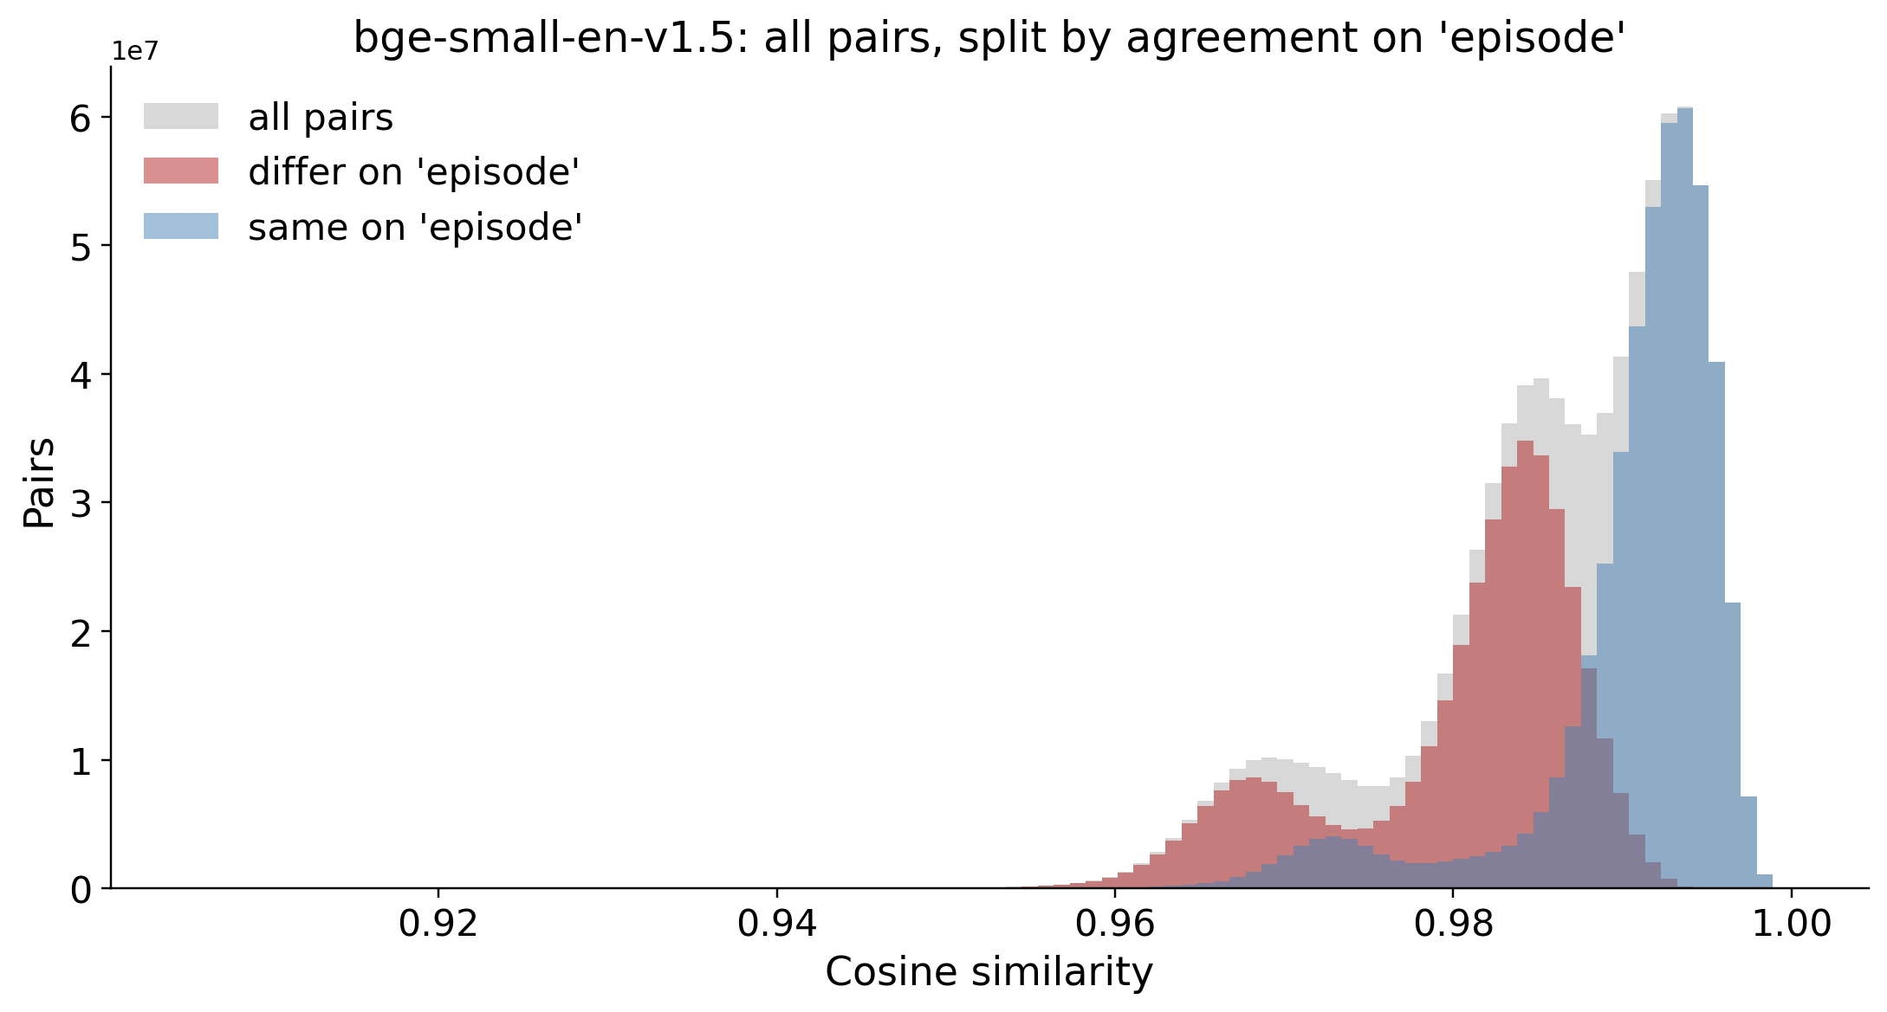
(B) Cluster A only (n = 14,438), split by the “recurrent” token
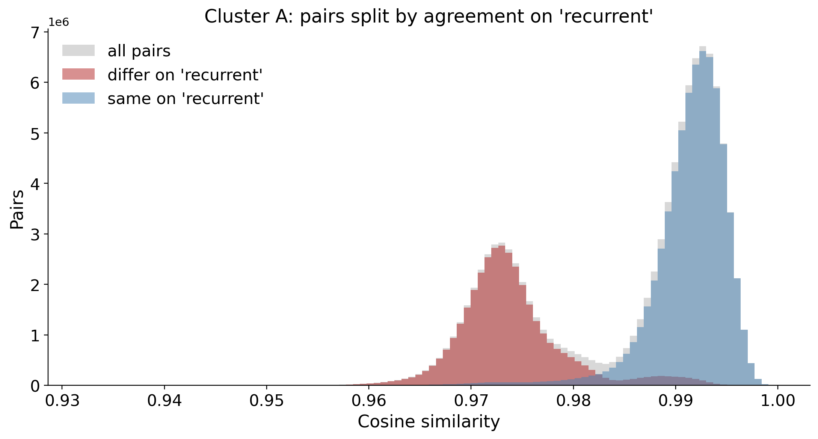
Figure S5. Pairwise cosine-similarity distributions for bge-small-en-v1.5, decomposed by whether the two patients in a pair use the same wording for one token. Blue is same, red is different, and grey is all pairs in the set shown. (A) All 42,579 patients, split on the “episode” token. Same-wording pairs form the upper mode near 0.99 and differing-wording pairs the lower mode near 0.97, so the bimodality in Figure S4A is driven by recurrence phrasing rather than by holistic clinical similarity. (B) Cluster A only, the 14,438 patients whose narratives lack “episode”, split on the “recurrent” token. The two colours again separate, so this cluster is itself genuinely divided, once more along a surface-lexical axis. Cluster B admits no comparable second split and is not plotted.
The lowest-capacity encoder therefore organises its geometry around the presence or absence of one recurrence-phrasing token rather than around holistic clinical content. That lexical split produces the second mode of Figure S4A. The higher-capacity encoders show no such artifact.
On visual inspection each of the two parent clusters looks as though it might contain two further sub-modes. Table S5 tests whether those apparent sub-modes are real. The test is the same one run twice: take a parent cluster on its own, re-run k-means inside it, ask how clean the resulting two-way split is, and then ask which word the split tracks.
Cleanliness is measured by the cosine silhouette, on a 5,000-point subsample with a fixed seed. It scores from −1 to 1 and asks, for each patient, whether it sits closer to its own sub-cluster than to the other one. Higher means better separated. The number is only interpretable by comparison, so the reference point is the top-level split of Table S4, which scores 0.48 under the same metric. A within-cluster split scoring well above 0.48 is more clearly separated than the split it came from. One scoring well below is not really a split at all.
The two parents give opposite answers. Cluster A subdivides more cleanly than the parent split itself, at a silhouette of 0.69. It separates into an explicitly recurrent subgroup of 11,425 patients, carrying the token “recurrent” in 98% along with the severity words moderate, mild and severe. The other side is a smaller unspecified-recurrence subgroup of 3,013, carrying “unspecified” in 100% and no severity wording. That smaller subgroup is the same group of about 3,000 patients, 7% of the cohort, that a flat three-cluster solution peels off.
Cluster B does not meaningfully subdivide. Its silhouette is 0.21, well below the parent 0.48. What little structure it has is keyed on the narrative’s Missing sentinel, present in 88% of one putative subgroup and 2% of the other, which is a data-completeness gradient rather than a clinical contrast. Consistent with that reading, the better-populated side additionally carries named SSRIs, at 0.24 for citalopram, 0.16 for escitalopram and 0.17 for sertraline, simply because those patients have more recorded medication.
Table S5. Do the two clusters of Table S4 split again? Each parent cluster was re-clustered on its own with k-means. “Driving token” is the word whose presence best separates the two resulting sub-clusters. The two proportions are the fraction of narratives containing that word in each sub-cluster, so 0.98 against 0.00 means the word is essentially present in one sub-cluster and absent from the other. “Split silhouette” scores how cleanly the two sub-clusters separate, and should be compared against 0.48, the score of the top-level split under the same metric. Cluster A splits cleanly, on recurrence phrasing. Cluster B does not split: its 0.21 is a weak data-completeness gradient on the missing-data sentinel, which is why it is not plotted in Figure S5.
Parent cluster (n) | Splits into (n / n) | Driving token | Token present, sub 1 / sub 2 | Split silhouette (top level = 0.48) | Real split?
A: no “episode” token (14,438) | recurrent + severity (11,425) / unspecified (3,013) | recurrent | 0.98 / 0.00 | 0.69 | Yes
B: single-episode (28,141) | sparse record (6,594) / populated record (21,547) | missing | 0.88 / 0.02 | 0.21 | No
This layered reading reinforces the single-token interpretation rather than complicating it. At the top level the encoder keys on the recurrence token, and the only genuine finer structure is a further split of cluster A on recurrence phrasing, which is again a surface-lexical axis. Where a candidate second split does not track clinical content, as in cluster B, the silhouette correctly declines to support it and the apparent mode reduces to how completely the record was filled in.
Two things follow. The result is consistent with bge-small-en-v1.5 being the weakest discriminator in the cross-embedder comparison of main-text Table 6. And it is a cautionary note that a small sentence-transformer can organise its geometry around individual surface tokens rather than around clinical content. The analysis is descriptive, resting on k-means splits and binary token-presence rates, and it is specific to this encoder. All primary analyses use Qwen3-Embedding-8B.

Supplement S6. Example patient narratives
The embedded representation encodes a deterministically rendered Markdown narrative of each patient’s pre-index window. To make the encoder’s input concrete, two representative narratives are reproduced below, one TRD-positive and one TRD-negative. They were extracted by scripts/pipeline/neighbors/narrative_audit.py as the first patient by sorted de-identified hash in each outcome class, with output written to results/Qwen-Qwen3-Embedding-8B/google_medgemma-27b-text-it/narrative_audit/. Each narrative contains only structured EHR-derived fields, with no free text, names or direct identifiers. Section headers and field order are fixed across all patients, absent findings are rendered explicitly as “Absent” and unrecorded values as “Missing”, so every patient reaches the encoder through the same constant template.
The renderer’s own field labels predate the manuscript’s terminology: where the narrative prints MDD-to-anchor gap and Baseline window, the manuscript says the MDD-to-index gap and the lookback window. The narratives are reproduced exactly as the encoder received them and are not re-labelled here.
Three things visible in these examples are not matched by the feature representation, and all three are recorded as a limitation of the head-to-head comparison in the main text and in Supplement S11:
- the PHYSICAL HEALTH section renders the within-patient mean vital signs that were dropped from the feature matrix at load time;
- the SOCIODEMOGRAPHICS / ACCESS line renders a recorded sexual-orientation field that is absent from the feature inventory entirely, and renders an unrecorded value there as the literal token nan rather than as Missing;
- the COHORT & INDEX line renders the index date, for which the feature representation has no column.
The MEDICATION BURDEN and TREATMENT EXPOSURE sections also name individual ingredients where the feature representation carries only their counts. The imbalance runs the other way once: pre-index history length is a feature-representation column that the narrative does not render.
TRD-positive example.
### COHORT & INDEX
Condition: MDD (Dysthymia, Unspecified) | Index date: 2022-10-06 | Baseline window: -730...0 days | MDD-to-anchor gap: 57 days | Encounters in window: 34 | MDD within window: Present
### SOCIODEMOGRAPHICS / ACCESS
Sex: Male | PreferredLanguage: English | AgeInYears: 37 | SexualOrientation: nan | MaritalStatus: Married | Religion: Baptist | SmokingStatus: Never | Race_Ethnicity: American Indian or Alaska Native
SDOH: None Recorded
### PHYSICAL HEALTH
BMI: 29.8 | BP (mean): 140/88
### PSYCH HISTORY
SOCIAL_ANXIETY: Absent | OCD: Absent | ANXIETY: Present | ADJUSTMENT_DISORDER: Absent | PTSD: Absent | DYSTHYMIA: Present | SUD: Present | INSOMNIA: Present
SUICIDE FLAG (2y): Absent
SUBSTANCE ABUSE: Nicotine
### MEDICAL COMORBIDITY
CHRONIC_PAIN: Absent | HYPERLIPIDEMIA: Absent | THYROID: Absent | DIABETES: Present
### TREATMENT EXPOSURE
Prior adequate AD trials: MIRTAZAPINE: 0 | SSRI: 1 | VORTIOXETINE: 0 | BUPROPION: 0 | SNRI: 0
Benzodiazepine days (2y): 0
Hypnotics: eszopiclone
Augmentation: Absent
### MEDICATION BURDEN
Active meds at baseline: 0 (Absent)
NSAID burden: 0 (Absent)
### UTILIZATION
Psych inpatient days: 0 (2y) | ED psych visits: 0 (2y)
### SAFETY
UNCONTROLLED_HTN: Present | EPILEPSY: Absent

TRD-negative example.
### COHORT & INDEX
Condition: MDD (Recurrent, Moderate) | Index date: 2025-05-09 | Baseline window: -730...0 days | MDD-to-anchor gap: 0 days | Encounters in window: 2 | MDD within window: Present
### SOCIODEMOGRAPHICS / ACCESS
Sex: Female | PreferredLanguage: English | AgeInYears: 52 | SexualOrientation: nan | MaritalStatus: Single | Religion: Baptist | SmokingStatus: Every Day | Race_Ethnicity: White or Caucasian
SDOH: None Recorded
### PHYSICAL HEALTH
BMI: 35.6 | BP (mean): 138/86
### PSYCH HISTORY
SOCIAL_ANXIETY: Absent | OCD: Absent | ANXIETY: Present | ADJUSTMENT_DISORDER: Absent | PTSD: Absent | DYSTHYMIA: Absent | SUD: Present | INSOMNIA: Absent
SUICIDE FLAG (2y): Absent
SUBSTANCE ABUSE: Nicotine
### MEDICAL COMORBIDITY
CHRONIC_PAIN: Absent | HYPERLIPIDEMIA: Absent | THYROID: Absent | DIABETES: Absent
### TREATMENT EXPOSURE
Prior adequate AD trials: MIRTAZAPINE: 0 | SSRI: 0 | VORTIOXETINE: 0 | BUPROPION: 0 | SNRI: 0
Benzodiazepine days (2y): 0
Hypnotics: Absent
Augmentation: Absent
### MEDICATION BURDEN
Active meds at baseline: 0 (Absent)
NSAID burden: 0 (Absent)
### UTILIZATION
Psych inpatient days: 0 (2y) | ED psych visits: 0 (2y)
### SAFETY
UNCONTROLLED_HTN: Present | EPILEPSY: Absent

Supplement S8. Discrimination stratified by length of pre-index history
The main text tests the volume and recency confound by correlating the TRD label with three proxies for how much data a patient has, and finds all three associations weak and negative. That test asks whether the outcome tracks data volume. This section asks the stronger question: whether discrimination tracks it. That is what one would expect if the predictor were partly reading data volume rather than clinical content.
The held-out test set was divided into quintiles of pre-index history length and the neighbour-weighted predictor scored within each. The nearest-retrieval, judge-weighted arm is reported in Table S7, and the pattern is the same for the other weighting strategies.
Table S7. Neighbor-weighted discrimination by quintile of pre-index history length (nearest retrieval, LLM weighting, embedded representation, held-out test set). Quintile bounds are in days of pre-index history.
Pre-index history (days) | Patients | ROC AUC
731–1,110 | 1,706 | 0.588
1,110–1,554 | 1,704 | 0.601
1,554–2,066 | 1,701 | 0.572
2,066–2,733 | 1,704 | 0.613
2,733–5,288 | 1,701 | 0.579
Discrimination is flat across the range. The spread between best and worst quintile is 0.041 ROC AUC with no monotone trend, across a span of history length that varies more than fourfold from the shortest quintile to the longest. Had the predictor been exploiting record volume, discrimination should have risen with it. It does not.
Two limits attach to this analysis. It covers the neighbour-weighted arm only rather than the trained classifiers that carry the main comparison, because the stratification was computed over the neighbour predictions. And each quintile holds roughly 1,700 patients, so the per-quintile estimates are individually imprecise and the claim rests on the absence of a trend rather than on any single value. A parallel stratification by embedding-neighbourhood density was computed and is not reported: the density distribution is concentrated enough that three of its five bins were empty, leaving too little coverage to interpret.

Supplement S9. The held-out set against the training set
The main text reports the split’s sizes and outcome counts and states that every per-predictor standardized mean difference is small. This section shows the distributions behind that statement, because a claim about comparability that is asserted rather than displayed cannot be checked by a reader.
The split is the frozen stratified 80/20 split every evaluation in this paper uses. Nothing was refit or re-split to produce this table, and the standardized mean differences use the same pooled-standard-deviation definition as main-text Table 1, so the two tables are directly comparable.
Over the 100 predictor rows the largest absolute value is 0.036, and no row reaches the conventional 0.1 threshold for a non-trivial imbalance. The maximum sits on a social-determinant flag recorded for 22 training patients and none of the held-out patients. That is a small-cell artifact rather than a distributional difference: the flag’s prevalence is 0.1% in the arm that has it. The outcome rate matches by construction, the split having been stratified on it, and is therefore not evidence of anything.
Table S8. Held-out patients against training patients on the characteristics reported in main-text Table 1. Continuous variables are median with interquartile range, and categorical and boolean entries are n with per cent. SMD is training minus held-out, in pooled standard deviations. Vital signs are shown because they describe the cohort. They are rendered only in the narrative representation and are absent from the feature matrix as published, as Supplement S11 records.
Characteristic | Training | Held-out | SMD
Demographics
Age (years) | 55 (38-70) | 55 (38-70) | -0.014
Age band: 18-29 | 4,428 (13.0%) | 1,085 (12.7%) | +0.008
Age band: 30-44 | 7,198 (21.1%) | 1,827 (21.5%) | -0.008
Age band: 45-64 | 10,632 (31.2%) | 2,636 (31.0%) | +0.006
Age band: 65+ | 11,805 (34.7%) | 2,968 (34.9%) | -0.004
Sex: Female | 24,682 (72.5%) | 6,168 (72.4%) | +0.001
Race: White/Caucasian | 27,244 (80.0%) | 6,835 (80.3%) | -0.007
Race: Black/African American | 1,894 (5.6%) | 474 (5.6%) | -0.000
Race: Am. Indian/Alaska Native | 1,637 (4.8%) | 396 (4.7%) | +0.007
Race: Missing | 247 (0.7%) | 50 (0.6%) | +0.017
Language: English only | 33,698 (98.9%) | 8,425 (98.9%) | -0.000
Depression phenotype
MDD recurrence: Recurrent | 9,036 (26.5%) | 2,177 (25.6%) | +0.022
MDD severity: Severe | 1,818 (5.3%) | 468 (5.5%) | -0.007
MDD severity: Moderate | 5,807 (17.0%) | 1,426 (16.7%) | +0.008
Psychiatric and substance comorbidity
Suicidality flagged | 1,392 (4.1%) | 361 (4.2%) | -0.008
Anxiety disorder | 17,975 (52.8%) | 4,426 (52.0%) | +0.016
Substance use disorder (any) | 7,472 (21.9%) | 1,793 (21.1%) | +0.021
Insomnia | 7,452 (21.9%) | 1,898 (22.3%) | -0.010
PTSD | 1,241 (3.6%) | 300 (3.5%) | +0.006
Alcohol use disorder | 1,523 (4.5%) | 352 (4.1%) | +0.017
Medical comorbidity
High cholesterol | 12,591 (37.0%) | 3,156 (37.1%) | -0.002
Uncontrolled hypertension | 12,544 (36.8%) | 3,136 (36.8%) | +0.000
Vital signs (narrative only)
BMI | 29 (25-35) | 29 (25-35) | -0.013
Systolic BP | 126 (118-136) | 126 (118-136) | -0.010
BMI: not recorded | 7,484 (22.0%) | 1,911 (22.4%) | -0.011
Treatment and utilization
Active med count | 1 (0-2) | 1 (0-2) | +0.008
Encounter count | 21 (8-46) | 20 (8-47) | -0.001
Pre-index history (days) | 1792 (1213-2547) | 1797 (1222-2541) | +0.004
Prior adequate AD trial (any class) | 5,014 (14.7%) | 1,262 (14.8%) | -0.003
Benzodiazepine days recorded | 3,775 (11.1%) | 949 (11.1%) | -0.002
Hypnotic recorded | 1,319 (3.9%) | 342 (4.0%) | -0.007
Augmentation therapy used | 326 (1.0%) | 96 (1.1%) | -0.017
What this does and does not establish. It establishes that the patients the models were scored on are distributionally interchangeable with the patients they were trained on, so the reported discrimination is not an artifact of an unrepresentative evaluation sample.
It establishes nothing about representativeness of any wider population. The delivered extract is case-enriched by design and both halves of the split inherit that enrichment equally, and a table comparing two halves of a selected cohort cannot detect the selection they share. The calibration reported in this paper remains calibration to this cohort’s own base rate, and the limitation stands as written.

Supplement S10. Subgroup discrimination and calibration
This paper makes no fairness claim. The permutation slate it reports measures how much a model’s discrimination depends on a concept being present in its input, which is a different question from whether performance is even across groups. This section reports the subgroup evidence itself.

S10.1 Design
Nothing was refit. The per-patient held-out predicted probabilities the pipeline persists were partitioned by stratum, and discrimination and calibration recomputed inside each group. Subsetting a per-patient prediction vector is arithmetically identical to scoring that model on the subset, so no published number can drift. Refitting within a subgroup would answer a different question, namely how a model trained only on one group predicts that group, and it would break comparability with everything else reported.
All three prediction arms are covered, not only the classifiers. The embedded and feature arms contribute their four classifiers each, and the neighbour-weighted arm contributes its sixteen retrieval-scheme by weighting-strategy configurations. Only the four nearest-retrieval configurations are contrasted across groups. Whether a deliberately uninformative retrieval scheme is evenly uninformative across subgroups is not a fairness question, and including the negative controls would triple the multiplicity burden on the contrasts that are.
Strata. Six sociodemographic families and two clinical ones. The sociodemographic families are sex, race, age band, marital status, smoking status and religion. The clinical families are MDD recurrence and severity. Race is collapsed to majority against recorded minority, because a level-by-level breakdown is not estimable at 80.0% White or Caucasian. Preferred language is absent by necessity rather than by choice: 98.9% of the cohort prefers English, which leaves one estimable level and therefore no contrast. A group whose smaller class holds fewer than 20 outcome events is declared not estimable rather than reported.
Intervals and multiplicity. Within-group intervals are percentile bootstraps over that group’s own patients. Between-group intervals are unpaired bootstraps, because two subgroups are disjoint patient sets and each must be resampled independently. That is unlike the paired test used for the representation contrasts in main-text Figure 3.
Two hundred and eighty-eight contrasts were computed. At that number, nominally significant results arise from sampling alone, so each contrast carries a two-sided bootstrap P value taken from the same draws and adjusted across the entire reported set by Benjamini-Hochberg. The adjusted value is what we interpret, and both are tabulated so a reader can see the effect of the correction.
Calibration slope is the coefficient of a logistic regression of the outcome on the logit of predicted risk, where 1.0 is perfect. Calibration-in-the-large is mean predicted risk minus observed rate, where 0.0 is perfect. Both are computed directly rather than from the binned calibration surface used in main-text Table 3, because a bin-mean fit over a few thousand patients describes the bin grid more than it describes the model.

S10.2 Sociodemographic strata
Table S9. Discrimination and calibration by sociodemographic stratum, one representative model per arm, held-out test set. Groups are not disjoint across families: every patient with a recorded sex appears in one sex row and every patient with a recorded race in one race row.
Group | n | TRD+ | Arm | ROC AUC (95% CI) | Brier | Calibration slope | Calibration-in-the-large
All held-out patients | 8,516 | 1,491 | Embedded (logistic regression) | 0.657 (0.643–0.672) | 0.137 | 0.97 | +0.000
All held-out patients | 8,516 | 1,491 | Feature vector (logistic regression) | 0.629 (0.613–0.644) | 0.139 | 0.95 | -0.000
All held-out patients | 8,516 | 1,491 | Neighbour-weighted (nearest, LLM) | 0.595 (0.578–0.610) | 0.142 | 0.52 | -0.011
Male | 2,347 | 386 | Embedded (logistic regression) | 0.653 (0.622–0.682) | 0.131 | 0.94 | -0.003
Male | 2,347 | 386 | Feature vector (logistic regression) | 0.626 (0.595–0.655) | 0.133 | 0.86 | -0.003
Male | 2,347 | 386 | Neighbour-weighted (nearest, LLM) | 0.599 (0.566–0.631) | 0.135 | 0.56 | -0.010
Female | 6,168 | 1,105 | Embedded (logistic regression) | 0.658 (0.641–0.675) | 0.139 | 0.98 | +0.002
Female | 6,168 | 1,105 | Feature vector (logistic regression) | 0.630 (0.612–0.648) | 0.141 | 0.99 | +0.001
Female | 6,168 | 1,105 | Neighbour-weighted (nearest, LLM) | 0.591 (0.572–0.610) | 0.145 | 0.50 | -0.012
White/Caucasian | 6,835 | 1,181 | Embedded (logistic regression) | 0.657 (0.640–0.674) | 0.136 | 0.97 | +0.002
White/Caucasian | 6,835 | 1,181 | Feature vector (logistic regression) | 0.633 (0.615–0.652) | 0.137 | 0.98 | +0.001
White/Caucasian | 6,835 | 1,181 | Neighbour-weighted (nearest, LLM) | 0.605 (0.586–0.623) | 0.140 | 0.57 | -0.011
Non-White (recorded) | 1,631 | 302 | Embedded (logistic regression) | 0.652 (0.620–0.684) | 0.144 | 0.95 | -0.004
Non-White (recorded) | 1,631 | 302 | Feature vector (logistic regression) | 0.608 (0.573–0.643) | 0.147 | 0.79 | -0.004
Non-White (recorded) | 1,631 | 302 | Neighbour-weighted (nearest, LLM) | 0.553 (0.516–0.590) | 0.152 | 0.34 | -0.011
Race not recorded | 50 | 8 | Embedded (logistic regression) | not estimable | — | — | —
Race not recorded | 50 | 8 | Feature vector (logistic regression) | not estimable | — | — | —
Race not recorded | 50 | 8 | Neighbour-weighted (nearest, LLM) | not estimable | — | — | —
Age band: 18-29 | 1,085 | 218 | Embedded (logistic regression) | 0.611 (0.568–0.654) | 0.156 | 0.78 | +0.003
Age band: 18-29 | 1,085 | 218 | Feature vector (logistic regression) | 0.570 (0.524–0.615) | 0.160 | 0.60 | +0.012
Age band: 18-29 | 1,085 | 218 | Neighbour-weighted (nearest, LLM) | 0.547 (0.505–0.592) | 0.162 | 0.32 | -0.006
Age band: 30-44 | 1,827 | 372 | Embedded (logistic regression) | 0.653 (0.621–0.682) | 0.154 | 0.95 | -0.002
Age band: 30-44 | 1,827 | 372 | Feature vector (logistic regression) | 0.636 (0.605–0.667) | 0.155 | 1.00 | -0.002
Age band: 30-44 | 1,827 | 372 | Neighbour-weighted (nearest, LLM) | 0.587 (0.552–0.619) | 0.159 | 0.56 | -0.020
Age band: 45-64 | 2,636 | 473 | Embedded (logistic regression) | 0.652 (0.623–0.679) | 0.140 | 0.98 | +0.007
Age band: 45-64 | 2,636 | 473 | Feature vector (logistic regression) | 0.607 (0.580–0.636) | 0.143 | 0.88 | -0.001
Age band: 45-64 | 2,636 | 473 | Neighbour-weighted (nearest, LLM) | 0.593 (0.564–0.620) | 0.145 | 0.55 | -0.010
Age band: 65+ | 2,968 | 428 | Embedded (logistic regression) | 0.658 (0.630–0.682) | 0.117 | 1.10 | -0.005
Age band: 65+ | 2,968 | 428 | Feature vector (logistic regression) | 0.641 (0.614–0.669) | 0.119 | 1.18 | -0.003
Age band: 65+ | 2,968 | 428 | Neighbour-weighted (nearest, LLM) | 0.587 (0.555–0.619) | 0.121 | 0.42 | -0.010
Marital status: Divorced | 882 | 211 | Embedded (logistic regression) | 0.640 (0.593–0.681) | 0.173 | 0.90 | -0.046
Marital status: Divorced | 882 | 211 | Feature vector (logistic regression) | 0.607 (0.563–0.649) | 0.177 | 0.85 | -0.049
Marital status: Divorced | 882 | 211 | Neighbour-weighted (nearest, LLM) | 0.582 (0.537–0.624) | 0.182 | 0.34 | -0.067
Marital status: Never Married | 2,364 | 438 | Embedded (logistic regression) | 0.634 (0.609–0.661) | 0.145 | 0.85 | +0.013
Marital status: Never Married | 2,364 | 438 | Feature vector (logistic regression) | 0.598 (0.569–0.627) | 0.149 | 0.72 | +0.016
Marital status: Never Married | 2,364 | 438 | Neighbour-weighted (nearest, LLM) | 0.566 (0.537–0.597) | 0.151 | 0.40 | -0.002
Marital status: Now Married | 4,251 | 694 | Embedded (logistic regression) | 0.670 (0.650–0.690) | 0.129 | 1.05 | -0.001
Marital status: Now Married | 4,251 | 694 | Feature vector (logistic regression) | 0.644 (0.623–0.666) | 0.131 | 1.10 | -0.002
Marital status: Now Married | 4,251 | 694 | Neighbour-weighted (nearest, LLM) | 0.610 (0.587–0.634) | 0.133 | 0.63 | -0.007
Marital status: Separated | 99 | 21 | Embedded (logistic regression) | 0.518 (0.364–0.673) | 0.171 | 0.08 | +0.001
Marital status: Separated | 99 | 21 | Feature vector (logistic regression) | 0.518 (0.357–0.687) | 0.169 | 0.30 | -0.003
Marital status: Separated | 99 | 21 | Neighbour-weighted (nearest, LLM) | 0.544 (0.378–0.706) | 0.168 | 0.22 | -0.012
Marital status: Widowed | 891 | 120 | Embedded (logistic regression) | 0.654 (0.597–0.708) | 0.111 | 1.09 | +0.022
Marital status: Widowed | 891 | 120 | Feature vector (logistic regression) | 0.625 (0.572–0.678) | 0.112 | 1.17 | +0.017
Marital status: Widowed | 891 | 120 | Neighbour-weighted (nearest, LLM) | 0.576 (0.516–0.629) | 0.116 | 0.38 | +0.001
Smoking status: Current Smoker | 1,126 | 243 | Embedded (logistic regression) | 0.667 (0.631–0.706) | 0.158 | 1.01 | -0.009
Smoking status: Current Smoker | 1,126 | 243 | Feature vector (logistic regression) | 0.617 (0.575–0.660) | 0.162 | 0.87 | -0.011
Smoking status: Current Smoker | 1,126 | 243 | Neighbour-weighted (nearest, LLM) | 0.624 (0.585–0.661) | 0.164 | 0.79 | -0.026
Smoking status: Former Smoker | 2,532 | 443 | Embedded (logistic regression) | 0.663 (0.636–0.690) | 0.137 | 0.98 | +0.003
Smoking status: Former Smoker | 2,532 | 443 | Feature vector (logistic regression) | 0.633 (0.603–0.660) | 0.140 | 0.89 | +0.001
Smoking status: Former Smoker | 2,532 | 443 | Neighbour-weighted (nearest, LLM) | 0.581 (0.549–0.611) | 0.144 | 0.45 | -0.014
Smoking status: Never Smoker | 4,788 | 793 | Embedded (logistic regression) | 0.646 (0.623–0.665) | 0.132 | 0.93 | +0.001
Smoking status: Never Smoker | 4,788 | 793 | Feature vector (logistic regression) | 0.625 (0.603–0.645) | 0.133 | 0.99 | +0.002
Smoking status: Never Smoker | 4,788 | 793 | Neighbour-weighted (nearest, LLM) | 0.586 (0.563–0.607) | 0.136 | 0.45 | -0.006
Religion: Catholic | 608 | 93 | Embedded (logistic regression) | 0.695 (0.634–0.754) | 0.120 | 1.29 | +0.009
Religion: Catholic | 608 | 93 | Feature vector (logistic regression) | 0.648 (0.587–0.710) | 0.124 | 1.06 | +0.002
Religion: Catholic | 608 | 93 | Neighbour-weighted (nearest, LLM) | 0.626 (0.562–0.686) | 0.126 | 0.74 | +0.005
Religion: Non-Christian | 50 | 16 | Embedded (logistic regression) | not estimable | — | — | —
Religion: Non-Christian | 50 | 16 | Feature vector (logistic regression) | not estimable | — | — | —
Religion: Non-Christian | 50 | 16 | Neighbour-weighted (nearest, LLM) | not estimable | — | — | —
Religion: Orthodox | 9 | 3 | Embedded (logistic regression) | not estimable | — | — | —
Religion: Orthodox | 9 | 3 | Feature vector (logistic regression) | not estimable | — | — | —
Religion: Orthodox | 9 | 3 | Neighbour-weighted (nearest, LLM) | not estimable | — | — | —
Religion: Other/Unknown | 759 | 145 | Embedded (logistic regression) | 0.615 (0.565–0.664) | 0.151 | 0.72 | -0.013
Religion: Other/Unknown | 759 | 145 | Feature vector (logistic regression) | 0.589 (0.537–0.642) | 0.153 | 0.66 | -0.010
Religion: Other/Unknown | 759 | 145 | Neighbour-weighted (nearest, LLM) | 0.547 (0.494–0.603) | 0.155 | 0.31 | -0.021
Religion: Protestant | 4,654 | 793 | Embedded (logistic regression) | 0.665 (0.644–0.685) | 0.134 | 1.00 | +0.003
Religion: Protestant | 4,654 | 793 | Feature vector (logistic regression) | 0.642 (0.620–0.662) | 0.135 | 1.05 | +0.002
Religion: Protestant | 4,654 | 793 | Neighbour-weighted (nearest, LLM) | 0.601 (0.580–0.624) | 0.139 | 0.56 | -0.011

S10.3 Clinical strata
Table S10. Discrimination and calibration by recorded depression phenotype, one representative model per arm.
Group | n | TRD+ | Arm | ROC AUC (95% CI) | Brier | Calibration slope | Calibration-in-the-large
MDD severity: Mild | 633 | 105 | Embedded (logistic regression) | 0.683 (0.624–0.742) | 0.130 | 1.39 | -0.020
MDD severity: Mild | 633 | 105 | Feature vector (logistic regression) | 0.607 (0.547–0.667) | 0.135 | 0.86 | -0.018
MDD severity: Mild | 633 | 105 | Neighbour-weighted (nearest, LLM) | 0.558 (0.501–0.619) | 0.139 | 0.36 | -0.026
MDD severity: Moderate | 1,426 | 255 | Embedded (logistic regression) | 0.652 (0.618–0.687) | 0.142 | 0.98 | +0.003
MDD severity: Moderate | 1,426 | 255 | Feature vector (logistic regression) | 0.634 (0.599–0.670) | 0.142 | 1.06 | +0.001
MDD severity: Moderate | 1,426 | 255 | Neighbour-weighted (nearest, LLM) | 0.595 (0.556–0.631) | 0.146 | 0.57 | -0.007
MDD severity: Psychotic | 18 | 8 | Embedded (logistic regression) | not estimable | — | — | —
MDD severity: Psychotic | 18 | 8 | Feature vector (logistic regression) | not estimable | — | — | —
MDD severity: Psychotic | 18 | 8 | Neighbour-weighted (nearest, LLM) | not estimable | — | — | —
MDD severity: Remission | 143 | 19 | Embedded (logistic regression) | not estimable | — | — | —
MDD severity: Remission | 143 | 19 | Feature vector (logistic regression) | not estimable | — | — | —
MDD severity: Remission | 143 | 19 | Neighbour-weighted (nearest, LLM) | not estimable | — | — | —
MDD severity: Severe | 468 | 137 | Embedded (logistic regression) | 0.700 (0.648–0.749) | 0.187 | 1.21 | +0.029
MDD severity: Severe | 468 | 137 | Feature vector (logistic regression) | 0.636 (0.578–0.690) | 0.197 | 0.88 | +0.029
MDD severity: Severe | 468 | 137 | Neighbour-weighted (nearest, LLM) | 0.665 (0.611–0.716) | 0.193 | 0.99 | -0.001
MDD severity: Unspecified | 5,828 | 967 | Embedded (logistic regression) | 0.641 (0.621–0.660) | 0.133 | 0.94 | -0.000
MDD severity: Unspecified | 5,828 | 967 | Feature vector (logistic regression) | 0.615 (0.595–0.634) | 0.134 | 0.98 | -0.001
MDD severity: Unspecified | 5,828 | 967 | Neighbour-weighted (nearest, LLM) | 0.575 (0.555–0.595) | 0.138 | 0.40 | -0.012
MDD recurrence: | 32 | 7 | Embedded (logistic regression) | not estimable | — | — | —
MDD recurrence: | 32 | 7 | Feature vector (logistic regression) | not estimable | — | — | —
MDD recurrence: | 32 | 7 | Neighbour-weighted (nearest, LLM) | not estimable | — | — | —
MDD recurrence: Dysthymia | 584 | 97 | Embedded (logistic regression) | 0.690 (0.638–0.748) | 0.130 | 1.33 | +0.008
MDD recurrence: Dysthymia | 584 | 97 | Feature vector (logistic regression) | 0.627 (0.565–0.687) | 0.134 | 1.13 | +0.010
MDD recurrence: Dysthymia | 584 | 97 | Neighbour-weighted (nearest, LLM) | 0.584 (0.526–0.650) | 0.137 | 0.56 | +0.001
MDD recurrence: Recurrent | 2,177 | 433 | Embedded (logistic regression) | 0.698 (0.671–0.726) | 0.146 | 1.09 | -0.000
MDD recurrence: Recurrent | 2,177 | 433 | Feature vector (logistic regression) | 0.676 (0.648–0.703) | 0.148 | 1.07 | -0.002
MDD recurrence: Recurrent | 2,177 | 433 | Neighbour-weighted (nearest, LLM) | 0.650 (0.623–0.678) | 0.151 | 0.79 | -0.011
MDD recurrence: Single Episode | 5,723 | 954 | Embedded (logistic regression) | 0.633 (0.612–0.652) | 0.134 | 0.86 | +0.000
MDD recurrence: Single Episode | 5,723 | 954 | Feature vector (logistic regression) | 0.605 (0.584–0.626) | 0.136 | 0.83 | -0.000
MDD recurrence: Single Episode | 5,723 | 954 | Neighbour-weighted (nearest, LLM) | 0.565 (0.543–0.585) | 0.139 | 0.33 | -0.012

S10.4 What survives correction
Seventy-two of the 288 contrasts exclude zero unadjusted, and 35 survive Benjamini-Hochberg adjustment. They are not the ones the analysis was commissioned to look for.
Table S11. Contrasts surviving Benjamini-Hochberg adjustment across all 288 reported comparisons, grouped by contrast and arm. “Models surviving” counts how many of that arm’s contrasted models cleared the threshold.
Contrast | Arm | Models surviving | ΔROC AUC range | smallest p (BH)
Age: 18-29 vs rest | Feature vector | 3 of 4 | -0.071 to -0.066 | 0.0384
Marital status: Never Married vs rest | Embedded | 2 of 4 | -0.054 to -0.051 | 0.0125
MDD recurrence: Recurrent vs rest | Embedded | 4 of 4 | +0.059 to +0.072 | 0.0125
MDD recurrence: Recurrent vs rest | Feature vector | 4 of 4 | +0.060 to +0.068 | 0.0125
MDD recurrence: Recurrent vs rest | Neighbour-weighted | 4 of 4 | +0.075 to +0.082 | 0.0125
MDD recurrence: Single Episode vs rest | Embedded | 4 of 4 | -0.071 to -0.065 | 0.0125
MDD recurrence: Single Episode vs rest | Feature vector | 4 of 4 | -0.064 to -0.054 | 0.0230
MDD recurrence: Single Episode vs rest | Neighbour-weighted | 4 of 4 | -0.077 to -0.073 | 0.0125
MDD severity: Severe vs rest | Neighbour-weighted | 4 of 4 | +0.086 to +0.087 | 0.0384
MDD severity: Unspecified vs rest | Neighbour-weighted | 2 of 4 | -0.051 to -0.047 | 0.0125
Sex: no difference anywhere. All twelve male-minus-female contrasts include zero, across every arm and model, and the largest absolute difference is 0.012 ROC AUC. Nothing here needs qualification.
Race: consistent in direction, not significant after correction. All twelve White-minus-non-White contrasts are positive, from +0.005 to +0.055 ROC AUC, and seven exclude zero unadjusted. Those seven include all four neighbour-weighted configurations, which is a structurally different predictor reproducing the same sign. None survives adjustment, and the smallest adjusted P is .08. Calibration moves the same way in the feature arm, where the slope among non-White patients is 0.79 against 0.98 among White patients, while the embedded arm holds at 0.95 against 0.97.
The correct reading is neither “no difference” nor “a gap of 0.04”. This cohort lacks the power to settle it. The minority stratum carries 302 outcome events against 1,181, so its intervals are roughly twice as wide, and a real difference of the size observed could as easily have gone undetected.
What the data do show is a sign consistent across twelve contrasts and three independent predictor families, which is not the shape sampling noise usually takes. Alongside it sits a calibration deficit concentrated in one representation. Both are reported for that reason, and neither is claimed as established.
What the data do show is a sign consistent across twelve contrasts and three independent predictor families, which is not the shape sampling noise usually takes, together with a calibration deficit concentrated in one representation. Both are reported for that reason. Neither is claimed as established.
What does survive is how the depression is coded. Twenty-four of the 35 surviving contrasts concern MDD recurrence and severity. Discrimination is higher among patients coded with recurrent MDD, by +0.059 to +0.082 against the rest, and lower among those coded single-episode, by −0.077 to −0.054, in twelve of twelve arm-model combinations in each direction. Severity behaves the same way in the neighbour-weighted arm: higher among patients coded severe at +0.086, lower among those coded unspecified at −0.051 to −0.047.
The pattern is coherent and it is as much about documentation as about phenotype. The models discriminate better where the diagnosis is recorded specifically and worse where the coding is left unspecified, which is the majority of this cohort: 5,828 of 8,516 held-out patients are coded unspecified severity.
Two sociodemographic contrasts survive, and both point the same way as the documentation story. Discrimination is lower among patients aged 18-29 than among the rest in the feature arm, by −0.071 to −0.066 in three of four classifiers with an adjusted P of .04. It is also lower among never-married patients in the embedded arm, by −0.054 and −0.051 with an adjusted P of .01. Younger and never-married patients accumulate less recorded history, which is consistent with thinner records supporting weaker prediction. This analysis cannot separate that explanation from any other.
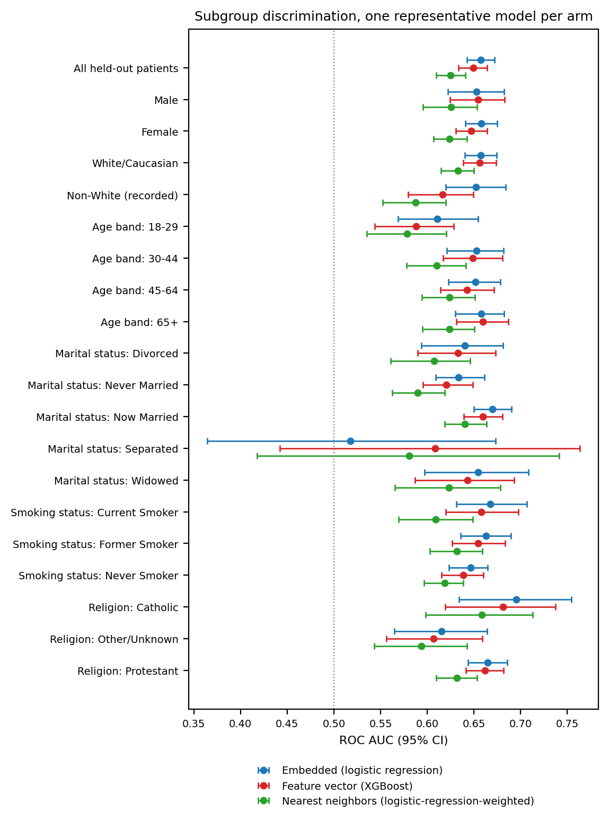
Figure S9. Subgroup discrimination across sociodemographic strata, one representative model per arm, with 95% bootstrap confidence intervals. The dotted line marks chance. Strata declared not estimable are omitted.

Supplement S11. Field-level crosswalk of the two representations
The head-to-head comparison in this paper is between two encodings of one record, so it is only a comparison of encodings to the extent that both encodings are given the same fields. They are not, and this section is the field-by-field accounting that difference requires. Every row was read off the pipeline source rather than from the manuscript’s description of it: scripts/data_loading/feature_vector.py for the feature column, and scripts/data_loading/deterministic_narrative.py for the rendered text.
Temporal availability is the same for every row and is stated once here rather than repeated thirty times. Every field is measured at or before the index date, inside the 730-day lookback window, except recorded history length, which measures the window’s own extent. No field in either representation reads post-index data.
Table S12. Field-level crosswalk. Asymmetric marks a row where the two representations do not receive the same information. Missing-value rules are as implemented, not as intended.
Source field | Feature-matrix encoding | Narrative rendering | Missing-value rule | Parity
MDD recurrence, severity | two categorical columns | Condition: MDD (recurrence, severity) | empty string is a level in both | matched
Index date | no column | Index date: YYYY-MM-DD | never missing | asymmetric
Lookback window width | no column (constant) | Baseline window: −730...0 days | never missing | matched (carries no information)
MDD-to-index gap | mdd_to_anchor_days, float | MDD-to-anchor gap: N days | never missing | matched
Encounter count in window | num_encounters, float | Encounters in window: N | never missing | matched
MDD inside lookback window | mdd_within_window, boolean | MDD within window: Present/Absent | never missing | matched
Recorded pre-index history length | pre_anchor_history_days, float | not rendered | never missing | asymmetric
Age | AgeInYears, float | AgeInYears: N | never missing | matched
Sex | categorical | Sex: X | absent value becomes its own one-hot level; narrative prints the raw token | matched
Race / ethnicity | categorical, seven levels | Race_Ethnicity: X | own one-hot level; narrative prints raw token | matched
Preferred language | categorical, collapsed to five levels | raw Epic value | own one-hot level | asymmetric (finer in narrative)
Marital status | categorical, collapsed to five levels | raw Epic value | own one-hot level | asymmetric (finer in narrative)
Religion | categorical, collapsed to five levels | raw Epic value | own one-hot level | asymmetric (finer in narrative)
Smoking status | categorical, collapsed to three levels | raw Epic value | own one-hot level | asymmetric (finer in narrative)
Sexual orientation | no column | SexualOrientation: X | rendered as the literal token nan when recorded-but-empty | asymmetric
Social determinants of health | nine boolean columns | SDOH: list of present categories only | absence is an explicit False in the matrix, an omission from the list in the narrative | matched in content
BMI, systolic BP, diastolic BP | dropped at load | BMI: N \| BP (mean): S/D, or Missing | dropped, so no rule; narrative prints Missing | asymmetric
Psychiatric comorbidity (8 flags) | eight boolean columns | ARM: Present/Absent for all eight | never missing | matched
Suicidality flag | boolean | SUICIDE FLAG (2y): Present/Absent | never missing | matched
Substance-use specifics (10) | ten boolean columns | names of present substances only | absence explicit in matrix, omitted in narrative | matched in content
General medical comorbidity (4) | four boolean columns | ARM: Present/Absent for all four | never missing | matched
Prior adequate AD trials | five trials_<class> counts | Prior adequate AD trials: CLASS: n for all five | never missing | matched
Benzodiazepine days | benzo_days_coverage, float | Benzodiazepine days (2y): N | never missing | matched
Hypnotics | hypnotics_burden, count only | count plus ingredient names | never missing | asymmetric (finer in narrative)
Active medications | polypharmacy_count, count only | count plus ingredient names | never missing | asymmetric (finer in narrative)
NSAIDs | nsaid_count, count only | count plus ingredient names | never missing | asymmetric (finer in narrative)
Psychiatric inpatient days, ED visits | two float columns | Psych inpatient days: N \| ED psych visits: N | never missing | matched
Prescribing-safety comorbidity (2) | two boolean columns | ARM: Present/Absent | never missing | matched
What the crosswalk shows. The imbalance is not symmetric, and it is larger than a count of fields suggests. Eleven rows are asymmetric and ten of them favour the narrative:
- two fields it renders and the matrix has no column for, the index date and sexual orientation;
- three vital signs the matrix drops at load;
- four sociodemographic fields where the matrix collapses raw Epic values into coarse categories and the narrative prints the raw token;
- three medication blocks where the matrix carries a count and the narrative names the ingredients.
One row favours the feature matrix: recorded history length, which the narrative does not render.
Two rules are worth stating because they are easy to assume wrongly. Missingness is not silently imputed on the categorical side of the feature matrix. An absent value becomes its own one-hot level, so the model can use the fact of a missing record. And the vital signs were dropped rather than imputed, so the published feature arm never saw them in any form. That reason is mechanical rather than principled: a numeric column carrying nulls cannot pass through the pipeline’s scaler.
Whether this imbalance carries the head-to-head result was tested rather than conceded. The two largest asymmetries were closed and the primary comparison re-run on matched inputs. The feature matrix received the vitals under an explicit missingness indicator per block with within-fold median imputation, and the narrative rendered recorded history length. The best-versus-best contrast remains a null on matched inputs. That analysis is reported separately and is available from the corresponding author, and the main text states the imbalance itself, which is what bounds the claim.

Supplement S12. Subgroup outcome prevalence
This section reports the within-subgroup prevalence of TRD: the number of TRD-positive patients divided by the total patients in that subgroup. Main-text Table 1 gives column percentages conditioned on TRD status rather than row percentages, so the prevalences below were computed from the raw subgroup counts. The 18-29 age band is the worked example: its TRD prevalence is 20.6%, or 1,135 TRD-positive patients out of 5,513.
TRD prevalence varied modestly across subgroups. By sex it was 18.0% in women against 16.2% in men. By age band it followed a clear gradient. The two youngest bands were highest and nearly tied, at 20.6% in 18-29-year-olds (1,135 of 5,513) and 20.3% in 30-44-year-olds (1,836 of 9,025). It then fell through 18.4% at 45-64 (2,445 of 13,268) to 13.8% in those aged 65 or older (2,039 of 14,773).
Several small social-determinant strata showed elevated but imprecise prevalence: an upbringing-related issue at 33.0%, a legal or criminal issue at 26.1%, an employment issue at 24.0%, and a family or support-group issue at 22.9%. Patients with missing race or ethnicity did not show elevated prevalence, at 15.5% against the 17.5% base rate. Strata with fewer than 20 patients set a small-cell ceiling on the subgroup performance analysis in Supplement S10. A psychosocial-circumstances flag, at n = 12, is one such stratum.

