Multimedia Appendix 1
  - Feature Vectors and Narrative Embeddings for Predicting a Treatment Switching Proxy for Treatment Resistant Depression

Contents
M1–M13 Detailed methods and predictor inventory
S1 Clinical similarity judge and rubric audit
S2 Embedding dimensionality
S3–S4 Precision–recall performance and calibration
S5–S6 Similarity geometry and example narratives
S7 Neighbor prediction and retrieval fusion
S8–S9 Record length and sample comparability
S10–S12 Subgroup performance, field crosswalk, and cohort characteristics
S13 Additional model diagnostics and encoder estimates
This appendix provides detailed methods, supporting analyses, and results for the comparison of structured feature vectors and narrative embeddings. Sections M1–M13 describe the methods and predictor inventory; sections S1–S13 report supporting analyses and extended results. TRD denotes the treatment-switching proxy defined in section M3, not symptom-confirmed treatment-resistant depression. FEATURE and EMBEDDED identify the structured and narrative pipelines, respectively.

M1 Source Data and Sampling
The study used a single de-identified extract from the Epic EHR of Saint Francis Health System. Seven files were delivered: person, encounter, diagnosis, medication, procedure, and laboratory/flowsheet tables together with a medication-to-RxNorm mapping table. The clinical tables originated from the Caboodle enterprise data warehouse; the RxNorm mapping originated from the Clarity reporting database. Body mass index and systolic and diastolic blood pressure were obtained from the laboratory/flowsheet table. Each table was delivered as a flat file after patient and encounter keys had been replaced by one-way MD5 hashes, and was transferred by secure file transfer protocol. No names, medical record numbers, direct identifiers, or dates of birth were included.
The delivering data team restricted the person table to one administrative division of the health system and to patients who were current, valid, non-test, non-historical, not recorded as deceased, and aged 18-110 years at extraction. Eligible source encounters were completed on or before the extraction date, had at least one associated diagnosis, and had an inpatient, outpatient, observation, or emergency patient class.
Investigators prespecified the diagnosis code lists. Depression comprised ICD-9 codes 296.2, 296.3, 300.4, and 311 or ICD-10 codes F32.*, F33.*, and F34.1. Bipolar disorder comprised ICD-9 codes 296.0 and 296.4-296.8 or ICD-10 codes F30.* and F31.*. Schizophrenia-spectrum disorders comprised ICD-9 codes 295.* and 298.* or ICD-10 codes F20.*, F23.*, F25.*, F28.*, and F29.*.
The extract was assembled as a case-enriched sample. All patients with a depression diagnosis on the problem list were retained, and a random sample of patients without that flag was added at an approximate 4:1 unflagged-to-flagged ratio; the remaining tables were then linked to the person table. The delivered extract included 501,718 patients: 100,420 (20.0%) with and 401,298 (80.0%) without a problem-list depression flag.
Sampling used problem-list flags, whereas eligibility used encounter diagnoses. Of 42,579 eligible patients, 12,530 (29.4%) lacked the problem-list flag and entered through the randomly sampled group. The analytic cohort therefore does not enumerate all patients with depression in the health system. Its outcome and subgroup frequencies are sample descriptions, not population prevalence estimates. Both representations were evaluated in the same sampled patients.
The setting is a single community health system in Tulsa, Oklahoma, serving inpatient, outpatient, observation, and emergency care. Patients enter the cohort through routine antidepressant prescribing across those settings rather than through psychiatric specialty referral, and the index prescription may be written in any of them.
Analyses used data version DV260629v1 and patient version PV260710v1. Source files were extracted June 29, 2026; analysis-ready tables were created July 10, 2026. No later refresh entered the study.

M2 Eligibility and Temporal Design
Eligibility was applied hierarchically from the full delivered extract. Patients were required to have: (1) a qualifying MDD diagnosis; (2) no bipolar-disorder diagnosis and no schizophrenia-spectrum diagnosis, to isolate unipolar depression; (3) an eligible antidepressant index prescription; (4) an MDD diagnosis recorded on or before the index date; (5) at least 730 days of pre-index history; and (6) at least 365 days of post-index follow-up. Patients failing the chronological or observation prerequisites were assigned explicit rejection reasons for attrition accounting.
Table M1. Participant flow through the hierarchical eligibility filters. Each row applies one additional filter to the survivors of the row above. The first row is the delivered extract, a case-enriched sample by design (Supplement M1).
Stage | Remaining | Rejected at stage
Delivered extract (4:1 case-enriched) | 501,718 | —
MDD-diagnosed | 144,110 | 357,608
Not bipolar AND not schizophrenia-spectrum | 124,188 | 19,922
Has antidepressant index prescription | 107,636 | 16,552
Has MDD before index | 103,458 | 4,178
≥2 years pre-index history | 54,215 | 49,243
≥1 year post-index follow-up (final cohort) | 42,579 | 11,636
Upstream data preparation assembled, for each patient, all antidepressant medication orders beginning on or after the date of the first documented depression diagnosis. The earliest start date in that set defined the index date, one per patient. Among candidate index orders, 57.9% begin on the same date as the first recorded depression diagnosis.
Index selection did not depend on subsequent dose, exposure duration, response, or switching. Post-index information was used to establish 365 days of follow-up and ascertain the outcome. Clinical content was restricted to the 730-day window ending on the index date. Total recorded pre-index history length (median 1,792 days) was retained separately as a duration variable, although clinical content outside the fixed window was not used.
Prior antidepressant exposure did not exclude patients: 24.0% had some recorded pre-index exposure and 14.7% had a course meeting the 42-day duration threshold. The index was the first recorded prescription on or after a documented depression diagnosis, not necessarily the first lifetime exposure or first adequate trial.

M3 Outcome Definition
The binary outcome was generated in the upstream R data-preparation pipeline independently of the predictors and supplied to the modeling workflow as a fixed label. TRD was assigned when a patient with MDD received at least three distinct antidepressant treatments within 365 days of the index date, the index agent counting as the first. Patients with fewer than three treatments were classified TRD-negative.
A treatment is a distinct antidepressant agent rather than an order or prescribing event. Addition of a second agent while the current antidepressant continues is augmentation and does not advance the outcome count; restarting a previously used agent also does not advance it. Augmentation is available as a pre-index predictor where its definition is met.
The follow-up requirement provided a 365-day observation window for outcome ascertainment. It did not ensure complete capture of care, including treatment outside the health system; a negative label therefore indicates that the qualifying sequence was not observed.
The label does not establish inadequate response to at least 2 trials of adequate dose and duration [1,2]. Standardized symptom response was unavailable, and adequacy was not verified for counted post-index treatments. Switching could reflect nonresponse, intolerance, cost, formulary restrictions, preference, or clinical practice. It also depends on continuity and access, which differ across demographic groups [3,4]. Chart adjudication and symptom trajectories are needed to validate the label, together with sensitivity analyses requiring documented adequate courses.

M4 Predictors and Structured Representation
Predictor domains were selected clinically and from prior literature before model fitting or inspection of outcome associations [5]. No univariate screening or automated selection determined the source-field inventory; subsequent model regularization operated on the encoded predictors.
Domains included depression severity and recurrence, psychiatric and substance-use comorbidity, medical comorbidity, prior treatment, medication burden, utilization, and sociodemographic characteristics [5-8]. Severity was represented by diagnosis codes because standardized symptom scales were not available.
Prescribing-constraint flags described potential limits on treatment options. Sociodemographic and social-determinant fields were retained to evaluate their direct contribution by permutation. Body mass index and blood pressure were subsequently removed from FEATURE because of missingness (section M6).
FEATURE assigns explicit types to counts and durations, binary indicators, and nominal categories. Prior antidepressant trial counts required at least 42 continuous days of exposure; adequate dose was not established by this rule. Tables M2–M4 provide the 59 retained source fields and their expansion to 92 model columns.
After removal of 3 vital-sign fields, the inventory comprised 15 quantitative, 36 binary, and 8 categorical source fields. Categorical expansion produced 41 columns, for a total of 92. Display labels are those used in the original analyses.
Table M2. Quantitative predictors.
Predictor
MDD history before index (days)
History length (days)
Encounter count
ED visits (count)
Inpatient days before index
Age (years)
Medications active at index
Anti-inflammatories active at index
Sleep meds active at index
Anxiolytic days before index
Bupropion trials (6+ wk)
Mirtazapine trials (6+ wk)
SNRI trials (6+ wk)
SSRI trials (6+ wk)
Vortioxetine trials (6+ wk)
Table M3. Binary predictors by domain.
Block | Predictors
Clinical flags (3) | MDD in history; Suicidality; Augmentation therapy
Psychiatric comorbidities (8) | Adjustment disorder; Anxiety disorder; Dysthymia (chronic depression); Insomnia; OCD; PTSD; Social anxiety disorder; Substance use disorder (any)
Medical comorbidities (4) | Chronic pain; Diabetes; High cholesterol; Thyroid disorder
Prescribing-constraint / safety (2) | Seizure disorder; Uncontrolled hypertension
Substance use disorders (10) | Alcohol; Cannabis; Cocaine; Hallucinogen; Inhalant; Nicotine; Opioid; Other stimulant; Other substance; Sedative/hypnotic
Social determinants of health (9) | Education or literacy issue; Employment issue; Housing or financial issue; Legal or criminal issue; Occupational hazard exposure; Family/support group issue; Psychosocial circumstances; Social environment issue; Upbringing issue
Table M4. Categorical fields and encoded levels.
Field | One-hot columns | Levels
Sex | 1 | Male (Female = reference, dropped)
Preferred language | 6 | Asian/Pacific Islander; English; Other; Other Indo-European; Spanish; Missing
Marital status | 6 | Divorced; Never married; Married; Separated; Widowed; Missing
Religion | 6 | Catholic; Non-Christian; Orthodox; Other/Unknown; Protestant; Missing
Smoking status | 4 | Current; Former; Never; Missing
Race/ethnicity | 8 | American Indian/Alaska Native; Asian; Black/African American; Hispanic/Latino; Multi-race; Native Hawaiian/Pacific Islander; White/Caucasian; Missing
MDD recurrence | 4 | Unspecified; Single episode; Recurrent; Dysthymia (chronic depression)
MDD severity | 6 | Unspecified; Mild; Moderate; Severe; Psychotic; Remission

M5 Deterministic Narratives and Embeddings
Fixed rules rendered the pre-index structured record as a Markdown narrative. No generative model wrote the summaries, preserving traceability and avoiding unsupported generated content [9]. Example inputs appear in section S6.
Each narrative was mapped to a fixed-length vector with a pretrained sentence-transformer encoder [10]. The four independently evaluated encoders were bge-small-en-v1.5 [11], bge-en-icl [12], Qwen3-Embedding-4B, and Qwen3-Embedding-8B [13]. This serialization-and-encoding strategy follows evidence that general-purpose language-model embeddings of serialized EHR records can perform competitively with purpose-built EHR foundation models across prediction tasks [14].
The pipelines share a source record and temporal cutoff but differ in field content. Section S11 documents these differences. Accordingly, the primary comparison evaluates complete pipelines rather than the isolated effect of numeric versus language encoding.

M6 Missing Data
No statistical imputation was performed. Mean body mass index and mean systolic and diastolic blood pressure were present in the intermediate feature file but removed from the FEATURE matrix at load time. Each value is the within-patient mean across that patient’s own pre-index encounters, not a mean across patients. Mean body mass index was missing for 22.1% of patients, and at least one vital sign was absent for 21.0%. Body mass index was missing for 28.8% of TRD-positive and 20.6% of TRD-negative patients, an approximately 8-percentage-point difference.
Outcome-associated missingness argues against missing completely at random but does not establish missing not at random. The primary FEATURE analysis excluded the vital signs without imputation or continuous missingness indicators. A sensitivity analysis retaining them with missingness indicators and within-fold median imputation was reported to leave the best-model comparison nonsignificant. Quantitative results are not included here and are available from the corresponding author.
FEATURE encoded missing categorical values as separate levels. Narratives generally used “Missing,” with field-specific exceptions documented in section S11. Marital and smoking status were less than 0.5% missing. Religion was missing in 29.4% overall, ranging from 43.8% at ages 18–29 to 17.5% at age 65 or older. A sensitivity analysis removing religion from both pipelines was reported to yield paired discrimination CIs including zero; quantitative results are available from the corresponding author.

M7 Sample Size and Model Dimensionality
Cohort size was determined by eligibility rather than a formal sample-size calculation. Events per variable (EPV) was calculated as 5,964 outcome-positive training patients divided by the number of encoded input columns.
FEATURE contains 92 encoded columns, giving EPV = 5,964/92 ≈ 64.8. EMBEDDED dimensionality is encoder-specific: bge-small-en-v1.5 has 384 dimensions (EPV ≈ 15.5), Qwen3-Embedding-4B has 2,560 (EPV ≈ 2.3), and bge-en-icl and Qwen3-Embedding-8B each have 4,096 (EPV ≈ 1.5). Only the smallest encoder exceeds the conventional threshold of 10.
EPV is a descriptive ratio, not a sufficient sample-size criterion for high-dimensional regularized models. The larger encoders nevertheless have many inputs relative to outcome events, reinforcing the need for independent validation. Sparsity in a fitted model does not establish stability of the selected dimensions.

M8 Training and Test Split
All models used the same stratified split: 34,063 training patients (5,964 positive) and 8,516 test patients (1,491 positive). Across 100 predictor rows, the largest absolute standardized mean difference was 0.036. The largest imbalance concerned a rare social-determinant flag present in 22 training patients and no test patient. Outcome frequencies matched by design. Selected distributions are in section S9.
Scaling parameters and category levels were estimated within each cross-validation training fold. The selected pipeline was then refitted on all training patients and applied to the test set; exploratory analyses subsequently reused these held-out predictions.
The retrieval index contained training patients only. Test patients served as query anchors, with no self-retrieval or test-patient labels used to predict another test patient. Internal balance does not establish transportability because both partitions share the same sampling frame.

M9 Model Development
Four classifiers were fitted to each representation: logistic regression, random forest, gradient boosting, and XGBoost. For FEATURE, the column transformer standardized the numeric block, one-hot encoded categorical variables with binary categories collapsed and unknown inference-time levels ignored, and cast boolean indicators to integer without further transformation. EMBEDDED entered through the numeric branch only.
Each classifier and its preprocessing steps formed a single scikit-learn pipeline. Five-fold grid search optimized training-set ROC AUC, after which the selected pipeline was refitted on all training patients. Scaling and category encoding were fitted within each fold. Classifier-specific tuning grids were identical across representations.

M10 Neighbor Prediction
For EMBEDDED only, the predicted TRD probability for query patient q was the weighted mean of binary TRD labels among K = 50 retrieved training neighbors:
$$\hat{P}(TRD∣q)=\frac{\sum_{i=1}^{K}{w_{i}} y_{i}}{\sum_{i=1}^{K}{w_{i}}},$$
where $y_{i}∈\{0,1\}$ is neighbor $i$’s TRD label and $w_{i}$ its non-negative weight. Neighborhood concentration was summarized by the effective sample size,
$$ESS=\frac{{\left(\sum_{i=1}^{K}{w_{i}}\right)}^{2}}{\sum_{i=1}^{K}{w_{i}^{2}}},$$
which equals $K$ under uniform weighting and falls as weight concentrates on fewer neighbors. Four weighting strategies were tested: uniform (all weights equal), cosine (anchor-neighbor cosine similarity), language-model similarity, and combined (the harmonic mean of cosine and language-model similarity).
MedGemma-27B [15] compared deterministic narratives using a 6-domain rubric and returned an overall similarity score from 0 to 100, rescaled to 0–1 for weighting. It did not receive outcomes or classify TRD. No human-rated pairs were available to validate its similarity judgments [16]. The implemented prompts, schema, and audit are in section S1.
Nearest retrieval selected the 50 training patients with the highest cosine similarity; farthest retrieval selected the lowest as a negative control. Random retrieval sampled uniformly. Subsampled retrieval first drew a random candidate pool and retained its 50 nearest patients. These analyses were restricted to embeddings; no mixed-data similarity metric was specified for FEATURE.

M11 Concept Permutation
Each concept was reassigned through a one-to-one donor permutation across patients. Section permutations exchanged complete sections; field permutations changed only the specified field. Narratives were then re-embedded and scored by frozen classifiers. The analysis estimates reliance on the perturbed input, conditional on the remaining fields. It does not show whether retraining could recover performance from correlated information.
Psychiatric history (section). Present/absent indicators for anxiety disorder, social anxiety disorder, obsessive-compulsive disorder, posttraumatic stress disorder, adjustment disorder, dysthymia, insomnia, and any substance-use disorder; any suicidal-ideation or suicide-attempt code in the two-year lookback; and named substance categories including alcohol, cannabis, cocaine, nicotine, opioid, and sedative/hypnotic disorders. It carries documented diagnoses rather than treatments.
Medication burden (section). The count and names of distinct active drug ingredients at the index date across all therapeutic classes, and the count and names of distinct non-steroidal anti-inflammatory ingredients prescribed for at least seven days. It stands in for overall medical complexity and pill burden, not psychiatric treatment specifically.
Treatment exposure (section). Pre-index counts of adequate trials for selective serotonin reuptake inhibitors, serotonin-norepinephrine reuptake inhibitors, bupropion, mirtazapine, and vortioxetine, each requiring at least 42 continuous days on the agent; total benzodiazepine days covered during the lookback; hypnotic agents prescribed for at least seven days; and augmentation, defined as overlap of an antidepressant with lithium, an antipsychotic, or buspirone for at least 14 days. It is distinct from all-class medication burden and from the post-index agents used to construct the outcome.
Treatment contraindications (section). Seizure disorder, which weighs against bupropion, and uncontrolled hypertension, which weighs against serotonin-norepinephrine reuptake inhibitors. The concept is constraint on escalation options rather than general medical comorbidity, which the narrative reports in a separate section that was not permuted.
Race/ethnicity (field). The recorded race/ethnicity category, including an explicit unrecorded level, permuted within an otherwise unchanged sociodemographic section. Sex, age, preferred language, marital status, religion, and smoking status were not altered in this ablation.
Social determinants of health (field). ICD-10 Z-code categories recorded during the lookback: education/literacy, employment, occupational exposure, housing/economic circumstances, social environment, upbringing, primary support group/family circumstances, psychosocial circumstances, and legal/criminal circumstances. The narrative renders “None Recorded” when no qualifying code is present. Only this field was permuted.
Permutation does not establish equitable labeling or performance. Correlated diagnosis, medication, and utilization fields may retain demographic information, and sparse recording may limit the contribution of an explicitly permuted field.

M12 Evaluation Coverage
Standard classifiers, encoder comparisons, and concept permutations used the full cohort and common test split. The primary Qwen3-Embedding-8B encoder received the complete 4-by-4 retrieval and weighting grid. Other encoders were evaluated with nearest and random retrieval crossed with uniform and cosine weighting. Their results therefore do not validate the full MedGemma-weighted grid across encoders.

M13 Performance Metrics and Uncertainty
Discrimination was summarized by ROC AUC and AUPRC. The original overall calibration summaries fit a line to binned observed and predicted probabilities. These binned slopes and intercepts are retained in section S4 and are not conventional individual-level logistic calibration parameters. Section S10 separately reports logistic calibration slopes and mean predicted minus observed risk. All estimates describe the enriched sample.
Sensitivity, specificity, and likelihood ratios were calculated at the test-set threshold maximizing Youden J. Selecting and evaluating a threshold in the same patients introduces optimism. These operating points are descriptive; a clinical threshold would require selection in development data and evaluation in an independent cohort.
Bootstrap resampling drew test patients with replacement. Paired contrasts applied identical resampled patient indices to both prediction vectors and recalculated their ROC AUC difference. The 2.5th and 97.5th percentiles formed the 95% CI.
Classifier-matched comparisons varied the representation while holding the learner fixed. The best-model comparison selected the leading classifier for each representation from test performance and is therefore post hoc. A common resampling matrix was used across contrasts.
No equivalence or noninferiority margin was prespecified. A paired confidence interval containing zero indicates that superiority was not established at the precision achieved; it does not establish equivalence.

S1 Clinical Similarity Judge

S1 1 Task
MedGemma-27B received paired narratives and returned structured JSON. Only overall_similarity contributed to prediction; domain scores and free-text lists were retained for audit. Each unordered pair was scored once and cached. Reuse of the cache makes subsequent calculations reproducible but does not establish reproducibility of uncached model judgments.

S1 2 System prompt verbatim
You are a clinical similarity scorer for major depressive disorder (MDD).
Compare two patient narratives that contain only structured EHR data from a fixed baseline window.
Judge similarity ONLY on factors that affect antidepressant response/tolerability.
Treat "Missing" as unknown (neutral). Treat "Absent" as truly absent. Do not infer beyond text.
Weight these dimensions when scoring (sum=100):
1. Baseline symptom phenotype (PHQ-9 subitems): 25 points
2. Psychiatric comorbidity & threat/anxiety/trauma & SUD/suicidality: 20 points
3. Medical/metabolic & pain/NSAIDs: 20 points
4. Treatment exposure & medication burden (polypharmacy, prior adequate trials, 3y complexity): 20 points
5. Social/functional access (no-show, marital/employment/SDOH): 10 points
6. Safety flags (contraindications): 5 points
Return JSON only.
Do not repeat items in lists.
Do NOT provide explanations, reasoning, or calculations. Output raw JSON only.

S1 3 User prompt and output schema verbatim
The two narratives are injected at {narrative_a} and {narrative_b}.
INDEX PATIENT:
{narrative_a}
CANDIDATE PATIENT:
{narrative_b}
Limit "top_similarity_drivers" and "key_mismatches" to at most 5 items each. Return this JSON:
{
"overall_similarity": 0-100,
"phenotype": 0-100,
"psych_comorbidity": 0-100,
"metabolic_pain": 0-100,
"treatment_burden": 0-100,
"social_functional": 0-100,
"safety": 0-100,
"top_similarity_drivers": ["driver 1", "...up to 5"],
"key_mismatches": ["mismatch 1", "...up to 5"]
}
Scoring rules:
- Same band (e.g., NSAID 0 vs 1) = small penalty; different band (0 vs >=2) = large penalty.
- Reward matches on polypharmacy, pain/NSAIDs, anxiety/fatigue most.
- If a dimension has 'Missing' data, strictly output the value 0 for that score.

S1 4 Worked examples
The audit examined the 5 lowest- and 5 highest-scoring cached pairs for the primary encoder. All 5 low scores were 25; high scores ranged from 98 to 100. Four illustrative responses are reproduced below. The extraction script was scripts/pipeline/neighbors/llm_similarity_audit.py.
Ties at the low end and near-ceiling scores at the high end preclude meaningful rankings within these bands. These examples illustrate model behavior rather than validate clinical similarity.

Low similarity example score 25 dissimilar patients
Narrative A — MDD (Single Episode, Unspecified); Female, 55, Divorced, Spanish-preferring, never-smoker; no psychiatric comorbidity, no suicidality; no medical comorbidity; 0 prior adequate AD trials; 0 active meds; no safety flags.
Narrative B — MDD (Recurrent, Moderate); Male, 77, Married, heavy smoker; anxiety, substance-use disorder (alcohol, nicotine), and insomnia present; chronic pain, hyperlipidemia, thyroid disease; 2 prior SNRI trials, 346 benzodiazepine days, augmentation present; 3 active meds (buspirone, diazepam, duloxetine).
{
"overall_similarity": 25,
"phenotype": 0,
"psych_comorbidity": 25,
"metabolic_pain": 0,
"treatment_burden": 25,
"social_functional": 0,
"safety": 100,
"top_similarity_drivers": [
"Absent suicide flag",
"Absent epilepsy",
"Absent uncontrolled hypertension",
"Absent psych inpatient days",
"Absent ED psych visits"
],
"key_mismatches": [
"Presence of SUD/Anxiety/Insomnia in Index",
"Prior SNRI exposure in Index",
"Active medications at baseline in Index"
]
}

Top band example score 98 near duplicate patients
Narrative A — MDD (Single Episode, Unspecified); Female, 68, Married, never-smoker; anxiety present, no other psychiatric or medical comorbidity; 0 prior adequate AD trials; 0 active meds; uncontrolled hypertension; BMI and blood pressure missing.
Narrative B — Identical on every clinical field; differs only in recorded religion (Missing vs Non-Denominational) and index timing (MDD-to-anchor gap 40 vs 0 days).
{
"overall_similarity": 98,
"phenotype": 100,
"psych_comorbidity": 100,
"metabolic_pain": 100,
"treatment_burden": 100,
"social_functional": 100,
"safety": 100,
"top_similarity_drivers": [
"Age 68",
"Female",
"Married",
"Anxiety Present",
"No Prior AD Trials"
],
"key_mismatches": []
}

Additional responses JSON only
A second low-similarity example (score 25) — index patient with severe recurrent MDD and anxiety/adjustment/PTSD/SUD versus a candidate with dysthymia and no comorbidity:
{
"overall_similarity": 25,
"phenotype": 0,
"psych_comorbidity": 25,
"metabolic_pain": 25,
"treatment_burden": 25,
"social_functional": 0,
"safety": 100,
"top_similarity_drivers": [
"Absent Epilepsy",
"Absent Uncontrolled HTN",
"Absent NSAID burden",
"Absent Benzodiazepine use",
"Absent Hypnotic use"
],
"key_mismatches": [
"Age difference (55 vs 84)",
"Comorbidity presence (Anxiety, PTSD, SUD, Chronic Pain vs Absent)",
"Treatment burden (Active meds 2 vs 0)"
]
}
A second top-band pair (score 100) — two demographically and clinically identical patients (both female, 32, single, no comorbidity, no prior trials), with the overall score of 100 assigned despite a phenotype sub-score of 0:
{
"overall_similarity": 100,
"phenotype": 0,
"psych_comorbidity": 100,
"metabolic_pain": 100,
"treatment_burden": 100,
"social_functional": 100,
"safety": 100,
"top_similarity_drivers": [
"No prior adequate AD trials",
"No benzodiazepine use",
"No substance abuse",
"No chronic pain",
"No medical comorbidities"
],
"key_mismatches": []
}

S1 5 Interpretation and caveats
Across 1,710,849 cached judgments, overall similarity ranged from 25 to 100, with a median of 55 and modal values of 45–65. The examples show that the score distinguishes some dissimilar and near-duplicate narratives, but no human reference standard was available.
The prompts are reproduced verbatim, including wording not supported by the inputs. The phenotype domain mentions PHQ-9 items, although no symptom instrument appeared in the narratives. The social domain mentions no-show behavior, which was unavailable, and the treatment domain refers to 3 years despite the 2-year lookback. Psychiatric comorbidity, medical burden, and safety together accounted for 45 of the rubric’s 100 points and were supported by the template.
In a systematic 1-in-57 sample of cached judgments, phenotype scores were 0 in 31.4% of pairs and otherwise took 15 values (median 60). Their correlation with overall similarity was 0.58. This indicates that the model assigned values despite absent PHQ-9 data; the available diagnosis and comorbidity fields may have informed those scores. Zero scores occurred in 0.0%, 1.0%, and 14.7% of pairs for the 3 fully supported domains.
Only the overall score entered the predictor, but unsupported rubric content could still influence that score. The outcome-based evaluation measures the performance of this implementation, not the accuracy of its similarity judgments. The small gain under nearest retrieval should not be generalized to other clinical-similarity rubrics or models.
Domain scores and explanatory lists require separate caution.
Overall similarity was not an arithmetic decomposition of domain scores: low-similarity examples had safety scores of 100, and one pair received overall similarity 100 despite phenotype 0.
The free-text similarity drivers and mismatches were not validated at scale and did not enter the prediction.

S1 6 Rubric Sensitivity Analysis
To assess sensitivity to one rubric defect, a sample of cached pairs was re-scored after removing the unsupported phenotype domain.
The remaining domain weights changed from 20/20/20/10/5 to 27/27/27/13/6, and the phenotype field was removed from the response schema. Other wording and scoring rules were unchanged, including the no-show and 3-year references. This tested removal of one domain rather than a fully corrected rubric.
A seeded random sample of 5,000 of the 1,710,849 cached pairs was re-scored with the same model and temperature. New outputs were stored separately. Agreement was assessed for overall similarity and the derived weight, defined in this audit as (score/100) raised to a weighting exponent.
The analysis plan stated that close agreement would retain the existing cache and material divergence would trigger re-scoring. A numerical agreement threshold is not reported.
Overall scores correlated at Pearson r=0.929 and Spearman ρ=0.923; derived weights correlated at r=0.932. Median absolute difference was 0 points and mean absolute difference was 3.2 points. Of pairs, 69.0% differed by no more than 5 points and 99.1% by no more than 10 points.
Mean similarity decreased from 56.6 to 55.4, with a reported unrounded mean shift of −1.1 points; SD increased from 13.6 to 14.5. The removed phenotype domain had a mean score of 50.1. Correlation supports similar ranking but does not by itself establish unchanged weights, calibration, or predictive performance.
Phenotype was scored 0 in 30.5% of the sampled pairs, close to the 31.4% in the earlier audit. No parse or schema failures were reported in the 5,000 re-scored requests.
The original cache was retained and all reported prediction results use the original rubric. The audit supports limited sensitivity of sampled scores to removing this domain. It does not establish clinical validity or test the complete prediction pipeline under a fully corrected rubric.
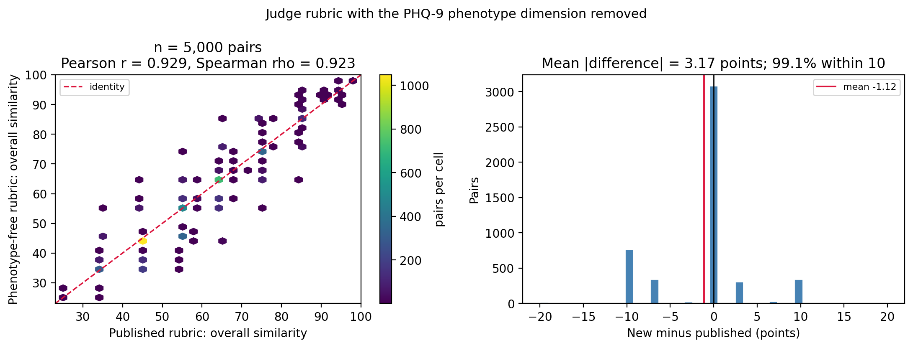
Figure S1. Cached and revised-rubric similarity scores for 5,000 randomly sampled pairs. Left: paired scores with the identity line. Right: revised minus cached score. Removing the phenotype domain produced high correlation but does not establish clinical validity.

S2 Embedding Dimensionality
Latent embedding coordinates do not have individual clinical interpretations. We therefore examined fitted sparsity, cumulative correlations, and performance after principal component reduction for Qwen3-Embedding-8B. These exploratory analyses describe the fitted representation rather than identify distinct clinical mechanisms.

S2 1 Sparsity and cumulative built in importance
The selected logistic regression used elastic-net regularization (l1_ratio=0.25; C=0.01). It assigned nonzero coefficients to 385 of 4,096 dimensions; approximately 80% of total absolute coefficient magnitude fell in 179 dimensions and 90% in 236 (Figure S2). These are model-specific measures of coefficient concentration, not estimates of intrinsic dimensionality or independent predictive information.
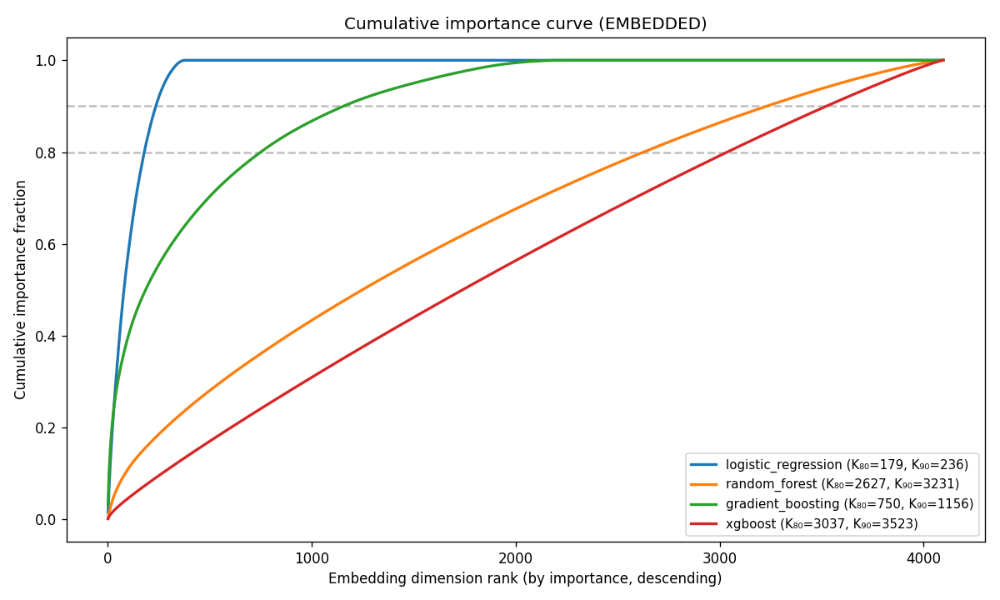
Figure S2. Cumulative built-in importance across embedding dimensions, ranked within each classifier. For logistic regression, importance is absolute coefficient magnitude; tree models use native feature importance. K80 and K90 identify the numbers of coordinates accounting for 80% and 90% of that model-specific total.

S2 2 Cumulative univariate correlation
We ranked coordinates by absolute Spearman correlation with the outcome and, separately, with each classifier’s predicted risk (Figure S3). The cumulative curves were broadly distributed. A sparse coefficient vector and diffuse marginal correlations can coexist because embedding coordinates are correlated; neither identifies unique clinical factors.
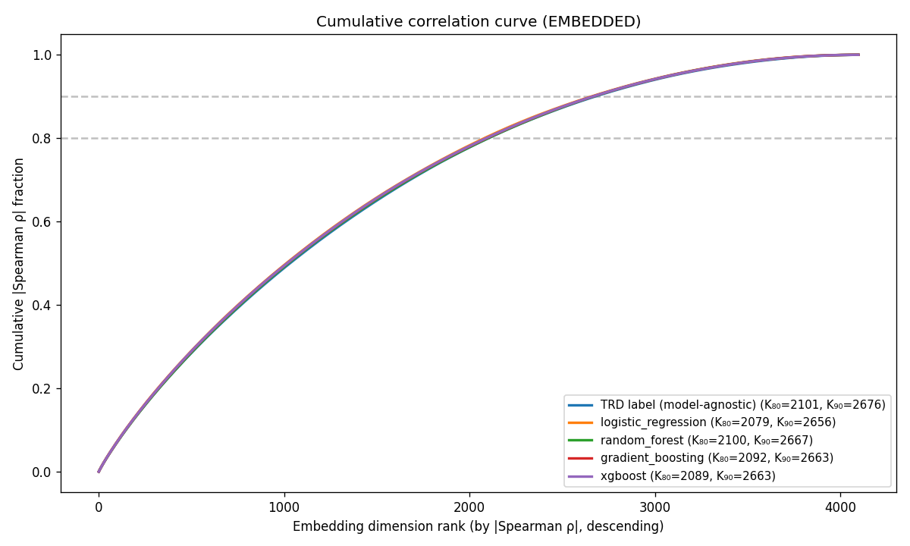
Figure S3. Cumulative absolute univariate (Spearman) correlation. One model-agnostic baseline curve ranks dimensions by |ρ(dim, outcome)|; the four per-classifier curves rank by |ρ(dim, predicted risk)|. Cumulative fraction of total |ρ| mass versus rank, with K₈₀ / K₉₀ knees in the legend.

S2 3 PCA K discrimination sweep
Each classifier was retrained on the top K principal components, with K in {1, 2, 4, 8, 16, 32, 64, 128, 256, 512, 1024}. Held-out ROC AUC generally improved as components were added, with model-specific plateaus and some deterioration at larger K (Figure S4). These curves do not identify a unique effective dimension, and choosing K from them would require further independent evaluation.
A Logistic regression
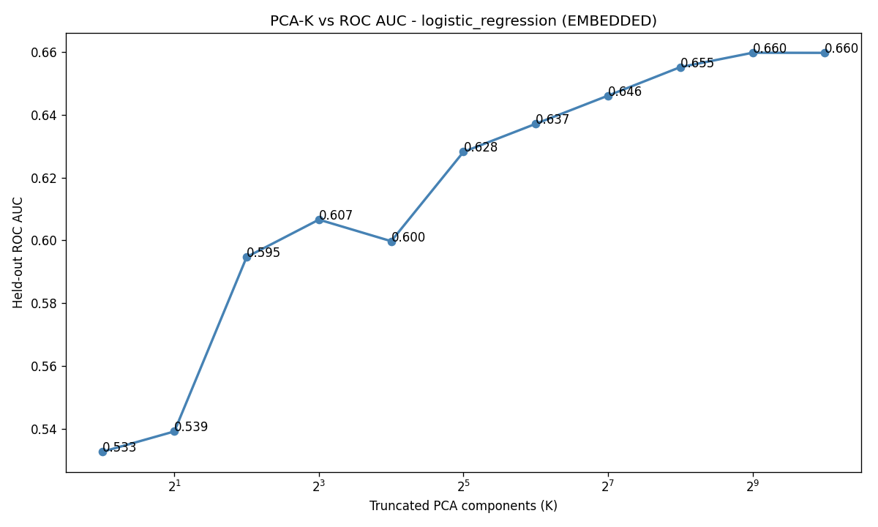
B Random forest
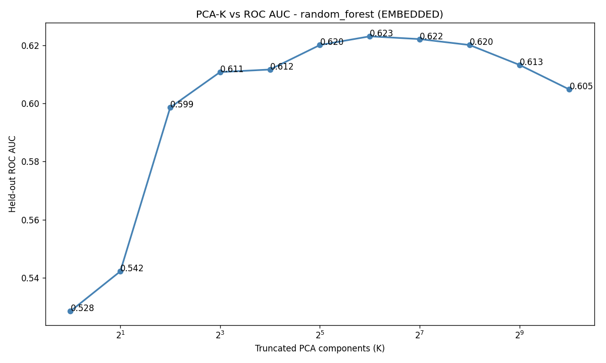
Figure S4. Continued on the next page.

C Gradient boosting
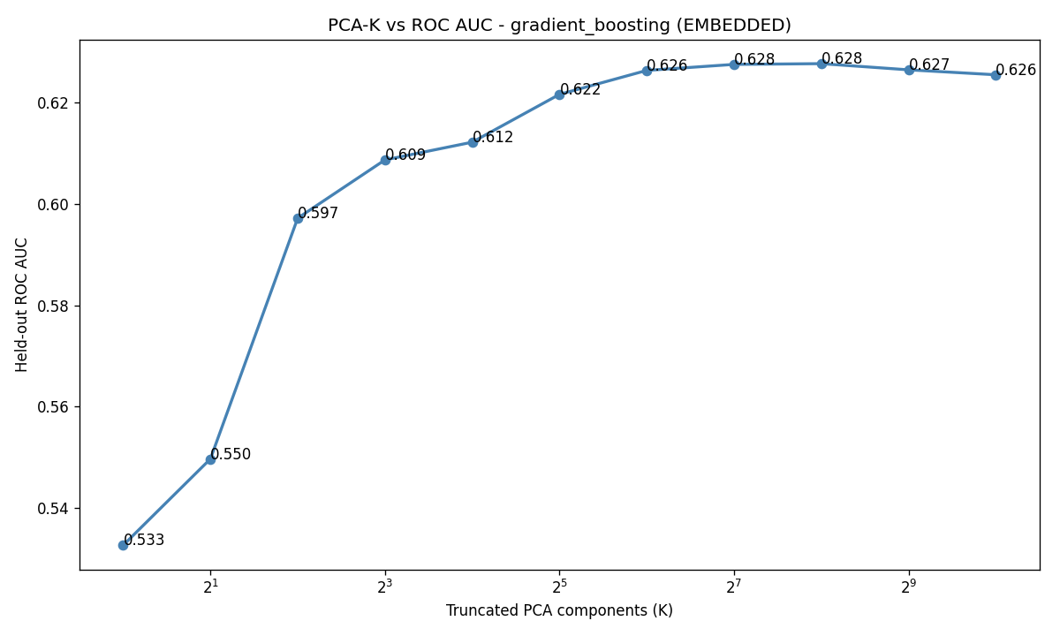
D XGBoost
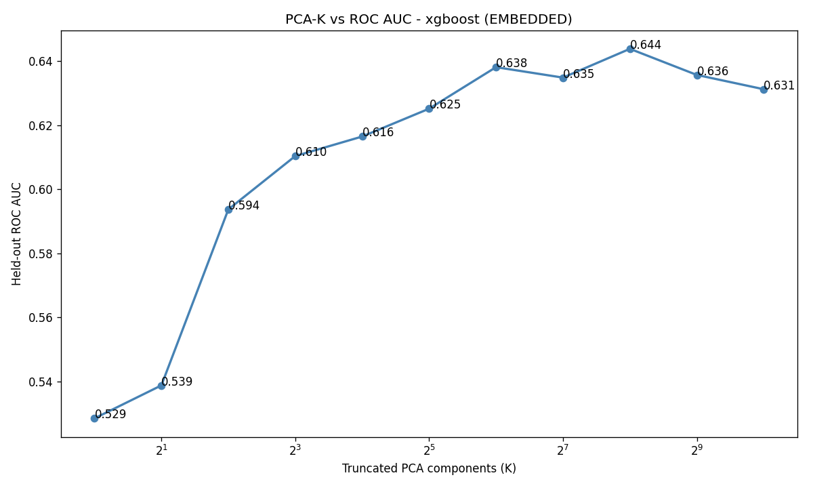
Figure S4. ROC AUC by retained principal components for logistic regression (A), random forest (B), gradient boosting (C), and XGBoost (D). The number of components is shown on a logarithmic scale. These are exploratory comparisons on the shared test set.

S3 Precision Recall Performance
AUPRC complements ROC AUC by describing precision across recall levels. Its no-skill reference is the cohort’s positive fraction, 0.175. Because it depends on outcome frequency, AUPRC should not be compared across populations without accounting for prevalence.
AUPRC remained modest across models (Tables S1–S2; Figure S5). The leading embedded and feature models achieved 0.302 and 0.298, respectively. These values are also summarized in Table 2.
Table S1. AUPRC of the four classifiers on each representation (held-out test set). No-skill baseline = 0.175 (the positive rate).
Representation | Classifier | AUPRC
EMBEDDED | Logistic regression | 0.302
EMBEDDED | Random forest | 0.270
EMBEDDED | Gradient boosting | 0.276
EMBEDDED | XGBoost | 0.278
FEATURE | Logistic regression | 0.278
FEATURE | Random forest | 0.293
FEATURE | Gradient boosting | 0.288
FEATURE | XGBoost | 0.298
Table S2. Embedded logistic-regression AUPRC by encoder (held-out test set). No-skill baseline = 0.175.
Encoder | AUPRC
bge-small-en-v1.5 | 0.281
bge-en-icl | 0.297
Qwen3-Embedding-4B | 0.297
Qwen3-Embedding-8B | 0.302
A Embedded logistic regression
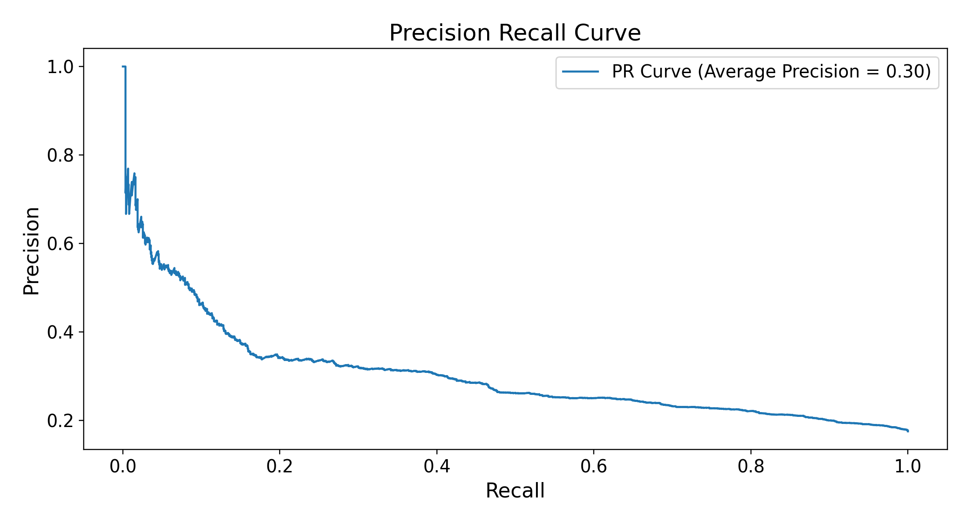
B Feature vector XGBoost
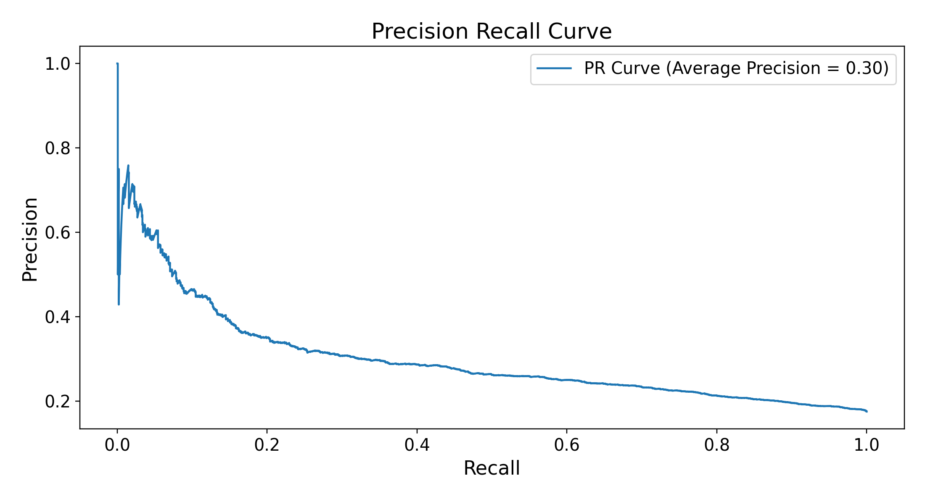
Figure S5. Precision–recall curves for the best classifier on each representation (held-out test set; primary Qwen3-Embedding-8B encoder). (A) Embedded logistic regression; (B) feature-vector XGBoost. The no-skill AUPRC reference is 0.175, the positive rate.

S4 Calibration
Table S3 reports Brier score and weighted calibration error (WCE), for which lower values are better. Scores ranged from 0.137 to 0.140 and 0.004 to 0.018, respectively. The binned calibration slopes and intercepts originally reported in the manuscript are retained below, separately from the individual-level logistic slopes in section S10. Binned slopes should not be interpreted as conventional logistic calibration slopes.
Table S3. Brier score and weighted calibration error for all 8 primary representation–classifier combinations. Both metrics describe the cohort’s observed outcome frequency.
Representation | Classifier | Brier | WCE
EMBEDDED | Logistic regression | 0.137 | 0.010
EMBEDDED | Random forest | 0.140 | 0.006
EMBEDDED | Gradient boosting | 0.139 | 0.004
EMBEDDED | XGBoost | 0.139 | 0.013
FEATURE | Logistic regression | 0.139 | 0.005
FEATURE | Random forest | 0.139 | 0.018
FEATURE | Gradient boosting | 0.138 | 0.010
FEATURE | XGBoost | 0.138 | 0.012
Table S4. Slopes and intercepts fitted to the binned calibration curves. These descriptive values are retained from the original overall calibration analysis and are not individual-level logistic calibration parameters. See section S10 for the latter.
Representation | Classifier | Binned slope | Binned intercept
EMBEDDED | Logistic regression | 1.27 | −0.07
EMBEDDED | Random forest | 1.15 | −0.02
EMBEDDED | Gradient boosting | 1.01 | 0.01
EMBEDDED | XGBoost | 0.75 | 0.07
FEATURE | Logistic regression | 0.78 | 0.06
FEATURE | Random forest | 1.84 | −0.15
FEATURE | Gradient boosting | 0.87 | 0.04
FEATURE | XGBoost | 1.02 | 0.02
A Embedded logistic regression
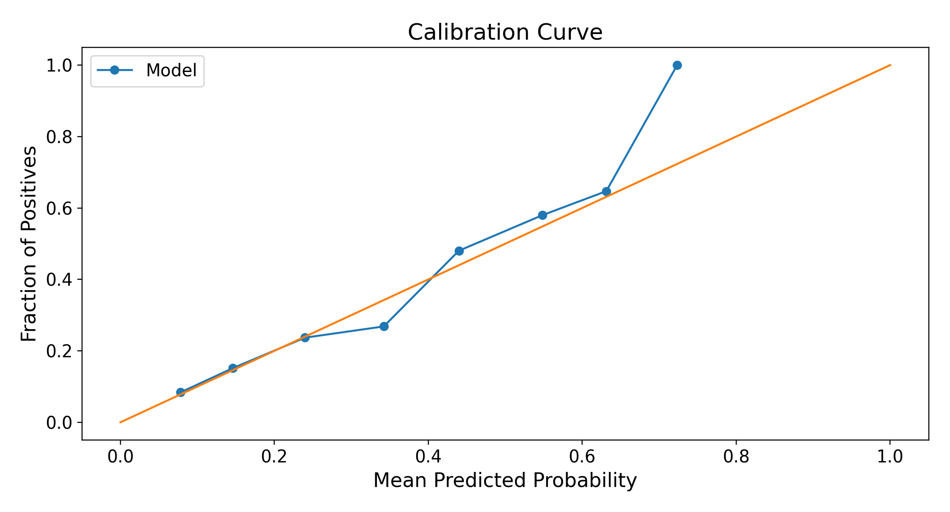
B Feature vector XGBoost
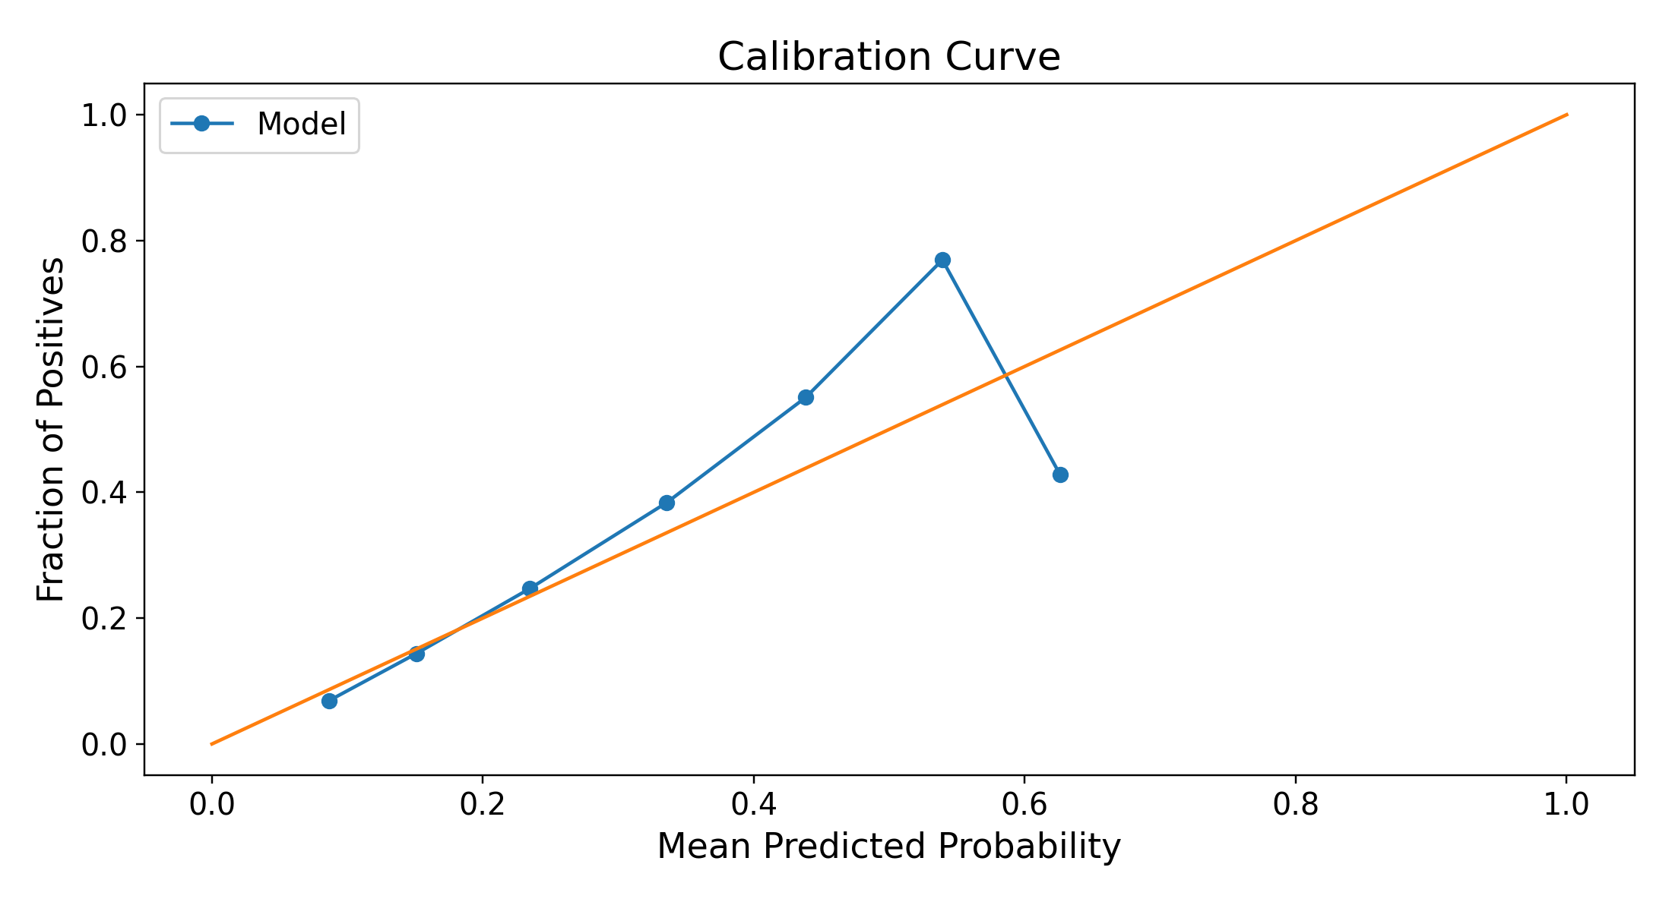
Figure S6. Calibration curves for embedded logistic regression (A) and feature-vector XGBoost (B). The diagonal indicates agreement between predicted and observed outcome frequency; points above it indicate underprediction in that bin, and points below indicate overprediction. The sample is enriched for depression.

S5 Encoder Similarity Geometry
Figure S7 compares cosine similarities for random patient pairs and nearest-neighbor pairs. The 3 larger encoders produced broadly unimodal random-pair distributions. bge-small-en-v1.5 showed multiple modes at high similarity values, prompting a descriptive analysis of the corresponding narrative wording.
A bge-small-en-v1.5
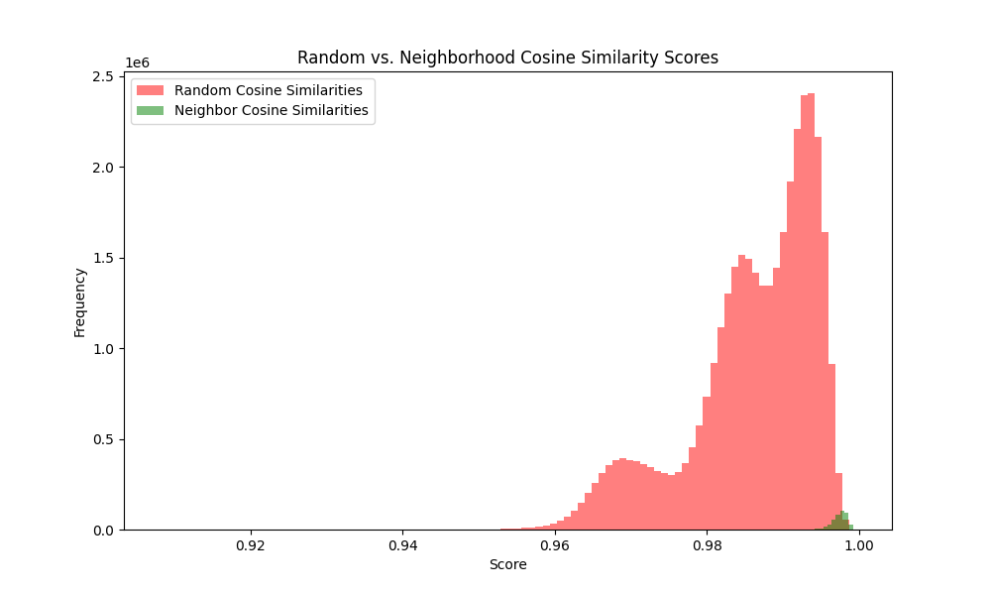
B bge-en-icl
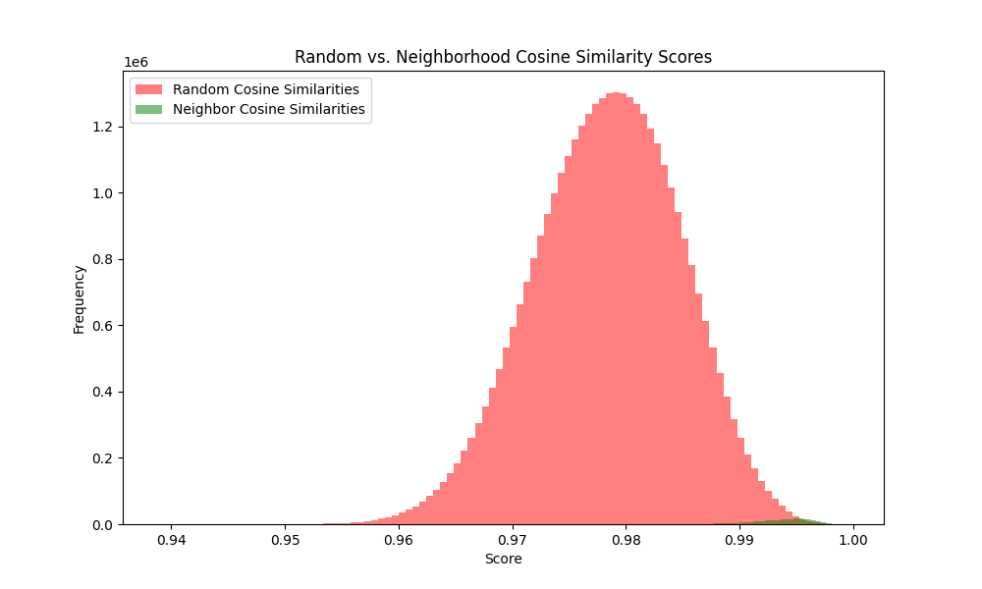
Figure S7. Continued on the next page.

C Qwen3-Embedding-4B
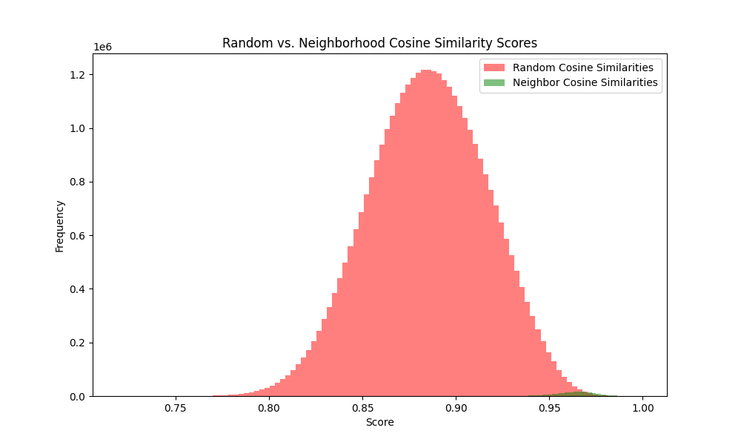
D Qwen3-Embedding-8B
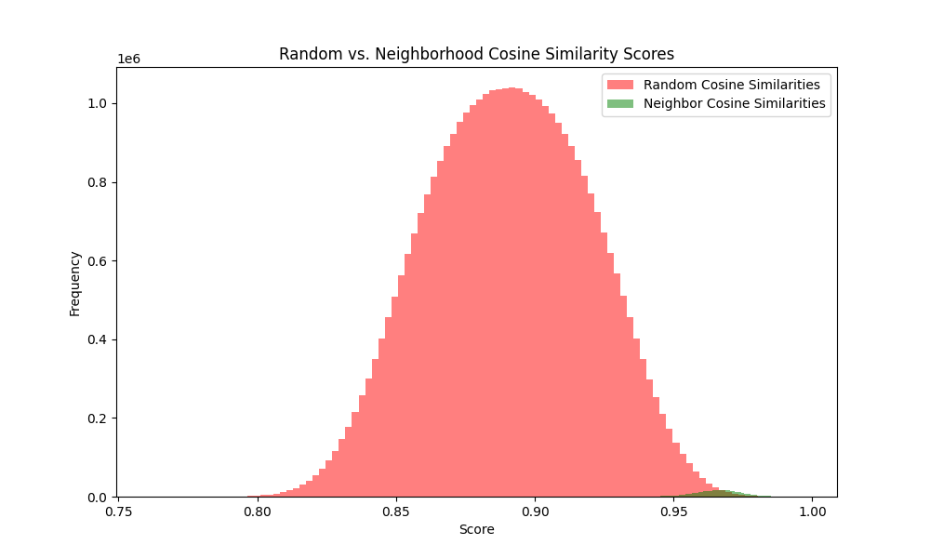
Figure S7. Cosine similarity for random pairs (red) and nearest-neighbor pairs (green) for bge-small-en-v1.5 (A), bge-en-icl (B), Qwen3-Embedding-4B (C), and Qwen3-Embedding-8B (D). Axis ranges differ across encoders. The smallest encoder shows a multimodal random-pair distribution.
K-means clustering of L2-normalized bge-small embeddings (k=2) separated 42,579 patients into groups of 14,438 and 28,141. The partition closely tracked whether the narrative contained the token “episode” (Table S5).
The token occurs in “Single Episode” but not “Recurrent” or “Dysthymia.” Thus, the partition should not be described simply as recurrent versus nonrecurrent depression.
Cluster B (n=28,141) largely comprised narratives containing “episode”; the full cohort contained 28,206 patients coded single episode.
Cluster A (n=14,438) largely lacked “episode” and included both recurrent and other depression codes. The full cohort contained 11,213 recurrent-coded patients.
Table S5. Fraction of narratives containing selected tokens within each top-level k-means cluster. Cluster A has 14,438 patients and cluster B has 28,141. “Single” may also denote marital status.
Token | P(present | cluster A) | P(present | cluster B) | |Δ|
episode | 0.00 | 1.00 | 1.00
recurrent | 0.78 | 0.00 | 0.78
single | 0.30 | 1.00 | 0.70
unspecified | 0.39 | 0.83 | 0.45
moderate | 0.32 | 0.09 | 0.23
Figure S8 stratifies pairwise similarities by token agreement. Blue denotes pairs agreeing on token presence, red denotes disagreement, and gray denotes all pairs.
Across the cohort, pairs agreeing on “episode” had higher similarities than pairs differing on that token (Figure S8A). This association links the observed modes to diagnostic wording but does not isolate a causal token effect from correlated clinical information.
Within cluster A, the same comparison using “recurrent” again separated similarity distributions (Figure S8B). The nested k-means subgroups contained 11,425 and 3,013 patients; these cluster sizes should not be equated with diagnosis-code counts.
Within cluster B, similarity distributions showed little separation by the “Missing” token. Nested cluster results are summarized in Table S6.
A All patients
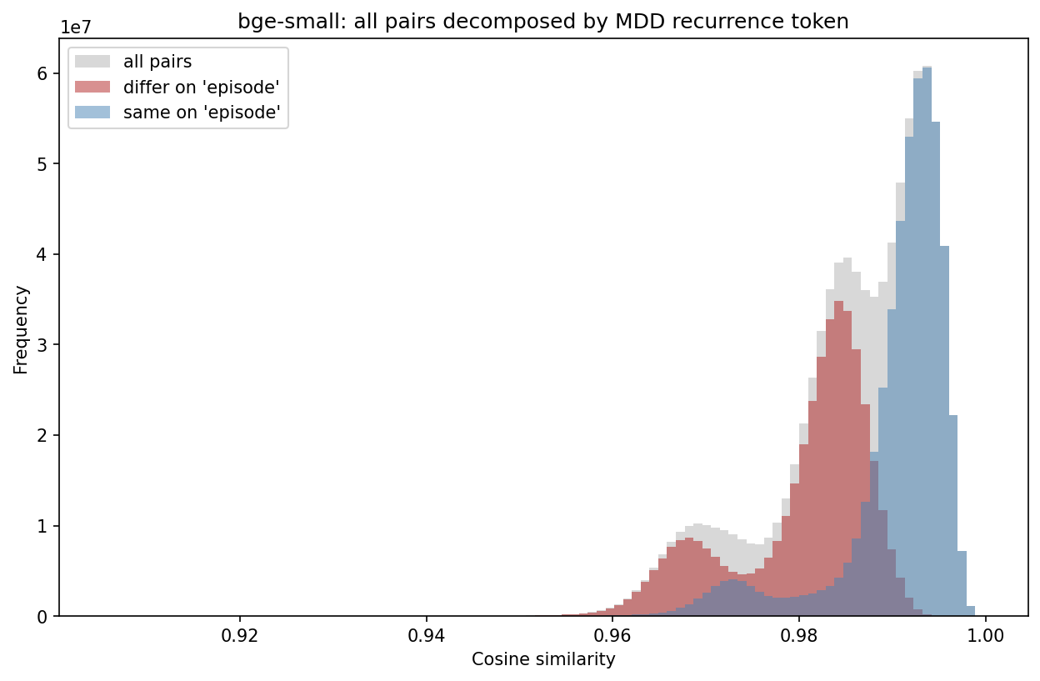
B Cluster A
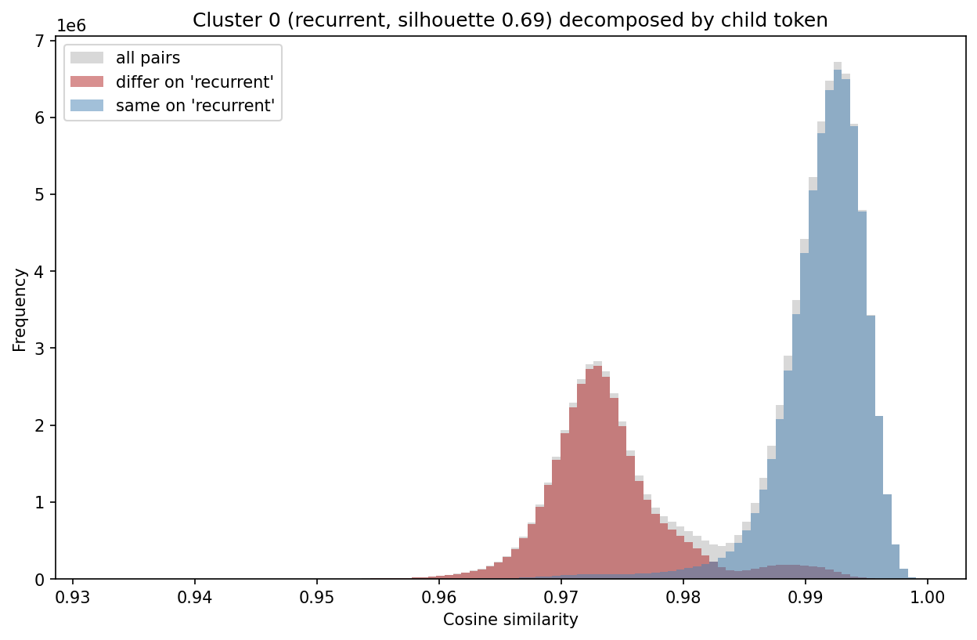
Figure S8. Pairwise similarity by agreement on “episode” across the cohort (A) and on “recurrent” within cluster A (B). Blue denotes token agreement, red disagreement, and gray all pairs. The analysis is descriptive and does not establish that wording alone causes the separation.
We re-ran k-means (k=2) within each parent cluster and described separation using the cosine silhouette in a seeded 5,000-patient subsample. The top-level silhouette was 0.48.
Silhouette values summarize within- versus between-cluster similarity and are descriptive, not hypothesis tests. They do not by themselves establish discrete biological or clinical subgroups.
Cluster A had a nested silhouette of 0.69. The larger subgroup (n=11,425) contained “recurrent” in 98% of narratives, whereas the smaller subgroup (n=3,013) contained “unspecified” in all narratives. Cluster B had weaker separation (silhouette 0.21); “Missing” appeared in 88% versus 2% of its subgroups. Medication tokens also differed, consistent with differences in record content.
Table S6. Nested k-means results within each parent cluster. Token proportions describe presence in the 2 subgroups. The top-level cosine silhouette was 0.48; higher values indicate greater geometric separation, without establishing clinical validity.
Parent cluster (n) | Splits into (n / n) | Driving token | Token present, sub 1 / sub 2 | Split silhouette (top level = 0.48) | Separation
A: no “episode” token (14,438) | recurrent + severity (11,425) / unspecified (3,013) | recurrent | 0.98 / 0.00 | 0.69 | Stronger
B: single-episode (28,141) | sparse record (6,594) / populated record (21,547) | missing | 0.88 / 0.02 | 0.21 | Weaker
These findings show sensitivity of the smallest encoder’s geometry to diagnostic wording and missing-value tokens. They may help explain its retrieval behavior, but do not establish why its discrimination was lower (Table S16). Primary analyses used Qwen3-Embedding-8B.

S6 Example Patient Narratives
Two deterministic narratives are reproduced verbatim, one from each outcome class. They were selected as the first patient by sorted deidentified hash within each class using scripts/pipeline/neighbors/narrative_audit.py. Inputs contained structured EHR fields only. Fixed section order, explicit absence labels, and missing-value tokens formed the template.
The original renderer uses “anchor” for the index and “Baseline window” for the lookback window. These labels are preserved because they show the actual encoder input.
The examples show field asymmetries documented in section S11: narratives include vital signs, sexual orientation, index dates, raw sociodemographic values, and medication names. FEATURE omits some of these fields or uses coarser encodings, but includes total recorded history length. A missing sexual-orientation value appears as the literal token nan.
TRD-positive example.
### COHORT & INDEX
Condition: MDD (Dysthymia, Unspecified) | Index date: 2022-10-06 | Baseline window: -730...0 days | MDD-to-anchor gap: 57 days | Encounters in window: 34 | MDD within window: Present
### SOCIODEMOGRAPHICS / ACCESS
Sex: Male | PreferredLanguage: English | AgeInYears: 37 | SexualOrientation: nan | MaritalStatus: Married | Religion: Baptist | SmokingStatus: Never | Race_Ethnicity: American Indian or Alaska Native
SDOH: None Recorded
### PHYSICAL HEALTH
BMI: 29.8 | BP (mean): 140/88
### PSYCH HISTORY
SOCIAL_ANXIETY: Absent | OCD: Absent | ANXIETY: Present | ADJUSTMENT_DISORDER: Absent | PTSD: Absent | DYSTHYMIA: Present | SUD: Present | INSOMNIA: Present
SUICIDE FLAG (2y): Absent
SUBSTANCE ABUSE: Nicotine
### MEDICAL COMORBIDITY
CHRONIC_PAIN: Absent | HYPERLIPIDEMIA: Absent | THYROID: Absent | DIABETES: Present
### TREATMENT EXPOSURE
Prior adequate AD trials: MIRTAZAPINE: 0 | SSRI: 1 | VORTIOXETINE: 0 | BUPROPION: 0 | SNRI: 0
Benzodiazepine days (2y): 0
Hypnotics: eszopiclone
Augmentation: Absent
### MEDICATION BURDEN
Active meds at baseline: 0 (Absent)
NSAID burden: 0 (Absent)
### UTILIZATION
Psych inpatient days: 0 (2y) | ED psych visits: 0 (2y)
### SAFETY
UNCONTROLLED_HTN: Present | EPILEPSY: Absent
TRD-negative example.
### COHORT & INDEX
Condition: MDD (Recurrent, Moderate) | Index date: 2025-05-09 | Baseline window: -730...0 days | MDD-to-anchor gap: 0 days | Encounters in window: 2 | MDD within window: Present
### SOCIODEMOGRAPHICS / ACCESS
Sex: Female | PreferredLanguage: English | AgeInYears: 52 | SexualOrientation: nan | MaritalStatus: Single | Religion: Baptist | SmokingStatus: Every Day | Race_Ethnicity: White or Caucasian
SDOH: None Recorded
### PHYSICAL HEALTH
BMI: 35.6 | BP (mean): 138/86
### PSYCH HISTORY
SOCIAL_ANXIETY: Absent | OCD: Absent | ANXIETY: Present | ADJUSTMENT_DISORDER: Absent | PTSD: Absent | DYSTHYMIA: Absent | SUD: Present | INSOMNIA: Absent
SUICIDE FLAG (2y): Absent
SUBSTANCE ABUSE: Nicotine
### MEDICAL COMORBIDITY
CHRONIC_PAIN: Absent | HYPERLIPIDEMIA: Absent | THYROID: Absent | DIABETES: Absent
### TREATMENT EXPOSURE
Prior adequate AD trials: MIRTAZAPINE: 0 | SSRI: 0 | VORTIOXETINE: 0 | BUPROPION: 0 | SNRI: 0
Benzodiazepine days (2y): 0
Hypnotics: Absent
Augmentation: Absent
### MEDICATION BURDEN
Active meds at baseline: 0 (Absent)
NSAID burden: 0 (Absent)
### UTILIZATION
Psych inpatient days: 0 (2y) | ED psych visits: 0 (2y)
### SAFETY
UNCONTROLLED_HTN: Present | EPILEPSY: Absent

S7 Neighbor Prediction and Exploratory Fusion
The primary encoder’s retrieval comparison is reported first, followed by an exploratory test of whether inverted farthest-neighbor predictions add information to nearest-neighbor predictions.
Nearest retrieval yielded ROC AUCs of 0.593–0.595, subsampled retrieval 0.543–0.554, random retrieval 0.495–0.517, and farthest retrieval 0.432–0.436 (Table S7). Weighting had little effect after nearest-neighbor selection. MedGemma weighting increased the random-retrieval point estimate from 0.495 to 0.517 and the subsampled estimate from 0.543 to 0.554. Mean effective sample size under nearest retrieval was 40.6 for MedGemma weighting versus 50.0 for uniform weighting.
Table S7. Neighbor-prediction ROC AUC by retrieval and weighting strategy for the primary encoder, using 50 training neighbors per test patient. LLM: MedGemma-27B similarity weighting; combined: cosine and LLM weighting.
Retrieval scheme | Uniform | Cosine | LLM | Combined
Nearest | 0.593 | 0.594 | 0.595 | 0.595
Subsampled | 0.543 | 0.544 | 0.554 | 0.552
Random | 0.495 | 0.499 | 0.517 | 0.512
Farthest | 0.434 | 0.432 | 0.436 | 0.434
A Nearest retrieval
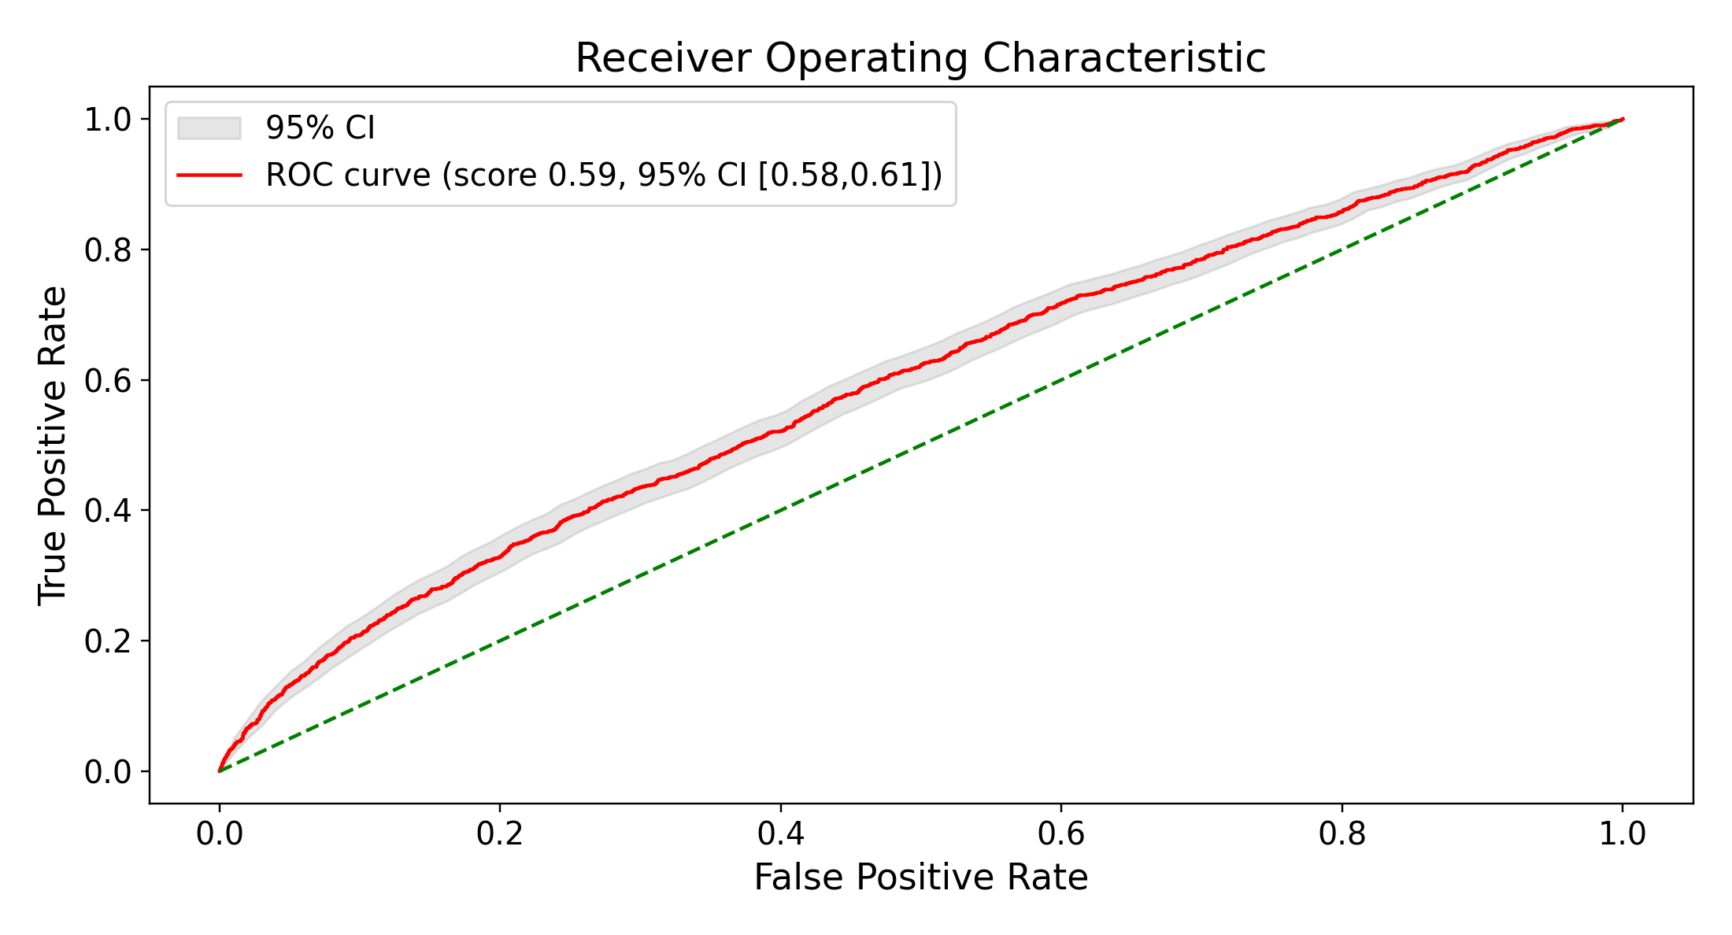
B Random retrieval
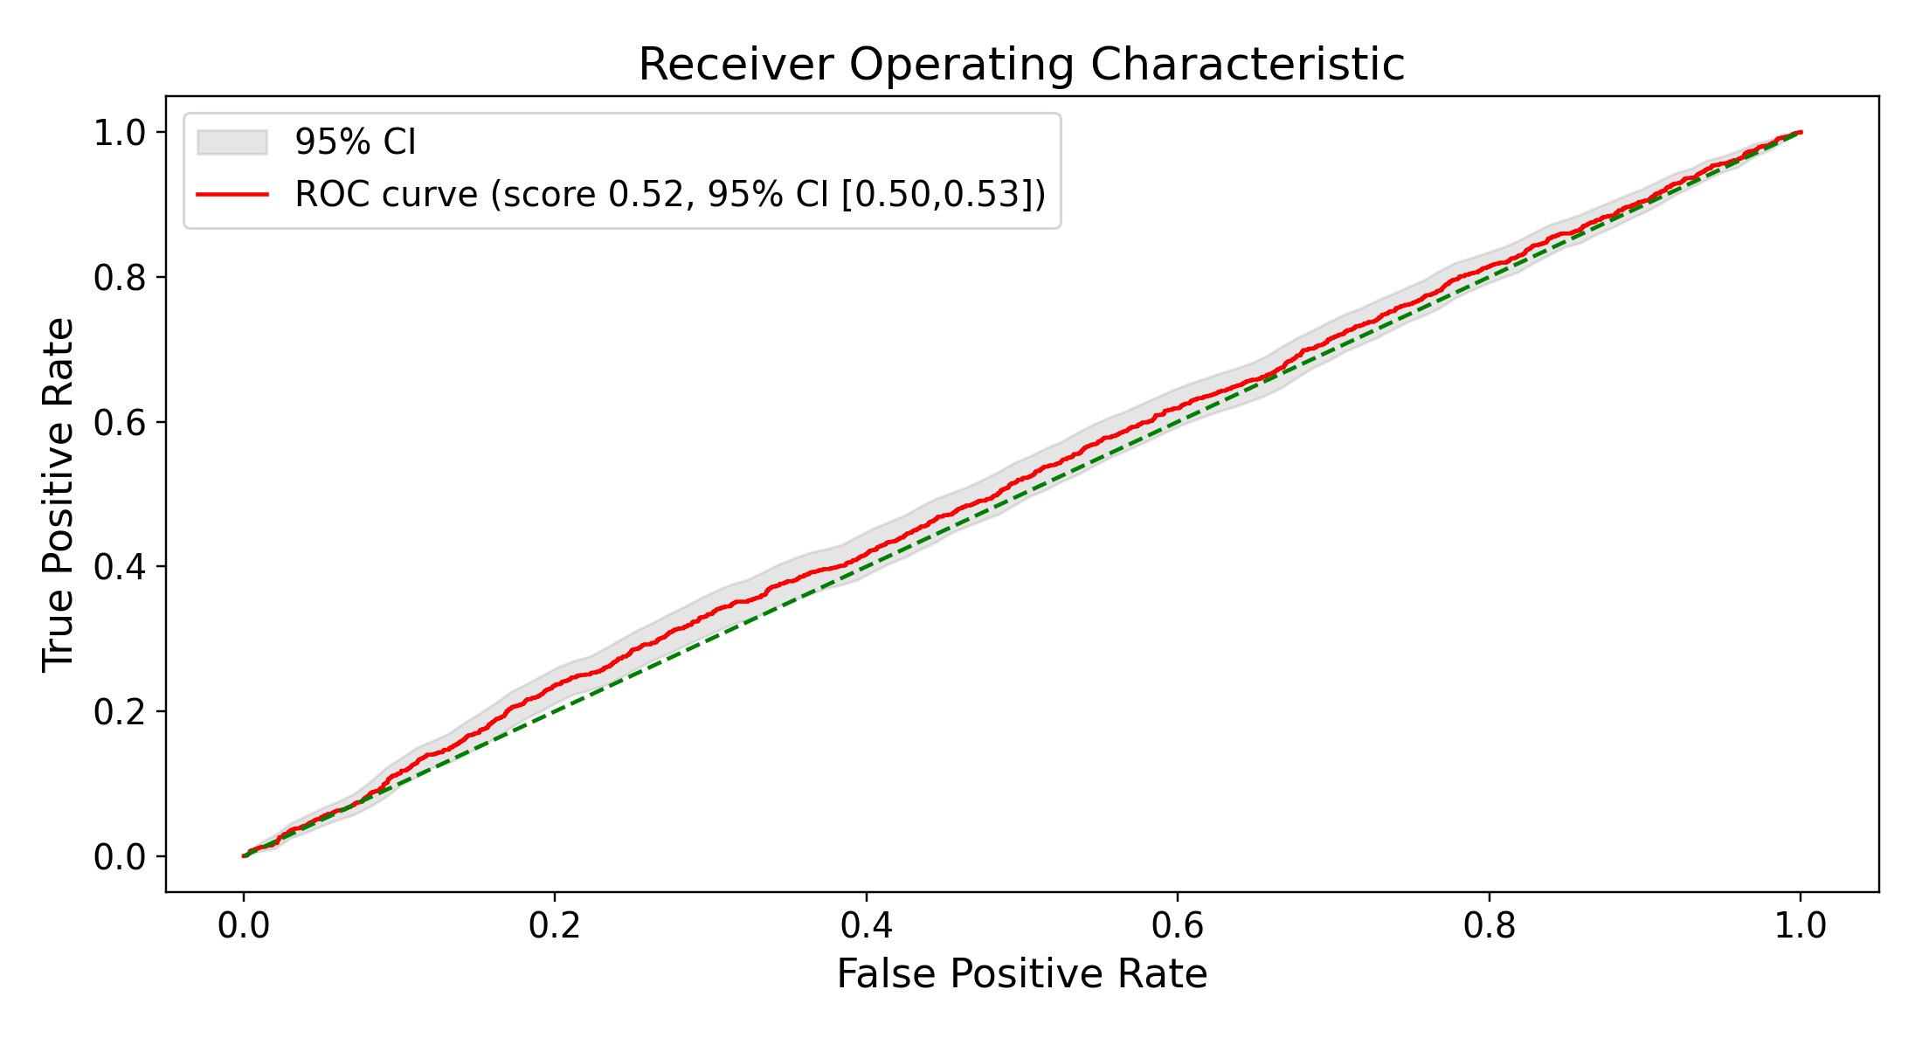
Figure S9. ROC curves for MedGemma-weighted nearest (A) and random (B) retrieval. Shaded bands are bootstrap 95% CIs. ROC: receiver operating characteristic.
A Nearest retrieval
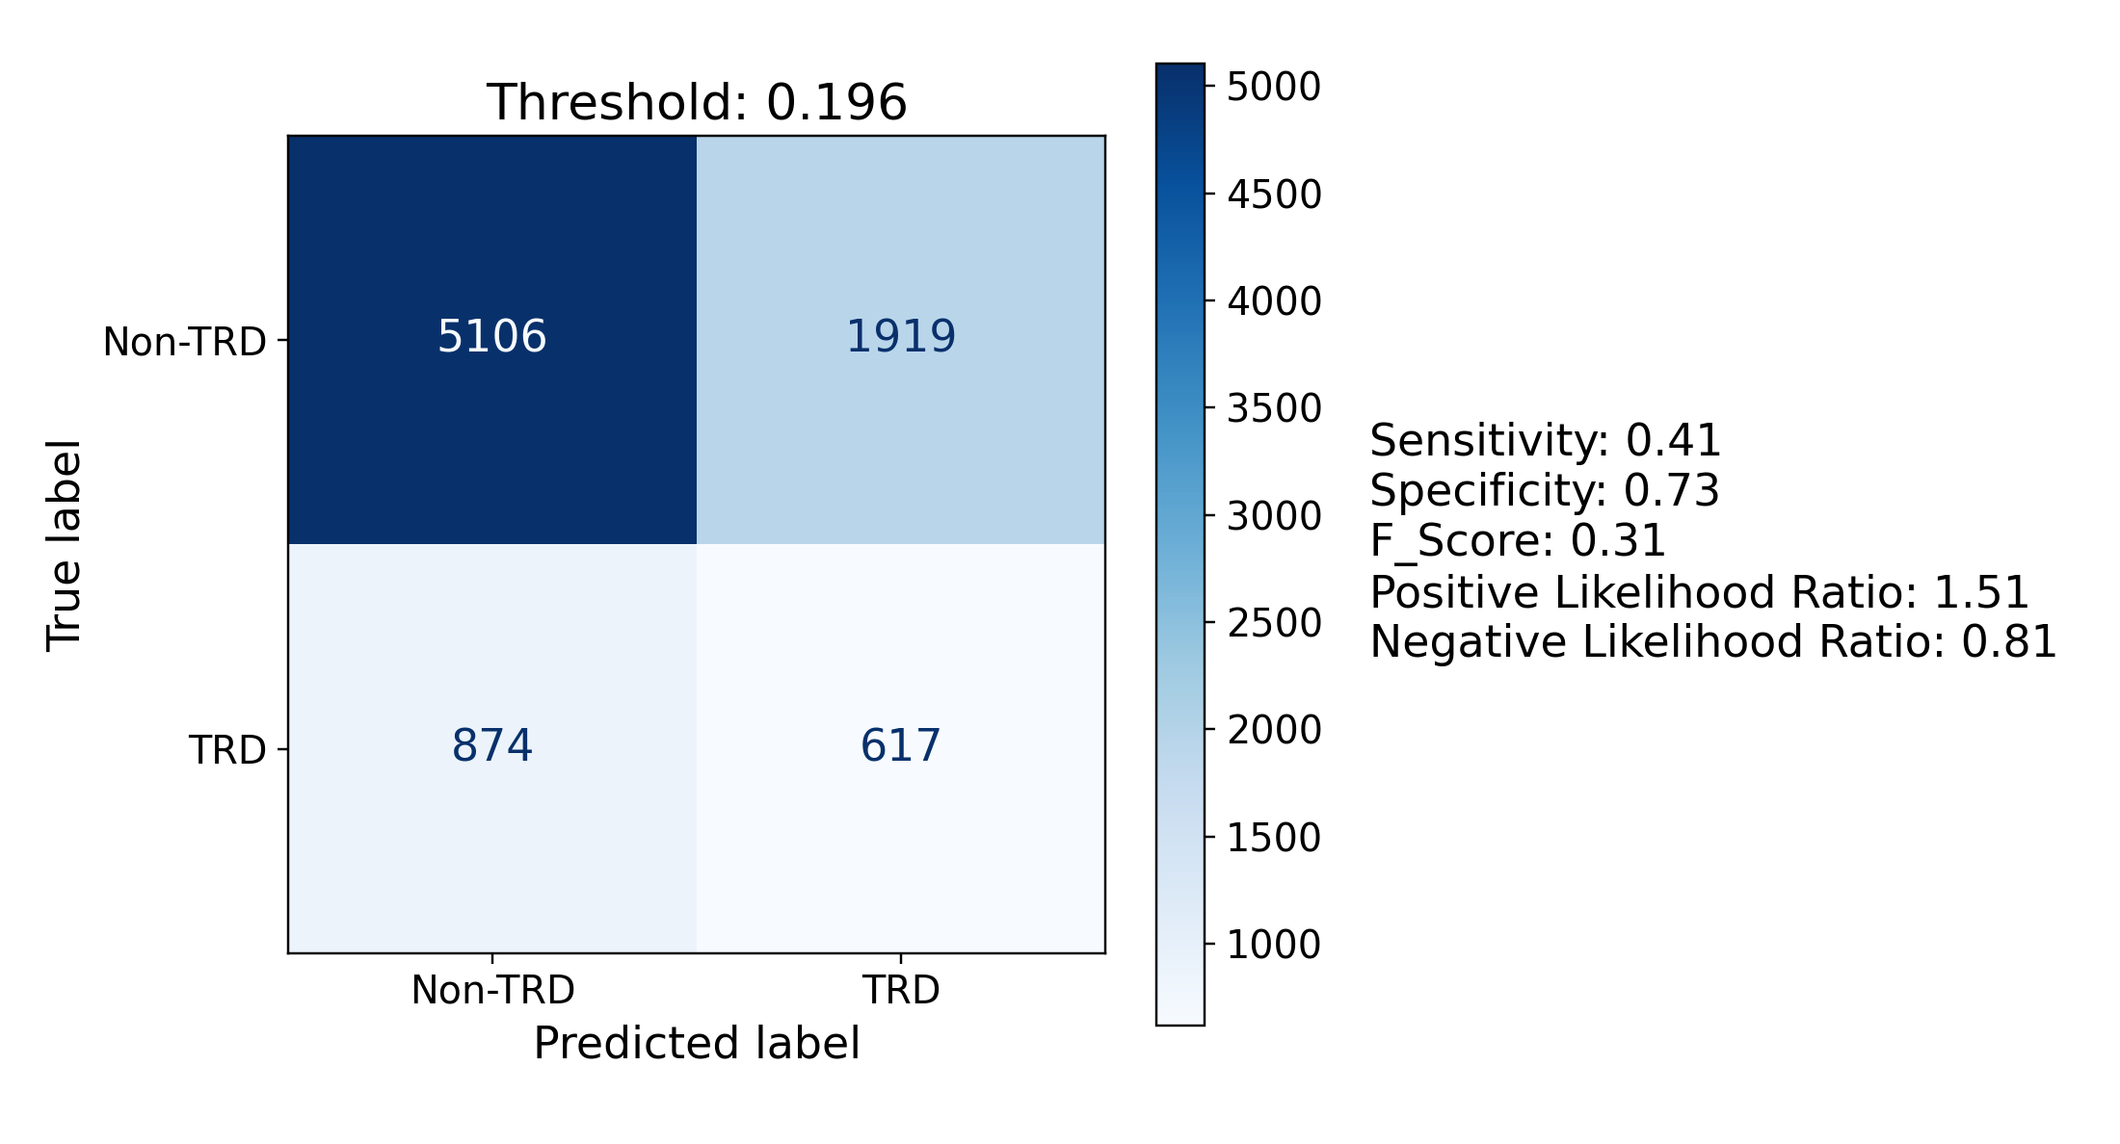
B Random retrieval
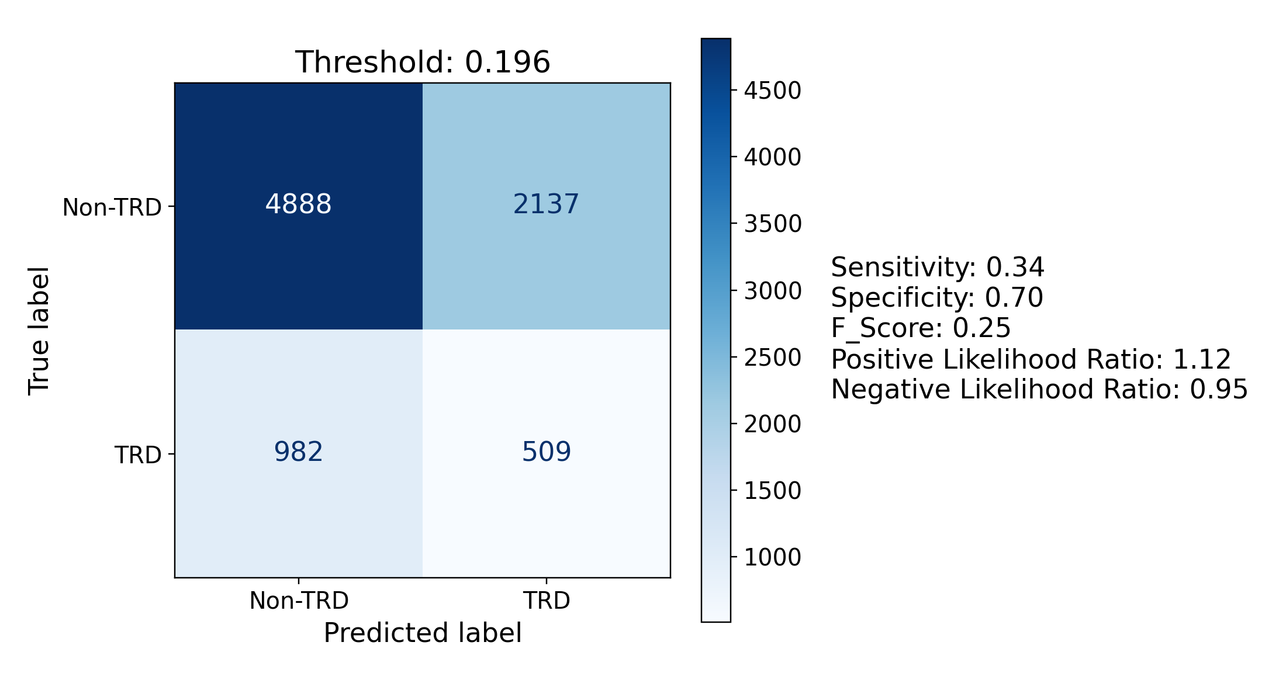
Figure S10. Confusion matrices for MedGemma-weighted nearest (A) and random (B) retrieval at test-selected Youden J thresholds. These operating points were selected and evaluated in the same patients and are descriptive.

Exploratory Retrieval Fusion
Under uniform weighting, nearest retrieval achieved ROC AUC 0.593 and farthest retrieval 0.434 (Table S7). Inverting the farthest score gives an AUC of approximately 0.566. Figure S11 displays the component predictions used in the fusion analysis.
A Nearest retrieval
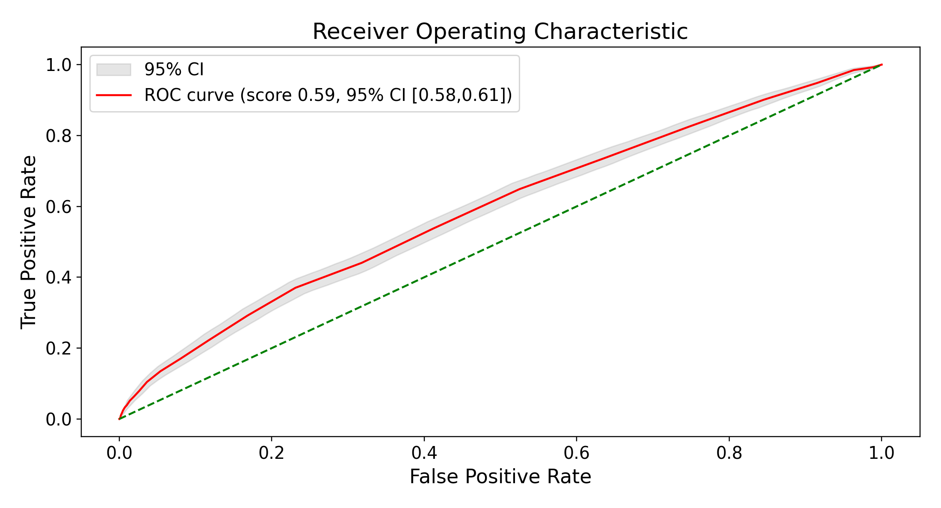
B Farthest retrieval
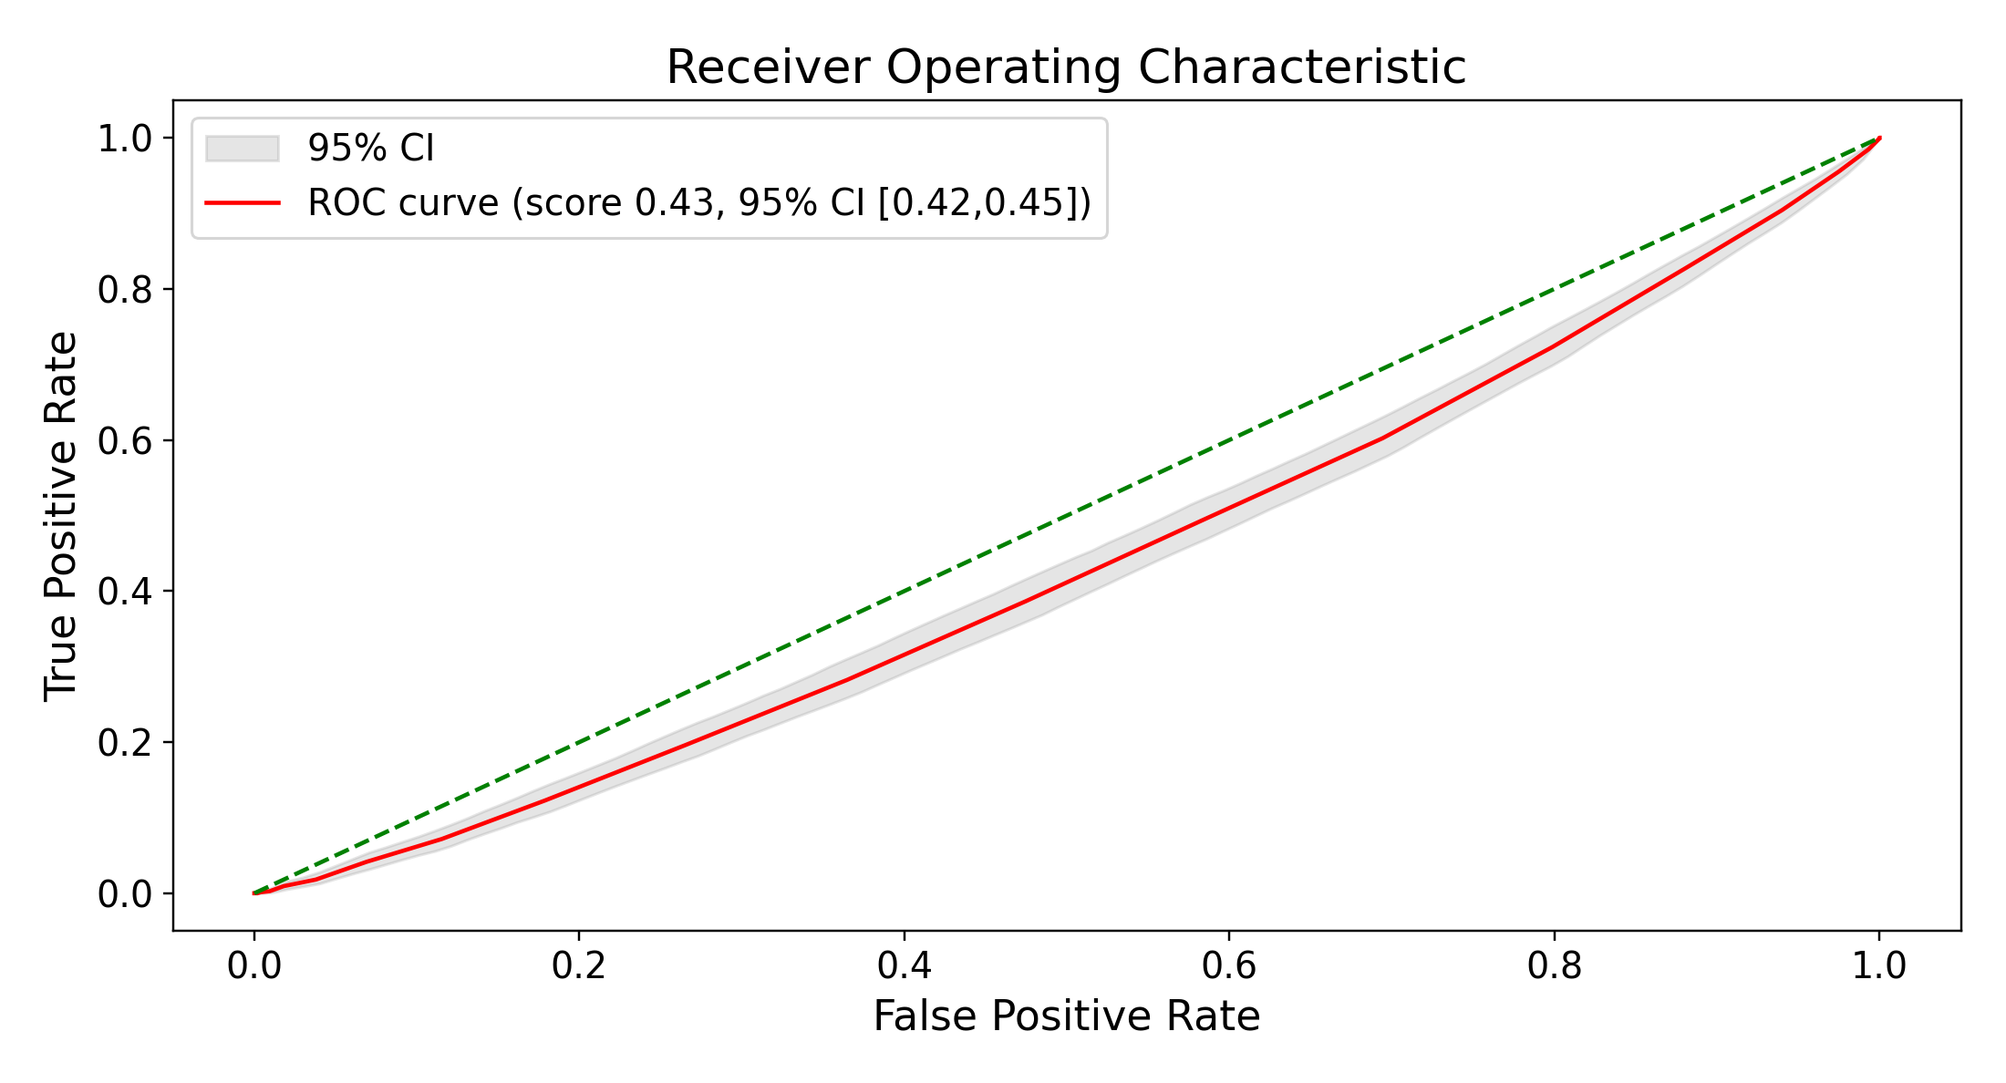
Figure S11. The two component scores entering the fusion: neighbor-weighted ROC for (A) nearest and (B) farthest retrieval under uniform weighting (embedded representation, held-out test set, n = 8,516, K = 50; primary Qwen3-Embedding-8B encoder). Shaded bands are bootstrap 95% intervals and the dashed diagonal is chance. Uniform weighting is shown because it is the weighting fused here; under LLM weighting the same contrast gives 0.595 and 0.436 (Table S7).

S7 1 Design
The fusion analysis was post hoc and reused predictions for 8,516 test patients, including 1,491 positive outcomes. It was restricted to Qwen3-Embedding-8B, the only encoder with farthest-neighbor predictions. No new retrieval or similarity judging was performed.
All fusion variants used uniform weights so that scores reflected the outcome frequency among 50 geometrically selected neighbors. Each variant was compared with the same uniformly weighted nearest-neighbor baseline.
Writing pnear and pfar for a patient’s nearest- and farthest-neighborhood predicted risk, three fusions were compared against pnear alone:
Variant (a) — a parameter-free equal average of pnear and (1 − pfar).
Variant (b) — a convex blend α·pnear + (1 − α)·(1 − pfar), with α chosen from a grid of 21 equally spaced values on [0, 1] by maximizing ROC AUC.
Variant (c) — a logistic stack on the raw pair (pnear, pfar), which fits a coefficient on each term plus an intercept and is therefore free both to learn the sign on pfar rather than being told to invert it, and to place weights that do not sum to one.

Estimation and reporting for the tuned variants
For the tuned blend and logistic stack, parameters were estimated using a shared stratified 5-fold partition of the original test patients. This was an exploratory second-stage analysis, not evaluation on a new independent test set.
Within each fold, blend weights or stacking coefficients were fitted using 4 folds and applied to the fifth. Performance was computed from the pooled out-of-fold predictions. The AUC-maximizing blend achieved 0.600 when fitted and scored in the full test set but 0.594 out of fold, illustrating the optimism introduced by tuning on evaluation data [17].
For descriptive reporting, fitting all 8,516 patients gave α=0.65 for the blend and coefficients 3.49 for the nearest score and −2.00 for the farthest score, with intercept −1.80, for the logistic stack. These parameters have not been independently validated and should not be regarded as deployment parameters.
Paired CIs used 1,000 bootstrap resamples of the 8,516 patients, applying the same indices to each variant and baseline. The interval was defined by the 2.5th and 97.5th percentiles of the AUC difference.

S7 2 Results
None of the fusion variants demonstrated improved discrimination (Table S8; Figure S12). All point differences were below 0.006 ROC AUC, and every paired 95% CI included zero. The logistic stack’s difference was 0.0059 (95% CI −0.0008 to 0.0122).
Table S8. Nearest-alone baseline versus three nearest–farthest fusions (uniform weighting, embedded representation, held-out test set, n = 8,516; primary Qwen3-Embedding-8B encoder). Δ is the difference in ROC AUC against the nearest-alone baseline with a paired bootstrap 95% interval. WCE = weighted calibration error. Lower is better for Brier and WCE. Farthest retrieval alone scores 0.434 (Table S7).
Score | ROC AUC (95% CI) | Δ vs nearest alone (95% CI) | AUPRC | Brier | WCE
Nearest alone | 0.593 (0.578–0.609) | — | 0.253 | 0.142 | 0.026
(a) Equal average | 0.599 (0.583–0.615) | +0.0051 (−0.0054 to +0.0149) | 0.254 | 0.241 | 0.316
(b) CV-tuned blend | 0.594 (0.579–0.610) | +0.0004 (−0.0081 to +0.0087) | 0.249 | 0.187 | 0.213
(c) Logistic stack | 0.599 (0.584–0.615) | +0.0059 (−0.0008 to +0.0122) | 0.256 | 0.141 | 0.003
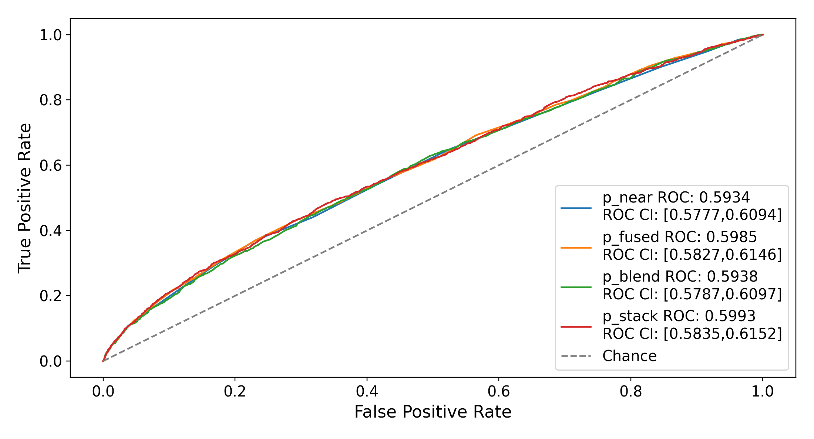
Figure S12. ROC curves for nearest retrieval and the 3 fusion variants. Tuned variants use pooled out-of-fold predictions from the exploratory analysis of the original test set. Legend intervals are bootstrap 95% CIs.
These intervals do not establish equivalence or exclude all potentially useful gains. Their precision concerns fixed predictions in this sample and does not replace external evaluation.
The fitted stack assigned a negative coefficient to the raw farthest score, consistent with its inverse discrimination. Normalizing coefficient magnitudes gives a nearest-score weight of approximately 0.64, close to the fitted blend weight of 0.65; fold-specific blend weights ranged from 0.60 to 0.70.
The equal average and tuned blend worsened calibration: Brier scores were 0.241 and 0.187, compared with 0.142 for nearest retrieval, and WCE values were 0.316 and 0.213 versus 0.026. The inverted farthest score can rank outcomes without being a calibrated probability, so averaging it into the nearest score distorts risk estimates. Neither blend assigned probabilities below 0.1, compared with 14.5% of patients under nearest retrieval. The logistic stack had Brier score 0.141 and WCE 0.003, but still requires independent validation.

S7 3 Interpretation
Fusion did not demonstrate incremental discrimination in this exploratory analysis. Redundancy between 2 scores derived from the same embedding is one possible explanation. Combining genuinely different representations or encoders remains untested.

S8 Record Length and Prediction
We examined record volume descriptively by correlating the outcome with history length, encounter count, and the diagnosis-to-index interval, then assessed neighbor-prediction discrimination across history-length quintiles.
Using the full recorded history, outcome correlations were small: Spearman ρ=−0.073 for pre-index history length, −0.064 for encounter count, and −0.029 for diagnosis-to-index interval. Same-day diagnosis and prescribing occurred in 27,906 patients with outcome frequency 18.4%, compared with 14,673 patients and 15.9% for delayed prescribing. These weak marginal relationships do not rule out care-process contributions to prediction.
A Pre-index history length
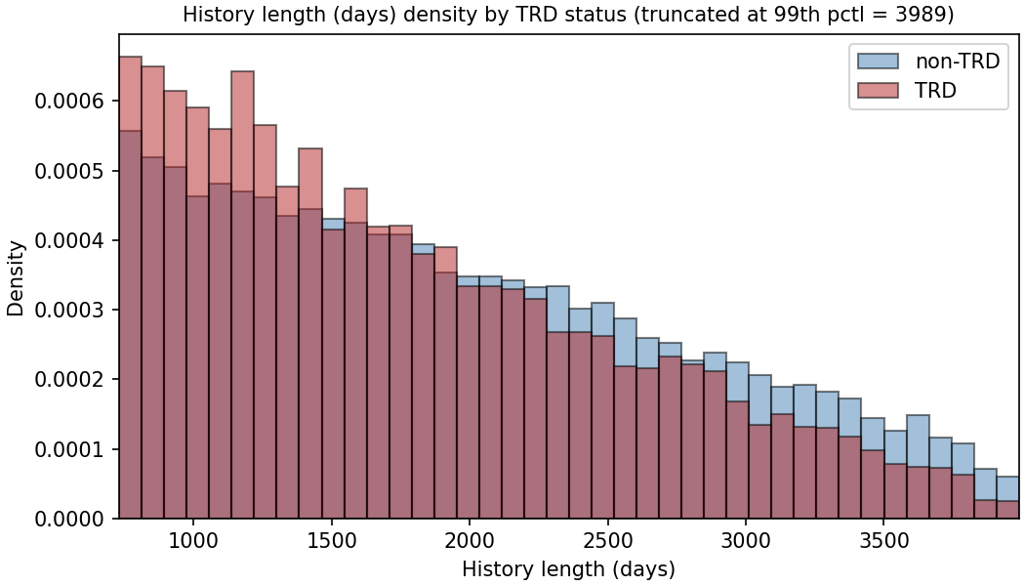
B Diagnosis-to-index interval
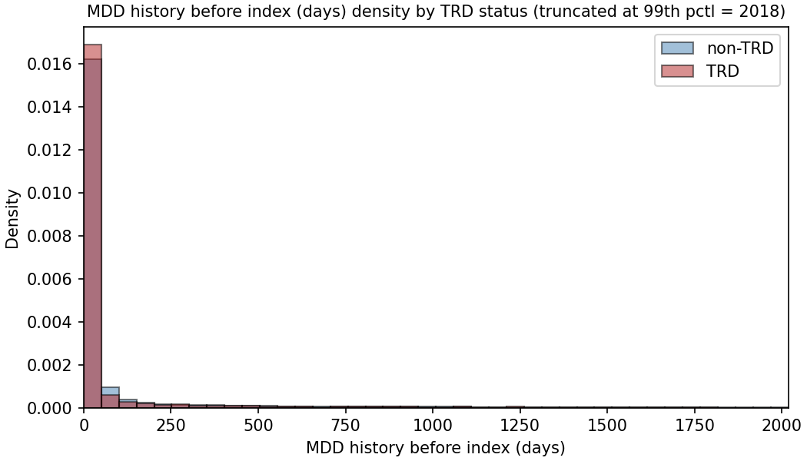
Figure S13. Continued on the next page.

C Encounter count
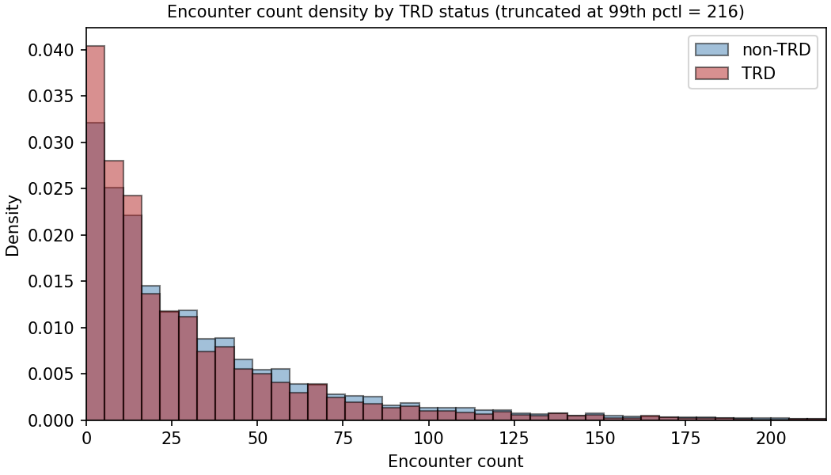
D Outcome frequency by prescription timing
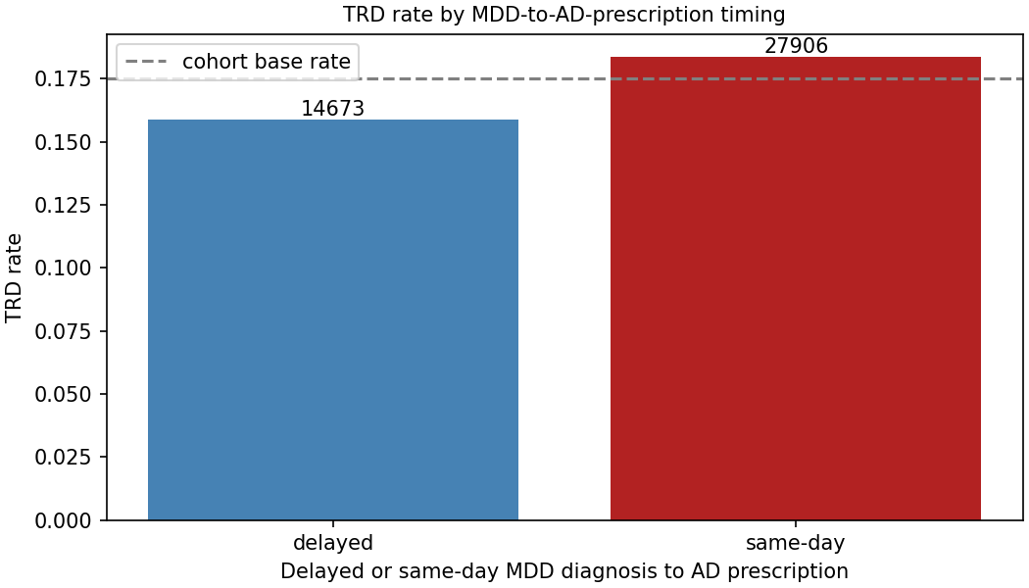
Figure S13. Record length, diagnosis-to-index interval, encounter count, and outcome frequency by prescription timing. A–C show outcome-stratified distributions; axes are truncated as labeled in the original plots. D compares same-day and delayed prescribing, with group counts above bars and the 17.5% cohort reference as a dashed line.
The held-out test set was divided into quintiles of pre-index history length and the neighbor-weighted predictor was scored within each quintile. The nearest-retrieval, LLM-weighted arm is reported in Table S9; the pattern is the same for the other weighting strategies.
Table S9. Neighbor-weighted discrimination by quintile of pre-index history length (nearest retrieval, LLM weighting, embedded representation, held-out test set). Quintile bounds are in days of pre-index history.
Pre-index history (days) | Patients | ROC AUC
731–1,110 | 1,706 | 0.588
1,110–1,554 | 1,704 | 0.601
1,554–2,066 | 1,701 | 0.572
2,066–2,733 | 1,704 | 0.613
2,733–5,288 | 1,701 | 0.579
AUC ranged from 0.572 to 0.613 across quintiles without a monotonic trend. This does not establish independence from record volume; differing case mix and imprecision within strata limit interpretation.
The stratification covers neighbor prediction only, not the trained classifiers. Each quintile contained about 1,700 patients. An analysis by embedding-neighborhood density was not interpretable because 3 of 5 bins were empty.

S9 Training and Test Characteristics
Table S10 compares selected characteristics in the shared training and test split.
Across 100 predictor rows, maximum absolute SMD was 0.036. The largest value involved a social-determinant flag present in 22 training patients and no test patient. Outcome rates match because the split was stratified.
Table S10. Held-out patients against training patients on the characteristics reported in Table 1. Continuous variables are median (IQR); categorical and boolean entries are n (%). SMD is training minus held-out, in pooled standard deviations. Vital signs are shown because they describe the cohort, but they are rendered only in the narrative representation and are absent from the feature matrix as published (Supplement S11).
Characteristic | Training | Held-out | SMD
Demographics
Age (years) | 55 (38-70) | 55 (38-70) | -0.014
Age band: 18-29 | 4,428 (13.0%) | 1,085 (12.7%) | +0.008
Age band: 30-44 | 7,198 (21.1%) | 1,827 (21.5%) | -0.008
Age band: 45-64 | 10,632 (31.2%) | 2,636 (31.0%) | +0.006
Age band: 65+ | 11,805 (34.7%) | 2,968 (34.9%) | -0.004
Sex: Female | 24,682 (72.5%) | 6,168 (72.4%) | +0.001
Race: White/Caucasian | 27,244 (80.0%) | 6,835 (80.3%) | -0.007
Race: Black/African American | 1,894 (5.6%) | 474 (5.6%) | -0.000
Race: Am. Indian/Alaska Native | 1,637 (4.8%) | 396 (4.7%) | +0.007
Race: Missing | 247 (0.7%) | 50 (0.6%) | +0.017
Language: English only | 33,698 (98.9%) | 8,425 (98.9%) | -0.000
Depression phenotype
MDD recurrence: Recurrent | 9,036 (26.5%) | 2,177 (25.6%) | +0.022
MDD severity: Severe | 1,818 (5.3%) | 468 (5.5%) | -0.007
MDD severity: Moderate | 5,807 (17.0%) | 1,426 (16.7%) | +0.008
Psychiatric and substance comorbidity
Suicidality flagged | 1,392 (4.1%) | 361 (4.2%) | -0.008
Anxiety disorder | 17,975 (52.8%) | 4,426 (52.0%) | +0.016
Substance use disorder (any) | 7,472 (21.9%) | 1,793 (21.1%) | +0.021
Insomnia | 7,452 (21.9%) | 1,898 (22.3%) | -0.010
PTSD | 1,241 (3.6%) | 300 (3.5%) | +0.006
Alcohol use disorder | 1,523 (4.5%) | 352 (4.1%) | +0.017
Medical comorbidity
High cholesterol | 12,591 (37.0%) | 3,156 (37.1%) | -0.002
Uncontrolled hypertension | 12,544 (36.8%) | 3,136 (36.8%) | +0.000
Vital signs (narrative only)
BMI | 29 (25-35) | 29 (25-35) | -0.013
Systolic BP | 126 (118-136) | 126 (118-136) | -0.010
BMI: not recorded | 7,484 (22.0%) | 1,911 (22.4%) | -0.011
Treatment and utilization
Active med count | 1 (0-2) | 1 (0-2) | +0.008
Encounter count | 21 (8-46) | 20 (8-47) | -0.001
Pre-index history (days) | 1792 (1213-2547) | 1797 (1222-2541) | +0.004
Prior adequate AD trial (any class) | 5,014 (14.7%) | 1,262 (14.8%) | -0.003
Benzodiazepine days recorded | 3,775 (11.1%) | 949 (11.1%) | -0.002
Hypnotic recorded | 1,319 (3.9%) | 342 (4.0%) | -0.007
Augmentation therapy used | 326 (1.0%) | 96 (1.1%) | -0.017
The measured balance supports internal comparability. It does not establish distributional identity or representativeness of the health system, because both partitions inherit the same sampling design.

S10 Subgroup Performance
Subgroup analyses address performance differences, a question distinct from direct-input reliance under permutation. They do not establish fairness of the outcome label or of a proposed clinical decision.

S10 1 Design
Held-out predicted probabilities were partitioned by subgroup without refitting models. Discrimination and calibration were recalculated within each group.
The analysis included 4 FEATURE classifiers, 4 EMBEDDED classifiers, and 16 neighbor configurations. Between-group contrasts included the 4 nearest-neighbor configurations but excluded random, farthest, and subsampled retrieval controls.
Strata comprised sex, recorded race, age, marital status, smoking, religion, MDD recurrence, and severity. Race was aggregated as White versus other recorded categories because of small subgroup counts; this masks potentially important heterogeneity. Preferred language was not contrasted because 98.9% preferred English. A subgroup was treated as not estimable when its smaller outcome class contained fewer than 20 patients.
Within-group CIs used percentile bootstrap resampling. Contrasts between disjoint groups used independent resampling of each group. Two-sided bootstrap P values were adjusted across 288 contrasts with the Benjamini–Hochberg procedure.
The individual-level calibration slope was estimated by logistic regression of outcome on logit predicted risk. Mean predicted risk minus observed outcome frequency was also reported; the original table label “calibration-in-the-large” is retained as “mean risk difference” to identify the quantity actually calculated. This is not a logistic calibration intercept. Both differ from the binned-curve parameters in section S4.

S10 2 Sociodemographic strata
Table S11. Discrimination and calibration by sociodemographic stratum, one representative model per arm, held-out test set. Groups are not disjoint across families: every patient with a recorded sex appears in one sex row and every patient with a recorded race in one race row.
Group | n | Events | Arm | ROC AUC (95% CI) | Brier | Logistic  slope | Mean risk  difference
All held-out patients | 8,516 | 1,491 | E LR | 0.657 (0.643–0.672) | 0.137 | 0.97 | +0.000
All held-out patients | 8,516 | 1,491 | F LR | 0.629 (0.613–0.644) | 0.139 | 0.95 | -0.000
All held-out patients | 8,516 | 1,491 | N LLM | 0.595 (0.578–0.610) | 0.142 | 0.52 | -0.011
Male | 2,347 | 386 | E LR | 0.653 (0.622–0.682) | 0.131 | 0.94 | -0.003
Male | 2,347 | 386 | F LR | 0.626 (0.595–0.655) | 0.133 | 0.86 | -0.003
Male | 2,347 | 386 | N LLM | 0.599 (0.566–0.631) | 0.135 | 0.56 | -0.010
Female | 6,168 | 1,105 | E LR | 0.658 (0.641–0.675) | 0.139 | 0.98 | +0.002
Female | 6,168 | 1,105 | F LR | 0.630 (0.612–0.648) | 0.141 | 0.99 | +0.001
Female | 6,168 | 1,105 | N LLM | 0.591 (0.572–0.610) | 0.145 | 0.50 | -0.012
White/Caucasian | 6,835 | 1,181 | E LR | 0.657 (0.640–0.674) | 0.136 | 0.97 | +0.002
White/Caucasian | 6,835 | 1,181 | F LR | 0.633 (0.615–0.652) | 0.137 | 0.98 | +0.001
White/Caucasian | 6,835 | 1,181 | N LLM | 0.605 (0.586–0.623) | 0.140 | 0.57 | -0.011
Non-White (recorded) | 1,631 | 302 | E LR | 0.652 (0.620–0.684) | 0.144 | 0.95 | -0.004
Non-White (recorded) | 1,631 | 302 | F LR | 0.608 (0.573–0.643) | 0.147 | 0.79 | -0.004
Non-White (recorded) | 1,631 | 302 | N LLM | 0.553 (0.516–0.590) | 0.152 | 0.34 | -0.011
Race not recorded | 50 | 8 | E LR | not estimable | — | — | —
Race not recorded | 50 | 8 | F LR | not estimable | — | — | —
Race not recorded | 50 | 8 | N LLM | not estimable | — | — | —
Age band: 18-29 | 1,085 | 218 | E LR | 0.611 (0.568–0.654) | 0.156 | 0.78 | +0.003
Age band: 18-29 | 1,085 | 218 | F LR | 0.570 (0.524–0.615) | 0.160 | 0.60 | +0.012
Age band: 18-29 | 1,085 | 218 | N LLM | 0.547 (0.505–0.592) | 0.162 | 0.32 | -0.006
Age band: 30-44 | 1,827 | 372 | E LR | 0.653 (0.621–0.682) | 0.154 | 0.95 | -0.002
Age band: 30-44 | 1,827 | 372 | F LR | 0.636 (0.605–0.667) | 0.155 | 1.00 | -0.002
Age band: 30-44 | 1,827 | 372 | N LLM | 0.587 (0.552–0.619) | 0.159 | 0.56 | -0.020
Age band: 45-64 | 2,636 | 473 | E LR | 0.652 (0.623–0.679) | 0.140 | 0.98 | +0.007
Age band: 45-64 | 2,636 | 473 | F LR | 0.607 (0.580–0.636) | 0.143 | 0.88 | -0.001
Age band: 45-64 | 2,636 | 473 | N LLM | 0.593 (0.564–0.620) | 0.145 | 0.55 | -0.010
Age band: 65+ | 2,968 | 428 | E LR | 0.658 (0.630–0.682) | 0.117 | 1.10 | -0.005
Age band: 65+ | 2,968 | 428 | F LR | 0.641 (0.614–0.669) | 0.119 | 1.18 | -0.003
Age band: 65+ | 2,968 | 428 | N LLM | 0.587 (0.555–0.619) | 0.121 | 0.42 | -0.010
Marital status: Divorced | 882 | 211 | E LR | 0.640 (0.593–0.681) | 0.173 | 0.90 | -0.046
Marital status: Divorced | 882 | 211 | F LR | 0.607 (0.563–0.649) | 0.177 | 0.85 | -0.049
Marital status: Divorced | 882 | 211 | N LLM | 0.582 (0.537–0.624) | 0.182 | 0.34 | -0.067
Marital status: Never Married | 2,364 | 438 | E LR | 0.634 (0.609–0.661) | 0.145 | 0.85 | +0.013
Marital status: Never Married | 2,364 | 438 | F LR | 0.598 (0.569–0.627) | 0.149 | 0.72 | +0.016
Marital status: Never Married | 2,364 | 438 | N LLM | 0.566 (0.537–0.597) | 0.151 | 0.40 | -0.002
Marital status: Now Married | 4,251 | 694 | E LR | 0.670 (0.650–0.690) | 0.129 | 1.05 | -0.001
Marital status: Now Married | 4,251 | 694 | F LR | 0.644 (0.623–0.666) | 0.131 | 1.10 | -0.002
Marital status: Now Married | 4,251 | 694 | N LLM | 0.610 (0.587–0.634) | 0.133 | 0.63 | -0.007
Marital status: Separated | 99 | 21 | E LR | 0.518 (0.364–0.673) | 0.171 | 0.08 | +0.001
Marital status: Separated | 99 | 21 | F LR | 0.518 (0.357–0.687) | 0.169 | 0.30 | -0.003
Marital status: Separated | 99 | 21 | N LLM | 0.544 (0.378–0.706) | 0.168 | 0.22 | -0.012
Marital status: Widowed | 891 | 120 | E LR | 0.654 (0.597–0.708) | 0.111 | 1.09 | +0.022
Marital status: Widowed | 891 | 120 | F LR | 0.625 (0.572–0.678) | 0.112 | 1.17 | +0.017
Marital status: Widowed | 891 | 120 | N LLM | 0.576 (0.516–0.629) | 0.116 | 0.38 | +0.001
Smoking status: Current Smoker | 1,126 | 243 | E LR | 0.667 (0.631–0.706) | 0.158 | 1.01 | -0.009
Smoking status: Current Smoker | 1,126 | 243 | F LR | 0.617 (0.575–0.660) | 0.162 | 0.87 | -0.011
Smoking status: Current Smoker | 1,126 | 243 | N LLM | 0.624 (0.585–0.661) | 0.164 | 0.79 | -0.026
Smoking status: Former Smoker | 2,532 | 443 | E LR | 0.663 (0.636–0.690) | 0.137 | 0.98 | +0.003
Smoking status: Former Smoker | 2,532 | 443 | F LR | 0.633 (0.603–0.660) | 0.140 | 0.89 | +0.001
Smoking status: Former Smoker | 2,532 | 443 | N LLM | 0.581 (0.549–0.611) | 0.144 | 0.45 | -0.014
Smoking status: Never Smoker | 4,788 | 793 | E LR | 0.646 (0.623–0.665) | 0.132 | 0.93 | +0.001
Smoking status: Never Smoker | 4,788 | 793 | F LR | 0.625 (0.603–0.645) | 0.133 | 0.99 | +0.002
Smoking status: Never Smoker | 4,788 | 793 | N LLM | 0.586 (0.563–0.607) | 0.136 | 0.45 | -0.006
Religion: Catholic | 608 | 93 | E LR | 0.695 (0.634–0.754) | 0.120 | 1.29 | +0.009
Religion: Catholic | 608 | 93 | F LR | 0.648 (0.587–0.710) | 0.124 | 1.06 | +0.002
Religion: Catholic | 608 | 93 | N LLM | 0.626 (0.562–0.686) | 0.126 | 0.74 | +0.005
Religion: Non-Christian | 50 | 16 | E LR | not estimable | — | — | —
Religion: Non-Christian | 50 | 16 | F LR | not estimable | — | — | —
Religion: Non-Christian | 50 | 16 | N LLM | not estimable | — | — | —
Religion: Orthodox | 9 | 3 | E LR | not estimable | — | — | —
Religion: Orthodox | 9 | 3 | F LR | not estimable | — | — | —
Religion: Orthodox | 9 | 3 | N LLM | not estimable | — | — | —
Religion: Other/Unknown | 759 | 145 | E LR | 0.615 (0.565–0.664) | 0.151 | 0.72 | -0.013
Religion: Other/Unknown | 759 | 145 | F LR | 0.589 (0.537–0.642) | 0.153 | 0.66 | -0.010
Religion: Other/Unknown | 759 | 145 | N LLM | 0.547 (0.494–0.603) | 0.155 | 0.31 | -0.021
Religion: Protestant | 4,654 | 793 | E LR | 0.665 (0.644–0.685) | 0.134 | 1.00 | +0.003
Religion: Protestant | 4,654 | 793 | F LR | 0.642 (0.620–0.662) | 0.135 | 1.05 | +0.002
Religion: Protestant | 4,654 | 793 | N LLM | 0.601 (0.580–0.624) | 0.139 | 0.56 | -0.011
E LR: embedded logistic regression; F LR: feature-vector logistic regression; N LLM: nearest-neighbor prediction with MedGemma weighting. Events denotes positive TRD proxy outcomes. Mean risk difference is mean predicted probability minus observed frequency.

S10 3 Clinical strata
Table S12. Discrimination and calibration by recorded depression phenotype, one representative model per arm.
Group | n | Events | Arm | ROC AUC (95% CI) | Brier | Logistic  slope | Mean risk  difference
MDD severity: Mild | 633 | 105 | E LR | 0.683 (0.624–0.742) | 0.130 | 1.39 | -0.020
MDD severity: Mild | 633 | 105 | F LR | 0.607 (0.547–0.667) | 0.135 | 0.86 | -0.018
MDD severity: Mild | 633 | 105 | N LLM | 0.558 (0.501–0.619) | 0.139 | 0.36 | -0.026
MDD severity: Moderate | 1,426 | 255 | E LR | 0.652 (0.618–0.687) | 0.142 | 0.98 | +0.003
MDD severity: Moderate | 1,426 | 255 | F LR | 0.634 (0.599–0.670) | 0.142 | 1.06 | +0.001
MDD severity: Moderate | 1,426 | 255 | N LLM | 0.595 (0.556–0.631) | 0.146 | 0.57 | -0.007
MDD severity: Psychotic | 18 | 8 | E LR | not estimable | — | — | —
MDD severity: Psychotic | 18 | 8 | F LR | not estimable | — | — | —
MDD severity: Psychotic | 18 | 8 | N LLM | not estimable | — | — | —
MDD severity: Remission | 143 | 19 | E LR | not estimable | — | — | —
MDD severity: Remission | 143 | 19 | F LR | not estimable | — | — | —
MDD severity: Remission | 143 | 19 | N LLM | not estimable | — | — | —
MDD severity: Severe | 468 | 137 | E LR | 0.700 (0.648–0.749) | 0.187 | 1.21 | +0.029
MDD severity: Severe | 468 | 137 | F LR | 0.636 (0.578–0.690) | 0.197 | 0.88 | +0.029
MDD severity: Severe | 468 | 137 | N LLM | 0.665 (0.611–0.716) | 0.193 | 0.99 | -0.001
MDD severity: Unspecified | 5,828 | 967 | E LR | 0.641 (0.621–0.660) | 0.133 | 0.94 | -0.000
MDD severity: Unspecified | 5,828 | 967 | F LR | 0.615 (0.595–0.634) | 0.134 | 0.98 | -0.001
MDD severity: Unspecified | 5,828 | 967 | N LLM | 0.575 (0.555–0.595) | 0.138 | 0.40 | -0.012
MDD recurrence: | 32 | 7 | E LR | not estimable | — | — | —
MDD recurrence: | 32 | 7 | F LR | not estimable | — | — | —
MDD recurrence: | 32 | 7 | N LLM | not estimable | — | — | —
MDD recurrence: Dysthymia | 584 | 97 | E LR | 0.690 (0.638–0.748) | 0.130 | 1.33 | +0.008
MDD recurrence: Dysthymia | 584 | 97 | F LR | 0.627 (0.565–0.687) | 0.134 | 1.13 | +0.010
MDD recurrence: Dysthymia | 584 | 97 | N LLM | 0.584 (0.526–0.650) | 0.137 | 0.56 | +0.001
MDD recurrence: Recurrent | 2,177 | 433 | E LR | 0.698 (0.671–0.726) | 0.146 | 1.09 | -0.000
MDD recurrence: Recurrent | 2,177 | 433 | F LR | 0.676 (0.648–0.703) | 0.148 | 1.07 | -0.002
MDD recurrence: Recurrent | 2,177 | 433 | N LLM | 0.650 (0.623–0.678) | 0.151 | 0.79 | -0.011
MDD recurrence: Single Episode | 5,723 | 954 | E LR | 0.633 (0.612–0.652) | 0.134 | 0.86 | +0.000
MDD recurrence: Single Episode | 5,723 | 954 | F LR | 0.605 (0.584–0.626) | 0.136 | 0.83 | -0.000
MDD recurrence: Single Episode | 5,723 | 954 | N LLM | 0.565 (0.543–0.585) | 0.139 | 0.33 | -0.012
E LR: embedded logistic regression; F LR: feature-vector logistic regression; N LLM: nearest-neighbor prediction with MedGemma weighting. Events denotes positive TRD proxy outcomes. Mean risk difference is mean predicted probability minus observed frequency.

S10 4 Adjusted Subgroup Comparisons
Of 288 contrasts, 72 had unadjusted CIs excluding zero and 35 survived Benjamini–Hochberg adjustment (Table S13).
Table S13. Contrasts surviving Benjamini-Hochberg adjustment across all 288 reported comparisons, grouped by contrast and arm. “Models surviving” counts how many of that arm’s contrasted models cleared the threshold.
Contrast | Arm | Models surviving | ΔROC AUC range | smallest p (BH)
Age: 18-29 vs rest | Feature vector | 3 of 4 | -0.071 to -0.066 | 0.0384
Marital status: Never Married vs rest | Embedded | 2 of 4 | -0.054 to -0.051 | 0.0125
MDD recurrence: Recurrent vs rest | Embedded | 4 of 4 | +0.059 to +0.072 | 0.0125
MDD recurrence: Recurrent vs rest | Feature vector | 4 of 4 | +0.060 to +0.068 | 0.0125
MDD recurrence: Recurrent vs rest | Neighbour-weighted | 4 of 4 | +0.075 to +0.082 | 0.0125
MDD recurrence: Single Episode vs rest | Embedded | 4 of 4 | -0.071 to -0.065 | 0.0125
MDD recurrence: Single Episode vs rest | Feature vector | 4 of 4 | -0.064 to -0.054 | 0.0230
MDD recurrence: Single Episode vs rest | Neighbour-weighted | 4 of 4 | -0.077 to -0.073 | 0.0125
MDD severity: Severe vs rest | Neighbour-weighted | 4 of 4 | +0.086 to +0.087 | 0.0384
MDD severity: Unspecified vs rest | Neighbour-weighted | 2 of 4 | -0.051 to -0.047 | 0.0125
All 12 male-minus-female AUC contrasts included zero; the largest absolute point difference was 0.012. This does not establish equivalent performance.
All 12 White-minus-non-White AUC contrasts were positive (0.005–0.055); 7 excluded zero before adjustment, but none survived adjustment (minimum adjusted P=.08). For FEATURE logistic regression, calibration slopes were 0.98 in White patients and 0.79 in patients with other recorded racial categories; corresponding EMBEDDED logistic-regression slopes were 0.97 and 0.95.
The other-recorded-race stratum had 302 events, compared with 1,181 among White patients, and wider CIs. The direction is consistent across related models, but these are correlated comparisons rather than independent replications. The data leave racial differences unresolved.
Thirty of the 35 adjusted contrasts involved recurrence or severity. Recurrent coding was associated with higher discrimination in all 12 contrasted models (differences 0.059–0.082), and single-episode coding with lower discrimination (−0.077 to −0.054). In nearest-neighbor models, severe coding was associated with higher discrimination (0.086–0.087) and unspecified severity with lower discrimination (−0.051 to −0.047). These patterns may reflect clinical heterogeneity, documentation, or both.
The remaining 5 adjusted contrasts indicated lower discrimination at ages 18–29 in 3 FEATURE classifiers (−0.071 to −0.066; minimum adjusted P=.0384) and among never-married patients in 2 EMBEDDED classifiers (−0.054 to −0.051; minimum adjusted P=.0125). Their causes were not established.
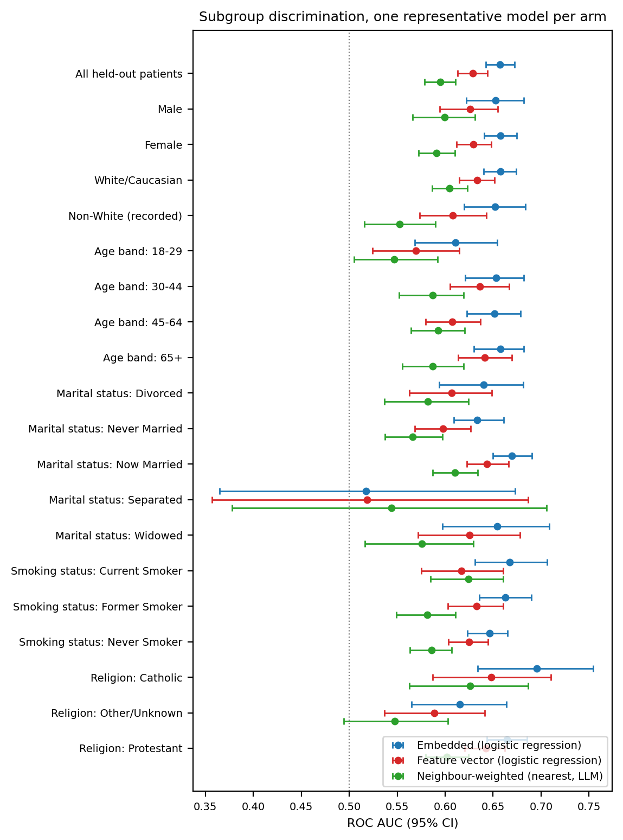
Figure S14. Subgroup discrimination across sociodemographic strata, one representative model per arm, with 95% bootstrap confidence intervals. The dotted line marks chance. Strata declared not estimable are omitted.

S11 Representation Field Crosswalk
Table S14 documents how the pipelines encode each source field, based on scripts/data_loading/feature_vector.py and scripts/data_loading/deterministic_narrative.py. It distinguishes shared information from differences in field content and resolution.
Fields were available by the index date. Clinical content used the 730-day lookback, while recorded history length summarized the longer pre-index record and index date identified the prediction date. Neither representation used post-index clinical data.
Table S14. Field-level crosswalk. Asymmetric marks a row where the two representations do not receive the same information. Missing-value rules are as implemented, not as intended.
Source field | Feature-matrix encoding | Narrative rendering | Missing-value rule | Parity
MDD recurrence, severity | two categorical columns | Condition: MDD (recurrence, severity) | empty string is a level in both | matched
Index date | no column | Index date: YYYY-MM-DD | never missing | asymmetric
Lookback window width | no column (constant) | Baseline window: −730...0 days | never missing | matched (carries no information)
MDD-to-index gap | mdd_to_anchor_days, float | MDD-to-anchor gap: N days | never missing | matched
Encounter count in window | num_encounters, float | Encounters in window: N | never missing | matched
MDD inside lookback window | mdd_within_window, boolean | MDD within window: Present/Absent | never missing | matched
Recorded pre-index history length | pre_anchor_history_days, float | not rendered | never missing | asymmetric
Age | AgeInYears, float | AgeInYears: N | never missing | matched
Sex | categorical | Sex: X | absent value becomes its own one-hot level; narrative prints the raw token | matched
Race / ethnicity | categorical, seven levels | Race_Ethnicity: X | own one-hot level; narrative prints raw token | matched
Preferred language | categorical, collapsed to five levels | raw Epic value | own one-hot level | asymmetric (finer in narrative)
Marital status | categorical, collapsed to five levels | raw Epic value | own one-hot level | asymmetric (finer in narrative)
Religion | categorical, collapsed to five levels | raw Epic value | own one-hot level | asymmetric (finer in narrative)
Smoking status | categorical, collapsed to three levels | raw Epic value | own one-hot level | asymmetric (finer in narrative)
Sexual orientation | no column | SexualOrientation: X | rendered as the literal token nan when recorded-but-empty | asymmetric
Social determinants of health | nine boolean columns | SDOH: list of present categories only | absence is an explicit False in the matrix, an omission from the list in the narrative | matched in content
BMI, systolic BP, diastolic BP | dropped at load | BMI: N \| BP (mean): S/D, or Missing | dropped, so no rule; narrative prints Missing | asymmetric
Psychiatric comorbidity (8 flags) | eight boolean columns | ARM: Present/Absent for all eight | never missing | matched
Suicidality flag | boolean | SUICIDE FLAG (2y): Present/Absent | never missing | matched
Substance-use specifics (10) | ten boolean columns | names of present substances only | absence explicit in matrix, omitted in narrative | matched in content
General medical comorbidity (4) | four boolean columns | ARM: Present/Absent for all four | never missing | matched
Prior adequate AD trials | five trials_<class> counts | Prior adequate AD trials: CLASS: n for all five | never missing | matched
Benzodiazepine days | benzo_days_coverage, float | Benzodiazepine days (2y): N | never missing | matched
Hypnotics | hypnotics_burden, count only | count plus ingredient names | never missing | asymmetric (finer in narrative)
Active medications | polypharmacy_count, count only | count plus ingredient names | never missing | asymmetric (finer in narrative)
NSAIDs | nsaid_count, count only | count plus ingredient names | never missing | asymmetric (finer in narrative)
Psychiatric inpatient days, ED visits | two float columns | Psych inpatient days: N \| ED psych visits: N | never missing | matched
Prescribing-safety comorbidity (2) | two boolean columns | ARM: Present/Absent | never missing | matched
Eleven rows are asymmetric. Ten provide additional or finer information to the narrative, including index date, sexual orientation, vital signs, 4 sociodemographic categories, and 3 medication blocks. Recorded history length is available only to FEATURE. The primary comparison therefore cannot isolate encoding from information content.
FEATURE retains categorical missingness as explicit levels. Its primary vital-sign fields were dropped rather than imputed; narratives retained measured values or missing-value tokens. The raw sexual-orientation token nan is a further implementation-specific exception to the general missing-value convention.
A sensitivity analysis added vital signs to FEATURE using missingness indicators and within-fold median imputation and added recorded history length to the narratives. The best-model contrast was reported to remain nonsignificant. These changes address selected asymmetries, not all differences listed above. Quantitative results are not included here and are available from the corresponding author.

S12 Cohort Characteristics and Outcome Frequency
Within-subgroup outcome frequency divides positive patients by all patients in that subgroup. This differs from the outcome-conditioned column percentages in the cohort table below. All frequencies describe the enriched analytic sample.
Outcome frequency was 18.0% among female and 16.2% among male patients. It declined across age groups: 20.6% at 18–29 years (1,135/5,513), 20.3% at 30–44 (1,836/9,025), 18.4% at 45–64 (2,445/13,268), and 13.8% at 65 or older (2,039/14,773). Selected social-determinant strata had higher frequencies: upbringing-related issues, 33.0%; legal issues, 26.1%; employment issues, 24.0%; and family or support-group issues, 22.9%. Small counts limit these comparisons. Missing race/ethnicity was associated with a frequency of 15.5% (46/297), versus 17.5% overall.
Table S15. Expanded cohort characteristics by TRD proxy status. Values are median (IQR) or n (%); percentages within outcome columns use the corresponding outcome-group denominator. SMD: standardized mean difference; AD: antidepressant; ED: emergency department; MDD: major depressive disorder; PTSD: posttraumatic stress disorder. Total N=42,579; positive n=7,455; negative n=35,124.
Characteristic | Level | Overall | TRD+ | TRD− | SMD
Demographics
Age (years) | median (IQR) | 55 (38–70) | 51 (36–66) | 56 (39–71) | −0.193
Age band | 18–29 | 5,513 (12.9%) | 1,135 (15.2%) | 4,378 (12.5%) | 0.080
 | 30–44 | 9,025 (21.2%) | 1,836 (24.6%) | 7,189 (20.5%) | 0.100
 | 45–64 | 13,268 (31.2%) | 2,445 (32.8%) | 10,823 (30.8%) | 0.043
 | 65+ | 14,773 (34.7%) | 2,039 (27.4%) | 12,734 (36.3%) | −0.192
Sex | Female | 30,850 (72.5%) | 5,552 (74.5%) | 25,298 (72.0%) | 0.055
Race/ethnicity | White/Caucasian | 34,079 (80.0%) | 5,942 (79.7%) | 28,137 (80.1%) | −0.010
 | Black/African American | 2,368 (5.6%) | 401 (5.4%) | 1,967 (5.6%) | −0.010
 | Am. Indian/Alaska Native | 2,033 (4.8%) | 394 (5.3%) | 1,639 (4.7%) | 0.028
 | Missing | 297 (0.7%) | 46 (0.6%) | 251 (0.7%) | −0.012
Depression phenotype
MDD recurrence | Recurrent | 11,213 (26.3%) | 2,189 (29.4%) | 9,024 (25.7%) | 0.082
 | Single episode | 28,206 (66.2%) | 4,721 (63.3%) | 23,485 (66.9%) | −0.074
MDD severity | Severe | 2,286 (5.4%) | 720 (9.7%) | 1,566 (4.5%) | 0.204
 | Moderate | 7,233 (17.0%) | 1,300 (17.4%) | 5,933 (16.9%) | 0.014
 | Psychotic | 112 (0.3%) | 35 (0.5%) | 77 (0.2%) | 0.043
 | Unspecified | 28,951 (68.0%) | 4,803 (64.4%) | 24,148 (68.8%) | −0.092
Psychiatric and substance comorbidity
Suicidality flagged | True | 1,753 (4.1%) | 641 (8.6%) | 1,112 (3.2%) | 0.232
Anxiety disorder | True | 22,401 (52.6%) | 4,499 (60.3%) | 17,902 (51.0%) | 0.190
Substance use disorder (any) | True | 9,265 (21.8%) | 2,006 (26.9%) | 7,259 (20.7%) | 0.147
Insomnia | True | 9,350 (22.0%) | 2,021 (27.1%) | 7,329 (20.9%) | 0.147
PTSD | True | 1,541 (3.6%) | 450 (6.0%) | 1,091 (3.1%) | 0.141
Alcohol use disorder | True | 1,875 (4.4%) | 501 (6.7%) | 1,374 (3.9%) | 0.125
Opioid use disorder | True | 1,281 (3.0%) | 337 (4.5%) | 944 (2.7%) | 0.098
Adjustment disorder | True | 2,918 (6.9%) | 663 (8.9%) | 2,255 (6.4%) | 0.093
Medical comorbidity
High cholesterol | True | 15,747 (37.0%) | 2,202 (29.5%) | 13,545 (38.6%) | −0.191
Uncontrolled hypertension | True | 15,680 (36.8%) | 2,366 (31.7%) | 13,314 (37.9%) | −0.130
Treatment and utilization
Active med count | median (IQR) | 1 (0–2) | 1 (0–2) | 1 (0–2) | 0.084
Encounter count | median (IQR) | 21 (8–46) | 17 (6–40) | 21 (8–47) | −0.140
Pre-index history (days) | median (IQR) | 1,792 (1,216–2,546) | 1,629 (1,141–2,335) | 1,830 (1,239–2,587) | −0.198
Any prior treatment exposure recorded | True | 10,230 (24.0%) | 1,793 (24.1%) | 8,437 (24.0%) | 0.001
Prior adequate AD trial (any class) | True | 6,276 (14.7%) | 1,050 (14.1%) | 5,226 (14.9%) | −0.023
Benzodiazepine days recorded | True | 4,724 (11.1%) | 989 (13.3%) | 3,735 (10.6%) | 0.081
Hypnotic recorded | True | 1,661 (3.9%) | 292 (3.9%) | 1,369 (3.9%) | 0.001
Augmentation therapy used | True | 422 (1.0%) | 108 (1.4%) | 314 (0.9%) | 0.052

S13 Additional Model Diagnostics and Encoder Estimates

S13 1 Primary ROC Curves and Descriptive Operating Points
The primary ROC curves are shown in Figure S15. At test-selected Youden J thresholds of 0.165 and 0.173, embedded logistic regression and feature-vector XGBoost had sensitivity 0.65 and 0.62 and specificity 0.58 and 0.61. They identified 964 and 917 of 1,491 positive patients, with 2,932 and 2,768 false positives, respectively (Figure S16). These thresholds were chosen and evaluated in the same test patients; the estimates are optimistic descriptions and are not deployment thresholds.
A Embedded logistic regression
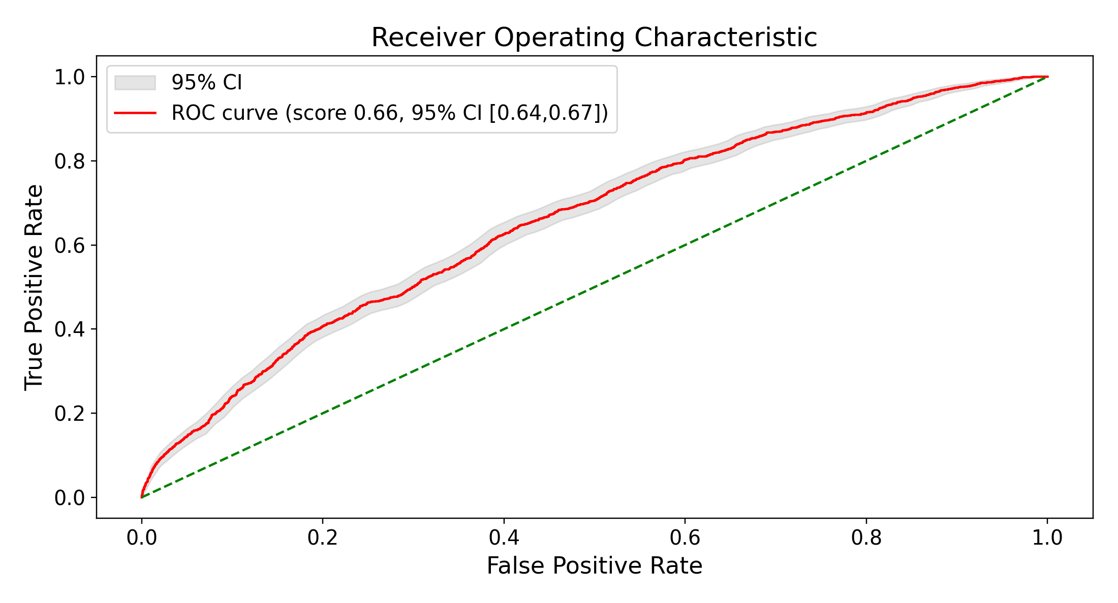
B Feature vector XGBoost
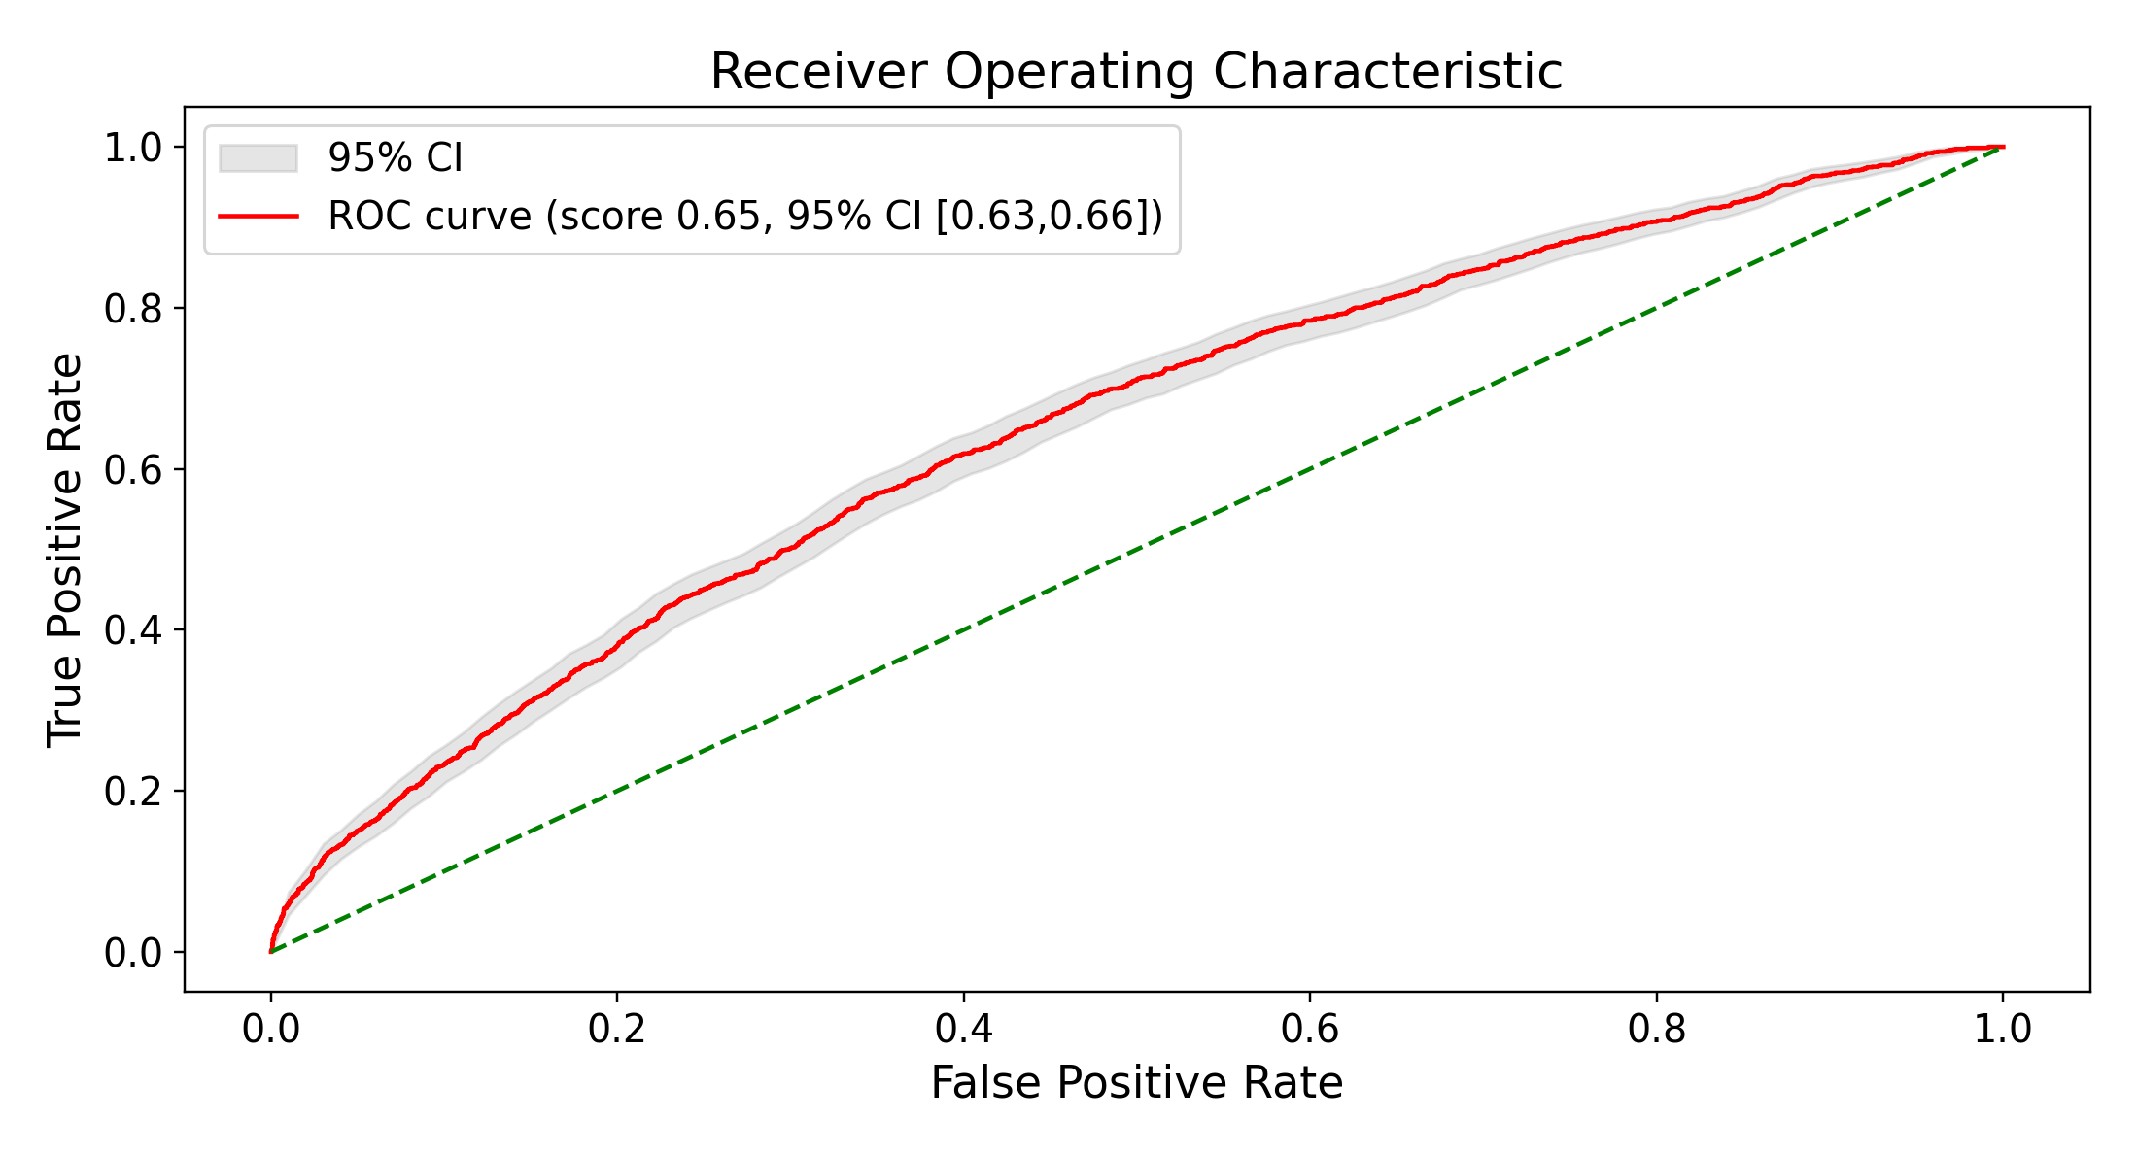
Figure S15. Primary ROC curves for embedded logistic regression (A) and feature-vector XGBoost (B). Shaded bands are bootstrap 95% CIs. ROC AUCs are reported in main-text Table 2.
A Embedded logistic regression
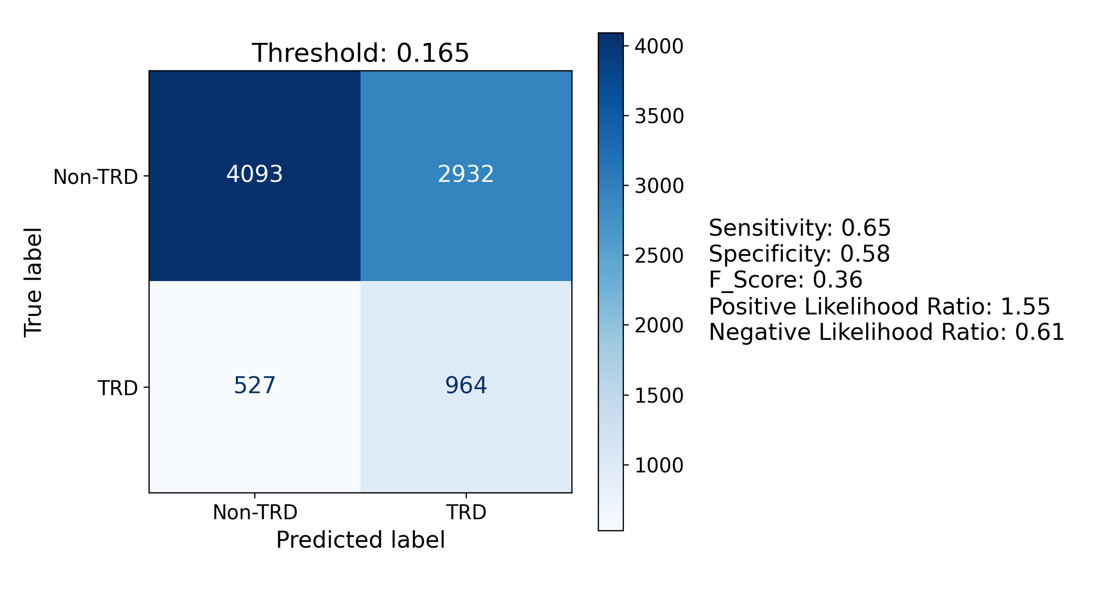
B Feature vector XGBoost
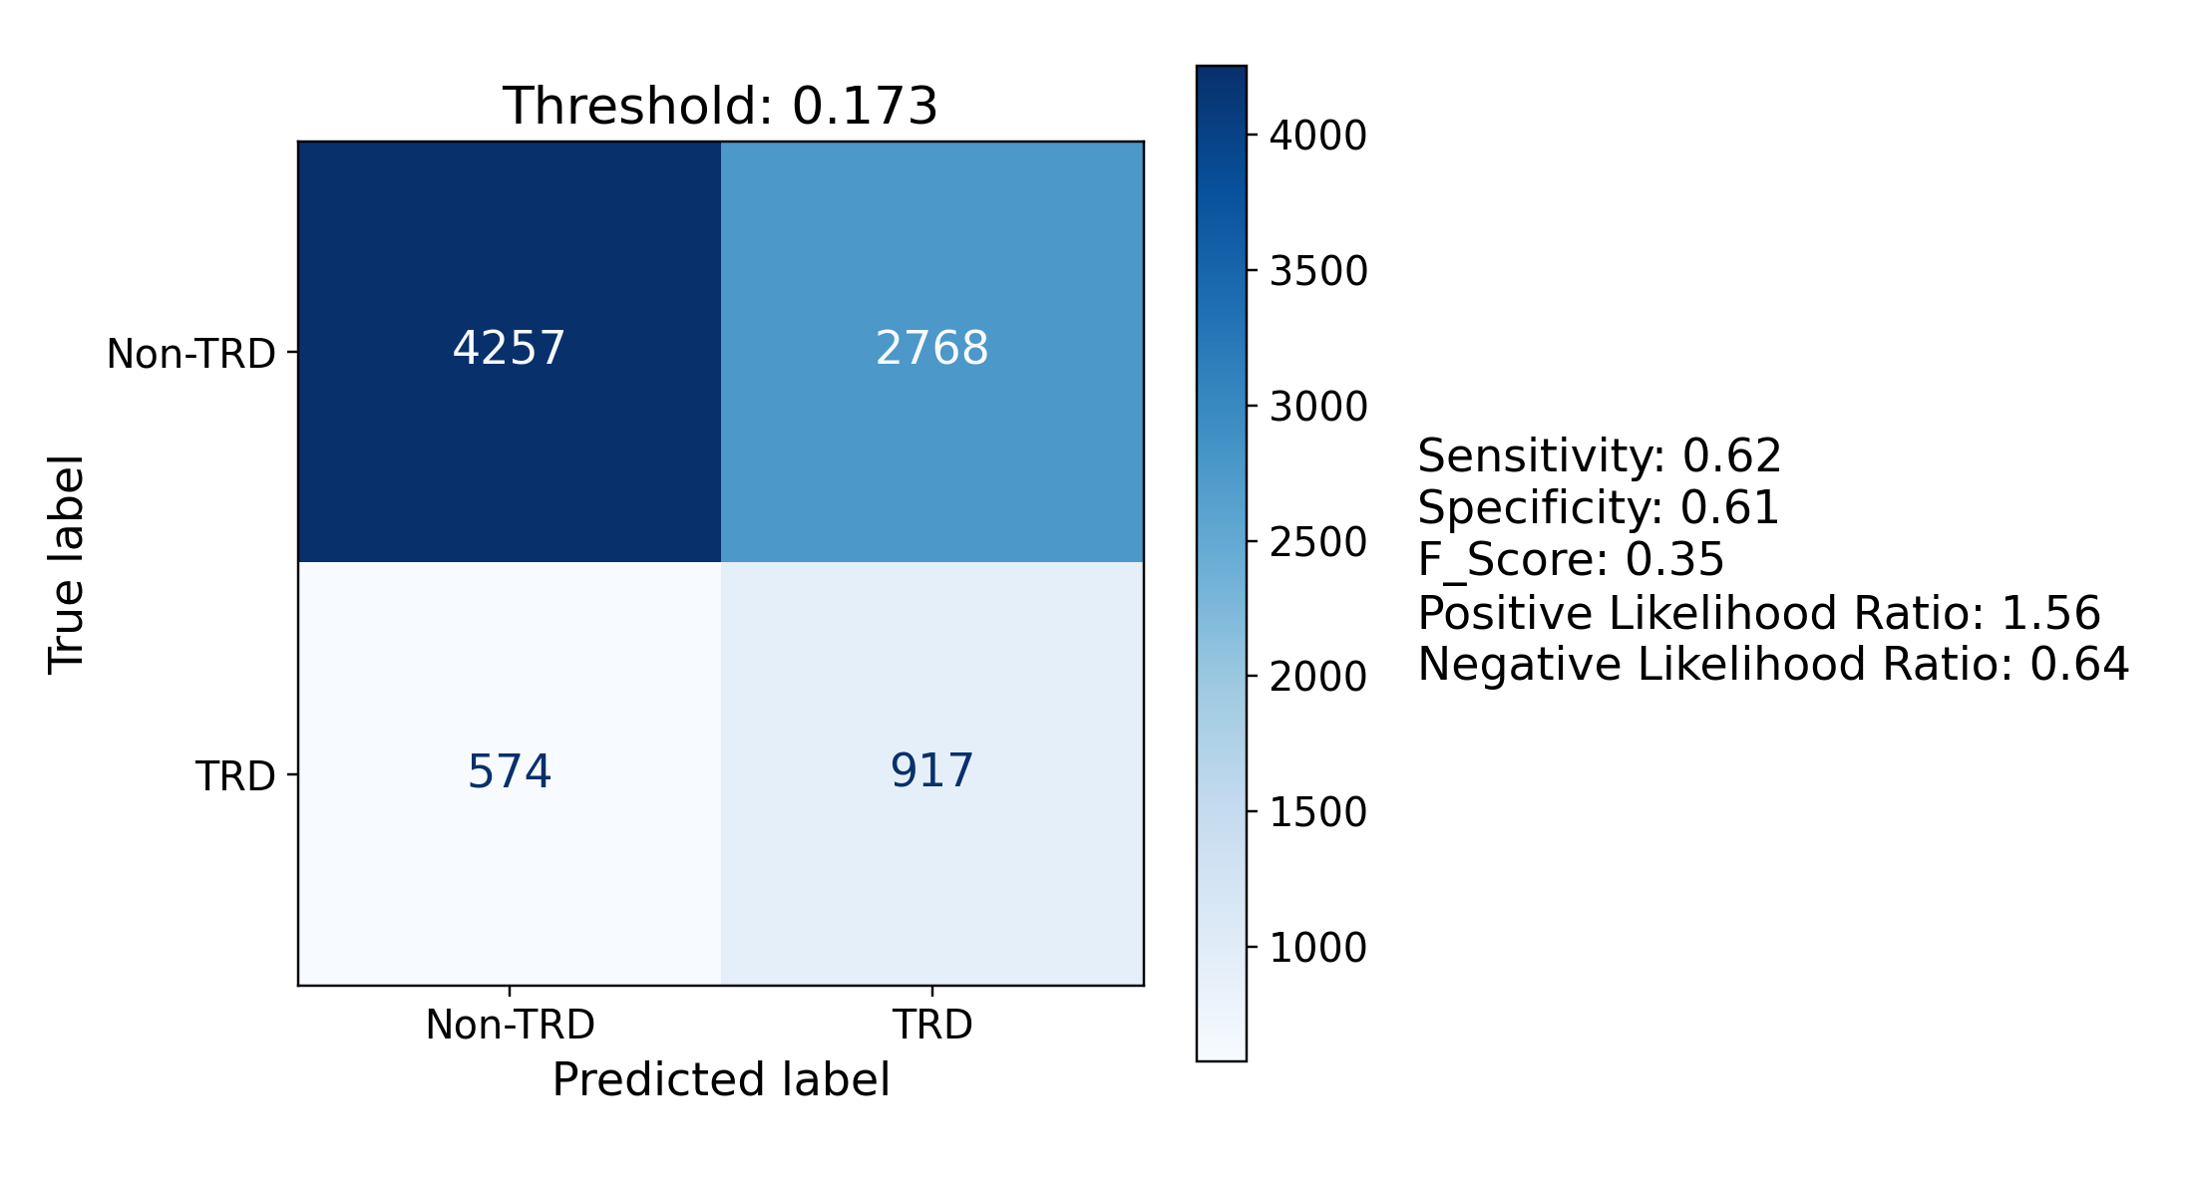
Figure S16. Confusion matrices at test-selected Youden J thresholds for embedded logistic regression (A) and feature-vector XGBoost (B). TRD refers to the treatment-switching proxy.

S13 2 Structured Feature Importance
Positive logistic-regression coefficients included severe depression coding, suicidality, insomnia, obsessive-compulsive disorder, opioid use disorder, posttraumatic stress disorder, and anxiety. Negative coefficients included missing smoking status, hyperlipidemia, longer pre-index history, and male sex. Tree importance rankings varied and also emphasized record length, age, utilization, and psychiatric burden (Figure S17). For trees, plotted colors derive from univariate correlations and do not give the direction of the fitted model’s conditional effect. None of these rankings supports causal interpretation.
A Logistic regression
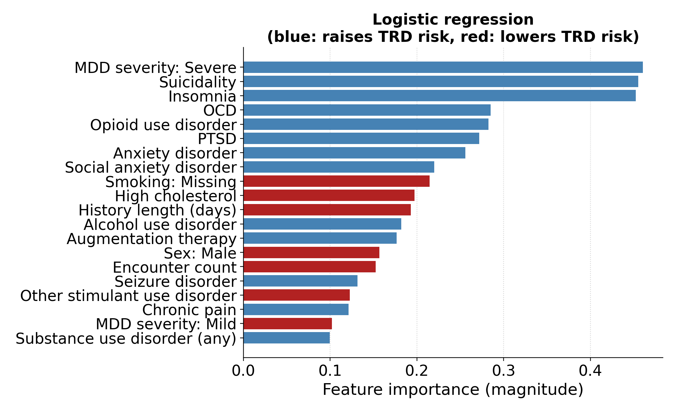
B Random forest
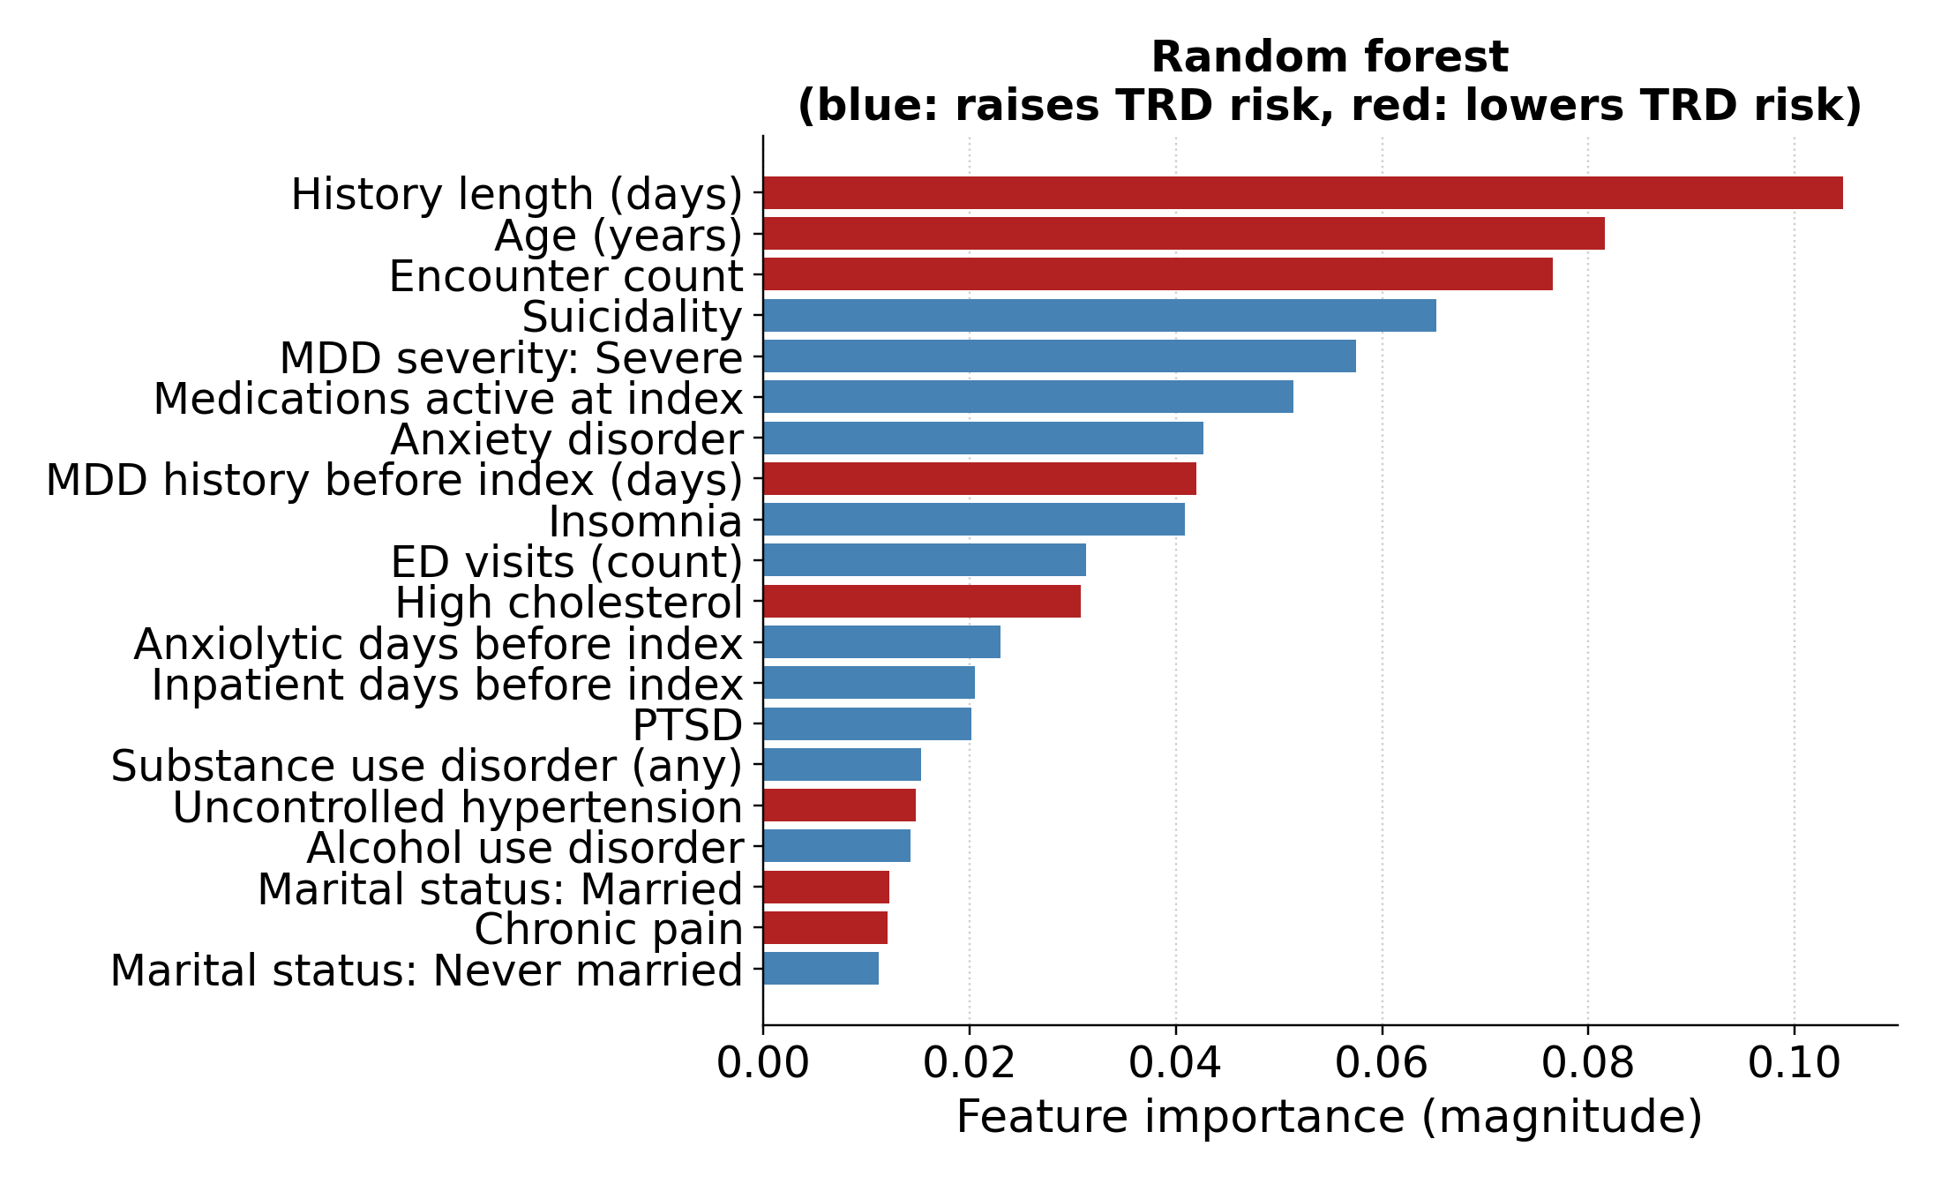
Figure S17. Continued on the next page.

C Gradient boosting
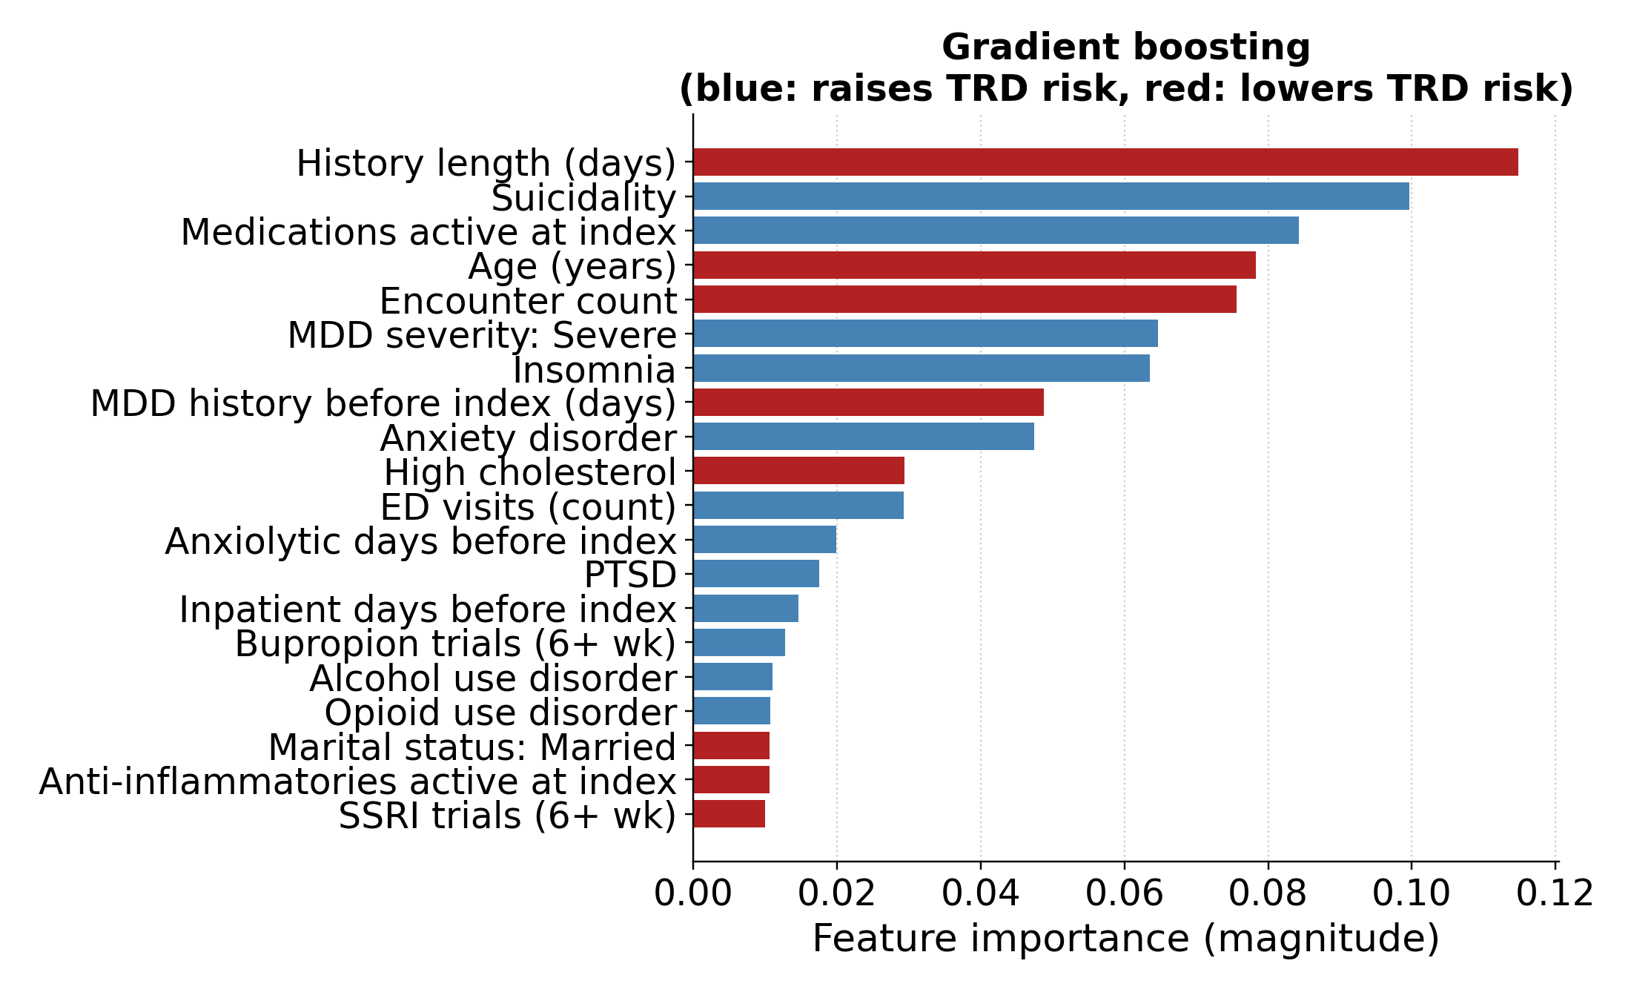
D XGBoost
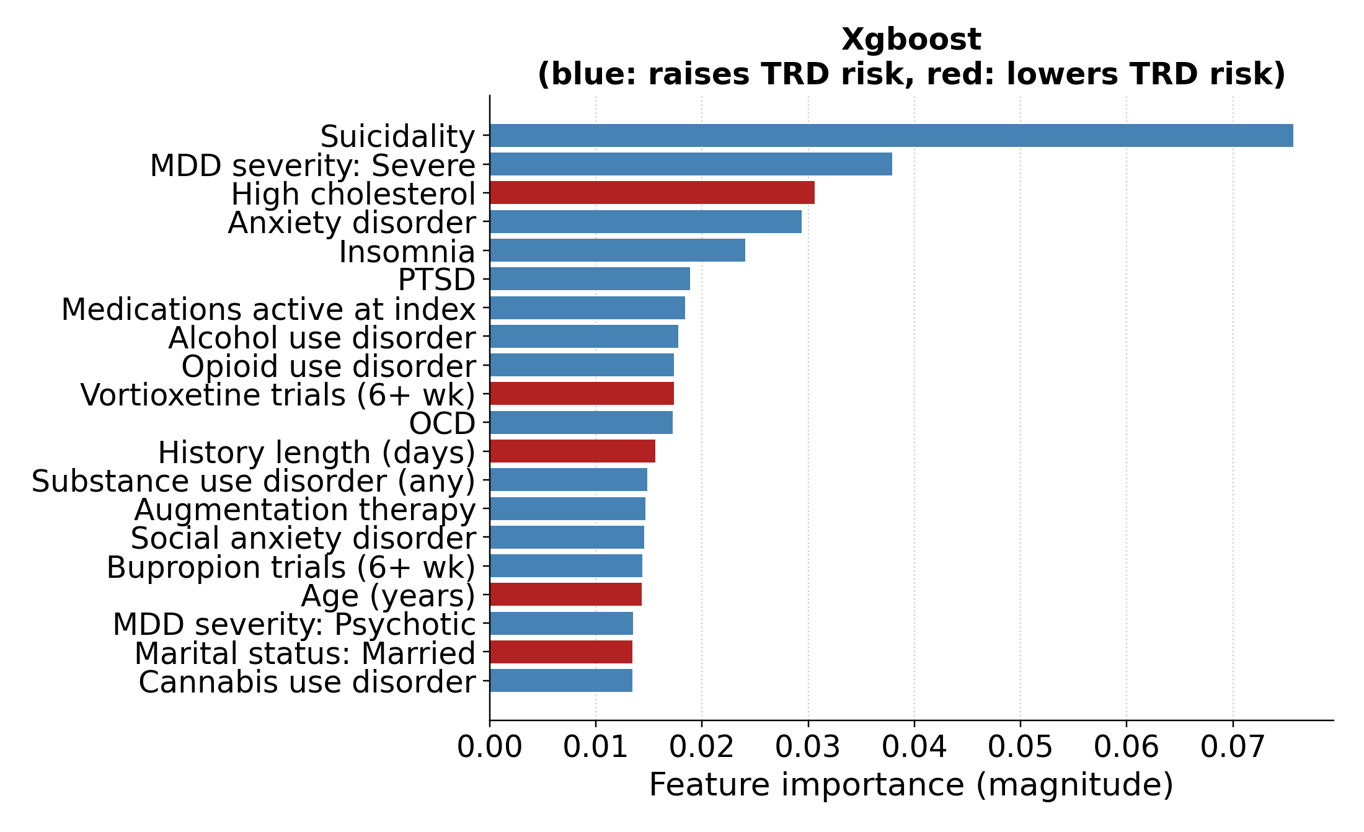
Figure S17. Structured feature importance for logistic regression (A), random forest (B), gradient boosting (C), and XGBoost (D). Logistic-regression bars show signed coefficients. Tree bars show native importance; colors reflect univariate associations, not conditional model effects or causal directions.

S13 3 Concept Permutation and Encoder Comparison
In the primary encoder, psychiatric-history permutation reduced AUC by 0.024–0.028 across classifiers; all paired CIs excluded zero. Medication burden reduced AUC by 0.003–0.027, with CIs excluding zero for 3 classifiers. Prior treatment reduced embedded logistic-regression AUC by 0.019 and the other models by 0.000–0.011, with CIs excluding zero for logistic regression and XGBoost. Among the remaining concepts, only the XGBoost contraindication contrast excluded zero (−0.005; 95% CI −0.008 to −0.001). Main-text Table 3 gives point differences; Figure S18 gives each model’s absolute AUC.
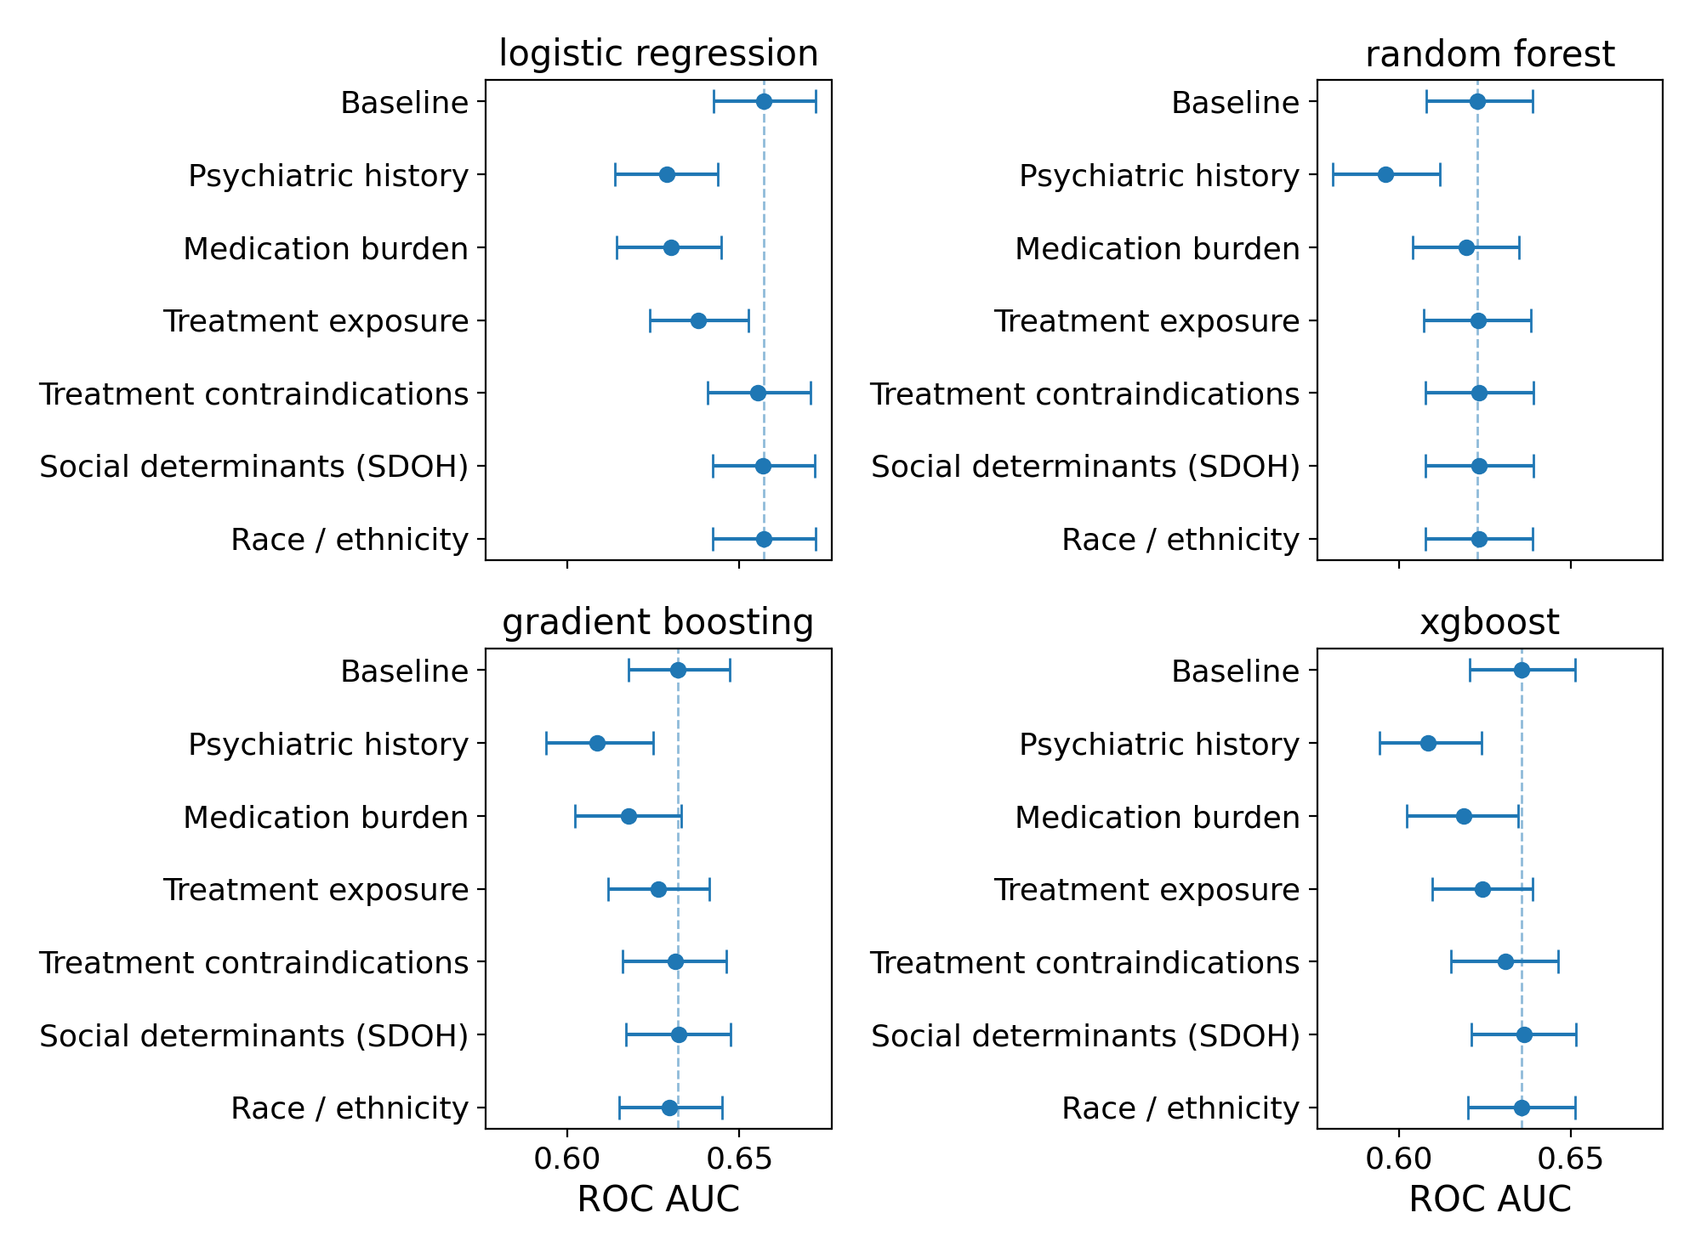
Figure S18. Absolute ROC AUC after concept permutation for each primary embedded classifier. Each panel includes the unperturbed baseline and 6 permutations. Bars are each run’s bootstrap 95% CIs, rather than paired CIs for the differences. SDOH: social determinants of health.
Embedded logistic regression had the highest AUC for every encoder. Across encoders, psychiatric-history permutation reduced its AUC by 0.027–0.030 and medication-burden permutation by 0.022–0.034, with all paired CIs excluding zero. Medication burden exceeded psychiatric history in bge-en-icl (−0.034 versus −0.027); psychiatric history had the larger effect in the other 3 encoders. The ordering applies to these tested concepts and does not establish unique or causal contributions.
Table S16. Embedded logistic-regression discrimination by encoder. EPV is 5,964 positive training outcomes divided by input dimension and is descriptive for these regularized models.
Encoder | Dimensions | EPV | ROC AUC (95% CI)
bge-small-en-v1.5 | 384 | 15.5 | 0.645 (0.629–0.660)
bge-en-icl | 4,096 | 1.5 | 0.655 (0.641–0.670)
Qwen3-Embedding-4B | 2,560 | 2.3 | 0.655 (0.641–0.670)
Qwen3-Embedding-8B | 4,096 | 1.5 | 0.657 (0.643–0.672)

References
1. Gaynes BN, Lux L, Gartlehner G, Asher G, Forman-Hoffman V, Green J, et al. Defining treatment-resistant depression. Depress Anxiety. 2020;37(2):134-145. doi:10.1002/da.22968.
2. Rush AJ, Trivedi MH, Wisniewski SR, Nierenberg AA, Stewart JW, Warden D, et al. Acute and longer-term outcomes in depressed outpatients requiring one or several treatment steps: a STAR*D report. Am J Psychiatry. 2006;163(11):1905-1917. doi:10.1176/ajp.2006.163.11.1905.
3. González HM, Vega WA, Williams DR, Tarraf W, West BT, Neighbors HW. Depression care in the United States: too little for too few. Arch Gen Psychiatry. 2010;67(1):37-46. doi:10.1001/archgenpsychiatry.2009.168.
4. Alegría M, Chatterji P, Wells K, Cao Z, Chen CN, Takeuchi D, et al. Disparity in depression treatment among racial and ethnic minority populations in the United States. Psychiatr Serv. 2008;59(11):1264-1272. doi:10.1176/ps.2008.59.11.1264.
5. Perlis RH. A clinical risk stratification tool for predicting treatment resistance in major depressive disorder. Biol Psychiatry. 2013;74(1):7-14. doi:10.1016/j.biopsych.2012.12.007.
6. Kautzky A, Baldinger-Melich P, Kranz GS, Vanicek T, Souery D, Montgomery S, et al. A new prediction model for evaluating treatment-resistant depression. J Clin Psychiatry. 2017;78(2):215-222. doi:10.4088/JCP.15m10381.
7. Sheu YH, Magdamo C, Miller M, Das S, Blacker D, Smoller JW. AI-assisted prediction of differential response to antidepressant classes using electronic health records. npj Digit Med. 2023;6:73. doi:10.1038/s41746-023-00817-8.
8. Chekroud AM, Zotti RJ, Shehzad Z, Gueorguieva R, Johnson MK, Trivedi MH, et al. Cross-trial prediction of treatment outcome in depression: a machine learning approach. Lancet Psychiatry. 2016;3(3):243-250. doi:10.1016/S2215-0366(15)00471-X.
9. Hegselmann S, Shen SZ, Gierse F, Agrawal M, Sontag D, Jiang X. A data-centric approach to generate faithful and high quality patient summaries with large language models. Proc Mach Learn Res. 2024;248:339-379.
10. Reimers N, Gurevych I. Sentence-BERT: sentence embeddings using Siamese BERT-networks. In: Proceedings of the 2019 Conference on Empirical Methods in Natural Language Processing and the 9th International Joint Conference on Natural Language Processing (EMNLP-IJCNLP); 2019 Nov; Hong Kong. Stroudsburg (PA): Association for Computational Linguistics; 2019. p. 3982-3992. doi:10.18653/v1/D19-1410.
11. Xiao S, Liu Z, Zhang P, Muennighoff N, Lian D, Nie JY. C-Pack: packed resources for general Chinese embeddings. In: Proceedings of the 47th International ACM SIGIR Conference on Research and Development in Information Retrieval (SIGIR ’24); 2024 Jul 14-18; Washington (DC). New York: ACM; 2024. p. 641-649. doi:10.1145/3626772.3657878.
12. Li C, Qin M, Xiao S, Chen J, Luo K, Shao Y, et al. Making text embedders few-shot learners. arXiv:2409.15700. 2024.
13. Zhang Y, Li M, Long D, Zhang X, Lin H, Yang B, et al. Qwen3 embedding: advancing text embedding and reranking through foundation models. arXiv:2506.05176. 2025.
14. Hegselmann S, von Arnim G, Rheude T, Kronenberg N, Sontag D, Hindricks G, et al. Large language models are powerful electronic health record encoders. arXiv:2502.17403. 2025.
15. Sellergren A, Kazemzadeh S, Jaroensri T, Kiraly A, Traverse M, et al. MedGemma technical report. arXiv:2507.05201. 2025.
16. Lee C, Zeng T, Jeong J, Sohn JY, Lee K. How to correctly report LLM-as-a-judge evaluations. arXiv. 2026;arXiv:2511.21140. doi:10.48550/arXiv.2511.21140.
17. Varma S, Simon R. Bias in error estimation when using cross-validation for model selection. BMC Bioinformatics. 2006;7:91. doi:10.1186/1471-2105-7-91.

