Supplement S1. Effective dimensionality of the embedded representation
Individual embedding dimensions carry no clinical meaning. Per-feature interpretability, available for the feature vector in main-text Figure 6, therefore does not transfer to the 4,096-dimensional embedded representation. Instead we characterize how many latent dimensions carry the predictive signal, using three complementary views. All figures are for the primary Qwen3-Embedding-8B encoder on the held-out test set.

S1.1 Sparsity and cumulative built-in importance
The best logistic-regression fit used an elasticnet penalty (l1_ratio 0.25, C 0.01) that zeroed most coefficients. Only 385 of the 4,096 dimensions carry nonzero weight, so the signal is concentrated in a sparse subset of them. We then ranked dimensions by each fitted classifier’s native importance, using |coef| for logistic regression and feature_importances_ for the tree ensembles, and accumulated the importance mass. That confirms the concentration. For logistic regression, 80% of the coefficient magnitude falls in roughly 179 of the 4,096 dimensions and 90% in roughly 236 (main-text Figure 7). TRD-relevant information is therefore carried by a modest subset of embedding dimensions rather than spread across the space.

S1.2 Cumulative univariate correlation
An importance ranking is model-specific. As a model-agnostic check we ranked dimensions by the absolute Spearman correlation between each dimension and the outcome, |ρ(dim, y)|, and overlaid that baseline against per-classifier curves ranking dimensions by |ρ(dim, risk score)| (Figure S1). Divergence between the model-agnostic baseline and a classifier’s curve would flag dimensions the classifier weights through regularization or interactions that a univariate ranking cannot see. The model-agnostic correlation curve remained diffuse, with many dimensions each weakly correlated with the outcome. The elasticnet logistic-regression curve was far more concentrated, the regularization having selected a compact predictive subset from a broadly informative space. Only |ρ| is used, because the sign of a correlation on an unnamed latent dimension is not interpretable.
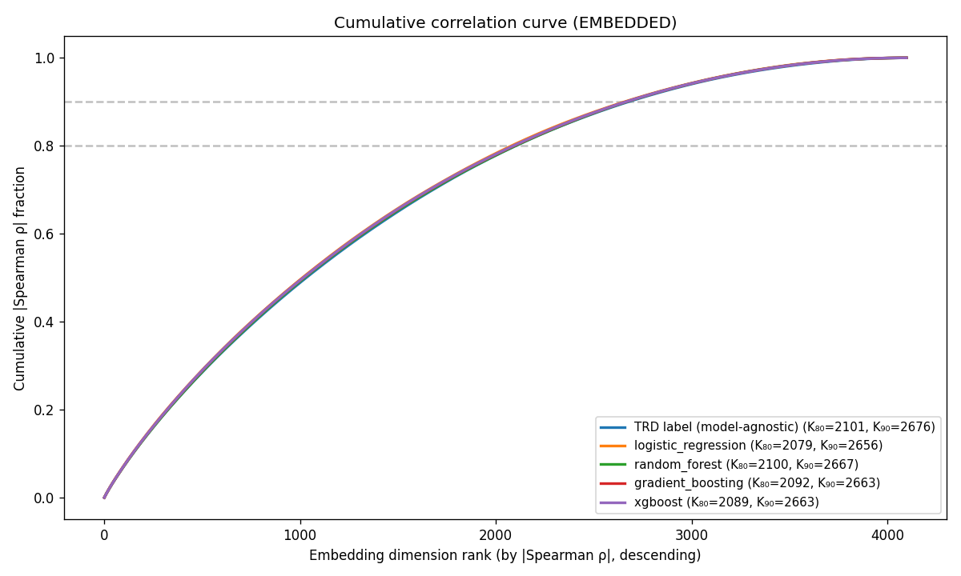
Figure S1. Cumulative absolute univariate (Spearman) correlation. One model-agnostic baseline curve ranks dimensions by |ρ(dim, outcome)|. The four per-classifier curves rank by |ρ(dim, predicted risk)|. Cumulative fraction of total |ρ| mass versus rank, with K₈₀ / K₉₀ knees in the legend.

S1.3 PCA-K discrimination sweep
To locate the geometric plateau, each classifier was retrained on the top K ∈ {1, 2, 4, 8, 16, 32, 64, 128, 256, 512, 1024} principal components of the embedding and its held-out ROC AUC plotted against K (Figure S2). Discrimination rose steeply over the first handful of components and then plateaued, with no single low-dimensional projection recovering the full-rank performance. That matches the diffuse model-agnostic curve in S1.2. The compact subset in S1.1 is what the elasticnet penalty selects out of a broadly informative space, not a low-dimensional subspace the signal already occupies.
(A) Logistic regression
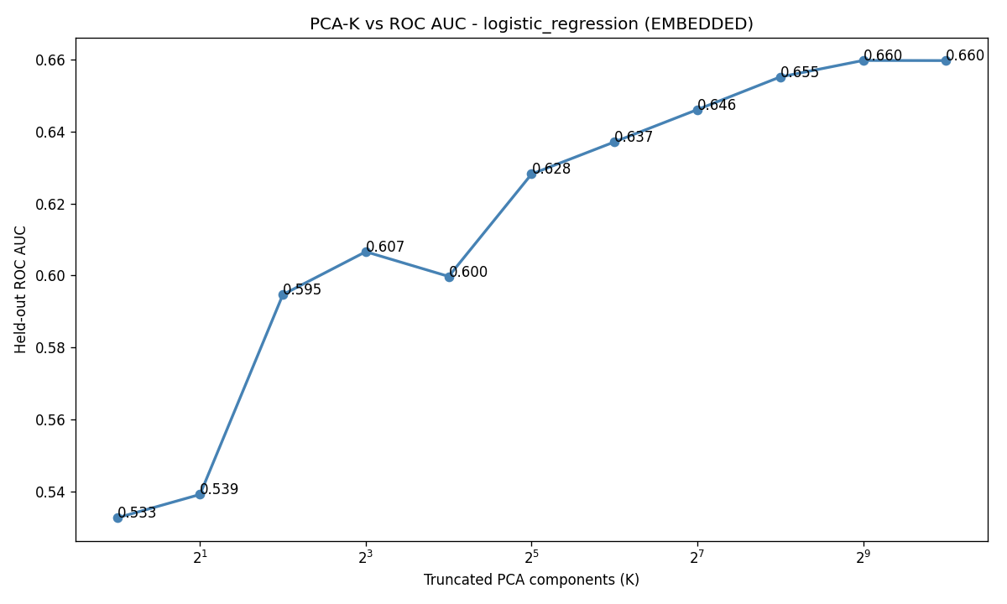
(B) Random forest
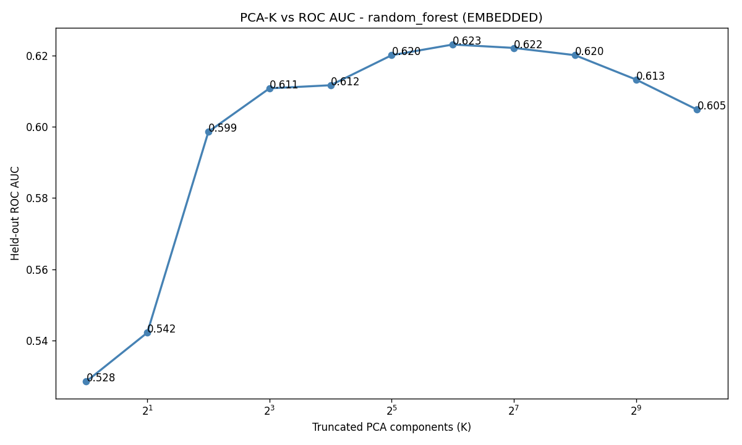
(C) Gradient boosting
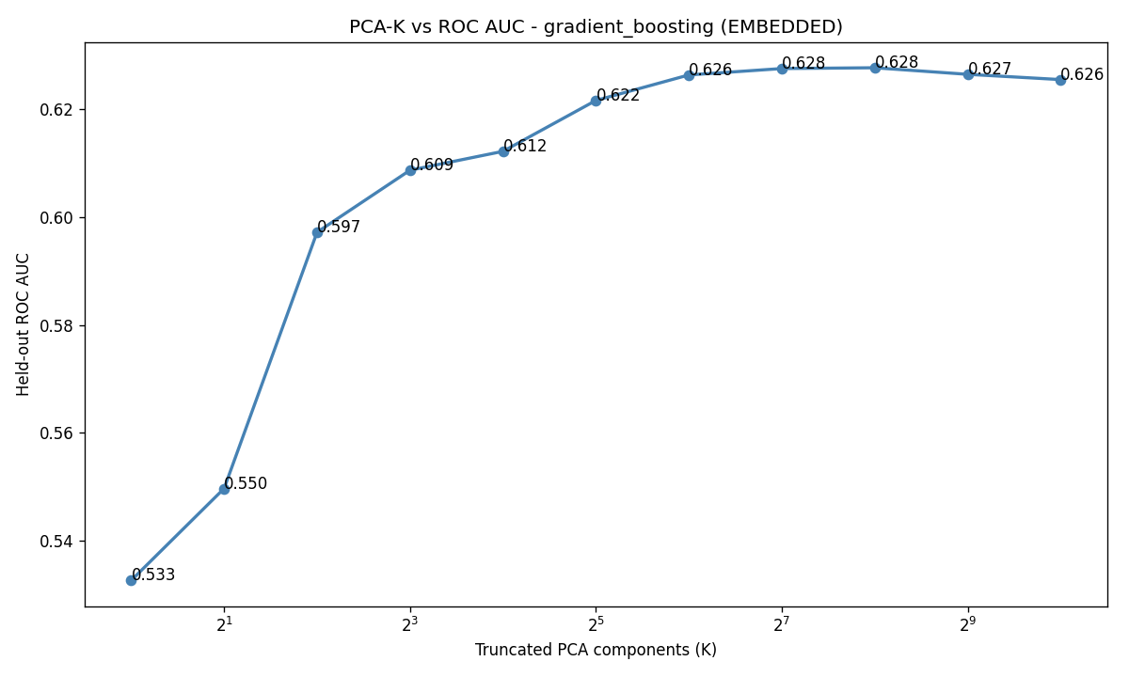
(D) XGBoost
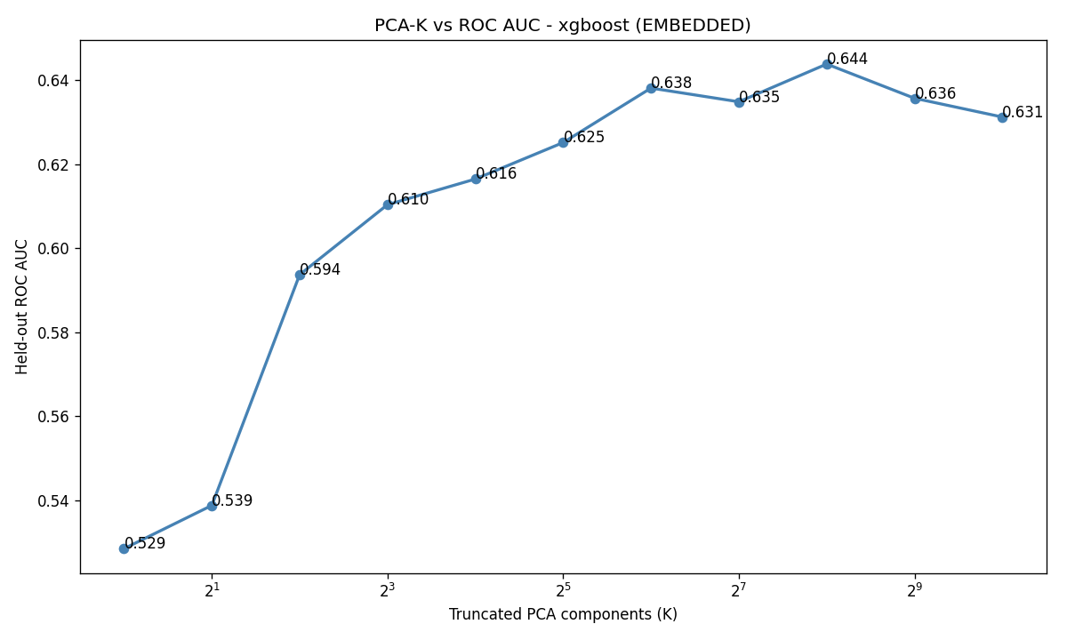
Figure S2. ROC AUC versus number of retained principal components, one panel per classifier: (A) logistic regression, (B) random forest, (C) gradient boosting, (D) XGBoost. The plateau marks the effective number of principal directions beyond which added components do not improve discrimination.

