Supplement S2. Precision–recall performance
The main text reports discrimination as ROC AUC. Under the cohort’s ~5:1 class imbalance (17.5% TRD-positive), ROC AUC can flatter apparent performance because the true-negative-dominated specificity term stays high regardless of how the positive class is ranked. The area under the precision–recall curve (AUPRC) is the complementary view: its no-skill baseline is the positive rate itself (0.175), not 0.5, and it exposes the precision cost of capturing TRD cases. We report it here rather than in the main text.
AUPRC tracked ROC AUC closely and remained modest for every model (Table S1): at this base rate, capturing high recall on the TRD proxy necessarily forces low precision. No clinical role is inferred from these values. The main text’s Discussion, Implications and future directions, records that temporal and external validation are prerequisites for any such claim.
Table S1. AUPRC of the four classifiers on each representation (held-out test set). No-skill baseline = 0.175 (the positive rate).
Representation | Classifier | AUPRC
EMBEDDED | Logistic regression | 0.302
EMBEDDED | Random forest | 0.270
EMBEDDED | Gradient boosting | 0.276
EMBEDDED | XGBoost | 0.278
FEATURE | Logistic regression | 0.278
FEATURE | Random forest | 0.293
FEATURE | Gradient boosting | 0.288
FEATURE | XGBoost | 0.298
Table S2. Embedded logistic-regression AUPRC by encoder (held-out test set). No-skill baseline = 0.175.
Encoder | AUPRC
bge-small-en-v1.5 | 0.281
bge-en-icl | 0.297
Qwen3-Embedding-4B | 0.297
Qwen3-Embedding-8B | 0.302
(A) Embedded logistic regression
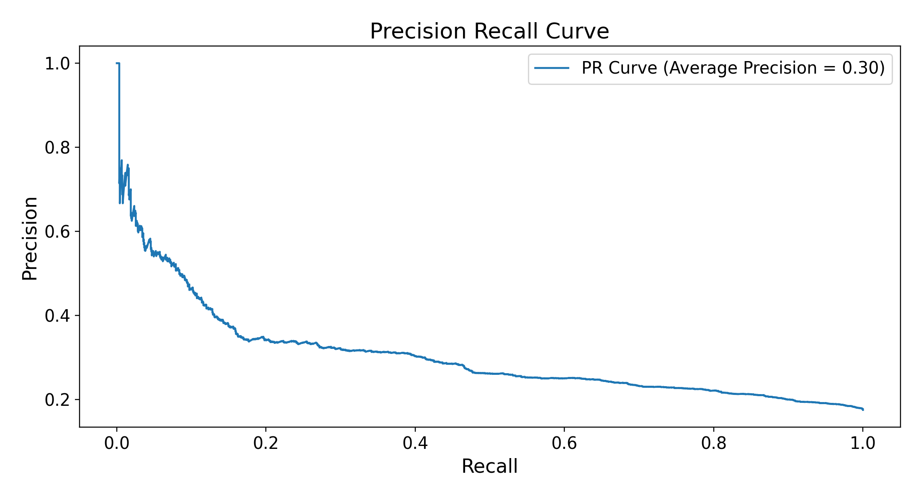
(B) Feature-vector XGBoost
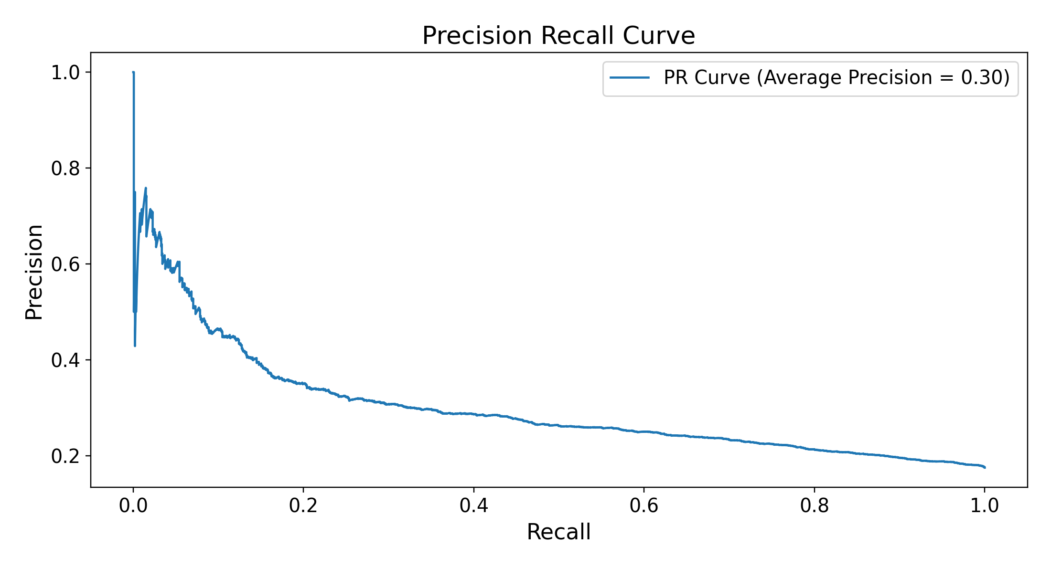
Figure S3. Precision–recall curves for the best classifier on each representation (held-out test set; primary Qwen3-Embedding-8B encoder). (A) Embedded logistic regression; (B) feature-vector XGBoost. The horizontal reference is the no-skill baseline (0.175, the positive rate).

