Title page
Title. Typed Feature Vectors Versus Neural Narrative Embeddings for Predicting a Treatment-Switch–Defined Electronic Health Record Proxy for Treatment-Resistant Depression: Retrospective Cohort Study
Short title. EHR Representations for Predicting a Treatment-Switch Proxy for Treatment-Resistant Depression
Authors. Mikey Ferguson, BS¹; Martin Paulus, MD¹; Rayus Kuplicki, PhD¹; Katherine L. Forthman, MS¹; Dale Peasley, MS¹; Sandip Sen, PhD².
Affiliations.
¹ Laureate Institute for Brain Research, Tulsa, OK, United States
² The University of Tulsa, Tulsa, OK, United States
ORCIDs.
Author | ORCID iD
Mikey Ferguson | 0009-0005-1365-5609
Martin Paulus | 0000-0002-0825-3606
Rayus Kuplicki | 0000-0003-2954-6421
Katherine L. Forthman | 0000-0002-8695-8388
Dale Peasley | 0009-0003-7696-595X
Sandip Sen | 0000-0001-6107-4095
Corresponding author.
Mikey Ferguson, BS Laureate Institute for Brain Research 6655 South Yale Avenue, Tulsa, OK 74136, United States Email: mferguson@laureateinstitute.org ORCID: 0009-0005-1365-5609

Abstract
Background. As many as 1 in 3 patients with major depressive disorder (MDD) fail successive antidepressant trials and progress to treatment-resistant depression (TRD), which carries disproportionate clinical and economic burden [1]. Identifying such patients early could provide empirical support to consider more aggressive treatment options. However, it is unclear whether structural elements of electronic health record (EHR) data together with applying generalized pre-trained transformer approaches provide signals that could be used to predict TRD.
Objective. To evaluate whether EHR-derived patient representations predict a treatment-switch–defined EHR proxy for incident TRD at a patient’s first antidepressant prescription, and to compare a transparent typed feature vector against a generalized pre-trained transformer embedding of a patient narrative.
Methods. We used a retrospective cohort of 42,579 individuals with unipolar MDD (bipolar and schizophrenia-spectrum diagnoses excluded) drawn from the inpatient and outpatient records of one community health system. Based on previous approaches, TRD was operationalized as > 2 antidepressant treatments within 1 year from the anchor date, the first instance of antidepressant treatment in the EHR. Each individual’s record was restricted to a fixed window of pre-treatment history ending at the anchor date. The outcome variable was the presence or absence of > 2 antidepressant treatments within one year post anchor date as TRD+ or TRD-. Two representations were used: a typed feature vector, and a deterministic Markdown narrative embedded by a pretrained sentence-transformer encoder (four encoders evaluated; primary Qwen3-Embedding-8B). Four classifiers (logistic regression, random forest, gradient boosting, XGBoost) were tuned by cross-validated grid search on each representation and evaluated on one held-out stratified 20% split (8,516 patients, 1,491 TRD-positive). We tested a nearest-neighbor prediction model on the embeddings and used a large language model to assess clinical similarity. To isolate the predictive signals, we systematically permuted individual narrative concepts. Discrimination (ROC AUC), calibration, and a test-set Youden-J operating point are reported with bootstrap CIs; the operating point is descriptive of this cohort rather than a candidate deployment threshold. The study follows TRIPOD+AI [10].
Results. TRD proxy predictive accuracy was modest, and no evidence of superior discrimination for either representation was found: embedded logistic regression reached ROC AUC 0.657 (95% CI 0.643–0.672) and the best feature-vector model (XGBoost) 0.649 (0.634–0.664), a paired difference of +0.008 (95% CI −0.003 to +0.019). Holding the classifier fixed, the embedding significantly helped logistic regression (+0.028) and significantly hurt all three tree ensembles (−0.013 to −0.022), so representation and learner are not separable choices. Logistic regression was the strongest embedded classifier for every encoder, spanning a narrow band (0.645–0.657). The neighbor-weighted predictor confirmed label-informative geometry — nearest-neighbor retrieval (ROC AUC ≈0.59) outperformed random (≈0.50–0.52) and inverted below chance under farthest retrieval (≈0.43) — but stayed below the trained classifiers, and retrieval scheme dominated weighting strategy. The ablation localized the signal to psychiatric history (ΔROC AUC −0.024 to −0.028, every paired-bootstrap interval excluding zero), medication burden and prior treatment exposure, rather than to race/ethnicity or social determinants; the psychiatric-history and medication-burden pattern reproduced across all four encoders.
Conclusions. Structured EHR data carry modes predictive signal for a treatment-switch–defined TRD proxy detectable at a patient’s first antidepressant prescription. A generalized pre-trained transformer embeddingof a deterministic narrative matched, but did not significantly exceed, a transparent feature vector. The ablation shows that neither model’s predictions rely on their race/ethnicity or social-determinant inputs; subgroup discrimination, subgroup calibration, and equity of the outcome label itself were not assessed, so no fairness conclusion follows from it. The absolute discrimination (ROC AUC ≈0.65) is too modest for clinical use, and temporal and external validation are required before any clinical role can be considered.
Keywords. treatment-resistant depression; major depressive disorder; electronic health records; clinical prediction model; machine learning; text embeddings; large language models; TRIPOD+AI.

Introduction
Major depressive disorder is among the most prevalent and disabling medical conditions, and antidepressant pharmacotherapy is its first-line treatment. A substantial minority of patients, however, fail to achieve remission despite successive adequate trials and are described as having treatment-resistant depression (TRD) — most commonly operationalized as the failure of at least two antidepressant trials of adequate dose and duration [2]. The sequential-treatment evidence base, anchored by the STAR*D program, established that remission rates fall sharply with each successive treatment step, so that patients who move into a third or fourth step face a markedly lower probability of recovery [3]. TRD accordingly accounts for a disproportionate share of the clinical morbidity, functional impairment, and health-care cost attributable to depression [1].
Because escalation options — augmentation, combination, switching to a different class, or neuromodulation — become both more necessary and less likely to succeed as resistance develops, there is longstanding interest in identifying, as early as possible, which patients are at high risk of progressing to TRD. If such patients could be flagged at the point of their first antidepressant prescription, clinicians could in principle monitor them more closely and escalate sooner.

Because electronic health records (EHRs) rarely capture standardized symptom change or treatment adequacy, studies operationalize treatment-resistant depression (TRD) using observable medication trajectories. While these computable phenotypes enable large-scale analysis, they remain distinct from symptom-confirmed nonresponse; varying the operational rules materially alters TRD prevalence and cohort composition [1-3]. Structural EHR elements encode clinically relevant illness burden and care pathways. While initial models utilizing demographics, utilization, and history report high internal performance (AUROC 0.83) [4], independent external validations yield more conservative estimates (AUROC 0.652) [5]. Combining structured data with clinical notes (AUROC 0.728) or neuroimaging further optimizes performance [6], establishing that tabular data is informative but benefits from multimodal integration.

A prior multi-system evaluation demonstrated poor external generalization (AUROCs 0.51-0.58) [7]. This highlights a fundamental methodological vulnerability: unless researchers enforce strict temporal separation between the prediction index and the forecast window, models may simply reconstruct the operationalized treatment-history label rather than identify a distinct treatment-resistance liability [1,3,4,7]. Consequently, structural EHR features currently represent candidates for risk stratification, not deployable clinical tools. Therefore, credible models must enforce temporal separation, evaluate transportability, and determine whether structural features outperform simpler medication rules or narrative-text embeddings, explicitly maintaining the distinction between a computable proxy and verified nonresponse [3,5-7].

Two considerations motivate this study. First, we aim to evaluate the representational capacity of generalized pre-trained transformer embeddings. While predicting clinical outcomes using large, purpose-built EHR foundation models requires inaccessible data and compute scales, serializing EHRs into text and applying generalized language model embeddings offers a computationally efficient alternative. Despite their competitive performance on broad clinical tasks, we must directly compare these generalized embeddings against transparent, hand-crafted feature vectors for TRD prediction, and systematically determine whether their predictive signals isolate clinically appropriate mechanisms. Second, to ensure methodological transparency and facilitate rigorous appraisal, we report this study in full accordance with the TRIPOD+AI guidelines.

This study evaluated whether EHR-derived patient data can predict an EHR-operationalized definition of treatment-resistant depression (TRD) within one year. We sequentially address three objectives. First, we compare a transparent typed feature vector against generalized pre-trained transformer embeddings of patient narratives, evaluating both via four standard classifiers on an identical cohort split. Second, we determined the robustness of these embeddings across four sentence-transformer encoders and evaluate their geometry using a nearest-neighbor predictor and an LLM-based clinical-similarity judge to verify if representation proximity tracks TRD risk. Finally, we isolated the predictive signals using a semantic-feature ablation that systematically permutes individual clinical concepts. This ablation determines whether the models rely on clinically coherent content rather than sociodemographic variables—a condition that establishes clinical plausibility and remains necessary, albeit insufficient, for equitable model performance..

Methods

Source of data and study design
This was a retrospective cohort study using a single de-identified extract from the Epic electronic health record of Saint Francis Health System. Seven tables were delivered: person, encounter, diagnosis, medication, procedure, and laboratory/flowsheet tables drawn from the Caboodle enterprise data warehouse, together with a medication-to-RxNorm mapping table drawn from the Clarity reporting database. The vital-sign fields considered here (body mass index, systolic and diastolic blood pressure) come from the laboratory/flowsheet table. Each table was delivered to the investigators as a de-identified flat file in which the patient and encounter keys had been replaced by one-way MD5 hashes, transferred over SFTP; no direct identifiers, names, medical record numbers, or dates of birth were included.
Person-level eligibility for the extract itself was set by the delivering data team: records were restricted to one administrative division of the health system, to patients who were current, valid, non-test, non-historical and not recorded as deceased, and to ages 18–110 years at extraction. Encounters were restricted to completed encounters on or before the extraction date with at least one associated diagnosis and a patient class of inpatient, outpatient, observation, or emergency. Depression, bipolar-disorder, and schizophrenia-spectrum status were flagged in the extract from explicit code lists specified by the investigators: depression as ICD-9 296.2, 296.3, 300.4, and 311 or ICD-10 F32., F33., and F34.1; bipolar disorder as ICD-9 296.0 and 296.4–296.8 or ICD-10 F30.* and F31.; and schizophrenia-spectrum disorders as ICD-9 295. and 298.* or ICD-10 F20., F23., F25., F28., and F29.*.

Study population. The extract was assembled as a case-enriched sample rather than as a census of the health system’s patients. Every patient carrying a depression diagnosis code on their problem list was retained, and a random sample of patients without that code was added at an approximate 4:1 unflagged-to-flagged ratio; the remaining six tables were then joined to that person file. The delivered extract therefore contains 501,718 patients: 100,420 (20.0%) carrying a problem-list depression code and 401,298 (80.0%) sampled at random from those who did not.
Two features of that design bear on how the cohort should be read. First, the flag used to build the extract and the eligibility criteria applied below read different parts of the record. The flag was computed from the patient’s problem list, the curated summary of conditions carried on their chart. Eligibility here is assessed from diagnosis codes recorded at individual encounters. A depression code entered at a visit is a documented diagnosis whether or not it was ever added to the problem list, and in routine care the problem list is frequently not updated, so the two sets overlap without either containing the other. Patients therefore qualify for this study without having carried the flag: 12,530 of the 42,579 analysis-cohort patients (29.4%) did so, reaching the cohort through the randomly sampled group rather than the fully retained one. Second, and following directly from that, the cohort is a sample of the health system’s depressed patients rather than an enumeration of them: prevalence-type figures reported below — the proportion of the cohort that is TRD-positive, and the subgroup proportions in Table 2 — describe this cohort, not the underlying patient population. Neither feature affects the comparison of representations that is this study’s primary objective, since both representations are derived from the same patients and evaluated on the same held-out split.
All analyses reported here were run against one frozen version of that extract, identified internally as data version DV260629v1 and patient version PV260710v1. The delivered files are date-stamped 2026-06-29, which is the source-data cut; the analysis-ready tables were built from them on 2026-07-10. No data released after that cut entered any analysis, and no table was re-extracted or refreshed during the study.

Setting. All data were extracted from a single community health system — Saint Francis Health System in Tulsa, Oklahoma, United States. The extract covers inpatient, outpatient, observation, and emergency encounters. The cohort is therefore a general health-system population rather than a psychiatric specialty sample: patients enter it by receiving an antidepressant somewhere in routine care, not by being referred to psychiatry, and the antidepressant anchor may be prescribed in any of those settings. This is a single-centre study in one metropolitan area, which bears directly on the demographic composition reported below and on generalizability (Discussion, Limitations).
Anchor dates, i.e., the date of each patient’s first antidepressant prescription following a documented depression diagnosis (Participants and eligibility, Anchor selection), span 2016–2024. For every patient an anchor date defines the temporal origin: a fixed pre-anchor window of clinical history is used to construct predictors, and a post-anchor follow-up window is used to ascertain the TRD outcome. The development and the held-out evaluation samples were drawn from the same data source and time period and partitioned by a single random split (see Train/test split below); this is therefore an internal validation by random split, not a temporal or external validation.

Participants and eligibility
We applied the inclusion and exclusion criteria as a series of hierarchical filters (Table 1). Beginning from every patient in the delivered extract, we required: (1) a qualifying MDD diagnosis; (2) absence of bipolar disorder and absence of schizophrenia-spectrum diagnoses (to isolate unipolar depression); (3) an antidepressant anchor (defined below); (4) an MDD diagnosis recorded on or before the anchor; (5) at least two years of pre-anchor history; and (6) at least one year of post-anchor follow-up, so that the TRD outcome could be ascertained reliably. Patients failing the chronological or follow-up prerequisites were recorded with an explicit rejection reason for attrition accounting.

Anchor selection. The anchor is a patient’s first antidepressant prescription recorded on or after their first documented depression diagnosis. The upstream data-preparation stage assembles, for every patient, the set of antidepressant medication orders starting on or after that first depression-diagnosis date; the anchor is the start date of the earliest such order, one per patient. Every patient in the analysis cohort therefore has exactly one anchor, and 57.9% of the candidate orders in that upstream table begin on the same day as the first recorded depression diagnosis.
No property of the anchor is conditioned on data recorded after the anchor date. In particular, adequacy of dose or duration is not required of the anchor exposure, so the anchor is fully observable at the moment the prescription is written and the prediction point coincides with it. Post-anchor information enters the study in exactly two places, both concerning eligibility and outcome rather than prediction: at least 365 days of post-anchor follow-up must exist (filter 6 above), and the outcome is ascertained over those 365 days (Outcome). The lookback window is the 730 days ending at the anchor date, and every predictor is computed inside it (Predictors and patient representations).
Prior antidepressant exposure is handled as a predictor and never as an exclusion. Because the anchor is indexed to the first documented depression diagnosis, a patient may carry antidepressant courses that began before that diagnosis was recorded: 24.0% of the cohort has some recorded pre-anchor antidepressant exposure and 14.7% has at least one pre-anchor course meeting the 42-day adequacy threshold used for the trial-count predictors (Table 2). The anchor is thus the first antidepressant prescription written for a documented depression diagnosis, and is not necessarily a patient’s first antidepressant exposure or first adequate antidepressant course; it is referred to throughout as the anchor prescription rather than as a first adequate trial.
The design is summarized in Figure 1: everything to the left of time zero is available to the model, and everything to its right enters only through the eligibility filter and the outcome label.
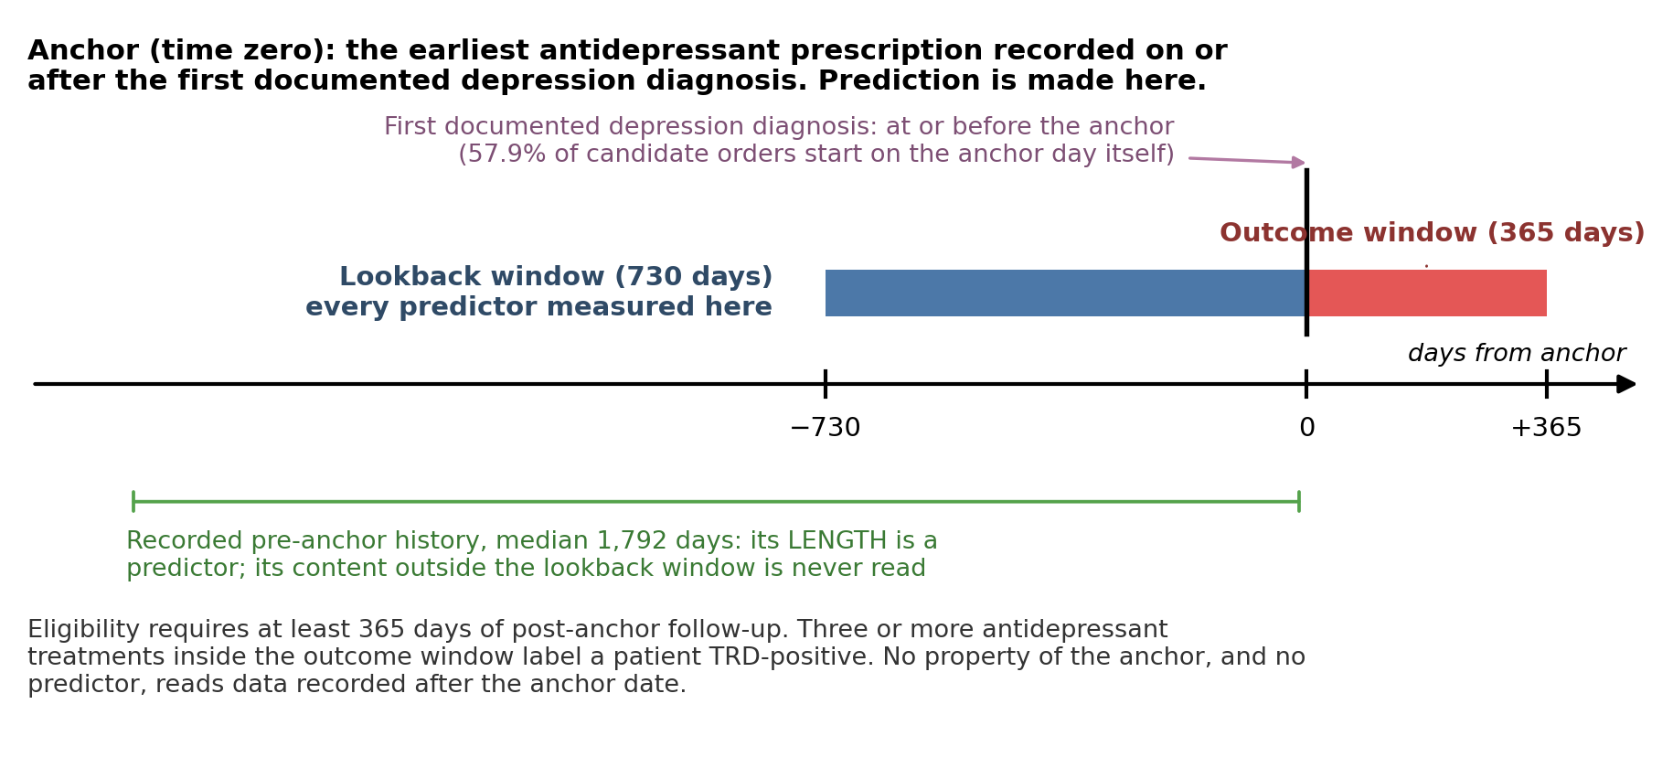
Figure 1. Time zero, the lookback window, and the outcome ascertainment window. The anchor is the earliest antidepressant prescription recorded on or after the patient’s first documented depression diagnosis; no property of it is conditioned on post-anchor data, so the prediction point coincides with the prescription date. Every predictor is measured inside the 730-day lookback window. Recorded history frequently extends further back (median 1,792 days) and its length is itself a predictor, but its content outside the lookback window is never read. Post-anchor data enters in exactly two places: eligibility requires at least 365 days of follow-up, and the outcome is ascertained over those 365 days.

Outcome
The prediction target was a treatment-switch–defined EHR proxy for incident TRD, supplied as a pre-defined external binary label and consumed as-is by the modeling pipeline. The label was computed in the upstream R data-preparation stage and assigned independently of the predictors used in this study.
Operational definition. TRD was assigned to patients with MDD who received three or more antidepressant treatments within one year — the same EHR-based operational definition applied by Forthman et al. in the All of Us Research Program cohort [20], adopted here unchanged so that the target of this model is the one already characterized in that work. The window is the year following the anchor date, and the anchor agent counts as the first of the three treatments; equivalently, a patient was labelled TRD-positive if at least two antidepressant medication changes occurred in the post-anchor year. Patients receiving fewer than three antidepressant treatments in that window were labelled TRD-negative.
A treatment is a distinct antidepressant agent, not a prescribing event, so two cases deliberately do not advance the count: augmentation, in which a second agent is added alongside the current one rather than replacing it, and restarting an antidepressant the patient had taken before. Augmentation enters this study as a predictor rather than as an outcome event (Multimedia Appendix 1; Table 2).
The one-year ascertainment window is the reason eligibility required at least one year of post-anchor follow-up (Participants and eligibility): every patient in the analysis cohort is observed across the full window over which the outcome is defined, so a negative label reflects an absence of further antidepressant treatments rather than an absence of observation.

Relation to the consensus definition. Counting antidepressant treatments is a proxy for the consensus characterization of TRD as inadequate response to at least two antidepressant trials of adequate dose and duration [2,3], and it departs from that characterization in two respects that bear on interpretation. First, non-response is inferred from the act of moving to another agent rather than measured: no symptom-severity instrument enters the label. Second, adequacy of dose and duration is not verified for any of the counted treatments, the anchor included, so a change prompted by adverse effects, intolerance, cost, insurance formulary, fragmented care, or patient preference is counted the same as one prompted by non-response. This reflects a constraint of the data rather than a design preference — standardized symptom-severity measures are not systematically recorded in this EHR extract, so response cannot be assessed directly — but it means the target is a treatment-switch proxy rather than treatment resistance itself, and its consequences are revisited under Limitations. It also means the label may encode differential access to care as though it were clinical signal: switching depends on continuity of care, insurance, and prescriber practice as well as on response, and depression treatment in the United States is not equally delivered across racial and ethnic groups [18,19]. The label was not validated against chart review or against a symptom-severity instrument, and no higher-specificity variant requiring documented post-anchor adequate courses was evaluated; both are named under Limitations as the natural next steps.

Predictors and patient representations
All predictors were derived solely from data within the pre-anchor window; no post-anchor information entered any predictor. Each eligible patient was rendered into two independent representations from the same timeline-sliced source record.
Predictor selection. The predictor set was specified a priori, on clinical and prior-literature grounds, before any model was fitted. We followed the manual-selection strategy of the treatment-resistance risk model of Perlis [4], in which clinically plausible candidate variables are assembled by review and then pruned to protect the events-per-variable ratio, rather than a data-driven screen. No predictor was kept or discarded on the strength of its measured association with TRD, and no automated selection step ran at any stage. The predictor list was therefore settled before any patient’s outcome was consulted, which is what rules out the reported performance having been inflated by a selection step that had already seen the data it was later scored on.

Two considerations governed which domains were represented. The first was prior evidence. The fields span the domains that earlier treatment-resistance and antidepressant-response prediction studies found informative: baseline depression severity and recurrence, psychiatric and substance-use comorbidity, medical comorbidity, prior antidepressant exposure and medication burden, health-care utilization, and sociodemographic characteristics [4,5]. Here they are restricted to those recoverable from routine EHR structured fields rather than from research assessments. That restriction is what separates this predictor set from those built on clinical-trial data. Perlis [4] and Kautzky et al. [5] could draw on symptom-severity rating scales and standardized diagnostic interviews administered on a fixed schedule; neither is systematically recorded in this extract, so depression severity enters our predictor set as a diagnostic code rather than as a scale score. Where prior work has modelled antidepressant outcomes directly from EHR data, the available predictor domains have been closer to those used here [6,7].
The second consideration was this study’s own design. Prescribing-constraint flags were retained because they are the fields a clinician would actually consult in deciding whether escalation is available for a given patient; sociodemographic and social-determinant fields were retained so that the semantic-feature ablation could test directly whether the models lean on them, rather than leaving that question unanswerable by construction (Semantic-feature ablation; Discussion, Principal findings). The only fields dropped after specification were the three vital signs, each of which enters as the mean of that patient’s own recorded readings across their pre-anchor encounters, and which were removed for missingness reasons unrelated to their association with the outcome (Missing data); the resulting inventory is given in full in Multimedia Appendix 1.

Typed feature vector (FEATURE). A typed feature vector was constructed per patient, with every field carrying an explicit data type that determines how it is preprocessed downstream: quantitative counts and durations (e.g., encounter count, pre-anchor history length, age, per-agent adequate-trial counts, polypharmacy count) as continuous values; single-valued binary clinical flags and multi-label clinical indicator sets (psychiatric comorbidities, medical comorbidities, prescribing-constraint flags, substance-use-disorder categories, and social-determinant categories) as booleans; and single-valued nominal fields (sex, preferred language, marital status, religion, smoking status, race/ethnicity, MDD recurrence, MDD severity) as categoricals compressed via standardized vocabularies. Adequate antidepressant trials were defined by a 42-day (six-week) minimum continuous exposure threshold per agent. The complete predictor inventory, with each field’s type and encoded form, is given in Multimedia Appendix 1.

Deterministic narrative and generalized pre-trained transformer embedding(EMBEDDED). The same sliced record was deterministically rendered into a human-readable Markdown narrative summarizing only the pre-anchor window (two example narratives are provided in Supplement S6). Rendering is deterministic and reproducible — no generative model participates in narrative construction, so the narrative introduces no stochastic content. That choice is deliberate. When language models are used to write summaries of clinical records they do introduce statements the record does not support, at rates that have been measured directly [23]. In this pipeline the narrative is the predictor, so an invented detail would alter a patient’s model input with no way to detect it afterwards. A deterministic renderer gives up fluency in exchange for a guarantee that every statement in the narrative traces back to a field in the record. Each narrative was then mapped to a fixed-length dense vector by a pretrained sentence-transformer encoder [11]. Four encoders were evaluated independently: bge-small-en-v1.5 [12], bge-en-icl [13], Qwen3-Embedding-4B, and Qwen3-Embedding-8B [14]. Serializing a structured record into natural-language text and encoding it with a general-purpose neural language model, rather than hand-building a numeric feature vector, follows a recently validated design in which LLM embeddings of serialized EHR records rival purpose-built EHR foundation models across clinical prediction tasks [9].

The two representations are built from the same timeline-sliced record but do not receive an identical field inventory. Supplement S11 is the field-level crosswalk — source field, feature encoding, narrative rendering, missing-value rule, and temporal availability for every field in either representation — and Limitations item 9 states what the resulting imbalance does to the head-to-head claim.

Missing data
No imputation was performed in this pipeline. The handling of missingness was representation-specific.

Three vital-sign columns (BMI, systolic blood pressure, diastolic blood pressure) were present in the feature parquet but dropped from the FEATURE modeling matrix at load time. Each is a within-patient mean — the average of that patient’s own readings over their pre-anchor encounters, not an average taken across patients. Mean BMI was missing for 22.1% of patients and at least one vital was absent for 21.0%, and the missingness was associated with the outcome: BMI was missing for 28.8% of TRD-positive versus 20.6% of TRD-negative patients (an ~8 percentage-point gap).

That gap establishes that these values are not missing completely at random: whether a vital sign was recorded is associated with the outcome being predicted. It does not establish that they are missing not at random in the technical sense, which cannot be determined from the observed data — the association is equally consistent with missingness depending on health-system contact that the recorded predictors capture only partly. The three columns were dropped rather than filled on the weaker and sufficient grounds that no imputation model could be justified from the observed predictors alone (the consequences, including the alternative of retaining the columns with explicit missingness indicators, are taken up in Discussion, Limitations). No NaN cells reached any transformer, and no missingness indicators were created for the continuous block.

Rather than imputing data, we treated missing categorical values as a separate category. On the FEATURE side this enters the one-hot encoder as an implicit “Missing” level; on the EMBEDDED side the deterministic narrative encodes absence with a literal “Missing” token. Marital status and smoking status are effectively complete (<0.5% missing). Religion is not clean: 29.4% missing overall with a monotone age gradient (43.8% in ages 18–29 falling to 17.5% in ages ≥65), a missing-at-random pattern with respect to age that propagates into the model as a missing-indicator level. The treatment of religion (retain the indicator, drop the field, or document as a limitation) is reported transparently and discussed under Limitations.

Sample size and events per variable
No formal a-priori sample-size calculation was performed; the cohort size was fixed by the eligibility cascade. What can be reported instead is whether each representation gives the model enough outcome cases to support the number of predictors it contains. The conventional summary of this is events per variable (EPV):
$$EPV=\frac{\text{TRD-positive patients in the training set}}{\text{encoded predictor columns}}.$$
Two points about that ratio matter for reading the numbers below. The numerator counts events, not patients: it is the 5,964 TRD-positive patients in the training set, not the full 34,063. What limits how precisely a coefficient can be estimated is the size of the minority class, so the 28,099 TRD-negative training patients add far less information than a raw sample size would suggest. The denominator counts the columns the model actually receives after encoding — one column per embedding dimension on the EMBEDDED side, one per transformed feature column on the FEATURE side. The conventional adequacy threshold is EPV ≥ 10; below it the model has few positive cases per fitted parameter and is prone to overfitting.
On the FEATURE side the data-type-routed column transformer expands the record to 92 encoded columns, so EPV = 5,964 ÷ 92 ≈ 64.8 — comfortably above threshold, and the same for every model because the feature matrix does not depend on the encoder.
On the EMBEDDED side the denominator is the encoder’s output dimensionality, which differs across the four encoders, so EPV is encoder-specific rather than a single number: 5,964 ÷ 384 ≈ 15.5 for bge-small-en-v1.5, 5,964 ÷ 2,560 ≈ 2.3 for Qwen3-Embedding-4B, and 5,964 ÷ 4,096 ≈ 1.5 for both bge-en-icl and the primary Qwen3-Embedding-8B (per-encoder values in Table 8). Only the smallest encoder clears the conventional threshold, and it does so purely by construction: the same 5,964 events are spread over roughly one tenth as many columns. Two consequences follow. First, the three larger encoders sit far below threshold by construction, so their models are interpreted as high-dimensional, regularized learners rather than as the low-dimensional regression models for which EPV was devised. Second, EPV does not explain the discrimination ordering: bge-small-en-v1.5 has by far the most favourable EPV and is nonetheless the weakest encoder (Table 8), so a shortfall in nominal events per variable is not what limits performance here.

Train/test split
A single stratified 80/20 train/test split was created once and shared across every evaluation arm to ensure fair comparison. The split preserved the natural class imbalance: 34,063 training patients (5,964 TRD-positive, 17.5%) and 8,516 test patients (1,491 TRD-positive, 17.5%). In the neighbor-weighted pipeline the searchable neighbor pool was restricted to training-set patients: every test patient served as a query anchor, but all test identifiers were removed from the retrieval index, so each anchor’s neighbors — and therefore the labels driving its prediction — were drawn exclusively from the training set. This prevents any test label from informing another test patient’s prediction and prevents an anchor from retrieving itself. Train-versus-test comparability was checked on the predictors, not on the outcome. For each predictor in turn we computed the standardized mean difference (SMD) between the two sets: the difference in that predictor’s mean between training and test patients, divided by their pooled standard deviation. All were small in magnitude: over 100 predictor rows the largest absolute SMD is 0.036 and none reaches the conventional 0.1 threshold, with the maximum sitting on a social-determinant flag recorded for 22 training patients and no held-out patient — a small-cell artifact rather than a distributional difference. The distributions themselves are tabulated in Supplement S9, in the same form as Table 2, so the claim can be checked rather than taken on report. The TRD rate itself is matched by construction rather than by observation, since the split was stratified on the outcome. What this establishes is that the evaluation sample is interchangeable with the development sample; it establishes nothing about either one’s representativeness of a wider population, since both halves inherit the delivered extract’s case enrichment equally (Sampling frame).

Model development
Standard machine learning. Four classifiers — logistic regression, random forest, gradient boosting, and XGBoost — were trained on each representation. Each classifier was wrapped in a pipeline with a column transformer that routes each field by its declared data type: the numeric block was standardized; the categorical block was one-hot encoded (binary categories collapsed, unknown categories ignored at inference); the boolean block was cast to integer and passed through. The embedded representation is a single all-numeric block and flows through the numeric branch only. Every classifier was tuned by five-fold cross-validated grid search optimizing ROC AUC; the refit best estimator supplied predicted probabilities.
The standardizer and the one-hot encoder both estimate their parameters from data — column means and standard deviations, and the set of category levels — so fitting either outside the cross-validation loop would let held-out rows inform their own transformation. Bundling the column transformer with the estimator inside a single pipeline prevents this: on each of the five folds, scikit-learn re-fits both steps on that fold’s training rows only and then applies them to the held-out rows. With no imputation anywhere in the pipeline (Missing data), these are the only two fitted preprocessing steps, so the cross-validated estimates carry no preprocessing leakage.
Neighbor-weighted retrieval prediction. On the EMBEDDED representation only, each anchor patient’s predicted TRD probability was computed from its $K=50$ retrieved neighbors as a weighted average of the neighbors’ binary TRD labels,
$$\hat{P}(TRD)=\frac{\sum_{i=1}^{K}{w_{i}} y_{i}}{\sum_{i=1}^{K}{w_{i}}},$$
where $y_{i}∈\{0,1\}$ is the TRD label of neighbor $i$ and $w_{i}$ its weight. Four schemes defined the per-neighbor weight: uniform (every $w_{i}=1$, so the prediction is the unweighted TRD fraction among neighbors), cosine (the anchor–neighbor cosine similarity), LLM (a clinical-similarity score assigned to each anchor–neighbor pair by a large language model judge and rescaled to the unit interval), and combined (the harmonic mean of the cosine and LLM weights). As a neighborhood-confidence diagnostic we also report the effective sample size,
$$ESS=\frac{{\left(\sum_{i=1}^{K}{w_{i}}\right)}^{2}}{\sum_{i=1}^{K}{w_{i}^{2}}},$$
which equals $K$ under uniform weighting and falls as weight concentrates on fewer neighbors. The LLM judge — MedGemma-27B, an instruction-tuned medical large language model [15] — scored each pair by comparing the two deterministic narratives against a fixed six-dimension clinical-similarity rubric and returning structured JSON; only the overall 0–100 similarity, rescaled to the unit interval, entered the weighting. The verbatim prompts, scoring rubric, and worked high- and low-similarity examples are provided in Supplement S1. The judge never decides anything on its own. It only sets how much each neighbor counts when their outcomes are averaged, and the resulting prediction is then scored against whether those patients actually became treatment-resistant. That design matters because a judge whose sensitivity and specificity fall short of perfect will bias any figure computed directly from its verdicts, and removing that bias requires a set of human-scored pairs to calibrate against, which this study does not have [24]. No such figure is reported here. A wrong judgement mis-weights one neighbor and so degrades the predictor, which can only lower the discrimination we report against observed outcomes; the judge never sees those outcomes, and the only judge-level quantities given anywhere are descriptive (Supplement S1). Each weighting was evaluated under four retrieval schemes that isolate predictive lift against negative and random baselines: nearest (the $K$ neighbors of highest cosine similarity to the anchor), farthest (the $K$ of lowest similarity, a negative control), random ($K$ neighbors drawn uniformly at random), and subsampled. The subsampled scheme is a two-stage retrieval: it first draws a large random candidate pool from the cohort and then keeps the $K$ most cosine-similar neighbors from within that pool, rather than from the cohort as a whole. Its motivation is to inject diversity into the neighborhood and dilute the influence of geometric “hub” vectors — patients who, if present in the embedding, would fall among the nearest neighbors of almost every anchor and be returned repeatedly by a pure nearest search. The scheme was designed to test whether discrimination survives when the very closest, and potentially redundant, neighbors are replaced by merely similar ones; whether such hubs actually distort this particular cohort is an empirical question the scheme probes rather than a mechanism we assume. In the event, subsampled retrieval landed between random and nearest and stayed below nearest (Table 6), so no strong hub effect was needed to account for the results. This pipeline is embedding-only because cosine similarity is not well defined over mixed categorical/numeric features.
Semantic-feature ablation. The deterministic narrative is built from labeled sections and fields — a psychiatric-history section, a medication-burden section, a race/ethnicity field, and so on — which lets us probe how much the embedding’s predictive signal depends on each clinical concept individually. The analysis is one of direct-input reliance: it measures how much discrimination a fitted model loses when one named input is severed from the patient it describes. It is not a fairness audit, and three questions it cannot answer are stated here rather than left to inference. It does not test whether the outcome label is itself inequitably distributed; it does not test whether a permuted concept is reconstructible from the concepts left in place, so a negligible delta on race/ethnicity does not rule out sociodemographic information reaching the model through psychiatric, medication, or utilization content; and it says nothing about subgroup discrimination or subgroup calibration, which are separate quantities and are not reported in this study (Discussion, Limitations). For one target concept at a time we overwrote that concept’s content in every patient’s narrative with content taken from another patient, re-embedded the resulting perturbed narratives, applied the already-trained baseline classifiers without retraining them, and measured the resulting drop in discrimination (ΔROC AUC) against the unperturbed baseline. A large drop indicates the embedder’s representation of that concept was carrying real predictive weight. Holding the classifiers frozen is deliberate: it answers the input-perturbation question “does the embedder’s encoding of concept X drive predictions?” rather than “could a retrained model find a substitute signal and route around the ablation?” — a retrained baseline would mask the very dependence we set out to measure.
The overwrite used cohort-wide donor permutation: for a given concept, each patient’s value was replaced by that of one other patient under a random one-to-one shuffle across the cohort. This preserves the cohort-wide distribution of the concept (the same set of values is present, merely reassigned to different patients) while severing the link between each patient’s concept value and their own outcome, so any discrimination lost is attributable to that broken link rather than to injecting artificial or out-of-distribution text. Section-level specifications swap an entire narrative section between donor and recipient; field-level specifications swap a single field, leaving the rest of that section in place.
The slate comprised six specifications. Each is defined below by the narrative content it destroys, since a permutation result is only interpretable if the concept it names is unambiguous. Like every other predictor, all six are measured at or before the anchor (Predictors and patient representations), and permuting one leaves the remainder of the narrative untouched.
- Psychiatric history (section). The patient’s psychiatric diagnostic record: present/absent flags for eight comorbid conditions (anxiety disorder, social anxiety disorder, OCD, PTSD, adjustment disorder, dysthymia, insomnia, and any substance use disorder); a suicidality flag, set by any suicidal-ideation or suicide-attempt code in the two-year pre-anchor window; and the named substances behind any substance-use diagnosis (alcohol, cannabis, cocaine, nicotine, opioid, sedative/hypnotic, and the remaining categories listed in Multimedia Appendix 1). It carries what the patient has been diagnosed with, not what they have been treated for.
- Medication burden (section). How much medication the patient is carrying at the anchor, irrespective of indication: the number and names of distinct drug ingredients active on the anchor date across every therapeutic class, not psychiatric agents only, together with the number and names of distinct anti-inflammatory (NSAID) ingredients prescribed for at least seven days. It stands in for overall medical complexity and pill burden.
- Treatment exposure (section). Prior psychiatric pharmacotherapy recorded at or before the anchor: per-class counts of adequate antidepressant trials (SSRI, SNRI, bupropion, mirtazapine, vortioxetine, each requiring ≥42 continuous days on the agent), total benzodiazepine days of coverage across the pre-anchor window, the named hypnotic agents prescribed for at least seven days, and an augmentation flag, set when an antidepressant and an augmenting agent (lithium, an antipsychotic, or buspirone) overlapped for at least 14 days. It is distinct from medication burden, which counts drugs of any kind and does not ask what they were for, and from the outcome, which counts antidepressant treatments after the anchor.
- Treatment contraindications (section). The two conditions in this extract that narrow which antidepressants may be prescribed: seizure disorder, which weighs against bupropion, and uncontrolled hypertension, which weighs against SNRIs. The concept is the constraint on a clinician’s escalation options, not general medical comorbidity, which the narrative reports in a separate section that was not permuted.
- Race/ethnicity (field). The single recorded race/ethnicity category (eight levels including an explicit unrecorded level; Multimedia Appendix 1, Table A3), permuted on its own inside an otherwise intact sociodemographic section, so that any loss is attributable to race/ethnicity rather than to the sex, age, language, marital-status, religion, or smoking fields beside it.
- Social determinants of health (field). The set of social-risk categories flagged by ICD-10 Z-codes anywhere in the pre-anchor window — education/literacy, employment, occupational exposure, housing/economic, social environment, upbringing, primary support group/family, psychosocial circumstances, and legal/criminal — rendered explicitly as “None Recorded” when no such code appears. Also permuted alone, leaving the rest of the sociodemographic section in place.
Evaluation coverage. Classical-ML performance, the cross-embedder comparison, and the semantic-feature ablations were all evaluated on the 42,579-patient cohort using the single held-out 8,516-patient test split described above, with Qwen3-Embedding-8B as the primary encoder and MedGemma-27B as the similarity judge. Confidence intervals for ablation deltas were estimated by paired bootstrapping on the AUC. The neighbor-weighted predictor was evaluated on a full retrieval grid for the primary encoder only, crossing all four retrieval schemes (nearest, farthest, random, subsampled) with all four weighting strategies, including the LLM judge. On that encoder the retrieval scheme proved to dominate the weighting strategy: the weightings were nearly indistinguishable under nearest retrieval, and the judge added value only where retrieval was already uninformative (Results, Neighbor-weighted prediction). The farthest and subsampled schemes, and the LLM and combined weightings, were therefore not rerun for the remaining three encoders. Those were evaluated on a reduced grid (nearest and random retrieval crossed with uniform and cosine weighting), sufficient to establish whether the nearest-versus-random ordering held across encoders.

Statistical analysis and performance metrics
Model performance was characterized along four axes.
Discrimination. The area under the receiver operating characteristic curve (ROC AUC).
Calibration. The calibration slope and intercept (ideal slope 1, intercept 0). Both are computed in the held-out split of a case-enriched cohort (Study population), whose TRD rate is a property of the sample rather than of the underlying patient population. Calibration in the large is therefore reported as calibration to this cohort’s base rate; it does not transfer to a sampling-representative population, and no recalibration to an external prevalence is attempted.
Operating point. Continuous risk scores were converted to a binary classification at the threshold maximizing Youden’s J statistic; from the resulting confusion matrix we report sensitivity, specificity, and positive and negative likelihood ratios. The threshold is chosen on the held-out test set, on which the same models are also scored, so the resulting sensitivity and specificity are optimistic and are reported to characterize the shape of each model’s ROC curve rather than as candidate operating characteristics. A threshold intended for use would have to be derived within the development data and then evaluated, unseen, on a held-out or external sample; no such threshold is reported here.
Uncertainty. Confidence intervals were obtained by bootstrapping the test set — resampling patients with replacement and recomputing the metric. For the ablation, every patient carries two predicted probabilities, one from the baseline embedding and one from the ablated embedding, so the interval on the change in AUC used a paired bootstrap: each draw resampled patients once, applied that same resample to both the baseline and the ablated predictions, and recomputed both AUCs and their difference. The 2.5th and 97.5th percentiles of the resulting distribution of differences gave the interval, with the point estimate taken as the difference on the full test set. Applying one resample to both models preserves the correlation from scoring the same patients twice; bootstrapping them independently would overstate the uncertainty of the difference.
The same paired procedure was applied to the head-to-head comparison between the two representations, which is a comparison of exactly this form: every held-out patient is scored once from their embedding and once from their feature vector, so the two AUCs are positively correlated by construction and asking whether their marginal intervals overlap is a substantially weaker test than resampling both score vectors on one set of patient draws. Two families of contrast are reported. The classifier-matched contrasts hold the learner fixed and vary only the representation, which is the clean test of the representation itself; the best-versus-best contrast compares each representation’s own strongest classifier, which is the quantity a reader takes away but is selected post hoc on the same test set and is therefore read as descriptive rather than as a test. One resample matrix was drawn and reused across all five contrasts, so they are mutually comparable as well as individually interpretable.
No equivalence or noninferiority margin was specified for any of these contrasts, and none of them is an equivalence test. A paired interval that includes zero is reported throughout as an absence of evidence for superiority, bounded by the interval’s own width, and never as evidence that the two representations perform equivalently.

Reproducibility and software
All randomness was seeded. Models were implemented in Python with scikit-learn [16] and XGBoost [17]; embeddings used sentence-transformer encoders [11]. The full analysis code is available at https://github.com/Pirate-Hunter-Zoro/TRD-EHR.

Results

Participant flow
Of the 501,718 patients in the delivered extract, 42,579 satisfied every inclusion and exclusion criterion and formed the analysis cohort (Table 1), of whom 7,455 (17.5%) were TRD-positive.

Table 1. Participant flow through the hierarchical eligibility filters. Each row applies one additional filter to the survivors of the row above. The first row is the delivered extract, a case-enriched sample by design; see Methods, Study population.
Stage | Remaining | Rejected at stage
Delivered extract (4:1 case-enriched) | 501,718 | —
MDD-diagnosed | 144,110 | 357,608
Not bipolar AND not schizophrenia-spectrum | 124,188 | 19,922
Has antidepressant anchor | 107,636 | 16,552
Has MDD before anchor | 103,458 | 4,178
≥2 years pre-anchor history | 54,215 | 49,243
≥1 year post-anchor follow-up (final cohort) | 42,579 | 11,636

Cohort characteristics (Table 1 of manuscript)
The cohort was middle-aged and predominantly female. Median age was 55 years (IQR 38–70; mean 54.4), with 34.7% aged 65 or older and 12.9% aged 18–29. Female patients comprised 72.5% of the cohort. The population was predominantly White/Caucasian (80.0%) and English-preferring (98.9%). Differences between TRD-positive and TRD-negative patients are summarized below with the standardized mean difference (SMD) — the gap between the two groups’ means for a given characteristic, divided by their pooled standard deviation, so that the gap is expressed in standard deviations and is comparable across variables measured on different scales. A positive SMD means the characteristic is more common (or higher) in TRD-positive patients; |SMD| ≥ 0.1 is the conventional marker of a non-trivial difference.

The characteristics most associated with TRD were a flagged suicidality history (8.6% of TRD-positive versus 3.2% of TRD-negative patients; SMD 0.232), severe MDD coding (9.7% versus 4.5%; SMD 0.204), and anxiety disorder (60.3% versus 51.0%; SMD 0.190). Beyond these, a broader band of psychiatric and substance-use comorbidity was consistently more common in TRD-positive patients — substance-use disorder (26.9% versus 20.7%; SMD 0.147), insomnia (27.1% versus 20.9%; SMD 0.147), PTSD (6.0% versus 3.1%; SMD 0.141), and alcohol use disorder (6.7% versus 3.9%; SMD 0.125) — a coherent pattern of greater psychiatric complexity rather than any single dominant marker. Conversely, TRD-positive patients were modestly younger (age SMD −0.193) and had shorter pre-anchor histories (SMD −0.198), and carried less hyperlipidemia (29.5% versus 38.6%; SMD −0.191). All TRD-stratified associations were weaker than in the prior data version — recurrent MDD coding, previously a strong correlate, showed only a weak association here (29.4% versus 25.7%; SMD 0.082). Prior treatment exposure was sparse across the cohort and did not separate the outcome groups: any exposure recorded for 24.0% of patients (SMD 0.001), a prior adequate trial for 14.7% (SMD −0.023). Selected characteristics are summarized in Table 2; the full descriptive set (continuous summaries, all boolean indicators, and all categorical levels) is available in the supporting figure tables.
Table 2. Selected cohort characteristics by TRD status. Continuous variables are median (IQR); categorical/boolean entries are n (%). SMD = standardized mean difference (TRD-positive vs TRD-negative). Full table in supporting material.
Characteristic | Level | Overall | TRD+ | TRD− | SMD
Demographics
Age (years) | median (IQR) | 55 (38–70) | 51 (36–66) | 56 (39–71) | −0.193
Age band | 18–29 | 5,513 (12.9%) | 1,135 (15.2%) | 4,378 (12.5%) | 0.080
 | 30–44 | 9,025 (21.2%) | 1,836 (24.6%) | 7,189 (20.5%) | 0.100
 | 45–64 | 13,268 (31.2%) | 2,445 (32.8%) | 10,823 (30.8%) | 0.043
 | 65+ | 14,773 (34.7%) | 2,039 (27.4%) | 12,734 (36.3%) | −0.192
Sex | Female | 30,850 (72.5%) | 5,552 (74.5%) | 25,298 (72.0%) | 0.055
Race/ethnicity | White/Caucasian | 34,079 (80.0%) | 5,942 (79.7%) | 28,137 (80.1%) | −0.010
 | Black/African American | 2,368 (5.6%) | 401 (5.4%) | 1,967 (5.6%) | −0.010
 | Am. Indian/Alaska Native | 2,033 (4.8%) | 394 (5.3%) | 1,639 (4.7%) | 0.028
 | Missing | 297 (0.7%) | 46 (0.6%) | 251 (0.7%) | −0.012
Depression phenotype
MDD recurrence | Recurrent | 11,213 (26.3%) | 2,189 (29.4%) | 9,024 (25.7%) | 0.082
 | Single episode | 28,206 (66.2%) | 4,721 (63.3%) | 23,485 (66.9%) | −0.074
MDD severity | Severe | 2,286 (5.4%) | 720 (9.7%) | 1,566 (4.5%) | 0.204
 | Moderate | 7,233 (17.0%) | 1,300 (17.4%) | 5,933 (16.9%) | 0.014
 | Psychotic | 112 (0.3%) | 35 (0.5%) | 77 (0.2%) | 0.043
 | Unspecified | 28,951 (68.0%) | 4,803 (64.4%) | 24,148 (68.8%) | −0.092
Psychiatric and substance comorbidity
Suicidality flagged |  | 1,753 (4.1%) | 641 (8.6%) | 1,112 (3.2%) | 0.232
Anxiety disorder |  | 22,401 (52.6%) | 4,499 (60.3%) | 17,902 (51.0%) | 0.190
Substance use disorder (any) |  | 9,265 (21.8%) | 2,006 (26.9%) | 7,259 (20.7%) | 0.147
Insomnia |  | 9,350 (22.0%) | 2,021 (27.1%) | 7,329 (20.9%) | 0.147
PTSD |  | 1,541 (3.6%) | 450 (6.0%) | 1,091 (3.1%) | 0.141
Alcohol use disorder |  | 1,875 (4.4%) | 501 (6.7%) | 1,374 (3.9%) | 0.125
Opioid use disorder |  | 1,281 (3.0%) | 337 (4.5%) | 944 (2.7%) | 0.098
Adjustment disorder |  | 2,918 (6.9%) | 663 (8.9%) | 2,255 (6.4%) | 0.093
Medical comorbidity
High cholesterol |  | 15,747 (37.0%) | 2,202 (29.5%) | 13,545 (38.6%) | −0.191
Uncontrolled hypertension |  | 15,680 (36.8%) | 2,366 (31.7%) | 13,314 (37.9%) | −0.130
Treatment and utilization
Active med count | median (IQR) | 1 (0–2) | 1 (0–2) | 1 (0–2) | 0.084
Encounter count | median (IQR) | 21 (8–46) | 17 (6–40) | 21 (8–47) | −0.140
Pre-anchor history (days) | median (IQR) | 1,792 (1,216–2,546) | 1,629 (1,141–2,335) | 1,830 (1,239–2,587) | −0.198
Any prior treatment exposure recorded |  | 10,230 (24.0%) | 1,793 (24.1%) | 8,437 (24.0%) | 0.001
Prior adequate AD trial (any class) |  | 6,276 (14.7%) | 1,050 (14.1%) | 5,226 (14.9%) | −0.023
Benzodiazepine days recorded |  | 4,724 (11.1%) | 989 (13.3%) | 3,735 (10.6%) | 0.081
Hypnotic recorded |  | 1,661 (3.9%) | 292 (3.9%) | 1,369 (3.9%) | 0.001
Augmentation therapy used |  | 422 (1.0%) | 108 (1.4%) | 314 (0.9%) | 0.052

Subgroup outcome prevalence
We report the within-subgroup prevalence of TRD (i.e., the number of TRD-positive patients divided by the total patients in that subgroup). Note that Table 2 provides column percentages based on TRD status, not row percentages; therefore, we calculated the prevalences discussed below using the raw subgroup counts. For instance, the TRD prevalence for the 18–29 age band is 20.6% (1,135 TRD-positive patients out of 5,513).

TRD prevalence varied modestly across subgroups. By sex it was 18.0% (female) versus 16.2% (male). By age band it followed a clear gradient: the two youngest bands were highest and nearly tied — 20.6% in 18–29-year-olds (1,135/5,513) and 20.3% in 30–44-year-olds (1,836/9,025) — falling through 18.4% at 45–64 (2,445/13,268) to 13.8% in those aged ≥65 (2,039/14,773). Several small social-determinant strata showed elevated but imprecise prevalence (e.g., upbringing-related issue 33.0%, legal/criminal issue 26.1%, employment issue 24.0%, family/support-group issue 22.9%). Unlike the prior data version, patients with missing race/ethnicity (n=297) did not show elevated prevalence (15.5% versus the 17.5% base rate). Strata with fewer than 20 patients (e.g., a psychosocial-circumstances flag, n=12) were flagged as a small-cell ceiling on any eventual subgroup performance analysis.

Subgroup performance
We evaluated subgroup performance directly on the held-out predicted probabilities across eight sociodemographic and clinical strata, employing the Benjamini-Hochberg (BH) procedure across 288 between-group contrasts to control for spurious associations. Of the 35 contrasts surviving correction, the majority (24) demonstrate that predictive performance systematically tracks diagnostic specificity: discrimination increases significantly for patients coded with recurrent or severe major depressive disorder (+0.059 to +0.086 ROC AUC) and decreases for those with single-episode or unspecified codes (–0.077 to –0.047). Regarding demographic variables, the models exhibit equivalent performance across sexes, and language was excluded from analysis due to cohort homogeneity (98.9% preferred English). However, discrimination degrades significantly for patients aged 18–29 in the feature-vector arm (adjusted P = .04) and for never-married patients in the embedded arm (adjusted P = .01). Furthermore, the data neither establish nor rule out a race-associated performance gap; although all 12 White-minus-non-White discrimination contrasts are directionally positive (+0.005 to +0.055 ROC AUC), none survive BH correction (minimum adjusted P = .08) due to wider confidence intervals in the minority stratum. Notably, while the feature-vector calibration slope degrades among non-White patients (0.79 versus 0.98), the embedded arm remains robust (0.95 versus 0.97), indicating differential stability between the representational approaches across demographic groups.

Train/test comparability## Train/test comparability
The training and test sets were closely matched on every predictor. The largest absolute standardized mean difference across all predictors was approximately 0.04, well below the 0.1 threshold conventionally taken to indicate meaningful imbalance, supporting the fairness of the shared-split comparison (Table 3).

Table 3. Train/test split summary. Per-predictor SMDs were all small (max |SMD| = 0.036 over 100 rows; full distributions in Supplement S9).
Split | n | TRD-positive | TRD rate
Train | 34,063 | 5,964 | 17.5%
Test | 8,516 | 1,491 | 17.5%

Density and chronology checks
To test whether data volume could act as a confound (richer records appearing higher-risk), we correlated the TRD label with three volume/recency proxies on the full untruncated data. All associations were weak: pre-anchor history length (Spearman ρ = −0.073), encounter count (ρ = −0.064), and MDD-to-anchor gap (ρ = −0.029), each negative and small, indicating that TRD-positive patients did not simply have more data. The TRD-stratified distributions of all three proxies are shown in Figure 2 (A–C). Discrimination itself is also flat across quintiles of pre-anchor history length, which is the stronger form of the same test (Supplement S8). Patients whose antidepressant was prescribed on the same day as their MDD diagnosis (the majority, n = 27,906) had a modestly higher TRD rate (18.4%) than those with a delayed prescription (n = 14,673; 15.9%), both near the 17.5% cohort base rate (Figure 2D).

(A) Pre-anchor history length
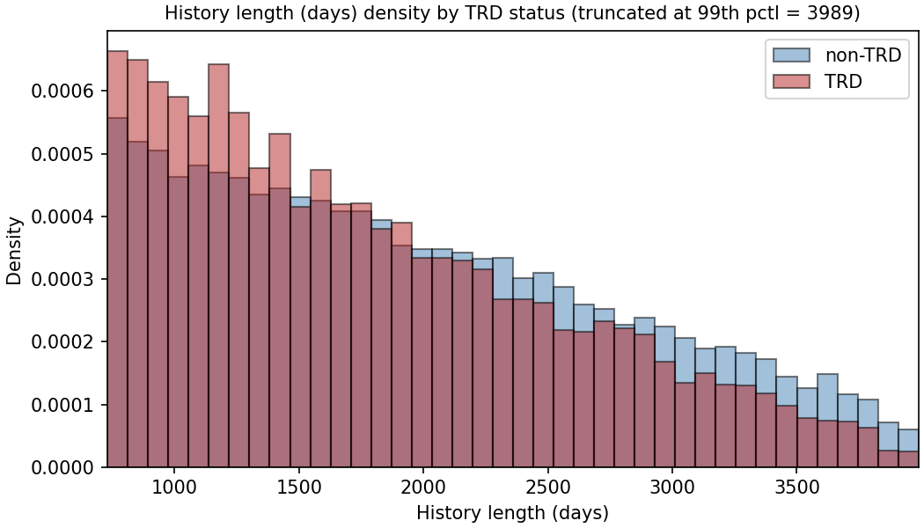
(B) MDD-to-anchor gap
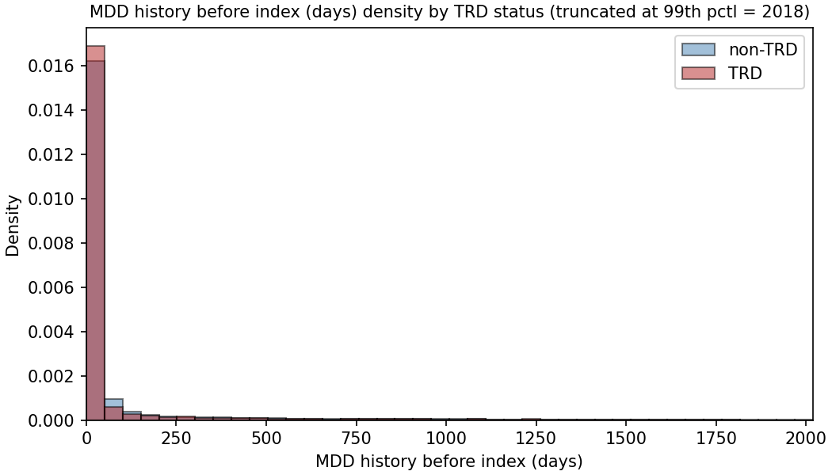
(C) Encounter count
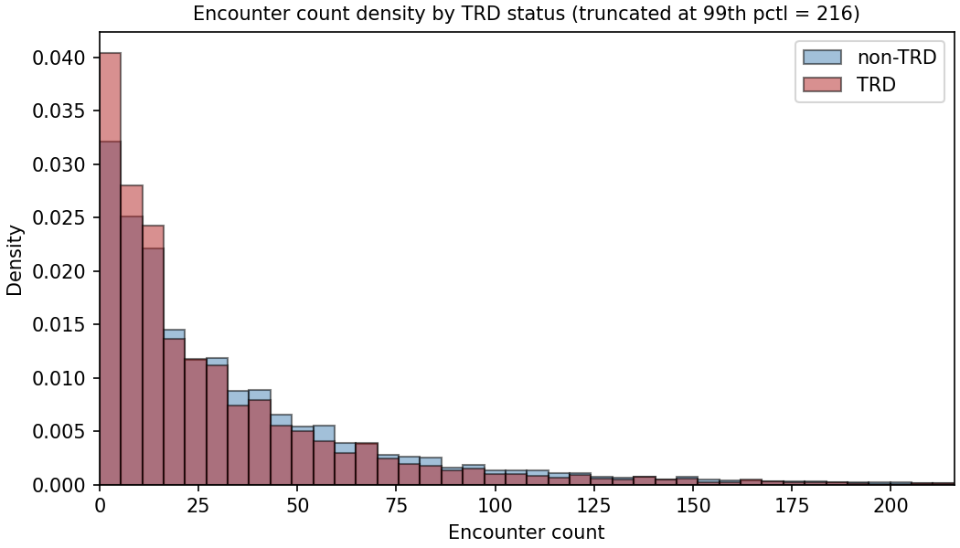
(D) TRD rate, same-day vs delayed prescription
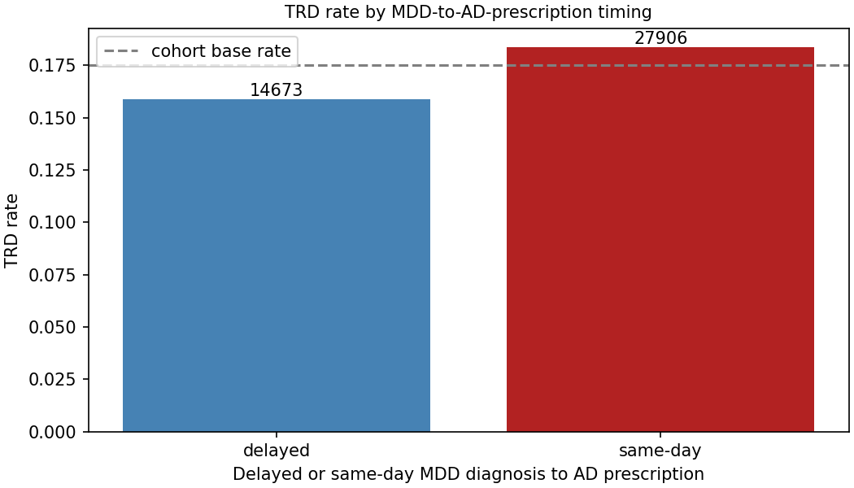
Figure 2. Volume/recency confound checks on the full untruncated data. (A–C) TRD-stratified distributions of the three volume/recency proxies: (A) pre-anchor history length; (B) MDD-to-anchor gap; (C) encounter count. (D) TRD rate among patients with a same-day versus delayed MDD-to-antidepressant prescription (dashed line = 17.5% cohort base rate; bar labels are group n).

Model discrimination
Overall model discrimination remained modest across all configurations, reflecting the difficulty of predicting the TRD phenotype. On the embedded representation, logistic regression achieved the highest discrimination (ROC AUC 0.657, 95% CI 0.643–0.672), whereas XGBoost led the feature-vector models (0.649, 95% CI 0.634–0.664). A paired bootstrap directly comparing these best-in-class models yielded a non-significant difference of +0.008 AUC (95% CI −0.003 to +0.019); this narrow interval confirms a genuine absence of advantage rather than insufficient power. However, classifier-matched contrasts revealed a significant interaction between representation and learner. The embedded approach significantly improved logistic regression (+0.028, 95% CI +0.017 to +0.039) but significantly degraded performance across all three tree ensembles (−0.013 to −0.022). This divergence occurs because dense, high-dimensional embeddings suit regularized linear models but hinder tree ensembles, which rely on splitting individual, meaningful coordinates. Consequently, the apparent parity between the top models obscures a structural dependence: the utility of the representation is strictly conditional on the classification algorithm applied to it.

Table 4. Discrimination of the four classifiers on each representation (held-out test set). 95% CIs are bootstrap percentile intervals. FEATURE-side values are from the 92-column feature matrix.
Representation | Classifier | ROC AUC (95% CI)
EMBEDDED | Logistic regression | 0.657 (0.643–0.672)
EMBEDDED | Random forest | 0.623 (0.608–0.639)
EMBEDDED | Gradient boosting | 0.632 (0.618–0.647)
EMBEDDED | XGBoost | 0.636 (0.621–0.651)
FEATURE | Logistic regression | 0.629 (0.613–0.644)
FEATURE | Random forest | 0.644 (0.630–0.659)
FEATURE | Gradient boosting | 0.645 (0.629–0.660)
FEATURE | XGBoost | 0.649 (0.634–0.664)
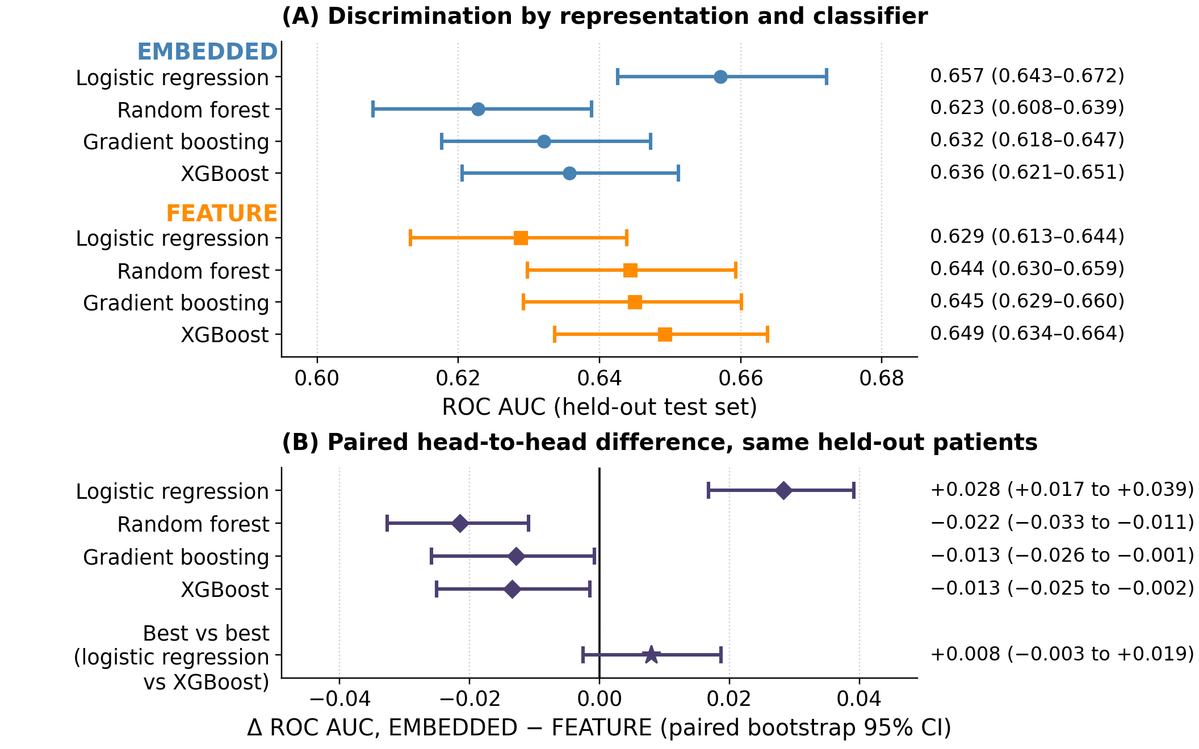
Figure 3. Discrimination by representation and classifier (held-out test set, n = 8,516; primary Qwen3-Embedding-8B encoder). (A) All eight representation-by-classifier combinations. Markers are ROC AUC point estimates; horizontal bars are bootstrap percentile 95% confidence intervals. Models are grouped by representation — EMBEDDED above, FEATURE below — and appear in the same classifier order within each group so the two representations can be compared row for row. Point estimates and intervals are tabulated in Table 4. (B) The paired head-to-head difference in ROC AUC, EMBEDDED minus FEATURE, with a paired bootstrap 95% confidence interval; the solid line marks zero, and an interval spanning it is a null result. Because both representations score the same patients, the paired difference is the appropriate test and is roughly three times more precise than comparing the marginal intervals in panel A. The four diamonds hold the classifier fixed and vary only the representation; the star is the post-hoc best-versus-best contrast (embedded logistic regression minus feature-vector XGBoost), whose interval includes zero — the embedded representation does not significantly outperform the feature vector. The classifier-matched contrasts show the parity is an interaction, not a uniform tie: the embedding significantly helps logistic regression and significantly hurts all three tree ensembles.
(A) Embedded logistic regression
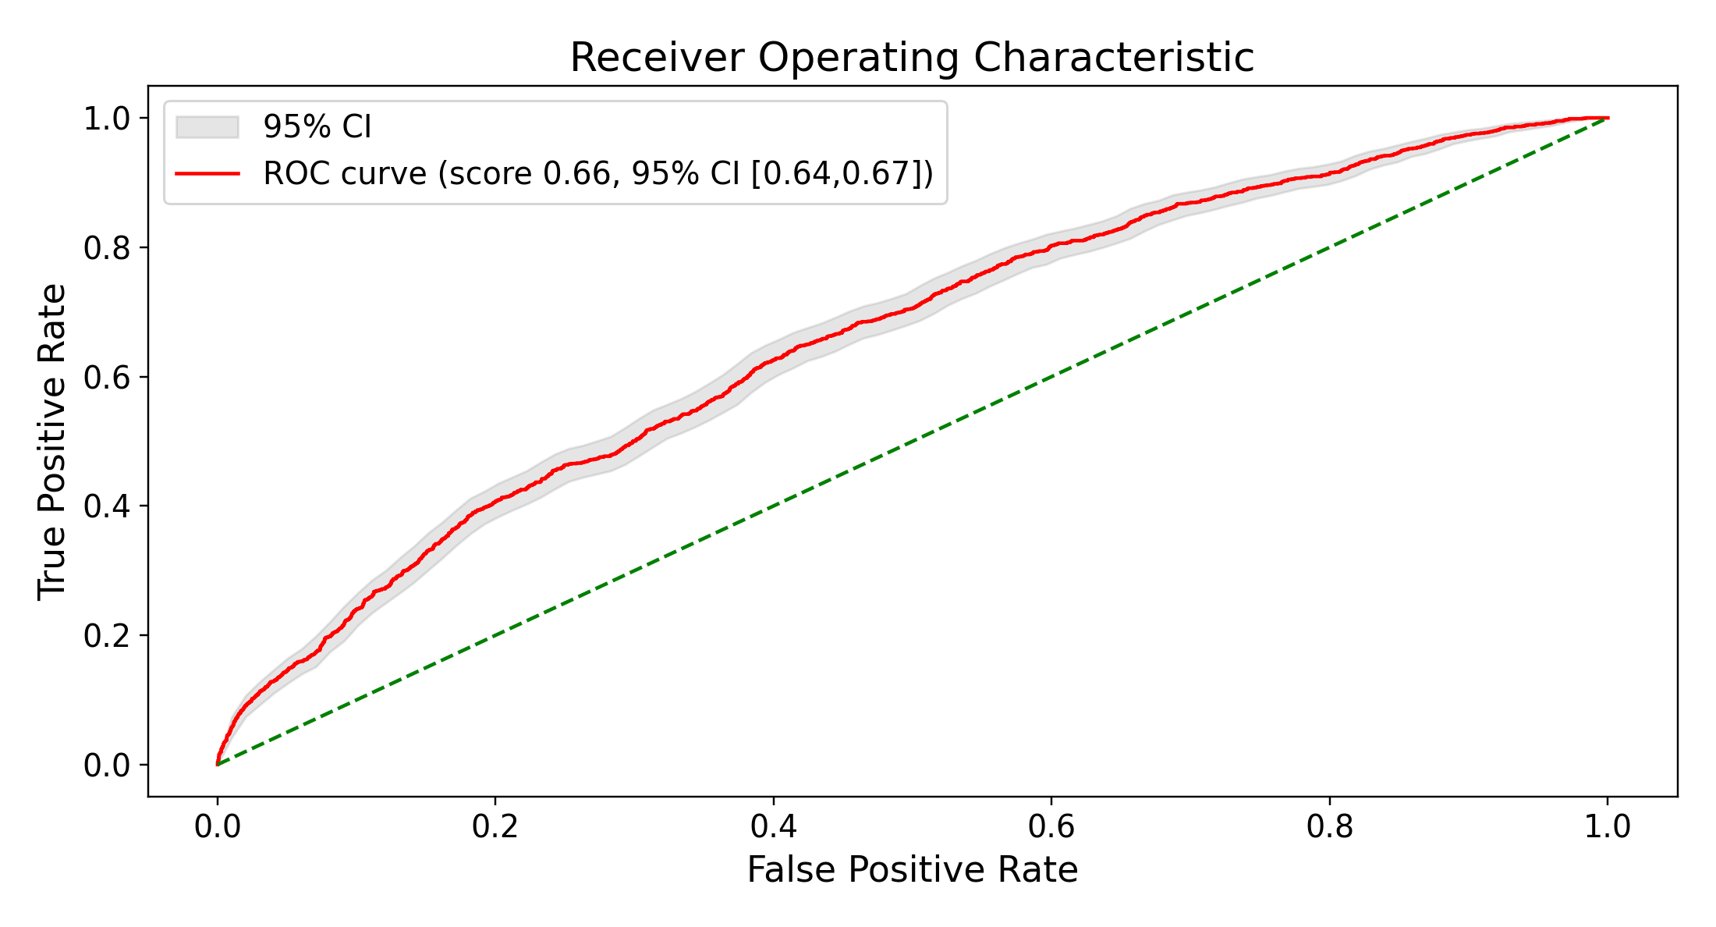
(B) Feature-vector XGBoost
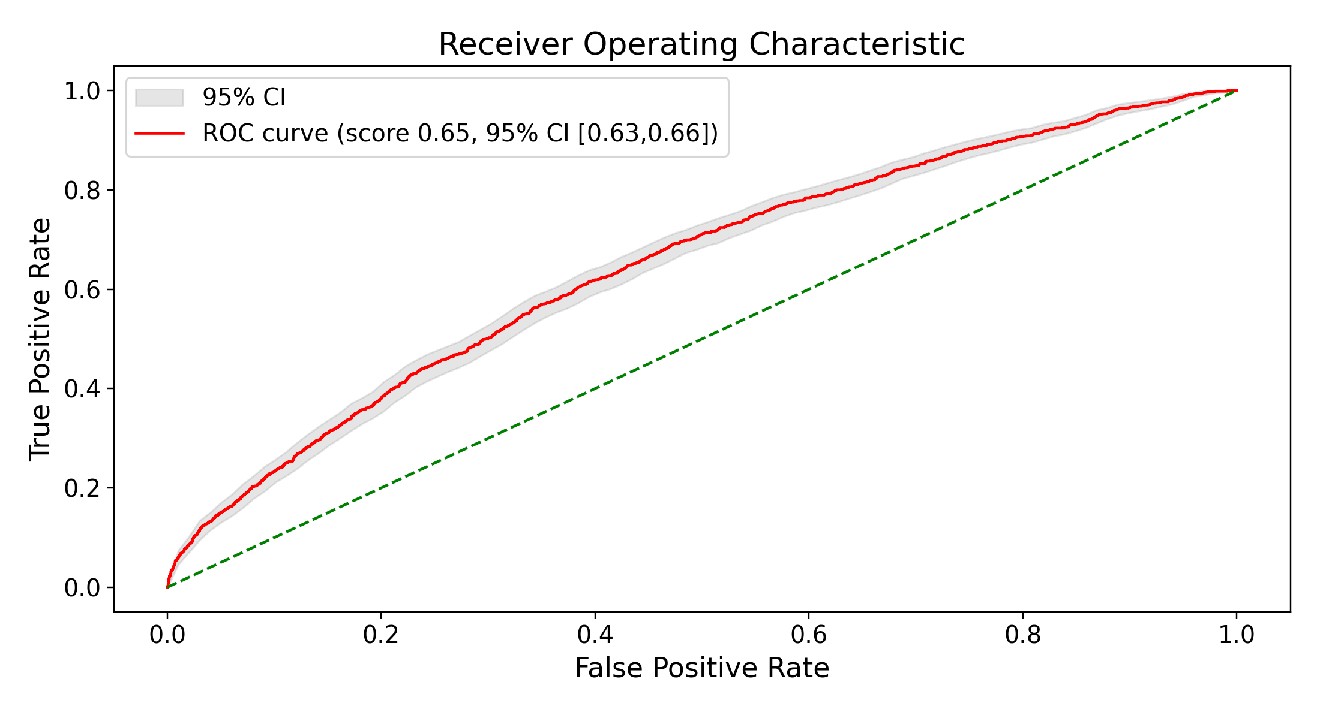
Figure 4. Receiver-operating-characteristic curves for the best classifier on each representation (held-out test set; primary Qwen3-Embedding-8B encoder). Shaded bands are bootstrap 95% confidence intervals; point AUCs are given in Table 4. The cross-embedder discrimination comparison is shown in Figure 12.
At their Youden-J optimal operating points the two representations behaved similarly (Figure 5). Embedded logistic regression operated at slightly higher sensitivity than the feature-vector XGBoost model (0.65 versus 0.62), correctly flagging 964 of 1,491 held-out TRD patients versus 917, but at slightly lower specificity (0.58 versus 0.61) and therefore somewhat more false positives (2,932 versus 2,768). The two models’ ROC AUCs are nearly identical (0.657 versus 0.649) and both Youden thresholds fell near 0.17 (0.165 versus 0.173). These thresholds were selected on the same held-out patients the models are scored on, so the sensitivity and specificity above are optimistic and describe the shape of each ROC curve rather than performance either model would deliver at a prespecified threshold (Methods, Operating point). They are not offered as candidate operating characteristics, and no clinical use is inferred from them.
(A) Embedded logistic regression
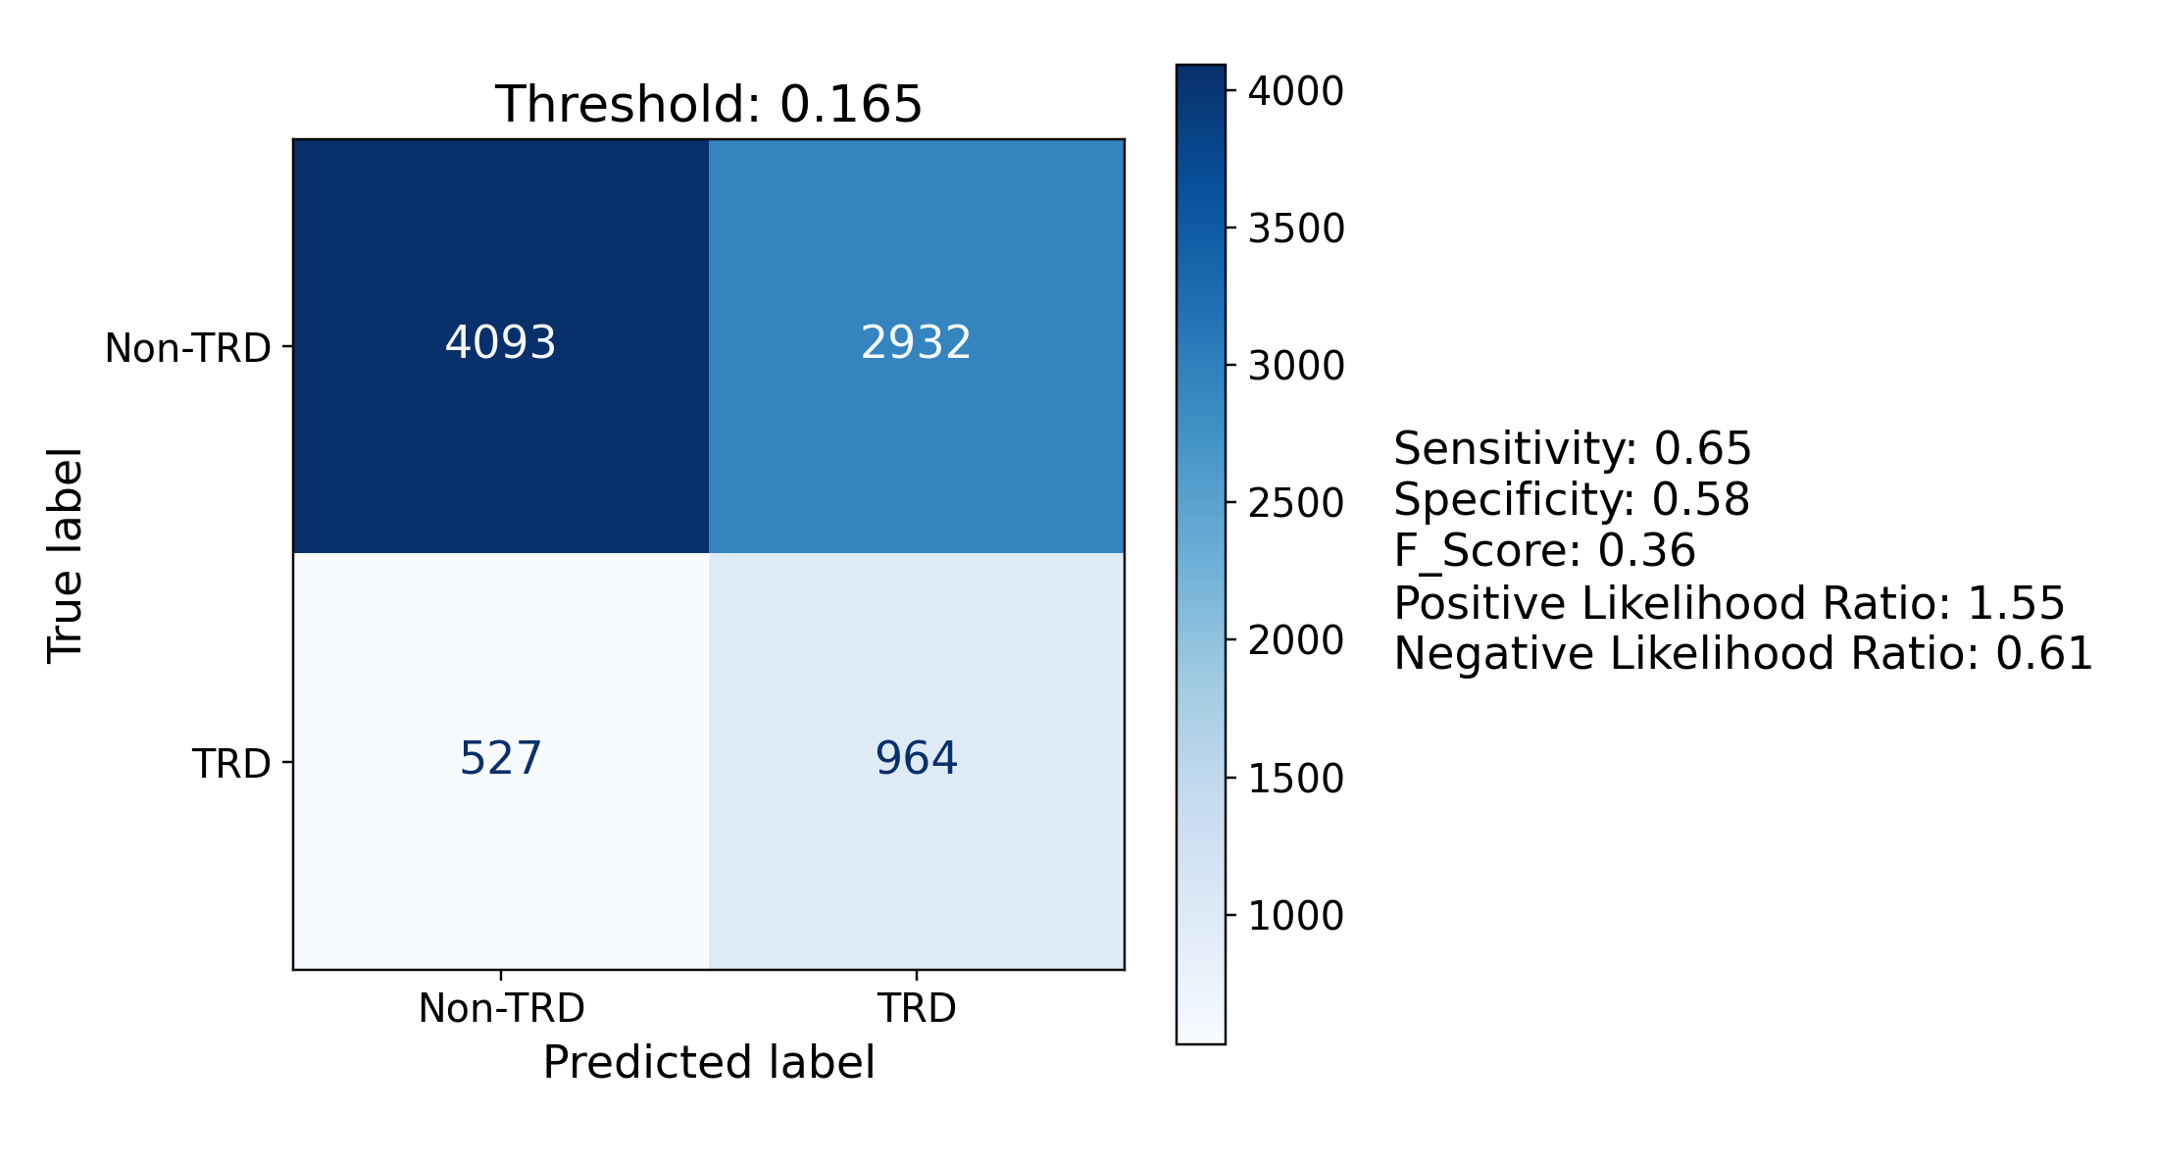
(B) Feature-vector XGBoost
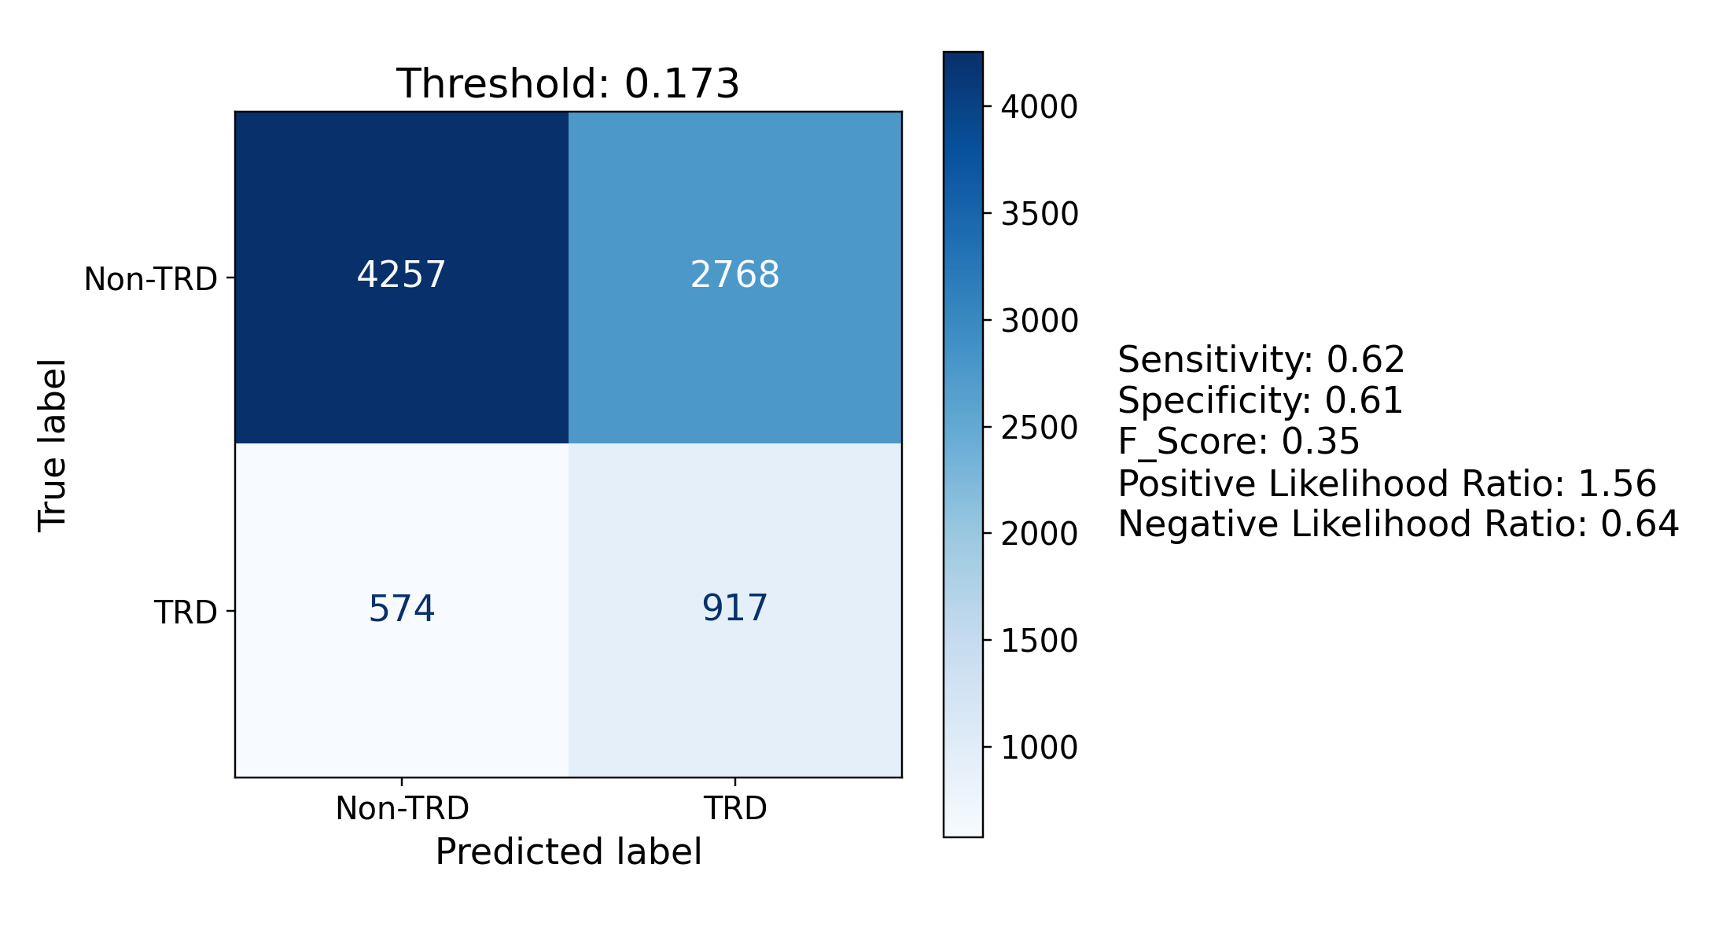
Figure 5. Confusion matrices at the Youden-J optimal operating point for the best classifier on each representation (held-out test set; primary Qwen3-Embedding-8B encoder).

Model calibration
Calibration varied by classifier and representation (Table 5, Figure 6). On the embedded representation, gradient boosting was the best-calibrated model (slope 1.01, intercept 0.01 — essentially ideal); logistic regression was mildly under-confident (slope 1.27, the slope above 1 indicating probabilities pulled toward the base rate), random forest similar (1.15), while XGBoost was mildly over-confident (slope 0.75). On the feature vector, XGBoost was best-calibrated (slope 1.02, intercept 0.02) and random forest the worst (slope 1.84). No model placed any test prediction above 0.9, as expected. Absolute-error metrics (Brier score and weighted calibration error) are reported in Supplement S4. All of these quantities are calibration to this cohort’s 17.5% TRD rate, which is a property of a case-enriched sample rather than of the source population (Methods, Study population), so they bound how well each model’s probabilities are scaled here and do not establish calibration in any sampling-representative population.
Table 5. Calibration slope (ideal 1) and intercept (ideal 0) of the four classifiers on each representation (held-out test set). Brier score and weighted calibration error are reported in Supplement S4 (Table S3).
Representation | Classifier | Slope | Intercept
EMBEDDED | Logistic regression | 1.27 | −0.07
EMBEDDED | Random forest | 1.15 | −0.02
EMBEDDED | Gradient boosting | 1.01 | 0.01
EMBEDDED | XGBoost | 0.75 | 0.07
FEATURE | Logistic regression | 0.78 | 0.06
FEATURE | Random forest | 1.84 | −0.15
FEATURE | Gradient boosting | 0.87 | 0.04
FEATURE | XGBoost | 1.02 | 0.02
(A) Embedded logistic regression
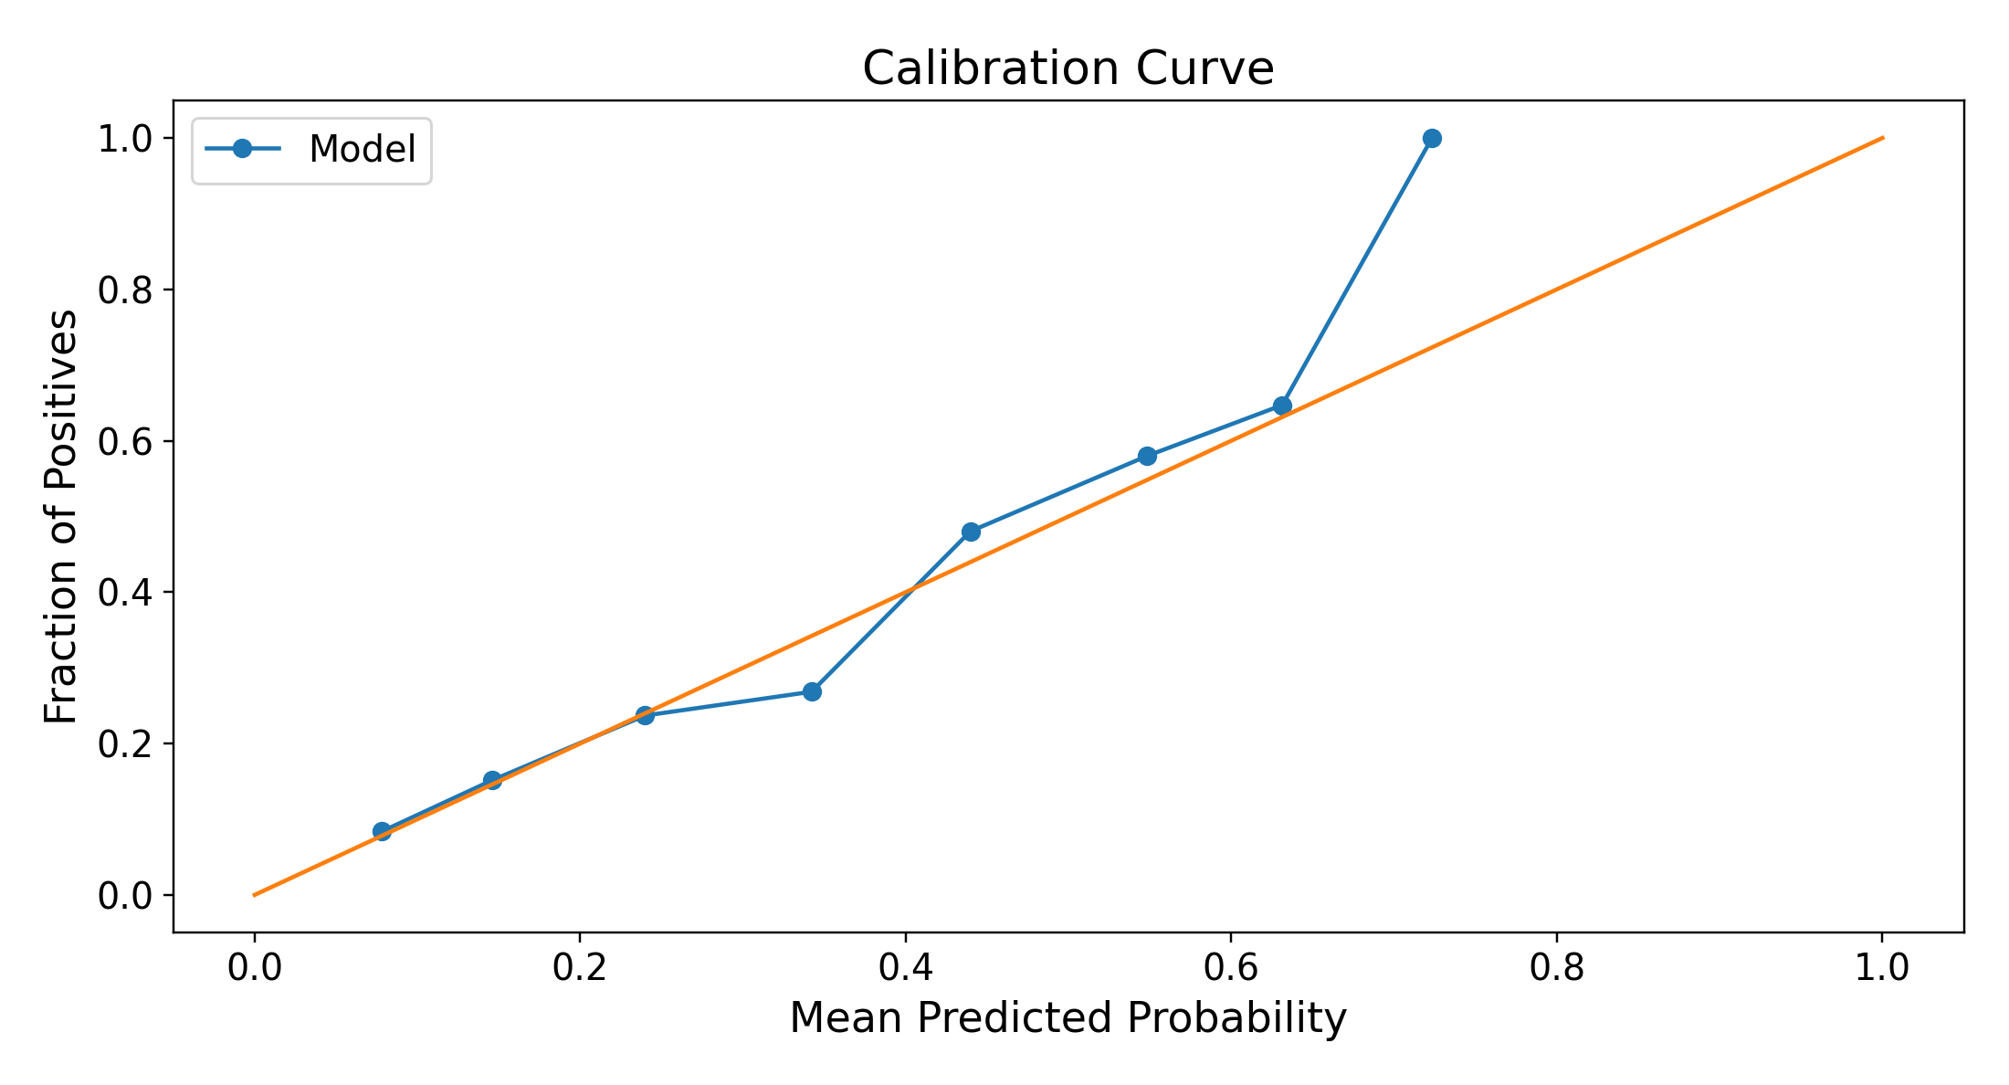
(B) Feature-vector XGBoost
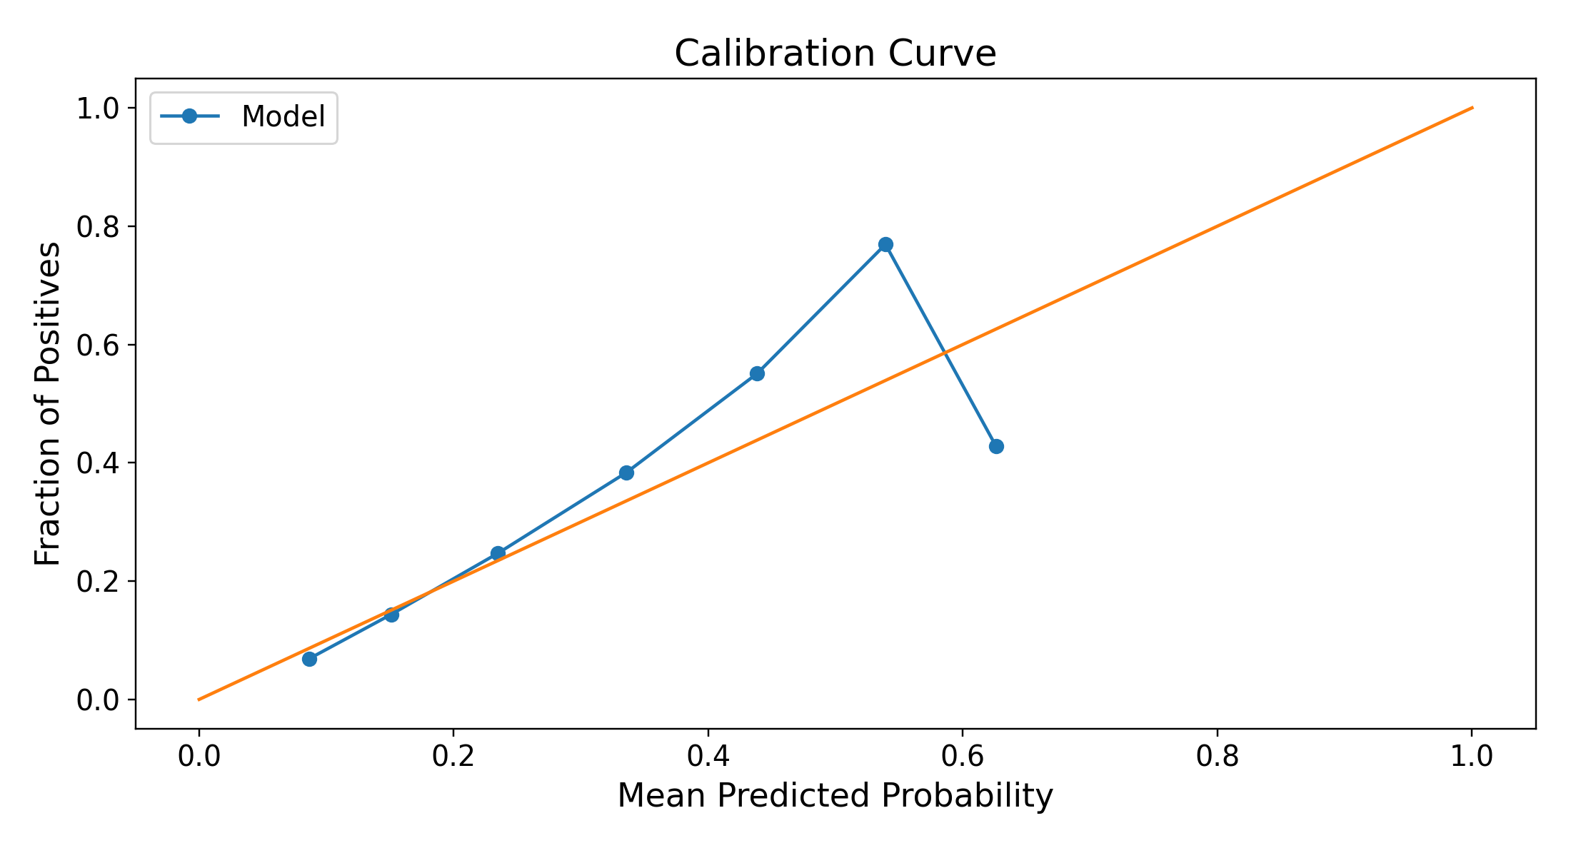
Figure 6. Calibration curves for the best classifier on each representation (held-out test set; primary Qwen3-Embedding-8B encoder). The diagonal is perfect calibration; deviations above it indicate under-confidence and below it over-confidence. Per-classifier calibration slope and intercept are given in Table 5; Brier score and weighted calibration error in Supplement S4.

Feature importance
Feature-level interpretability is available only for the feature-vector representation: the embedded representation’s 4,096 latent dimensions carry no individual clinical meaning, so per-concept attribution on the embedded side is addressed by the semantic-feature ablation below rather than by a feature-importance ranking, and its effective dimensionality is shown in Figure 8 and characterized further in Supplement S2. On the feature-vector representation, the highest-weighted predictors were clinically coherent and recapitulated the strongest univariate correlates of TRD (Table 2): severe MDD coding, a flagged suicidality history, insomnia, obsessive–compulsive disorder, opioid use disorder, PTSD, and anxiety disorder carried the largest positive logistic-regression weights, while indicators such as missing smoking status, hyperlipidemia, longer pre-anchor history, and male sex carried negative weights. Importances for all four classifiers are shown in Figure 7; the tree ensembles (random forest, gradient boosting, XGBoost) concentrated on a similar set of psychiatric and substance-use predictors at the top, with direction-of-effect recovered by univariate correlation.
(A) Logistic regression
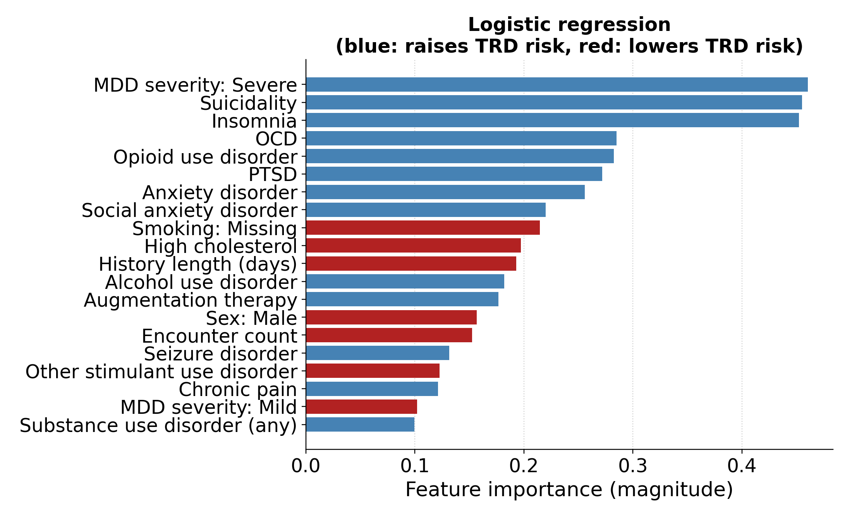
(B) Random forest
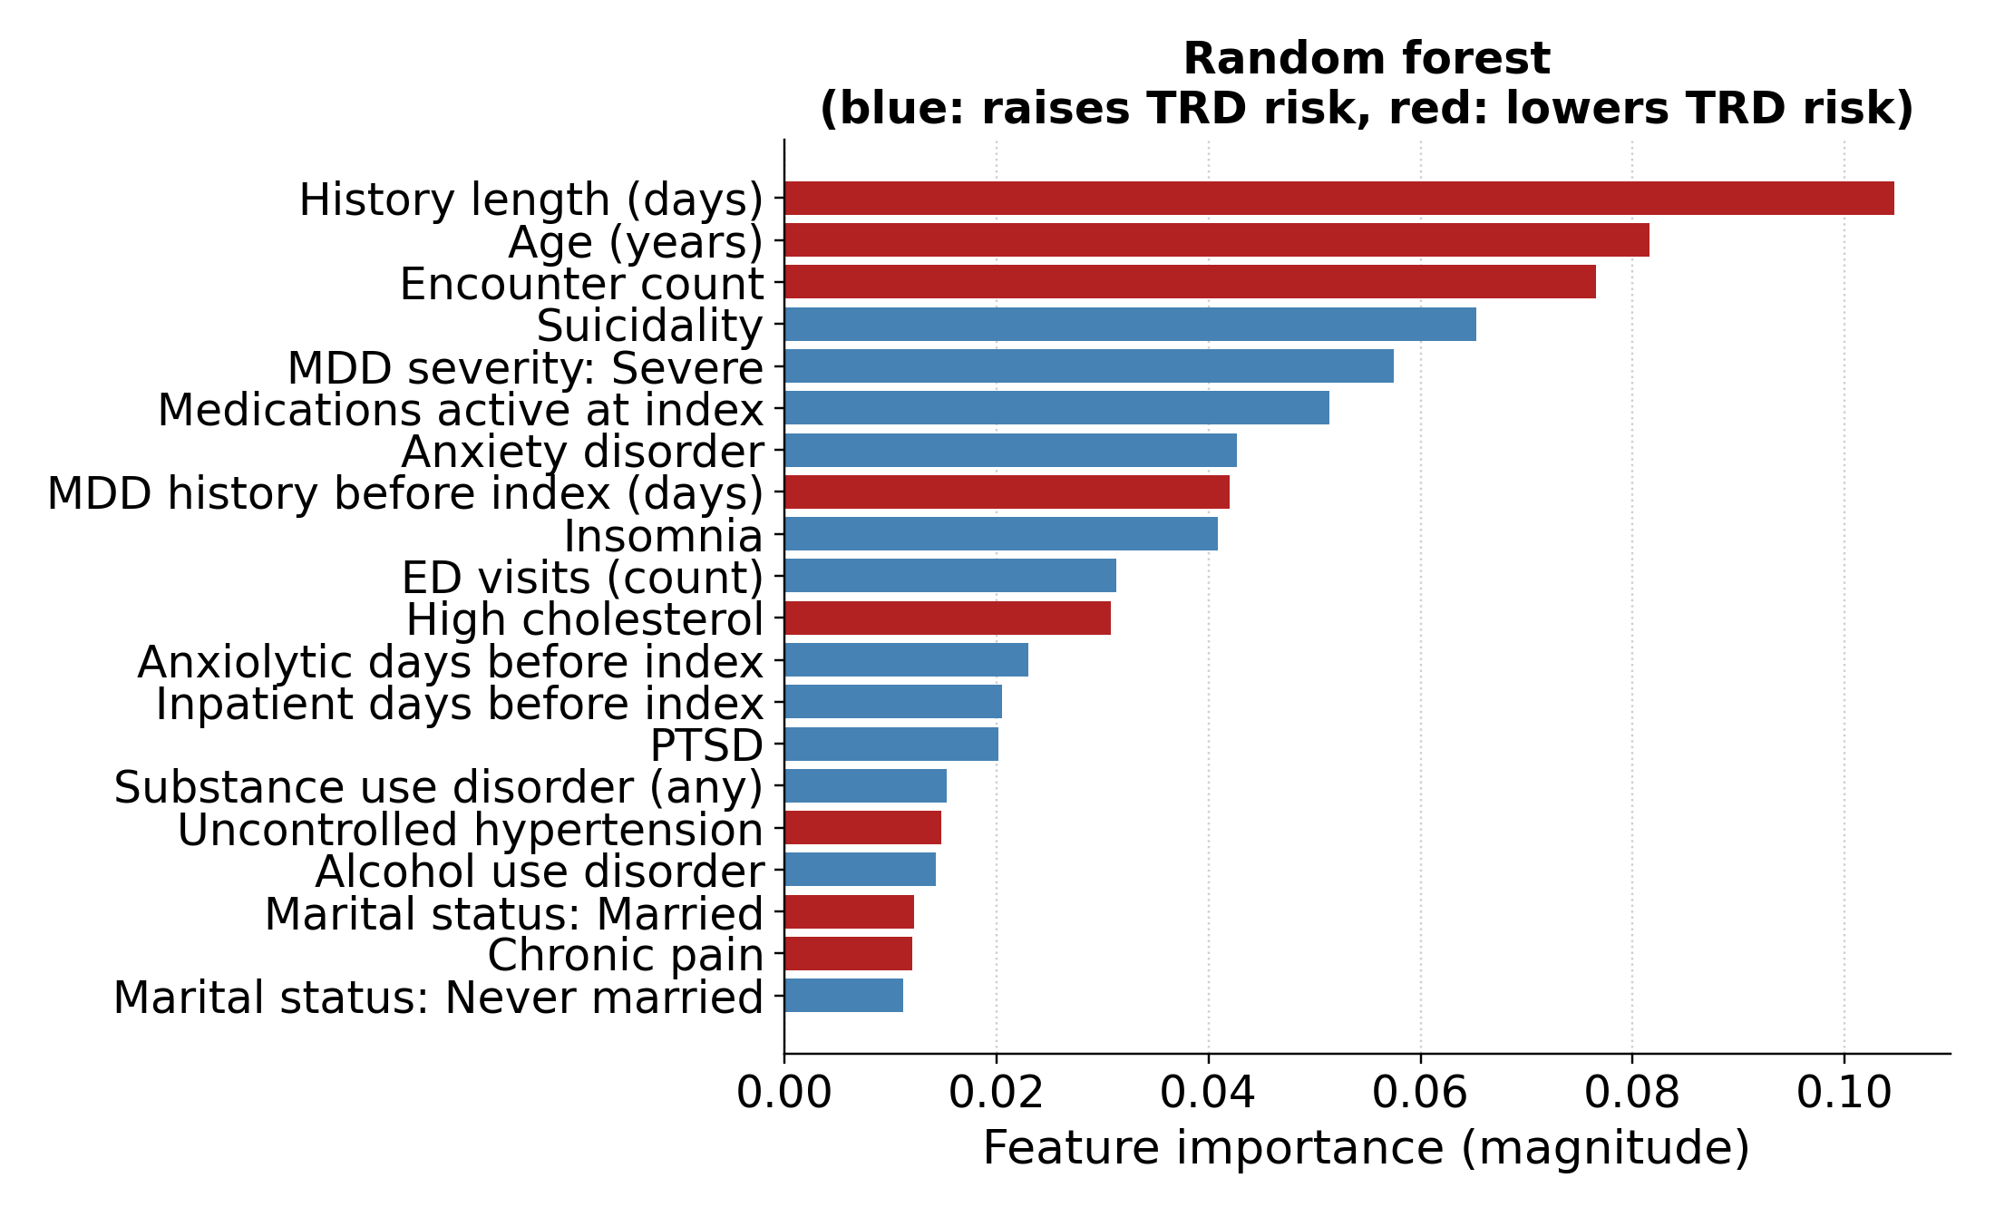
(C) Gradient boosting
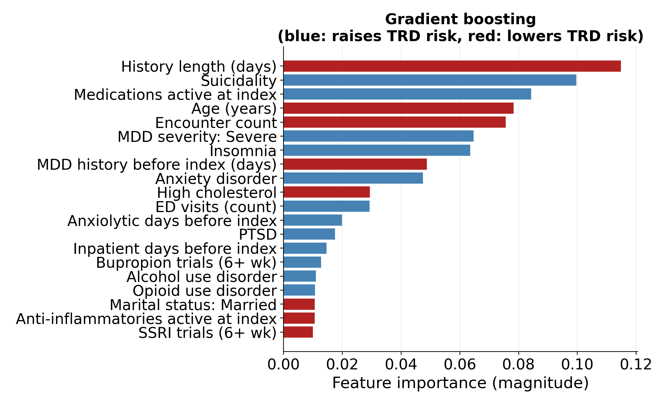
(D) XGBoost
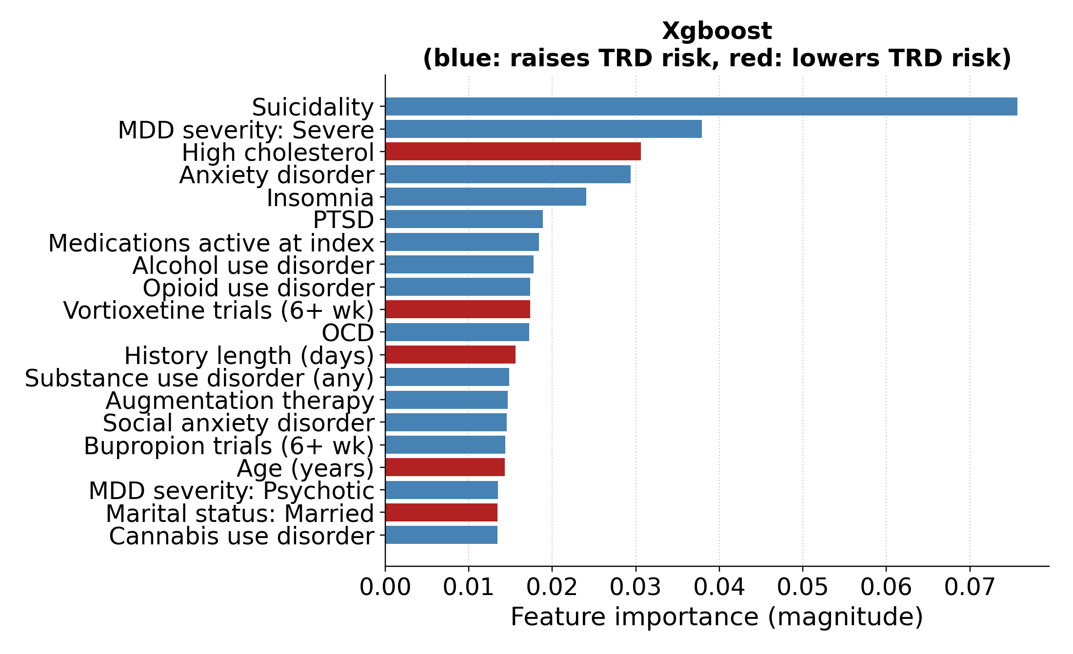
Figure 7. Feature importance on the feature-vector representation, one panel per classifier. (A) Signed logistic-regression coefficients (steelblue raises TRD risk, firebrick lowers it). (B) Random forest, (C) gradient boosting, and (D) XGBoost importances, with direction-of-effect recovered by univariate correlation. The highest-ranked predictors mirror the largest TRD-stratified differences in Table 2.
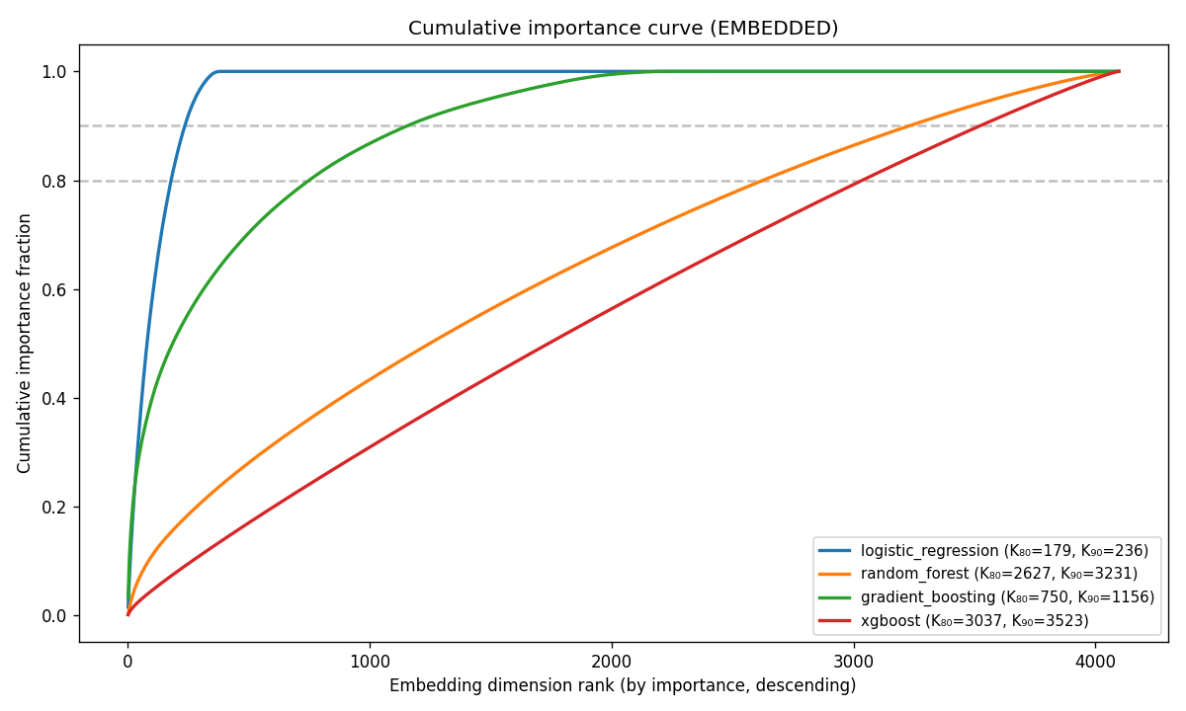
Figure 8. Effective dimensionality of the embedded representation (primary Qwen3-Embedding-8B encoder): cumulative built-in feature importance for the four embedded classifiers. Each curve plots the cumulative fraction of total importance mass against dimension rank (dimensions sorted by descending native importance); the K₈₀ / K₉₀ knees are reported in the legend. For logistic regression, the elasticnet penalty selected a sparse solution — only 385 of the 4,096 dimensions carry nonzero weight — and 80% of the coefficient magnitude falls in roughly 179 of them (90% in 236), a signal concentrated in a modest subset of latent directions rather than spread across the full space. Model-agnostic correlation and PCA-based dimensionality checks are reported in Supplement S2.

Neighbor-weighted prediction
The neighbor-weighted predictor behaved coherently with respect to the embedding geometry (Table 6). Retrieving the nearest neighbors yielded the best discrimination (ROC AUC 0.593–0.595 across weighting strategies), retrieving the farthest neighbors inverted the signal to well below chance (0.432–0.436), and random retrieval landed in between (0.495–0.517). The two-stage subsampled mode sat between the random and nearest schemes (0.543–0.554). This nearest ≫ random ≫ farthest ordering is the expected signature of a label-informative metric space. The choice of weighting was second-order to the choice of retrieval scheme: within the nearest scheme the four weightings were indistinguishable (0.593–0.595, LLM and combined marginally highest), so the LLM-similarity score added no discrimination over plain cosine or uniform weighting where the neighbors were already maximally similar. The judge’s reweighting mattered only where retrieval was uninformative — under random retrieval LLM weighting lifted ROC AUC from 0.495 (uniform) to 0.517, and under subsampled retrieval from 0.543 to 0.554 — by concentrating weight on the few clinically congruent neighbors that random draws happen to include; consistent with this, the LLM effective sample size fell below the uniform value (nearest mean ESS 40.6 vs 50.0). Overall the neighbor-weighted predictor remained below both the feature-vector classifiers and the embedded logistic regression (best neighbor ROC AUC ≈ 0.595 versus ≈ 0.66), so retrieval-based prediction did not match the trained models on this cohort.
The farthest scheme is not merely uninformative but inverted: at ROC AUC ≈0.43 its curve bows below the chance diagonal rather than tracking it, so reversing its output recovers a discrimination of ≈0.57. Whether that reversed signal adds anything to nearest retrieval was tested directly and it does not; the analysis is reported in Supplement S7.
Table 6. Neighbor-weighted ROC AUC by retrieval scheme and weighting strategy (embedded representation, held-out test set; K = 50 neighbors).
Retrieval scheme | Uniform | Cosine | LLM | Combined
Nearest | 0.593 | 0.594 | 0.595 | 0.595
Subsampled | 0.543 | 0.544 | 0.554 | 0.552
Random | 0.495 | 0.499 | 0.517 | 0.512
Farthest | 0.434 | 0.432 | 0.436 | 0.434
(A) Nearest retrieval
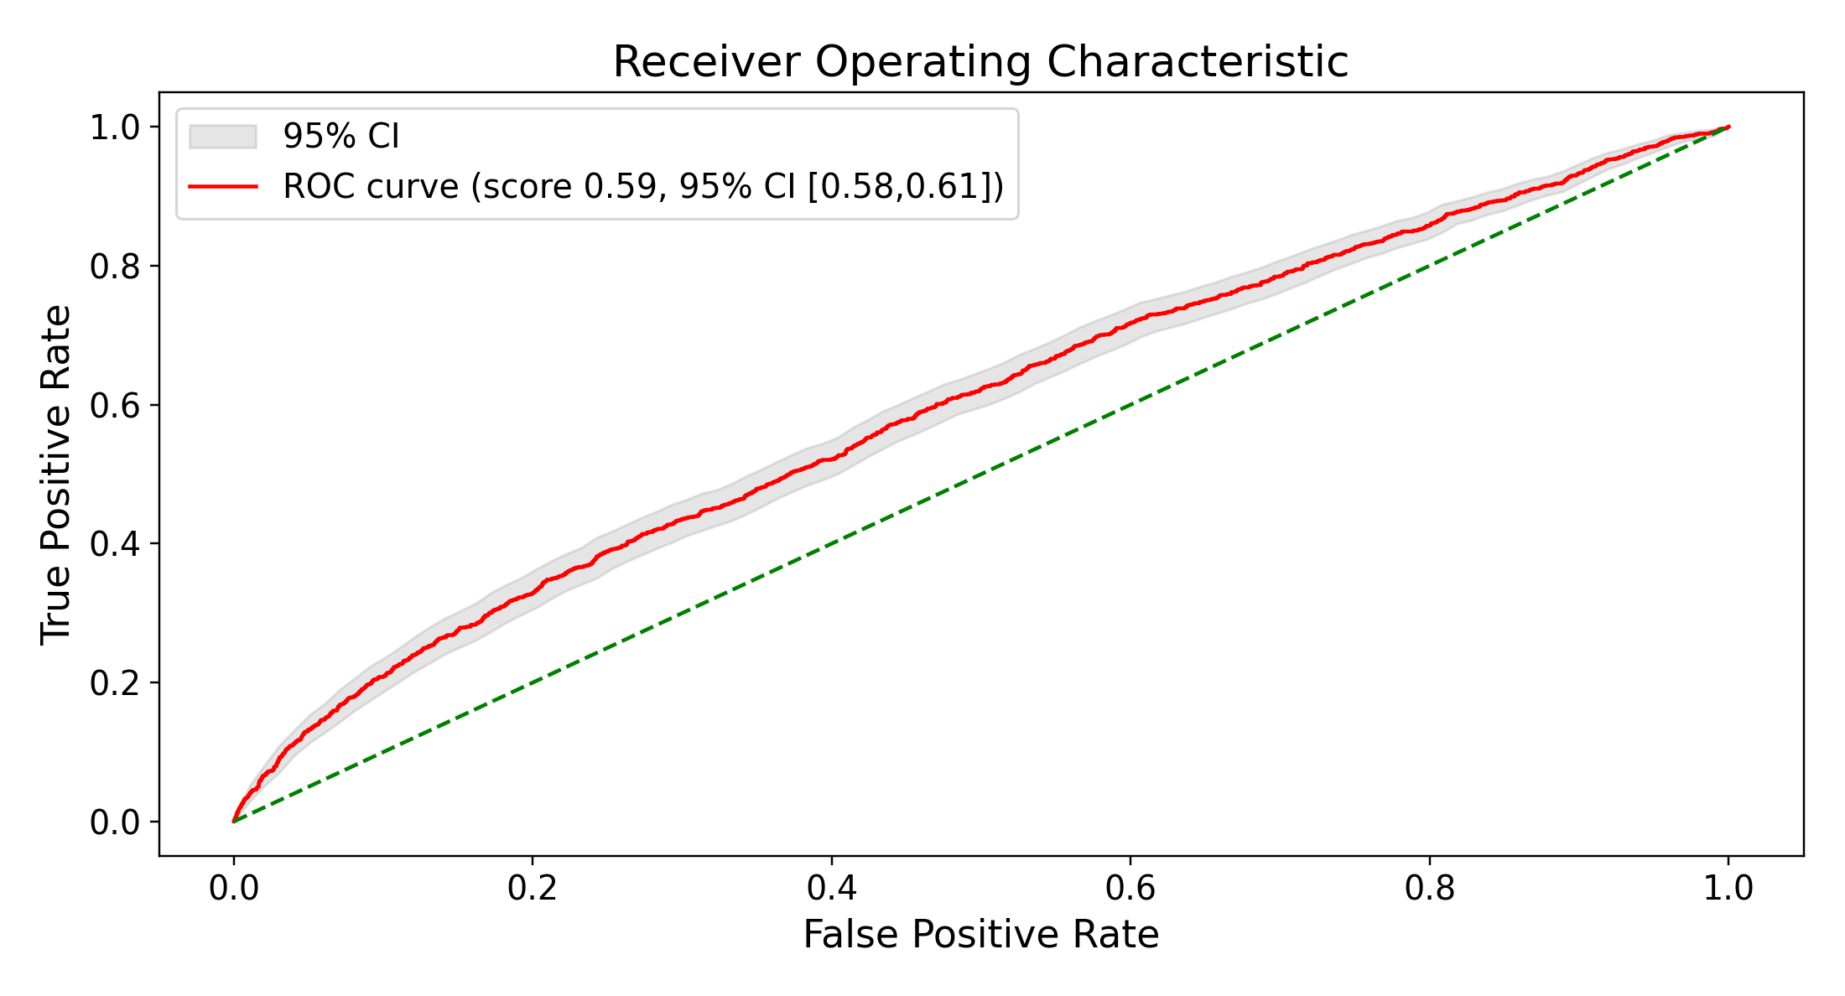
(B) Random retrieval
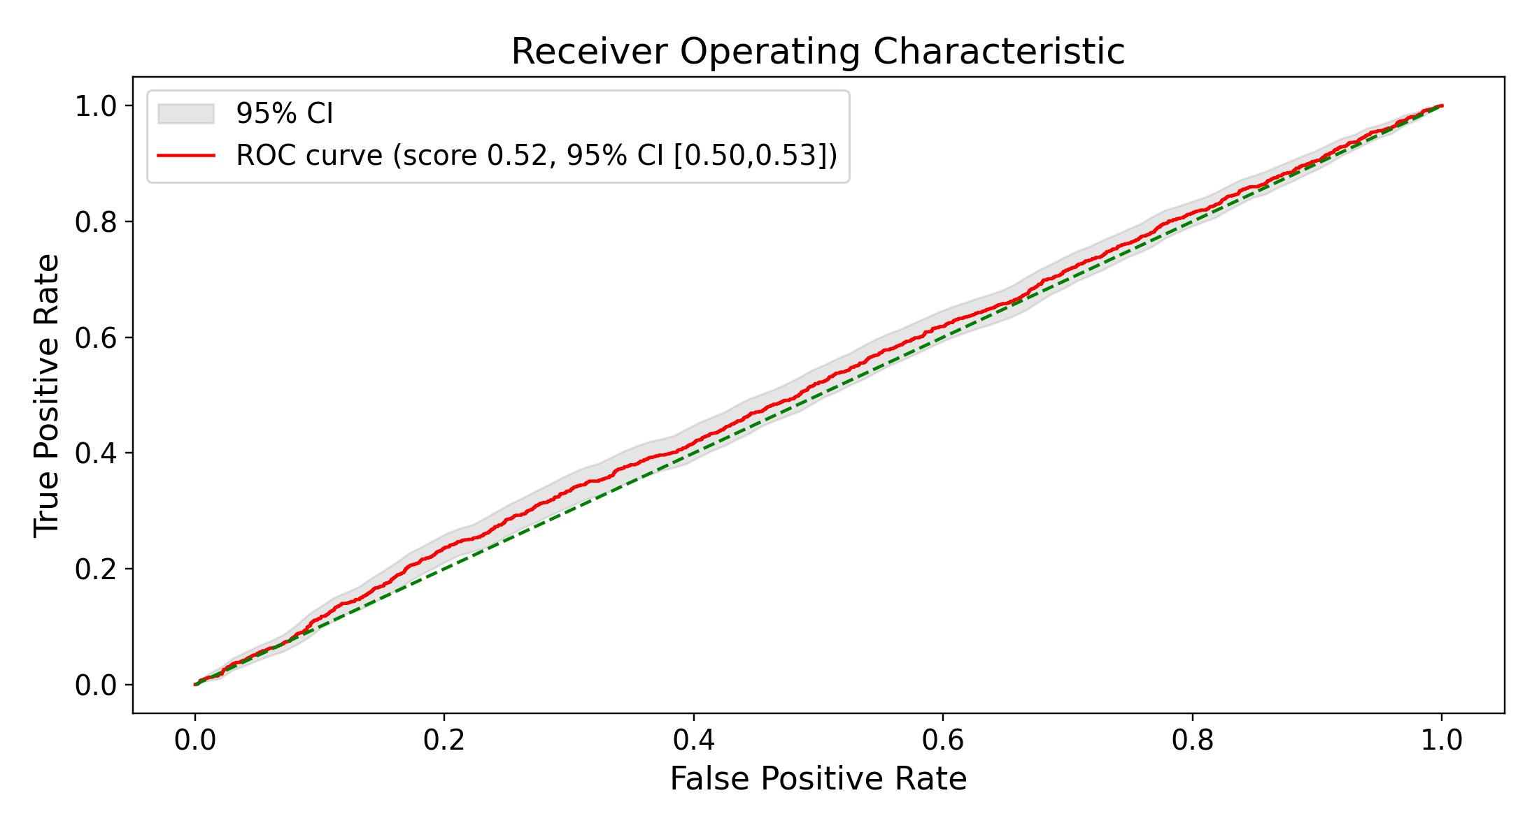
Figure 9. Neighbor-weighted ROC for the LLM-weighted predictor on the embedded representation (held-out test set). (A) Nearest retrieval; (B) random retrieval. The separation between the nearest and random schemes is the discriminative signal; weighting-strategy and the farthest/subsampled schemes are reported in Table 6 and the supplement.
(A) Nearest retrieval
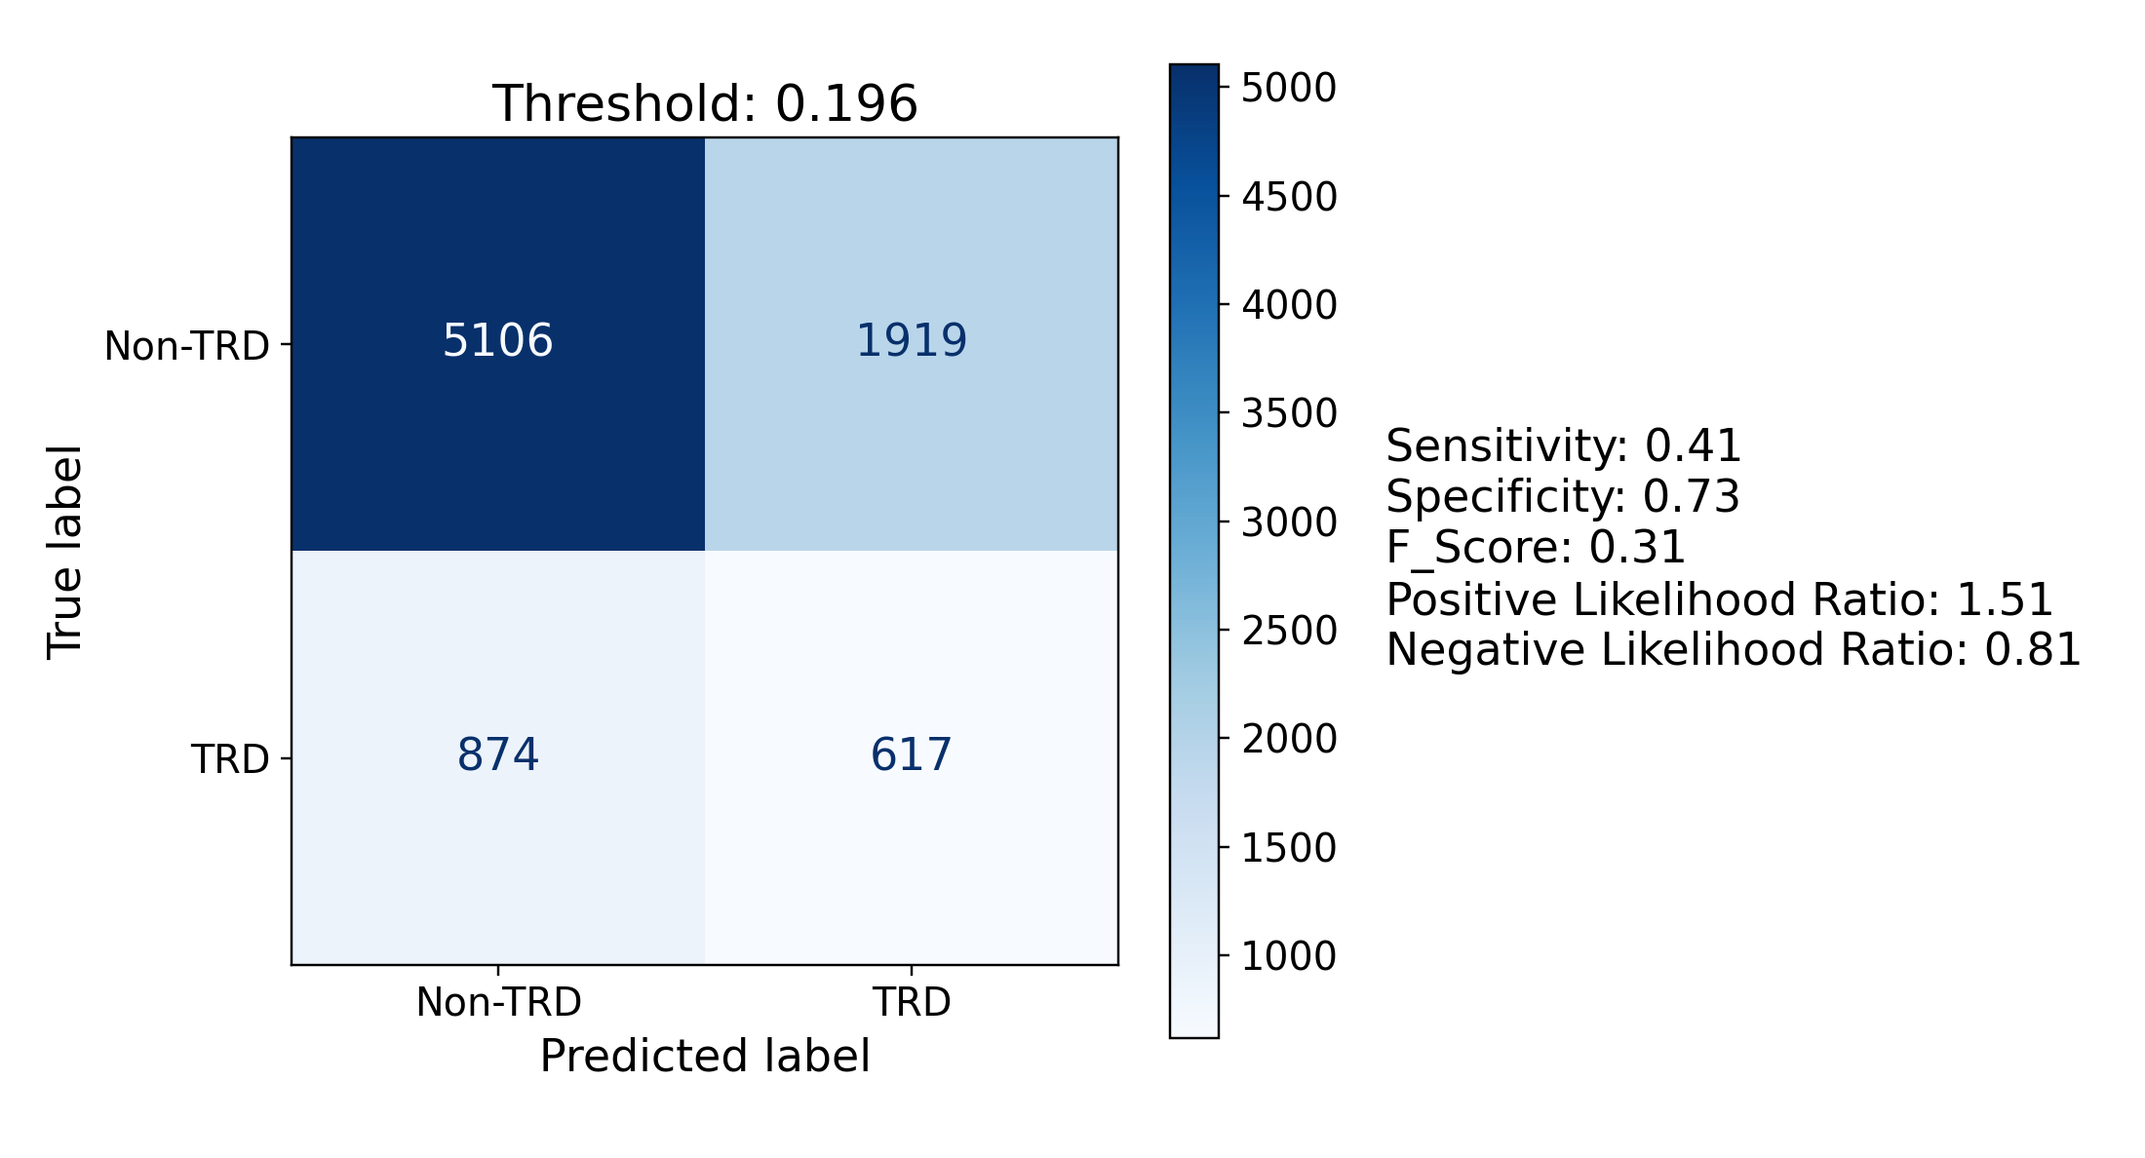
(B) Random retrieval
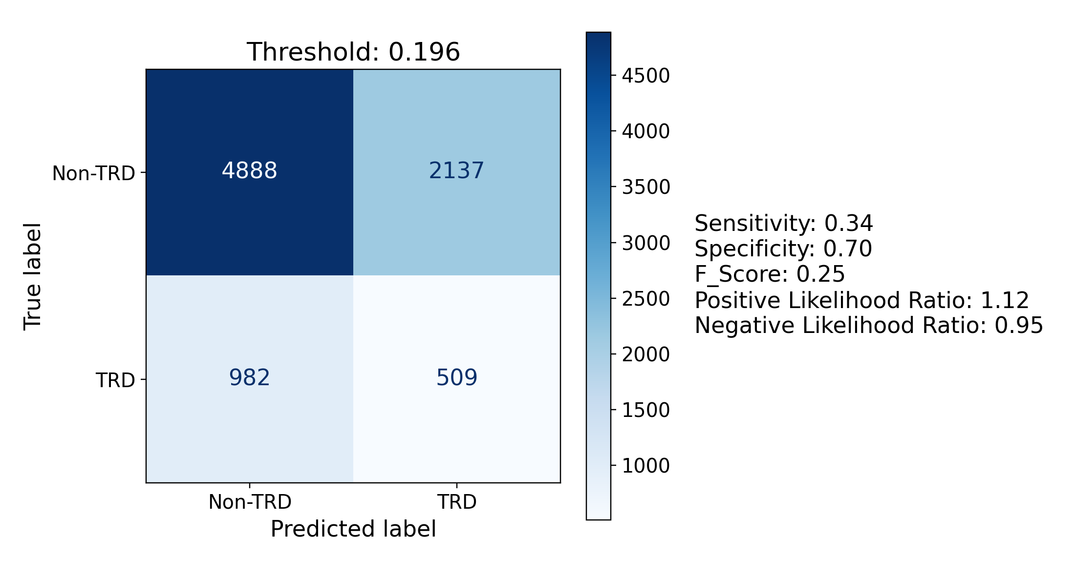
Figure 10. Confusion matrices at the Youden-J optimal operating point for the LLM-weighted neighbor predictor (embedded representation).

Semantic-feature ablation
Semantic feature ablation demonstrated that the psychiatric history domain provided the most substantial predictive signal, yielding the largest discrimination loss upon permutation (logistic regression ΔROC AUC = −0.028; other classifiers ranged from −0.024 to −0.027). Medication burden produced the second-largest decrease in performance (−0.003 to −0.027), and treatment exposure the third (−0.019 for logistic regression; the other three classifiers spanned +0.000 to −0.011). Conversely, permuting the two sociodemographic concepts — race/ethnicity and social determinants of health — or the treatment-contraindication section resulted in negligible performance changes (within ±0.005 across all classifiers). Paired-bootstrap delta-AUC confidence intervals excluded zero for psychiatric history across all four classifiers, for medication burden in three of four (random forest’s interval included zero), and for treatment exposure in two of four (logistic regression and XGBoost). Among those three remaining concepts only one interval excluded zero — treatment contraindications under XGBoost, at −0.005 (−0.008 to −0.001) — and race and social determinants moved AUC by less than 0.003 under every classifier.
Table 7. Semantic-feature ablation: change in ROC AUC versus the frozen baseline when each narrative concept is permuted across donors (embedded representation, primary Qwen3-Embedding-8B encoder). More negative = larger reliance on that concept. Rows are ordered by descending logistic-regression loss, matching Figure 11. Point estimates; the paired-bootstrap intervals on these differences are quoted in the text where they bear on a conclusion, and plotted for the two largest concepts across all four encoders in Figure 12B. Figure 11 shows the same runs on an absolute-AUC axis with each run’s own bootstrap interval.
Permuted concept | LR | RF | GB | XGB
Psychiatric history | −0.028 | −0.027 | −0.024 | −0.027
Medication burden | −0.027 | −0.003 | −0.014 | −0.017
Treatment exposure | −0.019 | +0.000 | −0.006 | −0.011
Treatment contraindications | −0.002 | +0.001 | −0.001 | −0.005
Social determinants (SDOH) | −0.000 | +0.000 | +0.000 | +0.001
Race/ethnicity | −0.000 | +0.000 | −0.003 | −0.000
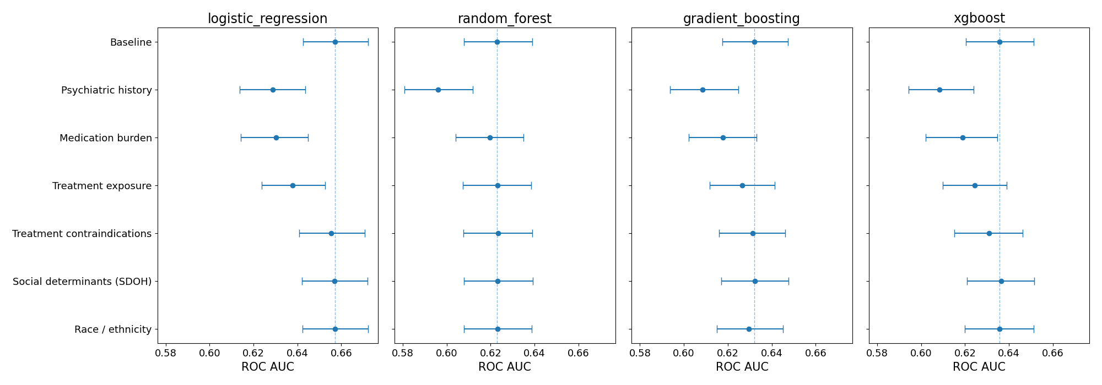
Figure 11. Semantic-feature ablation, absolute-discrimination view (embedded representation, primary Qwen3-Embedding-8B encoder). Each row is a run — the unablated baseline on top, then the six permutation specifications ordered by descending logistic-regression AUC drop (the same ordering reused across panels) — with one panel per classifier on a shared AUC axis and a reference line at the baseline AUC. Permuting psychiatric history, medication burden and treatment exposure produces the largest discrimination loss, whereas the remaining three concepts move AUC comparatively little (deltas in Table 7).

Embedder comparison
Across the four encoders the embedded logistic-regression model occupied a narrow discrimination band (ROC AUC 0.645–0.657; Table 8, Figure 12A). The primary Qwen3-Embedding-8B was highest (0.657, 95% CI 0.643–0.672), with bge-en-icl and Qwen3-Embedding-4B tied just behind (both 0.655) and bge-small-en-v1.5 lowest (0.645); the band spanned only 0.012 AUC, so encoder choice mattered little. The encoders also differed in how they organized the cohort geometrically: bge-small-en-v1.5 alone produced a multimodal pairwise-similarity distribution, traceable to the encoder keying on a single MDD-recurrence token rather than holistic clinical content (Supplement S5). Logistic regression was the best-discriminating classifier on the embedded representation for every encoder. The semantic-feature ablation reproduced across encoders (Figure 12B): permuting psychiatric history and medication burden produced the largest discrimination losses for all four (psychiatric history ΔROC AUC −0.027 to −0.030; medication burden −0.022 to −0.034), each with paired-bootstrap intervals excluding zero, whereas the two sociodemographic permutations moved AUC little. The rank order of these two concepts was stable except in bge-en-icl: it was the one encoder for which medication burden produced a larger discrimination loss than psychiatric history, and uniquely it did so for all four classifiers (embedded logistic regression −0.034 versus −0.027), whereas psychiatric history was the single largest concept for the other three encoders. The principal conclusions — modest discrimination led by the linear model, and reliance on clinical rather than sociodemographic content — therefore hold beyond the Qwen3-Embedding-8B encoder.

Table 8. Embedded logistic-regression discrimination by encoder (held-out test set). 95% CIs are bootstrap percentile intervals. “Dimensions” is the encoder’s output dimensionality, which is also the number of predictor columns the classifier receives; EPV is events per variable, 5,964 TRD-positive training patients divided by that column count (Methods, Sample size and events per variable). Note that EPV runs opposite to discrimination: the encoder with the most favourable EPV is the least discriminating.
Encoder | Dimensions | EPV | ROC AUC (95% CI)
bge-small-en-v1.5 | 384 | 15.5 | 0.645 (0.629–0.660)
bge-en-icl | 4,096 | 1.5 | 0.655 (0.641–0.670)
Qwen3-Embedding-4B | 2,560 | 2.3 | 0.655 (0.641–0.670)
Qwen3-Embedding-8B | 4,096 | 1.5 | 0.657 (0.643–0.672)
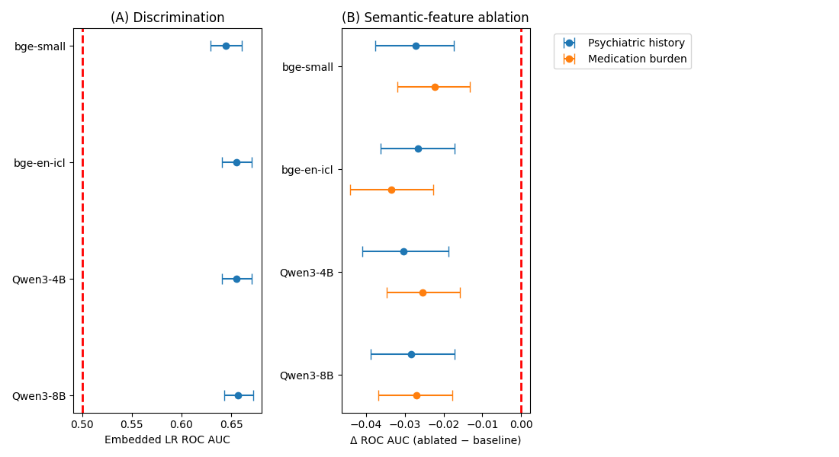
Figure 12. Cross-embedder robustness: embedded logistic-regression ROC AUC (A) and the two largest semantic-feature ablation deltas (psychiatric history, medication burden; B) across all four encoders (bge-small-en-v1.5, bge-en-icl, Qwen3-Embedding-4B, Qwen3-Embedding-8B), demonstrating that the principal conclusions hold beyond the Qwen3-Embedding-8B encoder. Error bars are bootstrap (A) and paired-bootstrap (B) 95% confidence intervals.

Discussion

Principal findings
EHR-derived patient representations carried modest but real signal for a treatment-switch–defined EHR proxy for incident TRD at the point of a patient’s first antidepressant prescription. A generalized pre-trained transformer embeddingof a deterministic patient narrative, classified by logistic regression, discriminated essentially as well as the best feature-vector model (embedded logistic regression ROC AUC 0.657 versus feature-vector XGBoost 0.649). A paired bootstrap on that difference — the appropriate test, since both representations score the same patients — returned +0.008 (95% CI −0.003 to +0.019), so the embedding’s apparent edge is not statistically significant, and the interval is tight enough to rule out any gain much beyond 0.02 AUC. The finding is parity, not superiority. Logistic regression was the strongest embedded classifier on all four encoders and the single best-discriminating model overall on the primary encoder; that a linear model matched or beat the tree ensembles suggests the predictive structure in the embedding is approximately linear.
The classifier-matched paired contrasts sharpen that last point into something stronger than a suggestion. Holding the learner fixed, the embedding significantly outperformed the feature vector for logistic regression (+0.028) and significantly underperformed it for all three tree ensembles (−0.013 to −0.022). Representation and learner are thus not separable choices: the same embedding that is the better input for a regularized linear model is the worse input for the tree ensembles, which split on one coordinate at a time and are left with no coordinate that means anything in particular once the interpretable columns are replaced by 4,096 dense dimensions.
The embedding did not spread its predictive signal thinly across all 4,096 of its dimensions; it concentrated that signal in a small number of them. Under an elasticnet penalty the logistic-regression fit assigned a nonzero weight to only 385 of the 4,096 dimensions, and 80% of the total coefficient magnitude fell within roughly 179 of those (Figure 8). In other words, fewer than 5% of the available latent directions carry the information the model actually uses. This matters for two reasons. It means the encoder is not merely diluting a weak signal over a large space: there are specific, identifiable directions in which TRD-relevant structure lives. It also means the model’s effective complexity is far lower than its 4,096 inputs suggest, which makes the events-per-variable concern raised under Limitations less severe than the raw dimension count implies — though it does not remove it. The semantic-feature ablation traced the signal to psychiatric history, medication burden and prior treatment exposure, and not to the sociodemographic fields the models were given: severing race/ethnicity or social determinants from the patient they describe cost essentially no discrimination. That is clinically coherent, and it is the specific claim the analysis supports — neither model’s predictions rest on its direct sociodemographic inputs. It is not a fairness result. It leaves untested whether sociodemographic information reaches the model indirectly through psychiatric, medication, or utilization content, whether the treatment-switch label is itself distributed inequitably, and whether discrimination and calibration hold within demographic subgroups; none of the three is assessed here (Limitations).
The neighbor-weighted predictor was informative about the embedding’s geometry rather than competitive as a model. Retrieving a patient’s nearest neighbors discriminated markedly better than random retrieval (Table 6), confirming that proximity in the embedding tracks TRD risk; which neighbors were retrieved mattered far more than how they were weighted. The LLM similarity judge added discrimination only when retrieval was uninformative, where it could recover the few clinically congruent neighbors a non-targeted draw happened to include. Even at its best the retrieval predictor stayed below the trained classifiers (≈0.60 versus ≈0.66), so we read it as evidence for label-informative geometry, not as a deployable model. The judge’s overall similarity score — the only quantity used for weighting — was well-behaved, but its per-dimension sub-scores and free-text rationales were unreliable, and we treat them as diagnostic only (Supplement S1).

Clinical interpretation
The strongest TRD correlates in this cohort — a flagged suicidality history, severe MDD coding, and broad psychiatric and substance-use comorbidity (anxiety, insomnia, PTSD, and substance-use disorders) — are clinically coherent markers of a more severe, complex illness course, and the models recovered these same features as their top predictors. That the signal concentrates in illness severity and comorbidity rather than in demographics is reassuring evidence that the cohort and labels behave as expected.
The absolute discrimination we observed (ROC AUC ≈0.65) sits squarely within the modest band reported by prior EHR- and trial-based prediction of antidepressant resistance and response. Clinical risk-stratification approaches to treatment resistance have historically achieved only limited separation [4], and machine-learning models built on richly phenotyped clinical-trial and registry cohorts have reported comparable discrimination for treatment-resistance and antidepressant-response outcomes [5,7]. EHR-scale models predicting antidepressant response across drug classes have likewise landed in a similar range despite far larger samples [6]. Our results are therefore consistent with, rather than an advance on, the ceiling this literature has repeatedly encountered — a ceiling that appears to reflect the intrinsic difficulty of the outcome rather than any single modeling choice, and that underscores the field’s caution that discrimination at this level does not by itself establish clinical utility or generalizability [8]. The contribution here is not a higher ceiling but a like-for-like comparison showing that a generalized pre-trained transformer embeddingof a serialized narrative reaches that same ceiling as a transparent feature vector, while relying on clinically coherent content.

Limitations
Several limitations constrain these findings. First, representativeness: this is a single-centre study drawn from one community health system in a single metropolitan area (Methods, Setting), and the resulting cohort skews middle-aged and older (mean age 54.4; 34.7% aged ≥65), predominantly female (72.5%), and overwhelmingly White (80.0%) and English-preferring (98.9%). Both the single-centre design and that demographic profile limit transfer to more diverse or non-English-preferring populations, and to health systems whose case mix, prescribing culture, or referral patterns differ. Because the anchor can be prescribed anywhere in the system rather than in specialty psychiatric care, the cohort is also weighted toward routine rather than referred management, which is likely to bear on the observed 17.5% TRD-positive rate.
Second, outcome definition: the target is a treatment-switch proxy rather than a measured treatment response (Outcome). Because a patient is labelled TRD-positive on the basis of receiving three or more antidepressant treatments in the year after the anchor, switches driven by adverse effects, intolerance, cost, insurance formulary, or patient preference are indistinguishable from switches driven by non-response, and adequacy of dose and duration is not verified for the post-anchor trials. The label will therefore over-count patients who cycled through agents for reasons unrelated to efficacy and under-count patients who remained on a single inadequate agent without ever switching — the latter arguably the more clinically concerning group, and one this study cannot see at all. A label built from how a patient’s treatment actually unfolded can also encode unequal access to care as though it were clinical signal, since switching depends on continuity of care, insurance, and prescriber practice as well as on response (Outcome). Because the same proxy defines the outcome in both study arms, it does not bias the head-to-head comparison of representations, which is the paper’s primary claim; but it does bound what the absolute discrimination means, and it is the most likely explanation for part of the ceiling discussed above. Two things would sharpen it and neither is done here: validation of the label against chart-reviewed or symptom-scale-confirmed non-response, and a higher-specificity sensitivity label that requires documented post-anchor adequate courses and clinically plausible intervals between switches. Until one of them exists, the target is named as what it is — a treatment-switch–defined proxy — in the title, the abstract, and at first mention of every result.
Third, missing data: the vital-sign columns were dropped rather than imputed because their recording is associated with the outcome being predicted (BMI absent for 28.8% of TRD-positive versus 20.6% of TRD-negative patients) and with how much routine health-system contact the patient had, which the recorded predictors capture only partly. That association rules out missingness completely at random; it does not by itself identify the missingness mechanism, and whether these values are missing at random given the observed predictors or missing not at random cannot be determined from the observed data. Dropping the columns is therefore a conservative handling rather than a mechanism-justified one, and it costs three genuinely clinical predictors. It is also arguably the wrong handling for a prediction problem, where an informative pattern of missingness is usable signal rather than a nuisance: the missingness in fields such as religion and race/ethnicity is likewise associated with TRD. The comparison this study does not report, and should, is a matched set of models fitted with no vitals, with vitals plus explicit missingness indicators, and with a within-training-fold imputation, which would settle empirically what the dropped columns were worth. A further inconsistency follows from the same decision and is set out under representation parity below: the vital signs were dropped from the feature vector while the narrative continued to render them.
Fourth, validation: this is internal validation by a single random split of one health system’s records spanning 2016–2024. There is no temporal split and no external cohort, so nothing here speaks to transportability across time or site, and the study cannot detect the coding, documentation, and prescribing drift that accumulates over a nine-year window — a random split distributes any such drift evenly across both sides and hides it. Reported discrimination should be read as an upper bound on what the same models would achieve on later data or in another system. The embedded representation, being high-dimensional, runs below the conventional events-per-variable threshold by construction on three of the four encoders (EPV ≈ 1.5–2.3; only the 384-dimensional bge-small-en-v1.5 clears it at ≈15.5, and it is the weakest encoder, so the shortfall does not track performance). The feature-vector model comfortably exceeds the threshold at ≈65 events per variable.
Fifth, the ablation isolates one named concept at a time and cannot disentangle co-correlated clinical features without joint perturbation.
Sixth, the embedding held no significant advantage over the transparent feature vector on the primary encoder (embedded logistic regression 0.657 versus feature-vector XGBoost 0.649; paired difference +0.008, 95% CI −0.003 to +0.019). Its appeal is therefore parity without an explicit feature vector, plus stability across encoders — but this is not a free lunch: the embedding still depends on the hand-built deterministic narrative, which required the same parsing and structuring of the raw record. The engineering effort is relocated from designing a feature vector to designing a narrative template, not eliminated. The paired intervals also do not license the stronger reading: no equivalence or noninferiority margin was prespecified, so the correct statement is that this study found no evidence of superior internal discrimination for the embedding, bounded at roughly 0.02 AUC by the interval’s own width, rather than that the two representations are equivalent.
Seventh, fairness: this study reports no fairness evidence. The semantic-feature ablation establishes only that neither model’s predictions rely on the race/ethnicity and social-determinant fields supplied directly to it (Methods, Semantic-feature ablation), and three distinct questions are left open by it. Sociodemographic information may still reach the models indirectly, through psychiatric, medication, or utilization content correlated with it, which a one-concept permutation cannot detect. The outcome label is derived from prescribing behaviour and so may itself be inequitably distributed, given documented racial and ethnic disparities in the delivery of depression treatment in the United States [18,19]. Age, sex, preferred language, marital status, religion, and smoking status also remain in both representations and were never permuted. Subgroup discrimination and calibration are now reported, across six sociodemographic strata and both clinical ones, for all three prediction arms (Supplement S10; Results, Subgroup performance), and they do not return a uniform null. Sex shows no difference anywhere: all twelve male-minus-female contrasts include zero and none exceeds 0.012 ROC AUC. Race is the harder case. All twelve White-minus-non-White contrasts are positive and seven exclude zero unadjusted, including all four neighbor-weighted configurations, but none survives Benjamini-Hochberg adjustment across the 288 contrasts reported (smallest adjusted P = .08), and non-White calibration is materially worse in the feature-vector arm (slope 0.79 against 0.98). This cohort therefore neither establishes a race-associated performance gap nor excludes one, and the reason is power rather than ambiguity: the minority stratum carries 302 outcome events against 1,181, so its intervals are about twice as wide as the majority’s, and a difference of the size observed could as easily have escaped detection. The direction being consistent across twelve contrasts and three independent predictors is the reason it is reported rather than dismissed. Two sociodemographic contrasts do survive correction — discrimination is lower among patients aged 18-29 in the feature-vector arm and lower among never-married patients in the embedded arm — and both are consistent with the model performing worse where records are thinner. A level-by-level race breakdown remains not estimable, the cohort being 80.0% White/Caucasian and 98.9% English-preferring with several social-determinant strata below 20 patients (Results, Subgroup outcome prevalence), so the groups that matter most are still the ones this cohort cannot resolve. A full fairness assessment needs a cohort whose minority strata are large enough to estimate, and remains future work.
Eighth, operating point and calibration: the Youden-J threshold was selected on the same held-out patients the models were then scored on, so the reported sensitivity and specificity are optimistic and are not candidate operating characteristics (Methods, Operating point). Calibration is likewise measured inside a case-enriched sample whose 17.5% TRD rate is a design property rather than a population prevalence (Methods, Study population), so calibration in the large is calibration to this cohort and does not transfer. Deriving a threshold in development data and evaluating calibration in a sampling-representative or external cohort — with decision-curve analysis if a clinical-use claim is ever made — is required before any operating point is proposed.
Ninth, representation parity: the two representations are built from the same timeline-sliced record but do not receive an identical field inventory, so the head-to-head comparison is a comparison of encodings and of the fields each encoding happens to carry. The field-level crosswalk that establishes this — source field, feature encoding, narrative rendering, missing-value rule, and temporal availability for every field in either representation — is Supplement S11, and it found the imbalance to be wider than a count of absent columns suggests. Eleven fields are asymmetric and ten of them favour the narrative: two it renders and the matrix has no column for (the anchor’s calendar date and a recorded sexual-orientation field); the three within-patient mean vital signs, dropped from the feature matrix at load time but still rendered (Missing data); four sociodemographic fields — preferred language, marital status, religion, and smoking status — where the feature matrix collapses raw values into coarse categories and the narrative prints the raw value; and three medication blocks where the matrix carries a count and the narrative names the individual ingredients. One field favours the feature matrix: pre-anchor history length, which the narrative does not render. Because the deltas involved (≈0.008 AUC on the head-to-head contrast) are the size of the effect under test, this bounds the parity claim rather than merely qualifying it, and the direction is predictable rather than unknown: closing the gap should raise the feature arm relative to the embedded one. A re-run of the primary comparison with the two largest asymmetries closed — the vital signs restored to the feature matrix under an explicit missingness indicator per block with within-fold median imputation, and recorded history length rendered into the narrative — leaves the best-versus-best contrast a null; that analysis is available from the corresponding author.

Future directions
One direction follows from these results but is beyond the present scope. Because the feature vector is interpretable and the treatment-exposure variables are explicit, causal-forest or heterogeneous-treatment-effect modeling could shift the question from who becomes treatment-resistant toward which patients benefit from which next-step strategy. That analysis is not pursued here.
Two narrower questions are left open by the analyses that are. The ablation slate perturbs one concept at a time, so the shared contribution of concepts drawn from the same pre-anchor window — prior treatment exposure and medication burden most clearly — would need joint perturbation to separate (Limitations). And the retrieval geometry supports only one fused predictor here, because the nearest and farthest neighborhoods are two readings of the same embedding; fusing retrieval signals across different representations, or across encoders whose similarity geometries disagree, is a materially different proposition on which the present null does not bear (Supplement S7).

Conclusions
Routinely collected EHR data carry modest, clinically coherent signal for a treatment-switch–defined EHR proxy for TRD, detectable at the point of a patient’s first antidepressant prescription. A generalized pre-trained transformer embeddingof a deterministic narrative showed no evidence of superior discrimination over a transparent typed feature vector (embedded ROC AUC ≈ 0.66 versus feature ≈ 0.65 on the primary encoder; paired difference +0.008, 95% CI −0.003 to +0.019, with no equivalence margin prespecified), with logistic regression the strongest embedded model across all four encoders evaluated and relying on clinical rather than on its direct sociodemographic inputs. Which representation is preferable proved inseparable from the classifier applied to it: the embedding significantly helped a regularized linear model and significantly hurt every tree ensemble. The absolute discrimination (ROC AUC ≈ 0.65) is too modest for clinical deployment in any form, and the model requires temporal and external validation, subgroup performance evidence, and a prospectively derived operating point before a clinical role could be considered.

Declarations
Funding. This work was funded by the William K. Warren Foundation. No other funding agency in the public, commercial, or not-for-profit sectors supported this research. M. Ferguson was supported by a graduate assistantship from the Laureate Institute for Brain Research while enrolled as a graduate student at The University of Tulsa. The funder had no role in the design of the study, the analysis or interpretation of the data, the writing of the manuscript, or the decision to submit it for publication.
Conflicts of interest. None declared.
Ethics and data handling. This study is a secondary analysis of de-identified data and is therefore not human-subjects research subject to institutional review board approval; no IRB review, protocol number, or waiver of informed consent applies. The analysis used a de-identified EHR extract containing no direct patient identifiers; no protected health information was accessible to the investigators at any stage. All computation was performed on local institutional hardware, including the sentence-transformer embedding of the patient narratives and the MedGemma-27B clinical-similarity judging. No patient data, structured or narrative, was transmitted to any external, third-party, or commercial service or application programming interface.
Authors’ contributions. MF designed and implemented the analysis pipeline, performed all modelling and statistical analysis, produced the figures and tables, and wrote the manuscript. MP directed the project and supervised its scientific design and interpretation. KLF prepared the upstream clinical data, including the treatment-resistant depression labels and the antidepressant anchor dates that define the cohort and the outcome. RK, SS, and DP provided methodological feedback and guidance on the analysis and its interpretation throughout. All authors reviewed and approved the final manuscript.
Patient and public involvement. No patients or members of the public were involved in the design, conduct, reporting, or dissemination of this study.
Protocol. A study protocol was not prepared.
Registration. This study was not registered.
Data availability. The EHR data are not publicly shareable. The analysis code is available at https://github.com/Pirate-Hunter-Zoro/TRD-EHR. Fitted model objects are not distributed, as they are derived from non-shareable patient data.
Reporting. This study is reported in accordance with the TRIPOD+AI guideline for prediction-model studies [10]. The completed TRIPOD+AI checklist is provided as a separate submission document.

References
- Al-Harbi KS. Treatment-resistant depression: therapeutic trends, challenges, and future directions. Patient Prefer Adherence. 2012;6:369-388. doi:10.2147/PPA.S29716.
- Gaynes BN, Lux L, Gartlehner G, Asher G, Forman-Hoffman V, Green J, et al. Defining treatment-resistant depression. Depress Anxiety. 2020;37(2):134-145. doi:10.1002/da.22968.
- Rush AJ, Trivedi MH, Wisniewski SR, Nierenberg AA, Stewart JW, Warden D, et al. Acute and longer-term outcomes in depressed outpatients requiring one or several treatment steps: a STAR*D report. Am J Psychiatry. 2006;163(11):1905-1917. doi:10.1176/ajp.2006.163.11.1905.
- Perlis RH. A clinical risk stratification tool for predicting treatment resistance in major depressive disorder. Biol Psychiatry. 2013;74(1):7-14. doi:10.1016/j.biopsych.2012.12.007.
- Kautzky A, Baldinger-Melich P, Kranz GS, Vanicek T, Souery D, Montgomery S, et al. A new prediction model for evaluating treatment-resistant depression. J Clin Psychiatry. 2017;78(2):215-222. doi:10.4088/JCP.15m10381.
- Sheu YH, Magdamo C, Miller M, Das S, Blacker D, Smoller JW. AI-assisted prediction of differential response to antidepressant classes using electronic health records. npj Digit Med. 2023;6:73. doi:10.1038/s41746-023-00817-8.
- Chekroud AM, Zotti RJ, Shehzad Z, Gueorguieva R, Johnson MK, Trivedi MH, et al. Cross-trial prediction of treatment outcome in depression: a machine learning approach. Lancet Psychiatry. 2016;3(3):243-250. doi:10.1016/S2215-0366(15)00471-X.
- Chekroud AM, Bondar J, Delgadillo J, Doherty G, Wasil A, Fokkema M, et al. The promise of machine learning in predicting treatment outcomes in psychiatry. World Psychiatry. 2021;20(2):154-170. doi:10.1002/wps.20882.
- Hegselmann S, von Arnim G, Rheude T, Kronenberg N, Sontag D, Hindricks G, et al. Large language models are powerful electronic health record encoders. arXiv:2502.17403. 2025.
- Collins GS, Moons KGM, Dhiman P, Riley RD, Beam AL, Van Calster B, et al. TRIPOD+AI statement: updated guidance for reporting clinical prediction models that use regression or machine learning methods. BMJ. 2024;385:e078378. doi:10.1136/bmj-2023-078378.
- Reimers N, Gurevych I. Sentence-BERT: sentence embeddings using Siamese BERT-networks. In: Proceedings of the 2019 Conference on Empirical Methods in Natural Language Processing and the 9th International Joint Conference on Natural Language Processing (EMNLP-IJCNLP); 2019 Nov; Hong Kong. Stroudsburg (PA): Association for Computational Linguistics; 2019. p. 3982-3992. doi:10.18653/v1/D19-1410.
- Xiao S, Liu Z, Zhang P, Muennighoff N, Lian D, Nie JY. C-Pack: packed resources for general Chinese embeddings. In: Proceedings of the 47th International ACM SIGIR Conference on Research and Development in Information Retrieval (SIGIR ’24); 2024 Jul 14-18; Washington (DC). New York: ACM; 2024. p. 641-649. doi:10.1145/3626772.3657878.
- Li C, Qin M, Xiao S, Chen J, Luo K, Shao Y, et al. Making text embedders few-shot learners. arXiv:2409.15700. 2024.
- Zhang Y, Li M, Long D, Zhang X, Lin H, Yang B, et al. Qwen3 embedding: advancing text embedding and reranking through foundation models. arXiv:2506.05176. 2025.
- Sellergren A, Kazemzadeh S, Jaroensri T, Kiraly A, Traverse M, et al. MedGemma technical report. arXiv:2507.05201. 2025.
- Pedregosa F, Varoquaux G, Gramfort A, Michel V, Thirion B, Grisel O, et al. Scikit-learn: machine learning in Python. J Mach Learn Res. 2011;12:2825-2830.
- Chen T, Guestrin C. XGBoost: a scalable tree boosting system. In: Proceedings of the 22nd ACM SIGKDD International Conference on Knowledge Discovery and Data Mining (KDD ’16); 2016 Aug 13-17; San Francisco (CA). New York: ACM; 2016. p. 785-794. doi:10.1145/2939672.2939785.
- González HM, Vega WA, Williams DR, Tarraf W, West BT, Neighbors HW. Depression care in the United States: too little for too few. Arch Gen Psychiatry. 2010;67(1):37-46. doi:10.1001/archgenpsychiatry.2009.168.
- Alegría M, Chatterji P, Wells K, Cao Z, Chen CN, Takeuchi D, et al. Disparity in depression treatment among racial and ethnic minority populations in the United States. Psychiatr Serv. 2008;59(11):1264-1272. doi:10.1176/ps.2008.59.11.1264.
- Forthman KL, Kuplicki R, Thompson WK, Nemeroff CB, Si Y, Fan CC, et al. Treatment resistant depression: socio-demographic characteristics, comorbidity and treatment patterns from the All of Us Research Program. J Affect Disord. 2025;390:119858. doi:10.1016/j.jad.2025.119858.
- Shmatko A, Jung AW, Gaurav K, Brunak S, Mortensen LH, Birney E, et al. Learning the natural history of human disease with generative transformers. Nature. 2025;647(8082):248-256. doi:10.1038/s41586-025-09529-3.
- Waxler S, Blazek P, White D, Sneider D, Chung K, Nagarathnam M, et al. Generative medical event models improve with scale. arXiv. 2025;arXiv:2508.12104. doi:10.48550/arXiv.2508.12104.
- Hegselmann S, Shen SZ, Gierse F, Agrawal M, Sontag D, Jiang X. A data-centric approach to generate faithful and high quality patient summaries with large language models. Proc Mach Learn Res. 2024;248:339-379.
- Lee C, Zeng T, Jeong J, Sohn JY, Lee K. How to correctly report LLM-as-a-judge evaluations. arXiv. 2026;arXiv:2511.21140. doi:10.48550/arXiv.2511.21140.

Multimedia Appendix 1. FEATURE predictor inventory
The FEATURE representation comprises 59 source fields (the three within-patient mean vital signs having been dropped at load time; see Missing data). Quantitative and boolean fields map one-to-one to model columns; the eight categorical fields are one-hot encoded (drop='if_binary' for the single binary field, all levels retained otherwise), and five of them carry an additional automatic “Missing” level for patients with no recorded value. The resulting design matrix has 92 columns (15 quantitative + 36 boolean + 41 one-hot levels). Display names are those used in the feature-importance figures.
Table A1. Quantitative predictors (15; continuous, standardized).
Predictor
MDD history before index (days)
History length (days)
Encounter count
ED visits (count)
Inpatient days before index
Age (years)
Medications active at index
Anti-inflammatories active at index
Sleep meds active at index
Anxiolytic days before index
Bupropion trials (6+ wk)
Mirtazapine trials (6+ wk)
SNRI trials (6+ wk)
SSRI trials (6+ wk)
Vortioxetine trials (6+ wk)
Table A2. Boolean predictors (36; cast to 0/1), grouped by block.
Block | Predictors
Clinical flags (3) | MDD in history; Suicidality; Augmentation therapy
Psychiatric comorbidities (8) | Adjustment disorder; Anxiety disorder; Dysthymia (chronic depression); Insomnia; OCD; PTSD; Social anxiety disorder; Substance use disorder (any)
Medical comorbidities (4) | Chronic pain; Diabetes; High cholesterol; Thyroid disorder
Prescribing-constraint / safety (2) | Seizure disorder; Uncontrolled hypertension
Substance use disorders (10) | Alcohol; Cannabis; Cocaine; Hallucinogen; Inhalant; Nicotine; Opioid; Other stimulant; Other substance; Sedative/hypnotic
Social determinants of health (9) | Education or literacy issue; Employment issue; Housing or financial issue; Legal or criminal issue; Occupational hazard exposure; Family/support group issue; Psychosocial circumstances; Social environment issue; Upbringing issue
Table A3. Categorical predictors (8 fields → 41 one-hot columns). “Missing” indicates an automatic one-hot level for unrecorded values.
Field | One-hot columns | Levels
Sex | 1 | Male (Female = reference, dropped)
Preferred language | 6 | Asian/Pacific Islander; English; Other; Other Indo-European; Spanish; Missing
Marital status | 6 | Divorced; Never married; Married; Separated; Widowed; Missing
Religion | 6 | Catholic; Non-Christian; Orthodox; Other/Unknown; Protestant; Missing
Smoking status | 4 | Current; Former; Never; Missing
Race/ethnicity | 8 | American Indian/Alaska Native; Asian; Black/African American; Hispanic/Latino; Multi-race; Native Hawaiian/Pacific Islander; White/Caucasian; Missing
MDD recurrence | 4 | Unspecified; Single episode; Recurrent; Dysthymia (chronic depression)
MDD severity | 6 | Unspecified; Mild; Moderate; Severe; Psychotic; Remission

