Methods

Study Design and Data Source
We conducted a retrospective cohort study using a frozen, deidentified Epic EHR extract from Saint Francis Health System in Tulsa, Oklahoma. The extract contained 501,718 patients and included diagnoses, encounters, medications, procedures, and laboratory data. Patients with a problem-list depression flag were retained, together with a random sample without that flag. The resulting sample was enriched for depression and does not represent health-system prevalence. Encounter-level diagnoses determined study eligibility; 12,530 eligible patients (29.4%) entered through the randomly sampled group.
We used data version DV260629v1 and patient version PV260710v1, extracted on June 29, 2026, and processed on July 10, 2026. Index dates spanned 2013–2025. Evaluation used a random internal split from the same source and period. Source definitions and sampling details are provided in Multimedia Appendix 1, sections M1–M2. We used TRIPOD+AI to guide reporting [19].

Participants and Prediction Time
Eligible patients met the study’s coded depression definition, had no bipolar or schizophrenia-spectrum diagnosis, had an antidepressant index prescription on or after a documented depression diagnosis, and had at least 730 days of prior history and 365 days of subsequent follow-up. The depression code set included major depressive disorder (MDD), dysthymia, and unspecified depression. The final cohort included 42,579 patients; the eligibility cascade and code lists appear in Multimedia Appendix 1, sections M1–M2.
The index was the earliest recorded antidepressant prescription on or after the first documented depression diagnosis. It was not necessarily the first lifetime exposure: prior antidepressant use was retained as a predictor. Index selection did not require subsequent dose adequacy, duration, response, or treatment change. Clinical content was restricted to the 730-day window ending on the index date; total recorded pre-index history length was an additional duration variable. Post-index information established follow-up eligibility and the outcome (Figure 1).
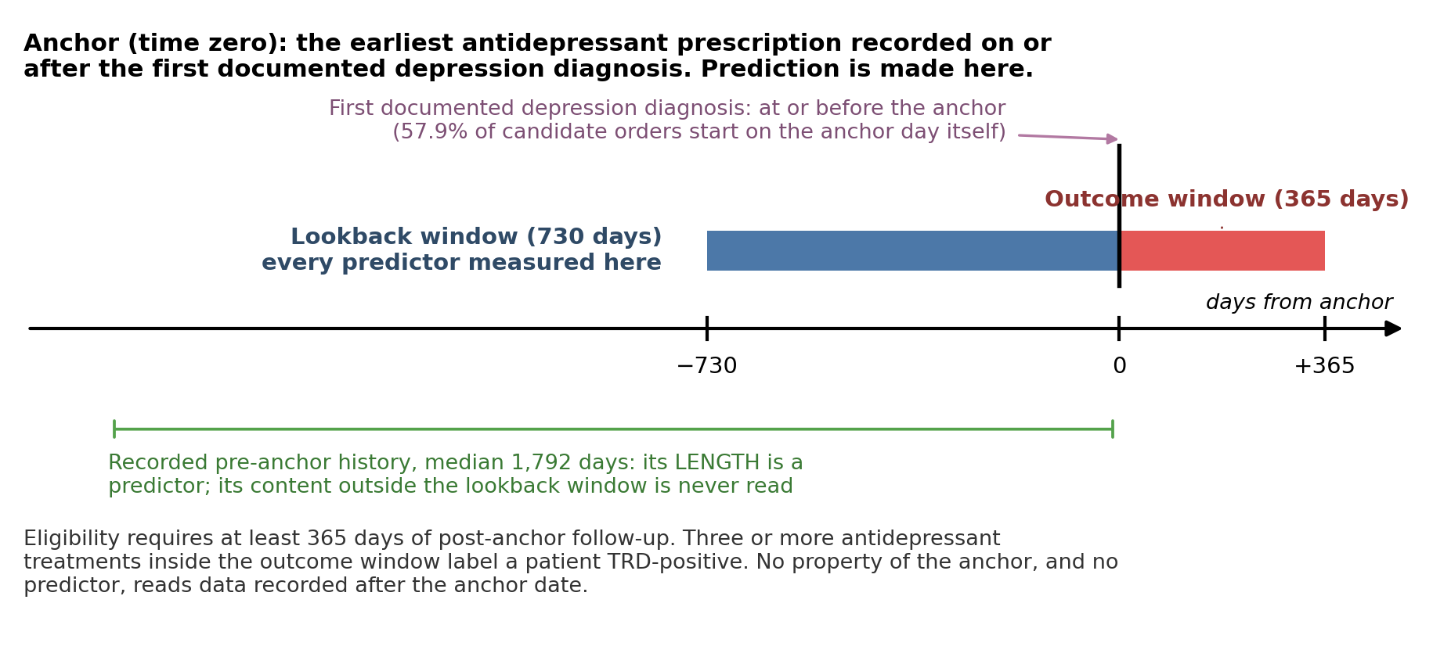
Figure 1. Prediction time and observation windows. The index is the earliest antidepressant prescription on or after the first recorded depression diagnosis. Clinical content comes from the preceding 730 days through the index date. Total recorded pre-index history length is a separate duration predictor and can exceed this window. The subsequent 365 days establish follow-up eligibility and the treatment-switching outcome. The 57.9% annotation describes candidate index orders, not the final cohort. EHR: electronic health record; MDD: major depressive disorder; TRD: treatment-resistant depression proxy.

Outcome
The prespecified outcome was a treatment-switching proxy for TRD, generated upstream and supplied as a fixed label [20]. Patients were positive if they received at least 3 distinct antidepressant treatments within 365 days, counting the index agent first. This required at least 2 subsequent changes to distinct agents. Augmentation without replacement and restarting a previously used agent did not increase the count.
The outcome did not verify inadequate response to 2 adequate trials. Standardized symptom response was unavailable, and dose and duration adequacy were not established for the counted treatments. Switching could reflect nonresponse, intolerance, preference, access, or prescribing practice. The label was not validated by chart review or symptom measures (Multimedia Appendix 1, section M3). We use “TRD proxy” throughout to distinguish this outcome from clinically confirmed resistance.

Patient Representations and Missing Data
Predictor domains were selected before model fitting or examination of outcome associations. They included depression coding, psychiatric and medical comorbidity, prior treatment, medication burden, utilization, prescribing constraints, and sociodemographic characteristics [4-7]. The structured representation (FEATURE) comprised 92 encoded columns. Continuous variables were standardized, categorical variables were one-hot encoded, and binary variables were coded as 0 or 1. Prior antidepressant trial counts required at least 42 days of continuous exposure; this duration rule did not establish adequate dose.
For the embedded representation (EMBEDDED), fixed rules converted structured fields into Markdown narratives. No generative model wrote the narratives, preserving traceability to the source fields [21]. We evaluated bge-small-en-v1.5, bge-en-icl, Qwen3-Embedding-4B, and Qwen3-Embedding-8B; the last was the primary encoder [22-25].
The pipelines differed in information content. Narratives retained vital signs, individual medication names, index dates, sexual orientation, and finer sociodemographic categories; FEATURE included total recorded history length, which the narratives omitted. Missing vital signs were excluded from FEATURE, and no statistical imputation was used in the primary analysis. Missing categorical information was represented explicitly, although some narrative fields retained raw missing-value tokens. Encoding rules, the predictor inventory, example narratives, and the field crosswalk are provided in Multimedia Appendix 1, sections M4–M6, S5, and S10.

Model Development and Evaluation
All models used one stratified 80:20 split: 34,063 training patients, including 5,964 outcome-positive patients, and 8,516 test patients, including 1,491 outcome-positive patients. We fitted logistic regression, random forest, gradient boosting, and XGBoost to each representation. Five-fold cross-validated grid search optimized ROC AUC within the training set. Scaling and category encoding were fitted within each training fold; the selected pipeline was then refitted on all training patients and applied to the test set. Tuning grids were identical across representations for each classifier (Multimedia Appendix 1, sections M7–M9).
We assessed ROC AUC, area under the precision–recall curve (AUPRC), Brier score, and calibration. The supplementary calibration-curve summaries use slopes and intercepts fitted to binned probabilities; the subgroup analyses separately report logistic calibration slopes based on individual predicted probabilities. These quantities are distinguished because they are not interchangeable. All calibration estimates concern this enriched cohort.
Nonparametric bootstrap resampling of test patients provided 95% CIs. Paired resampling estimated differences between representations and between original and perturbed predictions. Classifier-matched contrasts held the learner fixed. The comparison of the best model for each representation was post hoc because the leading models were identified from test performance. No equivalence margin was prespecified; a CI containing zero does not establish equivalence. Sensitivity and specificity at test-selected Youden J thresholds are reported only as descriptive analyses in Multimedia Appendix 1, section S12.

Supporting Analyses
We examined embedded-model reliance on 6 concepts by permuting one narrative section or field across patients, re-embedding the narratives, and applying the original classifiers without retraining. The concepts were psychiatric history, medication burden, prior treatment exposure, prescribing contraindications, race/ethnicity, and social determinants of health. Change in ROC AUC measures reliance under the specified perturbation; it does not identify causal mechanisms or establish fairness.
We also predicted each test patient’s outcome from its nearest training-set neighbors. Test patients served only as queries. The risk score was the similarity-weighted mean outcome of the k most similar training patients (Equation 2). Similarity was measured in 2 ways. Plain cosine similarity used the raw embeddings. Importance-weighted cosine similarity first standardized each embedding dimension with the embedded logistic regression’s own scaler. It then weighted each dimension by its share of that model’s absolute coefficients (Equation 1). The coefficients were fitted on training patients only, so no test outcome entered a risk score.
simw(x,y)=d​wd zd(x) zd(y)d​wd zd(x)2 d​wd zd(y)2, wd=|βd|e​|βe| (1)
r(x)=i∈Nk(x)​siα yii∈Nk(x)​siα, si=max{sim(x,i),0} (2)
Here $z_{d}$ is dimension $d$ after standardization, $β_{d}$ is its logistic-regression coefficient, $N_{k}(x)$ is the set of the $k$ most similar training patients, $y_{i}$ is a neighbor’s outcome, and $α$ is a sharpening exponent. Plain cosine similarity is Equation 1 with raw embeddings and equal weights. The primary analysis used k = 50 and α = 5. A sweep evaluated every k from 1 to all 34,063 training patients, under α = 1, 2, and 5. Random and farthest retrieval served as negative controls. Details appear in Multimedia Appendix 1, sections M10–M12 and S6.
Additional analyses examined encoder robustness, model dimensionality, record length, and subgroup performance. Subgroup comparisons used held-out predictions without refitting and Benjamini–Hochberg adjustment across 240 contrasts. Full methods and results appear in Multimedia Appendix 1. All random processes were seeded; analyses used Python, scikit-learn, XGBoost, and sentence-transformers [22,26,27].

Ethical Considerations
We analyzed deidentified secondary records without direct identifiers. No institutional review board review or consent waiver was obtained because the study was considered not to involve human participants. All analytic computation, including embedding, ran on local institutional hardware; patient-level analytic data were not transmitted to external services. No patients or members of the public participated in the design, conduct, or reporting of the study.

