S1 Embedding Dimensionality
Latent embedding coordinates do not have individual clinical interpretations. We therefore examined fitted sparsity, cumulative correlations, and performance after principal component reduction for Qwen3-Embedding-8B. These exploratory analyses describe the fitted representation rather than identify distinct clinical mechanisms.

S1 1 Sparsity and cumulative built in importance
The selected logistic regression used elastic-net regularization (l1_ratio=0.25; C=0.01). It assigned nonzero coefficients to 385 of 4,096 dimensions; approximately 80% of total absolute coefficient magnitude fell in 179 dimensions and 90% in 236 (Figure S1). These are model-specific measures of coefficient concentration, not estimates of intrinsic dimensionality or independent predictive information.
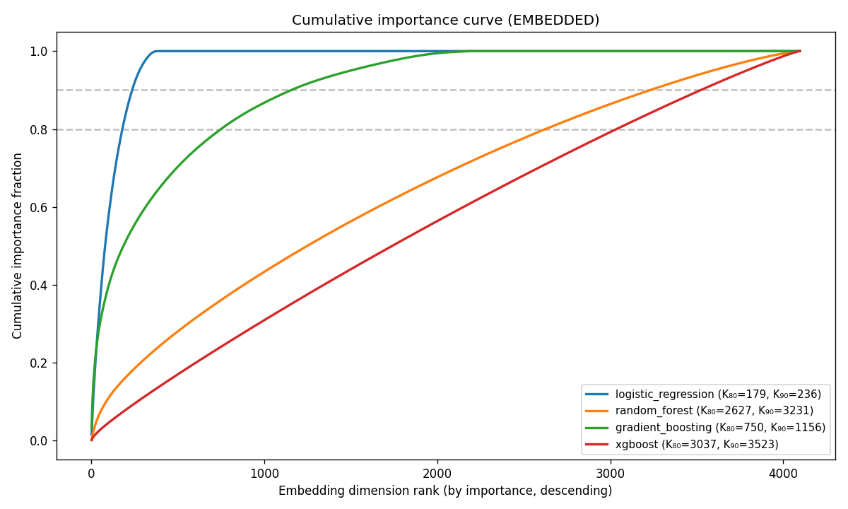
Figure S1. Cumulative built-in importance across embedding dimensions, ranked within each classifier. For logistic regression, importance is absolute coefficient magnitude; tree models use native feature importance. K80 and K90 identify the numbers of coordinates accounting for 80% and 90% of that model-specific total.

S1 2 Cumulative univariate correlation
We ranked coordinates by absolute Spearman correlation with the outcome and, separately, with each classifier’s predicted risk (Figure S2). The cumulative curves were broadly distributed. A sparse coefficient vector and diffuse marginal correlations can coexist because embedding coordinates are correlated; neither identifies unique clinical factors.
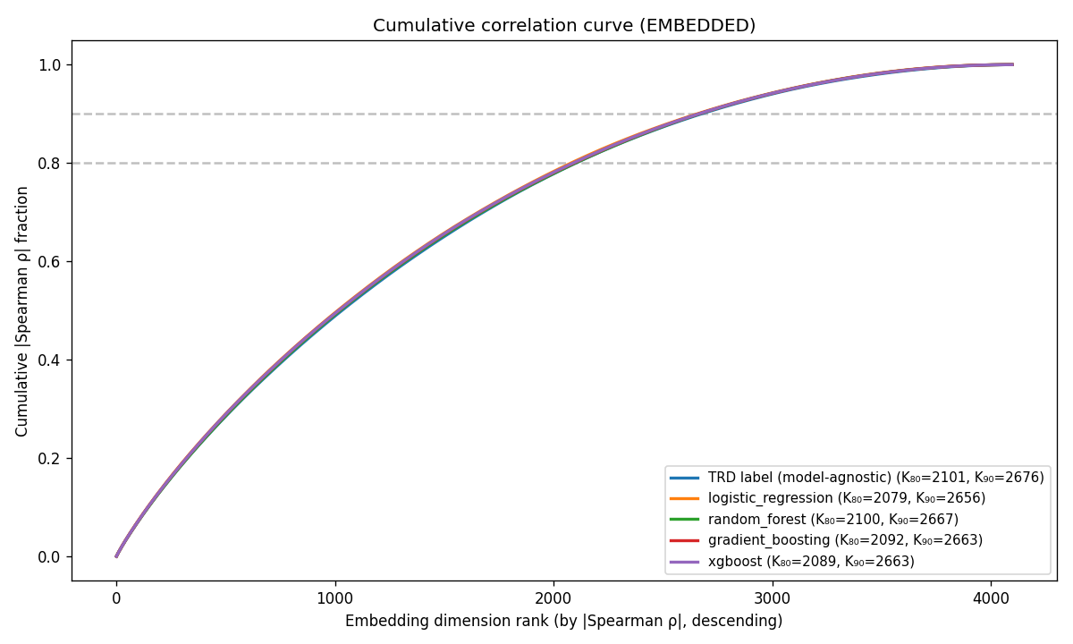
Figure S2. Cumulative absolute univariate (Spearman) correlation. One model-agnostic baseline curve ranks dimensions by |ρ(dim, outcome)|; the four per-classifier curves rank by |ρ(dim, predicted risk)|. Cumulative fraction of total |ρ| mass versus rank, with K₈₀ / K₉₀ knees in the legend.

S1 3 PCA K discrimination sweep
Each classifier was retrained on the top K principal components, with K in {1, 2, 4, 8, 16, 32, 64, 128, 256, 512, 1024}. Held-out ROC AUC generally improved as components were added, with model-specific plateaus and some deterioration at larger K (Figure S3). These curves do not identify a unique effective dimension, and choosing K from them would require further independent evaluation.
A Logistic regression
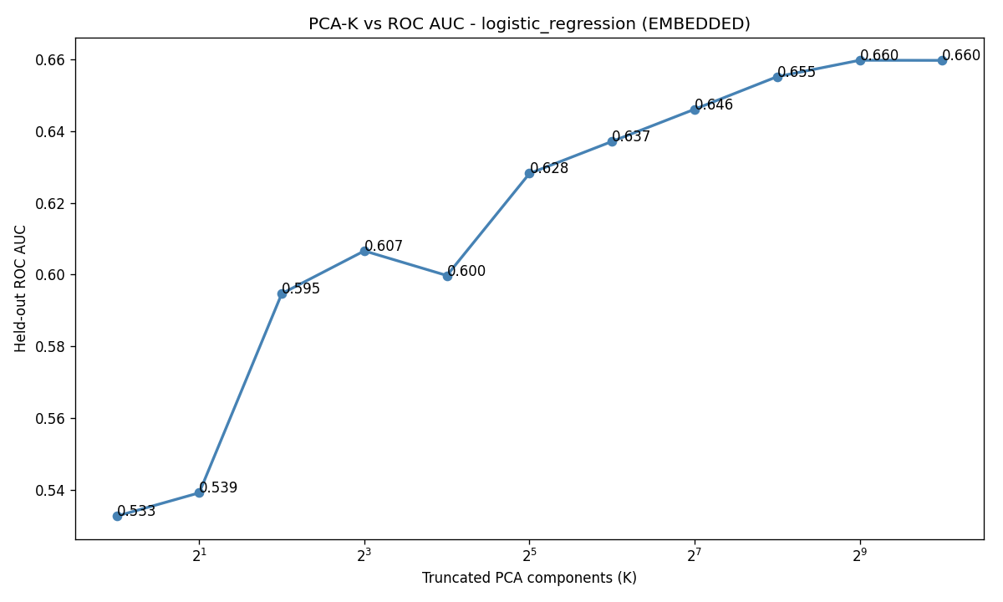
B Random forest
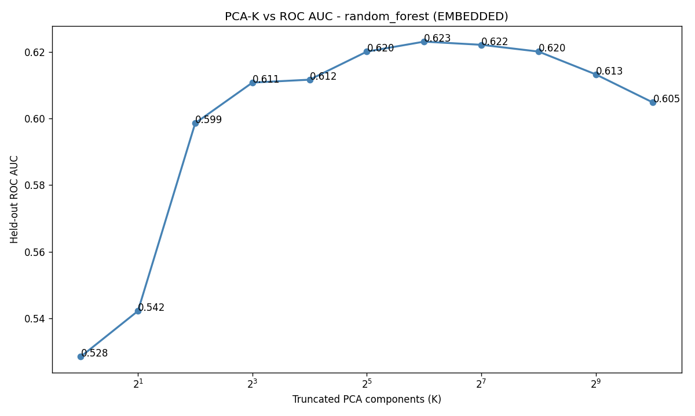
Figure S3. Continued on the next page.
C Gradient boosting
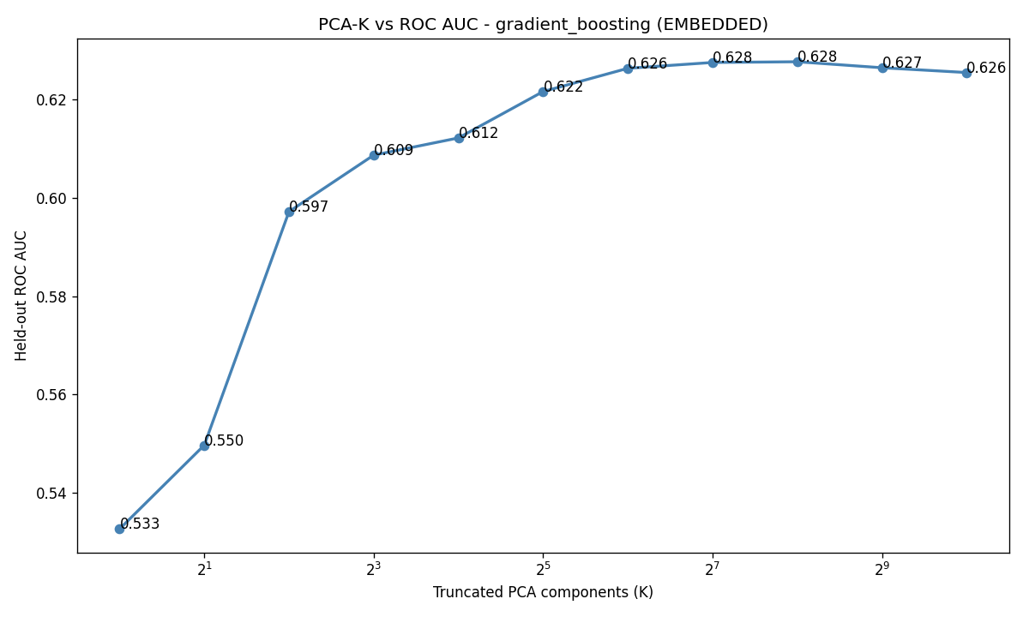
D XGBoost
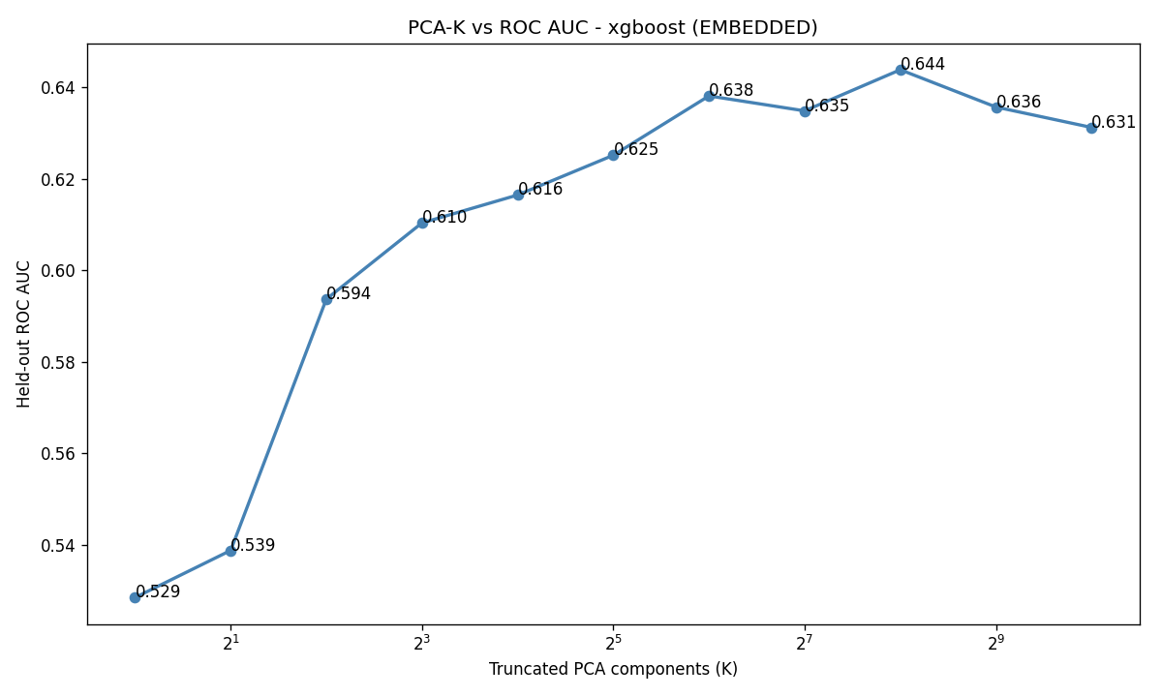
Figure S3. ROC AUC by retained principal components for logistic regression (A), random forest (B), gradient boosting (C), and XGBoost (D). The number of components is shown on a logarithmic scale. These are exploratory comparisons on the shared test set.

