S3 Calibration
Table S3 reports Brier score and weighted calibration error (WCE), for which lower values are better. Scores ranged from 0.137 to 0.140 and 0.004 to 0.018, respectively. The binned calibration slopes and intercepts originally reported in the manuscript are retained below, separately from the individual-level logistic slopes in section S9. Binned slopes should not be interpreted as conventional logistic calibration slopes.
Table S3. Brier score and weighted calibration error for all 8 primary representation–classifier combinations. Both metrics describe the cohort’s observed outcome frequency.
Representation | Classifier | Brier | WCE
EMBEDDED | Logistic regression | 0.137 | 0.010
EMBEDDED | Random forest | 0.140 | 0.006
EMBEDDED | Gradient boosting | 0.139 | 0.004
EMBEDDED | XGBoost | 0.139 | 0.013
FEATURE | Logistic regression | 0.139 | 0.005
FEATURE | Random forest | 0.139 | 0.018
FEATURE | Gradient boosting | 0.138 | 0.010
FEATURE | XGBoost | 0.138 | 0.012
Table S4. Slopes and intercepts fitted to the binned calibration curves. These descriptive values are retained from the original overall calibration analysis and are not individual-level logistic calibration parameters. See section S9 for the latter.
Representation | Classifier | Binned slope | Binned intercept
EMBEDDED | Logistic regression | 1.27 | −0.07
EMBEDDED | Random forest | 1.15 | −0.02
EMBEDDED | Gradient boosting | 1.01 | 0.01
EMBEDDED | XGBoost | 0.75 | 0.07
FEATURE | Logistic regression | 0.78 | 0.06
FEATURE | Random forest | 1.84 | −0.15
FEATURE | Gradient boosting | 0.87 | 0.04
FEATURE | XGBoost | 1.02 | 0.02
A Embedded logistic regression
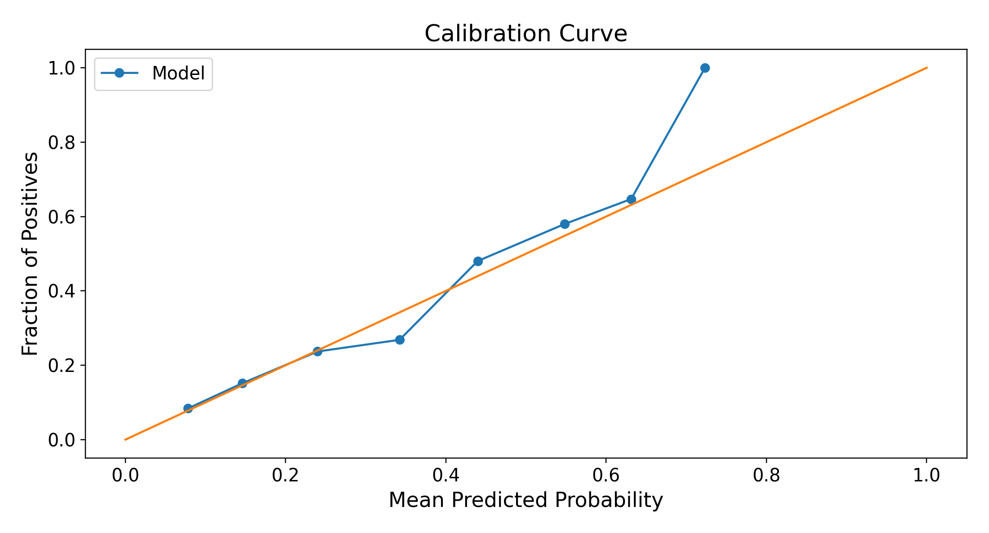
B Feature vector XGBoost
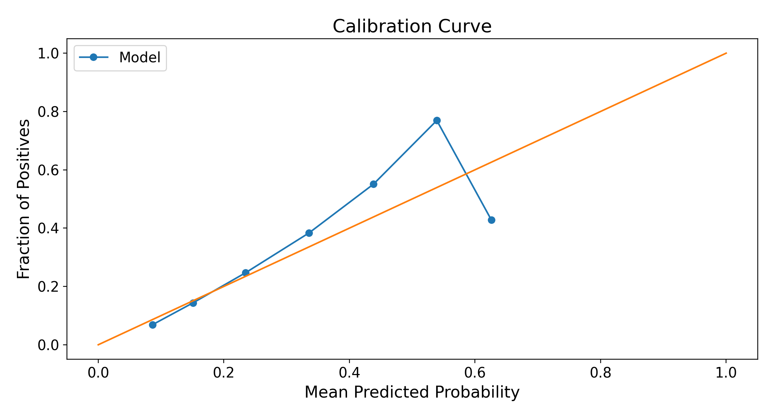
Figure S5. Calibration curves for embedded logistic regression (A) and feature-vector XGBoost (B). The diagonal indicates agreement between predicted and observed outcome frequency; points above it indicate underprediction in that bin, and points below indicate overprediction. The sample is enriched for depression.

