S9 Subgroup Performance
Subgroup analyses address performance differences, a question distinct from direct-input reliance under permutation. They do not establish fairness of the outcome label or of a proposed clinical decision.

S9 1 Design
Held-out predicted probabilities were partitioned by subgroup without refitting models. Discrimination and calibration were recalculated within each group.
The analysis included 4 FEATURE classifiers, 4 EMBEDDED classifiers, and 4 neighbor configurations: nearest retrieval under plain cosine similarity (k = 50) and under importance-weighted similarity (best k, 295), and the random and farthest controls. Between-group contrasts included the 2 nearest-neighbor configurations and excluded the controls.
Strata comprised sex, recorded race, age, marital status, smoking, religion, MDD recurrence, and severity. Race was aggregated as White versus other recorded categories because of small subgroup counts; this masks potentially important heterogeneity. Preferred language was not contrasted because 98.9% preferred English. A subgroup was treated as not estimable when its smaller outcome class contained fewer than 20 patients.
Within-group CIs used percentile bootstrap resampling. Contrasts between disjoint groups used independent resampling of each group. Two-sided bootstrap P values were adjusted across 240 contrasts with the Benjamini–Hochberg procedure.
The individual-level calibration slope was estimated by logistic regression of outcome on logit predicted risk. Mean predicted risk minus observed outcome frequency was also reported; the original table label “calibration-in-the-large” is retained as “mean risk difference” to identify the quantity actually calculated. This is not a logistic calibration intercept. Both differ from the binned-curve parameters in section S3.

S9 2 Sociodemographic strata
Table S10. Discrimination and calibration by sociodemographic stratum, one representative model per arm, held-out test set. Groups are not disjoint across families: every patient with a recorded sex appears in one sex row and every patient with a recorded race in one race row.
Group | n | Events | Arm | ROC AUC (95% CI) | Brier | Logistic slope | Mean risk difference
All held-out patients | 8,516 | 1,491 | E LR | 0.657 (0.643–0.672) | 0.137 | 0.97 | +0.000
All held-out patients | 8,516 | 1,491 | F LR | 0.629 (0.613–0.644) | 0.139 | 0.95 | -0.000
All held-out patients | 8,516 | 1,491 | N WTD | 0.625 (0.610–0.641) | 0.140 | 1.15 | -0.004
Male | 2,347 | 386 | E LR | 0.653 (0.622–0.682) | 0.131 | 0.94 | -0.003
Male | 2,347 | 386 | F LR | 0.626 (0.595–0.655) | 0.133 | 0.86 | -0.003
Male | 2,347 | 386 | N WTD | 0.625 (0.595–0.653) | 0.133 | 1.04 | -0.001
Female | 6,168 | 1,105 | E LR | 0.658 (0.641–0.675) | 0.139 | 0.98 | +0.002
Female | 6,168 | 1,105 | F LR | 0.630 (0.612–0.648) | 0.141 | 0.99 | +0.001
Female | 6,168 | 1,105 | N WTD | 0.624 (0.607–0.642) | 0.142 | 1.20 | -0.005
White/Caucasian | 6,835 | 1,181 | E LR | 0.657 (0.640–0.674) | 0.136 | 0.97 | +0.002
White/Caucasian | 6,835 | 1,181 | F LR | 0.633 (0.615–0.652) | 0.137 | 0.98 | +0.001
White/Caucasian | 6,835 | 1,181 | N WTD | 0.633 (0.615–0.650) | 0.138 | 1.22 | -0.004
Non-White (recorded) | 1,631 | 302 | E LR | 0.652 (0.620–0.684) | 0.144 | 0.95 | -0.004
Non-White (recorded) | 1,631 | 302 | F LR | 0.608 (0.573–0.643) | 0.147 | 0.79 | -0.004
Non-White (recorded) | 1,631 | 302 | N WTD | 0.587 (0.553–0.620) | 0.148 | 0.85 | -0.004
Race not recorded | 50 | 8 | E LR | not estimable | — | — | —
Race not recorded | 50 | 8 | F LR | not estimable | — | — | —
Race not recorded | 50 | 8 | N WTD | not estimable | — | — | —
Age band: 18-29 | 1,085 | 218 | E LR | 0.611 (0.568–0.654) | 0.156 | 0.78 | +0.003
Age band: 18-29 | 1,085 | 218 | F LR | 0.570 (0.524–0.615) | 0.160 | 0.60 | +0.012
Age band: 18-29 | 1,085 | 218 | N WTD | 0.578 (0.535–0.620) | 0.158 | 0.81 | -0.007
Age band: 30-44 | 1,827 | 372 | E LR | 0.653 (0.621–0.682) | 0.154 | 0.95 | -0.002
Age band: 30-44 | 1,827 | 372 | F LR | 0.636 (0.605–0.667) | 0.155 | 1.00 | -0.002
Age band: 30-44 | 1,827 | 372 | N WTD | 0.610 (0.578–0.642) | 0.158 | 1.08 | -0.015
Age band: 45-64 | 2,636 | 473 | E LR | 0.652 (0.623–0.679) | 0.140 | 0.98 | +0.007
Age band: 45-64 | 2,636 | 473 | F LR | 0.607 (0.580–0.636) | 0.143 | 0.88 | -0.001
Age band: 45-64 | 2,636 | 473 | N WTD | 0.624 (0.594–0.651) | 0.142 | 1.16 | -0.002
Age band: 65+ | 2,968 | 428 | E LR | 0.658 (0.630–0.682) | 0.117 | 1.10 | -0.005
Age band: 65+ | 2,968 | 428 | F LR | 0.641 (0.614–0.669) | 0.119 | 1.18 | -0.003
Age band: 65+ | 2,968 | 428 | N WTD | 0.624 (0.595–0.651) | 0.119 | 1.28 | +0.003
Marital status: Divorced | 882 | 211 | E LR | 0.640 (0.593–0.681) | 0.173 | 0.90 | -0.046
Marital status: Divorced | 882 | 211 | F LR | 0.607 (0.563–0.649) | 0.177 | 0.85 | -0.049
Marital status: Divorced | 882 | 211 | N WTD | 0.607 (0.561–0.646) | 0.179 | 1.07 | -0.061
Marital status: Never Married | 2,364 | 438 | E LR | 0.634 (0.609–0.661) | 0.145 | 0.85 | +0.013
Marital status: Never Married | 2,364 | 438 | F LR | 0.598 (0.569–0.627) | 0.149 | 0.72 | +0.016
Marital status: Never Married | 2,364 | 438 | N WTD | 0.590 (0.562–0.619) | 0.149 | 0.85 | +0.002
Marital status: Now Married | 4,251 | 694 | E LR | 0.670 (0.650–0.690) | 0.129 | 1.05 | -0.001
Marital status: Now Married | 4,251 | 694 | F LR | 0.644 (0.623–0.666) | 0.131 | 1.10 | -0.002
Marital status: Now Married | 4,251 | 694 | N WTD | 0.640 (0.619–0.663) | 0.131 | 1.31 | +0.002
Marital status: Separated | 99 | 21 | E LR | 0.518 (0.364–0.673) | 0.171 | 0.08 | +0.001
Marital status: Separated | 99 | 21 | F LR | 0.518 (0.357–0.687) | 0.169 | 0.30 | -0.003
Marital status: Separated | 99 | 21 | N WTD | 0.581 (0.418–0.741) | 0.162 | 0.73 | -0.018
Marital status: Widowed | 891 | 120 | E LR | 0.654 (0.597–0.708) | 0.111 | 1.09 | +0.022
Marital status: Widowed | 891 | 120 | F LR | 0.625 (0.572–0.678) | 0.112 | 1.17 | +0.017
Marital status: Widowed | 891 | 120 | N WTD | 0.623 (0.565–0.678) | 0.113 | 1.22 | +0.015
Smoking status: Current Smoker | 1,126 | 243 | E LR | 0.667 (0.631–0.706) | 0.158 | 1.01 | -0.009
Smoking status: Current Smoker | 1,126 | 243 | F LR | 0.617 (0.575–0.660) | 0.162 | 0.87 | -0.011
Smoking status: Current Smoker | 1,126 | 243 | N WTD | 0.609 (0.569–0.649) | 0.163 | 1.12 | -0.020
Smoking status: Former Smoker | 2,532 | 443 | E LR | 0.663 (0.636–0.690) | 0.137 | 0.98 | +0.003
Smoking status: Former Smoker | 2,532 | 443 | F LR | 0.633 (0.603–0.660) | 0.140 | 0.89 | +0.001
Smoking status: Former Smoker | 2,532 | 443 | N WTD | 0.632 (0.603–0.659) | 0.139 | 1.16 | -0.005
Smoking status: Never Smoker | 4,788 | 793 | E LR | 0.646 (0.623–0.665) | 0.132 | 0.93 | +0.001
Smoking status: Never Smoker | 4,788 | 793 | F LR | 0.625 (0.603–0.645) | 0.133 | 0.99 | +0.002
Smoking status: Never Smoker | 4,788 | 793 | N WTD | 0.618 (0.596–0.638) | 0.134 | 1.13 | +0.001
Religion: Catholic | 608 | 93 | E LR | 0.695 (0.634–0.754) | 0.120 | 1.29 | +0.009
Religion: Catholic | 608 | 93 | F LR | 0.648 (0.587–0.710) | 0.124 | 1.06 | +0.002
Religion: Catholic | 608 | 93 | N WTD | 0.658 (0.598–0.713) | 0.124 | 1.52 | +0.011
Religion: Non-Christian | 50 | 16 | E LR | not estimable | — | — | —
Religion: Non-Christian | 50 | 16 | F LR | not estimable | — | — | —
Religion: Non-Christian | 50 | 16 | N WTD | not estimable | — | — | —
Religion: Orthodox | 9 | 3 | E LR | not estimable | — | — | —
Religion: Orthodox | 9 | 3 | F LR | not estimable | — | — | —
Religion: Orthodox | 9 | 3 | N WTD | not estimable | — | — | —
Religion: Other/Unknown | 759 | 145 | E LR | 0.615 (0.565–0.664) | 0.151 | 0.72 | -0.013
Religion: Other/Unknown | 759 | 145 | F LR | 0.589 (0.537–0.642) | 0.153 | 0.66 | -0.010
Religion: Other/Unknown | 759 | 145 | N WTD | 0.594 (0.543–0.643) | 0.151 | 0.93 | -0.014
Religion: Protestant | 4,654 | 793 | E LR | 0.665 (0.644–0.685) | 0.134 | 1.00 | +0.003
Religion: Protestant | 4,654 | 793 | F LR | 0.642 (0.620–0.662) | 0.135 | 1.05 | +0.002
Religion: Protestant | 4,654 | 793 | N WTD | 0.632 (0.609–0.653) | 0.136 | 1.19 | -0.003
E LR: embedded logistic regression; F LR: feature-vector logistic regression; N WTD: importance-weighted nearest-neighbor prediction (k = 295). Events denotes positive TRD proxy outcomes. Mean risk difference is mean predicted probability minus observed frequency.

S9 3 Clinical strata
Table S11. Discrimination and calibration by recorded depression phenotype, one representative model per arm.
Group | n | Events | Arm | ROC AUC (95% CI) | Brier | Logistic slope | Mean risk difference
MDD severity: Mild | 633 | 105 | E LR | 0.683 (0.624–0.742) | 0.130 | 1.39 | -0.020
MDD severity: Mild | 633 | 105 | F LR | 0.607 (0.547–0.667) | 0.135 | 0.86 | -0.018
MDD severity: Mild | 633 | 105 | N WTD | 0.607 (0.547–0.668) | 0.137 | 1.30 | -0.020
MDD severity: Moderate | 1,426 | 255 | E LR | 0.652 (0.618–0.687) | 0.142 | 0.98 | +0.003
MDD severity: Moderate | 1,426 | 255 | F LR | 0.634 (0.599–0.670) | 0.142 | 1.06 | +0.001
MDD severity: Moderate | 1,426 | 255 | N WTD | 0.631 (0.593–0.666) | 0.143 | 1.58 | -0.005
MDD severity: Psychotic | 18 | 8 | E LR | not estimable | — | — | —
MDD severity: Psychotic | 18 | 8 | F LR | not estimable | — | — | —
MDD severity: Psychotic | 18 | 8 | N WTD | not estimable | — | — | —
MDD severity: Remission | 143 | 19 | E LR | not estimable | — | — | —
MDD severity: Remission | 143 | 19 | F LR | not estimable | — | — | —
MDD severity: Remission | 143 | 19 | N WTD | not estimable | — | — | —
MDD severity: Severe | 468 | 137 | E LR | 0.700 (0.648–0.749) | 0.187 | 1.21 | +0.029
MDD severity: Severe | 468 | 137 | F LR | 0.636 (0.578–0.690) | 0.197 | 0.88 | +0.029
MDD severity: Severe | 468 | 137 | N WTD | 0.678 (0.622–0.730) | 0.193 | 1.86 | +0.014
MDD severity: Unspecified | 5,828 | 967 | E LR | 0.641 (0.621–0.660) | 0.133 | 0.94 | -0.000
MDD severity: Unspecified | 5,828 | 967 | F LR | 0.615 (0.595–0.634) | 0.134 | 0.98 | -0.001
MDD severity: Unspecified | 5,828 | 967 | N WTD | 0.609 (0.590–0.628) | 0.135 | 1.14 | -0.003
MDD recurrence: | 32 | 7 | E LR | not estimable | — | — | —
MDD recurrence: | 32 | 7 | F LR | not estimable | — | — | —
MDD recurrence: | 32 | 7 | N WTD | not estimable | — | — | —
MDD recurrence: Dysthymia | 584 | 97 | E LR | 0.690 (0.638–0.748) | 0.130 | 1.33 | +0.008
MDD recurrence: Dysthymia | 584 | 97 | F LR | 0.627 (0.565–0.687) | 0.134 | 1.13 | +0.010
MDD recurrence: Dysthymia | 584 | 97 | N WTD | 0.628 (0.567–0.688) | 0.135 | 2.22 | +0.003
MDD recurrence: Recurrent | 2,177 | 433 | E LR | 0.698 (0.671–0.726) | 0.146 | 1.09 | -0.000
MDD recurrence: Recurrent | 2,177 | 433 | F LR | 0.676 (0.648–0.703) | 0.148 | 1.07 | -0.002
MDD recurrence: Recurrent | 2,177 | 433 | N WTD | 0.666 (0.639–0.693) | 0.150 | 1.26 | -0.005
MDD recurrence: Single Episode | 5,723 | 954 | E LR | 0.633 (0.612–0.652) | 0.134 | 0.86 | +0.000
MDD recurrence: Single Episode | 5,723 | 954 | F LR | 0.605 (0.584–0.626) | 0.136 | 0.83 | -0.000
MDD recurrence: Single Episode | 5,723 | 954 | N WTD | 0.603 (0.584–0.623) | 0.136 | 1.03 | -0.004
E LR: embedded logistic regression; F LR: feature-vector logistic regression; N WTD: importance-weighted nearest-neighbor prediction (k = 295). Events denotes positive TRD proxy outcomes. Mean risk difference is mean predicted probability minus observed frequency.

S9 4 Adjusted Subgroup Comparisons
Of 240 contrasts, 60 had unadjusted CIs excluding zero and 24 survived Benjamini–Hochberg adjustment (Table S12).
Table S12. Contrasts surviving Benjamini-Hochberg adjustment across all 240 reported comparisons, grouped by contrast and arm. “Models surviving” counts how many of that arm’s contrasted models cleared the threshold.
Contrast | Arm | Models surviving | ΔROC AUC range | Smallest P (BH)
Age: 18-29 vs rest | Feature vector | 1 of 4 | -0.068 | 0.040
MDD recurrence: Recurrent vs rest | Embedded | 4 of 4 | +0.059 to +0.072 | 0.014
MDD recurrence: Recurrent vs rest | Feature vector | 4 of 4 | +0.060 to +0.068 | 0.014
MDD recurrence: Recurrent vs rest | Nearest neighbors | 2 of 2 | +0.060 to +0.076 | 0.014
MDD recurrence: Single Episode vs rest | Embedded | 4 of 4 | -0.071 to -0.065 | 0.014
MDD recurrence: Single Episode vs rest | Feature vector | 3 of 4 | -0.064 to -0.056 | 0.025
MDD recurrence: Single Episode vs rest | Nearest neighbors | 2 of 2 | -0.074 to -0.058 | 0.014
MDD severity: Severe vs rest | Nearest neighbors | 1 of 2 | +0.087 | 0.040
Marital status: Never Married vs rest | Embedded | 2 of 4 | -0.054 to -0.051 | 0.014
Marital status: Never Married vs rest | Nearest neighbors | 1 of 2 | -0.047 | 0.040
All 10 male-minus-female AUC contrasts included zero; the largest absolute point difference was 0.012. This does not establish equivalent performance.
All 10 White-minus-non-White AUC contrasts were positive (0.005–0.052); 5 excluded zero before adjustment, but none survived adjustment (minimum adjusted P=.11). For FEATURE logistic regression, calibration slopes were 0.98 in White patients and 0.79 in patients with other recorded racial categories.
The other-recorded-race stratum had 302 events, compared with 1,181 among White patients, and wider CIs. The direction is consistent across related models, but these are correlated comparisons rather than independent replications. The data leave racial differences unresolved.
Nineteen of the 24 adjusted contrasts involved recurrence. Recurrent coding was associated with higher discrimination in all 10 contrasted models (differences 0.059–0.076), and single-episode coding with lower discrimination (−0.074 to −0.054), which survived adjustment in 9. In plain-cosine nearest-neighbor prediction, severe coding was associated with higher discrimination (+0.087; adjusted P=.04).
The remaining 4 adjusted contrasts indicated lower discrimination among never-married patients in 2 EMBEDDED classifiers (−0.054 to −0.051; minimum adjusted P=.014) and in importance-weighted retrieval (−0.047; adjusted P=.04), and at ages 18–29 in FEATURE XGBoost (−0.068; adjusted P=.04). Their causes were not established.
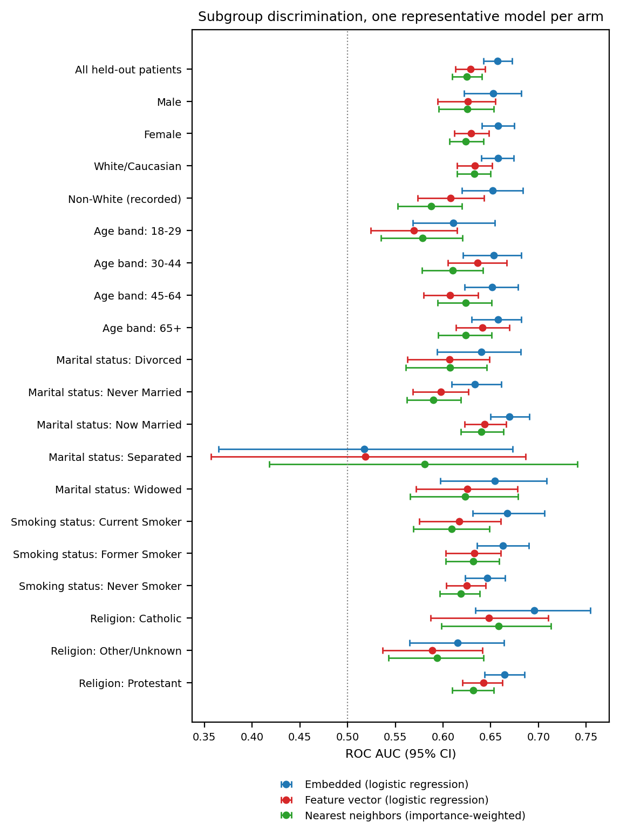
Figure S11. Subgroup discrimination across sociodemographic strata, one representative model per arm, with 95% bootstrap confidence intervals. The dotted line marks chance. Strata declared not estimable are omitted.

