S2 Precision Recall Performance
AUPRC complements ROC AUC by describing precision across recall levels. Its no-skill reference is the cohort’s positive fraction, 0.175. Because it depends on outcome frequency, AUPRC should not be compared across populations without accounting for prevalence.
AUPRC remained modest across models (Tables S1–S2; Figure S4). The leading embedded and feature models achieved 0.302 and 0.298, respectively. These values are also summarized in Table 2. At each retrieval arm’s best k, AUPRC was 0.272 (95% CI 0.251–0.294) for importance-weighted, 0.264 (95% CI 0.244–0.286) for plain cosine, and 0.176 (95% CI 0.165–0.188) for random retrieval. Random retrieval therefore sat at the no-skill reference. The best k was chosen on the test patients by ROC AUC, so these values are optimistic.
Table S1. AUPRC of the four classifiers on each representation (held-out test set). No-skill baseline = 0.175 (the positive rate).
Representation | Classifier | AUPRC
EMBEDDED | Logistic regression | 0.302
EMBEDDED | Random forest | 0.270
EMBEDDED | Gradient boosting | 0.276
EMBEDDED | XGBoost | 0.278
FEATURE | Logistic regression | 0.278
FEATURE | Random forest | 0.293
FEATURE | Gradient boosting | 0.288
FEATURE | XGBoost | 0.298
Retrieval rows, each at its own test-selected best k, with bootstrap 95% CIs:
Retrieval arm | AUPRC (95% CI)
Importance-weighted cosine, k = 295 | 0.272 (0.251–0.294)
Plain cosine, k = 757 | 0.264 (0.244–0.286)
Random, uniform weights, k = 32,720 | 0.176 (0.165–0.188)
Table S2. Embedded logistic-regression AUPRC by encoder (held-out test set). No-skill baseline = 0.175.
Encoder | AUPRC
bge-small-en-v1.5 | 0.281
bge-en-icl | 0.297
Qwen3-Embedding-4B | 0.297
Qwen3-Embedding-8B | 0.302
A Embedded logistic regression
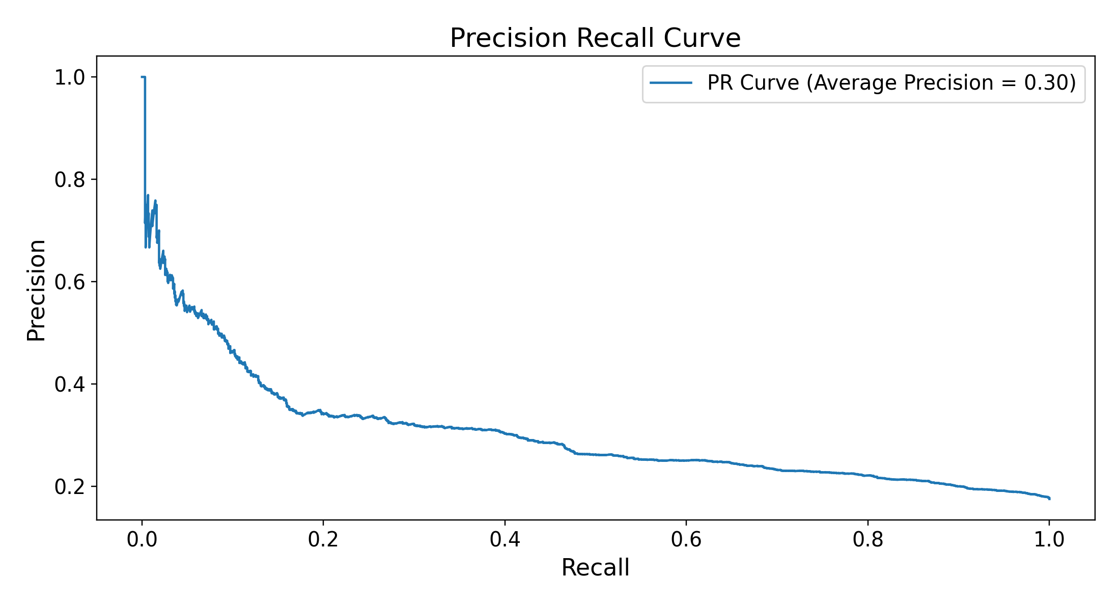
B Feature vector XGBoost
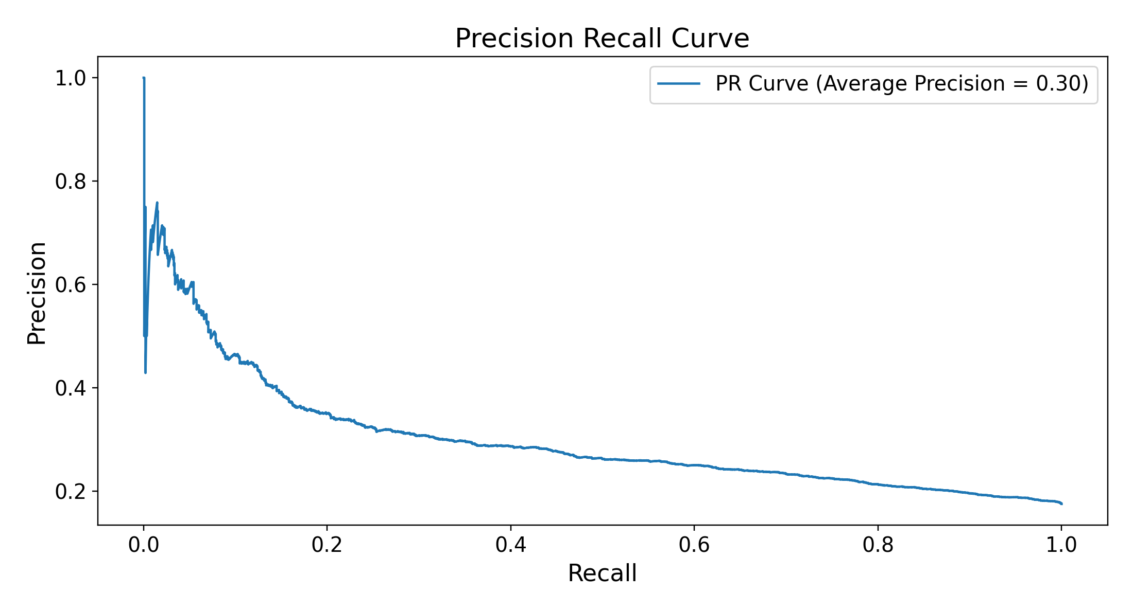
C Importance-weighted nearest retrieval, k = 295
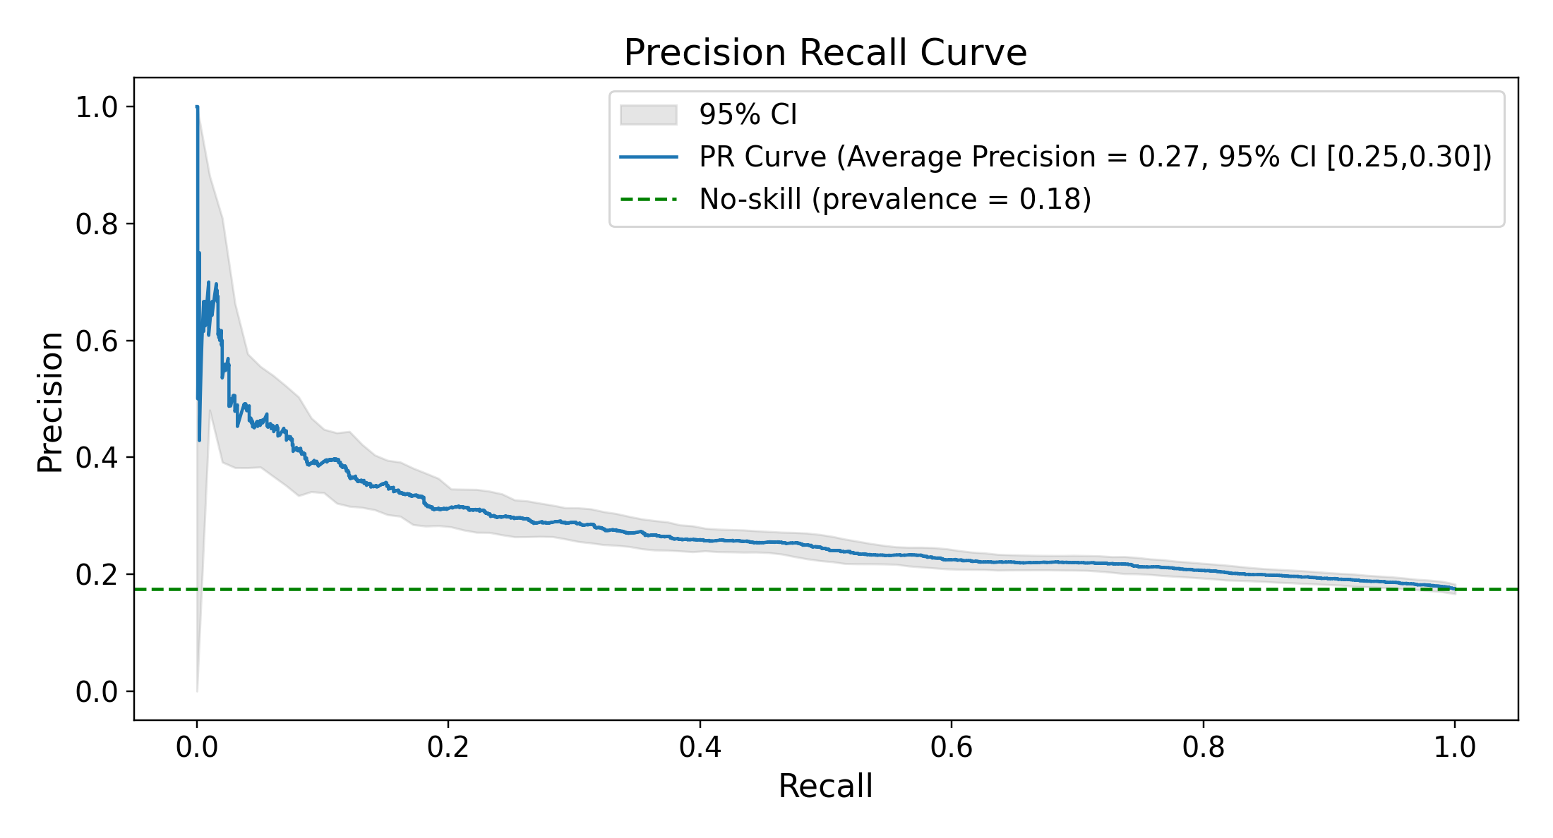
D Plain-cosine nearest retrieval, k = 757
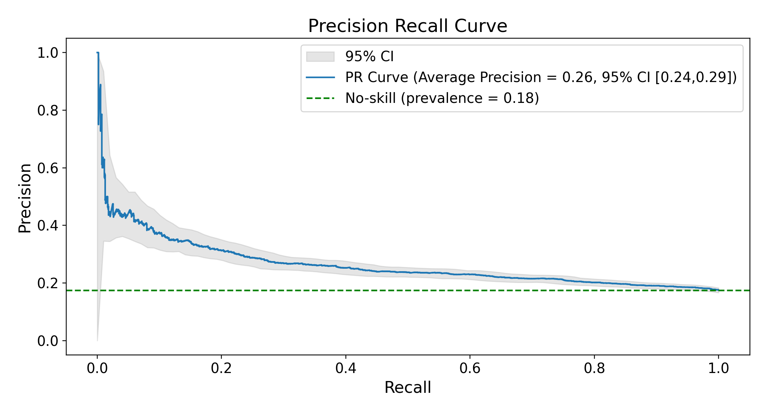
E Random retrieval, uniform weights, k = 32,720
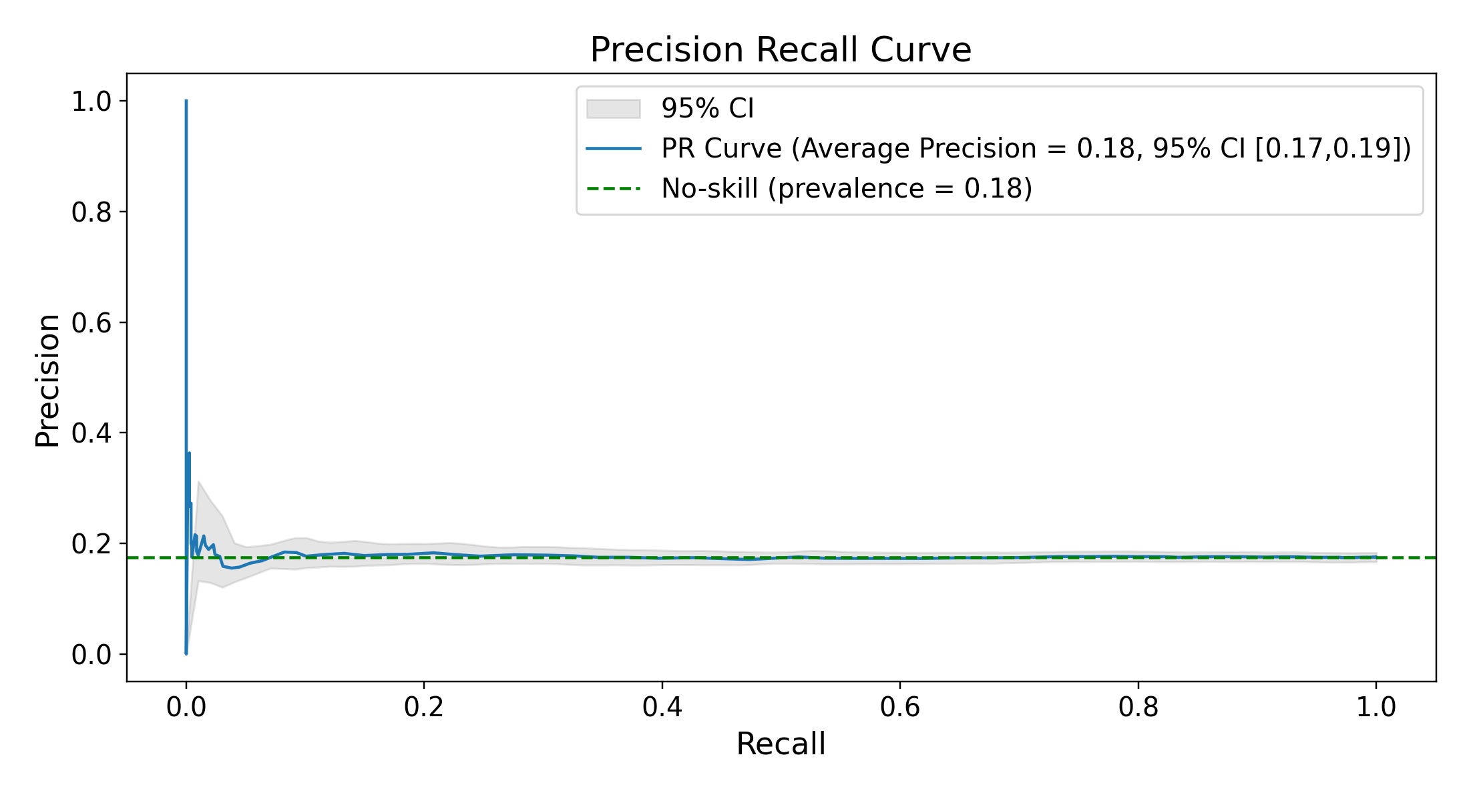
Figure S4. Precision–recall curves (held-out test set; primary Qwen3-Embedding-8B encoder). (A) Embedded logistic regression; (B) feature-vector XGBoost; (C–E) the 3 retrieval arms, each at its own test-selected best k. C is the draw of 1,000 whose ROC AUC at that k is closest to their mean. Retrieval panels print average precision, which differs from the table AUPRC in the third decimal. The no-skill reference is 0.175, the positive rate.

