S6 Neighbor Prediction
Retrieval over the embedding carried outcome information but did not reach the trained classifiers. Random retrieval stayed at chance at every k: its band across draws covered 0.5 at all 34,063. Its best k, 32,720, reached 0.500 (2.5th–97.5th percentile across draws 0.484–0.515), and that k is noise. Farthest retrieval reached 0.432 (95% CI 0.416–0.449) (Table S7). At their best k, importance-weighted retrieval exceeded random by 0.125 (95% CI 0.103–0.147) and plain cosine by 0.118 (95% CI 0.096–0.140). These intervals combine bootstrap resampling of the test patients with the spread across the 1,000 random draws. AUPRC at each arm’s best k was 0.272 (95% CI 0.251–0.294) for importance-weighted, 0.264 (95% CI 0.244–0.286) for plain cosine, and 0.176 (95% CI 0.165–0.188) for random retrieval, against an outcome rate of 0.175 (section S2). Calibration is in section S3.
Neighborhood size mattered more than the metric. Both curves rose to a plateau from about 300 neighbors (manuscript Figure 4). Each metric at its own best k differed by 0.007 (95% CI −0.001 to 0.014). The best k was selected on test patients, so those maxima are optimistic. Using every training patient as a neighbor involves no selection and gave 0.624 (95% CI 0.607–0.639) for the importance-weighted metric and 0.608 (95% CI 0.592–0.624) for plain cosine. The sharpening exponent changed the maxima by at most 0.002.
The best retrieval result over every k and exponent, 0.625, remained below feature-vector XGBoost by 0.024 (95% CI 0.012–0.036) and below embedded logistic regression by 0.032 (95% CI 0.022–0.043), from paired bootstrap resampling of the 8,516 test patients.
Table S7. Neighbor-prediction ROC AUC for the primary encoder by retrieval scheme, similarity metric, and neighborhood size, with $α$ = 1. Best k is the test-selected maximum and is optimistic. The uniform random row gives the mean across 1,000 draws and the 2.5th–97.5th percentile of the draws. Farthest retrieval uses the retrieval pipeline’s k = 50 and $α$ = 5.
Retrieval | Similarity | Neighbors (k) | ROC AUC (95% CI)
Nearest | Plain cosine | best, 757 | 0.618 (0.602–0.634)
Nearest | Importance-weighted | best, 295 | 0.625 (0.610–0.641)
Nearest | Plain cosine | all, 34,063 | 0.608 (0.592–0.624)
Nearest | Importance-weighted | all, 34,063 | 0.624 (0.607–0.639)
Random | Uniform | best, 32,720 | 0.500 (0.484–0.515)
Farthest | Plain cosine | 50 | 0.432 (0.416–0.449)
A Importance-weighted nearest retrieval, k = 295
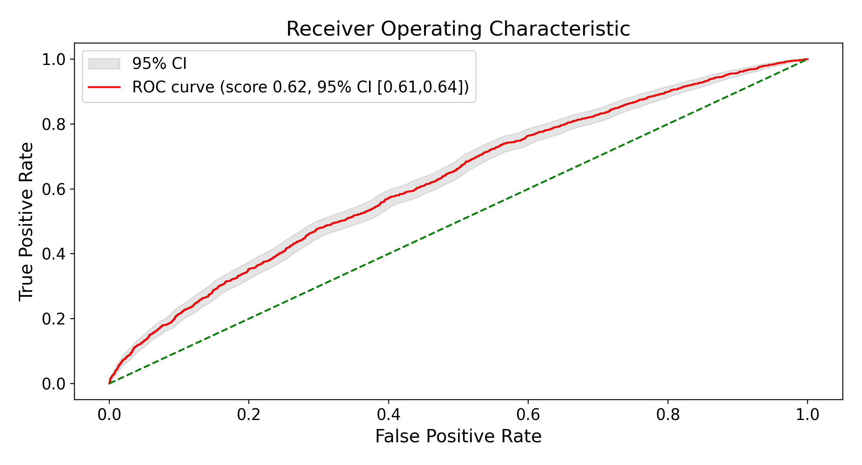
B Plain-cosine nearest retrieval, k = 757
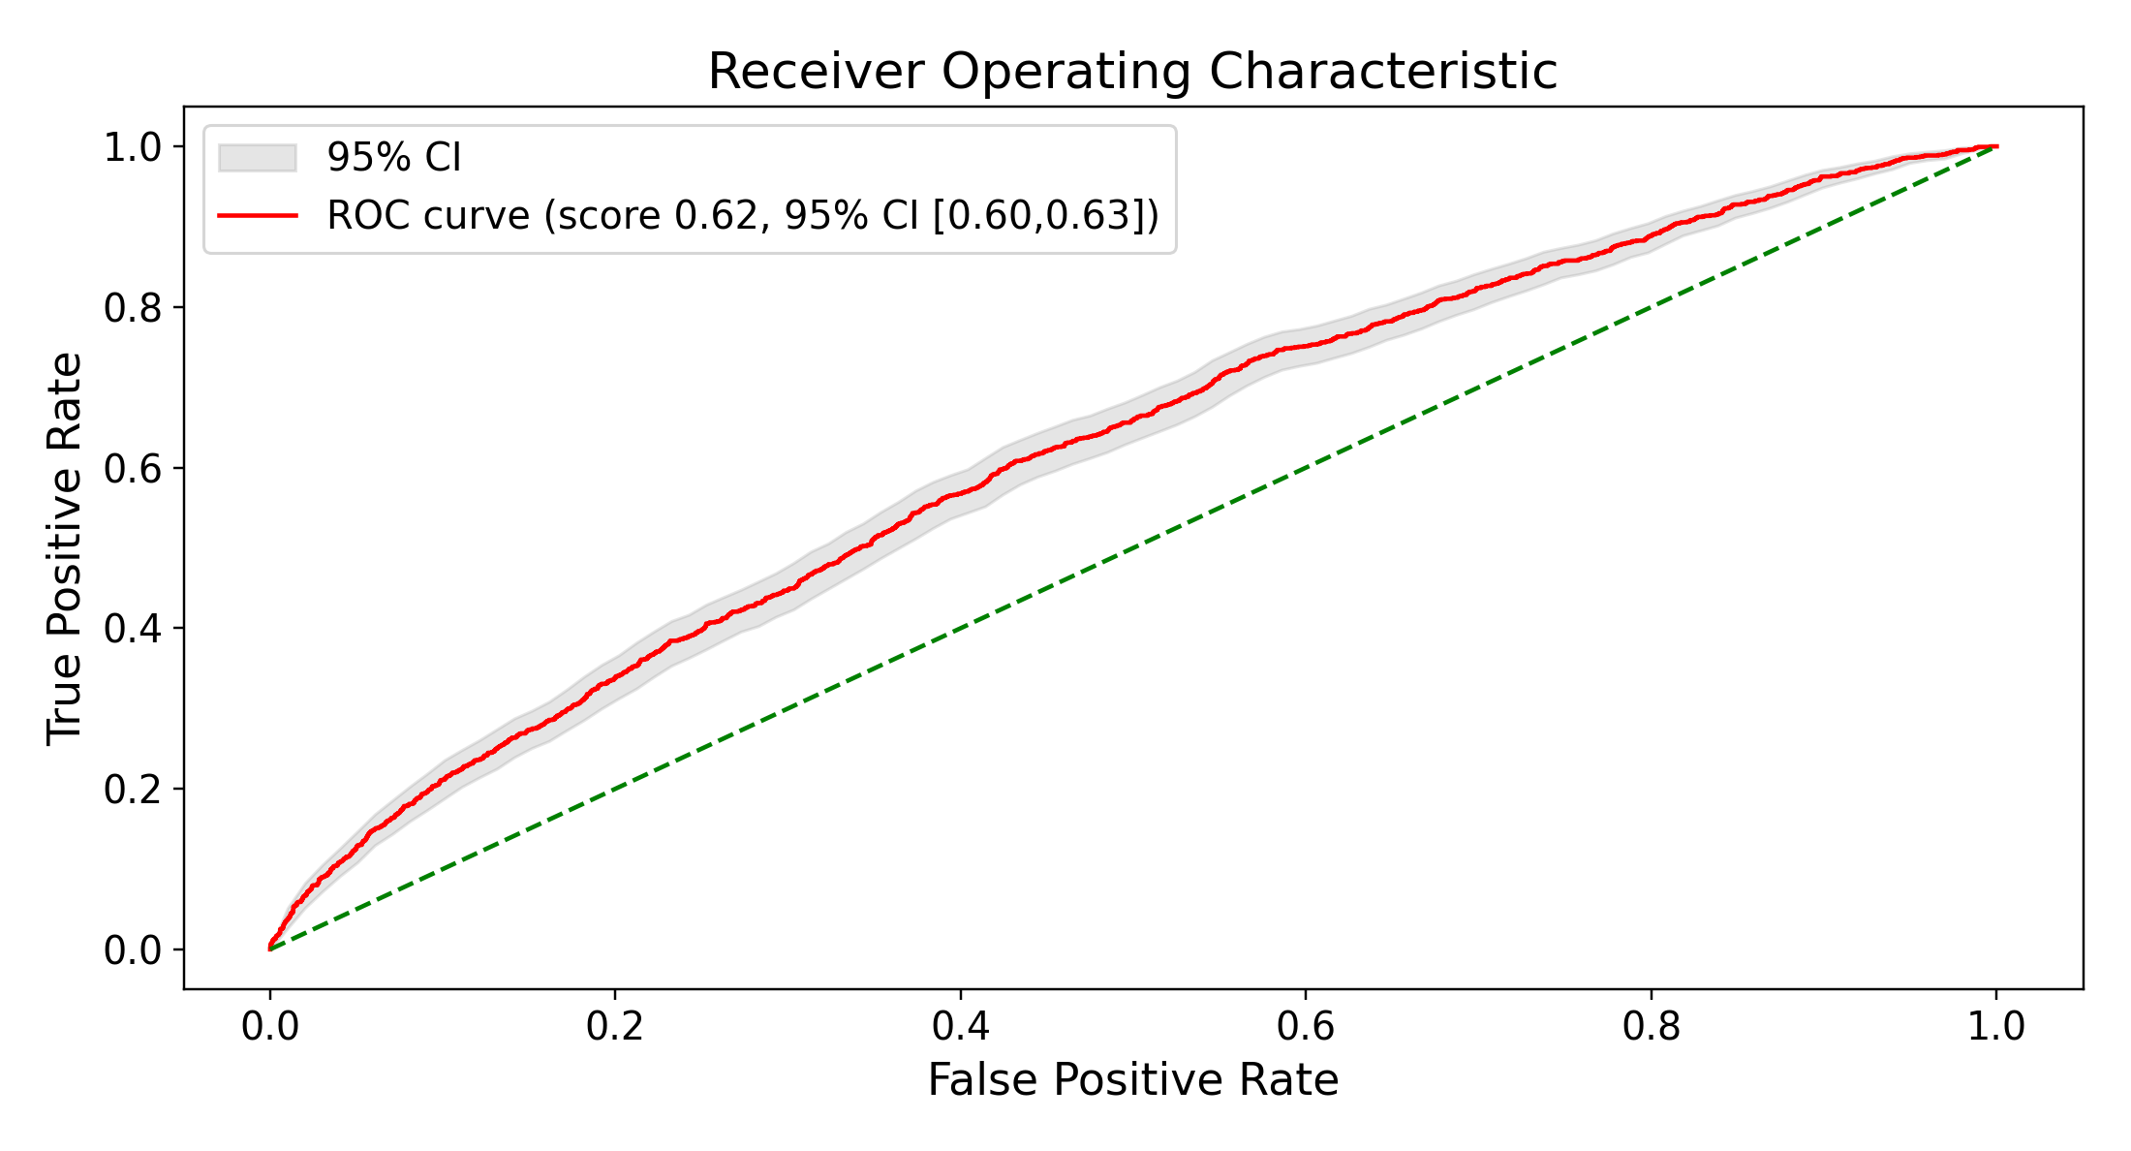
C Random retrieval, uniform weights, k = 32,720
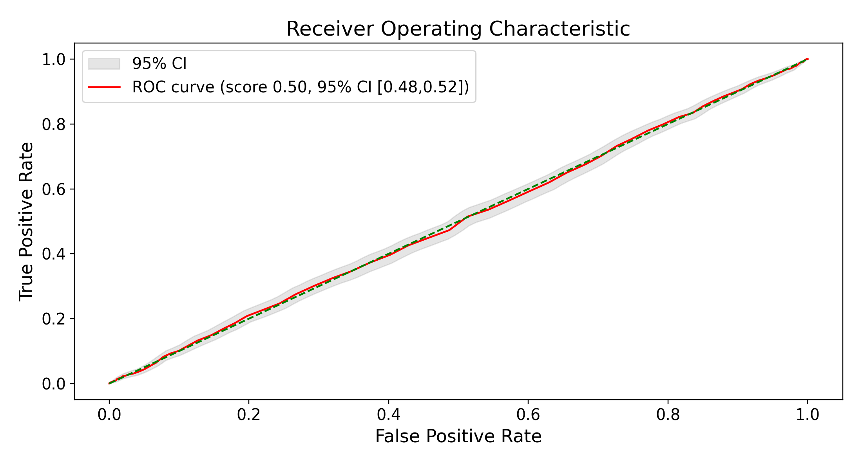
Figure S8. ROC curves for importance-weighted (A) and plain-cosine (B) nearest retrieval and uniform random retrieval (C), each at its own test-selected best k, with $α$ = 1 for A and B. C is the draw whose AUC at that k is closest to the mean of 1,000 draws. Shaded bands are bootstrap 95% CIs. ROC: receiver operating characteristic.
A Importance-weighted nearest retrieval, k = 295
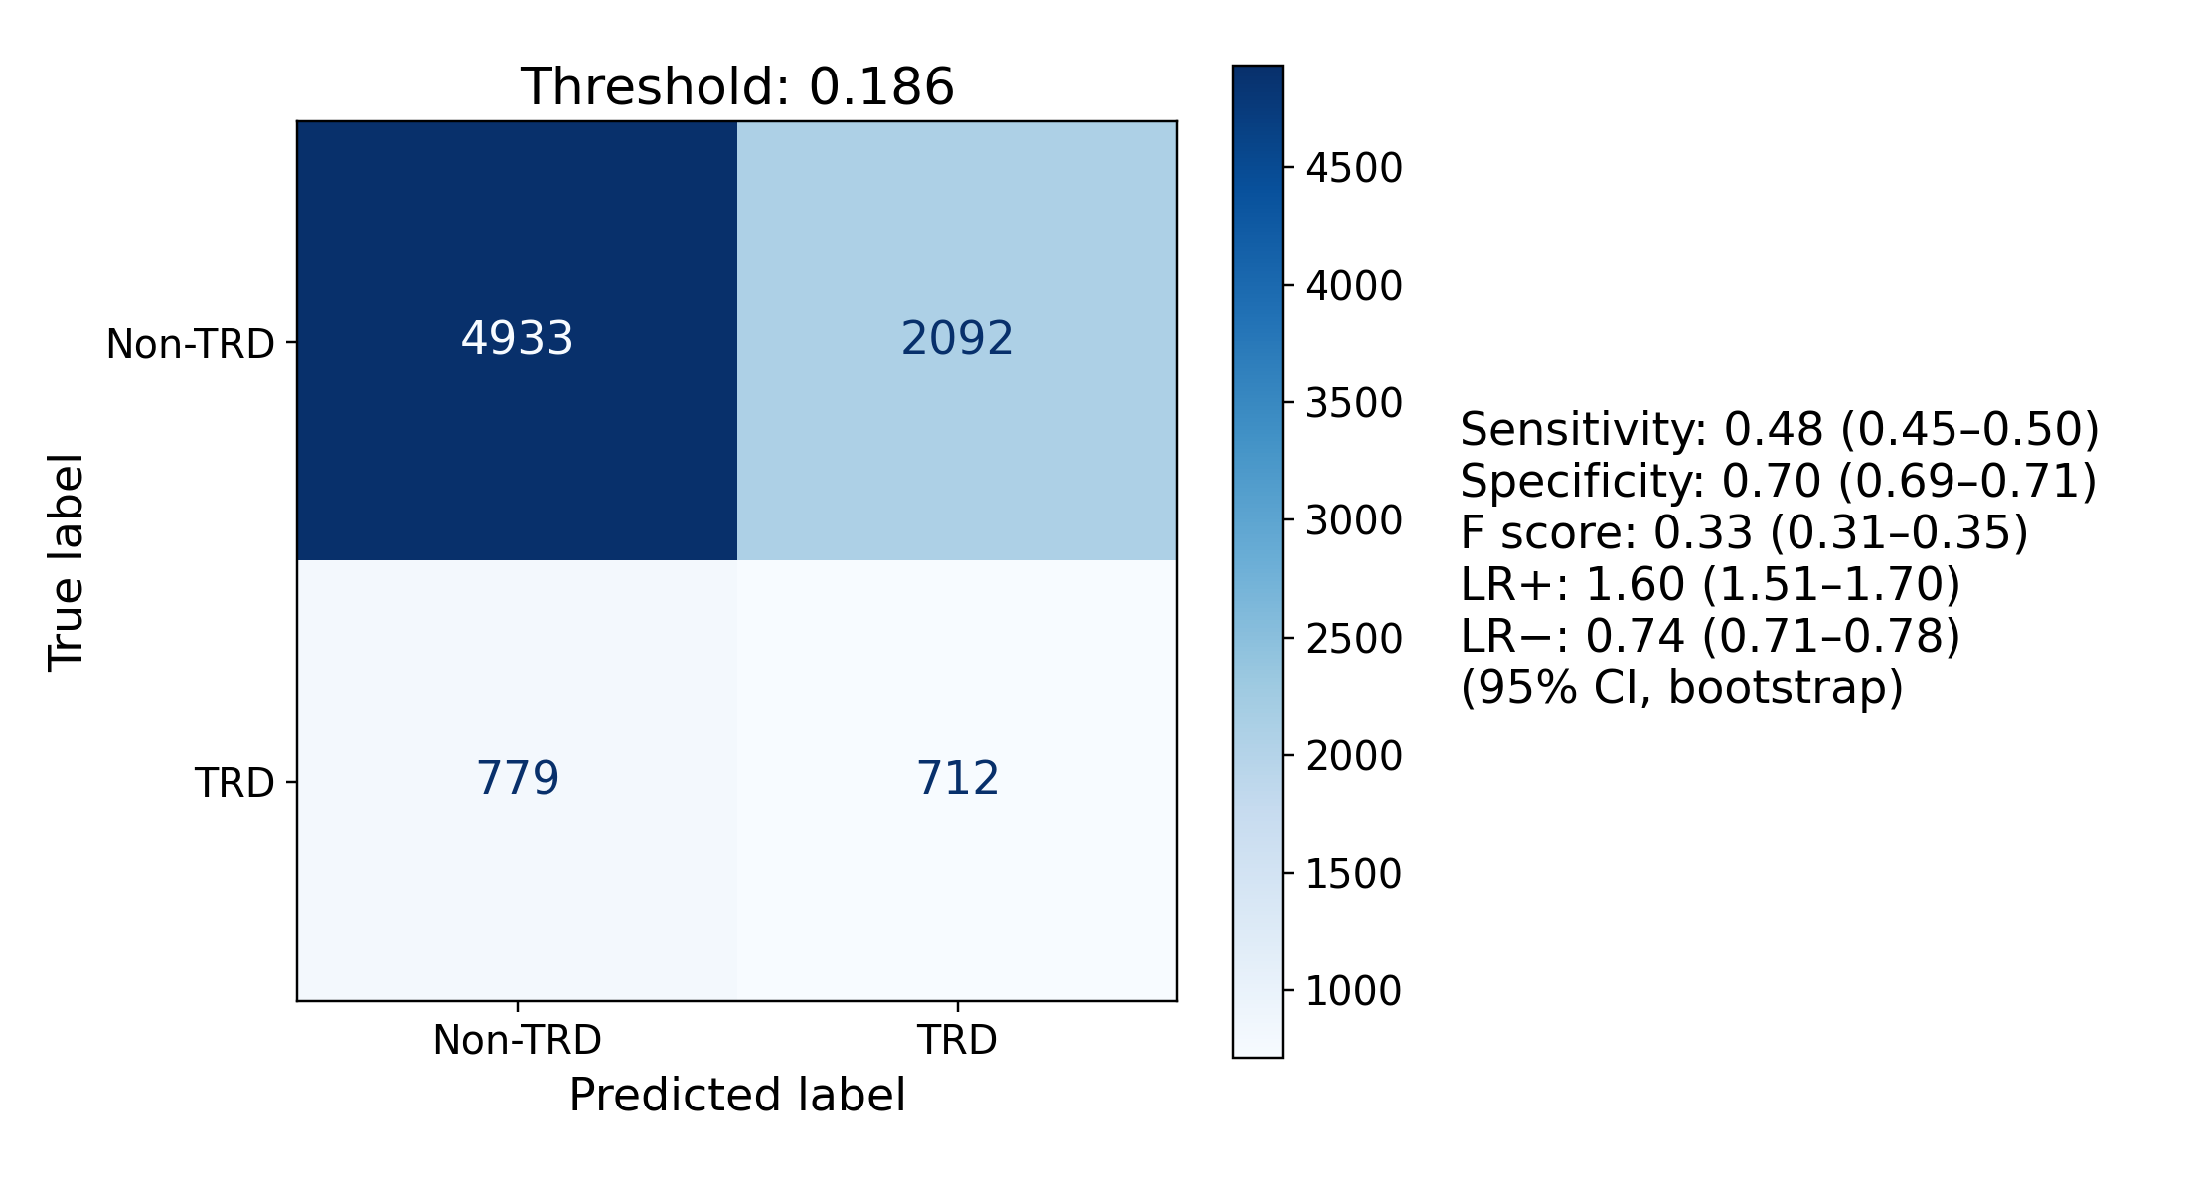
B Plain-cosine nearest retrieval, k = 757
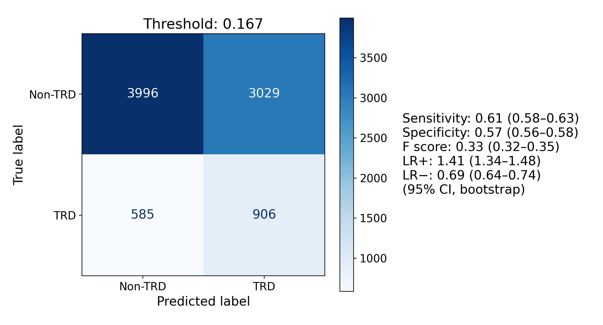
C Random retrieval, uniform weights, k = 32,720
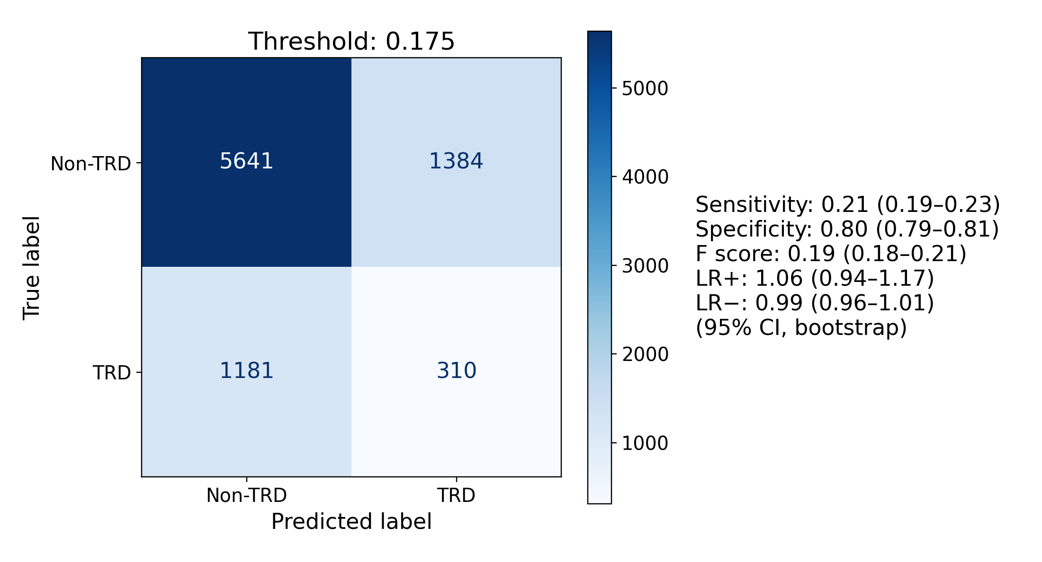
Figure S9. Confusion matrices for the three arms of Figure S8 at the same k, at test-selected Youden J thresholds, with bootstrap 95% CIs on every metric at that threshold. These operating points were selected and evaluated in the same patients and are descriptive.

