S7 Record Length and Prediction
We examined record volume descriptively by correlating the outcome with history length, encounter count, and the diagnosis-to-index interval, then assessed neighbor-prediction discrimination across history-length quintiles.
Using the full recorded history, outcome correlations were small: Spearman ρ=−0.073 for pre-index history length, −0.064 for encounter count, and −0.029 for diagnosis-to-index interval. Prescribing on the day of diagnosis or the next day occurred in 27,906 patients, with outcome frequency 18.4%, compared with 14,673 patients and 15.9% for later prescribing. These weak marginal relationships do not rule out care-process contributions to prediction.
A Pre-index history length
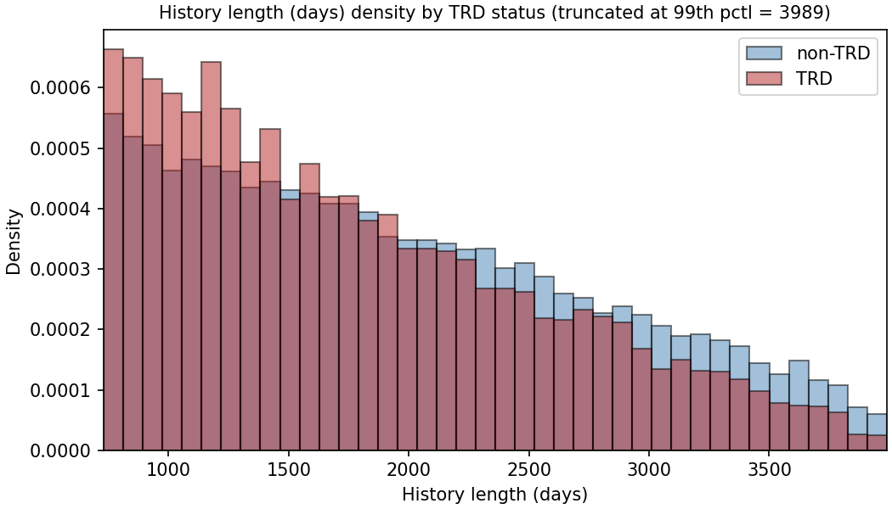
B Diagnosis-to-index interval
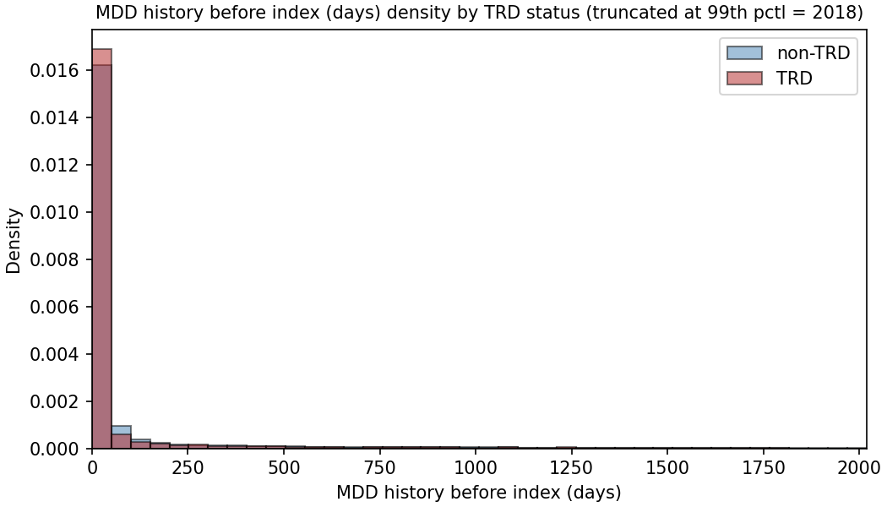
Figure S10. Continued on the next page.
C Encounter count
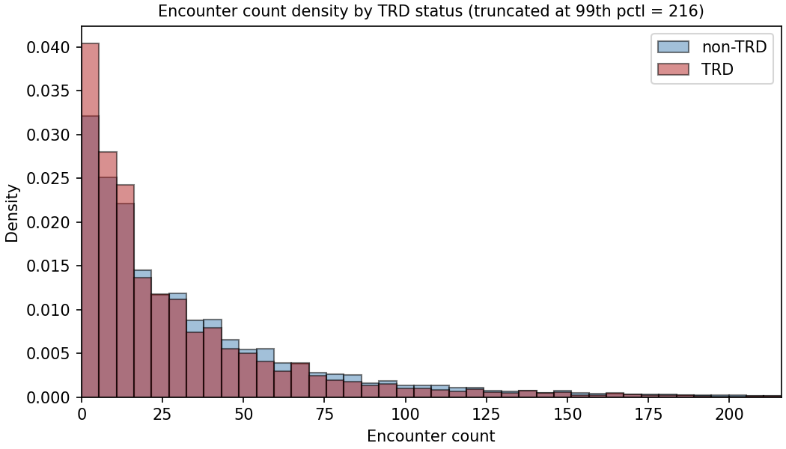
D Outcome frequency by prescription timing
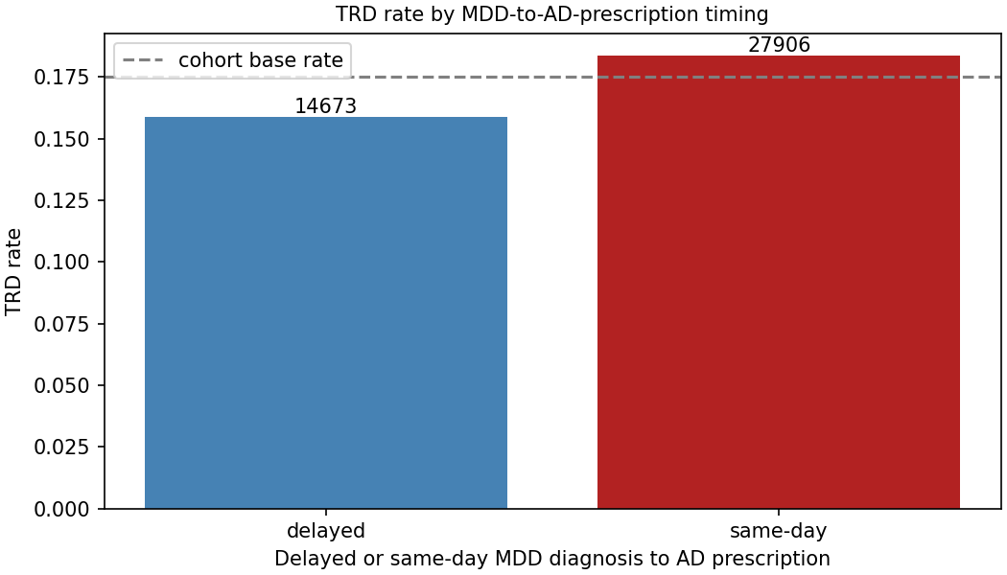
Figure S10. Record length, diagnosis-to-index interval, encounter count, and outcome frequency by prescription timing. A–C show outcome-stratified distributions; axes are truncated as labeled in the original plots. D compares prescribing within 1 day of diagnosis with later prescribing, with group counts above bars and the 17.5% cohort reference as a dashed line.
The held-out test set was divided into quintiles of pre-index history length, and each retrieval arm was scored within each quintile at its own best k from section S6. The best k was chosen on all test patients, so these values are optimistic in the same way.
Table S8. Neighbor-prediction ROC AUC by quintile of pre-index history length (embedded representation, held-out test set, $α$ = 1), with bootstrap 95% CIs within each quintile. Days are the quintile’s bounds of pre-index history. Weighted: importance-weighted cosine; plain: plain cosine. Random retrieval uses uniform weights and the draw whose AUC at its best k is closest to the mean of 1,000 draws.
Days | n | Events | Weighted, k = 295 | Plain, k = 757 | Random, k = 32,720
731–1,110 | 1,706 | 372 | 0.625 (0.592–0.657) | 0.619 (0.585–0.651) | 0.479 (0.447–0.513)
1,111–1,554 | 1,704 | 317 | 0.624 (0.590–0.658) | 0.619 (0.584–0.652) | 0.526 (0.489–0.561)
1,555–2,066 | 1,701 | 290 | 0.600 (0.564–0.636) | 0.608 (0.572–0.643) | 0.531 (0.492–0.564)
2,067–2,733 | 1,704 | 282 | 0.633 (0.598–0.669) | 0.626 (0.592–0.663) | 0.487 (0.449–0.523)
2,734–5,288 | 1,701 | 230 | 0.619 (0.580–0.655) | 0.598 (0.561–0.636) | 0.479 (0.437–0.519)
AUC ranged from 0.600 to 0.633 for importance-weighted and 0.598 to 0.626 for plain cosine retrieval, without a monotonic trend, and every quintile’s interval overlapped the others. Random retrieval stayed near 0.5, and its interval included 0.5 in every quintile. This does not establish independence from record volume; differing case mix and imprecision within strata limit interpretation.
The stratification covers neighbor prediction only, not the trained classifiers. Each quintile contained about 1,700 patients.

