S1 Embedding Dimensionality
Latent embedding coordinates do not have individual clinical interpretations. We therefore examined fitted sparsity, cumulative correlations, and performance after principal component reduction for Qwen3-Embedding-8B. These exploratory analyses describe the fitted representation rather than identify distinct clinical mechanisms.

S1.1 Sparsity and cumulative built-in importance
The selected logistic regression used elastic-net regularization (l1_ratio=0.25; C=0.01). It assigned nonzero coefficients to 385 of 4,096 dimensions; approximately 80% of total absolute coefficient magnitude fell in 179 dimensions and 90% in 236 (Figure S1). These are model-specific measures of coefficient concentration, not estimates of intrinsic dimensionality or independent predictive information.
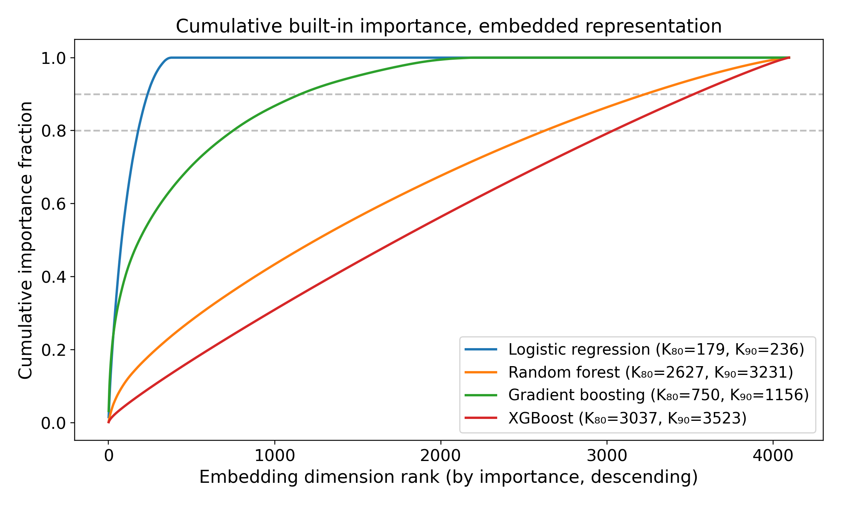
Figure S1. Cumulative built-in importance across embedding dimensions, ranked within each classifier. For logistic regression, importance is absolute coefficient magnitude; tree models use native feature importance. K80 and K90 identify the numbers of coordinates accounting for 80% and 90% of that model-specific total.

S1.2 Cumulative univariate correlation
We ranked coordinates by absolute Spearman correlation with the outcome and, separately, with each classifier’s predicted risk (Figure S2). The cumulative curves were broadly distributed. A sparse coefficient vector and diffuse marginal correlations can coexist because embedding coordinates are correlated; neither identifies unique clinical factors.
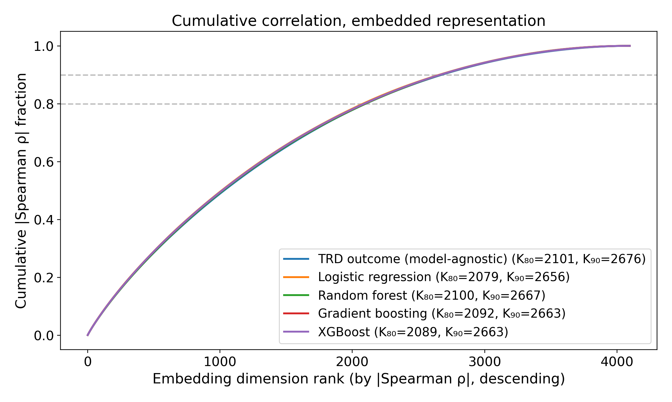
Figure S2. Cumulative absolute univariate (Spearman) correlation. One model-agnostic baseline curve ranks dimensions by |ρ(dim, outcome)|; the four per-classifier curves rank by |ρ(dim, predicted risk)|. Cumulative fraction of total |ρ| mass versus rank, with K₈₀ / K₉₀ knees in the legend.

S1.3 PCA-K discrimination sweep
Each classifier was retrained on the top K principal components, with K in {1, 2, 4, 8, 16, 32, 64, 128, 256, 512, 1024}. Held-out ROC AUC generally improved as components were added, with model-specific plateaus and some deterioration at larger K (Figure S3). These curves do not identify a unique effective dimension, and choosing K from them would require further independent evaluation.
A Logistic regression
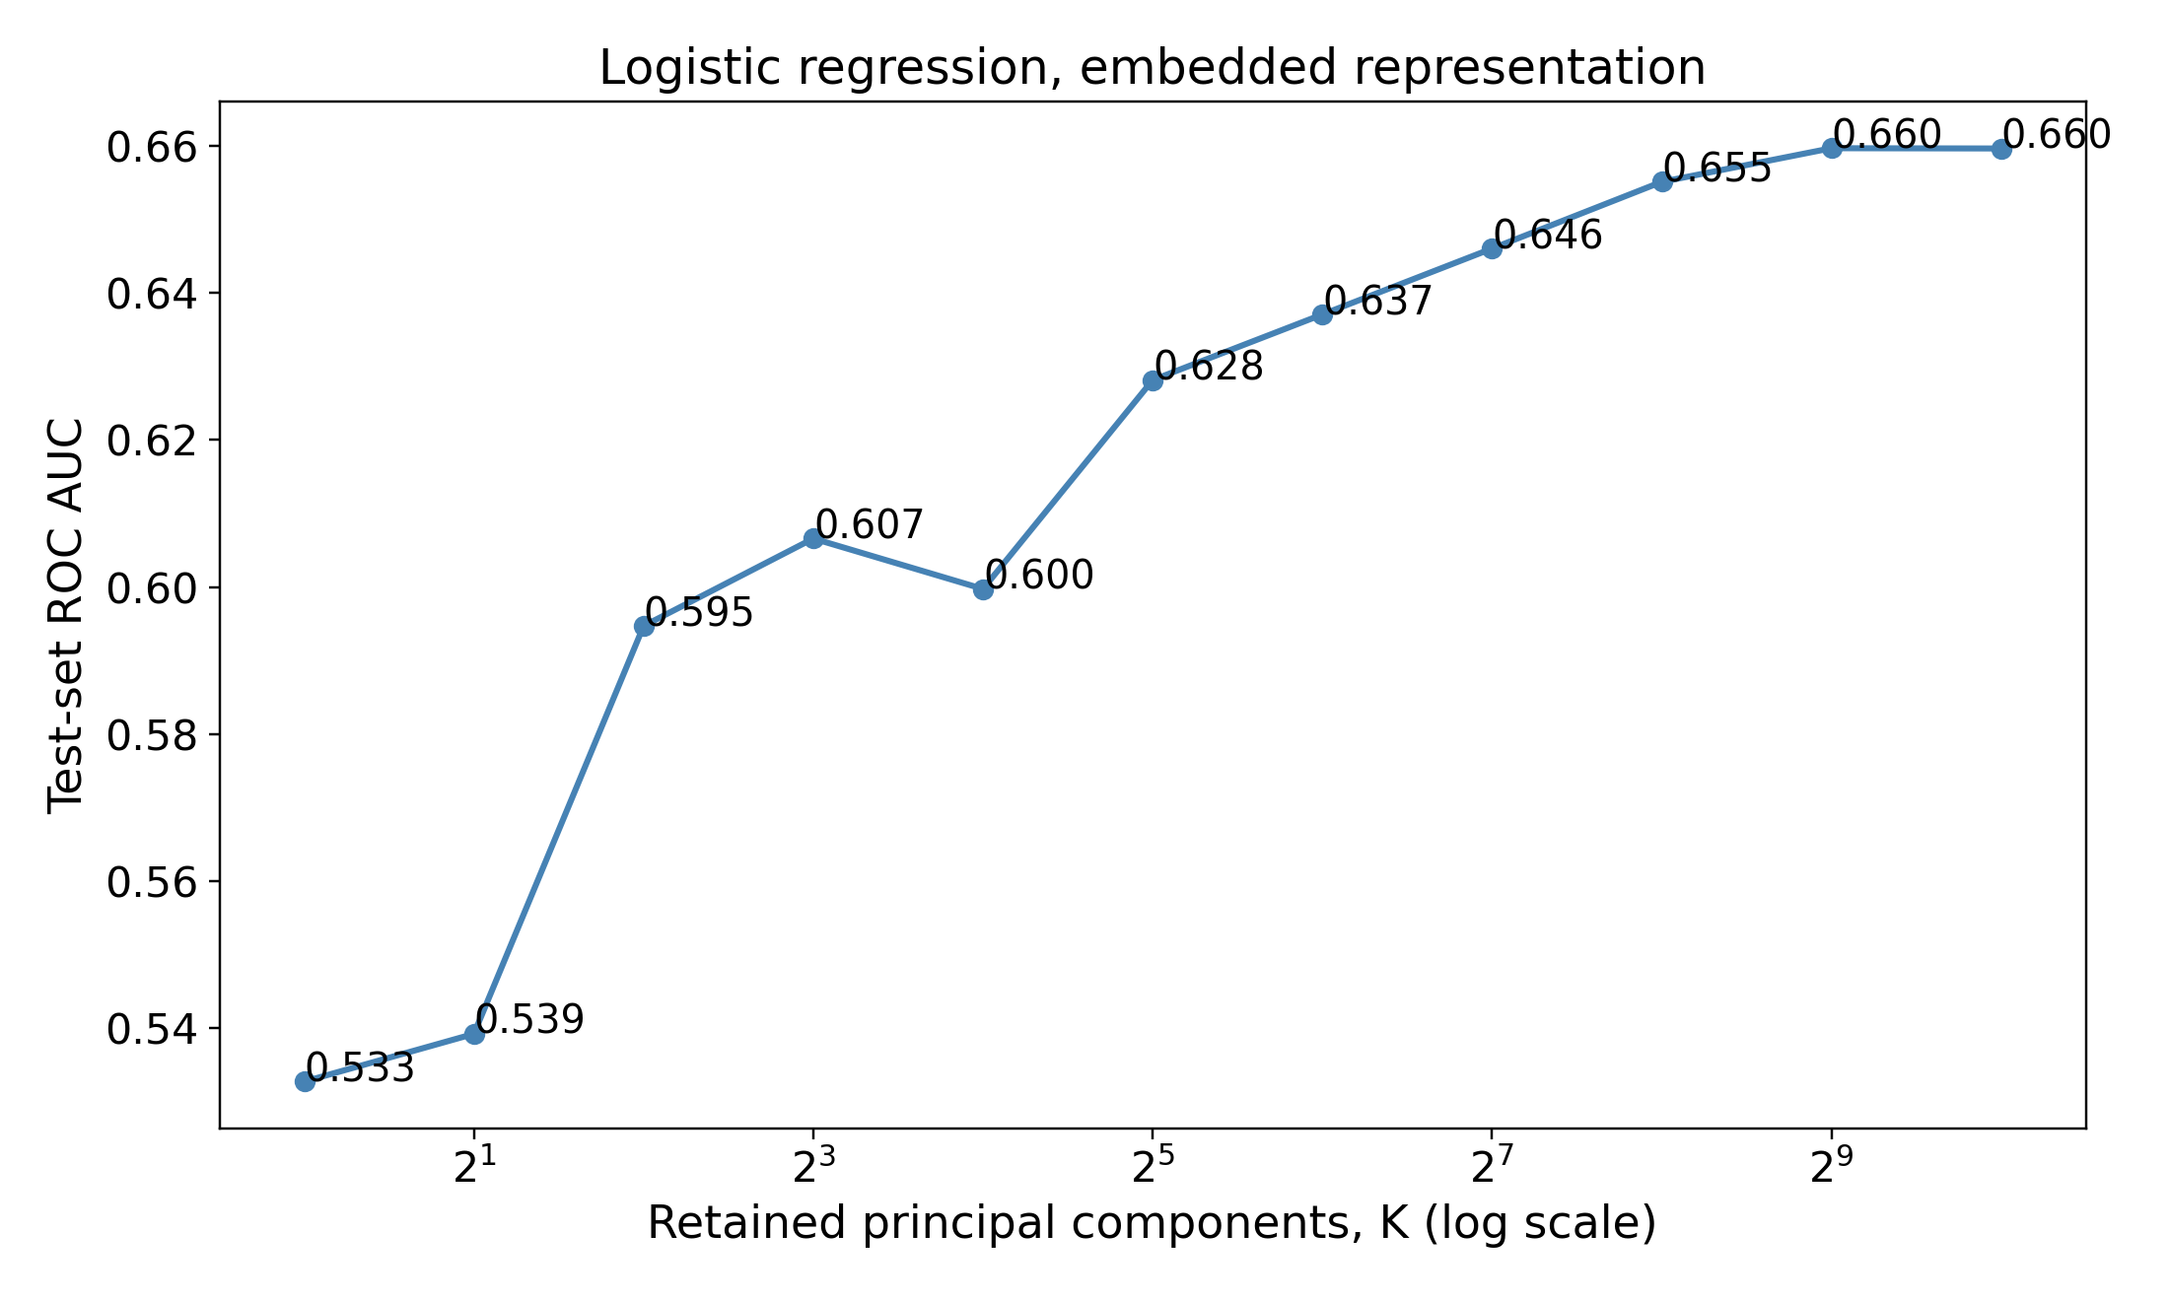
B Random forest
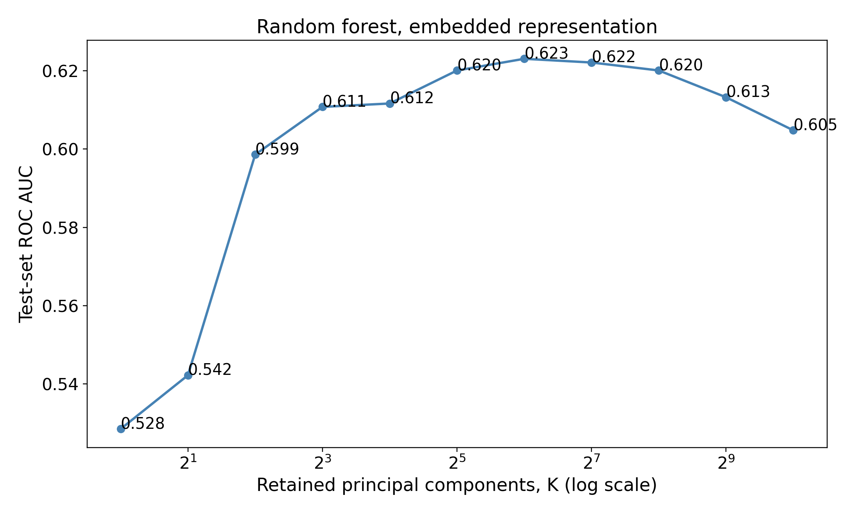
C Gradient boosting
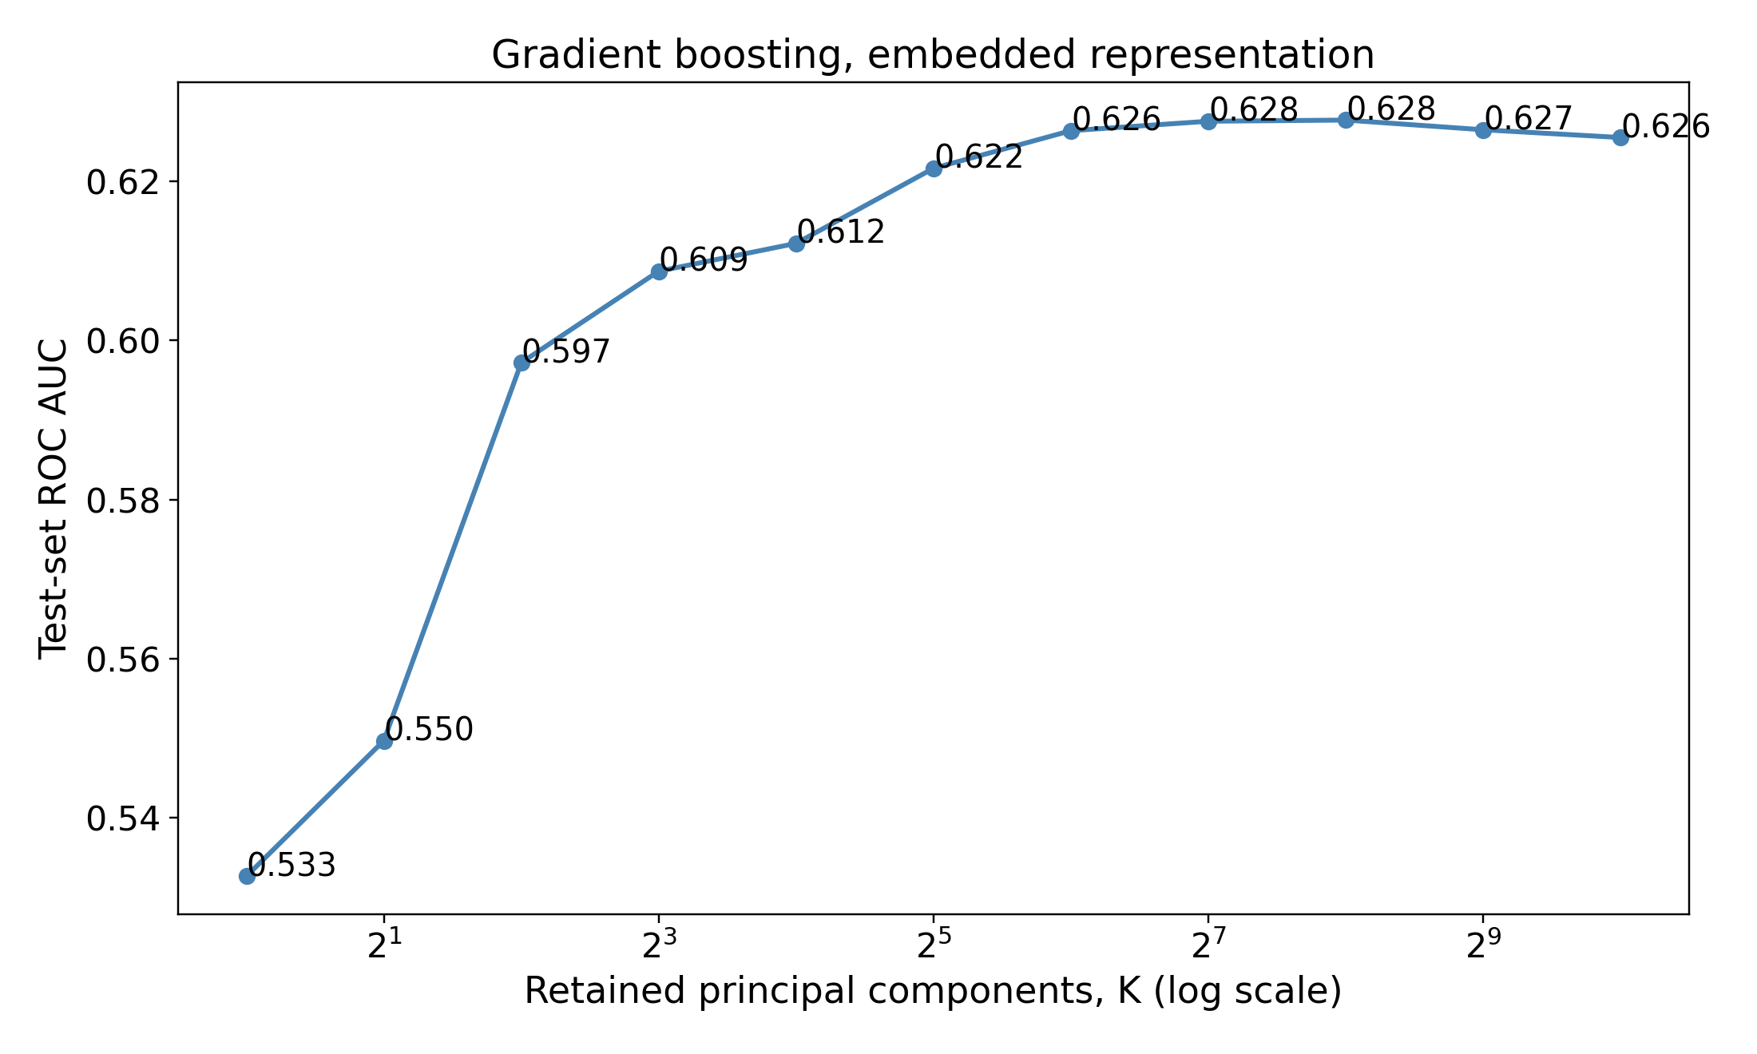
D XGBoost
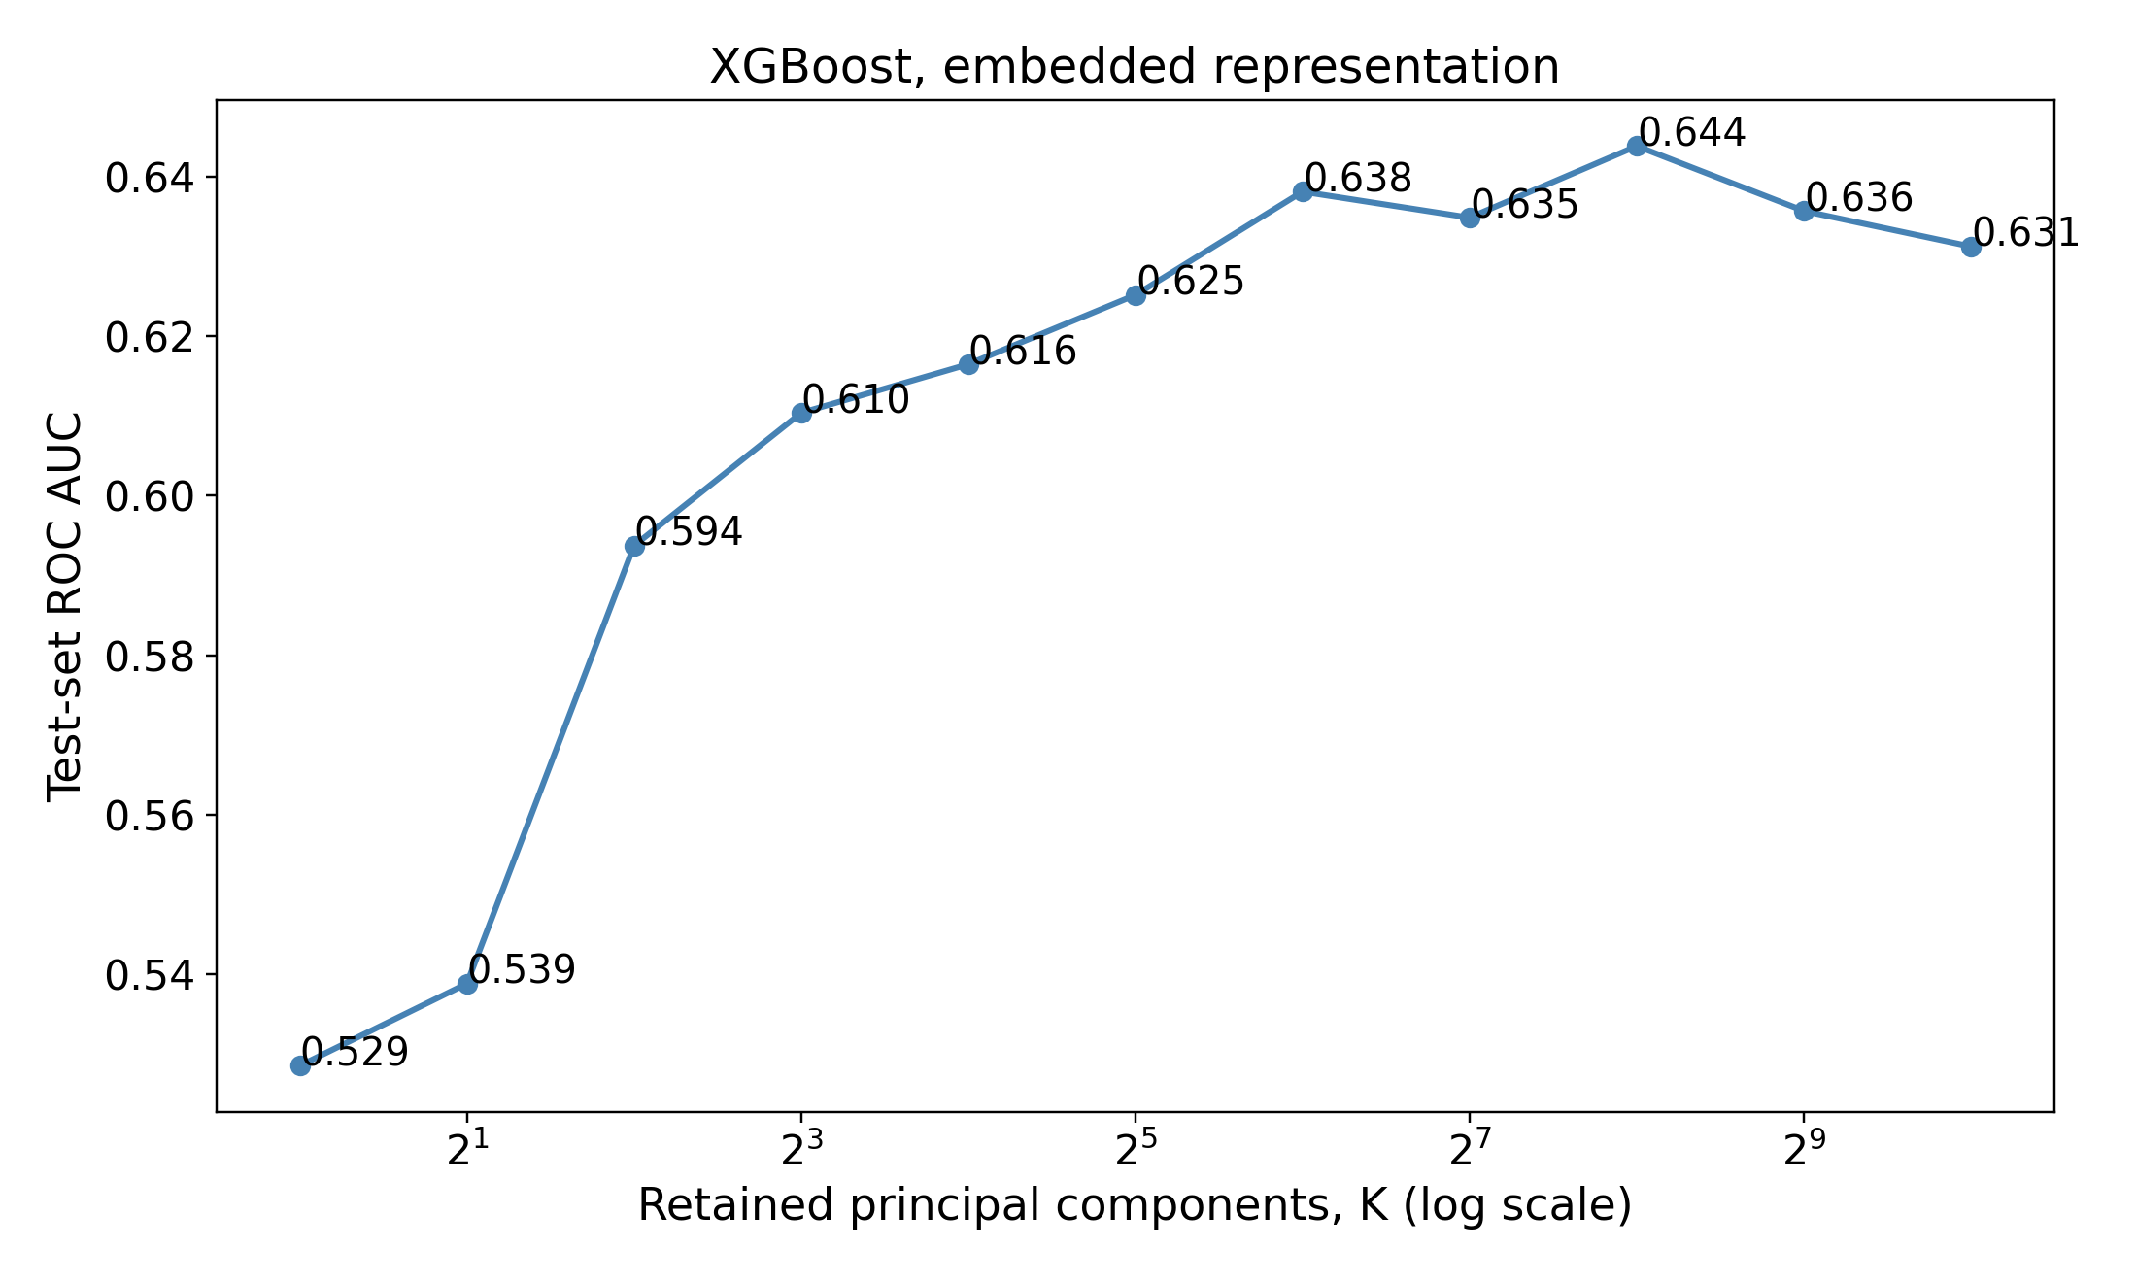
Figure S3. ROC AUC by retained principal components for logistic regression (A), random forest (B), gradient boosting (C), and XGBoost (D). The number of components is shown on a logarithmic scale. These are exploratory comparisons on the shared test set.

