Contents
M1–M13 Detailed methods and predictor inventory
S1 Embedding dimensionality
S2–S3 Precision–recall performance and calibration
S4–S5 Similarity geometry and example narratives
S6 Neighbor prediction
S7–S8 Record length and sample comparability
S9–S11 Subgroup performance, field crosswalk, and cohort characteristics
S12 Additional model diagnostics and encoder estimates
This appendix provides detailed methods, supporting analyses, and results for the comparison of structured feature vectors and narrative embeddings. Sections M1–M13 describe the methods and predictor inventory; sections S1–S12 report supporting analyses and extended results. TRD denotes the treatment-switching proxy defined in section M3, not symptom-confirmed treatment-resistant depression. FEATURE and EMBEDDED identify the structured and narrative pipelines, respectively.

M1 Source Data and Sampling
The study used a single de-identified extract from the Epic EHR of Saint Francis Health System. Seven files were delivered: person, encounter, diagnosis, medication, procedure, and laboratory/flowsheet tables together with a medication-to-RxNorm mapping table. The clinical tables originated from the Caboodle enterprise data warehouse; the RxNorm mapping originated from the Clarity reporting database. Body mass index and systolic and diastolic blood pressure were obtained from the laboratory/flowsheet table. Each table was delivered as a flat file after patient and encounter keys had been replaced by one-way MD5 hashes, and was transferred by secure file transfer protocol. No names, medical record numbers, direct identifiers, or dates of birth were included.
The delivering data team restricted the person table to one administrative division of the health system and to patients who were current, valid, non-test, non-historical, not recorded as deceased, and aged 18-110 years at extraction. Eligible source encounters were completed on or before the extraction date, had at least one associated diagnosis, and had an inpatient, outpatient, observation, or emergency patient class.
Investigators prespecified the diagnosis code lists. Depression comprised ICD-9 codes 296.2, 296.3, 300.4, and 311 or ICD-10 codes F32.*, F33.*, and F34.1. Bipolar disorder comprised ICD-9 codes 296.0 and 296.4-296.8 or ICD-10 codes F30.* and F31.*. Schizophrenia-spectrum disorders comprised ICD-9 codes 295.* and 298.* or ICD-10 codes F20.*, F23.*, F25.*, F28.*, and F29.*.
The extract was assembled as a case-enriched sample. All patients with a depression diagnosis on the problem list were retained, and a random sample of patients without that flag was added at an approximate 4:1 unflagged-to-flagged ratio; the remaining tables were then linked to the person table. The delivered extract included 501,718 patients: 100,420 (20.0%, 95% CI 19.9–20.1) with and 401,298 (80.0%, 95% CI 79.9–80.1) without a problem-list depression flag.
Sampling used problem-list flags, whereas eligibility used encounter diagnoses. Of 42,579 eligible patients, 12,530 (29.4%, 95% CI 29.0–29.9) lacked the problem-list flag and entered through the randomly sampled group. The analytic cohort therefore does not enumerate all patients with depression in the health system. Its outcome and subgroup frequencies are sample descriptions, not population prevalence estimates. Both representations were evaluated in the same sampled patients.
The setting is a single community health system in Tulsa, Oklahoma, serving inpatient, outpatient, observation, and emergency care. Patients enter the cohort through routine antidepressant prescribing across those settings rather than through psychiatric specialty referral, and the index prescription may be written in any of them.
Analyses used data version DV260629v1 and patient version PV260710v1. Source files were extracted June 29, 2026; analysis-ready tables were created July 10, 2026. No later refresh entered the study.

M2 Eligibility and Temporal Design
Eligibility was applied hierarchically from the full delivered extract. Patients were required to have: (1) a qualifying MDD diagnosis; (2) no bipolar-disorder diagnosis and no schizophrenia-spectrum diagnosis, to isolate unipolar depression; (3) an eligible antidepressant index prescription; (4) an MDD diagnosis recorded on or before the index date; (5) at least 730 days of pre-index history; and (6) at least 365 days of post-index follow-up. Patients failing the chronological or observation prerequisites were assigned explicit rejection reasons for attrition accounting.
Table M1. Participant flow through the hierarchical eligibility filters. Each row applies one additional filter to the survivors of the row above. The first row is the delivered extract, a case-enriched sample by design (Supplement M1).
Stage | Remaining | Rejected at stage
Delivered extract (4:1 case-enriched) | 501,718 | —
MDD-diagnosed | 144,110 | 357,608
Not bipolar AND not schizophrenia-spectrum | 124,188 | 19,922
Has antidepressant index prescription | 107,636 | 16,552
Has MDD before index | 103,458 | 4,178
≥2 years pre-index history | 54,215 | 49,243
≥1 year post-index follow-up (final cohort) | 42,579 | 11,636
Upstream data preparation assembled, for each patient, all antidepressant medication orders beginning on or after the date of the first documented depression diagnosis. The earliest start date in that set defined the index date, one per patient. In 25,645 of the 42,579 cohort patients (60.2%, 95% CI 59.8–60.7), the index prescription was written on the same day as the first recorded depression diagnosis.
The index was chosen without looking at anything after it, such as later dose, exposure duration, response, or switching. Post-index information was used to establish 365 days of follow-up and ascertain the outcome. Clinical content was restricted to the 730-day window ending on the index date. Total recorded pre-index history length (median 1,792 days) was retained separately as a duration variable, although clinical content outside the fixed window was not used.
Prior antidepressant exposure did not exclude patients: 24.0% (95% CI 23.6–24.4) had some recorded pre-index exposure and 14.7% (95% CI 14.4–15.1) had a course meeting the 42-day duration threshold. The index was the first recorded prescription on or after a documented depression diagnosis, not necessarily the first lifetime exposure or first adequate trial.

M3 Outcome Definition
The binary outcome was generated in the upstream R data-preparation pipeline independently of the predictors and supplied to the modeling workflow as a fixed label. TRD was assigned when a patient with MDD received at least three distinct antidepressant treatments within 365 days of the index date, the index agent counting as the first. Patients with fewer than three treatments were classified TRD-negative.
A treatment is a distinct antidepressant agent rather than an order or prescribing event. Addition of a second agent while the current antidepressant continues is augmentation and does not advance the outcome count; restarting a previously used agent also does not advance it. Augmentation is available as a pre-index predictor where its definition is met.
The follow-up requirement provided a 365-day observation window for outcome ascertainment. It did not ensure complete capture of care, including treatment outside the health system; a negative label therefore indicates that the qualifying sequence was not observed.
The label does not establish inadequate response to at least 2 trials of adequate dose and duration [1,2]. Standardized symptom response was unavailable, and adequacy was not verified for counted post-index treatments. Switching could reflect nonresponse, intolerance, cost, formulary restrictions, preference, or clinical practice. It also depends on continuity and access, which differ across demographic groups [3,4]. Chart adjudication and symptom trajectories are needed to validate the label, together with sensitivity analyses requiring documented adequate courses.

M4 Predictors and Structured Representation
Predictor domains were selected clinically and from prior literature before model fitting or inspection of outcome associations [5]. No univariate screening or automated selection determined the source-field inventory; subsequent model regularization operated on the encoded predictors.
Domains included depression severity and recurrence, psychiatric and substance-use comorbidity, medical comorbidity, prior treatment, medication burden, utilization, and sociodemographic characteristics [5-8]. Severity was represented by diagnosis codes because standardized symptom scales were not available.
Prescribing-constraint flags described potential limits on treatment options. Sociodemographic and social-determinant fields were retained to evaluate their direct contribution by permutation. Body mass index and blood pressure were subsequently removed from FEATURE because of missingness (section M6).
FEATURE assigns explicit types to counts and durations, binary indicators, and nominal categories. Prior antidepressant trial counts required at least 42 continuous days of exposure; adequate dose was not established by this rule. Tables M2–M4 provide the 59 retained source fields and their expansion to 92 model columns.
After removal of 3 vital-sign fields, the inventory comprised 15 quantitative, 36 binary, and 8 categorical source fields. Categorical expansion produced 41 columns, for a total of 92. Display labels are those used in the original analyses.
Table M2. Quantitative predictors.
Predictor
MDD history before index (days)
History length (days)
Encounter count
ED visits (count)
Inpatient days before index
Age (years)
Medications active at index
Anti-inflammatories active at index
Sleep meds active at index
Anxiolytic days before index
Bupropion trials (6+ wk)
Mirtazapine trials (6+ wk)
SNRI trials (6+ wk)
SSRI trials (6+ wk)
Vortioxetine trials (6+ wk)
Table M3. Binary predictors by domain.
Block | Predictors
Clinical flags (3) | MDD in history; Suicidality; Augmentation therapy
Psychiatric comorbidities (8) | Adjustment disorder; Anxiety disorder; Dysthymia (chronic depression); Insomnia; OCD; PTSD; Social anxiety disorder; Substance use disorder (any)
Medical comorbidities (4) | Chronic pain; Diabetes; High cholesterol; Thyroid disorder
Prescribing-constraint / safety (2) | Seizure disorder; Uncontrolled hypertension
Substance use disorders (10) | Alcohol; Cannabis; Cocaine; Hallucinogen; Inhalant; Nicotine; Opioid; Other stimulant; Other substance; Sedative/hypnotic
Social determinants of health (9) | Education or literacy issue; Employment issue; Housing or financial issue; Legal or criminal issue; Occupational hazard exposure; Family/support group issue; Psychosocial circumstances; Social environment issue; Upbringing issue
Table M4. Categorical fields and encoded levels.
Field | One-hot columns | Levels
Sex | 1 | Male (Female = reference, dropped)
Preferred language | 6 | Asian/Pacific Islander; English; Other; Other Indo-European; Spanish; Missing
Marital status | 6 | Divorced; Never married; Married; Separated; Widowed; Missing
Religion | 6 | Catholic; Non-Christian; Orthodox; Other/Unknown; Protestant; Missing
Smoking status | 4 | Current; Former; Never; Missing
Race/ethnicity | 8 | American Indian/Alaska Native; Asian; Black/African American; Hispanic/Latino; Multi-race; Native Hawaiian/Pacific Islander; White/Caucasian; Missing
MDD recurrence | 4 | Unspecified; Single episode; Recurrent; Dysthymia (chronic depression)
MDD severity | 6 | Unspecified; Mild; Moderate; Severe; Psychotic; Remission

M5 Deterministic Narratives and Embeddings
Fixed rules rendered the pre-index structured record as a Markdown narrative. No generative model wrote the summaries, preserving traceability and avoiding unsupported generated content [9]. Example inputs appear in section S5.
Each narrative was mapped to a fixed-length vector with a pretrained sentence-transformer encoder [10]. The four independently evaluated encoders were bge-small-en-v1.5 [11], bge-en-icl [12], Qwen3-Embedding-4B, and Qwen3-Embedding-8B [13]. This serialization-and-encoding strategy follows evidence that general-purpose language-model embeddings of serialized EHR records can perform competitively with purpose-built EHR foundation models across prediction tasks [14].
The pipelines share a source record and temporal cutoff but differ in field content. Section S10 documents these differences. Accordingly, the primary comparison evaluates complete pipelines rather than the isolated effect of numeric versus language encoding.

M6 Missing Data
No statistical imputation was performed. Mean body mass index and mean systolic and diastolic blood pressure were present in the intermediate feature file but removed from the FEATURE matrix at load time. Each value is the within-patient mean across that patient’s own pre-index encounters, not a mean across patients. Mean body mass index was missing for 22.1% (95% CI 21.7–22.5) of patients, and at least one vital sign was absent for 21.0%. Body mass index was missing for 28.8% of TRD-positive and 20.6% of TRD-negative patients, an approximately 8-percentage-point difference.
Outcome-associated missingness argues against missing completely at random but does not establish missing not at random. The primary FEATURE analysis excluded the vital signs without imputation or continuous missingness indicators. A sensitivity analysis retaining them with missingness indicators and within-fold median imputation was reported to leave the best-model comparison nonsignificant. Quantitative results are not included here and are available from the corresponding author.
FEATURE encoded missing categorical values as separate levels. Narratives generally used “Missing,” with field-specific exceptions documented in section S10. Marital and smoking status were less than 0.5% missing. Religion was missing in 29.4% overall, ranging from 43.8% at ages 18–29 to 17.5% at age 65 or older. A sensitivity analysis removing religion from both pipelines was reported to yield paired discrimination CIs including zero; quantitative results are available from the corresponding author.

M7 Sample Size and Model Dimensionality
Cohort size was determined by eligibility rather than a formal sample-size calculation. Events per variable (EPV) was calculated as 5,964 outcome-positive training patients divided by the number of encoded input columns.
FEATURE contains 92 encoded columns, giving EPV = 5,964/92 ≈ 64.8. EMBEDDED dimensionality is encoder-specific: bge-small-en-v1.5 has 384 dimensions (EPV ≈ 15.5), Qwen3-Embedding-4B has 2,560 (EPV ≈ 2.3), and bge-en-icl and Qwen3-Embedding-8B each have 4,096 (EPV ≈ 1.5). Only the smallest encoder exceeds the conventional threshold of 10.
EPV is a descriptive ratio, not a sufficient sample-size criterion for high-dimensional regularized models. The larger encoders nevertheless have many inputs relative to outcome events, reinforcing the need for independent validation. Sparsity in a fitted model does not establish stability of the selected dimensions.

M8 Training and Test Split
All models used the same stratified split: 34,063 training patients (5,964 positive) and 8,516 test patients (1,491 positive). Across 100 predictor rows, the largest absolute standardized mean difference was 0.036. The largest imbalance concerned a rare social-determinant flag present in 22 training patients and no test patient. Outcome frequencies matched by design. Selected distributions are in section S8.
Scaling parameters and category levels were estimated within each cross-validation training fold. The selected pipeline was then refitted on all training patients and applied to the test set; exploratory analyses subsequently reused these held-out predictions.
The retrieval index contained training patients only. Test patients served as query anchors, with no self-retrieval or test-patient labels used to predict another test patient. Internal balance does not establish transportability because both partitions share the same sampling frame.

M9 Model Development
Four classifiers were fitted to each representation: logistic regression, random forest, gradient boosting, and XGBoost. For FEATURE, the column transformer standardized the numeric block, one-hot encoded categorical variables with binary categories collapsed and unknown inference-time levels ignored, and cast boolean indicators to integer without further transformation. EMBEDDED entered through the numeric branch only.
Each classifier and its preprocessing steps formed a single scikit-learn pipeline. Five-fold grid search optimized training-set ROC AUC, after which the selected pipeline was refitted on all training patients. Scaling and category encoding were fitted within each fold. Classifier-specific tuning grids were identical across representations.

M10 Neighbor Prediction
For EMBEDDED only, the predicted TRD probability for query patient q was the similarity-weighted mean of binary TRD labels among its k retrieved training neighbors:
$$\hat{P}(TRD∣q)=\frac{\sum_{i=1}^{k}{w_{i}} y_{i}}{\sum_{i=1}^{k}{w_{i}}}, w_{i}=max\{s_{i},0\}^{α},$$
where $y_{i}∈\{0,1\}$ is neighbor $i$’s TRD label, $s_{i}$ its similarity to q, and $α$ a sharpening exponent. Neighborhood concentration was summarized by the effective sample size,
$$ESS=\frac{{\left(\sum_{i=1}^{k}{w_{i}}\right)}^{2}}{\sum_{i=1}^{k}{w_{i}^{2}}},$$
which equals $k$ when all weights are equal and falls as weight concentrates on fewer neighbors.
Two similarity metrics were compared. Plain cosine similarity used the raw embeddings. Logistic-regression-weighted cosine similarity standardized each dimension with the embedded logistic regression’s own scaler, $z_{d}=(x_{d}−μ_{d})/σ_{d}$, and weighted dimension $d$ by its share of that model’s absolute coefficients:
simw(x,y)=d​wd zd(x) zd(y)d​wd zd(x)2 d​wd zd(y)2, wd=|βd|e​|βe|.
The coefficients came from the model fitted on training patients, so no test outcome entered a risk score. The metric is supervised, whereas plain cosine similarity is not. Of 4,096 dimensions, 385 had non-zero coefficients, and the top 41 (1%) carried 31% of the absolute coefficient mass. To compare encoders whose logistic regressions were fitted under different penalties, the dimensions each model used were counted as the fewest holding 90% of its absolute coefficient mass, because a non-zero count is the full width under an L2 penalty. These counts describe the fitted models and carry no sampling interval.
Neighbors were chosen in 2 ways, nearest and random. Nearest retrieval selected the k most similar training patients. Random retrieval drew k training patients at random for each test patient and averaged their outcomes with equal weights. A sweep evaluated every k from 1 to all 34,063 training patients for both, nearest retrieval under both metrics and $α$ = 1, 2, and 5. Random retrieval was nested so that k + 1 neighbors extend the k already drawn, and repeated in 1,000 draws seeded from the study seed; its band at each k is the 2.5th to 97.5th percentile of the AUC across draws. Each retrieval arm, the 2 nearest-neighbor metrics and random retrieval, therefore yields a curve over k, and no single k is the result. Where one value is needed, including ROC curves and confusion matrices, it is read at the arm’s best k: the k with the highest test AUC, the smallest on a tie, and for random retrieval the highest mean across draws. For the primary encoder, the best k was 295 for logistic-regression-weighted and 757 for plain cosine similarity under $α$ = 1, and 32,720 for random retrieval. Every best k was selected on the test patients, so the values at it are optimistic. These analyses were restricted to embeddings; no mixed-data similarity metric was specified for FEATURE.

M11 Concept Permutation
Each concept was reassigned through a one-to-one donor permutation across patients. Section permutations exchanged complete sections; field permutations changed only the specified field. Narratives were then re-embedded and scored by frozen classifiers. The analysis estimates reliance on the perturbed input, conditional on the remaining fields. It does not show whether retraining could recover performance from correlated information.
Psychiatric history (section). Present/absent indicators for anxiety disorder, social anxiety disorder, obsessive-compulsive disorder, posttraumatic stress disorder, adjustment disorder, dysthymia, insomnia, and any substance-use disorder; any suicidal-ideation or suicide-attempt code in the two-year lookback; and named substance categories including alcohol, cannabis, cocaine, nicotine, opioid, and sedative/hypnotic disorders. It carries documented diagnoses rather than treatments.
Medication burden (section). The count and names of distinct active drug ingredients at the index date across all therapeutic classes, and the count and names of distinct non-steroidal anti-inflammatory ingredients prescribed for at least seven days. It stands in for overall medical complexity and pill burden, not psychiatric treatment specifically.
Treatment exposure (section). Pre-index counts of adequate trials for selective serotonin reuptake inhibitors, serotonin-norepinephrine reuptake inhibitors, bupropion, mirtazapine, and vortioxetine, each requiring at least 42 continuous days on the agent; total benzodiazepine days covered during the lookback; hypnotic agents prescribed for at least seven days; and augmentation, defined as overlap of an antidepressant with lithium, an antipsychotic, or buspirone for at least 14 days. It is distinct from all-class medication burden and from the post-index agents used to construct the outcome.
Treatment contraindications (section). Seizure disorder, which weighs against bupropion, and uncontrolled hypertension, which weighs against serotonin-norepinephrine reuptake inhibitors. The concept is constraint on escalation options rather than general medical comorbidity, which the narrative reports in a separate section that was not permuted.
Race/ethnicity (field). The recorded race/ethnicity category, including an explicit unrecorded level, permuted within an otherwise unchanged sociodemographic section. Sex, age, preferred language, marital status, religion, and smoking status were not altered in this ablation.
Social determinants of health (field). ICD-10 Z-code categories recorded during the lookback: education/literacy, employment, occupational exposure, housing/economic circumstances, social environment, upbringing, primary support group/family circumstances, psychosocial circumstances, and legal/criminal circumstances. The narrative renders “None Recorded” when no qualifying code is present. Only this field was permuted.
Permutation does not establish equitable labeling or performance. Correlated diagnosis, medication, and utilization fields may retain demographic information, and sparse recording may limit the contribution of an explicitly permuted field.

M12 Evaluation Coverage
Standard classifiers, encoder comparisons, and concept permutations used the full cohort and common test split. All 4 encoders received both similarity metrics, random retrieval, and the neighborhood-size sweep under the same rules, each weighted by its own embedded logistic regression (manuscript, Nearest-Neighbor Retrieval Across Encoders; manuscript Figure 4; section S6). ROC curves and confusion matrices at best k are reported for all 4 encoders (section S6). Paired contrasts, the precision–recall and calibration panels at best k (sections S2–S3), and the subgroup analyses describe the primary encoder only.

M13 Performance Metrics and Uncertainty
Discrimination was summarized by ROC AUC and AUPRC. The overall calibration summaries fit a line to binned observed and predicted probabilities. These binned slopes and intercepts are in section S3 and are not conventional individual-level logistic calibration parameters. Section S9 separately reports logistic calibration slopes and mean predicted minus observed risk. All estimates describe the enriched sample.
Sensitivity, specificity, F1 score, and likelihood ratios were calculated at the test-set threshold maximizing Youden J. Their 95% CIs come from the same bootstrap resampling of test patients, with the threshold held fixed. Selecting and evaluating a threshold in the same patients introduces optimism. These operating points are descriptive; a clinical threshold would require selection in development data and evaluation in an independent cohort.
Bootstrap resampling drew test patients with replacement. Paired contrasts applied identical resampled patient indices to both prediction vectors and recalculated their ROC AUC difference. The 2.5th and 97.5th percentiles formed the 95% CI.
Classifier-matched comparisons varied the representation while holding the learner fixed. The best-model comparison selected the leading classifier for each representation from test performance and is therefore post hoc. A common resampling matrix was used across contrasts.
No equivalence or noninferiority margin was prespecified. A paired confidence interval containing zero indicates that superiority was not established at the precision achieved; it does not establish equivalence.

S1 Embedding Dimensionality
Latent embedding coordinates do not have individual clinical interpretations. We therefore examined fitted sparsity, cumulative correlations, and performance after principal component reduction for Qwen3-Embedding-8B. These exploratory analyses describe the fitted representation rather than identify distinct clinical mechanisms.

S1.1 Sparsity and cumulative built-in importance
The selected logistic regression used elastic-net regularization (l1_ratio=0.25; C=0.01). It assigned nonzero coefficients to 385 of 4,096 dimensions; approximately 80% of total absolute coefficient magnitude fell in 179 dimensions and 90% in 236 (Figure S1). These are model-specific measures of coefficient concentration, not estimates of intrinsic dimensionality or independent predictive information.
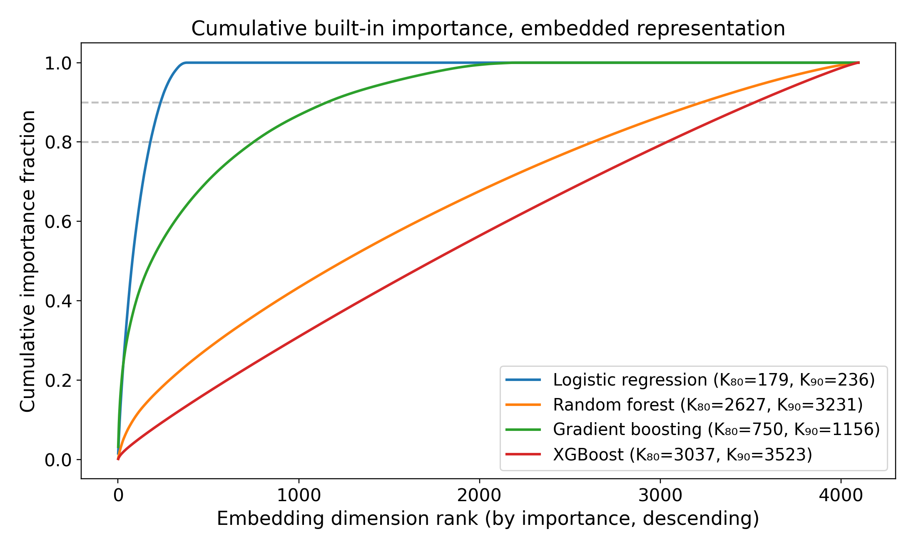
Figure S1. Cumulative built-in importance across embedding dimensions, ranked within each classifier. For logistic regression, importance is absolute coefficient magnitude; tree models use native feature importance. K80 and K90 identify the numbers of coordinates accounting for 80% and 90% of that model-specific total.

S1.2 Cumulative univariate correlation
We ranked coordinates by absolute Spearman correlation with the outcome and, separately, with each classifier’s predicted risk (Figure S2). The cumulative curves were broadly distributed. A sparse coefficient vector and diffuse marginal correlations can coexist because embedding coordinates are correlated; neither identifies unique clinical factors.
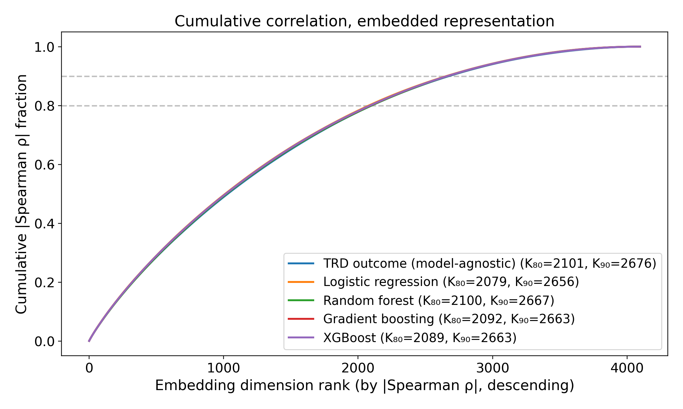
Figure S2. Cumulative absolute univariate (Spearman) correlation. One model-agnostic baseline curve ranks dimensions by |ρ(dim, outcome)|; the four per-classifier curves rank by |ρ(dim, predicted risk)|. Cumulative fraction of total |ρ| mass versus rank, with K₈₀ / K₉₀ knees in the legend.

S1.3 PCA-K discrimination sweep
Each classifier was retrained on the top K principal components, with K in {1, 2, 4, 8, 16, 32, 64, 128, 256, 512, 1024}. Held-out ROC AUC generally improved as components were added, with model-specific plateaus and some deterioration at larger K (Figure S3). These curves do not identify a unique effective dimension, and choosing K from them would require further independent evaluation.
A Logistic regression
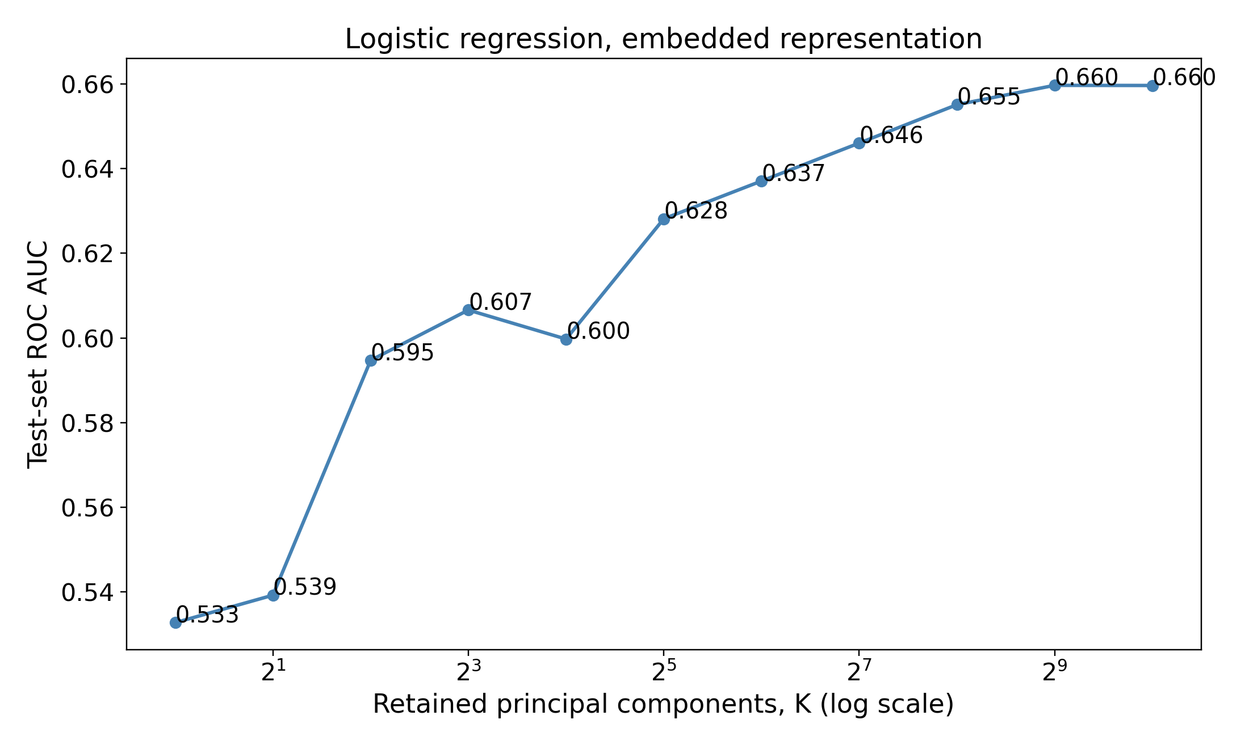
B Random forest
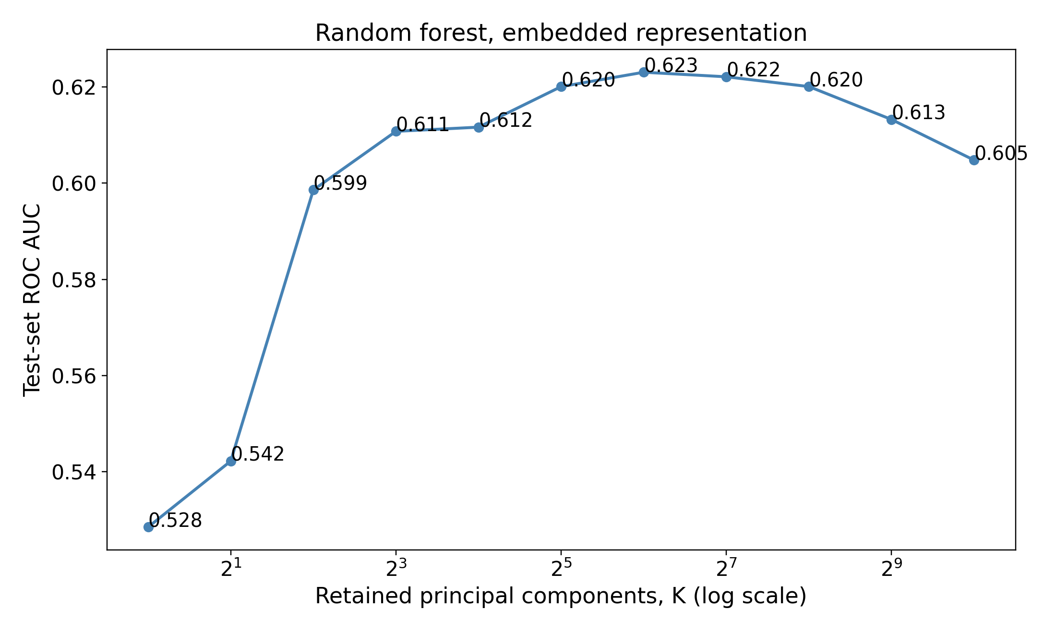
C Gradient boosting
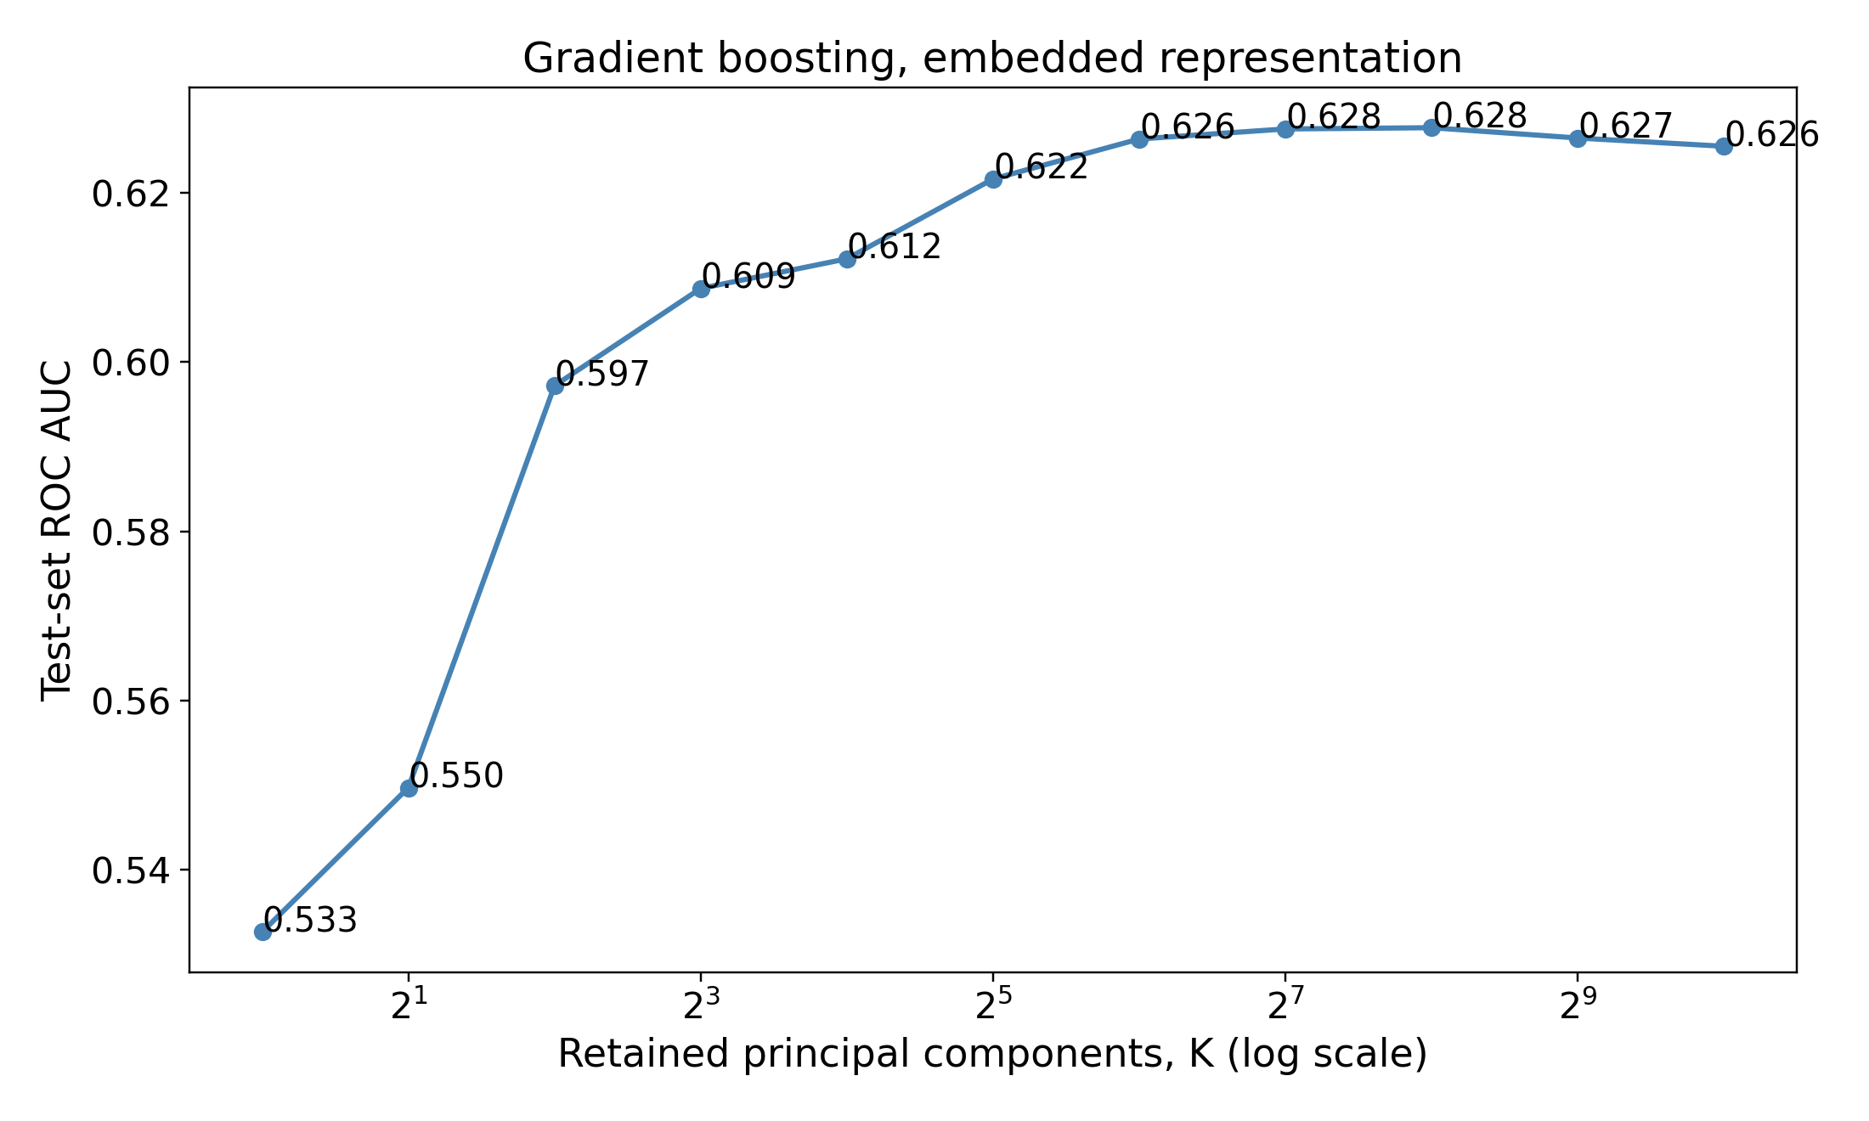
D XGBoost
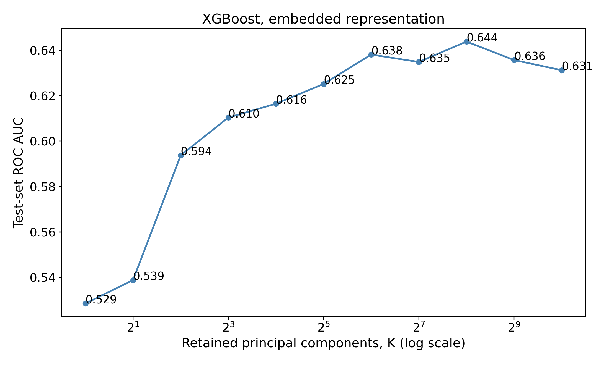
Figure S3. ROC AUC by retained principal components for logistic regression (A), random forest (B), gradient boosting (C), and XGBoost (D). The number of components is shown on a logarithmic scale. These are exploratory comparisons on the shared test set.

S2 Precision Recall Performance
AUPRC complements ROC AUC by describing precision across recall levels. Its no-skill reference is the cohort’s positive fraction, 0.175. Because it depends on outcome frequency, AUPRC should not be compared across populations without accounting for prevalence.
AUPRC remained modest across models (Tables S1–S2; Figure S4). The leading embedded and feature models achieved 0.302 (95% CI 0.281–0.325) and 0.298 (95% CI 0.276–0.322), respectively. These values are also summarized in Table 2. At each retrieval arm’s best k, AUPRC was 0.272 (95% CI 0.251–0.294) for logistic-regression-weighted, 0.264 (95% CI 0.244–0.286) for plain cosine, and 0.176 (95% CI 0.165–0.188) for random retrieval. Random retrieval therefore sat at the no-skill reference. The best k was chosen on the test patients by ROC AUC, so these values are optimistic.
Table S1. AUPRC of the four classifiers on each representation and of the 3 retrieval arms, each arm at its own test-selected best k (held-out test set), with bootstrap 95% CIs. No-skill baseline = 0.175 (the positive rate, 95% CI 0.167–0.183).
Representation | Model | AUPRC (95% CI)
EMBEDDED | Logistic regression | 0.302 (0.281–0.325)
EMBEDDED | Random forest | 0.270 (0.250–0.291)
EMBEDDED | Gradient boosting | 0.276 (0.256–0.298)
EMBEDDED | XGBoost | 0.278 (0.257–0.300)
FEATURE | Logistic regression | 0.278 (0.256–0.300)
FEATURE | Random forest | 0.293 (0.271–0.315)
FEATURE | Gradient boosting | 0.288 (0.267–0.309)
FEATURE | XGBoost | 0.298 (0.276–0.322)
Retrieval | Logistic-regression-weighted cosine, k = 295 | 0.272 (0.251–0.294)
Retrieval | Plain cosine, k = 757 | 0.264 (0.244–0.286)
Retrieval | Random, uniform weights, k = 32,720 | 0.176 (0.165–0.188)
Table S2. Embedded logistic-regression AUPRC by encoder (held-out test set), with bootstrap 95% CIs. No-skill baseline = 0.175.
Encoder | AUPRC (95% CI)
bge-small-en-v1.5 | 0.281 (0.260–0.303)
bge-en-icl | 0.297 (0.277–0.320)
Qwen3-Embedding-4B | 0.297 (0.274–0.319)
Qwen3-Embedding-8B | 0.302 (0.281–0.325)
A Embedded logistic regression
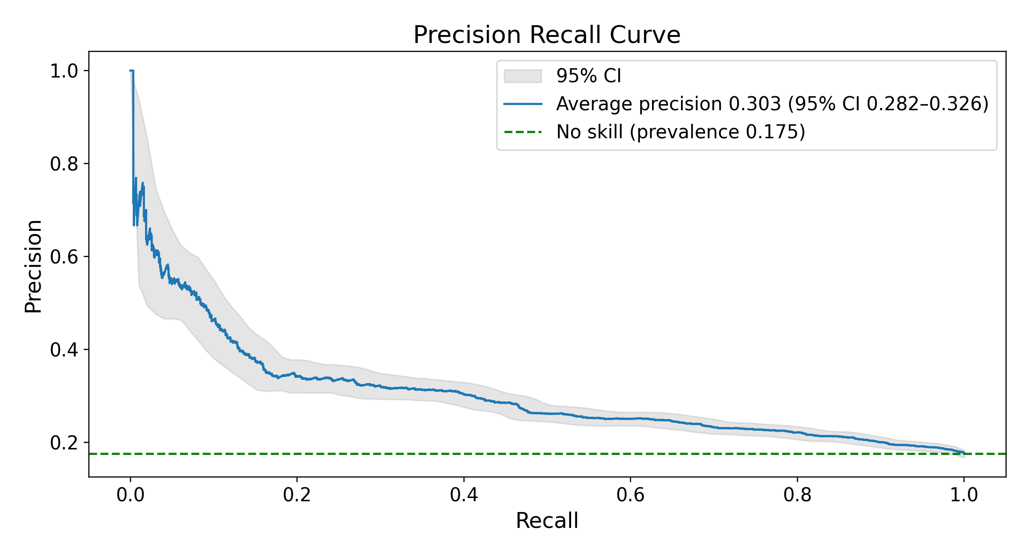
B Feature vector XGBoost
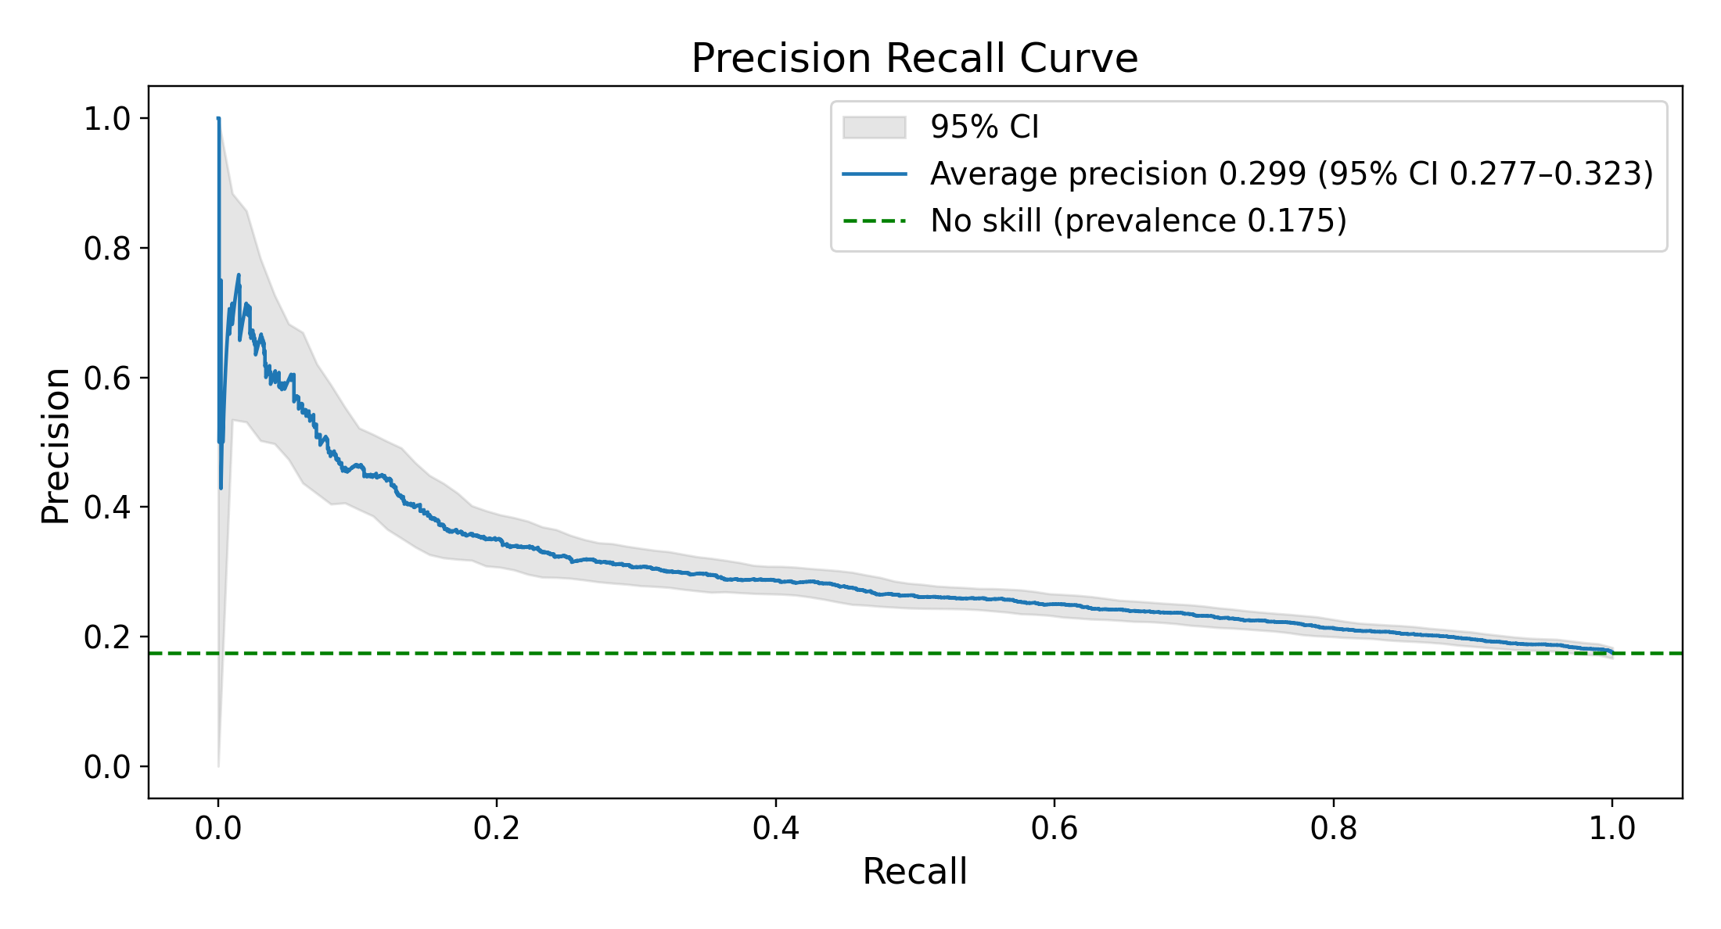
C Logistic-regression-weighted nearest retrieval, k = 295
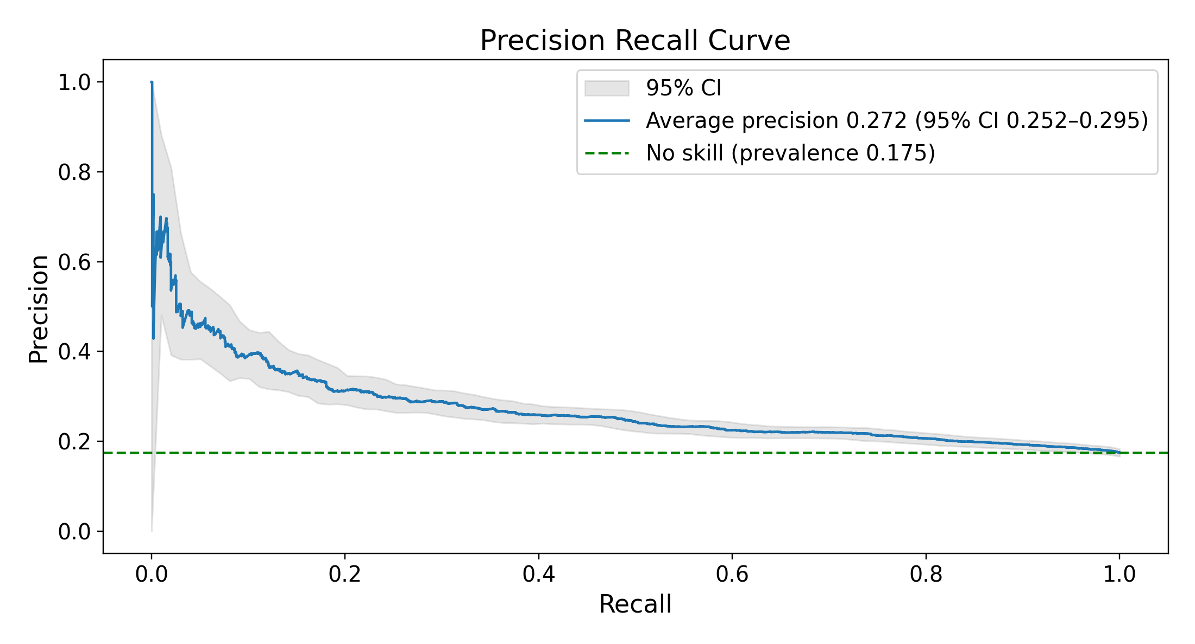
D Plain-cosine nearest retrieval, k = 757
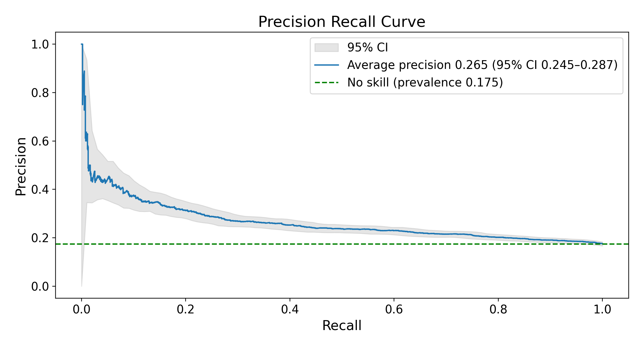
E Random retrieval, uniform weights, k = 32,720
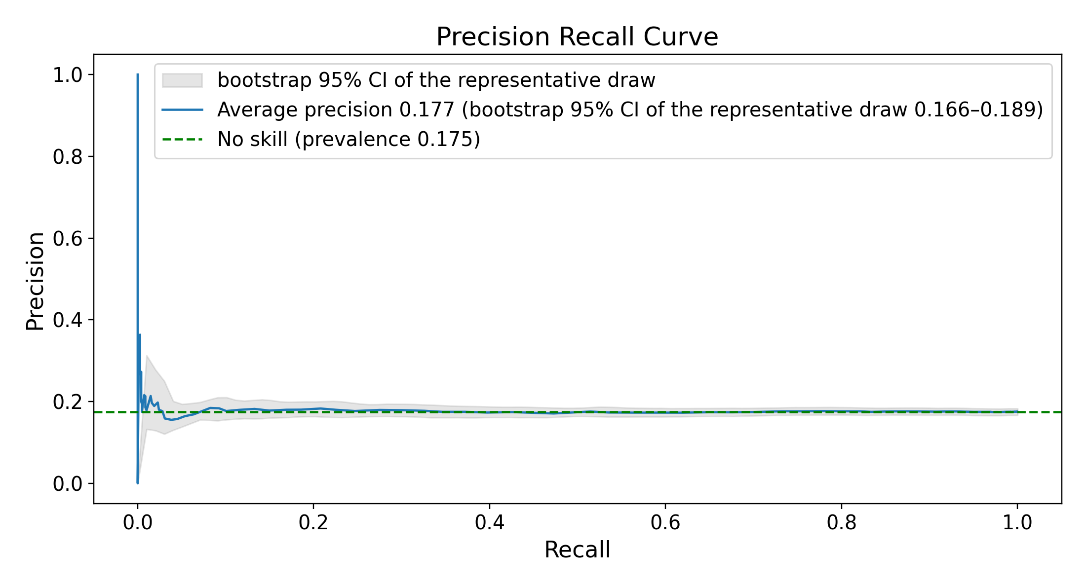
Figure S4. Precision–recall curves (held-out test set; primary Qwen3-Embedding-8B encoder). (A) Embedded logistic regression; (B) feature-vector XGBoost; (C–E) the 3 retrieval arms, each at its own test-selected best k. E is the draw of 1,000 whose ROC AUC at that k is closest to their mean. Every panel’s legend prints average precision with its bootstrap 95% CI (in E, the CI of that one draw over test patients) and the no-skill reference, the positive rate, 0.175 (95% CI 0.167–0.183). Legend average precision differs from the table AUPRC by at most 0.001.

S3 Calibration
Table S3 reports Brier score and weighted calibration error (WCE), for which lower values are better. Across the 8 classifiers, Brier scores ran from 0.137 (95% CI 0.132–0.142) to 0.140 (95% CI 0.134–0.145) and WCE from 0.004 (95% CI 0.003–0.013) to 0.018 (95% CI 0.011–0.026). Table S4 reports binned calibration slopes and intercepts, separately from the individual-level logistic slopes in section S9. Binned slopes should not be interpreted as conventional logistic calibration slopes.
Table S3. Brier score and weighted calibration error for all 8 primary representation–classifier combinations and the 3 retrieval arms, each arm at its own test-selected best k, with bootstrap 95% CIs. Both metrics describe the cohort’s observed outcome frequency.
Representation | Model | Brier (95% CI) | WCE (95% CI)
EMBEDDED | Logistic regression | 0.137 (0.132–0.142) | 0.010 (0.007–0.019)
EMBEDDED | Random forest | 0.140 (0.134–0.145) | 0.006 (0.005–0.015)
EMBEDDED | Gradient boosting | 0.139 (0.134–0.144) | 0.004 (0.003–0.013)
EMBEDDED | XGBoost | 0.139 (0.134–0.144) | 0.013 (0.007–0.022)
FEATURE | Logistic regression | 0.139 (0.134–0.144) | 0.005 (0.003–0.015)
FEATURE | Random forest | 0.139 (0.134–0.144) | 0.018 (0.011–0.026)
FEATURE | Gradient boosting | 0.138 (0.133–0.143) | 0.010 (0.005–0.018)
FEATURE | XGBoost | 0.138 (0.132–0.143) | 0.012 (0.006–0.020)
Retrieval | Logistic-regression-weighted cosine, k = 295 | 0.140 (0.134–0.145) | 0.005 (0.003–0.014)
Retrieval | Plain cosine, k = 757 | 0.141 (0.135–0.146) | 0.009 (0.004–0.016)
Retrieval | Random, uniform weights, k = 32,720 | 0.144 (0.139–0.150) | 0.00001* (0.0001–0.009)
* The random arm’s WCE lies below its own bootstrap interval. Its predicted risks all sit within 0.002 of the outcome rate, so on the full test set the binned error is almost zero. Every resample moves the observed rate away from those fixed risks, so the resampled errors are larger. The interval therefore describes resampling noise around a near-zero error, not uncertainty about a positive one.
Table S4. Slopes and intercepts fitted to the binned calibration curves, with bootstrap 95% CIs, for the 8 classifiers and the 3 retrieval arms at their own test-selected best k. These values are descriptive and are not individual-level logistic calibration parameters. See section S9 for the latter. The classifier rows fit a line through 10 equal-width bins, several of which hold few patients, so their intervals are wide. The retrieval rows use 10 bins of equal patient count, matching Figure S5. For random retrieval every predicted risk lies between 0.173 and 0.176, so its slope and intercept are not estimable.
Representation | Model | Binned slope (95% CI) | Binned intercept (95% CI)
EMBEDDED | Logistic regression | 1.27 (0.86–1.43) | −0.07 (−0.10 to +0.03)
EMBEDDED | Random forest | 1.15 (0.34–1.98) | −0.02 (−0.18 to +0.13)
EMBEDDED | Gradient boosting | 1.01 (0.42–1.59) | +0.01 (−0.12 to +0.14)
EMBEDDED | XGBoost | 0.75 (0.22–1.39) | +0.07 (−0.08 to +0.19)
FEATURE | Logistic regression | 0.78 (0.20–1.33) | +0.06 (−0.08 to +0.20)
FEATURE | Random forest | 1.84 (1.41–2.23) | −0.15 (−0.22 to −0.08)
FEATURE | Gradient boosting | 0.87 (0.28–1.48) | +0.04 (−0.11 to +0.19)
FEATURE | XGBoost | 1.02 (0.53–1.52) | +0.02 (−0.09 to +0.13)
Retrieval | Logistic-regression-weighted cosine, k = 295 | 1.13 (0.98–1.28) | −0.02 (−0.04 to +0.01)
Retrieval | Plain cosine, k = 757 | 1.43 (1.23–1.63) | −0.07 (−0.10 to −0.03)
Retrieval | Random, uniform weights, k = 32,720 | not estimable (predicted risk spans 0.173–0.176) | not estimable
A Embedded logistic regression
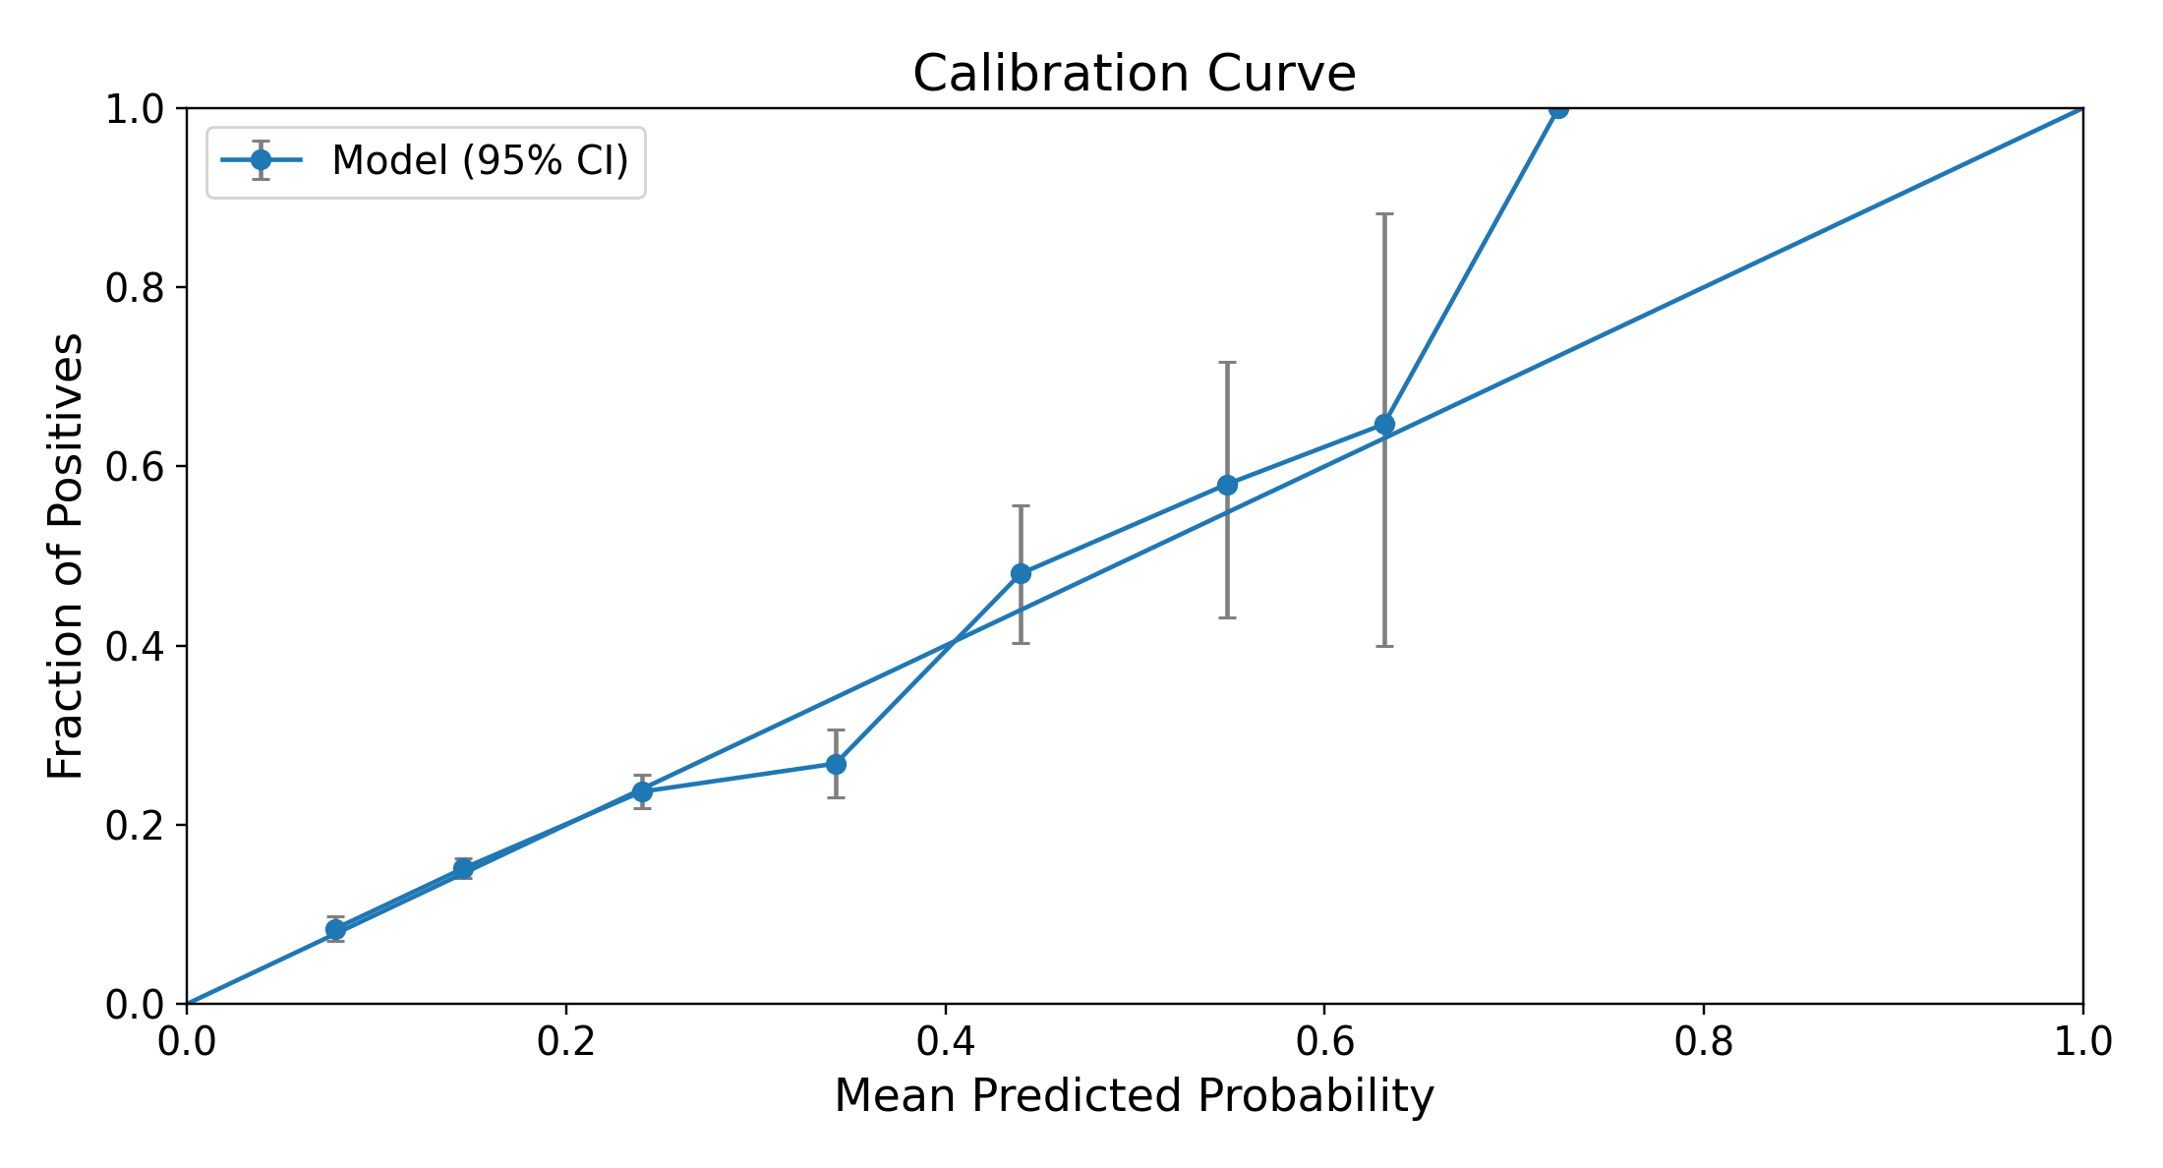
B Feature vector XGBoost
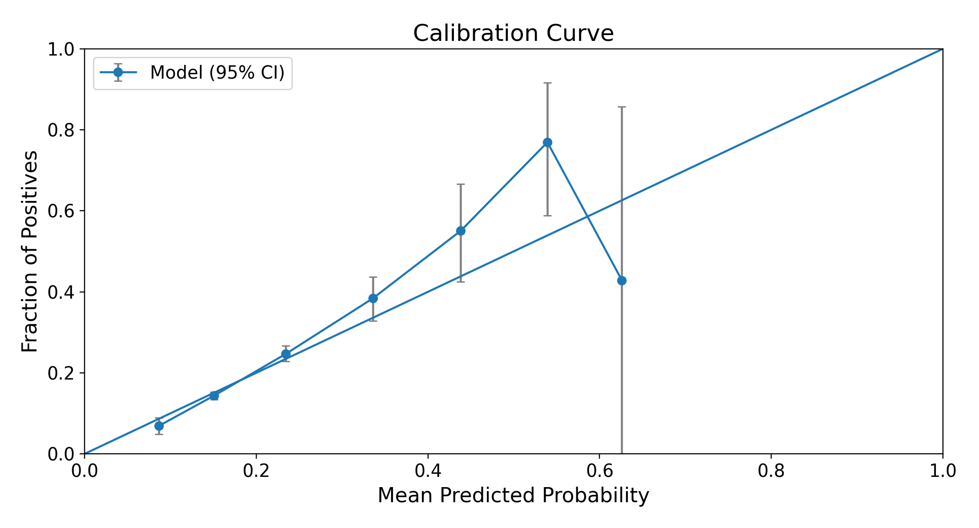
C Logistic-regression-weighted nearest retrieval, k = 295
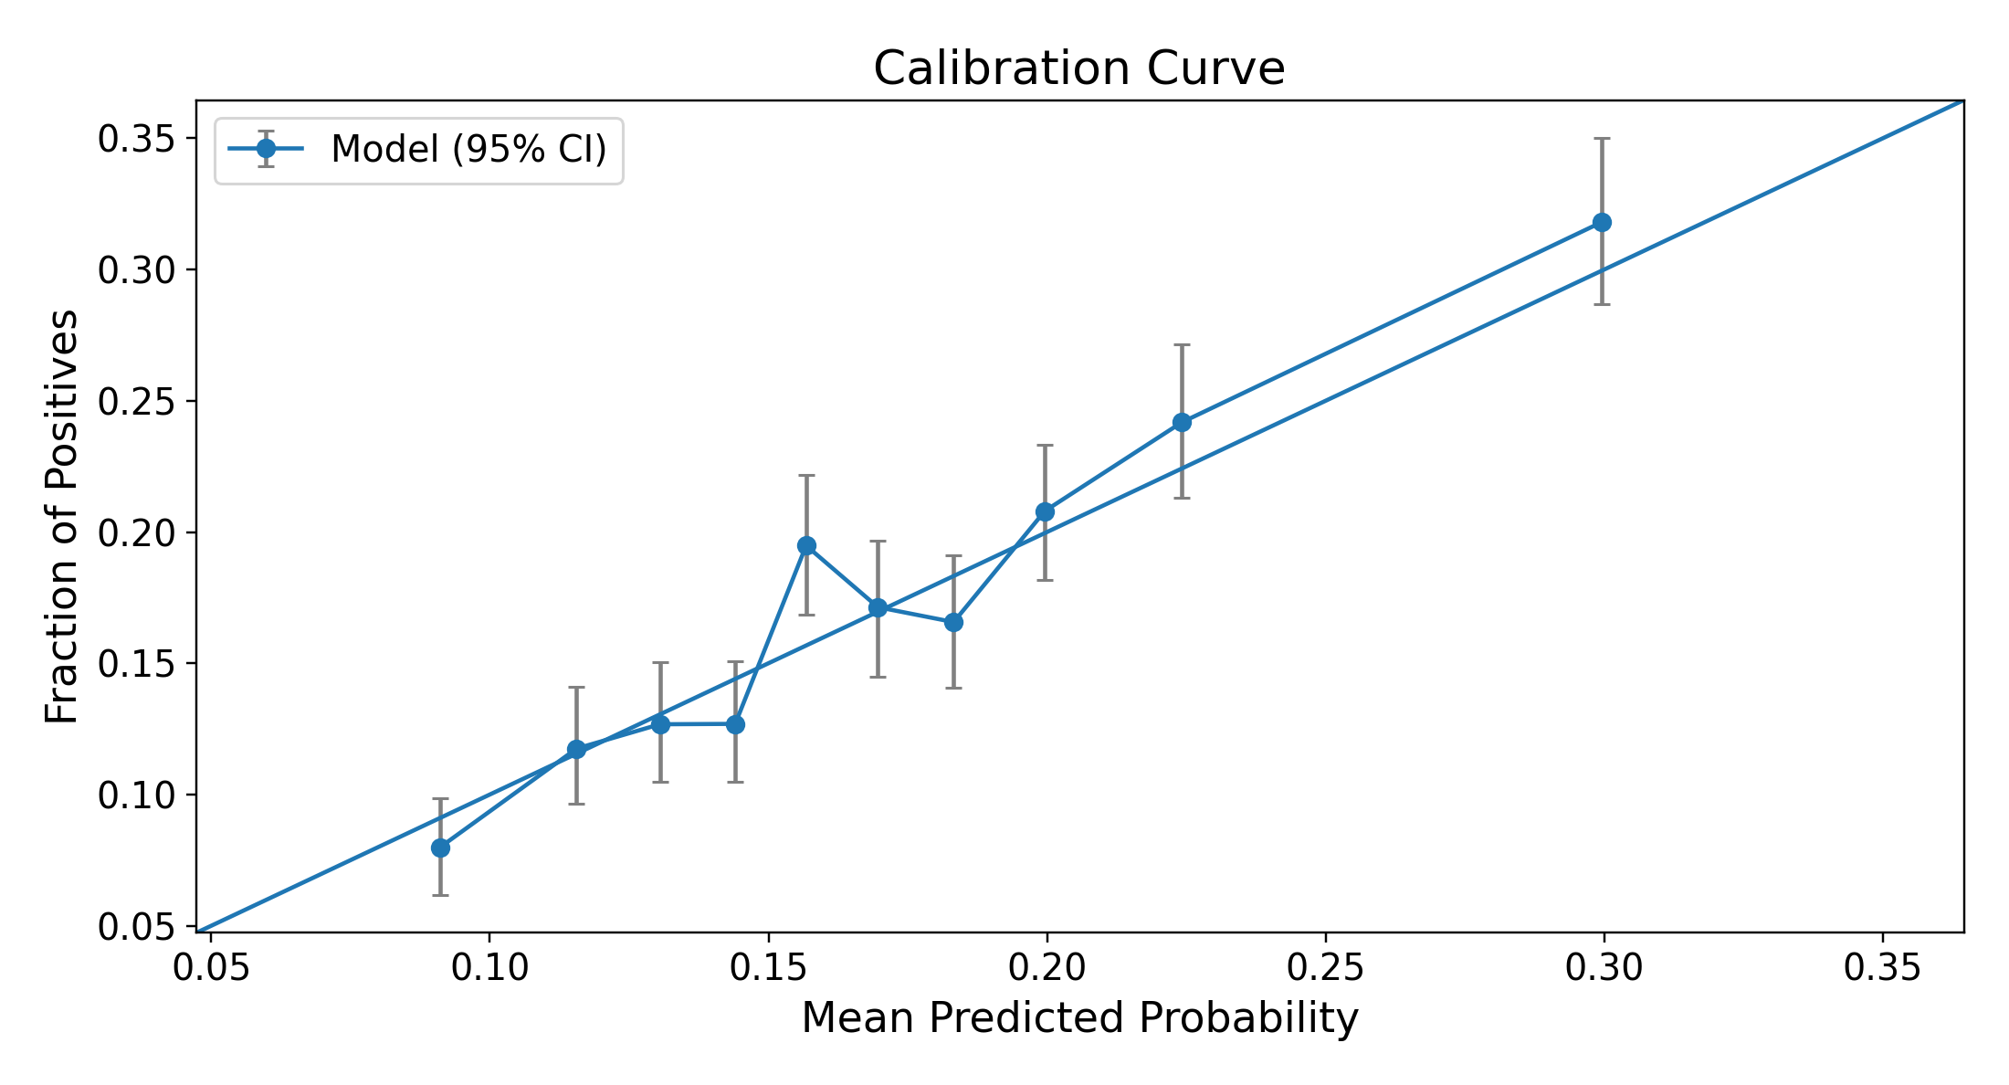
D Plain-cosine nearest retrieval, k = 757
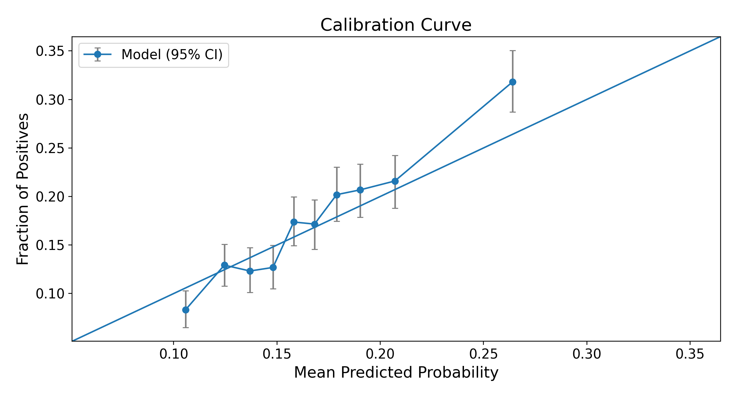
E Random retrieval, uniform weights, k = 32,720
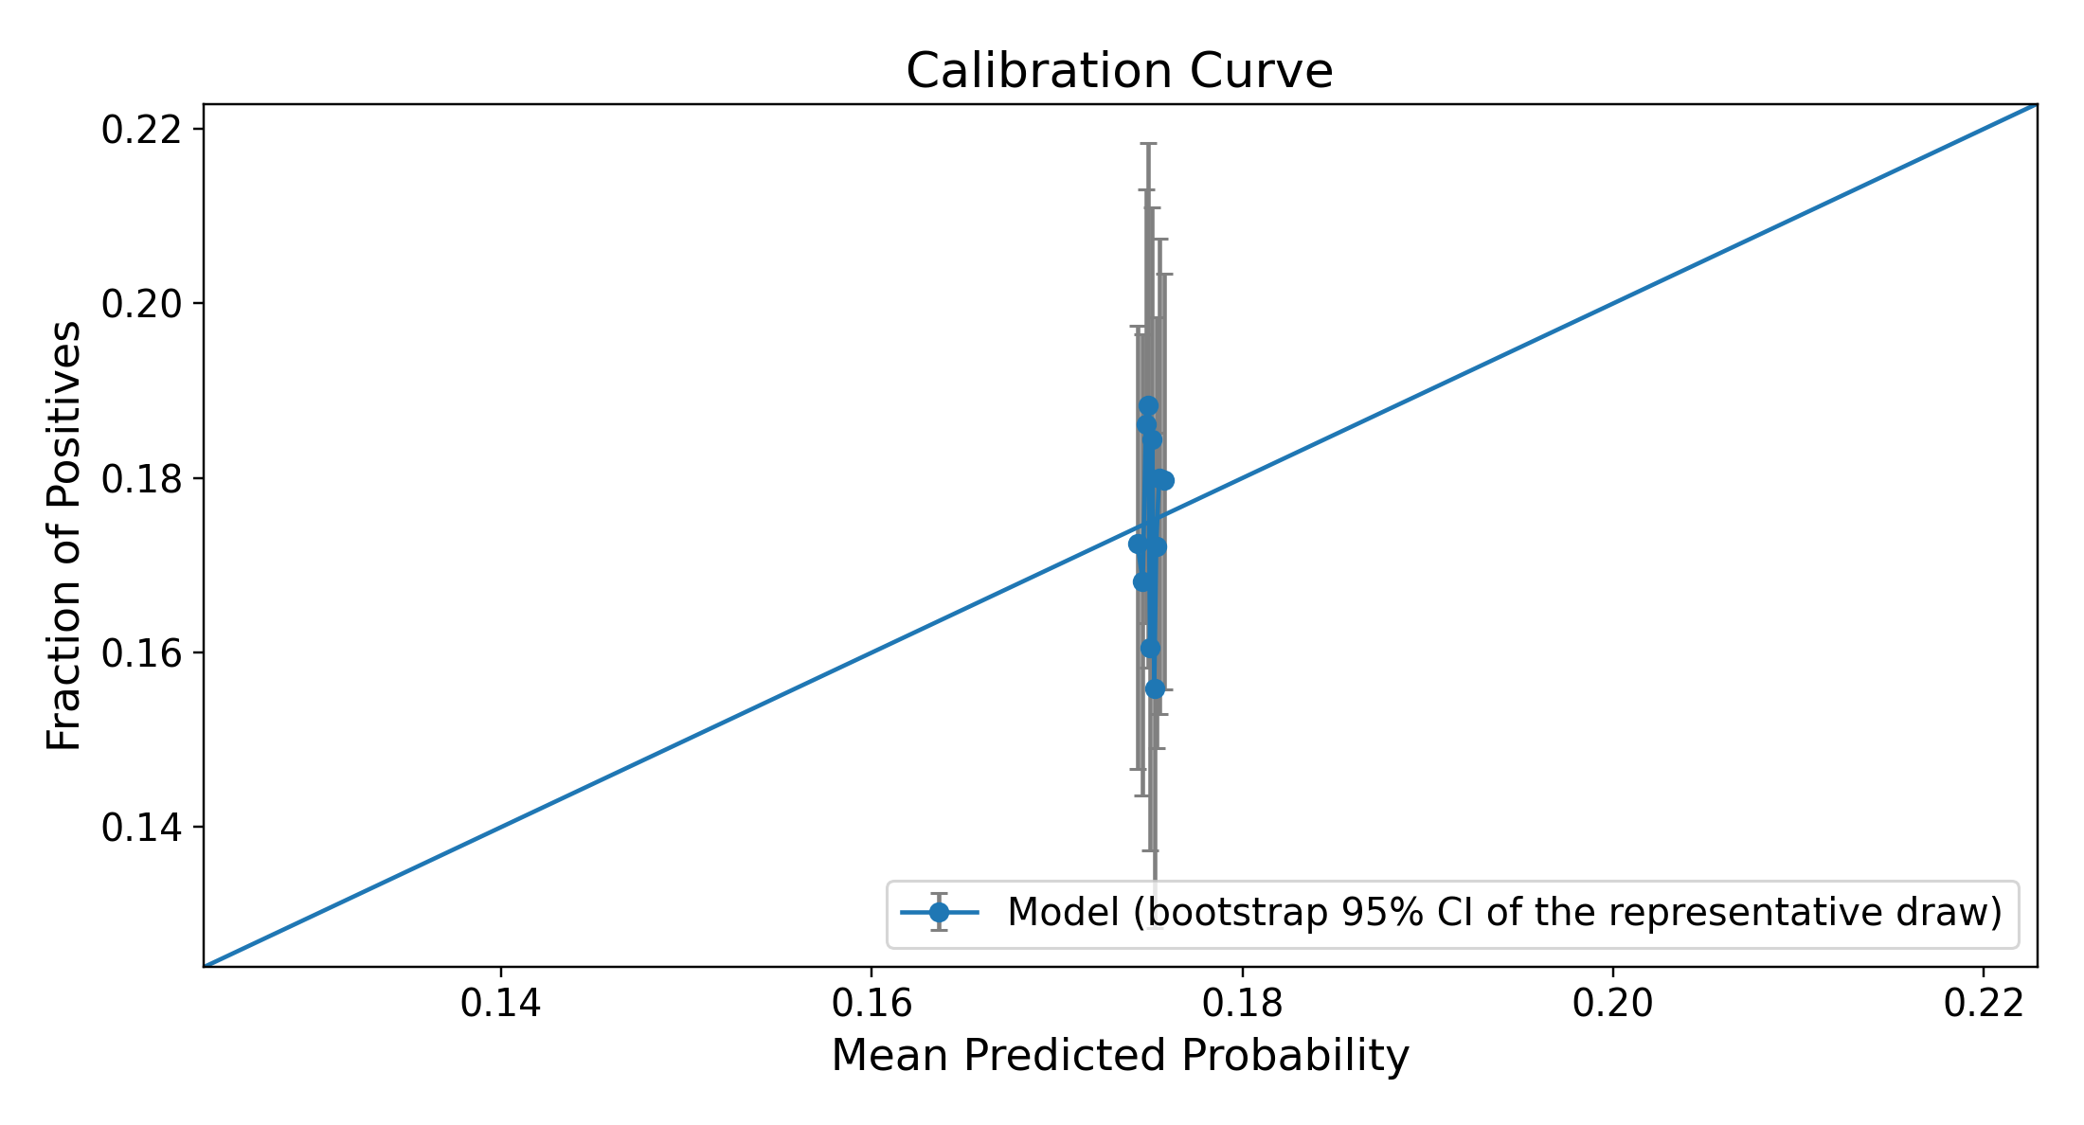
Figure S5. Calibration curves for embedded logistic regression (A), feature-vector XGBoost (B), and the 3 retrieval arms at their own test-selected best k (C–E). E is the same random draw as Figure S4E, the one of 1,000 whose ROC AUC at that k is closest to their mean. Panels C–E carry a 95% CI on each bin. Retrieval panels use 10 bins of equal patient count, because retrieval risks crowd near the outcome rate. Random risks all lie near 0.175, so panel E is one cluster of points. The diagonal indicates agreement between predicted and observed outcome frequency; points above it indicate underprediction in that bin, and points below indicate overprediction. The sample is enriched for depression.

S4 Encoder Similarity Geometry
Figure S6 compares cosine similarities for random patient pairs and nearest-neighbor pairs. The 3 larger encoders produced broadly unimodal random-pair distributions. bge-small-en-v1.5 showed multiple modes at high similarity values, prompting a descriptive analysis of the corresponding narrative wording.
A bge-small-en-v1.5
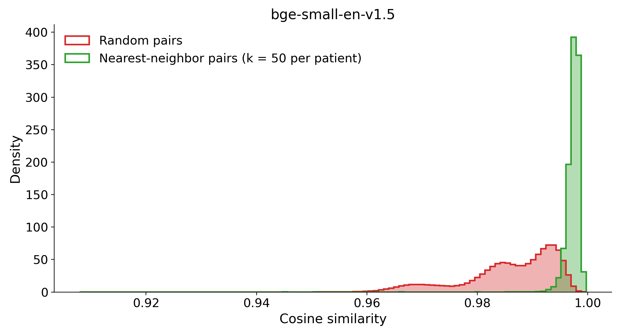
B bge-en-icl
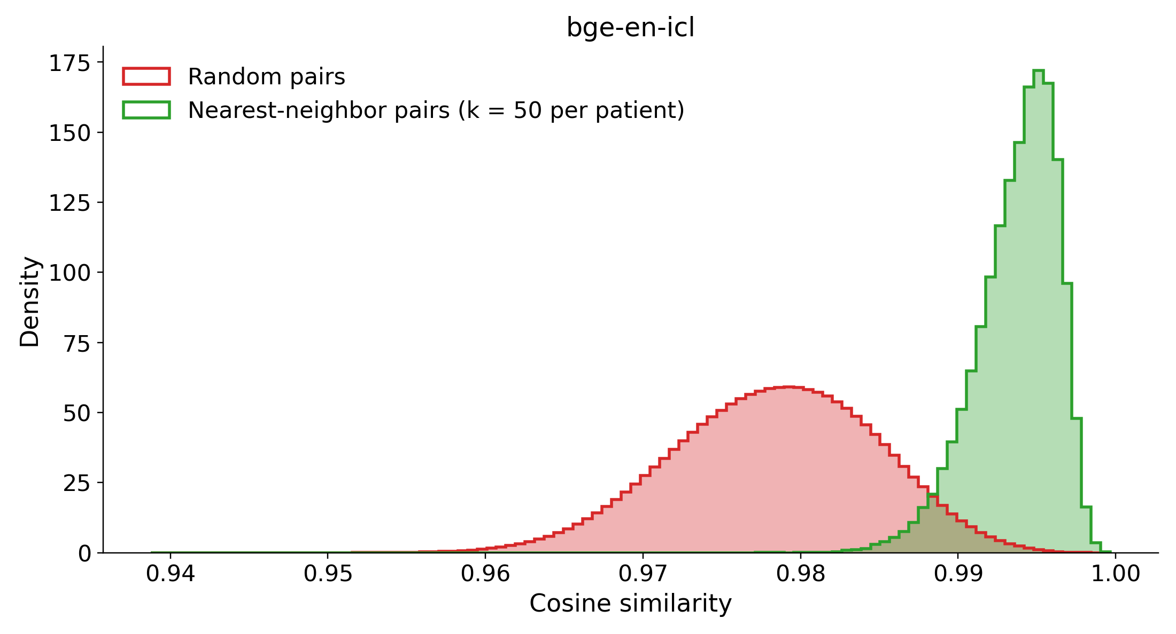
C Qwen3-Embedding-4B
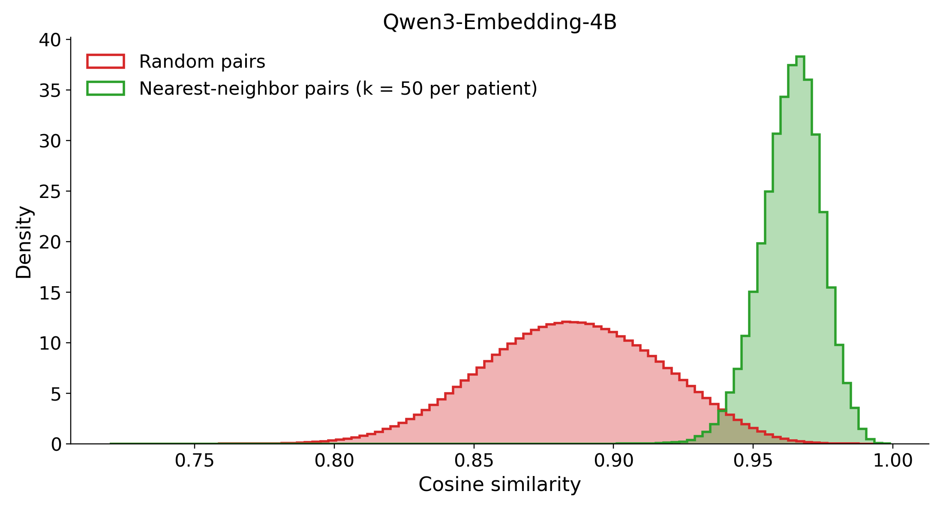
D Qwen3-Embedding-8B
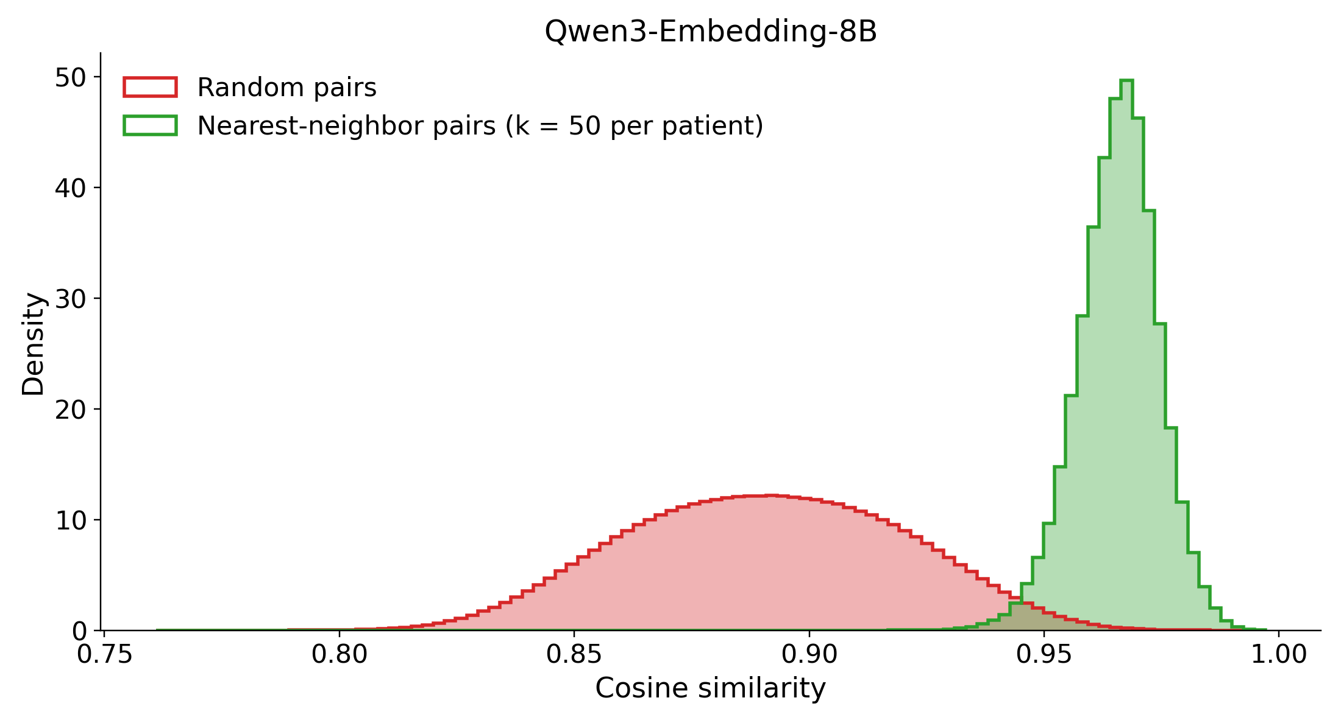
Figure S6. Cosine similarity for random pairs (red) and nearest-neighbor pairs (green) for bge-small-en-v1.5 (A), bge-en-icl (B), Qwen3-Embedding-4B (C), and Qwen3-Embedding-8B (D). Axis ranges differ across encoders. The smallest encoder shows a multimodal random-pair distribution.
K-means clustering of L2-normalized bge-small embeddings (k=2) separated 42,579 patients into groups of 14,438 and 28,141. The partition closely tracked whether the narrative contained the token “episode” (Table S5).
The token occurs in “Single Episode” but not “Recurrent” or “Dysthymia.” Thus, the partition should not be described simply as recurrent versus nonrecurrent depression.
Cluster B (n=28,141) largely comprised narratives containing “episode”; the full cohort contained 28,206 patients coded single episode.
Cluster A (n=14,438) largely lacked “episode” and included both recurrent and other depression codes. The full cohort contained 11,213 recurrent-coded patients.
Table S5. Fraction of narratives containing selected tokens within each top-level k-means cluster. Cluster A has 14,438 patients and cluster B has 28,141. “Single” may also denote marital status.
Token | P(present | cluster A) | P(present | cluster B) | |Δ|
episode | 0.00 | 1.00 | 1.00
recurrent | 0.78 | 0.00 | 0.78
single | 0.30 | 1.00 | 0.70
unspecified | 0.39 | 0.83 | 0.45
moderate | 0.32 | 0.09 | 0.23
Figure S7 stratifies pairwise similarities by token agreement. Blue denotes pairs agreeing on token presence, red denotes disagreement, and gray denotes all pairs.
Across the cohort, pairs agreeing on “episode” had higher similarities than pairs differing on that token (Figure S7A). This association links the observed modes to diagnostic wording but does not isolate a causal token effect from correlated clinical information.
Within cluster A, the same comparison using “recurrent” again separated similarity distributions (Figure S7B). The nested k-means subgroups contained 11,425 and 3,013 patients; these cluster sizes should not be equated with diagnosis-code counts.
Within cluster B, similarity distributions showed little separation by the “Missing” token. Nested cluster results are summarized in Table S6.
A All patients
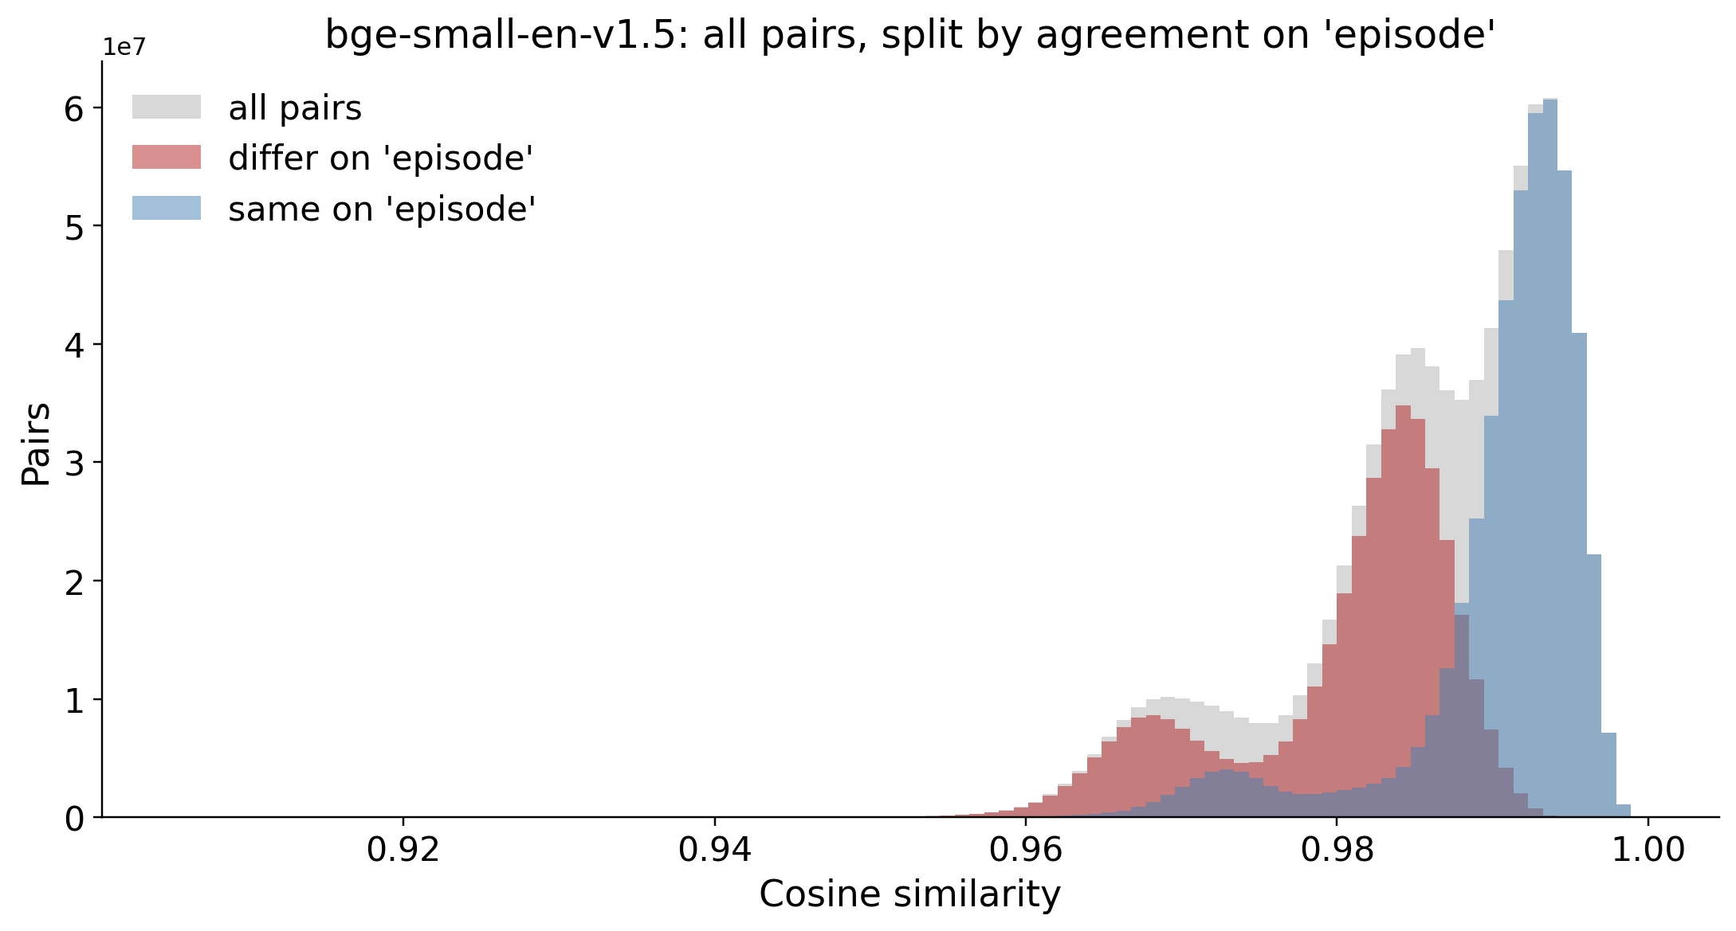
B Cluster A
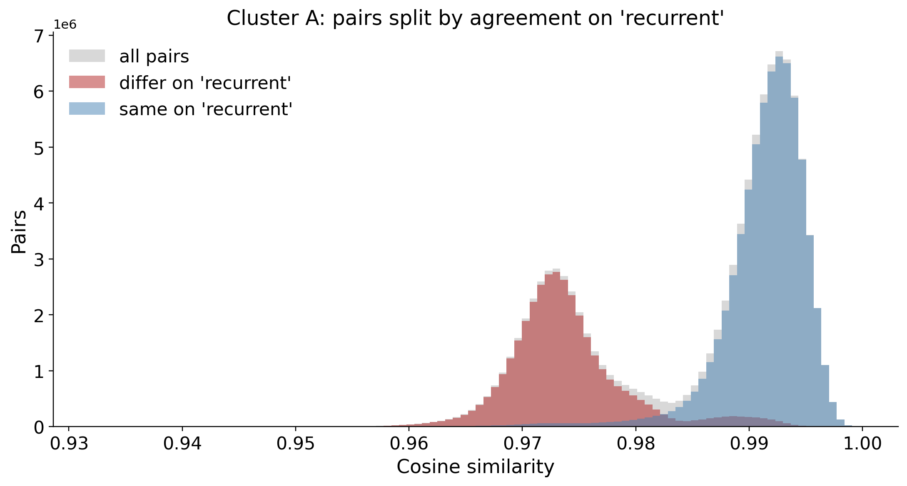
Figure S7. Pairwise similarity by agreement on “episode” across the cohort (A) and on “recurrent” within cluster A (B). Blue denotes token agreement, red disagreement, and gray all pairs. The analysis is descriptive and does not establish that wording alone causes the separation.
We re-ran k-means (k=2) within each parent cluster and described separation using the cosine silhouette in a seeded 5,000-patient subsample. The top-level silhouette was 0.48.
Silhouette values summarize within- versus between-cluster similarity and are descriptive, not hypothesis tests. They do not by themselves establish discrete biological or clinical subgroups.
Cluster A had a nested silhouette of 0.69. The larger subgroup (n=11,425) contained “recurrent” in 98% of narratives, whereas the smaller subgroup (n=3,013) contained “unspecified” in all narratives. Cluster B had weaker separation (silhouette 0.21); “Missing” appeared in 88% versus 2% of its subgroups. Medication tokens also differed, consistent with differences in record content.
Table S6. Nested k-means results within each parent cluster. Token proportions describe presence in the 2 subgroups. The top-level cosine silhouette was 0.48; higher values indicate greater geometric separation, without establishing clinical validity.
Parent cluster (n) | Splits into (n / n) | Driving token | Token present, sub 1 / sub 2 | Split silhouette (top level = 0.48) | Separation
A: no “episode” token (14,438) | recurrent + severity (11,425) / unspecified (3,013) | recurrent | 0.98 / 0.00 | 0.69 | Stronger
B: single-episode (28,141) | sparse record (6,594) / populated record (21,547) | missing | 0.88 / 0.02 | 0.21 | Weaker
These findings show sensitivity of the smallest encoder’s geometry to diagnostic wording and missing-value tokens. They may help explain its retrieval behavior, but do not establish why its discrimination was lower (section S12.3). Primary analyses used Qwen3-Embedding-8B.

S5 Example Patient Narratives
Two deterministic narratives are reproduced verbatim, one from each outcome class. They were selected as the first patient by sorted deidentified hash within each class using scripts/pipeline/neighbors/narrative_audit.py. Inputs contained structured EHR fields only. Fixed section order, explicit absence labels, and missing-value tokens formed the template.
The original renderer uses “anchor” for the index and “Baseline window” for the lookback window. These labels are preserved because they show the actual encoder input.
The examples show field asymmetries documented in section S10: narratives include vital signs, sexual orientation, index dates, raw sociodemographic values, and medication names. FEATURE omits some of these fields or uses coarser encodings, but includes total recorded history length. A missing sexual-orientation value appears as the literal token nan.
TRD-positive example.
### COHORT & INDEX
Condition: MDD (Dysthymia, Unspecified) | Index date: 2022-10-06 | Baseline window: -730...0 days | MDD-to-anchor gap: 57 days | Encounters in window: 34 | MDD within window: Present
### SOCIODEMOGRAPHICS / ACCESS
Sex: Male | PreferredLanguage: English | AgeInYears: 37 | SexualOrientation: nan | MaritalStatus: Married | Religion: Baptist | SmokingStatus: Never | Race_Ethnicity: American Indian or Alaska Native
SDOH: None Recorded
### PHYSICAL HEALTH
BMI: 29.8 | BP (mean): 140/88
### PSYCH HISTORY
SOCIAL_ANXIETY: Absent | OCD: Absent | ANXIETY: Present | ADJUSTMENT_DISORDER: Absent | PTSD: Absent | DYSTHYMIA: Present | SUD: Present | INSOMNIA: Present
SUICIDE FLAG (2y): Absent
SUBSTANCE ABUSE: Nicotine
### MEDICAL COMORBIDITY
CHRONIC_PAIN: Absent | HYPERLIPIDEMIA: Absent | THYROID: Absent | DIABETES: Present
### TREATMENT EXPOSURE
Prior adequate AD trials: MIRTAZAPINE: 0 | SSRI: 1 | VORTIOXETINE: 0 | BUPROPION: 0 | SNRI: 0
Benzodiazepine days (2y): 0
Hypnotics: eszopiclone
Augmentation: Absent
### MEDICATION BURDEN
Active meds at baseline: 0 (Absent)
NSAID burden: 0 (Absent)
### UTILIZATION
Psych inpatient days: 0 (2y) | ED psych visits: 0 (2y)
### SAFETY
UNCONTROLLED_HTN: Present | EPILEPSY: Absent
TRD-negative example.
### COHORT & INDEX
Condition: MDD (Recurrent, Moderate) | Index date: 2025-05-09 | Baseline window: -730...0 days | MDD-to-anchor gap: 0 days | Encounters in window: 2 | MDD within window: Present
### SOCIODEMOGRAPHICS / ACCESS
Sex: Female | PreferredLanguage: English | AgeInYears: 52 | SexualOrientation: nan | MaritalStatus: Single | Religion: Baptist | SmokingStatus: Every Day | Race_Ethnicity: White or Caucasian
SDOH: None Recorded
### PHYSICAL HEALTH
BMI: 35.6 | BP (mean): 138/86
### PSYCH HISTORY
SOCIAL_ANXIETY: Absent | OCD: Absent | ANXIETY: Present | ADJUSTMENT_DISORDER: Absent | PTSD: Absent | DYSTHYMIA: Absent | SUD: Present | INSOMNIA: Absent
SUICIDE FLAG (2y): Absent
SUBSTANCE ABUSE: Nicotine
### MEDICAL COMORBIDITY
CHRONIC_PAIN: Absent | HYPERLIPIDEMIA: Absent | THYROID: Absent | DIABETES: Absent
### TREATMENT EXPOSURE
Prior adequate AD trials: MIRTAZAPINE: 0 | SSRI: 0 | VORTIOXETINE: 0 | BUPROPION: 0 | SNRI: 0
Benzodiazepine days (2y): 0
Hypnotics: Absent
Augmentation: Absent
### MEDICATION BURDEN
Active meds at baseline: 0 (Absent)
NSAID burden: 0 (Absent)
### UTILIZATION
Psych inpatient days: 0 (2y) | ED psych visits: 0 (2y)
### SAFETY
UNCONTROLLED_HTN: Present | EPILEPSY: Absent

S6 Neighbor Prediction
Retrieval over the embedding carried outcome information but did not reach the trained classifiers at any k. Random retrieval stayed at chance at every k: its band across draws covered 0.5 at every k from 1 to 34,063. Its best k, 32,720, reached 0.500 (2.5th–97.5th percentile across draws 0.484–0.515), and that k is noise (Table S7). At their best k, logistic-regression-weighted retrieval exceeded random by 0.125 (95% CI 0.103–0.147) and plain cosine by 0.118 (95% CI 0.096–0.140). These intervals combine bootstrap resampling of the test patients with the spread across the 1,000 random draws. AUPRC at each arm’s best k was 0.272 (95% CI 0.251–0.294) for logistic-regression-weighted, 0.264 (95% CI 0.244–0.286) for plain cosine, and 0.176 (95% CI 0.165–0.188) for random retrieval, against an outcome rate of 0.175 (95% CI 0.167–0.183) (section S2). Calibration is in section S3.
Neighborhood size mattered more than the metric. Both curves rose with k up to a few hundred neighbors (manuscript Figure 4D). From k = 261 onward, logistic-regression-weighted retrieval stayed inside the interval at its best k. Plain cosine retrieval peaked at k = 757 and then drifted down, to 0.605 (95% CI 0.589–0.620) at k = 16,988, still inside the interval at its best k. Each metric at its own best k differed by 0.007 (95% CI −0.001 to 0.014). The best k was selected on test patients, so those maxima are optimistic. Using every training patient as a neighbor involves no selection and gave 0.624 (95% CI 0.607–0.639) for the logistic-regression-weighted metric and 0.608 (95% CI 0.592–0.624) for plain cosine. The sharpening exponent changed the maxima by at most 0.002.
The best retrieval result over every k and exponent was logistic-regression-weighted retrieval with $α$ = 2 at k = 1,090, 0.625 (95% CI 0.610–0.640). It remained below feature-vector XGBoost by 0.024 (95% CI 0.012–0.036) and below embedded logistic regression by 0.032 (95% CI 0.022–0.043), from paired bootstrap resampling of the 8,516 test patients.
Table S7. Neighbor-prediction ROC AUC for the primary encoder by neighbor selection, similarity metric, and neighborhood size, with $α$ = 1. Best k is the test-selected maximum and is optimistic. The uniform random row gives the mean across 1,000 draws and the 2.5th–97.5th percentile of the draws.
Retrieval | Similarity | Neighbors (k) | ROC AUC (95% CI)
Nearest | Plain cosine | best, 757 | 0.618 (0.602–0.634)
Nearest | Logistic-regression-weighted | best, 295 | 0.625 (0.610–0.641)
Nearest | Plain cosine | all, 34,063 | 0.608 (0.592–0.624)
Nearest | Logistic-regression-weighted | all, 34,063 | 0.624 (0.607–0.639)
Random | Uniform | best, 32,720 | 0.500 (0.484–0.515)
Figures S8 and S9 draw ROC curves and confusion matrices only at each arm’s best k, for all 4 encoders. Panels A–C are the primary encoder’s 3 arms. Panels D–I are each other encoder’s 2 nearest-neighbor metrics, whose ROC AUCs at those k are reported in the manuscript (Nearest-Neighbor Retrieval Across Encoders). Random retrieval does not use the embedding, so it is drawn once, in panel C.
A Qwen3-Embedding-8B, logistic-regression-weighted nearest retrieval, k = 295
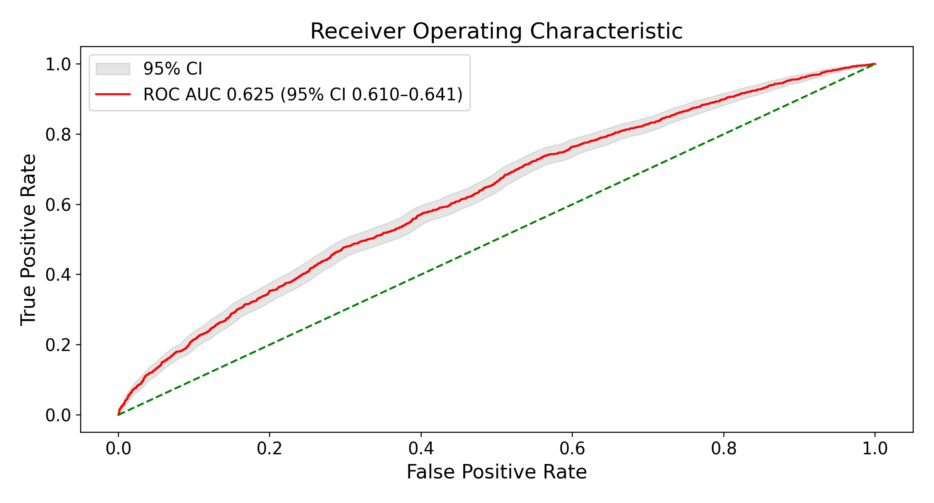
B Qwen3-Embedding-8B, plain-cosine nearest retrieval, k = 757
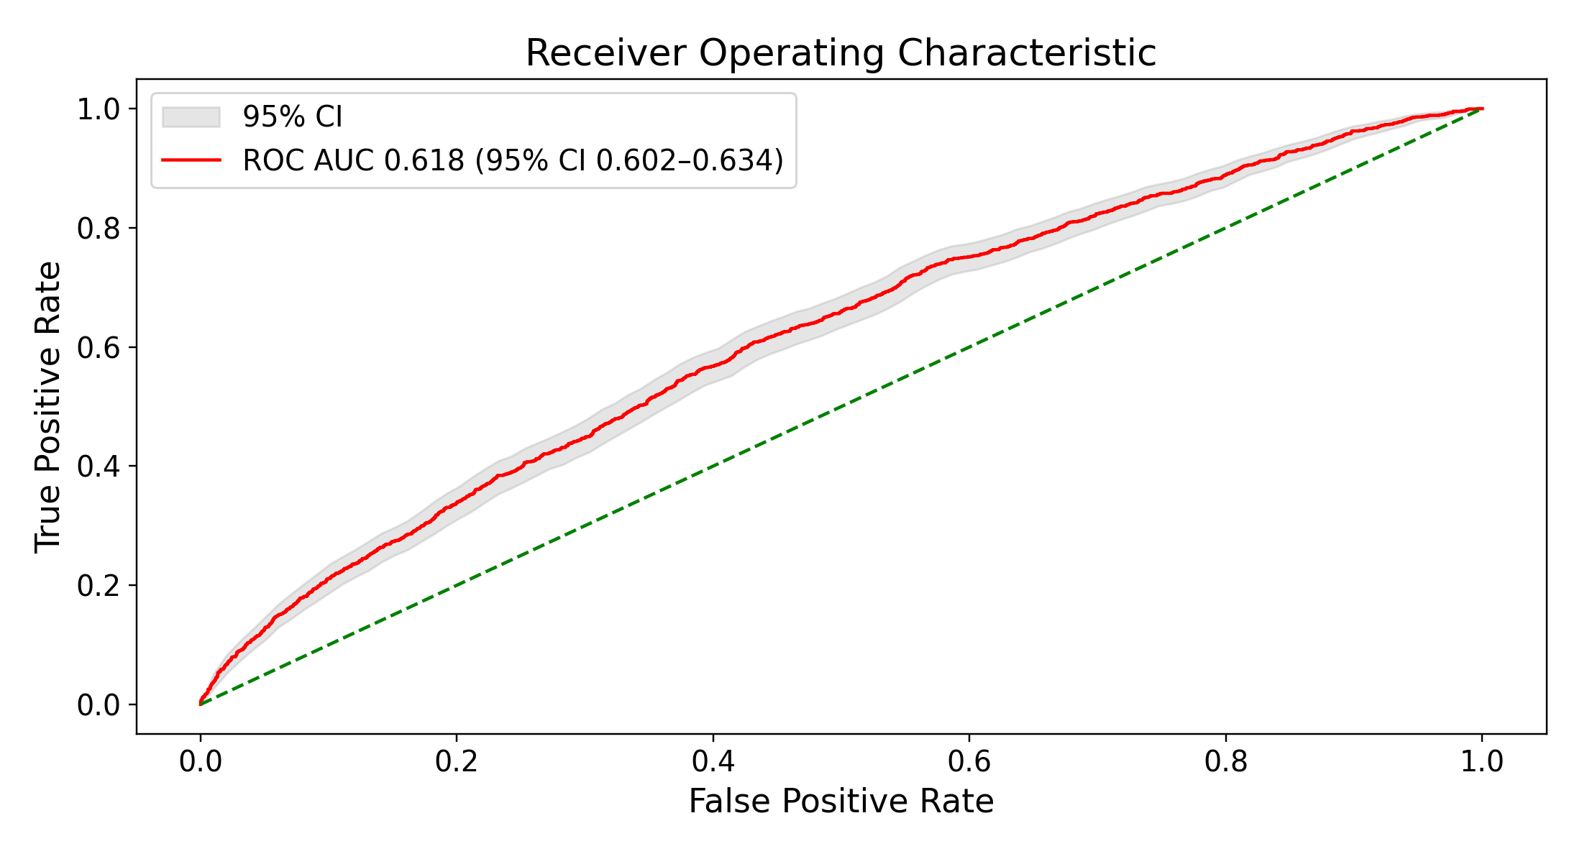
C Random retrieval, uniform weights, k = 32,720
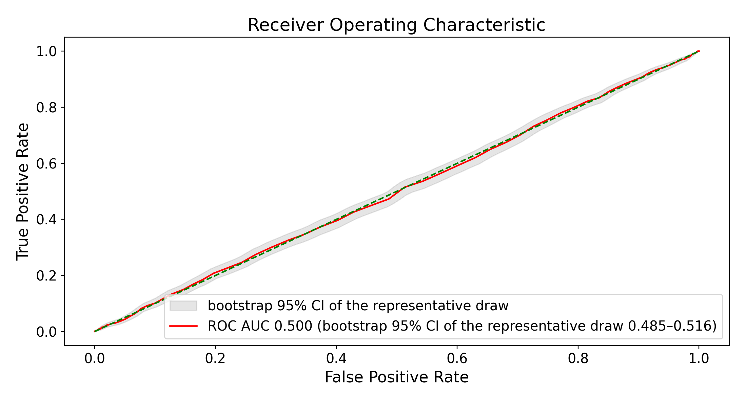
D bge-small-en-v1.5, logistic-regression-weighted nearest retrieval, k = 579
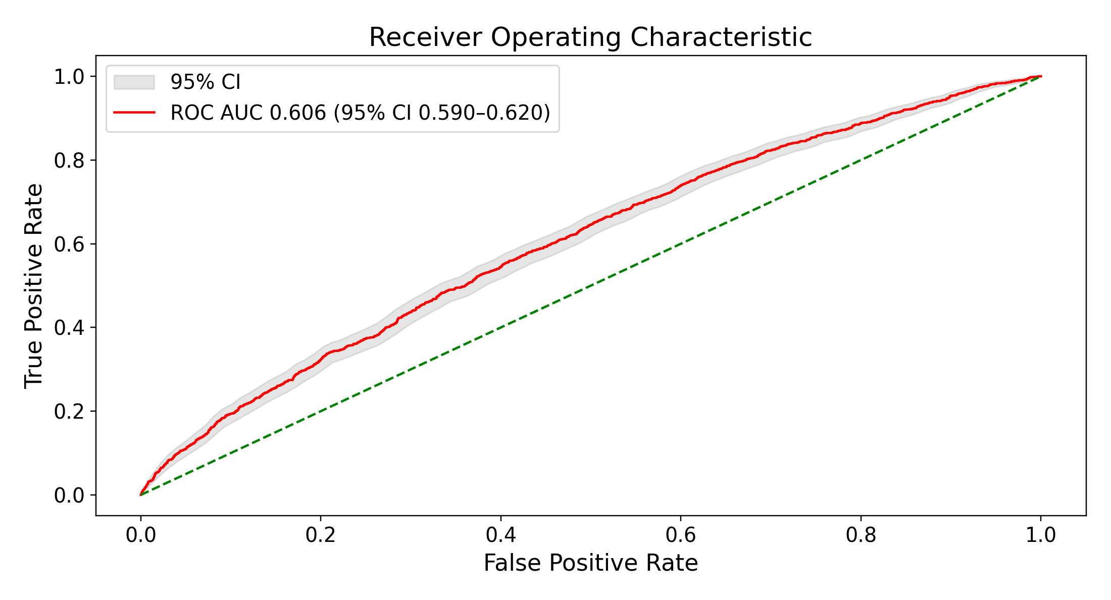
E bge-small-en-v1.5, plain-cosine nearest retrieval, k = 1,243
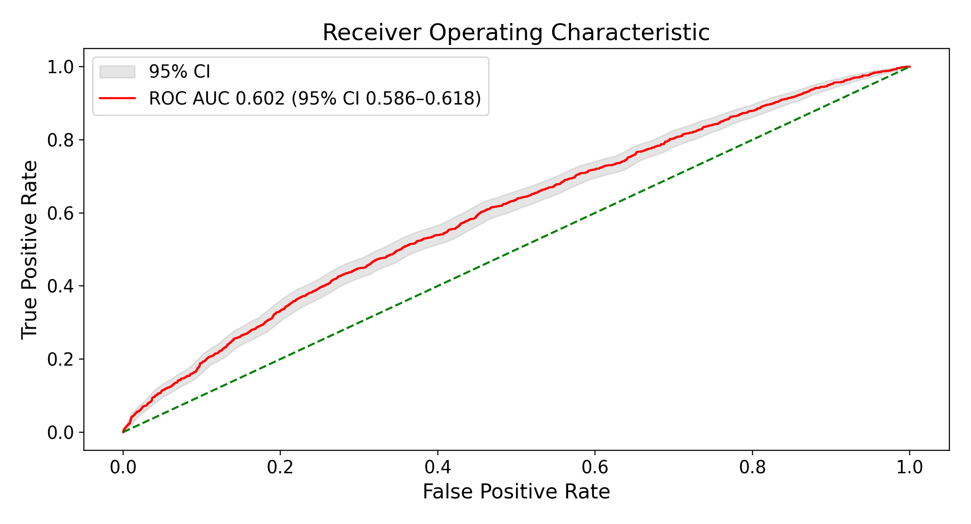
F bge-en-icl, logistic-regression-weighted nearest retrieval, k = 1,519
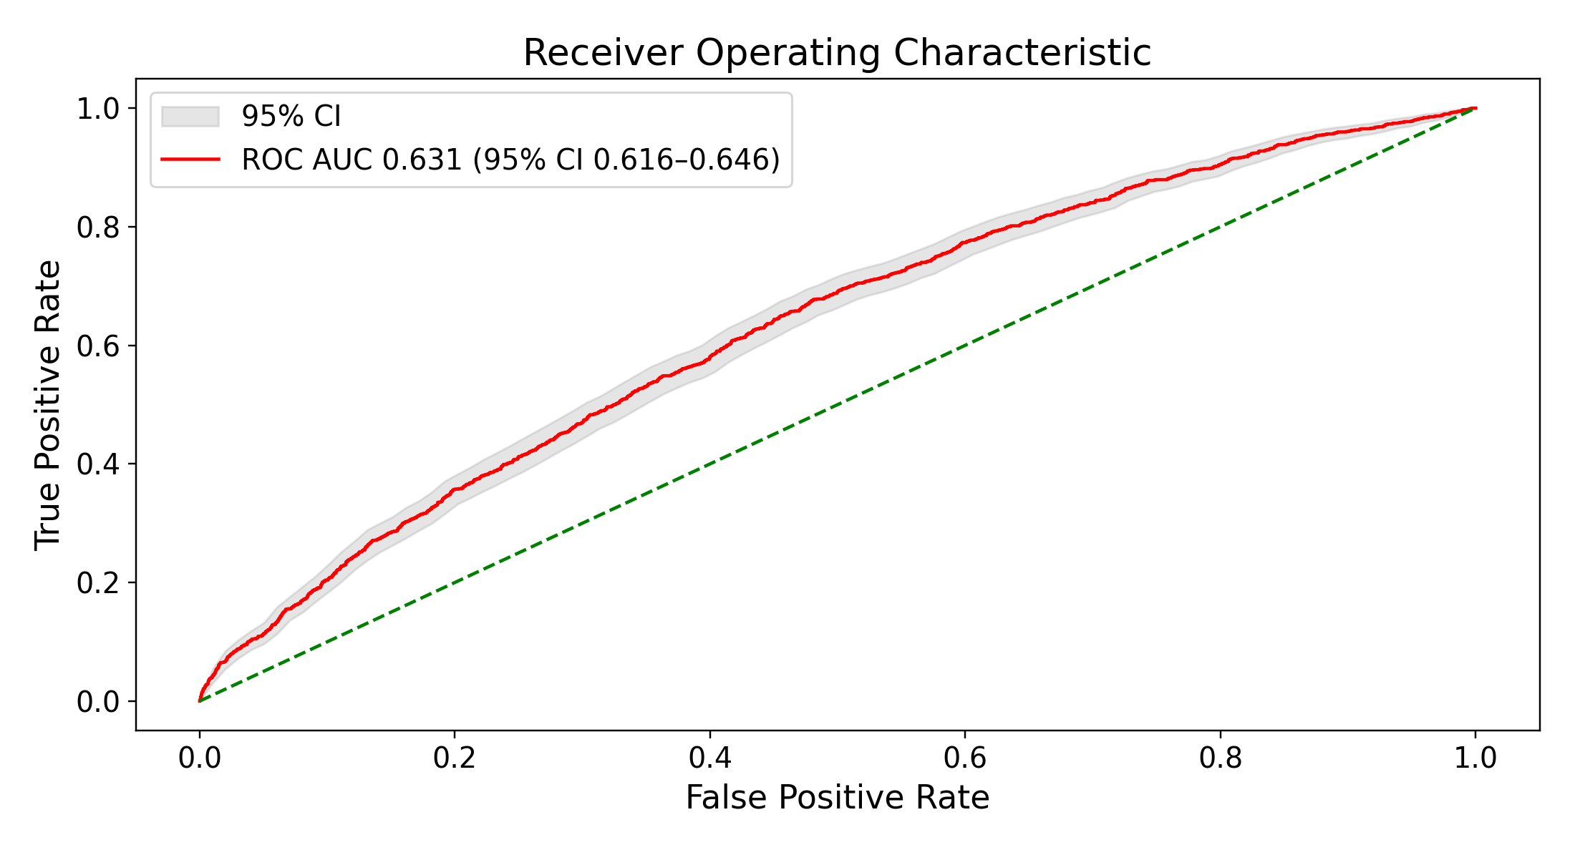
G bge-en-icl, plain-cosine nearest retrieval, k = 413
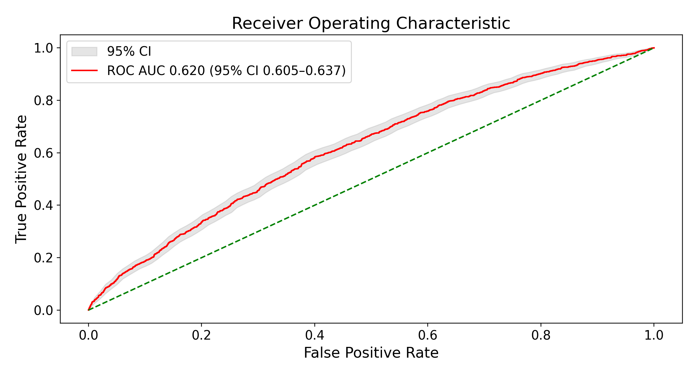
H Qwen3-Embedding-4B, logistic-regression-weighted nearest retrieval, k = 684
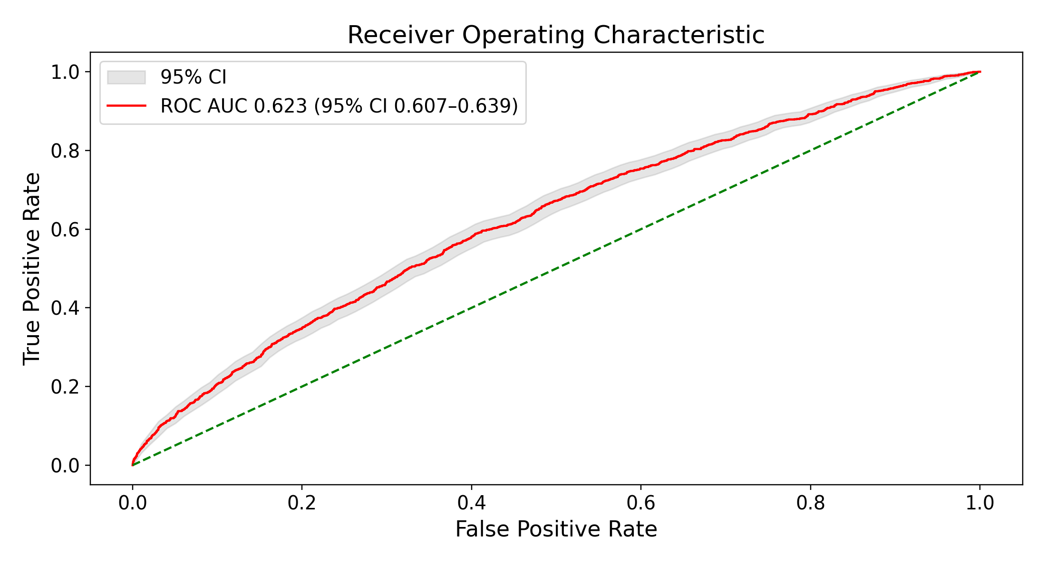
I Qwen3-Embedding-4B, plain-cosine nearest retrieval, k = 493
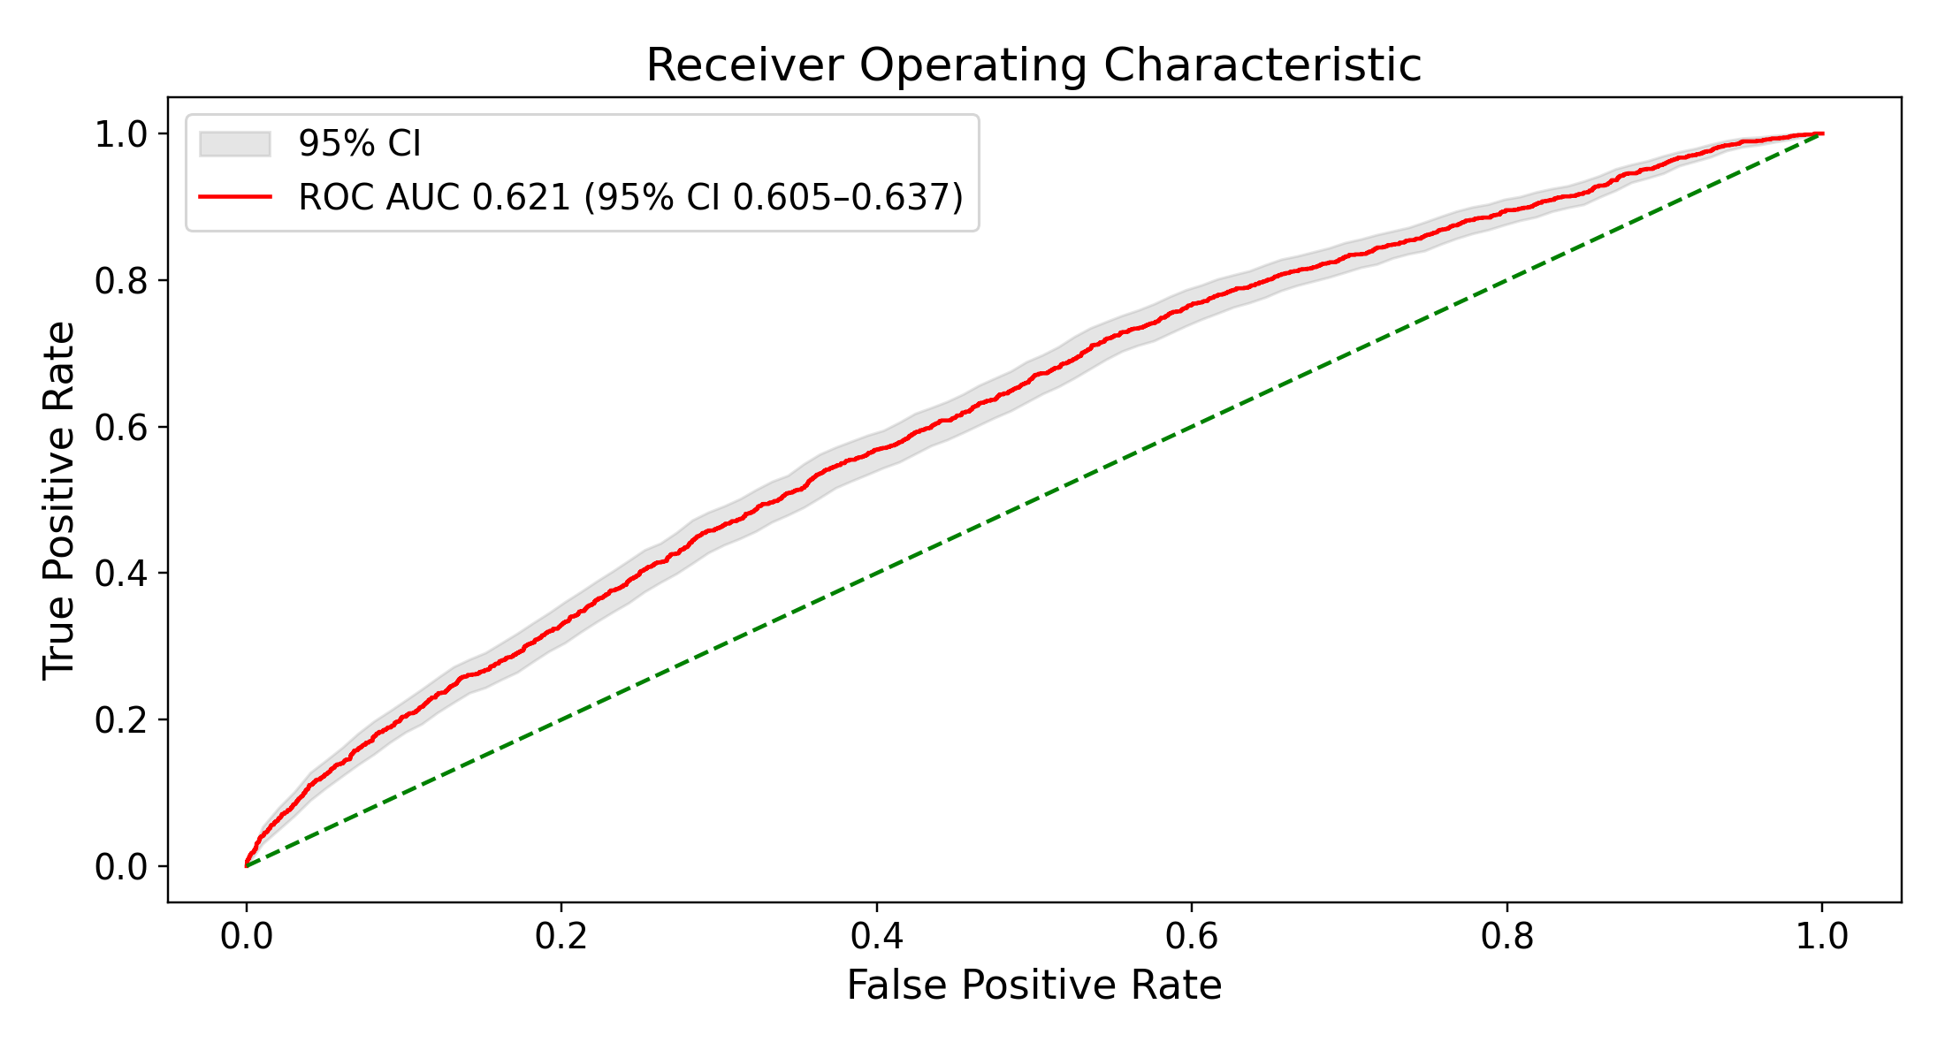
Figure S8. ROC curves at each arm’s own test-selected best k, with $α$ = 1 for nearest retrieval. A–C: the primary encoder, Qwen3-Embedding-8B, under logistic-regression-weighted (A) and plain-cosine (B) nearest retrieval and uniform random retrieval (C). D–I: logistic-regression-weighted and plain-cosine nearest retrieval for bge-small-en-v1.5 (D–E), bge-en-icl (F–G), and Qwen3-Embedding-4B (H–I), each weighted by its own embedded logistic regression. C is the draw whose AUC at that k is closest to the mean of 1,000 draws; its band, and the intervals in Figure S9C, are the bootstrap 95% CI of that one draw over test patients, not the 2.5th–97.5th percentile across draws in Table S7. Best k was chosen on the test patients, so every panel is optimistic. Shaded bands are bootstrap 95% CIs. ROC: receiver operating characteristic.
A Qwen3-Embedding-8B, logistic-regression-weighted nearest retrieval, k = 295
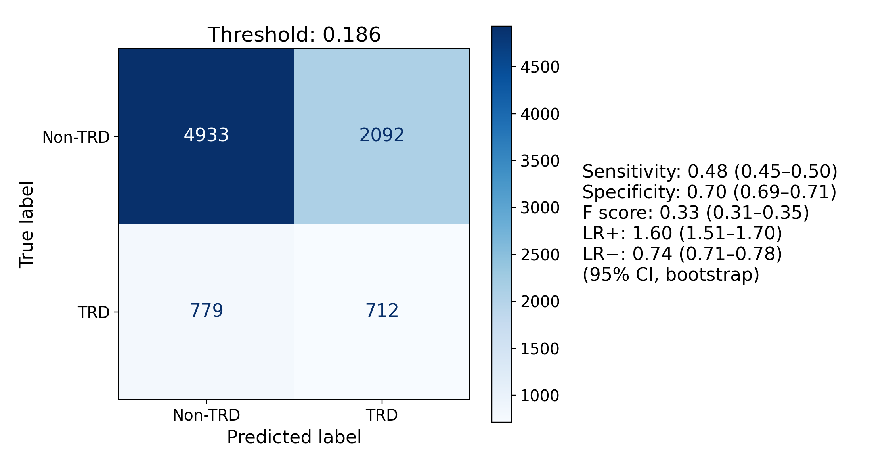
B Qwen3-Embedding-8B, plain-cosine nearest retrieval, k = 757
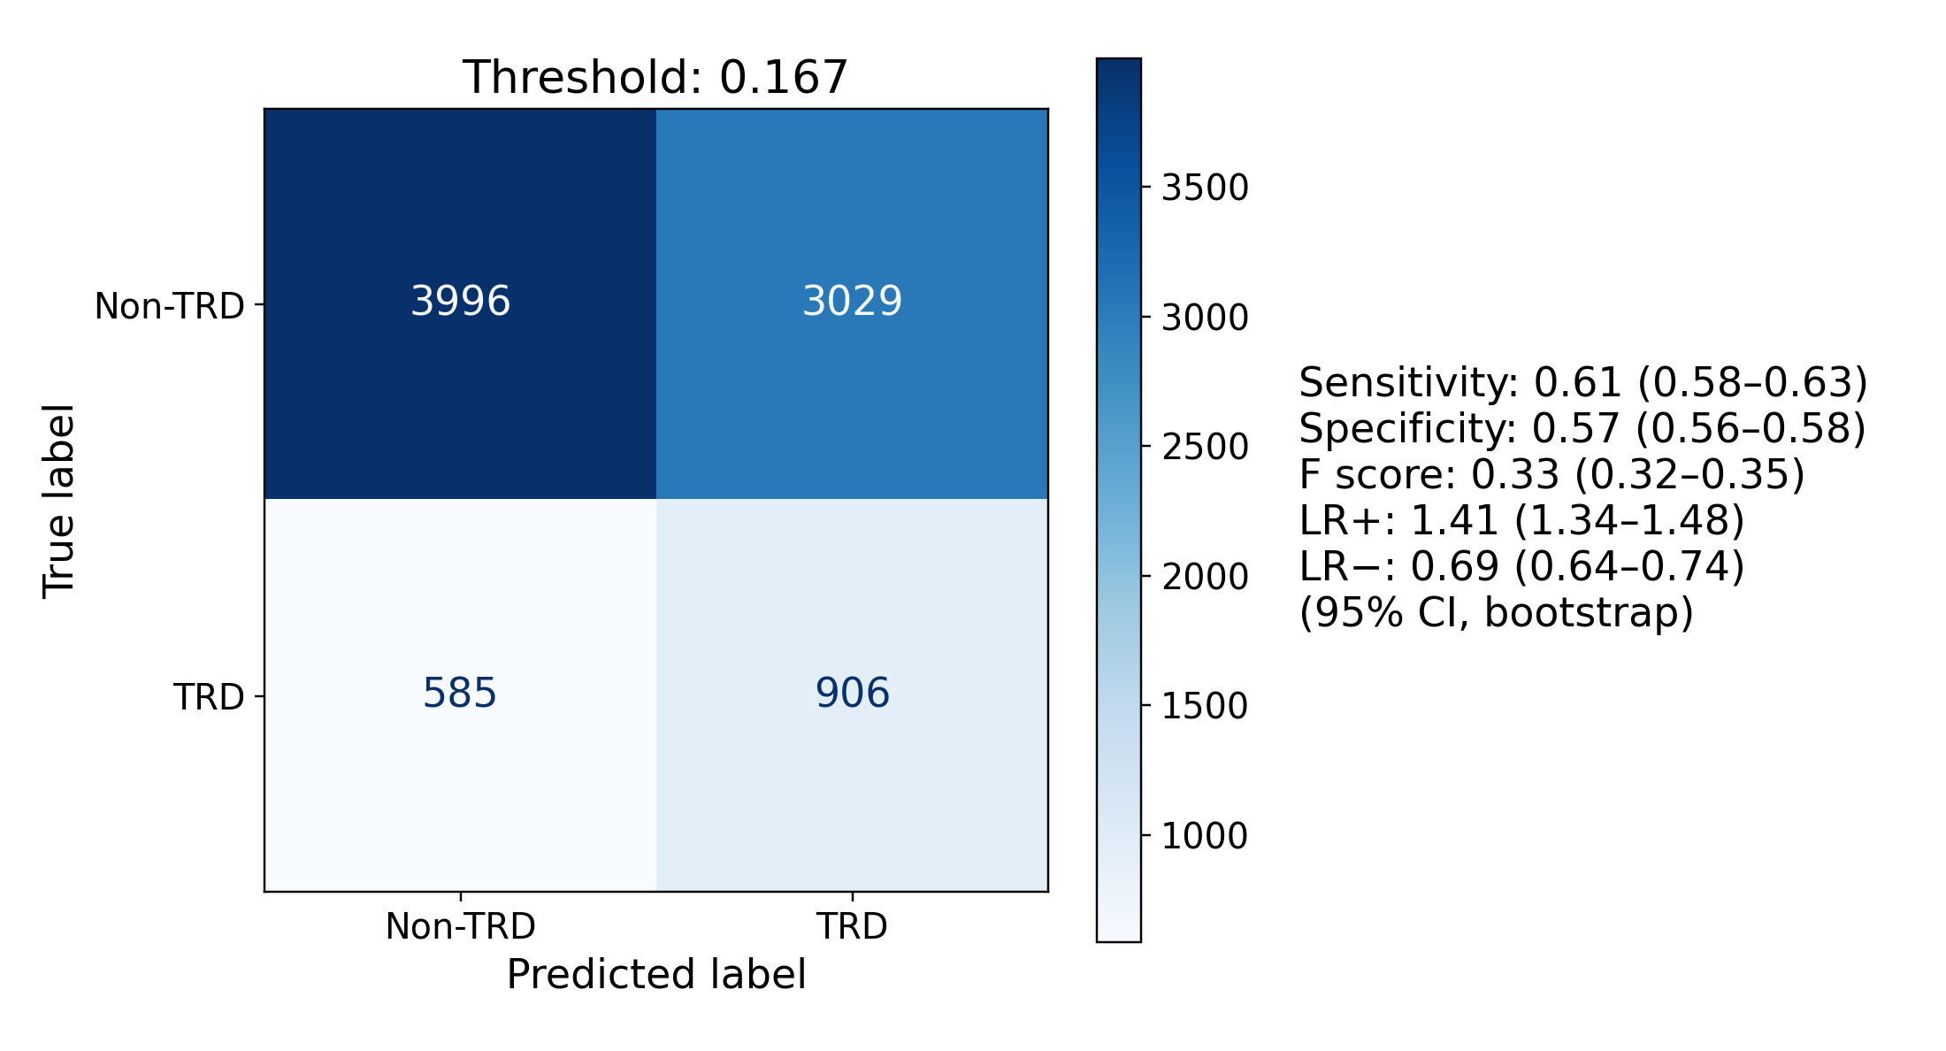
C Random retrieval, uniform weights, k = 32,720
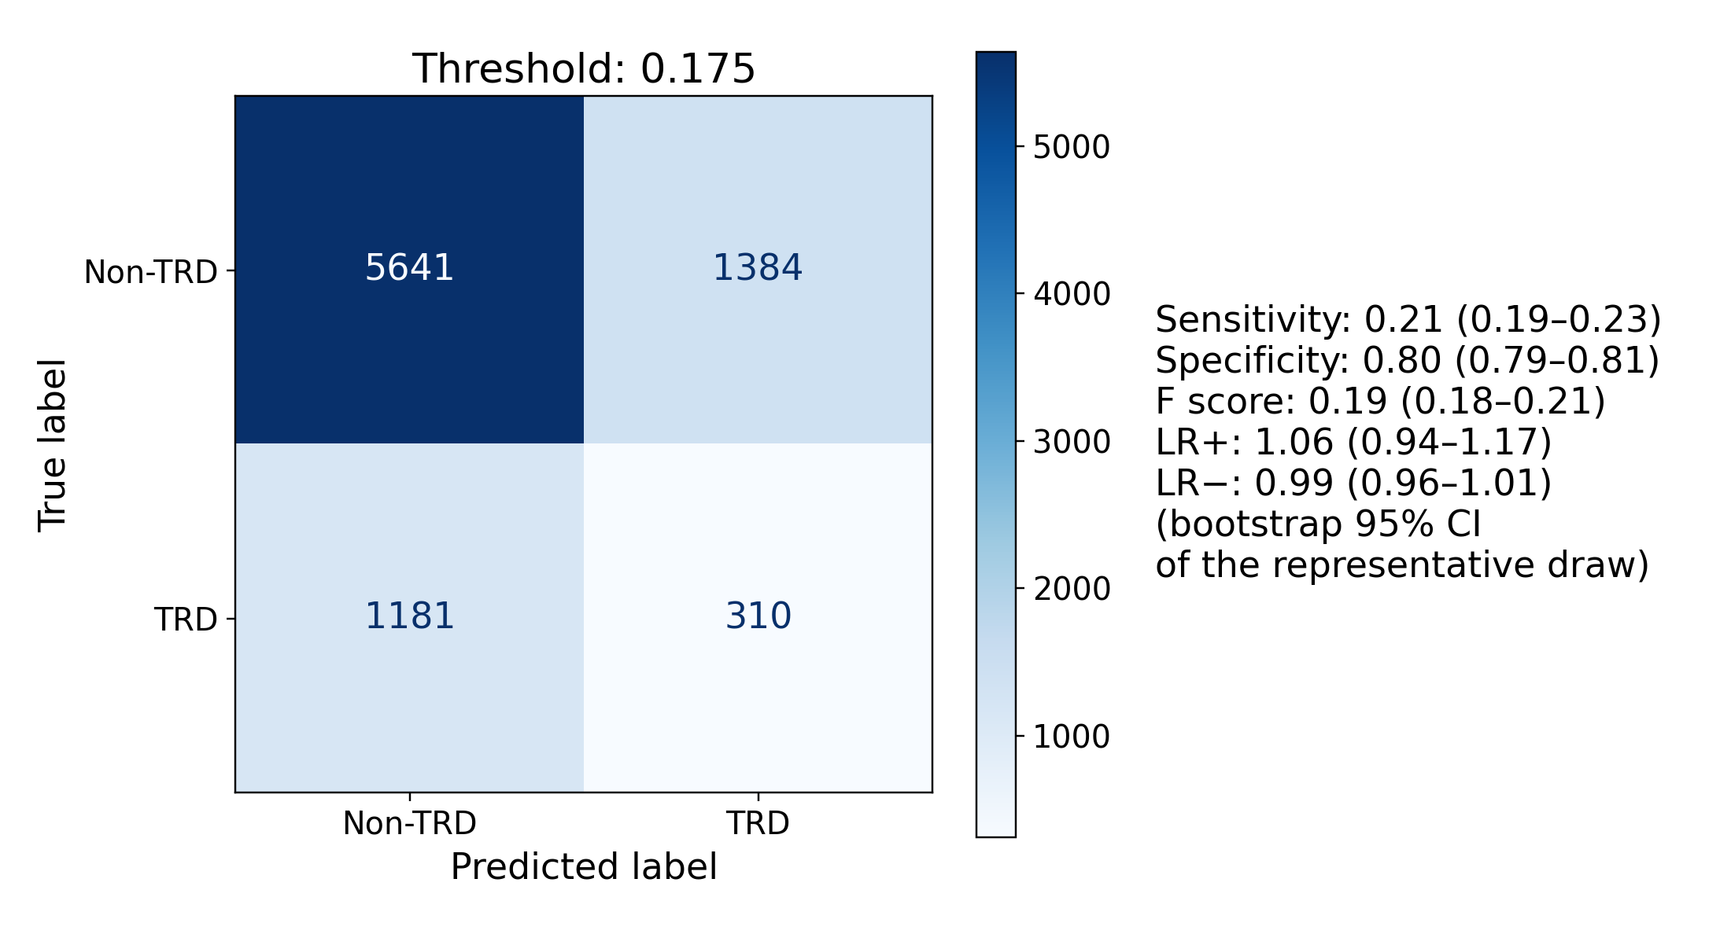
D bge-small-en-v1.5, logistic-regression-weighted nearest retrieval, k = 579
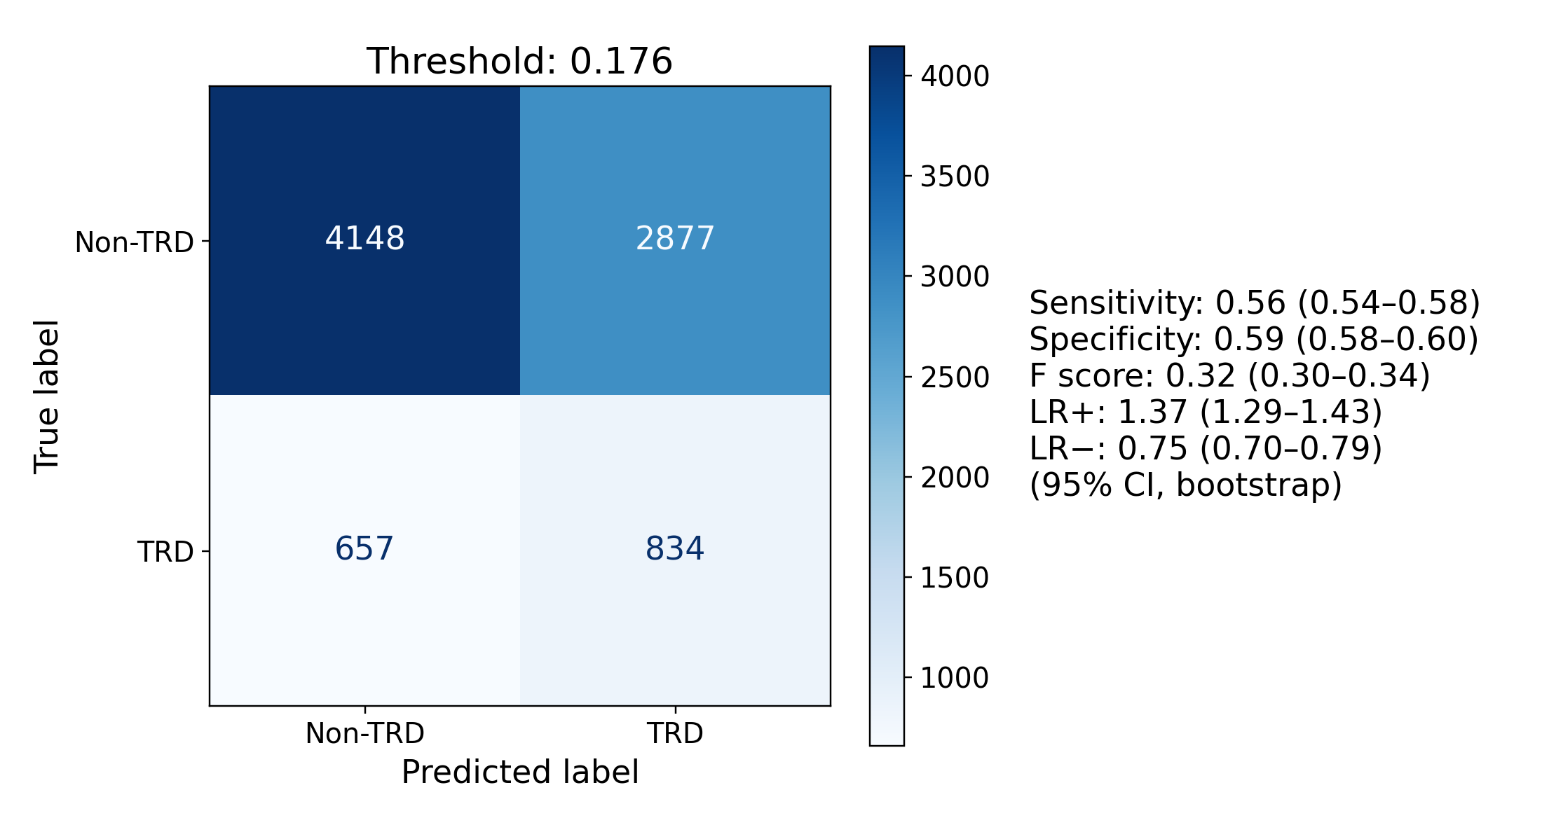
E bge-small-en-v1.5, plain-cosine nearest retrieval, k = 1,243
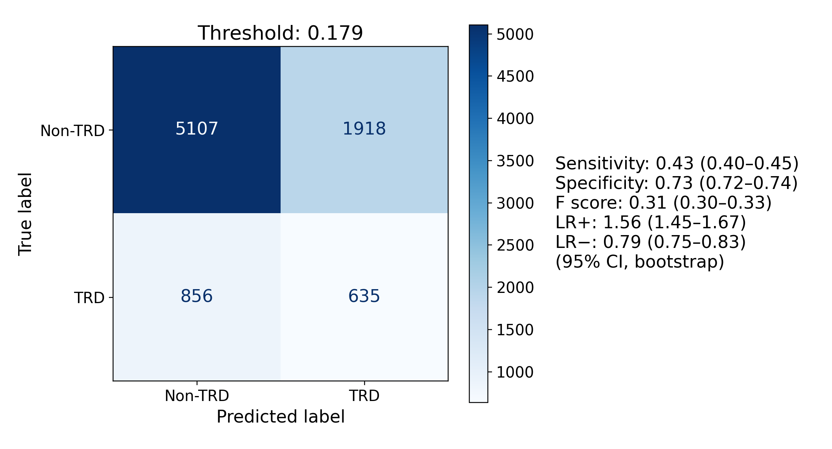
F bge-en-icl, logistic-regression-weighted nearest retrieval, k = 1,519
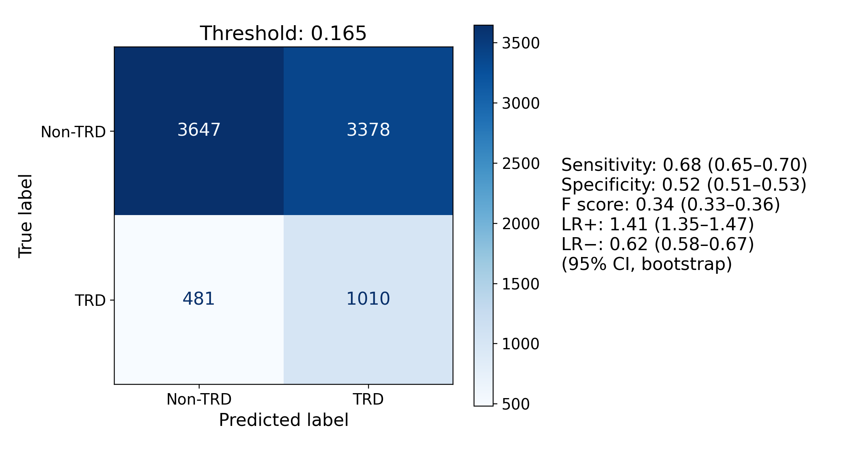
G bge-en-icl, plain-cosine nearest retrieval, k = 413
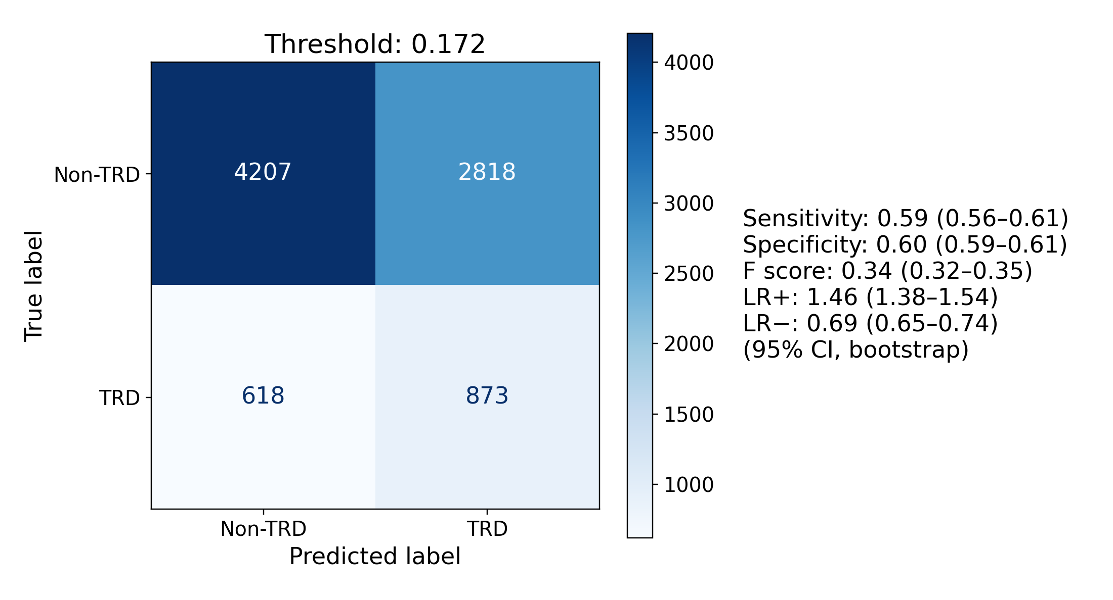
H Qwen3-Embedding-4B, logistic-regression-weighted nearest retrieval, k = 684
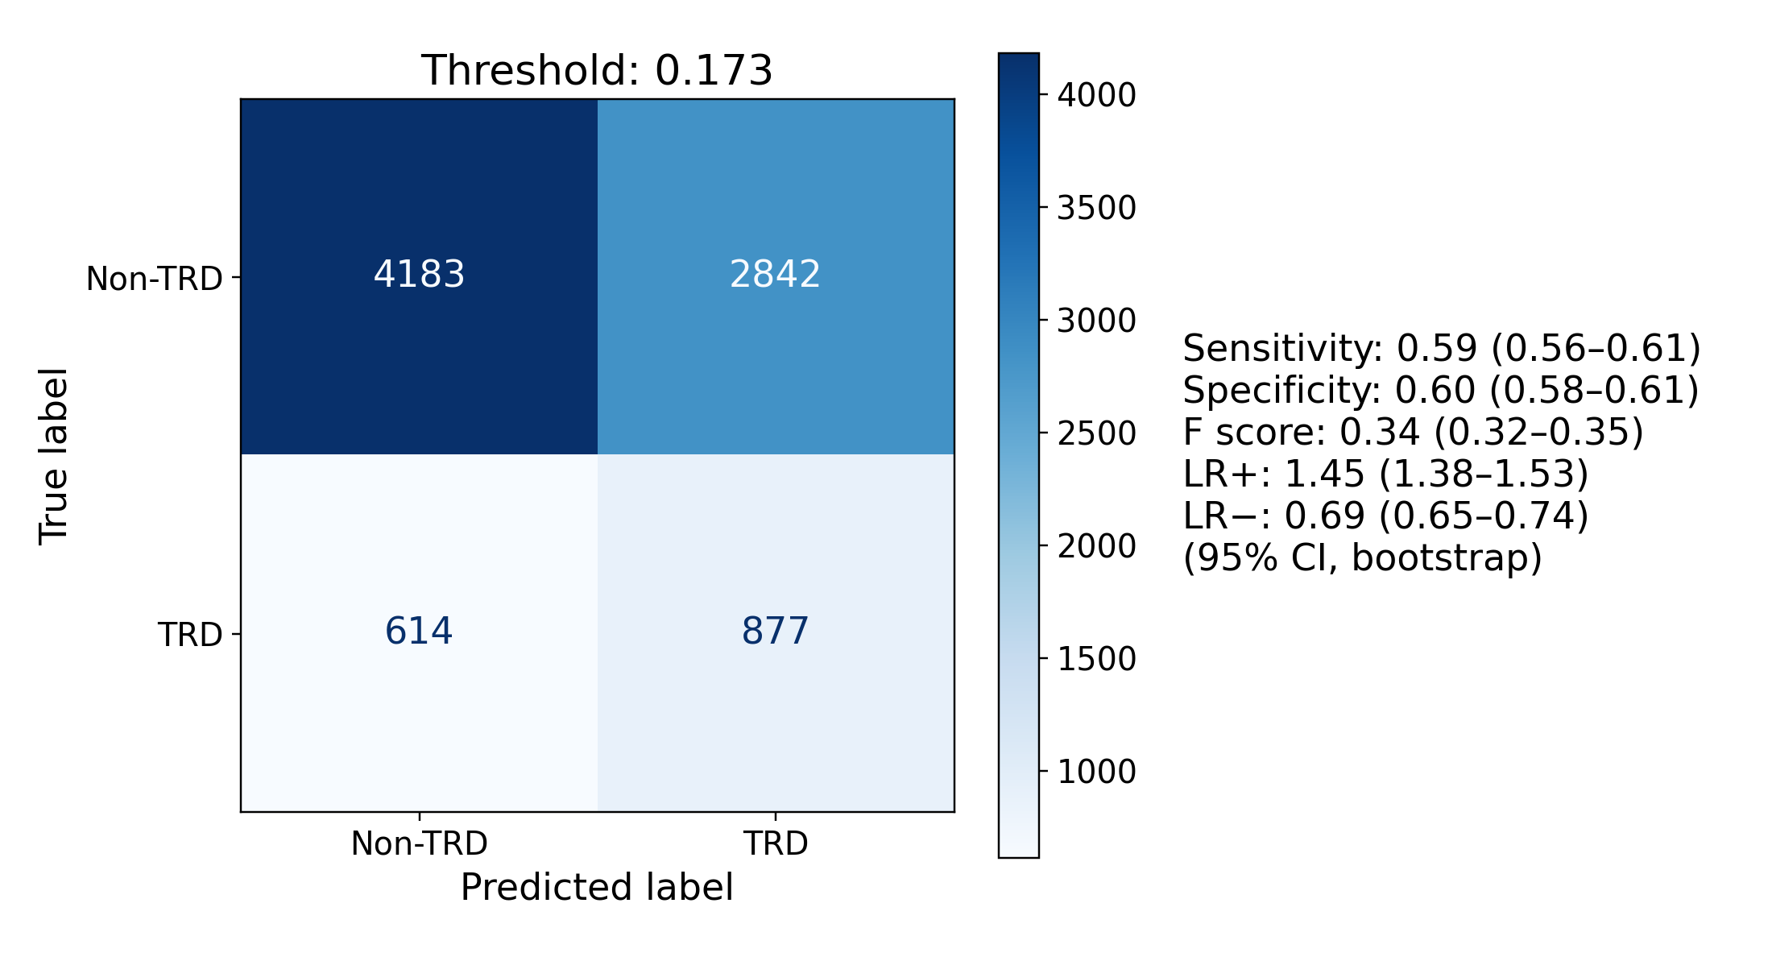
I Qwen3-Embedding-4B, plain-cosine nearest retrieval, k = 493
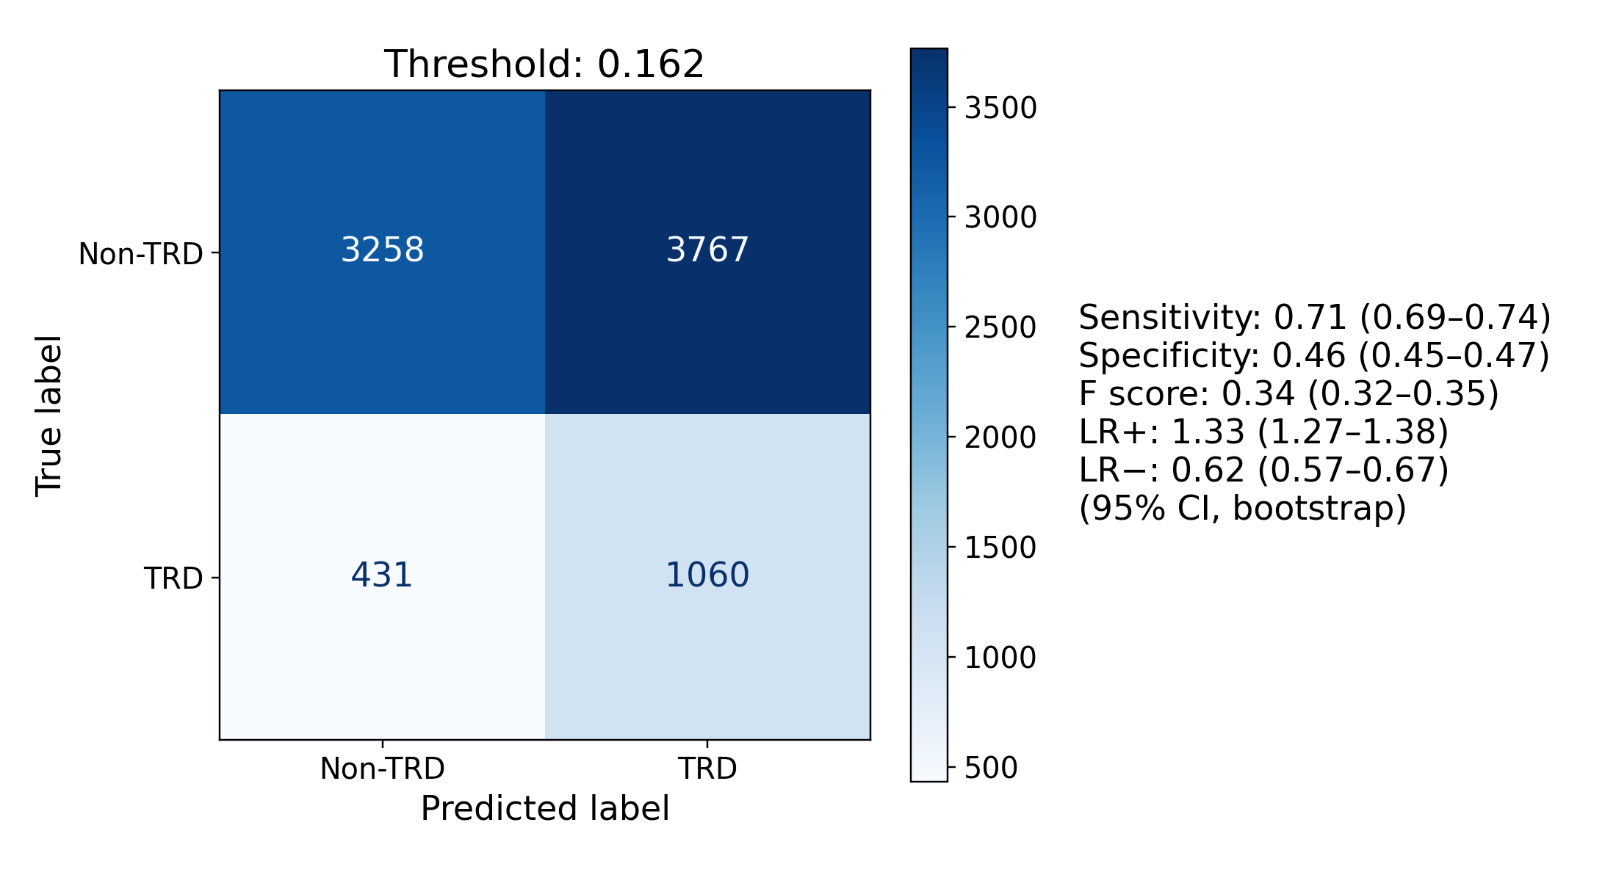
Figure S9. Confusion matrices for the 9 panels of Figure S8 at the same k, at test-selected Youden J thresholds, with bootstrap 95% CIs on every metric at that threshold; the panels’ F score is F1. These operating points were selected and evaluated in the same patients and are descriptive.
Each encoder’s logistic regression relied on a similar number of embedding dimensions for 3 of the 4 encoders. The fewest dimensions holding 90% of the absolute coefficient mass were 253 for bge-small-en-v1.5, 271 for bge-en-icl, 1,626 for Qwen3-Embedding-4B, and 236 for Qwen3-Embedding-8B. These counts describe each fitted model and carry no sampling interval. Best k did not follow them. Qwen3-Embedding-4B used the most dimensions, yet its best k, 684 and 493 for the 2 metrics, lay inside the range of the other encoders (Figure S10).
Dividing each count by the encoder’s number of dimensions gives the share the model relied on: 65.9% for bge-small-en-v1.5 (253 of 384), 6.6% for bge-en-icl (271 of 4,096), 63.5% for Qwen3-Embedding-4B (1,626 of 2,560), and 5.8% for Qwen3-Embedding-8B (236 of 4,096). The share split the encoders by penalty, not by size. The grid search chose an L2 penalty for the 2 encoders near 65%, which keeps every coefficient, and an elastic-net penalty for the 2 near 6%, which sets most coefficients to zero. Best k did not follow the share either (Figure S11). The 2 encoders near 6% had both the highest and the lowest logistic-regression-weighted best k, 1,519 and 295.
These counts describe a fitted model in its own coordinates. They do not measure how many independent risk factors the records hold, and they need not match the number of neighbors that predicts best. With 4 encoders, both figures describe a relation and do not test one.
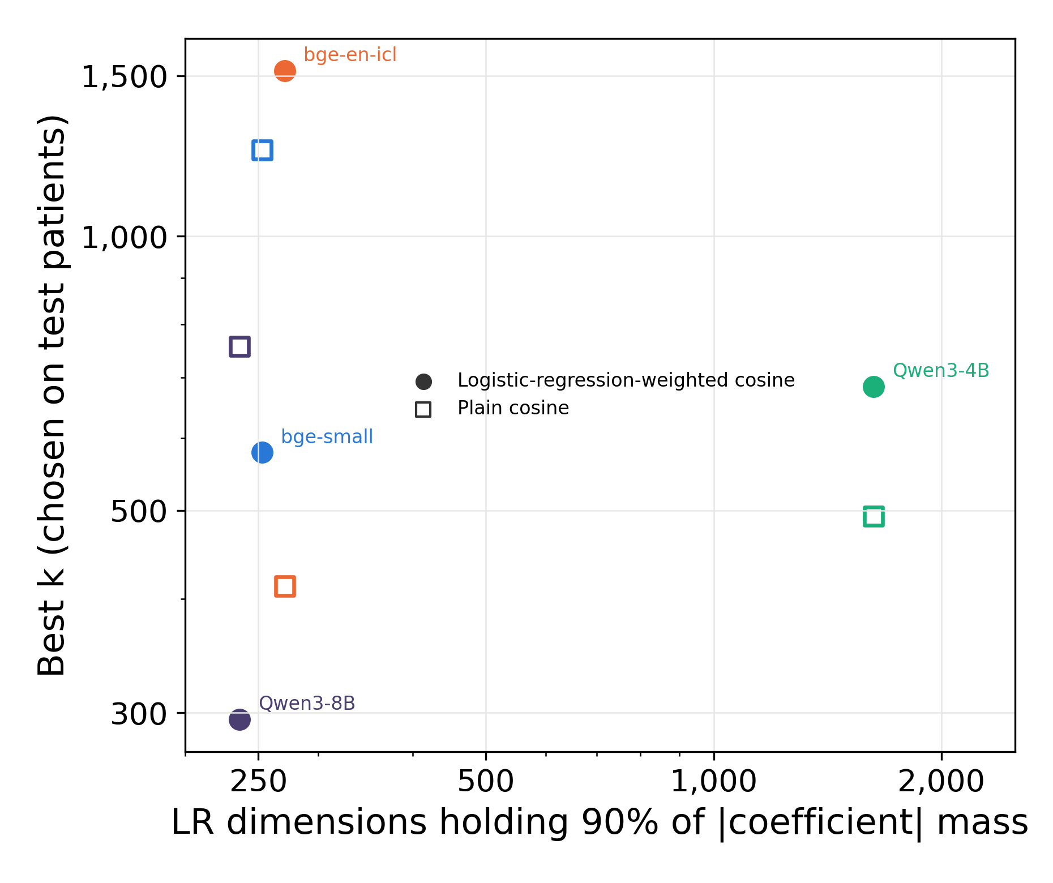
Figure S10. Logistic-regression dimensions against best k for the 4 encoders. The horizontal axis is the fewest embedding dimensions holding 90% of the absolute coefficient mass of each encoder’s embedded logistic regression. The vertical axis is the best k of logistic-regression-weighted (filled markers) and plain cosine retrieval (open markers), chosen on the test patients and therefore optimistic. Both axes are logarithmic. In-plot labels abbreviate bge-small-en-v1.5, Qwen3-Embedding-4B, and Qwen3-Embedding-8B.
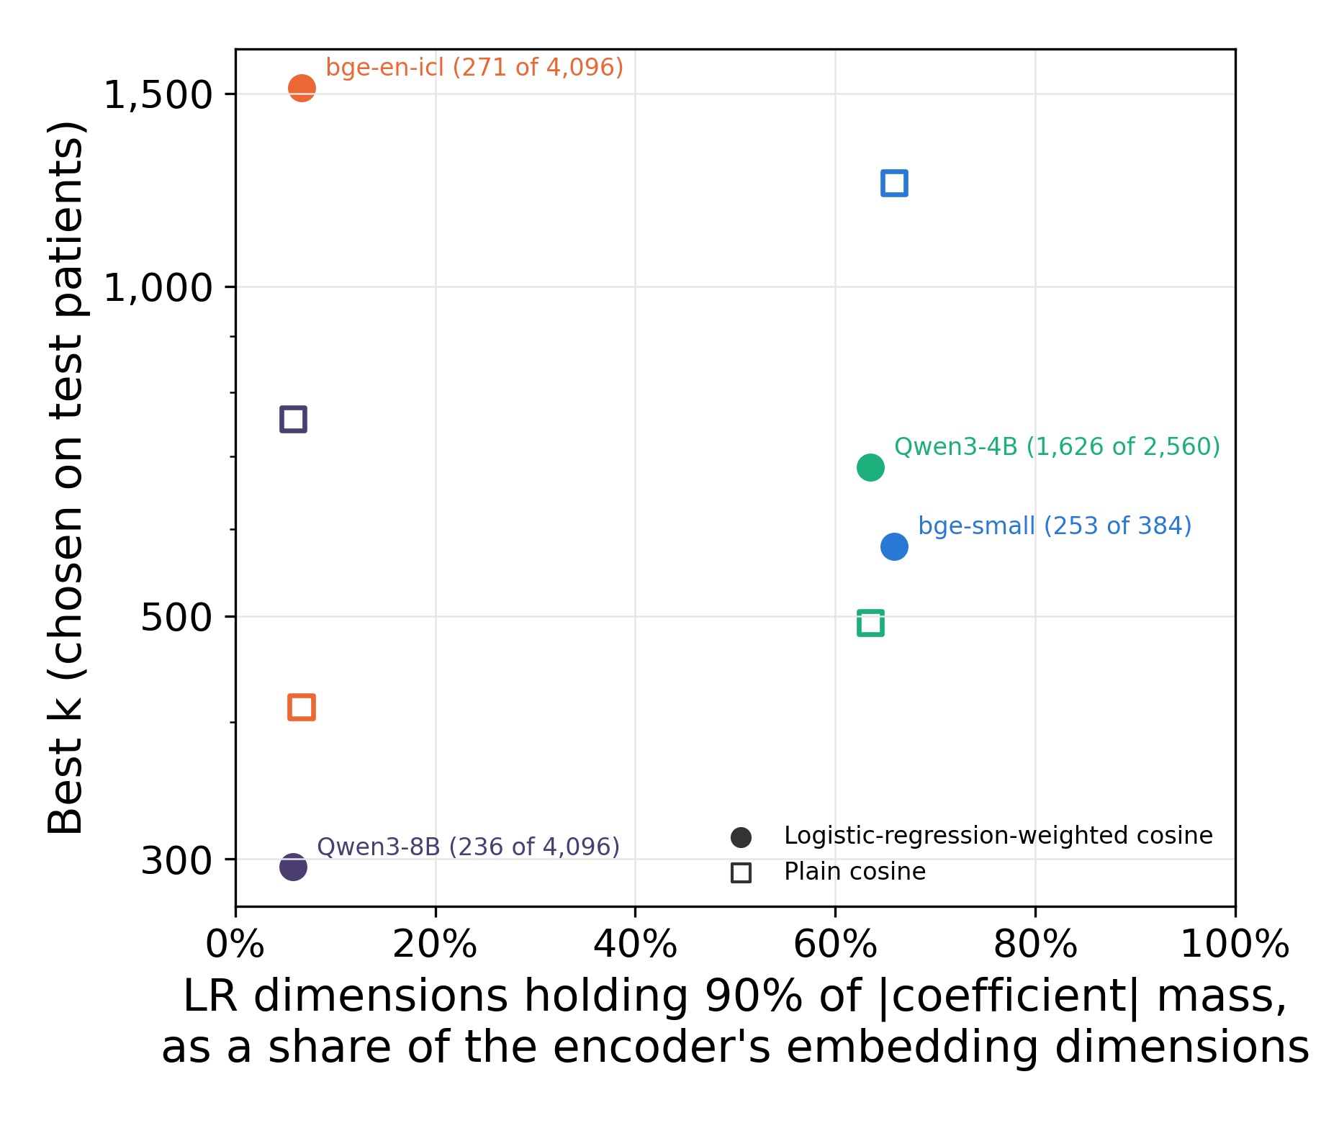
Figure S11. Share of embedding dimensions against best k for the 4 encoders. The horizontal axis is the count in Figure S10 divided by the encoder’s number of embedding dimensions; each label gives the count and the total. The vertical axis is as in Figure S10 and is logarithmic. The 2 encoders near 65% were fitted with an L2 penalty and the 2 near 6% with an elastic-net penalty.

S7 Record Length and Prediction
We examined record volume descriptively by correlating the outcome with history length, encounter count, and the diagnosis-to-index interval, then assessed neighbor-prediction discrimination across history-length quintiles.
Using the full recorded history, outcome correlations were small: Spearman ρ=−0.073 (95% CI −0.082 to −0.064) for pre-index history length, −0.064 (95% CI −0.073 to −0.054) for encounter count, and −0.029 (95% CI −0.038 to −0.020) for diagnosis-to-index interval. Prescribing on the day of diagnosis or the next day occurred in 27,906 patients, with outcome frequency 18.4% (95% CI 17.9–18.8), compared with 14,673 patients and 15.9% (95% CI 15.3–16.5) for later prescribing (Figure S12). These weak marginal relationships do not rule out care-process contributions to prediction.
A Pre-index history length
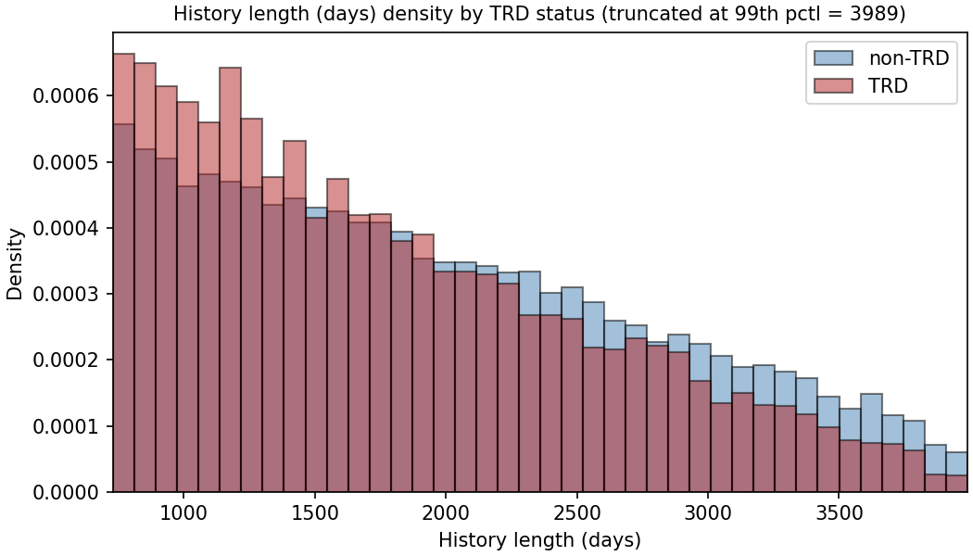
B Diagnosis-to-index interval
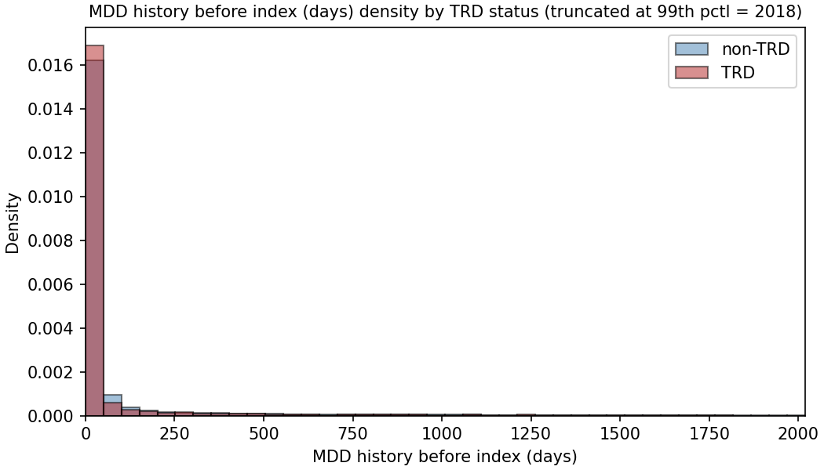
C Encounter count
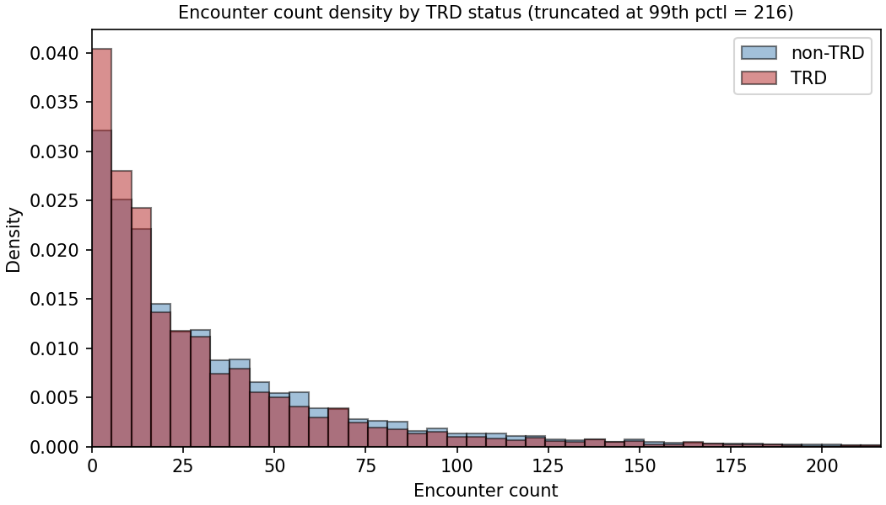
D Outcome frequency by prescription timing
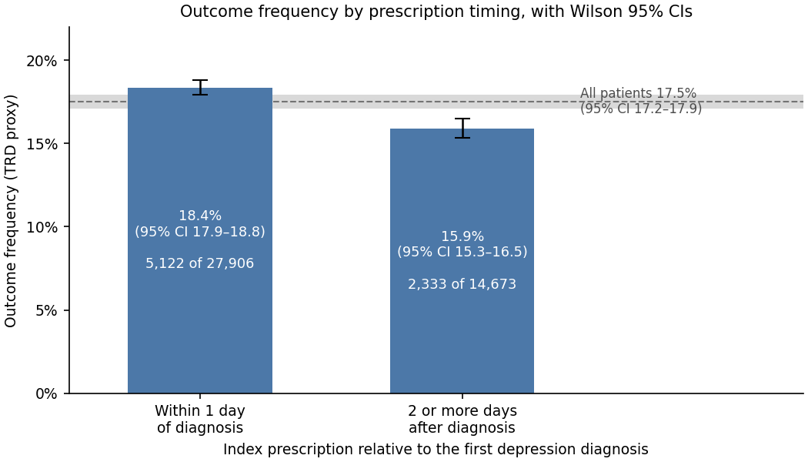
Figure S12. Record length, diagnosis-to-index interval, encounter count, and outcome frequency by prescription timing. A–C show outcome-stratified distributions; axes are truncated as labeled. D compares prescribing within 1 day of diagnosis (the day of diagnosis or the next day) with prescribing 2 or more days later. Bars carry Wilson 95% CIs, and each bar is labeled with its outcome frequency and counts. The dashed line is the cohort outcome frequency, 17.5%, with its 95% CI (17.2–17.9) shaded.
The held-out test set was divided into quintiles of pre-index history length, and each retrieval arm was scored within each quintile at its own best k from section S6 (Table S8). The best k was chosen on all test patients, so these values are optimistic in the same way.
Table S8. Neighbor-prediction ROC AUC by quintile of pre-index history length (embedded representation, held-out test set, $α$ = 1), with bootstrap 95% CIs within each quintile. Days are the quintile’s bounds of pre-index history. Weighted: logistic-regression-weighted cosine; plain: plain cosine. Random retrieval uses uniform weights and the draw whose AUC at its best k is closest to the mean of 1,000 draws.
Days | n | Events | Weighted, k = 295 | Plain, k = 757 | Random, k = 32,720
731–1,110 | 1,706 | 372 | 0.625 (0.592–0.657) | 0.619 (0.585–0.651) | 0.479 (0.447–0.513)
1,111–1,554 | 1,704 | 317 | 0.624 (0.590–0.658) | 0.619 (0.584–0.652) | 0.526 (0.489–0.561)
1,555–2,066 | 1,701 | 290 | 0.600 (0.564–0.636) | 0.608 (0.572–0.643) | 0.531 (0.492–0.564)
2,067–2,733 | 1,704 | 282 | 0.633 (0.598–0.669) | 0.626 (0.592–0.663) | 0.487 (0.449–0.523)
2,734–5,288 | 1,701 | 230 | 0.619 (0.580–0.655) | 0.598 (0.561–0.636) | 0.479 (0.437–0.519)
AUC ranged from 0.600 to 0.633 for logistic-regression-weighted and 0.598 to 0.626 for plain cosine retrieval, without a monotonic trend, and every quintile’s interval overlapped the others. Random retrieval stayed near 0.5, and its interval included 0.5 in every quintile. This does not establish independence from record volume; differing case mix and imprecision within strata limit interpretation.
The stratification covers neighbor prediction only, not the trained classifiers. Each quintile contained about 1,700 patients.

S8 Training and Test Characteristics
Table S9 compares selected characteristics in the shared training and test split.
Across 100 predictor rows, maximum absolute SMD was 0.036. The largest value involved a social-determinant flag present in 22 training patients and no test patient. Outcome rates match because the split was stratified.
Table S9. Held-out patients against training patients on the characteristics reported in Table 1. Continuous variables are median (IQR); categorical and boolean entries are n (%). SMD is training minus held-out, in pooled standard deviations. Vital signs are shown because they describe the cohort, but they are rendered only in the narrative representation and are absent from the feature matrix as published (Supplement S10).
Characteristic | Training | Held-out | SMD
Demographics
Age (years) | 55 (38-70) | 55 (38-70) | -0.014
Age band: 18-29 | 4,428 (13.0%) | 1,085 (12.7%) | +0.008
Age band: 30-44 | 7,198 (21.1%) | 1,827 (21.5%) | -0.008
Age band: 45-64 | 10,632 (31.2%) | 2,636 (31.0%) | +0.006
Age band: 65+ | 11,805 (34.7%) | 2,968 (34.9%) | -0.004
Sex: Female | 24,682 (72.5%) | 6,168 (72.4%) | +0.001
Race: White/Caucasian | 27,244 (80.0%) | 6,835 (80.3%) | -0.007
Race: Black/African American | 1,894 (5.6%) | 474 (5.6%) | -0.000
Race: Am. Indian/Alaska Native | 1,637 (4.8%) | 396 (4.7%) | +0.007
Race: Missing | 247 (0.7%) | 50 (0.6%) | +0.017
Language: English only | 33,698 (98.9%) | 8,425 (98.9%) | -0.000
Depression phenotype
MDD recurrence: Recurrent | 9,036 (26.5%) | 2,177 (25.6%) | +0.022
MDD severity: Severe | 1,818 (5.3%) | 468 (5.5%) | -0.007
MDD severity: Moderate | 5,807 (17.0%) | 1,426 (16.7%) | +0.008
Psychiatric and substance comorbidity
Suicidality flagged | 1,392 (4.1%) | 361 (4.2%) | -0.008
Anxiety disorder | 17,975 (52.8%) | 4,426 (52.0%) | +0.016
Substance use disorder (any) | 7,472 (21.9%) | 1,793 (21.1%) | +0.021
Insomnia | 7,452 (21.9%) | 1,898 (22.3%) | -0.010
PTSD | 1,241 (3.6%) | 300 (3.5%) | +0.006
Alcohol use disorder | 1,523 (4.5%) | 352 (4.1%) | +0.017
Medical comorbidity
High cholesterol | 12,591 (37.0%) | 3,156 (37.1%) | -0.002
Uncontrolled hypertension | 12,544 (36.8%) | 3,136 (36.8%) | +0.000
Vital signs (narrative only)
BMI | 29 (25-35) | 29 (25-35) | -0.013
Systolic BP | 126 (118-136) | 126 (118-136) | -0.010
BMI: not recorded | 7,484 (22.0%) | 1,911 (22.4%) | -0.011
Treatment and utilization
Active med count | 1 (0-2) | 1 (0-2) | +0.008
Encounter count | 21 (8-46) | 20 (8-47) | -0.001
Pre-index history (days) | 1792 (1213-2547) | 1797 (1222-2541) | +0.004
Prior adequate AD trial (any class) | 5,014 (14.7%) | 1,262 (14.8%) | -0.003
Benzodiazepine days recorded | 3,775 (11.1%) | 949 (11.1%) | -0.002
Hypnotic recorded | 1,319 (3.9%) | 342 (4.0%) | -0.007
Augmentation therapy used | 326 (1.0%) | 96 (1.1%) | -0.017
The measured balance supports internal comparability. It does not establish distributional identity or representativeness of the health system, because both partitions inherit the same sampling design.

S9 Subgroup Performance
Subgroup analyses address performance differences, a question distinct from direct-input reliance under permutation. They do not establish fairness of the outcome label or of a proposed clinical decision.

S9.1 Design
Held-out predicted probabilities were partitioned by subgroup without refitting models. Discrimination and calibration were recalculated within each group.
The analysis included 4 FEATURE classifiers, 4 EMBEDDED classifiers, and 3 neighbor configurations for the primary encoder, each at its own best k from section S6: nearest retrieval under plain cosine similarity (k = 757) and under logistic-regression-weighted similarity (k = 295), and uniform random retrieval (k = 32,720) as a control. Between-group contrasts included the 2 nearest-neighbor configurations and excluded the control. The best k was chosen on all test patients, not within each subgroup.
Strata comprised sex, recorded race, age, marital status, smoking, religion, MDD recurrence, and severity. Race was aggregated as White versus other recorded categories because of small subgroup counts; this masks potentially important heterogeneity. Preferred language was not contrasted because 98.9% (95% CI 98.7–99.1) of held-out patients preferred English. A subgroup was treated as not estimable when its smaller outcome class contained fewer than 20 patients.
Within-group CIs used percentile bootstrap resampling, and every within-group metric (ROC AUC, Brier score, logistic slope, mean risk difference) carries one, cut from the same resamples. Contrasts between disjoint groups used independent resampling of each group. Two-sided bootstrap P values were adjusted across 240 contrasts with the Benjamini–Hochberg procedure.
The individual-level calibration slope was estimated by logistic regression of outcome on logit predicted risk. Mean predicted risk minus observed outcome frequency was also reported, labeled “mean risk difference” rather than “calibration-in-the-large” to identify the quantity actually calculated. This is not a logistic calibration intercept. Both differ from the binned-curve parameters in section S3.

S9.2 Sociodemographic strata
Table S10 gives discrimination and calibration within each sociodemographic stratum, and Figure S13 plots the discrimination.
Table S10. Discrimination and calibration by sociodemographic stratum, one representative model per arm (embedded logistic regression, feature-vector XGBoost, and logistic-regression-weighted retrieval at k = 295, the leading model of each), primary encoder, held-out test set. Groups are not disjoint across families: every patient with a recorded sex appears in one sex row and every patient with a recorded race in one race row.
Group | n | Events | Arm | ROC AUC (95% CI) | Brier (95% CI) | Logistic slope (95% CI) | Mean risk difference (95% CI)
All held-out patients | 8,516 | 1,491 | E LR | 0.657 (0.643–0.672) | 0.137 (0.132–0.142) | 0.97 (0.88–1.06) | +0.000 (−0.007 to +0.008)
All held-out patients | 8,516 | 1,491 | F XGB | 0.649 (0.634–0.664) | 0.138 (0.132–0.143) | 1.25 (1.13–1.37) | +0.000 (−0.008 to +0.008)
All held-out patients | 8,516 | 1,491 | N WTD | 0.625 (0.610–0.641) | 0.140 (0.134–0.145) | 1.15 (1.01–1.29) | −0.004 (−0.012 to +0.005)
Male | 2,347 | 386 | E LR | 0.653 (0.622–0.682) | 0.131 (0.121–0.140) | 0.94 (0.76–1.13) | −0.003 (−0.017 to +0.012)
Male | 2,347 | 386 | F XGB | 0.654 (0.624–0.683) | 0.131 (0.122–0.140) | 1.18 (0.96–1.42) | +0.006 (−0.007 to +0.021)
Male | 2,347 | 386 | N WTD | 0.625 (0.595–0.653) | 0.133 (0.124–0.142) | 1.04 (0.78–1.28) | −0.001 (−0.014 to +0.013)
Female | 6,168 | 1,105 | E LR | 0.658 (0.641–0.675) | 0.139 (0.134–0.145) | 0.98 (0.87–1.09) | +0.002 (−0.007 to +0.011)
Female | 6,168 | 1,105 | F XGB | 0.647 (0.630–0.664) | 0.140 (0.134–0.146) | 1.27 (1.14–1.42) | −0.002 (−0.011 to +0.007)
Female | 6,168 | 1,105 | N WTD | 0.624 (0.607–0.642) | 0.142 (0.136–0.148) | 1.20 (1.04–1.37) | −0.005 (−0.013 to +0.004)
White/Caucasian | 6,835 | 1,181 | E LR | 0.657 (0.640–0.674) | 0.136 (0.130–0.141) | 0.97 (0.87–1.08) | +0.002 (−0.007 to +0.010)
White/Caucasian | 6,835 | 1,181 | F XGB | 0.656 (0.639–0.673) | 0.136 (0.130–0.141) | 1.28 (1.14–1.44) | −0.000 (−0.009 to +0.008)
White/Caucasian | 6,835 | 1,181 | N WTD | 0.633 (0.615–0.650) | 0.138 (0.132–0.143) | 1.22 (1.06–1.38) | −0.004 (−0.013 to +0.005)
Non-White (recorded) | 1,631 | 302 | E LR | 0.652 (0.620–0.684) | 0.144 (0.133–0.155) | 0.95 (0.74–1.16) | −0.004 (−0.023 to +0.013)
Non-White (recorded) | 1,631 | 302 | F XGB | 0.616 (0.579–0.650) | 0.146 (0.136–0.158) | 1.07 (0.75–1.36) | +0.000 (−0.019 to +0.017)
Non-White (recorded) | 1,631 | 302 | N WTD | 0.587 (0.553–0.620) | 0.148 (0.138–0.161) | 0.85 (0.53–1.15) | −0.004 (−0.024 to +0.013)
Race not recorded | 50 | 8 | E LR | not estimable | — | — | —
Race not recorded | 50 | 8 | F XGB | not estimable | — | — | —
Race not recorded | 50 | 8 | N WTD | not estimable | — | — | —
Age band: 18-29 | 1,085 | 218 | E LR | 0.611 (0.568–0.654) | 0.156 (0.142–0.171) | 0.78 (0.49–1.07) | +0.003 (−0.022 to +0.026)
Age band: 18-29 | 1,085 | 218 | F XGB | 0.588 (0.544–0.628) | 0.157 (0.144–0.172) | 0.96 (0.50–1.39) | +0.001 (−0.025 to +0.024)
Age band: 18-29 | 1,085 | 218 | N WTD | 0.578 (0.535–0.620) | 0.158 (0.144–0.174) | 0.81 (0.40–1.24) | −0.007 (−0.033 to +0.016)
Age band: 30-44 | 1,827 | 372 | E LR | 0.653 (0.621–0.682) | 0.154 (0.144–0.165) | 0.95 (0.76–1.14) | −0.002 (−0.021 to +0.016)
Age band: 30-44 | 1,827 | 372 | F XGB | 0.649 (0.617–0.681) | 0.154 (0.144–0.166) | 1.35 (1.08–1.66) | −0.004 (−0.023 to +0.014)
Age band: 30-44 | 1,827 | 372 | N WTD | 0.610 (0.578–0.642) | 0.158 (0.147–0.170) | 1.08 (0.78–1.36) | −0.015 (−0.035 to +0.002)
Age band: 45-64 | 2,636 | 473 | E LR | 0.652 (0.623–0.679) | 0.140 (0.130–0.148) | 0.98 (0.81–1.15) | +0.007 (−0.006 to +0.022)
Age band: 45-64 | 2,636 | 473 | F XGB | 0.642 (0.614–0.671) | 0.140 (0.131–0.149) | 1.24 (1.01–1.48) | +0.005 (−0.008 to +0.020)
Age band: 45-64 | 2,636 | 473 | N WTD | 0.624 (0.594–0.651) | 0.142 (0.133–0.151) | 1.16 (0.91–1.42) | −0.002 (−0.015 to +0.013)
Age band: 65+ | 2,968 | 428 | E LR | 0.658 (0.630–0.682) | 0.117 (0.108–0.126) | 1.10 (0.92–1.28) | −0.005 (−0.017 to +0.008)
Age band: 65+ | 2,968 | 428 | F XGB | 0.660 (0.631–0.687) | 0.118 (0.109–0.126) | 1.42 (1.19–1.66) | −0.002 (−0.015 to +0.011)
Age band: 65+ | 2,968 | 428 | N WTD | 0.624 (0.595–0.651) | 0.119 (0.111–0.128) | 1.28 (1.02–1.54) | +0.003 (−0.010 to +0.016)
Marital status: Divorced | 882 | 211 | E LR | 0.640 (0.593–0.681) | 0.173 (0.156–0.191) | 0.90 (0.64–1.14) | −0.046 (−0.074 to −0.018)
Marital status: Divorced | 882 | 211 | F XGB | 0.633 (0.590–0.673) | 0.175 (0.158–0.193) | 1.12 (0.79–1.45) | −0.053 (−0.082 to −0.026)
Marital status: Divorced | 882 | 211 | N WTD | 0.607 (0.561–0.646) | 0.179 (0.161–0.197) | 1.07 (0.69–1.42) | −0.061 (−0.089 to −0.034)
Marital status: Never Married | 2,364 | 438 | E LR | 0.634 (0.609–0.661) | 0.145 (0.137–0.155) | 0.85 (0.69–1.02) | +0.013 (−0.003 to +0.028)
Marital status: Never Married | 2,364 | 438 | F XGB | 0.620 (0.595–0.649) | 0.146 (0.137–0.156) | 1.12 (0.88–1.37) | +0.011 (−0.005 to +0.026)
Marital status: Never Married | 2,364 | 438 | N WTD | 0.590 (0.562–0.619) | 0.149 (0.139–0.159) | 0.85 (0.61–1.12) | +0.002 (−0.014 to +0.016)
Marital status: Now Married | 4,251 | 694 | E LR | 0.670 (0.650–0.690) | 0.129 (0.122–0.136) | 1.05 (0.92–1.19) | −0.001 (−0.012 to +0.009)
Marital status: Now Married | 4,251 | 694 | F XGB | 0.660 (0.639–0.681) | 0.130 (0.123–0.136) | 1.35 (1.17–1.54) | +0.002 (−0.009 to +0.012)
Marital status: Now Married | 4,251 | 694 | N WTD | 0.640 (0.619–0.663) | 0.131 (0.125–0.138) | 1.31 (1.12–1.52) | +0.002 (−0.009 to +0.013)
Marital status: Separated | 99 | 21 | E LR | 0.518 (0.364–0.673) | 0.171 (0.123–0.224) | 0.08 (−1.14 to 1.24) | +0.001 (−0.088 to +0.082)
Marital status: Separated | 99 | 21 | F XGB | 0.609 (0.442–0.764) | 0.164 (0.115–0.214) | 0.72 (−0.56 to 2.60) | −0.006 (−0.094 to +0.071)
Marital status: Separated | 99 | 21 | N WTD | 0.581 (0.418–0.741) | 0.162 (0.112–0.215) | 0.73 (−0.74 to 2.45) | −0.018 (−0.103 to +0.060)
Marital status: Widowed | 891 | 120 | E LR | 0.654 (0.597–0.708) | 0.111 (0.097–0.125) | 1.09 (0.73–1.45) | +0.022 (+0.000 to +0.043)
Marital status: Widowed | 891 | 120 | F XGB | 0.643 (0.587–0.693) | 0.112 (0.097–0.127) | 1.31 (0.87–1.74) | +0.017 (−0.004 to +0.039)
Marital status: Widowed | 891 | 120 | N WTD | 0.623 (0.565–0.678) | 0.113 (0.098–0.128) | 1.22 (0.70–1.76) | +0.015 (−0.007 to +0.038)
Smoking status: Current Smoker | 1,126 | 243 | E LR | 0.667 (0.631–0.706) | 0.158 (0.144–0.172) | 1.01 (0.80–1.27) | −0.009 (−0.032 to +0.014)
Smoking status: Current Smoker | 1,126 | 243 | F XGB | 0.658 (0.620–0.698) | 0.161 (0.146–0.174) | 1.25 (0.95–1.58) | −0.014 (−0.037 to +0.010)
Smoking status: Current Smoker | 1,126 | 243 | N WTD | 0.609 (0.569–0.649) | 0.163 (0.149–0.177) | 1.12 (0.79–1.49) | −0.020 (−0.043 to +0.004)
Smoking status: Former Smoker | 2,532 | 443 | E LR | 0.663 (0.636–0.690) | 0.137 (0.128–0.146) | 0.98 (0.82–1.15) | +0.003 (−0.012 to +0.017)
Smoking status: Former Smoker | 2,532 | 443 | F XGB | 0.654 (0.627–0.683) | 0.138 (0.128–0.147) | 1.22 (1.00–1.44) | −0.003 (−0.018 to +0.011)
Smoking status: Former Smoker | 2,532 | 443 | N WTD | 0.632 (0.603–0.659) | 0.139 (0.130–0.149) | 1.16 (0.92–1.39) | −0.005 (−0.020 to +0.009)
Smoking status: Never Smoker | 4,788 | 793 | E LR | 0.646 (0.623–0.665) | 0.132 (0.126–0.139) | 0.93 (0.80–1.05) | +0.001 (−0.009 to +0.011)
Smoking status: Never Smoker | 4,788 | 793 | F XGB | 0.639 (0.616–0.660) | 0.132 (0.126–0.139) | 1.26 (1.06–1.44) | +0.005 (−0.005 to +0.015)
Smoking status: Never Smoker | 4,788 | 793 | N WTD | 0.618 (0.596–0.638) | 0.134 (0.128–0.141) | 1.13 (0.92–1.30) | +0.001 (−0.009 to +0.011)
Religion: Catholic | 608 | 93 | E LR | 0.695 (0.634–0.754) | 0.120 (0.104–0.139) | 1.29 (0.88–1.77) | +0.009 (−0.018 to +0.034)
Religion: Catholic | 608 | 93 | F XGB | 0.681 (0.619–0.737) | 0.122 (0.105–0.140) | 1.52 (1.02–2.07) | +0.011 (−0.018 to +0.036)
Religion: Catholic | 608 | 93 | N WTD | 0.658 (0.598–0.713) | 0.124 (0.107–0.143) | 1.52 (0.98–2.08) | +0.011 (−0.017 to +0.037)
Religion: Non-Christian | 50 | 16 | E LR | not estimable | — | — | —
Religion: Non-Christian | 50 | 16 | F XGB | not estimable | — | — | —
Religion: Non-Christian | 50 | 16 | N WTD | not estimable | — | — | —
Religion: Orthodox | 9 | 3 | E LR | not estimable | — | — | —
Religion: Orthodox | 9 | 3 | F XGB | not estimable | — | — | —
Religion: Orthodox | 9 | 3 | N WTD | not estimable | — | — | —
Religion: Other/Unknown | 759 | 145 | E LR | 0.615 (0.565–0.664) | 0.151 (0.135–0.169) | 0.72 (0.42–1.04) | −0.013 (−0.041 to +0.013)
Religion: Other/Unknown | 759 | 145 | F XGB | 0.607 (0.556–0.659) | 0.151 (0.135–0.169) | 0.92 (0.50–1.35) | −0.011 (−0.038 to +0.015)
Religion: Other/Unknown | 759 | 145 | N WTD | 0.594 (0.543–0.643) | 0.151 (0.135–0.168) | 0.93 (0.49–1.40) | −0.014 (−0.042 to +0.012)
Religion: Protestant | 4,654 | 793 | E LR | 0.665 (0.644–0.685) | 0.134 (0.127–0.140) | 1.00 (0.87–1.13) | +0.003 (−0.007 to +0.013)
Religion: Protestant | 4,654 | 793 | F XGB | 0.662 (0.641–0.682) | 0.134 (0.127–0.141) | 1.33 (1.16–1.51) | −0.001 (−0.010 to +0.009)
Religion: Protestant | 4,654 | 793 | N WTD | 0.632 (0.609–0.653) | 0.136 (0.130–0.143) | 1.19 (0.99–1.40) | −0.003 (−0.012 to +0.007)
E LR: embedded logistic regression; F XGB: feature-vector XGBoost; N WTD: logistic-regression-weighted nearest-neighbor prediction (k = 295). Events denotes positive TRD proxy outcomes. Mean risk difference is mean predicted probability minus observed frequency.

S9.3 Clinical strata
Table S11. Discrimination and calibration by recorded depression phenotype, one representative model per arm (embedded logistic regression, feature-vector XGBoost, and logistic-regression-weighted retrieval at k = 295, the leading model of each), primary encoder.
Group | n | Events | Arm | ROC AUC (95% CI) | Brier (95% CI) | Logistic slope (95% CI) | Mean risk difference (95% CI)
MDD severity: Mild | 633 | 105 | E LR | 0.683 (0.624–0.742) | 0.130 (0.111–0.149) | 1.39 (0.96–1.88) | −0.020 (−0.049 to +0.007)
MDD severity: Mild | 633 | 105 | F XGB | 0.640 (0.581–0.702) | 0.133 (0.115–0.152) | 1.34 (0.73–1.97) | −0.007 (−0.036 to +0.020)
MDD severity: Mild | 633 | 105 | N WTD | 0.607 (0.547–0.668) | 0.137 (0.117–0.157) | 1.30 (0.54–2.12) | −0.020 (−0.049 to +0.008)
MDD severity: Moderate | 1,426 | 255 | E LR | 0.652 (0.618–0.687) | 0.142 (0.131–0.155) | 0.98 (0.74–1.24) | +0.003 (−0.018 to +0.021)
MDD severity: Moderate | 1,426 | 255 | F XGB | 0.655 (0.620–0.691) | 0.141 (0.129–0.154) | 1.45 (1.10–1.84) | −0.007 (−0.028 to +0.011)
MDD severity: Moderate | 1,426 | 255 | N WTD | 0.631 (0.593–0.666) | 0.143 (0.132–0.157) | 1.58 (1.10–2.09) | −0.005 (−0.026 to +0.013)
MDD severity: Psychotic | 18 | 8 | E LR | not estimable | — | — | —
MDD severity: Psychotic | 18 | 8 | F XGB | not estimable | — | — | —
MDD severity: Psychotic | 18 | 8 | N WTD | not estimable | — | — | —
MDD severity: Remission | 143 | 19 | E LR | not estimable | — | — | —
MDD severity: Remission | 143 | 19 | F XGB | not estimable | — | — | —
MDD severity: Remission | 143 | 19 | N WTD | not estimable | — | — | —
MDD severity: Severe | 468 | 137 | E LR | 0.700 (0.648–0.749) | 0.187 (0.171–0.201) | 1.21 (0.88–1.56) | +0.029 (−0.007 to +0.070)
MDD severity: Severe | 468 | 137 | F XGB | 0.682 (0.621–0.734) | 0.188 (0.172–0.204) | 1.41 (0.97–1.93) | +0.007 (−0.028 to +0.049)
MDD severity: Severe | 468 | 137 | N WTD | 0.678 (0.622–0.730) | 0.193 (0.178–0.208) | 1.86 (1.27–2.50) | +0.014 (−0.021 to +0.055)
MDD severity: Unspecified | 5,828 | 967 | E LR | 0.641 (0.621–0.660) | 0.133 (0.127–0.139) | 0.94 (0.81–1.07) | −0.000 (−0.010 to +0.009)
MDD severity: Unspecified | 5,828 | 967 | F XGB | 0.635 (0.617–0.654) | 0.134 (0.127–0.140) | 1.27 (1.10–1.43) | +0.002 (−0.008 to +0.011)
MDD severity: Unspecified | 5,828 | 967 | N WTD | 0.609 (0.590–0.628) | 0.135 (0.129–0.142) | 1.14 (0.94–1.35) | −0.003 (−0.013 to +0.006)
MDD recurrence: Unspecified | 32 | 7 | E LR | not estimable | — | — | —
MDD recurrence: Unspecified | 32 | 7 | F XGB | not estimable | — | — | —
MDD recurrence: Unspecified | 32 | 7 | N WTD | not estimable | — | — | —
MDD recurrence: Dysthymia | 584 | 97 | E LR | 0.690 (0.638–0.748) | 0.130 (0.113–0.149) | 1.33 (0.92–1.86) | +0.008 (−0.022 to +0.037)
MDD recurrence: Dysthymia | 584 | 97 | F XGB | 0.650 (0.593–0.707) | 0.134 (0.116–0.153) | 1.39 (0.82–2.01) | +0.012 (−0.019 to +0.040)
MDD recurrence: Dysthymia | 584 | 97 | N WTD | 0.628 (0.567–0.688) | 0.135 (0.116–0.156) | 2.22 (1.18–3.50) | +0.003 (−0.028 to +0.032)
MDD recurrence: Recurrent | 2,177 | 433 | E LR | 0.698 (0.671–0.726) | 0.146 (0.136–0.156) | 1.09 (0.94–1.26) | −0.000 (−0.017 to +0.015)
MDD recurrence: Recurrent | 2,177 | 433 | F XGB | 0.693 (0.665–0.720) | 0.146 (0.137–0.156) | 1.38 (1.18–1.59) | −0.006 (−0.022 to +0.009)
MDD recurrence: Recurrent | 2,177 | 433 | N WTD | 0.666 (0.639–0.693) | 0.150 (0.140–0.160) | 1.26 (1.07–1.48) | −0.005 (−0.021 to +0.011)
MDD recurrence: Single Episode | 5,723 | 954 | E LR | 0.633 (0.612–0.652) | 0.134 (0.128–0.141) | 0.86 (0.73–0.99) | +0.000 (−0.010 to +0.010)
MDD recurrence: Single Episode | 5,723 | 954 | F XGB | 0.627 (0.607–0.647) | 0.135 (0.129–0.141) | 1.14 (0.97–1.31) | +0.001 (−0.009 to +0.011)
MDD recurrence: Single Episode | 5,723 | 954 | N WTD | 0.603 (0.584–0.623) | 0.136 (0.130–0.143) | 1.03 (0.83–1.22) | −0.004 (−0.014 to +0.006)
E LR: embedded logistic regression; F XGB: feature-vector XGBoost; N WTD: logistic-regression-weighted nearest-neighbor prediction (k = 295). Events denotes positive TRD proxy outcomes. Mean risk difference is mean predicted probability minus observed frequency. MDD recurrence: Unspecified is the 32 test patients with no recurrence code recorded; every one of them is also coded Unspecified severity.

S9.4 Adjusted Subgroup Comparisons
Of 240 contrasts, 58 had unadjusted CIs excluding zero and 23 survived Benjamini–Hochberg adjustment (Table S12; each surviving model is drawn in manuscript Figure 5).
Table S12. Contrasts surviving Benjamini-Hochberg adjustment across all 240 reported comparisons, grouped by contrast and arm. “Models surviving” counts how many of that arm’s contrasted models cleared the threshold.
Contrast | Arm | Models surviving | ΔROC AUC range | Smallest P (BH)
Age: 18-29 vs rest | Feature vector | 1 of 4 | −0.068 (95% CI −0.117 to −0.022) | 0.042
MDD recurrence: Recurrent vs rest | Embedded | 4 of 4 | +0.059 (95% CI +0.030 to +0.089) to +0.072 (95% CI +0.041 to +0.104) | 0.015
MDD recurrence: Recurrent vs rest | Feature vector | 4 of 4 | +0.060 (95% CI +0.027 to +0.091) to +0.068 (95% CI +0.037 to +0.100) | 0.015
MDD recurrence: Recurrent vs rest | Nearest neighbors | 2 of 2 | +0.053 (95% CI +0.022 to +0.085) to +0.060 (95% CI +0.028 to +0.091) | 0.015
MDD recurrence: Single Episode vs rest | Embedded | 4 of 4 | −0.071 (95% CI −0.105 to −0.039) to −0.065 (95% CI −0.096 to −0.035) | 0.015
MDD recurrence: Single Episode vs rest | Feature vector | 3 of 4 | −0.064 (95% CI −0.098 to −0.030) to −0.056 (95% CI −0.088 to −0.024) | 0.027
MDD recurrence: Single Episode vs rest | Nearest neighbors | 2 of 2 | −0.058 (95% CI −0.090 to −0.026) to −0.047 (95% CI −0.079 to −0.014) | 0.027
Marital status: Never Married vs rest | Embedded | 2 of 4 | −0.054 (95% CI −0.090 to −0.019) to −0.051 (95% CI −0.086 to −0.016) | 0.015
Marital status: Never Married vs rest | Nearest neighbors | 1 of 2 | −0.047 (95% CI −0.080 to −0.012) | 0.042
Ranges run from the smallest to the largest surviving point estimate, each with its own 95% CI; a single-model row shows that model’s estimate and CI. Every surviving contrast’s 95% CI excludes zero.
All 10 male-minus-female AUC contrasts included zero; the largest absolute difference was +0.012 (95% CI −0.021 to +0.046), for FEATURE gradient boosting. This does not establish equivalent performance.
All 10 White-minus-non-White AUC contrasts were positive, from +0.005 (95% CI −0.031 to +0.042) to +0.046 (95% CI +0.006 to +0.087); 5 excluded zero before adjustment, but none survived adjustment (minimum adjusted P=.15). For the 2 leading models, calibration slopes in White patients and in patients with other recorded racial categories were 0.97 (95% CI 0.87–1.08) and 0.95 (95% CI 0.74–1.16) for embedded logistic regression, and 1.28 (95% CI 1.14–1.44) and 1.07 (95% CI 0.75–1.36) for feature-vector XGBoost.
The other-recorded-race stratum had 302 events, compared with 1,181 among White patients, and wider CIs. The direction is consistent across related models, but these are correlated comparisons rather than independent replications. The data leave racial differences unresolved.
Nineteen of the 23 adjusted contrasts involved recurrence. Recurrent coding was associated with higher discrimination in all 10 contrasted models, from +0.053 (95% CI +0.022 to +0.085) to +0.072 (95% CI +0.041 to +0.104). Single-episode coding was associated with lower discrimination, from −0.071 (95% CI −0.105 to −0.039) to −0.047 (95% CI −0.079 to −0.014), which survived adjustment in 9. Severe coding did not survive adjustment in either retrieval arm at its best k (plain cosine +0.053, 95% CI −0.008 to +0.104, adjusted P=.26; logistic-regression-weighted +0.064, 95% CI +0.005 to +0.118, adjusted P=.18).
The remaining 4 adjusted contrasts indicated lower discrimination among never-married patients in 2 EMBEDDED classifiers, from −0.054 (95% CI −0.090 to −0.019) to −0.051 (95% CI −0.086 to −0.016; minimum adjusted P=.015), and in logistic-regression-weighted retrieval, −0.047 (95% CI −0.080 to −0.012; adjusted P=.04), and at ages 18–29 in FEATURE XGBoost, −0.068 (95% CI −0.117 to −0.022; adjusted P=.04). Their causes were not established.
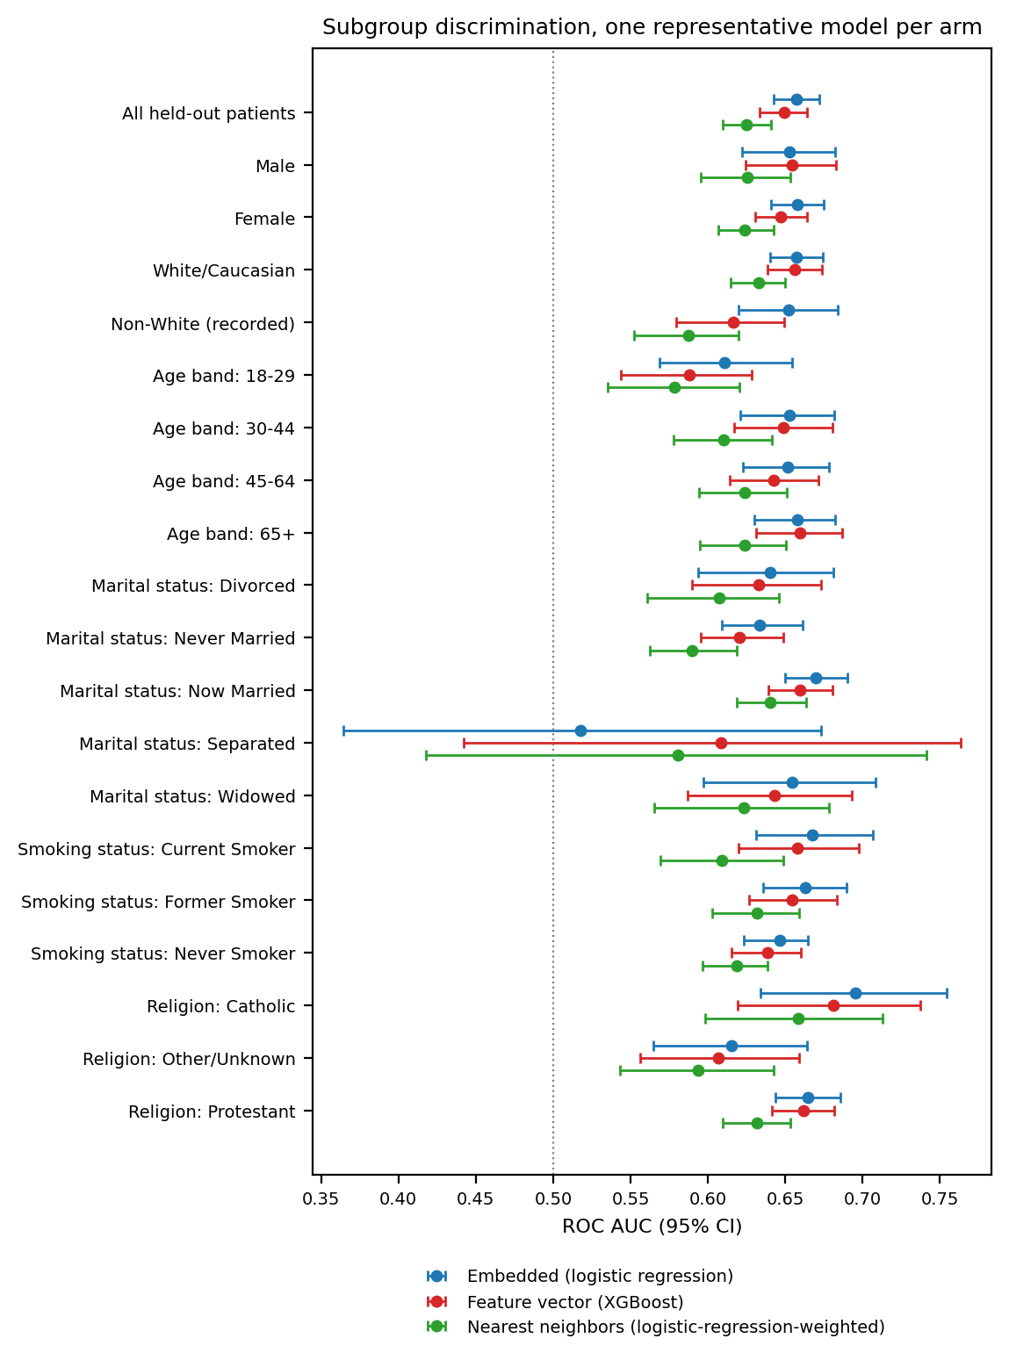
Figure S13. Subgroup discrimination across sociodemographic strata, one representative model per arm (embedded logistic regression, feature-vector XGBoost, and logistic-regression-weighted retrieval at k = 295, the leading model of each), primary encoder, with 95% bootstrap confidence intervals. The dotted line marks chance. Strata declared not estimable are omitted.

S10 Representation Field Crosswalk
Table S13 documents how the pipelines encode each source field, based on scripts/data_loading/feature_vector.py and scripts/data_loading/deterministic_narrative.py. It distinguishes shared information from differences in field content and resolution.
Fields were available by the index date. Clinical content used the 730-day lookback, while recorded history length summarized the longer pre-index record and index date identified the prediction date. Neither representation used post-index clinical data.
Table S13. Field-level crosswalk. Asymmetric marks a row where the two representations do not receive the same information. Missing-value rules are as implemented, not as intended.
Source field | Feature-matrix encoding | Narrative rendering | Missing-value rule | Parity
MDD recurrence, severity | two categorical columns | Condition: MDD (recurrence, severity) | empty string is a level in both | matched
Index date | no column | Index date: YYYY-MM-DD | never missing | asymmetric
Lookback window width | no column (constant) | Baseline window: −730...0 days | never missing | matched (carries no information)
MDD-to-index gap | mdd_to_anchor_days, float | MDD-to-anchor gap: N days | never missing | matched
Encounter count in window | num_encounters, float | Encounters in window: N | never missing | matched
MDD inside lookback window | mdd_within_window, boolean | MDD within window: Present/Absent | never missing | matched
Recorded pre-index history length | pre_anchor_history_days, float | not rendered | never missing | asymmetric
Age | AgeInYears, float | AgeInYears: N | never missing | matched
Sex | categorical | Sex: X | absent value becomes its own one-hot level; narrative prints the raw token | matched
Race / ethnicity | categorical, seven levels | Race_Ethnicity: X | own one-hot level; narrative prints raw token | matched
Preferred language | categorical, collapsed to five levels | raw Epic value | own one-hot level | asymmetric (finer in narrative)
Marital status | categorical, collapsed to five levels | raw Epic value | own one-hot level | asymmetric (finer in narrative)
Religion | categorical, collapsed to five levels | raw Epic value | own one-hot level | asymmetric (finer in narrative)
Smoking status | categorical, collapsed to three levels | raw Epic value | own one-hot level | asymmetric (finer in narrative)
Sexual orientation | no column | SexualOrientation: X | rendered as the literal token nan when recorded-but-empty | asymmetric
Social determinants of health | nine boolean columns | SDOH: list of present categories only | absence is an explicit False in the matrix, an omission from the list in the narrative | matched in content
BMI, systolic BP, diastolic BP | dropped at load | BMI: N | BP (mean): S/D, or Missing | dropped, so no rule; narrative prints Missing | asymmetric
Psychiatric comorbidity (8 flags) | eight boolean columns | ARM: Present/Absent for all eight | never missing | matched
Suicidality flag | boolean | SUICIDE FLAG (2y): Present/Absent | never missing | matched
Substance-use specifics (10) | ten boolean columns | names of present substances only | absence explicit in matrix, omitted in narrative | matched in content
General medical comorbidity (4) | four boolean columns | ARM: Present/Absent for all four | never missing | matched
Prior adequate AD trials | five per-class trial counts | Prior adequate AD trials: CLASS: n for all five | never missing | matched
Benzodiazepine days | benzo_days_coverage, float | Benzodiazepine days (2y): N | never missing | matched
Hypnotics | hypnotics_burden, count only | count plus ingredient names | never missing | asymmetric (finer in narrative)
Active medications | polypharmacy_count, count only | count plus ingredient names | never missing | asymmetric (finer in narrative)
NSAIDs | nsaid_count, count only | count plus ingredient names | never missing | asymmetric (finer in narrative)
Psychiatric inpatient days, ED visits | two float columns | Psych inpatient days: N | ED psych visits: N | never missing | matched
Prescribing-safety comorbidity (2) | two boolean columns | ARM: Present/Absent | never missing | matched
Eleven rows are asymmetric. Ten provide additional or finer information to the narrative, including index date, sexual orientation, vital signs, 4 sociodemographic categories, and 3 medication blocks. Recorded history length is available only to FEATURE. The primary comparison therefore cannot isolate encoding from information content.
FEATURE retains categorical missingness as explicit levels. Its primary vital-sign fields were dropped rather than imputed; narratives retained measured values or missing-value tokens. The raw sexual-orientation token nan is a further implementation-specific exception to the general missing-value convention.
A sensitivity analysis added vital signs to FEATURE using missingness indicators and within-fold median imputation and added recorded history length to the narratives. The best-model contrast was reported to remain nonsignificant. These changes address selected asymmetries, not all differences listed above. Quantitative results are not included here and are available from the corresponding author.

S11 Cohort Characteristics and Outcome Frequency
Within-subgroup outcome frequency divides positive patients by all patients in that subgroup. This differs from the outcome-conditioned column percentages in the cohort table below. All frequencies describe the enriched analytic sample.
Outcome frequency was 18.0% (95% CI 17.6–18.4) among female and 16.2% (95% CI 15.6–16.9) among male patients. It declined across age groups: 20.6% (95% CI 19.5–21.7) at 18–29 years (1,135/5,513), 20.3% (95% CI 19.5–21.2) at 30–44 (1,836/9,025), 18.4% (95% CI 17.8–19.1) at 45–64 (2,445/13,268), and 13.8% (95% CI 13.3–14.4) at 65 or older (2,039/14,773). Selected social-determinant strata had higher frequencies: upbringing-related issues, 33.0% (95% CI 27.3–39.3); legal issues, 26.1% (95% CI 18.9–34.8); employment issues, 24.0% (95% CI 17.9–31.4); and family or support-group issues, 22.9% (95% CI 20.0–26.2). Small counts limit these comparisons. Missing race/ethnicity was associated with a frequency of 15.5% (46/297; 95% CI 11.8–20.0), versus 17.5% (95% CI 17.2–17.9) overall.
Table S14. Expanded cohort characteristics by TRD proxy status. Values are median (IQR) or n (%); percentages within outcome columns use the corresponding outcome-group denominator. SMD: standardized mean difference; AD: antidepressant; ED: emergency department; MDD: major depressive disorder; PTSD: posttraumatic stress disorder. Total N=42,579; positive n=7,455; negative n=35,124.
Characteristic | Level | Overall | TRD+ | TRD− | SMD
Demographics
Age (years) | median (IQR) | 55 (38–70) | 51 (36–66) | 56 (39–71) | −0.193
Age band | 18–29 | 5,513 (12.9%) | 1,135 (15.2%) | 4,378 (12.5%) | 0.080
 | 30–44 | 9,025 (21.2%) | 1,836 (24.6%) | 7,189 (20.5%) | 0.100
 | 45–64 | 13,268 (31.2%) | 2,445 (32.8%) | 10,823 (30.8%) | 0.043
 | 65+ | 14,773 (34.7%) | 2,039 (27.4%) | 12,734 (36.3%) | −0.192
Sex | Female | 30,850 (72.5%) | 5,552 (74.5%) | 25,298 (72.0%) | 0.055
Race/ethnicity | White/Caucasian | 34,079 (80.0%) | 5,942 (79.7%) | 28,137 (80.1%) | −0.010
 | Black/African American | 2,368 (5.6%) | 401 (5.4%) | 1,967 (5.6%) | −0.010
 | Am. Indian/Alaska Native | 2,033 (4.8%) | 394 (5.3%) | 1,639 (4.7%) | 0.028
 | Missing | 297 (0.7%) | 46 (0.6%) | 251 (0.7%) | −0.012
Depression phenotype
MDD recurrence | Recurrent | 11,213 (26.3%) | 2,189 (29.4%) | 9,024 (25.7%) | 0.082
 | Single episode | 28,206 (66.2%) | 4,721 (63.3%) | 23,485 (66.9%) | −0.074
MDD severity | Severe | 2,286 (5.4%) | 720 (9.7%) | 1,566 (4.5%) | 0.204
 | Moderate | 7,233 (17.0%) | 1,300 (17.4%) | 5,933 (16.9%) | 0.014
 | Psychotic | 112 (0.3%) | 35 (0.5%) | 77 (0.2%) | 0.043
 | Unspecified | 28,951 (68.0%) | 4,803 (64.4%) | 24,148 (68.8%) | −0.092
Psychiatric and substance comorbidity
Suicidality flagged | True | 1,753 (4.1%) | 641 (8.6%) | 1,112 (3.2%) | 0.232
Anxiety disorder | True | 22,401 (52.6%) | 4,499 (60.3%) | 17,902 (51.0%) | 0.190
Substance use disorder (any) | True | 9,265 (21.8%) | 2,006 (26.9%) | 7,259 (20.7%) | 0.147
Insomnia | True | 9,350 (22.0%) | 2,021 (27.1%) | 7,329 (20.9%) | 0.147
PTSD | True | 1,541 (3.6%) | 450 (6.0%) | 1,091 (3.1%) | 0.141
Alcohol use disorder | True | 1,875 (4.4%) | 501 (6.7%) | 1,374 (3.9%) | 0.125
Opioid use disorder | True | 1,281 (3.0%) | 337 (4.5%) | 944 (2.7%) | 0.098
Adjustment disorder | True | 2,918 (6.9%) | 663 (8.9%) | 2,255 (6.4%) | 0.093
Medical comorbidity
High cholesterol | True | 15,747 (37.0%) | 2,202 (29.5%) | 13,545 (38.6%) | −0.191
Uncontrolled hypertension | True | 15,680 (36.8%) | 2,366 (31.7%) | 13,314 (37.9%) | −0.130
Treatment and utilization
Active med count | median (IQR) | 1 (0–2) | 1 (0–2) | 1 (0–2) | 0.084
Encounter count | median (IQR) | 21 (8–46) | 17 (6–40) | 21 (8–47) | −0.140
Pre-index history (days) | median (IQR) | 1,792 (1,216–2,546) | 1,629 (1,141–2,335) | 1,830 (1,239–2,587) | −0.198
Any prior treatment exposure recorded | True | 10,230 (24.0%) | 1,793 (24.1%) | 8,437 (24.0%) | 0.001
Prior adequate AD trial (any class) | True | 6,276 (14.7%) | 1,050 (14.1%) | 5,226 (14.9%) | −0.023
Benzodiazepine days recorded | True | 4,724 (11.1%) | 989 (13.3%) | 3,735 (10.6%) | 0.081
Hypnotic recorded | True | 1,661 (3.9%) | 292 (3.9%) | 1,369 (3.9%) | 0.001
Augmentation therapy used | True | 422 (1.0%) | 108 (1.4%) | 314 (0.9%) | 0.052

S12 Additional Model Diagnostics and Encoder Estimates

S12.1 Primary ROC Curves and Descriptive Operating Points
The primary ROC curves are shown in Figure S14. At test-selected Youden J thresholds of 0.165 and 0.173, embedded logistic regression and feature-vector XGBoost had sensitivity 0.647 (95% CI 0.623–0.670) and 0.615 (95% CI 0.591–0.638) and specificity 0.583 (95% CI 0.570–0.594) and 0.606 (95% CI 0.594–0.618). Their F1 scores were 0.36 (95% CI 0.34–0.37) and 0.35 (95% CI 0.34–0.37), positive likelihood ratios 1.55 (95% CI 1.48–1.62) and 1.56 (95% CI 1.48–1.63), and negative likelihood ratios 0.61 (95% CI 0.56–0.65) and 0.64 (95% CI 0.60–0.68). They identified 964 and 917 of 1,491 positive patients, missing 527 and 574, with 2,932 and 2,768 false positives and 4,093 and 4,257 true negatives among 7,025 negative patients, respectively (Figure S15). These thresholds were chosen and evaluated in the same test patients; the estimates are optimistic descriptions and are not deployment thresholds.
A Embedded logistic regression
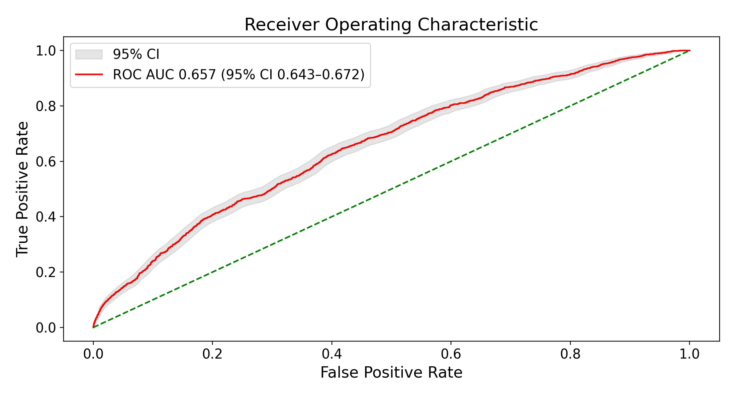
B Feature vector XGBoost
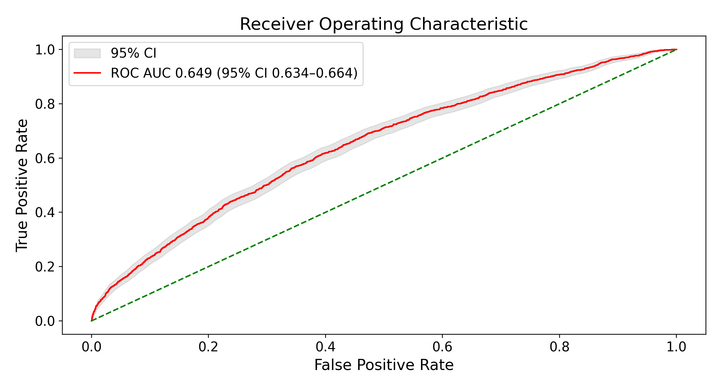
Figure S14. Primary ROC curves for embedded logistic regression (A) and feature-vector XGBoost (B). Shaded bands are bootstrap 95% CIs. ROC AUCs are reported in main-text Table 2.
A Embedded logistic regression
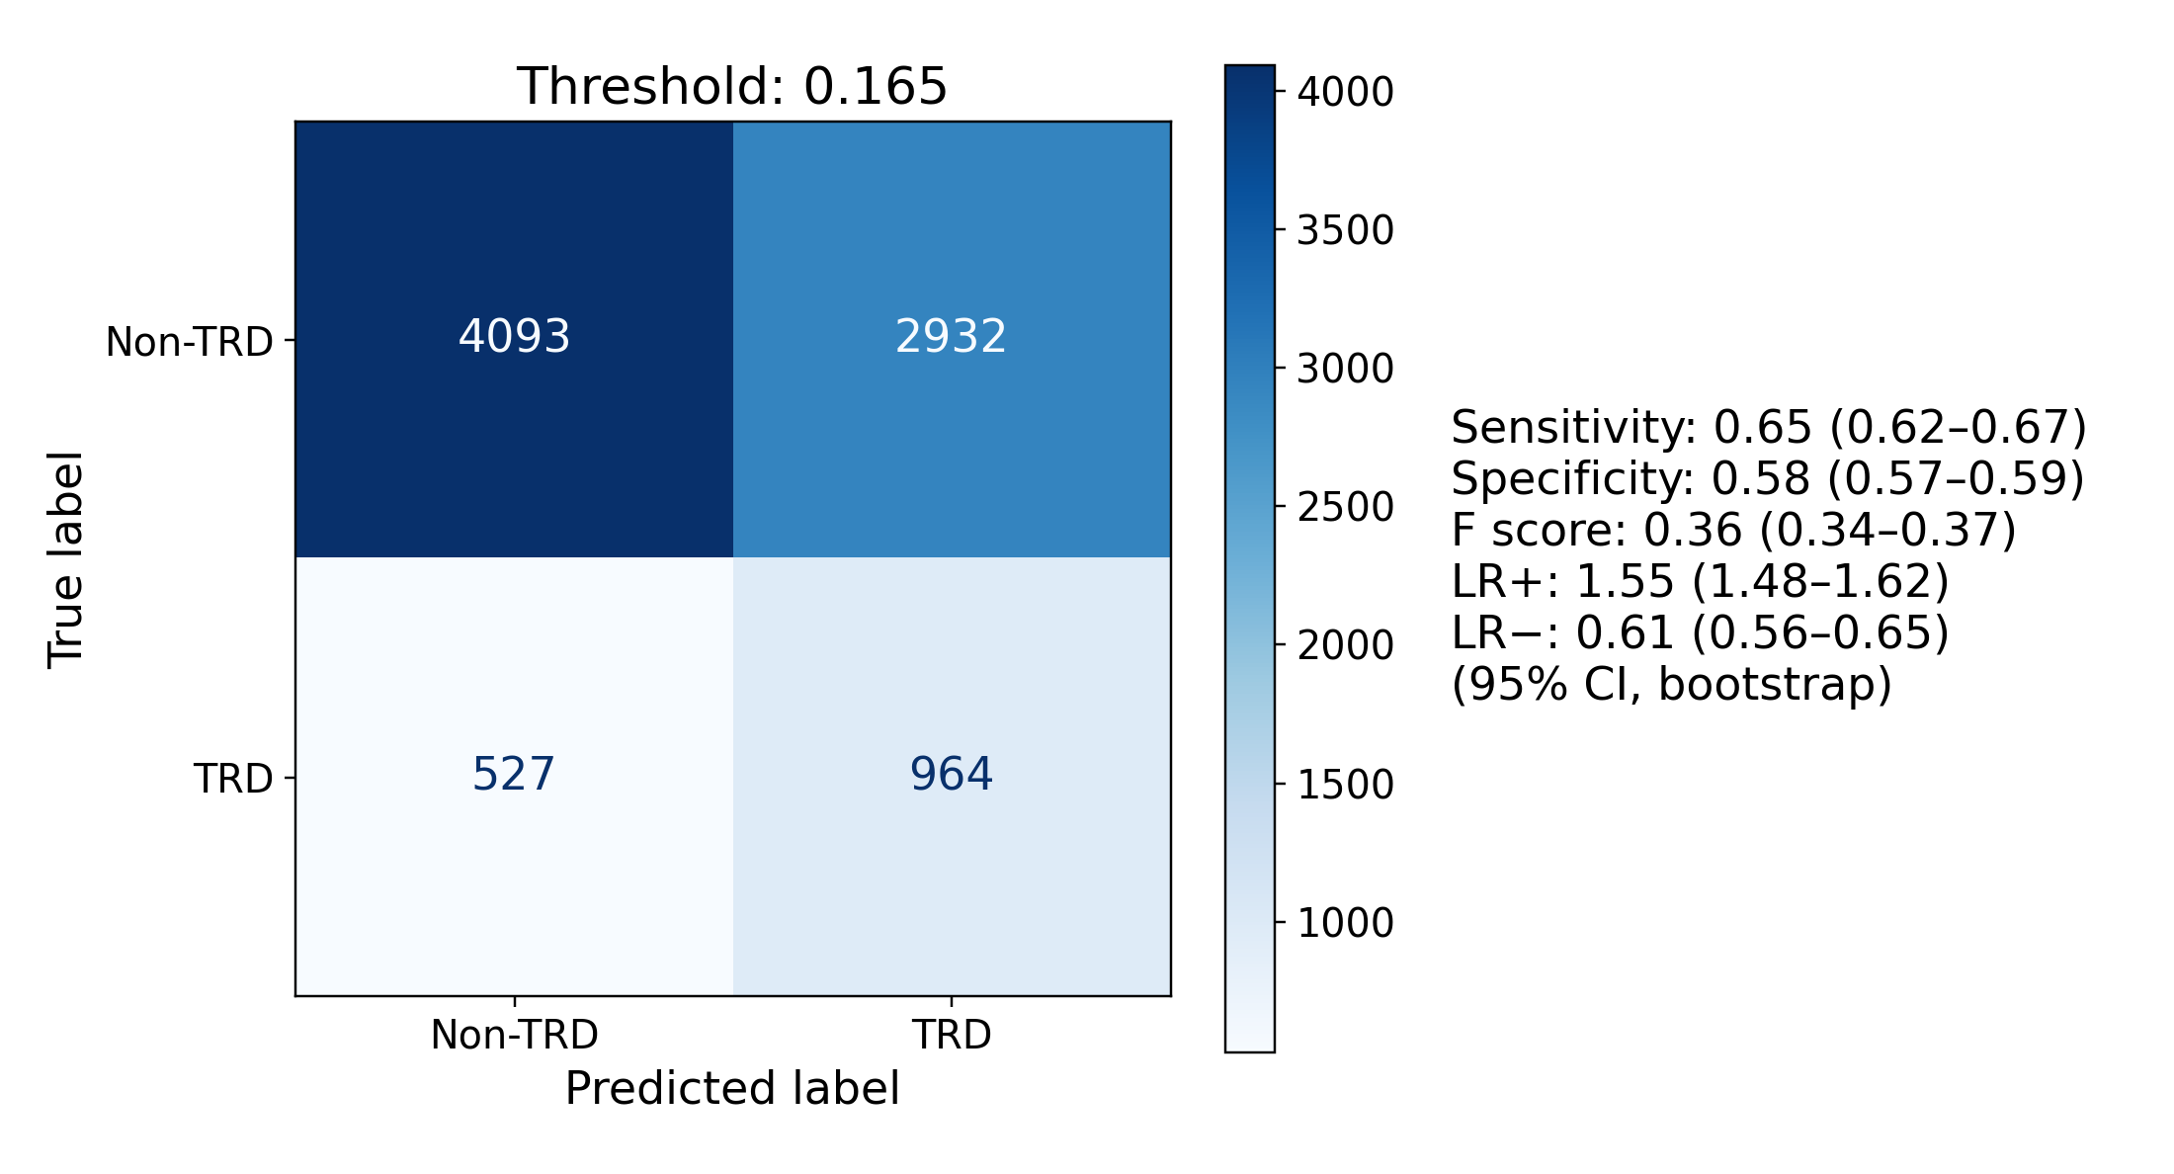
B Feature vector XGBoost
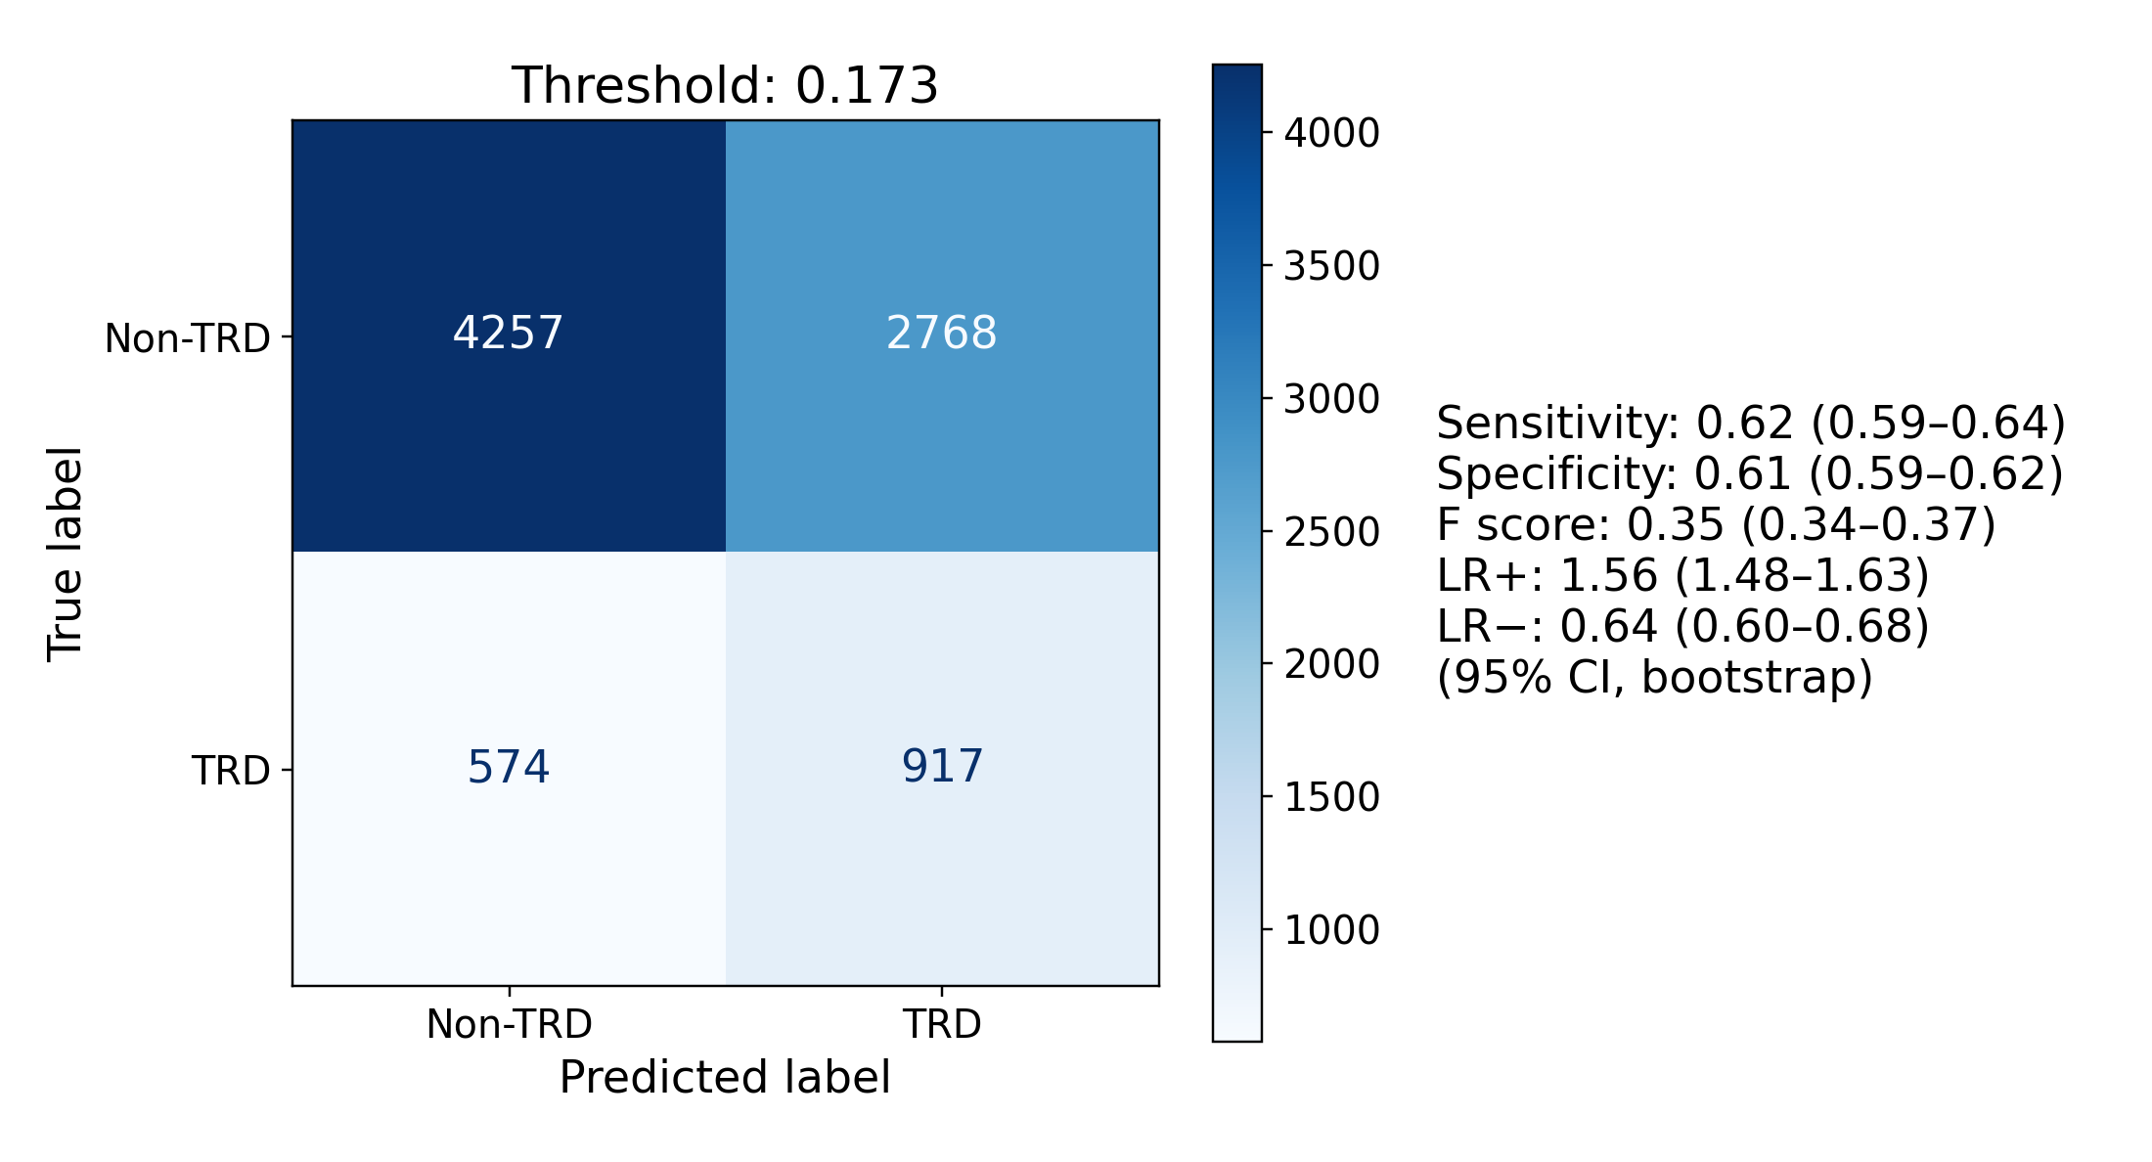
Figure S15. Confusion matrices at test-selected Youden J thresholds for embedded logistic regression (A) and feature-vector XGBoost (B); the panels’ F score is F1. TRD refers to the treatment-switching proxy.

S12.2 Structured Feature Importance
Positive logistic-regression coefficients included severe depression coding, suicidality, insomnia, obsessive-compulsive disorder, opioid use disorder, posttraumatic stress disorder, and anxiety. Negative coefficients included missing smoking status, hyperlipidemia, longer pre-index history, and male sex. Tree importance rankings varied and also emphasized record length, age, utilization, and psychiatric burden (Figure S16). For trees, plotted colors derive from univariate correlations and do not give the direction of the fitted model’s conditional effect. None of these rankings supports causal interpretation.
A Logistic regression
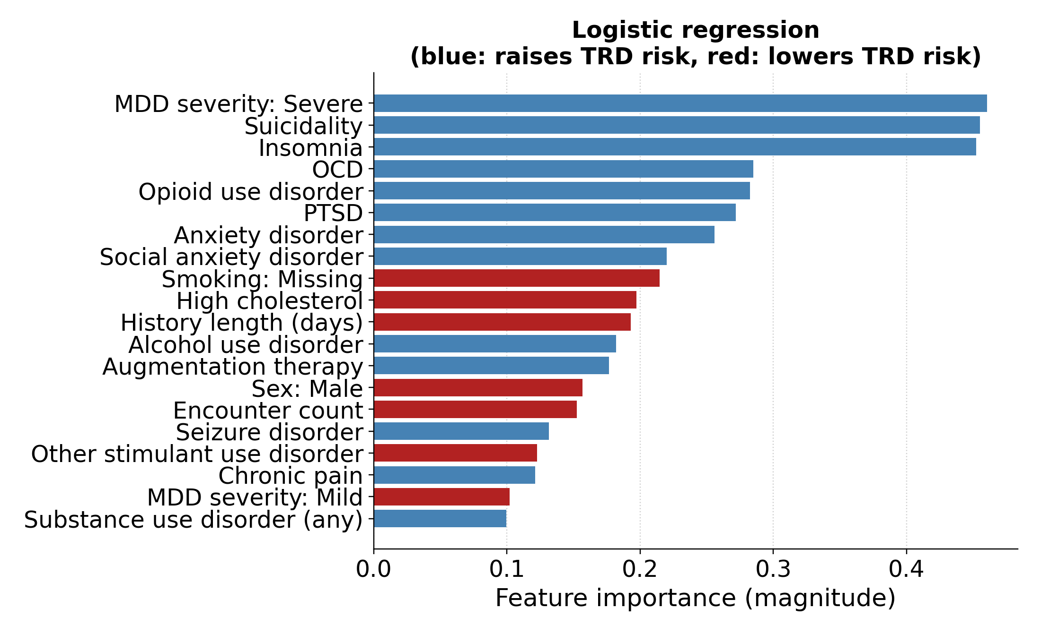
B Random forest
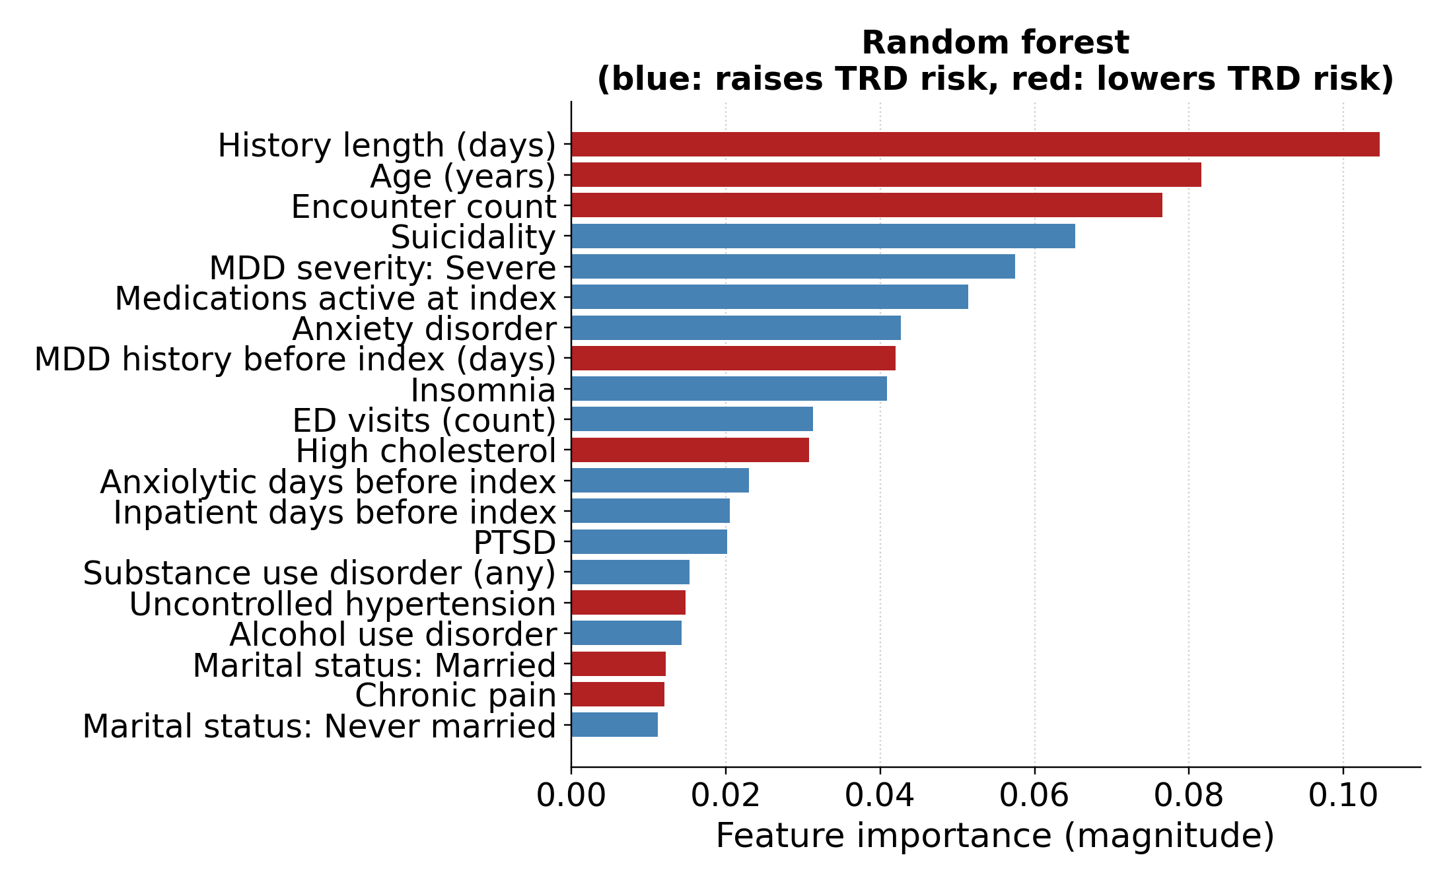
C Gradient boosting
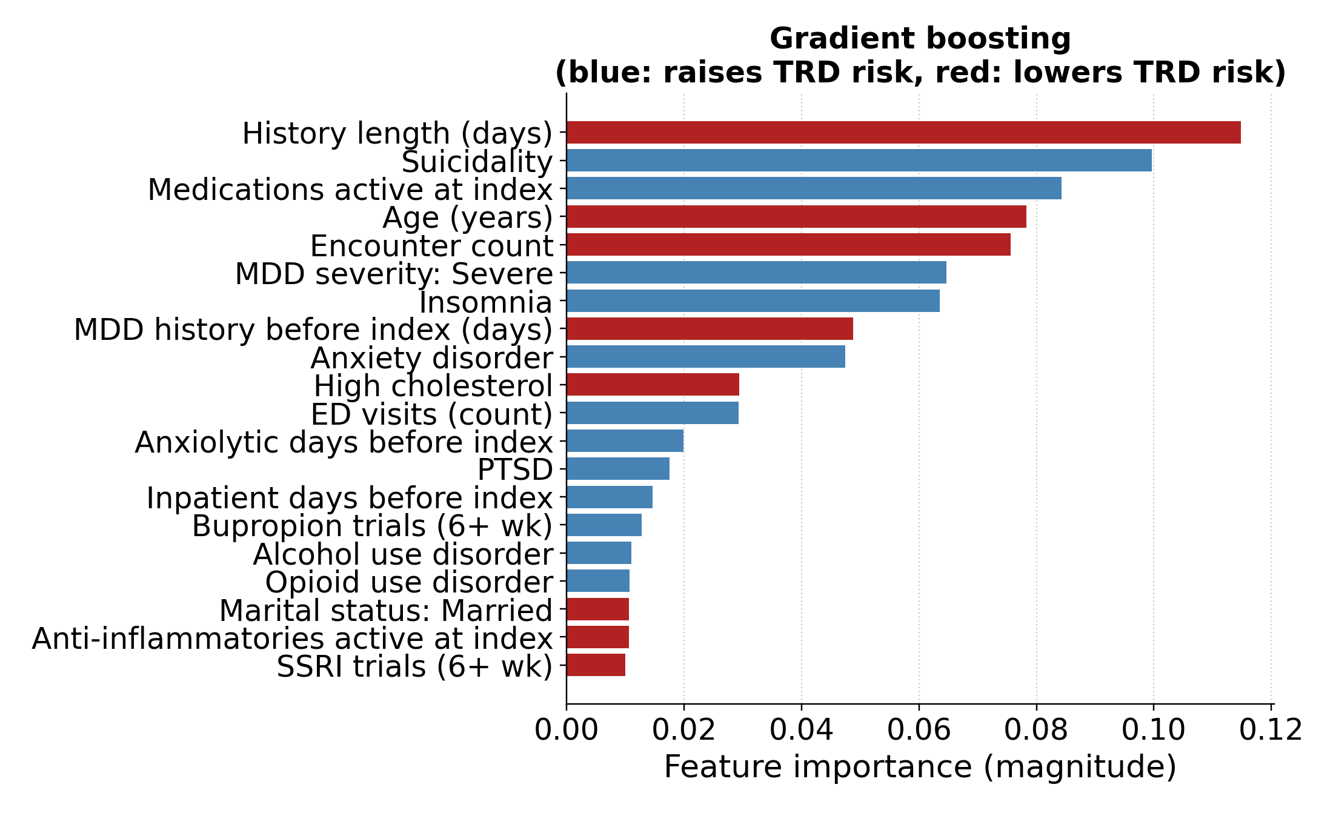
D XGBoost
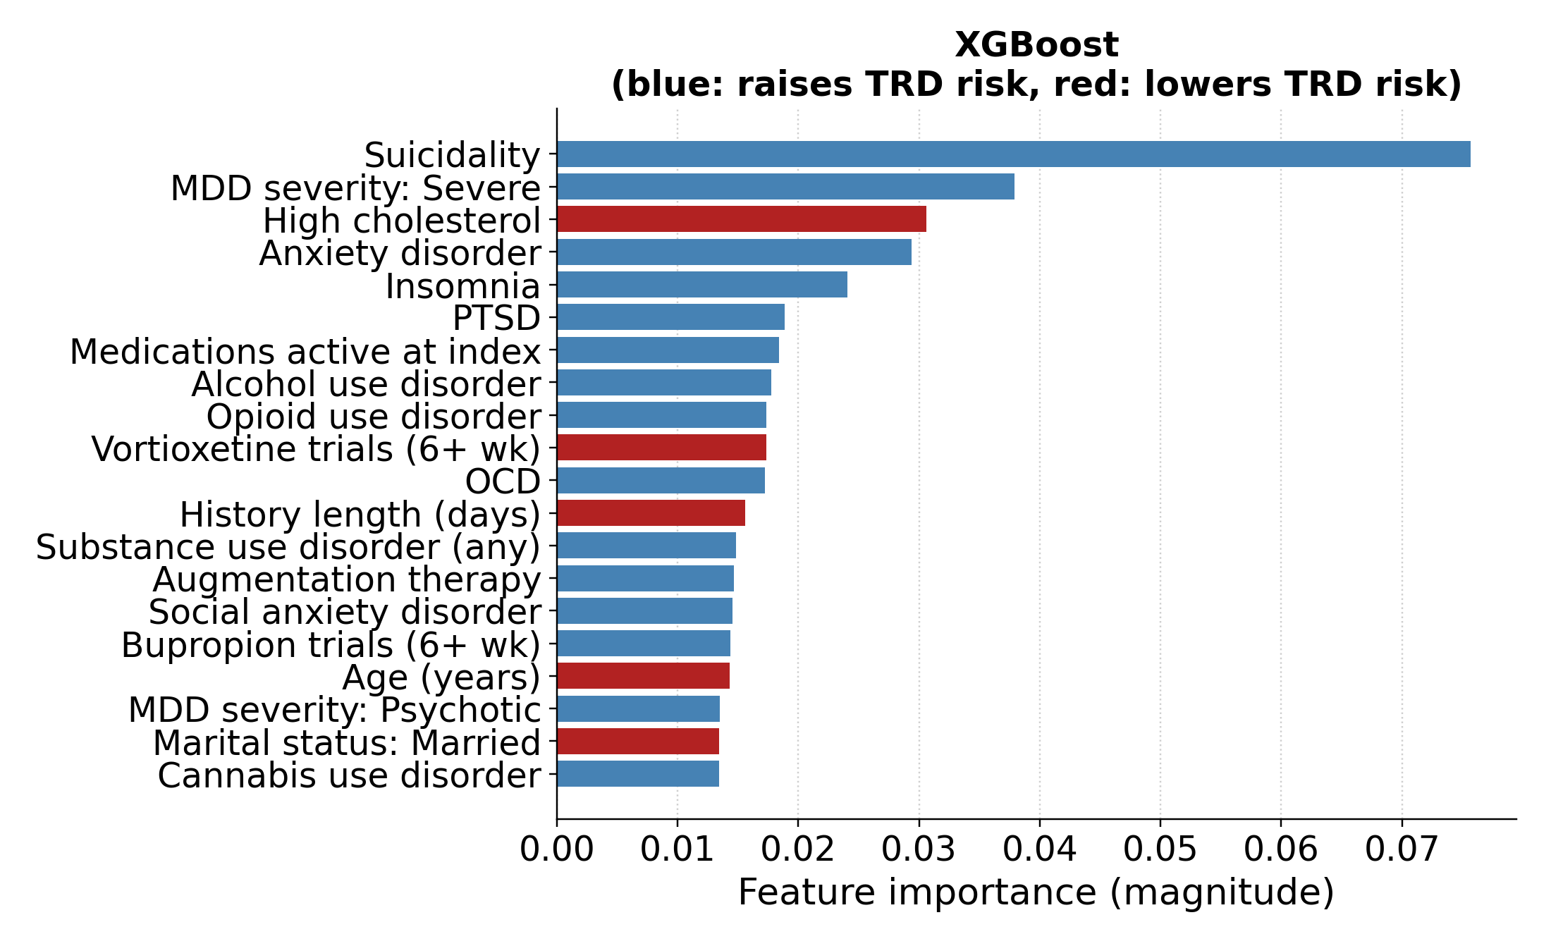
Figure S16. Structured feature importance for logistic regression (A), random forest (B), gradient boosting (C), and XGBoost (D). Logistic-regression bars show coefficient magnitude, with color giving the coefficient’s sign. Tree bars show native importance; colors reflect univariate associations, not conditional model effects or causal directions.

S12.3 Concept Permutation and Encoder Comparison
In the primary encoder, psychiatric-history permutation reduced AUC by 0.024 (95% CI 0.010–0.036) to 0.028 (95% CI 0.017–0.039) across classifiers; all paired CIs excluded zero. Medication burden reduced AUC by 0.003 (95% CI −0.004 to 0.011) to 0.027 (95% CI 0.018–0.037), with CIs excluding zero for 3 classifiers. Prior treatment reduced embedded logistic-regression AUC by 0.019 (95% CI 0.011–0.027) and the other models by 0.000 (95% CI −0.009 to 0.008) to 0.011 (95% CI 0.003–0.020), with CIs excluding zero for logistic regression and XGBoost. Among the remaining concepts, only the XGBoost contraindication contrast excluded zero (−0.005; 95% CI −0.008 to −0.001). Main-text Table 3 gives every difference with its paired CI; Figure S17 gives each model’s absolute AUC.
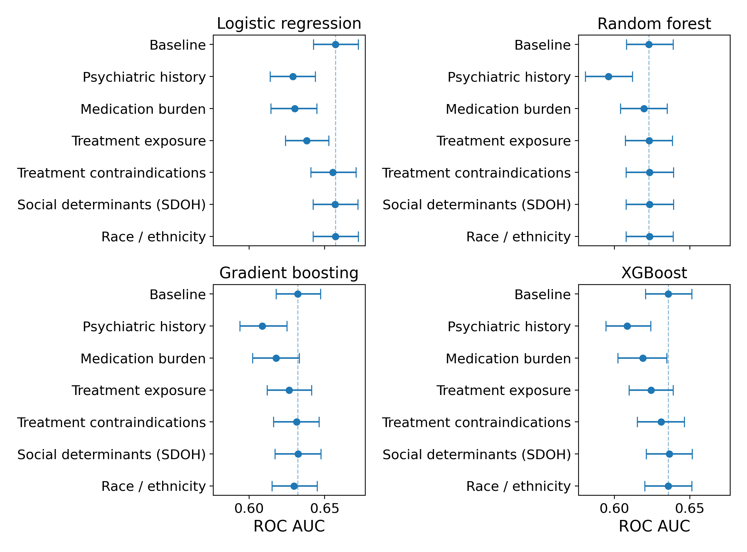
Figure S17. Absolute ROC AUC after concept permutation for each primary embedded classifier. Each panel includes the unperturbed baseline and 6 permutations. Bars are each run’s bootstrap 95% CIs, rather than paired CIs for the differences. SDOH: social determinants of health.
Embedded logistic regression had the highest AUC for every encoder. Across encoders, psychiatric-history permutation reduced its AUC by 0.027 (95% CI 0.017–0.036) to 0.030 (95% CI 0.019–0.041) and medication-burden permutation by 0.022 (95% CI 0.013–0.032) to 0.034 (95% CI 0.023–0.044), with all paired CIs excluding zero. Medication burden exceeded psychiatric history in bge-en-icl (−0.034, 95% CI −0.044 to −0.023, versus −0.027, 95% CI −0.036 to −0.017); psychiatric history had the larger effect in the other 3 encoders. The ordering applies to these tested concepts and does not establish unique or causal contributions.
Table S15. Embedded logistic-regression discrimination by encoder. EPV is 5,964 positive training outcomes divided by input dimension and is descriptive for these regularized models.
Encoder | Dimensions | EPV | ROC AUC (95% CI)
bge-small-en-v1.5 | 384 | 15.5 | 0.645 (0.629–0.660)
bge-en-icl | 4,096 | 1.5 | 0.655 (0.641–0.670)
Qwen3-Embedding-4B | 2,560 | 2.3 | 0.655 (0.641–0.670)
Qwen3-Embedding-8B | 4,096 | 1.5 | 0.657 (0.643–0.672)

References
1. Gaynes BN, Lux L, Gartlehner G, Asher G, Forman-Hoffman V, Green J, et al. Defining treatment-resistant depression. Depress Anxiety. 2020;37(2):134-145. doi:10.1002/da.22968.
2. Rush AJ, Trivedi MH, Wisniewski SR, Nierenberg AA, Stewart JW, Warden D, et al. Acute and longer-term outcomes in depressed outpatients requiring one or several treatment steps: a STAR*D report. Am J Psychiatry. 2006;163(11):1905-1917. doi:10.1176/ajp.2006.163.11.1905.
3. González HM, Vega WA, Williams DR, Tarraf W, West BT, Neighbors HW. Depression care in the United States: too little for too few. Arch Gen Psychiatry. 2010;67(1):37-46. doi:10.1001/archgenpsychiatry.2009.168.
4. Alegría M, Chatterji P, Wells K, Cao Z, Chen CN, Takeuchi D, et al. Disparity in depression treatment among racial and ethnic minority populations in the United States. Psychiatr Serv. 2008;59(11):1264-1272. doi:10.1176/ps.2008.59.11.1264.
5. Perlis RH. A clinical risk stratification tool for predicting treatment resistance in major depressive disorder. Biol Psychiatry. 2013;74(1):7-14. doi:10.1016/j.biopsych.2012.12.007.
6. Kautzky A, Baldinger-Melich P, Kranz GS, Vanicek T, Souery D, Montgomery S, et al. A new prediction model for evaluating treatment-resistant depression. J Clin Psychiatry. 2017;78(2):215-222. doi:10.4088/JCP.15m10381.
7. Sheu YH, Magdamo C, Miller M, Das S, Blacker D, Smoller JW. AI-assisted prediction of differential response to antidepressant classes using electronic health records. npj Digit Med. 2023;6:73. doi:10.1038/s41746-023-00817-8.
8. Chekroud AM, Zotti RJ, Shehzad Z, Gueorguieva R, Johnson MK, Trivedi MH, et al. Cross-trial prediction of treatment outcome in depression: a machine learning approach. Lancet Psychiatry. 2016;3(3):243-250. doi:10.1016/S2215-0366(15)00471-X.
9. Hegselmann S, Shen SZ, Gierse F, Agrawal M, Sontag D, Jiang X. A data-centric approach to generate faithful and high quality patient summaries with large language models. Proc Mach Learn Res. 2024;248:339-379.
10. Reimers N, Gurevych I. Sentence-BERT: sentence embeddings using Siamese BERT-networks. In: Proceedings of the 2019 Conference on Empirical Methods in Natural Language Processing and the 9th International Joint Conference on Natural Language Processing (EMNLP-IJCNLP); 2019 Nov; Hong Kong. Stroudsburg (PA): Association for Computational Linguistics; 2019. p. 3982-3992. doi:10.18653/v1/D19-1410.
11. Xiao S, Liu Z, Zhang P, Muennighoff N, Lian D, Nie JY. C-Pack: packed resources for general Chinese embeddings. In: Proceedings of the 47th International ACM SIGIR Conference on Research and Development in Information Retrieval (SIGIR ’24); 2024 Jul 14-18; Washington (DC). New York: ACM; 2024. p. 641-649. doi:10.1145/3626772.3657878.
12. Li C, Qin M, Xiao S, Chen J, Luo K, Shao Y, et al. Making text embedders few-shot learners. arXiv:2409.15700. 2024.
13. Zhang Y, Li M, Long D, Zhang X, Lin H, Yang B, et al. Qwen3 embedding: advancing text embedding and reranking through foundation models. arXiv:2506.05176. 2025.
14. Hegselmann S, von Arnim G, Rheude T, Kronenberg N, Sontag D, Hindricks G, et al. Large language models are powerful electronic health record encoders. arXiv:2502.17403. 2025.

